

CIVIL AND ENVIRONMENTAL ENGINEERING DEPARTMENT

COURSE PROJECT REPORT

Course Title: Advanced Structural Analysis (CE 511)
"Automated Structural Evaluation of Grid Frameworks Using AI Techniques"

SUBMITTED BY
MD. Faiyaz Shahriar (202427140)
Salman Sajjan (202391350)
MD. Sajid (202421300)
Jamir Uddin Mamun (202417200)
Irfan Hanief Bhat (202390210)

INSTRUCTOR
Dr. Saheed Kolawole Adekunle

Dated: May 19, 2025

Contents
COURSE PROJECT I
CE 511: Advanced Structural Analysis I
List of figures III
Abstract IV
Introduction 1
Objective: 1
Approach: 2
Fundamental Concept: 2
The Developed Program Features 6
The Process of Coding Using Python Program 8
Verifying the Accuracy of the Program: 26
Demonstration of the generated computer program 27
Input data: 27
Output data: 28
Textbook result 30
Conclusion: 30
Reference: 30
Contribution: 31

List of figures
Figure 1 Typical Grid Structure 1
Figure 2 Steps Followed for the Program Development 2
Figure 3 Rearrangement of stiffness matrices 4
Figure 4 Loading and Member Properties of a Book Problem on Grid 29
Figure 5 User Interface 30
Figure 6 Output Data 30
Figure 7 Shear and Moment Diagram of Member 1 31
Figure 8 Shear and Moment Diagram of Member 2 31
Figure 9 Textbook Solution 32

Abstract

In this project, a structural analysis program was developed to find joint displacement, support reactions, and member-end actions of grids framed structures with prismatic members, taking only the effects of loads into consideration. The program was developed in Python, utilizing the direct stiffness method in performing matrix manipulation to find the analysis results. Then, the program generated results were tested by solving one grid example and comparing the results with actual known results. The program proved its worthiness by successfully replicating the exact reported analysis results.

Introduction
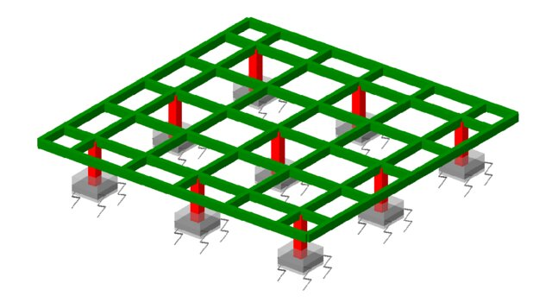
Figure 1 Typical Grid Structure
This report provides the structural analysis of a grid system using a simple computer program. The Direct Stiffness Method (DSM), as a very common numerical method for structural engineering, is introduced as the analysis method. Python coding was created in Visual Studio Code to automate the process to make it easy and efficient to analyse complicated grid structures. Grid structures form an integral part of most framed structures in structural and civil engineering. In this work, the grid is represented by straight members with prismatic cross-sections. The study is restricted to static loading; the effect of temperature change, dynamic or seismic loading is not considered in this project.
As a structural analyst, the goal was to design a program that could perform a total structural analysis. This encompasses the calculation of joint displacements, fixed-end actions, and support reactions. The procedure used in the program is largely based on the steps outlined in Chapter 5 of Matrix Analysis of Framed Structures by Weaver and Gere, which is a step-by-step textbook on stiffness-based structural analysis. It is simple to operate and accepts node coordinates, member connectivity, support conditions, and applied loads as input. It assembles the global stiffness matrix, applies boundary conditions, solves for unknown displacements, and computes member forces and support reactions. Automation of this kind minimizes manual intervention and errors, giving accurate and efficient structural analysis results for grid systems.

Objective:
- The main objective of this term project is to develop a Python based computer program that can perform a complete structural analysis of grid framed structure in 2-D plane using the Direct stiffness method.
- The program is designed to calculate the joint displacements, rotation and support reactions under static loading conditions.
- This automated tool aims to enhance the efficiency, accuracy and reliability of structural analysis of grid systems by visual interface and outputs.

Approach:
- An initial representative grid problem should be solved manually through direct stiffness method steps to outline clear computational processes.
- A Python program must contain functions that represent all manual steps for matrix assembly together with boundary condition application alongside displacement and internal force calculation.
- Verify the developed program through testing it with benchmark examples which possess known solutions to validate both accuracy and reliability of your results.
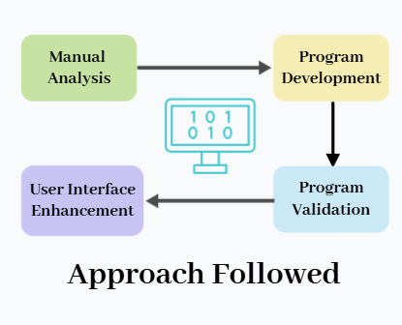
- The system needs a straightforward user interface that enables users to add structural information through an easy process while producing well-organized outputs that show displacements and member forces together with support reactions.

Figure 2 Steps Followed for the Program Development

Fundamental Concept:
The analysis of grid-framed structures within this project depends on the Direct Stiffness Method (DSM) approach. The theoretical basis of this section illustrates the formation process of stiffness matrices, while also showing their rearrangement methods for solving displacement, reaction and internal force calculations.
Formation and Rearrangement of the Joint Stiffness Matrix
Building the joint stiffness matrix (Sj) for the frame structure requires the assembly of stiffness components from individual members. The stiffness matrix for each member (SMSi) starts by defining its formulation within the member-oriented coordinate system. The member’s orientation dictates a transformation matrix to translate the local matrix into the global coordinate system. The formation of the global joint stiffness matrix Sj occurs by summing up all m member stiffness matrices that get properly positioned according to structural connectivity given as,

𝑚
S𝐽 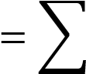 𝑆𝑀𝑆_{𝑖}
𝑖
The grid member stiffness matrix for member axes is shown below.
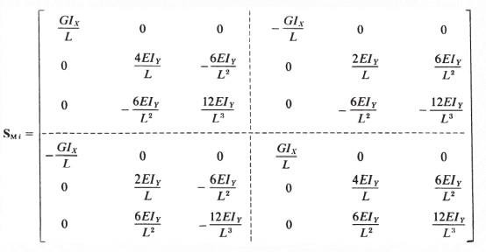
Rotation transformation matrix is shown below.
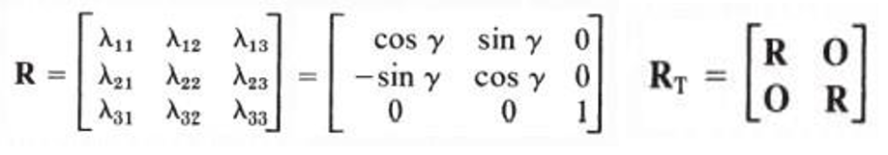
Where,
𝜆 is the angle from the global x-axis to the member-oriented x-axis.
Grid Member Stiffness Matrix for Structural axes are calculated using the following formula:
( 𝑆𝑀𝑠𝑖 = 𝑅𝑇𝑇 𝑆𝑀𝑖 𝑅𝑇 )
Once the stiffness matrix S𝐽 is assembled, it is typically rearranged in two stages for clarity.
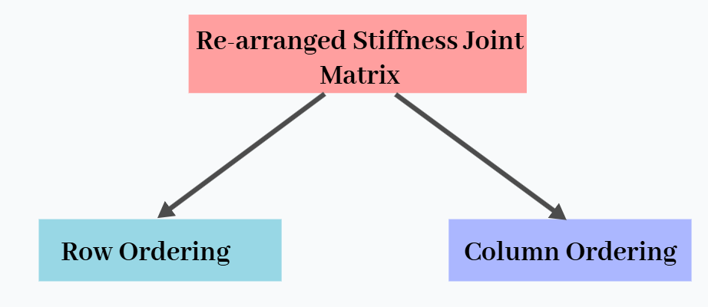
Figure 3 Rearrangement of stiffness matrices
Step-1st (Row re-ordering)- The Sj matrix rows are reorganized to place the entries regarding free displacements at its top section. The matrix contains free displacement rows at the top followed by restrained displacement rows kept in their original sequence.
Step-2nd (Column re-ordering)-The columns are also rearranged by moving freedom displacement columns to the first positions followed by restraint displacement columns in their default sequence.
The resulted matrix is called rearranged joint stiffness matrix, such as where F represents free ends and R represents restrained joints. The whole some matrix is arranged as,
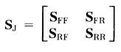

Load Vector
After assembling the joint stiffness matrix, the next step is to account for the external loads acting on the structure. Joint Loads represent both forces and moments which directly affect the joints of a structure. According to the stiffness method they can be directly incorporated into the global load vector for analysis. Member loads include all loads that act throughout the length of a member but do not connect directly to its joints. Member loads are excluded from being directly used in forming the global load vector. The member loads first must be changed into fixed-end actions which represent the internal forces and moments that would occur if member ends experienced complete restraint. The addition of equivalent joint load vectors to actual joint vectors creates the complete load vector.
The procedure of forming and arranging the load vector is depicted below:

The load vector is calculated as
A_{C} = A_{J} + A_{E} ,
where A_{E} 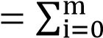 A_{MLi}
_{Aj = Joint loads,}
A_{E} is the equivalent joint load vector,
To accurately capture the effect of member loads we calculate the fixed end actions caused by these loads denoted by AMLi.
AMSi = RTT i AMLi.
After, AC is assembled, it is rearranged in a similar approach as rearranging the joint stiffness matrix, where AFC represents the free displacements combined action and ARC represents the restrained displacements combined actions.
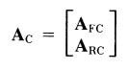

Calculation of Results
The free joint displacement:
DF = 𝑆𝐹𝐹−1 AFC The Reactions:
AR = - ARC + SRF DF
The member-end action:
AMi = AMLi + SMi D_{Mi} where D_{Mi is} the member-oriented displacement at both ends of the member.

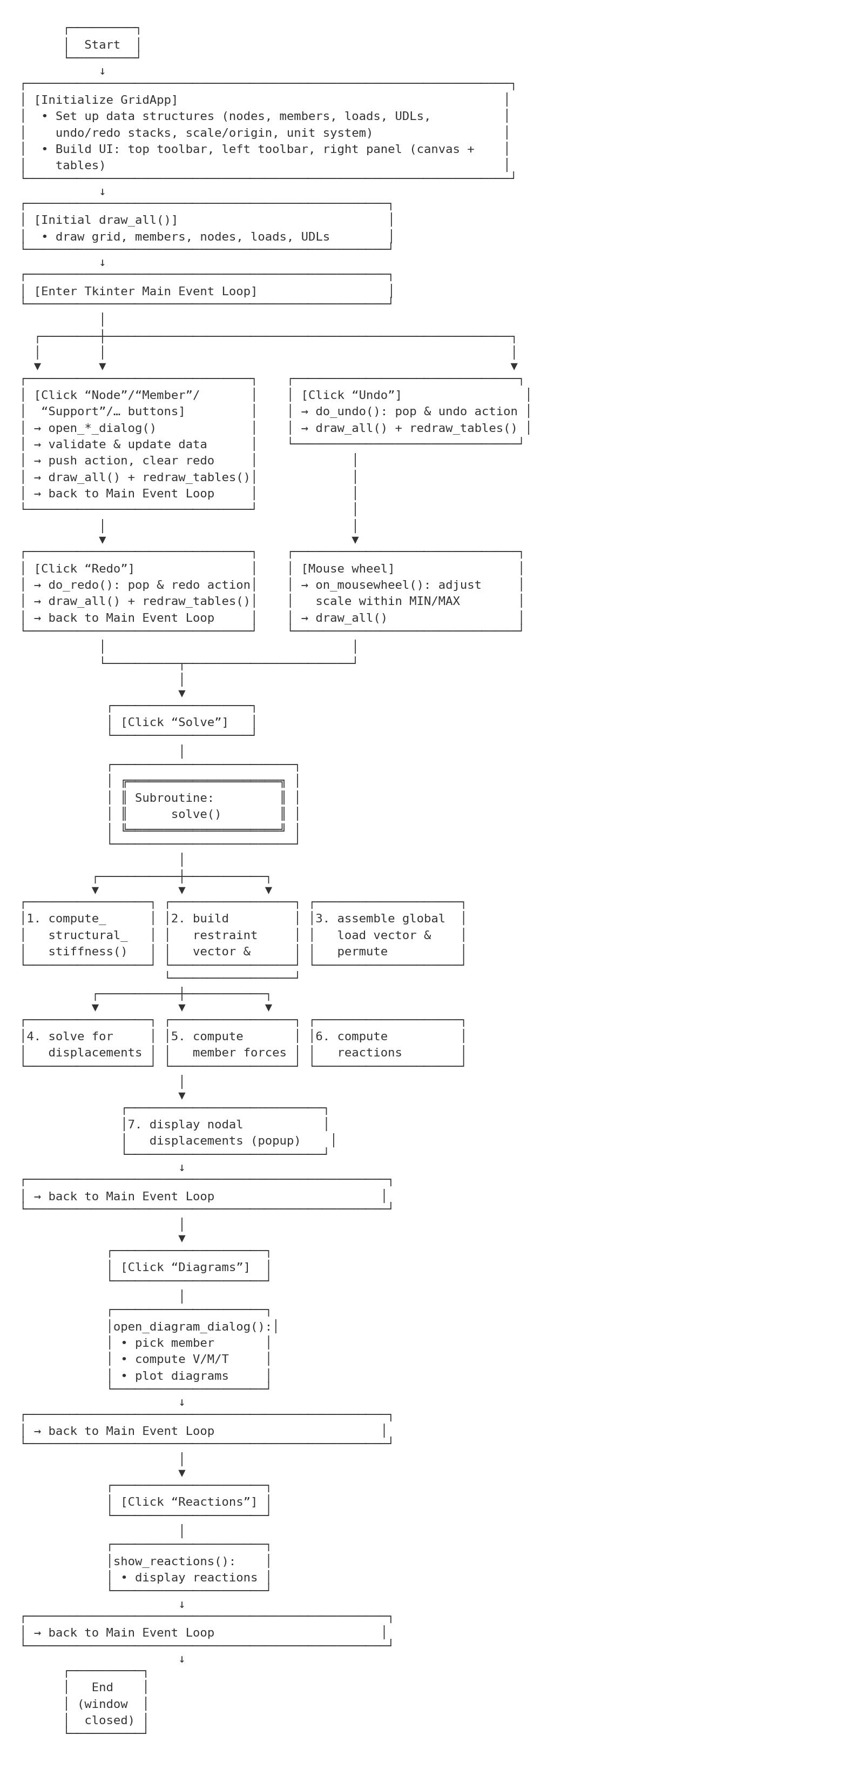
The Developed Program Features

The Process of Coding Using Python Program
import tkinter as tk
from tkinter import ttk, messagebox
import math
import numpy as np
import matplotlib.pyplot as plt

# =============================================================================
# Canvas/Grid Parameters
# =============================================================================
CANVAS_WIDTH = 600
CANVAS_HEIGHT = 400
MARGIN = 50
INIT_SCALE = 20
MIN_SCALE = 5
MAX_SCALE = 200

# =============================================================================
# Main Application Class
# =============================================================================
class GridApp:
def __init__(self, master):
"""
Initialize application, data structures, and UI.
"""
self.master = master
self.master.title("Frame Calculator")
self.master.geometry("1000x800")

# -----------------------
# Data Structures
# -----------------------
self.nodes = {} # node_id -> (x, y)
self.next_node_id = 1
self.members = {} # member_id -> (n1, n2)
self.next_member_id = 1
self.member_props = {} # member_id -> {"G","E","I","J"}
self.supports = {} # node_id -> "Fixed"/"Hinged"
self.loads = {} # load_id -> {"type","member","dist","value"}
self.udls = {} # udl_id -> {"member","start_pt","end_pt","start_mag","end_mag"}

# Counters for load IDs
self.point_count = 1
self.moment_count = 1
self.torsion_count = 1
self.udl_count = 1

# Undo/Redo stacks
self.action_stack = []
self.redo_stack = []

# Zoom and origin for canvas
self.scale = INIT_SCALE
self.origin_x = MARGIN
self.origin_y = CANVAS_HEIGHT - MARGIN

# Unit system
self.unit_system = tk.StringVar(value="Metric")

# Storage for solve results
self.perm = None
self.free_idx = None
self.res_idx = None
self.Sj_perm = None
self.Df = None
self.Ac_perm = None
self.member_forces = {}
self.reactions = {}

# -----------------------
# Build UI
# -----------------------
self.create_top_toolbar()
self.create_left_toolbar()
self.create_right_panel()

# Initial draw
self.draw_all()

# =============================================================================
# Top Toolbar
# =============================================================================
def create_top_toolbar(self):
f = tk.Frame(self.master, bd=1, relief=tk.RAISED, padx=2, pady=2)
f.pack(side=tk.TOP, fill=tk.X)
tk.Button(f, text="New", command=self.new_project).pack(side=tk.LEFT, padx=2)
tk.Button(f, text="Settings", command=self.open_settings).pack(side=tk.LEFT, padx=2)
tk.Button(f, text="Undo", command=self.do_undo).pack(side=tk.LEFT, padx=2)
tk.Button(f, text="Redo", command=self.do_redo).pack(side=tk.LEFT, padx=2)
tk.Button(f, text="Solve", command=self.solve).pack(side=tk.LEFT, padx=2)

# =============================================================================
# Left Toolbar (Tools)
# =============================================================================
def create_left_toolbar(self):
f = tk.Frame(self.master, bd=1, relief=tk.RAISED, padx=5, pady=5)
f.pack(side=tk.LEFT, fill=tk.Y)

tk.Button(f, text="Node", width=15, command=self.activate_node).pack(pady=5)
tk.Button(f, text="Member", width=15, command=self.activate_member).pack(pady=5)
tk.Button(f, text="Support", width=15, command=self.activate_support).pack(pady=5)
tk.Button(f, text="Point Load", width=15, command=self.activate_point_load).pack(pady=5)
tk.Button(f, text="Moment", width=15, command=self.activate_moment).pack(pady=5)
tk.Button(f, text="Torsion", width=15, command=self.activate_torsion).pack(pady=5)
tk.Button(f, text="Dist. Load", width=15, command=self.activate_udl).pack(pady=5)
tk.Button(f, text="Member Properties", width=15, command=self.activate_member_properties).pack(pady=5)
tk.Button(f, text="Reactions", width=15, command=self.show_reactions).pack(pady=5)
tk.Button(f, text="Diagrams", width=15, command=self.open_diagram_dialog).pack(pady=5)

# =============================================================================
# Right Panel: Canvas + Tables
# =============================================================================
def create_right_panel(self):
rf = tk.Frame(self.master)
rf.pack(side=tk.RIGHT, fill=tk.BOTH, expand=True)

# -- Canvas frame --
cf = tk.Frame(rf)
cf.pack(side=tk.TOP, fill=tk.BOTH, expand=True)
self.canvas = tk.Canvas(cf, width=CANVAS_WIDTH, height=CANVAS_HEIGHT, bg="white")
self.canvas.pack(fill=tk.BOTH, expand=True)
self.canvas.bind("<MouseWheel>", self.on_mousewheel)

# -- Member Table --
mtf = tk.Frame(rf, bd=1, relief=tk.SUNKEN)
mtf.pack(side=tk.TOP, fill=tk.X)
cols = ("ID","Start","End","Length","Cx","Cy","G","E","I","J")
self.member_table = ttk.Treeview(mtf, columns=cols, show="headings", height=5)
widths = {"ID":30,"Start":30,"End":30,"Length":60,"Cx":40,"Cy":40,"G":60,"E":60,"I":60,"J":60}
for h in cols:
self.member_table.heading(h, text=h)
self.member_table.column(h, width=widths[h], anchor=tk.CENTER)
self.member_table.pack(side=tk.LEFT, fill=tk.X, padx=5, pady=5)

# -- Load & UDL Tables --
luf = tk.Frame(rf, bd=1, relief=tk.SUNKEN)
luf.pack(side=tk.TOP, fill=tk.X)
self.load_table = ttk.Treeview(luf, columns=("LID","Val"), show="headings", height=5)
self.load_table.heading("LID", text="Load ID")
self.load_table.heading("Val", text="Value")
self.load_table.column("LID", width=50, anchor=tk.CENTER)
self.load_table.column("Val", width=80, anchor=tk.CENTER)
self.load_table.pack(side=tk.LEFT, padx=5, pady=5)

self.udl_table = ttk.Treeview(luf, columns=("UID","sPt","ePt","sMag","eMag"), show="headings", height=5)
for h,w in [("UID",50),("sPt",50),("ePt",50),("sMag",80),("eMag",80)]:
self.udl_table.heading(h, text=h)
self.udl_table.column(h, width=w, anchor=tk.CENTER)
self.udl_table.pack(side=tk.LEFT, padx=5, pady=5)

# =============================================================================
# Mouse Wheel Zoom Handler
# =============================================================================
def on_mousewheel(self, event):
factor = 1.1 if event.delta > 0 else 0.9
new_scale = self.scale * factor
if MIN_SCALE <= new_scale <= MAX_SCALE:
self.scale = new_scale
self.draw_all()

# =============================================================================
# Toolbar Callbacks
# =============================================================================
def new_project(self):
self.__init__(self.master)

def open_settings(self):
d = tk.Toplevel(self.master); d.title("Settings"); d.grab_set()
tk.Radiobutton(d, text="Metric (m,KN)", variable=self.unit_system, value="Metric")\
.grid(row=0,column=0,padx=5,pady=5,sticky="w")
tk.Radiobutton(d, text="Imperial (ft,Kip)", variable=self.unit_system, value="Imperial")\
.grid(row=1,column=0,padx=5,pady=5,sticky="w")
tk.Label(d, text="Upward force positive").grid(row=2,column=0,padx=5,pady=5)
tk.Label(d, text="Anticlockwise rotation positive").grid(row=3,column=0,padx=5,pady=5)
tk.Button(d, text="OK", command=d.destroy).grid(row=4,column=0,pady=10)

def do_undo(self):
if not self.action_stack:
return
act = self.action_stack.pop()
self.undo_action(act)
self.redo_stack.append(act)

def do_redo(self):
if not self.redo_stack:
return
act = self.redo_stack.pop()
self.do_action(act)
self.action_stack.append(act)

def solve(self):
# Assemble Sj, apply supports, build Ac, solve Df, etc.
Sj, n_dof = self.compute_structural_stiffness()

# Restraint vector
r = np.zeros(n_dof, dtype=int)
for nid, st in self.supports.items():
idx = (nid - 1) * 3
if st == "Fixed":
r[idx:idx+3] = 1
elif st == "Hinged":
r[idx+0] = 0
r[idx+1] = 0
r[idx+2] = 1

# Permute Sj
free_idx = np.where(r == 0)[0]
res_idx = np.where(r == 1)[0]
perm = np.concatenate((free_idx, res_idx))
Sj_perm = Sj[np.ix_(perm, perm)]
n_free = len(free_idx)
Sff = Sj_perm[:n_free, :n_free]

# Build Ac
Ac = np.zeros(n_dof)
# Torsion
for lid, info in self.loads.items():
if info["type"] == "torsion":
m_id, val = info["member"], info["value"]
n1, n2 = self.members[m_id]
Ac[(n1-1)*3 + 0] += val
Ac[(n2-1)*3 + 0] -= val
# Point/Moment
for lid, info in self.loads.items():
lt, mid, a, P = info["type"], info["member"], info["dist"], info["value"]
if lt in ("point", "moment"):
n1, n2 = self.members[mid]
x1,y1 = self.nodes[n1]; x2,y2 = self.nodes[n2]
L = math.hypot(x2-x1, y2-y1)
MA = P * a*a * (3*L - a) / L**3
MB = -P * (L - a)*(L - a)*(L + 2*a) / L**3
VA = P * (L - a)*(2*L + a) / L**3
VB = P * a*a * (3*L - a) / L**3 / L
Ac[(n1-1)*3 + 1] += MA
Ac[(n2-1)*3 + 1] += MB
Ac[(n1-1)*3 + 2] += VA
Ac[(n2-1)*3 + 2] += VB
# UDL
for uid, info in self.udls.items():
mid = info["member"]
n1,n2 = self.members[mid]
x1,y1 = self.nodes[n1]; x2,y2 = self.nodes[n2]
L = math.hypot(x2-x1, y2-y1)
s,e,w1,w2 = info["start_pt"],info["end_pt"],info["start_mag"],info["end_mag"]
w_avg = (w1+w2)/2; P = w_avg*(e-s); a = (s+e)/2
MA = P*a*a*(3*L - a)/L**3
MB = -P*(L - a)*(L - a)*(L+2*a)/L**3
VA = P*(L - a)*(2*L + a)/L**3
VB = P*a*a*(3*L - a)/L**3/L
Ac[(n1-1)*3 + 1] += MA
Ac[(n2-1)*3 + 1] += MB
Ac[(n1-1)*3 + 2] += VA
Ac[(n2-1)*3 + 2] += VB

# Permute Ac -> Afc
Ac_perm = Ac[perm]
Afc = Ac_perm[:n_free]

# Solve Df
Df = np.linalg.solve(Sff, Afc)

# Store
self.free_idx = free_idx
self.res_idx = res_idx
self.perm = perm
self.Sj_perm = Sj_perm
self.Df = Df
self.Ac_perm = Ac_perm

# Member forces & Reactions
self.compute_member_forces()
self.compute_reactions()

# Show displacements
win = tk.Toplevel(self.master); win.title("Nodal Displacements")
cols = ("Node","DOF","Type","Value")
tv = ttk.Treeview(win, columns=cols, show="headings")
for h in cols:
tv.heading(h, text=h)
tv.column(h, width=120, anchor=tk.CENTER)
tv.pack(fill=tk.BOTH, expand=True)
for i, dof in enumerate(free_idx):
nid = dof//3 + 1
dt = dof%3
kind = ["Axial rotation","Rotation","Displacement"][dt]
tv.insert("", "end", values=(nid, dof+1, kind, f"{Df[i]:.6g}"))
# =============================================================================
# Compute Member Forces
# =============================================================================
def compute_member_forces(self):
n_dof = 3*len(self.nodes)
Dfull = np.zeros(n_dof)
Dfull[self.free_idx] = self.Df
self.member_forces = {}
for m_id,(n1,n2) in self.members.items():
x1,y1 = self.nodes[n1]; x2,y2 = self.nodes[n2]
L = math.hypot(x2-x1, y2-y1)
p = self.member_props.get(m_id, {"G":0,"E":0,"I":0,"J":0})
G,E,I,J = p["G"],p["E"],p["I"],p["J"]
# Local Smi
Smi = np.array([
[ G*J/L, 0, 0, -G*J/L, 0, 0 ],
[ 0, 4*E*I/L, -6*E*I/L**2, 0, 2*E*I/L, 6*E*I/L**2],
[ 0, -6*E*I/L**2, 12*E*I/L**3, 0, -6*E*I/L**2, -12*E*I/L**3],
[-G*J/L, 0, 0, G*J/L, 0, 0 ],
[ 0, 2*E*I/L, -6*E*I/L**2, 0, 4*E*I/L, 6*E*I/L**2],
[ 0, 6*E*I/L**2, -12*E*I/L**3, 0, 6*E*I/L**2, 12*E*I/L**3]
])
# Amsi
Amsi = np.zeros(6)
# torsion
for lid,info in self.loads.items():
if info["type"]=="torsion" and info["member"]==m_id:
Amsi[0]+=info["value"]; Amsi[3]-=info["value"]
# point/moment
for lid,info in self.loads.items():
lt,mid,a,P = info["type"],info["member"],info["dist"],info["value"]
if mid==m_id and lt in ("point","moment"):
MA = P*a*a*(3*L - a)/L**3
MB = -P*(L - a)*(L - a)*(L +2*a)/L**3
VA = P*(L - a)*(2*L + a)/L**3
VB = P*a*a*(3*L - a)/L**3/L
Amsi[1]+=MA; Amsi[4]+=MB
Amsi[2]+=VA; Amsi[5]+=VB
# UDL
for uid,info in self.udls.items():
if info["member"]==m_id:
s,e,w1,w2 = info["start_pt"],info["end_pt"],info["start_mag"],info["end_mag"]
w_avg = (w1+w2)/2; P=w_avg*(e-s); a=(s+e)/2
MA = P*a*a*(3*L - a)/L**3
MB = -P*(L - a)*(L - a)*(L +2*a)/L**3
VA = P*(L - a)*(2*L + a)/L**3
VB = P*a*a*(3*L - a)/L**3/L
Amsi[1]+=MA; Amsi[4]+=MB
Amsi[2]+=VA; Amsi[5]+=VB
idxs = [(n1-1)*3 + i for i in range(3)] + [(n2-1)*3 + i for i in range(3)]
Dji = Dfull[idxs]
Ami = Amsi + Smi.dot(Dji)
self.member_forces[m_id] = Ami

# =============================================================================
# Compute Reactions
# =============================================================================
def compute_reactions(self):
n_free = len(self.free_idx)
Srf = self.Sj_perm[n_free:, :n_free]
Arc = self.Ac_perm[n_free:]
Ar = Srf.dot(self.Df) - Arc
self.reactions = {}
for i, idx in enumerate(self.res_idx):
nid = idx//3 +1
dt = idx%3
kind = ["Axial rotation","Rotation","Displacement"][dt]
self.reactions[(nid,kind)] = Ar[i]

def show_reactions(self):
win = tk.Toplevel(self.master); win.title("Reactions")
tv = ttk.Treeview(win, columns=("Node","DOF","Value"), show="headings")
for h,w in [("Node",60),("DOF",150),("Value",120)]:
tv.heading(h, text=h); tv.column(h, width=w, anchor=tk.CENTER)
tv.pack(fill=tk.BOTH, expand=True)
for (nid,kind),val in self.reactions.items():
tv.insert("", "end", values=(nid,kind,f"{val:.6g}"))

# =============================================================================
# Diagrams Dialog (with full SFD/BMD/Torsion)
# =============================================================================
def open_diagram_dialog(self):
d = tk.Toplevel(self.master); d.title("Diagrams"); d.grab_set()
tk.Label(d, text="Member ID:").grid(row=0,column=0,padx=5,pady=5)
mids = list(self.members.keys())
if not mids:
messagebox.showinfo("No Members","Add a member first."); d.destroy(); return
cb = ttk.Combobox(d, values=mids, state="readonly"); cb.grid(row=0,column=1); cb.current(0)

def show():
m_id = int(cb.get())
if m_id not in self.member_forces:
messagebox.showerror("Error","Solve first."); return

Ami = self.member_forces[m_id]
L = self.compute_length(m_id)
x_s = np.linspace(0,L,200)

# Shear
V = np.full_like(x_s, Ami[2], dtype=float)
# UDL
for uid,info in self.udls.items():
if info["member"]!=m_id: continue
s,e,w1,w2=info["start_pt"],info["end_pt"],info["start_mag"],info["end_mag"]
for i,x in enumerate(x_s):
if x<=s: continue
x0=min(x,e)
dx=x0-s; W=w2-w1
V[i] -= (w1*dx + (W*dx*dx)/(2*(e-s)))
# point
for lid,info in self.loads.items():
if info["type"]=="point" and info["member"]==m_id:
a,P=info["dist"],info["value"]
V[x_s>=a] -= P

# Moment
M = np.empty_like(x_s)
M[0]=Ami[1]
for i in range(1,len(x_s)):
dx=x_s[i]-x_s[i-1]
M[i]=M[i-1]+0.5*(V[i]+V[i-1])*dx

# Torsion
T = np.full_like(x_s, Ami[0], dtype=float)
for lid,info in self.loads.items():
if info["type"]=="torsion" and info["member"]==m_id:
a,Pt=info["dist"],info["value"]
T[x_s>=a] -= Pt

# Plot
fig,axs=plt.subplots(3,1,sharex=True,figsize=(6,8))
for arr,lbl,ax in zip([V,M,T],["Shear","Moment","Torsion"],axs):
ax.plot(x_s,arr,color="blue",linewidth=2)
ax.fill_between(x_s,arr,0,where=arr>=0,facecolor="green",alpha=0.3)
ax.fill_between(x_s,arr,0,where=arr<=0,facecolor="red",alpha=0.3)
ax.axhline(0,color="black",linewidth=0.8)
ax.set_ylabel(lbl)
axs[2].set_xlabel("Length along member")
plt.tight_layout()
plt.show()

tk.Button(d,text="Show",command=show).grid(row=1,column=0,columnspan=2,pady=10)

def compute_length(self,m_id):
n1,n2 = self.members[m_id]
x1,y1=self.nodes[n1]; x2,y2=self.nodes[n2]
return math.hypot(x2-x1,y2-y1)

# =============================================================================
# Assemble Global Stiffness Matrix Sj
# =============================================================================
def compute_structural_stiffness(self):
n_nodes = len(self.nodes)
n_dof = 3*n_nodes
Sj = np.zeros((n_dof,n_dof))
for m_id,(n1,n2) in self.members.items():
x1,y1=self.nodes[n1]; x2,y2=self.nodes[n2]
dx,dy = x2-x1, y2-y1
L=math.hypot(dx,dy); Cx, Cy = dx/L, dy/L
p=self.member_props.get(m_id,{"G":0,"E":0,"I":0,"J":0})
G,E,I_,J=p["G"],p["E"],p["I"],p["J"]
Smi = np.array([
[G*J/L,0,0,-G*J/L,0,0],
[0,4*E*I_/L,-6*E*I_/L**2,0,2*E*I_/L,6*E*I_/L**2],
[0,-6*E*I_/L**2,12*E*I_/L**3,0,-6*E*I_/L**2,-12*E*I_/L**3],
[-G*J/L,0,0,G*J/L,0,0],
[0,2*E*I_/L,-6*E*I_/L**2,0,4*E*I_/L,6*E*I_/L**2],
[0,6*E*I_/L**2,-12*E*I_/L**3,0,6*E*I_/L**2,12*E*I_/L**3]
])
R=np.array([[Cx,Cy,0],[-Cy,Cx,0],[0,0,1]])
Rt=np.block([[R,np.zeros((3,3))],[np.zeros((3,3)),R]])
Sms = Rt.T.dot(Smi).dot(Rt)
for i in range(6):
for j in range(6):
gi = (n1-1)*3 + (i if i<3 else i-3)
gj = (n1-1)*3 + (j if j<3 else j-3)
if i>=3: gi=(n2-1)*3+(i-3)
if j>=3: gj=(n2-1)*3+(j-3)
Sj[gi,gj]+=Sms[i,j]
return Sj, n_dof

# =============================================================================
# Undo / Redo Internals
# =============================================================================
def do_action(self, act):
typ=act[0]
if typ=="add_node":
_,nid,x,y=act; self.nodes[nid]=(x,y)
elif typ=="add_member":
_,mid,n1,n2=act; self.members[mid]=(n1,n2)
elif typ=="add_support":
_,nid,st=act; self.supports[nid]=st
elif typ=="add_load":
_,lid,lt,mid,d,v=act
self.loads[lid]={"type":lt,"member":mid,"dist":d,"value":v}
elif typ=="add_udl":
_,uid,mid,s,e,sm,em=act
self.udls[uid]={"member":mid,"start_pt":s,"end_pt":e,"start_mag":sm,"end_mag":em}
elif typ=="edit_props":
_,mid,old,new=act; self.member_props[mid]=new
self.draw_all(); self.redraw_tables()

def undo_action(self, act):
typ=act[0]
if typ=="add_node":
_,nid,_,_=act
self.nodes.pop(nid,None)
self.supports.pop(nid,None)
for mid in list(self.members):
if nid in self.members[mid]: self.members.pop(mid)
for lid in list(self.loads):
if self.loads[lid]["member"] not in self.members: self.loads.pop(lid)
for uid in list(self.udls):
if self.udls[uid]["member"] not in self.members: self.udls.pop(uid)
elif typ=="add_member":
_,mid,_,_=act; self.members.pop(mid,None)
elif typ=="add_support":
_,nid,_=act; self.supports.pop(nid,None)
elif typ=="add_load":
_,lid,_,_,_,_=act; self.loads.pop(lid,None)
elif typ=="add_udl":
_,uid,_,_,_,_,_=act; self.udls.pop(uid,None)
elif typ=="edit_props":
_,mid,old,_=act; self.member_props[mid]=old
self.draw_all(); self.redraw_tables()

# =============================================================================
# Refresh Tables
# =============================================================================
def redraw_tables(self):
for item in self.member_table.get_children():
self.member_table.delete(item)
for mid,(n1,n2) in self.members.items():
x1,y1=self.nodes[n1]; x2,y2=self.nodes[n2]
L=math.hypot(x2-x1,y2-y1) if (x2,y2)!=(x1,y1) else 0
cx=(x2-x1)/L if L else 0; cy=(y2-y1)/L if L else 0
p=self.member_props.get(mid,{"G":0,"E":0,"I":0,"J":0})
vals=(mid,n1,n2,f"{L:.2f}",f"{cx:.2f}",f"{cy:.2f}",p["G"],p["E"],p["I"],p["J"])
self.member_table.insert("", "end", values=vals)
for tbl in (self.load_table,self.udl_table):
for item in tbl.get_children(): tbl.delete(item)
for lid,info in self.loads.items():
self.load_table.insert("", "end", values=(lid,info["value"]))
for uid,info in self.udls.items():
self.udl_table.insert("", "end", values=(
uid, info["start_pt"], info["end_pt"],
info["start_mag"], info["end_mag"]
))

# =============================================================================
# Tool Activation
# =============================================================================
def activate_node(self): self.open_node_dialog()
def activate_member(self): self.open_member_dialog()
def activate_support(self): self.open_support_dialog()
def activate_point_load(self): self.open_load_dialog("point")
def activate_moment(self): self.open_load_dialog("moment")
def activate_torsion(self): self.open_load_dialog("torsion")
def activate_udl(self): self.open_udl_dialog()
def activate_member_properties(self): self.open_member_properties_dialog()

# =============================================================================
# Input Dialogs: Node
# =============================================================================
def open_node_dialog(self):
d = tk.Toplevel(self.master); d.title("Add Node"); d.grab_set()
tk.Label(d,text="X:").grid(row=0,column=0,padx=5,pady=5)
ex = tk.Entry(d); ex.grid(row=0,column=1,padx=5,pady=5)
tk.Label(d,text="Y:").grid(row=1,column=0,padx=5,pady=5)
ey = tk.Entry(d); ey.grid(row=1,column=1,padx=5,pady=5)
def apply():
try:
x,y = float(ex.get()), float(ey.get())
except:
return messagebox.showerror("Error","Invalid coordinates")
nid=self.next_node_id; self.next_node_id+=1
self.nodes[nid]=(x,y)
self.action_stack.append(("add_node",nid,x,y))
self.redo_stack.clear()
self.draw_all(); d.destroy()
tk.Button(d,text="Apply",command=apply).grid(row=2,column=0,columnspan=2,pady=10)

# =============================================================================
# Input Dialogs: Member
# =============================================================================
def open_member_dialog(self):
d=tk.Toplevel(self.master); d.title("Add Member"); d.grab_set()
tk.Label(d,text="Start Node ID:").grid(row=0,column=0,padx=5,pady=5)
es=tk.Entry(d); es.grid(row=0,column=1,padx=5,pady=5)
tk.Label(d,text="End Node ID:").grid(row=1,column=0,padx=5,pady=5)
ee=tk.Entry(d); ee.grid(row=1,column=1,padx=5,pady=5)
def apply():
try:
n1,n2=int(es.get()),int(ee.get())
except:
return messagebox.showerror("Error","Invalid IDs")
if n1 not in self.nodes or n2 not in self.nodes:
return messagebox.showerror("Error","Node missing")
mid=self.next_member_id; self.next_member_id+=1
self.members[mid]=(n1,n2)
self.action_stack.append(("add_member",mid,n1,n2))
self.redo_stack.clear()
self.redraw_tables(); d.destroy()
tk.Button(d,text="Apply",command=apply).grid(row=2,column=0,columnspan=2,pady=10)

# =============================================================================
# Input Dialogs: Support
# =============================================================================
def open_support_dialog(self):
d=tk.Toplevel(self.master); d.title("Add Support"); d.grab_set()
tk.Label(d,text="Node ID:").grid(row=0,column=0,padx=5,pady=5)
en=tk.Entry(d); en.grid(row=0,column=1,padx=5,pady=5)
tk.Label(d,text="Type:").grid(row=1,column=0,padx=5,pady=5)
cb=ttk.Combobox(d,values=["Fixed","Hinged"],state="readonly"); cb.grid(row=1,column=1,padx=5,pady=5)
cb.current(0)
def apply():
try: nid=int(en.get())
except: return messagebox.showerror("Error","Invalid ID")
if nid not in self.nodes: return messagebox.showerror("Error","Node missing")
st=cb.get()
self.supports[nid]=st
self.action_stack.append(("add_support",nid,st))
self.redo_stack.clear()
self.draw_all(); d.destroy()
tk.Button(d,text="Apply",command=apply).grid(row=2,column=0,columnspan=2,pady=10)

# =============================================================================
# Input Dialogs: Load/Moment/Torsion
# =============================================================================
def open_load_dialog(self,lt):
d=tk.Toplevel(self.master); d.title(f"Add {lt.capitalize()}"); d.grab_set()
tk.Label(d,text="Member ID:").grid(row=0,column=0,padx=5,pady=5)
em=tk.Entry(d); em.grid(row=0,column=1,padx=5,pady=5)
tk.Label(d,text="Distance:").grid(row=1,column=0,padx=5,pady=5)
ed=tk.Entry(d); ed.grid(row=1,column=1,padx=5,pady=5)
tk.Label(d,text="Value:").grid(row=2,column=0,padx=5,pady=5)
ev=tk.Entry(d); ev.grid(row=2,column=1,padx=5,pady=5)
def apply():
try:
mid=int(em.get()); dist=float(ed.get()); val=float(ev.get())
except:
return messagebox.showerror("Error","Invalid input")
if mid not in self.members:
return messagebox.showerror("Error","Member missing")
if lt=="point":
lid=f"L{self.point_count}"; self.point_count+=1
elif lt=="moment":
lid=f"M{self.moment_count}"; self.moment_count+=1
else:
lid=f"T{self.torsion_count}"; self.torsion_count+=1
self.loads[lid]={"type":lt,"member":mid,"dist":dist,"value":val}
self.action_stack.append(("add_load",lid,lt,mid,dist,val))
self.redo_stack.clear()
self.draw_all(); d.destroy()
tk.Button(d,text="Apply",command=apply).grid(row=3,column=0,columnspan=2,pady=10)

# =============================================================================
# Input Dialogs: UDL
# =============================================================================
def open_udl_dialog(self):
d=tk.Toplevel(self.master); d.title("Add UDL"); d.grab_set()
labels=["Member ID:","Start Pt:","End Pt:","Start Mag:","End Mag:"]
entries=[]
for i,txt in enumerate(labels):
tk.Label(d, text=txt).grid(row=i,column=0,padx=5,pady=5)
e=tk.Entry(d); e.grid(row=i,column=1,padx=5,pady=5)
entries.append(e)
def apply():
try:
mid=int(entries[0].get())
spt,ept,sm,em=[float(e.get()) for e in entries[1:]]
except:
return messagebox.showerror("Error","Invalid input")
if mid not in self.members:
return messagebox.showerror("Error","Member missing")
uid=f"U{self.udl_count}"; self.udl_count+=1
self.udls[uid]={
"member":mid,
"start_pt":spt,
"end_pt":ept,
"start_mag":sm,
"end_mag":em
}
self.action_stack.append(("add_udl",uid,mid,spt,ept,sm,em))
self.redo_stack.clear()
self.draw_all(); d.destroy()
tk.Button(d,text="Apply",command=apply).grid(row=len(labels),column=0,columnspan=2,pady=10)

# =============================================================================
# Input Dialogs: Member Properties
# =============================================================================
def open_member_properties_dialog(self):
d=tk.Toplevel(self.master); d.title("Edit Member Properties"); d.grab_set()
tk.Label(d,text="Member ID:").grid(row=0,column=0,padx=5,pady=5)
mids=list(self.members.keys())
if not mids:
messagebox.showinfo("No Members","Add a member first."); d.destroy(); return
cb=ttk.Combobox(d,values=mids,state="readonly"); cb.grid(row=0,column=1); cb.current(0)
labels=["G","E","I","J"]
entries=[]
for i,txt in enumerate(labels, start=1):
tk.Label(d,text=txt+":").grid(row=i,column=0,padx=5,pady=5)
e=tk.Entry(d); e.grid(row=i,column=1,padx=5,pady=5)
entries.append(e)
def load_vals(ev=None):
mid=int(cb.get())
p=self.member_props.get(mid,{"G":0,"E":0,"I":0,"J":0})
for ent,key in zip(entries,labels):
ent.delete(0,tk.END)
ent.insert(0,str(p.get(key,0)))
cb.bind("<<ComboboxSelected>>",load_vals)
load_vals()
def apply():
try:
mid=int(cb.get())
G,E,I_,J=[float(e.get()) for e in entries]
except:
return messagebox.showerror("Error","Invalid input")
old=self.member_props.get(mid,{"G":0,"E":0,"I":0,"J":0})
new={"G":G,"E":E,"I":I_,"J":J}
self.member_props[mid]=new
self.action_stack.append(("edit_props",mid,old,new))
self.redo_stack.clear()
self.redraw_tables(); d.destroy()
tk.Button(d,text="Apply",command=apply).grid(row=5,column=0,columnspan=2,pady=10)

# =============================================================================
# Drawing Routines
# =============================================================================
def draw_all(self):
self.canvas.delete("all")
self.draw_grid()
self.draw_members()
self.draw_udls()
self.draw_nodes()
self.draw_loads()

def draw_grid(self):
w,h=self.canvas.winfo_width(),self.canvas.winfo_height()
max_x=int((w-self.origin_x-MARGIN)/self.scale)
max_y=int((self.origin_y-MARGIN)/self.scale)
for i in range(max_x+1):
x1,y1=self.world_to_canvas(i,0)
x2,y2=self.world_to_canvas(i,max_y)
self.canvas.create_line(x1,y1,x2,y2,fill="lightgrey")
self.canvas.create_text(x1,y1+12,text=str(i))
for j in range(max_y+1):
x1,y1=self.world_to_canvas(0,j)
x2,y2=self.world_to_canvas(max_x,j)
self.canvas.create_line(x1,y1,x2,y2,fill="lightgrey")
self.canvas.create_text(x1-12,y1,text=str(j))
x0,y0=self.world_to_canvas(0,0)
x_max,_=self.world_to_canvas(max_x,0)
_,y_max=self.world_to_canvas(0,max_y)
self.canvas.create_line(x0,y0,x_max,y0,width=2,arrow=tk.LAST)
self.canvas.create_line(x0,y0,x0,y_max,width=2,arrow=tk.LAST)

def draw_nodes(self):
r=4
for nid,(x,y) in self.nodes.items():
cx,cy=self.world_to_canvas(x,y)
if nid in self.supports:
st=self.supports[nid]
color="black" if st=="Fixed" else "orange"
label=f"N{nid}({st})"
else:
color="red"; label=f"N{nid}"
self.canvas.create_oval(cx-r,cy-r,cx+r,cy+r,fill=color)
self.canvas.create_text(cx+10,cy-10,text=label,fill="blue",font=("Arial",8))

def draw_members(self):
for mid,(n1,n2) in self.members.items():
if n1 in self.nodes and n2 in self.nodes:
x1,y1=self.nodes[n1]; x2,y2=self.nodes[n2]
c1=self.world_to_canvas(x1,y1); c2=self.world_to_canvas(x2,y2)
self.canvas.create_line(*c1,*c2,fill="green",width=2)
mx,my=(c1[0]+c2[0])/2,(c1[1]+c2[1])/2
self.canvas.create_text(mx,my,text=f"M{mid}",fill="purple",font=("Arial",8))

def draw_loads(self):
for lid,info in self.loads.items():
m,d,v=info["member"],info["dist"],info["value"]
if m not in self.members: continue
n1,n2=self.members[m]
if n1 not in self.nodes or n2 not in self.nodes: continue
x1,y1=self.nodes[n1]; x2,y2=self.nodes[n2]
L=math.hypot(x2-x1,y2-y1)
frac=d/L if L else 0
px,py=x1+frac*(x2-x1),y1+frac*(y2-y1)
cx,cy=self.world_to_canvas(px,py)
color={"point":"blue","moment":"magenta","torsion":"brown"}[info["type"]]
self.canvas.create_oval(cx-3,cy-3,cx+3,cy+3,fill=color)
self.canvas.create_text(cx+12,cy,text=lid,fill="black",font=("Arial",8))

def draw_udls(self):
for uid,info in self.udls.items():
m=info["member"]
if m not in self.members: continue
n1,n2=self.members[m]
if n1 not in self.nodes or n2 not in self.nodes: continue
x1,y1=self.nodes[n1]; x2,y2=self.nodes[n2]
L=math.hypot(x2-x1,y2-y1)
if not L: continue
s=info["start_pt"]/L; e=info["end_pt"]/L
p1=(x1+s*(x2-x1),y1+s*(y2-y1))
p2=(x1+e*(x2-x1),y1+e*(y2-y1))
c1=self.world_to_canvas(*p1); c2=self.world_to_canvas(*p2)
self.canvas.create_line(*c1,*c2,fill="cyan",width=3)
mx,my=(c1[0]+c2[0])/2,(c1[1]+c2[1])/2
self.canvas.create_text(mx,my-10,text=uid,fill="darkblue",font=("Arial",8))

def world_to_canvas(self,wx,wy):
return (self.origin_x + wx*self.scale,
self.origin_y - wy*self.scale)

# =============================================================================
# Run Application
# =============================================================================
if __name__ == "__main__":
root = tk.Tk()
app = GridApp(root)
root.mainloop()

Verifying the Accuracy of the Program:

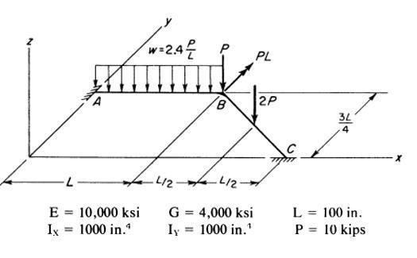
To verify the accuracy of generated program, a numerical grid example has been taken for comparison as follows: a solved grid example provided by Weaver, & Gere, (1990) will be resolved by the developed program, and later compared to the actual solution. The example to be solved is shown in Figure 4.

Figure 4 Loading and Member Properties of a Book Problem on Grid

Demonstration of the generated computer program

Input data:
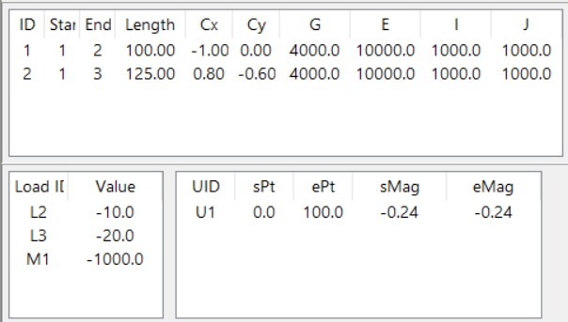
In this section, the developed program features will be shown for the analysis of grids. The input data required by the computer program are summarized in figure 5. Units are according to the textbook problem. Here,
UID = UDL id,
sPt = Starting point,
ePt = Ending point,
sMag = Stating magnitude of UDL,
eMag = Ending magnitude of UDL
Figure 5 Input Data

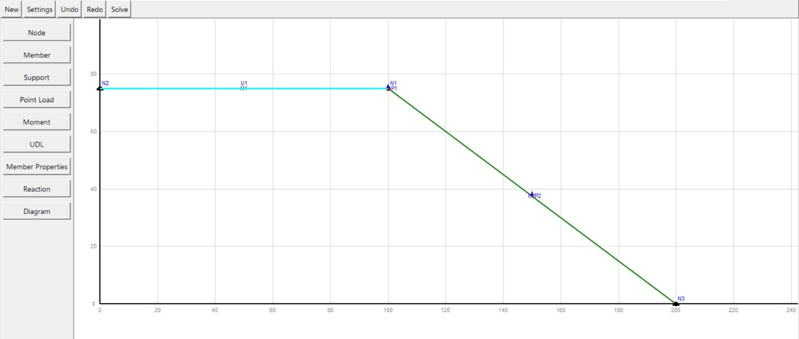
Figure 6 User Interface

Output data:
The results of the program analysis for the grid example are shown in Figure 7.
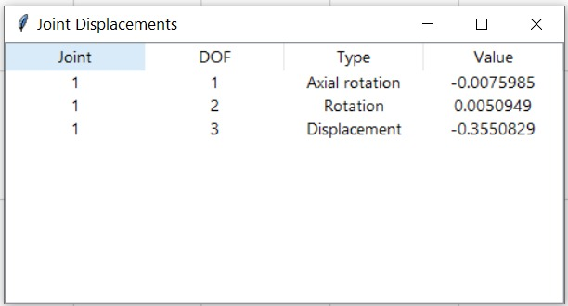
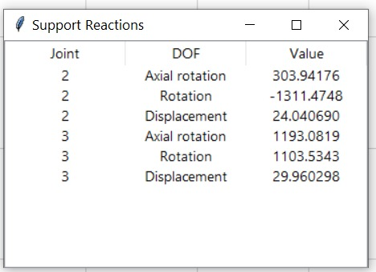

Figure 7 Output Data

The shear force, bending moment and torsion diagrams at figures 8 and 9 are developed by the program to show the visual results.
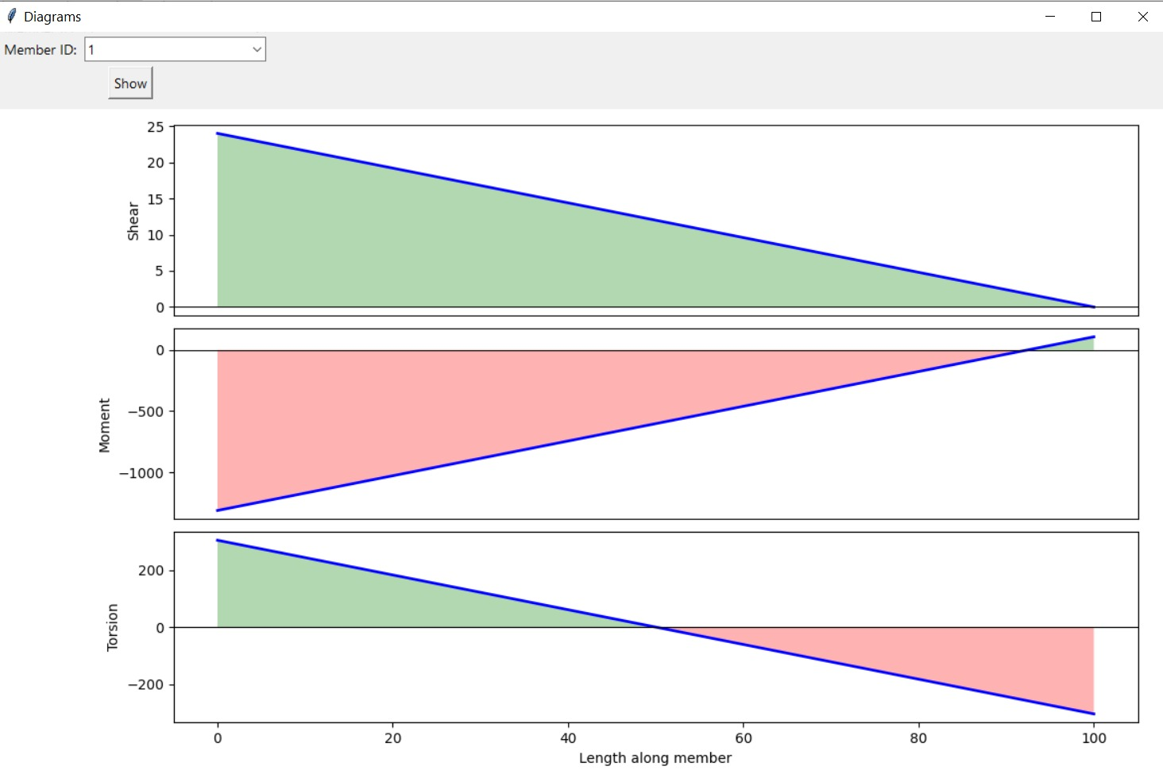
Figure 8 Shear and Moment Diagram of Member 1

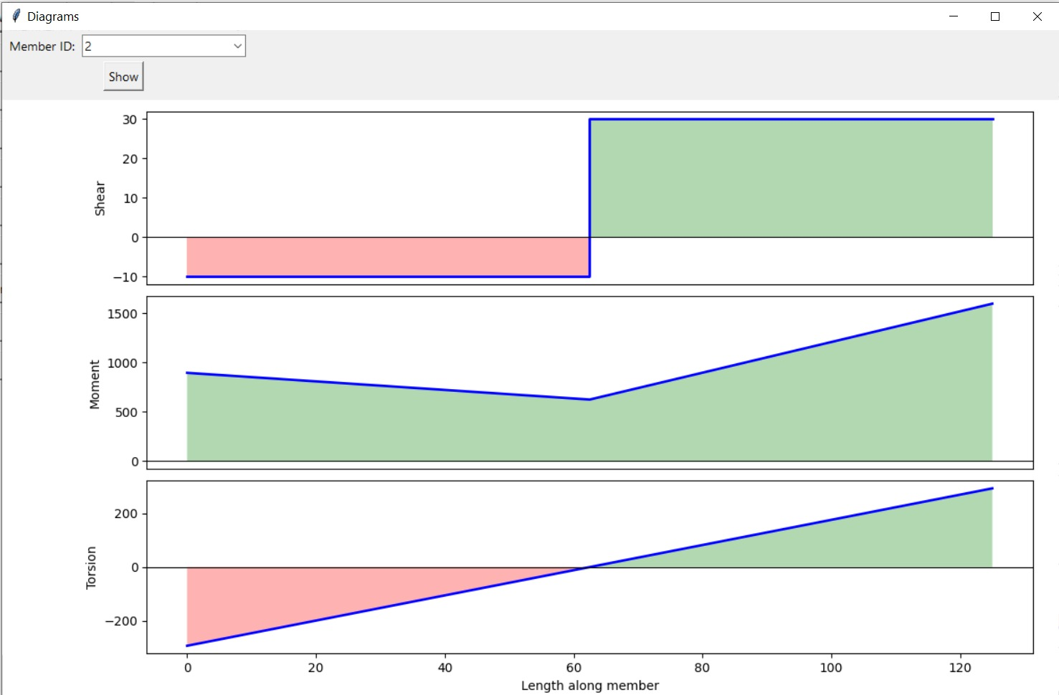
Figure 9 Shear and Moment Diagram of Member 2

Textbook result
The Textbook grid analysis results are shown in Figure 10.
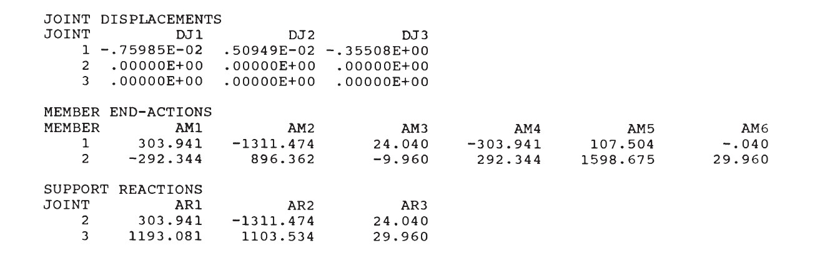
Figure 10 Textbook Solution

Conclusion:

The objective of this project was to develop a computer program that can assist engineers in performing complete analysis, that is, finding joint displacements, rotation and support reactions for grid framed structures. The objective was met by utilizing the direct stiffness method matrix manipulations into Phyton to perform the analysis. After coding the program, a textbook solved example for grid framed structure was solved by the developed program. The results from the program were compared with the textbook solutions and showed the same results.
In conclusion, the developed program served its purpose doing analysis and showing results visually.

Reference:

Weaver, W., & Gere, J. (1990). Matrix analysis of framed structures (3rd ed.). Kluwer Academic.

Contribution:
Programming: MD. Faiyaz Shahriar (202427140) and Salman Sajjan (202391350)
Report Writing: MD. Sajid (202421300), Jamir Uddin Mamun (202417200) and Irfan Hanief Bhat (202390210)

