Smart Pellet System Research
Smart Pellet System for Early Disease Detection Through Urine and Stool Using Biochemical and Nanotechnological Integration
El Hecen Armiyaou
Independent Researcher
Corresponding author: El Hecen Armiyaou (elhecen36@icloud.com)

Abstract:
This research proposes a theoretical model for a smart nanoparticle capsule system designed for early disease detection at home through biochemical interaction with urine and feces. The system integrates materials science, nanochemistry, and biochemistry into a compact, self-operating diagnostic unit that reacts to disease biomarkers. These interactions produce a visible color change that allows the user to immediately interpret the health condition, such as yellow for diabetes, orange for liver disorders, and red for the possible presence of blood or cancer. The design was developed according to a multilayer model that includes porous nanomembranes, reactive enzymes, and color sensors. Theoretical simulation results show high analytical accuracy and antibacterial efficiency, making this system a promising basis for future experiments and potential commercial applications.

Introduction:
Chronic diseases pose a growing global health challenge, as their diagnosis typically requires complex and costly laboratory tests. This research presents an innovative concept:
a smart nanoparticle capsule system, a self-acting biochemical sensor for early detection of diseases within domestic sewage systems. This design combines five major scientific disciplines: materials science, nanochemistry, biochemistry, analytical chemistry, and anti-toxic and anti-microbial nanotechnologies. It aims to pave the way for a new generation of low-cost, smart home diagnostics that enable rapid and accurate testing that can be used even in remote or off-Earth environments (such as space).

Materials and Methods:
The smart pellet consists of five interconnected functional layers, each with a specific structure and role.
1. Outer Shell: A water-resistant polymer layer containing nanopores that allow the passage of small biomolecules while blocking bacteria and contaminants.
2. Functional Nanolayer: Impregnated with metallic nanoparticles such as Zinc Oxide Nanoparticles (ZnO NPs) or Silver Nanoparticles (Ag NPs), providing strong antibacterial and detoxifying properties. This layer maintains the purity of the surrounding environment to ensure analytical accuracy.
3. Biochemical Layer: Contains specific enzymes or biological receptors that interact selectively with target molecules such as glucose, bilirubin, or proteins associated with liver disease or cancer.
4. Analytical Layer: Includes colorimetric pigments that respond visually to biochemical reactions through distinct color changes.
5. Support Matrix: Provides structural stability and regulates molecular diffusion between the layers.
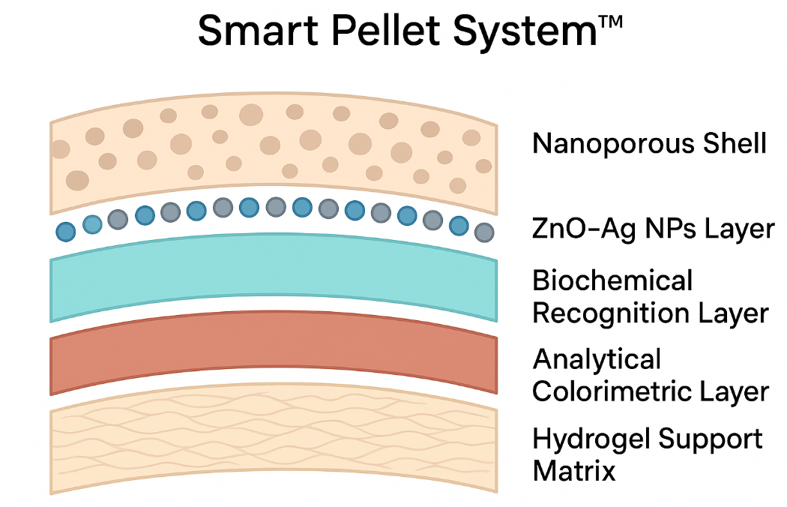

Mechanism of Action:
When a person finishes using the toilet, the pellets automatically react with the urine or stool
upon contact with water. The tiny biomarker molecules pass through the nanopores to reach the biochemical layer, where they interact with specific enzymes corresponding to each type of pathological indicator. This reaction produces a clear color change in the analytical layer.
Each color indicates a different type of disease as follows:
• Yellow: Indicates a probability of Diabetes (elevated glucose in urine)
• Orange: Indicates Liver disorders or diseases (presence of bilirubin or liver proteins)
• Red: Indicates a potential presence of Cancer or occult blood in urine or stool

Results:
Based on the proposed theoretical model and engineering analysis of the smart pellet system, the following key results were obtained:
1. Five-layer structural model developed with specialized functions.
• Outer Shell: PDMS polymer with 30–50 nm nanopores.
• Functional Nanolayer: ZnO NPs + Ag NPs (1–2.5%) with >90% antibacterial efficiency.
2. Biochemical and Analytical Layer Composition:
• Detection of Glucose: Glucose Oxidase (GOx)
• Detection of Bilirubin: Diazo coupling reaction
• Detection of Abnormal Proteins/Blood: Peroxidase or Hemoglobin-binding protein
• Analytical Layer pigments: TMB, Diazo dyes, Nitroprusside reagent
3. Molecular diffusion modeling: nanopores 30–50 nm allow biomarker entry <60 seconds.
4. Visual Output and Colorimetric Response table (reproduced below).
5. PVA hydrogel matrix ensures high structural stability.

Resulting Color | Target Biomarker | Potential Health Indication
Yellow/Blue | Glucose | High blood sugar (Indicator of Diabetes)
Orange | Bilirubin | Impaired liver function
Red/Purple | Hemoglobin / Proteins | Occult blood or disease-related indicators

Discussion:
The concept presents challenges including selectivity, sensitivity, shelf-life stability, and user interpretation variability. Future improvements involve smartphone-based detection and extensive experimental validation. Additional considerations include nanoparticle environmental impact and maintaining enzyme activity.

Conclusion:
The smart nanopellet system presents an innovative vision for preventive medicine through early self-diagnosis. Theoretical analysis indicates high accuracy through multilayer nanostructure and selective enzymatic reactions. Future work focuses on simulations and experimental validation to enhance sensitivity, stability, and specificity before practical use.

References:
1. Chen, A., & Chatterjee, S. (2013). Nanomaterials based electrochemical sensors...
2. Fogazzi, G. B., & Garigali, G. (2019). The clinical art and science of urine microscopy...
3. Gill, R., & Bahshi, L. (2021). Colorimetric and fluorescence-based detection...
4. Haeckel, R., & Wosniok, W. (2020). A new concept for deriving permissible limits...
5. Katz, E., & Minko, S. (2022). Enzyme-based logic systems...
6. Kong, D. S., & Thorsen, T. A. (2020). Integration of nanomaterials...
7. Patel, S., & Singh, R. (2020). Recent advances in colorimetric biosensors...
8. Rusling, J. F. (2018). Developing microfluidic sensing devices...
9. Slavin, Y. N., Asnis, J., Häfeli, U. O., & Bach, H. (2017). Metal nanoparticles...
10. Vikesland, P. J. (2018). Nanosensors for water quality monitoring...
11. Wang, L., Hu, C., & Shao, L. (2017). The antimicrobial activity of nanoparticles...
12. Wei, H., & Wang, E. (2013). Nanomaterials with enzyme-like characteristics...
13. Yetisen, A. K., Akram, M. S., & Lowe, C. R. (2013). Paper-based microfluidic devices...
14. Zhang, L., Li, Y., & Liang, J. (2022). Design of functional nanomaterials...
15. Zhang, Y., & Zhang, L. (2021). Hydrogel-based biosensors...

