Suppa Brace 5000
5/04/2017
Andrew Dugan, Ben Vanhove, Carl Krumenauer, Alex Gruber, Wes Boyarski
Need: Before we can explain the need for our product we first need to establish some background on what Arthritis is. According to Dictionary.com Arthritis is “acute or chronic inflammation of a joint, often accompanied by painand structural changes and having diverse causes, as infection, crystal deposition, or injury”. (Dictionary.com). In lemans terms this means Arthritis is an infection that causes the joints affected to swell and cause pain. Through some research we found that patients who struggle with arthritis need exercise and proper joint movement in order to move fluids around the joints. This is because without movement the fluid begins to thicken and swell. When the patients move it reduces swelling and pain. However moving the joints causes pain and causes the patients to not want to move the joints. Being that no one really likes to experience pain the majority of the time patients don’t get the correct exercise they truly need. Our plan to fix these problems faced by arthritis patients is to have a brace that attaches to the bicep and to the forearm. It will oscillate back and forth with feedback making sure the patient doesn’t feel discomfort. We will have an on/off switch to turn the device on and off in case the patient doesn’t want to continue the exercise.

`
If the user is too sore or unable to move their joint they can switch the brace off so they can rest and try again later
When the sensor is activated the brace will automatically switch directions and then sets that angle to the new maximum or minimum angle
The system will repeat, until the pressure sensors inside the brace sense resistance up or down
When higher degree is reached, motor switches and lowers to minimum degree
Motor than lifts forearm at the elbow joint and goes up to set max Degree
User flips the switch
User/Helper Puts on Brace, and straps it in

Parts:
Exotec Extension Flexion (already have)​
Large/Powerful Servo Motor​
Battery Pack​
Arduino Bread Board​
Bar Stock​
Miscellaneous Hardware​
Pressure Sensors

Description: We are making a brace to help people with severe arthritis. Our brace is designed to help the patient to expand their range of motion. We will achieve this by flexing the elbow joint without hyperextending the joint.

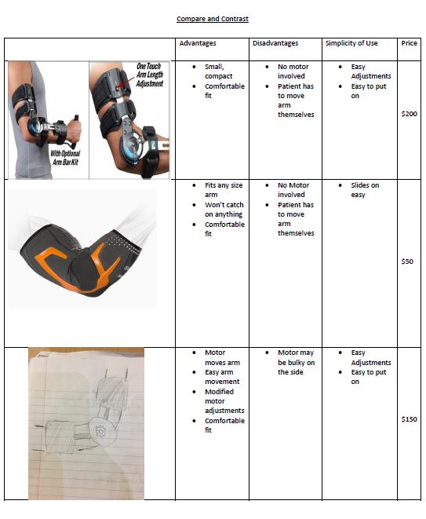
Design Changes: For the final prototype the initial design needed to be changed. This was completely unexpected because the initial design worked completely until the night before the presentation. We believe the reason for the abrupt failure was due to the “Easy-Driver” had burnt out from excessive use or the motor itself malfunctioned. For the final design we had to mount a larger servo motor to the brace to move the arm. This required us to use temporary fixtures like Duct tape. Although the end result was not visually appealing it worked to show the concept. Another change to the design was to place the force sensors on the inner side of the forearm part to sense the force of the arm and the direction.
Circuit:
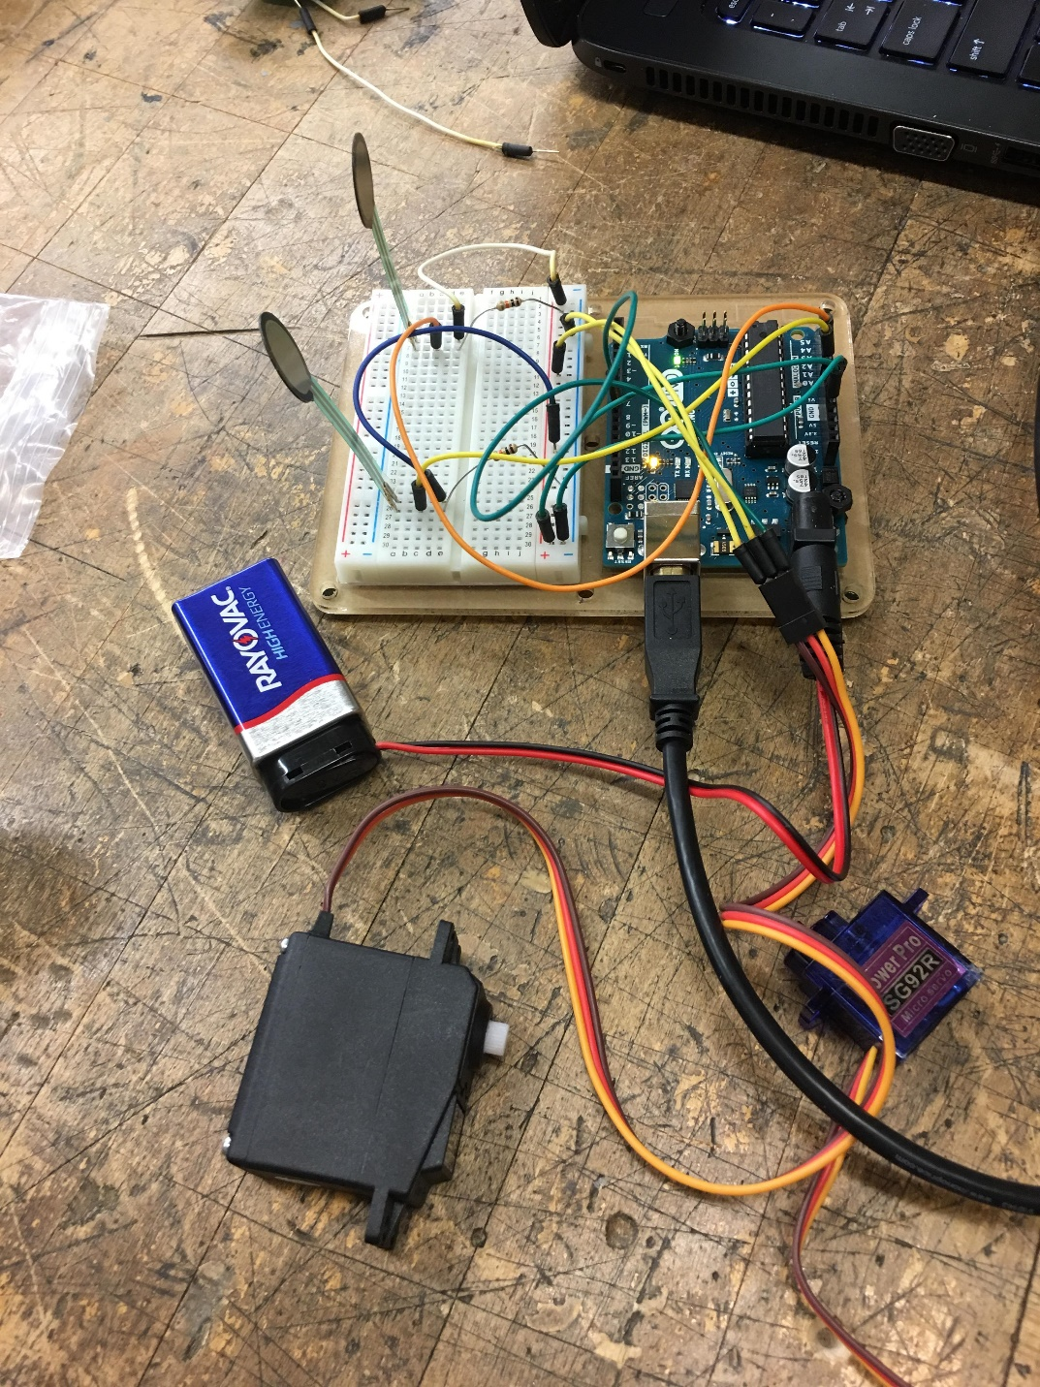
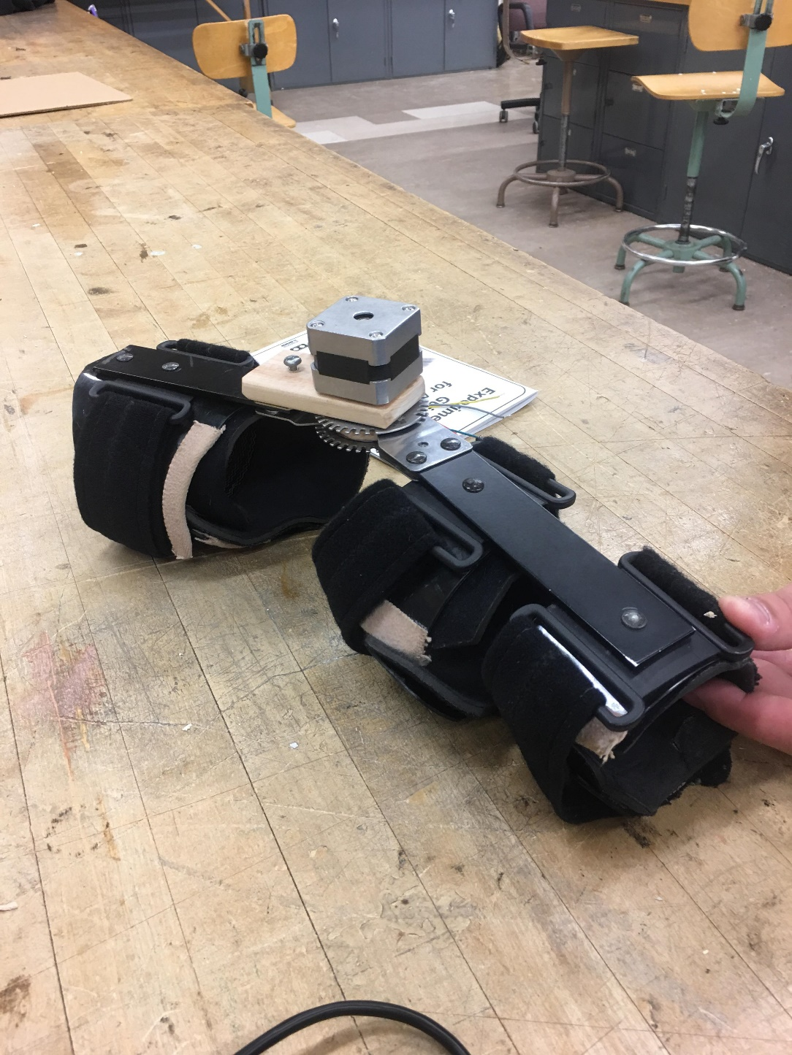
Physical construction:

For the physical construction we had to trash our previous design because it malfunctioned the night before. Due to the time constraints of the project we had to resort to a less “put together” look for the design. The final construction of the brace had the Arduino Uno mounted to the bicep portion of the brace, it was affixed with Duct tape to save time and to simplify the design. The Arduino powered the larger servo that was also mounted with Duct tape to the fulcrum point of the brace to apply the most torque to the arm ensuring brace movement. The overall brace remained the same because the design revolved around it.
Code Logic:
Flow Chart:
The motor is activated in the opposite direction until the minimum degree is reached or the sensor is deactivated
If the down sensor is activated by the arm
As soon as the sensor is deactivated the motor will immediately stop
Once the sensor is activated by the arm, the brace then lifts the arm to the max degree
Brace does not move until the up sensor is activated
User turns it on
User/Helper Puts on Brace, and straps it in

When the brace is worn, there is two sensors on the inside of the brace that go on the top and bottom of the arm. If the person applies any bit of force upward, their arm will push against that sensor and raise the arm up to the max degree. Then, if the person applies force in the downward direction, their arm will push against the down force sensor and the brace will go down to the minimum degree. The min and max degrees are enforced so the person wearing the brace is always comfortable and it doesn’t hyperextend their arm.

Sources:
Barlett, Susan. "Role of Exercise in Arthritis Management." Arthritis Information. John Hopkins
Arthritis, 13 Oct. 2011. Web. 20 Mar. 2017. <https://www.hopkinsarthritis.org/patient
corner/disease-management/role-of-exercise-in-arthritis-management/>.
Dodge, Carole. "Exercise and Arthritis." Rheumatology.org. Rheumatology.org, 1 Apr. 2015.
Web. 20 Mar. 2017. <http://www.rheumatology.org/I-Am-A/Patient-Caregiver/Diseases
Conditions/Living-Well-with-Rheumatic-Disease/Exercise-and-Arthritis>.
Mayo Clinic Staff Print. "Rheumatoid Arthritis." Mayo Clinic. Mayo Clinic, 18 Mar. 2016. Web.
27 Feb. 2017. <http://www.mayoclinic.org/diseases-conditions/rheumatoid
arthritis/symptoms-causes/dxc-20197390>.
Various, Authors. "Arthritis." Dictionary.com. Dictionary.com, n.d. Web. 20 Mar. 2017.
<http://www.dictionary.com/browse/arthritis>.
Various, Authors. "Aging-Muscles Bones and Joints." Better Health. Victoria State Government,
1 Nov. 2012. Web. 27 Feb. 2017.
<https://www.betterhealth.vic.gov.au/health/conditionsandtreatments/ageing
muscles-bones-and-joints>.
Various, Authors. "Arthritis." Dictionary.com. Dictionary.com, n.d. Web. 20 Mar. 2017.
<http://www.dictionary.com/browse/arthritis>.
Various, Authors. "Exercising With Osteoarthritis." www.arthritis.org. Arthritis Foundation, n.d.
Web. 27 Feb. 2017. <http://www.arthritis.org/living-with-
arthritis/exercise/benefits/osteoarthritis-exercise.php>.
Zernicke, Jan, et al. "A Prospective Pilot Study to Evaluate an Animated Home-Based Physical
Exercise Program as a Treatment Option for Patients with Rheumatoid Arthritis." BMC
Musculoskeletal Disorders, vol. 17, 18 Aug. 2016, pp. 1-12. EBSCOhost,
doi:10.1186/s12891-016-1208-3.

Appendix:
#include <Servo.h>
Servo myservo;
int pos = 0;
int potpin = 0; // analog pin used to connect the potentiometer
int val;
int sensorValue1=0;
int sensorValue2=0;

void setup() {
// put your setup code here, to run once:
myservo.attach(9);
Serial.begin(9600);
pinMode(A0, INPUT);
pinMode(A1, INPUT);
pinMode(9,OUTPUT);

}

void loop() {
// put your main code here, to run repeatedly:

sensorValue1 = analogRead(A0);
sensorValue2 = analogRead(A1);

while(val<130 && sensorValue1/4>100)
{
myservo.write(val);
Serial.println("up");
delay(15);
val++;
sensorValue1 = analogRead(A0);
}
while(val>55 && sensorValue2/4>100)
{
myservo.write(val);
Serial.println("down");
delay(15);
val--;
sensorValue2 = analogRead(A1);
}

}

