Mark Herman, Joe Popple, Jordan Ewings, Jack Thammavongsa, Aaron Broyles.
Muscular Dystrophy/Spinal Cord injuries
Automated Blinds
ETECH-100
4/16/2017
Draft Report
There are many individuals who, with certain disabilities, are unable to move around and function with ease. These are the people who have certain disabilities that are being targeted with this design have a particularly tough time moving around and moving their extremities to grab something. Specifically, a disease that causes inadequate muscle movement is muscular dystrophy. The concentration of it called ‘Facioscapulohumeral Muscular Dystrophy’ or ‘FSH’ for short, have a progressive muscle mass loss and it makes it harder for them to move around. Also affects the way they can move their extremities away from their bodies. A vast area where FSH affects a certain person’s ability to move around can be the certain motion of their shoulders as well as lower legs. Now to open a manual blind you must walk over to an area as well as reach above your head using your shoulder to pull the blind up or let it go down. According to the MDA (Muscular Dystrophy association), “the muscles that hold the shoulder blades in place weaken, allowing these bones to move excessively. The shoulder blades stick out and rise toward the neck as they move…Leverage is at least partially lost. The weakness often isn’t the same on both sides of the body.” Leverage is a very important part of being able to move a blind up and down.
Another type of disability/injury that is being targeted with the use of this design is people that may have happened to have a spinal cord injury. There are varying forms of how mild to severe a spinal cord injury but it can range from just having a long time to recover to permanent paralysis. According to Mayo Clinic there are variety of symptoms that arrange from a spinal cord injury such as, “Loss of movement, Loss of sensation, including the ability to feel heat, cold and touch, Loss of bowel or bladder control, Exaggerated reflex activities or spasms, Changes in sexual function, sexual sensitivity, and fertility, pain or an intense stinging sensation cause by damage to the nerve fibers in your spinal cord, difficulty breathing coughing or clearing secretions from your lungs” As you can see from the multitude of issues that arise for someone with this type of disability, struggling to operate a mechanical blind should not have to cause them anguish. Now with using a simple key fob, people with muscular dystrophy and spinal cord injuries that can push a simple button can move the blinds up, down, open and shut. With how simple this design is caretakers can simply work this device as well. Say for example, a person with a spinal cord injury Is in a wheelchair from paralysis and has limited motion of their upper body, two possible issues would arise. One with the bulkiness of a wheelchair the user would have a tough time getting to reach the blind sitting down, also with the limited motion of their upper body there is a possibility that they wouldn’t be able to have the strength to pull the blind down. Instead the solution is a simple button and can operate it as simply as using a phone. The need for assistive technology in homes has always been a demand, people spend a lot of time in their homes and for people not being able to accomplish the same tasks as someone without a disability being able to help them as much as we can. According to the CDC, “AT’s can help enhance functional independence and make daily living tasks easier through the use of aids that help a person travel, communicate with others, learn, work, and participate in social and recreational activities.”

Changes to original construction:
1.Originally we had some ideas of how to move the locking mechanism of the blind to lock the position of the blind in a particular spot if we were to let go of the key fob. The initial idea was to create a moving system like almost a rail way to move the whole system independently on the bottom of the frame holding the blind. We later found out that if we have a large enough stepper motor that the stepper motor would have enough power to hold the blind in place so we positioned a pulley to keep the locking mechanism always open so the motor would have all the control. We ended up using a baseplate like the design above to keep the whole thing in one place for simplicity and to help us finish within the time we have allotted to us.
2. Another issue we ran into was with the key fob. We continued to try and get the fob to work even with the most simple of circuits and codes, and couldn’t figure out if the part was defective to begin with or we were doing something else that wasn’t allowing it to work. Within the time constraints we couldn’t wait for another one to be sent to us praying that the second one would work after we had so much time into the fob. So with the help of the professor (Ghosh) we decided to switch to a Bluetooth transmitter with your phone to see if we could make it work going that route.
3. Another idea for the stepper motor to spool up the line originally was to use a fishing spool and mount it to the stepper motor. We come to find out that mounting a plastic spool with a considerable amount of torque on the system would be at risk of failing. So Aaron decided to make up an aluminum spool and tap the middle of it so we can put in a set screw to securely fasten it to the stepper motor itself and that found to be way more sturdy than the other one.
4. We started off with a motor shield to protect the Arduino from taking too much current needed for the stepper motor to run properly. We found that using the motor shield for our two dc motors would require a considerable amount of soldering to make it work, along with us not being able to figure out how the motor shield library works, professor Ghosh encouraged us to go a different route with an l293 H bridge and with that we were able to make it work that way.
Circuit:
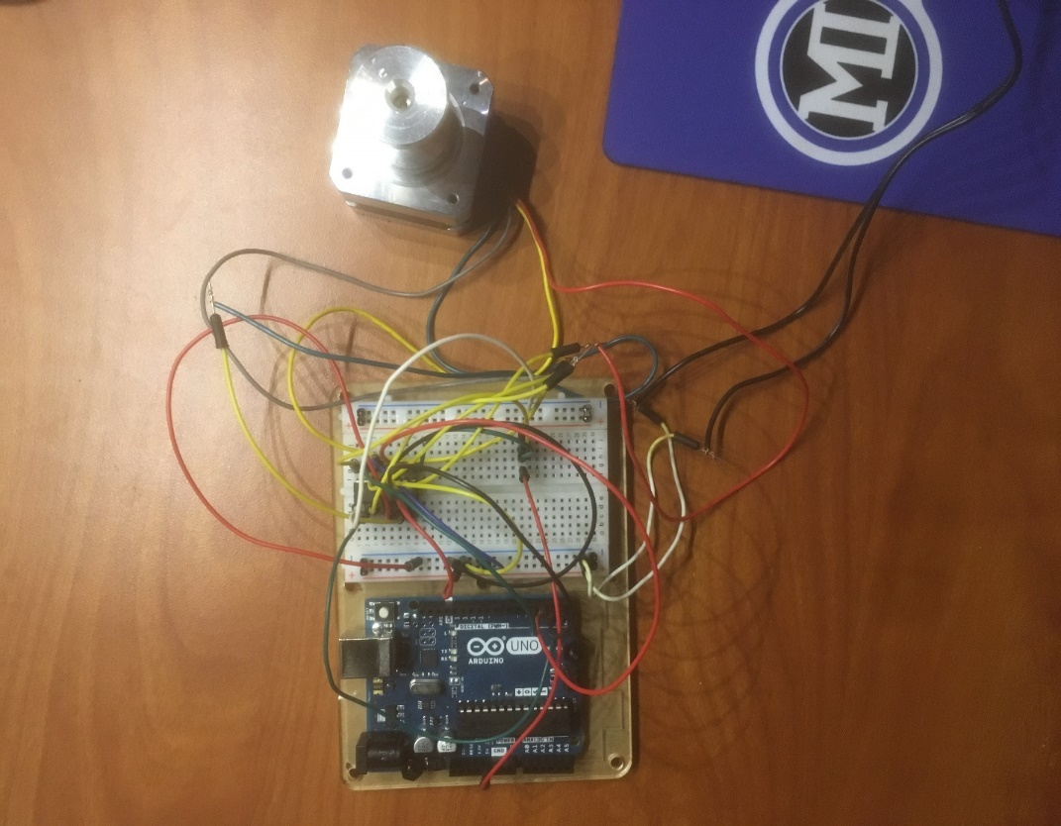
This is a portion of our circuit, with the key fob not working we had a setback which delayed us working with the Bluetooth transmitter. The picture bellow is a circuit on how the stepper motor will be able to operate in both directions using the L293d H Bridge, now we need another DC motor to run both ways, so we bought another L293d to have that operate both ways which will look very like the setup we have below. To bypass the current running through the Arduino, we have the power running straight to the breadboard so it only will power the motor and not fry the Arduino. We need to find out a way to incorporate the Bluetooth into the circuit to allow us to operate it remotely. The Arduino has input codes that run into the H-bridge, the H-Bridge has 16 ports, two inputs, two outputs, two hot ports along with six ground ports. Those go to the corresponding spots. We used an example code to see if the circuit worked and fortunately it did.

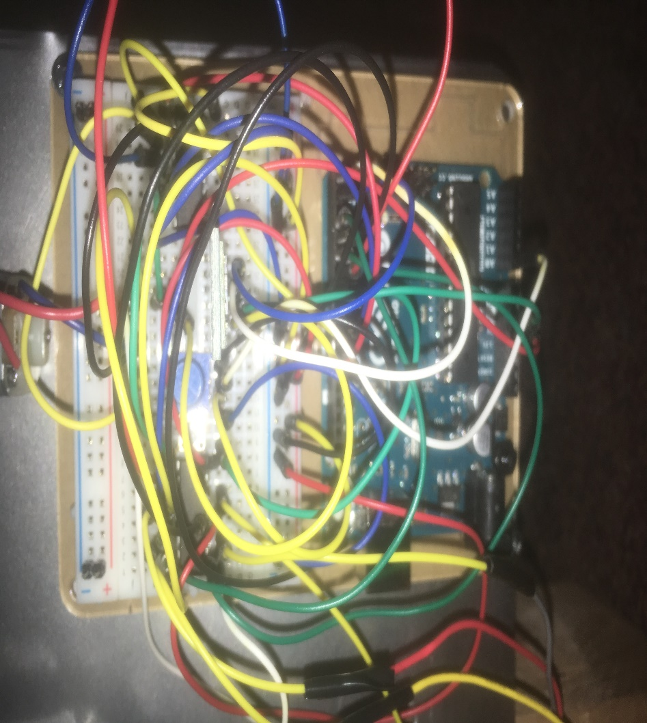

Physical Construction:
We used a frame to hold the blind in place with two legs holding the bottom to keep it stable, we then had a 2x4 come across the frame horizontally to hold our bracket in place (like the figure shown below) we then used a piece of sheet metal mounted it on the bottom left part of the horizontal 2x4 going across the frame. A pulley is located right across from the baseplate to have the string run on it.

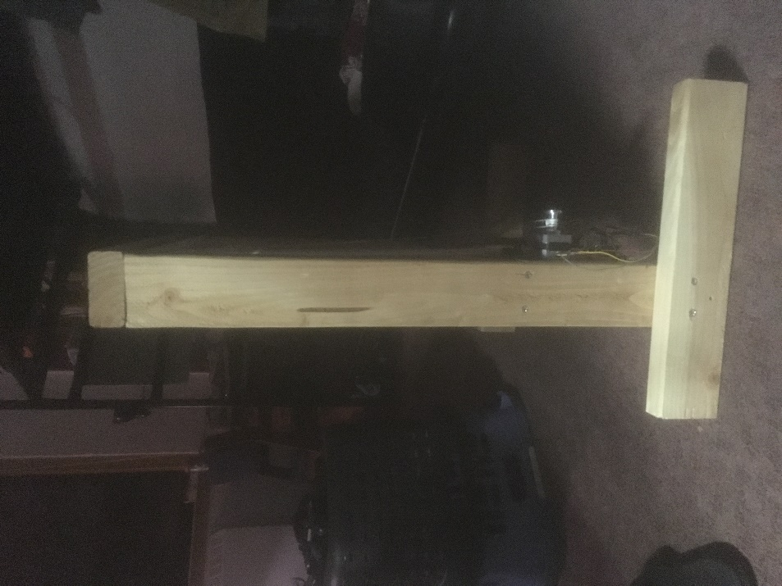
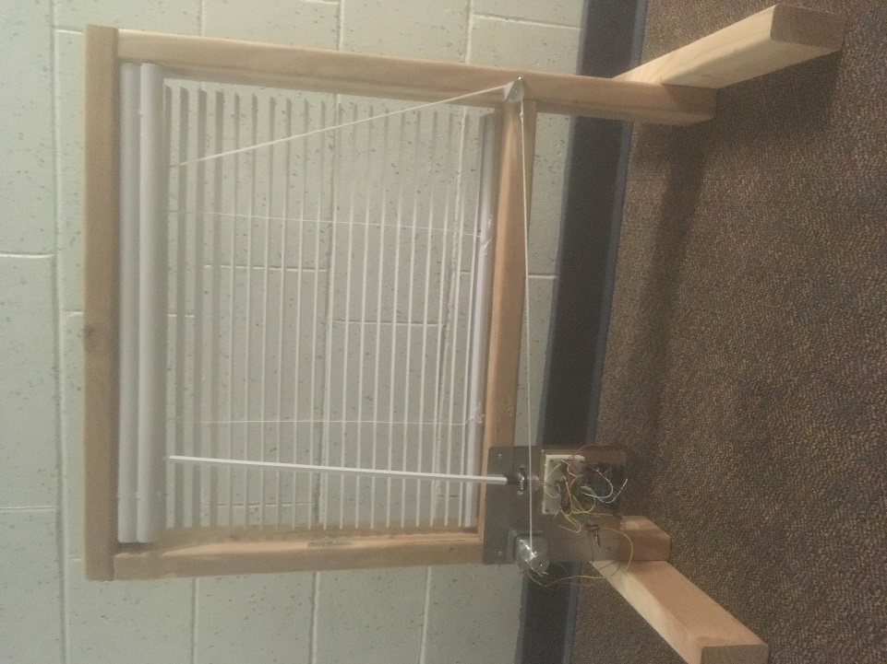

Design:
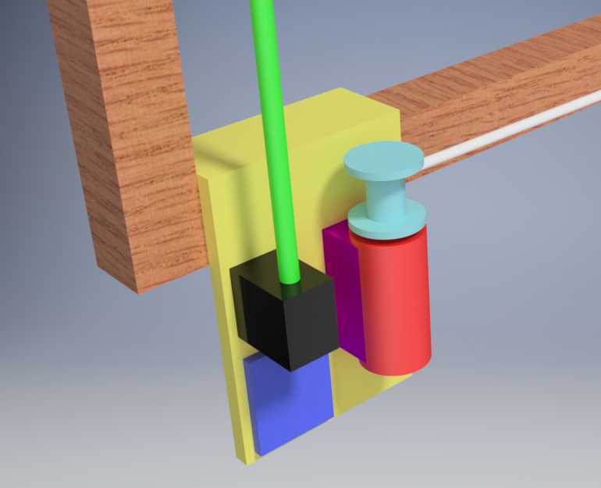

- Wood: Windowsill
- Yellow: Bracket
- Blue: Arduino
- Black: Servo
- Green: Adjustment rod
- Magenta: Motor support
- Red: DC Motor
- Light Blue: Spool
- White: Drawstring

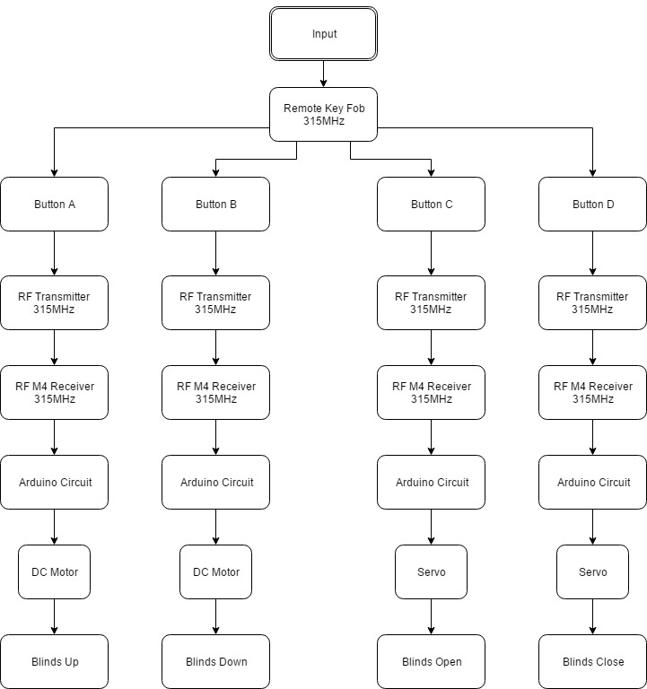
Flowchart

How the logic is explained:
The logic itself is self-explanatory, the input is the Bluetooth module, the processing unit is the Arduino, and the outputs are the stepper motor and the DC motor we got in the kit itself. Buttons A and B are associated with the stepper motor for bringing the blinds up and down, while C and D are associated with the DC motor for opening and shutting the blinds. Button A from the input is sent to the processing unit, processes through code and then is sent to the stepper motor to move the blind up. Button B from the input is sent to the processing unit processes through code and then is sent to the stepper motor to move the blind down. Button C is sent through the input to the processing unit, then sent to the DC motor to be spun clockwise to open the blind. Button D is sent through the input to the processing unit, then sent to the DC motor to be spun counterclockwise to close the blind.
Sources
- Motorized Blinds and Shades Benefits Seniors and the Disabled. (2016, November 03). Retrieved February 21, 2017, from http://www.justblindsinc.com/2016/11/03/motorized-blinds-shades-benefits-seniors-disabled/
- Window Treatment Solutions for Seniors. (n.d.). Retrieved February 21, 2017, from https://www.blindschalet.com/kba-window-treatments-seniors-204.html
- 1.Webb, S. J., & Dunn, W. F. (1985, September 03). Patent US4644990 - Automatic closing system for window blinds. Retrieved February 26, 2017, from https://www.google.com/patents/US4644990
- Harmo, P., Taipalus, T., Knuuttila, J., Vallet, J., & Halme, A. (n.d.). Needs and solutions - home automation and service robots for the elderly and disabled - IEEE Xplore Document. Retrieved February 26, 2017, from http://ieeexplore.ieee.org/xpls/icp.jsp?arnumber=1545387
- Facioscapulohumeral Muscular Dystrophy (FSH, FSHD) - Signs and Symptoms. (2016, January 07). Retrieved March 26, 2017, from https://www.mda.org/disease/facioscapulohumeral-muscular-dystrophy/signs-and-symptoms
- Spinal cord injury. (n.d.). Retrieved March 26, 2017, from http://www.mayoclinic.org/diseases-conditions/spinal-cord-injury/basics/definition/con-20023837
- People with Disabilities. (2016, March 17). Retrieved March 26, 2017, from https://www.cdc.gov/ncbddd/disabilityandhealth/people.html

