GERALD
An automatic pill dispenser that dispenses one pill at the press of a button
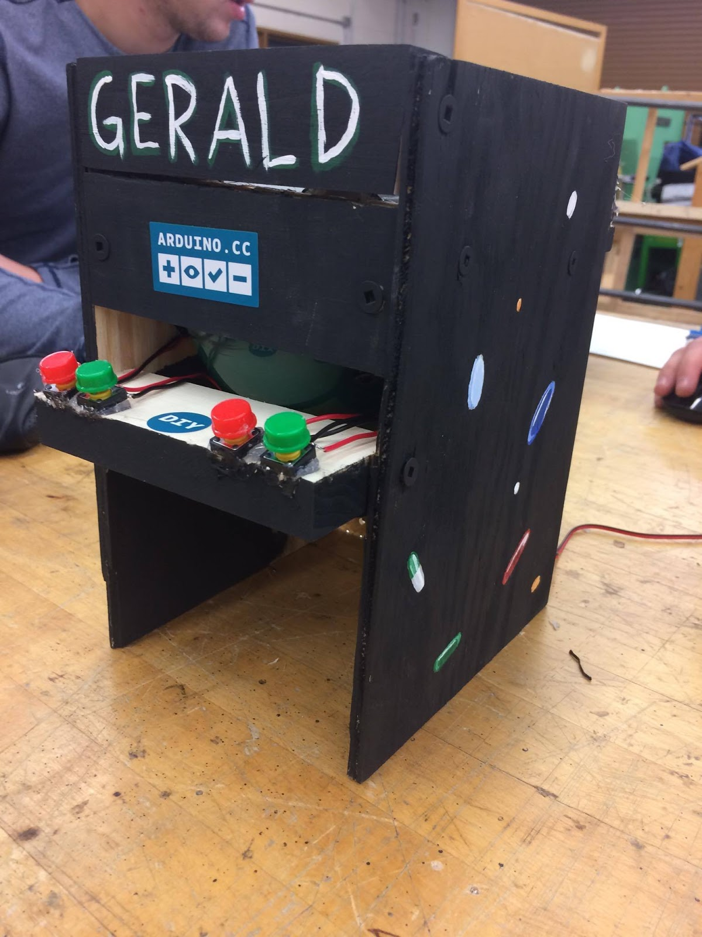
Tyler Frischmon
Aaron Daly
Erin Renshaw
05.2.2017
ETECH 100-001

INTRODUCTION
Gerald is an automatic pill dispenser designed to dispense a pill when a button is pressed and has the capability of being programed to extend an alert at certain times. It is customizable, and able to dispense up to four different varieties of pills, and it drops the pill into an easy to access dish. This product is designed to serve memory impaired individuals by supplying them with the correct medication at the correct time all by pressing a button when it is time for the specific medication, which makes it easier to avoid confusion when it comes to taking important medications.

BACKGROUND
As of today, it has been estimated that 1 in every 3 people have a memory disability (James). At the same time, 32 million Americans are prescribed to take more than 3 medications a day (“Opioid”). With a great percent of people prescribed to take more than 3 medications a day and people with a memory disability, it’s safe to say the likelihood of someone forgetting to take a certain medication or taking too much of a medication is common. In many cases, it’s possible the medications being misused are narcotics sense there was around 259 million narcotic prescriptions written in 2012, which vitalizes how common it can be for someone memory disabled to end up severely affected from medications (“Patient”). With this said, our group did research and found a lot of good reviews for automatic pill dispensers, but in many circumstances, we noticed on Amazon, most of automatic pill dispensers range in price from $80-$100 which we thought to be overly expensive. So, we decided to make our own, which as seen in the bill of materials came to be plenty cheap and economically efficient.
DESIGN DESCRIPTION
The concept of our project is simple yet effective. Our project allows you to insert your prescriptions of medication into their specific funnels, which are connected to a hole in the PVC tube with the larger diameter. The funnels are compatible to thread a whole pill container onto them, to keep an airtight seal. From there, pressing a button causes a servo to rotate a PVC tube with the smaller diameter (that is inside of the larger PVC tube), which has a hole that lines up with the hole in the larger PVC tube. Once the holes in the two PVC tubes line up a pill drops from the funnel into the smaller PVC tube. After the pill has dropped into the smaller PVC tube you are able to press the other button which rotates the smaller PVC tube 180 degrees, (with the pill inside) to another hole. The pill then drops into another funnel and into the tray where you can reach the pill.

BILL OF MATERIALS:
AMOUNT | DIMENSION | DESCRIPTION | COST
2 | 6” x 8.5” x .25” | Oak Wood Sheet | Free
4 | 5” x 1.35” x .7” | Oak Wood Block | Free
1 | 5” x 1.35” x .5” | Oak Wood Block | Free
2 | Can Rotate 180 degrees | Tower Pro MG995R Servo | Rent
2 | Diameter =.75”  length =4.8” | PVC Tube | Free
2 | Diameter =1”  length =4.5” | PVC TUBE | Free
14 | SBHCSCREW 0.06-80x0.625-HX-N | Screws | Free
4 | N/A | Buttons | Rent
1 | N/A | Arduino Uno Kit | Given
4 | Diameter= .38” | Funnel | $0.99 each
1 | Diameter= 2” | Food Funnel | $2.00
1 | 4.5” x 3” x 2.5” | Dispenser  Tray (3D Printed) | Free

MEASUREMENTS
Frame:
Front View : Side View:

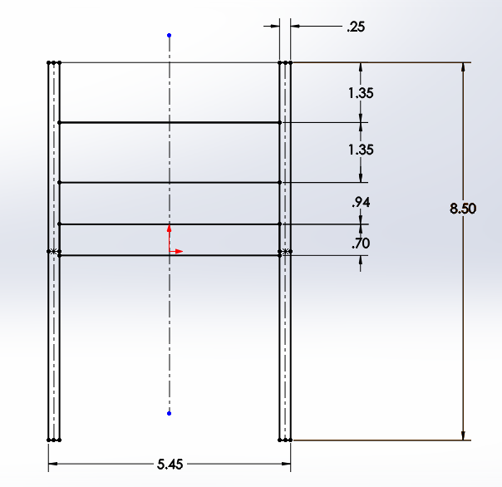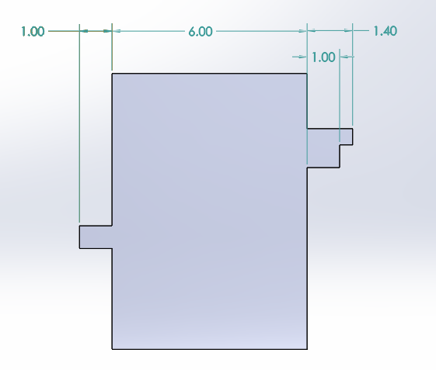
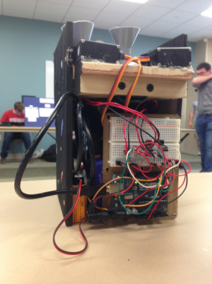

DESIGN ANALYSIS
The design has greatly evolved since the first idea. We started with the idea of having a horizontally circular rotating gear driven by a single servo to dispense the pills, but we were concerned that it would get jammed while funneling multiple the pills through it. Overall, we struggled to create a design that would only dispense one pill at a time. Finally, we came up with the idea to use gravitational force that allowed the pill to drop vertically through a funnel into a nested PVC cylinder that is horizontally perpendicular to the funnel. This stops the pill from dropping vertically until the PVC cylinder rotates to a spot where it can fall vertically again until it is stopped by the tray where you can grab the single pill.
This design allowed us to create a solution to our problem, which was only allowing one pill to be dispensed at a time. Once we found this solution, we were allowed to make our project function properly.
We were originally going to make the frame out of clear plastic, but then decided to use wood which is both cheaper and more economically friendly. Overall our final project complied with our starting goal which gave us a successful outcome.

REFERENCES
Cave, Edgar, et al. Medication Pill Dispenser. Medication Pill Dispenser. N.p., n.d. Web. 03 May 2017.
James, Steve. "1 in 8 Boomers Reports Memory Loss, Large Survey Finds." NBCNews.com. NBCUniversal News Group, 09 May 2013. Web. 03 May 2017.
"Opioid Painkiller Prescribing." Centers for Disease Control and Prevention. Centers for Disease Control and Prevention, 01 July 2014. Web. 03 May 2017.
"Patient Compliance Medication Adherence Medication Non-Adherence Statistics & References." STATISTICS Patient Compliance Medication Adherence. GigaNano, 2011. Web. 03 May 2017.

