Beyond Collision Avoidance: Balance and Gesture Related Biomechanical Effects of Working with the Presence of Mobile Robots

Yuetong Wu ¹, Xiangrui Wang ¹, Boyi Hu ^{1*}
¹ Department of Industrial and Systems Engineering, University of Florida, Gainesville, FL, USA.
*Corresponding Author. Email: boyihu@ise.ufl.edu

Abstract
Autonomous mobile robots (AMRs) are increasingly deployed in shared occupational environments, where safety is primarily defined by collision avoidance. However, robot motion may also impose balance related demands without physical contact. This study examined how robot-initiated guidance influences human movement and neuromuscular responses during a retail-like shelf picking task. Sixteen healthy adults completed trials under three conditions: no robot, low-speed guidance, and high-speed guidance. Whole body kinematics and surface electromyography were analyzed across pre, transient, and post interaction phases to differentiate steady state behavior from short term adaptations. Results showed that robot guidance increased segment velocity and acceleration while posture related position measures remained unchanged. Speed dependent effects were most evident during transient interaction, where higher robot speeds produced greater distal segment accelerations and short-term increases in muscle activation. The findings highlight the importance of considering transient biomechanical demands when designing AMR guidance strategies in shared work environments.

Keywords: Autonomous mobile robots; Balance control; Occupational safety; Whole body biomechanics; Proactive robot guidance

Introduction
Autonomous mobile robots (AMRs) are increasingly deployed in retail, logistics, and industrial environments to improve operational efficiency and support routine work activities (Fragapane et al., 2021; Fragapane et al., 2022; Haney & Liang, 2024). As these systems transition from isolated automation to shared human workspaces, interactions between humans and robots are becoming more continuous during task execution. In close-proximity settings, robot motion becomes a dynamic environmental factor that can influence how humans move, adapt, and maintain stability while performing work related activities (Cai et al., 2023). Despite this shift, safety in collaborative robots is still predominantly framed around collision avoidance (Liu et al., 2023; Sousa et al., 2025). While collision prevention is essential, this overlooks other categories of incidents relevant to occupational environments, such as falls and balance related events. Importantly, even in the absence of a collision, an AMR’s trajectory, speed, or proximity can induce rapid postural adjustments that perturb balance control, potentially increasing fall risk (Rubagotti et al., 2022; Salvini et al., 2022). Much like a pedestrian abruptly entering one’s walking path, such unexpected intrusions can induce sudden corrective responses that challenge balance stability and increase risk of falling. Recognizing AMRs as agents that can influence human balance is therefore critical for a more complete understanding of safety in shared workspaces.
Prior research in AMR based human-robot interaction (HRI) has shown that robot motion characteristics strongly affect safety, trust, and comfort during close-proximity encounters (Chen, Yang, et al., 2022; Haney & Liang, 2024; Luo et al., 2023; MacArthur et al., 2016). These findings have motivated the development of socially aware navigation strategies that aim to balance efficiency with user acceptance. However, evaluations of these interactions have largely relied on subjective assessments or high level spatial behaviors such as interpersonal distance and path deviations (Obaid et al., 2016). While important, such measures provide limited insight into the physical demands imposed on the human body, particularly in environments where stability and balance are crucial. From a biomechanical perspective, human movement emerges from coordinated control across multiple body segments, optimized for energy efficiency and stability. When an AMR enters a human's immediate moving space/envelop, it introduces a dynamic constraint that requires a reorganization of movement patterns. While these responses have been extensively studied in biomechanics for environmental obstacles and human-human interactions (Murakami et al., 2022; Yiou et al., 2016), the specific mechanisms by which AMR motion parameters directly influence balance control and fall risk remain largely unexplored.
Additionally, less is known about how similar adaptations arise during proximity interaction where the robot takes a proactive role, such as robot-initiated guidance. Robot-initiated guidance refers to scenarios in which an AMR intentionally approaches a human to lead, redirect, or influence their movement, often as part of a safety or assistance purpose (Robinette et al., 2014; Yedidsion et al., 2019). This form of interaction is increasingly common in retail assistance and industrial settings where robots actively guide workers (Edirisinghe et al., 2023). There also remains a gap in scenarios where robots play a proactive role in shaping human movement rather than being passively avoided. In particular, robot-initiated guidance, where an AMR intentionally approaches a human to lead, redirect, or influence their movement, has emerged as a common interaction paradigm in retail and industrial settings (Edirisinghe et al., 2023; Robinette et al., 2014; Yedidsion et al., 2019). Unlike passive avoidance, robot-initiated guidance explicitly requires humans to modify their motor behavior in response to the robot’s intent, potentially imposing additional balance and postural control demands (Cai et al., 2023).
Recent reviews indicate that only a limited number of HRI studies have incorporated direct
measurements of full body biomechanics, postural control, or neuromuscular demand when
evaluating robot behavior in shared environments (Rubagotti et al., 2022). Consequently, there
remains insufficient empirical evidence linking robot motion parameters to both transient and
steady state human movement responses under controlled conditions. This gap is particularly
relevant for understanding fall related risks, as repeated exposure to balance perturbations during
proximity interaction may contribute to altered movement strategies, or long-term injury
risk. Moreover, human responses to robot motion are not static. Interaction with a moving robot
may induce short term, transient adaptations as humans accommodate the robot’s behavior,
followed by stabilization or reorganization once the robot disengages. Distinguishing between
these phases is critical for understanding how humans adapt to robot presence over time and
whether robot induced movement strategies persist beyond the interaction itself.
The present study addresses this gap through a controlled experimental investigation of human responses to robot-initiated guidance in a retail-like task environment. Participants performed a standardized task while an autonomous mobile robot approached and guided them using different motion parameters. Whole body kinematics were analyzed across pre-interaction, active-interaction, and post-interaction phases to capture both transient adaptations and steady-state movement behavior. We hypothesized that (1) robot-initiated guidance would induce phase-dependent changes in human movement, reflected by increased kinematic variability and elevated velocity and acceleration during the active interaction phase, and (2) higher robot guidance speeds and more abrupt motion patterns would further amplify these responses. By explicitly examining balance related biomechanical responses beyond collision outcomes, this study aims to clarify how proactive AMR behavior can both mitigate and influence fall related risk and to inform the design of guidance strategies that enhance safety without introducing unintended balance demands in shared work environments.

Methods
Experimental Platform and Robot Safety-Guidance System
Experiment Platform and Hardware
The experiment was conducted in a controlled, retail-like mixed-reality experimental environment designed to support repeatable robot-guided retailing tasks, the overall experimental environmental setup is shown in Figure 1. In this platform, a human agent performs shelf picking tasks, while a mobile robot served as a safety enhancement agent, operating in proximity to the human agent to guide the human agent out of risky areas. A grid map that shows shelf locations and ground hazard information was projected onto the ground using a projector (as shown in Fig. 2). The robot, human, and shelf position was tracked through Vicon motion capture system (Vicon, Oxford, UK) as the world frame (in meters), while the ground hazard regions were in the projector frame (in pixels).
To ensure consistent spatial coordination between the robot, human, and environment for robot path planning, a homography matrix was calculated. Specifically, the homography matrix H mapped points from the projector’s pixel frame $p=\left(x_{p},y_{p}\right)$ to the Vicon world frame $w=\left(x_{w},y_{w}\right)$, according to $W \sim Hp.$ Using homogenous coordinate, the transformation is expressed as:
$$\begin{aligned}\left[\begin{matrix}x_{w}^{'} \\ y_{w}^{'} \\ w_{w}^{'}\end{matrix}\right]=\left[\begin{matrix}h_{11} & h_{12} & h_{13} \\ h_{21} & h_{22} & h_{23} \\ h_{31} & h_{32} & h_{33}\end{matrix}\right]\left[\begin{matrix}x_{p} \\ y_{p} \\ 1\end{matrix}\right]\#\left(1\right)\end{aligned}$$
Where the metric coordinates are obtained by normalization $x_{w}=x_{w}^{'}/w_{w}^{'}$ and $y_{w}=y_{w}^{'}/w_{w}^{'}$.
Finally, all hazard sensing, and robot path planning were implemented within the Robot Operating System 2 (ROS 2), enabling synchronized real-time communication across different entities in this experimental environment.
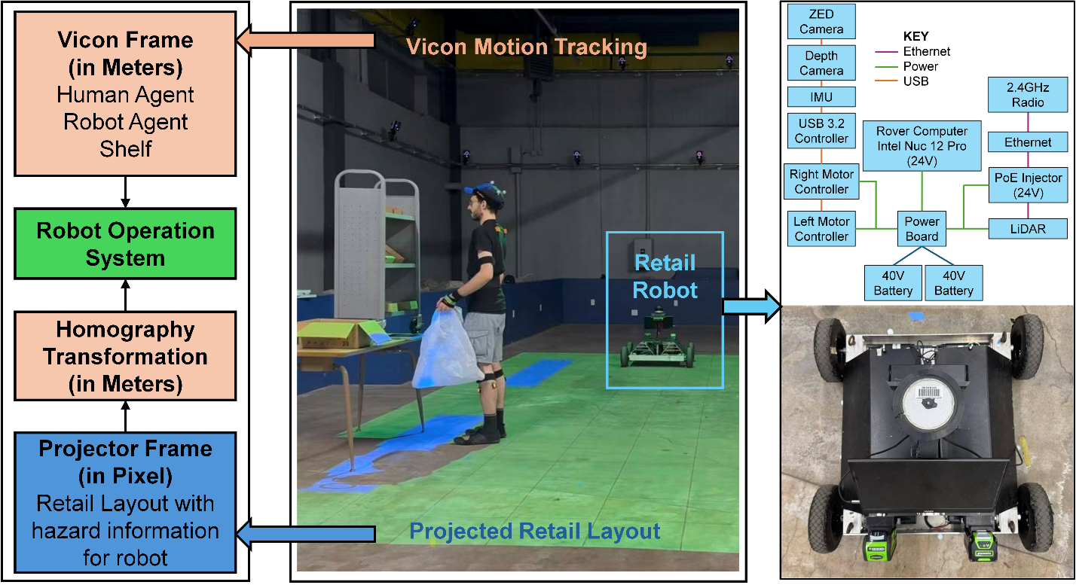
Figure 1. Integrated experimental platform and robot-initiated safety guidance system.
Robot Guidance Framework
Robot-initiated safety guidance was triggered when a participant’s position entered a predefined unsafe region. Once triggered, an intervention target point was predefined. The target location was selected to guide the participant away from the current area , without issuing verbal instructions or making physical contact, while preserving their orientation toward the shelf. This design minimized disruption to the primary picking task and ensured that observed movement adaptations reflected responses to robot guidance rather than task reorientation.
Robot motion was planned using an online Monte Carlo Tree Search (MCTS) planner. MCTS was selected for its ability to search for a near-optimal action for the next time steps by balancing a multi-objective reward function, including goal, collision avoidance, and social distance constraints (Oh et al., 2023). Specifically, the robot action space consisted of linear and angular velocity commands $u=(v,ω)$. This study tested the robot moving in a low speed and a high speed to guide human away from unsafe areas. For the low-speed, the linear velocities in the action space for the tree search were $\left\{0.2, 0.3\right\} m/s$, while the high-speed action space were $\left\{0.5, 0.6, 0.7\right\} m/s$. The angular velocities were set to {-0.6, −0.4, −0.2, 0.0, 0.2, 0.4, 0.6} for both the low and high speed driving modes.
To select a near-optimal action for the next time step, the cumulative reward for a candidate action was defined as
$$\begin{aligned}R\left(u\right)=w_{g}R_{\text{goal}}+w_{c}R_{\text{collision}}+w_{s}R_{\text{social}}+R_{\text{time}}\#\left(2\right)\end{aligned}$$
where the $R_{\text{goal}}$ encouraged the robot to minimize the Euclidean distance between its current position and the predefined intervention target point, $R_{\text{collision}}$ applied a substantial negative reward if a potential collision with the participant or static shelves was detected during the simulation, $R_{\text{social}}$ penalized the robot for violating a comfortable social buffer (1.2 m in this study), ensuring the guidance remained non-intrusive, and $R_{\text{time}}$ imposed a constant cost per time step to promote the selection of temporally efficient actions. By using this reward function, MCTS can search for an action $u=(v,ω)$ avoids collisions while maintaining social compliance.
Participants
16 participants were recruited for this study. The participants had an average age of 25.4 (3.0) years, height of 176.8 (5.8) cm, and weight of 64.1 (6.4) kg. Prior to participating, individuals were to confirm good health condition and no history of musculoskeletal disorders within the past year. Additionally, all participants reported to be right hand dominant. The study was approved by University of Florida Institutional Review Board (IRB#202501605), and all participants provided written informed consent before beginning the experiment.
Experiment Design
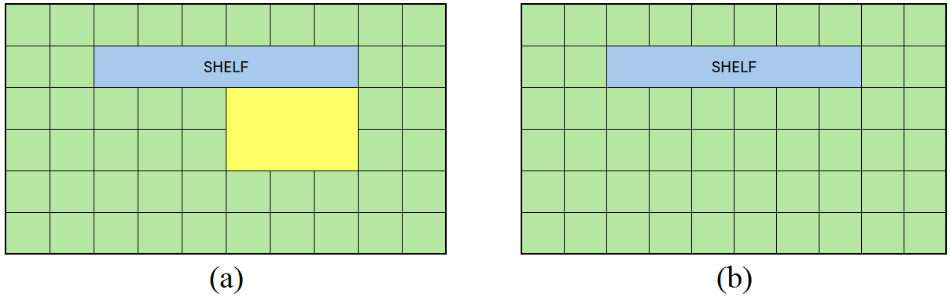
Figure 2. Grid-based experimental environment with underlying unsafe regions. Green areas denote safe working regions, yellow areas denote unsafe regions.
As shown in Figure 2, the experimental environment was represented using a grid-based map that defined shelf locations and regions of varying working conditions. The map consisted of two visual categories, green areas indicating normal, safe working environments, and yellow areas denoting less safe regions (e.g., regions with liquid contaminants and thus have high risk of falling). The shelf picking task was performed within a designated shelf area, as illustrated in Figure 2. To ensure that participants remained focused on the cognitively demanding picking task and did not rely on visual cues to anticipate environmental conditions, participants were assumed to have no prior knowledge of the environment safety layout. Accordingly, during all trials the ground projection displayed a uniform green surface (Figure 2(b)), hiding the true unsafe regions (Figure 2(a)) from the participants’ view.
The experimental task was designed to simulate a structured retail shelf-picking activity with concurrent environmental hazard mitigation. Participants began each trial from a fixed start location with a shelving unit containing ten numbered boxes (1–10). A randomized picking sequence was provided at the start of each trial to define the order in which items were retrieved, ensuring that movement patterns were not predictable across trials. Participants used their right hand to retrieve items from the shelf and placed each selected box into a shopping bag held in the left hand, maintaining a consistent asymmetric manual load throughout the task. After completing the full picking sequence, participants indicated task completion by placing the filled bag into a designated collection bin located to the right of the shelving unit. In the robot-guided condition, a mobile robot continuously monitored the pedestrian’s position relative to predefined floor regions with reduced safety. When the participant entered a less safe region while performing the shelf picking task, the robot initiated an intervention by moving toward a computed near-target point and establishing guidance. This interaction was intended to redirect the participant away from the hazardous area without interrupting the primary task objective. Once the participant was successfully guided out of the unsafe zone, the robot stopped and disengaged. The participant then resumed the remaining shelf-picking actions and completed the task following the same endpoint procedure as in the non-robot condition.
Although the experimental environment was implemented using a simplified grid-based layout, the design captures characteristics common to a broad class of retail and occupational settings in which humans and mobile robots operate. Shelf-based picking tasks, asymmetric manual loads, and locally degraded floor conditions are ubiquitous in warehouses, retail aisles, and service environments, even when the precise geometry and visual appearance vary. The present setup abstracts these elements into a controlled spatial representation that preserves the essential task demands and interaction dynamics relevant to human balance control during robot-initiated guidance. By focusing on relative motion, transient perturbations, and segmental acceleration redistribution rather than environment specific geometry, the findings are expected to generalize to scenarios in which pedestrians are guided away from localized hazards during ongoing task execution. Moreover, the intentionally simplified environment facilitates experimental reproducibility and methodological transparency. Grid-based representations allow precise specification of working regions, robot intervention timing, and interaction phases, enabling replication across laboratories and systematic comparison across studies. This design choice reduces confounding variability while retaining the biomechanical and neuromuscular challenges imposed by proactive robot motion. As such, the setup serves as a controlled testbed for isolating fundamental human responses to robot-initiated guidance, upon which future studies can incrementally introduce greater environmental complexity.
This protocol yielded three experimental conditions. In the No Robot (NR) condition, the participant completed the task without any robotic presence. In the With Robot Low Speed (LOW) condition, the robot intervened by approaching and guiding the participant at a lower movement speed when less safe regions were detected. In the With Robot High Speed (HIGH) condition, the same intervention strategy was applied, but with the robot moving at a higher speed.
To capture the time-varying nature of human responses to robot-initiated guidance, each trial was segmented into distinct interaction phases. This segmentation reflects that proactive robot guidance introduces a brief, externally imposed movement constraint within an otherwise continuous task. The pre-interaction phase was defined as the period from trial onset until the robot entered close proximity to the participant (approximately 1.5 m), during which no robot guidance was active. The active interaction (transient) phase spanned the interval in which the robot approached the participant and actively guided them away from the unsafe regions, representing a brief period of externally imposed movement constraint. The post-interaction phase extended from robot disengagement to task completion, during which participants resumed normal task execution.
Dependent variables were grouped into two main categories, (1) Whole body kinematics including segment (pelvis, right shoulder, right upper arm, right forearm, bilateral upper/lower legs) position, velocity, and acceleration. Mean values were computed over the full trial to represent steady state movement behavior under each experimental condition. To capture transient balance responses during robot interaction, acceleration signals were further processed, specifically, a redistribution index, defined as the ratio of proximal to distal acceleration (in this study, we chose pelvis and bilaterial feet as representative proximal and distal segments, respectively), was calculated to quantify shifts in segmental acceleration distribution associated with reactive balance control. This approach builds on prior work demonstrating that gait related accelerations are attenuated from distal to proximal body segments and that relative acceleration magnitudes across segments reflect postural control strategies during locomotion (Craig et al., 2016; Morrison et al., 2015); (2) muscle activation levels recorded via EMG sensors. A total of ten muscles were monitored. We collected data bilaterally (left and right sides) for the Tibialis Anterior (R/LTA), Lateral Gastrocnemius (R/LGAL), Rectus Femoris (R/LRF), and Upper Trapezius (R/LUT) muscles. For the dominant hand's arm, we measured the Biceps Brachii (RBB) and Triceps Brachii (RTB). EMG signals were processed to compute integrated EMG (iEMG) values and were calculated for each muscle over the full trial to characterize steady-state activation patterns across conditions.
Protocol
Upon arrival, participants were briefed on the study objectives and experimental procedures, and informed consent was obtained prior to data collection. Muscle activity was recorded using ten surface EMG sensors from the Trigno Wireless EMG System (Delsys Inc., Boston, MA, USA), which were placed on the target muscles as illustrated in Figure 3(a). Seventeen inertial measurement unit (IMU) sensors from the Xsens Awinda motion capture system (Xsens Technologies B.V., Enschede, Netherlands) were then attached to each participant in accordance with the manufacturer’s guidelines (Figure 3b). Anthropometric measurements were collected, followed by a standard calibration procedure performed using the Xsens MVN Analyze/Animate software. Calibration included a five-second static standing posture and a brief walking sequence to ensure proper sensor alignment and accurate motion tracking.
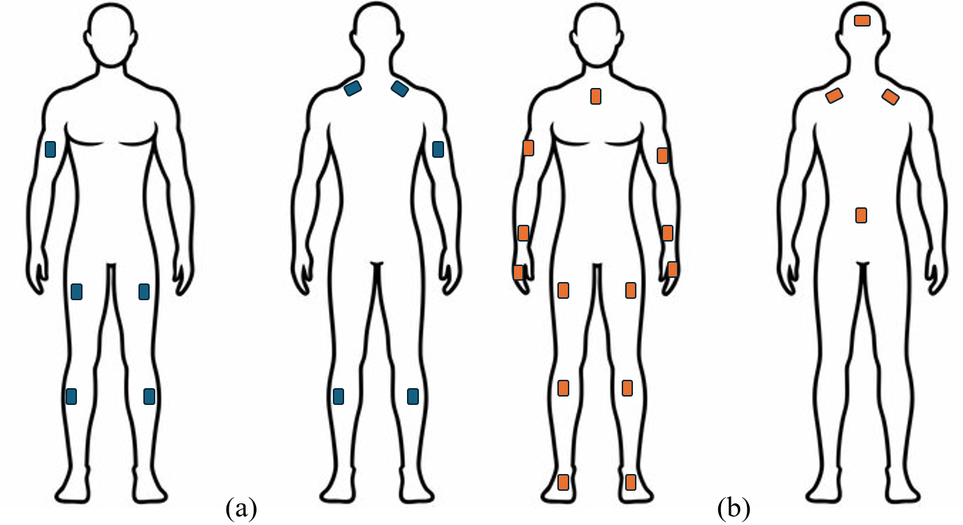
Figure 3. Full body sensor placement for (a) EMG and (b) IMU Xsens sensors
The experiment was designed to reduce potential confounding factors. Each participant completed two repeated trials for each of the three conditions, resulting in 2*3=6 trials total. The order of the NR, LOW, and HIGH conditions was counterbalanced across participants. To mitigate learning effects and task interference, two elements were randomized for every trial. (1) the sequence specifying which boxes were to be picked, and (2) the spatial arrangement of the ten boxes on the shelf. Each trial concluded when the participant successfully retrieved all required items and placed the shopping bag into a designated box near the shelf. Each trial lasted around 1 minute, during which data was recorded. The total duration of the experimental session lasted around 2 hours.
Data Processing and Statistical Analysis
Kinematic data was acquired using the Xsens Awinda motion capture system and processed with the manufacturer’s software. Participant movements were recorded at a sampling frequency of 60 Hz, and the resulting data were exported for subsequent analysis. EMG signal preprocessing was performed in MATLAB R2023b. Raw EMG signals were first baseline corrected by removing the DC offset. A 60 Hz notch filter was applied to suppress power line interference, followed by a fourth-order Butterworth band-pass filter (15–450 Hz) to retain physiologically relevant signal components while attenuating noise. The filtered signals were then full-wave rectified and smoothed using a fourth-order Butterworth low-pass filter with a 6 Hz cutoff frequency to obtain the linear envelope. Each EMG signal was subsequently normalized to the peak value recorded during maximum voluntary contraction (MVC) trials to enable between-subject comparisons. A one-way analysis of variance (ANOVA) was used to assess differences across posture conditions with a significance value set to p<0.05. For variables demonstrating significant main effects, multiple comparisons were controlled using a false discovery rate (FDR) correction.

Results
Steady State Phase
Table 1. Mean ± SD of (left) segment position (m), (middle) segment velocity (m/s), and (right) segment acceleration (m/s^2) across NR, LOW, and HIGH conditions. Significant main effects after false discovery rate (FDR) correction are indicated by *.
 | Position |  |  |  | Velocity |  |  |  | Acceleration
Segment | NR | LOW | HIGH | F  p  Q | NR | LOW | HIGH | F  p  Q | NR | LOW | HIGH | F  p  Q
Pelvis | 8.15±2.52 | 8.32±2.22 | 7.95±2.57 | 0.188  0.829  - | 0.06±0.01 | 0.07±0.02 | 0.07±0.02 | 5.686  0.005  0.011* | 0.33±0.10 | 0.38±0.11 | 0.41±0.13 | 4.215  0.018  0.053
Right Shoulder | 8.25±2.46 | 8.44±2.19 | 8.08±2.52 | 0.178  0.837  - | 0.08±0.02 | 0.10±0.02 | 0.11±0.03 | 10.221  0.001  0.001* | 0.87±0.27 | 0.96±0.30 | 1.05±0.38 | 2.587  0.081  -
Right Upper Arm | 8.38±2.48 | 8.56±2.19 | 8.18±2.54 | 0.193  0.825  - | 0.15±0.04 | 0.16±0.03 | 0.17±0.04 | 1.719  0.185  - | 1.34±0.34 | 1.31±0.31 | 1.37±0.34 | 0.308  0.735  -
Right Forearm | 8.42±2.53 | 8.60±2.22 | 8.23±2.59 | 0.187  0.829  - | 0.37±0.08 | 0.37±0.06 | 0.38±0.06 | 0.205  0.815  - | 3.03±0.70 | 2.95±0.64 | 3.08±0.71 | 0.311  0.734  -
Right Upper Leg | 8.24±2.53 | 8.41±2.22 | 8.02±2.58 | 0.198  0.820  - | 0.06±0.01 | 0.07±0.02 | 0.08±0.02 | 7.771  0.001  0.004* | 0.48±0.11 | 0.57±0.14 | 0.63±0.18 | 8.976  <0.001  0.004*
Right Lower Leg | 8.17±2.59 | 8.34±2.25 | 7.93±2.64 | 0.212  0.809  - | 0.05±0.01 | 0.06±0.02 | 0.06±0.02 | 4.722  0.011  0.019* | 0.44±0.16 | 0.52±0.17 | 0.59±0.24 | 4.437  0.014*  0.053
Left Upper Leg | 8.07±2.51 | 8.24±2.21 | 7.88±2.56 | 0.178  0.837  - | 0.06±0.02 | 0.07±0.02 | 0.08±0.02 | 5.044  0.008  0.016* | 0.48±0.11 | 0.55±0.13 | 0.59±0.17 | 5.877  0.004  0.030*
Left Lower Leg | 7.99±2.58 | 8.17±2.26 | 7.79±2.63 | 0.190  0.827  - | 0.05±0.01 | 0.06±0.02 | 0.13±0.35 | 1.474  0.234  - | 0.46±0.12 | 0.56±0.18 | 8.19±42.91 | 1.026  0.362  -

Significant effects of robot control mode were primarily observed in segment velocity and acceleration, whereas position level measures showed no significant differences across conditions for any segment (all p > 0.79) (Table 1). For pelvis kinematics, velocity differed significantly across conditions (F = 5.69, p = 0.005, Q = 0.011), with both LOW (0.07 ± 0.02) and HIGH (0.07 ± 0.02) exceeding NR (0.06 ± 0.01). Pelvis acceleration also showed a significant effect, increasing progressively from NR (0.33 ± 0.10) to LOW (0.38 ± 0.11) and HIGH (0.41 ± 0.13), though this effect did not survive FDR correction (Q = 0.053) (Table 1). Upper-limb responses were most pronounced at the right shoulder, where velocity increased significantly with robot speed (F = 10.22, p = 0.001, Q = 0.001) from NR (0.08 ± 0.02) to LOW (0.10 ± 0.02) and HIGH (0.11 ± 0.03). No significant effects were observed for shoulder acceleration (p = 0.081). All other upper limb kinematics showed no statistical difference (Table 1). In contrast, lower-limb segments exhibited robust velocity and acceleration modulation. For the right upper leg, velocity and acceleration differed significantly across conditions (F = 7.77, p = 0.001, Q = 0.004; F = 8.98, p < 0.001, Q = 0.004), with the highest values observed in HIGH condition (0.63 ± 0.18). Similar patterns were observed for the right lower leg, where both velocity (F = 4.72, p = 0.011, Q = 0.019) and acceleration (F = 4.44, p = 0.014) increased with robot speed, though the acceleration effect close but did not survive FDR correction (Q = 0.053) (Table 1).
On the left side, the upper leg demonstrated significant increases in both velocity (F = 5.04, p = 0.008, Q = 0.016) and acceleration (F = 5.88, p = 0.004, Q = 0.030).
Table 2. Mean ± SD of iEMG (μV) values and one-way ANOVA comparing NR, LOW, and HIGH conditions
Sensor | NR | LOW | HIGH | F | p | Q
LGAL | 25.91±14.65 | 27.76±17.27 | 24.34±14.00 | 0.370 | 0.692 | -
LRF | 30.75±48.90 | 27.35±35.11 | 29.13±43.20 | 0.047 | 0.954 | -
LTA | 14.46±12.07 | 15.12±12.76 | 16.46±13.63 | 0.190 | 0.827 | -
LUT | 68.67±52.65 | 68.63±50.52 | 71.50±52.23 | 0.030 | 0.970 | -
RBB | 20.56±12.37 | 20.15±12.71 | 21.67±14.37 | 0.106 | 0.900 | -
RGAL | 22.18±9.87 | 28.96±12.67 | 32.96±15.21 | 5.456 | 0.006* | 0.059
RRF | 12.27±9.34 | 13.57±8.82 | 14.60±9.10 | 0.494 | 0.612 | -
RTA | 14.01±10.67 | 17.55±11.82 | 20.42±11.85 | 2.354 | 0.101 | -
RTB | 31.05±23.07 | 32.72±23.00 | 37.12±26.82 | 0.496 | 0.611 | -
RUT | 93.87±68.80 | 92.87±63.20 | 97.70±58.13 | 0.048 | 0.953 | -

Integrated EMG (iEMG) activity was compared across conditions using one-way ANOVA for each muscle sensor (Table 2). Overall, condition-dependent effects on muscle activation were limited with the majority of sensors showing no significant differences across conditions. A significant uncorrected condition effect was observed for the RGAL (F = 5.456, p = 0.006), with mean iEMG values increasing under LOW and HIGH relative to NR. However, this effect did not survive FDR correction (Q = 0.059).
Transient Phase
Table 3. Mean ± SD of (left) segment position (m), (middle) segment velocity (m/s), and (right) segment acceleration (m/s^2) across LOW and HIGH conditions during transient phase. Significant main effects after false discovery rate (FDR) correction are indicated by *.
 | Position |  |  | Velocity |  |  | Acceleration
Segment | LOW | HIGH | t  p  Q | LOW | HIGH | t  p  Q | LOW | HIGH | t  p  Q
Pelvis | 8.46±2.26 | 8.10±2.62 | 0.589  0.558  - | 0.13±0.05 | 0.17±0.04 | -3.503  0.001  0.002* | 0.64±0.23 | 0.80±0.24 | -2.837  0.006  0.010*
Right Shoulder | 8.56±2.23 | 8.22±2.57 | 0.578  0.565  - | 0.15±0.05 | 0.19±0.06 | -3.159  0.002  0.003* | 1.11±0.37 | 1.31±0.38 | -2.183  0.033  0.044*
Right Upper Arm | 8.69±2.23 | 8.33±2.59 | 0.597  0.553  - | 0.20±0.05 | 0.24±0.05 | -3.094  0.003  0.003* | 1.41±0.45 | 1.59±0.42 | -1.685  0.097  0.111
Right Forearm | 8.73±2.26 | 8.36±2.64 | 0.596  0.553  - | 0.38±0.09 | 0.43±0.10 | -2.273  0.026  0.026* | 2.80±0.97 | 3.01±0.91 | -0.881  0.382  0.382
Right Upper Leg | 8.54±2.26 | 8.18±2.63 | 0.601  0.550  - | 0.13±0.05 | 0.17±0.05 | -3.537  0.001  0.002* | 1.05±0.37 | 1.38±0.46 | -3.186  0.002  0.006*
Right Lower Leg | 8.49±2.29 | 8.10±2.70 | 0.620  0.537  - | 0.13±0.05 | 0.17±0.05 | -3.214  0.002  0.003* | 0.96±0.34 | 1.33±0.50 | -3.362  0.001  0.005*
Left Upper Leg | 8.37±2.25 | 8.02±2.61 | 0.575  0.567  - | 0.13±0.05 | 0.17±0.05 | -3.648  0.001  0.002* | 0.97±0.33 | 1.29±0.42 | -3.365  0.001  0.005*
Left Lower Leg | 8.31±2.30 | 7.94±2.68 | 0.589  0.558  - | 0.13±0.05 | 0.18±0.05 | -3.333  0.001  0.003* | 1.08±0.40 | 1.44±0.58 | -2.885  0.005  0.010*
Across the transient phase, analyses of segment level kinematic variables revealed that while segment position did not differ between LOW and HIGH conditions, most velocity and acceleration measures showed significant differences that remained significant after false discovery rate correction (Table 3).
Table 4. Mean ± SD of iEMG (μV) values and paired t-test comparing LOW and HIGH conditions during transient phase
Sensor | LOW | HIGH | t | p | Q
LGAL | 24.72 ± 12.29 | 29.69 ± 17.19 | −2.05 | 0.049 | 0.115
LRF | 13.63 ± 10.91 | 15.31 ± 16.18 | −0.95 | 0.352 | -
LTA | 8.84 ± 6.15 | 10.61 ± 8.40 | −1.49 | 0.146 | -
LUT | 60.44 ± 46.03 | 67.21 ± 50.25 | −2.01 | 0.054 | -
RBB | 17.35 ± 11.53 | 21.11 ± 15.94 | −1.94 | 0.063 | -
RGAL | 18.59 ± 8.20 | 20.68 ± 9.12 | −1.81 | 0.081 | --
RRF | 10.45 ± 8.72 | 12.61 ± 13.21 | −1.24 | 0.223 | -
RTA | 13.13 ± 11.93 | 17.22 ± 14.81 | −2.69 | 0.012 | 0.06
RTB | 27.29 ± 23.59 | 43.41 ± 40.89 | −2.90 | 0.007 | 0.06
RUT | 85.52 ± 52.65 | 114.28 ± 77.82 | −1.85 | 0.075 | -

As shown in Table 4, the muscle activation pattern showed substantial difference from steady state phases. Specifically, the RTA and RTB exhibited significant uncorrected increases in iEMG under the HIGH condition compared with LOW (RTA: t = −2.69, p = 0.012; RTB: t = −2.90, p = 0.007). These effects nearly approached significance after FDR correction (both Q = 0.06). The LGAL and LUT also showed marginal uncorrected differences (p = 0.049 and p = 0.054, respectively), with higher mean activation observed under the HIGH condition, though these effects were not significant after correction.
Table 5. Pelvis–foot redistribution index under low- and high-speed robot intervention.
Metric | LOW | HIGH | t | p
Redistribution Index (pelvis/right foot) | 0.81 ± 0.18 | 0.72 ± 0.24 | 2.032 | 0.06
Redistribution Index (pelvis/left foot) | 0.84 ± 0.22 | 0.71 ± 0.23 | 4.178 | <0.001*

Pelvis–foot redistribution indices differed between robot speed conditions (Table 5, Figure 4). For the right foot, the redistribution index decreased from the LOW condition (0.81 ± 0.18) to the HIGH condition (0.72 ± 0.24), almost reaching statistical significance (t = 2.03, p = 0.06). In contrast, a significant reduction in the redistribution index was observed for the left foot, which decreased from 0.84 ± 0.22 under LOW intervention to 0.71 ± 0.23 under HIGH intervention (t = 4.18, p < 0.001).
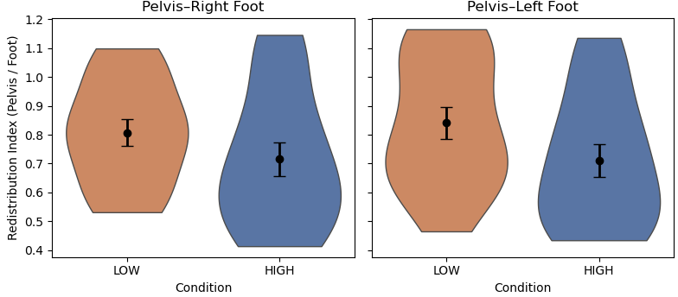
Figure 4. Pelvis–foot redistribution index during the robot active phase. Plots show the distribution of pelvis-to-foot acceleration ratios for the right and left feet under LOW and HIGH robot guidance. Points and error bars indicate mean ± SEM.

Discussion
This study examined how robot-initiated interaction influences human movement dynamics and neuromuscular responses during a retail-like task. As autonomous mobile robots increasingly operate in close proximity to humans, understanding safety solely through collision avoidance is insufficient. Instead, safety must also account for how robot motion perturbs balance, alters movement organization, and imposes additional physical demands during task execution (Luo et al., 2022). By combining whole body kinematics and EMG measures across steady state and transient interaction phases, the present work provides a biomechanically grounded characterization of how proactive robot behaviors shape human responses beyond collisions.
Effects of Robot Guidance on Human Movement Dynamics
Across conditions, robot presence primarily influenced velocity and acceleration level kinematics, while position remains largely unchanged. This suggests that robot-initiated guidance does not substantially alter overall task posture or spatial configuration, but it instead modifies how movement is executed. This pattern is consistent with established models of human balance control, which emphasize regulation of dynamic variables rather than static posture during steady-state tasks (Winter, 1995). From this perspective, the observed increases in segment velocities and accelerations reflect adjustments in movement execution to accommodate an external constraint, rather than a reorganization of task level posture.
Segment velocity increased at the pelvis, right shoulder, and other lower extremities. In balance
and locomotor control, segment velocity and translation are closely linked to anticipatory and adaptive regulation of the center of mass (Schinkel-Ivy et al., 2020; Tesio & Rota, 2019). Increased pelvis velocity indicates enhanced trunk-pelvis involvement in stabilizing whole body motion, consistent with prior studies, also shows that center of mass velocity is a primary mechanism for maintaining stability during perturbated or constrained movement (Pai & Patton, 1997; Vlutters et al., 2016). Additionally, the observed increase in shoulder velocity likely reflects a combination of balance and task related factors. Upper limb motion has been shown to contribute to balance regulation by assisting with control during externally constrained movement, including situations that require subtle postural adjustments (Bruijn et al., 2010; Bruijn et al., 2022). In terms of tasks, following robot guidance, participants continued the shelf-picking task, which required active object manipulation with the dominant arm. As a result, increased shoulder velocity may partly reflect task completion demands rather than a direct consequence of robot induced movement disruption. Importantly, these changes were localized and occurred without corresponding increases in trunk or global body acceleration, suggesting that robot presence elicited task compatible adaptations rather than inefficient upper limb movement.
In contrast, segment velocity and acceleration increased at both legs, indicating that robot guidance predominantly altered the dynamic output of lower limb segments. The lower extremities play a central role in controlling motion, and modulation of leg velocity is a common strategy for accommodating external spatial constraints while preserving overall posture (Hof et al., 2005; Tesio & Rota, 2019). Importantly, the gradual increases in leg dynamics suggest a short-term adaptation process in which participants adjusted their movement dynamics upon detecting the approaching robot and responding to its guidance. Similar increases in lower limb acceleration have been reported in perturbation-based gait studies, where rapid modulation of leg dynamics is used to redirect the center of mass and stabilize movement (Vlutters et al., 2018). From this perspective, increased leg velocity and acceleration represent a functional and expected response to robot interaction rather than an indicator of instability. The larger effects observed under the high-speed guidance condition further indicate that faster robot motion elicited slightly more abrupt lower limb adjustments. Consistent with this interpretation, prior work in HRI has shown that mobile robot guidance and close-proximity navigation systematically alter human motion dynamics, including movement speed and trajectory characteristics, even when task goals remain unchanged (Chen, Luo, et al., 2022; Jevtić et al., 2015). These findings suggest that robots act as dynamic environmental agents that shape human movement execution rather than merely being passively avoided.
Despite changes in kinematics, integrated EMG signals showed limited modulation. Only the RGAL exhibited a nearly significant (p=0.059) increase under different conditions. From an experimental perspective, this pattern is likely attributable to changes in task geometry following robot guidance. After being guided away from the unsafe region, participants were repositioned further from the shelving unit, requiring continued reaching and object retrieval. This task requirement may have increased reliance on the right lower limb for postural support and subtle weight shifting during reaching, leading to elevated RGAL activity. Such localized increases in lower limb muscle activation during upper limb reaching are consistent with prior findings showing that standing reaching tasks elicit increased activation of plantar flexor muscles to support postural stability and balance control (Zhang et al., 2025). Importantly, the absence of significant changes across other lower and upper limb muscles indicates that robot-initiated guidance did not impose substantial additional muscular load. Taken together, these findings suggest that proactive robot guidance alters movement kinematics without inducing widespread increases in muscle activation, suggesting that observed kinematic adaptations reflect efficient, task compatible balance regulation rather than elevated physical strain.
Effects of Robot Guidance on Transient State Movement
During the transient interaction phase, segment level kinematics exhibited clear speed-dependent modulation. Similar to steady-state findings, segment velocity and acceleration were generally higher under the HIGH guidance condition, indicating that faster robot motion elicited greater movement dynamics during the initial response period. Because comparable kinematic increases were already observed during sustained task execution, their presence in the transient phase confirms that higher robot speeds consistently amplify dynamic movement demands throughout the interaction. In contrast to the kinematic measures, neuromuscular responses during the transient phase showed limited modulation. Although several muscles exhibited trends toward increased activation under HIGH condition, none of these effects reached statistical significance after correction. This pattern suggests that robot-initiated guidance did not elicit robust changes in muscle activation at the level captured by integrated EMG. One possible explanation is that neuromuscular control during brief, externally imposed guidance may involve complex coordination strategies that are not fully reflected in gross EMG amplitude measures, particularly during short dynamic adjustments rather than sustained force production.
The absence of EMG effects motivated a more fine-grained biomechanical analysis focused on how balance related demands were redistributed across body segments during the transient interaction phase. Rather than relying solely on segment averaged kinematics or muscle activation levels, we therefore examined proximal–distal acceleration redistribution as a means of capturing coordination strategies underlying rapid balance regulation. Given constraints on scope and length, the analysis focused specifically on the pelvis and feet. The pelvis represents the primary proxy for whole body center of mass dynamics, while the feet are the distal effectors responsible for rapid corrective actions during balance perturbations. Prior biomechanical studies have shown that relative acceleration patterns between the pelvis and feet provide a sensitive indicator of balance control and segmental coordination during walking and in response to perturbations (Vlutters et al., 2016, 2018). Accordingly, focusing on pelvis–foot dynamics allowed us to target the most biomechanically relevant segments for assessing transient balance regulation. During this phase, the pelvis-to-foot redistribution index decreased under the HIGH guidance condition compared to LOW, indicating a relative increase in foot level acceleration with faster robot motion. This pattern suggests that higher robot speeds were associated with greater involvement of lower limb adjustments rather than proportional increases in pelvis level acceleration. This finding is consistent with prior perturbation-based studies demonstrating that early balance responses are primarily mediated by distal mechanisms, whereas proximal contributions emerge more prominently during later stabilization phases. For example, Tang et al. (1998) reported rapid activation of distal lower limb muscles following sudden perturbations during walking, while Freyler et al. (2015) showed that increases in perturbation velocity amplified distal responses. In contrast to these studies, which emphasized neuromuscular activation measured via EMG, the present results reflect redistribution at the level of segmental acceleration during proactive human-robot interaction. The confinement of these effects to the transient interaction phase suggests that robot-initiated guidance functions as a brief perturbation, eliciting short-term balance adjustments without producing sustained changes in overall movement stability.
Limitations
Several limitations of the present study should be acknowledged. First, the participant sample consisted of young, healthy adults, which may limit direct generalization to older workers or individuals with reduced balance capacity or musculoskeletal impairments. However, this population provides a conservative baseline for assessing balance-related responses to robot-initiated guidance. If transient kinematic modulation and distal acceleration amplification are observed in this cohort, such effects may be more pronounced in occupational populations with diminished balance reserves, fatigue, or age-related declines. Second, the experimental task was conducted in a controlled, retail-like environment with predefined ‘unsafe’ regions and a structured shelf-picking activity. While this design ensured repeatability and enabled high-resolution biomechanical measurement, real-world environments are characterized by greater variability in working conditions, spatial constraints, and concurrent cognitive demands. Human responses to robot guidance may differ when environmental hazards are uncertain, dynamic, or perceptually visible. Third, robot guidance in this study was implemented as an implicit, non-contact intervention without verbal communication or physical assistance. This approach isolated the biomechanical consequences of robot motion itself, but other guidance modalities commonly used in practice, such as verbal cues, visual signaling, or physical guidance, may impose different cognitive, perceptual, and motor demands. Comparative evaluation of these intervention strategies would help clarify how guidance modality interacts with movement dynamics and balance control.

Conclusion
This study examined how robot-initiated guidance influences human movement dynamics and balance related responses during a retail-like task. Results show that proactive robot behavior alters movement execution rather than overall posture, primarily through increases in segment velocity and acceleration, particularly in the lower limbs. These adaptations reflect functional adjustments to a moving external constraint rather than inefficient or destabilizing movement strategies. Speed dependent effects were most evident during the transient interaction phase, when higher robot guidance speeds amplified distal acceleration responses, indicating greater reliance on rapid lower limb corrections for balance regulation. These effects did not persist after robot disengagement, suggesting that guidance acts as a brief perturbation rather than a sustained disruption to stability. Overall, the findings highlight that safety in shared human–robot workspaces should consider transient balance demands in addition to collision avoidance, providing biomechanically grounded insight for the design of proactive AMR guidance strategies in occupational environments.

Acknowledgments
The authors would like to thank Read Hayes from LPRC for providing experimental design input from a real-world industrial application perspective. The authors also gratefully acknowledge the robotics students from Professor Gu’s research group for their contributions to the development of the prototype system. The authors further acknowledge the West Virginia University (WVU) team for providing software and hardware architecture support, which facilitated system integration and experimental implementation. Their assistance with system setup and data collection was essential to the successful completion of this study.
Funding
The author(s) disclosed receipt of the following financial support for the research, authorship, and/or publication of this article: This material is based upon work supported by the U.S. National Science Foundation under Award No. 2132936 and No. 2132937.

References
Bruijn, S. M., Meijer, O. G., Beek, P. J., & Van Dieen, J. H. (2010). The effects of arm swing on human gait stability. Journal of Experimental Biology, 213(23), 3945–3952.
Bruijn, S. M., Sloot, L. H., Kingma, I., & Pijnappels, M. (2022). Contribution of arm movements to balance recovery after tripping in older adults. Journal of biomechanics, 133, 110981.
Cai, J., Du, A., Liang, X., & Li, S. (2023). Prediction-based path planning for safe and efficient human–robot collaboration in construction via deep reinforcement learning. Journal of computing in civil engineering, 37(1), 04022046.
Chen, Y., Luo, Y., Yang, C., Yerebakan, M. O., Hao, S., Grimaldi, N., Li, S., Hayes, R., & Hu, B. (2022). Human mobile robot interaction in the retail environment. Scientific Data, 9(1), 673.
Chen, Y., Yang, C., Gu, Y., & Hu, B. (2022). Influence of mobile robots on human safety perception and system productivity in wholesale and retail trade environments: A pilot study. IEEE Transactions on Human-Machine Systems, 52(4), 624–635.
Craig, J. J., Bruetsch, A., & Huisinga, J. M. (2016). Relationship between trunk and foot accelerations during walking in healthy adults. Gait & posture, 49, 25–29.
Edirisinghe, S., Satake, S., & Kanda, T. (2023). Field trial of a shopworker robot with friendly guidance and appropriate admonishments. ACM Transactions on Human-Robot Interaction, 12(3), 1–37.
Fragapane, G., De Koster, R., Sgarbossa, F., & Strandhagen, J. O. (2021). Planning and control of autonomous mobile robots for intralogistics: Literature review and research agenda. European journal of operational research, 294(2), 405–426.
Fragapane, G., Ivanov, D., Peron, M., Sgarbossa, F., & Strandhagen, J. O. (2022). Increasing flexibility and productivity in Industry 4.0 production networks with autonomous mobile robots and smart intralogistics. Annals of operations research, 308(1), 125–143.
Freyler, K., Gollhofer, A., Colin, R., Brüderlin, U., & Ritzmann, R. (2015). Reactive balance control in response to perturbation in unilateral stance: interaction effects of direction, displacement and velocity on compensatory neuromuscular and kinematic responses. PLoS one, 10(12), e0144529.
Haney, J. M., & Liang, C.-J. (2024). A literature review on safety perception and trust during human–robot interaction with autonomous mobile robots that apply to industrial environments. IISE transactions on occupational ergonomics and human factors, 12(1-2), 6–27.
Hof, A. L., Gazendam, M., & Sinke, W. (2005). The condition for dynamic stability. Journal of biomechanics, 38(1), 1–8.
Jevtić, A., Doisy, G., Parmet, Y., & Edan, Y. (2015). Comparison of interaction modalities for mobile indoor robot guidance: Direct physical interaction, person following, and pointing control. IEEE Transactions on Human-Machine Systems, 45(6), 653–663.
Liu, W., Liang, X., & Zheng, M. (2023). Task-constrained motion planning considering uncertainty-informed human motion prediction for human–robot collaborative disassembly. IEEE/ASME Transactions on Mechatronics, 28(4), 2056–2063.
Luo, Y., Chen, Y., & Hu, B. (2023). Multisensory Evaluation of Human-Robot Interaction in Retail Stores-The Effect of Mobile Cobots on Individuals' Physical and Neurophysiological Responses. Companion of the 2023 ACM/IEEE International Conference on Human-Robot Interaction,
Luo, Y., Chen, Y., Yerebakan, M. O., Hao, S., Grimaldi, N., Yang, C., Hayes, R., & Hu, B. (2022). How do humans adjust their motion patterns in mobile robots populated retail environments? 2022 IEEE 3rd International Conference on Human-Machine Systems (ICHMS),
MacArthur, K. R., Stowers, K., & Hancock, P. A. (2016). Human-robot interaction: proximity and speed—slowly back away from the robot! Advances in Human Factors in Robots and Unmanned Systems: Proceedings of the AHFE 2016 International Conference on Human Factors in Robots and Unmanned Systems, July 27-31, 2016, Walt Disney World®, Florida, USA,
Morrison, S., Russell, D. M., Kelleran, K., & Walker, M. L. (2015). Bracing of the trunk and neck has a differential effect on head control during gait. Journal of neurophysiology, 114(3), 1773–1783.
Murakami, H., Tomaru, T., Feliciani, C., & Nishiyama, Y. (2022). Spontaneous behavioral coordination between avoiding pedestrians requires mutual anticipation rather than mutual gaze. Iscience, 25(11).
Obaid, M., Sandoval, E. B., Złotowski, J., Moltchanova, E., Basedow, C. A., & Bartneck, C. (2016). Stop! That is close enough. How body postures influence human-robot proximity. 2016 25th IEEE international symposium on robot and human interactive communication (RO-MAN),
Oh, J., Heo, J., Lee, J., Lee, G., Kang, M., Park, J., & Oh, S. (2023). Scan: Socially-aware navigation using monte carlo tree search. 2023 IEEE International Conference on Robotics and Automation (ICRA),
Pai, Y.-C., & Patton, J. (1997). Center of mass velocity-position predictions for balance control. Journal of biomechanics, 30(4), 347–354.
Robinette, P., Wagner, A. R., & Howard, A. M. (2014). Assessment of robot guidance modalities conveying instructions to humans in emergency situations. The 23rd IEEE international symposium on robot and human interactive communication,
Rubagotti, M., Tusseyeva, I., Baltabayeva, S., Summers, D., & Sandygulova, A. (2022). Perceived safety in physical human–robot interaction—A survey. Robotics and Autonomous Systems, 151, 104047.
Salvini, P., Paez-Granados, D., & Billard, A. (2022). Safety concerns emerging from robots navigating in crowded pedestrian areas. International Journal of Social Robotics, 14(2), 441–462.
Schinkel-Ivy, A., Komisar, V., & Duncan, C. A. (2020). Quantifying segmental contributions to center-of-mass motion during dynamic continuous support surface perturbations using simplified estimation models. Journal of Applied Biomechanics, 36(4), 198–208.
Sousa, L. C., Silva, Y. M., Schettino, V. B., Santos, T. M., Zachi, A. R., Gouvêa, J. A., & Pinto, M. F. (2025). Obstacle Avoidance Technique for Mobile Robots at Autonomous Human-Robot Collaborative Warehouse Environments. Sensors, 25(8), 2387.
Tang, P.-F., Woollacott, M. H., & Chong, R. K. (1998). Control of reactive balance adjustments in perturbed human walking: roles of proximal and distal postural muscle activity. Experimental brain research, 119(2), 141–152.
Tesio, L., & Rota, V. (2019). The motion of body center of mass during walking: a review oriented to clinical applications. Frontiers in neurology, 10, 999.
Vlutters, M., Van Asseldonk, E. H., & Van der Kooij, H. (2016). Center of mass velocity-based predictions in balance recovery following pelvis perturbations during human walking. Journal of Experimental Biology, 219(10), 1514–1523.
Vlutters, M., van Asseldonk, E. H., & van der Kooij, H. (2018). Lower extremity joint-level responses to pelvis perturbation during human walking. Scientific reports, 8(1), 14621.
Winter, D. A. (1995). Human balance and posture control during standing and walking. Gait & posture, 3(4), 193–214.
Yedidsion, H., Deans, J., Sheehan, C., Chillara, M., Hart, J., Stone, P., & Mooney, R. J. (2019). Optimal use of verbal instructions for multi-robot human navigation guidance. International Conference on Social Robotics,
Yiou, E., Artico, R., Teyssedre, C. A., Labaune, O., & Fourcade, P. (2016). Anticipatory postural control of stability during gait initiation over obstacles of different height and distance made under reaction-time and self-initiated instructions. Frontiers in human neuroscience, 10, 449.
Zhang, Y., Matsumoto, A., Oshima, C., Sakamoto, K., Sugiyama, T., & Liang, N. (2025). Standing postural control during an upper limb reaching task in a mixed reality condition: analysis of center of pressure and lower limb muscle activities. Virtual Reality, 29(3), 93.

