Future Hydrogen Markets for Transportation and Industry – The Impact of CO₂ Taxes
Simonas CERNIAUSKAS,⁽¹⁾ Thomas GRUBE,⁽¹⁾ Aaron PRAKTIKNJO,⁽²⁾ Detlef STOLTEN^{(1,3)} and Martin ROBINIUS⁽¹⁾
⁽¹⁾ Institute of Electrochemical Process Engineering (IEK-3), Forschungszentrum Jülich GmbH, Wilhelm-Johnen-Str., D-52428, Germany
⁽²⁾ RWTH Aachen University, Institute for Future Energy Consumer Needs and Behavior (FCN), Mathieustr. 10, Aachen, 52074, Germany
⁽³⁾ Chair for Fuel Cells, RWTH Aachen University, c/o Institute of Electrochemical Process Engineering (IEK-3), Forschungszentrum Jülich GmbH, Wilhelm-Johnen-Str., D-52428, Germany
Abstract
The technological lock-in of the transportation and industrial sector can be largely attributed to the limited availability of alternative fuel infrastructures. Herein, a countrywide supply chain analysis of Germany, spanning until 2050, is applied to investigate promising infrastructure development pathways and associated hydrogen distribution costs for each analyzed hydrogen market. Analyzed supply chain pathways include seasonal storage to balance fluctuating renewable power generation with necessary purification, as well as trailer- and pipeline-based hydrogen delivery. The analysis encompasses green hydrogen feedstock in the chemical industry and fuel cell-based mobility applications, such as local buses, non-electrified regional trains, material handling vehicles, and trucks, as well as passenger cars.
Our results indicate that the utilization of low-cost, long-term storage and improved refueling station utilization have the highest impact during the market introduction phase. We find that public transport and captive fleets offer a cost-efficient countrywide renewable hydrogen supply roll-out option. Furthermore, we show that, at comparable effective carbon tax resulting from the current energy tax rates in Germany, hydrogen is cost-competitive in the transportation sector by the year 2025. Furthermore, we show that sector-specific CO₂ taxes are required to provide cost-competitive green hydrogen supply in both the transportation and industrial sectors.

Highlights
- Public transport and captive fleets are very suitable for market introduction
- Hydrogen is cost-competitive at current effective CO₂ tax in Germany by 2025
- Sector-specific CO₂ taxes are required for transportation and industrial sectors

Keywords: market introduction, hydrogen infrastructure, CO2 tax, fuel cell vehicles, geospatial analysis

Introduction
Renewable hydrogen and its applications, such as fuel cell electric vehicles (FCEVs) and industrial feed-stocks are an important option for reducing greenhouse gas emissions (GHGs) and reaching the ambitious European and global GHG reduction targets (2018c). However, alongside the existing conventional fuel-based hydrogen demand in the industry, the market diffusion of FCEVs and the related additional hydrogen demand growth pace is slow. The main stated reasons for the very gradual market penetration of FCEVs are an underdeveloped hydrogen supply infrastructure and associated high hydrogen cost (Gnann and Plötz, 2015). However, studies have shown that the expansion of the hydrogen supply infrastructure can promote cost reduction and lead to low hydrogen supply costs at large market diffusion scenarios (Robinius et al., 2017). Therefore, it raises a question as to the most important leverages for short- to medium-term hydrogen cost reduction. Moreover, a growing number of hydrogen demonstration projects (2019a; Wulf et al., 2018) raises the question of the best-suited hydrogen markets for countrywide infrastructure roll-out and their cost-competitiveness under various CO₂ tax rates.
The optimal design of a hydrogen supply chain is one of the main questions for hydrogen infrastructure introduction, and therefore the literature is rich in publications dedicated to this issue. The research reported here is mainly focused on minimizing the supply chain cost by incorporating a variety of technological pathways while considering the general geospatial differences between production and demand regions. Central papers in this research area include publications focusing on the general mathematical formulation of the problem of hydrogen supply chain optimization (Almansoori and Shah, 2009; Hugo et al., 2005). From this starting point, ongoing research can be differentiated in terms of the geographical scope of the analysis and related geospatial resolution. Most of the studies are concerned with national studies dealing with countrywide optimization and generally focused on a small number of single regions and lower geospatial resolution (Agnolucci et al., 2013; De-León Almaraz et al., 2015; Han et al., 2012; Hwangbo et al., 2017; Kim and Kim, 2016; Li et al., 2008; Moreno-Benito et al., 2017; N.V.S.N. Murthy Konda, 2011; Nunes et al., 2015; Sabio et al., 2010; Stiller et al., 2010). These publications focus primarily on strategic decision-making on the national level regarding production and hydrogen transport capacities in the considered sub-regions. Research papers concerned with hydrogen infrastructure optimization within smaller areas or sub-regions of countries use the improved geospatial resolution as the questions of refueling station location and trailer or pipeline routing come to the forefront (Dayhim et al., 2014; Kim and Kim, 2017; Welder et al., 2018; Yang and Ogden, 2013). Even higher geospatial resolution is applied in the case of district optimization (He et al., 2017; Kuby et al., 2009; Stephens-Romero et al., 2010) that generally focus on optimal refueling station placement in accordance with transport flows and geospatial coverage of the area. In summary, optimization models rely on the trade-off between geospatial resolution and problem complexity, as well as geographical scope, to adapt the methodology to answer specific questions of cost-optimal infrastructure design. For a more comprehensive review regarding hydrogen supply chain optimization, the reader is referred to the literature (Li et al., 2019). As optimization problems are generally formulated in the form of linear or mixed-integer linear problems, supply chain component-related technology characteristics are depicted in the simplified linear format. Consequently, relevant scaling and learning effects for single supply chain components are neglected. As a result, a second trade-off between the size of the solution space and the exactness of the technology description is made. To address this issue, different piece-wise linearization approaches can be applied (Heuberger et al., 2017; Kahouli-Brahmi, 2008; Kohler et al., 2006), but one must balance the level of technical detail and computability of the problem carefully.
Alternatively, the aforementioned shortcomings of geospatial resolution constraints and linearized description of technologies can also be addressed within the framework of the pathway simulation, which – at the cost of the variety of analyzed pathways – enables the incorporation of more detailed technological properties and better geospatial resolution. Similarly to the optimization approach, the pathway analysis first and foremost relies on the generalized problem definition, which in this case is mainly concerned with a single component analysis (Bolat and Thiel, 2014; Grüger et al., 2019; Nistor et al., 2016; Reuß et al., 2017; Yang and Odgen, 2007) that focuses on technical aspects, as well as the scaling effects of supply chain components. Subsequently, the derived cost functions are then applied to simulate a countrywide (Krieg, 2012; Qadrdan et al., 2008; Shafiei et al., 2017; Tzimas et al., 2007) or sub-regional (Brey et al., 2014) hydrogen supply chain. The simulation approach allows for much smaller geospatial granularity in the model, thus enabling the analysis to penetrate up to the final point of the demand, such as individual hydrogen refueling stations. Nevertheless, the limited number of pathway options diminishes the analysis spectrum, which is essential in a strategic discussion of optimal hydrogen supply chain configuration.
Optimization and pathway simulation are mostly applied in a static manner, thus focusing on the optimal future system without a deeper analysis of different system configurations during hydrogen market evolution. Worthy exceptions in the supply chain optimization area are publications that apply exogenous hydrogen market penetration scenarios to investigate hydrogen supply chain evolution (Almansoori and Shah, 2012; N.V.S.N. Murthy Konda, 2011; Yang and Ogden, 2013). In the case of pathway simulation, lower computational complexity enables the incorporation of a more in-depth look at different hydrogen supply chain configurations at various maturity levels of the hydrogen market, as well as transition pathways between different market evolution phases (Qadrdan et al., 2008; Tzimas et al., 2007). A further important aspect of infrastructure introduction is the question of geospatial demand distribution and its evolution over time, as it can substantially affect the optimal hydrogen supply chain design. Moreover, different hydrogen applications, such as industrial feedstocks and FCEVs have different requirements regarding the supply infrastructure and hydrogen purity that affect the final cost of the infrastructure. Most of the analyzed studies, however, focus their analysis on a narrow single market, especially passenger cars, thus neglecting potential network effects with other relevant markets, such as commercial vehicles, heavy industry or stationary applications (Agnolucci et al., 2013; Almansoori and Shah, 2012; Heinz et al., 2013; Kim and Kim, 2016; Nunes et al., 2015; Robinius et al., 2017; Sabio et al., 2010; Stiller et al., 2010).
To close this research gap, building upon the modular approach (Reuß et al., 2017), a method is developed that is capable of analyzing a broad spectrum of hydrogen demand types and future market penetration scenarios, while including a variety of supply chain configurations and associated transitional effects, including scaling and learning effects of the components. For the case of Germany, a country with features comparable to other industrialized nations, the structural development of hydrogen supply chains are analyzed to address the question of the most important infrastructure cost reduction potentials in the short- to medium-term. Special focus is laid upon the liquid and gaseous trailer, as well as pipeline delivery. Moreover, hydrogen production with electrolysis and hydrogen import is taken into the account. The scope of this analysis encompasses application-specific hydrogen supply cost analysis for local buses, regional non-electrified trains, passenger cars, and trucks, as well as material handling vehicles (MHVs) and industrial feedstocks. For reasons of result transparency, no changes regarding the currency valuation, fleet size, mileage or overall industrial output are assumed. The derived costs are subsequently compared to gasoline fuel and steam methane reforming (SMR) costs under consideration of CO₂ taxes. Based on these findings, each hydrogen market is accessed with regard to its suitability for hydrogen infrastructure introduction, whereupon recommendations for hydrogen market introduction strategies are drawn.

Material and Methods
In this chapter, the methodology of the Bass model is used to derive market introduction curves and the implemented extensions of the model will be described. Furthermore, based on the broad scenario review, market penetrations for each relevant hydrogen market will be presented. On the basis of the gathered literature scenarios, the extended Bass model will be fitted to map exploratory market diffusion according to the trends observed in the literature. Subsequently, factors governing geospatial hydrogen demand distribution up to the final point of demand will be described for each hydrogen market. Lastly, the methodology of hydrogen supply chain analysis and single supply chain components, which are applied to investigate application-specific supply cost, will be presented.

Bass Diffusion Model
Studies have shown that common property of new technologies is an s-shaped market penetration curve containing three main phases: a slow introduction, fast market expansion, and saturation phase accompanied by decelerating market growth (Adner and Kapoor, 2016; Meade, 1984). One of the most widely applied forecasting methods for new products and technologies is the Bass diffusion model which, in the form of a differential equation, employs the notions of innovators and imitators in order to model the innovation spread amongst potential adopters (Bass, 1969). Additionally, in order to consider the further effects of cost reduction or marketing, a generalized Bass model has been developed (F. Bass et al., 1994; Park et al., 2011). One important aspect of the Bass model is the elimination of the integration constant in its initial formulation, leading to the zero-initial level condition (Bass, 1969; F. Bass et al., 1994). This creates a challenge to fit with the historical data, which is especially important in the case of the early adoption phase. Moreover, due to pilot and pre-commercial deployments of the technology, the zero-initial level condition leads to problems while defining the starting point of the market introduction of the technology. These issues can be addressed by incorporating an integration constant into the Bass model (Kim and Hong, 2015):
$$N\left(t\right)=m\frac{c\left(p+q\right)+pe^{-(p+q)t}}{c\left(p+q\right)-pe^{-(p+q)t}} with c= {-p}/{(q+p)}$$
Where N is the fleet penetration, m the market size, p and q represent innovators and imitators and t the time step. Another issue with the Bass formulation is neglecting the product lifetime, as the initial model only considers first time adopters and thus overlooks different product generations (Bass, 1969). This aspect is especially relevant for durable applications, such as vehicles or industrial equipment, as it can substantially impact the speed of market penetration. One suitable methodology to this problem is the Markov chain, as it describes the sequence probability of possible events according to the state of the previous event (Gagniuc, 2017). By employing Markov chain methodology, product purchase factors for different product generations can be incorporated into the Bass model. All consumers after first time adoption of the product are subject to a repurchase rate, displaying repurchase probability after the end of the product’s life and a return to product probability for first time adopters who did not own the product in the last time step. In this study, we have considered product introduction as well as product retraction after the end of the lifetime for each of the analysis years. The assumed product lifetime for each conventional application that affects the diffusion speed is given in Table 1.

Table 1.
Assumed application lifetime in each market.
Application | Car | Bus | Train | Truck | MHV | Industrial equipment
Lifetime (Years) | 12 | 10 | 30 | 10 | 5 | 20

One of the main general issues in the application of the Bass diffusion model is the estimation of the innovation and imitation parameters. This is especially true for fuel cell applications that are entering the commercialization phase and do not provide enough data for appropriate regression analysis. Methodologies to circumvent this challenge encompass discrete choice experiments based on the potential consumer survey (Tran et al., 2013) or regression methods based on comparable products with extensive sales data (Benvenutti et al., 2017; Heinz et al., 2013; Lee et al., 2014). The derived results are, however, highly dependent on the survey sample and are generally focused on a single application, for example, a FCEV. Due to the broad envisaged scope of demand technologies in this study and the lack of relevant data for most of the hydrogen markets, an alternative approach was developed. Instead of extrapolating historical data or choice survey results, fleet penetration scenario data from the scenario and system optimization studies are fitted with the extended Bass diffusion model to derive market penetration tendencies for each analyzed market. This methodology enables the acquisition of exploratory market diffusion scenarios for each relevant technology in accordance with scenario tendencies derived from the literature.

Market diffusion scenarios
To analyze the market growth rate and utilization of the relevant hydrogen market potential, a scenario review regarding market diffusion scenarios from 2023 to 2050 for each hydrogen market was conducted. The focus of the scenario overview is set on Germany, however, and in the case of very sparse data, relevant European or Worldwide scenarios were also taken into account. In the case of early market developments, such as in the years 2023-2025, which are mostly beyond the scope of future scenarios, pilot projects, and market assessment data were additionally considered.
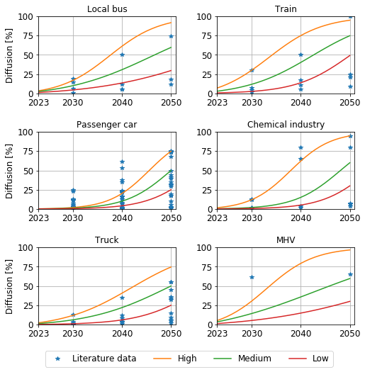
Figure 1. Hydrogen market diffusion scenario overview for six pre-selected markets
From the scenario overview depicted in Figure 1, we can observe that different studies and scenarios come to a variety of conclusions regarding the future importance of hydrogen, indicating high uncertainty of market growth (for data see the Appendix). Moreover, a trend can be derived in which some studies and scenarios appear to strongly favor hydrogen adoption, whereas others expect hydrogen to play only a minor role in the relevant market. Nevertheless, studies envisioning high hydrogen share expect more substantial growth in the majority of analyzed markets after the year of 2030, indicating an anticipated slow market penetration at the beginning of the analysis time frame.
Based on the analyzed studies, high and low exploratory market penetration scenarios for each hydrogen application are derived. To include a more balanced picture, which is especially rare in the case of less analyzed hydrogen demand sectors, the third scenario with medium market penetration is also included in the further analysis. The s-curves of each scenario are generated by applying the extended Bass diffusion model, described in Section 2.1, by fitting the gathered scenario data and exogenous target penetrations for the year of 2050 as displayed in Table 2, below.

Table 2.
Exploratory hydrogen market penetration for each pre-selected market by 2050.
Scenario | Bus | Train | Car | Industry | Truck | MHV
Low | 30% | 50% | 25% | 30% | 25% | 30%
Medium | 60% | 75% | 50% | 60% | 50% | 60%
High | 95% | 95% | 75% | 95% | 75% | 95%

Based on the derived exploratory hydrogen scenarios, Figure 2 depicts the accumulated hydrogen demand for medium market penetration (see Figure 1) in the analyzed green hydrogen markets. Note that for reasons of simplification, no evolution regarding vehicle mileage and fleet size or chemical stock production are assumed. Nevertheless, green hydrogen demand potential in the refineries is dynamically adapted to conventional fuel substitution in the relevant market penetration scenario. The hydrogen demand structure is noticeably evolving over the analysis period. In the period from 2023 to approximately 2030, hydrogen demand is largely driven by captive fleet vehicles in public transportation, such as regional non-electric trains and local buses and other commercial fleets, such as trucks and MHV. In the second phase of the analysis time frame after 2030, the green hydrogen market is increasingly dominated by passenger vehicles and industrial feedstock. In the following sections, the methodology regarding geospatial hydrogen demand distribution and supply chain modeling will be described.
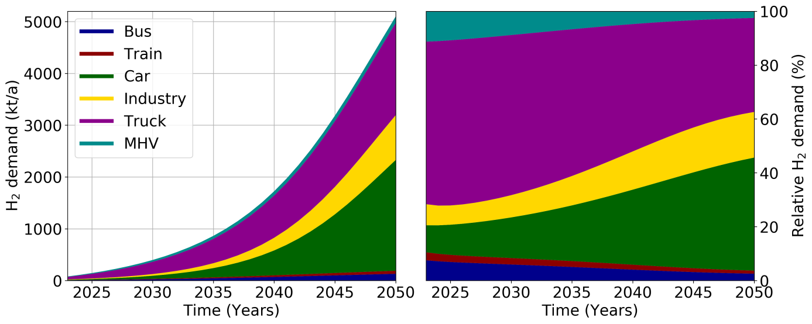
Figure 2. Total demand development and its relative structure in the case of the medium hydrogen demand scenario.

Demand distribution
The future geospatial distribution of hydrogen demand will be one of the key variables determining infrastructure cost and therefore the size of the overall hydrogen market. Based on the approach for a top-down distribution of FCEV proposed in the literature (Robinius et al., 2017), the methodology was further developed by extending the analysis with pre-selected markets and relevant geospatial factors. As the relative importance of each factor is difficult to assess, the factors of each market are weighted equally. The overview of the chosen criteria is given in Table 3.

Table 3.
Criteria for geospatial hydrogen demand distribution on a county level.
Source: (2009; 2015; 2016a; 2016b; 2017; 2018a; 2018b; Robinius et al., 2017; Statistisches Bundesamt, 2015, 2017)
Bus | Train | Car | Industry | Truck | MHV
Population | Diesel train lines | Population | Plant capacity | Loaded freight mass | Loaded freight mass
Income | Federal support | Population density |  | Unloaded freight mass | Unloaded freight mass
 | Diesel train mileage | Income |  | Fleet size | Logistic space
 | Refueling stations | Fleet size

In the case of local buses, the factor of the population was chosen to resemble the mileage driven and the associated challenges of nitrogen oxide and noise pollution, which can be reduced with the implementation of fuel cell buses. Moreover, the mean available income has shown a good correlation with federal support and existing pilot projects of zero-emission transportation. Non-electrified train lines and diesel train mileage at the federal state level, as well as federal support for regional development, were used to weight the federal states in terms of regional diesel train mileage. Subsequently, counties were weighted according to the number of existing refueling stations for trains. In the case of trucks, the distribution of mileage is approximated with freight intensity and registered vehicles in the district, whereas freight intensity is estimated with the loaded and unloaded mass. Governed by the assumed correlation between the size of the logistic fleet and the logistics area, the distribution of material handling vehicles is subject to freight intensity and the logistic space data at the postal code level.
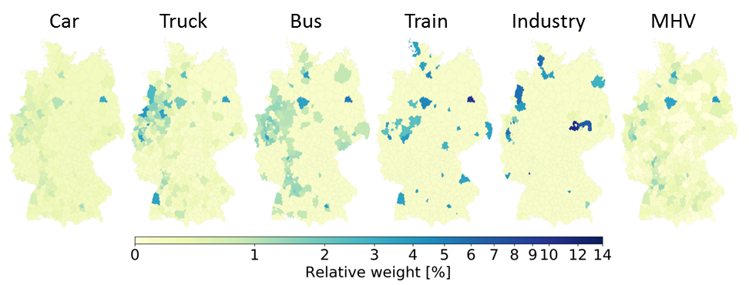
Figure 3. Geospatial hydrogen demand-weight distribution for each selected hydrogen market.
Figure 3 demonstrates the resulting geospatial weight distribution for each market when all mentioned weighting criteria are taken into account. We can perceive that passenger cars are significantly more equally distributed across the regions than analyzed commercial vehicles and industry. Consequently, countrywide coverage of passenger car demand necessitates a larger number of hydrogen distribution links and refueling stations than for local buses or non-electrified train lines. Local buses are mostly localized in larger metropolitan areas with significant suburban populations, which is in line with the anticipated fuel cell bus deployment in larger suburban areas (Bekkers, 2018). Despite common influencing factors, MHV allocation is more evenly distributed than in the case of the trucks, indicating substantial freight loading and unloading not related to logistical space. In the case of local diesel train allocation, which is highly affected by existing train refueling stations, it exhibits the prominence of rail traffic hubs. High demand concentration indicates that even though fuel cell trains are expected to be deployed on less busy non-electrified lines in the less densely populated areas, the trains would be fueled in larger rail hubs, which are often located in high population centers. Finally, the industrial hydrogen demand distribution showcases the most important chemical industry centers. After countrywide demand distribution on the county level, hydrogen demand is subsequently appointed to single sinks within each county. Table 4 summarizes the applied data and methods regarding the utilized data for points of hydrogen demand. For more details regarding associated market size and fuel cell efficiency developments of specific markets, see the Appendix.

Table 4.
Criteria for geospatial HRS capacity distribution within the county.
Type | Public |  | Non-Public
Application | Car | Truck | Bus | Train | Industry | MHV | Car | Truck
Maximum number of sinks | 9800 | 8000 | 402 | 170 | 90 | 10000 | 7150 | 2340
Capacity distribution in a region | Mixed-integer optimization |  | Equally among the refueling stations |  | Maximum capacity | Logistic area | Commercial area | Commercial area
Constraints | 212 kg/d if < 10% of existing fuel stations |  | Fleet > 25 | Fleet > 5 | - | Fleet > 70 | Fleet > 50 | Fleet > 20

Once the hydrogen demand scenario is defined and geospatial distribution up to the point of demand is implemented, the corresponding hydrogen supply chain can be designed. The following section will describe the modeling methodology of the hydrogen supply chain design and present the most relevant parameters of different links in the supply chain.

Hydrogen supply chain
The hydrogen supply chain model used for this analysis allows the analysis of different hydrogen supply chain pathways based on electrolytic hydrogen production. Liquid (LH₂) and gaseous (GH₂) pathways are considered with production and import, storage, purification with temperature swing adsorption (TSA), hydrogen delivery and fueling. Due to the expanded variety of hydrogen demand options, 350 bar refueling stations and relevant captive fleet operational constraints were additionally incorporated into the analysis. The overview of the considered hydrogen supply chain options is given in Figure 4. The following subsections describe the single supply chain components and associated techno-economic parameters.
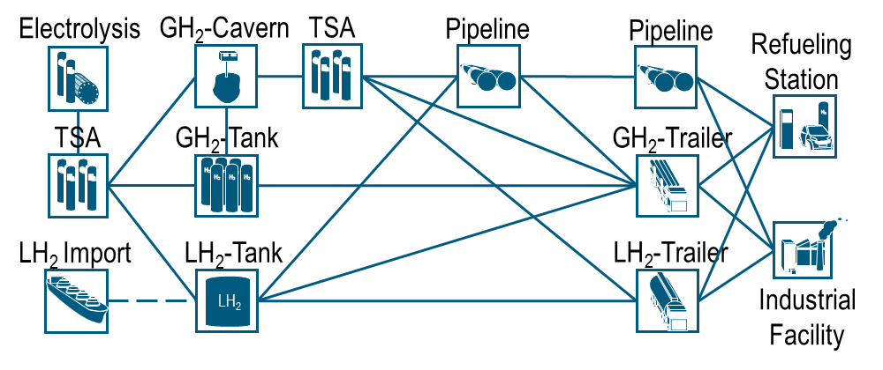
Figure 4. Overview of analyzed hydrogen supply chains.

Electrolysis and import
Multiple long-term energy system modeling results indicate that water electrolysis will be a key element in the future energy system (Brynolf et al., 2018; Kim and Kim, 2016; Robinius et al., 2017). Considering its high flexibility and cost reduction potential, proton exchange membrane (PEM) electrolysis is seen as the most feasible option for sector coupling applications in this study (Brinner et al., 2018). Electrolysis investment costs are estimated on the basis of the nationwide single factor learning curve, including scaling effects on the balance of plant components according to:
$$I_{new}=I_{base}*\left(\left({f*\left(1-LR\right)}^{\log_{2}\left(\frac{P_{cum}}{P_{now}}\right)}\right)+\left(\left(1-f\right)*{\left(\frac{P_{new}}{P_{base}}\right)}^{α}\right)\right)$$

Table 5.
Techno-economic assumptions of electrolysis.
I_{base} | f | LR | P_{now} | P_{base} | α
1500 €/kW | 67% | 20% | 20 MW | 1 MW | 0.925

In Table 5 the variable I_{base} describes the reference electrolysis investment cost, f the stack and electronics cost fraction in the reference investment cost structure, α the scaling factor and LR the learning rate. The reference electrolysis cost is assumed according to the project reviews and expert estimates in the literature (Glenk and Reichelstein, 2019; Saba et al., 2018) The learning rate LR is assumed to be 20%, which is comparable to PEM fuel cell and alkaline electrolysis LR estimates of 16-22% and 18%, respectively (Meyer and Winebrake, 2009; Schmidt et al., 2017; Schoots et al., 2008; Staffel, 2009; Staffell and Green, 2013; Wei et al., 2017). Moreover, early energy technologies tend to have learning rates in the range of 15-25% (Samadi, 2018). The scaling factor α is derived from estimated component scaling (Tractebel and Hinicio, 2017) with respect to the reference capacity P_{base} and assumed module size of 20 MW. The total installed PEM capacity in Europe in 2018 was 20 MW (Wulf et al., 2018) and is depicted by the variable P_{now}. Finally, the variable P_{cum} depicts the total installed PEM capacity in Germany. The locations of electrolyzers are considered on the basis of a power sector scenario dominated by major renewable energy expansion in northern Germany, with a cumulative hydrogen production potential of up to 3.1 Mt of hydrogen (Robinius, 2015). Additional hydrogen imports can be considered if the local hydrogen production potential is overreached. Drawing on the methodology of Heuser et al., the estimated hydrogen import price at the port in Germany is estimated to be 3.9 €/kg_{H2} (Heuser et al., 2019).

Long-term storage
Different hydrogen storage options, such as salt caverns, liquid, and compressed gaseous tanks are considered in this study for a storage period of 60 days. All relevant techno-economic parameters were considered according to the earlier studies (Reuß et al., 2017). Due to geological availability in northern Germany, it is assumed that long-term storage locations are close to the production sites and connection cost to the electrolysis can be neglected. The minimal geometric volume of the cavern is assumed to be 70,000 m³, which is the typical smallest cavern volume in Germany (Noack et al., 2015). For smaller storage volumes, caverns are substituted in the supply chain by compressed gaseous hydrogen tanks.

Conversion and conditioning equipment
The different technical characteristics of the equipment with respect to pressure and the hydrogen state require conversion technologies, such as a compressor, liquefaction, and evaporation in order to enable the necessary transition between distinct parts of the supply chain. All techno-economic parameters used for the modeling of the conversion and conditioning technologies in this study are derived from the literature (2008; Reddi et al., 2015; Reuß et al., 2017; Stolzenburg and Mubbala, 2013). Furthermore, due to the high requirements of hydrogen quality in different steps of the supply chain, purification is also considered. The most widely used purification options are pressure swing adsorption and temperature swing adsorption (TSA), both of which can achieve comparably high hydrogen purity levels and sufficiently high hydrogen recovery rates (Ben-Mansour and Qasem, 2018; Zhu et al., 2018a, b). In this study, due to its higher efficiency at low absorbent concentrations, TSA will be used for hydrogen drying with PEM electrolyzer and cavern storage (Lively and Realff, 2016). For more details regarding cost assessment of the purification see Appendix.

Transmission and distribution
Hydrogen transport options considered in this study are a pipeline, a compressed gaseous trailer, and liquid hydrogen trailer. All techno-economic parameters used in the analysis are derived from countrywide hydrogen infrastructure analyses in the literature (Reuß et al., 2017; Robinius et al., 2017). Natural gas network and street grid are used as candidate grids for the pipeline and trailer supply, respectively. Due to the complex nature of natural gas network optimization, the algorithm of a minimum spanning tree is applied to reduce the number of possible network branches in the candidate grid before the optimization (Held and Karp, 1970). Furthermore, distance matrices amongst sources and sinks, as well as natural gas or street networks, are considered in the linear flow optimization. Moreover, centroids of German counties are included in the pipeline network design, enabling a commonly used separation of transmission and distribution grids (Reddi et al., 2015; Yang and Odgen, 2007). Figure 5 depicts the resulting hydrogen supply chain evolution for the case of an LH2 trailer in the medium hydrogen demand scenario. Increasing refueling station density and growing hydrogen trailer transport, especially on the main north-south highways, can be observed with the forthcoming time evolution. Moreover, a wide distribution of refueling stations over the whole analyzed period can be perceived, leading to a countrywide supply system. Nevertheless, cluster regions, such as Berlin, Frankfurt and Rhine-Ruhr, identified by joint venture installing hydrogen refueling stations in Germany, are also clearly observable (2019b).
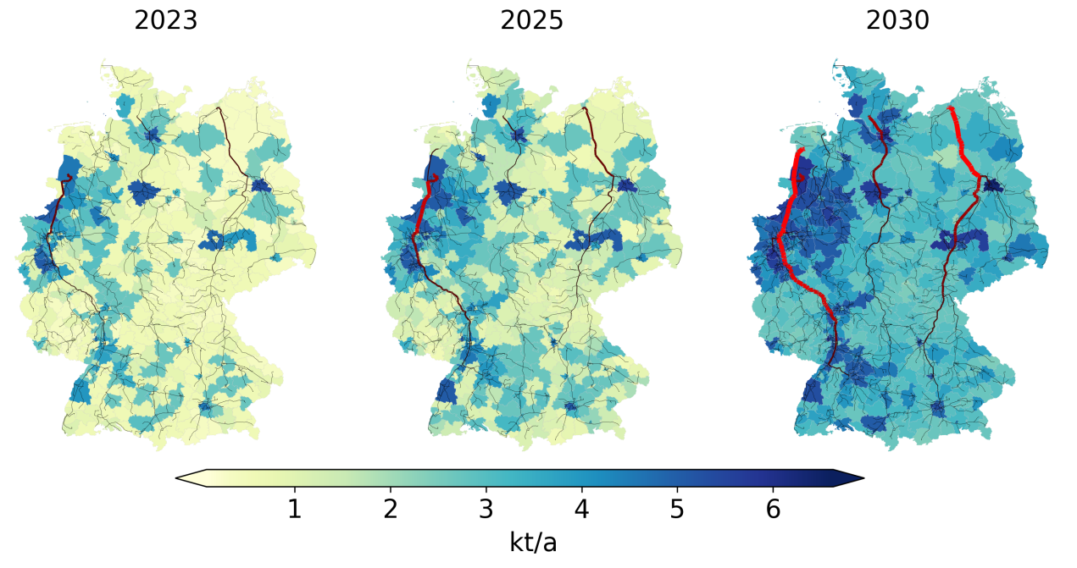
Figure 5. Exemplary geospatial hydrogen demand and LH₂ trailer supply capacity development from 2023 to 2030.

Hydrogen refueling station
Considered hydrogen refueling stations (HRS) can be divided into public and non-public HRS, supplying captive fleets, and into two distinct pressure level designs: 350 and 700 bar. Public HRS are assumed to be constructed on existing refueling station sites and are modeled by applying a mixed-integer optimization problem to minimize the investment cost of discrete refueling station sizes. Additionally, the model is constrained to build only small-sized refueling stations (S) if less than 10% of existing stations in the region contain hydrogen refueling equipment. This assumption is in line with a number of other studies that analyze the required minimal station network size to provide appropriate geographical coverage in the introduction phase (Joest et al., 2009; Meyer and Winebrake, 2009; Seydel, 2008; Stolzenburg, 2014). Moreover, in accordance with the strategy of joint venture installing HRS in Germany (2019b), the refueling stations are first constructed along the highways, which are then followed by main and rural roads. Further techno-economic parameters for HRS are derived from the literature (Elgowainy et al., 2014; Reddi et al., 2015; Reuß et al., 2017). Captive HRS construction is also limited to the relevant existing infrastructure, such as industrial plants, commercial sites and depots. In contrast to public HRS, non-public HRS can be designed in accordance with the relevant captive fleet demand. Table 6 summarizes the assumed base investment costs of different 700 and 350 bar refueling station size types. For more information regarding market-specific refueling requirements that are relevant for HRS cost calculations (see Appendix).

Table 6.
Main techno-economic assumptions of hydrogen refueling stations.
 | S | M | L | XL | XXL
Capacity [kg/d] | 212 | 420 | 1000 | 1500 | 3000
Investment 700 bar [€] | 800,000 | 1,100,000 | 1,940,000 | 2,700,000 | 4,850,000
Investment 350 bar [€] | 700,000 | 960,000 | 1,700,000 | 2,335,000 | 4,240,000
LR (Robinius et al., 2018) | 6% | 6% | 6% | 6% | 6%

Results and Discussion
Drawing on the described methodology, this section evaluates hydrogen supply cost development in accordance with derived hydrogen demand scenarios and compares the resulting costs to the relevant conventional fuels under different CO₂ taxation levels. Table 7 shows the applied parameters for the benchmark definition. Due to the similar CO₂ footprint of gasoline and diesel, we select the former as a representative benchmark for transportation. To account the actual quality of the provided service, the calculated gasoline benchmark is additionally corrected by the comparison of ICV and FCEV real-world efficiencies. Due to the high uncertainty of future ICV hybridization and efficiency development, it is assumed that both ICV and FCEV future efficiency develops at the same pace. In the case of industrial hydrogen feedstock, natural gas-based steam methane reforming (SMR) is used as the reference benchmark. For the further analysis, hydrogen supply chain costs are analyzed against the backdrop of CO₂ taxes in the range of 100-300 €/t CO₂, which covers effective CO₂ tax rates of approximately 75% reported countries OECD and G20 countries, including Germany with effective carbon tax on gasoline of 290 €/tCO₂ (2018d).
Table 7
Benchmark cost definition
Source:(2018e; Eichman et al., 2016; Juhrich, 2016; MWV, 2019)
Parameter | Transportation | Industry | Comments
Energy carrier | Gasoline | Grey hydrogen | SMR for the industry sector
CO2 intensity | 73.1 tCO2/TJ | 56.1 tCO2/TJ* | Diesel: 74.1 tCO2/TJ
Pre-tax cost | 0.069 ct/kWh** | 0.06 ct/kWh | Diesel: 0.064 ct/kWh**
Conversion efficiency | - | 73% | SMR for the industry sector
Energy efficiency factor | 2.1 | - | η_{gasoline}=69 kWh/100 km**  η_{diesel}=67 kWh/100 km**  η_{FCEV}=33 kWh/100 km
*Natural gas **10-year mean

Infrastructure cost reduction with increasing demand
In order to highlight the electrolytic hydrogen supply chain development of the most promising trailer and pipeline pathways, countrywide hydrogen demand by passenger cars is first analyzed. From Figure 6 it can be determined that both trailer pathways provide substantial cost reductions and become cost-competitive with conventional fuels, as it reaches the 300 €/tCO₂ gasoline benchmark in the hydrogen demand range of 250 to 300 kt p.a., thus less than 8% of the passenger car market. The main cost reductions can be attributed to the decreasing specific HRS cost and improving utilization. The observed small plateau at 20-30 kt p.a. is caused by the requirement to build the network of HRS comprising 10% of existing refueling stations in the region before larger stations can be installed. Furthermore, early cost reductions can be observed in the case of GH2 storage, as there is a storage volume-based switch from gaseous hydrogen tanks to salt caverns as a long-term storage solution. This process is completed at 20-30 kt p.a. From there on, long-term hydrogen storage has a negligible effect on overall GH2 trailer system cost. Finally, cost reductions are visible on the production side that is affected by the considered learning and scaling effects of electrolysis units. Electrolysis cost reduction appears to have a lower short-term impact on overall provision cost in the introductory phase than the improved utilization of refueling stations and the availability of underground storage. Combined, these effects enable 200 €/tCO₂ target to be reached by an overall demand of 550 and >1000 kt p.a. for LH2 and GH2 trailers, respectively. Therefore, indicating high cost-competitiveness with gasoline at 10-20% of the passenger car market. Finally, we can observe, that carbon tax of 100 €/tCO₂ is not sufficient to facilitate a self-supporting hydrogen market for only passenger cars even at improved infrastructure utilization at large overall demand.
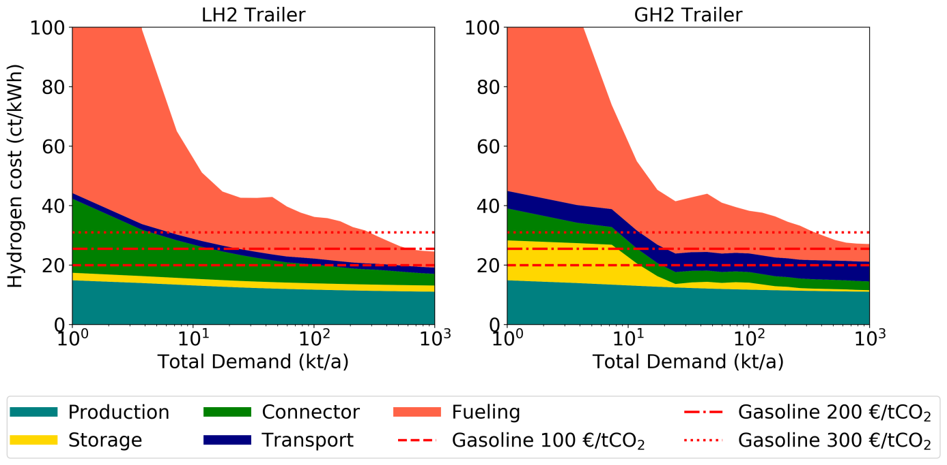
Figure 6. Supply chain cost structure for a passenger car (700 bar) market in the case of GH2 and LH2 trailer supply pathways, with cavern and LH2 tank storage, respectively.
In the case of the pipeline pathways depicted in Figure 7, comparable cost reductions of production, storage, and fueling can be observed. However, the underutilization of the initial pipeline transmission system causes a significant price peak at very low hydrogen demands that overshadow all other expenses by a large margin. Nevertheless, improving pipeline utilization with growing demand enables rapid cost reductions so that cost competitiveness with conventional fuel at 300 €/tCO₂ is reached at 400 to 500 kt p.a. Consequently, to achieve comparable results to trailer supply, pipeline systems require approx. 1.6 times larger hydrogen market than in the event of trailer supply. However, in the case of 200 €/tCO₂ tax, the difference is significantly smaller as the target costs are reached at an overall demand of 600-900 kt p.a., thus requiring approximately the same hydrogen market as in the case of the hydrogen supply with trailers. Moreover, similar to the trailer supply chains, a carbon tax of 100 €/tCO₂ is insufficient to support only the hydrogen market for passenger cars. These results show that despite the significantly higher costs of the pipelines during the introductory phase, pipeline transmission has substantial long-term economic potential. At sufficient hydrogen market size, relevant pipeline transmission and distribution costs reach levels of less than 2 ct/kWh, which is comparable to today's natural gas grid costs for private and commercial consumers in Germany (2019c). For these reasons, pipeline pathways can be classified as cost-competitive medium- to long-term solutions, whereas trailer supply is more suitable as a short- to the medium-term solution during the introduction phase.
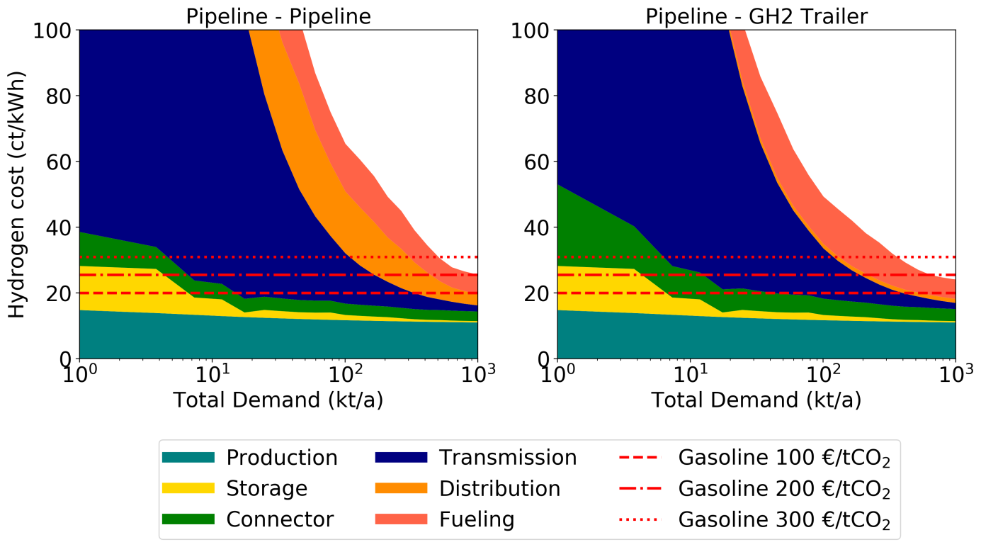
Figure 7. Supply chain cost structure for a passenger car (700 bar) market in the case of pipeline transmission with respective trailer and pipeline distribution pathways
When comparing pipeline and trailer distribution from the regional hub to the final point of demand, we can find that pipeline distribution is not competitive with trailer supply over the analyzed demand interval, indicating that a mean hydrogen refueling station does not reach sufficient capacity to justify pipeline over trailer distribution. Similarly, to trailer pathways long-term hydrogen costs are mainly governed by hydrogen production and HRS costs that make up to 75% of the overall hydrogen cost and thus highlight the importance of HRS, as it remains one of the main cost drivers during both the introductory and market saturation phases.

Market-specific hydrogen cost
The analysis in the last section on the hydrogen supply chain cost development has shown that refueling station utilization has a major effect on early hydrogen infrastructure cost. In the case of passenger vehicles, a countrywide network of high-performance, 700 bar refueling stations, whose implementation is required to offer adequate regional coverage, contributes significantly to the hydrogen infrastructure cost. This is less of a challenge for trucks which use hydrogen at 350 bar, thus lowering the investment cost for one of the main cost drivers of the refueling station – the compressor. Captive fleet vehicles such as regional buses, trains and material handling vehicles do not require a refueling station network, as all of these use private refueling stations dimensioned according to the demand of the fleet, thus enabling full utilization of the HRS. Finally, in the case of the industry, no refueling station is required as industrial plants can be directly connected to the supply infrastructure and do not necessitate high hydrogen pressure levels. Moreover, the varying geospatial distribution properties of each market affect the hydrogen transportation distances, thus impacting the transmission and distribution costs. In order to assess these effects, countrywide supply costs for every single pre-selected segment, as well as relevant hydrogen cost benchmarks, are depicted in Figure 8.
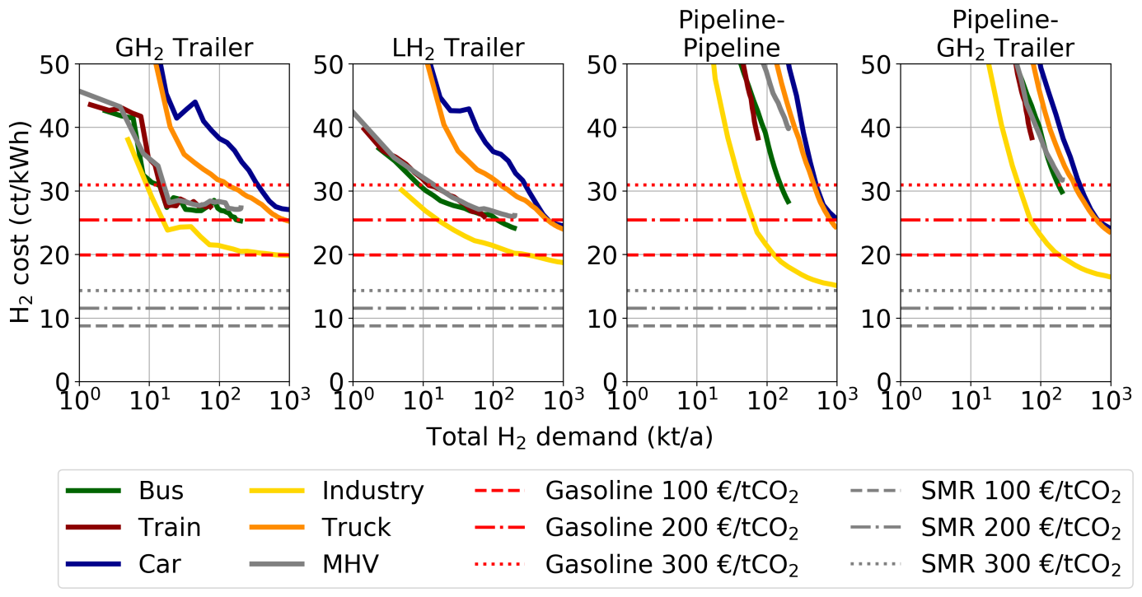
Figure 8. Market-specific hydrogen cost of analyzed hydrogen transmission and distribution options.
It can be observed that each demand sector exhibits unique infrastructure cost development with increasing countrywide demand for each of the analyzed hydrogen supply chain pathways, whereas the extent of the curve along the x-axis marks the overall demand potential of each market. Firstly, the effect of underutilized public refueling station networks is clearly visible with the example of passenger cars and trucks, whereas the lower cost of 350 bar refueling station trucks diminishes the resulting cost by 5-20%. Both markets with public refueling station networks reach the 200 €/tCO₂ cost target at hydrogen demand of 700-1000 kt p.a. Nevertheless, trucks already reach the cost parity with 300 €/tCO₂ at 150 kt p.a. for trailer pathways, thus indicating a cost-efficient option for public hydrogen refueling station network build-up, that requires little additional policy measures. Secondly, on the example of captive fleets, the positive effect of non-public HRS can be observed. As the cost competitiveness is already reached with 300 €/tCO₂ at the demand of 10-20 kt p.a., captive fleets provide a highly attractive option for hydrogen infrastructure introduction if necessary carbon taxation policy is introduced. Even though regional trains enable cost-efficient hydrogen supply, the relevant train market size of 60 kt p.a. is too small to independently reach sufficient hydrogen demand, which would enable cost competitiveness with conventional fuel taxed with 200 €/tCO₂. Alternatively, local buses with trains provide the lowest costs amongst captive fleet vehicles at demands of up to 50 kt p.a. and comprise sufficient market potential to reach the 200 €/tCO₂ cost benchmark. Lastly, the lowest infrastructure cost for the analyzed demands is found to be in the case of the industry supply that avoids cost-intensive HRS. Yet, renewable hydrogen supply for industry competes with a considerably lower benchmark of grey hydrogen generally produced with steam methane reforming of natural gas. As a result, hydrogen supply for the industry does not reach the designated benchmarks within analyzed demand range, indicating the requirement of a substantially lower renewable hydrogen production to natural gas (incl. carbon tax) cost ratio in order to be an economically feasible alternative to SMR hydrogen production.

Comparison of hydrogen supply chain cost development
After analyzing the hydrogen infrastructure up-scaling and constructing of the exogenous hydrogen demand, Figure 9 demonstrates the hydrogen supply chain’s cost development over time for different supply chain options in the case of electrolytic hydrogen production in the north of Germany. Substantial cost reductions of 40% to 50% can be observed in both cases of the truck- and pipeline-based hydrogen supply chains, as hydrogen demand develops over time. Accordingly, the 300 €/tCO₂ benchmark is reached by truck pathways between the years of 2024 and 2026 at overall demand ranging from 50-120 kt p.a. Even though pipeline systems provide superior long-term cost efficiency, due to the high upfront investment and underutilization, pipeline-based supply systems reach the cost parity with 300 €/tCO₂ in 2028 and 2035, respectively, depending on whether the final hydrogen distribution is performed with trailers or pipelines. The demand that is required to scale the pipeline system to a cost-competitive level ranges from 300 kt to 900 kt, showing that the transmission pipeline system can reach cost competitiveness under already modest overall demand comparable to 8% of German passenger car market is sufficient, whereas pipeline distribution systems are more suitable for larger markets than 24% of passenger cars in Germany. Furthermore, with a demand of 500 kt p.a., pipeline transmission combined with gaseous trailer distribution becomes cost-competitive with an exclusively gaseous trailer supply. This finding highlights a cost-effective transition scenario by substituting longer and larger hydrogen trailer routes with transmission pipelines. Long-term renewable hydrogen costs are cost-competitive with 100 €/tCO₂ gasoline benchmark indicating relatively low carbon abatement cost in the fully-developed market. Long-term infrastructure cost in 2050 is found to be between 20 and 24 ct/kWh, compared the values of 16-20 ct/kWh found in the literature (Reuß et al., 2019; Robinius et al., 2017). The main reasons for the observed deviation are different methodological approaches and the incorporation of hydrogen purification into the supply chain analysis as well as the wider scope of analyzed consumer applications, thus leading to a significantly larger number of refueling stations, which affects the length and cost of the distribution. The LH2 pathway provides the most cost-efficient option in the introduction phase, as it allows the 300 €/tCO₂ target to be met within the first analysis years at rather modest hydrogen demand of 30 kt p.a. and remains the cheapest option of up to 750 kt p.a. when it is surpassed by pipeline transmission and the trailer distribution option, which then remains the most cost-efficient supply chain over the analysis period.
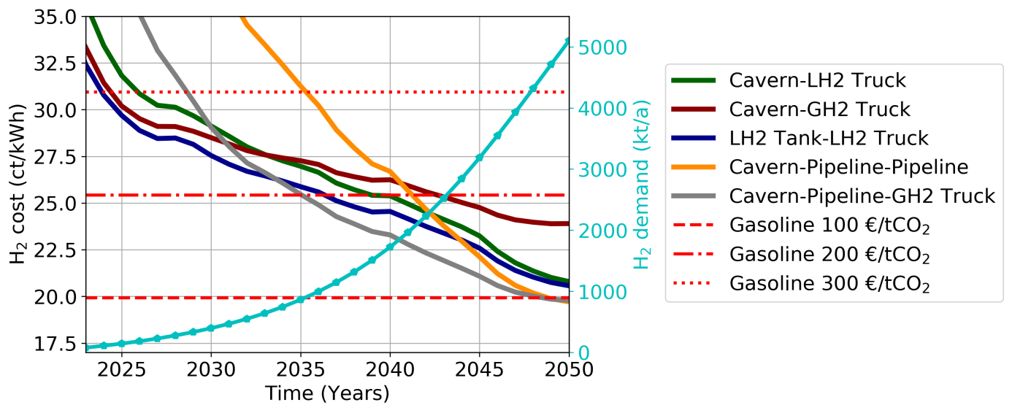
Figure 9. Hydrogen supply chain cost development in the case of electrolytic hydrogen production.
As we have observed substantial supply chain cost dependency to overall hydrogen demand, a sensitivity analysis regarding hydrogen market growth is conducted. Figure 10 displays the variation of the results regarding the low, medium and high renewable hydrogen scenario. It can be observed that trailer supply pathways are less sensitive to demand scenario than pipelines; however, all three scenarios are sufficient to reach the 200-300 €/tCO₂ cost benchmarks by the year 2050. Low demand generally delays the reaching of benchmark costs by 5-7 years, while high hydrogen demand expansion accelerates the cost reductions so that benchmark costs are reached up to 7 to 10 years earlier than in the case of the medium scenario, thus leading to a cost-competitive hydrogen supply with conventional fuels with 200 €/tCO₂ before the year 2030 in all analyzed hydrogen pathways. Moreover, in the case of LH2 trailer and pipeline transmission pathways, high demand scenario enables cost parity with gasoline taxed with 100 €/tCO₂. These findings highlight the potential of rapid cost reductions if appropriate market boundary conditions for accelerated hydrogen market development in addition to carbon taxation are set in place.
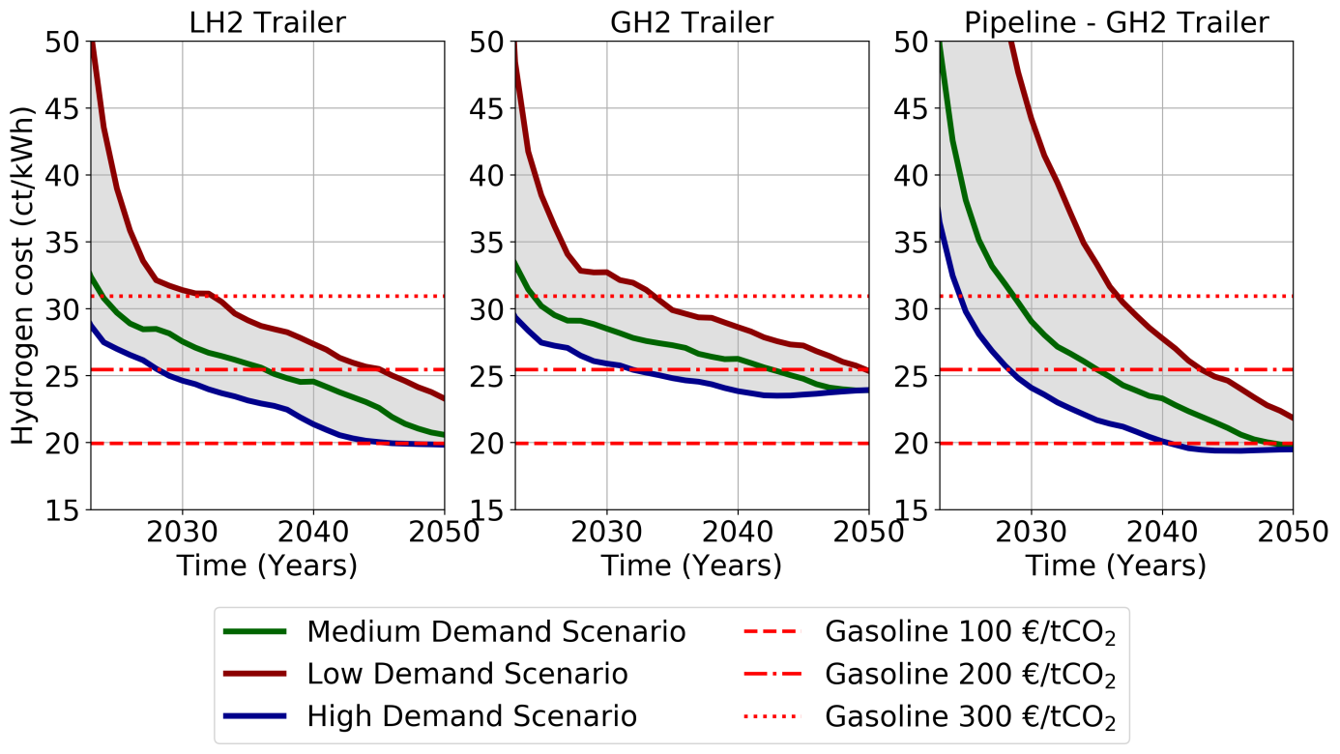
Figure 10. Market growth sensitivity of selected hydrogen supply chain pathway options.

Market-led infrastructure development strategies
Based on the aforementioned findings, it can be determined that substantial hydrogen cost reductions can be reached with increasing overall demand, while refueling station utilization can be improved by optimizing the hydrogen demand structure and utilizing underground salt caverns for long-term storage. Moreover, as we have observed, a CO₂ tax rate of 300 €/tCO₂ is sufficient to support the hydrogen roll-out after a very small overall demand in many markets, especially for trains, buses, and MHV.
Figure 11 depicts selected exemplary market-led hydrogen development strategies derived from the results regarding the positive effect of 350 bar technology and improved refueling station utilization of the commercial vehicles. The analyzed strategies include public transport, comprising trains and local buses, and captive vehicles that benefit the most from the aforementioned positive effects of commercial vehicles. Due to the recent interest in fuel cell trucks and MHV, a combined strategy of these two markets is also included. Moreover, the broad market expansion of all considered markets is being considered.
Firstly, the results show that selected strategies enable cost parity to gasoline at 300 €/tCO₂ within the first years of the analysis, indicating a comparably short time-frame of fewer than three years that would require government support to sufficiently develop the hydrogen market. Secondly, we can observe that targeted strategies provide comparable results to the broad market development strategy depicted by the medium scenario. Therefore, even though the broad market comprises significantly larger overall hydrogen demand, the associated scaling effects do not offset the additional cost related to the required public refueling station infrastructure. Additionally, smaller overall hydrogen demand in market-led strategies indicates the significantly smaller governmental support that is required to roll-out the initial market diffusion. Thirdly, a comparison of commercial vehicles shows that public transport offers the lowest cost solution, as the two smallest markets (see Figure 8) are sufficient to reach comparable cost to the other strategies, indicating the high suitability of public transport such as local buses and non-electrified trains to building a cost-competitive hydrogen infrastructure. Fourthly, the public transport curve is only surpassed by the captive fleet strategy that comprises all commercial vehicles, including freight trucks and passenger car fueling at private refueling stations, while combining a broad application spectrum with cost-efficient infrastructure implementation. This captive fleet strategy enables cost-efficient early access to large passenger car and freight vehicle markets and simultaneously provides lower costs than the medium technology scenario that additionally includes non-captive fleets. Therefore, it provides an affordable strategy comprising substantial market scaling potential that can be utilized after the initial infrastructure’s implementation.
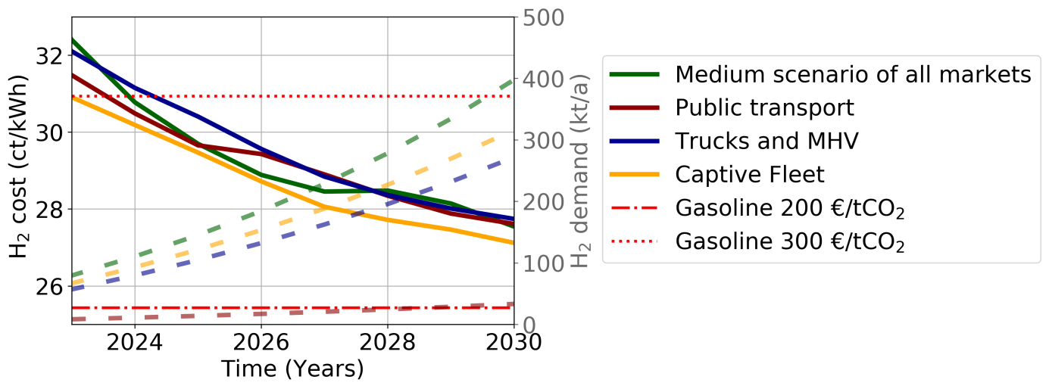
Figure 11. Exemplary market-led strategies cost in the medium hydrogen demand scenario with LH₂ trailer supply.

Conclusions and policy implications
In this study, we have incorporated hydrogen market-specific analyses into a countrywide infrastructure design model. Each relevant hydrogen market encompasses unique geospatial demand distribution criteria, as well as specific refueling station locations, including differentiation of public and non-public HRS. The derived cost curves are analyzed against the backdrop of carbon tax scenarios and suitable market-led hydrogen infrastructure strategies are discussed. The results provide important policy implications for hydrogen infrastructure development and carbon tax implementation to promote accelerated hydrogen market expansion.
GH2 and LH2 trailers were found to be the most cost-efficient hydrogen supply options in the introduction phase, whereas pipeline transmission with subsequent GH2 trailer distribution offers the lowest cost long-term hydrogen supply solution. The main short- to medium-term cost reduction potentials are found to be the use of underground storage and the improvement of refueling station utilization, whereas hydrogen production cost has the highest long-term impact on hydrogen supply cost. The LH2 trailer approach is identified as the most cost-competitive pathway in the introduction phase; however, the GH2 trailer option possesses the larger potential of cost reduction as it is more compatible with pipeline transmission.
A comparison of market-specific hydrogen supply costs has shown the benefits of commercial vehicles that use cheaper and less complex 350 bar refueling stations and which are often refilled at non-public stations. It was found that in the event of extending the analytical scope to commercial vehicles, the hydrogen infrastructure cost is reduced by up to 40% when compared to passenger cars. As a result cost parity with gasoline taxed with 300 €/tCO₂ could already be attained at a very small overall demand of 10-20 kt p.a. In the case of Germany, a comparison of the diesel and gasoline fuels shows the effective carbon taxes of 180€/tCO₂ and 290€/tCO₂ respectively (2018d). Furthermore, analysis of the industrial hydrogen market indicates that assessed carbon taxes are insufficient to support a cost-competitive green hydrogen market with grey hydrogen from SMR. Based on these findings, marked-led hydrogen infrastructure strategies, combining technological network effects, were derived. The analysis of these strategies has shown that the captive-fleet strategy offers both a broad application spectrum and low-cost hydrogen supply that is cost-competitive to gasoline with 300 €/tCO₂ from the beginning of the analysis period in 2023.
In addition to the general uncertainty about the cost, technical and economic parameter developments, among the main limitations of the applied approach are the actual geospatial hydrogen demand distribution of the respective markets. Only greenfield investment costs are considered in the analysis, thus neglecting inefficiencies that may occur during supply chain build-up, i.e., project delays, overcapacity while transitioning from one supply chain to another, etc. Nevertheless, the described methodology provides insight into the most important geospatial and technological effects governing the hydrogen supply chain roll-out.
From these results, we conclude that, under comparable effective carbon tax resulting from current energy tax rates in Germany, countrywide hydrogen supply can be cost-competitive with gasoline by the mid of the 2020s. Moreover, with continuing market growth as well as improved infrastructure scale and utilization, even lower carbon taxation of 100-200€/tCO₂ is attainable, thus indicating a less expensive energy service than current gasoline system. Therefore, for the successful hydrogen market introduction, in addition to market development measures no new additional tax but rather a tax system reform, streamlining the energy taxes according to the carbon intensity of the relevant fuels, is required. Especially, as current effective carbon taxes on diesel fuel are generally lower than in the case of gasoline (2018d). Furthermore, our results show that sector-specific carbon taxes are necessary to provide cost-competitive green hydrogen supply in both the transportation and industrial sectors. Thus, a successful introduction of effective CO₂ tax measures for alternative fuel market introduction requires a detailed sector-specific analysis of the associated infrastructure costs and market-specific boundary conditions.

Acknowledgments
This work was supported by the Helmholtz Association under the Joint Initiative ‘‘EnergySystem 2050 – A Contribution of the Research Field Energy” and the Project “Energy System Integration”. The authors furthermore gratefully acknowledge funding by the German Federal Ministry of Transport and Digital Infrastructure (BMVI) within the Project „BIC H2 – Beschaffung und Einsatz einer Großflotte von Brennstoffzellen-Hybridbussen für den ÖPNV und Einrichtung einer entsprechenden H2-Infrastruktur in der Region Köln“ (FKZ 03B10201E).

References
2008. H2A hydrogen delivery infrastructure analysis models and conventional pathway options analysis results. Nexant.
2009. Fuel Cells and Hydrogen in a Sustainable Energy Economy: Final Report of the Roads2HyCom Project, p. 122.
2015. Logistikimmobilien - Markt und Standorte 2015, in: Uwe Veres-Homm, A.K., Natalie Weber, Estella Cäsar (Ed.). Fraunhofer IIS, Nürnberg.
2016a. Grundlagenbericht zum UmweltMobilCheck. Deutsche Bahn Regio AG.
2016b. VDV Statistik 2016. VDV e.V.
2017. Petrol station locations and product availability Germany. DB Energie GmbH.
2018a. EUROSTAT: Annual road freight transport by region of loading (1 000 t, Mio Tkm, 1 000 Jrnys). Statistical Office of the European Communities.
2018b. EUROSTAT: Annual road freight transport by region of unloading (1 000 t, Mio Tkm, 1 000 Jrnys). Statistical Office of the European Communities.
2018c. REGULATION (EU) 2018/842 OF THE EUROPEAN PARLIAMENT AND OF THE COUNCIL of 30 May 2018 on binding annual greenhouse gas emission reductions by Member States from 2021 to 2030 contributing to climate action to meet commitments under the Paris Agreement and amending Regulation (EU) No 525/2013. The European Parliament, The European Council, Official Journal of the European Union.
2018d. Taxing Energy Use 2018. OECD.
2018e. Verkehr in Zahlen 2018/2019. Federal Motor Transport Authority, Flensburg.
2019a. FCH JU Projects. Fuel Cells and Hydrogen Joint Undertaking (FCH JU).
2019b. H2 MOBILITY We are building the filling station network of the future. H2 MOBILITY Deutschland GmbH & Co KG.
2019c. Monitoringbericht 2018. Bundesnetzagentur für Elektrizität, Gas, Telekommunikation, Post und Eisenbahnen.
Adner, R., Kapoor, R., 2016. Innovation ecosystems and the pace of substitution: Re-examining technology S-curves. Strategic Management Journal 37, 625-648.
Agnolucci, P., Akgul, O., McDowall, W., Papageorgiou, L.G., 2013. The importance of economies of scale, transport costs and demand patterns in optimising hydrogen fuelling infrastructure: An exploration with SHIPMod (Spatial hydrogen infrastructure planning model). International Journal of Hydrogen Energy 38, 11189-11201.
Almansoori, A., Shah, N., 2009. Design and operation of a future hydrogen supply chain: Multi-period model. International Journal of Hydrogen Energy 34, 7883-7897.
Almansoori, A., Shah, N., 2012. Design and operation of a stochastic hydrogen supply chain network under demand uncertainty. International Journal of Hydrogen Energy 37, 3965-3977.
Bass, F., 1969. A new product growth for model consumer durables. Management Science 15, 215–227.
Bekkers, H., 2018. Are Zero Emissions Buses Ready For Mass Market Production, European Zero Emission Bus Conference, Cologne.
Ben-Mansour, R., Qasem, N.A.A., 2018. An efficient temperature swing adsorption (TSA) process for separating CO2 from CO2/N-2 mixture using Mg-MOF-74. Energy Conversion and Management 156, 10-24.
Benvenutti, L.M.M., Ribeiro, A.B., Uriona, M., 2017. Long term diffusion dynamics of alternative fuel vehicles in Brazil. Journal of Cleaner Production 164, 1571-1585.
Bolat, P., Thiel, C., 2014. Hydrogen supply chain architecture for bottom-up energy systems models. Part 1: Developing pathways. International Journal of Hydrogen Energy 39, 8881-8897.
Brey, J.J., Carazo, A.F., Brey, R., 2014. Analysis of a hydrogen station roll-out strategy to introduce hydrogen vehicles in Andalusia. International Journal of Hydrogen Energy 39, 4123-4130.
Brinner, A., Schmidt, M., Schwarz, S., Wagner, L., Zuberbühler, U., 2018. Technologiebericht 4.1 Power-to-gas (Wasserstoff), Technologien für die Energiewende. Teilbericht 2 an das Bundesministerium für Wirtschaft und Energie (BMWi). Wuppertal Institut, ISI, IZES, Wuppertal, Karlsruhe, Saarbrücken.
Brynolf, S., Taljegard, M., Grahn, M., Hansson, J., 2018. Electrofuels for the transport sector: A review of production costs. Renewable and Sustainable Energy Reviews 81, 1887-1905.
Dayhim, M., Jafari, M.A., Mazurek, M., 2014. Planning sustainable hydrogen supply chain infrastructure with uncertain demand. International Journal of Hydrogen Energy 39, 6789-6801.
De-León Almaraz, S., Azzaro-Pantel, C., Montastruc, L., Boix, M., 2015. Deployment of a hydrogen supply chain by multi-objective/multi-period optimisation at regional and national scales. Chemical Engineering Research and Design 104, 11-31.
Eichman, J., Townsend, A., Melaina, M., 2016. Economic Assessment of Hydrogen Technologies Participating in California Electricity Markets. National Renewable Energy Laboratory (NREL).
Elgowainy, A., Reddi, K., Sutherland, E., Joseck, F., 2014. Tube-trailer consolidation strategy for reducing hydrogen refueling station costs. International Journal of Hydrogen Energy 39, 20197-20206.
F. Bass, T. Krishnan, Jain, D., 1994. Why the Bass model ﬁts without decision variables. Marketing Science 3, 203-223.
Gagniuc, P.A., 2017. Markov Chains: From Theory to Implementation and Experimentation. John Wiley & Sons, USA, NJ.
Glenk, G., Reichelstein, S., 2019. Economics of converting renewable power to hydrogen. Nature Energy 4, 216-222.
Gnann, T., Plötz, P., 2015. A review of combined models for market diffusion of alternative fuel vehicles and their refueling infrastructure. Renewable and Sustainable Energy Reviews 47, 783-793.
Grüger, F., Hoch, O., Hartmann, J., Robinius, M., Stolten, D., 2019. Optimized electrolyzer operation: Employing forecasts of wind energy availability, hydrogen demand, and electricity prices. International Journal of Hydrogen Energy 44, 4387-4397.
Han, J.-H., Ryu, J.-H., Lee, I.-B., 2012. Modeling the operation of hydrogen supply networks considering facility location. International Journal of Hydrogen Energy 37, 5328–5346.
He, C., Sun, H., Xu, Y., Lv, S., 2017. Hydrogen refueling station siting of expressway based on the optimization of hydrogen life cycle cost. International Journal of Hydrogen Energy 42, 16313-16324.
Heinz, B., Graeber, M., Praktiknjo, A.J., 2013. The diffusion process of stationary fuel cells in a two-sided market economy. Energy Policy 61, 1556-1567.
Held, M., Karp, R.M., 1970. TRAVELING-SALESMAN PROBLEM AND MINIMUM SPANNING TREES. Operations Research 18, 1138-&.
Heuberger, C.F., Rubin, E.S., Staffell, I., Shah, N., Mac Dowell, N., 2017. Power capacity expansion planning considering endogenous technology cost learning. Applied Energy 204, 831-845.
Heuser, P.M., Ryberg, D.S., Grube, T., Robinius, M., Stolten, D., 2019. Techno-economic analysis of a potential energy trading link between Patagonia and Japan based on CO2 free hydrogen. International Journal of Hydrogen Energy 44, 12733-12747.
Hugo, A., Rutter, P., Pistikopoulos, S., Amorelli, A., Zoia, G., 2005. Hydrogen infrastructure strategic planning using multi-objective optimization. International Journal of Hydrogen Energy 30, 1523-1534.
Hwangbo, S., Lee, I.-B., Han, J., 2017. Mathematical model to optimize design of integrated utility supply network and future global hydrogen supply network under demand uncertainty. Applied Energy 195, 257-267.
Joest, S., Fichtner, M., Wietschel, M., Bünger, U., Stiller, C., Schmidt, P., Merten, F., 2009. Studie zur Frage" Woher kommt der Wasserstoff in Deutschland bis 2050?": GermanHy.
Juhrich, K., 2016. CO2 Emission Factors for Fossil Fuels, Climate Change. German EnvironmentAgency (UBA).
Kahouli-Brahmi, S., 2008. Technological learning in energy-environment-economy modelling: A survey. Energy Policy 36, 138-162.
Kim, M., Kim, J., 2016. Optimization model for the design and analysis of an integrated renewable hydrogen supply (IRHS) system: Application to Korea's hydrogen economy. International Journal of Hydrogen Energy 41, 16613-16626.
Kim, M., Kim, J., 2017. An integrated decision support model for design and operation of a wind-based hydrogen supply system. International Journal of Hydrogen Energy 42, 3899-3915.
Kim, T., Hong, J., 2015. Bass model with integration constant and its applications on initial demand and left-truncated data. Technological Forecasting & Social Change 95, 120-134.
Kohler, J., Grubb, M., Popp, D., Edenhofer, O., 2006. The transition to endogenous technical change in climate-economy models: A technical overview to the Innovation Modeling Comparison Project. Energy Journal, 17-55.
Krieg, D., 2012. Konzept und Kosten eines Pipelinesystems zur Versorgung des deutschen Straßenverkehrs mit Wasserstoff. Forschungszentrum Jülich, Zentralbibliothek, Jülich.
Kuby, M., Lines, L., Schultz, R., Xie, Z., Kim, J.-G., Lim, S., 2009. Optimization of hydrogen stations in Florida using the Flow-Refueling Location Model. International Journal of Hydrogen Energy 34, 6045-6064.
Lee, H., Kim, S.G., Park, H.W., Kang, P., 2014. Pre-launch new product demand forecasting using the Bass model: A statistical and machine learning-based approach. Technological Forecasting and Social Change 86, 49-64.
Li, L., Manier, H., Manier, M.A., 2019. Hydrogen supply chain network design: An optimization-oriented review. Renewable & Sustainable Energy Reviews 103, 342-360.
Li, Z., Gao, D., Chang, L., Liu, P., Pistikopoulos, E.N., 2008. Hydrogen infrastructure design and optimization: A case study of China. International Journal of Hydrogen Energy 33, 5275-5286.
Lively, R.P., Realff, M.J., 2016. On Thermodynamic Separation Efficiency: Adsorption Processes. Aiche Journal 62, 3699-3705.
Meade, N., 1984. The use of growth curves in forecasting market development—a review and appraisal. Journal of Forecasting 3, 429-451.
Meyer, P.E., Winebrake, J.J., 2009. Modeling technology diffusion of complementary goods: The case of hydrogen vehicles and refueling infrastructure. Technovation 29, 77-91.
Moreno-Benito, M., Agnolucci, P., Papageorgiou, L.G., 2017. Towards a sustainable hydrogen economy: Optimisation-based framework for hydrogen infrastructure development. Computers & Chemical Engineering 102, 110-127.
MWV, 2019. Jährliche Verbraucherpreise für Mineralölprodukte. Mineralölwirtschaftsverband e.V
N.V.S.N. Murthy Konda, N.S., Nigel P. Brandon 2011. Optimal transition towards a large-scale hydrogen infrastructure for the transport sector: The case for the Netherlands. International Journal of Hydrogen Energy, 4619-4635.
Nistor, S., Dave, S., Fan, Z., Sooriyabandara, M., 2016. Technical and economic analysis of hydrogen refuelling. Applied Energy 167, 211-220.
Noack, C., Burggraf, F., Hosseiny, S.S., Lettenmeier, P., Kolb, S., Belz, S., Kallo, J., Friedrich, K.A., Pregger, T., Cao, K.-K., Heide, D., Naegler, T., Borggrefe, F., Bünger, U., Michalski, J., Raksha, T., Voglstätter, C., Smolinka, T., Crotogino, F., Donadei, S., Horvath, P.-L., Schneider, G.-S., 2015. Studie über die Planung einer Demonstrationsanlage zur Wasserstoff-Kraftstoffgewinnung durch Elektrolyse mit Zwischenspeicherung in Salzkavernen unter Druck. Deutsches Zentrum für Luft- und Raumfahrt (DLR).
Nunes, P., Oliveira, F., Hamacher, S., Almansoori, A., 2015. Design of a hydrogen supply chain with uncertainty. International Journal of Hydrogen Energy 40, 16408-16418.
Park, S.Y., Kim, J.W., Lee, D.H., 2011. Development of a market penetration forecasting model for Hydrogen Fuel Cell Vehicles considering infrastructure and cost reduction effects. Energy Policy 39, 3307-3315.
Qadrdan, M., Saboohi, Y., Shayegan, J., 2008. A model for investigation of optimal hydrogen pathway, and evaluation of environmental impacts of hydrogen supply system. International Journal of Hydrogen Energy 33, 7314-7325.
Reddi, K., Elgowainy, A., Brown, D., Rustagi, N., Mintz, M., Gillete, J., 2015. Hydrogen Delivery Scenario Analysis Model. Department of Energy (DOE), USA.
Reuß, M., Grube, T., Robinius, M., Preuster, P., Wasserscheid, P., Stolten, D., 2017. Seasonal storage and alternative carriers: A flexible hydrogen supply chain model. Applied Energy 200, 290-302.
Reuß, M., Grube, T., Robinius, M., Stolten, D., 2019. A hydrogen supply chain with spatial resolution: Comparative analysis of infrastructure technologies in Germany. Applied Energy 247, 438-453.
Robinius, M., 2015. Strom- und Gasmarktdesign zur Versorgung des deutschen Straßenverkehrs mit Wasserstoff, Institut für Energie- und Klimaforschung. Rheinisch-Westfälische Technische Hochschule, p. 271.
Robinius, M., Linßen, J., Grube, T., Reuß, M., Stenzel, P., Syranidis, K., Kuckertz, P., Stolten, D., 2018. Comparative Analysis of Infrastructures: Hydrogen Fueling and Electric Charging of Vehicles.
Robinius, M., Otto, A., Syranidis, K., Ryberg, D.S., Heuser, P., Welder, L., Grube, T., Markewitz, P., Tietze, V., Stolten, D., 2017. Linking the Power and Transport Sectors—Part 2: Modelling a Sector Coupling Scenario for Germany. Energies 10, 957.
Saba, S.M., Muller, M., Robinius, M., Stolten, D., 2018. The investment costs of electrolysis - A comparison of cost studies from the past 30 years. International Journal of Hydrogen Energy 43, 1209-1223.
Sabio, N., Gadalla, M., Guillén-Gosálbez, G., Jiménez, L., 2010. Strategic planning with risk control of hydrogen supply chains for vehicle use under uncertainty in operating costs: A case study of Spain. International Journal of Hydrogen Energy 35, 6836-6852.
Samadi, S., 2018. The experience curve theory and its application in the field of electricity generation technologies – A literature review. Renewable and Sustainable Energy Reviews 82, 2346-2364.
Schmidt, O., Gambhir, A., Staffell, I., Hawkes, A., Nelson, J., Few, S., 2017. Future cost and performance of water electrolysis: An expert elicitation study. International Journal of Hydrogen Energy 42, 30470-30492.
Schoots, K., Ferioli, F., Kramer, G.J., van der Zwaan, B.C.C., 2008. Learning curves for hydrogen production technology: An assessment of observed cost reductions. International Journal of Hydrogen Energy 33, 2630-2645.
Seydel, P., 2008. Entwicklung und Bewertung einer langfristigen regionalen Strategie zum Aufbau einer Wasserstoffinfrastruktur - aus Basis der Modellverknüpfung eines Geografischen Informationssystems und eines Energiesystemmodells.
Shafiei, E., Davidsdottir, B., Leaver, J., Stefansson, H., Asgeirsson, E.I., 2017. Energy, economic, and mitigation cost implications of transition toward a carbon-neutral transport sector: A simulation-based comparison between hydrogen and electricity. Journal of Cleaner Production 141, 237-247.
Staffel, I., 2009. Fuel Cells for Domestic Heat and Power: Are They Worth It?, Chemical Engineering. University of Birmingham.
Staffell, I., Green, R., 2013. The cost of domestic fuel cell micro-CHP systems. International Journal of Hydrogen Energy 38, 1088-1102.
Statistisches Bundesamt, 2015. Personenverkehr mit Bussen und Bahnen - Fachserie 8 Reihe 3.1 -.
Statistisches Bundesamt, 2017. Verkehr - Verkehr aktuell, Fachserie 8 Reihe 1.1. Statistisches Bundseamt.
Stephens-Romero, S.D., Brown, T.M., Kang, J.E., Recker, W.W., Samuelsen, G.S., 2010. Systematic planning to optimize investments in hydrogen infrastructure deployment. International Journal of Hydrogen Energy 35, 4652–4667.
Stiller, C., Bünger, U., Møller-Holst, S., Svensson, A.M., Espegren, K.A., Nowak, M., 2010. Pathways to a hydrogen fuel infrastructure in Norway. International Journal of Hydrogen Energy 35, 2597-2601.
Stolzenburg, K., 2014. Integration von Wind-Wasserstoff-Systemen in das Energiesystem - Abschlussbericht, Oldenburg.
Stolzenburg, K., Mubbala, R., 2013. Integrated Design for Demonstration of Efficient Liquefaction of Hydrogen (IDEALHY). Fuel Cells and Hydrogen Joint Undertaking (FCH JU).
Tractebel, Hinicio, 2017. STUDY ON EARLY BUSINESS CASES FOR H2 IN ENERGY STORAGE AND MORE BROADLY POWER TO H2 APPLICATIONS. Fuel Cells and Hydrogen Joint Undertaking (FCH JU).
Tran, M., Banister, D., Bishop, J.D.K., McCulloch, M.D., 2013. Simulating early adoption of alternative fuel vehicles for sustainability. Technological Forecasting and Social Change 80, 865-875.
Tzimas, E., Castello, P., Peteves, S., 2007. The evolution of size and cost of a hydrogen delivery infrastructure in Europe in the medium and long term. International Journal of Hydrogen Energy 32, 1369-1380.
Wei, M., Smith, S.J., Sohn, M.D., 2017. Experience curve development and cost reduction disaggregation for fuel cell markets in Japan and the US. Applied Energy 191, 346-357.
Welder, L., Ryberg, D.S., Kotzur, L., Grube, T., Robinius, M., Stolten, D., 2018. Spatio-temporal optimization of a future energy system for power-to-hydrogen applications in Germany. Energy 158, 1130-1149.
Wulf, C., Linßen, J., Zapp, P., 2018. Review of Power-to-Gas Projects in Europe. Energy Procedia 155, 367-378.
Yang, C., Odgen, J.M., 2007. Determining the lowest-cost hydrogen delivery mode. International Journal of Hydrogen Energy 32, 268–286.
Yang, C., Ogden, J.M., 2013. Renewable and low carbon hydrogen for California e Modeling the long term evolution of fuel infrastructure using a quasi-spatial TIMES model. International Journal of Hydrogen Energy 38, 4250-4265.
Zhu, X., Shi, Y., Li, S., Cai, N., 2018a. Elevated temperature pressure swing adsorption process for reactive separation of CO/CO2 in H2-rich gas. International Journal of Hydrogen Energy 43, 13305-13317.
Zhu, X., Shi, Y., Li, S., Cai, N., 2018b. Two-train elevated-temperature pressure swing adsorption for high-purity hydrogen production. Applied Energy 229, 1061–1071.

¹ D-52425 Jülich, +49 2461 61-9154, s.cerniauskas@fz-juelich.de, http://www.fz-juelich.de/iek/iek-3
Ammonia, methanol, petrochemical industry and merchant steam methane reformer plants.
A pipeline detour factor of $\sqrt{2}$ is considered to account for the additional costs in the urbanized area.

