Achieving theoretical thermal conductivity and coeffieicent of thermal expansion in a W-Cu composite sheet
Xingang Wang^{a,*},Chon Zhaoª, Xin Chenª, Huailong Zhang^{b}, Yezhi Du^{b}, Peng Cao^{c,d*}
ª School of Materials Science and Engineering, Chang'an University, Xi'an 710064, China
^{b} Suzhou Imotec Materials Technology Company, Kunshan 215300, China
^{c} Department of Chemical and Materials Engineering, the University of Auckland, Auckland 1142, New Zealand
^{d} MacDiarmid Institute for Advanced Materials and Nanotechnology, Victoria University of Wellington, PO Box 600, Wellington 6140, New Zealand
Abstract
W-20wt.%Cu composite sheets with full density and good surface quality were successfully fabricated through an infiltration process followed by a hot rolling. After a total thickness reduction of 75%, the majority of the tungsten (W) particles have been deformed and elongated along the rolling direction. The aspect ratio of the W particles in the composite has reached 2.5. The relative density increases considerably to a maximum value of 99.8% when the rolling ratio increases. The thermal conductivity and microhardness of the W-Cu composites increase significantly with the rolling reduction. On the contrary, the coefficient of thermal expansion (CTE) of the composite samples decreases with the rolling ratio. Specifically, after subjected to 75% of thickness reduction, we obtained a large W-Cu thin sheet. This thin sheet demonstrates a low CTE of 7.27×10⁻⁶/K and the highest thermal conductivity of 224.91 W/(m⋅K); both values are close to the respective theoretical ones.

Keywords: W-Cu, rolling, Coefficient of thermal expansion, Thermal conductivity
- Introduction
One of the most critical challenges for modern microelectronic devices is their thermal management systems, in which the heat sink materials play a decisive role. In the realm of microelectronics, W-Cu composites are a good candidate for heat dissipation. Due to the presence of a Cu-phase, the W-Cu composites have high thermal conductivity and good electrical conductivity [1]. Equally importantly, the coefficient of thermal expansion (CTE) of the composites can be tuned by adjusting the content of Cu, thus matching well with the electronic chip materials such as silicon, gallium arsenide, gallium nitride [2-7]. The good match between the chip and packaging material can avoid thermal fatigue damage arising from thermal stress [8]. The W-Cu composites have been widely used as important electronic packaging and heat sink materials in radio frequency, microwave, high power diode packaging and optical communication systems [9-11]. In order to ensure high thermal conductivity and airtightness, the density of W-Cu composite must be greater than 98% of theoretical density. Meanwhile, for the chip packaging materials, W-Cu thin sheets are required [12].
It has been challenging to achieve a full density in W-Cu composites. This is primarily because the binary W-Cu systems have no mutual solubility and the wettability between Cu and W is inferior. Many methods have been explored for the W-Cu composites, including powder sintering, hot pressing, and mechanochemical synthesis [13, 14]. The infiltration of liquid Cu through a porous pre-sintered W skeleton is by far the most common method for the W-Cu composites [15]. The infiltration is generally undertaken in vacuum, H₂ or N₂ environments. Some common defects such as pores and W agglomerates are persistent in the sintered composites. In order to obtain ultra-thin and high-density W-Cu sheets, thermomechanical processes such as rolling are required. However, macro-cracking on the periphery of the rolled sheets is common and many micro-cracks inside the W-Cu sheet are unavoidable. These cracks are caused by the large difference in the CTE and the various deforming abilities between the W and Cu phases [16-18]. To avoid cracking during rolling and ensure good quality of the obtained products, in this work we encapsulated the workpiece in a steel container that harmonizes the deformation of W and Cu during rolling. In this way, we were able to obtain ultra-thin and large sheets of W-Cu composites without cracking We also evaluated the microstructural evolution in the rolled W-Cu sheets. The relative density, hardness, CTE and thermal conductivity of the sheets that have been rolled at various thickness reduction ratios, were reported.
- Experimental procedure
Commercially available W powder (99.95% purity, oxygen content <300 ppm) with an average particle size of 6 μm was used. As shown in Fig. 1, W particles exhibit polyhedral morphology with well-defined crystallographic planes visible. The W powder was firstly mixed with a polymeric binder, and then cold pressed in a steel mold. The green compact was subsequently debound and sintered to produce a porous W skeleton. The sintering was undertaken at 1400 °C for 2 hours under a hydrogen atmosphere. The relative density of the as-sintered W skeleton was 75%. After that, an oxygen-free ultrapure copper block was placed on the top of the as-sintered W compact and heated at 1350 °C in the vacuum of 5×10⁻² Pa. The molten copper infiltrated into the open pores of the as-sintered W skeleton under capillary pressure. The W-Cu (with 20 wt.% Cu) plate billets with dimensions of 80 mm× 60 mm× 3 mm were finally obtained. The billets were then encapsulated in low carbon steel cans and sealed by a tungsten inert gas (TIG) welding process. These encapsulated samples were hot-rolled on a two-high mill with rolls of 350 mm in diameter and 300 mm in width. Before rolling, the encapsulated samples were heated to 900 °C and held for 30 min. Each encapsulated preform was rolled at a speed of 100-150 mm/s with a thickness reduction of 15% per pass, until a total thickness reduction of 75% was achieved. The rolled plates were put into a furnace preheated at 900 °C for 0.5 hour and then cooled to room temperature under the protection of nitrogen. Finally, the capsule was removed by machining.
The density of each sample before and after rolling was determined by the Archimedes principle. Vicker's microhardness tests were conducted using a Micromet 682 microhardness tester (Buehler). For each sample, the final reported density and hardness represent an average of at least three measurements. Microstructures of the samples were characterized using a field emission scanning electron microscope (FESEM, S4800, Hitachi). Phase identifications were performed by X-ray diffraction (XRD, D8 Advance, Bruker) using Cu Kα radiation. Thermal conductivity, κ, was determined as per , where α, Cp and ρ represent the thermal diffusivity, specific heat capacity and density, respectively. The thermal diffusivity was measured using a laser flash thermal conductivity meter (LFA457, Netzsch) in the temperature range of 25 - 300 °C. Meanwhile, the specific heat capacity was measured using a differential scanning calorimeter (DSC 404C, TA). The CTE was determined using a DIL402SE dilatometer (Netzsch), which operated in the range of 25-200 °C at a heating rate of 5 °C / min under an Ar atmosphere.
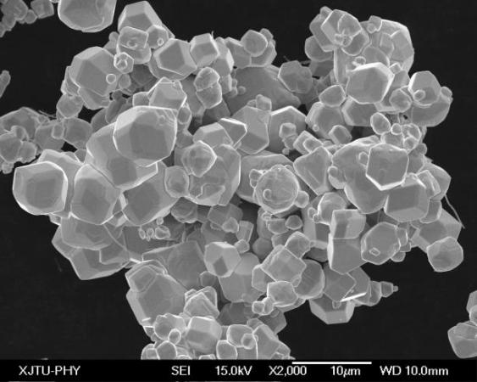
Fig.1 SEM image of W powder
- Results and discussion
3.1 XRD analysis
Fig. 2 shows the XRD results of the W-Cu composite samples with different rolling ratios. As shown in this figure, the (110), (200), (211) and (220) peaks can be well indexed to the W phase, while the (111), (200) and (220) peaks can be indexed to the Cu phase. Except for the well-defined W and Cu phases, there is no secondary phase, neither any solid solutions of W and Cu in the rolled composite samples.
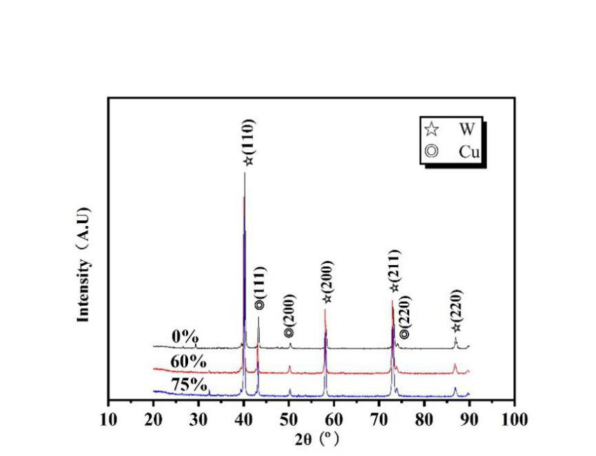
Fig.2 XRD patterns of the as-rolled W-Cu plates with different rolling reduction ratios.
3.2 Microstructure
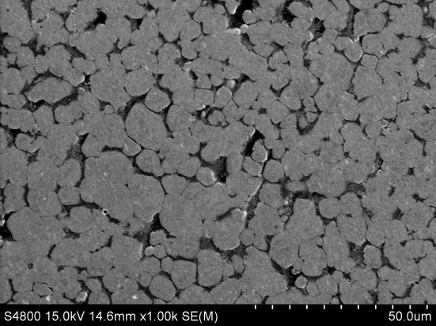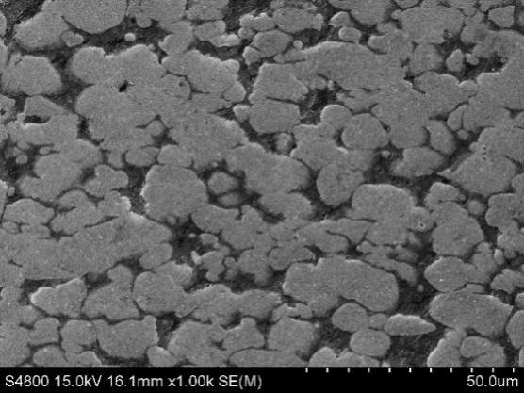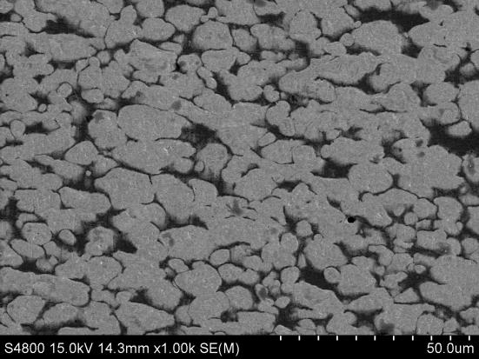
(a)
(b)
(c)
Fig.3 Microstructures of W-Cu plates with different thickness reduction ratios: (a) before rolling ( 0% thickness reduction), (b) 60%, (c) 75%. All samples were polished but without etching.
The microstructural evolution of the W-Cu composite during rolling is presented in Fig. 3. The gray particles are tungsten and the dark areas are copper phases. Before rolling, the microstructure features the round-shape tungsten particles and well-distributed copper surrounding the W particles, Fig. 3(a). After the W-Cu composite was hot rolled, the copper phase underwent large deformation. The majority of the tungsten particles were also deformed and elongated along the rolling direction. Only a small fraction of W particles remain round shape, Figs. 3(b) and 3(c). In the sample after 75% of rolling reduction, the aspect ratio of the W particles is 2.5. This high aspect ratio indicates large deformation has occurred in W. Some W particles even broke into small particles due to severe deformation. Nevertheless, the copper phase is still tightly wrapping the W particles, and the porosity decreases with rolling ratio.
3.3 Appearance of the as-rolled plates
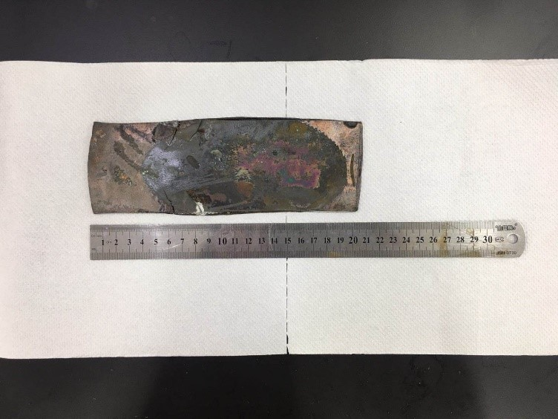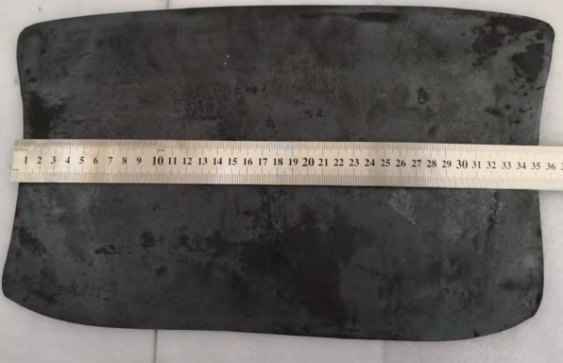
(a)
(b)
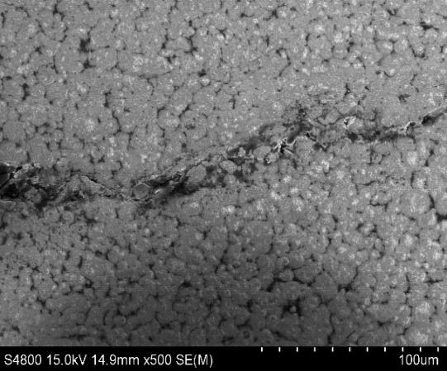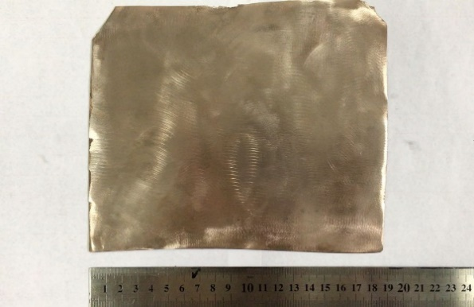
crack
W
(c)
(d)
Fig. 4 Macro-photographs of hot rolled W-Cu plates with a total reduction of 75%: (a) sample rolled without capsule, (b) encapsulated sample after rolling, (c) cracks observed on the sample of (a), (d) the as-rolled W-Cu composite sheets after being taken out from the steel capsule.
Figs. 4(a) and 4(b) compare the appearances of the as-rolled W-Cu sheets, which were subjected to an identical rolling ratio of 75%. As shown in Fig. 4(a), there are many zigzag cracks appearing on the edge of the rolled sheet if the sample was not encapsulated. After the black oxidation layer on the surface of the W-Cu sheet was removed using sandpaper, a strip of deep crack appears on the surface, Fig. 4(c). By contrast, if the sample was encapsulated, no macrocracks were found in the as-rolled W-Cu composite plates, Fig. 4(b). The surface quality of the rolled sheet is excellent, as shown in Fig. 4(d). In this study we obtained a large flat sheet with dimensions of 350 mm × 220 mm × 0.75 mm. Based on this rolling process, an industrial scale-up is underway.
In the W-Cu system, there exists no solubility between W and Cu. Therefore, effective chemical bonds and metallurgical bonding interfaces arising from atomic diffusion cannot be established between W and Cu, resulting in a low interface strength. The deformation abilities of Cu and W are dramatically different since Cu is an FCC metal while W is a BCC metal. During conventional rolling, the Cu readily deforms while W does not. The unsynchronized deformation causes shear stress and formation of the strip-shaped shear zone between the W particles and Cu phase. The shear stress increases and the shear zones extend with the rolling ratio. In addition, the large difference in the coefficient of thermal expansion (CTE) between Cu and W causes residual thermal stress in the W-Cu preform if the preform is obtained by Cu infiltration into the W skeleton. When the overall cumulative stress exceeds the interfacial strength, the W/Cu interfaces will be torn apart. As a result, many cracks emerge in the rolled samples after only two rolling passes with 20 – 30% thickness reduction (see Fig. 4c). Such cracks are more prominent at the periphery of the plates, due to no constraint for the deformation of Cu phases and W particles. On the contrary, if the W-Cu billet is encapsulated in the steel container, the deformation of both Cu and W is constrained during the rolling process. The steel case exerts a compressive stress on the W-Cu composite inside the capsule. Therefore, the W particles and Cu phase can deform synchronously. The shear zone between the W particle and Cu phase is avoided, and the W/Cu interfacial integrity remains, as shown in Fig. 3(c) and Fig. 4(d). Another role of the steel capsule is to prevent oxidation of W and Cu during heating and rolling. As such, excellent surface quality can be achieved in the rolled W-Cu composites.
3.4 Hardness and density
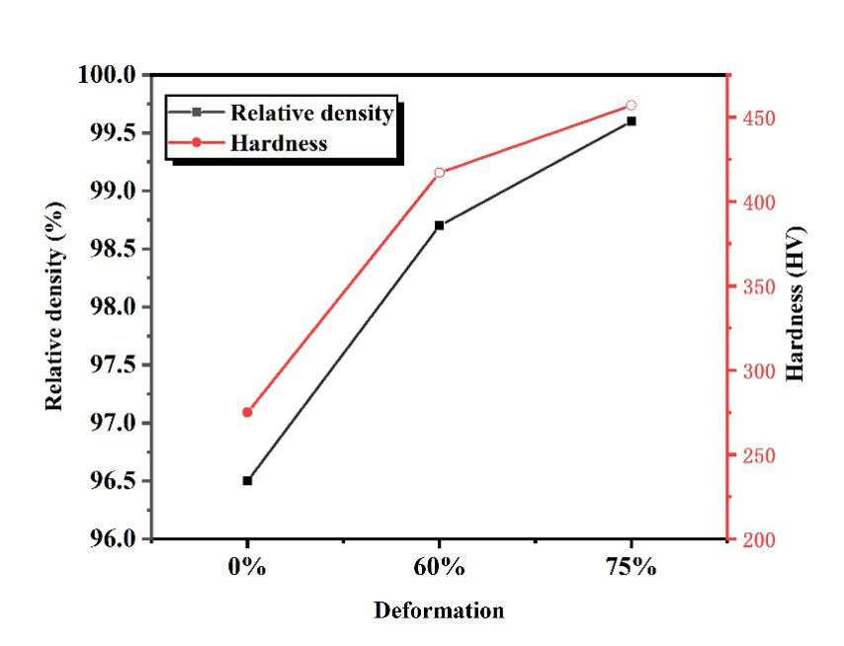
Fig. 5 Relative density and microhardness of the W-Cu plates vs. rolling ratio.
Fig. 5 displays the relative density of the as-rolled W-Cu composite sheets with different rolling reduction ratios. Clearly, the relative density increases significantly with the rolling ratio. It increases considerably from 96.5% (before rolling) to a maximum value of 99.8% when the rolling ratio reaches 75%. Since the infiltration of Cu was undertaken in high vacuum, the pores left behind after infiltration are free of gases. These gas-free pores can be closed up mechanically. During rolling, accompanied by plastic deformation of Cu and W is the closure of the pores that arise from the previous processing steps (skeleton sintering and Cu infiltration).
Also shown in Fig. 5 is the microhardness of the W-Cu composites. The Vicker’s hardness increases monotonically with the rolling ratio, from 275HV (at 0% thickness reduction) to a peak value of 457HV (at 75% thickness reduction). The microhardness increase is a result of a high relative density, grain refinement strengthening and work hardening associated with rolling. Since the rolling process was performed at 900 °C, the dynamic recrystallization is expected to occur, giving rise to grain refinement. The hard W particles also broke down and thus the particle size of W becomes smaller during rolling. Therefore, grain refinement of Cu, particle size reduction of W and enhanced densification lead to the increased microhardness in the as-rolled W-Cu composites.
3.5 Thermal properties of W-Cu composites
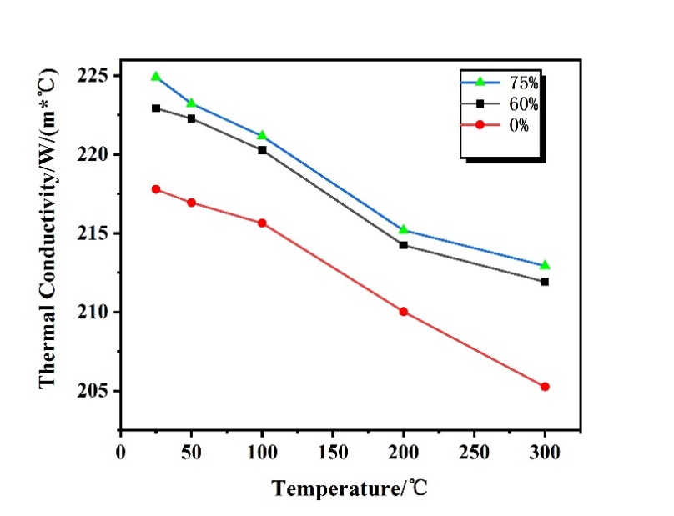
Fig.6 The effect of rolling reduction on the thermal conductivity of W-Cu plate
Generally, the theoretical thermal conductivity is given by the following equation: [19]
$λ_{c}=\frac{v_{1}λ_{1}+v_{2}λ_{2}\frac{3λ_{1}}{2λ_{1}+λ_{2}}}{v_{1}+v_{2}\frac{3λ_{1}}{2λ_{1}+λ_{2}}}$ (1)
where $λ_{c}$ is the thermal conductivity of the composite，$λ_{1}$ and $λ_{2}$ is the theoretical thermal conductivity of W and Cu, respectively.$v_{1}$ and $v_{2}$ is the volume fraction of the W and Cu components, respectively. Eq. (1) assumes that there is no interaction between different components and no porosity in the composite. According to the Eq. (1), the calculated thermal conductivity of the W-20Cu composite is 225 W/(m*K).
Fig.6 displays the thermal conductivities of the W-Cu composites rolled with the different ratios. Obviously, the thermal conductivity of the W-Cu composites increases significantly with the rolling reduction, and decreases with the measuring temperature in the range of room temperature to 300 °C. At room temperature, the measured thermal conductivity of the infiltrated W-Cu composite is 217.78W/(m*K). After 75% rolling reduction, the thermal conductivity increases to 224.91W/(m*K). This value is very close to the theoretical thermal conductivity of the W-20Cu composite. Clearly, the thermal conductivity achieved in the composites directly relates to the relative density. It is well known that the thermal and electrical conductions occur mainly through electron transport in metals. The presence of pores inhibits the motion of free electrons in metals [20]. By increasing the rolling reduction, the porosity is dramatically reduced, thereby increasing the thermal conductivity of the W-Cu composite. Meanwhile, the homogeneity of the microstructure is another important factor affecting the thermal conductivity of W-Cu composite [21]. The continuous network of high-purity Cu throughout the microstructure of composites in combination with homogeneously distributed W particles is beneficial to enhance the thermal conduction of free electrons. The good interfacial contact between the W and Cu in the composites also improves the electron conduction efficiency because heat transfer between W and Cu is one path for thermal conduction. As can be seen from Fig. 3, the W-Cu composite with a rolling ratio of 75% has the most homogeneous distribution of W and Cu, an ideal network structure of Cu, and enhanced interfacial bond. As a result, the thermal conductivity in the W-20Cu composite is close to the theoretical value.
The CTE of the W-Cu composite is given by[21]:
$T=v_{1}T_{1}+v_{2}T_{2}+\frac{4G_{1}}{K}\frac{\left(K_{1}-K_{2}\right)\left(T_{1}-T_{2}\right)v_{2}}{4G_{1}+3K_{2}}$ (2)
$K=\frac{\frac{K_{1}v_{1}}{3K_{1}+4G_{1}}+\frac{K_{2}v_{2}}{3K_{2}+4G_{1}}}{\frac{v_{1}}{3K_{1}+4G_{1}}+\frac{v_{2}}{3K_{2}+4G_{1}}}$ (3)
where $T$ is the CTE of W-Cu composite，$T_{1}$ and $T_{2}$ is the CTE of W and Cu, $v_{1}$ and $v_{2}$ is volume fraction of W and Cu phase, respectively.$G_{1}$ is the shear modulus of Cu, $K_{1}$ and $K_{2}$ is the bulk modulus of W and Cu. According to Eq. (2), the calculated CTE of the W-20Cu composite is 7.4×10⁻⁶/K.
Fig. 7 shows the measured CTE of the W–Cu composite in the temperature range of room temperature to 200 °C and how the values of CTE vary with the rolling ratio. It can be seen that, in the temperature range of 25 to 50 °C, the CTE of the W-Cu composite does not vary with the rolling ratio. The governing mechanism of CTE at low temperatures is the vibration of the crystal lattice. As expected, the CTE increases with temperature. However, in the high-temperature range, the CTE decreases significantly with the rolling ratio. It is worth noting that the W-20Cu composite with the rolling ratio of 75% exhibits the lowest CTE of 7.27×10-6/K, which is even lower than the theoretical CTE value. It suggests that high density, homogenous structure and well-bonded interfaces between W and Cu after rolling are the main reasons for the excellent thermal expansion property. First, any residual air in the pores is considered the third phase with a very large CTE. Therefore, the elimination of pores can significantly reduce the CTE of the composite. In other words, an increased relative density leads to a decreased CTE. Secondly, the CTE of the composite is also affected by the distribution of W and Cu and interfacial bond strength. The more homogenous distribution of W particles and the stronger interfacial bonds generally give rise to a lower CTE, because the high thermal expansion of Cu is constrained by the W particles whose CTE value is much lower [22]. The measured CTE values are consistent with the microstructures (Fig. 3) and relative density (Fig. 5) observed in the W-Cu composites.

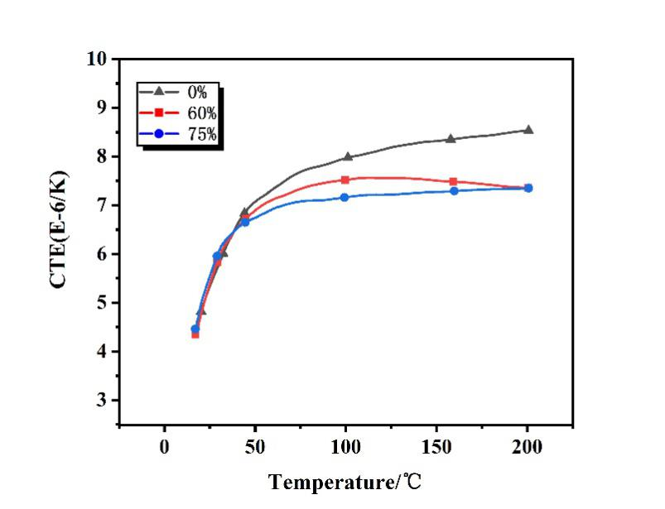
Fig.7 The effect of rolling reduction on the thermal expansion coefficient of W-Cu plate
- Conclusions
This work demonstrates a simple yet novel rolling process, which involves the use of encapsulation for the workpieces. The encapsulation rolling is able to produce large, ultra-thin and crack-free W-20Cu sheet with good surface quality. The total thickness reduction ratio could be as high as 75% and the largest sheet obtained has dimensions of 350 mm × 220 mm × 0.75 mm. In the W-Cu composite, the majority of the W particles were deformed and elongated along the rolling direction. The aspect ratio of the W particles in the W-Cu composite, when rolled by 75% has reached 2.5. The highest values of relative density and hardness are 99.8% and 457 HV, respectively. The W-Cu composite sheet attained a low coefficient of thermal expansion of 7.27×10⁻⁶/K and a close-to-theoretical thermal conductivity of 224.91W/(m*K).
Acknowledgments
The authors acknowledge the financial support by the National Key Research and Development Project (2017YFB0406100).

References
[1] Dong L, Chen W, Zheng C, Nan D. Microstructure and properties characterization of tungsten–copper composite materials doped with graphene. Journal of Alloys & Compounds. 2017;695:1637-46.
[2] Vettivel SC, Selvakumar N, Leema N. Experimental and prediction of sintered Cu–W composite by using artificial neural networks. Materials & Design. 2013;45(6):323-35.
[3] Zhang L, Chen W, Luo G, Chen P, Qiang S, Wang C. Low-temperature densification and excellent thermal properties of W–Cu thermal-management composites prepared from copper-coated tungsten powders. Journal of Alloys & Compounds. 2014;588(588):49-52.
[4] Luo LM, Tan XY, Lu ZL, Zhu XY, Zan X, Luo GN, et al. Sintering behavior of W-30Cu composite powder prepared by electroless plating. International Journal of Refractory Metals & Hard Materials. 2014;42(1):51-6.
[5] ECHLIN, Mclean P, MOTTURA, Alessandro, WANG, Michael, et al. Three-dimensional characterization of the permeability of W―Cu composites using a new TriBeam technique. Acta Materialia. 2014;64:307-15.
[6] Ibrahim H, Aziz A, Rahmat A. Enhanced liquid-phase sintering of W–Cu composites by liquid infiltration. International Journal of Refractory Metals & Hard Materials. 2014;43(3):222-6.
[7] Qiang Z, Chen P. Fabrication of W–Cu composite by shock consolidation of Cu-coated W powders. Journal of Alloys & Compounds. 2016;657:215-23.
[8] Schubert T, Brendel A, Schmid K, Koeck T, Ciupinski L, Zielinski W, et al. Interfacial design of Cu/SiC composites prepared by powder metallurgy for heat sink applications. Composites Part A. 2007;38(12):2398-403.
[9] Fan J, Tao L, Song Z, Yong H. Synthesis of ultrafine/nanocrystalline W–(30–50)Cu composite powders and microstructure characteristics of the sintered alloys. International Journal of Refractory Metals & Hard Materials. 2012;30(1):33-7.
[10] Ardestani M, Arabi H, Rezaie HR, Razavizadeh H. Synthesis and densification of W–30 wt%Cu composite powders using ammonium meta tungstate and copper nitrate as precursors. International Journal of Refractory Metals & Hard Materials. 2009;27(4):796-800.
[11] Ahmadi E, Malekzadeh M, Sadrnezhaad SK. WITHDRAWN: W–15 wt% Cu nano-composite produced by hydrogen-reduction/sintering of WO 3 –CuO nano-powder. International Journal of Refractory Metals\s&\shard Materials. 2009;28(3):441–5.
[12] Yang N, Wang Z, Chen L, Wang Y, Zhu YB. A new process for fabricating W-15 wt.%Cu sheet by sintering, cold rolling and re-sintering. International Journal of Refractory Metals & Hard Materials. 2010;28(2):198-200.
[13] Dong LL, Ahangarkani M, Chen WG, Zhang YS. Recent progress in development of tungsten-copper composites: Fabrication, modification and applications. International Journal of Refractory Metals & Hard Materials. 2018;75:30-42.
[14] Dolatmoradi A, Raygan S, Abdizadeh H. Mechanochemical synthesis of W–Cu nanocomposites via in-situ co-reduction of the oxides. Powder Technology. 2013;233(none):208-14.
[15] Xie X, Qiang L, Liu DI, Liu Z, Wang E. Research on the densification of W-30 wt%Cu composite powder by hot extrusion with steel cup. Materials Science & Engineering A. 2013;578(9):187-90.
[16] Daoush WM, Yao J, Shamma M, Morsi K. Ultra-rapid processing of high-hardness tungsten&ndash;copper nanocomposites. Scripta Materialia. 2016;113:246–9.
[17] Hashempour M, Razavizadeh H, Rezaie H. Investigation on wear mechanism of thermochemically fabricated W–Cu composites. Wear. 2010;269(5):405-15.
[18] Dong LL, Ahangarkani M, Zhang W, Zhang B, Chen WG, Fu YQ, et al. Formation of gradient microstructure and mechanical properties of hot-pressed W-20 wt% Cu composites after sliding friction severe deformation. Materials Characterization. 2018;144:325-35.
[19] Chen P, Luo G, Qiang S, Li M, Zhang L. Thermal and electrical properties of W–Cu composite produced by activated sintering. Materials & Design. 2013;46(4):101-5.
[20] Tang XQ, Zhang HB, Du DM, Qu D, Hu CF, Xie RJ, et al. Fabrication of W-Cu functionally graded material by spark plasma sintering method. International Journal of Refractory Metals & Hard Materials. 2014;42:193-9.
[21] Guo Y, Guo H, Gao B, Wang X, Hu Y, Shi Z. Rapid consolidation of ultrafine grained W-30 wt.% Cu composites by field assisted sintering from the sol-gel prepared nanopowders. Journal of Alloys and Compounds. 2017;724:155-62.
[22] Ibrahim A, Abdallah M, Mostafa SF, Hegazy AA. An experimental investigation on the W–Cu composites. Materials & Design. 2009;30(4):1398-403.

