Spherical Bézier–based fillet construction for spherical involute forge straight bevel gears
Kejia Chen Yunfeng Zhu
Gear Research Institute, Zhejiang Shuanghuan Driveline Co., Ltd., China
Abstract
Spherical involute straight bevel gears exhibit inherent advantages, including conjugate tooth surfaces and reduced sensitivity to assembly errors. However, their unfavorable machinability has limited their widespread adoption over the past two decades, and most practical applications have relied on approximations based on equivalent cylindrical straight gears. Recent advances in manufacturing technologies, such as precision forging and additive manufacturing, have now made the direct production of spherical involute straight bevel gears technically feasible. For small-tooth-number straight bevel gears, the base angle is often greater than the root angle, which leads to a highly constrained and mechanically critical root region. As a result, the design and optimization of the fillet become essential for improving bending strength and load-carrying capacity.
In this work, a new approach for constructing the root transition surface based on third-order spherical Bézier curves is proposed. The analytical formulation of the method is derived, followed by computational geometric modeling, numerical simulation, and parametric optimization. The results demonstrate that the proposed fillet modeling strategy substantially reduces root bending stresses, indicating strong potential for practical industrial implementation.

Keywords: Spherical bevel gear Tooth root surface Spherical Bezier curve

- Introduction
Straight bevel gears are extensively used in electric vehicle differentials and engineering tools. With technological advancements, higher demands have emerged for bevel gear size, weight, and meshing performance. However, achieving lightweight designs necessitates reducing tooth count, resulting in the root cone angles smaller than the base cone angle. The region between the two that does not participate in tooth surface contact is termed the transition surface. Theoretically, it can be configured into any shape as long as it complies with draft angle constraints, offering exceptional design flexibility. Simultaneously, improving meshing performance necessitates reducing the pressure angle, which significantly increases tooth root bending stress.
To reduce tooth root bending stress, numerous researchers have conducted studies, primarily focusing on new materials [1], shot peening strengthening [2], forged bi-metal[3], and geometric improvements[4]. Undoubtedly, geometric improvements represent the most economical and practical approach among these. ISO10300-1[5] standards provide detailed instructions about load capacity of bevel gears. However the method based on the theory of Tredgold’s approximation [6] and not applicable to conjugate spherical involute bevel gear. Costopoulos et al attempted to enhance root strength by employing an asymmetric pressure angle structure on both sides of the gear, but this approach is unsuitable for gears where teeth frequently mesh simultaneously on both sides, thus limiting its applicability [7]. D. Miller et al proposed using genetic algorithms to modify positive profile shift for root strength enhancement, but positive shift increases the center distance of the gear, consequently enlarging the housing volume and weight [8]. Zeng et al. investigated fillets for straight-toothed bevel gears, but their research focused on machined bevel gears rather than spherical involute profiles, failing to leverage the high manufacturing flexibility inherent in forging processes [9]. Zeng et al. investigated transition surfaces for straight-toothed bevel gears, but employed transition surfaces formed by second-order surfaces on a plane. This resulted in the modeling failing to align the plate with the tooth width and did not correctly explain the interference principles in the transition region [10]. Sankar et al. effectively reduced root bending stress and improved gear fatigue life by replacing straight gear tooth surface fillets with circular arcs [11]. However, for straight bevel gears, constrained by the design positions of the base cone and root cone, it may not be feasible to find a full circular arc that satisfies all conditions. Dong et al. simulated planar root Bézier curves using hobs to enhance root bending stress, employing a genetic algorithm to identify an optimal value [12]. He et al reduced root bending stress by 6%-10% through cutter geometry and motion design [13]. Spitas et al proposed a circular root machining theory, yet these approaches remain tool-based with limited flexibility [14]. Senthilvelan et al used finite element analysis to calculate stress levels under roots with varying radii, finding that smaller radii resulted in higher root bending stress [15]. Hussein proposed a universal fillet transition surface to ensure smooth transitions in fillet regions, achieving superior curvature radii compared to circular fillet profiles and thereby enhancing root bending strength, though this remained confined to flat cylindrical gears [16]. Spitas et al. used finite element analysis to demonstrate that standard arc roots exhibit greater strength than standard cycloidal gears [17].
In summary, three conclusions can be drawn:
- Previous research has predominantly focused on cylindrical gears, with limited investigation into bevel gears. Because of root surface design remains primarily centered on two-dimensional curves, without extension to three-dimensional surfaces.
- Most root surface designs are constrained by cutting tool machining, failing to fully leverage the manufacturing flexibility of forged bevel gears.
- The current standard applies to flat-toothed bevel gears but not to spherical-toothed bevel gears.
According to this the main goals of this work are as follows:
- Based on the generation principle of spherical involutes, proposes a spatial three-dimensional driven root transition surface method
- To address root interference issues in bevel gears, a detailed calculation method using the ease-off approach is provided to prevent tooth surface interference. Detailed elaboration on the mechanism of the geometric constraints for forging bevel gears
- optimizes root bending strength using FEA.
Meanwhile this approach resolves the issues of abrupt curvature changes in tooth surfaces and modeling difficulties caused by the inability of two-dimensional Bézier curves to conform to spherical surfaces. This provides a more flexible solution for designing root transition surfaces in forged straight-toothed bevel gears.
- Formation of spherical involute
In recent years, the tooth surfaces of straight bevel gears manufactured by forging are commonly designed as theoretically conjugate spherical involute surfaces to achieve improved meshing performance.
A spherical involute profile is the path traced by any point on a plane as it rolls purely around a cone, with the point moving along a spherical surface corresponding to the cone's pitch (as shown by the red curve in Figure 1).
The relevant theory is based on the definitions established by Alfonso et al [18], with only a brief explanation provided herein. As shown in Figure 1, $γ_{b}$ denotes the cone angle (base cone angle), $θ$ represents the polar angle and $ψ=θ+∅$ is referred to as the roll angle.
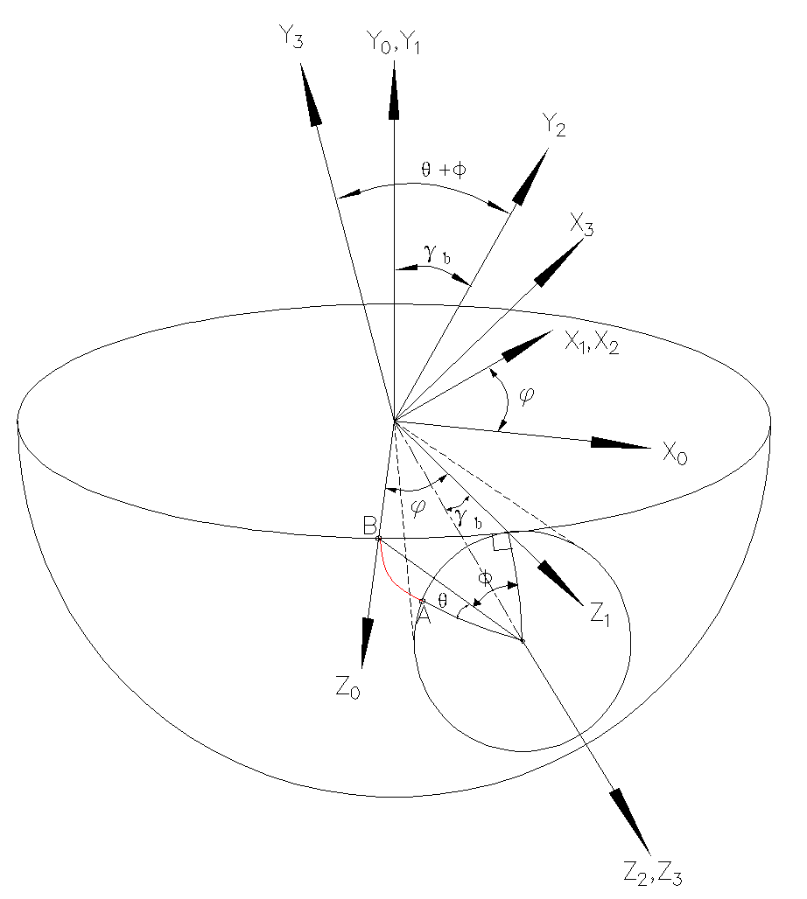
Fig1. spherical involute profile generation principle
Using the coordinate system transformation method, the coordinates of point B in the fixed coordinate system S0 are $n_{0}$=[0,0,R]T, and $n_{3}$ is its position vector in the S3 coordinate system:
$$n_{3}=M_{30}n_{0}=M_{32}M_{21}M_{10}n_{0}$$
(1)
The rotation matrices $M_{10}$, $M_{21}$, and $M_{32}$ are respectively defined as follows:
$M_{10}$=$\left[\begin{matrix}cosφ & 0 & -sinφ \\ 0 & 1 & 0 \\ sinφ & 0 & cosφ\end{matrix}\right]$ , $M_{21}$=$\left[\begin{matrix}1 & 0 & 0 \\ 0 & cosγ_{b} & sinγ_{b} \\ 0 & -sinγ_{b} & cosγ_{b}\end{matrix}\right]$ , $M_{32}$=$\left[\begin{matrix}cosψ & sinψ & 0 \\ -sinψ & cosψ & 0 \\ 0 & 0 & 1\end{matrix}\right]$
This yields the position vector of point B in the S3 coordinate system, which is the equation of the spherical involute curves.
$$x=-R(cosψsinφ-sinψcosφsinγ_{b})$$
$$y=R(sinψsinφ+cosψcosφsinγ_{b})$$
$$z=R(cosφcosγ_{b})$$
(2)
To account for the tooth thickness during modeling, the tooth profile will also be rotated around the Z-axis by an angle equal to half the tooth thickness. Therefore, the rotation matrix $M_{43}$ is introduced.
$M_{43}$=$\left[\begin{matrix}cosα & -sinα & 0 \\ sinα & cosα & 0 \\ 0 & 0 & 1\end{matrix}\right]$
In the formula, $α$ is the angle subtended by half the tooth thickness.
Therefore, the final spherical involute surface formula is:
$$x=R\left(cosψsinφ-sinψcosφsinγ_{b}\right)cosα-R(sinψsinφ+cosψcosφsinγ_{b})sinα$$
$$y=R\left(cosψsinφ-sinψcosφsinγ_{b}\right)cosα+R(sinψsinφ+cosψcosφsinγ_{b})sinα$$
$$z=R(cosφcosγ_{b})$$
(3)
- Spherical Bézier curve tooth root surface
Bézier curves are a class of parametric curves defined by control points, characterized by the following core features:
The shape is pulled out by a small number of control points. The curve does not necessarily pass through intermediate control points but is influenced by them.
Bézier curves offer advantages such as smoothness, controllability, parametric nature, and ease of optimization.
  - Principles of planar Bézier curves
The Bézier curve is a type of vector curve proposed by Pierre Bézier [19]. Taking a cubic Bézier curve as an example (see Figure 2), points A, B, and C serve as the control points. Point D is located on line segment AB, and point E is located on line segment BC such that
$\frac{AD}{AB}=\frac{BE}{BC}$.
Subsequently, point F is located on line segment DE such that
$\frac{DF}{FE}=\frac{AD}{AB}=\frac{BE}{BC}$.
There exist infinitely many points F on the plane. The curve formed by connecting all points F constitutes the Bézier curve. It is also evident that the starting and ending points of the Bézier curve are tangent to line segments AB and BC, respectively, ensuring smooth transitions at points A and B.
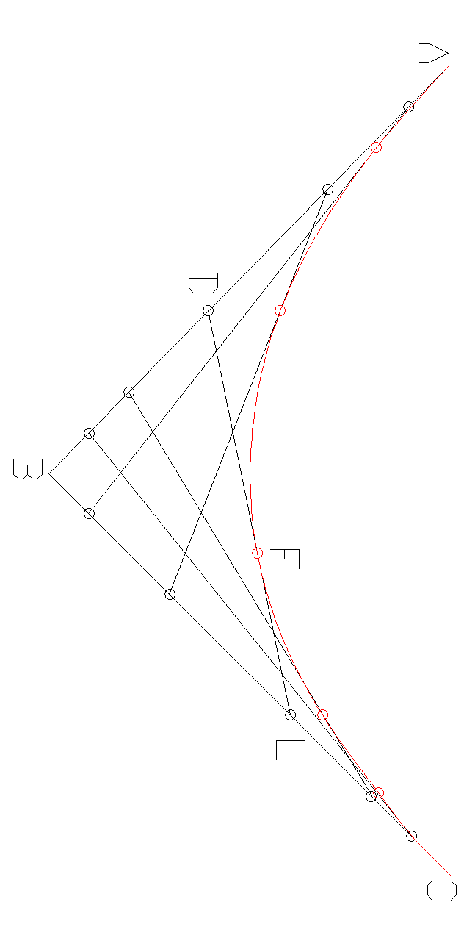
Fig2 Bezier curve generation principle
  - Calculate control points on a sphere
Bézier curves on a plane can be extended to spherical surfaces in three-dimensional space for designing transition surfaces on spherical involutes (see Figure 3). At any spherical cone pitch, four control points can be found attached to the spherical surface: P3 intersects the root cone, P2 is the point obtained by rotating P3 around the axis by a certain angle, P0 intersects the base cone, and P1 is the point obtained by rotating P0 a certain angle along the tangential direction of the sphere. (This paper uses unmodified tooth surfaces as an example; when tooth surfaces are modified, simply replace the coordinates of P0 with those of the modified point.)
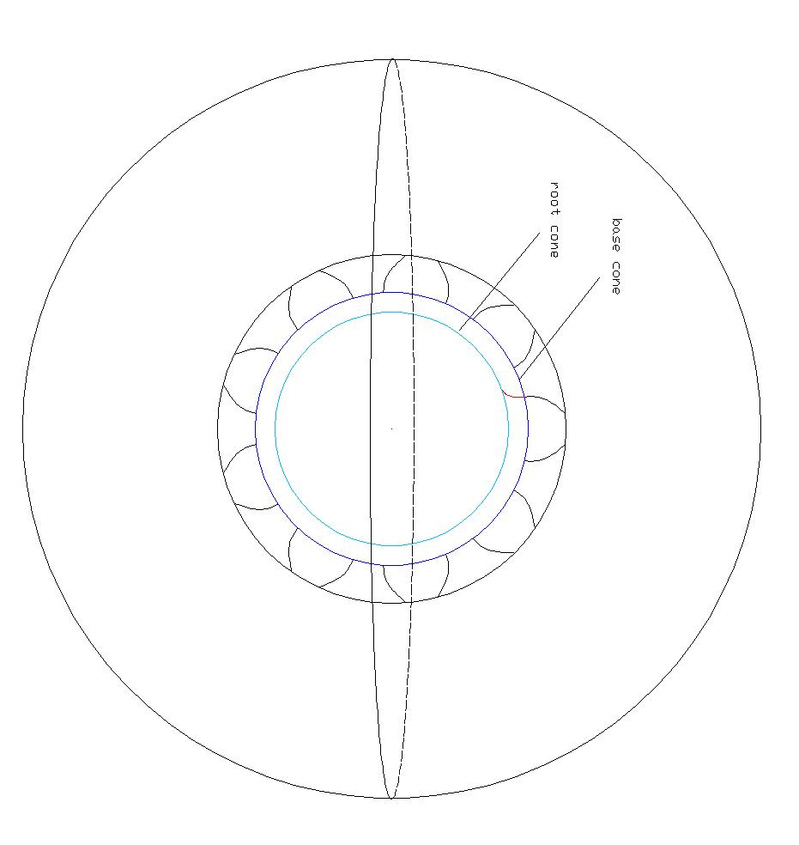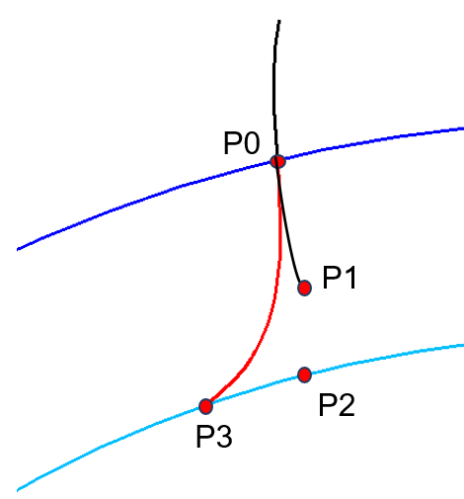
Fig3 contral point coordinate

Substituting $ψ=0$ and $φ=0$ (i.e., the starting point of the tooth surface) into (3) yields the coordinates of point P0 as:
$$\left\{\begin{aligned}&P0\left(x\right)=Rsin\left(γ_{b}\right)(-sinα) \\ &P0\left(y\right)=Rsin\left(γ_{b}\right)cosα \\ &P0\left(z\right)=Rcos(γ_{b})\end{aligned}\right.$$
(4)
In the equation, R is the cone pitch, $γ_{b}$ is the base cone angle, and $α$ is the angle subtended by half the tooth thickness.
To calculate the coordinates of point P1, we first need to determine the tangent direction of the spherical involute on the sphere. Based on the principle of generating involutes from spherical surfaces, the tangent vector at the starting point of the involute coincides with the great circle of the hemisphere.
Define a vector $t_{0}$ in the coordinate system $O_{0}$ such that P0 lies on it:
$$t_{0}=(0,-1,R)$$
By applying the rotation matrix, the vector $t_{3}$ in coordinate system $O_{3}$ can be obtained.
$$t_{3}=M_{32}M_{21}M_{10}t_{0}$$
$$t_{3}=\left[\begin{matrix}-Rcos\left(ψ\right)\sin\left(φ\right)+sin⁡(ψ)(cos⁡(γ_{b})+Rsin(γ_{b})sin⁡(φ)) \\ Rsin\left(φ\right)sin\left(ψ\right)+cos(ψ)(cos⁡(γ_{b})+Rsin(γ_{b})sin⁡(φ)) \\ -sin\left(γ_{b}\right)+Rcos(γ_{b})cos⁡(φ)\end{matrix}\right]$$
(5)
Substituting $ψ$=0 and $φ$=0 into (5) yields the tangent direction at P0 as
$$t_{3}=(0,\cos\left(γ_{b}\right),-sin\left(γ_{b}\right)+Rcos(γ_{b}))$$
Therefore, according to the Rodrigues rotation formula, the direction of the unit rotation axis can be expressed by the following equation:
$$u=\frac{P0×t_{3}}{\left\|P0×t_{3}\right\|}$$
$$P1=P0cosθ+\left(u×P0\right)sinθ+u(u·P0)(1-cosθ)$$
In the equation, $θ$ is the angle of rotation around the $u$-axis.
P3 intersects the root cone, yielding:
$$\left\{\begin{aligned}&P3\left(x\right)=R\sin\left(θ_{f}\right)sin⁡(γ) \\ &P3\left(y\right)=R\sin\left(θ_{f}\right)cos⁡(γ)⁡ \\ &P3\left(z\right)=Rcos⁡(θ_{f})\end{aligned}\right.$$
Where R is the radius, $θ_{f}$ is the root cone angle, and $γ$ is the tooth thickness angle.
P2 is the point obtained by rotating P3 through a certain angle about the Z-axis. Therefore, the coordinate transformation for P2 is:
$$\left\{\begin{aligned}&P2(x)=R\sin{θ_{f}}sinγcosβ+R\sin{θ_{f}}cosγsinβ \\ &P2\left(y\right)=-R\sin{θ_{f}}sinγsinβ+R\sin{θ_{f}}cosγcosβ \\ &P2\left(z\right)=Rcosθ_{f}⁡\end{aligned}\right.$$
Where $R$ is the pitch radius, $θ_{f}$ is the root cone angle, $γ$ is the cone tooth thickness angle, and $β$ is the distance (angle) rotated along the tangent direction.
  - Function of Spherical Linear Interpolation
Spherical linear interpolation is a function applied to interpolation on a sphere, widely used in computer graphics. Unlike linear interpolation on a plane, SLERP ensures interpolation points always lie on the sphere, making it particularly suitable for describing paths on a spherical surface.
In three-dimensional space, given any two non-collinear unit direction vectors V1 and V2 on the sphere, any point on the sphere can be linearly represented by these two vectors.
$$V=aV1+bV2$$
Here, a and b are coefficients, and V is the interpolation point in arbitrary units.
Since arc length equals angle multiplied by radius, arc length is directly proportional to angle. By calculus principles, sine represents the projection component of angle onto the circle, which is proportional to arc length distribution. Thus, $\sin\left(\left(1-t\right)θ\right)$ and $sin⁡(tθ)$ can express the proportional distribution of arc length between two endpoints. Consequently, coefficients a and b can be expressed as
$a=\frac{\sin\left(\left(1-t\right)θ\right)}{sin⁡(θ)}$ $b=\frac{sin⁡(tθ)}{sin⁡(θ)}$
  - Geometric design of the root transition fillet surface
By utilizing the SLERP function, all interpolation points on the sphere can be obtained. Subsequently, following principles analogous to planar Bézier curves (see Figure 4), Q0, Q1, and Q2 represent the proportional points of arcs P0P1, P1P2, and P2P3, respectively; A0 and A1 represent the proportional points of arcs Q0Q1 and Q1Q2, respectively; and B0 is the proportional point of A0 and A1. That is：
$$Q0=SLERP(P0,P1,t)$$
$$Q1=SLERP(P1,P2,t)$$
$$Q2=SLERP(P2,P3,t)$$
$$A0=SLERP(Q0,Q1,t)$$
$$A1=SLERP(Q1,Q2,t)$$
$$B0=SLERP(A0,A1,t)$$
All B0 points form a transition curve on the sphere (red line in Figure 4).
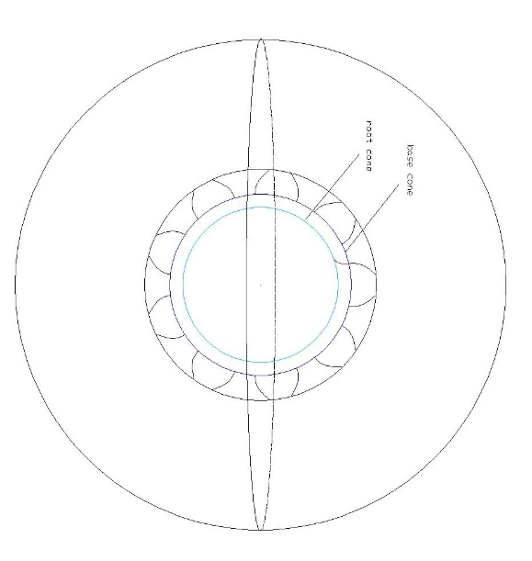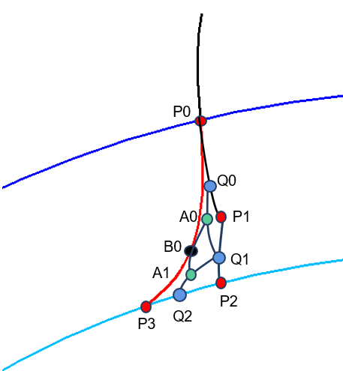
Fig4 bezier curve on spherical
For each R, such a transition curve can be obtained. By cycling through R, the surface point cloud can be generated (see Figure 5).
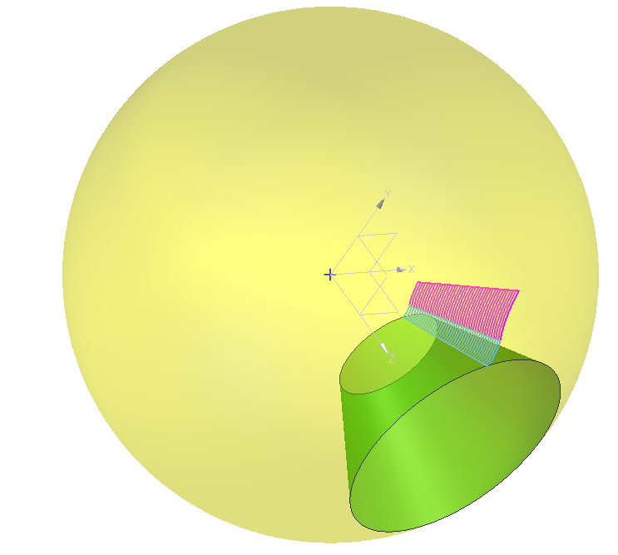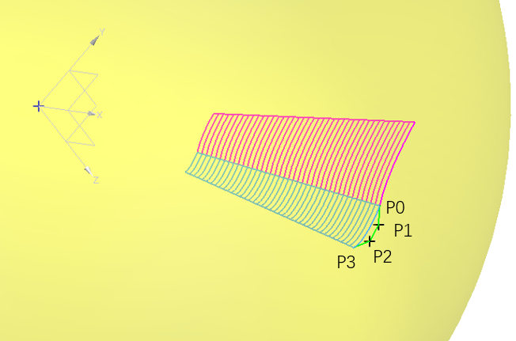
Fig5 fillet generated by bezier curve
From the previous steps, a point cloud of the transition surface is obtained. Subsequently, a complete surface can be generated using a skinning method (see Figure 6).
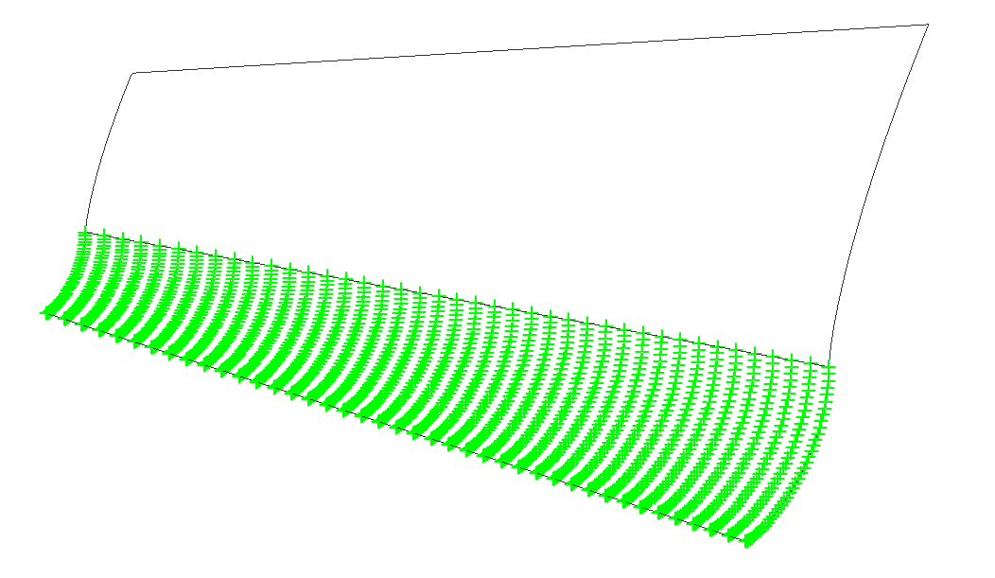
Fig 6 surface of the fillet
Through operations such as mirroring and array in CAD software, the complete bevel gear is obtained (see Figure 7).
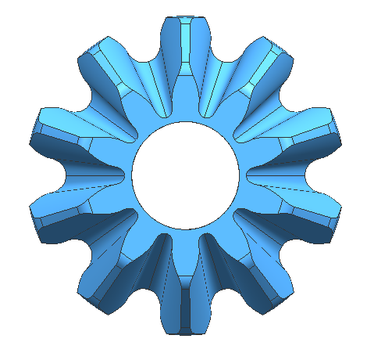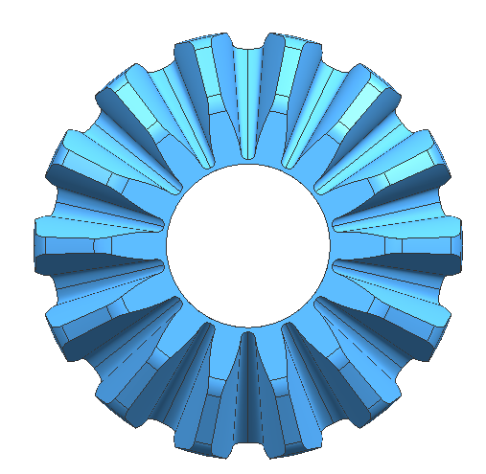
Fig 7 model of gear set
Although spherical Bézier fillets are applied to bevel gears, engineering constraints such as interference risk must also be considered.
- Geometric Constraints for Forged Bevel Gear Fillets
Due to design and manufacturing constraints, forged bevel gears must account for draft angles, strength requirements, interference, and other engineering limitations.
4.1 Interference characteristics of forge spherical involute straight bevel gears
Interference refers to the phenomenon where tooth surfaces that should not participate in contact prematurely or erroneously engage during meshing, thereby disrupting the theoretical conjugate meshing relationship. Since forged spherical involute bevel gears are not machined by tool generation, they are prone to interference risks. Interference causes a sharp increase in root stress, abnormal contact stresses, significantly heightened risks of wear and adhesion, and noise issues arising from the disruption of conjugate conditions. This section primarily focuses on crown and root interference in spherical involute straight-toothed bevel gears.
The logically permissible contact range for spherical involute bevel gears extends from the base cone to the face cone. Research by Kahraman et al. enables the determination of instantaneous contact lines in space [20], from which a method for calculating the conjugate surfaces of the tooth surfaces can be derived. The calculation method is expressed as follows:
$$R\left(a^{p}×r_{ij}^{p}\right)·n_{ij}^{p}=\left(a^{g}×r_{ij}^{a}\right)·n_{ij}^{p}$$
The contact line between tooth surfaces at different angles is shown in Figure 8.
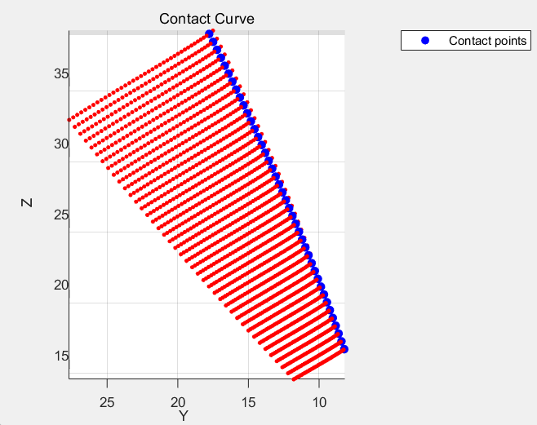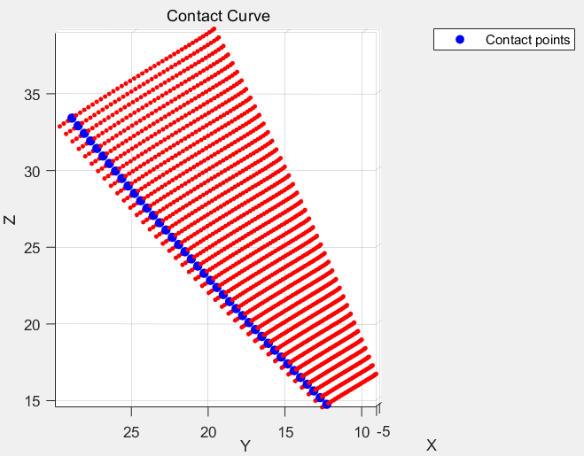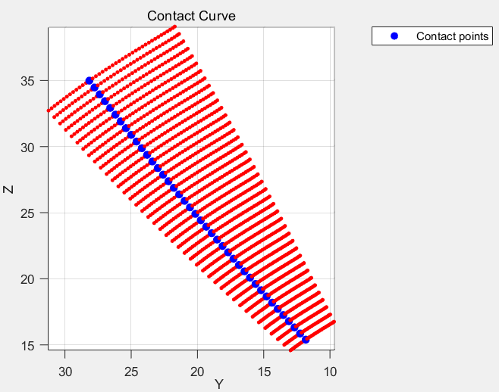
t=-30° t=-20° t=-10°
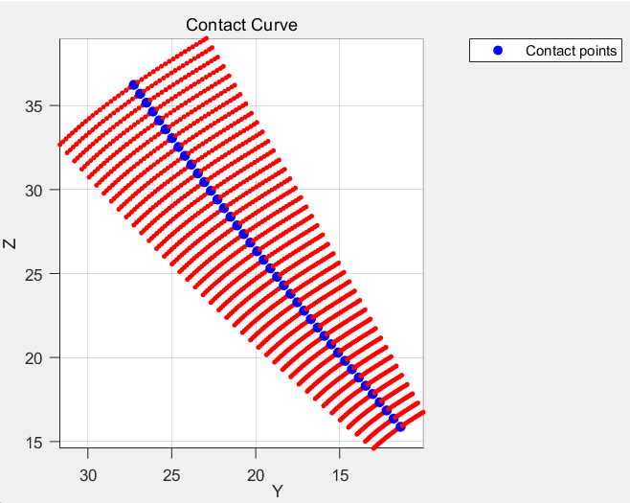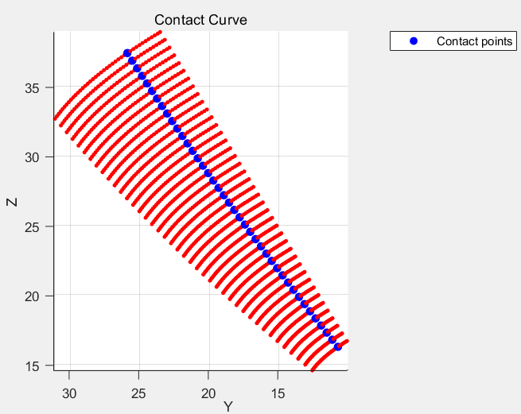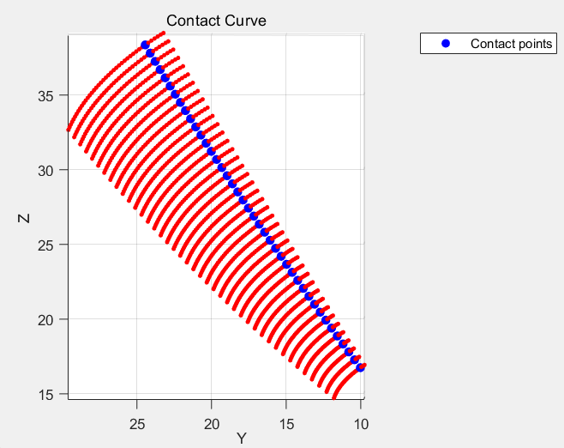
t=0° t=10° t=20°
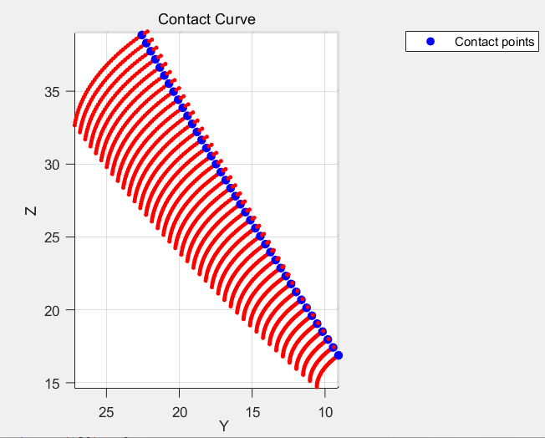
t=30°
Fig 8. Instantaneous contact line at different rotation angles
Combining the instantaneous contact lines in space yields the conjugate surface. Therefore, the condition for avoiding interference is that the tip cone angle and base cone angle of one bevel gear fall within the range of the tip cone angle and base cone angle of its mating gear's conjugate gear. This is conformally mapped onto a plane, as shown in Figure 9.
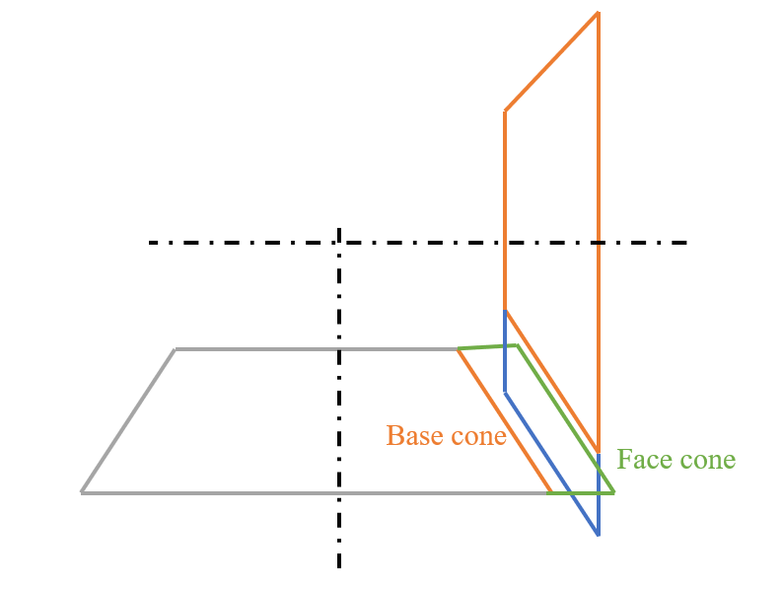
Fig 9. Conditions for No Interference
4.2 Geometric Constraints of Spherical Bezier Fillets
Transition surfaces designed using spherical Bézier curves require optimization of only two parameters: θ and β, which determine the positions of points P1 and P2. The value of θ should neither be too large nor too small. When β < 3°, interruptions in the tooth width create sharp points, rendering the surface unsuitable for forging (see figure 10 a). When β > 10°, significant root structure deficiency occurs alongside a negative draft angle (see figure 10 b). Therefore, β is restricted to 3–10 degrees. For θ, values exceeding 5° produce the shape shown in figure 10 c), which is unfavorable for forging. Thus, θ is limited to 0–5 degrees.
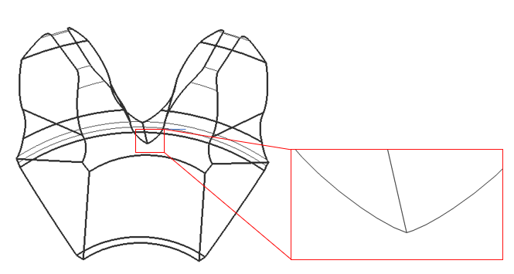
a) Spike
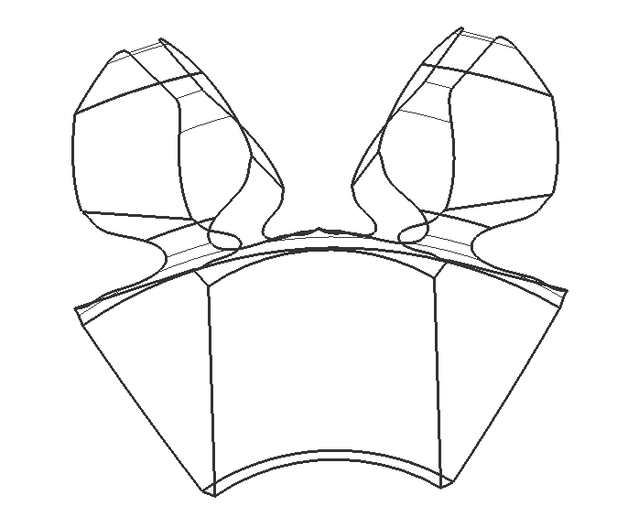
b）Insufficient draft angle
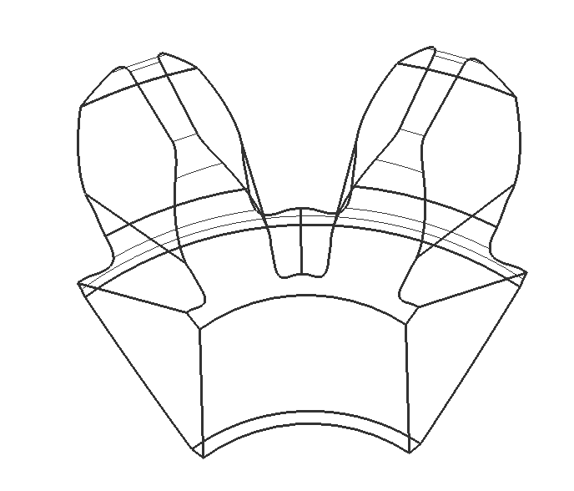
c）Significantly insufficient strength
Fig. 10 Boundary Cases for θ and β
- Finite Element-Based Fillet Parameter Optimization
Optimization problem formulation
The fillet design is parameterized by two geometric control variables, x = [β, θ], which govern the spatial distribution of the spherical Bézier control points (P1 and P2) and therefore the local morphology of the transition surface. The design objective is to minimize the maximum tooth-root bending stress under the prescribed loading condition.
The optimization problem is stated as:
minimize σ_max(β, θ)
subject to β_min ≤ β ≤ β_max,
θ_min ≤ θ ≤ θ_max,
g_draft(β, θ) ≤ 0,
g_interf(β, θ) ≤ 0,
g_strength(β, θ) ≤ 0,
where σ_max denotes the maximum bending stress at the root critical section computed by finite element analysis. The bounds (β_min, β_max, θ_min, θ_max) are determined by the feasible design domain identified in the preceding geometric-constraint analysis (draft-angle, manufacturability, and interference-risk constraints). The constraint functions g_draft, g_interf, and g_strength correspond to: (i) minimum draft angle requirement, (ii) non-conjugate premature contact avoidance based on the ease-off / instantaneous contact-line criterion, and (iii) prevention of extreme stress concentration in the root region.
Design of experiments and response surface regression
A Taguchi orthogonal array was adopted to sample the (β, θ) design space efficiently. For each design point, σ_max was evaluated by the same finite element procedure, yielding the dataset listed in Table 2.
To quantify the coupled effect of β and θ and to enable smooth sensitivity assessment, a second-order polynomial response surface was fitted via least-squares regression in the form:
σ_max(β, θ) = 209.831 + 33.161β + 17.789θ + 0.070928β^2 + 2.986θ^2 + 1.310βθ
Over the investigated range, the fitted model achieved R^2 = 0.9964 (adjusted R^2 = 0.9939) with an RMSE of 6.79 MPa, indicating that the quadratic surrogate captures the stress response reliably for the present design space. The resulting response surface is discussed in the next subsection.
Based on the previous root fillet modeling approach and boundary conditions, the bending stress can be calculated through finite element analysis using the bevel gear model.
The following table presents the macro parameters of a bevel gear pair. Using this gear pair as an example, we will analyze the gear pair.
Table 1 Macro parameters of gear part
Parameter | pinion |  |  | wheel
Module(heel) |  | 10 |  | 14
Pressure angle, deg |  | 23 |  | 23
Number of tooth |  | 10 |  | 14
Tooth width, mm |  | 23 |  | 23
Profile shift coefficient |  | 0 |  | 0
Backlash， mm |  | 0 |  | -0.1
Tip cone angle, deg |  | 42.61356 |  | 63.28432
Root cone angle, deg |  | 27.44775 |  | 48.05743
Table 2 Test Sheet
Number | β |  | θ | Bending Stress
1 |  | 6.5 | 2.55 | 513.171
2 |  | 3 | 2.55 | 398.954
3 |  | 6.5 | 2.55 | 513.171
4 |  | 6.5 | 2.55 | 513.171
5 |  | 6.5 | 0.1 | 443.413
6 |  | 6.5 | 2.55 | 513.171
7 |  | 10 | 2.55 | 641.067
8 |  | 6.5 | 2.55 | 513.171
9 |  | 6.5 | 5 | 630.720
10 |  | 10 | 5 | 784.550
11 |  | 3 | 0.1 | 301.001
12 |  | 3 | 5 | 490.171
13 |  | 10 | 0.1 | 550.431

To analyze the influence of geometric control parameters β and θ on the root bending stress of bevel gears, a response surface model for root bending stress was established based on finite element calculation results. A three-dimensional response surface was plotted, as shown in Figure ×. In the figure, β and θ are geometric parameters used to adjust the distribution of tooth surface control points, thereby altering the local tooth surface morphology and root transition characteristics; σ represents the maximum root bending stress. As shown in the three-dimensional response surface in Figure ×, within the studied parameter range, the root bending stress exhibits an overall increasing trend with increasing geometric control parameters β and θ.
When β is small, variations in θ have a relatively limited effect on root bending stress. However, as β increases, the slope of the response surface along the θ direction markedly increases, indicating a significant coupling effect between the geometric control parameters.
This phenomenon demonstrates that changes in tooth surface morphology induced by adjusting the distribution of control points simultaneously affect the stress state of the root critical section. When both β and θ are set to large values, the load distribution on the tooth surface tends to concentrate, leading to a significant increase in local bending stress at the root.
Furthermore, the response surface exhibits a pronounced nonlinear uplift characteristic in the high β–high θ region, indicating that root bending strength is highly sensitive to geometric control parameters. This region should be prioritized as a key constraint zone in the optimization design of tooth profile parameters.

- Result
This paper investigates spherical involute straight-toothed bevel gears. Addressing the issues of severe stress concentration in the root region under low-tooth-count conditions and the limited design freedom of traditional root radius designs, a root transition surface construction method based on third-order spherical Bézier curves is proposed. The geometric modeling, interference characteristics, and influence patterns on mechanical properties are systematically studied. Key conclusions are as follows:
Based on the formation mechanism of spherical involutes, a unified spatial geometric description model for the transition region between tooth surfaces and tooth roots is established. By introducing spherical Bézier curves onto the sphere and combining them with spherical linear interpolation (SLERP), continuous construction of root transition curves on the sphere is achieved, effectively avoiding the curvature discontinuity issues arising from direct mapping of traditional 2D Bézier curves onto the sphere.
A spatial 3D-driven method for generating root transition surfaces was proposed. By defining geometric constraints and parametric expressions for control points P0–P3, smooth connections between the transition surfaces and spherical involute tooth surfaces were achieved. This method, independent of tool envelope principles, overcomes geometric limitations in conventional cutting gear root design, fully leveraging the high-degree-of-freedom forming advantages inherent in forged straight-toothed bevel gears within the root region.
Addressing the characteristics of forged spherical involute straight bevel gears, this paper redefines the root interference criterion. It treats interference as premature or erroneous contact in non-theoretically conjugate regions during meshing, rather than the conventional root cutting issue. Based on the instantaneous contact line theory, it explicitly provides geometric constraints for the conjugate contact range of tooth surfaces, establishing theoretical boundaries for rational transition surface design.
Using the position parameters β and θ of the transition control points in spherical Bézier curves as geometric control variables, a Taguchi design was constructed. Finite element analysis was employed to calculate root bending stresses under various parameter combinations. Results indicate that β and θ significantly influence root bending strength, exhibiting pronounced coupling effects.
A quantitative relationship model between root bending stress and geometric control parameters was established through response surface analysis. Findings indicate that root bending stress generally increases with rising β and θ values. In the high-β–high-θ region, stress growth accelerates markedly, identifying this area as a critical constraint zone for root structure optimization.
Finite element results demonstrate that, compared to conventional tooth root arc forms, the proposed spherical Bézier tooth root transition surface significantly improves stress distribution at critical sections, effectively reducing maximum bending stress levels. This provides a feasible and efficient structural design approach for enhancing the bending load capacity and fatigue life of spherical involute straight-tooth bevel gears.
In summary, the root transition surface modeling method based on spherical Bézier curves proposed in this paper demonstrates distinct advantages in geometric continuity, structural strength, and manufacturability. This approach is not only applicable to root optimization design for spherical involute straight bevel gears but also provides a new theoretical foundation and engineering reference for flexible tooth profile design and mold life enhancement in precision forged bevel gears.
- Declaration of Competing Interest
None.
Reference
- Concli F. Austempered Ductile Iron (ADI) for gears: Contact and bending fatigue behavior[J]. Procedia Structural Integrity, 2018, 8: 14-23.
- Benedetti M, Fontanari V, Höhn B R, et al. Influence of shot peening on bending tooth fatigue limit of case hardened gears[J]. International journal of fatigue, 2002, 24(11): 1127-1136.
- Yılmaz T G, Doğan O, Karpat F. A comparative numerical study of forged bi-metal gears: bending strength and dynamic response[J]. Mechanism and machine theory, 2019, 141: 117-135.
- Endo H, Randall R B, Gosselin C. Differential diagnosis of spall vs. cracks in the gear tooth fillet region: Experimental validation[J]. Mechanical Systems and Signal Processing, 2009, 23(3): 636-651.
- ISO 10300-1:2014. Calculation of load capacity of bevel gears — Part 1: Introduction and general influence factors.International Organization for Standardization, Geneva, Switzerland.
- Dooner D B, Vivet M, Mundo D. Deproximating tredgold's approximation[J]. Mechanism and Machine Theory, 2016, 102: 36-54.
- Costopoulos T, Spitas V. Reduction of gear fillet stresses by using one-sided involute asymmetric teeth[J]. Mechanism and Machine Theory, 2009, 44(8): 1524-1534.
- Miler D, Lončar A, Žeželj D, et al. Influence of profile shift on the spur gear pair optimization[J]. Mechanism and Machine Theory, 2017, 117: 189-197.
- Zeng Q L, Wang K, Wan L R. Modelling of straight bevel gear transmission and simulation of its meshing performance[J]. Int j simul model, 2018, 17(3): 521-533.
- Zeng H, Wang L, Sun H, et al. Optimized design of straight bevel gear tooth root transition surface[J]. Structural and Multidisciplinary Optimization, 2022, 65(1): 36.
- Sankar S, Nataraj M. Profile modification—a design approach for increasing the tooth strength in spur gear[J]. The International Journal of Advanced Manufacturing Technology, 2011, 55: 1-10.
- Dong P, Zuo S, Du S, et al. Optimum design of the tooth root profile for improving bending capacity[J]. Mechanism and Machine Theory, 2020, 151: 103910.
- He R, Tenberge P, Xu X, et al. Study on the optimum standard parameters of hob optimization for reducing gear tooth root stress[J]. Mechanism and Machine Theory, 2021, 156: 104128.
- Spitas V, Costopoulos T, Spitas C. Increasing the strength of standard involute gear teeth with novel circular root fillet design[J]. American Journal of Applied Sciences, 2005, 2(6): 1058-1064.
- Senthilvelan S, Gnanamoorthy R. Effect of gear tooth fillet radius on the performance of injection molded Nylon 6/6 gears[J]. Materials & design, 2006, 27(8): 632-639.
- Hussein A W, Abdullah M Q. A novel fillet form for non-generation cutting gear teeth[J]. Results in Engineering, 2022, 16: 100523.
- Spitas C, Spitas V. A FEM study of the bending strength of circular fillet gear teeth compared to trochoidal fillets produced with enlarged cutter tip radius[J]. Mechanics Based Design of Structures and Machines, 2007, 35(1): 59-73.
- Fuentes-Aznar A, Gonzalez-Perez I. Mathematical definition and computerized modeling of spherical involute and octoidal bevel gears generated by crown gear[J]. Mechanism and Machine Theory, 2016, 106: 94-114.
- Bézier P E. Example of an existing system in the motor industry: The Unisurf system[J]. Proceedings of the Royal Society of London. A. Mathematical and Physical Sciences, 1971, 321(1545): 207-218.
- Kolivand M, Kahraman A. A general approach to locate instantaneous contact lines of gears using surface of roll angle[J]. 2011.

