Grabbin’ Pills

Cameron Bunne
Richard Meilahn
Kyle Juhlke
Jake Johnson
Zach Speikers

Background – need for the project, intended user base, similar products found in the market.

If anyone has had a problem with taking daily medication then our project, Grabbin’ pills, is what they need. It’s possible they can’t get their medication bottle open. It may be that they can’t remember which medication that they need to take 2 pills and which one they take 3. Or what about someone who needs their daily medication laid out for them because they won't be able do it for themselves. These situations and many more all can be solved or greatly improved by implementing our project. Since many people are on several medications, a pill dispensing system can often be helpful (5). Grabbin’ pills is a pill dispensing device that can not only assist someone in need, but save lives.
Some of the problems that our projects potential users are facing on a daily basis is remembering to actually take the pills and to know which pills to take on a daily basis. “Drugs don't work in patients who don't take them”-C. Everett Koop, MD (3). Additionally,Having to remember which pills to take daily and the amount of pills to take can be very confusing. On average 40% of people over the age of 65 take 5 or more medications (6). Another problem that our potential clients may have is inability to use their hands for fine motor movement. This could make it nearly impossible for them to pick up a pill or open a small container/ compartment.
As you can see, our project is beneficial for many different kinds of people. A small list of disabled persons who would benefit from this device include: alzheimers, amputees, cerebral palsy, dementia, elderly, muscular dystrophy, parkinsons, people who have had a severe stroke, and someone with a traumatic brain injury. Also, including any disability or disease that needs to take medication every day.
There are some potential solutions for the memory based problems. One potential solution is to make a note describing how many pills to take and which pills to take each day. This can help some people but is very inconvenient and cumbersome for the caretaker and doesn’t help the individual in need of medication access the medication. Another possible solution is using a medichest with your weekly or monthly pills presorted (14). This works for some people but is inconvenient to load and access the medication. Also, it is not safe as the user could access any of the medication at one time resulting in a medication reaction or an overdose. There also is a current product that can alert the person when it is time to take their medication and lock them out of the excess medication until programed to dispense (15). The biggest problem with this device is the size of the compartments are so small that it would need to be refilled often. Something that our device has that none of the others do is ease of use (once set up). The person in need of the medication can easily grab our convenient lightweight dish that the medication is in and take the pills. There is no need to fuss with opening a container and grabbing one pill at a time.
What the intended user can do with help from our device is to have multiple daily reminders to take their pills and to sort out which pills the user needs and program the exact quantity of each pill the user needs. This device is easy to use by the user because all the user needs to do is to take the pills that are dispensed into the dish, and the device is also easy for the caregiver because all the care giver needs to do is correctly place the pills into the correct container and to correctly set the number of pills and the dates and times of pills to be dispensed daily.

Initial design – Schematic, basic operation, explaining input, processing, and output to be done
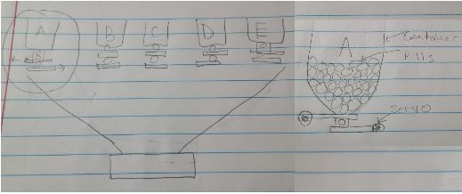

The initial design of our project was to be a fully functional pill dispensing machine that would run on its own at a set time per week and you could change the amount of pills that the dispenser would dispense through a phone. The pill dispenser’s original dimensions for the exterior of the device was 1’x1’x1’ and to be made out of wood. The top of the pill dispensing machine would have a plexiglass door connected to hinges to allow easy access to be able to get inside of the pill dispensing machine easily. Another feature to the door was to add a locking system to allow kids from getting into the machine and mistakenly take any of the pills for candy. The inside of the pill dispensing machine is going to have 5 PVC pipe containers to hold the medicine, hoppers to dispense the pills, a ramp to guide the pills down into the container at the end of the ramp so the pills would be accessible to the person taking the pills. The hoppers would be wired and connected to a breadboard that would be hooked up to an Arduino. The Arduino would send an output to said hopper to make the hopper dispense the pill and also tell it how many pills to dispense. The Arduino would have a Bluetooth device attached to the breadboard so that the Arduino could be accessible and ran through a phone. The phone would have an app installed onto it and the app itself would send the code to the Arduino so that the Arduino could send an output. The app also would allow people to also be able to change the time of which the pills were dispensed and how many pills the hoppers would dispense.
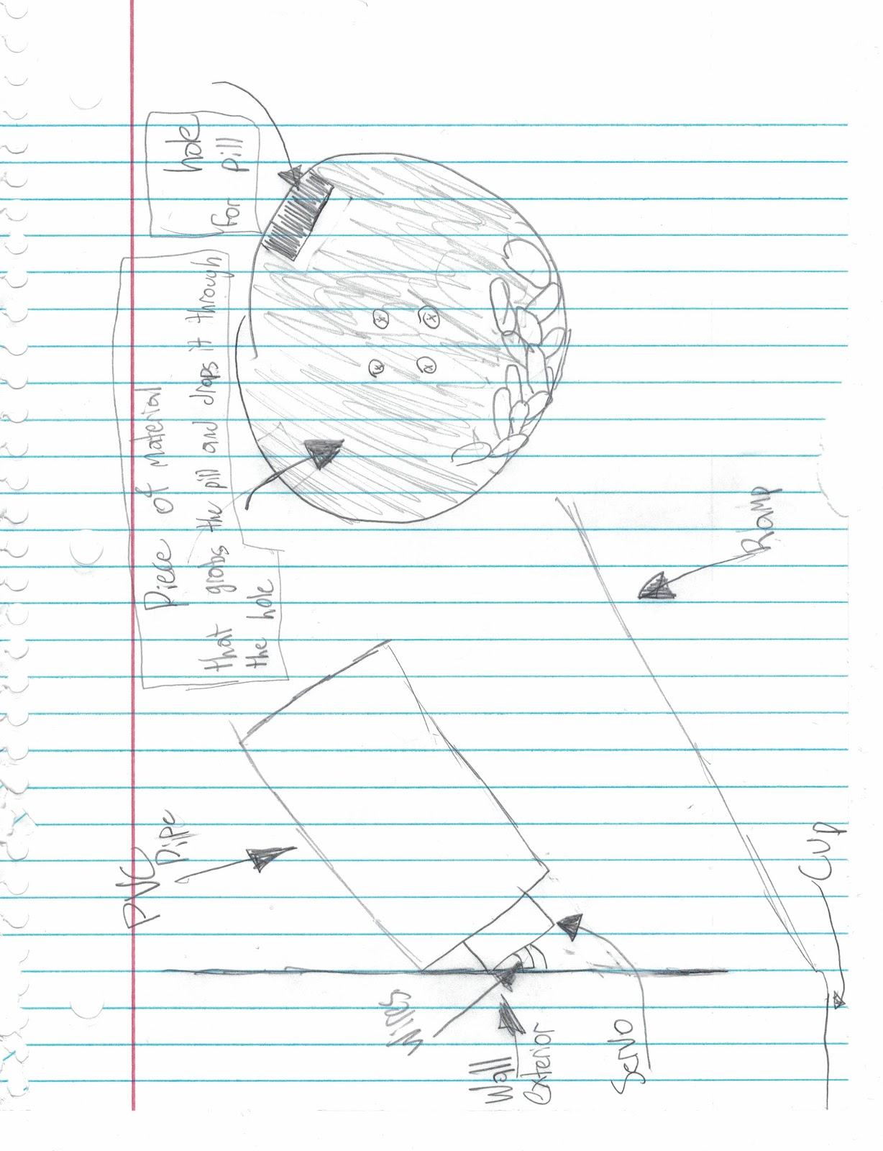

Changes made to the initial design – What changes have you made since your initial idea presentation, why were they necessary, how are they going to change the outcomes of your project.

In this project, our group has made a few changes to the initial design that were crucial to for the final project. One of the changes that we made to the design is how the pill would be dispensing out of the machine. Originally, we wanted a hopper to dispense the pill one at a time but we decided instead to then use a Geneva wheel to dispense a pill by rotating the Geneva wheel a certain degree. After searching the web we then found that the Geneva wheel would not work because we could not find them online to buy fairly cheap so then we went to a servo and two cut out cardboard disks (13). The disks would overlap each other, the first was stationary with a hole cut out of it so the pill would dispense, and the other disk was secured to the moving part of the servo so it would grab a pill and dispense it when it got to the top. Another thing that we changed from our original design is that instead of using an Arduino we used a raspberry pi. The reason we decided to use a raspberry pi is because for what our group had envisioned, an Arduino would not be able to run all of these tasks that we wanted at a specific time, and be accessible through a phone app. The next thing that we changed in our original design was to only have three operating pill dispensers instead of five. We decided to use three instead of five is because first we didn't have enough room to be able to fit five PVC pipes into our box, second we didn't have 5 working servos, and finally we decided three was a perfect number because it shows that the code we used could be repeatable and it could function properly and because three PVC fit perfectly in our box. Finally the last thing we changed from our final design was not to add a lock because in our prototype we were always accessing it internally and opening and closing the top and we felt that would be annoying to have to keep unlocking the top every time we wanted to access the machine internally, and once we wanted to do that we had no time left to be able to add a lock, so that is why we didn’t have a locking system on our device.

Circuit – Photos of the circuit and schematic of the same circuit (multiple photos if circuit is complex or on two boards etc.), explaining the role of each connection

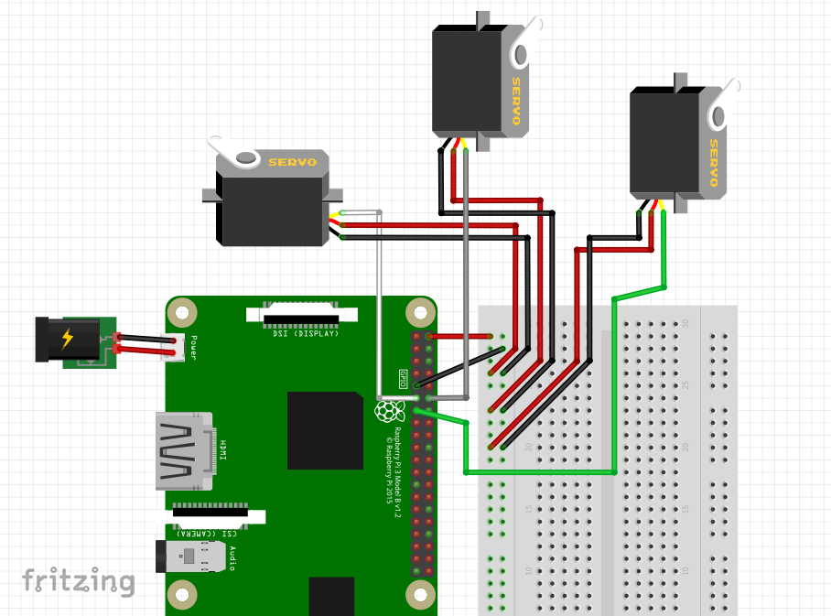

In the circuit we don’t have many connections in it. There are 5 main connections that are involved in circuitry. The first and second connections are the red and gray wires and those are the 5v wire and the ground wire respectively. The next connection that we have is for pin 11 which allows the raspberry control the servo. Finally the last connection that we have is the servo to the 5v, ground, and pin 11. This is needed to actually be able to run the servo. 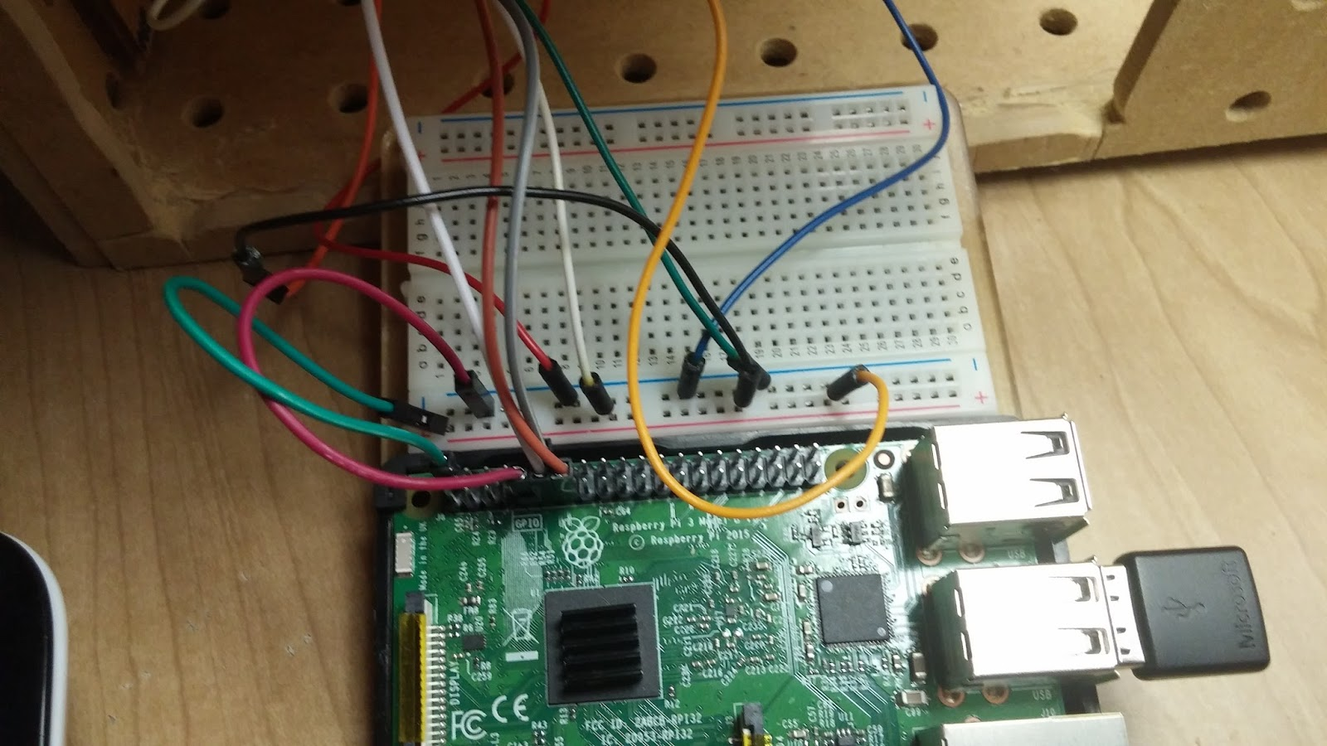

Physical construction – Explain how you constructed your box or car or anything else that holds the circuitry and parts; add photos from different angles with short explanations for each

Figure 1 (before putting front piece on) Figure 2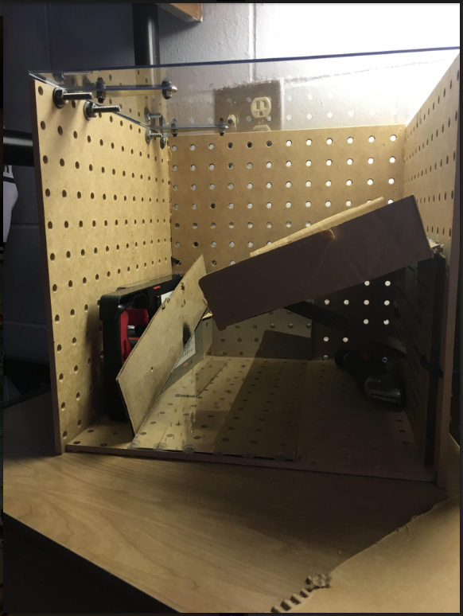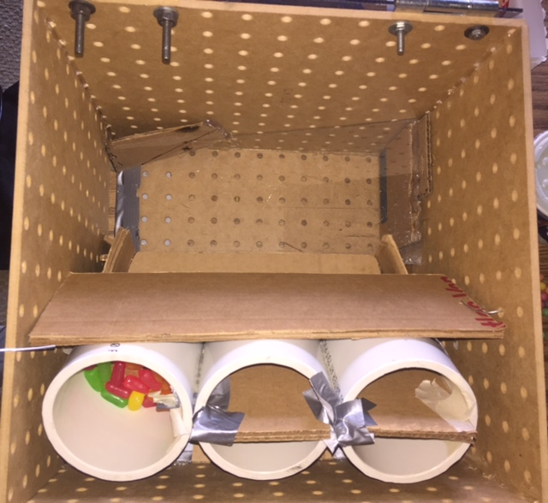

We used five foot by foot pieces of wood to make a box like container to hold all the interior parts together. For the top of the whole assembly we have a square cut out of plexiglass with hinges attached to it so that you can open and close the top. For the first ramp we made something to have the pills slide down on after having the pill dispensed, so we used cardboard and built walls on each side so that the pills would not go sliding off of either side. Right below the first ramp we made room to put all of our boards and wiring. Coming off of the first ramp we put another ramp made out of plexiglass to direct the pills in a different direction so they are able to fall out of the box. On the plexiglass ramp we also had to put cardboard walls so that the pills would be directed to the hole cut out at the end of the ramp so they wouldn't get stuck in the interior. We also but a flat piece of cardboard over the PVC pipe assembly and attached wires at the end so that we could make a slight angle for the pills to fall out at. Moreover, you can take the cardboard and pivot it so that you can take the PVC pipe assembly come out and clean it.
For the PVC pipe assembly we used three PVC Pipes and stuck them all together. Inside of each pipe has two circular pieces of cardboard that almost exactly matched with the diameter of the pipes (we wanted to make sure the servos would be able to twist back and forth inside of the pipes) and used the servos to connect the two circular pieces of cardboard. On the top portion of pipe (Figure 4) for the top circular cut out we made a hole slightly bigger than the actually pill (hole size varies based on pill) and put a rectangular piece of cardboard down the middle so that we could make sure that we were getting one pill every time. On the bottom portion of the pipe (Figure 3) we have the servo, which connects that two circular cardboard cut outs. We also cut a hole on the bottom circular cut out (which is bigger than the top circular cut out hole), 180 degrees from the top hole so that the pills would be able to drop through after performing the twisting motion. We put duct tape on the bottom so that everything would be held together.
Figure 3 Figure 4
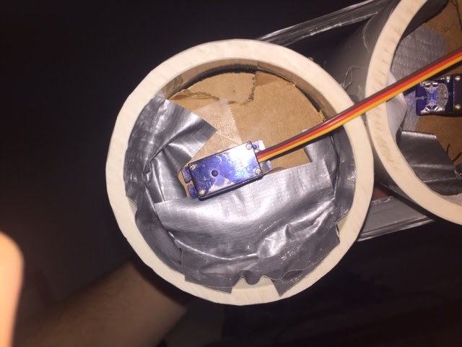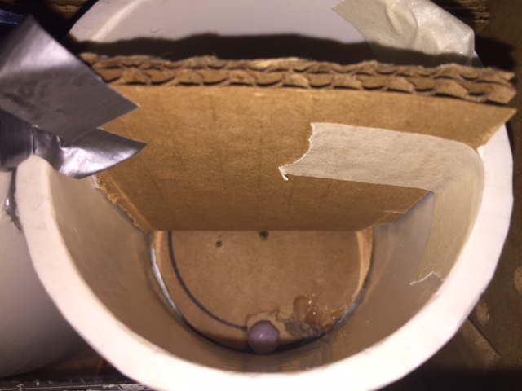

Code logic – Explain how the logic of your code works through the use of flowcharts and then explained in paragraphs.

The logic of our code runs through two different programs. The two different programs run during different parts of the flow chart. The first one being crontab which keep track of time and when to run the second part of code(12). The second program that runs for our code is logic is a python script that run the each of the servos for certain amount of rotations(8). These two programs work with each other to provide different parts of the code logic. The first part that will go over is the crontab and how that relates within the code logic.
The crontab program allows the user to run the selected program at certain times. For it to work it uses the clock within the raspberry pi to keep track of time and date(12). The raspberry pi’s clock keeps itself correct by using the wifi to keep the correct time. When the time on clock matches with crontab set time it will run the program that we have set up in the python script(12). The python code that we have set up will be in two parts that will be explain in the next paragraph.
The python code that we will have set up will work two parts a day and night script. Both scripts are almost the same with the only difference being the amount that the person sets the servo to rotate at. This allow the person to set up different time and different amount of pills for day and night time. Both code runs in the same order which is running the first servo the X amount of time(8). Then running the second servo and finally the last servo before stopping(8). Now even while this code runs the crontab is still keeping track of the time.
Now these two programs the crontab and the python code allow it run constantly drop pills at the correct times. Using both these programs may seem like a lot more work than what is needed for the code logic but this allows it to not have the time become mixed up.
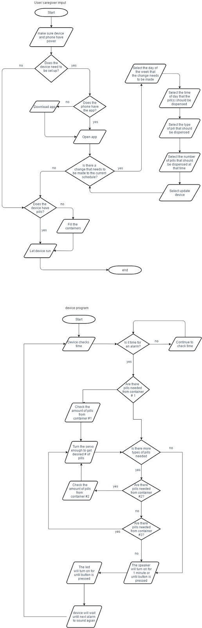
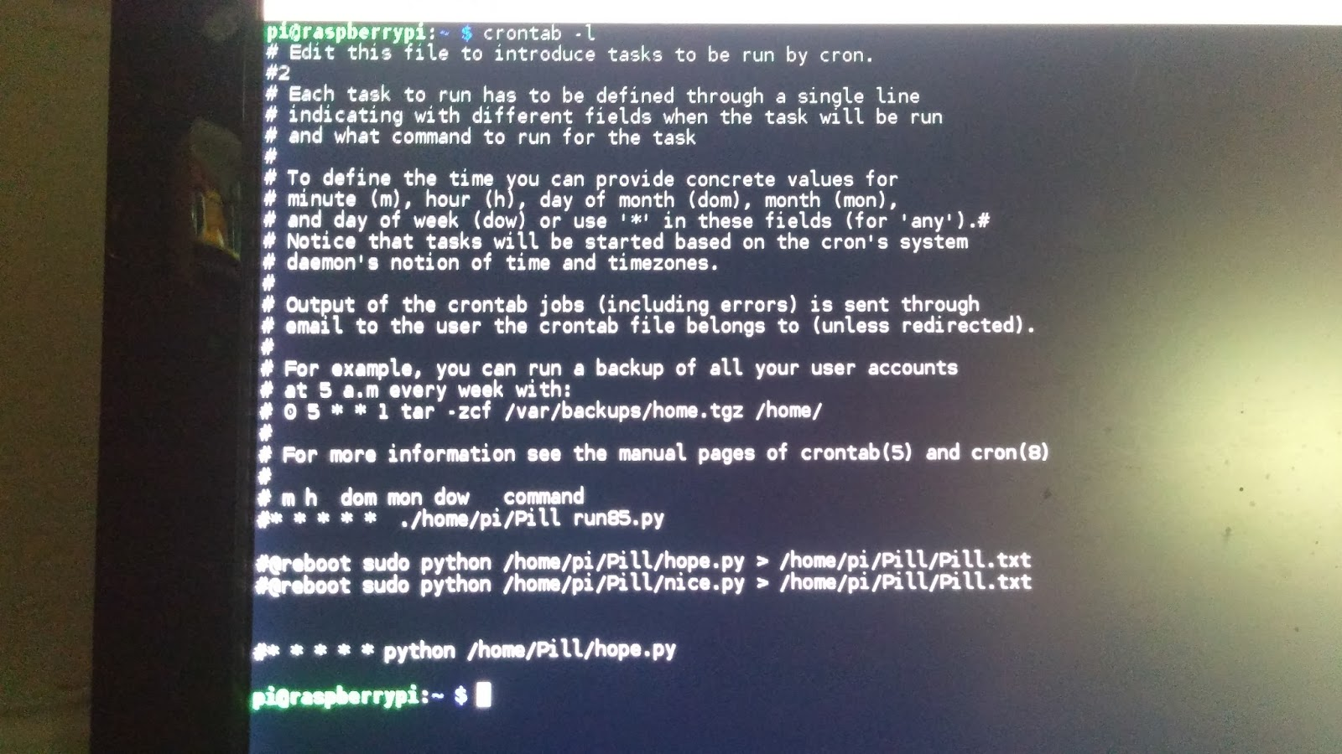

References – List all the sources used

- http://abc3340.com/archive/elderly-population-more-at-risks-for-accidental-overdose
- https://www.agingcare.com/articles/senior-drug-overdose-148701.htm
- http://www.epill.com/statistics.html
- Kyle's grandpa
- https://www.verywell.com/medication-administration-options-for-dementia-patients-98171
- http://www.merckmanuals.com/home/older-people%E2%80%99s-health-issues/aging-and-drugs/aging-and-drugs
- https://www.agingcare.com/articles/medication-problems-elderly-people-have-146111.htm
- https://www.youtube.com/watch?v=SGwhx1MYXUs&t=2582s
- https://pihw.wordpress.com/guides/direct-network-connection/
- https://www.element14.com/community/servlet/JiveServlet/previewBody/73950-102-10-339300/pi3_gpio.png
- https://www.dexterindustries.com/howto/walk-through-and-tutorial-on-how-to-connect-the-raspberry-pi-and-mobile-phone-connect-raspberry-pi-mobiletablet/
- https://help.ubuntu.com/community/CronHowto
- https://www.youtube.com/watch?v=tcoCbNUKJPc
- https://iremedysupply.com/apex-medichest-7-day-pill-organizer.html?dfw_tracker=16083-2479&gclid=Cj0KEQjwrsDIBRDX3JCunOrr_YYBEiQAifH1FsamJ9wkqXJW8Lvsm4KnPCy6LNowcTuJnrPt1hME3xQaAjMH8P8HAQ
- https://jet.com/product/detail/5d251726a014417fb84d2c9c8fd1a068?jcmp=pla:ggl:gen_health_beauty_a2:health_care_pillboxes_a2_other:na:PLA_348434580_24222189060_pla-161971819980:na:na:na:2&code=PLA15

Appendix- Your Code
import RPi.GPIO as GPIO
import time
from datetime import datetime
GPIO.setmode(GPIO.BOARD)
GPIO.setup(11,GPIO.OUT)
GPIO.setup(12,GPIO.OUT)
GPIO.setup(13,GPIO.OUT)
pwm = GPIO.PWM(11,50)
pwm2 = GPIO.PWM(12,50)
pwm3 = GPIO.PWM(13,50)
def run1 ():
pwm.start(2)
time.sleep(1)
pwm.start(12)
time.sleep(1)
pwm.start(2)
time.sleep(1)
pwm.start(0)
time.sleep(1)
print('Run 1')
def run2 ():
run1()
run1()
print('Run 2')
def run3 ():
run2()
run1()
print('Run 3')
def run4 ():
run2()
run2()
print('Run 4')
def run5 ():
run3()
run2()
print('Run 5')
def run21 ():
pwm2.start(2)
time.sleep(1)
pwm2.start(12)
time.sleep(1)
pwm2.start(2)
time.sleep(1)
pwm2.start(0)
time.sleep(1)
print('Run 21')
def run22 ():
run21()
run21()
print('Run 22')
def run23 ():
run22()
run21()
print('Run 23')
def run24 ():
run22()
run22()
print('Run 24')
def run25 ():
run23()
run22()
print('Run 25')
def run31 ():
time.sleep(1)
pwm3.start(2)
time.sleep(1)
pwm3.start(12)
time.sleep(1)
pwm3.start(2)
time.sleep(1)
pwm3.start(0)
time.sleep(1)
print('Run 31')
def run32 ():
run31()
run31()
print('Run 32')
def run33 ():
run32()
run31()
print('Run 33')
def run34 ():
run32()
run32()
print('Run 34')
def run35 ():
run33()
run32()
print('Run 35')
def done ():
print('Finished')
#Runs the first servo, Just remove the “#” from the number you want to run and place the “#” before the previous line that was running
#run1()
#run2()
#run3()
#run4()
run5()
time.sleep(1)
#Runs the second servo ex. run21() will run the second servo once.
#run21()
#run22()
#run23()
#run24()
run25()
time.sleep(1)
#Runs the third servo
#run31()
#run32()
#run33()
#run34()
run35()
time.sleep(1)
done()

