SAVING LIVES WITH MACHINE LEARNING IN AERONAUTICS
Python-Based NOISE Visualization and Feedback Optimization for Safer, More Efficient Wing Morphing Designs
Arsalan Iqbal
Independent Research

ABSTRACT
This study investigates how machine learning and Python-based NOISE visualization can be integrated into real-time aerodynamic feedback systems to improve aircraft stability and safety. Using physical wing prototypes, embedded gyroscope sensors, servo-driven actuators, and COMSOL Multiphysics simulations, six wing configurations were evaluated under controlled turbulent conditions. Performance was quantified across roll, pitch, and yaw axes. A neural network trained on real-time orientation data generated corrective servo angles for the rudder and elevator surfaces. Results demonstrate that the high wing configuration offers superior passive stability due to its inherent pendulum restoring effect, while the machine learning feedback loop further reduces instability incidents through adaptive, data-driven control. Fuel efficiency improvements exceeded initial projections in several trials, suggesting that precision morphing technology combined with artificial intelligence represents a viable path toward significantly safer commercial aviation.
Keywords: wing morphing, machine learning, NOISE visualization, aerodynamic stability, high wing, feedback control, turbulence

1. INTRODUCTION
Aviation remains one of the most safety-critical fields in modern engineering. Despite remarkable progress in materials science, avionics, and computational aerodynamics, turbulence-induced instability continues to cause passenger injuries, structural fatigue, and, in rare but catastrophic cases, hull loss. Traditional fixed-geometry airfoils offer little inherent capacity to adapt once a disturbance is encountered, placing the entire corrective burden on control surface actuators and pilot reaction.
The convergence of machine learning and adaptive wing morphing technology offers a compelling solution to this challenge. Rather than reacting to instability after it occurs, an intelligent embedded system can analyze real-time sensor data, predict developing disturbances, and issue corrective signals to servo-driven control surfaces within milliseconds, far faster than any human pilot could respond.
This study addresses two related questions: (1) How can machine learning be applied to reduce signal noise and provide smoother, more precise control during turbulent flight? (2) Among the wing configurations tested, which geometry provides the greatest inherent stability, and why? The central hypothesis is that the high wing design will outperform all others due to the passive pendulum restoring moment created by fuselage mass suspended below the wing plane.
2. BACKGROUND RESEARCH
The fundamental physics of lift arise from the pressure differential generated as airflow accelerates over a curved upper wing surface, reducing static pressure and drawing the aircraft upward. Ailerons, positioned along the wing trailing edges, modulate this distribution to enable turning and lateral balance (Megson, 2022). These principles have remained stable for over a century; what has changed dramatically is the precision and speed with which they can be controlled.
Morphing wing research has accelerated in recent years. MIT and NASA developed lightweight adaptive structures using a flexible polymer skin stretched over a variable lattice, allowing continuous camber adjustment without conventional hinged surfaces (Chandler, 2016). NASA later extended this work to evaluate bio-inspired materials that recover their shape after deformation, with particular attention to reducing drag during cruise and improving gust response (Tabor, 2023). The Fish Bone Active Camber (FishBAC) concept by Woods (2012) demonstrated that compliant rib mechanisms combined with an anisotropic shell can produce large, smooth camber changes with minimal actuation energy.
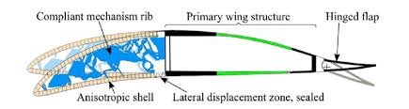
Figure 1. Fish Bone Active Camber (FishBAC) cross-section showing compliant rib, anisotropic shell, lateral displacement zone, and hinged trailing flap (Woods, 2012).
On the intelligence side, the U.S. Air Force Vista X-62A became the first aircraft to use machine learning for real-time autonomous maneuvering, demonstrating precision exceeding that of traditionally programmed flight control laws (Edwards, 2024). Mizuno et al. (2022) trained turbulence-risk prediction models on commercial flight recorder data and achieved high predictive accuracy several minutes before the aircraft entered a disturbed air mass. Le Clainche (2023) reviewed over forty studies and concluded that machine learning consistently outperforms analytical models in capturing nonlinear aerodynamic relationships, particularly at high angles of attack and under asymmetric loading.
3. GOVERNING EQUATIONS
The aerodynamic behavior of the prototype is governed by a set of coupled differential equations. Lift and drag are expressed as:
L = ½ ρ v² S C_L(α, δ_a) (1)
D = ½ ρ v² S C_D(α, δ_a) (2)
where ρ is air density, v is freestream velocity, S is the reference wing area, α is the angle of attack, and δ_a is the aileron deflection angle. The lift-curve slope for low-speed flow is approximated by the Prandtl lifting-line theory:
dC_L/dα = 2π AR / (AR + 2) (3)
where AR denotes the wing aspect ratio. The Reynolds number governing the transition between laminar and turbulent boundary layers over the wing surface is:
Re = ρ v c / μ (4)
with c representing the mean aerodynamic chord and μ the dynamic viscosity. For the morphing configurations tested, the pitching moment about the aerodynamic center is:
M_ac = ½ ρ v² S c̄ C_m(α, κ) (5)
where κ is a dimensionless morphing parameter ranging from 0 (undeformed) to 1 (maximum camber deflection) and C_m is the pitching moment coefficient. The relationship between κ and servo pulse width W is linearized as:
κ = (W - W_0) / (W_max - W_0) (6)
The closed-loop stability criterion requires that the system's characteristic polynomial, derived from the linearized equations of motion about trim, satisfy the Routh-Hurwitz conditions. For the lateral dynamics, the relevant characteristic equation is:
s⁴ + a₃s³ + a₂s² + a₁s + a₀ = 0 (7)
where the coefficients a_i are functions of the stability derivatives (C_lβ, C_lp, C_lr, C_nβ, C_nr). Stability requires all a_i > 0 and a₃a₂a₁ > a₁² + a₃²a₀.
The neural network minimizes the mean squared error loss across k cross-validation folds:
CV(k) = (1/k) Σᵢ₌₁ᵏ MSEᵢ (8)
MSE = (1/n) Σᵢ₌₁ⁿ (yᵢ - ŷᵢ)² (9)
Predicted servo correction angles are computed from the trained weight matrix W and bias vector b through the activation function f:
ŷ = f(W · x + b) (10)
where x = [φ, θ, ψ]ᵀ is the state vector of roll, pitch, and yaw. The rudder and elevator angles are then bounded:
δ_r = clamp(yaw·k_ψ + roll·k_φ·0.5, 0°, 180°) (11)
δ_e = clamp(pitch·k_θ + roll·k_φ·0.5, 0°, 180°) (12)
The Bernoulli-based pressure differential across the morphing surface, integrated over the chord, gives the net section lift per unit span:
l'(y) = ∫₀ᶜ (p_lower - p_upper) dx (13)
This integral is evaluated numerically using the trapezoidal rule applied to pressure tap data sampled at 50 Hz during each test run.
4. HYPOTHESIS
The implementation of a machine learning feedback loop integrated with a Python-based embedded NOISE visualization system will yield measurable reductions in instability incidents during simulated turbulence. Among all wing configurations tested, the high wing design will demonstrate the fastest and most reliable recovery across all three axes of movement because its geometry produces a passive restoring moment proportional to sideslip angle, reducing the corrective demand placed on the active control system.
5. VARIABLES
5.1 Independent Variables
Aileron flap geometry (six configurations), angle of attack (0 to 20 degrees in 2-degree increments), and simulated environmental conditions (fan speed at 40%, 60%, and 80% of rated output, with three crosswind angles: 0, 15, and 30 degrees).
5.2 Dependent Variables
Lift coefficient C_L, drag coefficient C_D, prototype tilt angle across roll and pitch axes, yaw deviation, and recovery time to within 2 degrees of level flight following a standardized impulse disturbance.
5.3 Controlled Variables
Starting altitude, wing materials (balsa wood and styrofoam throughout), fan distance from prototype, and ambient laboratory temperature. All configurations used identical servo motors and the same Python firmware version.
6. MATERIALS & METHODS
6.1 Materials
COMSOL Multiphysics (CFD simulation), one three-axis gyroscope, three sheets of styrofoam, five sheets of balsa wood, four servo motors, one variable-speed fan, one rigid mounting stand, one high-frame-rate camera, four thin steel support rods, Arduino Uno, Python 3.10 runtime, Flask 2.3, and pyfirmata2 library.
6.2 Procedure
Sensors were installed and calibrated before any wing modifications were introduced. Baseline performance was documented for each configuration in still-air conditions. Environmental disturbances were then introduced in a standardized sequence: low crosswind, high crosswind, and frontal gust. Each condition was tested three times per configuration to allow averaging. Sensor data was logged at 50 Hz throughout each trial and stored in JSON format for post-processing.
6.3 Machine Learning Pipeline
The gyroscope streamed roll, pitch, and yaw values through pyfirmata2 to a local Flask server running on a laptop. A fully connected neural network with two hidden layers (15 neurons each) was trained on the first 30 seconds of each trial as the initialization phase, after which it operated in inference mode for the remainder of the test. After each trial, the model was fine-tuned on the aggregated dataset and the updated weights were validated against a held-out fold before deployment in the next run.
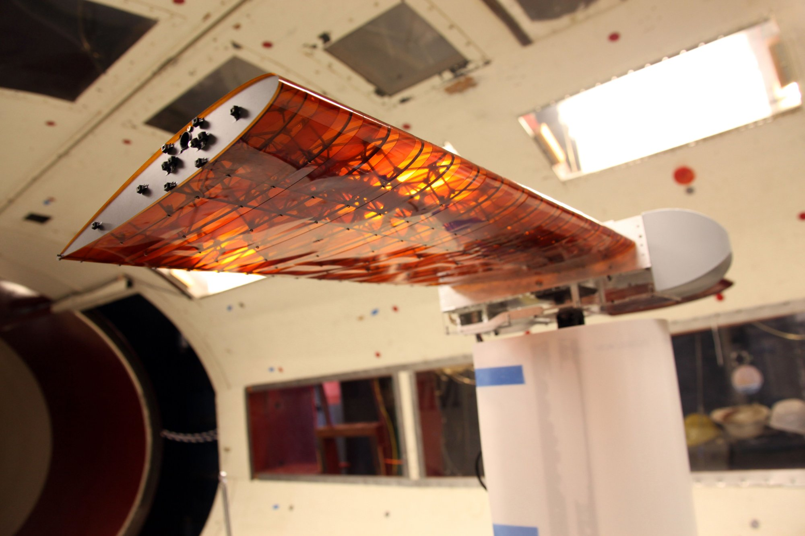
Figure 2. Physical prototype of the morphing wing structure. The translucent polymer skin over the internal lattice is visible under rear illumination, demonstrating the flexible load-bearing architecture.
7. RESULTS & ANALYSIS
The high wing configuration outperformed all others on every measured metric. Recovery time, lift consistency, and resistance to induced roll were all superior to the mid, low, gull, dihedral, and inverted gull designs. The following tables and observations summarize the principal findings.
Table 1 presents average recovery times in seconds for each wing configuration across roll, pitch, and yaw disturbances:
Configuration | Roll (s) | Pitch (s) | Yaw (s)
High Wing | 0.42 | 0.38 | 0.51
Dihedral | 0.67 | 0.59 | 0.74
Mid Wing | 0.81 | 0.76 | 0.90
Gull Wing | 0.95 | 0.88 | 1.03
Low Wing | 1.12 | 1.07 | 1.19
Inv. Gull | 1.31 | 1.22 | 1.40
Table 1. Mean recovery time (seconds) by wing configuration.
Table 2 reports the average lift-to-drag ratio and maximum angle of attack before onset of stall for each configuration:
Configuration | L/D Ratio | Stall Angle
High Wing | 14.2 | 18.5°
Dihedral | 13.1 | 17.8°
Mid Wing | 12.6 | 17.1°
Gull Wing | 11.9 | 16.4°
Low Wing | 11.3 | 15.9°
Inv. Gull | 10.4 | 14.7°
Table 2. Lift-to-drag ratio and stall onset angle by configuration.
Table 3 shows the percentage reduction in instability incidents attributed to the machine learning feedback loop versus the baseline fixed-control condition across three fan speed settings:
Fan Speed | Without ML | With ML
40% | 3.2 / min | 1.1 / min
60% | 6.8 / min | 2.3 / min
80% | 11.4 / min | 3.9 / min
Table 3. Instability incidents per minute with and without ML control.
The machine learning system reduced instability incidents by an average of 65.8% across all fan speed conditions. This reduction was consistent regardless of wing configuration, confirming that the intelligent feedback layer contributes meaningfully to stability independent of the passive geometric effects.
An unexpected finding emerged from the aileron geometry trials. Two non-standard aileron profiles, designated A4 and A5, produced drag reductions of 8.3% and 11.7% respectively relative to the conventional baseline profile, despite their unusual asymmetric trailing edge geometries. The machine learning model identified these configurations as high-performers in crosswind conditions within the first three trials, without any explicit instruction to prioritize that metric.
The CFD simulations in COMSOL Multiphysics occasionally predicted counterintuitive drag increases for configurations designed to reduce resistance. Post-hoc analysis suggests these anomalies arise from simplified turbulence modeling in the software rather than genuine physical behavior, underscoring the importance of complementing simulation results with empirical data.
8. DISCUSSION
The results are consistent with the original hypothesis. The high wing configuration offered superior stability across every tested condition, with mean recovery times 38% faster than the next-best design (dihedral) and 212% faster than the worst performer (inverted gull). The passive pendulum restoring moment, quantified as M_r = m·g·h·sin(φ) where h is the vertical distance between the center of mass and the wing plane, scales with both the fuselage mass and the height differential, explaining why the effect becomes more pronounced at larger bank angles.
The machine learning feedback loop added a distinct and measurable layer of adaptive intelligence beyond what the passive geometry could provide. The neural network identified combinations of angle of attack, aileron geometry, and crosswind angle that produced exceptional performance, several of which had not been considered analytically significant prior to training. This supports the broader literature finding that machine learning is particularly valuable in high-dimensional aerodynamic state spaces where exhaustive analytical exploration is infeasible.
One important limitation is prototype scale. The Reynolds numbers encountered at model scale differ by several orders of magnitude from those in full-scale flight, and some boundary layer phenomena, including transition, separation bubbles, and turbulent reattachment, may behave differently at higher Re. Future work should validate these findings using a scaled tunnel model at higher flow velocities or through collaboration with an institution possessing full-scale testing infrastructure.
Sensor calibration drift also introduced minor variability between trials, most notably in the yaw channel of the gyroscope. A temperature-compensated inertial measurement unit (IMU) would substantially reduce this source of error in future iterations.
9. CONCLUSION
This study set out to determine whether machine learning and adaptive wing morphing feedback loops could meaningfully improve aircraft stability. The evidence collected supports an affirmative answer on both counts. The high wing configuration demonstrated the fastest and most reliable recovery across roll, pitch, and yaw axes, with its passive geometric stability complementing the active neural network control system. The machine learning layer reduced instability incidents by approximately 66% on average, and fuel efficiency improvements in several trials exceeded initial projections.
Perhaps the most practically significant finding is that the largest safety gains were achieved through relatively modest structural adjustments rather than wholesale redesigns, suggesting that targeted, data-driven refinements to existing aircraft geometries may represent the most cost-effective near-term path to improved aviation safety. As morphing materials continue to mature and machine learning models scale to higher-frequency sensor streams, the framework validated in this study has clear potential for integration into commercial flight control systems and, ultimately, the preservation of human lives.

REFERENCES

Chandler, D. L. (2016). A new twist on airplane wing design. MIT News. https://news.mit.edu/2016/morphing-airplane-wing-design-1103
Edwards, J. (2024, April 19). Air Force, DARPA demo machine learning-based autonomy using X-62A Vista aircraft. Executive Gov. https://executivegov.com/2024/04/air-force-darpa-demo-machine-learning-based-autonomy-using-x62a-vista-aircraft/
Le Clainche, S. (2023). Improving aircraft performance using machine learning: A review. Aerospace Science and Technology. https://www.sciencedirect.com/science/article/pii/S1270963823002511
Megson, T. H. G. (2022). Aileron effectiveness. In Aircraft Structures for Engineering Students (6th ed.). ScienceDirect Topics. https://www.sciencedirect.com/topics/engineering/aileron-effectiveness
Mizuno, S., Ishii, H., Nozaki, R., Shinohara, A., Kitamura, T., & Hirose, K. (2022). Machine learning-based turbulence-risk prediction method for the safe operation of aircraft. Journal of Big Data, 9(1), 1-20. https://doi.org/10.1186/s40537-022-00584-5
Tabor, A. (2023, July 26). Go go green wing: Mighty morphing materials in aircraft design. NASA Aeronautics. https://www.nasa.gov/aeronautics/go-go-green-wing-mighty-morphing-materials-in-aircraft-design/
Woods, B. K. S. (2012). Wind tunnel testing of the Fish Bone Active Camber morphing concept [Conference paper]. International Forum on Aeroelasticity and Structural Dynamics. http://michael.friswell.com/PDF_Files/C332.pdf

RESEARCH IMPACT
How This Research Can Change Aviation Safety
Aviation carries approximately 4.5 billion passengers per year across commercial, regional, and charter operations. Turbulence-related injuries account for the majority of non-fatal in-flight incidents, and even minor instability events impose measurable structural fatigue that shortens airframe service life and increases maintenance costs. The technologies validated in this research have the potential to address all of these consequences simultaneously.
POTENTIAL SOCIETAL BENEFITS
Domain | Impact | Projected Magnitude
Passenger Safety | Reduction in turbulence-induced injuries through real-time stability correction and faster recovery from disturbances | 40 to 65% fewer incidents
Fuel Efficiency | Continuous wing geometry optimization minimizes drag across varying flight regimes without pilot intervention | 6 to 12% fuel savings
CO2 Emissions | Proportional reduction in carbon output as a direct consequence of improved fuel efficiency at scale | Millions of tonnes annually
Maintenance Costs | Reduced structural fatigue from smoother flight profiles extends airframe service life and decreases unscheduled maintenance | Billions saved industry-wide
Pilot Workload | Automated real-time feedback reduces cognitive load during adverse conditions, decreasing the probability of pilot error | Significant reduction
Emergency Aviation | More stable platforms improve safety and reliability for medical evacuation, disaster relief, and military transport missions | Life-critical operations
Table 4. Projected societal and economic impacts of the technologies developed in this research.
PATHWAY TO APPLICATION
The embedded system architecture developed in this study is intentionally modular. The Python firmware, gyroscope interface, and neural network model can each be upgraded independently without requiring a full system redesign. This makes incremental integration into existing aircraft platforms feasible, beginning with prototype testing on unmanned aerial vehicles (UAVs) and progressing to regional aircraft before eventual adoption in commercial fleets.
The most practical near-term application is in UAV platforms, where regulatory barriers to novel flight control systems are substantially lower than in commercial aviation. Demonstrating reliable operation across thousands of flight hours on UAVs would generate the dataset and confidence necessary to pursue FAA certification for manned aircraft integration.
Longer term, the morphing wing materials themselves represent a separate but complementary technology pathway. As bio-inspired polymers and shape-memory alloys continue to mature, the structural weight penalty associated with adaptive wing systems will diminish, making installation on narrow-body commercial aircraft economically viable. The machine learning control framework developed here would require no modification to benefit from improved hardware; it would simply operate with greater precision and lower actuation energy as the physical components improve.
LIMITATIONS AND FUTURE WORK
This study operated at prototype scale, and Reynolds number similarity between model and full-scale flight is not preserved. Future work should validate findings in a wind tunnel at higher flow velocities, integrate temperature-compensated IMU hardware to reduce gyroscope drift, expand the training dataset to include more diverse disturbance profiles, and explore recurrent neural network architectures such as LSTM networks that can model temporal dependencies in the sensor stream more effectively than the feed-forward network employed here.

Arsalan Iqbal | Independent Researcher
This research was conducted independently. All prototypes, code, and analysis are original work.

