Hydroelectric Turbine and Pully System
Magnetic Power Company is run by a man named Hastings in Malawi. His business is to spread and create the access of electricity to the people of his community. The way that Hastings has been able to generate electricity in his community is by creating hydroelectric generators. Some of the details that pertain to this project and why Hastings is trying to improve his system are as follows. Currently, only about 11.9% (The World Bank, 2017) of the Malawi community has the access electricity. Hastings has built his business on converting motor casings, and other materials he finds in the scrap-yard, into nano-hydro-generators. The job of our group is to aid in the processes of maximizing the efficiency of electrical output from flowing water. We also plan to increase the longevity of the of the design to allow for less repairs to the already existing system. Our group was given some of the following design details; the turbine spins at 1500 RPM during nominal operation, casting processes are available for use in creating a new design, and potential tolerance of the two shafts can be difficult to maintain. Our groups objective is to determine how we plan to approach the problem, why our design would be an appropriate approach, and how Hastings could create this system for the people of his town. We believe that utilizing the materials and processes Hastings has access to, he will be able to create our design and effectively create a better system.
Currently, Hastings is working with a generator, shaft, and a turbine that he has found from a scrap-yard that he has access to. Large companies dump lots of usable materials into this scrap-yard that Hastings is able to sift through and use in his generator systems. This system works by using water from higher elevation flows downward into the city where Hastings controls the water with a valve system. From that valve system, Hastings directs the water into an enclosure where he has a 247-volt alternating current generator. That generator is connected to a shaft that has a turbine on the end of it. There is also a reservoir system that sifts all the large stones and sand out of the water to prevent damage to the turbine connect to the shaft. The idea of this system is to utilize the water flowing down and effectively pressurize it. Once the water has been pressurized, it is directed into the turbine, which turns the shaft, which runs the generator. The problem with this system is that when the water is not flowing as quickly as normal, the turbine is not producing enough rotational velocity to allow the generator to produce enough electricity. Hastings has tried to alleviate this predicament by digging holes to direct the flow of water. Hastings idea behind this is to attempt to control the water more predictable, in a similar manner to a damn. The problem with this solution is that these ponds are still relatively unpredictable, and doesn’t completely solve the problem at hand. Hastings has a lot of tools at his disposal that would allow form him to create a new system. First, he has access to the aforementioned scrap-yard, to utilize materials from. Also, he has the ability to sand cast aluminum parts if needed. Lastly, he has lathe to turn material down. Our group believes that with everything at Hastings disposal, we can design a new system that will allow for consistent flow of electricity.
The goal of our project is to allow Hastings to use his generator powered by the current water streams available in whatever RPM output there is. Currently the water stream provides the force to spin the wheel of the generator shaft. The issue that Hastings has is the inconsistency of the water flow. The generator must be spun at a certain RPM in order to provide the adequate amount of voltage to supply a home with power. Our goal as a team is to come up with a new system that will allow Hastings to utilize the stream to generate electricity at all speeds of the stream. This will be done through a series of pullies and a belt system. Similar to how you move a belt on a drill press or manual lathe, by adjusting the location of the belt on the pullies will in turn give you different speed outputs. Hastings will be able to start the generator and measure the output of the generator as he has before. If the reading shows that he must increase or decrease the speed of the generators shaft, he can then stop the generator and make adjustments. This will allow him to use the mechanical advantage of the pully system to turn the generator at a consistent speed at all times.
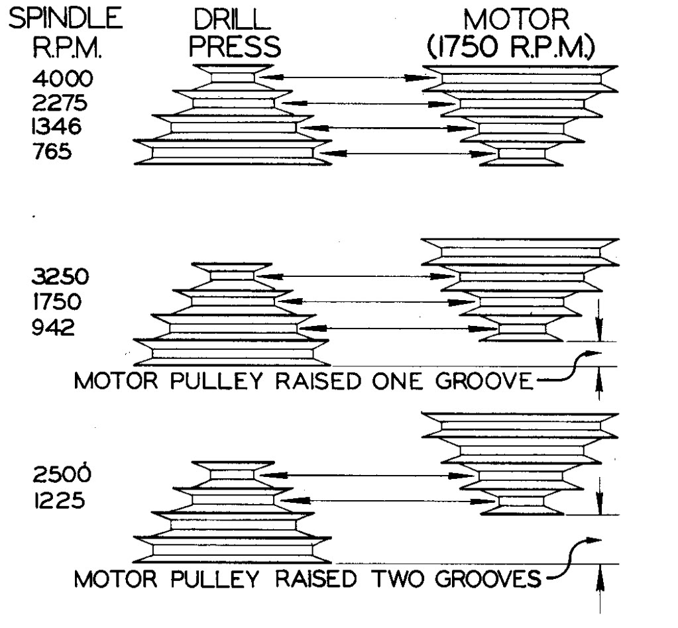
The idea of using a multiple pully system is similar to that of a drill press or a manual lathe. Essentially, the idea is that when the water is flowing at a slower speed you can move the belt and still produce a higher RPM. This will allow Hastings to hit the mark of 1500 RPM easier than he does now. So essentially the only change to the system that needs to be made is splitting the shaft into two parts. Hastings needs to utilize the existing turbine and shaft, but split that shaft into two pieces. The idea is to connect one of these pullies to each end of the two pieces of shafts and connect them with a belt that can be moved from one grove to the next. Essentially we are utilizing this simple machine to increase, and possible decrease, the amount of RPM’s being used in the system. We believe that this will alleviate the problems Hastings is facing.

How to build the System: From research of the background of the project, Hastings has access to a scrap-yard and also can do some sand casting. The items that Hastings would need in order to build the pulley system would include a pulley system, a belt, bearings, and fasteners. The first item on the list, pulley system, can be found in the scrap-yard. Hastings should look for an old lathe, drill press, or any other machinery that utilized a pulley system to drive it. By removing the pulley system from the machinery, Hastings would then be able to see if that machinery used any bearings to support the pulley system shaft. He could then utilize these bearings to support the shaft of the generator. Also, when a pulley system is found that he
can salvage for use, there should also be a belt that can be salvaged to use to drive the shaft of the generator. The last needed parts to complete the build of the pulley system would be fasteners. Depending on what type of pulley system Hastings is able to salvage, he may need fasteners to secure down the generator, shaft, and other elements of the system. By stabilizing the shaft’s motion from “wobbling” all over the place will greatly decrease the fatigue stress introduced to the shaft and the system. This will increase the longevity of Hastings generator system which in turn will be able to provide electricity to the cities for longer periods of time. This system would be a great benefit to Hastings and the people of the city because it can constantly provide power to the city with a wider range of water velocity. Meaning that Hastings will still utilize his pond or water storage system, but instead of when the stream is moving too fast or slow that he can’t generate electricity, with our system he would be able to generate electricity at these different ranges of flow.
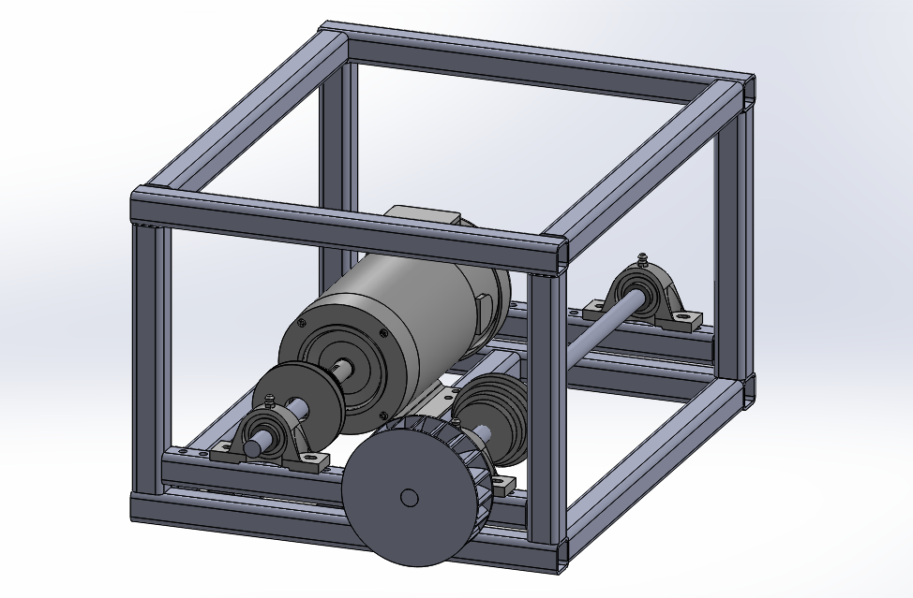
The system we have devised will allow Hastings to apply the same standardized generator setup for various motors he has sourced, and for different flow rates corresponding to different locations. This design can be easily fabricated from inexpensive structural steel, standard bearings and shafts, and sand cast pulleys; all utilizing tools that Hastings already has available to him. The ability to adapt to different flow rates and motors will allow his process to take a step towards being mass produced, that is the machine design will be relatively similar for many applications, making the fabrication process much easier.

References
The World Bank. (2017, May 2). The World Bank. Retrieved from The World Bank - Data: http://data.worldbank.org/indicator/EG.ELC.ACCS.ZS?locations=MW&page=1

