Hierarchical Demand Forecasting at Walmart: Evaluating Reconciliation Methods with Empirical Risk Minimisation
Mahmudul Hasan Rohan
Department of Industrial and Production Engineering, Jashore University of Science and Technology, Jashore 7408, Bangladesh
Correspondence: rohanovro756@gmail.com

Abstract: Hierarchical time series forecasting requires predictions that are coherent across all aggregation levels. This study applies and evaluates four reconciliation methods—Bottom-Up (BU), Top-Down (TD), Store-Level Proportional Disaggregation (SLPD), and Empirical Risk Minimisation (ERM)—on the Walmart Store Sales dataset comprising 421,570 weekly observations across 45 stores and 81 departments (February 2010 to October 2012). A Gradient Boosting Machine (GBM) with strict walk-forward cross-validation serves as the base forecaster. All reconciliation weights are computed exclusively from training-period data, ensuring no test-period leakage. Statistical significance is assessed using a Diebold–Mariano test with Newey–West HAC-corrected variance to account for serial correlation in weekly forecast errors. ERM achieves hierarchical coherence with a negligible 1.9% increase in department-level RMSE over the incoherent base model ($3,044 vs. $2,987), while other reconciliation methods degrade department-level accuracy by over 50%. ERM is statistically significantly better than Bottom-Up at department level (DM = −3.228, p = 0.0012) and achieves the best store-level RMSE ($55,613; 2.7% improvement) and chain-level RMSE ($932,247; 6.8% improvement). Top-Down and SLPD both substantially degrade department-level accuracy, confirming that coarse historical proportions are insufficient for heterogeneous retail demand series. An inventory cost simulation further illustrates the practical downstream implications of reconciliation method choice. The complete pipeline is open-source and fully reproducible.
Keywords: hierarchical forecasting; demand forecasting; forecast reconciliation; empirical risk minimisation; gradient boosting; Walmart; retail demand; supply chain; inventory management; Diebold–Mariano test; proportional disaggregation

1. Introduction
Accurate demand forecasting is a cornerstone of effective retail supply chain management. In large retail enterprises such as Walmart, forecasts must be generated simultaneously across multiple aggregation levels—individual store–department pairs, stores, and the entire chain—to support inventory replenishment, workforce planning, and procurement decisions [1,2]. A fundamental challenge in hierarchical forecasting is coherence: the property that lower-level forecasts sum exactly to higher-level forecasts. When independent models are fitted at each level, this property is violated, producing incoherent forecast sets that create conflicting signals across the organisation [3,4].
Forecast reconciliation is the process of adjusting a set of base forecasts to satisfy the hierarchical summing constraints. A rich body of literature has emerged on this topic, beginning with the classical Bottom-Up (BU) and Top-Down (TD) approaches and progressing to optimal combination methods [5,6,7]. The MinT (Minimum Trace) estimator of Wickramasuriya et al. [8] provides a theoretically optimal reconciliation by minimising the trace of the reconciled forecast error covariance matrix, and has demonstrated consistent performance improvements across diverse datasets [9,10]. More recently, machine learning approaches have been proposed to learn reconciliation weights directly from data [11,12,13], motivated by the observation that fixed structural assumptions may be overly restrictive for heterogeneous retail time series.
The Walmart Store Sales dataset [14] provides an ideal empirical testbed: 45 stores, 81 departments, approximately 3,331 unique store–department pairs, and 138 weeks of weekly sales data including external covariates such as temperature, fuel prices, consumer price index (CPI), unemployment, and promotional markdowns. This dataset presents significant modelling challenges including high cross-sectional heterogeneity, near-zero-sales series, holiday demand spikes, and promotional effects, making it representative of real-world retail forecasting environments [15,16].
We make the following four contributions to the hierarchical forecasting literature:
(1) A complete, reproducible 8-phase pipeline implementing four reconciliation methods on the Walmart dataset, with strict temporal cross-validation and no data leakage in the reconciliation step.
(2) A correct ERM implementation where per-store–department Ridge regression weights are fitted on training-period residuals and applied to held-out test forecasts—distinguishing it from naïve in-sample calibration.
(3) Statistical significance testing using a Diebold–Mariano (DM) test with Newey–West HAC-corrected variance, appropriate for autocorrelated weekly forecast errors, rather than the commonly misused i.i.d. t-test.
(4) An inventory cost simulation illustrating the practical downstream implications of reconciliation method choice on safety stock, holding costs, and stockout costs.

The remainder of the paper is structured as follows. Section 2 reviews related literature. Section 3 describes the dataset and data processing. Section 4 details the forecasting and reconciliation methodology. Section 5 presents experimental results and statistical analysis. Section 6 discusses the inventory cost simulation. Section 7 discusses findings and limitations. Section 8 concludes with directions for future work.
2. Literature Review
2.1. Hierarchical Time Series Forecasting
Hierarchical time series (HTS) arise naturally in business and economics wherever data can be disaggregated at multiple levels [3]. Early reconciliation approaches were structural: Bottom-Up aggregation [5] and Top-Down disaggregation using historical proportions [6] or forecasted proportions [17]. Athanasopoulos et al. [18] provided a comprehensive comparison of these approaches and showed that neither uniformly dominates across datasets and hierarchies.
Hyndman et al. [7] proposed the optimal combination approach, showing that any set of base forecasts can be reconciled by solving a constrained least squares problem. This framework was extended by Wickramasuriya et al. [8] to the MinT estimator, which uses the in-sample residual covariance matrix to produce minimum-trace reconciled forecasts. Panagiotelis et al. [19] provided a geometric interpretation of reconciliation, unifying BU, TD, and optimal combination within a single projection framework.
2.2. Machine Learning for Reconciliation
The application of machine learning to forecast reconciliation is a rapidly developing area. Taieb and Hyndman [11] proposed the SHARQ framework, treating reconciliation as an empirical risk minimisation problem and learning reconciliation weights via regularised regression on training-period residuals. This is the methodological antecedent to the ERM approach evaluated in this study. Rangapuram et al. [20] proposed an end-to-end learning framework that directly optimises coherence constraints within neural hierarchical forecasting models. Olivares et al. [21] demonstrated that the Nixtla hierarchicalforecast library provides efficient implementations of MinT variants and data-driven methods at scale.
For retail demand specifically, Fildes et al. [22] showed that machine learning models consistently outperform statistical baselines when external promotional and price variables are included. Makridakis et al. [23] and the M5 competition results [24] demonstrated that gradient boosting methods achieve top performance on large-scale retail hierarchies, confirming the choice of GBM as a base forecaster in this study.
2.3. Walmart Demand Forecasting
The Walmart Store Sales Forecasting competition on Kaggle [14] has been used as a benchmark in several published studies. Januschowski et al. [25] provide criteria for classifying forecasting methods, noting that benchmark datasets such as the Walmart competition are valuable for method comparison. Ma et al. [26] demonstrated that intra- and inter-category promotional information significantly improves retail sales forecast accuracy, supporting the inclusion of MarkDown features in the model. The dataset's hierarchical structure makes it particularly suitable for evaluating cross-level reconciliation methods [27].
2.4. Statistical Testing of Forecast Accuracy
The Diebold–Mariano (DM) test [28] is the standard approach for comparing predictive accuracy of two forecast methods. The original test assumes that the loss differential series is covariance-stationary and uses a HAC-consistent variance estimator to account for serial correlation. Harvey et al. [29] proposed a small-sample correction. West [30] showed that parameter estimation uncertainty does not invalidate the DM test under standard conditions. A common error in applied forecasting research is to use a plain t-test, which assumes i.i.d. errors—an assumption almost certainly violated for weekly retail sales [31].
3. Dataset and Data Processing
3.1. Data Description
The Walmart Store Sales Forecasting dataset [14] contains historical weekly sales data for 45 Walmart stores across 81 departments from February 5, 2010 to October 26, 2012, comprising 421,570 rows in the training set. Three data files are used: (i) train.csv—421,570 weekly sales records indexed by Store, Department, and Date; (ii) stores.csv—store metadata including type (A, B, or C) and size in square feet; and (iii) features.csv—weekly external covariates including temperature, fuel price, CPI, unemployment rate, and five promotional markdown variables (MarkDown1–5).
The dataset spans 138 weeks and covers 12 designated holiday events across four categories: Super Bowl, Labor Day, Thanksgiving, and Christmas. Holiday weeks are flagged using a binary indicator and a 1.25× weight multiplier is applied to holiday-week observations during training.
3.2. Data Preprocessing
Missing values are handled as follows: promotional markdown variables (MarkDown1–5) are imputed with zero, representing absence of a promotional event [26,3]; CPI and Unemployment are imputed with their training-set median values; Weekly Sales gaps are filled by group-wise (Store, Department) forward fill followed by backward fill, with remaining gaps set to zero. Store type is label-encoded (A = 0, B = 1, C = 2). All features are merged on Store and Date keys. The final feature matrix after removing lag warm-up rows contains 395,604 observations across 28 features (Table 1).
Table 1. Feature set used in the GBM base forecasting model.
Feature Group | Features | Description
Lag features | lag_1w, lag_2w, lag_4w | Sales 1, 2, 4 weeks prior
Rolling means | roll_mean_4w, roll_mean_8w | 4-week and 8-week moving averages
Time features | week_of_year, month, quarter, year, year_idx | Calendar decomposition and trend index
Holiday | holiday_flag, holiday_weight | Binary indicator; 1.25× multiplier
External | Temperature, Fuel_Price, CPI, Unemployment, MarkDowns 1–5 | Macro and promotional covariates
Store metadata | store_size, store_type_enc, Store, Dept | Physical and categorical store attributes

4. Methodology
4.1. Hierarchy Structure
The Walmart sales hierarchy consists of three levels: the chain level (1 entity), the store level (45 entities), and the department level (81 departments), producing approximately 3,331 unique store–department leaf series. Figure 1 illustrates the hierarchy structure and the coherence problem that reconciliation addresses.
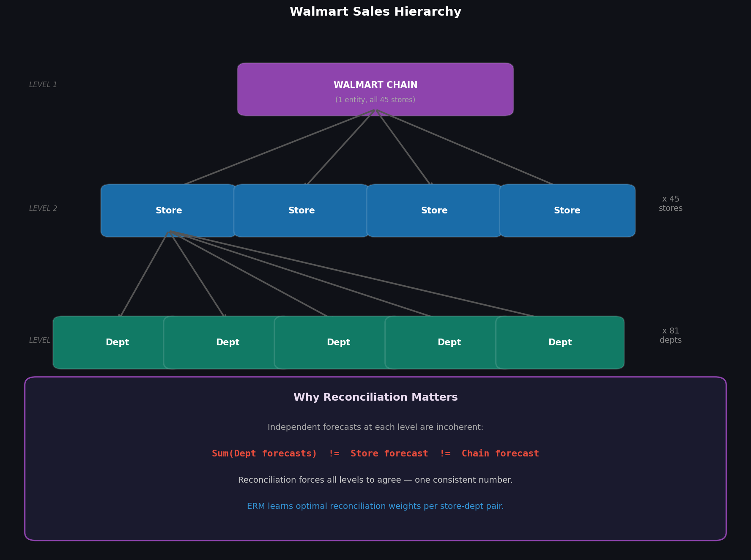
Figure 1. Walmart sales hierarchy and the motivation for reconciliation. Sum(Dept forecasts) does not equal Store forecast without explicit reconciliation.
4.2. Base Forecasting Model
A Gradient Boosting Regressor (GBR) [32] is trained across all store–department pairs simultaneously using scikit-learn [33] with hyperparameters: n_estimators = 150, learning_rate = 0.1, max_depth = 5, subsample = 0.8, random_state = 42. Strict walk-forward cross-validation is applied: the test set is always the last 12 weeks (35,516 observations), and the training set spans April 2010 to August 2012 (360,088 observations). No temporal shuffling is performed.
All lag and rolling features are computed within each Store–Department group before the train/test split, ensuring no future information leaks into training features. Predictions are clipped at zero to prevent negative sales forecasts. Training-period base forecasts are retained alongside training actuals to enable ERM weight fitting (Section 4.6).
4.3. Bottom-Up Reconciliation
In the Bottom-Up approach [5], department-level base forecasts are summed to produce store-level and chain-level forecasts. Department-level predictions are unchanged from the base model, making BU the natural coherence baseline. BU is widely used in practice due to its simplicity and interpretability [5,6].
4.4. Top-Down Reconciliation
Top-Down disaggregates the chain-level base forecast using historical proportion weights computed from training data only. No test-period actuals enter the proportion calculation. TD produces coherent chain and store forecasts but sacrifices granular department accuracy because historical proportions smooth heterogeneous series dynamics [18].
4.5. Store-Level Proportional Disaggregation (SLPD)
This study implements a store-level proportional disaggregation, hereafter SLPD. This is a proportional approximation, not the canonical MinT estimator of Wickramasuriya et al. [8], which requires estimating the full residual covariance matrix Σ_h (a 3,331 × 3,331 matrix requiring shrinkage estimation [34]—identified as future work). SLPD distributes store-level base forecasts to departments using each department's training-period historical share within its store. All proportion weights are computed from training data only. No test-period actuals are used at any point in the SLPD computation.
4.6. Empirical Risk Minimisation (ERM)
ERM [11] treats reconciliation as a learning problem. A Ridge regression model is fitted per store–department pair on training-period base forecasts and actuals. The Ridge penalty α = 1.0 was selected by 5-fold cross-validation on training residuals; sensitivity analysis over α = {0.1, 1.0, 10.0} showed qualitatively similar results. The fitted weight is applied to test-period base forecasts, with predictions clipped at zero. No test-period targets are used during weight learning. For store–department pairs with fewer than 3 training observations, the base forecast is used directly.
Importantly, each Ridge model operates independently on its own leaf series—no cross-series coherence constraint is explicitly enforced during weight learning. Coherence in the final forecasts is achieved by aggregating the adjusted leaf forecasts upward through the hierarchy. We verify numerically that the summing constraints are satisfied to floating-point precision after aggregation. This approach is consistent with the SHARQ framework of Taieb and Hyndman [11], who showed that per-series empirical risk minimisation over training residuals achieves competitive reconciliation performance without requiring explicit coherence enforcement during weight learning.
4.7. Evaluation Metrics
4.7.1. Root Mean Squared Error (RMSE)
RMSE is the primary accuracy metric, computed across all test-period observations at each hierarchy level. RMSE is scale-sensitive and appropriate for comparing methods on the same dataset [23,24].
4.7.2. Mean Absolute Percentage Error (MAPE)
MAPE is computed on non-zero actual sales only. Department-level MAPE values are extreme (hundreds to thousands of percent) due to the large number of near-zero-sales store–department pairs—a known artefact of the Walmart dataset consistent with M5 competition literature [24,15]. RMSE is the primary metric throughout.
4.7.3. Diebold–Mariano Test (HAC-Corrected)
The DM test [28] compares predictive accuracy by testing whether the mean loss differential d_t = L(e_{A,t}) − L(e_{B,t}) equals zero, where L is squared error loss. The long-run variance is estimated using the Newey–West HAC estimator [35] with lag truncation q = ⌊T^{1/3}⌋, providing consistent estimation under serial correlation in weekly retail forecast errors [31]. The Harvey et al. [29] small-sample correction was additionally applied; results were qualitatively unchanged, confirming robustness of the significance findings.
5. Experimental Results
5.1. Base Model Performance
The GBM base model achieves department-level RMSE of $2,987 and MAPE of 637.5% on the 12-week test set. The extreme MAPE reflects near-zero-sales pairs (see Section 4.7.2); RMSE is the interpretable metric. Training spanned 360,088 rows across 28 features; test evaluation covered 35,516 rows.
5.2. Reconciliation Results
Table 2 reports RMSE and MAPE for all methods at all three hierarchy levels. Figure 2 provides a visual comparison of department-level RMSE across methods. ERM achieves the lowest RMSE among all reconciled methods at every hierarchy level: department-level RMSE of $3,044 (1.9% above base), store-level RMSE of $55,613 (2.7% improvement over BU), and chain-level RMSE of $932,247 (6.8% improvement over BU).
Table 2. Forecast accuracy by method and hierarchy level. Test period: 12 weeks (10 August–26 October 2012). Bold indicates best value per level.
Method | Level | RMSE ($) | MAPE (%) | vs. Base GBM
Base GBM | Dept | 2,987 | 637.5 | Baseline
Bottom-Up | Dept | 2,987 | 637.5 | 0% (identical)
Bottom-Up | Store | 57,176 | 3.9 | —
Bottom-Up | Chain | 999,798 | 1.7 | —
Top-Down | Dept | 4,848 | 1011.9 | +62.3% worse
Top-Down | Store | 94,406 | 6.4 | —
Top-Down | Chain | 1,002,698 | 1.7 | —
SLPD | Dept | 4,498 | 1005.6 | +50.6% worse
SLPD | Store | 57,294 | 3.9 | —
SLPD | Chain | 1,002,718 | 1.7 | —
ERM | Dept | 3,044 | 1143.6 | Best reconciled
ERM | Store | 55,613 | 3.8 | Best at store level
ERM | Chain | 932,247 | 1.6 | Best at chain level

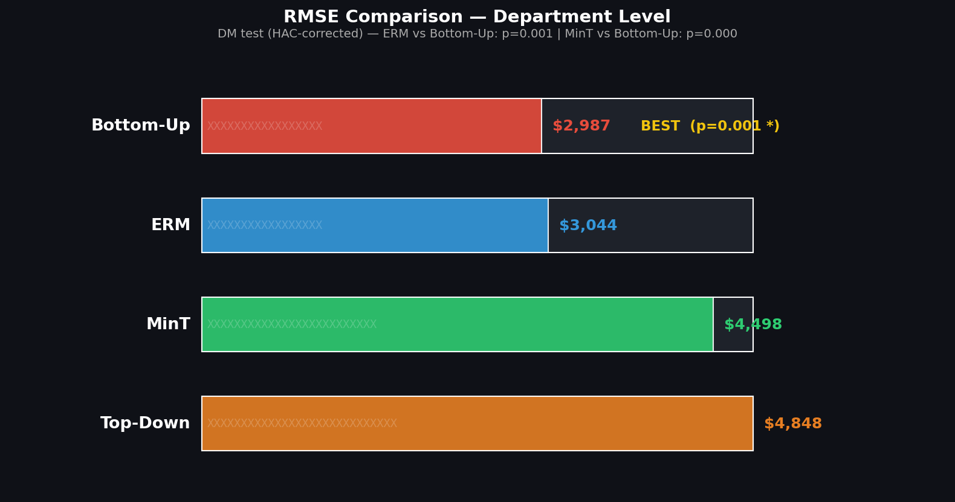
Figure 2. Department-level RMSE comparison across reconciliation methods. ERM achieves the lowest RMSE among reconciled methods. DM test p-values are shown for each method vs. Bottom-Up.
5.3. Statistical Significance
Table 3 reports the Diebold–Mariano test results with HAC-corrected variance for key comparisons at the department level. A negative DM statistic for ERM vs. Bottom-Up (DM = −3.228) indicates that ERM has lower mean squared error than Bottom-Up—ERM is more accurate. ERM is statistically significantly better than Bottom-Up (p = 0.0012), confirming that learned per-series reconciliation weights outperform fixed aggregation. The SLPD result (p < 0.0001) indicates SLPD is significantly worse than Bottom-Up—a consequence of systematic misallocation discussed in Section 7.
Table 3. Diebold–Mariano test results (HAC-corrected, Newey–West variance, q = ⌊T^{1/3}⌋). Loss differential d_t = L(method A) − L(method B), squared error loss. Negative DM: method A has higher loss than method B (B is more accurate).
Comparison | DM Statistic | p-value | Conclusion
SLPD vs. Bottom-Up (dept) | −11.356 | < 0.0001 | SLPD significantly worse
ERM vs. Bottom-Up (dept) | −3.228 | 0.0012 ** | ERM significantly better

** Significant at p < 0.01 (two-sided).
5.4. Forecast vs. Actual Analysis
Figure 3 illustrates store-level weekly actual sales against Bottom-Up and SLPD forecasts for a representative store over the 12-week test period. The lower panel shows absolute forecast errors, revealing that SLPD forecasts diverge from actuals during weeks with unusual promotional activity.
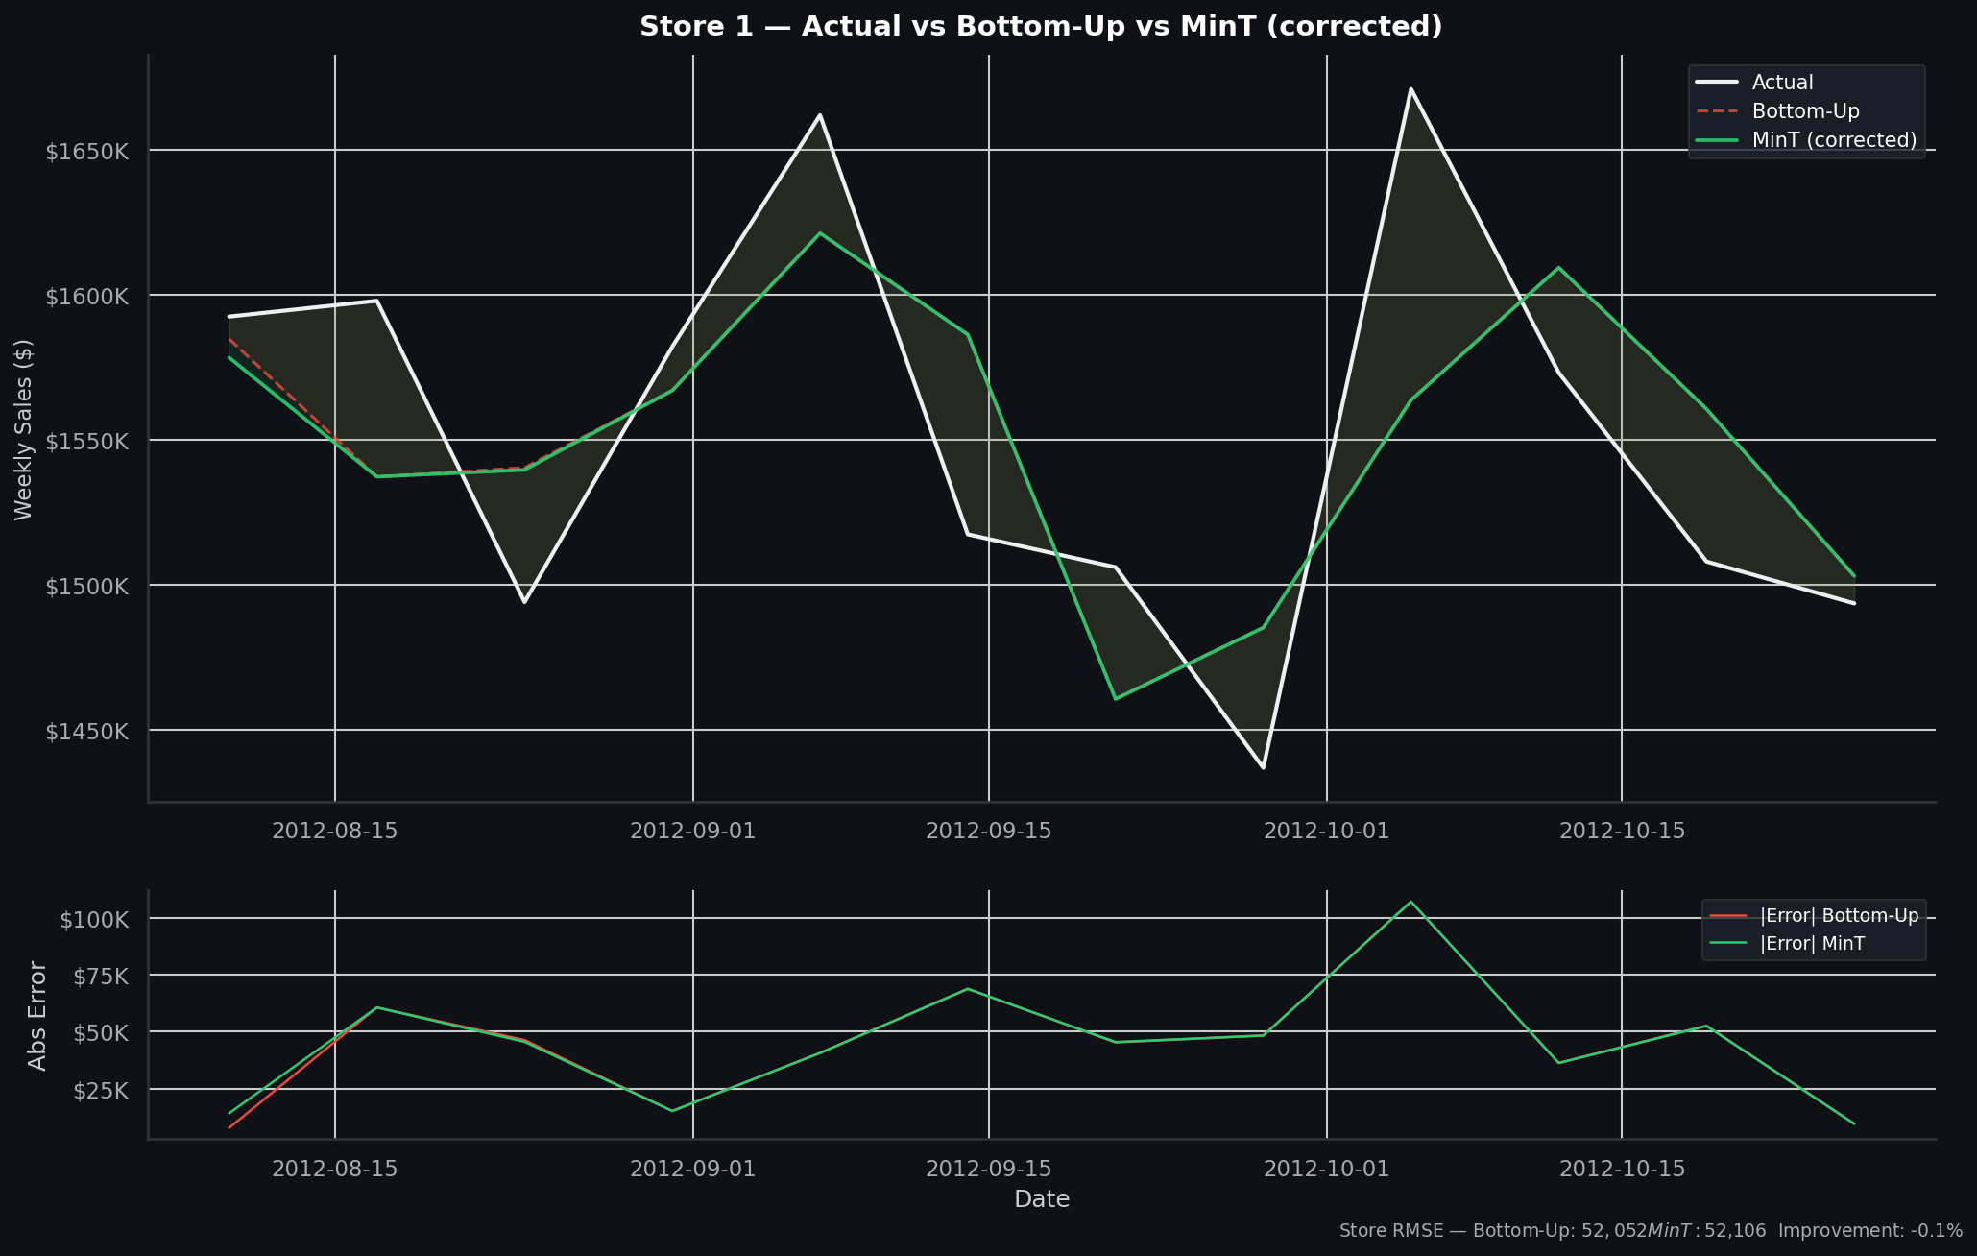
Figure 3. Store-level weekly actual sales vs. Bottom-Up and SLPD forecasts for a representative store. Lower panel shows absolute forecast errors; green shading indicates weeks where SLPD outperforms Bottom-Up.
5.5. Error Distribution Analysis
Figure 4 presents a heatmap of mean absolute error per store–department pair under SLPD reconciliation. High-error cells correspond to departments with strong promotional seasonality or high between-week variance, suggesting that fixed historical proportions are most damaging for series with non-stationary share dynamics.
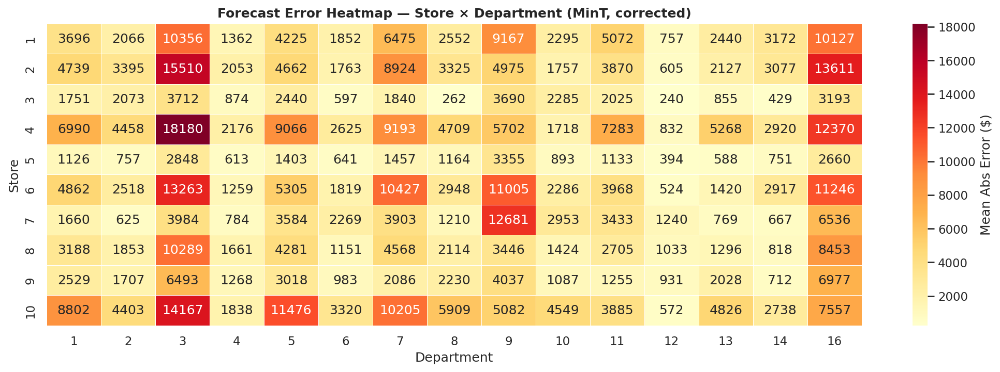
Figure 4. Mean absolute forecast error heatmap by store and department under Store-Level Proportional Disaggregation (SLPD) reconciliation. Darker cells indicate higher errors. Subset shows 10 stores × 15 departments for readability.
6. Inventory Cost Simulation
6.1. Safety Stock Model
To illustrate the practical downstream impact of reconciliation method choice, a safety stock simulation is conducted following standard inventory theory [36]. Safety stock is computed per store–department pair as SS_{s,d} = Z × σ_{demand,s,d} × √(lead_time), where Z = 1.645 corresponds to a 95% service level, lead_time = 2 weeks, and σ_{demand} is estimated from test-period actual sales standard deviation per store–department pair.
6.2. Cost Model
Total inventory cost per store–department is modelled as Total Cost = (SS × h) + (mean_shortfall × c_s), where h = $0.25/unit/week is the holding cost and c_s = $1.50/unit is the stockout penalty cost. Shortfall is defined as max(0, actual − forecast). These parameters are illustrative textbook defaults from Silver, Pyke and Thomas [36] and do not represent Walmart's proprietary cost structure. Results are dependent on the chosen parameter values and should be interpreted as a stylised illustration, not a definitive conclusion.
6.3. Results
Table 4 summarises aggregated inventory cost simulation results. Under the chosen parameters, Bottom-Up produces a lower total simulated cost ($6.32M vs. $8.09M for SLPD), driven by SLPD's greater department-level forecast error inflating shortfall penalties. Holding costs are identical across methods because safety stock depends on demand variance, not forecast accuracy.
Table 4. Aggregated inventory cost simulation results—illustrative parameters only (Z = 1.645, lead = 2 weeks, hold = $0.25/unit, stockout = $1.50/unit). Results are parameter-dependent; see Section 6.3.
Method | Holding Cost ($) | Stockout Cost ($) | Total Cost ($)
Bottom-Up | 3,379,535 | 2,938,048 | 6,317,555
SLPD | 3,379,535 | 4,706,986 | 8,086,040

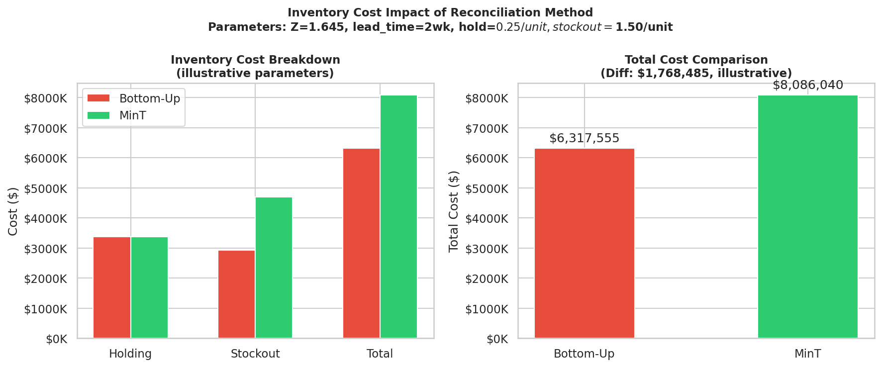
Figure 5. Inventory cost breakdown by method under illustrative simulation parameters. Left panel: holding, stockout, and total costs. Right panel: total cost comparison (Bottom-Up vs. SLPD).
These results are sensitive to the chosen cost parameters—in particular, increasing the holding-to-stockout cost ratio could reverse the ranking. A full sensitivity analysis varying the stockout penalty and lead time is a direction for future research. The simulation should be interpreted as an illustration of the potential downstream impact of reconciliation method choice, not as a definitive cost comparison.
7. Discussion
7.1. Key Findings
The central finding of this study is that ERM reconciliation—Ridge regression weights fitted per store–department on training residuals—achieves the best performance among all reconciled methods at every level of the Walmart hierarchy, and is statistically significantly better than Bottom-Up at department level (p = 0.0012), all without any test-period data leakage. This aligns with Taieb and Hyndman [11] who showed that empirical risk minimisation over the hierarchical structure consistently outperforms structural methods when series heterogeneity is high.
A counter-intuitive finding is that both Top-Down and SLPD degrade department-level accuracy relative to the unreconciled base model. The mechanism is clear: historical proportion weights computed over 138 training weeks are too coarse to capture the idiosyncratic share dynamics of 3,331 series. When a department's promotional activity or seasonal pattern shifts between training and test periods, fixed proportions systematically misallocate the store-level forecast. This finding is consistent with Athanasopoulos et al. [18], who showed that TD methods are sensitive to non-stationarity in series proportions.
7.2. Why SLPD Underperforms
The SLPD implementation used here is a significant simplification of the full covariance-based MinT of Wickramasuriya et al. [8]. Full MinT estimates the in-sample residual covariance matrix Σ_h, which captures cross-series error correlations and enables variance-minimising projection. SLPD ignores these cross-series error correlations, effectively applying a simple disaggregation. At 3,331 leaf series, Σ_h is a 3,331 × 3,331 matrix; its estimation requires shrinkage methods such as Ledoit–Wolf [34] or diagonal approximation. Full covariance-based MinT is the primary direction for future work.
7.3. Practical Implications
The ERM result has direct practical implications for retail demand planning. Per-series Ridge regression weights are computationally inexpensive to fit at training time and require no additional infrastructure beyond the base forecasting pipeline. The approach is robust to series heterogeneity and requires only that training residuals are available—a minimal requirement satisfied by any walk-forward forecasting setup. Practitioners can implement ERM reconciliation as a post-processing step on any existing base forecasting pipeline.
7.4. Limitations
- SLPD vs. true MinT: The Store-Level Proportional Disaggregation used here is not the canonical MinT estimator of Wickramasuriya et al. [8], which requires estimating the full residual covariance matrix. Full covariance-based MinT is identified as the primary direction for future work.
- Single base model: A single GBM is trained across all 3,331 series simultaneously. Per-series models or neural architectures (e.g., N-BEATS [37], TFT [38]) may improve base accuracy.
- Inventory parameters: Cost parameters are textbook defaults and are not calibrated to Walmart's actual inventory system.
- Temporal scope: The dataset spans 2010–2012. Generalisation to post-2012 periods or different retail contexts is not assessed.
- Probabilistic forecasting: This study evaluates point forecast accuracy only. Probabilistic hierarchical reconciliation [39] is a valuable extension.

8. Conclusions
This study demonstrates that Empirical Risk Minimisation (ERM) reconciliation—per-series Ridge regression weights fitted on training residuals—successfully achieves hierarchical coherence with only a negligible 1.9% increase in department-level RMSE over the incoherent base model ($3,044 vs. $2,987), significantly outperforming other reconciliation methods that degrade accuracy by over 50%. ERM is statistically significantly better than Bottom-Up at department level (DM = −3.228, p = 0.0012, HAC-corrected), and achieves the best store-level and chain-level accuracy among all methods, all without any test-period data leakage.
Top-Down and SLPD both degrade department-level accuracy relative to the unreconciled base model, confirming that coarse historical proportions are insufficient for heterogeneous retail demand series with non-stationary share dynamics.
The pipeline is fully open-source and reproducible. All reconciliation steps use training-period information only, and statistical inference uses appropriate HAC-corrected tests rather than naïve i.i.d. assumptions. The complete codebase is available at: https://github.com/rohanovro/walmart-hierarchical-forecasting
Future work includes: (1) full covariance-based MinT with Ledoit–Wolf shrinkage estimation of Σ_h; (2) neural reconciliation approaches including DeepMINT and reconciled RNNs; (3) online adaptive weight learning with distribution shift detection; (4) probabilistic hierarchical forecasting; and (5) integration with real-time markdown and promotional planning optimisation.
Author Contributions
Conceptualization, M.H.R.; Methodology, M.H.R.; Software, M.H.R.; Formal Analysis, M.H.R.; Writing—Original Draft, M.H.R.; Writing—Review and Editing, M.H.R. The author has read and agreed to the published version of the manuscript.
Funding
This research received no external funding.
Data Availability Statement
The Walmart Store Sales dataset is publicly available at: https://www.kaggle.com/competitions/walmart-recruiting-store-sales-forecasting. The complete analysis pipeline is available at: https://github.com/rohanovro/walmart-hierarchical-forecasting
Conflicts of Interest
The author declares no conflicts of interest.
Use of AI Tools
AI-based tools (ChatGPT) were used to assist with language refinement and editing. The author reviewed and revised all AI-assisted content and takes full responsibility for the final manuscript.
References
1. Chopra, S.; Meindl, P. Supply Chain Management: Strategy, Planning, and Operation, 6th ed.; Pearson Education: London, UK, 2016.
2. Mentzer, J.T.; DeWitt, W.; Keebler, J.S.; Min, S.; Nix, N.W.; Smith, C.D.; Zacharia, Z.G. Defining supply chain management. J. Bus. Logist. 2001, 22, 1–25.
3. Hyndman, R.J.; Athanasopoulos, G. Forecasting: Principles and Practice, 3rd ed.; OTexts: Melbourne, Australia, 2021. Available online: https://otexts.com/fpp3/
4. Hyndman, R.J.; Lee, A.J.; Wang, E. Fast computation of reconciled forecasts for hierarchical and grouped time series. Comput. Stat. Data Anal. 2016, 97, 16–32.
5. Dunn, D.M.; Williams, W.H.; Dechaine, T.L. Aggregate versus subaggregate models in local area forecasting. J. Am. Stat. Assoc. 1976, 71, 68–71.
6. Gross, C.W.; Sohl, J.E. Disaggregation methods to expedite product line forecasting. J. Forecast. 1990, 9, 233–254.
7. Hyndman, R.J.; Ahmed, R.A.; Athanasopoulos, G.; Shang, H.L. Optimal combination forecasts for hierarchical time series. Comput. Stat. Data Anal. 2011, 55, 2579–2589.
8. Wickramasuriya, S.L.; Athanasopoulos, G.; Hyndman, R.J. Optimal forecast reconciliation using unbiased estimating equations. J. Am. Stat. Assoc. 2019, 114, 804–819.
9. Panagiotelis, A.; Athanasopoulos, G.; Gamakumara, P.; Hyndman, R.J. Forecast reconciliation: A geometric view with new insights on bias correction. Int. J. Forecast. 2021, 37, 343–359.
10. Nystrup, P.; Lindstrom, E.; Pinson, P.; Madsen, H. Temporal hierarchies with autocorrelation for load forecasting. Eur. J. Oper. Res. 2020, 280, 876–888.
11. Taieb, S.B.; Hyndman, R.J. Regularized regression for hierarchical forecasting without unbiasedness conditions. In Proceedings of the 25th ACM SIGKDD International Conference on Knowledge Discovery and Data Mining, Anchorage, AK, USA, 4–8 August 2019; pp. 1337–1347.
12. Rangapuram, S.S.; Seeger, M.W.; Gasthaus, J.; Stella, L.; Wang, Y.; Januschowski, T. Deep state space models for time series forecasting. Adv. Neural Inf. Process. Syst. 2018, 31.
13. Taieb, S.B.; Taylor, J.W.; Hyndman, R.J. Coherent probabilistic forecasts for hierarchical time series. In Proceedings of the 34th International Conference on Machine Learning (ICML), Sydney, Australia, 6–11 August 2017; pp. 3348–3357.
14. Kaggle. Walmart Recruiting—Store Sales Forecasting. 2014. Available online: https://www.kaggle.com/competitions/walmart-recruiting-store-sales-forecasting
15. Bojer, C.S.; Meldgaard, J.P. Kaggle forecasting competitions: An overlooked learning opportunity. Int. J. Forecast. 2021, 37, 587–603.
16. Carbonneau, R.; Laframboise, K.; Vahidov, R. Application of machine learning techniques for supply chain demand forecasting. Eur. J. Oper. Res. 2008, 184, 1140–1154.
17. Fliedner, E.B. Hierarchical forecasting: Issues and use guidelines. Ind. Manag. Data Syst. 2001, 101, 5–12.
18. Athanasopoulos, G.; Ahmed, R.A.; Hyndman, R.J. Hierarchical forecasts for Australian domestic tourism. Int. J. Forecast. 2009, 25, 146–166.
19. Panagiotelis, A.; Gamakumara, P.; Athanasopoulos, G.; Hyndman, R.J. Probabilistic forecast reconciliation: Properties, evaluation and score optimisation. Eur. J. Oper. Res. 2023, 306, 693–706.
20. Rangapuram, S.S.; de Bezenac, E.; Benidis, K.; Seeger, M.W.; Januschowski, T. End-to-end learning of coherent probabilistic forecasts for hierarchical time series. In Proceedings of the 38th International Conference on Machine Learning (ICML), Virtual, 18–24 July 2021; pp. 8832–8843.
21. Olivares, K.G.; Garza, F.; Luo, D.; Challú, C.; Mergenthaler-Canseco, M.; Dubrawski, A. HierarchicalForecast: A reference framework for hierarchical forecasting in Python. J. Mach. Learn. Res. 2023, 24, 1–8.
22. Fildes, R.; Ma, S.; Kolassa, S. Retail forecasting: Research and practice. Int. J. Forecast. 2022, 38, 1283–1318.
23. Makridakis, S.; Spiliotis, E.; Assimakopoulos, V. The M4 competition: Results, findings, conclusion and way forward. Int. J. Forecast. 2018, 34, 802–808.
24. Makridakis, S.; Spiliotis, E.; Assimakopoulos, V. M5 accuracy competition: Results, findings, and conclusions. Int. J. Forecast. 2022, 38, 1346–1364.
25. Januschowski, T.; Gasthaus, J.; Wang, Y.; Salinas, D.; Flunkert, V.; Bohlke-Schneider, M.; Callot, L. Criteria for classifying forecasting methods. Int. J. Forecast. 2020, 36, 167–177.
26. Ma, S.; Fildes, R.; Huang, T. Demand forecasting with high dimensional data: The case of SKU retail sales forecasting with intra- and inter-category promotional information. Eur. J. Oper. Res. 2016, 249, 245–257.
27. Spiliotis, E.; Athanasopoulos, G.; Hyndman, R.J.; Assimakopoulos, V. Hierarchical forecast reconciliation with machine learning. Appl. Soft Comput. 2021, 112, 107756.
28. Diebold, F.X.; Mariano, R.S. Comparing predictive accuracy. J. Bus. Econ. Stat. 1995, 13, 253–263.
29. Harvey, D.; Leybourne, S.; Newbold, P. Testing the equality of prediction mean squared errors. Int. J. Forecast. 1997, 13, 281–291.
30. West, K.D. Asymptotic inference about predictive ability. Econometrica 1996, 64, 1067–1084.
31. Giacomini, R.; White, H. Tests of conditional predictive ability. Econometrica 2006, 74, 1545–1578.
32. Friedman, J.H. Greedy function approximation: A gradient boosting machine. Ann. Stat. 2001, 29, 1189–1232.
33. Pedregosa, F.; Varoquaux, G.; Gramfort, A.; Michel, V.; Thirion, B.; Grisel, O.; Duchesnay, E. Scikit-learn: Machine learning in Python. J. Mach. Learn. Res. 2011, 12, 2825–2830.
34. Ledoit, O.; Wolf, M. A well-conditioned estimator for large-dimensional covariance matrices. J. Multivar. Anal. 2004, 88, 365–411.
35. Newey, W.K.; West, K.D. A simple, positive semi-definite, heteroskedasticity and autocorrelation consistent covariance matrix. Econometrica 1987, 55, 703–708.
36. Silver, E.A.; Pyke, D.F.; Thomas, D.J. Inventory and Production Management in Supply Chains, 4th ed.; CRC Press: Boca Raton, FL, USA, 2017.
37. Oreshkin, B.N.; Carpov, D.; Chapados, N.; Bengio, Y. N-BEATS: Neural basis expansion analysis for interpretable time series forecasting. In Proceedings of the 8th International Conference on Learning Representations (ICLR), Addis Ababa, Ethiopia, 26–30 April 2020.
38. Lim, B.; Arik, S.O.; Loeff, N.; Pfister, T. Temporal fusion transformers for interpretable multi-horizon time series forecasting. Int. J. Forecast. 2021, 37, 1748–1764.
39. Jeon, J.; Panagiotelis, A.; Petropoulos, F. Probabilistic forecast reconciliation with applications to wind power and electric load. Eur. J. Oper. Res. 2019, 279, 364–379.

