MODEL OF AN INTENSIVE TRANSPIRATION MODULE OF CONVEYOR-TYPE, EQUIVALENT IN POWER AND SIZE TO AN AVERAGE TREE

Yury Yakovenko

https://orcid.org/0009-0003-1183-6671

Retired engineer of Saint Petersburg State Electrotechnical University “LETI”, Saint Petersburg, Russia

lenkovenko@gmail.com

Subjects: Energy Engineering

Keywords: artificial intensive transpiration, super-hydrophilic surface, clean energy source

ABSTRACT

During transpiration, each tree obtains an average of about 0.7 joules of energy per second to raise soil water to the height of its canopy. In recent years, proposals have emerged for the creation of artificial transpiration devices capable of releasing the energy obtained during transpiration as a gain. The article presents a report on the development of an intensive transpiration module of conveyor type (ITMCT), designed to replicate the actions performed by trees when wetting and drying multiple capillaries. The module implements a technology for the continuous wetting and drying (in a flow mode) of a large number of plates with super-hydrophilic surfaces. The energy released during wetting is harvested as a gain. The synthesis of the ITMCT was conducted to determine the relationship between the performance (power) of device of this type and its size. In the course of synthesis, it was shown that the module is capable of producing a volume of energy not less than that of an average tree (about 0.7 watts) while remaining smaller in size. This result indicates the potential for using such device as source of clean energy. An arbitrary number of modules can be combined into module station, similar to how many trees form a forest; as a result, the power of the station can reach any given value. A report on the physical modeling of the main processes involved in the operation of the module is presented.

INTRODUCTION

In recent years [1, 2], a new understanding of the phenomenon of transpiration observed in living plants has emerged, viewing it as a process of alternating acts of wetting and drying of capillary surfaces, where each act of wetting is accompanied by the release of an amount of energy, the total volume of which W is expressed by the formula:
W = σS (1)
where σ = 0.073 n/m is the surface tension coefficient of water, and S is the total area of the capillary surfaces that have been wetted. (The validity of the formula is discussed in Part 2).
This understanding led to the idea of organizing a technological process of continuously repeating wetting and drying of a large number of assemblies made of plates with hydrophilic surfaces, with the aim of harvesting as much practically free energy as possible. The process of wetting a large number of assemblies is supposed to be organized in a closed-loop flow system, in each cycle of which the assemblies, one after another, are immersed in water in turn, so that their plates are wetted, then, one after another, they come out of the water with the plates previously tightly moved towards each other, one after another they undergo the slow process of complete drying in the open air, after which the dried plates move apart and immerse in water in the next cycle. The idea is based on the assumption that the weakness of the force generated during the wetting of the plates (the small value of the surface tension coefficient σ) can be compensated by selecting significantly larger values of S (the total surface area of the plates), measured in thousands and millions of square meters, ultimately leading to a noticeable gain in energy.
The article is presented in the form of a report on the solution of the task that arose first in the process of implementing the idea into specific devices: the task of the relationship between the performance (power) of device of this type and its size. Only by understanding this relationship we can begin to assess the potential of devices of this kind as energy sources. This task was addressed using a device referred to as the intensive transpiration module of conveyor type (ITMCT). The report on the design of the module is presented from the initial guess to the conceptual model. A convincing answer to the question about the relationship between the module's power and its size was obtained at the synthesis stage, without the need for producing a full-scale physical model of the module. This answer was derived during the selection of the dimensions of plates with super-hydrophilic surfaces, the selection of assembly sizes and the number of plates within them, the selection of the method for shifting plates in the assemblies, and the method for prolonged drying them before re-wetting. The question of organizing the wetting process was resolved from the very beginning in favor of distributing the assemblies along the belt of the moving conveyor, belt speed remained to be justified. During the synthesis process, as necessary, physical modeling was performed; for operations of critical importance, a physical model of the simple design was manufactured and tested.
The task of determining the relationship between the power and size of the module is of an approximate nature. As a result, the requirements for the accuracy of the result are symbolic. At the same time, the obtained result allows for a convincing assessment of the prospects for further development of devices of this type.
In synthesizing the ITMCT module, the objective was also to make it a direct analog of an average tree, that is, capable of producing roughly the same volume of energy through transpiration, and then compare the resulting size of the module with that of a tree. It was considered that trees almost entirely expend the energy produced to raise soil water to the height of their canopies for evaporation into the atmosphere. In the case of the module, there is no need to expend energy to lift water to heights of many meters, and almost all of the energy can be extracted as a gain.
In the article, the following parameters characterizing the average tree on the planet have been used. According to published data [1, 3], an average tree raises 200 kilograms of soil water to a height of 20 meters during daylight hours (15 hours), functioning like an engine that consumes some of the water as a sort of fuel and develops a power of about 0.7 watts. For calculation purposes, it is more convenient to use data referenced to an interval of time equal to 1 second: during one second (15 hours = 54,000 seconds), the average tree raises an amount of water with a mass of m^{1sec} = 200/54000 = 0.0037 kg to a height of 20 meters. Considering that nearly all the water raised by the tree evaporates into the atmosphere from the tree's crown, we find that in one second the tree evaporates m^{1sec} = 0.0037 kg of water.
Using these figures, it's easy to identify two key parameters characterizing a tree's activity as a source of transpiration energy: the total area of ​​capillary sections wetted per second, S^{1sec}, and the thickness, δ, of the water layer that forms on the wetted surface. S^{1sec} can be calculated by equating the two energies: energy W_{h}^{1sec}, expended on raising water with a mass m^{1sec} = 0.0037 kg to a height h = 20 meters in 1 second (W_{h}^{1sec} = m^{1sec}gh, where g = 9.8 m/s² is the acceleration due to gravity), and the energy received by the tree to compensate for these costs during wetting (for 1 second) of capillaries with a surface area of ​​S^{1sec}. This second energy is determined using formula (1), rewritten for a time interval of 1 second: W^{1sec} = σS^{1sec}. As a result of equating, we obtain: m^{1sec}gh = σS^{1sec}. From this equality we obtain: S^{1sec} = m^{1sec}gh /σ = 0.0037х9.8х20/0.073 = 10 m². Totally:
S^{1sec} = 10 m² (2)
Knowing the mass of water raised by a tree per second (m^{1sec} = 0.0037 kg) and the total area S^{1sec} = 10 m² from which it evaporates in the tree's crown, also per second, it is easy to determine the thickness δ of the water layer destined for evaporation. In volumetric terms, a mass m^{1sec} = 0.0037 kg is equivalent to a volume of water v^{1sec} = 0.0000037 m³, evaporated per second. The thickness δ is found by dividing v^{1sec} by S^{1sec} (0.0000037/10). Consequently:
δ = 0.37 microns (3)
Expressions (2, 3), in the terms we need, show that the average tree, producing 0.7 watt of energy and spending it entirely on raising water, achieves this during each separate second during the simultaneous execution of the following three actions: wetting 10 square meters of the surface of the tree's capillaries; raising 0.0037 kilograms of water to a height of 20 meters; evaporation of this amount of water into the atmosphere during the drying process of 10 square meters of the surface of the tree's leaf capillaries, wetted by a layer of water 0.37 microns thick.
Knowing these quantitative results demonstrated by the average tree, we can formulate the starting requirements for the ITMCT module: to become analogous to the average tree, the module must ensure the wetting of at least 10 square meters of capillary surface (flat in our case, combined into large assemblies of plates) per second, generate at least 0.7 watts of energy in this manner, and evaporate a mass of water comparable to 0.0037 kg per second into the atmosphere. Moreover, the module must evaporate the water without raising it above the water level in the source, to ensure the possibility of capturing all the generated energy as a gain.
In the case of the module, the prohibition on raising water intended for evaporation above the source level is a necessary measure, without which energy gain is impossible. This leads to a noticeable increase in the horizontal dimensions of the module (for comparison, imagine a tree crown lowered to ground level and distributed over an impressive area), but this proves to be an inevitable price for the energy gain.
During the synthesis process, the module dimensions are compared to the following dimensions of an average tree: 100 square meters in terms of occupied land surface area, or 2,000 cubic meters in volumetric dimensions, taking into account the height (20 meters) of the tree's crown.
The module can be used as a building block for creating large stations for clean energy production, similar to how trees become part of a large forest or the planet's forest as a whole. According to published research [4], the total of all the trees on the planet produces as much energy collectively as all the hydro-stations created by humans. Thus, the proposed module has impressive prospects if its size turns out to be comparable to that of a tree.
The report consists of 4 parts. Part 1 provides a report on the development of a conceptual model of a conveyor-type intensive transpiration device, without specifying particular parameters. In Part 2, based on the data obtained in Part 1, a detailed report is presented on the synthesis of the ITMCT module with the selection of specific parameters, making it a direct analogue of an average tree. Part 3 contains a report on the physical modeling of the operations that make up the module's work. Part 4 discusses conclusion, prospects for improving the module's performance, and prospects for creating large stations generating clean energy.

PART 1. Intensive transpiration device: from guesswork to conceptual model

In this part, we will trace the evolution of the idea of generating energy in a new way, from guesswork to a conceptual model of the device, without specifying particular parameters. Figures 1 and 2 illustrate this process with symbolic representations.

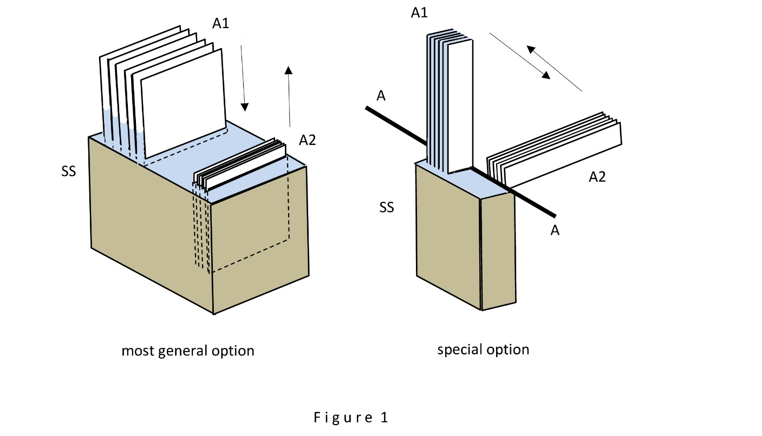

Figure 1 provides an overview of the guesswork. On the left side of Figure 1, a simple method of mimicking the functioning of a tree's capillary mechanism is schematically represented using a minimal set of specially manufactured moving parts: two assemblies made up of number of fairly thin, parallel plates of equal size that have super-hydrophilic surfaces. (In the case of thin plates, we can neglect the buoyant force of the water acting on them, simplifying the consideration). In assembly state A1, above the water, the plates are positioned a small distance apart. In assembly state A2, submerged underwater, the plates are fully wetted and tightly pressed together. It is assumed that at the moment of observation, the assembly in state A1 makes contact with the water's surface, allowing water to enter the gaps between the plates, drawn in by surface tension forces, and the entire assembly is pulled into the water with a force calculated by the formula:
F = Lσ (4)
where σ is the surface tension coefficient of water, and L is the total length of the contact line between the water and the surfaces of the plates. (Throughout the article, it is assumed that the contact angle θ between the water and the super-hydrophilic surfaces of the plates is always close to zero, which allows to use this simplified formula instead of its full form: F = Lσcosθ). Simultaneously, the assembly in state A2 begins to move upward out of the water, encountering virtually no resistance from the water, as the action of the surface tension forces is limited solely to the surfaces of the two outer plates and the vertical edges of the plates. The essence of the Figure 1 is that the left assembly, passing through state A1 and being pulled into the water with force F, is capable of releasing enough energy not only to lift the right assembly out of the water but also to supply the excess energy to an external consumer. It is assumed that after being extracted from the water, the right assembly undergoes a prolonged drying phase, during which the water from the gaps between the plates gradually evaporates completely into the atmosphere. Once this is complete, the plates effortlessly separate, and it moves back to state A1 to submerge in the water of source SS, thus beginning the next cycle of operation for this simple scheme. Meanwhile, the plates of the left assembly, now underwater, are tightly pressed together, and the assembly shifts to the right as it begins to emerge from the water.
On the right side of Figure 1, as an alternative, a second method is schematically shown, somewhat less transparent to understand than the first. In this case, the number of moving parts is smaller: the position of the plates within assemblies A1 and A2 is fixed, and the gap between them does not change. The movement of the assemblies is reduced to a 90-degree rotation around the AA axis (using an imaginary mechanism, not shown in the diagram, for ease of illustration), in such a way that the assembly that was in a vertical position moves to a horizontal position, and the assembly that was in a horizontal position moves to a vertical position in a strictly synchronized manner. Thanks to such a rigid organization of movement, each of the assemblies is brought to a vertical position in turn so that its lower end is lowered into the water of source SS (as shown on the right side of Figure 1 using assembly A1 as an example), and its plates are subjected to intensive wetting, during which water, under the influence of wetting forces, rises to the full height of the assembly (the distance between the plates is assumed to be quite small, for example, in the range up to ten microns). Each of the assemblies, in turn, also ends up in a horizontal position (like assembly A2 in the Figure 1). In this position, the assembly is completely isolated from the water of source SS and is able to fully dry over a certain limited time. With each turn, carried out simultaneously by both assemblies (using an imaginary mechanism), one of the assemblies (vertical, saturated with water) turns out to be significantly heavier than the other (horizontal, dry), so that, by descending, it is capable not only of doing the work of lifting the dried assembly upwards but also of performing noticeable useful work on an external load, that is, providing an energy gain. In the next cycle, the assemblies are swapped: assembly A2 undergoes complete wetting, while assembly A1 undergoes a prolonged drying process. This alternative variant proves useful at the stage of summarizing the work and is discussed in Part 4.
The guesswork remains abstract; it does not propose a method for extracting the energy gained during the movement of assemblies caused by their wetting, nor does it contain suggestions for achieving a wetting intensity comparable to that observed in an average tree (at least 10 square meters of plate surface per second).
In Figure 2, a diagram of the device model developed for the option shown on the left in Figure 1 is presented in a maximally simplified form (hereinafter, in Parts 1 and 2, all considerations focus on this option as the most general case). The model implements the process of organized as a conveyor of continuous immersion in water and extraction from water of a significant number of assemblies, with the collection of the energy produced in the process and the provision of conditions necessary for long-term drying of the assemblies that have undergone the wetting operation. The model diagram remains entirely abstract, without specifying the main parameters (sizes of plates and assemblies, number of plates in the assemblies, total number of assemblies) and the conveyor speed.

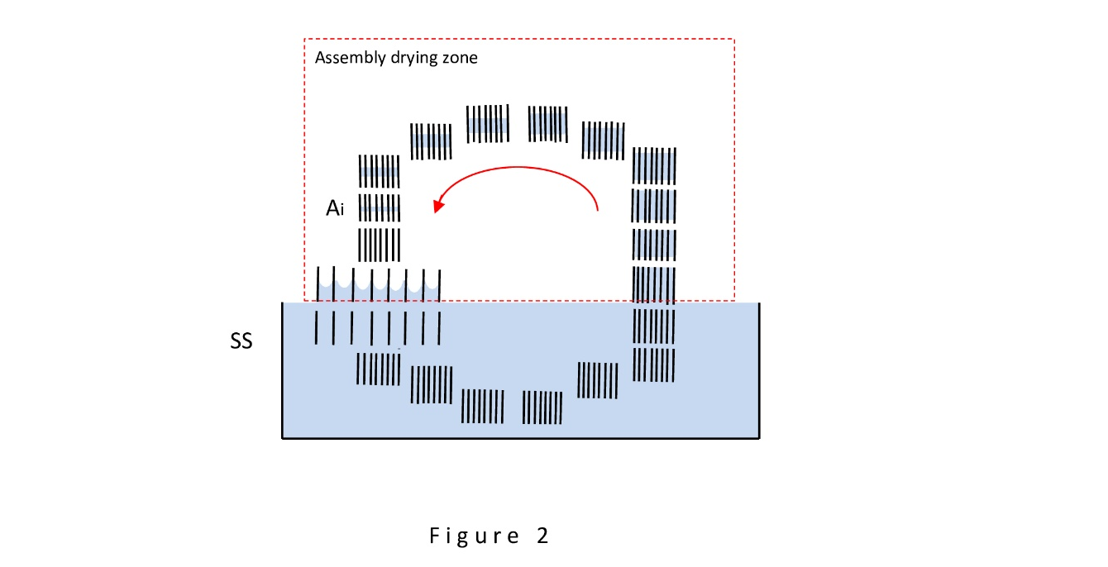

Here is a brief description of the operation of the scheme. The main working elements in Figure 2 are assemblies, each of which can be formed, for example, by hundreds of plates of the same size, parallel to each other, and equipped with a mechanism that allows the plates to be tightly moved together as well as spread apart to a given distance with practically no effort. The surfaces of all the plates are assumed to be super-hydrophilic. The movement of the entire set of assemblies is organized (in the diagram counterclockwise) like a conveyor; they line up one after another in a long queue, in the shape of an oval, the lower part of which is submerged in the source water SS, as shown in Figure 2. A special area is highlighted with a dashed line – the area of the drying assembly bank. The size of this area is set so that during the time each individual assembly passes through its boundaries, all gaps between the plates have time to completely dry, and the plates can spread without effort. Above each assembly, during its movement along the conveyor, the following operations are performed sequentially. At the moment the dried assembly exits the assembly bank, the plate spreading operation is carried out. Immediately after this, the assembly joins the queue for immersion in water behind the assembly ahead, which is finishing its immersion. Soon (after a few seconds), the operation of relatively slow immersion of the assembly in the SS water source begins. The immersion speed, which also is the speed of the conveyor, turns out to be an important parameter – it determines the power of the device and the correct operation of the wetting mechanism. After the assembly is fully immersed in water, the operation of tightly squeezing the wetted plates underwater is performed. After this, the assembly is moved underwater to the water exit area and then transferred to the assembly bank, where it remains for a long time until the plates are completely dry, gradually moving toward the exit area of the bank to participate in the next cycle of the device's operation. The drying process of the assemblies is conventionally depicted in the Figure 2 as a process of gradual (symmetrical, for simplicity) reduction of the wetting zones on the surface of the plates.
The diagram in Figure 2 implies that the conveyor line has one or more shafts and that the only force driving the entire mechanism is the force of drawing the current assembly into the water of the source, and that this force is capable, besides setting the conveyor in motion (overcoming frictional forces), of performing work on an external load. As a result, the extraction of the gained energy can be carried out in a device with one of the conveyor's shafts.

PART 2. Synthesis of the ITMCT module

First of all, a search of the scientific literature was carried out in order to determine the degree of novelty of the idea of creating an energy producer similar to the ITMCT module. A postulate was also formulated that allows performing the necessary calculations during the synthesis.
Publications [1, 2] turn out to be the only ones that contain proposals for using the surface tension forces of water and artificial transpiration devices to generate energy. At the same time, there are no mentions of the possibility of conveyor organization of the generation process. This can be considered sufficient to evaluate the idea as having novelty.
The postulate formulated in the following paragraph is intended to compensate for the fact that in the scientific literature there is uncertainty in the choice of the formula for directly calculating the wetting work W, which is at the focus of the present considerations, including the work performed by surface tension forces in the case of uniform motion of the wetted surface. The concepts of adhesion work and wetting heat are used, which can be measured in practice using known techniques [5] and can be used to indirectly determine the wetting work. There is also uncertainty in determining the role of the force F in performing the work W. According to fundamental concepts based on the Dupré equation [6, 7], the work W is performed in the process of transformations occurring with the potential energies of the solid, water, and air at the phase boundaries, and the force F plays some secondary role. The postulate eliminates uncertainty and allows direct use of formulas (1) and (4) to calculate the work W and the force F as the immediate cause of its performance.
The postulate states: during infinitely slow vertical immersion of a parallel-plate assembly in water, formed by parallel plates with super-hydrophilic surfaces, about one millimeter distance one from other, a force arises, calculated by formula (4), applied to the walls of the plates and directed strictly downward, which, during the immersion of the assembly, performs work W, calculated by formula (1); this work gradually decreases as the immersion speed increases.
The postulate serves as a starting point for the synthesis of a module with a given performance using formulas (1) and (4) and at the same time allows for the fact that formula (1) can also be used in the case of assembly immersion at a speed within a certain limited range.
The postulate allows to choose an acceptable immersion speed for the assembly, which, in our case, is the speed of the conveyor. To do this, the following condition must be met: the immersion speed must be at least ten times slower than the natural wetting speed of water on the plates – this will allow, within the limits of allowable approximation, to consider the immersion of the plates as infinitely slow. A search in the scientific literature [8] provided the wetting speed under conditions demonstrating the super-hydrophilicity effect, for the case of round capillaries: this speed is not less than 0.2 meters per second. Simple tests were carried out, which verified the suitability of this value (0.2 m/s) in the case of applying parallel-plate channels. Testing was carried out by immersing a parallel-plate channel, having a 1.0 mm gap between the plates, into water at different speeds, measuring the height of the water column raised by surface tension forces in the gap between the plates at different immersion speeds. The plates were machined from pottery sherds, which guaranteed the super-hydrophilicity of their surfaces. The tests confirmed that the wetting speed exceeds the value of 0.2 m/s obtained in [8]. Specifically, it was found that the height of the water column between the plates, maximum in the case of a stationary channel, decreased slightly when the channel was immersed at a speed of up to 5 centimeters per second and rapidly decreased to zero soon after a speed of 0.2 meters per second. The latter meant that the immersion speed became close to the wetting speed. The tests were not aimed at achieving high accuracy (considering the caveat about the accuracy of all measurements mentioned in the introduction). The tests made it possible to formulate a requirement for the immersion speed of assemblies (conveyor speed), the fulfillment of which ensures that the movement of the assemblies (at the chosen speed) does not affect the correctness of the plate wetting process. The requirement is as follows: this speed should not exceed 0.02 meters per second, that is, it should remain at least ten times lower than the wetting speed.
As a result of choosing the conveyor speed (the speed of immersing the assemblies in water) at 0.02 meters per second, we obtain a numerical value for the first of the parameters necessary for synthesizing the module. The justification and selection of numerical values for the remaining parameters, including the sizes of the plates and assemblies, the size of the assembly bank, and the allowable gap between squeezed plates of “wet” assemblies, were carried out as follows.
Figure 2, despite its schematic nature, is quite suitable for commenting the operation of the ITMCT module model and determining the quantitative characteristics of its parameters.
The need to justify the requirements for the sizes of plates and assemblies is caused by the fact that these sizes highly influence both the thickness of the gaps in the “wet” assemblies, as well as the duration of their drying, and ultimately, the size of the assembly bank and the ITMCT module as a whole. By choosing a module option with miniature plates, the size of which is measured, for example, in millimeters, and which are capable of shifting closely together, leaving a minimal gap (thickness up to 1 micron or less), it is possible to reduce the drying time of assemblies to a few minutes, and as a result, the size of the assembly bank and the module itself may turn out to be relatively miniature. Conversely, choosing sizes far from miniature can lead to an increase in the module size by tens of times compared to an average tree. Testing (physical modeling) of the drying speed of assemblies formed by plates of different shapes and sizes was conducted, which led to the development of the following simple requirement for selecting plate sizes in our specific circumstances: one of the dimensions of the plates (the width) must always be within a range of no more than 2 centimeters. Measurements showed that the best results (i.e., the shortest drying time of an assembly) are achieved when the plates have a width of no more than 2 cm and that these results practically do not depend on the length of the plates or the thickness of the gap. When choosing plates with a width of no more than 2 cm, the total drying time turns out to be no more than 2 hours under normal laboratory conditions.
Ultimately, a variant of "moderate" plate and assembly sizes was chosen (i.e., neither too small nor too large), and a single requirement for the dimensions was formulated: when designing assemblies, the plates used must have a width of no more than 2 cm or be made up of separable sections each no wider than 2 cm.
The complete set of requirements for the parameters that the ITMCT module must meet now reads as follows:
- the module must ensure wetting of at least 10 square meters of plate surface per second, while producing at least 0.7 watts of energy and allowing the evaporation into the atmosphere of a water mass comparable to 0.0037 kg, like that of a tree;
- the speed of the conveyor movement (and the lowering of assemblies into the source water) must not exceed 0.02 meters per second;
- the transfer of water in the gaps of "wet" assemblies into the assembly bank must be carried out without energy consumption;
- each assembly must completely dry under normal conditions within no more than 2 hours; for this, the width of the assembly plates (or their sections subjected to wetting) must not exceed 2 cm.
Taking these requirements into account, a module should appear, the dimensions of which will be compared to the dimensions of an average tree (10x10x20 meters), capable of delivering at least 0.7 watts of its power to an external load and evaporating into the atmosphere a mass of water comparable to 0.0037 kg per second. Here is the report on the synthesis process.
The main element of the module remains the standard assembly. When it was first synthesized, the goal was to combine as many thin plates as possible, each one-meter long and narrow (no more than 0.1 meters wide), into a single block with a convenient (for the designer) overall size of 0.1x1x1 meter. As a result, the first version of the assembly appeared, consisting of 500 plates measuring 0.1x1 meters with a thickness of 1.0 millimeter, installed 1.0 millimeter apart from each other (all dimensions were chosen to provide convenience for reasoning). In this version, the total area S⁵⁰⁰ of all 500 plates (both sides) available for wetting turned out to be 100 m², and the total length of the water contact line with the surface of the plates (both sides) L⁵⁰⁰ = 2x500x1 meter = 1000 meters. It was assumed that the shifting of such plates is carried out like an accordion.

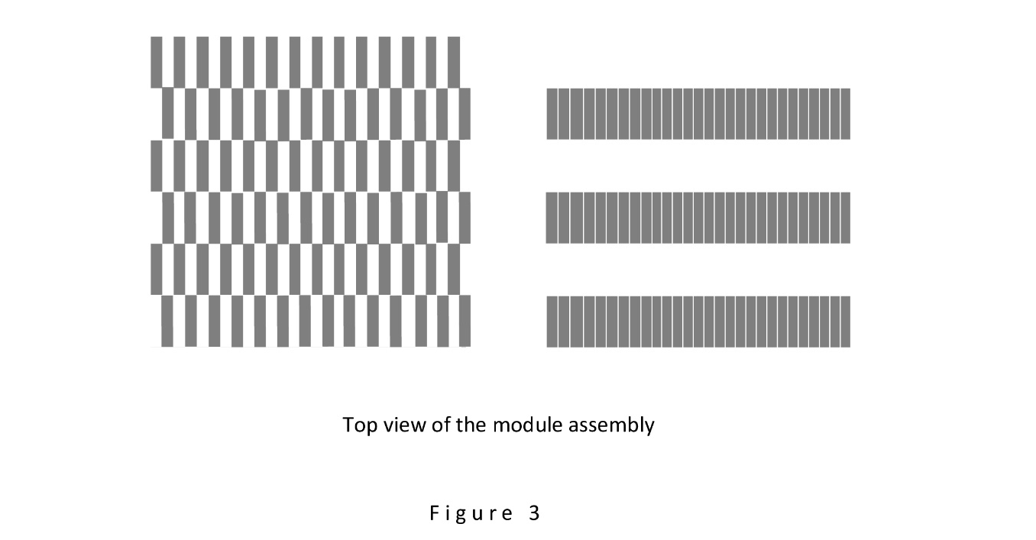

This first version was refined in accordance with the requirement for the plates to be organized as sets of sections no wider than 2 cm, allowing for quick drying after they are shifted. As a result of this refinement, each of the 500 plates, 1 mm thick and measuring 0.1×1 meters, was represented as consisting of 50 narrow vertical sections of the original thickness and 2 cm width (0.1×0.02 meters), so that the total area available for wetting still amounted to 100 square meters for the assembly, and the total length of the water contact line with the surface of the plates remained 1000 meters. In this version, it is more convenient to use another method of shifting the plates: like shuffling playing cards. The schematic in Figure 3 shows a top view of a typical assembly in this version. On the left side of the diagram, in schematic symbols, the position of the entire set of sections in the extended state is shown (for clarity, a reduced number of sections is used); on the right – the position of the sections in the shifted state in the form of parallel dense rows. As a comment, it should be noted that there are two advantages arising as a result of this choice. First, the type of shift used (similar to shuffling playing cards) ensures the constancy of the average thickness of the resulting gaps. Second, after shifting, an air space forms between the rows of shifted plates (sections), contributing to the ventilation of the assemblies and their rapid drying. It remained to make the correction of the thickness of the sections and the size of the gap between them in the shifted state so that the process of sliding apart and back together of the sections could be carried out without effort. (With a section thickness of exactly 1.0 mm, chosen initially, the shifting action is impossible). Solving this problem was not difficult and was verified using physical modeling tests.
Given the specified speed of immersion of the plates in water (0.02 meters per second), it turns out that each subsequent assembly will be lowered into the water along its short dimension (0.1 meters) over 5 seconds, so that 20 square meters of the surface of its plates (sections) will be wetted every second (S⁵⁰⁰/5sec = 100m²/5sec= 20 m² /sec), which meets the stated goal (wetting at least 10 square meters of surface per second, like an average tree). According to formula (1), when wetting S²⁰ = 20 m² of plate surface, the energy generated will be W²⁰ = σS²⁰ = 0.073 x 20 = 1.4 joules. After dividing this amount by the duration of the wetting process (1 sec), we get the value of power generated by the module: P = 1.4 watt.
In total, a module using assemblies with the selected parameters, in the case of implementing the process in conveyor mode, is capable of generating 1.4 watt of energy around the clock due to wetting 20 square meters of plate surface of assemblies every second.
The module size can be determined using the following calculations. The drying time of a single assembly in the assembly bank cannot exceed two hours. Considering that each assembly undergoes a wetting session lasting 5 seconds, we get that during 2 hours the number of assemblies that have completed wetting, entered the assembly bank, and are waiting for their turn for the next wetting session reaches 2 hours / 5 sec = 7200 sec / 5 sec = 1440 (with the size of one assembly being 0.1x1x1 meter). If we compactly stack 1440 assemblies, we get a stack 144 meters high, 1.0 square meter in cross-section, 144 cubic meters in volume. According to the specified requirements, all assemblies, during the drying process (in the assembly bank), must be positioned strictly at the water level of the source. As a result, to accommodate 1440 assemblies, a plot of land approximately 40x40 meters will be required. As an alternative, a project can be proposed that allows significantly reducing the area of this square. For this, the space of the assembly bank should be organized into several tiers, for example, about 0.5 meters in height each, built upwards and downwards from the level of the water source, so that incoming “wet” assemblies can be directed symmetrically both downwards and upwards, without requiring (in total) energy expenditure for vertical movement. In this case, there arises a need for special preparation of the space around the water source below its level.
Overall, the assessment of the module's dimensions is clearly positive, although with a slight advantage over the average tree: at a power of 1.4 watts (twice that of the average tree), the dimensions of the ITMCT module in the “unimproved” version turn out to be slightly smaller than the dimensions of the average tree (40x40x1 = 1600 cubic meters versus 10x10x20 = 2000 cubic meters).
The extraction of the generated energy (1.4 watts) in the module can be carried out directly from one of the shafts used to drive the conveyor belt. The force applied to the shaft, arising in the process of wetting the plates of the current assembly, is determined using formula (4): F⁵⁰⁰ = σL⁵⁰⁰ = 0.073x1000 = 73 n, where F⁵⁰⁰ is the force with which the water drags the submerged assembly downward (dragging 500 plates or the corresponding number of sections), σ is the surface tension coefficient of water, L⁵⁰⁰ = 1000 m is the total length of the line of contact of water with the surface of 500 plates (or their sections).
When analyzing the problem of extracting energy from the module, we confront the same issue that arises when analyzing the phenomenon of water movement in the trunk of a tall tree. The ascent of sap through vessels of microscopic diameter and up to 100 meters long (as, for example, in a sequoia of such height) hardly finds a satisfactory explanation among scientists. In the case of the module, a question may arise about the possibility of moving hundreds of "wet" assemblies, with a total mass of several tons, along a conveyor line using a force F⁵⁰⁰, equal to only 73 n. Considering modern technical capabilities, this question should be regarded as unfounded: there is no reason to doubt the operability of a massive conveyor driven by a force of 73 n. Losses due to friction in energy extraction should not exceed a few percent, considering the low speed (0.02 meters per second) of the conveyor.
The obtained assessment of the relationship between power and size completes the report on the synthesis of the ITMCT module. It is relative in nature, in terms of “better than the average tree”, still fully acceptable, considering the purpose of the research.

PART 3. Physical modeling of the operations constituting the work of the ITMCT module

In order to check the operability of the ITMCT module, work was carried out on the physical modeling of the main operations that constitute its function. Part of the work (tests to determine the allowable immersion speed of an assembly in water, tests to measure the drying time of parallel-plate channels of various sizes and shapes, tests to control the tightness of the plates shifting in assemblies) was performed during the ITMCT module synthesis, and the report on them is included in Part 2 along with the report on the execution of the corresponding operations. A physical model was developed and manufactured, represented in conventional symbols in Figure 4, which, despite its simplicity, proved suitable for modeling almost all operations that make up the module's work. The model is small in size, convenient for laboratory conditions, and is designed in the form of a swing, performing up-and-down movements of two assemblies, A1 and A2, each consisting of 20 plates 2.0 millimeters thick with dimensions of 40x40 millimeters. Unlike the ITMCT module, where the length of the contact line of water with the assembly plates surface is 1000 meters and its power is estimated at 1.4 watts, in the model in Figure 4 the length of the contact line of the plate assembly with water, L^{mod}, turned out to be 1.6 meters. All 40 plates are machined from pottery shards and, as a result, have super-hydrophilic surfaces. The plates of both assemblies easily slide apart by a distance of 1.0 mm from each other and can be tightly pressed together manually by the operator. The manufacturing precision of the plates is sufficient to create (when shifted) gaps no more than 0.01 mm thick. As a drawback, it should be noted that the plate material has an increased tendency to absorb water (up to 4% of the plate's volume), which, however, did not prevent the tests from being conducted correctly.
In Figure 4, the model is shown in a state where assembly A1, whose plates are spread apart, begins to enter the water of source SS, so that water rushes into the gaps between the plates to a certain height, and the entire assembly A1 is drawn into the water with a force F^{mod}, determined by formula (4). In this case, L^{mod} = 1.6 m, σ = 0.073 n/m, finally F^{mod} = 0.073×1.6 = 0.11 n. At the same time, assembly A2 begins to move upward out of the water, its plates tightly pressed together, with a small amount of water between them. The vertical movement of the assemblies up and down is limited by the height of the plates.
The operation of the model consists of alternately immersing in water either the left or right assembly, while simultaneously removing from the water the assembly located on the other side. The assembly taken out of the water, with its plates shifted, can remain in the air for several hours to simulate the process of complete drying of the gaps. Using this extremely simplified method, the cyclic operation mode of the device, fully controlled by the operator, is modeled. The absence of a bank of drying assemblies and a conveyor mechanism can be compensated by the use of imagination. The model allows solving the task of modeling operations of interest: operations of wetting the assembly with separated plates using a force F^{mod} to perform useful work (the method of energy extraction is determined by the operator); operations of shifting and spreading (accordion-style) the assembly's plates; operations of lifting the assembly with shifted plates out of the water.

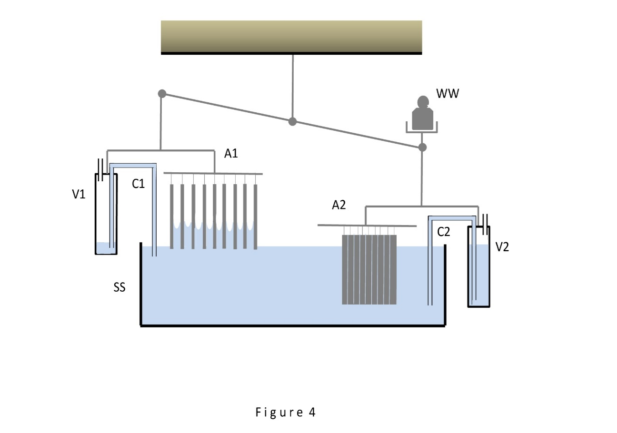

It remains to clarify the purpose of vessels V1 and V2, and load WW, shown in Figure 4. Vessels V1 and V2 play an important role in compensating for the buoyant effect of water on the assembly plates. The parameters (dimensions) of the vessels are chosen in such a way that during their downward-upward movement (synchronously with the corresponding assembly), water from source SS flows into them (or flows out of them) in a volume exactly equal to the volume of water displaced by the plates of that assembly. As a result, the buoyant effect of water is fully compensated, which means that the only forces causing the swing to move are the force F^{mod} = 0.11 n, with which the dry assembly is drawn into the water, and the weight of the water remaining in the 19 slots of the raised “wet” assembly with shifted 20 plates. Knowing the gap thickness (0.01 mm), the size of the plates (40x40 mm), and the number of gaps (19), we can calculate the mass of this water (assuming the density of water is 1.0): 0.01 x (40 x 40) x 19 = 304 mg = 0.304 g. The gravitational effect of this mass turns out to be 36 times smaller than the force F^{mod} (0.11 n), and it does not prevent performing tests to measure this force with an accuracy of several percent. (The ability of the plates to absorb water into their thickness was ignored when organizing the tests).
The weight WW conventionally denotes the work of the device carrying out the measurement of the force F^{mod}. In our case, the measurements are carried out by an operator: with the correct choice of the weight WW during the wetting of the plates, the swing comes into equilibrium, and the value of the force F^{mod} is determined by the mass of the weight WW.
Tests carried out with the help of this physical model made it possible to demonstrate the operability of the ITMCT module at the level of individual operations, in particular, to verify the correspondence of the force F^{mod} to the calculated value and the simplicity of the procedures for selecting the developed energy from the model.

PART 4. Conclusion and prospects

The work completed allows an important conclusion to be drawn: devices similar to the ITMCT module are capable of generating as much energy as an average tree while remaining smaller in size. This conclusion is equivalent to acknowledging the potential mentioned in the introduction: a collection of such devices, in a quantity comparable to the number of trees on the planet, can provide the same energy gain as all hydro-stations built by humans. It should be taken into account that the potential of devices is higher the smaller they can be in size. The prospects for significantly reducing the size of the devices are revealed as follows.
From the above reasoning, it follows that the size of devices like the ITMCT module largely depends on the size of the plates with super-hydrophilic surfaces used. Thus, the task of reducing the size of devices becomes primarily the task of creating a rich variety of such plates with the necessary sizes and shapes. The technology for producing plates with super-hydrophilic surfaces has actively developed in recent years [9]. Considering the possibilities hidden in this technology, and repeating the synthesis procedure of the ITMCT module as presented in Part 2 (choosing the thickness of the plates and their number in the assembly), it is easy to verify that the size of the module, with the correct choice of plates, can be significantly reduced (at least several times) while maintaining its performance.
In general, the prospects of the ITMCT module can be commented on in the following terms. In real conditions, it should be considered impractical to develop, based on the module, a source of energy of a universal nature, capable of operating efficiently in any conditions. If, in one case, it is reasonable to use devices that consume a minimal amount of water for evaporation into the atmosphere, in another case, devices are required that abundantly evaporate water in the process of artificial transpiration, thereby helping to restore the overall balance during evapotranspiration on the planet. If, in some cases, there are strict limitations on the horizontal dimensions of the device, then in the case of placing a device adapted for the use of seawater in the open sea, such requirements are absent. During the work, the possibility of building module options was constantly implied. In Part 1, one of the alternative options is proposed (in Figure 1 on the right). Due to the reduction of the gap between the assembly plates, this option can achieve greater savings in water consumption during evaporation (in the process of drying assemblies) into the atmosphere. Also, in this option, the requirements for water purity and salinity may be significantly reduced (there is no danger of plates sticking together), and the use of seawater is even permissible. The prospects of the module are determined by the prospects of all the device options that arise based on it.

References

- Yakovenko Y. The Ability of Artificial Transpiration Devices to Raise Water to Any Given Height and the Prospects of Creating Large Artificial Transpiration Systems as Sources of Clean Energy (2024) https://doi.org/10.20944/preprints202405.0240.v1
- Yakovenko Y. Two-stream Artificial Transpiration Device as Energy Source Using Molecular Properties of Water (2024) https://doi.org/10.20944/preprints202412.0925.v1
- Wullschleger S., Meinzer F., Vertessy R. A review of whole-plant water use studies in tree Tree Physiol. 1998 Aug – Sept; 18 (8-9): 499 – 512. Doi: 10.1093/treephys/18.8-9.499
- Quetin G., Anderegg L., Konings A., Trugman A. Quatifying the global power needed for sap ascent in plants (2022) Journal of Geophysical Research: Biogeosciences 127 (8) doi:10.1029/2022jg006922
- Israelachvili J., Intermolecular and Surface Forces, 2nd Ed (1991) Academic Press, London
- Dupré A., Théorie Mécanique del la Chaleur; Gauthier-Villars: Paris, 1869.
- Stokes R., Evans D. Fundamentals of Interfacial Engineering (1997) Wiley-VCH New York
- Seungyeop Baek, Sungjin Jeong, Sanggon Lee, Seunghwan Park, Jaegoun Choi, Hyomin Jeong Effects of Tube Radius and Surface Tension on Capillary Rise Dynamics of Water/Butanol Mixtures. Applied Science Volume 11 Issue 8
- Kwandwo E. Tettey, Majemite I. Dafinone, Dayeon Lee Progress in Superhydrophilic Surface Development, Materials Express 1, 89 – 104 (2011)

