Comparison Position of Solar PV System : College Learning Building South Lampung
Rishal Asri^{1a}, Guna Bangun Persada¹, Rihardian Maulana Wicaksono¹
¹Energy System Engineering Department, Institut Teknologi Sumatera
ªrishal.asri@tse.itera.ac.id
Sunlight is energy that can be converted into electrical energy. One of the uses is by applying it to the roof of the building. The application in this building has restrictions such as the placement of the PV modules horizontally and vertically. In the study comparing the results of energy obtained from the PV system with horizontal and vertical positions with a standard degree angle in the direction of azimuth sunlight. Position using the horizontal produces more energy and reaches a performance ratio of more than 80%.
Solar PV, Horizontal, Vertical, Energy, Azimuth

Introduction
Public Lecture Building is a learning building that can be used by every student from various levels, semesters, or other study programs. In this case the Sumatra Institute of Technology which is in the South Lampung regency has implemented the system. The system adopted is a public lecture building where buildings are not based on study programs or faculties but buildings are used together.
The public lecture building that is used today in the face of high occupancy space requires a lot of electrical energy. One solution that can be provided is the use of Solar Photo-Voltage (PV) on the roof of a building. The use of Solar PV on the roof of the building is a solution to address the building's electrical energy needs in addition to using electricity that has gone through the PLN grid directly. Solar PV uses clean and free energy sources which are very abundant in tropical regions such as Indonesia. The use of solar PV on the roof of the building compared to the terrain is more effective because it does not take land that can be used for other needs such as building construction or parking space around standing buildings.
In this study provides a comparison between the position of the Solar PV system vertically and horizontally on the roof of the building due to the influence of solar radiation. This comparison provides an overview of the energy produced, the design of the PV system used, and the image of the system produced.

Literature Review
In research [1] using a PV system to determine the position of the most optimal solar PV to produce electrical energy with the power capacity of solar PV is 100 kW. The location used is the roof of the building. From these results it was found that the most optimal angle was 370 from the azimuth. in research [2] evaluates existing PV systems by providing some additional tests such as horizontal, azimuth and polar tracking systems. In this research, there are two configurations to produce more solar energy potential, they are single axis and dual axis with 42.57% and 41.58% respectively.
In research [3] using a tracking system on orthogonal PV systems that are controlled by a programmable logic controller. system design that is used to improve the efficiency of energy rays obtained by 40%. In the study [4] focused on the equatorial orientation that can be applied to transportation such as aircraft in Japan. In this study, conclusions can be drawn on areas that produce high diffusion diffraction which can produce positions that are intended for PV modules to capture sunlight.
In research [5] identified the influence of azimuth on energy produced from 18 locations of PV systems in Saudi Arabia. In this study, more solar radiation was obtained in March and October compared to April and September. The optimum azimuth value produced in this study is 200 to 500 degrees in the west and south directions. In research [6] using LiDAR to measure the potential of solar energy in buildings in Spain. From the data produced in May, June, and July the potential for solar energy generated is 7 kW / m².
In research [7], PV modeling with various criteria such as azimuth, location, region, and annual data from various countries. From the results of the study obtained several clusters for each country as an independent variable. Some systems that become the main reference are metadata from each country and shadow factors.

Research Method
The potential of sunlight can be measured through three sunlight radiation criteria, namely global, direct and diffuse radiation. in the following equation is shown about direct solar radiation on the solar PV module [8].
GT = Global Total Irradiance , W/m²
GDT = Total Diffuse solar radiation on a tilted surface, W/m²
GBT = Total Beam solar radiation on a tilted surface, W/m²
GRT = Total Diffuse solar radiation on a tilted surface, W/m²
RB = The beam radiation tilt factor
RR = The ground-reflected radiation tilt factor
(1)
(2)
Meanwhile, to calculate the Plan of Array (POA) of the PV system adjusted to the location of the PV installation. POA is a combination of direct solar rays, diffuse irradiance and albedo (irradiation reflected by the ground). The direct irradiance on a panel or Plane of Array (POA) is the irradiation coming directly from the sun multiplied by the cosine of the angle of angle incidence (the angle between the direction of the sun and a vector normal to the panel).
E_{POA} = Energy Plan of Array, kWh/m²
E_{b} = Energy Beam, kWh/m²
E_{g} = Energy Global, kWh/m²
E_{d}= Energy Diffuse , kWh/m²

(3)
From the results of equations 1,2 and 3 the energy yields from each position are determined and compared with the value of each monthly position.
The research method used in this study is to evaluate each location and location of solar PV placement on the roof of the building which is the object of research by integrating the electrical system in the building. The deciding factors at the location of solar PV placement are the number of PV modules that are exposed, the direction of sunlight / azimuth, and the tilt position of the solar panel itself. From the results of modeling the position of the system there are two models that are compared with the distinguishing factors of position placement in the horizontal and vertical directions on the PV panel. at the time of conducting this research the following steps were carried out:
- Design each PV modeling system by providing limits on the area of PV used and the direction of sunlight. The direction of sunlight that changes every month affects the optimal point of the static PV system
- The energy produced by each PV is calculated and compared the performance ratio of the system made. The standard performance ratio used is 80%
- The type of solar PV model used is REC Solar with a capacity of 280 W per module with a length and width of 1 meter each.
In Figure 1 the location of the research object is shown in the ITERA public learning building
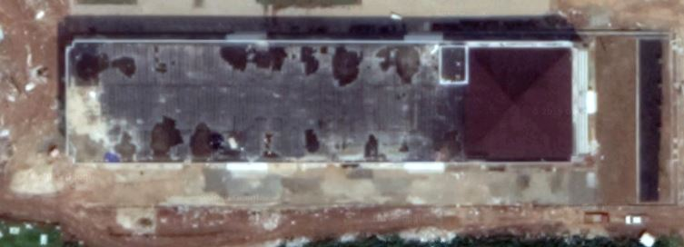
Figure 1 Location College Learning Building
In Figure 1 the location of the Public Lecture Building is shown. The roof of the public lecture building is straight flat and has no kemiriangga so that the installation of solar PV can be directly applied without using a more complicated installation. In Figure 1 it is also shown that the entire roof area that can be used is only 75%.
The method of mounting the solar PV position used is shown in Figures 2 and 3. The difference is the horizontal and vertical position of the PV installation. Installation of PV with this rotational position results in a reduction in modules and the addition of modules and several different performance ratios to meet the 80% standard.

Position 1 Solar PV
In the solar PV position placed horizontally has a detailed installation with a tilt 18 landscape, the distance between the PV rows is 0.5 M with the number of installed modules is 636. In Figure 2 the horizontal mounting model is shown.
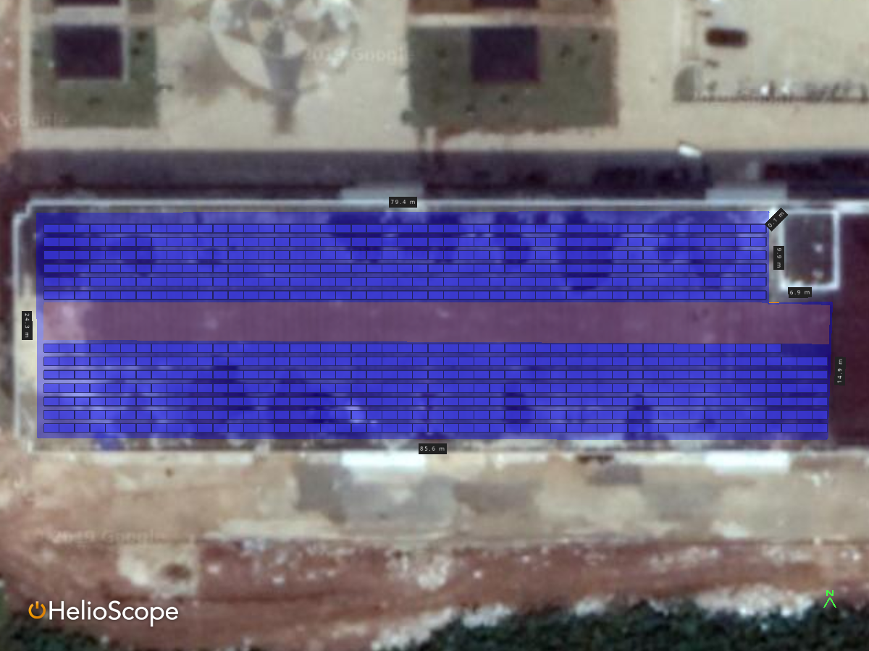
Figure 2 Design 1 Position Solar PV

In the design of Position 1 solar PV produces 1275.8 kWh / kWp. The following table shows the detailed energy produced during the year in position 1 design
Table 1 Output Power Position Solar PV 1
Month | GHI (kWh/m²) | POA (kWh/m²) | Shaded (kWh/m²) | Nameplate (kWh) | Grid (kWh)
January | 126.5 | 114.6 | 112.6 | 18,877.0 | 16,455.5
February | 117.5 | 110.1 | 108.1 | 18,211.7 | 15,848.8
March | 144.2 | 142.7 | 140.6 | 23,774.8 | 20,375.3
April | 135.3 | 141.0 | 138.9 | 23,560.0 | 20,167.4
May | 134.0 | 146.6 | 144.6 | 24,566.5 | 20,941.1
June | 123.8 | 139.0 | 137.2 | 23,335.2 | 19,964.8
July | 130.1 | 144.6 | 142.6 | 24,229.3 | 20,852.6
August | 138.6 | 147.4 | 145.2 | 24,640.3 | 21,167.6
September | 145.3 | 146.8 | 144.6 | 24,476.2 | 20,992.5
October | 137.5 | 130.7 | 128.6 | 21,671.1 | 18,635.2
November | 117.9 | 109.1 | 107.0 | 17,981.1 | 15,660.8
December | 126.4 | 112.6 | 110.6 | 18,518.8 | 16,134.1

Position 2 Solar PV
In the solar PV position placed vertically has a detailed installation with a tilt 18, the distance between the PV rows is 0.5 M with the number of installed modules is 629 less than 7 panels compared to the previous design of the solar PV position. Figure 2 shows the horizontal mounting model.
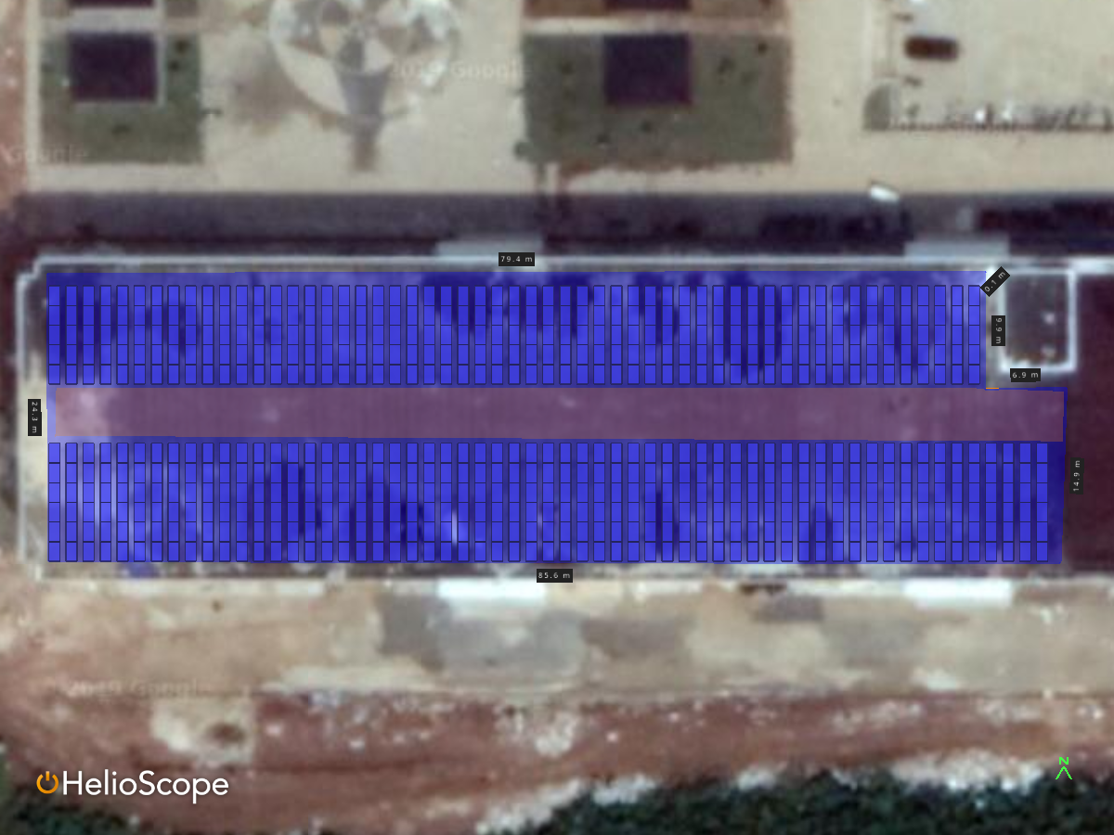
Figure 3 Design 2 position solar PV
In the design of Position 2 solar PV produces 1219.5 kWh / kWp. The following table shows the details of the energy produced during the year in position 2 design
Table 2 Output Power Position Solar PV 2

Month | GHI (kWh/m²) | POA (kWh/m²) | Shaded (kWh/m²) | Nameplate (kWh) | Grid (kWh)
January | 126.5 | 127.4 | 123.1 | 20,582.4 | 17,707.1
February | 117.5 | 115.0 | 111.9 | 18,722.7 | 16,127.6
March | 144.2 | 142.5 | 138.5 | 23,218.0 | 19,721.3
April | 135.3 | 129.4 | 125.9 | 21,029.6 | 18,020.5
May | 134.0 | 130.0 | 126.2 | 21,114.6 | 18,059.4
June | 123.8 | 119.0 | 115.9 | 19,341.8 | 16,648.7
July | 130.1 | 127.6 | 124.1 | 20,696.8 | 17,868.4
August | 138.6 | 137.0 | 133.1 | 22,249.3 | 19,128.9
September | 145.3 | 141.2 | 136.2 | 22,794.0 | 19,487.3
October | 137.5 | 131.7 | 127.5 | 21,323.9 | 18,214.4
November | 117.9 | 115.4 | 112.0 | 18,691.7 | 16,157.1
December | 126.4 | 127.6 | 122.5 | 20,480.2 | 17,643.4

Result and Discussion
On the results of the comparison of the position of solar PV 1 and PV 2 obtained the comparison results

Figure 4 Comparison Energy Output Position PV
Figure 4 shows the comparison of the energy generated from the horizontal and vertical PV positions. The figure shows that globally the vertical position produces more energy in the beginning of January and the end of December but in the beginning of March to December the horizontal position produces more energy.

Figure 5 Comparison Plan of Array Position Solar PV
Figure 5 shows the results of the Plan of Array which are more horizontal than vertical. The big difference from POA is that there is May to July. The horizontal position utilizes the location of the PV system facing directly north with the same slope in the vertical position.

Conclusion
The conclusion obtained from the results of this study is that the horizontal solar PV position produces a performance ratio with a value of 80.5% compared to the vertical solar PV position of 79%. The modules used in the horizontal position are more numerous than the vertical position so the investment value for using the horizontal position is more. In this case further research is needed in order to be able to know the comparison of conditions in the field and the direction of the sun's azimuth which currently has an impact on global warming. Vertical mounting positions that utilize direct sunlight from east to west can only produce more energy at the beginning of the year and at the end of the year. tahun.

Acknowledgment
Thanks spoken to the Higher Education Research and Technology Grants Research Lecturer Starter (PDP) in 2019 and the Institute of Technology of Sumatra with the contract number B / 180 / IT9.C1 / PT.01.03 / 2019. In this research there is no conflict of interest with any party.

References
[1]M. A. Mitiu, M. V. Olteanu, G. Deak, N. S. Raischi, and D. Cociorva, “Determination the optimal tilt and azimuth angle of photovoltaic system for maximum energy in Bucharest region Romania - Case Study”, E3S Web of Conferences, vol. 80, p. 01007, 2019.
[2]A. Z. Hafez, A. M. Yousef, and N. M. Harag, “Solar tracking systems: Technologies and trackers drive types A review”, Renewable and Sustainable Energy Reviews, vol. 91, pp. 754–782, Aug. 2018.
[3]S. A. A. Shufat, E. Kurt, and A. Hancerlioğullari, “Modeling and Design of Azimuth-Altitude Dual Axis Solar Tracker for Maximum Solar Energy Generation”, International Journal of Renewable Energy Development, vol. 8, no. 1, p. 7, Feb. 2019.
[4]C. Yu, Y. Khoo, J. Chai, S. Han, and J. Yao, “Optimal Orientation and Tilt Angle for Maximizing in-Plane Solar Irradiation for PV Applications in Japan”, Sustainability, vol. 11, no. 7, p. 2016, Apr. 2019.
[5]H. Z. A. Garni, A. Awasthi, and D. Wright, “Optimal orientation angles for maximizing energy yield for solar PV in Saudi Arabia”, Renewable Energy, vol. 133, pp. 538–550, Apr. 2019.
[6]E. Quirós, M. Pozo, and J. Ceballos, “Solar potential of rooftops in Cáceres city Spain”, Journal of Maps, vol. 14, no. 1, pp. 44–51, Jan. 2018.
[7]S. Killinger et al., “On the search for representative characteristics of PV systems: Data collection and analysis of PV system azimuth tilt, capacity, yield and shading”, Solar Energy, vol. 173, pp. 1087–1106, Oct. 2018.
[8] “PV Performance Modeling Collaborative | Plane of Array (POA) Irradiance.” .

