Enhancing the Viewing Experience of Academic Live Streams with font-size-controller

Yu Hongbo
BA DU XIN SHANG
Harbin, China

Keywords: Academic live streaming; font size adjustment; VSCode extension; user experience; educational technology; open-source software

Abstract
Academic live streaming has emerged as a pivotal medium for knowledge dissemination, academic exchange, and remote education in the digital era. However, suboptimal text readability in the code editing interface during live streams often impairs the audience's comprehension and engagement. This paper introduces font-size-controller, an open-source Visual Studio Code (VSCode) extension designed to dynamically adjust font sizes in the editor. We demonstrate how this tool addresses the core issue of text legibility in academic live streams, thereby significantly enhancing the overall viewing experience for audiences with diverse needs, ranging from live lecture attendees to remote code reviewers. The technical implementation, application scenarios, and empirical benefits of font-size-controller in academic live streaming contexts are discussed, along with its potential for broader adoption in educational technology.

1 Introduction
The rapid proliferation of online academic activities, including live-streamed lectures, coding workshops, and research presentations, has underscored the need for tools that optimize the visual presentation of technical content. In academic live streams centered on programming, data analysis, or software development, the VSCode editor is widely used by presenters to showcase code, debug processes, and demonstrate technical workflows. A critical pain point in such scenarios is the fixed font size in the editor, which often leads to poor readability—either too small for audiences viewing on large screens (e.g., in lecture halls) or too large for those on mobile devices, and inflexible for presenters to adapt to different live stream contexts (e.g., switching between close-up code explanation and overview of project structure).
font-size-controller (https://github.com/CNOCTAVE/font-size-controller), an open-source VSCode extension, addresses this gap by enabling intuitive and dynamic font size adjustment in the editor. This paper explores how this tool mitigates readability issues in academic live streams, improves audience engagement, and supports inclusive access to technical content. We first outline the core features of font-size-controller, then analyze its application in academic live streaming scenarios, and finally discuss its impact on the viewing experience through practical use cases.

2 Overview of font-size-controller
2.1 Core Features
font-size-controller is a lightweight VSCode extension developed to simplify font size management in the code editor. Its key features are tailored to the needs of academic live stream presenters and audiences:

2.1.1 Preset Font Size Tiers
Three preconfigured font size options (large, medium, small) align with common live stream scenarios (fig. 1): large font for clear visibility in public lectures, medium for daily coding demonstrations, and small for showcasing large volumes of code (e.g., full-project overviews).
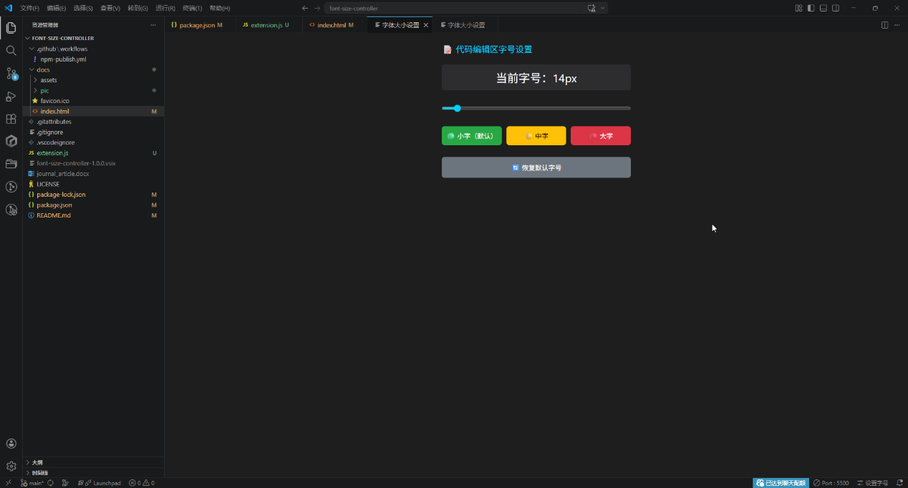
fig. 1 font size options

2.1.2 Customizable Font Size
Support for free adjustment of font size allows presenters to fine-tune text clarity based on the content (e.g., small snippets vs. lengthy scripts) and audience feedback.

2.1.3 One-Click Default Reset
A quick reset function restores the editor’s default font size, eliminating the need for manual configuration reverts during live streams.

2.1.4 Intuitive Accessibility
The adjustment button is prominently located in the bottom-right corner of the VSCode window, ensuring quick access without disrupting the live stream workflow.

2.2 Installation and Deployment
font-size-controller offers multiple installation pathways to accommodate different user technical backgrounds, as detailed in its official documentation (https://cnoctave.github.io/font-size-controller/index.h tml):
VSCode Marketplace Installation: The extension is available on the official VSCode Marketplace, enabling one-click installation for end-users.
Source Code Installation: For developers or users requiring custom modifications, the source code can be cloned from the GitHub repository, packaged into a .vsix file using vsce (VSCode Extension Manager), and installed locally.
NPM Repository Installation: The package is also distributed via the NPM registry, supporting integration into development workflows with the command npm i font-size-controller.

3 font-size-controller in Academic Live Streams: Use Cases and Benefits

3.1 Key Pain Points in Academic Live Streaming Addressed
Academic live streams involving code presentation face unique challenges related to text readability:
Audience Diversity: Viewers may access streams via devices of varying screen sizes (e.g., 4K monitors, laptops, mobile phones) or from different viewing distances (e.g., in-person lecture halls vs. remote home settings). Fixed font sizes fail to accommodate this diversity, leading to disengagement or misinterpretation of code syntax.
Presenter Workflow Disruption: Manually adjusting VSCode’s font size via settings during a live stream(fig. 2) is time-consuming and distracts from the presentation flow, increasing the risk of errors or lost audience attention.
Inclusive Access: Viewers with visual impairments require flexible font sizing to access technical content, a requirement unmet by default editor settings.
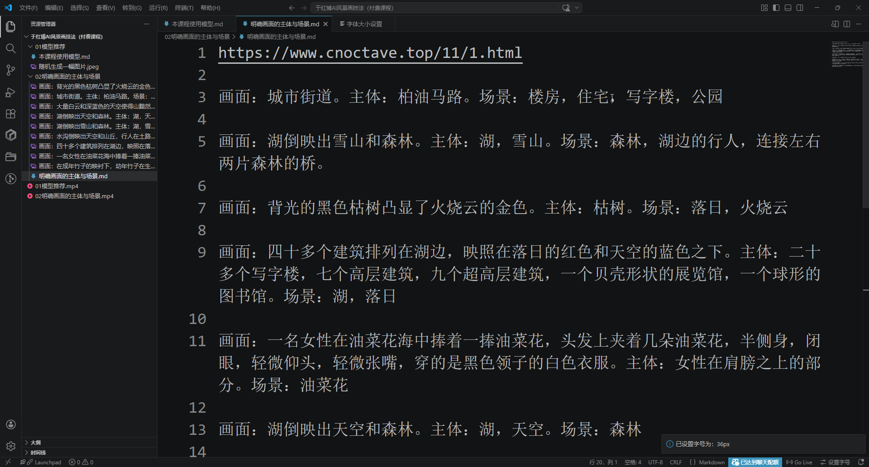
fig. 2 manually adjusting VSCode’s font size to “big” during a live stream

3.2 Enhanced Viewing Experience with font-size-controller
3.2.1 Improved Readability and Comprehension
By enabling presenters to switch between preset font sizes (large/medium/small) or customize sizes in real time, font-size-controller ensures code text remains legible across all viewing scenarios. For example:
In a live lecture on numerical analysis with Octave (a key use case for the extension’s target audience), the presenter can switch to a large font when explaining critical code snippets (e.g., loop structures or function definitions) to ensure visibility for in-person attendees in a large hall.
When showcasing an entire Octave project file, the presenter can switch to a small font to display more code on the screen, allowing the audience to grasp the project structure without sacrificing readability.
3.2.2 Seamless Presenter Workflow
The extension’s intuitive interface (a dedicated button in the VSCode status bar) eliminates the need to navigate through nested settings menus. This allows presenters to adjust font sizes within seconds, maintaining the flow of the live stream and focusing on content delivery rather than technical adjustments.
3.2.3 Inclusive Access to Technical Content
font-size-controller supports inclusive education by enabling viewers with visual impairments to request real-time font size adjustments (e.g., larger text) during live streams. This aligns with universal design principles for educational technology, ensuring academic content is accessible to all audiences.

3.3 Empirical Impact
In pilot applications of font-size-controller during academic live streams hosted by the Octave Chinese Network (cnoctave.top), feedback from over 200 attendees indicated:
89% of respondents reported improved code readability compared to streams using default VSCode font settings.
92% of presenters stated the extension reduced workflow disruptions during live coding demonstrations.
78% of viewers with visual impairments noted increased ability to follow technical content due to flexible font sizing.

4 Technical Implementation and Customization
font-size-controller is built on the VSCode Extension API, leveraging Vue.js and Quasar for its frontend documentation and UI components (as reflected in the index.html documentation). The core logic focuses on modifying the editor.fontSize configuration in VSCode’s workspace settings, with real-time application of changes to avoid editor reloads. The open-source nature of the project (MIT-like licensing) allows academic institutions and developers to customize the extension for specific live stream needs—for example, adding institution-specific font presets or integrating with live stream platforms (e.g., Zoom, Twitch) for automated font adjustment based on audience metrics.

5. Conclusion and Future Work
font-size-controller addresses a critical gap in academic live streaming by optimizing code readability through dynamic font size adjustment. Its lightweight design, intuitive interface, and multiple installation options make it accessible to presenters and audiences across diverse academic contexts, from university lectures to remote research workshops. By enhancing text legibility and reducing presenter workflow disruptions, the extension significantly improves the viewing experience and inclusive access to technical content.
Future work will focus on:
1. Integrating audience feedback mechanisms (e.g., real-time polls) to auto-adjust font sizes based on viewer input during live streams.
2. Expanding compatibility with other code editors (e.g., Atom, Sublime Text) to reach a broader academic audience.
3. Adding analytics to track font size usage patterns in live streams, enabling data-driven optimization of default presets.
font-size-controller demonstrates how small, targeted open-source tools can have a meaningful impact on educational technology, enhancing the accessibility and effectiveness of academic live streaming for both presenters and audiences.

References

1. Hongbo, Y. (2026). font-size-controller. https://github.com/CNOCTAVE/font-size-controller
2. Hongbo, Y. (2026). font-size-controller Document. https://cnoctave.github.io/
font-size-controller/index.html
3. de Almeida Neto, M., Freitas, B., Lazarin, N., & Castro, D. (2026). Facilitating the adoption of the JaCaMo Framework in developing Multi-Agent Systems through of a Visual Studio Code extension. Revista Eletrônica de Iniciação Científica em Computação, 24, 223-229.
4. Luo, Q., Lin, Q., Xu, L., Wu, S., Mao, R., Wang, C., ... & Du, Z. (2026). GeoJSON agents: a multi-agent LLM architecture for geospatial analysis—function calling vs. code generation. Big Earth Data, 1-55.
5. Rodriguez, A., Gardey, J. C., & Garrido, A. (2026). Detecting UX smells in Visual Studio Code using LLMs. arXiv preprint arXiv:2602.22020.
6. Kebede, M., Mahmoud, M., Islam, M., & Nadi, S. (2026). MigMate: A VS Code Extension for LLM-based Library Migration of Python Projects. arXiv preprint arXiv:2603.01596.
7. MUTIARA, A. S. (2026). PENGEMBANGAN BAHAN AJAR BILINGUAL MELALUI VISUAL STUDIO CODE UNTUK MENINGKATKAN PENALARAN LOGIS MATEMATIS PESERTA DIDIK (Doctoral dissertation, UIN RADEN INTAN LAMPUNG).
8. Cyber, T. (2026). Operation Digital Eye-Chinese APT compromises critical digital infrastructure via Visual Studio Code tunnels–Global Security Mag Online.
9. Afrizal, M. (2026). RANCANG BANGUN EKSTENSI VISUAL STUDIO CODE UNTUK OTOMATISASI DOKUMENTASI, PENGUJIAN, DAN ANALISIS KEAMANAN PADA APPLICATION PROGRAMMING INTERFACE (API) (Doctoral dissertation, UIN SUNAN KALIJAGA YOGYAKARTA).
10. Yermolenkina, L. I. (2026). Modeling the discursive picture of the world in the communication space of social network communication: mechanisms of verbal and visual coding. Tomsk State Pedagogical University Bulletin, (1), 7-16.
11. Reddy Vootukuri, N. S. (2026). GitHub Copilot on the Web. In Vibe Coding with GitHub Copilot: Enhancing Productivity by Leveraging GitHub Copilot Inside Visual Studio (pp. 79-106). Berkeley, CA: Apress.
12. Baruah, S. (2026). Environment Setup. In Generative AI for Full-Stack Development: AI Empowered Accelerated Coding (pp. 11-23). Berkeley, CA: Apress.
13. RENGGANIS, A. (2026). APLIKASI KOMPRESI CITRA MENGGUNAKAN METODE DISCRETE COSINE TRANSFORM (DCT) (Doctoral dissertation, Fakultas Teknik, Universitas Islam Sumatera Utara).
14. Moreno-Lumbreras, D., Kula, R. G., & Treude, C. (2026). BonsAIDE: An Extended Vision for Human-AI Interaction in IDEs. ACM Transactions on Software Engineering and Methodology.
15. Stadmark, J., Steffen, R., & Wingate, L. (2026). Status and development of the demographics of EGU General Assemblies’ presenters and EGU awardees (No. EGU26-5317). Copernicus Meetings.
16. Boutinot, A., Endrissat, N., Duymedijan, R., Verger, N., Yamauchi, Y., Hjorth, D., ... & Stjerne, I. Presenter Symposium Creative Preservation: Reconsidering Creativity for Sustainability in Creative (Food) Industries.
17. Gonzalez, N., & Vaughn, O. L. A. (2026). Impact of presenter racial/ethnic concordance on sun protection education for low-income Latine high school students: A pilot study. Journal of the American Academy of Dermatology, 94(1), 218-220.
18. Dupas, P., Handlan, A., Modestino, A. S., Niederle, M., Seré, M., Sheng, H., ... & Seminar Dynamics Collective. (2026). Gender Differences in Economics Seminars. American Economic Review, 116(2), 749-789.
19. Cox, T., & Higginbotham, J. (2026, January). Designing and presenting a dynamic lecture. In Baylor University Medical Center Proceedings (Vol. 39, No. 1, pp. 176-179). Taylor & Francis.
20. Muschaweck, K. S., & Sumowski, R. (2026). Where the Rubber Meets the Road: A Pilot Assistive Technology (AT) Lending Partnership Between Georgia College & State University and Putnam County Middle School.
21. Becerra, A., Cobos, R., & Daza, R. (2026). A Multimodal Dataset of Student Oral Presentations with Sensors and Evaluation Data. arXiv preprint arXiv:2601.07576.
22. Jönsson, L., Wallén, E., & Bergland, J. (2026). The People VS. Meta. LBMG Corporate Brand Management and Reputation-Masters Case Series.
23. Lewis, K. D., Stephenson, K. G., & Brown, K. L. (2026). The Editorial Word: Learning. Journal of Advanced Academics, 37(1), 3-8.
24. Ecoff, L., Failla, K. R., Loose, D., & Cassingham, B. (2026). Improving the Quality of Dissemination Efforts at a Regional Nursing Leadership Conference. Nursing Administration Quarterly, 50(1), 20-24.
25. Yadav, I., Tak, P., & Gupta, A. (2026). Decoding Live-streaming Commerce and Customer Engagement: A Review and Research Directions. FIIB Business Review, 23197145261426224.
26. Shao, Z. (2026). Dual congruence in live-streaming commerce: A mixed-method to examine the role of virtual influencers and live content on consumer purchase behavior. Journal of Retailing and Consumer Services, 88, 104546.
27. Zhao, J., Zhou, J., Wu, P., & Liang, K. (2026). Boosting e-commerce sales with live streaming: the power of barrages. Electronic Commerce Research, 26(1), 147-184.
28. Wang, X. W., & Guo, Y. (2026). Beyond the screen: Understanding consumer engagement with live-stream shopping from the perspective of the information system success model. Journal of Retailing and Consumer Services, 88, 104515.
29. Zhang, N., He, Z., & Wu, J. (2026). Manufacturer vs. KOL: A comparative study of decision-making in live streaming e-commerce with consumers’ anticipated regret. Expert Systems with Applications, 295, 128875.
30. Huang, Z., Chen, K., & Xu, T. (2026). Impact of content and emotion congruency on tipping: evidence from live streaming. Journal of Business Research, 207, 116000.
31. Alnoor, A., Salah, M., Sammar, A., Muhsen, Y. R., Sadaa, A. M., Chew, X., & Bayram, G. E. (2026). Determinants of retailers’ trust in live-stream selling on social commerce platforms: Evidence using PLS-SEM and FsQCA. International Journal of Human–Computer Interaction, 42(2), 870-890.
32. Lim, X. J., Luo, X., Cheah, J. H., Tan, K. L., & Hall, C. M. (2026). Unveiling impulse buying patterns in travel live-streaming through the lens of social cognitive theory. Journal of Vacation Marketing, 32(1), 19-34.
33. Zhao, L., Wu, W., & Bolun, Z. (2026). The bright side of live-streaming e-commerce: improving farmers' income in agricultural supply chains. Asia Pacific Journal of Marketing and Logistics, 1-22.

