The Linearity of the Release Behavior of Artificial Turf Surfaces
Ben Koerberª*, Bronislaw Gepnerª, James Caldwellª, Cody O’Cain^{b},
E. Meade Spratley^{b}, Gwansik Park^{b}, Richard Kentª, Jason Kerrigan^{a, c}
ªCenter for Applied Biomechanics, University of Virginia, Charlottesville, VA, USA; ^{b}Biomechanics Consulting and Research (Biocore) LLC, Charlottesville, Virginia, USA; ^{c}Department of Orthopaedic Surgery, University of Virginia, Charlottesville, VA, USA
*corresponding author (bmk2ck@virginia.edu, +1 434-297-8053)
Provide full correspondence details here including e-mail for the *corresponding author
The Linearity of the Release Behavior of Artificial Turf Surfaces
This study quantified the release traction behavior of four artificial turf surfaces and two American football cleat surrogates. Four different loading conditions representing various play-relevant maneuvers were applied with a 6 DOF robotic test system. In all test conditions, a strong linear relationship was found to exist between normal force applied to the surface and peak shear force or moment resisted by the surface before release across varying normal force inputs. This linear relationship represents a release traction relationship that is the upper limit of the ratio of shear force to normal force that a player can generate without slipping. Changes in turf surface design parameters were shown to change the slope of the release traction relationship. The release traction relationship was shown to be insensitive to changes in loading condition or loading rate. Evaluations of the release traction behavior of surfaces can greatly improve future surface designs for player injury and performance.

Introduction
The shoe-surface interaction of an athlete is critical for both injury prevention and performance. Changes in shoe type and playing surface influence a player’s ability to accelerate, change direction, and stop (Gains et al. 2010). Foot “entrapment”, when the player’s foot ceases to move relative to the playing surface while the player’s body continues to move in either translation or rotation, has been postulated as a mechanism of some lower extremity injuries (Torg et al., 1974; Lambson et al., 1996; Orchard et al., 2001). For example, lateral ankle ligaments can be injured by inversion of the ankle caused by foot entrapment (Bloemers & Bakker, 2006).
The phenomenon that occurs after foot entrapment is called “release”, which occurs when the player’s foot overcomes the resistive force generated by the interaction and moves relative to the playing surface. The release phenomenon has been shown to occur at the time of peak force in simplified pre-loaded translation testing on an artificial turf surface. (Koerber et al. 2025). Previous studies have employed the use of a ‘traction coefficient’ (Bowers and Martin 1975, Heidt et al 1996). This traction coefficient is used broadly in literature and is commonly defined as the ratio of shear force to normal force under a player’s cleat. Traction has been shown to be variable with time in both mechanical testing (Kent et al. 2012, Koerber et al. 2025) and player testing (Shorten et al. 2003). Other more useful terms used to describe the relationship between release and entrapment include a “release coefficient” (Torg et al. 1974), “available traction” (Shorten et al. 2003, Schrier et al. 2014), and “release traction” (Koerber et al. 2025). These terms all generally refer to the ratio of shear force or moment to the normal force between a player’s cleat and the playing surface at the time of release. In this study, the term “release traction” will be used to describe this ratio, both when describing previous literature or the current work. Here, care was taken to only use the term release traction when describing the relationship where release is clearly the event occurring, and otherwise this relationship will be defined more explicitly.
Methods of determining the forces required to calculate release traction of a shoe and surface pairing have traditionally involved mechanical testing. Torg et al. (1974) performed one of the first of these studies, which analyzed resistance to rotational motion from different combinations of cleated shoes and playing surfaces. Since then, These studies have often reported translational or rotational release traction but are limited in the scope of their results for a few key reasons. First, the normal force applied to the surfaces was limited to values well below the forces that can be generated during game-relevant maneuvers of the elite athlete (Riley et al., 2012). Kent et al. (2012, 2015a, 2015b, 2021) developed a method for testing playing surfaces that overcame this limitation by performing both translational and rotational testing at a normal load of 2.8 kN, which approximates the 50th percentile of the range of observed maximum vertical loading recorded for a sample of professional football athletes performing player-relevant movements. While characterizing release at this level is a clear benefit over previous work, the sensitivity of release to variations in the range of player-relevant normal loads was not identified. Another common limitation in most previous studies is that testing was performed at relatively low loading rates or at loading rates that were variable, e.g., through rotation applied manually via a torque wrench (Baker, 1990; Lambson et al., 1996; Torg et al., 1974, 1996). Kent et al. (2012, 2015a, 2015b, 2021) again overcame this limitation but did not explore loading-rate sensitivity. Finally, all of these studies performed similarly simplified test motions such as pre-loaded translation or pre-loaded rotation.
Professional football players have been shown to apply a wide range of peak normal forces across a variety of athletic maneuvers. Previous testing described in the literature has not addressed the effects that varying normal force or varying input kinematics (including test motions and test rates) have on release traction response. Koerber et al. (2025) described a device and methodology for testing cleat-surface interaction across a range of normal loads and found that shear release force increased linearly over the range of normal loads tested in one artificial turf construct. Further, while tests performed previously were similar to other studies in that they employed a simplified pre-loaded translation test, the test device described by Koerber et al. 2026 is capable of performing force/torque and position-controlled loading with 6 degrees of freedom (DOF). The current study aimed to apply the device and methodology used previously to address some of the limitations of previous studies. Specifically, our goal was to perform a detailed analysis of the linearity of release traction on artificial turf surfaces by evaluating the following hypotheses:
- The release traction is linear for pre-loaded translation tests across normal loads ranging from near zero to greater than 2500 N.
- The release traction slope is specific to the cleat-surface pairing tested and changes with changes in turf surface parameters.
- Peak shear force or moment increases linearly with the normal load at the time of the peak across multiple test inputs including pre-loaded rotation testing and simultaneous vertical and horizontal translation testing.
- Increasing rate will increase the release traction slope for otherwise similar cleat-surface pairings.

Materials and Methods
Surface characterization experiments were performed using the previously described robotic test system (Koerber et al. 2025). Two metal cleat surrogates (cleatforms) were used in this study (Table 2, Figure 1), specifically replicas of two U.S. Men’s size 12 football cleats used by professional athletes (Koerber et al. 2026). Four test motions were performed as a part of this study. The pre-loaded translation test involved an imposed motion displacing the cleatform rearward (posteriorly) relative to the turf surface (such as the direction the cleat would move if a player slipped during forward push off). The simultaneous load test involved displacements in both the vertical and rearward horizontal directions (such as the motion a player would experience during a forward running foot strike and slip). Rate sensitivity tests that were similar in motion to the simultaneous load tests but displaced anteriorly were performed at three different shear displacement rates. Pre-loaded rotation tests were performed that involved rotation of the cleat relative to the surface about a vertical axis at the center of contact area of the forefoot (such as the motion a player would experience during a cut and change in direction).
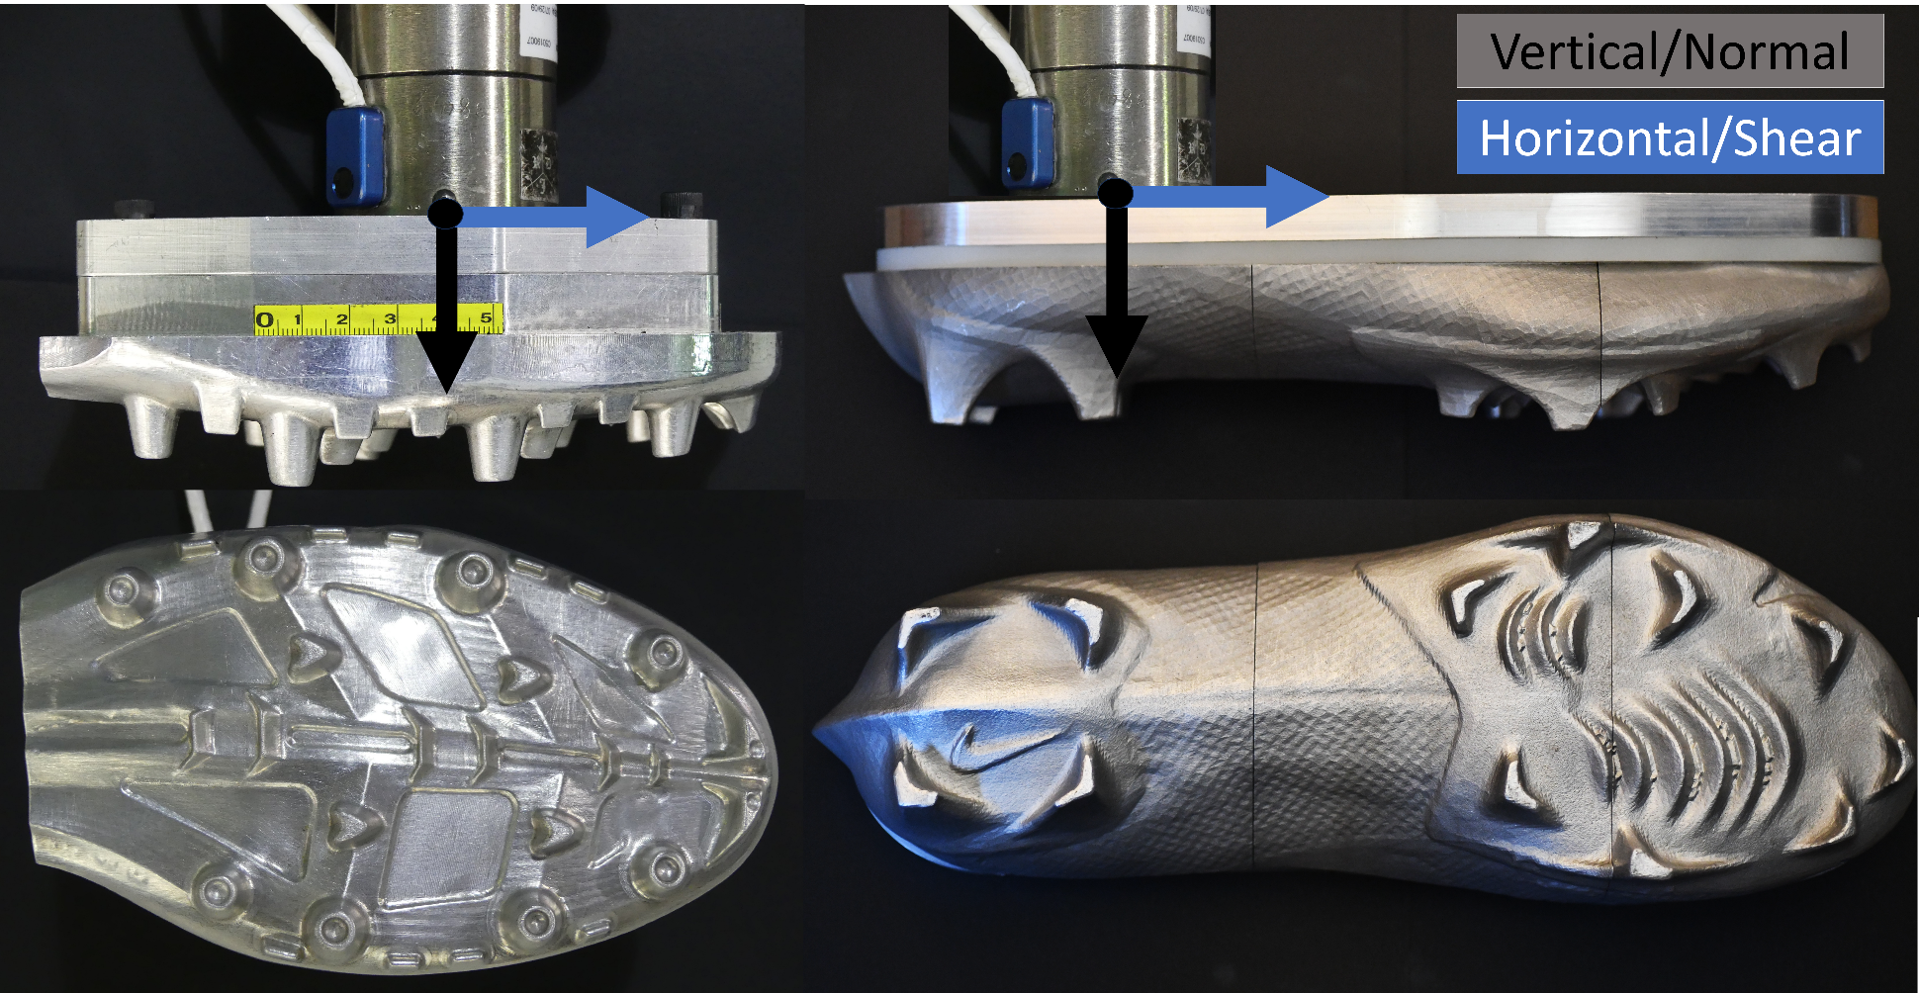
Figure 1: Cleat surrogates tested. (Left) Surrogate A, modelled after a Nike VaporJet Forefoot, (Right) Surrogate B, modelled after a Nike VaporEdge.
Four different turf systems were tested as a part of this study (Table 1). Our study targeted analysis of a substantial reduction in faceweight, and the addition of a shock-absorbing pad beneath the turf carpet as main parameters. Faceweight describes the weight of fibers per area of turf carpet and can be changed by adjusting the spacing of fiber stitching. Turf 1, Turf 2, and Turf 3 were constructed according to build parameters reported by Wannop et. al 2026. While not used in comparison, another turf grossly similar to Turf 1 in build parameters but with a slightly higher infill depth was also used for pre-loaded translation testing. Turf samples were constructed in custom built aluminum turf boxes and fixed to the laboratory floor for testing as previously described (Koerber et al. 2026).

Table 1: Surface Types
Surface | Faceweight (g/m^2) | Fiber Type | Pile Height (mm) | Infill | Infill Depth (mm) | Shockpad
Turf 1 | 1198.9 | Slit-film (Polyethylene) | 63.5 | 3-layer SBR/ sand system | 41 | None
Turf 2 | 640.8 | Slit-film (Polyethylene) | 63.5 | 3-layer SBR /sand system | 41 | None
Turf 3 | 1198.9 | Slit-film (Polyethylene) | 63.5 | 3-layer SBR/ sand system | 41 | 23 mm composite foam
Turf 4 | 1198.9 | Slit-film (Polyethylene) | 63.5 | 3-layer SBR/ sand system | 44 | None

Test Matrix
A total of 138 tests were performed in this study (Table 2).
Table 2: Test Matrix
Surface | Cleat Surrogate | # of Tests
Surface | Cleat Surrogate | Pre-loaded Translation | Simultaneous Load | Rate Sensitivity | Pre-loaded Rotation
Turf 1 (Control) | Surrogate A | 18 | 18
Turf 1 (Control) | Surrogate B |  |  | 9
Turf 2 (Low FW) | Surrogate A | 18 | 18
Turf 2 (Low FW) | Surrogate B |  |  | 9
Turf 3 (Shockpad) | Surrogate A | 18 | 18
Turf 4 | Surrogate A |  |  |  | 12

Boundary and Loading Conditions

Pre-loaded translation tests
This test followed the test procedure described previously (Koerber et al. 2026), including a compression phase to a specified depth, a hold phase to allow settling, followed by a 100 mm rearward displacement and simultaneous vertical ramp-out. In this study, test depths and ramp-outs were varied across varying vertical compression forces.

Simultaneous load tests
Tests involving a simultaneous normal and shear load were performed in displacement-control by both dynamically compressing and shearing the turf surface simultaneously (Figure 2). The surface was compressed to a target depth at a rate of 0.2 m/s, and sheared to a displacement of 100 mm at a nominal rate of 0.3 m/s. At 0.16 seconds a ramp out in vertical displacement was initiated (a decrease in vertical displacement). As with the pre-loaded translation tests, the vertical depths and ramp-outs were varied across tests to sample vertical forces ranging from ~100 N to 3000 N.
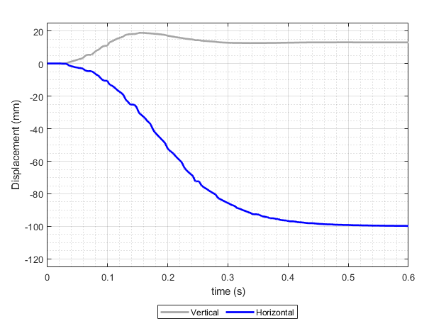
Figure 2: Representative displacement time history of a simultaneous input test. Negative horizontal displacement represents rearward (posterior) displacement of the cleat, and positive vertical displacement represents motion down into the surface.

Rate-sensitivity tests
Tests involving simultaneous vertical and horizontal displacement were performed at varying rates of displacement (Figure 3). These tests involved forward displacement of the cleat surrogate above the surface of the turf at an increasing rate until the target rate was achieved. At that time, the horizontal rate was held constant, and the cleat was displaced vertically into the surface. For a high-rate test, vertical displacement was initiated at approximately 1.2 seconds (Figure 3). A maximum depth of 18 mm was used for all tests across rates, and the displacement input was consistent across each test condition, which resulted in different responses based on changes in displacement rate and turf type. Horizontal displacement rates of 1.2 m/s, 0.6 m/s, and 0.3 m/s were tested, and three repeat tests were performed for each rate condition. The highest rate tested here represented a cleat displacement rate that is ~50% of that seen in player motion testing performing a cutting motion with various cleat types (Driscoll et al., 2012). Vertical displacement rate was also varied in proportion to the horizontal displacement rate. Vertical displacement rates of 0.1 m/s, 0.05 m/s, and 0.025 m/s were tested.
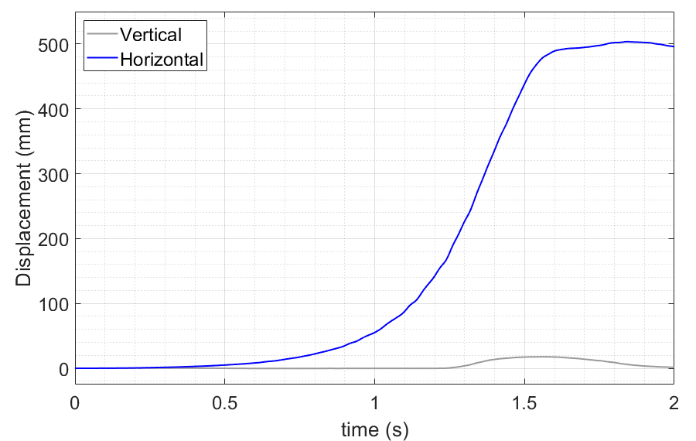
Figure 3: Representative displacement time history of a rate-sensitivity test (high rate: 1.2 m/s).

Pre-loaded rotation tests
These tests involved a vertical compression phase to a specified depth, a hold phase to allow settling, followed by a 120-degree rotation about the cleat vertical axis (based at the center of the load cell connection to the cleat surrogate and pointed superiorly) (Figure 4).
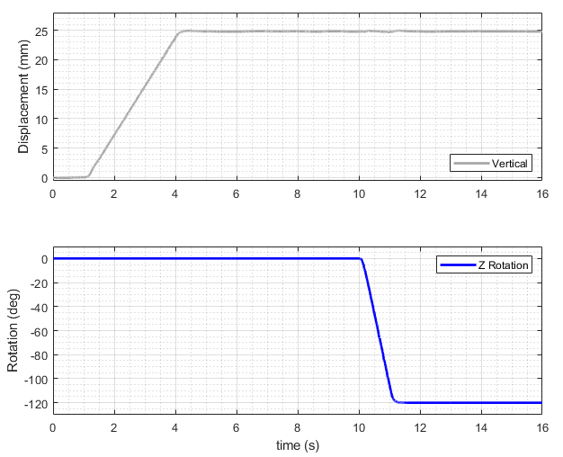
Figure 4: Representative displacement time history of a pre-loaded translation test.

Measurement and Analysis
Instrumentation used to measure forces/moments, displacements/rotations, and high-speed video was consistent with the previous study (Koerber et al. 2026). Force and torque data generated by each test were measured by a 6 DOF strain-gauge load cell (Model 1914, R.A. Denton, Rochester Hills, MI, USA) mounted between the cleat surrogate and the end effector of the robot arm. Position data for the cleated foot form was recorded by the robot control software at a coordinate system based at the center of the connection between the cleat and load cell. High speed video of each test was captured at 1000 frames per second from two angles (top, side).
For each test type and surface, a linear regression analysis was performed to test for a relationship between the peak shear force or moment and the normal force at the time of peak shear or moment (Figure 5). Linear regressions were calculated using both the form y=a*x+b and the form y=a*x. Regressions of the form y=a*x+b were performed only as a check for linearity, and to evaluate the need for an intercept term. Mean-centered R² values and root mean square error values (RMSE) were calculated for regressions of the form y=a*x. Slopes and percent differences on the slopes of the regressions of the form y=a*x are reported as a descriptor of the release traction.
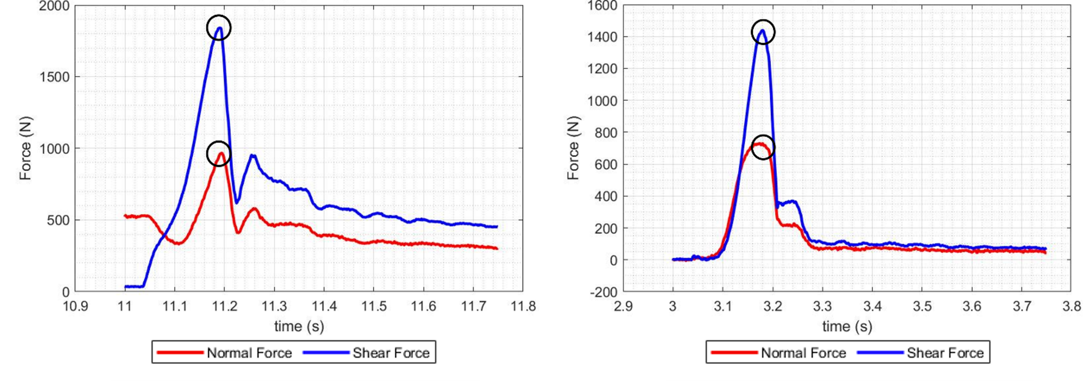
Figure 5: Peak shear force and normal force at time of peak shear circled for a pre-loaded translation test (left) and a simultaneous load test (right).

Results
Linear regression data of the form y=a*x+b yielded R² values greater than 0.97 for every turf type and test type combination performed. These linear regressions also exhibited low Y-intercept (Y-Int) values (<180 N) that were comparable to the RMSE calculated on each regression. This supported the use of a regression fit with no intercept term. Linear regression data of the form y=a*x yielded mean-centered R² values greater than 0.96 across every turf type and test type performed (Table 3).
Table 3: Linear regression metrics for all test types and turf types (Form: y=a*x).
 | Slope | R² | RMSE (N) | Slope Percent Change (from Turf 1) | Slope Percent Change (from Pre-Loaded Translation)
Pre-loaded Translation Tests
Turf 1 | 2.0871 | 0.9919 | 117.42 | 0% | NA
Turf 2 | 1.4951 | 0.9937 | 104.89 | -28% | NA
Turf 3 | 2.1814 | 0.9916 | 147.86 | 5% | NA
Simultaneous Load Tests
Turf 1 | 1.9853 | 0.9909 | 168.65 | 0% | -5%
Turf 2 | 1.3056 | 0.9656 | 337.19 | -34% | -13%
Turf 3 | 1.9748 | 0.9881 | 169.26 | -1% | -9%
Rate Sensitivity Tests
Turf 1 | 1.1352 | 0.9661 | 77.06 | 0% | NA
Turf 2 | 0.9224 | 0.9926 | 32.35 | -13% | NA
Rotation Tests
Turf 4 | 0.0569 | 0.9710 | 6.57 (Nm) | NA | NA
In pre-loaded translation testing, Turf 1 and Turf 3 yielded release traction slopes within 5%, while Turf 2, which used a carpet with a lower faceweight, gave a release traction slope that was 28% less than Turf 1 (Table 3, Figure 6). Simultaneous load tests produced a similar trend, with Turf 1 and Turf 3 yielding release traction slopes that varied by 1%, while Turf 2 generated a release traction slope that was 34% less than Turf 1. While simultaneous load tests always generated lower release traction slopes than pre-loaded translation tests, release traction slopes varied by less than 13% for all three turf types (Table 3, Figure 6).
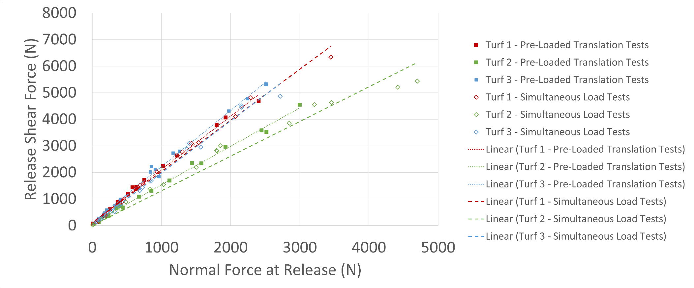
Figure 6: Release shear force vs. peak shear normal force for pre-loaded translation and simultaneous load tests with linear regressions (form y=a*x).
Rate sensitivity tests resulted in modest variance in peak shear force across test rates (Figure 7). Low-rate tests generally had the lowest peak force values and high-rate tests generated the highest peak shear force values. This difference was more clearly seen on testing on Turf 2, where low-rate tests exhibited a ~40% decrease in peak shear force compared to high-rate tests. However, peak shear force correlated linearly with vertical force across tests rates on both Turf 1 and Turf 2 (Table 3). Tests on Turf 1 had a regression slope value of 1.14 across normal forces ranging from 1091 N to 2422 N (Table 3, Figure 7). As with pre-loaded translation and simultaneous load testing (Figure 6), Turf 2 had a lower regression slope than Turf 1. Turf 2 yielded a regression slope of 0.92 over normal forces ranging from 377 N to 1705 N.
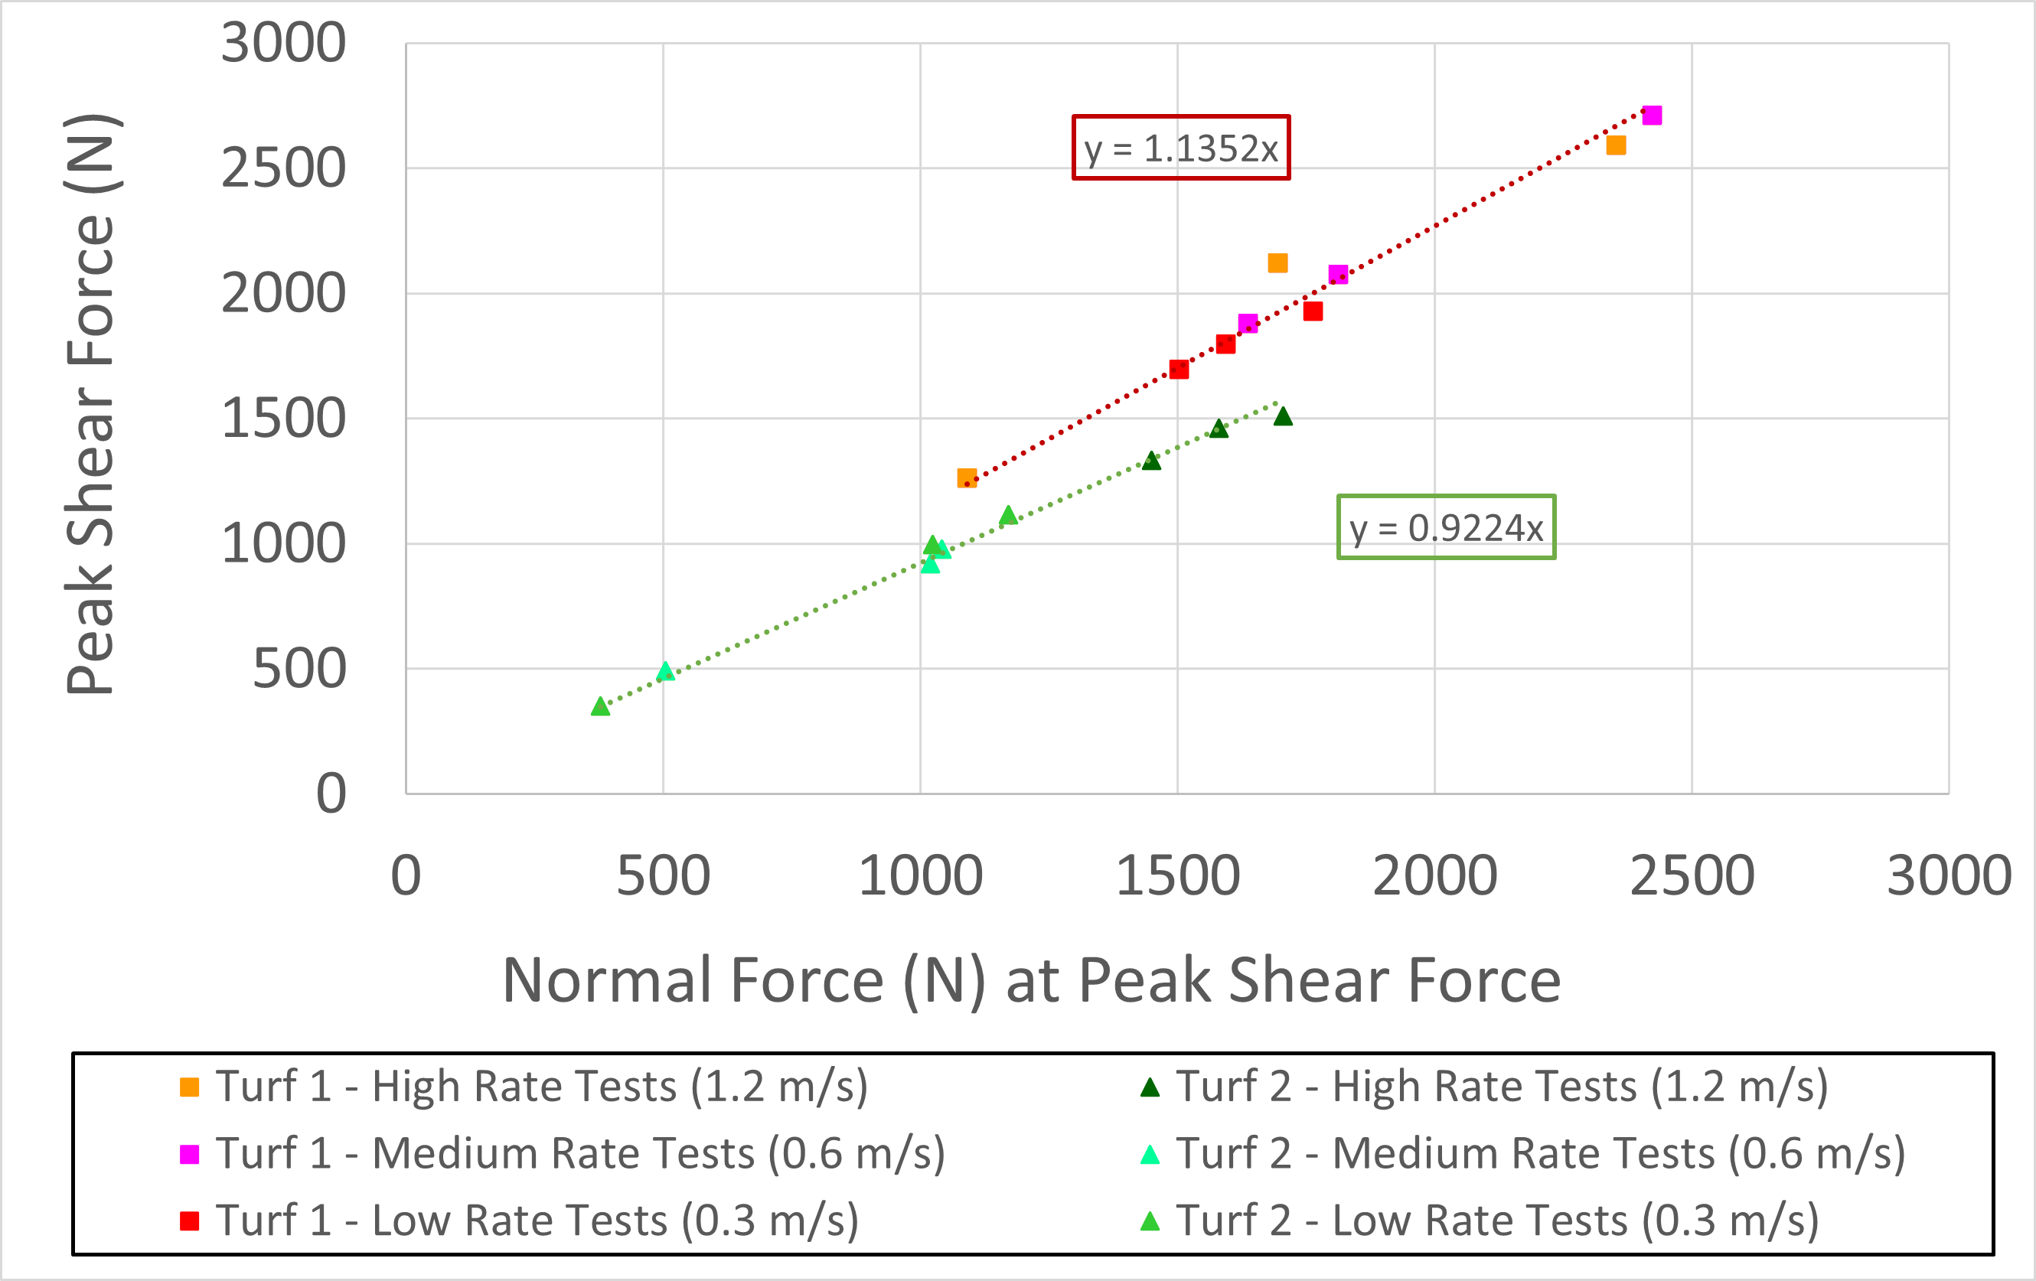
Figure 7: Peak shear force vs. peak shear normal force for rate sensitivity tests on Turf 1 and Turf 2 (Tests performed with Cleat Surrogate 2)
In pre-loaded rotation tests, peak moment increased linearly with normal force at time of peak moment across normal force values ranging from 944 N to 3076 N (Table 3, Figure 8).
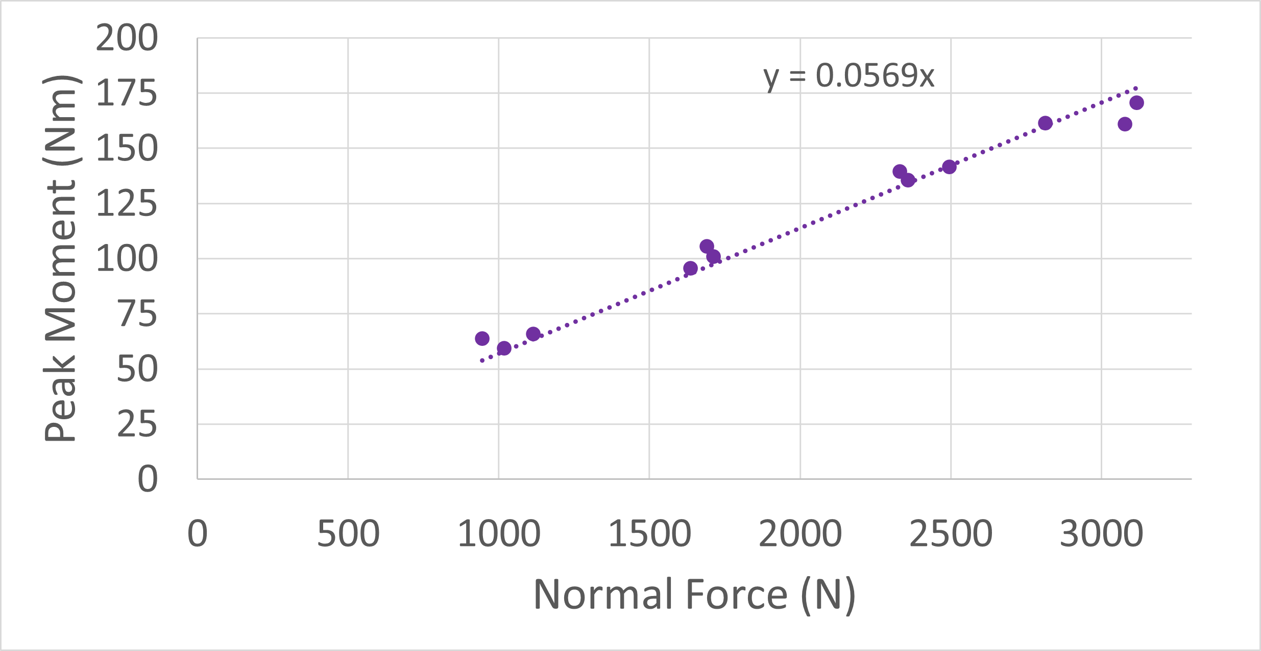
Figure 8: Peak moment vs. normal force at peak moment for pre-loaded rotation tests on Turf 4

Discussion
During athletic activity, movements such as running and cutting impart both normal and shear force components on a surface. The ratio of shear force to normal force changes with time during the stance phase of a player step (Shorten et al. 2003). By definition, the release traction represents the upper achievable limit of this ratio: if a player generates a ratio of horizontal shear force to normal force greater than the release traction, cleat slipping will occur. A linear release traction relationship, which intercepts zero, represents a constant release traction; release will happen at the same ratio of shear force to normal force for any given normal load input. An elite athlete can generate peak normal forces of up to an average of 2.8 kN during game-relevant maneuvers (Kent et al. 2012), and players generate forces that vary between zero and peak normal force during both foot strike and toe off.
In pre-loaded translation tests, a linear relationship existed between shear release force and normal force across a range of normal forces from 10 to 3000 N. This release traction relationship was found to be linear across three surfaces. The addition of a shockpad under the carpet of the turf construct was shown to have minimal effect on the release traction slope, but decreasing faceweight decreased the release traction slope by 28%.
Testing involving simultaneous vertical and horizontal translation also resulted in a strong linear relationship between normal force and horizontal shear force. It was observed that decreasing faceweight decreased the slope of this relationship. The release traction slopes calculated for each surface differed by at most 13% compared to those calculated from pre-loaded translation tests (Table 3). These results indicate that the type of test input - whether pre-loaded transition or simultaneous loading - has minimal effect on the release traction. Pre-loaded translation tests in this study were similar to other testing in the literature such as BEAST testing (Kent et. al. 2012), but a simultaneous normal and shear loading may be more realistic to represent player loading. Simultaneous load testing in this study aimed to more closely represent player loads and evaluate if these changes would greatly affect the release traction behavior. The insensitivity of release traction measurement to test input type suggests that surface evaluations with simplified test inputs may be appropriate to evaluate the release traction that a player could generate. Further, test results in both pre-loaded translation and simultaneous load tests indicate that release traction of a cleat and surface pairing can be modified by changing turf faceweight.
Torg et al. (1974) showed an increase in peak moment with increase in normal force to the surface, and the ratio of these values was called the “release coefficient”. They performed rotation testing on seven surfaces with normal loads up to 650 N. Similar pre-loaded rotation testing in this study found that peak moment increased linearly over normal forces greater than those tested by Torg et al. (1974) for one artificial surface and cleat combination. Further testing could be focused on how this linear relationship with peak moment may change with differing parameters of the turf surface such as faceweight, and whether changes occur in proportion to release shear traction changes.
The linear relationship between peak shear force and vertical force was found to be consistent across test rates ranging 0.3 to 1.2 m/s for two surfaces. Interestingly, peak shear force varied with changes in test rate for the same test displacement input, but vertical force also varied in a linear relationship to peak shear (Figure 7). The results of this testing suggest that infilled turf systems exhibit rate-sensitive effects in compressive stiffness (resistance to vertical deformation), but shear release response is invariant to changes in rate as release shear force increases linearly with normal force.
These rate sensitivity tests generated release traction slopes that were much lower than those calculated from other test types on the same turf types. While test input may have caused this change in calculated release traction, our hypothesis is that the change in cleat type was more critical to this change. Kent et. al. (2015b) demonstrated that cleat type can have a significant effect on kinetic test response. The cleat type used in rate sensitivity tests in this study (Surrogate A) had a significantly larger surface area than that used in other testing in this study (Surrogate B) (Figure 1). This larger cleat was subjected to a displacement-controlled input which resulted in an increase in the normal load for a given vertical displacement. This effect would decrease the traction slope if shear force was similar across cleat type. Further testing should aim to quantify the effect of changes in cleat type and cleat engagement on release traction behavior.
The release traction relationship is specific to the cleat-surface pairing. This study has shown that release traction behavior is affected by changes to turf surface design (such as faceweight) and potentially also cleat type and engagement. Test input type (between pre-loaded translation and simultaneous load) and test rate were shown to minimally affect the release traction behavior. Previously, and in this study, release traction was found to be highly linear across all artificial turf types, cleat types, and test inputs considered. Further testing should investigate the release traction behavior of more surface and cleat types. The methodology described previously and herein represents a system for determining the release traction of a given surface. Release traction behavior across a range of vertical forces may be able to be used as a design parameter for improvements in playing surfaces. Artificial turf design should target characteristic release traction behavior that is favorable for both injury risk and player performance, and future work should attempt to define this relationship. While there are other aspects of mechanical response that may be important for surface design, release traction response is a useful metric for surface design and evaluation.

Conclusions
In this study, four artificial turf surfaces were tested paired with two different cleat surrogates. Four separate test inputs were applied, and peak shear force or moment were found to have strong linear relationships to normal force for each test input. Changing parameters in turf surface design, such as faceweight, changed the slope of this regression relationship but did not affect the goodness of fit. When pre-loaded translation tests and simultaneous vertical and horizontal loading tests were performed with the same turf type and cleat, similar linear regressions were calculated, indicating that release traction slope is not specific to test input for the test types evaluated here. A relationship that was well represented with a linear fit was also found when performing pre-loaded rotation tests at varying normal loads. Loading rate did have an effect on peak shear force, but the release traction remained constant across changes in loading rate.

Acknowledgments
The research presented in this paper was made possible by a grant from the National Football League and the National Football League Players Association. The views expressed are solely those of the authors and do not represent those of the NFLPA, the NFL, or any of its affiliates.

References
Gains GL, Swedenhjelm AN, Mayhew JL, Bird HM, Houser JJ. (2010) Comparison of speed and agility performance of college football players on field turf and natural grass. J Strength Conditioning Res. 24(10):2613-2617.
Torg, J. S., Quedenfeld, T. C., & Landau, S. (1974). The shoe-surface interface and its relationship to football knee injuries. Journal of Sports Medicine, 2, 261–269.
Lambson, R. B., Barnhill, B. S., & Higgins, R. W. (1996). Football cleat design and its effect on anterior cruciate ligament injuries: A three-year prospective study. American Journal of Sports Medicine, 24, 155–159.
Orchard, J., Seward, H., McGivern, J., & Hood, S. (2001). Intrinsic and extrinsic risk factors for anterior cruciate ligament injury in Australian footballers. American Journal of Sports Medicine, 29, 196–200.
Bloemers, F.W., & Bakker, F. C. (2006). Acute ankle syndesmosis injury in athletes. European Journal of Trauma, 32, 350–356.
Koerber, B., Gepner, B., Jayathirtha, M., Caldwell, J., O’Cain, C., Spratley, E. M., Park, G., Kent, R., & Kerrigan, J. (2026). Assessment of the mechanics of the shoe-turf release phenomenon over a range of normal loads. Sports Engineering - PREPRINT (Version 1) available at Research Square https://doi.org/10.21203/rs.3.rs-8904480/v1
Wannop JW, Kowalchuk S, Smith-Bregeda E, Aldahir P, Spratley EM, O’Cain CM, Park G, Stefanyshyn D. Influence of Sport Surface Properties on Utilized Traction and Lower Extremity Biomechanics of American Football Players. Applied Sciences. 2026; 16(5):2423. https://doi.org/10.3390/app16052423
Bowers, Jr, K. D., & Martin, R. B. (1975). Cleat-surface friction on new and old AstroTurf. Medicine and Science in Sports, 7, 132–135.
Heidt, Jr, R. S., Dormer, S. G., Cawley, P. W., Scranton, Jr, P. E., Losse, G., & Howard, M. (1996). Differences in friction and torsional resistance in athletic shoe-turf surface interfaces. American Journal of Sports Medicine, 24, 834–842.
Kent, R., Crandall, J., Forman, J., Lessley, D., Lau, A. & Garson, C. (2012): Development and assessment of a device and method for studying the mechanical interactions between shoes and playing surfaces in situ at loads and rates generated by elite athletes, Sports Biomechanics, DOI:10.1080/14763141.2011.650188
Shorten, M., Hudson, B., Himmelsbach, J. (2003). Shoe-surface traction of conventional and in-filled synthetic turf football surfaces. Proceedings of XIX international congress of biomechanics: 1 - 6 International Society of Biomechanics, 2003.
Torg, J. S., Quedenfeld, T. C., & Landau, S. (1974). The shoe-surface interface and its relationship to football knee injuries. Journal of Sports Medicine, 2, 261–269.
Schrier, N. M., Wannop, J. W., Lewinson, R. T., Worobets, J., & Stefanyshyn, D. (2014). Shoe traction and surface compliance affect performance of soccer-related movements. Footwear Science, 6(2), 69–80. https://doi.org/10.1080/19424280.2014.886302
Andreasson, G., Lindenberger, U., Renstrom, P., & Peterson, L. (1986). Torque developed at simulated sliding between sport shoes and an artificial turf. The American Journal of Sports Medicine, 14, 225–230. doi:10.1177/036354658601400308
Bonstingl, R. W., Morehouse, C. A., & Niebel, B. W. (1975). Torques developed by different types of shoes on various playing surfaces. Medicine and Science in Sports, 7, 127–131.
Dura, J. V., Hoyos, J. V., Martinez, A., & Lozano, L. (1999). The influence of friction on sports surfaces in turning movements. Sports Engineering, 2, 97–102.doi:10.1046/j.14602687.1999.00024.x
Livesay, G. A., Reda, D. R., & Nauman, E. A. (2006). Peak torque and rotational stiffness developed at the shoe surface interface: The effect of shoe type and playing surface. The American Journal of Sports Medicine, 34, 415–422. doi:10.1177/0363546505284182
Torg, J. S., Stilwell, G., & Rogers, K. (1996). The effect of ambient temperature on the shoe-surface interface release coefficient. The American Journal of Sports Medicine, 24, 79–82. doi:10.1177/036354659602400114
Villwock, M. R., Meyer, E. G., Powell, J. W., Fouty, A. J., & Haut, R. (2009). Football playing surface and shoe design affect rotational traction. The American Journal of Sports Medicine, 37, 518525. doi:10.1177/0363546508328108
Kent, R., Forman, J., Lessley, D., Crandall, J. (2015) The mechanical interactions between an American football cleat and playing surfaces in-situ at loads and rates generated by elite athletes: a comparison of playing surfaces. Sports Biomechanics (Impact Factor 0.762) 14(1):1-17 DOI: 10.1080/14763141.2015.1024277.
Kent, R., Forman, J., Lessley, D., Crandall, J. (2015) The mechanics of American football cleats on natural grass and infill-type artificial playing surfaces with loads relevant to elite athletes. Sports Biomechanics (Impact Factor 0.762) 14(2):246–257 DOI: 10.1080/14763141.2015.1052749.
Kent, R., Yoder, J., O’Cain, C. M., Spratley, E. M., Arbogast, K. B., Sorochan, J., McNitt, A., Serensits, T. (2021) Force-Limiting and the Mechanical Response of Natural Turfgrass Used in the National Football League: A Step toward the Elimination of Differential Lower Limb Injury Risk on Synthetic Turf. Journal of Biomechanics, 127, DOI: 10.1016/j.jbiomech.2021.110670.
Baker, B. E. (1990). Prevention of ligament injuries to the knee. Exercise and Sport Sciences Reviews, 18, 291–305. doi:10.1249/00003677-199001000-00013
Koerber, B., Gepner, B., Thurman, C., George, C., Kerrigan, J., Development of a Test Methodology for Representing the Shoe-Turf Interaction of Complex Player-Like Motions. IRCOBI Conference Proceedings 2023.

