Mechanical Design ET 332:
Casted Aluminum & Belt Drivetrain Hydroelectric Generator

Prepared For: Dr. Devin Berg

Prepared By: Joshua Lemke
Brittney Hameister
Daniel Vandenberg
Tswjyeej Her

Abstract
This semester project involves designing a Malawi Hydroelectric Turbine Drive System Design. The project entailed extensive research on the current design, how the current design can be improved, and what design would be most suitable for the environment given. After the preliminary research, environmental factors, and resource availability, various design concepts were taken into consideration. The first step was to make a design matrix to help narrow down to the most suitable and final design concept. This will help with what calculations will be needed in order to determine the correct mechanisms to be used. Finally, to help visualize the design, a 3D model was made in Solidworks.

Table of Contents:

Introduction……………………………………………………………………………….1

Initial Designs and Concepts……………………………………………………………..3

Design Matrices.…………………………………………………………………………..5

Solidworks Model…………………………………….…………………………………...6

Calculations…………………………………….………………………………………….7

Final Design and Conclusion….………………………………………………………….9

Introduction
The city of Nkhata Bay, Malawi is a Malawian port town on the western shore of Lake Malawi. According to a 2008 census, the population of Nkhata Bay was 14,722. Only roughly 8% of the rural Malawi towns currently have access to electrical power. To combat this problem, Hastings Mkandawire, founder of Magnetic Power Company, designed and built a nano-hydro-generator (NHG) out of recycled scrap materials. The initial design converted a recycled car motor casting and other scrap materials into a NHG.
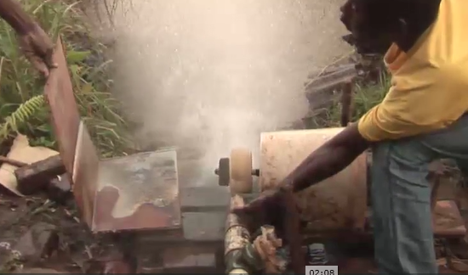
Figure 1: Hastings Mkandawire Initial Design for Hydro Power

A NHG is a type of hydroelectric power generator that typically produces from 5 kW to 100 kW of electricity using the natural flow of water. Installations below 5 kW are called pico hydro. These installations can provide power to an isolated home or small community (openei.org). Magnetic Power Company’s NGH produce 247 volts of alternating current (AC) and is enough to power a small television and a couple of lights for a single home.
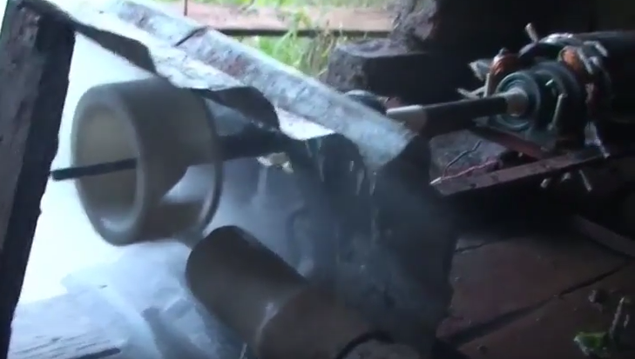
Figure 2: Hastings Mkandawire Updated Design for Hydro Power

Taking into consideration that water pressure propels the turbine, mechanisms can be designed to increase mechanical advantage and increase rotational speed to the electric motor. This will producing a higher power output to provide electricity to more people in his community. The thoughts on the initial design concepts included efficiency of the system, ease of casting parts, increasing rotational speed, cyclical loading, life cycles, and transfer for energy with little loss.

Initial Design Concepts:
The team brainstormed a multitude of various design concept, leaving non censored. After the brainstorming session, the team consolidated the numerous design concepts into the three most realistic options. Those three realistic design concepts are listed below.

*Design Concept 1: This design concept consists of gears that are casted separately than the shaft. The shaft would be taken from the junkyard and then a key would be used to attach the gears to the shaft. In this design, there would also be a need for bearings.
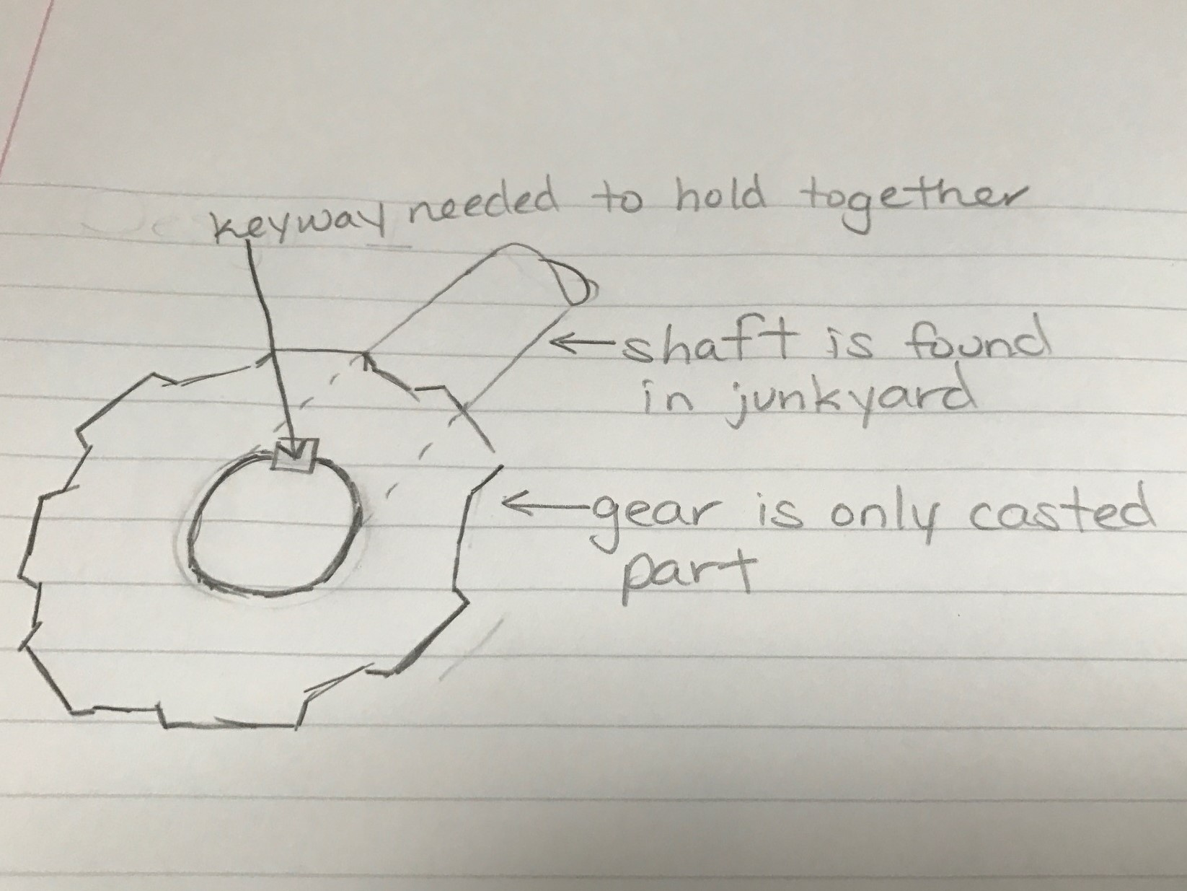
Figure 3: Concept 1 with gears press fitted to steel shaft

*Design Concept 2: This design concept is very similar to the first, but the gears and shaft would be casted together. The shaft would be hollow and there would also be a need for bearings.
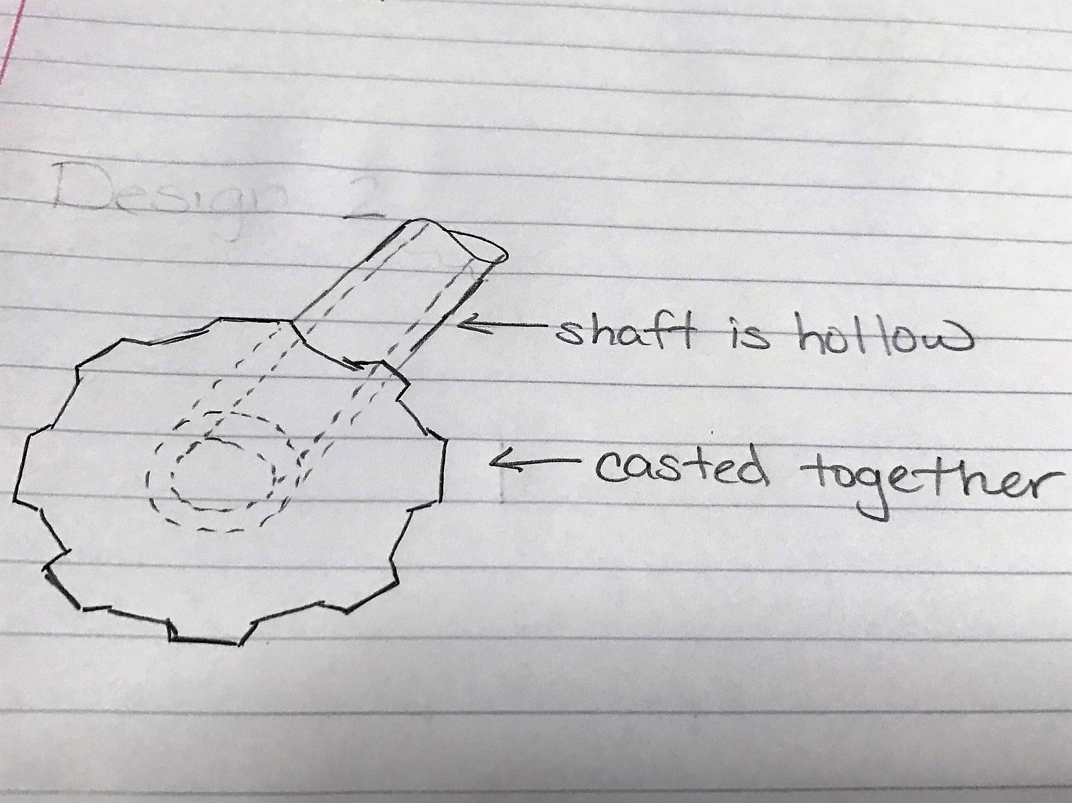
Figure 4: Concept 2 with gear and shaft casted together
*Design Concept 3: This design concepts consists of a fully casted pulley system and a hollow aluminum shaft with the belts taken from the junkyard. This design would also need bearings which can be scavenged from the junkyard.
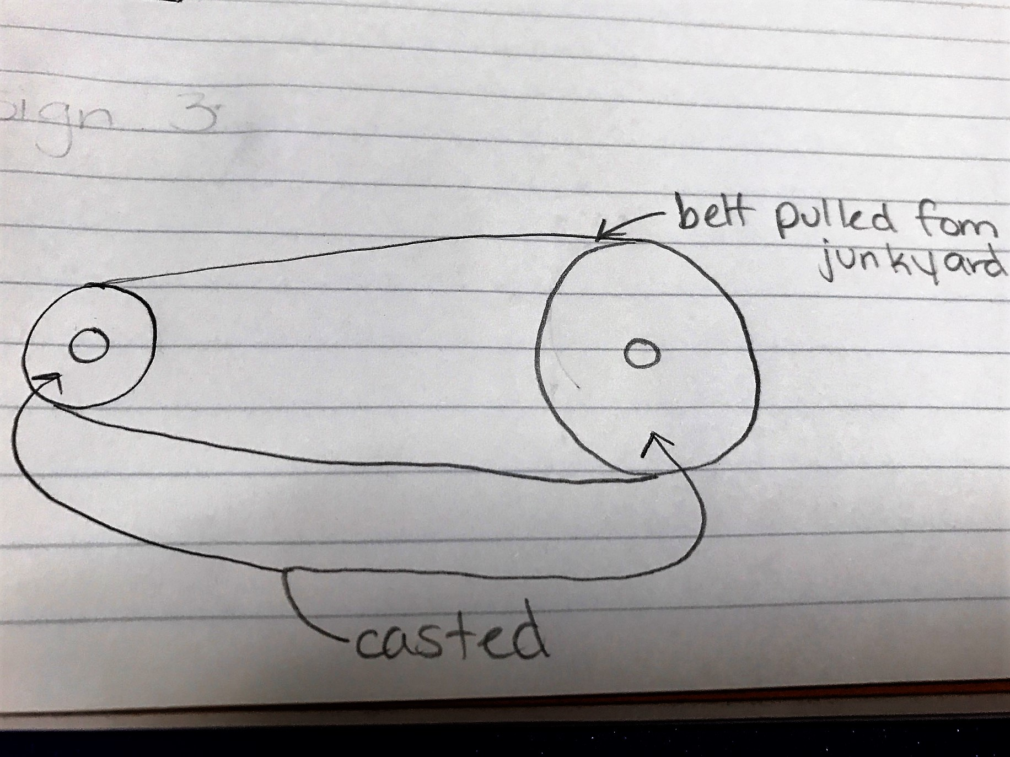
Figure 5: Concept 3 with casted pulleys
Design Matrices
Rating: 1(worst)-10(Best) |  | Design Concept 1 |  | Design Concept 2 |  | Design Concept 3
 | Weight | Rating | Score | Rating | Score | Rating | Score
Availability of Materials | .25 | 7 | 1.75 | 5 | 1.25 | 6 | 1.50
Machinability/ Casting | 0.25 | 8 | 2.00 | 7 | 1.75 | 7 | 1.75
Efficiency | 0.1 | 9 | 0.90 | 6 | 0.60 | 8 | 0.80
Assembly | 0.1 | 5 | 0.50 | 6 | 0.60 | 6 | 0.60
Life Cycles | 0.1 | 4 | 0.60 | 5 | 0.50 | 7 | 0.70
Functionality/ Reliability/ Durability | 0.1 | 7 | 0.70 | 5 | 0.50 | 8 | 0.80
Weight | 0.1 | 6 | 0.70 | 8 | 0.80 | 9 | 0.90
Total | 1.0 |  | 6.95 |  | 6.00 |  | 7.05

Table 1: Design Matrices

Solidworks Model
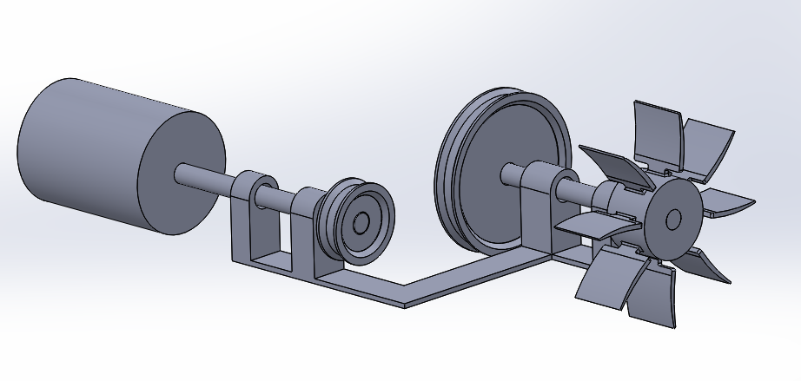
Figure 6: Solidworks Concept 3
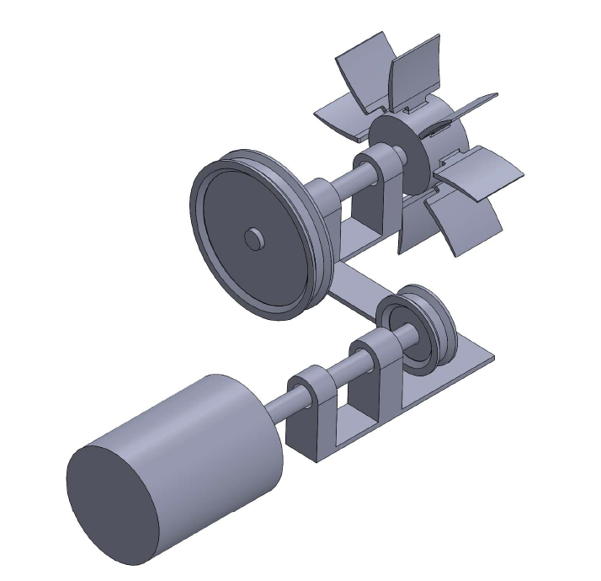
Figure 7: Solidworks Concept 3

Hand Calculations
- Equations Used:
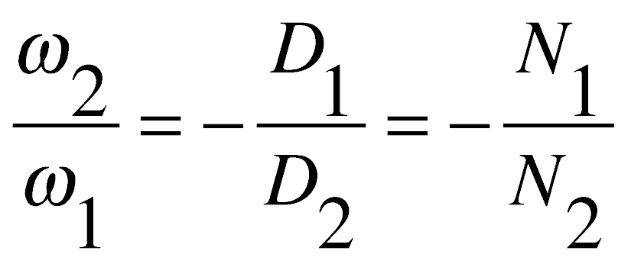  Angular Velocity: | 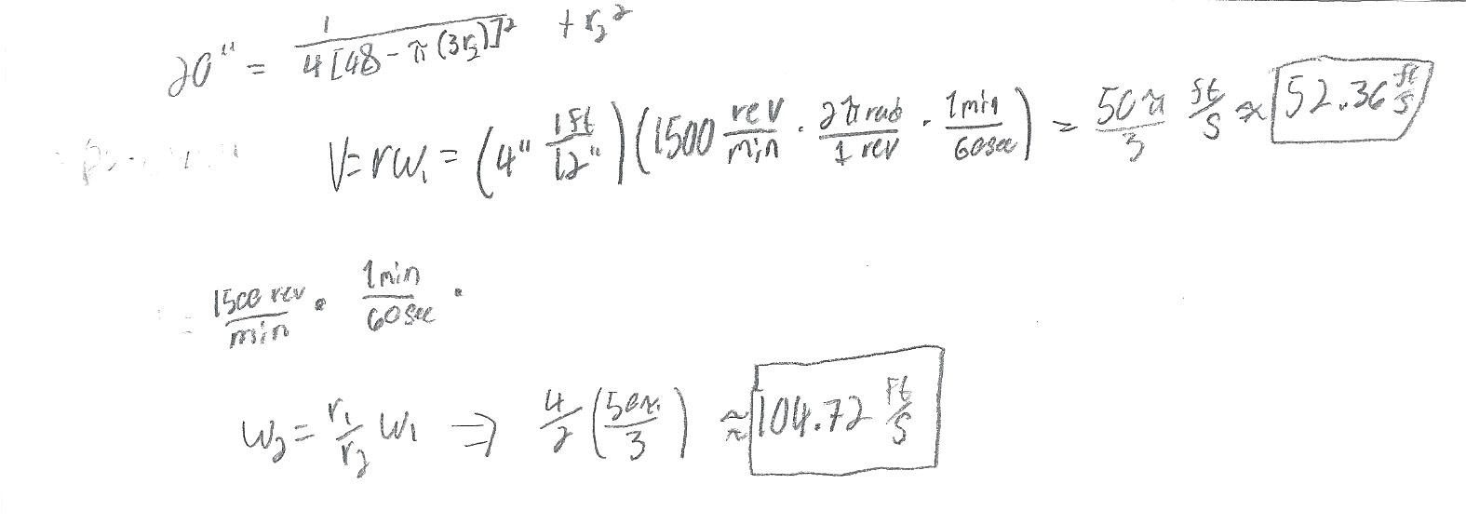
Figure 8: Angular Velocity Hand Calculation

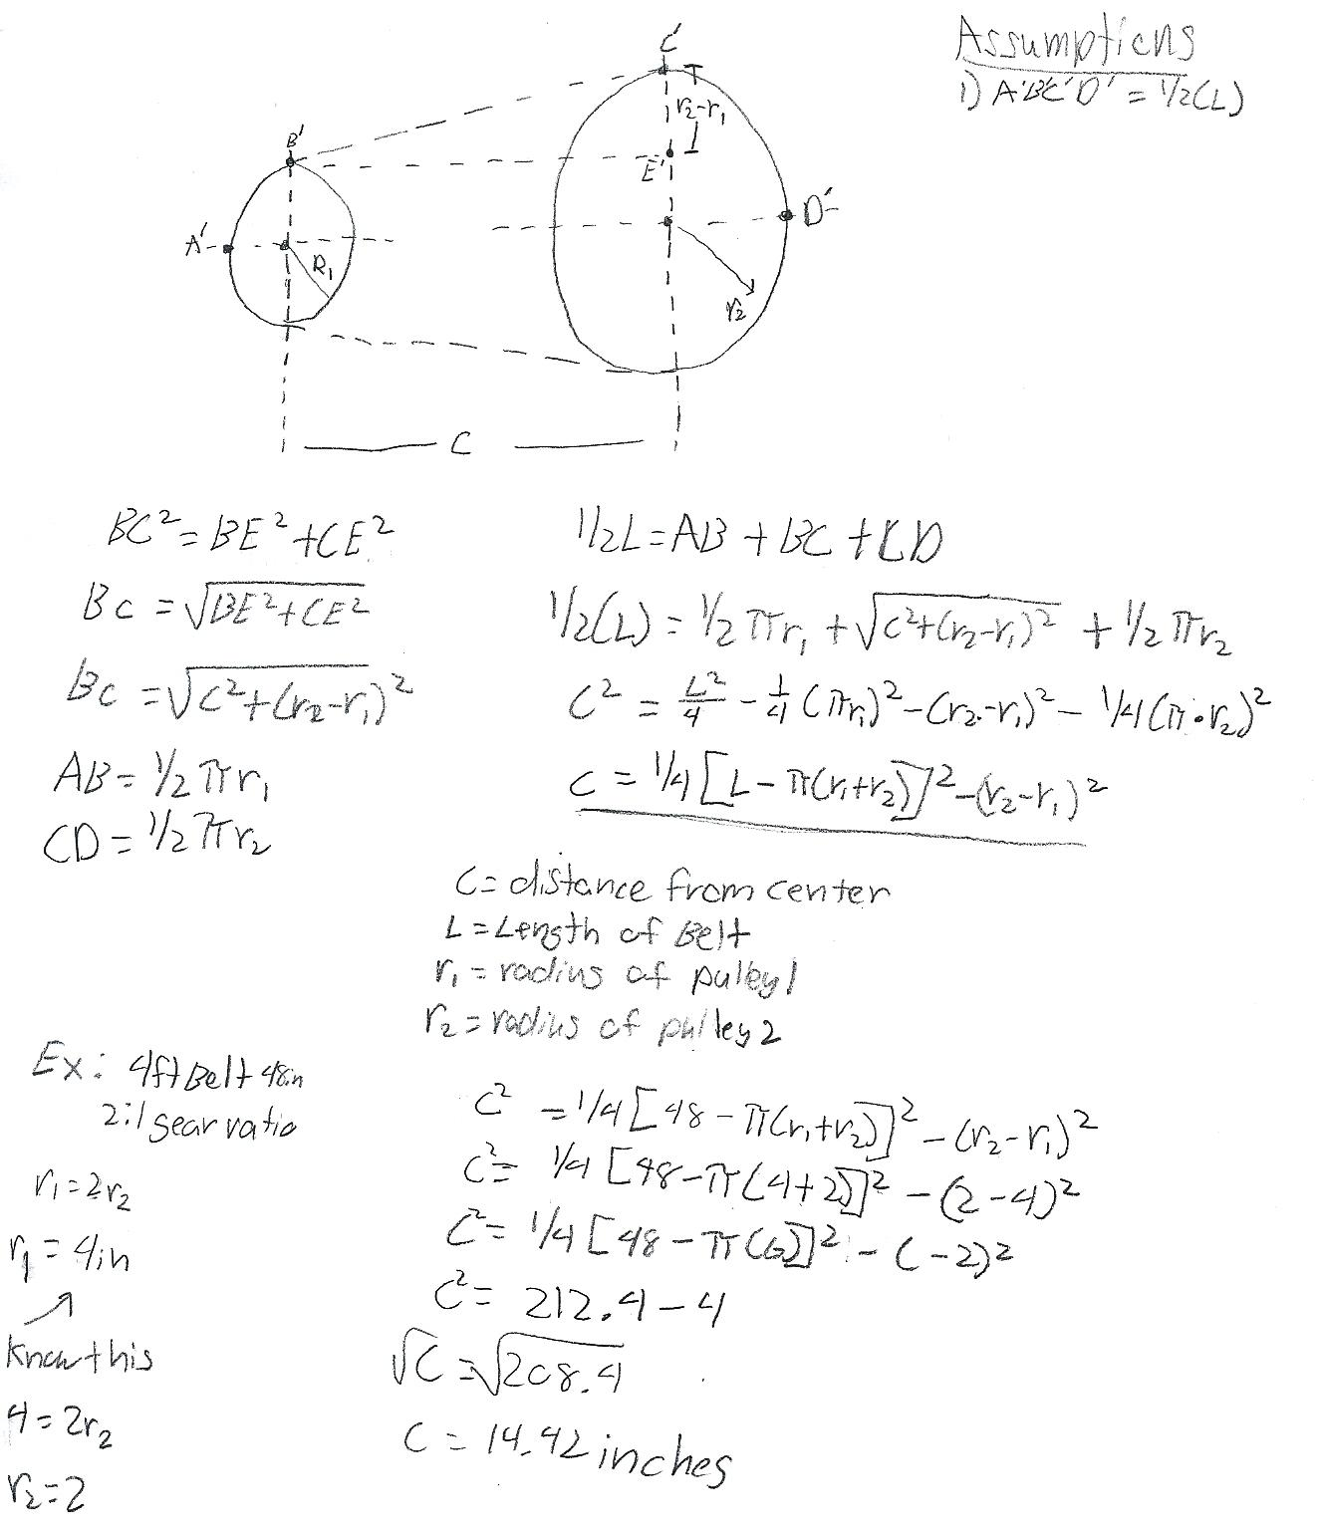
Belt Length and Pulley Radius:

Figure 9: Center to center calculation

Final Design and Conclusion
With the relative weakness of aluminum spur gears and their tendency to fail due to shear force earlier than their steel counterparts, we decided to forgo their use for this project. Moving away from using gears, we approached the idea that utilizing a pulley system would help extend the life of the casted parts by reducing the fatigue stress presented on the rotating parts. With this in mind, we needed to take into consideration how to mount the pulley onto the hollow aluminum shaft. To combat this problem, we chose to cast the pulley and shaft together, making them one single unit. This allows for easier maintenance on the overall system. If the shaft/pulley combination where to become damaged, the user can remove the shaft and send it in to be recasted. Once the replacement casting is onsite, the user can then easily reinstal it into the system without the use of multiple hardwares/tools. By reducing the number of individual parts down to 2, the large pulley/shaft and the small pulley/shaft, the system becomes more robust in comparison to a system that utilizes a multitude of interactive mechanisms. Due to the limited resources available in Malawi, Hastings Mkandawire would not be able to manufacture the belts that are needed to connect the input shaft to the output shaft. Mkandawire addresses this issue by scavenging materials from the local junkyard. With the decision matrix and consensus from the group, we decided to go with design concept 3.

