**Shear Wave Speeds Track Axial Stress in Porcine Collateral Ligaments**

Jonathon L. Blank (1), Darryl G. Thelen (1), Joshua D. Roth (1,2)

1. Department of Mechanical Engineering, University of Wisconsin-Madison, Madison, WI, USA
2. Department of Orthopedics and Rehabilitation, University of Wisconsin-Madison, Madison, WI, USA

Corresponding Author: Joshua D. Roth, [roth@ortho.wisc.edu](mailto:roth@ortho.wisc.edu)

1111 Highland Avenue Room 5037, Madison, WI 53705

**Keywords:** Total knee arthroplasty; Shear wave tensiometry;

Non-invasive intraoperative sensor development; Orthopedic surgery; Soft tissue balancing

**Highlights**

* Shear wave tensiometry is a promising method for gauging load in fibrous connective tissues*.*
* Porcine medial and lateral collateral ligaments exhibited highly linear (r2 > 0.9) relationships between squared shear wave speed and axial stress.
* Subtle differences in the slope of the squared shear wave speed-stress relationship may need to be considered when using shear wave tensiometry to infer loading of individual structures.

**Abstract**

Ligament tension is an important factor that can affect the success of total knee arthroplasty (TKA) procedures. However, surgeons currently lack objective approaches for assessing tension in a particular ligament intraoperatively. The purpose of this study was to investigate the use of noninvasive shear wave tensiometry to characterize stress in medial and lateral collateral ligaments (MCLs and LCLs) *ex vivo*. Nine porcine MCL and LCL specimens were subjected to cyclic axial loading while wave speeds were measured using laser vibrometry. We found that squared shear wave speed increased linearly with stress in both the MCL (r2avg = 0.94) and LCL (r2avg = 0.98). Wave speeds were slightly lower in the MCL than the LCL when subjected to comparable axial stress (p < 0.001). Ligament-specific wave speeds may arise from differences in geometry and stress distributions between ligaments. These observations suggest it may be feasible to use noninvasive shear wave speed measures as a proxy of ligament loading during orthopedic procedures such as TKA.

**1 Introduction**

Ligament balancing is critical to outcomes of total knee arthroplasty (TKA) (Blankevoort et al., 1988; Wilson et al., 1998). To achieve balance, surgeons must position TKA components in a way that adequately tensions the ligaments, without limiting motion. Tension in the superficial medial and lateral collateral ligaments (MCL and LCL, respectively) are of particular interest. The MCL and LCL are primary restraints to rotational motion in the frontal plane (i.e., varus-valgus rotation) and secondary restraints to rotation in the transverse plane (i.e., internal-external rotation) and translation in the sagittal plane (i.e., anterior-posterior translation) (Blankevoort et al., 1991; Grood et al., 1981; Haimes et al., 2007; Lim et al., 2012; Seering et al., 1980). Overly-loose (Abdel and Haas, 2014; Cottino et al., 2016; Vince, 2016), overly-tight (Babazadeh et al., 2009; Laskin and Beksac, 2004), or asymmetrically tensioned collateral ligaments (Vince et al., 2006) are associated with complications following TKA, including joint instability, stiffness, and pain. Hence, ligament tension is an important factor that can affect the success of TKA (Anderson et al., 1996; Harris and Sledge, 1994; Hawker et al., 1998). However, surgeons currently lack objective approaches for assessing tension in a particular ligament intraoperatively, and instead are reliant on qualitative and indirect approaches (Camarata, 2014; Daines and Dennis, 2014; Edwards et al., 1988; Fujimoto et al., 2015; Gustke, 2012; Gustke et al., 2014; Matsumoto et al., 2011; Nowakowski et al., 2012).

Shear wave tensiometry is an emerging, non-invasive approach for gauging soft tissue tension based on the propagation of induced shear waves. A tensioned beam model and experiments have demonstrated that squared shear wave speed increases linearly with axial stress in a tendon under physiological loads (Martin et al., 2018). This observation results from the anisotropic nature of tendons in which the aligned collagen fibers lead to a high axial stiffness, but a relatively low shear modulus because the fibers are able to slide relative to one another. The wave speed-stress relationship may extend to ligaments, which also consist of bundles of collagen fibers that bear physiological loads (Quapp and Weiss, 1998). However, the fibrous structure, boundary conditions, and geometry of ligaments differ from those of tendons in ways that could alter the shear wave speed-stress relationship. At the microstructural level, ligament fibers are generally less well aligned than in tendons (Amis, 1998). Ligaments are also anchored to the skeleton on the proximal and distal ends, resulting in boundary conditions which could reflect waves. Finally, ligaments like the MCL are sheet-like with large aspect ratios that differ considerably from the LCL as well as from the tendons (Achilles, patellar) that have been tested previously with shear wave tensiometry (Martin et al., 2018).

A fundamental pre-requisite step to using shear wave tensiometry intraoperatively is to determine whether the shear wave speed-stress relationship observed in tendons extends to collateral ligaments. Accordingly, the objectives of this study were (1) to characterize the squared shear wave speed-stress relationship in isolated collateral ligaments and (2) to determine whether the squared shear wave speed-stress relationship differed between the MCL and LCL.

**2 Materials and Methods**

**2.1 Specimen Preparation**

Nine MCLs and nine LCLs were procured from a crossbreed of large white, landrace, and red duroc pigs (weight = 132.5 ± 18.3 kg, age = 6 months). Porcine collateral ligaments were used for this study because MCLs from animals of this size have been previously shown to have an axial loading response similar to that of human MCLs (Germscheid et al., 2011). Each ligament was isolated by first removing superficial and surrounding tissue (Fig. 1a). Knees (i.e., stifle joints) were then flexed to the angle where the fibers across the ligament appeared to be most uniformly taught. This was typically around 80° of flexion (Germscheid et al., 2011). Next, bone blocks containing the bony ligament attachments were cut from the distal femoral condyles and tibia/fibula using an oscillating saw. Each bone block was secured in an aluminum cup using a potting material (Bondo Fiberglass Resin 3M, St. Paul MN). Excess tissue superficial and deep to the outer surface of the ligament was removed prior to experimentation.

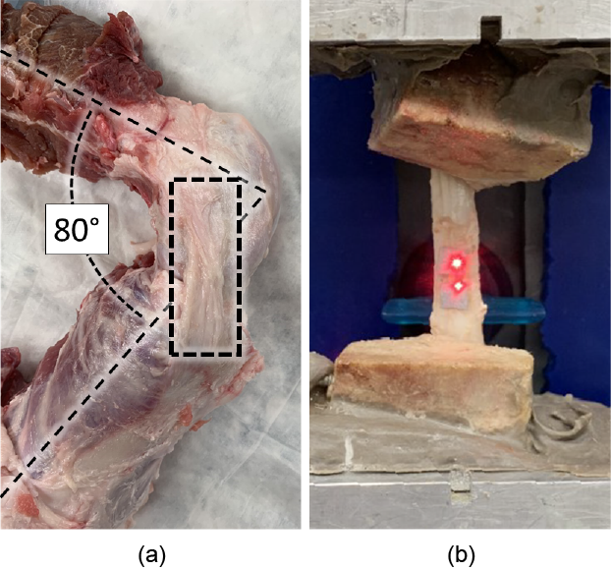

**Figure 1:** Representative images of (a) dissected porcine knee (i.e., stifle joint) and (b) isolated MCL. (a) The image shows the medial aspect of the knee with the MCL identified by the black dashed rectangle. Excess soft tissue was removed from the intact porcine knee to expose the MCL and LCL. The MCL and LCL were isolated with the knee at the flexion angle at which the fibers across the width of the ligament were most uniformly taught; this was typically at 80° flexion (Germscheid et al., 2011). (b) The image shows the deep surface of a representative MCL mounted in the MTS machine. The bone blocks were potted in aluminum fixtures to enable a rigid fixation within the MTS grips.

**2.2 Experimental Procedure**

Specimens were mounted in an electrodynamic testing system (Acumen 3, MTS, Eden Prairie, MN) and pre-loaded to 10 N of axial force. Specimens were first immersed in an acoustic tile-lined water bath (Aptflex F28, Precision Acoustics, Dorchester, UK) to facilitate ultrasound imaging (SonixTOUCH Research, BK Medical, Peabody, MA). A linear array ultrasound transducer (L14-5W/38, BK Medical, Peabody, MA) was affixed to a motorized linear stage (Newmark Systems Inc, Ranch Santa Margarita, CA) to facilitate collection of cross-sectional images at 0.1 mm increments along the length of the ligament. The B-Mode imaging was performed through an acoustic window (0.01 inch thick polycarbonate). Cross-sectional areas were segmented from the ultrasound images using an open source 3D visualization software (3D Slicer, Cambridge, MA). The aspect ratio was computed as the ratio between the major and minor axes of the ligament cross section (Fig. 2a). The major axis was the greatest edge-to-edge distance of the cross-section that intersected the centroid. The minor axis was the edge-to-edge distance perpendicular to the major axis and coincident with the centroid.

Following pre-conditioning (100 cycles from 10 to 250 N at 1 Hz), ligaments were subjected to cyclic axial loading to determine the shear wave speed-stress relationship. Ligament specimens underwent ten loading cycles from 10 to 250 N at 1 Hz in air. The maximum tension was limited to 250 N based on pilot studies that showed failures at the bony attachments of several porcine ligaments when applied loads exceeded 250 N. During cyclic loading, shear waves were excited using a custom piezoelectric (PK4JQP1, Thorlabs Inc., Newton, NJ) device to deliver 20 micron taps across the width of the ligament at 25 Hz. Transverse velocity of the deep surface of each ligament was measured using laser Doppler vibrometers (Polytec Inc., Irvine, CA) at two points spaced 5 mm apart with the first point 5 mm above the tap location (Fig. 2b). Three cyclic loading trials for each specimen were recorded, which summed to thirty total loading cycles for each specimen. Ligaments were kept moist with 0.9% saline for the duration of the testing procedure.

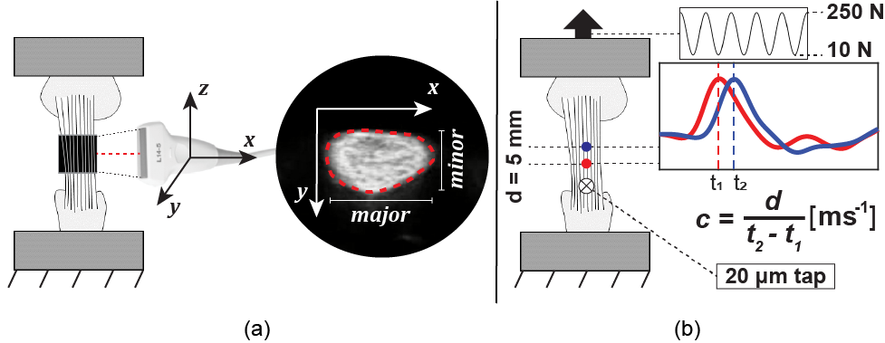

**Figure 2:** Diagrams show the testing setups used to determine the cross-sectional geometries of the ligaments and the shear wave speed stress relationships. (a) The cross-sectional area and aspect ratio were measured by segmenting B-mode ultrasound images collected along the length of the ligament. (b) Ligaments underwent cyclic axial loading at 1 Hz between 10 and 250 N. Simultaneously, shear waves were excited using a piezoelectric tapper and transverse ligament motion was measured using two laser Doppler vibrometers. Shear wave propagation speed, *c*, was computed based on laser spacing, *d*, and the time delay between the wave arrival, *t2 - t1,* at the two measurement locations.

**2.3 Post-Processing**

The induced shear wave speeds for each tap were computed by measuring the time delay between the arrivals of the wave at the two successive laser points. Waveforms were filtered using a 2nd order Butterworth bandpass filter (MATLAB R2018) with lower and upper cutoff frequencies of 100 and 5000 Hz, respectively. A time-dependent cross-correlation between the transient response of the two waveforms (i.e., the first 0.6 ms of each signal) was performed to determine the time delay in wave arrival between laser vibrometer points (Martin et al., 2018). Sub-sample interpolation was performed using a local 3-point cosine fit of the normalized cross-correlation values (Cespedes et al., 1995). Average axial stresses in ligaments during loading were computed using the applied force measured by the load cell (661.18E-02, MTS, reported hysteresis/non-linearity = 0.08% full scale) and average cross-sectional area between the measurement locations determined from the segmented ultrasonic scan of each ligament.

**2.4 Statistical Analysis**

Specimen-specific simple linear regressions were performed to ascertain the linearity of the squared shear wave speed-stress relationship with stress as the independent variable and squared shear wave speed the dependent variable. The level of significance, *α*, was set to 0.05. With nine ligaments of each type, strong relationships between squared shear wave speed and stress (i.e., r2 ≥ 0.55) could be detected with α = 0.05 and (1 - β) = 0.8 (Faul et al., 2009).

Stress and wave speed data were then grouped according to ligament type (i.e., MCL or LCL) to determine whether the squared shear wave speed-stress relationship differed between the MCL and LCL. For each ligament type, a simple linear regression was conducted with the stress as the independent variable and the squared shear wave speed as the dependent variable. A follow-up linear regression (Gujarati, 1970) was performed to determine whether the intercepts and slopes of the squared shear wave speed-stress relationships were different between ligament types (Eq. 1). Again, α was set at 0.05. The dependent variable in this follow up linear regression was the stress, *σ*. The independent variables were the squared shear wave speed, $c_{i}^{2}$, a binary indicator variable for ligament type, $D_{i}$ (D = 0 for MCL, D = 1 for LCL), and the interaction term between squared shear wave speed and the indicator variable, $c_{i}^{2}D_{i}$. The index, $i$, indicates the data point.

$σ_{i}=β_{0}+β_{1}c_{i}^{2}+β_{2}D_{i}+β_{3}c_{i}^{2}D_{i}+ε_{i}$ (1)

By including the indicator variable in the regression, the slope of the squared shear wave speed-stress relationship is $β_{1}$ for the MCL and $β_{1}+β_{3}$ for the LCL, and the intercept of the squared shear wave speed-stress relationship is $β_{0}$ for the MCL and $β_{0}+β_{2}$ for the LCL.

The average lengths and cross-sectional areas of the porcine MCLs and LCLs were compared using two-sample t-tests with α = 0.05. Average ligament aspect ratios were compared using one-sided t-test with α = 0.05 and the hypothesis that the MCL has a larger aspect ratio than the LCL.

**3 Results**

The shear wave speed of both the MCL and the LCL increased monotonically with axial stress (Fig. 3). There was a strong linear relationship from the specimen-specific simple linear regressions between the squared shear wave speed and axial stress in each MCL and LCL (r2 = 0.94 ± 0.06 (mean ± standard deviation across the 9 ligaments of each type) and 0.98 ± 0.02, respectively). When all of the data for each ligament type was grouped, there were also strong linear relationships (Table 1), but there was specimen-to-specimen variability that decreased the coefficients of determination of each ligament.

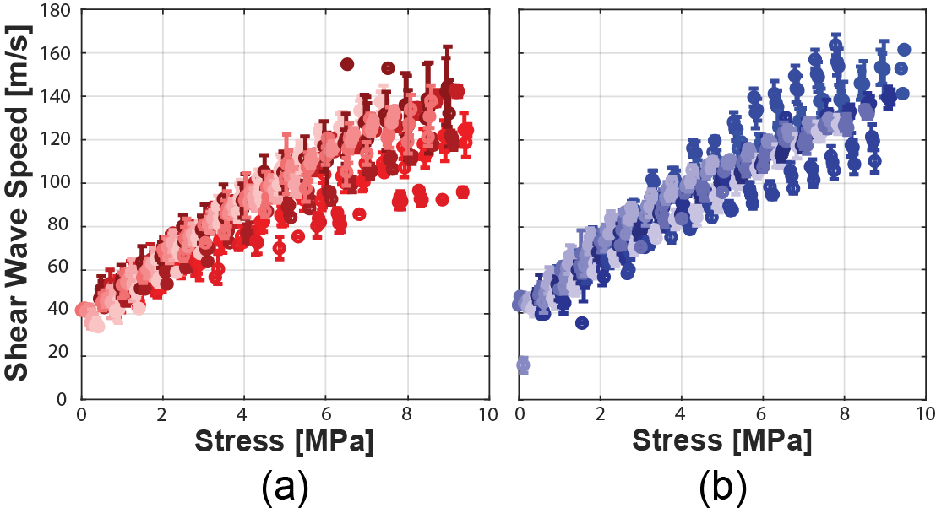

**Figure 3:** Scatter plots show the monotonically increasing shear wave speed-stress relationship in all nine MCLs (a) and all nine LCLs (b). Data from each MCL and LCL is plotted with a different shade of red or blue, respectively. Data points indicate the mean and error bars indicate the standard deviation of wave speeds within 0.5 MPa bins for each specimen.

|  |  |  |  |
| --- | --- | --- | --- |
|  | **(kPa/m2/s2)** | **(kPa)** | **R2** |
| **MCL** | 0.620 | -645 | 0.81 |
| **LCL** | 0.507 | -616 | 0.88 |
|  | **p < 0.001** | **p = 0.689** |  |

**Table 1:** Comparison of linear regression coefficients (Eq 1.) from the grouped data of each ligament type. The LCL exhibited slightly higher wave speeds than the MCL at a comparable stress, resulting in a smaller slope of the squared shear wave speed-stress relationship (Eq. 1). We did not detect a significant difference between intercept terms of each ligament type. The coefficients of determination, R2, for the simple linear regressions of grouped data were less than those for an individual specimen due to specimen-to-specimen differences.

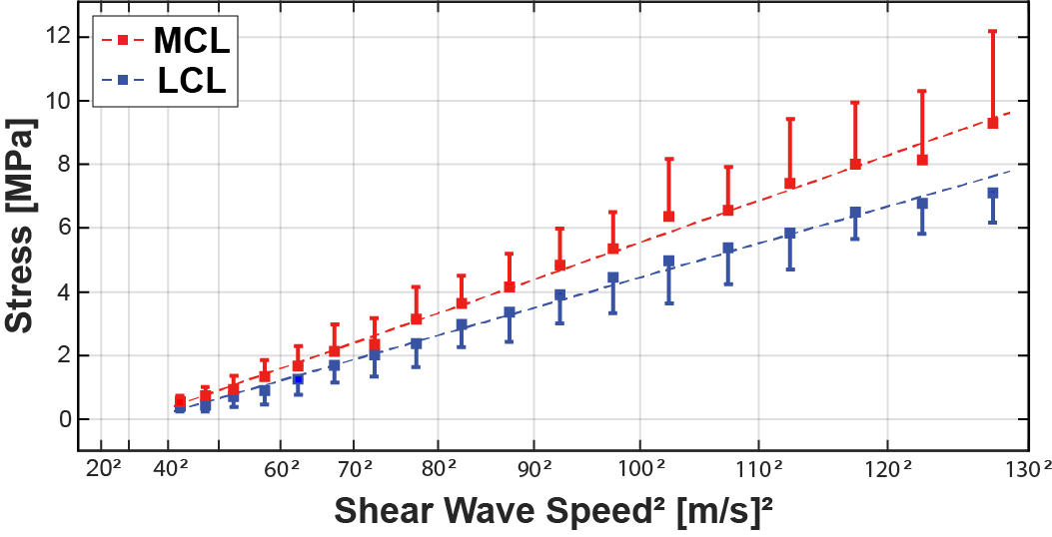

**Figure 4:** Scatter plot represents the mean (squares) and standard deviation (error bars) of the data from every specimen grouped into bins. Data was binned into 5 m2/s2 bins. The linear prediction model characterized over 80% of the variance in axial stress in the MCL and LCL (R2 = 0.81 and 0.88 from grouped simple linear regressions, respectively).

From the grouped data collected from each ligament type (Fig. 4, Table 1), the slope of the linear fit was significantly greater in the MCL than that of the LCL (p < 0.001). However, we did not detect a significant difference between the vertical axis intercepts of the squared shear wave speed-stress relationships between the MCL and LCL (p = 0.689) (Table 1).

The lengths and cross-sectional areas did not differ between the MCL and LCL (p = 0.698 and p = 0.325, respectively). However, the aspect ratios did differ between the MCL and LCL (p = 0.025), with the MCL (3.0 ± 0.9) being wider and flatter than the LCL (2.4 ± 0.5) (Table 2).

|  |  |  |  |
| --- | --- | --- | --- |
|  |  | **Ligament Geometry Measures (mean ± standard deviation)** | |
| **Ligament Geometry Parameter** |  | **MCL** | **LCL** |
| Length (mm) |  | 23.3 ± 8.3 | 24.5 ± 4.5 |
| Area (mm2) |  | 29.0 ± 8.9 | 32.9 ± 7.3 |
| Aspect Ratio* |  | 3.0 ± 0.9 | 2.4 ± 0.5 |

**Table 2:** Comparison of ligament geometry parameters of the MCL and LCL.The MCL had a significantly higher mean aspect ratio than the LCL (*p = 0.025). We did not detect a significant difference between the mean MCL and LCL length or cross-sectional area.

**4 Discussion**

The objectives of the present study were (1) to characterize the squared shear wave speed-stress relationship in isolated collateral ligaments and (2) to determine whether these relationships differed between the MCL and LCL. The first key finding is that strong linear relationships exist in both the MCL and LCL. This justifies the future use of shear wave speed measurements as a proxy measure for ligament loading. The second key finding is that there were subtle differences in the shear wave speed-stress relationship between the MCL and LCL, which may need to be considered when using shear wave speed to infer loading of individual structures.

The fundamental relationship between shear wave speed and ligament stress is similar to that observed previously in tendons. Specifically, there was a strong linear relationship between squared shear wave speed and axial stress in both the MCL and LCL (r2 = 0.94 and 0.98, Fig. 3), which is comparable to that observed previously in porcine digital flexor tendons (r2 = 0.96-0.98) (Martin et al., 2019, 2018) . The linear relationship is consistent with a tensioned beam model (Martin et al., 2018), which predicts that shear wave speed depends both on the applied axial stress and the shear modulus of the material. Further, the shear modulus depends on the resistance to interfibrillar sliding, which is relatively low in ligaments (Tanaka et al., 2007; Weiss et al., 2002). Hence, the dependence on shear wave speed is believed to become more dominant as loading is increased and gives rise to the linear squared shear wave speed-stress relationship that is observed.

While the fundamental shear wave speed-stress relationship is similar, the magnitudes of shear wave speeds in the porcine collateral ligaments were generally higher than those observed in porcine digital flexor tendons (Martin et al., 2019). For example, we observed average ligament wave speeds of 128 m/s for an 8 MPa load, which is 45% higher than that observed in tendon under similar loads *ex vivo*. Structural differences in the fibrous organization, boundary conditions and geometry are potentially contributing factors. At the microstructural level, ligament fibers are generally less well aligned than those in tendons (Amis, 1998). This may result in greater resistance to shear along the long axis of the ligament and hence a larger apparent shear modulus. If ligament exhibits substantial strain stiffening in shear (Weiss et al., 2002) with axial loading, then this would give rise to an enhanced effect of shear modulus on wave speed with loading. A second factor is boundary conditions. The ligaments were tested with intact bony attachments in contrast with previous studies that studied wave speeds in tendons secured in rigid metal grips (Martin et al., 2019, 2018). The ligament bony attachments appear to provide a soft enough interface to limit the reflections of shear waves from the ends of the ligament, and therefore, we did not observe standing waves in this study. In the previous *ex vivo* experiments in porcine digital flexor tendons, the rigid interfaces of the grips caused shear waves to reflect leading to the emergence of standing waves (Martin et al., 2019, 2018). A third potential factor are differences in geometry. Ligaments like the MCL are sheet-like with large aspect ratios that differ from both the LCL (Table 2) and the digital flexor tendons that have been tested previously (Martin et al., 2019, 2018). Moreover, wave-guided behavior in tendon and ligament gives rise to shear wave dispersion, which is known to depend on the thickness of the tissue relative to the shear wave length (Brum et al., 2014). Hence, the MCL and LCL, which both have high aspect ratios, may have a fundamentally different shear wave dispersion profile than that of tendon.

Although there were strong linear relationships between squared shear wave speed and axial stress in both the MCL and LCL, our results demonstrate that the slopes, and thus the linear relationships, do differ between ligament types (Fig. 4, Table 1). Unlike slope, we did not detect a significant difference between the intercepts of the linear regressions in the MCL and LCL, which indicates that the two ligament types have a similar shear wave speed in an unloaded state, and thus have similar inherent material properties (Martin et al., 2018). The difference in slope indicates that ligament-specific relationships might be necessary to use shear wave speed as a proxy measure of axial stress in ligaments moving forward. The greater slope in the shear wave speed-stress relationship in the MCL indicates that the shear wave speeds are lower in the MCL than those in the LCL for a comparable axial stress. One factor that might bring about this difference is non-uniformity in the axial stress across the width of the MCL. This non-uniformity is more likely to occur in the MCL due to its larger aspect ratio. In a non-uniformly loaded ligament, the local stress might be less than the average stress used to determine the squared shear wave speed-stress relationship due to high stresses near one of the edges of the ligament. It is feasible that these high edge stresses would increase the average stress leading to an over-estimation of the local stress under the laser points. Thus, the discrepancy between average and local stress could give rise to localized shear wave speeds in the MCL that differ from those measured in the LCL at a comparable applied average stress. This effect is likely more prominent in ligaments *in vivo*, where subtle changes in knee flexion angle are known to produce different stress or strain gradients across the ligament width (Gardiner and Weiss, 2003; Robinson et al., 2004). If shear wave speeds are indeed sensitive to local stress, then ligament shear wave tensiometry might enable clinicians to determine the stress distribution within the ligament rather than just the average axial stress.

Although a promising shear wave speed-stress relationship was determined in the porcine MCLs and LCLs, three important challenges in the clinical translation of shear wave tensiometry still remain. One challenge is that the shear wave speed-stress relationship in human ligaments may be unique from the relationship exhibited in porcine ligaments. Porcine collateral ligaments do provide an appropriate animal model for preliminary *ex vivo* testing (Germscheid et al., 2011) and have aspect ratios that are different between the MCL and LCL (3.0 and 2.4, respectively). However, human MCLs and LCLs have more distinct aspect ratios of 16 and 2 (Wilson et al., 2012), respectively. Thus, the difference between the shear wave speed-stress relationships of the MCL and LCL might be greater in human specimens. A second challenge is that shear wave speed measurements were taken on isolated collateral ligaments. Interactions with surrounding tissues/implants, including but not limited to the joint capsule, menisci, underlying femoral and tibial bone before TKA, and the underlying femoral and tibial implants after TKA would likely decrease the shear wave speed at a given stress by increasing the effective mass (Martin et al., 2018). A third challenge is creating a handheld shear wave tensiometer suitable for intraoperative use. Here, we showed that transient shear wave tensiometry via laser Doppler vibrometry is a viable approach to gauge isolated ligament stress *ex vivo*. However, the experimental setup we used is not practical for intraoperative checks made by surgeons. A miniaturized laser Doppler vibrometry approach exists to monitor pulse wave propagations using a handheld scanner (Mancini et al., 2019), which might allow for a more viable measurement within the operating room. Also, using miniature accelerometers to monitor transverse tissue motion might make intraoperative ligament tensiometry possible as this approach is used *in vivo* for tendons (Martin et al., 2018). Such a handheld device is a primary focus of ongoing research because it would enable the translation to TKA and other intraoperative applications including tendon repair (Beskin et al., 1987; Savin et al., 2017) and muscle lengthening (Novacheck and Gage, 2007; Schwartz et al., 2004).

In conclusion, shear wave tensiometry provides a useful and objective quantification of the axial stress in ligaments as it does in tendons. Both the porcine MCLs and LCLs used in this study have strongly linear but distinct squared shear wave speed-stress relationships. The findings indicate that shear wave speed measurements can be made in ligaments, which is the first step towards translating shear wave tensiometry to a clinical setting with the goal of improving outcomes after orthopedic surgeries like TKA.

**5 Acknowledgments**

This work was supported by the National Institute of Biomedical Imaging and Bioengineering (NIBIB) and the National Institute of Aging (NIA) of the National Institutes of Health under award numbers [NIBIB: R21EB024957; NIA: T32AG000213].

All specimens were procured from the University of Wisconsin-Madison Department of Animal Sciences.

**6 Appendices**

**References**

Abdel, M.P., Haas, S.B., 2014. The unstable knee: Wobble and Buckle. Bone Jt. J. 96B, 112–114. https://doi.org/10.1302/0301-620X.96B11.34325

Amis, A.A., 1998. Biomechanics of Bone, Tendon, and Ligament, in: Sciences Basic to Orthopaedics. pp. 222–239.

Anderson, J.G., Wixson, R.L., Tsai, D., Stulberg, S.D., Chang, R.W., 1996. Functional outcome and patient satisfaction in total knee patients over the age of 75. J. Arthroplasty 11, 831–840. https://doi.org/10.1016/S0883-5403(96)80183-5

Babazadeh, S., Stoney, J.D., Lim, K., Choong, P.F.M., 2009. The relevance of ligament balancing in total knee arthroplasty: how important is it? A systematic review of the literature. Orthop. Rev. (Pavia). 1, 70–78. https://doi.org/10.4081/or.2009.e26

Beskin, J.L., Sanders, R.A., Hunter, S.C., Hughston, J.C., 1987. Surgical repair of Achilles tendon ruptures. Am. J. Sports Med. 15, 1–8. https://doi.org/10.1177/036354658701500101

Blankevoort, L., Huiskes, R., de Lange, A., 1991. Recruitment of Knee Joint Ligaments. J. Biomech. Eng. 113, 94. https://doi.org/10.1115/1.2894090

Blankevoort, L., Huiskes, R., de Lange, A., 1988. The envelope of passive knee joint motion. J. Biomech. 21, 705–720. https://doi.org/10.1016/0021-9290(88)90280-1

Brum, J., Bernal, M., Gennisson, J., Tanter, M., 2014. In vivo evaluation of the elastic anisotropy of the human Achilles tendon using shear wave dispersion analysis. Phys. Med. Biol. 59, 505–523. https://doi.org/10.1088/0031-9155/59/3/505

Camarata, D., 2014. Soft tissue balance in total knee arthroplasty with a force sensor. Orthop. Clin. North Am. 45, 175–184. https://doi.org/10.1016/j.ocl.2013.12.001

Cespedes, I., Huang, Y., Ophir, J., Spratt, S., 1995. Methods for estimation of subsample time delays of digitized echo signals. Ultrason. Imaging 17, 142–171. https://doi.org/10.1006/uimg.1995.1007

Cottino, U., Sculco, P., Sierra, R., Abdel, M., 2016. Instability After Total Knee Arthroplasty. Orthop. Clin. North Am. 47, 311–316. https://doi.org/10.1016/j.ocl.2015.09.007

Daines, B.K., Dennis, D.A., 2014. Gap balancing vs. measured resection technique in total knee arthroplasty. Clin. Orthop. Surg. 6, 1–8. https://doi.org/10.4055/cios.2014.6.1.1

Edwards, E., Miller, J., Chan, K., 1988. The effect of postoperative collateral ligament laxity in total knee arthroplasty. Clin. Orthop. Relat. Res. 236, 44–51.

Faul, F., Erdfelder, E., Buchner, A., Lang, A.G., 2009. Statistical power analyses using G*Power 3.1: Tests for correlation and regression analyses. Behav. Res. Methods 41, 1149–1160. https://doi.org/10.3758/BRM.41.4.1149

Fujimoto, E., Sasashige, Y., Tomita, T., Sasaki, H., Touten, Y., Fujiwara, Y., Ochi, M., 2015. Intra-operative gaps affect outcome and postoperative kinematics in vivo following cruciate-retaining total knee arthroplasty. Int. Orthop. 40, 41–49. https://doi.org/10.1007/s00264-015-2847-y

Gardiner, J.C., Weiss, J.A., 2003. Subject-specific finite element models can predict strain in the human medial collateral ligament. J. Orthop. Res. 21, 1098–1106. https://doi.org/10.1016/S0736-0266(03)00113-X

Germscheid, N.M., Thornton, G.M., Hart, D.A., Hildebrand, K.A., 2011. A biomechanical assessment to evaluate breed differences in normal porcine medial collateral ligaments. J. Biomech. 44, 725–731. https://doi.org/10.1016/j.jbiomech.2010.10.036

Grood, E.S., Noyes, F.R., Bulter, D.L., Suntay, W.J., 1981. Ligamentous and capsular restraints preventing straight medial and lateral laxity in intact human cadaver knees. J. Bone Jt. Surg. - Ser. A 63, 1257–1269. https://doi.org/10.2106/00004623-198163080-00007

Gujarati, D., 1970. Use of Dummy Variables in Testing for Equality between Sets of Coefficients in Two Linear Regressions: A Note. Am. Stat. 24, 50–52. https://doi.org/10.1080/00031305.1970.10477181

Gustke, K., 2012. Use of smart trials for soft-tissue balancing in total knee replacement surgery. J. Bone Jt. Surg. 94, 147–150. https://doi.org/10.1302/0301-620X.94B11.30621

Gustke, K.A., Golladay, G.J., Roche, M.W., Elson, L.C., Anderson, C.R., 2014. Primary TKA patients with quantifiably balanced soft-tissue achieve significant clinical gains sooner than unbalanced patients. Adv. Orthop. 2014. https://doi.org/10.1155/2014/628695

Haimes, J.L., Wroble, R.R., Grood, E.S., Noyes, F.R., 2007. Role of the Medial Structures in the intact and Anterior Cruciate Ligament-Deficient Knee. Am. J. Sports Med. 22, 402–409. https://doi.org/10.1177/036354659402200317

Harris, W.H., Sledge, C.B., 1994. Total Hip and Total Knee Replacement. N. Engl. J. Med. 330, 1776–1781. https://doi.org/10.1056/NEJM199009133231106

Hawker, G., Wright, J., Coyte, P., Paul, J., Dittus, R., Croxford, R., Katz, B., Bombardier, C., Heck, D., Freund, D., 1998. Health-related quality of life after knee replacement. J. Bone Joint Surg. Am. 80, 163–73. https://doi.org/10.2106/00004623-199802000-00003

Laskin, R., Beksac, B., 2004. Stiffness after total knee arthroplasty. J. Arthroplasty 19, 41–46. https://doi.org/10.1016/j.arth.2004.02.008

Lim, H.C., Bae, J.H., Bae, T.S., Moon, B.C., Shyam, A.K., Wang, J.H., 2012. Relative role changing of lateral collateral ligament on the posterolateral rotatory instability according to the knee flexion angles: A biomechanical comparative study of role of lateral collateral ligament and popliteofibular ligament. Arch. Orthop. Trauma Surg. 132, 1631–1636. https://doi.org/10.1007/s00402-012-1591-7

Mancini, V., Tommasin, D., Li, Y., Reeves, J., Baets, R., Greenwald, S., Segers, P., 2019. Detecting carotid stenosis from skin vibrations using Laser Doppler Vibrometry – An in vitro proof-of-concept. PLoS One 14, 1–17. https://doi.org/10.1371/journal.pone.0218317

Martin, J.A., Brandon, S.C.E., Keuler, E.M., Hermus, J.R., Ehlers, A.C., Segalman, D.J., Allen, M.S., Thelen, D.G., 2018. Gauging force by tapping tendons. Nat. Commun. 9, 2–10. https://doi.org/10.1038/s41467-018-03797-6

Martin, J.A., Schmitz, D.G., Ehlers, A.C., Allen, M.S., Thelen, D.G., 2019. Calibration of the shear wave speed-stress relationship in ex vivo tendons. J. Biomech. 90, 9–15. https://doi.org/10.1016/j.jbiomech.2019.04.015

Matsumoto, T., Muratsu, H., Kubo, S., Matsushita, T., Kurosaka, M., Kuroda, R., 2011. Soft Tissue Tension in Cruciate-Retaining and Posterior-Stabilized Total Knee Arthroplasty. J. Arthroplasty 26, 788–795. https://doi.org/10.1016/j.arth.2010.06.006

Novacheck, T.F., Gage, J.R., 2007. Orthopedic management of spasticity in cerebral palsy. Childs Nerv. Syst. 23, 1015–1031. https://doi.org/10.1007/s00381-007-0378-6

Nowakowski, A., Majewski, M., Muller-Gerbl, M., Valderrabano, V., 2012. Measurement of knee joint gaps without bone resection: “physiologic” extension and flexion gaps in total knee arthroplasty are asymmetric and unequal and anterior and posterior cruciate ligament resections produce different gap changes. J. Orthop. Res. 30, 522–527. https://doi.org/doi.org/10.1002/jor.21564

Quapp, K.M., Weiss, J.A., 1998. Material Characterization of Human Medial Collateral Ligament. J. Biomech. Eng. 120, 757. https://doi.org/10.1115/1.2834890

Robinson, J.R., Sanchez-Ballester, J., Bull, A.M.J., Thomas, R. de W.M., Amis, A.A., 2004. The posteromedial corner revisited. J. Bone Joint Surg. Br. 86-B, 674–681. https://doi.org/10.1302/0301-620x.86b5.14853

Savin, D.D., Watson, J., Youderian, A.R., Lee, S., Hammarstedt, J.E., Hutchinson, M.R., Goldberg, B.A., 2017. Surgical management of acute distal biceps tendon ruptures. J. Bone Jt. Surg. - Am. Vol. 99, 785–796. https://doi.org/10.2106/JBJS.17.00080

Schwartz, M.H., Viehweger, E., Stout, J., Novacheck, T.F., Gage, J.R., 2004. Comprehensive Treatment of Ambulatory Children with Cerebral Palsy: An Outcome Assessment. J. Pediatr. Orthop. 24, 45–53. https://doi.org/10.1097/01241398-200401000-00009

Seering, W.P., Piziali, R.L., Nagel, D.A., Schurman, D.J., 1980. The function of the primary ligaments of the knee in varus-valgus and axial rotation. J. Biomech. 13, 785–794. https://doi.org/10.1016/0021-9290(80)90240-7

Tanaka, E., Inubushi, T., Takahashi, K., Shirakura, M., Sano, R., Dalla-Bona, D.A., Nakajima, A., van Eijden, T.M.G.J., Tanne, K., 2007. Dynamic shear properties of the porcine molar periodontal ligament. J. Biomech. 40, 1477–1483. https://doi.org/10.1016/j.jbiomech.2006.06.022

Vince, K., 2016. Mid-flexion instabiity after total knee arthroplasty: woolly thinking or a real concern? Bone Jt. J. 98-B, 84–88. https://doi.org/10.1302/0301-620X.98B1.36445

Vince, K., Abdeen, A., Sugimori, T., 2006. The unstable total knee arthroplasty: causes and cures. J. Arthroplasty 21, 44–49. https://doi.org/10.1016/j.arth.2006.02.101

Weiss, J.A., Gardiner, J.C., Bonifasi-Lista, C., 2002. Ligament material behavior is nonlinear, viscoelastic and rate-independent under shear loading. J. Biomech. 35, 943–950. https://doi.org/10.1016/S0021-9290(02)00041-6

Wilson, D.R., Feikes, J.D., O’Connor, J.J., 1998. Ligaments and articular contact guide passive knee flexion. J. Biomech. 31, 1127–1136. https://doi.org/10.1016/S0021-9290(98)00119-5

Wilson, W.T., Deakin, M.A.H., Payne, A.P., Picard, F., Wearing, S.C., 2012. Comparative Analysis of the Structural Properties of the Collateral Ligaments of the Human Knee. J. Orthop. Sports Phys. Ther. 42, 345–351. https://doi.org/10.2519/jospt.2012.3919