Adjustable Power Transfer System for a Hydroelectric Turbine

Jacob Bauer
Justin Berg
Fred Griffin
Nathan Hanson
Nick Relich

Prepared for:
Dr. Devin Berg

ET 332
Mechanical Design
5/10/17



Background/Introduction

History
The team was challenged with designing a drive system for Hastings Mkwandwire’s company, the Magnetic Power Company. Hastings wants to build more hydroelectric generators and provide electricity throughout his entire community. The goal of this project is to design a drive system that will maximize the output of electrical power with the given flow of water. The new design will be “mass produced” by the Magnetic Power Company for distribution to the rural community.

Known Factors
There are four main factors that can present problems with the design. These include the turbine’s speed, availability of parts, the ability to sand cast if needed, and that the position tolerance of the shafts is difficult to maintain. It is known that the turbine spins at 1500 RPM normally, and a goal with this factor is to design a gear ratio so that the turbine can spin slower in certain conditions if needed but is still able to provide enough power for the generator. Due to the location of Malawi and that these turbines are located in rural areas, most parts would ideally be found from a scrapyard. For parts that can not be found easily, the group assumed that these parts would be sand casted. Lastly, due to most of the parts being salvaged from other mechanical devices and repurposed on the rugged terrain of Malawi. Precise position tolerancing for shafts is very difficult.

Assumptions
There are certain assumptions that the group needed to make based on the situation given. The group assumes that common mechanical devices can be found within a reasonable distance (junkyard) of Hastings. The group also assumes that Hastings owns or has use of a welder and basic tools to build and maintain this drive system. During the team's brainstorming and development of the design, it was concluded that we must also assume that the force from the water is not enough to justify a Finite Element Analysis (FEA).

Design Specs
- Turbine must be able to spin at 1500 RPM normally
NOTE: This requirement must be met because current input for hydroelectric generators used by Hastings is 1500 RPM.
- Output should be able to reach 3000 RPM
NOTE: This max output for this powertrain was chosen to be 3000 RPM. This speed was chosen to accommodate for different sized motors and allow for the expansion of Hastings current power grids.
- Most parts must be able to be scavenged from an local scrap yard
NOTE: This is required due to the location of where Hastings operates out of. There is not much access to manufactures that could provide Hastings with parts.
- Some parts can be sand casted if needed
NOTE: If key components in the design can not be found in local scrapyards, Hastings has the ability to cast designed parts required to complete the design.

Brainstorm Solutions

- Bike Chain and Sprocket
- Automotive Timing Chain and Gear
- Automotive Transmission Gear
- Automotive Serpentine Belt and Pulley
- Custom Pulley System

The group decided a bike chain and its sprocket could be easily found in a scrap yard. The chain can support a good load without having to expect it breaking. The sprocket(s) on a bike give the option for different gear ratios or the potential to keep the bike drivetrain intact to allow for variable gear ratios.

Automobiles are assumed to be commonly found in a scrap yard. Repairing a vehicle could be limited due to the assumption that there are few mechanics and that there is a tight supply of money. This could land many vehicles in the scrap yard that have usable parts on them. The timing assembly (chain and sprocket) could be salvaged from most vehicles and one of the most common engine could be assumed to be a Chevy 350. The removal of the timing assembly would require a decent set of tools. The timing chain and gears of a Chevy 350 would secure a long lasting drive system due to its rigid construction and ideal life expectancy at high RPM’s.

Automotive transmission gears could also be used for a drive system. These gears would be very durable with an almost unlimited life expectancy due to its construction. These gears would require an extensive supply of tools to remove the transmission and extract the gears. Having a transmission open would allow for multiple gear ratios. Mounting the gears on a different shaft could be difficult to achieve. If achieved these gears could allow for smooth motion.

An automotive serpentine belt system could also be used in this application as a drive system. The system could be mounted in any way that would best transfer power to the generator. The necessary parts could be salvaged from any automobile or piece of heavy machinery. These are readily available and can easily be configured to Hastings needs. The downsides of this option is the size and condition of the belt. The level of use these belts were exposed to are unknown and could be near failure point. The size of the belt could also be a length greater than what is needed.

A custom pulley design was suggested because it allowed for a range of changeability. This idea also creates room for improvement on designs that can be refined. The down sides to a custom design include having to sand cast a majority of the parts, and making sure that parts that are found can be used.

Solution Rationale
The team realized that there were several factors that needed to weigh in on the design decision of the drive system. Accessibility, life expectancy, RPM capability, and size were deemed the most important in that order. The decision matrix below was used to deliver a feasible solution.

Decision Matrix

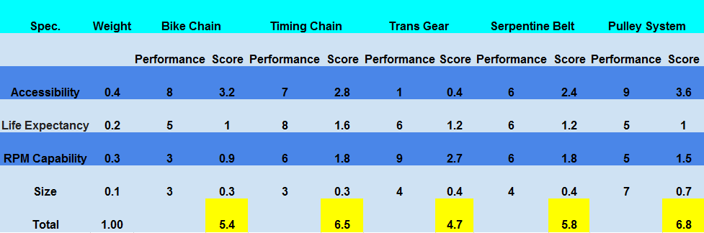

Based on the weight scale that the group used it was concluded that a custom pulley system would be the best solution for this problem. This is mainly because of the location of where this will be implemented and the access to parts. Most parts need to be salvaged from a scrap yard or be feasible to sand cast.

The secondary design concept that could be pursued if the pulley system does not work would be a timing chain design. This is due to the challenge of being able to find a timing chain easily from a local scrapyard.

Results
The final design for the product that could be implemented by the Magnetic Power Company is an adjustable pulley system with a 2:1 ratio. This ratio was chosen because it allows for a range of 750-1500 RPMs driving to get a respective output range of 1500-3000 RPMs. It was also decided to create a sizing apparatus that would allow for changing the distance of the two shafts to fit most situations. This sizing apparatus would be created by sand casting. This apparatus would also be fitted with a tensioning screw/pulley to accommodate the change in distance during installation and maintenance. Bearings with a half inch bore and three quarter inch diameter, are suggested for this build due to the geometry of the sizing apparatus and the availability of this type of bearing in Hastings location. In association with the bearings, half inch diameter shafts are required to fit this build.
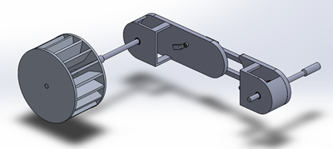
Full view of model.
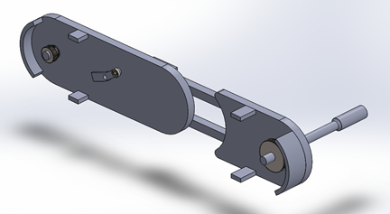
Section view showing the pulley mechanism.
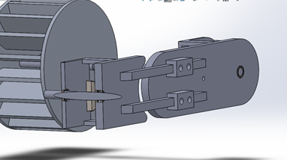
Section view showing the adjustable slide.

Summary/Conclusion
In conclusion the design that the team chose to pursue was based on a pulley system with a tension rod to accommodate the use of different sized pulleys/ belts. This also allows the ability to more accurately line up the shafts when the powertrain is in use. The design calls for a belt, two different sized pulleys with a ratio of about 2:1, two shafts that are ½ inch diameter, five bearings with a bore diameter of ½ inch, a propeller/water wheel, an adjustable slide plate, and a tensioner screw. Of these parts the adjustable slide plate and propeller would be sand casted and the rest would be salvaged from a local scrapyard. Collectively the group feels that this design could be easily implemented in the current situation and will meet Hastings needs.

