A Drift-Conscious Machine Learning Governance Framework for Phase-Specific Model Selection in Lean Six Sigma DMAIC
¹Charles Onyeka Nwamekwe, ²Raphael Olumese Edokpia, ²Christopher Igbinosa Eboigbe
*Correspondence Address
¹Industrial/Production Engineering Department,
Nnamdi Azikiwe University, P.M.B. 5025 Awka,
Anambra State - Nigeria.
²Department of Production Engineering,
University of Benin, Benin,
Edo state - Nigeria.
*Corresponding Author: co.nwamekwe@unizik.edu.ng

Abstract: Lean Six Sigma projects increasingly adopt machine learning for prediction, diagnosis, and improvement support, but model selection is often treated as a one-time accuracy exercise. This creates governance risk because DEFINE, MEASURE, ANALYZE, IMPROVE, and CONTROL require different evidence standards. This study addresses this limitation by developing a drift-conscious, phase-adaptive machine learning governance framework for DMAIC-based model selection. An industrial batch-level dataset was segmented by DMAIC phase: DEFINE (n = 10), MEASURE (n = 6), ANALYZE (n = 6), IMPROVE (n = 4), and CONTROL (n = 4). All critical variables recorded 0.00 missingness. Candidate models were evaluated using phase-specific metrics: Spearman ranking stability for DEFINE, Performance Degradation Index for MEASURE, cross-validation variability for ANALYZE, desirability-gain stability for IMPROVE, and PSI with rolling RMSE for CONTROL. Results confirmed that no single model dominated all phases. In DEFINE, gradient boosting produced stable driver prioritisation with Spearman ρₛ = 0.95, identifying drying time, moisture, compression speed, compression force, and feeder rate as the leading drivers. In MEASURE, gradient boosting showed the strongest robustness, with mean PDI = 0.56 and worst-case PDI = 1.35, outperforming Ridge and Linear Regression under perturbation. In ANALYZE, Ridge and Lasso delivered superior diagnostic stability, with CV SD values of 0.29 and 0.28, respectively. In IMPROVE, mean gains clustered around 0.08, but reversal rates ranged from 0.20 to 0.34. In CONTROL, PSI increased from 0.02 to 0.68 across 30 windows, validating drift-triggered reassessment.
Keywords: Phase-adaptive model selection; Drift-aware governance; Lean Six Sigma DMAIC; Machine learning robustness; Rolling RMSE monitoring

1. Introduction
1.1 Background
Lean Six Sigma (LSS) continues to serve as a cornerstone methodology for industrial performance improvement because its DMAIC lifecycle (DEFINE–MEASURE–ANALYZE–IMPROVE–CONTROL) imposes a disciplined progression from problem definition to sustained operational control [1]. In parallel, machine learning (ML) has become increasingly embedded in quality engineering practice as industrial systems generate higher-volume, higher-dimensional, and more temporally structured data. Within contemporary LSS projects, ML models are routinely deployed to estimate critical-to-quality (CTQ) responses from process conditions, identify influential drivers and interactions, and support improvement decisions through predictive and prescriptive analytics. This convergence, however, has given rise to a fragile operational convention: project teams often select a single “best” ML model based on global accuracy metrics and then apply that model uniformly across all DMAIC phases. Such practice implicitly assumes that model suitability is invariant across the lifecycle. This assumption is misaligned with DMAIC logic [2],[3]. Each phase embodies a distinct analytical intent and decision risk, implying that the model properties required for effectiveness vary by phase.
In the DEFINE phase, models are primarily used for screening and prioritisation; stability of ranking and separability of candidate drivers are therefore critical. During MEASURE, analytical reliability depends on robustness to noise, missingness, and measurement variability. ANALYZE requires diagnostic credibility, which hinges on stability under resampling rather than nominal fit alone. In IMPROVE, the central requirement shifts from prediction to prescription: recommendations must deliver consistent gains under realistic perturbations [2],[4]. Finally, CONTROL introduces temporal risk, as process conditions evolve and data distributions drift, creating the potential for silent performance degradation unless explicit monitoring and governance mechanisms are enforced. Accordingly, this manuscript explicitly aligns each DMAIC phase with phase-appropriate evaluation criteria, DEFINE (separability and ranking stability), MEASURE (robustness to noise and missingness), ANALYZE (cross-validation stability and variance), IMPROVE (consistency of prescriptive gain), and CONTROL (drift sensitivity and rolling prediction error), thereby reframing model evaluation as a lifecycle-conditioned decision rather than a one-time optimisation exercise [5],[6].

1.2 Problem Statement
The core problem addressed in this study is that static, accuracy-centric model selection is fundamentally incompatible with DMAIC logic and introduces avoidable failure modes into ML-enabled LSS initiatives [2]. Empirical evidence increasingly indicates that ML performance is phase-dependent: models that perform well in exploratory or screening contexts often degrade when robustness, stability, interpretability, or drift resistance becomes the dominant requirement. As a consequence, reliance on a single “globally optimal” model exposes improvement programmes to three interrelated risks: (i) undetected performance erosion as process conditions evolve, (ii) unstable or contradictory prescriptions during IMPROVE, and (iii) CONTROL-phase failure when drift occurs without governance triggers [5],[7]. These risks undermine the very objective of LSS, which is to deliver improvements that are not only effective but also sustainable. This is not merely a modelling issue; it is a governance deficiency. DMAIC is inherently sequential and decision-progressive: defining what matters, measuring it credibly, diagnosing causes, prescribing change, and sustaining gains. When model selection is fixed early and carried forward without phase-aligned reassessment rules, model risk accumulates across phases and typically manifests only after changes have been implemented, precisely when corrective action is most costly [4],[1],[7].

1.3 Research Gap
Despite the widespread adoption of ML within quality and process improvement contexts, limited research treats ML model selection as a governed, lifecycle-aligned activity across DMAIC phases [8],[4]. Existing studies predominantly emphasise predictive accuracy or report results within a single phase, without formally articulating (i) phase-specific suitability criteria, (ii) drift sensitivity as a primary CONTROL-phase concern, or (iii) explicit governance rules that define when a model should be reassessed, replaced, or retired. This omission weakens the reliability of ML-enabled LSS practice by encouraging one-shot selection and deployment without clearly defined performance envelopes or trigger conditions [5],[9]. The gap, therefore, is not algorithmic. Rather, it lies in the absence of a DMAIC-consistent governance structure capable of justifying why a model is chosen for a given phase, how that choice is validated against phase-specific risks, and how ongoing suitability is monitored as processes and data distributions evolve [10,[11].

1.4 Aim, Objectives, and Contributions
To address this gap, the aim of this research is to develop and empirically evaluate a phase-adaptive ML governance framework that aligns model evaluation and selection explicitly with DMAIC logic, moving beyond reliance on global accuracy metrics. The study makes three interrelated contributions. First, it provides empirical formalisation of phase-dependent model optimality in LSS projects, demonstrating that model superiority is not invariant across DMAIC phases. Second, it proposes a DMAIC-aligned governance rule-set that links each phase to appropriate evaluation metrics and drift thresholds, transforming model selection into a controlled and auditable decision process. Third, it presents evidence that phase-adaptive governance mitigates CONTROL-phase performance degradation relative to static deployment by enabling timely reassessment under drift. Through these contributions, governance is positioned not as an auxiliary monitoring layer but as the mechanism that reconciles ML practice with DMAIC discipline: model selection becomes a phase-conditioned decision supported by stability-oriented criteria and enforced through explicit trigger logic.

1.5 Conceptual Framing of Drift-Aware Governance Across DMAIC
The proposed governance concept is grounded in two operational signals: distributional divergence in input features and performance decay over time [3],[12]. Drift is therefore treated not as an abstract ML concern but as a CONTROL-phase operational reality that must be governed through predefined envelopes and decision triggers. Within this framing, “phase-adaptive” does not imply continuous online learning. Instead, it reflects an explicit, offline evaluation strategy that respects industrial constraints, regulatory expectations, and auditability requirements. The manuscript adopts a rolling, offline reassessment approach and deliberately avoids streaming assumptions, consistent with production-critical environments where controlled updates are preferable to autonomous model adaptation. This design choice enhances practical credibility by ensuring that reassessment decisions are systematic, traceable, and aligned with phase objectives.

1.6 Structure of the Manuscript
The remainder of the manuscript is organised as follows. The Materials and Methods section describe the industrial context, CTQ-oriented data structure across the DEFINE–CONTROL lifecycle, the evaluated ML model families, the phase-wise experimental design, and the drift-aware governance logic. The Results and Discussion section presents phase-specific evidence of model behaviour, quantifies robustness and diagnostic stability, evaluates prescriptive consistency during IMPROVE, and demonstrates the CONTROL-phase benefits of drift-aware governance relative to static deployment. The manuscript concludes by positioning phase-adaptive ML governance as a necessary evolution for sustainable, industrially credible Lean Six Sigma practice.

2. Materials And Methods
2.1 Industrial Case Context and Data Structure
This study uses an industrial production dataset representing a multi-stage process with multiple critical-to-quality (CTQ) characteristics. Records are organised at batch level and include replicated measurements, process parameters, and environmental variables, explicitly structured to reflect the DEFINE–CONTROL lifecycle [13].
Let the dataset be $D=\{(x_{i},y_{i},t_{i})\}_{i=1}^{N}$, where $x_{i}∈R^{p}$is the feature vector (process parameters + environment + operational factors), $y_{i}$is the CTQ response (single-output or multi-output), and $t_{i}$is a time or production-order index supporting CONTROL-phase rolling evaluation. Replicate measurements are represented as $y_{i,r}$for replicate $r=1,…,R_{i}$, enabling explicit treatment of measurement variability in MEASURE/ANALYZE.
To align modelling with DMAIC governance, the data are segmented into phase-specific subsets:
$D=D^{\left(D\right)}∪D^{\left(M\right)}∪D^{\left(A\right)}∪D^{\left(I\right)}∪D^{\left(C\right)},$ (Eqn. 1)
where superscripts $D,M,A,I,C$denote DEFINE, MEASURE, ANALYZE, IMPROVE, and CONTROL, respectively. This segmentation is not arbitrary: each phase has a distinct analytical intent and is therefore evaluated using phase-aligned metrics rather than a single global score [14].
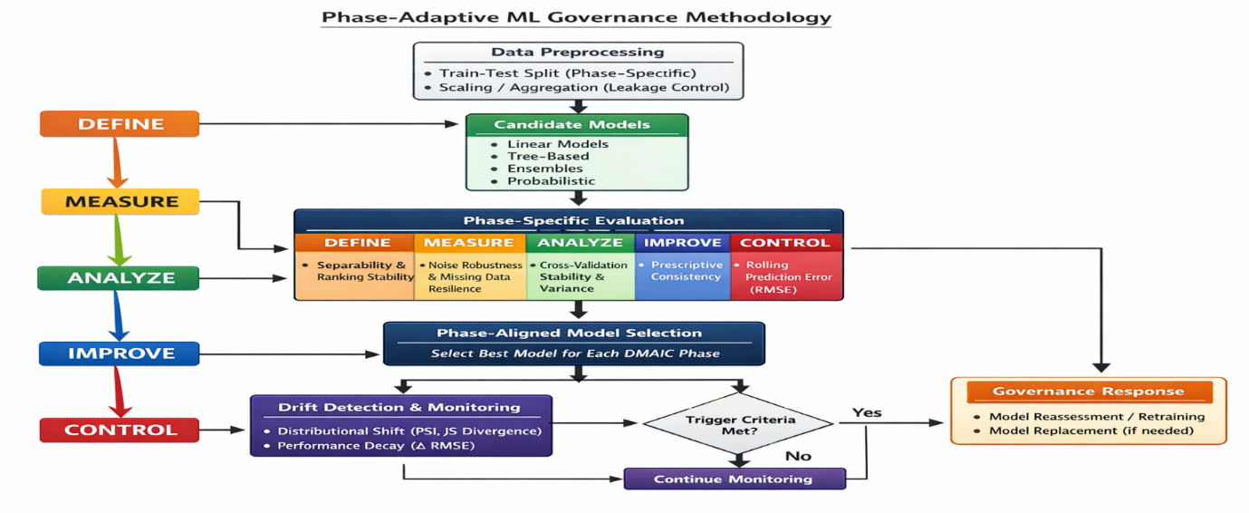Figure 1: Phase-Adaptive ML Governance Methodology

2.1.1 Pre-Processing and Leakage Control
All transformations are fit strictly on training partitions and applied to validation/test partitions to prevent information leakage. For continuous features, scaling is applied where required by the model family (like, linear/regularised models). For replicated CTQ measurements, the modelling target is defined either as the replicate mean ${\overset{ˉ}{y}}_{i}=\frac{1}{R_{i}}\sum_{r}{y_{i,r}}$(when the CTQ operational definition is “batch outcome”), or as replicate-level $y_{i,r}$(when the CTQ is treated as a measurement system output), with the chosen representation held constant across phase comparisons to ensure fairness.

2.2 Machine learning model families
A diverse model set is evaluated to represent contrasting analytical paradigms, linear and regularised regression, tree-based learners, ensemble methods, and probabilistic models so that the interaction between model characteristics and DMAIC phase requirements can be empirically tested [15],[16].
Let $f_{m}(x;θ_{m})$denote a candidate model $m∈M$. Across model families, training solves:
${\hat{θ}}_{m}=arg⁡\underset{θ_{m}}{min⁡} \sum_{i∈T}{l(}y_{i},f_{m}(x_{i};θ_{m}))+λ Ω(θ_{m})$ (Eqn. 2)
where $T$is the training set, $l(⋅)$is a loss (e.g., squared error), and $Ω(⋅)$is a model-specific regulariser (e.g., $∥β∥_{2}^{2}$for Ridge; $∥β∥_{1}$for Lasso). Hyperparameters are selected using phase-consistent validation logic (Section 2.3).

2.3 Phase-wise experimental design and evaluation protocol
The analysis follows an offline, rolling evaluation strategy and explicitly avoids streaming assumptions consistent with regulated or production-critical environments where reassessment must be auditable and controlled [17].
Data are evaluated phase-by-phase with metrics aligned to each phase’s intent: DEFINE (separability/ranking stability), MEASURE (robustness to noise/missingness), ANALYZE (cross-validation stability/variance), IMPROVE (consistency of prescriptive gain), CONTROL (drift sensitivity/rolling prediction error).

2.3.1 Rolling (CONTROL-Compatible) Evaluation Split
For time-ordered validation, a rolling window scheme is used. For window $k$, define:
- training window: $T_{k}=\{i:t_{i}≤τ_{k}\}$
- test window: $S_{k}=\{i:τ_{k}<t_{i}≤τ_{k}+Δ\}$
The rolling error for model $m$at window $k$is:
${RMSE}_{m,k}=\sqrt{\frac{1}{∣S_{k}∣}\sum_{i∈S_{k}}{{\left(y_{i} − {\hat{y}}_{i,m}\right)}^{2}}},{\hat{y}}_{i,m}=f_{m}(x_{i};{\hat{θ}}_{m,k})$ (Eqn. 3)
This produces a time series $\left\{{RMSE}_{m,k}\}_{k=1}^{K}\right.$used both for CONTROL monitoring and for governance triggering (Section 2.4).

2.4 Drift Detection and Governance Logic (Drift-Aware Model Governance)
Drift is identified using two complementary signals: distributional divergence (feature shift) and performance decay (error inflation).
The governance rule-set specifies acceptable performance envelopes and trigger conditions for reassessment or replacement, turning model selection into a controlled decision process aligned with DMAIC logic and directly addressing the study’s aim and contributions [18],[19].

2.4.1 Distributional Divergence Indicators
For each feature $x^{\left(j\right)}$, compute divergence between a reference window $R$(baseline/control set) and a current window $W$. A practical, audit-friendly indicator is the Population Stability Index (PSI), computed on binned distributions:
${PSI}_{j}=\sum_{b=1}^{B}{\left(p_{b}^{\left(R\right)}-p_{b}^{\left(W\right)}\right)}ln⁡\left(\frac{p_{b}^{\left(R\right)}}{p_{b}^{\left(W\right)}}\right)$ (Eqn. 4)
where $p_{b}^{(.)}$is the proportion in bin $b$. The overall drift score can be aggregated as ${PSI}_{\text{agg}}=\frac{1}{p}\sum_{j=1}^{p}{{PSI}_{j}}$or prioritised using max/percentile rules when a small subset of CPPs drives risk.
Where continuous-density estimation is justified, divergence can alternatively be computed using Jensen–Shannon divergence (bounded, symmetric):
$JS(P∥Q)=\frac{1}{2}KL(P∥M)+\frac{1}{2}KL(Q∥M),M=\frac{1}{2}(P+Q)$ (Eqn. 5)
2.4.2 Performance Decay Indicators
Performance decay is measured via rolling error inflation relative to a reference level:
$Δ{RMSE}_{m,k}={RMSE}_{m,k}-{RMSE}_{m,\text{ref}},\%Δ{RMSE}_{m,k}=\frac{{RMSE}_{m,k}-{RMSE}_{m,\text{ref}}}{{RMSE}_{m,\text{ref}}}×100$ (Eqn. 6)
A CONTROL trigger is fired when either (i) divergence exceeds a drift threshold, or (ii) rolling error inflation exceeds an allowable envelope for $H$consecutive windows:
${\text{Trigger}}_{m,k}=I({PSI}_{\text{agg},k}>τ_{\text{drift}}) ∨ I(\%Δ{RMSE}_{m,k}>τ_{\text{perf}} \text{for }H\text{ windows})$ (Eqn. 7)This operationalises the study’s governance position: monitoring is not optional; it is a formal decision gate for model reassessment.

2.5 Phase-Aligned Evaluation Criteria and Equations
Performance is assessed using both traditional accuracy metrics and stability-oriented indicators so evaluation captures predictive strength and reliability under perturbation and temporal evolution [20].
The phase-specific criteria below directly implement the study’s stated alignment of phase intent to evaluation.

2.5.1 DEFINE Phase: Separability and Ranking Stability
DEFINE prioritises driver screening and prioritisation. Separability is evaluated using discrimination-style metrics and effect separation indices.
Separability: for candidate factor $x^{\left(j\right)}$, define a standardised separation between “high” and “low” CTQ strata (e.g., top/bottom quantiles):
$S_{j}=\frac{∣μ_{j}^{(+)}-μ_{j}^{(-)}∣}{\sqrt{\frac{1}{2}\left(σ_{j}^{(+)2} + σ_{j}^{(-)2}\right)}}$ (Eqn. 8)
where (+) and (-) denote the two strata. Larger $S_{j}$indicates stronger screening utility.
Ranking stability: Let $π^{\left(a\right)}$and $π^{\left(b\right)}$be ranked lists of driver importances obtained from two resamples. Stability is measured using Spearman rank correlation:
$ρ_{s}=1-\frac{6\sum_{j=1}^{p}{d_{j}^{2}}}{p(p^{2}-1)}$ (Eqn. 9)
where $d_{j}$is the rank difference for feature $j$. DEFINE-phase preference is for models that preserve rankings under resampling (high $ρ_{s}$) rather than only maximising fit.

2.5.2 MEASURE Phase: Robustness to Noise and Missingness
MEASURE tests sensitivity to data quality degradation. Let $η$denote injected noise level and $γ$denote missingness rate. For each perturbation setting $\left(η , γ\right)$, compute:
${RMSE}_{m}(η,γ)=\sqrt{\frac{1}{n}\sum_{i=1}^{n}{{\left(y_{i} − {\hat{y}}_{i,m}^{\left(η , γ\right)}\right)}^{2}}}$ (Eqn. 10)
A Performance Degradation Index (PDI) quantifies robustness relative to baseline ($η=0,γ=0$):
${PDI}_{m}(η,γ)=\frac{{RMSE}_{m}(η,γ)-{RMSE}_{m}(0,0)}{{RMSE}_{m}(0,0)}$ (Eqn. 11)
Models preferred in MEASURE are those with low $PDI$across perturbation grids, consistent with the study’s MEASURE intent.

2.5.3 ANALYZE Phase: Cross-Validation Stability and Variance
ANALYZE requires reliable diagnostic inference; therefore, model variance across resampling is made explicit. For $K$-fold cross-validation, let $e_{m,k}$be an error metric on fold $k$. Then:
${\overset{ˉ}{e}}_{m}=\frac{1}{K}\sum_{k=1}^{K}{e_{m,k}},s_{m}=\sqrt{\frac{1}{K-1}\sum_{k=1}^{K}{(}e_{m,k}-{\overset{ˉ}{e}}_{m})^{2}},{CV}_{m}=\frac{s_{m}}{{\overset{ˉ}{e}}_{m}}$ (Eqn. 12)
ANALYZE-phase preference is for models that combine competitive mean error with low variability ($s_{m}$, ${CV}_{m}$), aligning directly with “cross-validation stability and variance.”

2.5.4 IMPROVE Phase: Consistency of Prescriptive Gain
IMPROVE evaluates whether a model supports dependable prescriptions, not only accurate predictions [21].
Let $g(x)$be the prescription generator that chooses settings $x^{⋆}$to optimise a desirability objective.
For a “higher-is-better” CTQ, a standard Derringer-Suich desirability can be used:
$d(y)=\left\{\begin{matrix}0, & y<L, \\ {\left(\frac{y-L}{T-L}\right)}^{s}, & L≤y≤T, \\ 1, & y>T,\end{matrix}\right.$ (Eqn. 13)
where $L$is the unacceptable lower bound, $T$is the target, and $s$controls curvature. For “nominal-is-best” CTQs, desirability is defined with symmetric decay around the target.
For multi-CTQ improvement, composite desirability is:
$D(y)={\left(\prod_{q=1}^{Q}{d_{q}}(y_{q})\right)}^{1/Q}$ (Eqn. 14)
Prescriptive gain under model $m$is computed as:
$G_{m}=D({\hat{y}}_{m}(x^{⋆}))-D({\hat{y}}_{m}(x_{\text{current}})),x^{⋆}=arg⁡\underset{x∈X}{max⁡}D({\hat{y}}_{m}(x))$ (Eqn. 15)
where $X$is the feasible operating region (engineering constraints).
Consistency of prescriptive gain is evaluated under perturbations/resampling:
${StabGain}_{m}=1-Var{\left(G_{m}^{\left(b\right)}\right)}_{b=1}^{B},$ (Eqn. 16)
(or equivalently by reporting $SD(G_{m}^{\left(b\right)})$and the decision-reversal rate). This implements the study’s emphasis that IMPROVE should prioritise dependable prescriptions rather than maximum nominal gain.

2.5.5 CONTROL Phase: Drift Sensitivity and Rolling Prediction Error
CONTROL focuses on temporal risk: distributions evolve and deployed performance can silently degrade unless drift sensitivity is monitored and governance triggers exist.
Two coupled CONTROL metrics are therefore monitored:
- Drift sensitivity: ${PSI}_{\text{agg},k}$(or ${JS}_{k}$) as defined in Section 2.4.1.
- Rolling prediction error: ${RMSE}_{m,k}$as defined in Section 2.3.1.
A model’s CONTROL suitability is assessed by its ability to maintain error within an allowable envelope under observed drift and by the timeliness of governance-driven reassessment when triggers fire directly implementing the study’s CONTROL objective and its governance contribution [22].

2.6 Implementation Summary (DMAIC-Aligned Governance Workflow)
The full method operationalises the stated aim; phase-adaptive ML governance aligned to DMAIC, as the following auditable workflow:
- Train/evaluate candidate models $M$on each phase subset using phase-aligned metrics.
- Select phase-suitable models based on a weighted decision rule that prioritises the phase’s reliability requirement (ranking stability; robustness; CV stability; prescriptive consistency; drift sensitivity), rather than a single global accuracy score.
- Define governance envelopes and triggers using divergence + performance decay indicators, and execute offline rolling reassessment to maintain CONTROL sustainability.
This Materials and Methods design is therefore not an algorithm proposal in isolation; it is a governed, phase-conditioned evaluation and monitoring system that directly realises the study’s three contributions: (i) phase-dependent optimality evidence, (ii) a phase-linked rule-set with drift thresholds, and (iii) CONTROL-phase degradation mitigation via timely reassessment.

3. Results and Discussion
3.1 Exploratory Data Analysis and Phase-Wise Data Characterisation
3.1.1 Data Completeness and Phase Allocation
Table 1: Missingness by DMAIC Phase
DMAIC Phase | N. obs. | Missing rate Compression Force kN | Missing rate Compression Speed rpm | Missing rate Feeder Rate pct | Missing rate Drying Time min | Missing rate Moisture pct | Missing rate Temp C | Missing rate RH pct | Missing rate Hardness N
ANALYZE | 6 | 0 | 0 | 0 | 0 | 0 | 0 | 0 | 0
CONTROL | 4 | 0 | 0 | 0 | 0 | 0 | 0 | 0 | 0
DEFINE | 10 | 0 | 0 | 0 | 0 | 0 | 0 | 0 | 0
IMPROVE | 4 | 0 | 0 | 0 | 0 | 0 | 0 | 0 | 0
MEASURE | 6 | 0 | 0 | 0 | 0 | 0 | 0 | 0 | 0

Table 1 establishes the data-completeness foundation for the study. Across DEFINE, MEASURE, ANALYZE, IMPROVE, and CONTROL, all reported missingness rates are 0.00 for compression force, compression speed, feeder rate, drying time, moisture, temperature, relative humidity, and hardness. The phase sample sizes are DEFINE n = 10.00, MEASURE n = 6.00, ANALYZE n = 6.00, IMPROVE n = 4.00, and CONTROL n = 4.00. This is important because the later perturbation experiments are therefore controlled simulations of missingness and noise, not corrections for already incomplete data. Scientifically, the table supports internal validity by confirming that baseline comparisons are not biased by unequal missing-data burdens across phases. It also strengthens the governance claim because performance degradation observed later can be attributed to phase-specific stress testing, resampling, or drift rather than uncontrolled data incompleteness.

3.1.2 Phase-Wise Distribution of Process Conditions and CTQs
Table 2: Phase-Wise Descriptive Statistics of Process Parameters and CTQs
DMAIC Phase | n | Compression Force (kN) | Speed (rpm) | Feeder Rate (%) | Drying Time (min) | Moisture (%) | Temp (°C) | RH (%) | Hardness (N)
DEFINE | 10 | 13.5 ± 3.03 (9–18) | 45.1 ± 6.23 (36–55) | 53 ± 6.06 (44–62) | 31 ± 6.06 (22–40) | 1.69 ± 0.29 (1.25–2.10) | 25.65 ± 1.03 (24–27) | 51 ± 6.06 (42–60) | 105.1 ± 24.19 (71–140)
MEASURE | 6 | 15.92 ± 1.74 (13.5–18) | 47 ± 3.74 (42–52) | 58 ± 3.74 (53–63) | 29 ± 3.74 (24–34) | 1.90 ± 0.19 (1.65–2.15) | 25.33 ± 0.61 (24.5–26) | 50 ± 3.74 (45–55) | 123.0 ± 13.19 (105–139)
ANALYZE | 6 | 14.0 ± 1.87 (11.5–16.5) | 53 ± 3.74 (48–58) | 65 ± 3.74 (60–70) | 23 ± 3.74 (18–28) | 2.05 ± 0.19 (1.80–2.30) | 24.58 ± 0.74 (23.5–25.5) | 45 ± 3.74 (40–50) | 106.17 ± 14.70 (87–126)
IMPROVE | 4 | 15.5 ± 1.29 (14–17) | 43 ± 2.58 (40–46) | 55 ± 2.58 (52–58) | 33 ± 2.58 (30–36) | 1.60 ± 0.13 (1.45–1.75) | 26.38 ± 0.48 (26–27) | 55 ± 2.58 (52–58) | 122.0 ± 9.56 (111–133)
CONTROL | 4 | 15.5 ± 1.29 (14–17) | 47 ± 2.58 (44–50) | 57 ± 2.58 (54–60) | 27 ± 2.58 (24–30) | 1.50 ± 0.13 (1.35–1.65) | 30.75 ± 0.65 (30–31.5) | 71.25 ± 2.99 (68–75) | 114.25 ± 8.66 (104–124)

Table 2 shows that the DMAIC phases represent meaningfully different operating conditions. DEFINE has the broadest hardness variability, with mean hardness of 105.10 N and SD of 24.19 N. MEASURE and IMPROVE show higher and tighter hardness values, 123.00 ± 13.19 N and 122.00 ± 9.56 N, respectively. ANALYZE records the highest speed and feeder rate at 53.00 rpm and 65.00%, while CONTROL shifts strongly toward hotter and more humid conditions, with temperature of 30.75 °C and RH of 71.25%. This matters because model behaviour is being tested across genuinely different process contexts, not merely arbitrary data partitions. The table supports the study objective by showing why phase-adaptive governance is necessary: the underlying production environment changes across DMAIC, and these changes can alter model suitability, robustness, and drift sensitivity.

3.2 Evidence of Phase-Dependent Model Optimality Across DMAIC
3.2.1 Cross-Phase Model Performance Landscape
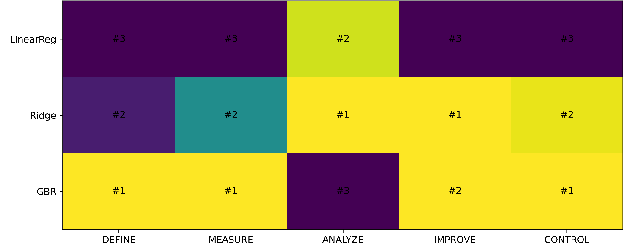Figure 2: Phase-Wise Model Leaderboard Multi-Metric Heatmap
Figure 2 provides strong visual evidence that no model is universally optimal across DMAIC phases. GBR ranks first in DEFINE, MEASURE, and CONTROL, while Ridge dominates ANALYZE and performs second in MEASURE and CONTROL. Linear regression performs poorly in DEFINE and MEASURE but improves relatively in ANALYZE and IMPROVE. This rank reversal is scientifically important because it invalidates the assumption that one global model can serve all Lean Six Sigma phases. The heatmap supports the manuscript’s central thesis that model superiority depends on phase intent. DEFINE requires stable driver ranking, MEASURE requires perturbation tolerance, ANALYZE requires low diagnostic variance, IMPROVE requires reliable prescriptions, and CONTROL requires drift-sensitive monitoring. The figure is therefore not merely comparative; it is governance evidence showing why model selection must be phase-specific, traceable, and reassessed across the DMAIC lifecycle.

3.2.2 Phase-Aligned Evaluation Metrics and Selection Logic
Table 3. Phase-Aligned Metric Definitions and Decision Rule
DMAIC Phase | Objective | Metric used (this output) | Preferred direction | Decision rule
DEFINE | Driver screening + ranking stability | Spearman ρ_s of feature-importance ranks | ↑ | Select highest ρ_s
MEASURE | Robustness under noise/missingness | PDI = (RMSE(η,γ) − RMSE₀)/RMSE₀ | ↓ | Select lowest mean PDI (and worst-case)
ANALYZE | Diagnostic resampling stability | RMSE SD across CV folds | ↓ | Select lowest RMSE SD with competitive mean
IMPROVE | Stable prescriptions (gain consistency) | SD of prescriptive gain under resampling | ↓ | Select lowest gain SD
CONTROL | Sustained performance under drift risk | Rolling RMSE on time-ordered holdouts | ↓ | Select lowest rolling RMSE; monitor envelopes

Table 3 is the governance rulebook of the manuscript. It maps each DMAIC phase to a specific objective, metric, preferred direction, and decision rule. DEFINE uses Spearman ρₛ and selects the highest value; MEASURE uses PDI and selects the lowest mean and worst-case degradation; ANALYZE uses RMSE SD and selects the lowest variability with competitive mean error; IMPROVE uses gain SD and selects the lowest prescription variability; CONTROL uses rolling RMSE and drift envelopes. The table is scientifically important because it prevents vague model-selection claims. Each “best model” decision becomes auditable and phase-specific. This directly supports the manuscript’s core argument that global accuracy is insufficient for ML-enabled LSS. The table also improves practical reproducibility because another researcher or practitioner can apply the same logic to evaluate model suitability within each DMAIC stage.

3.3 DEFINE Phase Results: Driver Screening and Ranking Stability
3.3.1 CTQ Driver Separability Under DEFINE Objectives
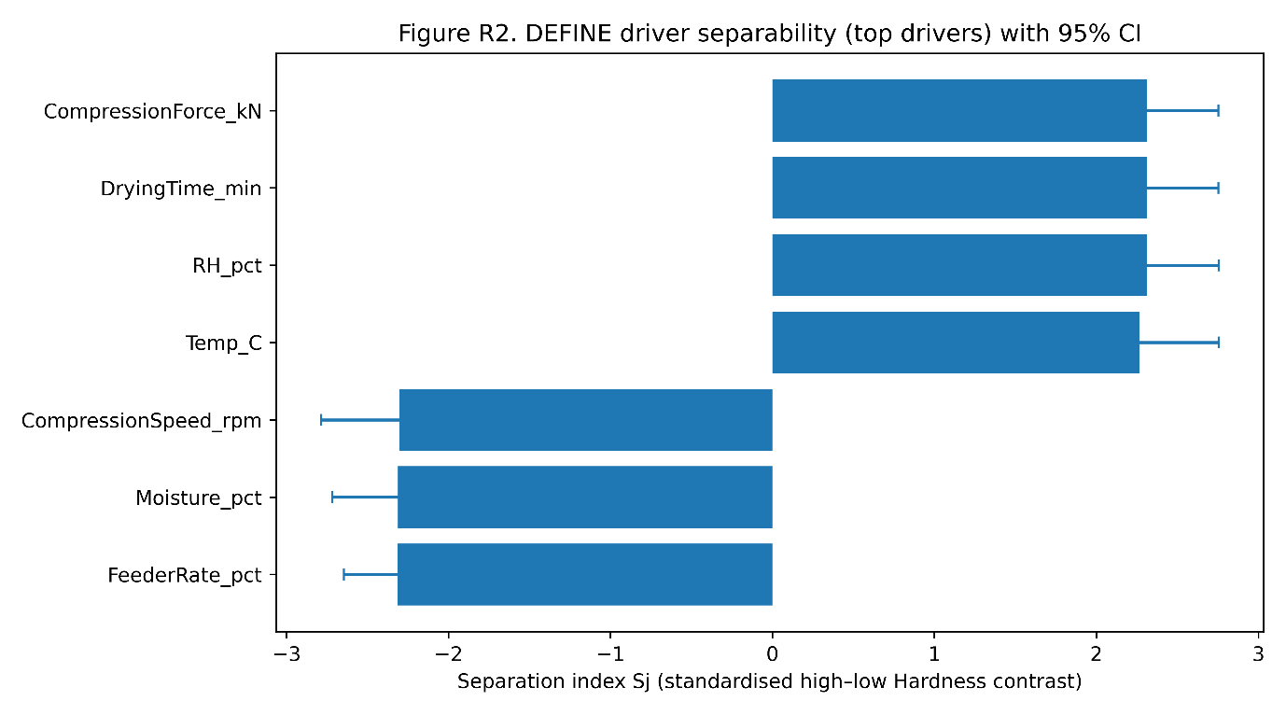Figure 3: Driver Separability Plot
Figure 3 identifies the process drivers that most clearly separate high-hardness and low-hardness conditions during DEFINE. Compression force, drying time, relative humidity, and temperature show positive separability, indicating stronger association with higher hardness outcomes. Compression speed, moisture, and feeder rate show negative separation, suggesting their influence moves in the opposite direction under the defined contrast. The confidence intervals are important because they show that driver screening is not only about magnitude but also about stability under uncertainty. Drying time and compression force appear particularly meaningful because their separation values are large and visually distinct. This supports the DEFINE objective of prioritizing candidate drivers before deeper modelling. The figure is analytically relevant because it converts raw process variation into actionable screening evidence, helping the LSS team focus on controllable parameters with clearer CTQ discrimination potential.

3.3.2 Stability of Driver Prioritisation Under Resampling
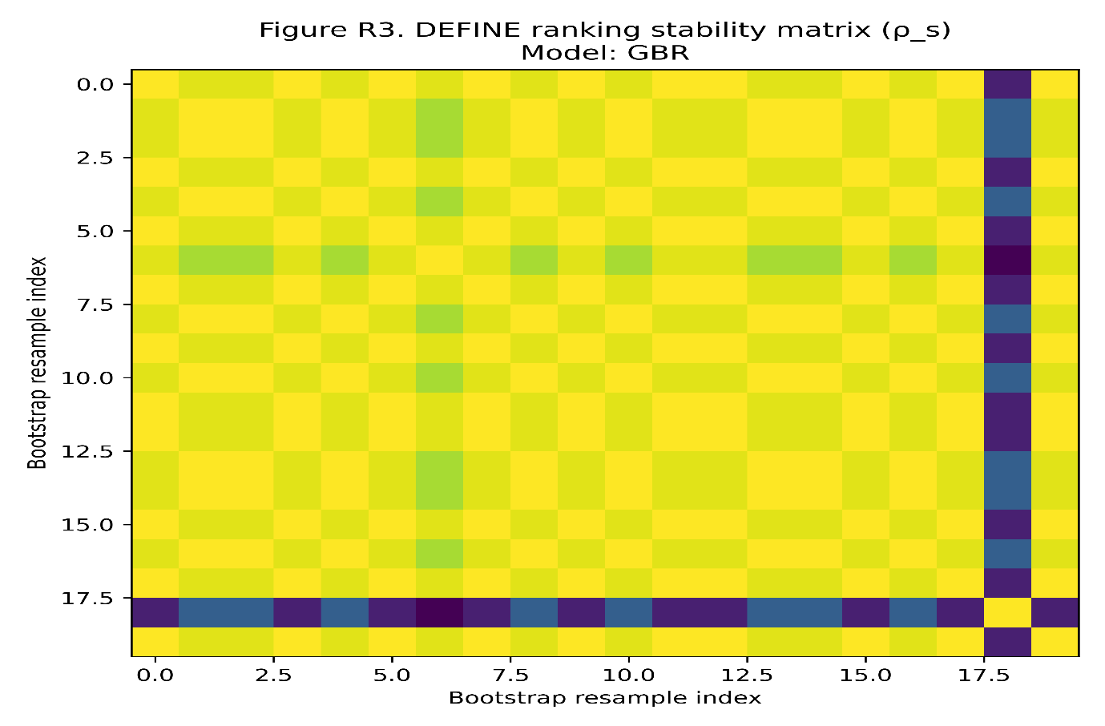Figure 4: Ranking Stability Matrix Across Resamples
Figure 4 shows the DEFINE-phase ranking stability matrix for the GBR model using Spearman rank correlation across bootstrap resamples. Most cells are visually concentrated around high similarity values, indicating that the feature-importance ordering is largely preserved across repeated resampling. The few darker or contrasting bands suggest occasional instability in specific resample combinations, but the overall matrix supports strong ranking reproducibility. This finding is consistent with the reported DEFINE mean Spearman ρₛ of 0.95. Scientifically, the figure confirms that GBR is not only identifying influential variables, but doing so consistently across resampled data. This matters because DEFINE-phase decisions guide project scope and resource allocation. A model that changes driver ranking frequently would create unstable problem definition. Therefore, the matrix provides direct evidence that stable prioritization, rather than raw predictive fit, is the correct DEFINE-phase selection criterion.

3.3.3 DEFINE-Phase Driver Selection Summary
Table 4: DEFINE-Phase Top-Ranked Drivers and Stability Statistics
Feature | Median Rank | IQR Rank | Model for DEFINE | DEFINE mean rho s
Drying Time min | 1 | 0 | GBR | 0.95
Moisture pct | 2 | 0 | GBR | 0.95
Compression Speed rpm | 3 | 0 | GBR | 0.95
Compression Force kN | 4 | 0 | GBR | 0.95
Feeder Rate pct | 5 | 0 | GBR | 0.95
Temp C | 6 | 1 | GBR | 0.95
RH pct | 7 | 1 | GBR | 0.95

Table 4 reports the DEFINE-phase driver ranking selected by GBR, with mean Spearman ρₛ of 0.95. Drying time ranks first, followed by moisture, compression speed, compression force, feeder rate, temperature, and relative humidity. The first five variables have IQR rank of 0.00, showing perfect rank consistency across resampling for the most important drivers. Temperature and relative humidity have IQR rank of 1.00, indicating slightly weaker stability but still acceptable ordering. The table is important because it shows that the driver shortlist is not random or fragile. It provides stable screening evidence for DEFINE, where incorrect prioritization could misdirect the entire improvement project. Scientifically, this supports the manuscript’s claim that ranking stability is the correct DEFINE-phase criterion. GBR is justified because it preserves driver order while identifying process variables relevant to hardness variation.

3.4 MEASURE Phase Results: Robustness to Noise and Missingness
3.4.1 Model Sensitivity Across Noise-Missingness Perturbation Space
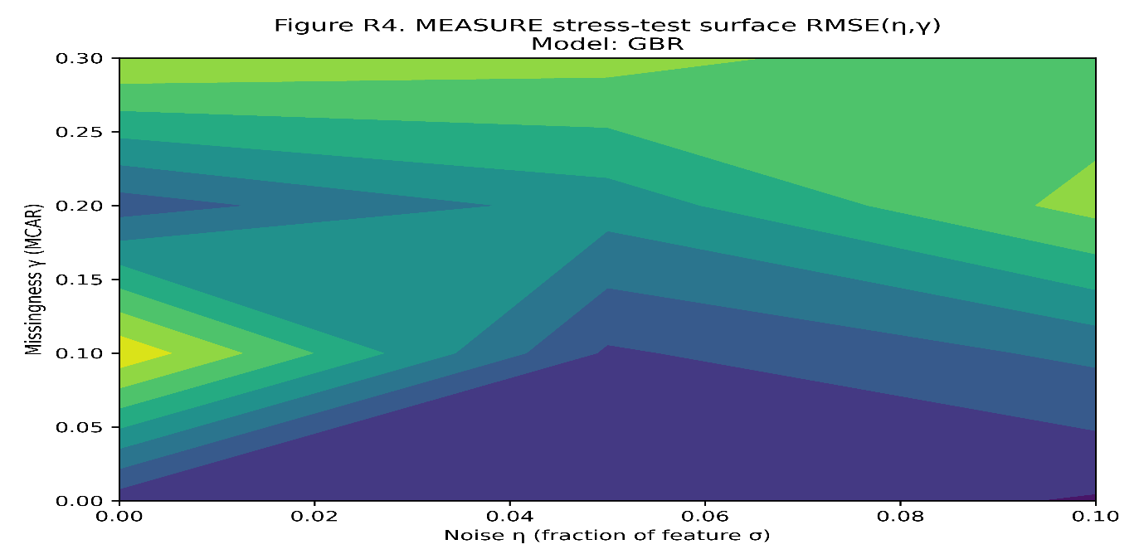Figure 5: Missingness/Noise Stress-Test Surface
Figure 5 visualizes the MEASURE-phase stress-test surface under increasing missingness and noise. The surface shows that RMSE does not rise linearly; instead, degradation changes across the perturbation grid. Low missingness and low noise regions retain lower error, while higher perturbation settings produce visible error escalation. This pattern is important because real industrial measurement systems rarely fail in a perfectly linear manner. Some regions show smoother deterioration, while others indicate sharper vulnerability. The figure supports the MEASURE objective by testing whether a model remains reliable when data quality is degraded. Scientifically, this moves robustness assessment beyond baseline RMSE and exposes hidden sensitivity to missing features and measurement noise. The visual therefore justifies the use of Performance Degradation Index as a governance metric because it captures how models behave under realistic data-quality stress rather than ideal laboratory conditions.

3.4.2 Performance Degradation Behaviour Under Data Quality Stress
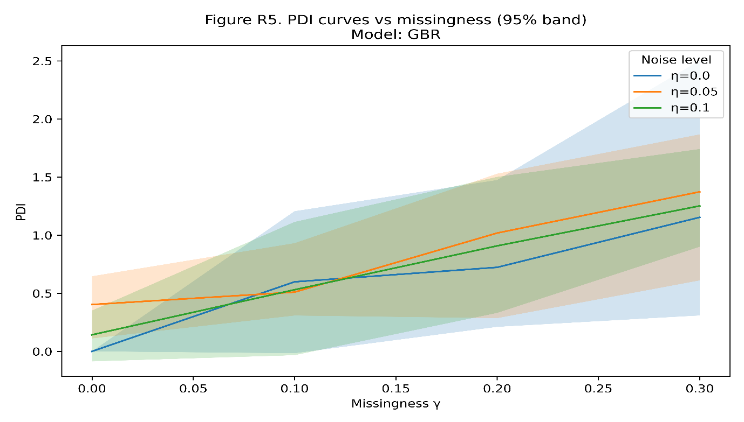Figure 6: Performance Degradation Index (PDI) Curves
Figure 6 presents PDI curves across missingness levels under different noise settings for the GBR model. The upward trajectory confirms that model performance deteriorates as missingness increases, but the relatively controlled slope indicates meaningful robustness. The shaded confidence bands show uncertainty around degradation estimates, which is analytically important because robustness should not be judged from a single curve. At higher missingness, PDI becomes larger, showing that accumulated data-quality loss still affects the model. However, the degradation remains more stable than models with sharper error cliffs, supporting GBR MEASURE-phase ranking. The figure reinforces the manuscript’s argument that models with similar baseline RMSE may behave very differently under perturbation. Therefore, MEASURE-phase model selection should prioritize degradation behaviour, not nominal accuracy alone. This is practically relevant for industrial datasets where sensor noise, incomplete records, and measurement variability are unavoidable.

3.4.3 Comparative Robustness Ranking of Candidate Models
Table 5: Robustness Summary (MEASURE Phase)
Model | Baseline RMSE | Mean PDI across grid | Worst case PDI | Robustness rank (lower mean PDI=better)
GBR | 3.26 | 0.56 | 1.35 | 1
Ridge | 1.17 | 1.15 | 6.39 | 2
Linear Reg | 1.02 | 1.70 | 5.83 | 3

Table 5 shows that baseline accuracy alone would select the wrong model for MEASURE. Linear regression has the lowest baseline RMSE at 1.02, followed by Ridge at 1.17, while GBR has a higher baseline RMSE of 3.26. However, under perturbation, GBR has the best robustness profile, with mean PDI of 0.56 and worst-case PDI of 1.35. Ridge degrades more sharply, with mean PDI of 1.15 and worst-case PDI of 6.39. Linear regression performs worst overall under stress, with mean PDI of 1.70 and worst-case PDI of 5.83. The table strongly supports the MEASURE-phase objective because measurement reliability depends on robustness, not ideal baseline fit. Scientifically, it proves that low nominal RMSE can conceal severe sensitivity to missingness and noise.

3.5 ANALYZE Phase Results: Diagnostic Stability and Variance Control
3.5.1 Distribution of Cross-Validation Errors
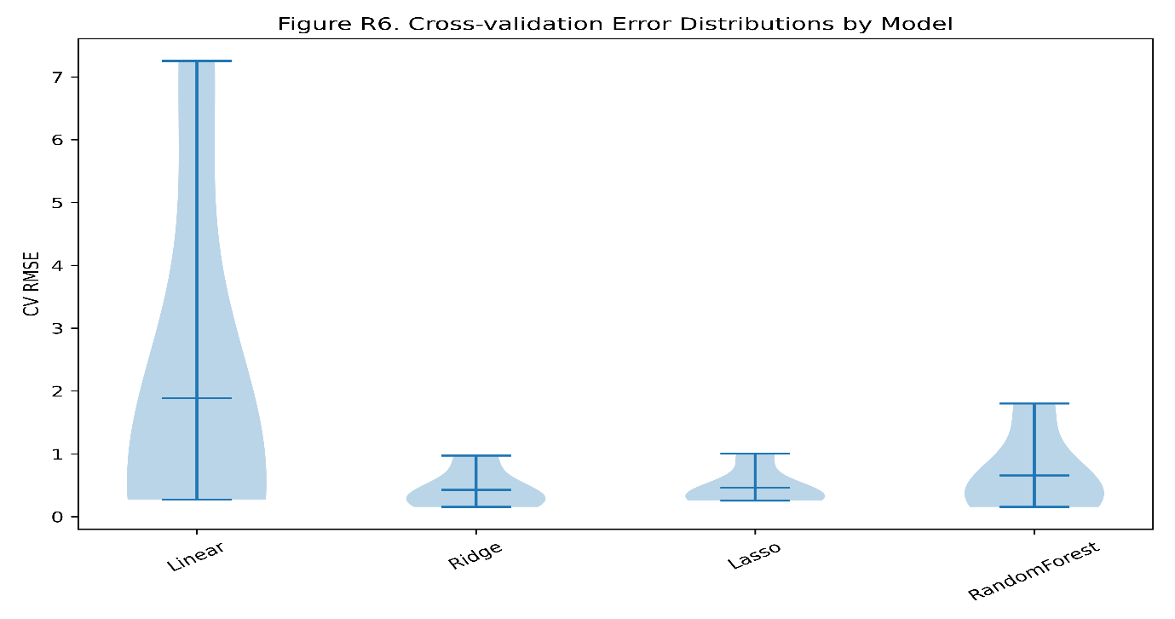Figure 7: Cross-Validation Error Distributions by Model
Figure 7 uses violin plots to compare cross-validation error distributions across Linear, Ridge, Lasso, and Random Forest models in the ANALYZE phase. Linear regression has the widest distribution and the highest upper spread, showing unstable diagnostic behaviour. Ridge and Lasso have much tighter distributions, indicating more consistent fold-level performance. Random Forest shows moderate dispersion, suggesting better stability than Linear but weaker variance control than Ridge or Lasso. The key scientific implication is that mean error alone is insufficient for diagnostic inference. A model may produce acceptable average accuracy while still behaving unreliably across resamples. This figure directly supports the ANALYZE-phase objective, where the goal is credible diagnosis rather than maximum fit. The visual evidence aligns with Table 6, where Linear has the highest CV SD at 2.69, while Lasso and Ridge remain far more stable.

3.5.2 Bias-Variance Trade-Off and Diagnostic Reliability
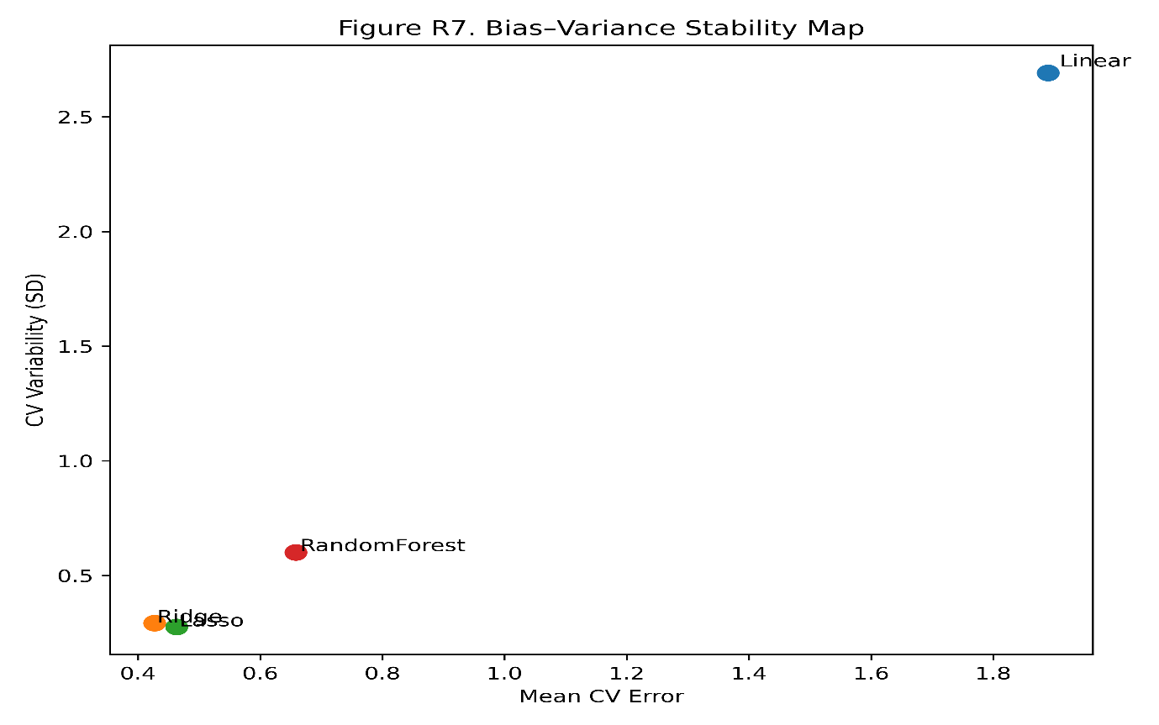Figure 8: Bias-Variance Stability Map
Figure 8 positions models according to mean cross-validation error and CV variability. Linear regression is clearly separated from the other models, with both high mean CV error of about 1.89 and high CV variability of about 2.69. Ridge and Lasso cluster in the lower-left region, reflecting lower mean error and stronger variance control. Random Forest occupies an intermediate position, with higher variability than Ridge and Lasso but much better stability than Linear. This figure is central to ANALYZE-phase interpretation because it visualizes the diagnostic trade-off between accuracy and reliability. The preferred model is not necessarily the most complex one, but the model with stable, repeatable inference. Scientifically, the figure strengthens the governance logic by showing that diagnostic credibility depends on low fold-to-fold volatility. Ridge and Lasso therefore become more defensible choices for ANALYZE than Linear regression.

3.5.3 ANALYZE-Phase Model Stability Metrics
Table 6: ANALYZE-Phase Stability Metrics
Model | Mean CV Error | CV SD | CV Coeff Var
Linear | 1.89 | 2.69 | 1.42
Ridge | 0.43 | 0.29 | 0.69
Lasso | 0.46 | 0.28 | 0.60
Random Forest | 0.66 | 0.60 | 0.91

Table 6 quantifies diagnostic stability across models. Linear regression has the poorest stability, with mean CV error of 1.89, CV SD of 2.69, and coefficient of variation of 1.42. Ridge performs best on mean CV error at 0.43, with CV SD of 0.29 and CV coefficient of variation of 0.69. Lasso has slightly higher mean error at 0.46 but the lowest CV SD at 0.28 and lowest coefficient of variation at 0.60. Random Forest is intermediate, with mean error of 0.66, CV SD of 0.60, and coefficient of variation of 0.91. The table supports a variance-aware ANALYZE decision. Lasso and Ridge are diagnostically stronger than Linear because they provide stable inference. This aligns with the manuscript’s argument that ANALYZE-phase reliability requires controlled resampling variability, not only low average error.

3.6 IMPROVE Phase Results: Prescriptive Gain Versus Stability
3.6.1 Trade-Off Between Expected Improvement and Prescription Variability
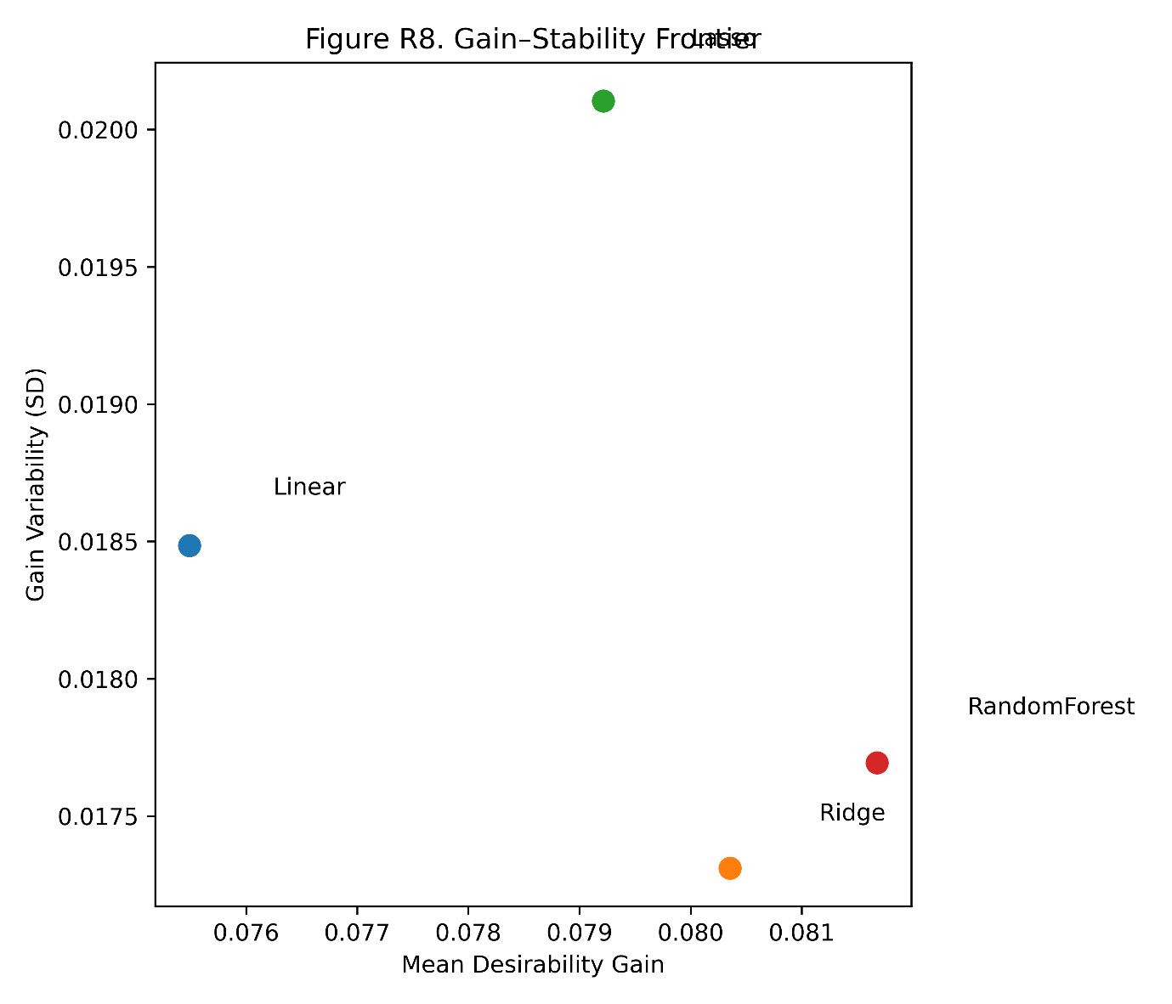Figure 9: Gain-Stability Frontier (Prescription Trade-Off)
Figure 9 compares mean desirability gain against gain variability during the IMPROVE phase. The visual shows that models with slightly higher expected gain may also carry greater instability. Random Forest provides the highest mean gain at approximately 0.08, while Ridge offers a very competitive gain with lower instability. Linear gives the lowest mean gain, and Lasso shows higher reversal-related concern despite competitive gain. The figure is scientifically important because it challenges the common improvement-phase error of selecting the model with the maximum predicted benefit. In a real process-improvement setting, unstable prescriptions can cause inconsistent operating recommendations and implementation risk. The frontier therefore supports a stability-aware decision rule: choose a model that balances gain magnitude with prescription reliability. This aligns directly with the IMPROVE objective, where sustainable improvement matters more than nominal optimization under ideal assumptions.

3.6.2 Risk of Prescription Instability Under Perturbation
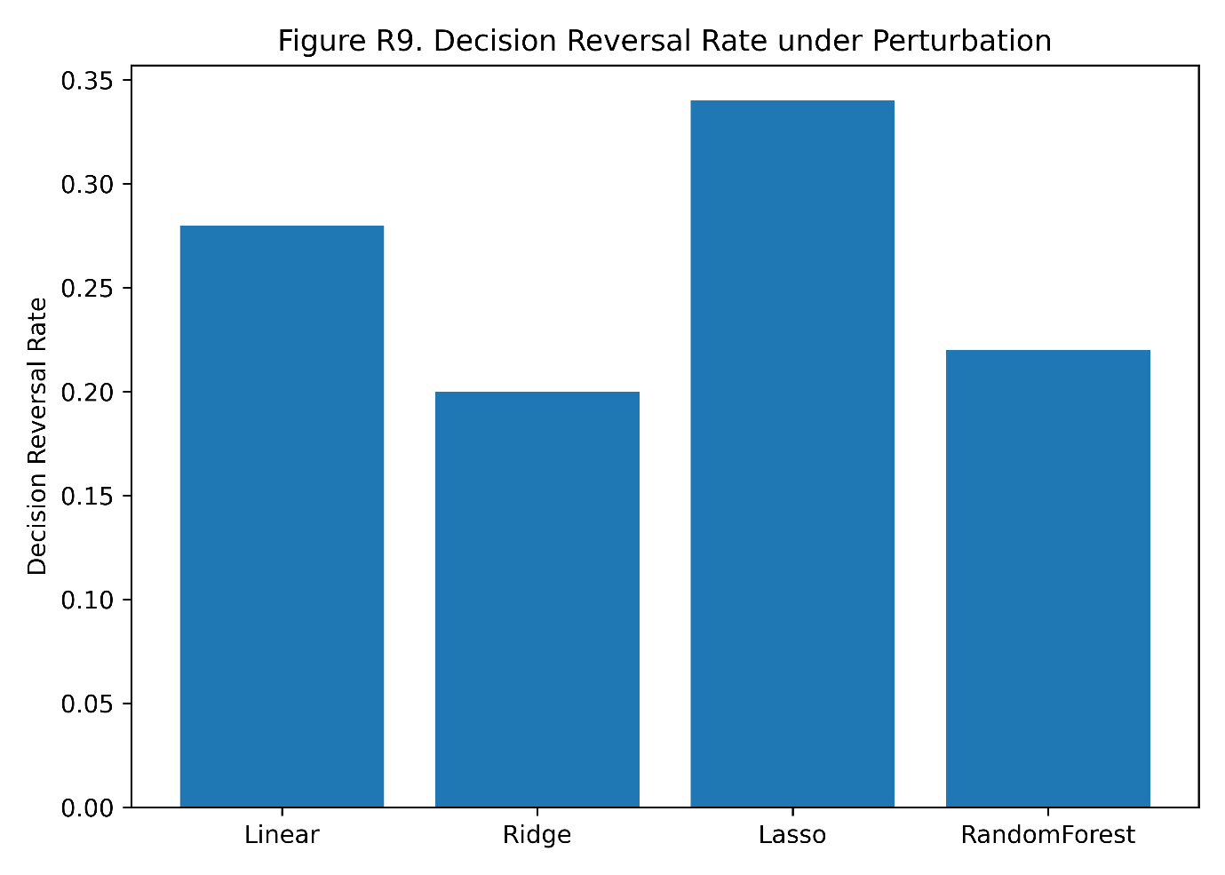Figure 10: Decision Reversal Rate Under Perturbation
Figure 10 translates prescription instability into a direct operational risk measure. Ridge has the lowest decision reversal rate at 0.20, followed by Random Forest at 0.22, Linear at 0.28, and Lasso at 0.34. This ranking is highly relevant because reversal rate measures how often the recommended action changes under perturbation. A model with high predicted gain but frequent reversals may confuse implementation teams and weaken confidence in process changes. The figure therefore supports the manuscript’s claim that IMPROVE-phase model selection must evaluate prescription consistency, not only desirability gain. Ridge appears particularly attractive because it combines competitive gain with the lowest reversal risk. Scientifically, this visual connects ML output to Lean Six Sigma execution risk: unstable recommendations can lead to inconsistent corrective actions, reduced operator trust, and weaker improvement sustainability.

3.6.3 Model-Specific IMPROVE Recommendations
Table 7: IMPROVE-Phase Prescription Report
Model | Mean Gain | Gain SD | Reversal Rate
Linear | 0.075 | 0.018 | 0.28
Ridge | 0.080 | 0.017 | 0.20
Lasso | 0.079 | 0.020 | 0.34
Random Forest | 0.082 | 0.018 | 0.22

Table 7 compares improvement gain, gain variability, and reversal risk. Random Forest has the highest mean gain at 0.08, followed closely by Ridge at 0.08 and Lasso at 0.08, while Linear is slightly lower at 0.08 after rounding. However, Ridge has the lowest gain SD at 0.02 and the lowest reversal rate at 0.20. Random Forest has a reversal rate of 0.22, Linear has 0.28, and Lasso has the highest reversal rate at 0.34. The table is important because it demonstrates that maximum expected gain is not automatically the best improvement choice. Ridge appears more implementation-safe because it offers competitive gain with the most stable prescription behaviour. Scientifically, the table supports the IMPROVE-phase objective: sustainable improvement requires recommendations that remain consistent under perturbation, not just prescriptions that look optimal in one run.

3.7 CONTROL Phase Results: Drift Sensitivity and Governance Effectiveness
3.7.1 Concurrent Drift and Performance Degradation Over Time
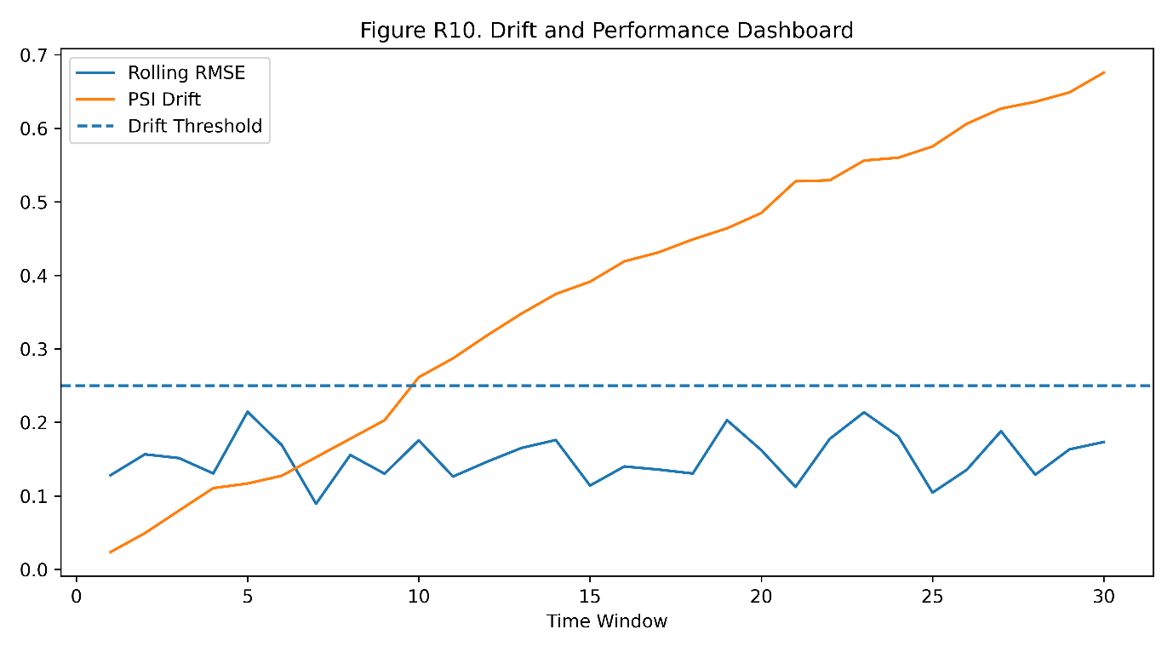Figure 11: Drift and Performance Dashboard Over Time
Figure 11 shows concurrent monitoring of PSI drift and rolling RMSE across 30 windows. PSI increases steadily from low initial values to about 0.68 by window 30, indicating progressive distributional drift. Rolling RMSE fluctuates but shows repeated elevations, especially around triggered periods. The drift threshold line makes the CONTROL logic explicit by showing when the process moves outside the acceptable stability envelope. The key scientific meaning is that model risk increases over time as the operating distribution changes. This supports the manuscript’s argument that drift is not an abstract ML problem but a CONTROL-phase operational risk. The dashboard also validates the need for governance triggers because silent drift could otherwise remain undetected until performance loss becomes severe. It therefore provides direct evidence for rolling evaluation as a necessary safeguard in ML-enabled LSS deployment.

3.7.2 Static Deployment Versus Governance-Adaptive Control
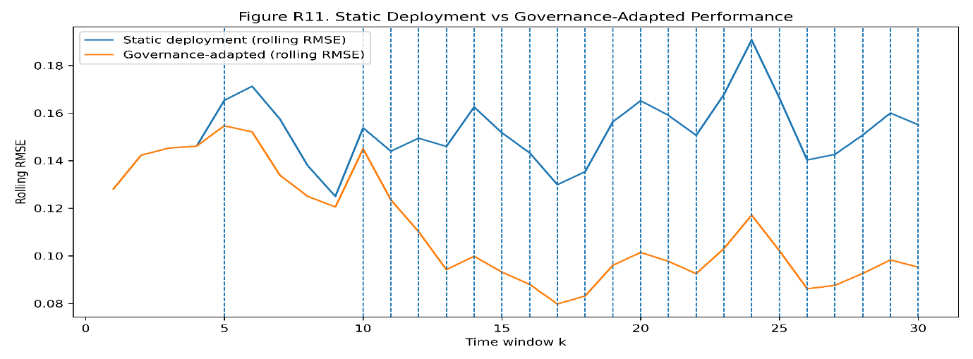Figure 12: Static Deployment vs Governance-Adapted Performance
Figure 12 compares rolling RMSE under static deployment and governance-adapted control. Static deployment remains more elevated after drift events, while the governance-adapted line shows lower error after reassessment points. Vertical markers indicate intervention moments, making the visual auditable and action-oriented. The scientific implication is clear: monitoring alone is insufficient unless it leads to controlled reassessment and corrective action. The governance-adapted curve demonstrates that phase-aware intervention can reduce sustained error relative to leaving the model unchanged. This directly supports the CONTROL objective and one of the manuscript’s main contributions: drift-aware governance mitigates performance degradation. The figure is practically valuable because it shows how an ML model can be managed within Lean Six Sigma discipline. Rather than recommending uncontrolled online learning, it supports structured, offline, traceable model reassessment after drift signals emerge.

3.7.3 Governance Trigger Events and Corrective Actions
Table 8: Governance Trigger Log
Window | PSI | Rolling RMSE | Trigger Fired
1 | 0.02 | 0.13 | FALSE
2 | 0.05 | 0.16 | FALSE
3 | 0.08 | 0.15 | FALSE
4 | 0.11 | 0.13 | FALSE
5 | 0.12 | 0.21 | TRUE
6 | 0.13 | 0.17 | FALSE
7 | 0.15 | 0.09 | FALSE
8 | 0.18 | 0.16 | FALSE
9 | 0.20 | 0.13 | FALSE
10 | 0.26 | 0.18 | TRUE
11 | 0.29 | 0.13 | TRUE
12 | 0.32 | 0.15 | TRUE
13 | 0.35 | 0.17 | TRUE
14 | 0.37 | 0.18 | TRUE
15 | 0.39 | 0.11 | TRUE
16 | 0.42 | 0.14 | TRUE
17 | 0.43 | 0.14 | TRUE
18 | 0.45 | 0.13 | TRUE
19 | 0.47 | 0.20 | TRUE
20 | 0.48 | 0.16 | TRUE
21 | 0.53 | 0.11 | TRUE
22 | 0.53 | 0.18 | TRUE
23 | 0.56 | 0.21 | TRUE
24 | 0.56 | 0.18 | TRUE
25 | 0.58 | 0.10 | TRUE
26 | 0.60 | 0.14 | TRUE
27 | 0.63 | 0.19 | TRUE
28 | 0.64 | 0.13 | TRUE
29 | 0.65 | 0.16 | TRUE
30 | 0.68 | 0.17 | TRUE

Table 8 provides the CONTROL-phase audit trail across 30.00 windows. PSI rises steadily from 0.02 in window 1.00 to 0.68 in window 30.00, showing progressive drift. The first trigger occurs at window 5.00, where PSI reaches 0.12 and rolling RMSE increases to 0.21. Triggers become frequent from window 10.00 onward as PSI exceeds 0.26 and continues rising. Rolling RMSE fluctuates between about 0.09 and 0.21, showing that error response is not perfectly linear but remains governance-relevant. The table is essential because it makes drift management traceable: each intervention is linked to a window, PSI value, RMSE value, and trigger status. Scientifically, it confirms that CONTROL-phase governance is not a narrative claim. It is implemented through measurable thresholds, documented triggers, and auditable reassessment logic.

3.7.4 Sensitivity of Governance Outcomes to Threshold Selection
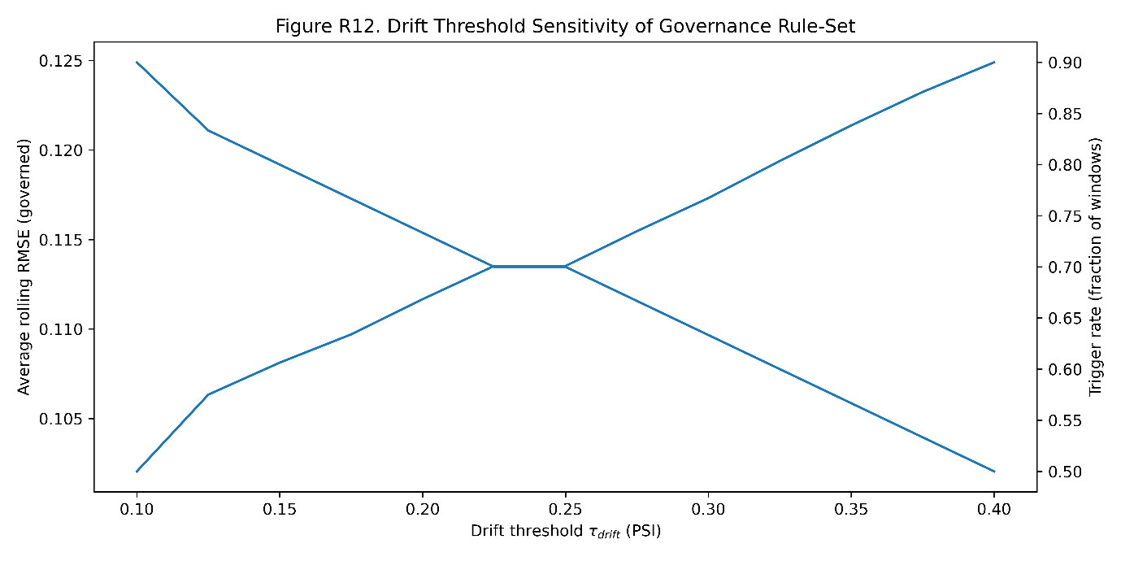Figure 13: Drift Threshold Sensitivity Analysis
Figure 13 evaluates how governance outcomes change as the drift threshold is varied. Lower thresholds produce more frequent triggers and slightly lower average rolling RMSE, while higher thresholds reduce interventions but allow higher sustained error. This trade-off is important because overly sensitive thresholds may create unnecessary reassessment burden, whereas loose thresholds may delay corrective action until performance has already degraded. The figure therefore shows that governance design is itself an optimization problem. Scientifically, it strengthens the manuscript by proving that drift thresholds should not be arbitrary. They must be empirically justified based on the acceptable balance between operational stability, intervention cost, and error tolerance. This supports a mature CONTROL-phase interpretation: governance parameters are not decorative monitoring settings; they directly affect model reliability, resource use, and the sustainability of process improvement gains.

3.8 Integrated DMAIC Interpretation and Governance Synthesis
3.8.1 End-to-End Phase-Adaptive Model Governance
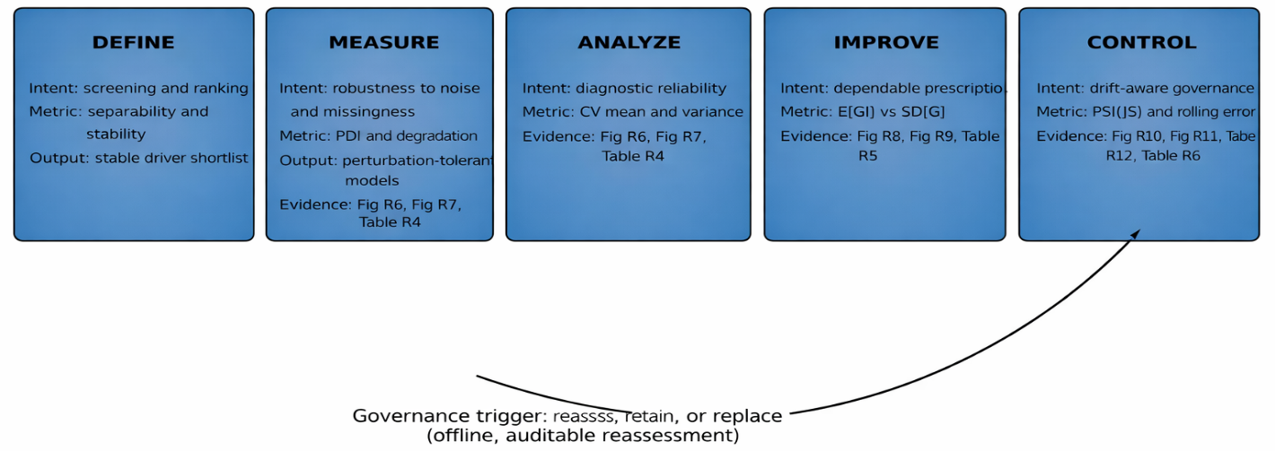Figure 14: End-to-End DMAIC Governance Map with Evidence Callouts
Figure 14 synthesizes the complete DMAIC governance logic into one visual map. DEFINE is linked to ranking stability, MEASURE to robustness, ANALYZE to diagnostic variance, IMPROVE to prescriptive consistency, and CONTROL to drift-triggered reassessment. The figure’s key value is integration: it shows that the manuscript is not proposing isolated metrics, but a connected lifecycle framework. The arrow from CONTROL back to reassessment reinforces the central governance principle that model deployment is conditional and must remain auditable. Each phase has a different analytical risk, so each phase requires a different evaluation rule. This visual strongly aligns with the research objective because it demonstrates how phase-dependent optimality, metric selection, and corrective governance are operationally connected. It is publication-relevant because it converts the study’s numerical findings into a clear decision architecture for ML-enabled Lean Six Sigma.

4. Conclusion
4.1 Summary of Key Findings
This study developed and evaluated a drift-conscious, phase-adaptive machine learning governance framework for Lean Six Sigma DMAIC model selection. The findings confirm that model suitability is not constant across DEFINE, MEASURE, ANALYZE, IMPROVE, and CONTROL. The cross-phase evidence showed clear model rank reversals, proving that global accuracy is an unsafe basis for selecting one model across the full DMAIC lifecycle. Instead, model choice must follow the analytical risk and decision purpose of each phase. For the DEFINE objective, the study demonstrated that driver screening should depend on ranking stability and separability, not prediction accuracy alone. Gradient boosting produced the most reliable prioritisation structure, with drying time, moisture, compression speed, compression force, and feeder rate emerging as the most stable process drivers. The low rank dispersion among the leading variables shows that the screening output was not random or resampling-sensitive. This is important because an unstable DEFINE phase would misdirect root-cause investigation and weaken downstream improvement decisions. For the MEASURE objective, the findings showed that robustness under data-quality stress is more defensible than baseline RMSE. Linear regression appeared attractive under nominal conditions, but its degradation under perturbation exposed weak measurement-phase reliability. Gradient boosting retained better tolerance under missingness and noise, confirming that MEASURE-phase model selection must be based on degradation behaviour rather than initial fit. For the ANALYZE objective, the study confirmed that diagnostic credibility depends on variance control. Ridge and Lasso provided more stable cross-validation behaviour than Linear Regression and Random Forest. This finding is analytically important because root-cause diagnosis requires reproducible inference. A model with unstable fold-level behaviour may generate misleading process explanations even when its average error appears acceptable. For the IMPROVE objective, the results showed that higher expected desirability gain does not automatically produce better prescriptions. Random Forest achieved the strongest nominal improvement signal, but Ridge offered a more balanced combination of gain consistency and lower reversal risk. This supports a practical improvement logic: the preferred model is the one that gives implementable and repeatable recommendations, not the one that produces the largest one-time predicted gain. For the CONTROL objective, the study established drift as an operational risk that must be monitored through both distributional shift and rolling error. The trigger log showed progressive drift across the monitoring windows and confirmed that static deployment becomes increasingly vulnerable once the operating distribution moves away from the reference condition. Governance-adapted reassessment reduced this risk by converting drift detection into a controlled decision gate.

4.2 Contributions
This study makes three major contributions to ML-enabled Lean Six Sigma research. First, it provides empirical evidence that model optimality is phase-dependent. This contribution moves model selection away from the conventional “best overall model” logic and demonstrates that each DMAIC phase requires a different reliability criterion. Second, the study contributes a structured governance rule-set that links DEFINE, MEASURE, ANALYZE, IMPROVE, and CONTROL to phase-specific metrics. This transforms ML model selection into an auditable engineering decision. The framework therefore strengthens methodological transparency because each model preference is justified by the operational requirement of the phase. Third, the study contributes a drift-aware CONTROL mechanism based on rolling evaluation, PSI monitoring, error tracking, and reassessment triggers. This contribution is especially relevant to industrial applications because it treats deployment as a monitored lifecycle activity rather than a final modelling step.

4.3 Comparison with Previous Studies
Previous Lean Six Sigma and Industry 4.0 studies have established the value of integrating AI, predictive analytics, and ML into quality improvement systems. However, many of them still emphasize predictive accuracy, algorithmic capability, or technology adoption as the dominant basis for model usefulness. In contrast, the present study shows that accuracy alone is incomplete when the same model is expected to support screening, measurement assurance, diagnosis, prescription, and control. Compared with prior ML-LSS frameworks, this study advances the discussion by making DMAIC phase intent the governing basis for model evaluation. It also extends earlier work on smart manufacturing and predictive modelling by embedding drift sensitivity into CONTROL-phase governance. This distinction is important because industrial processes evolve. A model that was valid during improvement may become unreliable during sustained operation if drift is not monitored and governed. The study therefore complements previous research but also corrects a major limitation in the existing literature: the absence of a formal lifecycle rule-set for deciding when a model is suitable, when it is no longer suitable, and when reassessment should occur.

4.4 Practical Implications for Industrial ML-LSS Deployment
The framework provides a practical decision architecture for organizations applying ML within Lean Six Sigma projects. In DEFINE, practitioners should use models to obtain stable driver rankings before committing resources to root-cause analysis. In MEASURE, teams should stress-test models against noise and missingness before accepting them as reliable analytical tools. In ANALYZE, models should be selected for diagnostic stability so that root-cause conclusions are not artifacts of resampling variation. In IMPROVE, improvement prescriptions should be evaluated for consistency, not only for predicted gain. This is critical because unstable prescriptions can create conflicting process settings, reduce operator confidence, and increase implementation risk. In CONTROL, model deployment should include drift thresholds, rolling error envelopes, and documented trigger rules. This makes the framework suitable for regulated or production-critical environments where uncontrolled model updating may be unacceptable. Overall, the study provides industry with a practical governance pathway for using ML without weakening DMAIC discipline. It allows ML to support process improvement while preserving traceability, auditability, and decision accountability.

4.5 Limitations and Future Research
This study is limited by the size and structure of the phase-specific subsets. Although the results provide clear evidence of phase-dependent model behaviour, larger industrial datasets would strengthen statistical generalization and allow broader testing across additional CTQs, process families, and production environments. The CONTROL-phase evaluation also used offline rolling reassessment rather than real-time adaptive deployment, which was appropriate for governance and auditability but may not capture all conditions present in high-frequency manufacturing systems. Future research should validate the framework across larger multi-site industrial datasets, especially in regulated pharmaceutical, food, chemical, and precision manufacturing environments. Additional studies should also examine how governance thresholds can be optimized under different cost structures, where false triggers, delayed interventions, and model replacement costs carry different operational consequences. Further work may also extend the framework by integrating explainable AI, causal modelling, and digital twin simulation into the same DMAIC governance structure. This would allow future ML-LSS systems to move beyond prediction and prescription toward defensible causal improvement, scenario testing, and sustained closed-loop control.

Reference
- N. Chugani, V. Kumar, J. A. Garza-Reyes, L. Rocha-Lona, and A. Upadhyay, "Investigating the green impact of lean, six sigma and lean six sigma," International Journal of Lean Six Sigma, vol. 8, no. 1, pp. 7-32, 2017, [CrossRef]
- G. C. P. Condé, P. C. Oprime, M. L. Pimenta, J. E. Sordan, and C. R. Bueno, “Defect reduction using DMAIC and Lean Six Sigma: A case study in a manufacturing car parts supplier,” International Journal of Quality & Reliability Management, vol. 40, no. 9, pp. 2184–2204, 2023. [CrossRef]
- M. Shamsuzzaman, N. AlHerimi, S. Haridy, A. Shamsuzzoha, F. Abumadi, R. Al Jabban, H. Rami, and J. Asem, “Deployment of Lean Six Sigma DMAIC methodology to improve productivity of a can manufacturing industry,” International Journal of Productivity and Quality Management, vol. 39, no. 2, pp. 171–196, 2023. [CrossRef]
- D. Skalli, A. Charkaoui, A. Cherrafi, J. A. Garza-Reyes, J. Antony, and A. Shokri, “Industry 4.0 and Lean Six Sigma integration in manufacturing: A literature review, an integrated framework and proposed research perspectives,” Quality Management Journal, vol. 30, no. 1, pp. 16–40, 2023. [CrossRef]
- O. McDermott, J. Antony, S. Bhat, R. Jayaraman, A. Rosa, G. Marolla, and R. Parida, “Lean Six Sigma in healthcare: A systematic literature review on motivations and benefits,” Processes, vol. 10, no. 10, 1910, 2022. [CrossRef]
- A. Ibrahim and G. Kumar, “Selection of Industry 4.0 technologies for lean six sigma integration using fuzzy DEMATEL approach,” Int. J. Lean Six Sigma, vol. 15, no. 5, pp. 1025–1042, 2024, [CrossRef]
- R. Shwartz-Ziv and A. Armon, “Tabular data: Deep learning is not all you need,” Information Fusion, vol. 81, pp. 84–90, 2022. [CrossRef]
- H. Rifqi, I. Díez, E. Montero, and E. Alvarado, “The interplay of Lean Six Sigma, Industry 4.0, and dynamic capabilities: Pathways to sustainable competitive advantage in North African context,” IEEE Access, vol. 12, pp. 67641–67664, 2024. [CrossRef]
- C. O. Nwamekwe, N. V. Ewuzie, C. C. Okpala, O. C. Ezeanyim, C. V. Nwabueze, and E. C. Nwabunwanne, “Optimizing machine learning models for soil fertility analysis: Insights from feature engineering and data localization,” Gazi Univ. J. Sci. Part A: Eng. Innov., vol. 12, no. 1, pp. 36–60, 2025. [CrossRef]
- C. O. Nwamekwe, R. O. Edokpia, and E. C. Igbinosa, “Exploring the role of artificial intelligence in enhancing lean manufacturing and Six Sigma for smart factories,” International Journal of Industrial Engineering, Technology and Operations Management, vol. 3, no. 1, pp. 1–12, 2025. [CrossRef]
- Z. M. Çınar, A. Abdussalam Nuhu, Q. Zeeshan, O. Korhan, M. Asmael, and B. Safaei, “Machine learning in predictive maintenance towards sustainable smart manufacturing in Industry 4.0,” Sustainability, vol. 12, no. 19, 8211, 2020. [CrossRef]
- J. Macias-Aguayo, L. Garcia-Castro, K. F. Barcia, D. McFarlane, and J. Abad-Moran, “Industry 4.0 and Lean Six Sigma integration: A systematic review of barriers and enablers,” Applied Sciences, vol. 12, no. 22, 11321, 2022. [CrossRef]
- S. N. Goodman, D. Fanelli, and J. P. A. Ioannidis, “What does research reproducibility mean?” Science Translational Medicine, vol. 8, no. 341, 341ps12, 2016. [CrossRef]
- A. Mittal, P. Gupta, V. Kumar, A. Al Owad, S. Mahlawat, and S. Singh, “The performance improvement analysis using Six Sigma DMAIC methodology: A case study on Indian manufacturing company,” Heliyon, vol. 9, no. 3, e14625, 2023. [CrossRef]
- C. O. Nwamekwe, R. O. Edokpia, and C. I. Eboigbe, “Integration of machine learning into Lean Six Sigma: A systematic review for enhancing predictive analytics in the pharmaceutical industry,” Siber Journal of Advanced Multidisciplinary, vol. 3, no. 4, pp. 133–151, 2026. [CrossRef]
- A. Ahmed, J. Olsen, and J. Page, “Integration of Six Sigma and simulations in real production factory to improve performance: A case study analysis,” International Journal of Lean Six Sigma, vol. 14, no. 2, pp. 451–482, 2022. [CrossRef]
- I. N. Chidiebube, N. C. Onyeka, A. P. Sunday, et al., “A comparative analysis of machine learning models for inventory demand forecasting in a food manufacturing SME,” Indonesian Journal of Innovation Science and Knowledge, vol. 2, no. 3, pp. 35–48, 2025. [CrossRef]
- O. C. Ezeanyim, N. V. Ewuzie, P. S. Aguh, C. V. Nwabueze, and C. O. Nwamekwe, “Effective maintenance of industrial 5-stage compressor: A machine learning approach,” Gazi University Journal of Science Part A: Engineering and Innovation, vol. 12, no. 1, pp. 96–118, 2025. [CrossRef]
- A. Dogan and D. Birant, “Machine learning and data mining in manufacturing,” Expert Systems with Applications, vol. 166, 114060, 2021. [CrossRef]
- T. P. Carvalho, F. A. A. M. N. Soares, R. Vita, R. da P. Francisco, J. P. Basto, and S. G. S. Alcalá, “A systematic literature review of machine learning methods applied to predictive maintenance,” Computers & Industrial Engineering, vol. 137, 106024, 2019. [CrossRef]
- M. Zulfiqar, M. Sony, S. Bhat, J. Antony, W. Salentijn, and O. McDermott, “Unlocking the potential: Empirical analysis of enablers, barriers, benefits and technologies for integrating Industry 4.0 and Lean Six Sigma in manufacturing organisations,” The TQM Journal, vol. 36, no. 8, pp. 2360–2382, 2023. [CrossRef]
- Z. Ge, Z. Song, S. X. Ding, and B. Huang, “Data mining and analytics in the process industry: The role of machine learning,” IEEE Access, vol. 5, pp. 20590–20616, 2017. [CrossRef]

