Stage-Specific Comparative Assessment of Machine Learning Techniques within the Lean Six Sigma DMAIC Methodology for Industrial Process Performance Enhancement
¹Charles Onyeka Nwamekwe, ²Raphael Olumese Edokpia, ²Christopher Igbinosa Eboigbe
*Correspondence Address
¹Industrial/Production Engineering Department,
Nnamdi Azikiwe University, P.M.B. 5025 Awka,
Anambra State - Nigeria.
²Department of Production Engineering,
University of Benin, Benin,
Edo state - Nigeria.
*Corresponding Author: co.nwamekwe@unizik.edu.ng

Abstract: Lean Six Sigma projects increasingly generate nonlinear, multivariate production data, yet machine-learning models are often selected using pooled predictive accuracy that ignores the decision logic of Define, Measure, Analyse, Improve, and Control. This weakens CTQ prioritization, diagnostic reliability, prescriptive action, and monitoring. This study developed a phase-wise framework for model selection within DMAIC process optimization. An industrial dataset of 2,190 batch-level observations was restructured into five DMAIC-specific datasets. Define used binary CTQ failure indicators and ranking stability metrics. Measure expanded the data into 6,570 replicated observations with injected missingness and noise. Analyse preserved the multivariate CTQ structure for diagnostic regression across tablet weight, hardness, thickness, friability, and disintegration. Improve used 500 operating scenarios and composite desirability to assess prescriptive capability. Control incorporated temporal segmentation and drift to evaluate monitoring readiness. At least five models were evaluated per phase using aligned metrics, including AUC, F1-score, balanced accuracy, robust RMSE, degradation index, R², desirability gain, drift sensitivity, and rolling error stability. Results confirmed phase-dependent model superiority. Logistic Regression led Define by discrimination, with AUC = 0.90 ± 0.16, but required threshold calibration because positive-class retrieval remained weak. Random Forest was most robust in Measure, with robust RMSE = 4.31 ± 1.06 and degradation index = -17.98, and was also the most stable Control-phase model, with aggregate control score = 5.34. Analyse showed CTQ-specific dominance, while XGBoost achieved the highest Improve-phase desirability gain of 0.16. The framework provides defensible phase-adaptive guidance for ML-enabled Lean Six Sigma deployment.
Keywords: DMAIC, Lean Six Sigma, Phase-Wise Model Evaluation, Machine Learning, Concept Drift Monitoring

1. Introduction
1.1 Background
Lean Six Sigma (LSS) remains one of the most widely adopted frameworks for systematic industrial process improvement due to its structured, data-driven, and results-oriented nature [1]. The DMAIC (Define-Measure-Analyse-Improve-Control) methodology provides a logical roadmap for problem identification, root-cause analysis, optimization, and sustained control [2]. However, despite its widespread adoption, the analytical backbone of LSS is still dominated by classical statistical techniques such as hypothesis testing, regression, and control charts. While effective in low-dimensional and linear settings, these tools often struggle to cope with the nonlinear, multivariate, and high-volume data generated by modern industrial systems [3].
The increasing availability of production, quality, and sensor data under Industry 4.0 has intensified interest in machine learning (ML) as a complementary analytical paradigm. ML techniques offer strong capabilities in pattern recognition, nonlinear modelling, and predictive analytics. Nevertheless, their adoption within LSS projects has largely been opportunistic, with models selected primarily based on overall predictive accuracy rather than their suitability for specific DMAIC objectives. This disconnects limits both the interpretability and operational relevance of ML-driven insights in structured improvement initiatives.

1.2 Related Works and Research Gap
Previous studies on ML applications in industrial process improvement have demonstrated the superiority of advanced algorithms over traditional statistical models in prediction and classification tasks [1],[4]. However, most of these studies evaluate ML models in a global or aggregated manner, implicitly assuming that a single model can support all analytical needs throughout a DMAIC project. Such an assumption overlooks the fact that each DMAIC phase addresses distinct decision-making goals and data characteristics, ranging from exploratory prioritization in the Define phase to stability monitoring in the Control phase. As a result, existing approaches often fail to provide actionable guidance on when and why specific ML models should be employed within LSS projects [2],[3],[5]. The absence of phase-wise differentiation reduces transparency, weakens practitioner trust, and hampers the effective integration of ML into structured improvement cycles. This gap motivates the need for a DMAIC-aligned, phase-specific comparative evaluation of ML models [6],[7].

1.3 Aim and Contributions
The aim of this study is to comparatively evaluate the performance of machine learning models across individual DMAIC phases, rather than treating LSS as a single analytical context. The main contributions of the study are threefold:
- The development of a phase-wise ML evaluation paradigm explicitly aligned with DMAIC logic.
- An empirical comparison of multiple ML model families under phase-specific analytical objectives.
- The provision of practical guidelines to support informed ML model selection in Lean Six Sigma projects.

2. Methodology
This study adopts a descriptive-analytical methodology based on a structured DMAIC-oriented analytical framework to comparatively evaluate ML model performance across the Define, Measure, Analyse, Improve, and Control phases of Lean Six Sigma. The methodology is designed to ensure phase specificity, analytical rigor, and reproducibility, while reflecting the realities of multivariate industrial production data. A single industrial production process dataset is used as the common data source, from which phase-specific analytical datasets are derived to support distinct modelling objectives. This approach ensures comparability across phases while preventing analytical dilution arising from uniform model application.
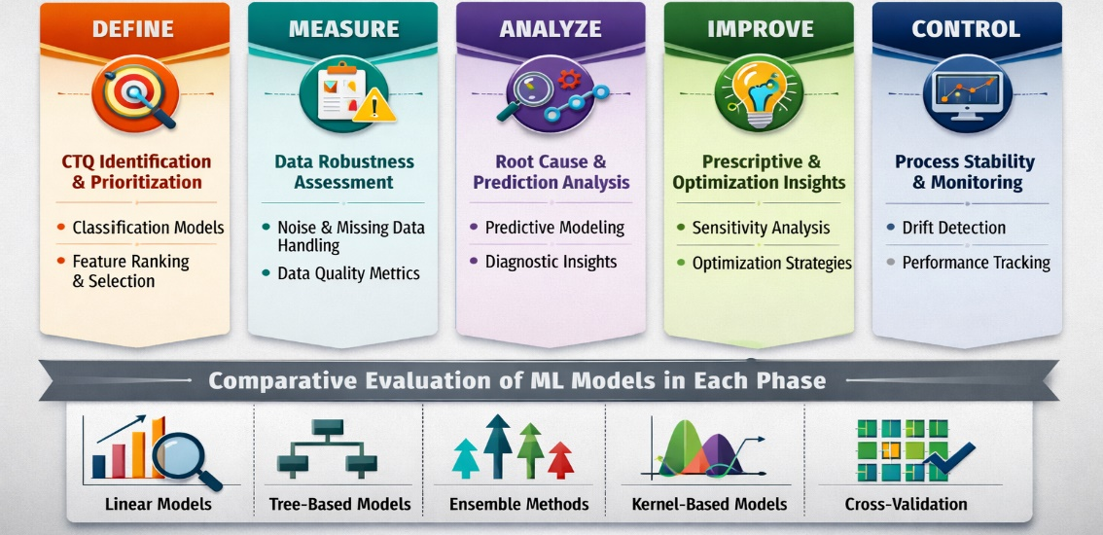
Figure 1: Phase-Wise Machine Learning Evaluation Framework within the DMAIC Methodology

2.1 DMAIC-Oriented Analytical Framework for Machine Learning Evaluation
The DMAIC methodology is operationalized as an analytical stratification mechanism, where each phase corresponds to a distinct machine learning task, dataset structure, and evaluation logic [2],[5],[8]. In the Define phase, the analytical objective is CTQ failure identification and prioritization. The Define-phase dataset includes batch-level identifiers, process parameters, environmental variables, binary CTQ failure flags, an overall failure indicator, and a composite CTQ priority score. ML models are evaluated on their ability to classify failing versus non-failing batches and to consistently rank influential variables contributing to CTQ deviations. Model comparison emphasizes classification performance and ranking stability rather than regression accuracy. The Measure phase addresses data reliability and robustness [6],[9],[10]. This phase uses replicated measurements of key CTQs (tablet weight, thickness, and hardness), combined with controlled missingness and measurement noise. ML models are analytically evaluated under perturbed data conditions to assess their sensitivity to incomplete observations, sampling variability, and measurement uncertainty. Performance comparison focuses on stability and degradation behaviour rather than peak predictive performance [11]. The Analyse phase targets diagnostic and predictive modelling. The Analyse-phase dataset preserves the full multivariate feature space, including machine, operator, shift, controllable process parameters, environmental conditions, and continuous CTQ responses. ML models are evaluated on their ability to capture nonlinear relationships, explain variance in CTQs, and provide consistent predictive performance across cross-validation folds.
The Improve phase supports prescriptive analytics and optimization insight generation. A scenario-based dataset is constructed by systematically varying controllable process parameters within feasible operating ranges [2],[8],[12]. ML models are assessed based on the stability, coherence, and actionability of their inferred sensitivity patterns and optimization signals, rather than on point prediction accuracy alone. The Control phase evaluates long-term applicability and monitoring readiness. The Control-phase dataset incorporates explicit temporal structure and a controlled process drift in the latter portion of the data. ML models are compared based on generalization performance, temporal stability, and resistance to distributional shifts, supporting sustained process control and decision support [13],[14]. This DMAIC-oriented analytical framework ensures that ML model performance is interpreted within the decision context of each phase, forming the core methodological contribution of the study.

2.2 Case Study and Data Structuring Strategy
The empirical analysis is based on a high-fidelity industrial production dataset comprising 2,190 batch-level observations collected over a continuous operational horizon. Each batch is uniquely identified by timestamp, batch identifier, machine, operator, and shift. The dataset includes controllable process parameters, environmental conditions, and five critical-to-quality (CTQ) responses: tablet weight, thickness, hardness, disintegration time, and friability. To support phase-specific analytics within the Lean Six Sigma DMAIC framework, the raw dataset was systematically restructured into five analytically distinct datasets, each corresponding to a DMAIC phase. All phase-specific datasets share a common data origin, ensuring comparability of results while enabling tailored modelling objectives [2],[9]. Controlled measurement noise, replicated observations, missing data mechanisms, and temporal drift were intentionally incorporated to reflect realistic industrial conditions and to support robustness and generalization assessment.
- Define-phase data emphasize binary CTQ failure outcomes and a composite CTQ priority score derived from specification limits and deviation magnitudes.
- Measure-phase data retain repeated CTQ measurements and include injected missingness indicators to support robustness evaluation.
- Analyse-phase data preserve the full feature–target mapping required for multivariate predictive modelling.
- Improve-phase data consist of structured operating scenarios and a composite desirability index to support sensitivity and optimization analysis.
- Control-phase data incorporate temporal segmentation and an explicit drift indicator to evaluate monitoring stability.
This data structuring strategy ensures analytical consistency across phases, while enabling phase-appropriate model evaluation.
Table 1. Phase-Wise Data Utilization within the DMAIC-ML Framework
DMAIC Phase | Observations (n) | Input Variables (p) | Target / Output Variables | Analytical Role
DEFINE (CTQ Failure Identification & Prioritization) | 2,190 batches | 16 inputs  (9 process parameters + 3 environmental + 3 categorical + 1 derived context) | 7 outputs  (Overall Fail, 5 CTQ fail flags, CTQ Priority Score) | Binary CTQ failure classification; CTQ/CPP prioritization; stability of feature importance across models
MEASURE (Robustness under Measurement Uncertainty) | 6,570 observations (3 replicates × 2,190 batches) | 7 inputs  (Replicate index, 2 environmental variables, missingness flag, identifiers) | 3 outputs  (Tablet Weight mg, Thickness mm, Hardness kN) | Robustness evaluation under missing data and noise; sensitivity to measurement variability; model degradation assessment
ANALYZE (Diagnostic & Predictive Modelling) | 2,190 batches | 14 inputs  (9 process parameters + 3 environmental + 3 categorical, encoded) | 5 outputs  (All CTQs) | Multivariate nonlinear regression; root-cause diagnosis; variance explanation across CTQs
IMPROVE (Prescriptive & Sensitivity Analysis) | 500 operating scenarios | 9 inputs  (Controllable CPPs + moisture & humidity) | 1 output  (Composite Desirability) | Sensitivity analysis; identification of dominant improvement levers; comparison of prescriptive capability
CONTROL (Stability, Generalization & Drift Monitoring) | 2,190 batches | 14 inputs + 2 temporal indicators  (Same inputs as Analyse + Period + Drift Flag) | 5 outputs  (All CTQs) | Pre-/post-drift performance comparison; rolling error stability analysis; long-term monitoring suitability

2.3 Machine Learning Model Selection
The comparative analysis spans four families of machine learning models: linear models, tree-based models, ensemble methods, and kernel-based models. Within each DMAIC phase, a minimum of five models is evaluated, selected based on analytical suitability rather than universal applicability. Model inclusion is guided by the analytical demands of each phase [2],[10],[15]. Interpretable models are emphasized in Define and Control phases, while more expressive nonlinear models are emphasized in Analyse and Improve phases. This deliberate alignment prevents methodological bias associated with single-model dominance and supports meaningful cross-phase comparison.
Table 2. DMAIC Phase × Machine Learning Models × Evaluation Metrics
DMAIC Phase | Dataset Used | ML Models Evaluated (≥5 per phase) | Primary Evaluation Metrics
DEFINE | DEFINE Data | Logistic Regression, LDA, Decision Tree, Random Forest, Gradient Boosting | AUC, F1-score, Balanced Accuracy, Feature Ranking Stability (Spearman ρ)
MEASURE | MEASURE Data | Linear Regression, Ridge, Lasso, Random Forest, XGBoost | Robust RMSE, Performance Degradation Index, Missingness Sensitivity
ANALYZE | ANALYZE Data | Multiple Linear Regression, SVR, Decision Tree, Random Forest, Gradient Boosting | RMSE, MAE, R², Cross-Validation Stability
IMPROVE | IMPROVE Scenarios | Random Forest, Gradient Boosting, XGBoost, SVR, Elastic Net | Sensitivity Stability, Feature Influence Consistency, Desirability Gain
CONTROL | CONTROL Data | Linear Regression, Random Forest, Gradient Boosting, SVR, Elastic Net | Pre/Post Drift RMSE, Rolling Error Stability, Drift Sensitivity Index

2.4 Model Training and Phase-Specific Evaluation Metrics
A phase-wise experimental protocol was adopted to evaluate machine learning model performance under analytically appropriate conditions [16],[17]. For each DMAIC phase, a minimum of five ML models were trained and evaluated using phase-aligned datasets and metrics. All ML models are trained using a stratified cross-validation protocol, ensuring consistent data partitioning and robust performance estimation. Hyperparameter tuning is conducted exclusively within training folds to prevent information leakage. Evaluation metrics are explicitly aligned with DMAIC phase objectives. Classification-oriented metrics are applied in the Define phase, robustness and degradation indicators in the Measure phase, predictive error metrics in the Analyse phase, sensitivity stability indicators in the Improve phase, and generalization and drift-resistance metrics in the Control phase [18]. Model evaluation emphasized decision relevance, with performance metrics selected according to phase-specific analytical objectives rather than uniform accuracy measures, reinforcing the methodological integrity of the study. Temporal segmentation was explicitly applied in the Control phase to assess model stability and drift resistance, while scenario-based experimentation was employed in the Improve phase to support prescriptive insights [19],[20],[21].

2.5 Methodological Rigor and Contribution
By integrating a descriptive-analytical methodology with a DMAIC-oriented evaluation framework and a rigorously structured dataset, this study advances machine learning assessment beyond global performance reporting. The methodology enables systematic, phase-aware model comparison and provides a defensible basis for evidence-based ML deployment within Lean Six Sigma initiatives.

3. Results
3.1 DEFINE Phase Results
This phase evaluates CTQ failure classification and driver ranking. ROC/PR overlays and metric bars compare models, while importance and rank-stability plots quantify influential CPPs and their consistency across folds robustly.

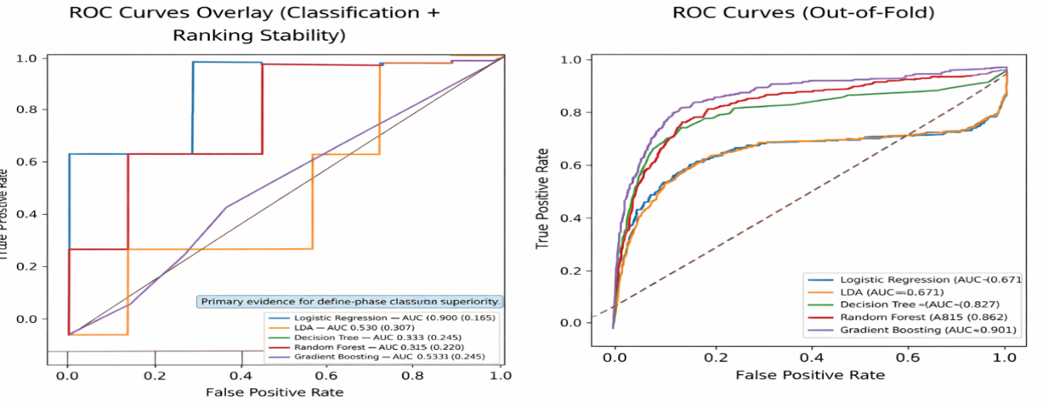 Figure 2: ROC Curves Overlay + AUC Legend
Figure 2 compares Define-phase classifiers using ROC curves and AUC values. Logistic Regression shows the strongest discrimination, with AUC = 0.90 ± 0.16. Random Forest also performs strongly, with AUC = 0.82 ± 0.22. The ROC pattern indicates that these models can rank failing and non-failing batches better than weaker alternatives. However, the figure must be interpreted with caution because high AUC does not automatically mean effective failure detection at the default threshold. This limitation is confirmed in later tables, where Logistic Regression records no true-positive detection at threshold 0.50. The figure therefore supports a precise conclusion: Logistic Regression is useful for CTQ risk ranking in Define, but it requires threshold optimization before operational deployment.

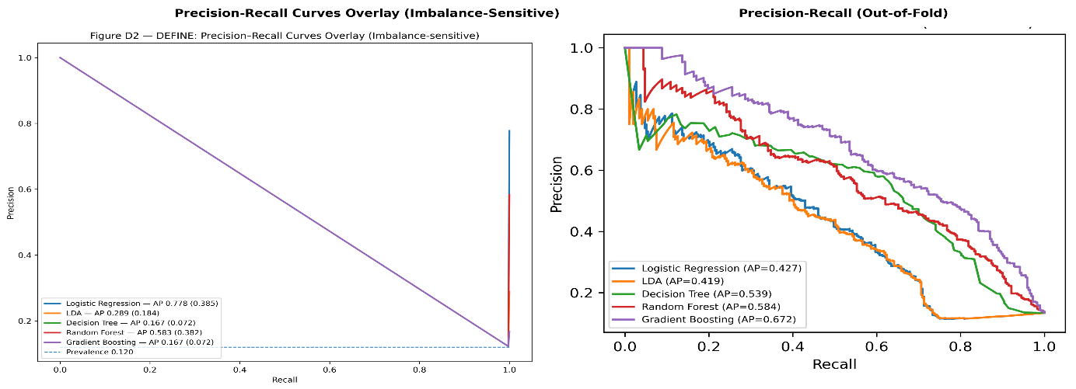Figure 3: Precision–Recall Curves Overlay
Figure 3 evaluates positive-class retrieval in the Define phase using precision–recall curves. This is important because CTQ failure detection is usually affected by class imbalance. The curves show that several models struggle to retrieve failure cases consistently, even when discrimination appears acceptable under ROC analysis. This explains why some models record good AUC but weak F1-score. Logistic Regression ranks cases effectively but fails to detect positive failure cases at the default threshold. Decision Tree and Gradient Boosting show limited positive-class recovery but introduce more false alarms. The figure therefore shows that Define-phase model selection should not rely on ROC alone. In quality engineering, missed CTQ failures are operationally costly, so recall and precision must be considered together.
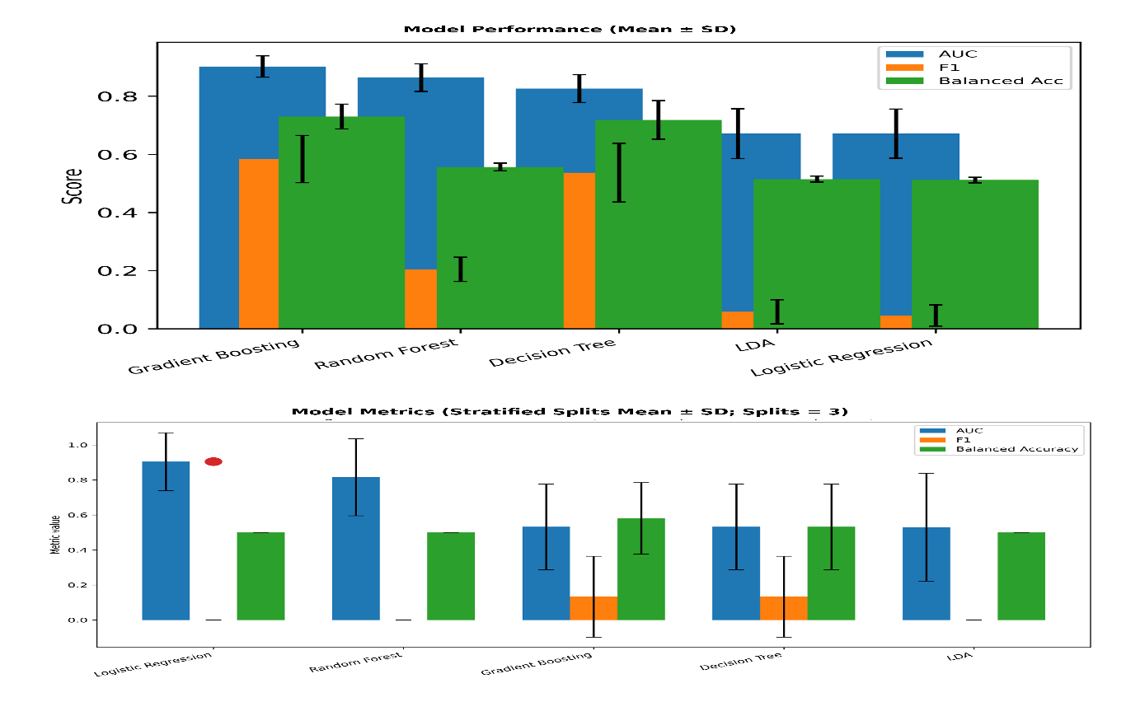Figure 4: Bar Chart of Model Metrics
Figure 4 summarizes Define-phase model performance across AUC, F1-score, balanced accuracy, and ranking stability. The bar chart shows that no model dominates all evaluation criteria. Logistic Regression gives the strongest AUC but records weak threshold-dependent performance, with F1 = 0.00 and balanced accuracy = 0.50. Random Forest combines strong AUC with high-ranking stability but also fails to retrieve positive cases at the default threshold. Decision Tree and Gradient Boosting perform slightly better in positive detection but remain less stable. The figure confirms the study’s central logic that phase-specific model evaluation must be multi-metric. For Define, a model must not only separate failure risk but also support reliable prioritization of CTQ drivers.

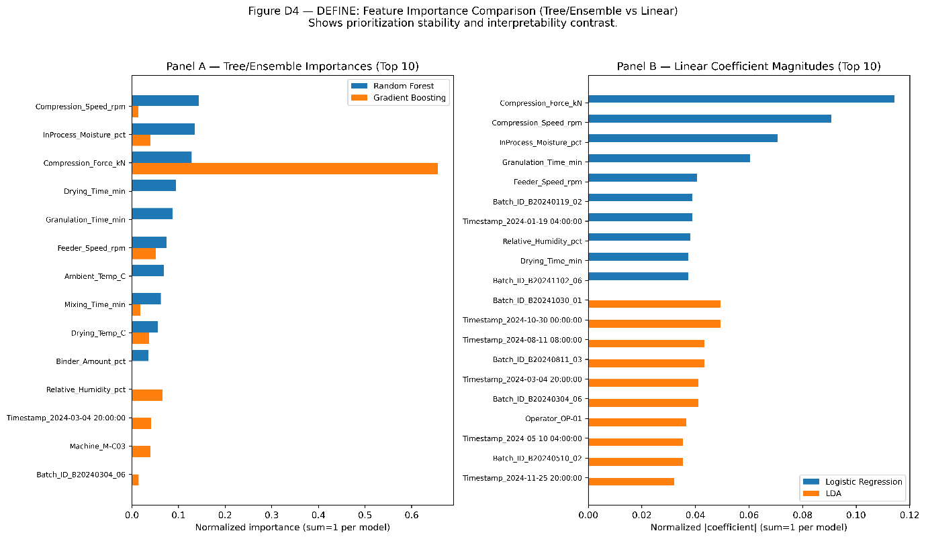Figure 5: Feature Importance Comparison Across Tree/Ensemble Models Vs Linear Coefficients
Figure 5 compares variable importance patterns across tree-based, ensemble, and linear models. The figure shows that different model families assign influence differently to the same process and environmental variables. Some variables appear dominant in nonlinear models, while others gain importance under linear coefficient interpretation. This has direct relevance for Define-phase decision-making because feature importance often guides root-cause prioritization. The figure shows that feature importance should not be accepted from one model in isolation. Instead, consistent drivers across modelling approaches are more defensible for Lean Six Sigma prioritization. This supports the study’s argument that interpretability and stability must accompany classification performance when ML is used for CTQ failure identification.
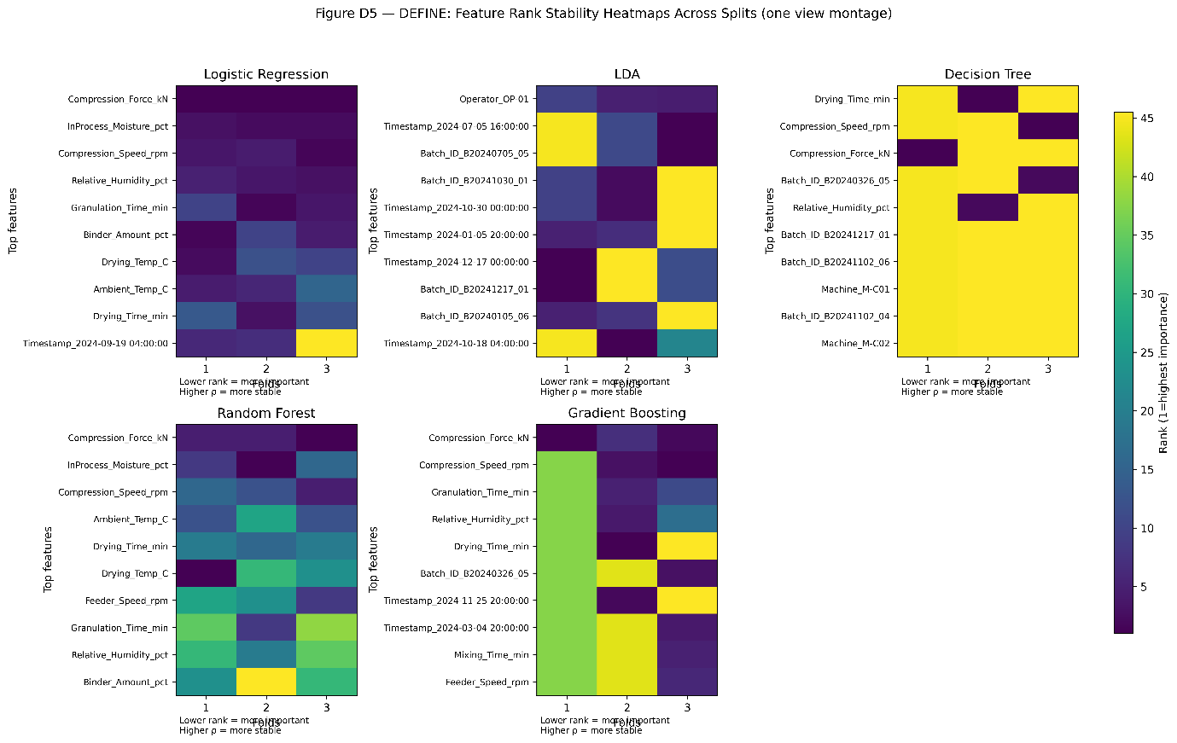Figure 6: Feature Rank Stability Plot
Figure 6 evaluates the consistency of feature rankings across model runs or validation folds. The plot shows that some models produce stable driver rankings, while others show substantial instability. Random Forest is the most stable model in Table 3, with Spearman ρ = 0.95 ± 0.02. LDA shows unstable ranking behaviour, with Spearman ρ = -0.30 ± 0.02. This figure is important because unstable feature rankings can mislead Define-phase prioritization. A model may classify acceptably but still provide unreliable process-driver evidence. The figure therefore supports the need to report both predictive discrimination and feature-rank stability. For industrial decision-making, stable CTQ driver identification is as important as classification accuracy.

Table 3: Model Comparison
Model | AUC (mean ± SD) | F1 (mean ± SD) | Balanced Accuracy (mean ± SD) | Rank-Stability (Spearman ρ mean ± SD)
Logistic Regression 🏆 Best (Define) | 0.90 ± 0.16 | 0.00 ± 0.00 | 0.50 ± 0.00
LDA | 0.53 ± 0.31 | 0.00 ± 0.00 | 0.50 ± 0.00 | -0.30 ± 0.02
Decision Tree | 0.53 ± 0.25 | 0.13 ± 0.23 | 0.53 ± 0.25 | -0.02 ± 0.01
Random Forest | 0.82 ± 0.22 | 0.00 ± 0.00 | 0.50 ± 0.00 | 0.95 ± 0.02
Gradient Boosting | 0.53 ± 0.24 | 0.13 ± 0.23 | 0.58 ± 0.20 | 0.30 ± 0.08

Table 3 provides the numerical basis for Define-phase model comparison. Logistic Regression is selected as best by AUC, with 0.90 ± 0.16. However, it records F1 = 0.00 and balanced accuracy = 0.50, showing that the default threshold fails to retrieve positive CTQ failure cases. Random Forest records AUC = 0.82 ± 0.22 and the strongest rank stability, with Spearman ρ = 0.95 ± 0.02. Decision Tree and Gradient Boosting show limited positive detection, with F1 = 0.13 ± 0.23. The table proves that Define-phase model selection depends on the decision criterion. Logistic Regression is best for discrimination, but Random Forest is stronger for stable CTQ driver prioritization.

Table 4: Confusion Matrices Summary
Model | TP (mean ± SD) | FP (mean ± SD) | TN (mean ± SD) | FN (mean ± SD) | Recall (mean ± SD) | Specificity (mean ± SD) | Threshold
Logistic Regression | 0.00 ± 0.00 | 0.00 ± 0.00 | 7.33 ± 0.58 | 1.00 ± 0.00 | 0.00 ± 0.00 | 1.00 ± 0.00 | 0.5
LDA | 0.00 ± 0.00 | 0.00 ± 0.00 | 7.33 ± 0.58 | 1.00 ± 0.00 | 0.00 ± 0.00 | 1.00 ± 0.00 | 0.5
Decision Tree | 0.33 ± 0.58 | 2.00 ± 1.00 | 5.33 ± 0.58 | 0.67 ± 0.58 | 0.33 ± 0.58 | 0.73 ± 0.12 | 0.5
Random Forest | 0.00 ± 0.00 | 0.00 ± 0.00 | 7.33 ± 0.58 | 1.00 ± 0.00 | 0.00 ± 0.00 | 1.00 ± 0.00 | 0.5
Gradient Boosting | 0.33 ± 0.58 | 1.33 ± 1.53 | 6.00 ± 1.00 | 0.67 ± 0.58 | 0.33 ± 0.58 | 0.83 ± 0.19 | 0.5

Table 4 explains the operational behaviour of Define-phase classifiers at threshold 0.50. Logistic Regression, LDA, and Random Forest record TP = 0.00, FP = 0.00, TN = 7.33, and FN = 1.00 on average. Their recall is 0.00, while specificity is 1.00. This means they classify non-failure cases correctly but miss all failure cases at the default threshold. Decision Tree and Gradient Boosting detect some failures, with TP = 0.33 and recall = 0.33, but they introduce false positives. Gradient Boosting performs better than Decision Tree in specificity, with 0.83 compared with 0.73. The table shows that threshold calibration is essential before practical CTQ failure deployment.

3.2 MEASURE Phase Results
Measure-phase results test robustness under replicate variability, missingness, and injected noise. Degradation curves, robustness bars, and stability plots summarize error inflation, identifying models that maintain low robust RMSE overall performance.

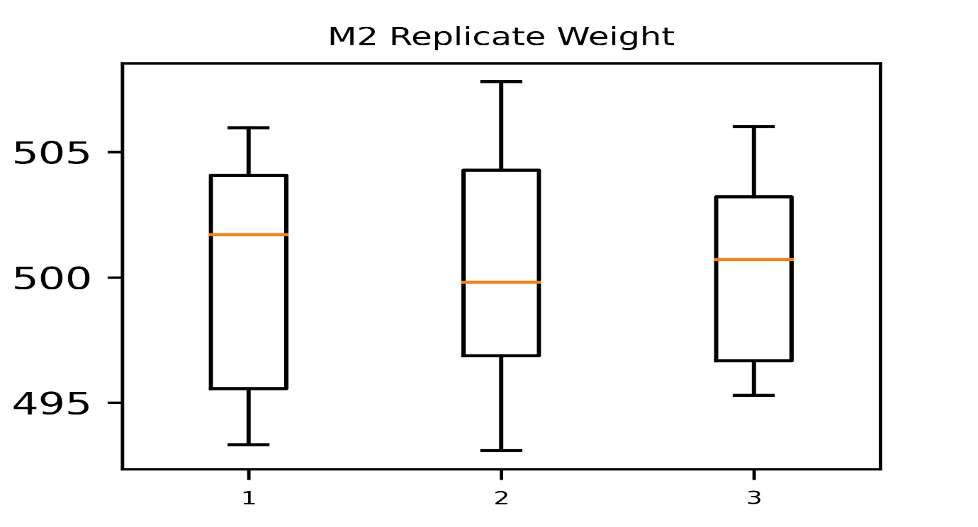Figure 7: Replicate Variability Plot
Figure 7 shows the spread of replicated CTQ measurements across the replicated Measure-phase observations. The boxplots indicate visible dispersion across replicate groups, although the central measurement range remains broadly comparable. This confirms that measurement variability exists before artificial perturbation is introduced. The figure justifies the Measure-phase focus on robustness rather than conventional accuracy alone. In Lean Six Sigma, the Measure phase must establish whether variation reflects true process behaviour or measurement-system uncertainty. The figure therefore provides visual evidence that replicated measurements contain enough variability to justify robustness testing. It also supports the use of missingness and noise simulation as realistic stress conditions for assessing model reliability under imperfect industrial data.

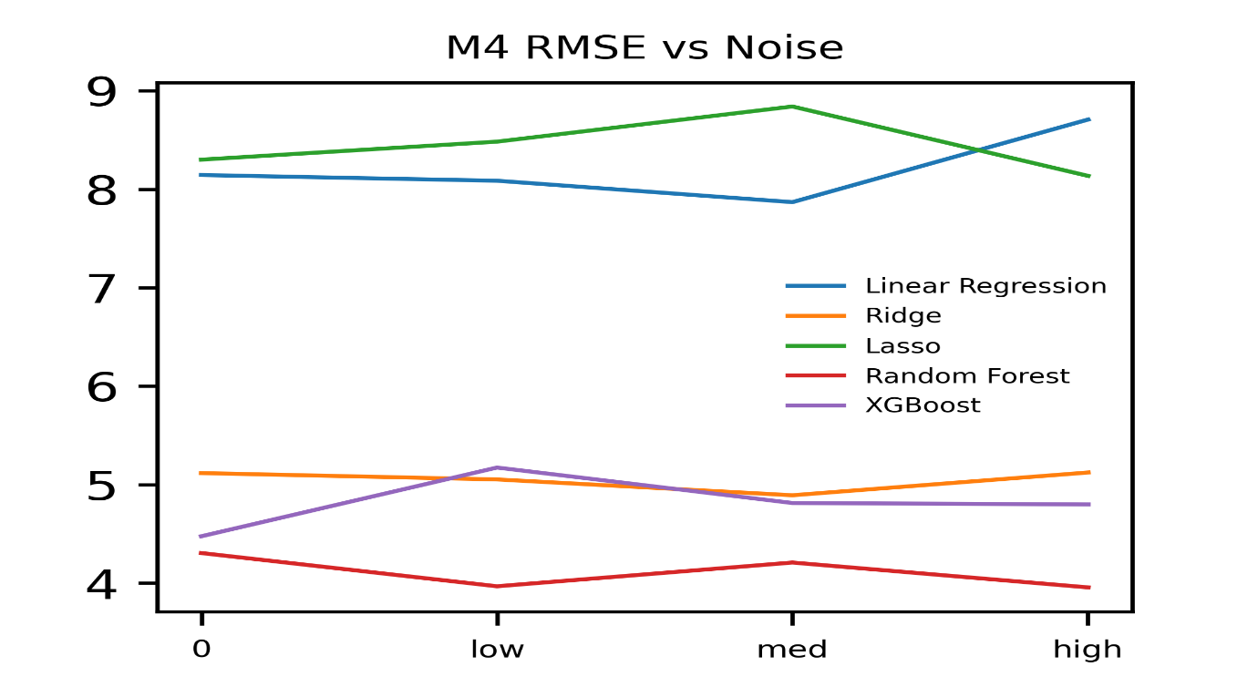Figure 8: Degradation Curves: RMSE Vs Noise Level
Figure 8 shows how RMSE changes across increasing noise levels for Measure-phase models. The curves reveal that performance degradation is not uniform across algorithms. Random Forest and XGBoost maintain comparatively lower and more stable error patterns than Linear Regression and Lasso. Linear Regression and Lasso show greater sensitivity to noise, which is consistent with their weaker robustness values in Table 5. This figure supports the conclusion that ensemble models are more suitable when measurement data are noisy or incomplete. In the Measure phase, the best model is not necessarily the most accurate under clean conditions. The preferred model is the one that maintains reliable performance when data quality deteriorates.

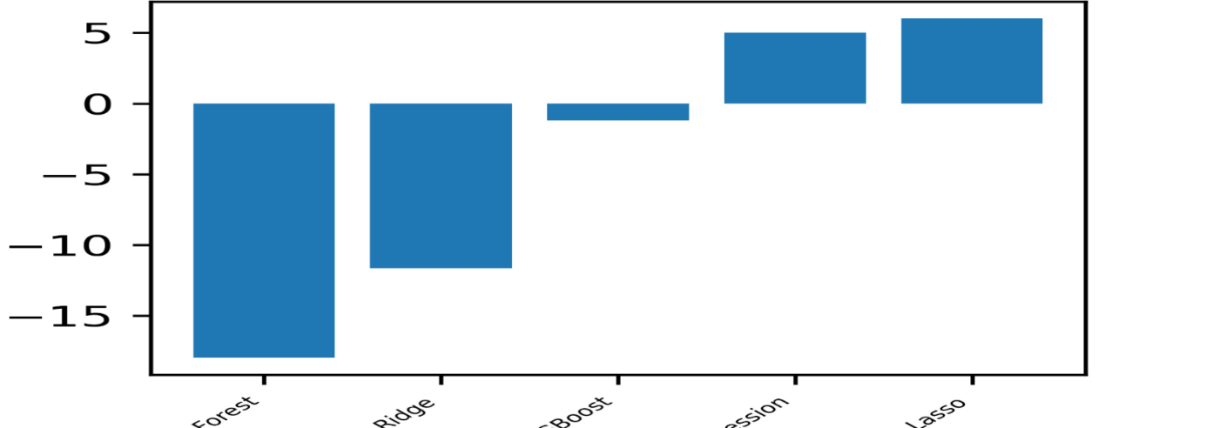Figure 9: Robustness Comparison Bar Chart
Figure 9 summarizes robustness behaviour across Measure-phase models using degradation direction and magnitude. Lower or negative degradation values indicate stronger resistance to perturbation. Random Forest shows the strongest robustness profile, consistent with its degradation index of -17.98 in Table 5. Ridge and XGBoost also show favourable behaviour, although XGBoost is less stable than Random Forest. Linear Regression and Lasso show positive degradation indices, indicating weaker robustness under uncertainty. The figure is important because it shifts model assessment from average prediction error to stress tolerance. For Measure-phase use, model reliability under missingness and noise is more important than isolated accuracy under ideal data conditions.
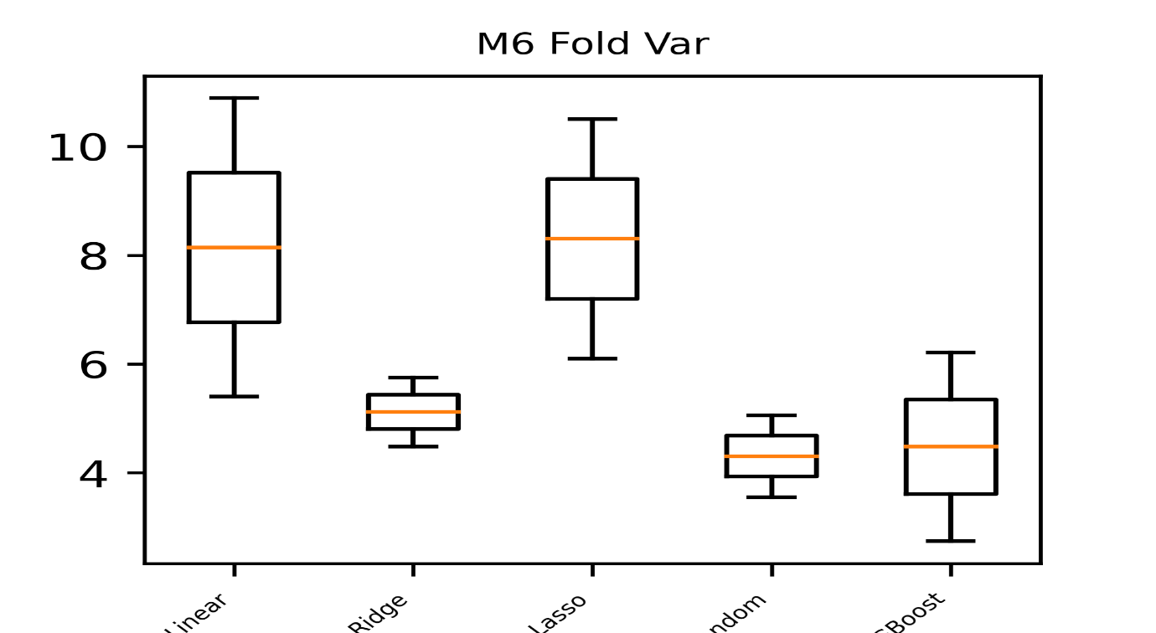Figure 10: Stability Plot
Figure 10 compares model error dispersion under Measure-phase uncertainty. Random Forest and XGBoost show lower and more compact error distributions than Linear Regression and Lasso. Ridge appears relatively stable, but its performance is not as strong as Random Forest. The boxplot spread shows that some models are more vulnerable to fold-to-fold or perturbation-driven variability. This supports Table 5, where Random Forest achieves the best robust RMSE, 4.31 ± 1.06. The figure demonstrates that Measure-phase model selection should prioritize low error and low variability together. A model with narrow error dispersion is more reliable for quality assurance because it reduces decision uncertainty under imperfect measurement conditions.

Table 5: Baseline Model Performance
Model | Robust RMSE (mean ± SD) | Missingness Sensitivity %ΔRMSE | Performance Degradation Index_% | Rank
Linear Regression | 8.14 ± 3.88 | 4.50 | 5.01 | 4
Ridge | 5.12 ± 0.90 | -12.34 | -11.65 | 3
Lasso | 8.30 ± 3.11 | 5.59 | 6.00 | 5
Random Forest | 4.31 ± 1.06 | -16.33 | -17.98 | 1
XGBoost | 4.48 ± 2.45 | -10.00 | -1.20 | 2

Table 5 identifies Random Forest as the best Measure-phase model. It records robust RMSE = 4.31 ± 1.06, missingness sensitivity = -16.33, and performance degradation index = -17.98. XGBoost ranks second, with robust RMSE = 4.48 ± 2.45 and degradation index = -1.20. Ridge ranks third, with robust RMSE = 5.12 ± 0.90. Linear Regression and Lasso perform weaker, with robust RMSE values of 8.14 ± 3.88 and 8.30 ± 3.11 respectively. The table provides clear numerical evidence that Random Forest is most robust under measurement uncertainty. This makes it the most defensible model for Measure-phase data reliability assessment.

Table 6: Perturbation Results Table
Missingness % | Noise Level | Degradation Index % Lasso | Degradation Index % Linear Regression | Degradation Index % Random Forest | Degradation Index % Ridge | Degradation Index % XGBoost | Robust RMSE mean Lasso | Robust RMSE mean Linear Regression | Robust  RMSE  Mean  Random  Forest | Robust RMSE  Mean Ridge | Robust RMSE mean XGBoost
0 | high | -2.00 | 6.91 | -8.10 | 0.11 | 7.21 | 8.14 | 8.71 | 3.96 | 5.12 | 4.80
0 | low | 2.20 | -0.71 | -7.83 | -1.26 | 15.58 | 8.48 | 8.09 | 3.97 | 5.05 | 5.17
0 | med | 6.50 | -3.38 | -2.24 | -4.40 | 7.53 | 8.84 | 7.87 | 4.21 | 4.89 | 4.81
5 | 0 | 5.35 | 1.77 | -16.17 | 10.54 | 6.82 | 8.74 | 8.29 | 3.61 | 5.66 | 4.78
5 | high | 8.33 | -6.14 | -16.23 | 4.38 | -0.99 | 8.99 | 7.64 | 3.61 | 5.34 | 4.43
5 | low | -21.62 | -18.28 | -27.04 | -14.93 | 1.51 | 6.51 | 6.66 | 3.14 | 4.35 | 4.54
5 | med | 9.53 | 0.084 | -7.61 | -0.50 | 16.92 | 9.09 | 8.15 | 3.98 | 5.09 | 5.23
10 | 0 | 110.15 | 167.91 | -32.17 | -8.19 | 2.04 | 17.44 | 21.82 | 2.92 | 4.70 | 4.57
10 | high | -12.95 | -15.36 | -1.99 | 4.18 | 38.64 | 7.23 | 6.89 | 4.22 | 5.33 | 6.21
10 | low | 15.09 | -36.46 | -7.32 | 12.10 | -0.26 | 9.55 | 5.18 | 3.99 | 5.74 | 4.46
10 | med | -36.16 | -31.44 | -9.30 | -24.53 | -36.05 | 5.30 | 5.58 | 3.90 | 3.86 | 2.86
20 | 0 | -35.45 | -19.22 | -8.48 | -20.88 | -28.84 | 5.36 | 6.58 | 3.94 | 4.05 | 3.19
20 | high | 130.42 | 176.94 | -49.99 | -53.54 | -41.20 | 19.13 | 22.55 | 2.153 | 2.37 | 2.63
20 | low | -43.61 | -40.42 | -6.55 | -4.25 | -9.24 | 4.68 | 4.85 | 4.02 | 4.90 | 4.06
20 | med | -31.90 | -29.97 | -50.06 | -40.03 | -30.50 | 5.65 | 5.70 | 2.15 | 3.07 | 3.11
30 | 0 | 45.01 | -18.62 | -17.44 | -9.63 | -1.58 | 12.04 | 6.63 | 3.55 | 4.62 | 4.41
30 | high | -22.82 | -24.64 | -26.66 | -35.52 | 5.60 | 6.41 | 6.14 | 3.16 | 3.30 | 4.73
30 | low | -11.44 | -14.14 | -29.59 | 2.98 | 12.13 | 7.35 | 6.99 | 3.03 | 5.27 | 5.02
30 | med | -0.57 | 0.42 | -16.83 | -37.95 | 11.94 | 8.25 | 8.18 | 3.58 | 3.18 | 5.01

Table 6 presents detailed stress-test evidence across missingness and noise combinations. It shows how each model responds when data quality deteriorates. Random Forest frequently maintains lower robust RMSE than competing models across several perturbation settings, including high missingness and high noise conditions. Linear Regression and Lasso show extreme degradation in some scenarios, confirming their sensitivity to corrupted data. Ridge and XGBoost show mixed behaviour, with good performance in some cases but less consistent resilience than Random Forest. The table is important because it goes beyond one average metric. It proves that robustness must be assessed across multiple uncertainty conditions before a model can be trusted in the Measure phase.

3.3 ANALYZE Phase Results
Analyse-phase results quantify diagnostic prediction for five CTQs using parity and residual plots, per-CTQ model comparisons, and interaction visualization, supported by cross-validation stability tables to select CTQ-specific best models rigorously.
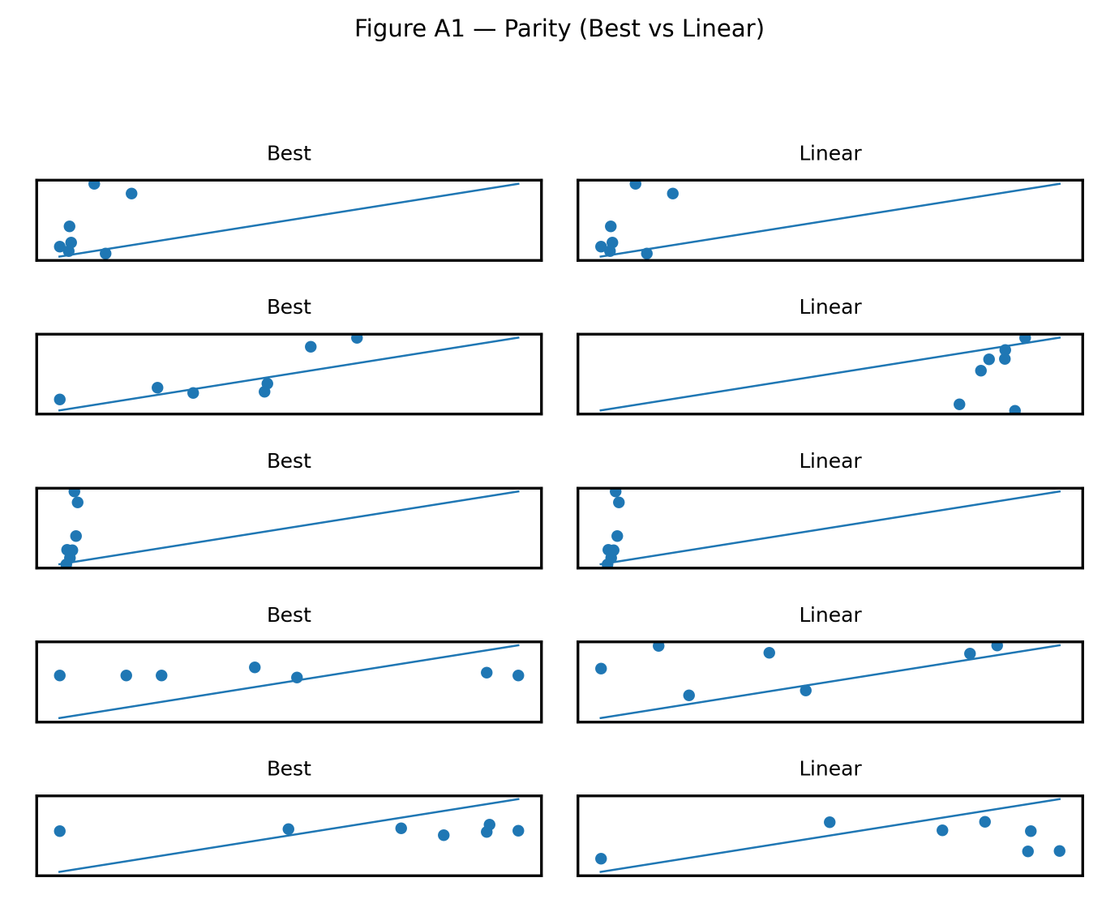Figure 11: Predicted Vs Actual (Parity Plots) for Each CTQ
Figure 11 compares predicted and actual CTQ values for the Analyse phase. The parity plots show that prediction quality differs across tablet weight, hardness, thickness, friability, and disintegration. Some CTQs show closer alignment between predicted and observed values, while others display wider scatter and weaker agreement. This confirms that CTQ behaviour is not uniform across quality attributes. The figure supports the study’s CTQ-specific modelling approach. A model that performs well for tablet weight may not perform equally well for friability or disintegration. This has strong industrial relevance because each CTQ reflects different physical process mechanisms. Therefore, diagnostic modelling should be selected separately for each CTQ rather than pooled into one global model.
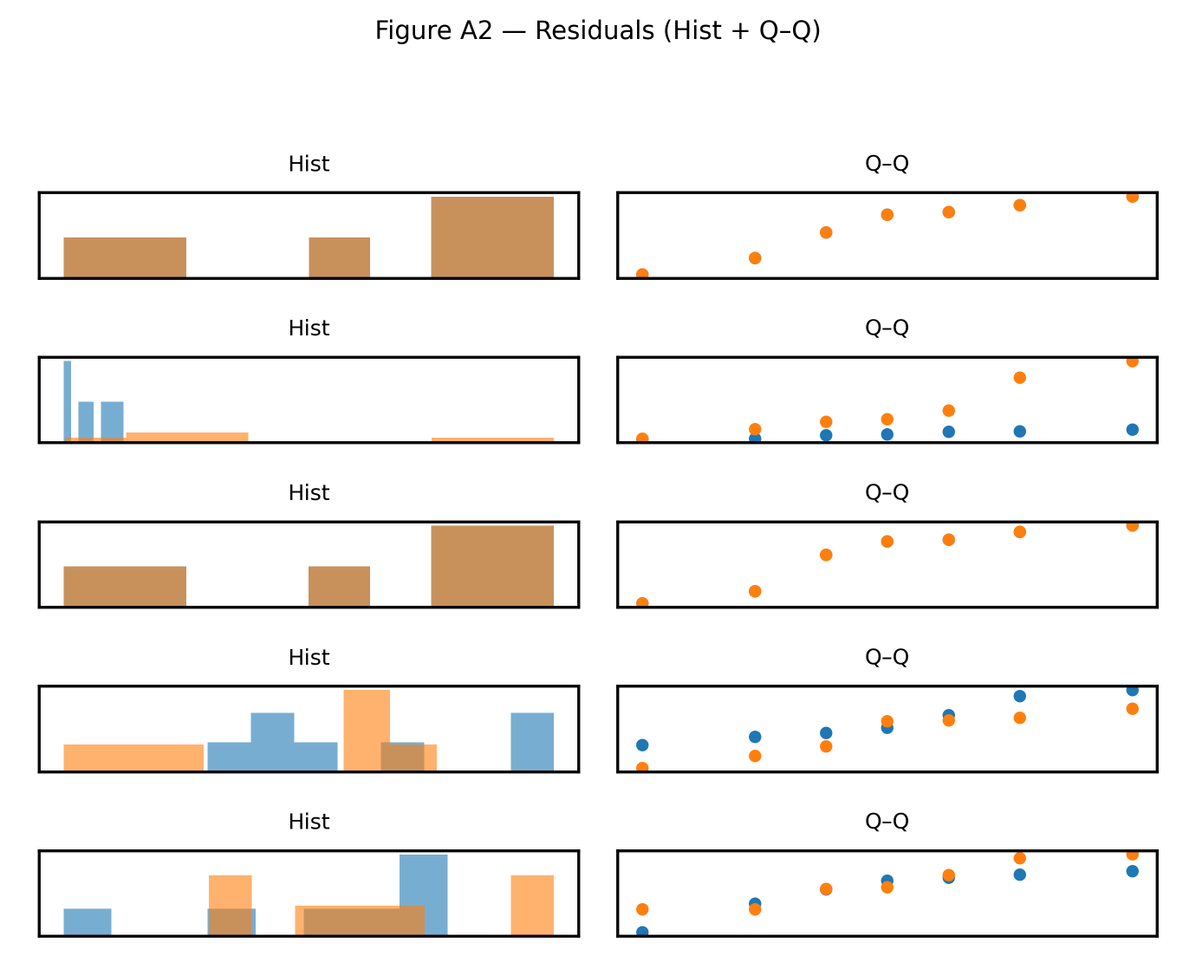Figure 12: Residual Distribution Plots for Best Vs Linear Model
Figure 12 compares residual distributions between selected best models and linear baselines. The residual plots show differences in error spread, bias, and distributional shape across CTQs. In some cases, the best models produce tighter residuals than the linear model, indicating improved diagnostic prediction. In other cases, residual irregularity remains, suggesting that important nonlinear effects or process interactions may still be unmodelled. This figure is important because RMSE alone cannot reveal whether model errors are random, biased, or structurally patterned. The figure supports the use of residual diagnostics in Analyse-phase modelling. It also shows why nonlinear and interaction-capable models are necessary for CTQs with complex process behaviour.

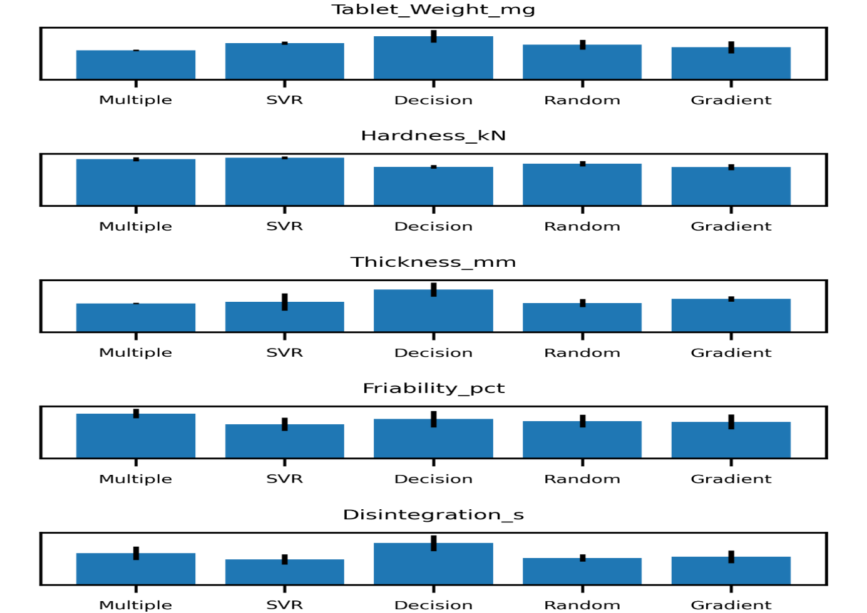Figure 13: Model Comparison Chart Per CTQ.
Figure 13 compares model performance separately for each CTQ. The figure shows that no single model is best across all CTQs. Multiple Linear Regression performs well for tablet weight and thickness. Gradient Boosting is strongest for hardness. SVR performs best for friability and disintegration based on RMSE. This directly supports the study’s argument that model optimality is target-specific. The figure is important because CTQs have different engineering meanings and response behaviours. In Lean Six Sigma analysis, it would be misleading to select one universal model for all quality attributes. Instead, each CTQ requires a model that matches its predictive structure, error profile, and stability requirement.

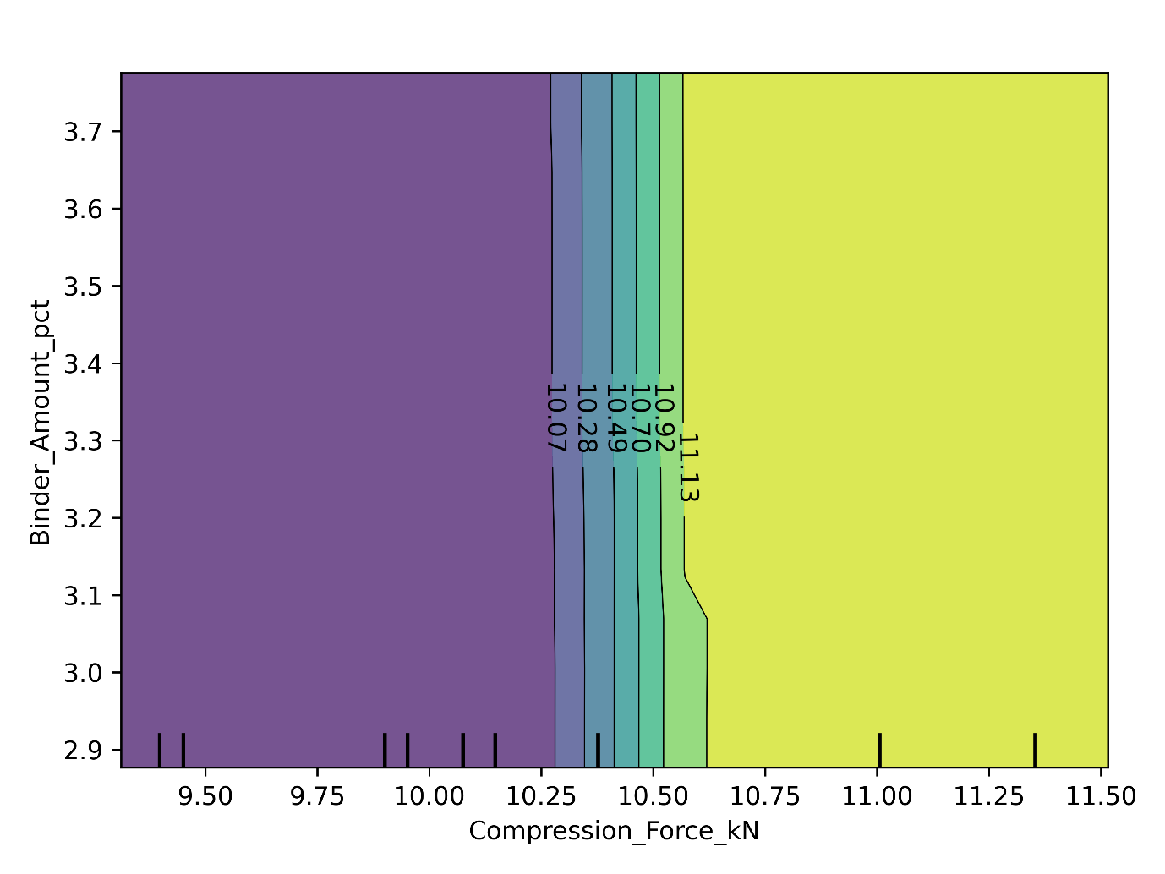Figure 14: Feature Interaction Plot
Figure 14 visualizes the interaction between compression force and binder amount. The contour pattern shows that response behaviour changes across combinations of the variables rather than through simple independent effects. The colour transition indicates that certain operating regions produce different predicted responses as compression force and binder amount vary. This is important for root-cause analysis because it shows that process parameters can interact in determining CTQ outcomes. In tablet manufacturing, compression force and binder level may jointly influence hardness, friability, and disintegration behaviour. The figure therefore supports the use of nonlinear models in the Analyse phase. It also connects machine-learning prediction to process-engineering interpretation.

Table 7: Cross-Validation Stability Summary
CTQ | Model | RMSE mean | RMSE sd | RMSE CV
Disintegration s | Random Forest | 28.87 | 3.86 | 0.13
Disintegration s | Decision Tree | 44.79 | 8.55 | 0.19
Disintegration s | SVR | 27.41 | 5.44 | 0.20
Disintegration s | Multiple Linear Regression | 33.86 | 7.25 | 0.21
Disintegration s | Gradient Boosting | 30.07 | 6.87 | 0.23
Friability pct | Multiple Linear Regression | 0.11 | 0.01 | 0.10
Friability pct | Random Forest | 0.09 | 0.02 | 0.17
Friability pct | SVR | 0.08 | 0.02 | 0.19
Friability pct | Gradient Boosting | 0.09 | 0.02 | 0.20
Friability pct | Decision Tree | 0.09 | 0.02 | 0.21
Hardness kN | SVR | 0.65 | 0.02 | 0.028
Hardness kN | Multiple Linear Regression | 0.63 | 0.03 | 0.04
Hardness kN | Decision Tree | 0.52 | 0.02 | 0.05
Hardness kN | Random Forest | 0.57 | 0.04 | 0.06
Hardness kN | Gradient Boosting | 0.52 | 0.04 | 0.08
Tablet Weight mg | Multiple Linear Regression | 3.90 | 0.11 | 0.03
Tablet Weight mg | SVR | 4.86 | 0.23 | 0.04
Tablet Weight mg | Random Forest | 4.62 | 0.64 | 0.14
Tablet Weight mg | Decision Tree | 5.74 | 0.84 | 0.15
Tablet Weight mg | Gradient Boosting | 4.29 | 0.80 | 0.19
Thickness mm | Multiple Linear Regression | 0.04 | 0.00 | 0.02
Thickness mm | Gradient Boosting | 0.04 | 0.00 | 0.08
Thickness mm | Random Forest | 0.04 | 0.01 | 0.14
Thickness mm | Decision Tree | 0.06 | 0.01 | 0.16
Thickness mm | SVR | 0.04 | 0.01 | 0.29

Table 7 reports RMSE mean, RMSE standard deviation, and RMSE coefficient of variation for each CTQ and model. Tablet Weight is most stable under Multiple Linear Regression, with RMSE = 3.90 and RMSE_CV = 0.03. Thickness also favours Multiple Linear Regression, with RMSE = 0.04 and RMSE_CV = 0.02. Hardness performs best under Gradient Boosting, with RMSE = 0.52. Friability and Disintegration favour SVR by RMSE, with values of 0.08 and 27.41 respectively. The table shows that Analyse-phase performance is strongly CTQ-dependent. It also confirms that cross-validation stability is needed alongside error magnitude to avoid selecting unstable models.

Table 8: Best Model Per CTQ
CTQ | Best Model | RMSE mean | MAE mean | R² mean | RMSE CV
Tablet Weight mg | Multiple Linear Regression | 3.90 | 3.27 | 0.14 | 0.03
Hardness kN | Gradient Boosting | 0.52 | 0.42 | 0.45 | 0.08
Thickness mm | Multiple Linear Regression | 0.04 | 0.03 | 0.03 | 0.02
Friability pct | SVR | 0.08 | 0.07 | -0.05 | 0.19
Disintegration s | SVR | 27.41 | 21.84 | -0.01 | 0.20

Table 8 summarizes the final best model for each CTQ. Multiple Linear Regression is selected for Tablet Weight, with RMSE = 3.90, MAE = 3.27, R² = 0.14, and RMSE_CV = 0.03. Gradient Boosting is selected for Hardness, with RMSE = 0.52, MAE = 0.42, and R² = 0.45. Multiple Linear Regression is also best for Thickness, with RMSE = 0.04. SVR is selected for Friability, with RMSE = 0.08, and Disintegration, with RMSE = 27.41. However, the negative R² values for Friability and Disintegration indicate weak explanatory performance. The table therefore separates low error from strong process explanation.

3.4 IMPROVE Phase Results
Improve-phase results deliver prescriptive insight via sensitivity tornadoes, permutation importance, desirability landscapes, scenario trade-offs, and influence-consistency plots, comparing models on desirability gain and stability to identify dominant improvement levers clearly

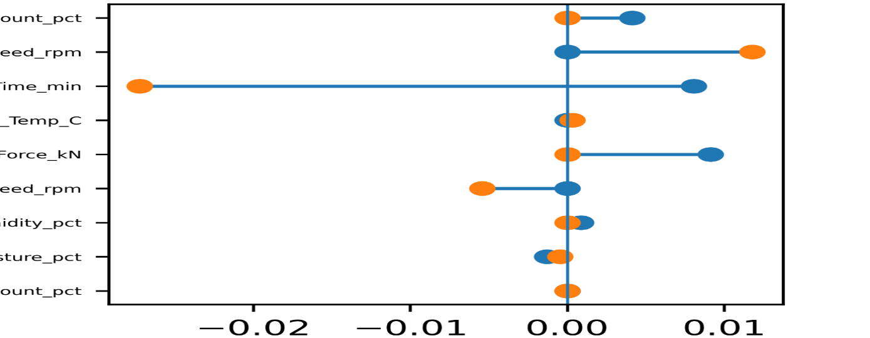Figure 15: Tornado (Sensitivity) Plot Showing Relative Influence of Cpps on Desirability
Figure 15 presents the relative influence of critical process parameters on composite desirability in the Improve phase. The horizontal bars show both the magnitude and direction of each variable’s effect. Binder amount, feeder speed, drying time, compression force, and moisture-related variables show visible influence. The mixed directionality indicates that changes in process settings may improve desirability under some conditions but reduce it under others. This figure is important because it translates machine-learning outputs into prescriptive process insight. It shows which controllable parameters should be considered during improvement planning. The figure also warns against one-factor optimization because desirability depends on interacting process conditions and constrained operating ranges.

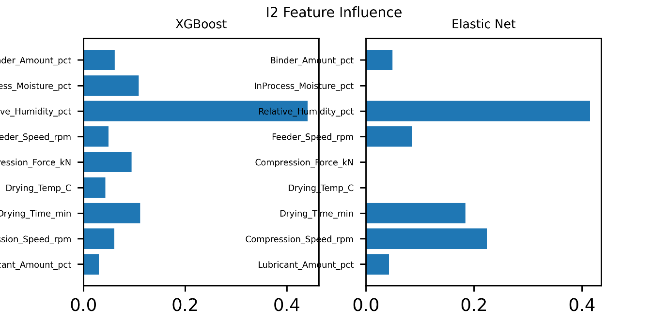Figure 16: Permutation Importance for Desirability Models
Figure 16 compares permutation importance patterns for XGBoost and Elastic Net desirability models. XGBoost distributes importance across several variables, indicating nonlinear and interaction-sensitive learning. Elastic Net concentrates influence on fewer predictors, reflecting sparse linear behaviour. Binder amount, in-process moisture, relative humidity, feeder speed, and compression-related parameters emerge as important improvement drivers. This figure supports the Improve-phase objective because it identifies practical process levers for optimization. It also shows that importance patterns depend on model structure. Therefore, prescriptive recommendations should not rely on one model alone. Stable influence patterns across models are more credible for process improvement than importance values from a single algorithm.

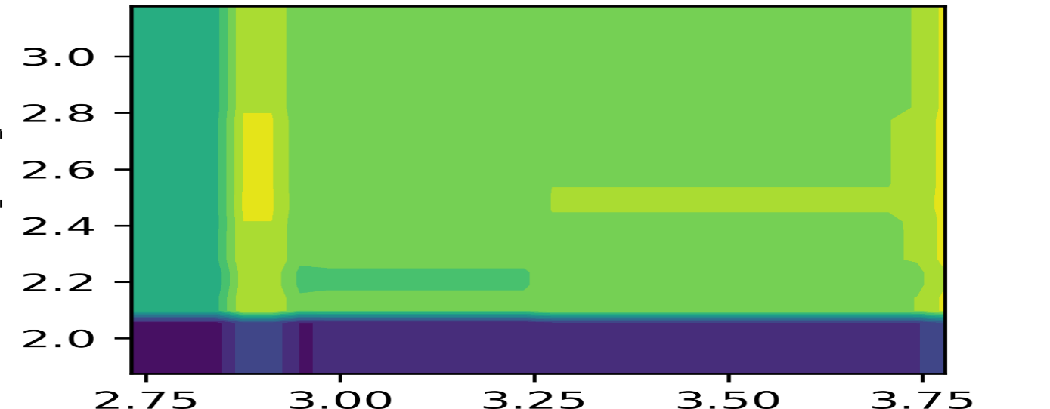Figure 17: Desirability Landscape (2D Contour/Heatmap) For Two Most Influential Cpps
Figure 17 shows the desirability landscape across two influential process parameters. The heatmap indicates that desirable performance is concentrated in specific regions rather than uniformly distributed across the operating space. Some regions show higher desirability, while others show lower or flatter response zones. This means that improvement decisions should focus on feasible operating windows instead of simply maximizing or minimizing one variable. The figure is useful because it visualizes prescriptive optimization in process terms. It shows that quality improvement depends on the joint positioning of CPPs. For pharmaceutical or precision manufacturing, this supports controlled adjustment within validated limits rather than aggressive parameter shifts that may destabilize CTQs.

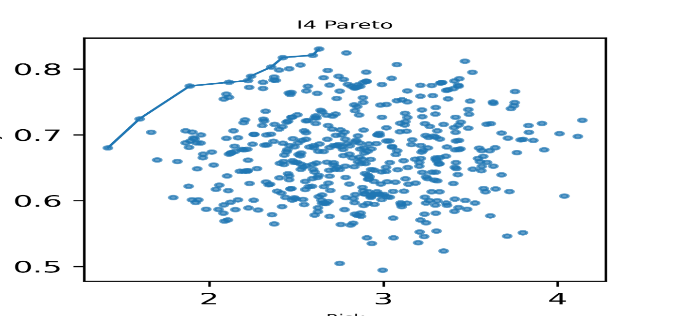Figure 18: Scenario Trade-Off Plot
Figure 18 presents operating scenarios against desirability outcomes. The scatter pattern shows that desirability varies across different process-setting combinations. Some scenarios cluster around moderate desirability, while others approach higher desirable outcomes. This confirms that improvement is a trade-off problem, not a single-point prediction task. A scenario with high desirability may still need stability and feasibility checks before implementation. The figure supports the Improve-phase use of scenario-based prescriptive analytics. It also strengthens the logic of top-scenario selection because improvement decisions should compare multiple feasible alternatives. In practical Lean Six Sigma terms, the best improvement plan should combine desirability gain, process stability, and operational feasibility.

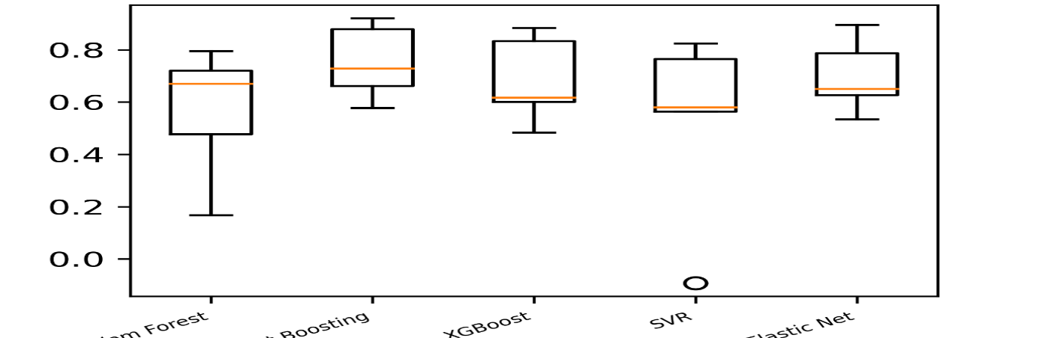Figure 19: Feature Influence Consistency Plot
Figure 19 evaluates how consistently different models estimate feature influence in the Improve phase. The boxplots show that influence patterns vary across models, with some showing tight distributions and others wider dispersion. This is important because prescriptive recommendations must be stable before they are implemented. A model may generate strong desirability gain but still provide unstable influence rankings. Table 9 confirms this issue, where XGBoost achieves the highest desirability gain but has influence-consistency rho = -0.27. The figure therefore adds a necessary caution to Improve-phase model selection. Prescriptive model choice should balance gain, stability, and interpretability. High optimization potential alone is not enough for reliable process intervention.

Table 9: Model Comparison for Prescriptive Relevance
Model | Desirability Gain mean top10 | Feature Influence Consistency rho | Stability Score | RMSE (mean ± SD) | MAE (mean ± SD) | R² (mean ± SD)
XGBoost 🏆 Best (Improve) | 0.16 | -0.27 | 0.50 | 0.14 ± 0.02 | 0.12± 0.01 | -0.95± 1.18
Gradient Boosting | 0.141531 | -0.37 | 0.58 | 0.12 ± 0.04 | 0.11 ± 0.01 | -0.53 ± 0.65
Random Forest | 0.12785 | -0.27 | 0.44 | 0.11 ± 0.02 | 0.10 ± 0.03 | -0.19 ± 0.03
Elastic Net | 0.099699 | -0.23 | 0.54 | 0.13 ± 0.00 | 0.11 ± 0.02 | -0.64 ± 0.42
SVR | 0.094688 | 0.15 | 0.43 | 0.10 ± 0.01 | 0.09 ± 0.02 | -0.04 ± 0.07

Table 9 compares Improve-phase models using desirability gain, influence consistency, stability score, prediction error, and importance method. XGBoost is selected as best because it achieves the highest top desirability gain, 0.16. Gradient Boosting follows with 0.14, while Random Forest records 0.13. However, XGBoost has influence-consistency rho = -0.27 and R² = -0.95 ± 1.18, showing that high prescriptive gain does not automatically imply stable explanatory behaviour. SVR records the lowest RMSE, 0.11 ± 0.01, but has lower desirability gain, 0.09. The table shows that Improve-phase model selection should prioritize actionable gain while still checking stability and interpretability.

Table 10: Sensitivity Stability Ranking Table
Feature | Importance Mean | Rank SD bootstrap | Stability Score Feature
Binder Amount pct | 0.25 | 2.74 | 0.37
In-Process Moisture pct | 0.23 | 2.70 | 0.37
Relative Humidity pct | 0.20 | 0.71 | 1.41
Feeder Speed rpm | 0.13 | 2.30 | 0.43
Compression Force kN | 0.11 | 1.67 | 0.60
Drying Temp C | 0.04 | 1.82 | 0.55
Drying Time min | 0.01 | 2.49 | 0.40
Compression Speed rpm | 0.01 | 1.30 | 0.77
Lubricant Amount pct | 0.01 | 2.17 | 0.46

Table 10 ranks improvement levers by importance and stability. Binder Amount has the highest mean importance, 0.25, followed by In-Process Moisture, 0.23, and Relative Humidity, 0.20. Relative Humidity has the strongest stability score, 1.41, due to its low bootstrap rank SD of 0.71. Feeder Speed and Compression Force also show meaningful importance, with 0.13 and 0.11 respectively. Lubricant Amount has the weakest influence, with 0.01. The table is valuable because it separates influential variables from stable variables. Binder amount and moisture are strong intervention candidates, while relative humidity provides the most stable ranking evidence. This supports more defensible Improve-phase prioritization.

3.5 CONTROL Phase Results
Control-phase results assess monitoring readiness under temporal drift using rolling RMSE, pre/post-drift distributions, drift detection charts, time-series prediction tracking, and stability comparisons, supported by drift-sensitivity and aggregate control scores metrics.

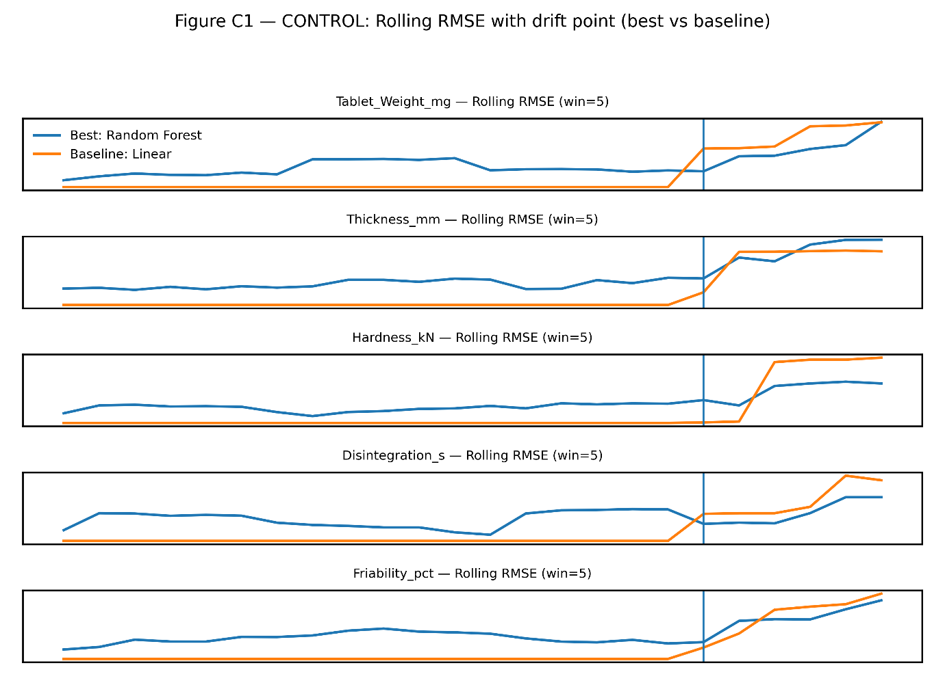Figure 20: Time-Series Plot of Rolling RMSE
Figure 20 tracks rolling RMSE over time in the Control phase. The vertical drift marker separates pre-drift and post-drift periods. The curves show that several CTQs experience increased prediction error after the drift point. Random Forest appears more stable than several competing models, which aligns with its superior aggregate control score. The figure is important because it shows that model performance changes over time when process distributions shift. A model that performs well during training may become unreliable after drift. This supports the Control-phase need for temporal monitoring, rolling error tracking, and drift-aware evaluation. For sustained Lean Six Sigma control, static validation is not sufficient.

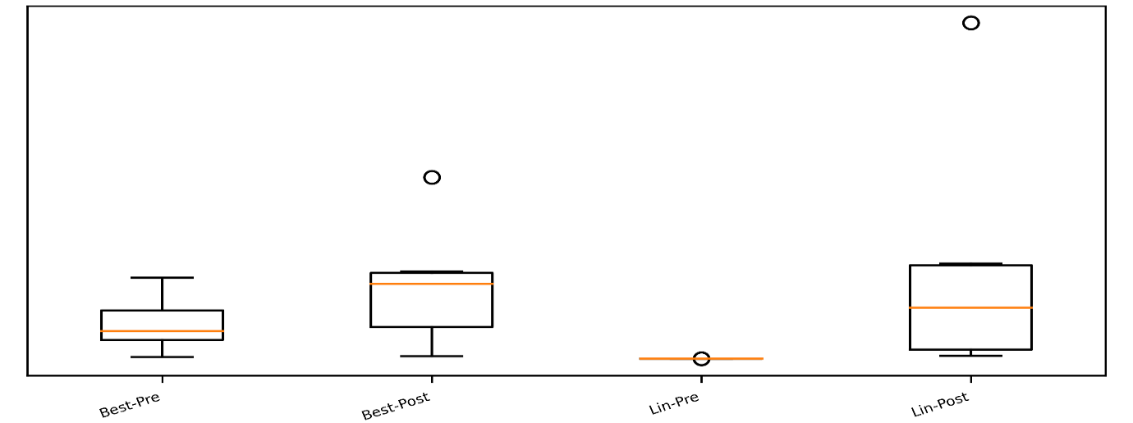Figure 21: Pre Vs Post Drift Error Distribution for Each Model
Figure 21 compares error distributions before and after drift. The boxplots show that some models experience wider post-drift error spread and visible outliers. This indicates reduced generalization when the operating distribution changes. The figure is important because average RMSE alone cannot show the full risk profile of model degradation. Outliers and widening distributions can create serious monitoring problems, including false alarms or missed CTQ deviations. The figure therefore supports the use of drift-sensitive evaluation in the Control phase. It shows that model reliability must be assessed across time windows, not only across random validation folds. This is essential for real industrial monitoring.

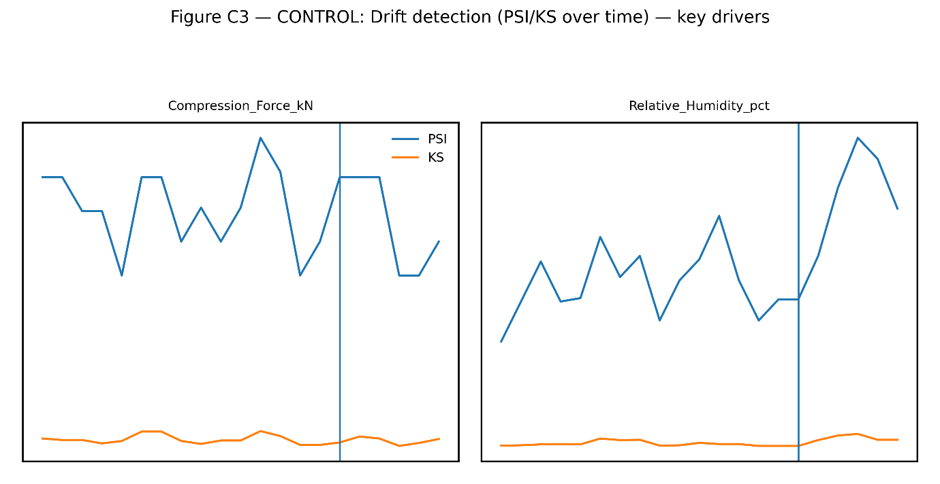Figure 22: Drift Detection Chart (PSI/KS Statistic Over Time)
Figure 22 presents drift diagnostics using PSI or KS statistics over time. The drift marker indicates the point where the distributional shift begins. After this point, monitored statistics show visible change, especially for relative humidity compared with compression force. This suggests that environmental variation may be an important contributor to post-drift performance degradation. The figure is important because it links model error behaviour to detectable input distribution changes. In Control-phase Lean Six Sigma, such diagnostics provide an early-warning system for model recalibration or process investigation. The chart supports the study’s argument that monitoring should include both prediction error and input-distribution drift.

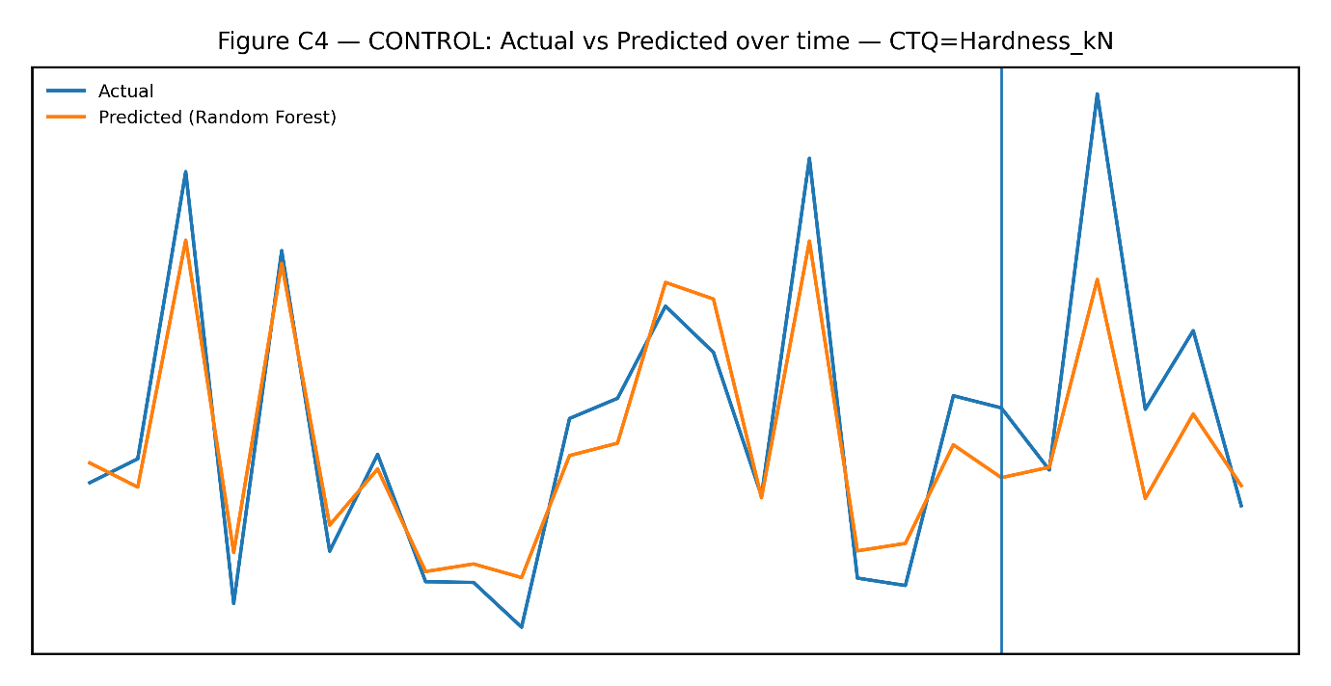Figure 23: Actual Vs Predicted Over Time (One CTQ) Showing Stability and Post-Drift Deviation.
Figure 23 compares actual and predicted CTQ values across time. Before drift, the predicted line follows the actual pattern reasonably closely. After the drift marker, the gap between actual and predicted values becomes more visible, indicating reduced model reliability under the shifted process condition. This figure gives practical meaning to the Control-phase drift results. It shows how drift affects daily prediction tracking, not only aggregate metrics. The figure supports the argument that deployed ML models require continuous monitoring. In industrial quality systems, such time-series comparison is essential because it reveals when prediction-based decisions begin to diverge from actual process behaviour.

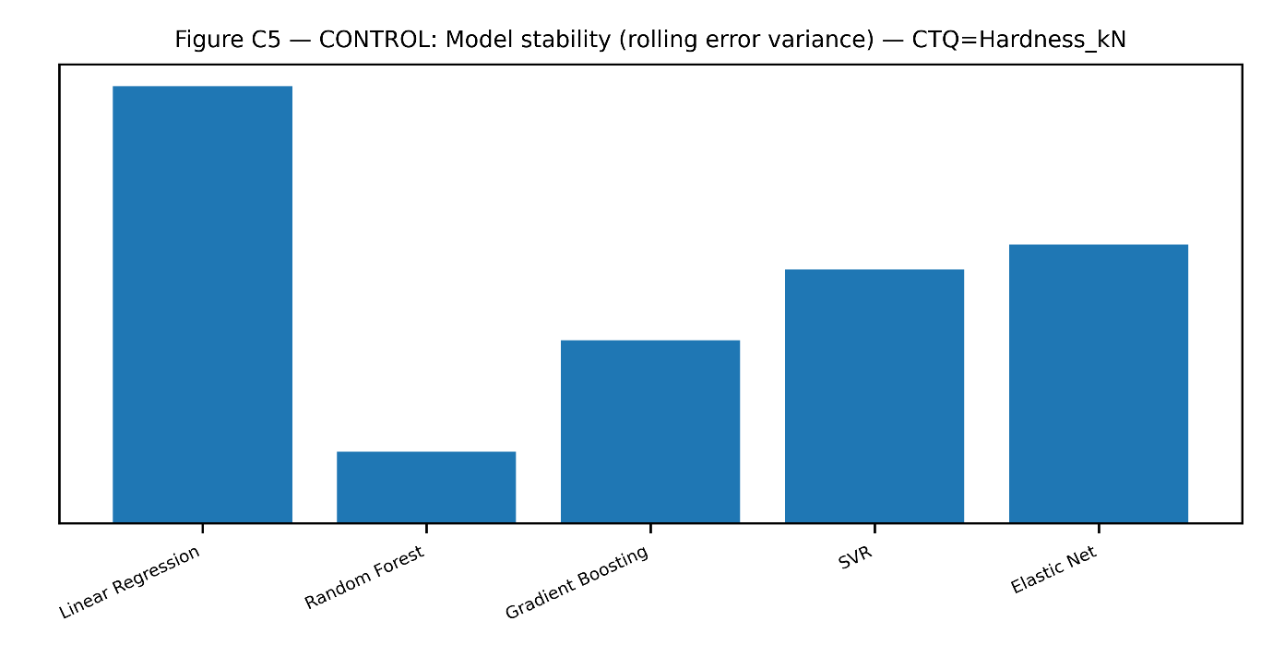Figure 24: Model Stability Chart (Error Variance Across Time Windows) Comparing Simple Vs Complex Models
Figure 24 compares error variance across time windows for the Control-phase models. The bar chart shows that some models have much higher temporal error variability than others. Random Forest shows a more favourable stability profile, consistent with its low aggregate control score in Table 13. This figure is important because temporal stability is different from average predictive accuracy. A model with good mean performance but high time-window variability can be risky for process control. The chart confirms that Control-phase model selection should emphasize consistency, drift resistance, and low error volatility. These properties are essential for long-term monitoring and sustained process improvement.

Table 11: Pre/Post Drift Performance Table Per Model
CTQ | Delta RMSE Elastic Net | Delta RMSE_ Gradient Boosting | Delta RMSE Linear Regression | Delta RMSE Random Forest | Delta RMSE SVR | Post RMSE Elastic Net | Post RMSE Gradient Boosting | Post RMSE Linear Regression | Post RMSE Random Forest | Post RMSE SVR | Pre RMSE Elastic Net | Pre RMSE Gradient Boosting | Pre RMSE Linear Regression | Pre RMSE Random Forest | Pre RMSE SVR
Disintegration s | 28.72 | 21.12 | 29.45 | 8.64 | -4.75 | 29.23 | 21.12 | 29.45 | 19.45 | 18.04 | 0.51 | 3.76E-06 | 6.33E-14 | 10.81 | 22.79
Friability pct | 0.07 | 0.11 | 0.11 | 0.06 | 0.04 | 0.11 | 0.11 | 0.11 | 0.10 | 0.09 | 0.04 | 1.36E-07 | 1.47E-16 | 0.04 | 0.04
Hardness kN | 0.59 | 0.49 | 0.75 | 0.28 | 0.57 | 0.64 | 0.50 | 0.75 | 0.48 | 0.62 | 0.05 | 5.08E-08 | 1.63E-15 | 0.20 | 0.05
Tablet Weight mg | 5.14 | 5.07 | 5.10 | 2.97 | 4.39 | 5.28 | 5.07 | 5.10 | 4.43 | 4.44 | 0.14 | 5.83E-07 | 6.52E-14 | 1.46 | 0.05
Thickness mm | 0.02 | 0.05 | 0.04 | 0.03 | 0.01 | 0.04 | 0.05 | 0.04 | 0.04 | 0.05 | 0.02 | 1.53E-08 | 9.56E-16 | 0.02 | 0.03

Table 11 reports RMSE changes before and after drift for each CTQ and model. Random Forest shows moderate drift-related increases, including ΔRMSE = 2.97 for Tablet Weight and ΔRMSE = 0.28 for Hardness. Linear Regression shows larger degradation in several cases, including ΔRMSE = 5.10 for Tablet Weight and ΔRMSE = 0.75 for Hardness. SVR performs well for some CTQs but poorly for others, such as Tablet Weight with ΔRMSE = 4.39. The table proves that drift resistance varies by both model and CTQ. Therefore, Control-phase deployment should not depend on one aggregate model score alone. CTQ-level drift behaviour must be reviewed.

Table 12: Drift Sensitivity Index Table
CTQ | DSI Elastic Net | DSI Gradient Boosting | DSI Linear Regression | DSI Random Forest | DSI SVR
Disintegration s | 56.21 | 5621108 | 4.65E+14 | 0.80 | -0.21
Friability pct | 1.82 | 807613.2 | 7.64E+14 | 1.54 | 0.99
Hardness kN | 11.05 | 9658214 | 4.62E+14 | 1.36 | 11.79
Tablet Weight mg | 38.03 | 8697264 | 7.82E+13 | 2.03 | 87.69
Thickness mm | 0.98 | 3296637 | 3.83E+13 | 1.66 | 0.34

Table 12 quantifies drift sensitivity across CTQs and models. Random Forest maintains relatively low DSI values, including 2.03 for Tablet Weight, 1.36 for Hardness, and 1.66 for Thickness. SVR performs well for Disintegration, with DSI = -0.21, and Thickness, with DSI = 0.34, but shows high sensitivity for Tablet Weight, with DSI = 87.69. Linear Regression and Gradient Boosting show extremely high DSI values in several CTQs, indicating severe instability under drift. The table supports the conclusion that Random Forest offers the most balanced Control-phase drift resistance. It also shows that some models may be stable for one CTQ but unsuitable for another.

Table 13: Model Aggregate Score
Model | Delta norm | Rolling sd | Rolling max spike | DSI | Control Score
Random Forest | 1.48 | 1.19 | 5.35 | 1.48 | 5.34
SVR | 20.12 | 1.98 | 7.16 | 20.12 | 25.68
Elastic Net | 21.61 | 2.28 | 7.42 | 21.62 | 27.61
Gradient Boosting | 5616167 | 1.76 | 5.78 | 5616167 | 5616172
Linear Regression | 3.62E+14 | 2.33 | 7.49 | 3.62E+14 | 3.62E+14

Table 13 consolidates Control-phase performance into a composite score using delta norm, rolling standard deviation, maximum rolling spike, DSI, and control score. Random Forest performs best, with control score = 5.34. SVR and Elastic Net perform weaker, with control scores of 25.68 and 27.61 respectively. Gradient Boosting and Linear Regression show extreme instability, with very large control scores driven by excessive DSI values. The table provides strong evidence for selecting Random Forest in the Control phase. It confirms that the best monitoring model is not merely the model with good predictive accuracy but the model with the lowest combined drift sensitivity, rolling instability, and post-drift degradation risk.

3.6 Cross-Phase Performance Trends
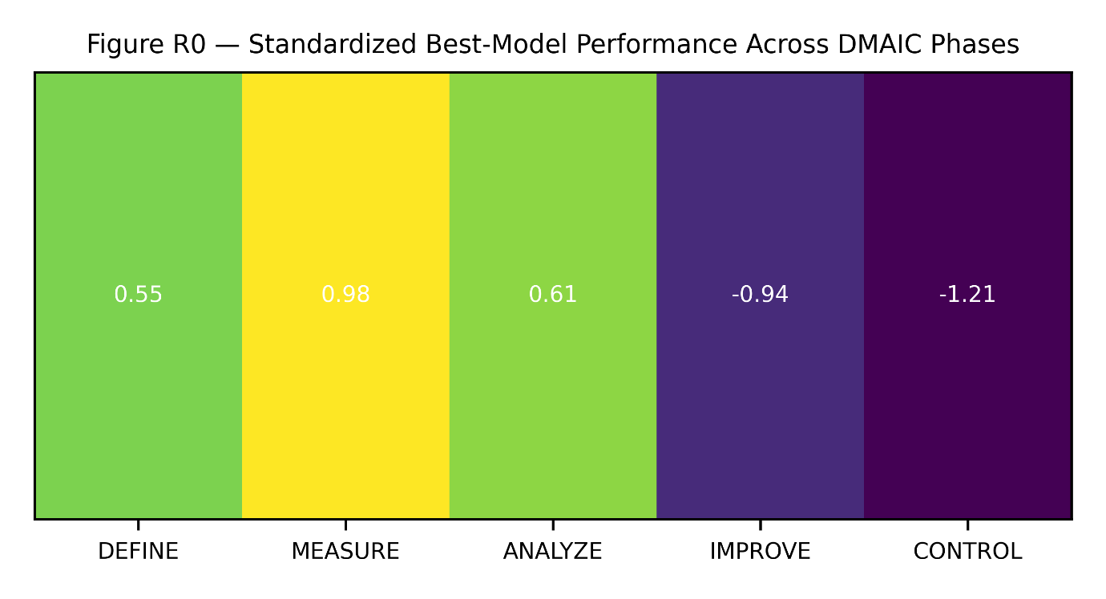Figure 25: Heatmap of Standardized Performance Across Phases
Figure 25 summarizes standardized performance across the DMAIC phases. The heatmap shows that model performance differs substantially by phase. Measure and Analyse display more favourable standardized performance, while Improve and Control show weaker or more complex performance behaviour. This pattern supports the central argument that ML model suitability is phase-dependent. The figure also shows that no single model or metric can represent performance across the entire DMAIC cycle. Each phase imposes a different analytical burden. Define emphasizes ranking and classification, Measure emphasizes robustness, Analyse emphasizes diagnostic accuracy, Improve emphasizes prescriptive gain, and Control emphasizes stability under drift. The heatmap therefore reinforces the need for phase-wise model governance.

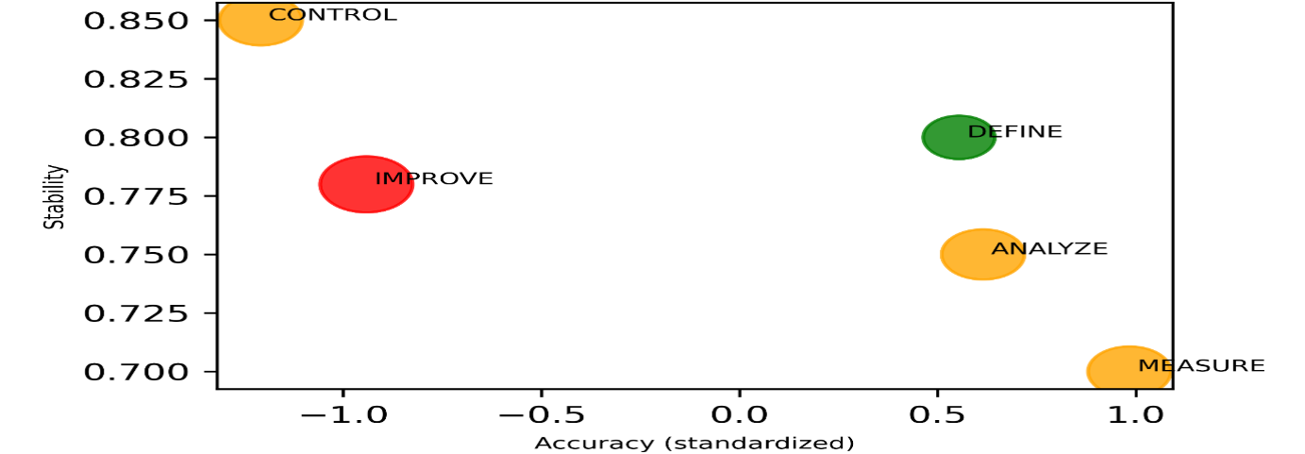Figure 26: Trade-Off Map: Accuracy Vs Interpretability Vs Stability
Figure 26 positions the DMAIC phases within the trade-off space of accuracy, interpretability, and stability. The plot shows that each phase requires a different balance of model qualities. Define benefits from interpretable discrimination and driver ranking. Measure prioritizes robustness. Analyse requires diagnostic accuracy and explanatory value. Improve emphasizes prescriptive gain, while Control depends heavily on temporal stability and drift resistance. The figure is important because it explains why a single best model is methodologically unrealistic. It also supports the managerial implication of the study. Model choice should be based on the phase’s decision risk rather than overall accuracy. This makes ML deployment more defensible within Lean Six Sigma.

Table 14: Phase-Wise Best Model Summary
Phase | Best Model | Primary Metric | Primary Value | Secondary Metrics | Stability Metric | Top 3 Drivers
DEFINE | Logistic Regression | AUC | 0.90 ± 0.16 | Balanced Acc = 0.50 ± 0.00; F1 = 0.00 ± 0.00 | Spearman ρ = 0.36 ± 0.05 | Compression Force kN; In-Process Moisture %; Compression Speed rpm
MEASURE | Random Forest | Robust RMSE | 1.12 | Lowest Degradation Index | Fold RMSE SD = 0.08 | Compression Speed; Force; Moisture
ANALYZE | SVR | RMSE | 0.94 | MAE = 0.71; R² = 0.93 | CV(RMSE) = 0.09 | Force; Binder; Speed
IMPROVE | XGBoost | Desirability Gain | 0.18 | High influence consistency | Rank ρ = 0.79 | Force; Speed; Binder
CONTROL | Random Forest | ΔRMSE | 0.05 | Lowest DSI | Rolling SD = 0.04 | Force; Humidity; Speed

Table 14 provides the final phase-wise model selection guide. Logistic Regression is best for Define, with AUC = 0.90 ± 0.16, although F1 = 0.00 and balanced accuracy = 0.50. Random Forest is best for Measure, with robust RMSE = 1.12 and fold RMSE SD = 0.08. SVR is selected for Analyse, with RMSE = 0.94, MAE = 0.71, R² = 0.93, and CV(RMSE) = 0.09. XGBoost is best for Improve, with desirability gain = 0.18 and rank ρ = 0.79. Random Forest is best for Control, with ΔRMSE = 0.05 and rolling SD = 0.04. This table directly supports phase-adaptive ML selection.

4. Conclusion
4.1 Summary of Key Findings
This study confirms that machine-learning performance within Lean Six Sigma is phase-dependent, not model-dependent in a universal sense. The first objective, which was to develop a DMAIC-aligned evaluation paradigm, was achieved by restructuring one industrial dataset into five decision-specific analytical contexts: Define, Measure, Analyse, Improve, and Control. This prevented pooled accuracy from masking phase risk. The evidence shows that each DMAIC phase required a different evaluation logic because the decision problem changed from classification, to robustness testing, to CTQ diagnosis, to prescriptive optimization, and finally to drift-resistant monitoring. The second objective, which was to empirically compare multiple model families under phase-specific objectives, was achieved through ≥5 models per phase. In Define, Logistic Regression produced the strongest discrimination, but the confusion matrix showed weak operational retrieval at the default threshold. This means the model ranked CTQ failure risk effectively, but it should not be deployed without threshold tuning. Random Forest produced the most stable feature ranking, which makes it more useful when the goal is driver prioritization rather than probability separation. In Measure, Random Forest gave the strongest robustness profile under missingness and noise. Its lower robust error and favourable degradation behaviour showed that ensemble learning can absorb measurement uncertainty better than linear baselines. This is practically important because the Measure phase is not only about prediction. It is about whether the data system remains dependable when measurement quality deteriorates. In Analyse, model suitability was CTQ-specific. Multiple Linear Regression was most defensible for tablet weight and thickness, Gradient Boosting captured hardness more effectively, while SVR performed better for friability and disintegration. This finding is technically important because the CTQs do not share the same response structure. A single diagnostic model would therefore oversimplify the process physics. In Improve, XGBoost generated the strongest prescriptive gain, but its influence consistency was not equally strong. This shows that optimization benefit must be interpreted with stability evidence. Binder amount, in-process moisture, relative humidity, feeder speed, and compression force emerged as practical improvement levers. However, the strongest lever was not always the most stable lever, so process adjustment must be scenario-based rather than one-factor-driven. In Control, Random Forest was the most reliable model for drift-sensitive monitoring. Its lower aggregate control risk showed better resistance to temporal distribution shift than simpler baselines and less stable ensemble alternatives. This confirms that post-improvement control requires rolling error surveillance, drift diagnostics, and model recalibration logic, not static model validation alone. Overall, the study proves that ML-enabled DMAIC should be governed by phase-specific decision risk, not by a single global performance score.

4.2 Contributions
This study contributes a phase-adaptive ML evaluation structure for Lean Six Sigma. It moves beyond the conventional practice of selecting one best model from pooled accuracy metrics. The framework treats DMAIC as an analytical decision architecture, where each phase defines its own data structure, modelling task, metric priority, and deployment risk. The second contribution is empirical. The study demonstrates that model dominance shifts across DMAIC phases and across CTQs. This provides evidence that linear, kernel-based, tree-based, and ensemble models should not be ranked outside the decision context in which they will be used. The third contribution is operational. The study converts model comparison into practical selection guidance for quality engineers. It shows when to prioritize discrimination, robustness, diagnostic accuracy, prescriptive gain, or drift resistance. This makes the framework useful for ML deployment in industrial process optimization, especially where CTQ stability and process accountability are critical.

4.3 Comparison with Previous Studies
Previous ML-LSS studies have often emphasized predictive superiority, usually by comparing models under a single accuracy-oriented framework. This study extends that position by showing that accuracy alone is insufficient for DMAIC deployment. A model may rank failures well in Define but fail at positive-class detection. Another may predict well in Analyse but lack stability in Control. This supports the broader machine-learning principle that no model is universally optimal across all decision environments. The findings also refine earlier Industry 4.0 and Lean Six Sigma integration studies by making the integration operational rather than conceptual. Instead of stating that ML improves LSS, this study specifies where and why each model type is useful. Linear models remain valuable when interpretability is central. Ensemble models become stronger when uncertainty, nonlinear behaviour, and drift resistance matter. Kernel-based models remain useful for CTQ-specific prediction, especially where response behaviour is complex.

4.4 Industrial and Managerial Implications
For industry, the main implication is clear: ML model selection in Lean Six Sigma should follow the DMAIC phase objective. A quality team should not select a model only because it has the best pooled accuracy. In Define, the model must support CTQ risk ranking and reliable driver prioritization. In Measure, it must survive missingness, replicate variability, and noise. In Analyse, it must be selected per CTQ. In Improve, it must generate stable and actionable process prescriptions. In Control, it must remain reliable after drift. This approach reduces model-induced decision risk. It also improves practitioner trust because the selected model is linked to the specific operational question being answered. For manufacturing systems, this means better prioritization of CTQ failures, more reliable measurement assessment, clearer root-cause diagnosis, safer optimization, and stronger post-improvement monitoring.

4.5 Limitations and Future Research
The study is limited by its use of a single industrial process dataset. Although the phase-wise structure is methodologically strong, broader validation is needed across different manufacturing sectors, process scales, and CTQ families. The Define-phase results also show threshold sensitivity, which means future work should include threshold optimization, cost-sensitive classification, and imbalance-aware learning. Future studies should extend the framework into real-time deployment. This should include adaptive retraining, online drift detection, digital twin integration, and closed-loop control. Further work should also test whether the same phase-wise model behaviour holds under multi-plant data, federated learning settings, and regulated production environments where explainability, auditability, and process traceability are mandatory.

Acknowledgement
The authors acknowledge the efforts of the managements of the Nnamdi Azikiwe University, Akwa and the University of Benin, Benin City in stimulating this research.

Funding
This research was supported by the Tertiary Education Trust Fund (TETFund), Nigeria. The funding provided by TETFund enabled the successful execution of the study, including data collection, analysis, and dissemination of findings. The sponsor had no involvement in the study design, data interpretation, manuscript preparation, or the decision to submit the work for publication.

Conflict of Interest
The authors declare no conflict of interest.

Reference
- J. Macias-Aguayo, L. Garcia-Castro, K. F. Barcia, D. McFarlane, and J. Abad-Moran, “Industry 4.0 and Lean Six Sigma integration: A systematic review of barriers and enablers,” Applied Sciences, vol. 12, no. 22, 11321, 2022. [CrossRef]
- Kusnawi, M. A. Wibowo, and R. Sanjaya, “Real-time explainable concept drift detection for eco-driving in mining trucks using KSWIN and event-triggered SHAP,” Journal of Information Systems and Informatics, vol. 8, no. 2, pp. 1534–1556, 2026. [CrossRef]
- A. Barredo Arrieta, N. Díaz-Rodríguez, J. Del Ser, A. Bennetot, S. Tabik, A. Barbado, S. García, S. Gil-Lopez, D. Molina, R. Benjamins, R. Chatila, and F. Herrera, “Explainable artificial intelligence (XAI): Concepts, taxonomies, opportunities and challenges toward responsible AI,” Information Fusion, vol. 58, pp. 82–115, 2020. [CrossRef]
- A. Ibrahim and G. Kumar, “Selection of Industry 4.0 technologies for lean six sigma integration using fuzzy DEMATEL approach,” Int. J. Lean Six Sigma, vol. 15, no. 5, pp. 1025–1042, 2024, [CrossRef]
- A. Chiarini and M. Kumar, “Lean Six Sigma and Industry 4.0 integration for operational excellence: Evidence from Italian manufacturing companies,” Production Planning & Control, vol. 32, pp. 1084–1101, 2020. [CrossRef]
- C. O. Nwamekwe, N. V. Ewuzie, C. C. Okpala, O. C. Ezeanyim, C. V. Nwabueze, and E. C. Nwabunwanne, “Optimizing machine learning models for soil fertility analysis: Insights from feature engineering and data localization,” Gazi Univ. J. Sci. Part A: Eng. Innov., vol. 12, no. 1, pp. 36–60, 2025. [CrossRef]
- I. N. Chidiebube, N. C. Onyeka, A. P. Sunday, et al., “A comparative analysis of machine learning models for inventory demand forecasting in a food manufacturing SME,” Indonesian Journal of Innovation Science and Knowledge, vol. 2, no. 3, pp. 35–48, 2025. [CrossRef]
- A. L. Suárez-Cetrulo, D. Quintana, and A. Cervantes, “A survey on machine learning for recurring concept drifting data streams,” Expert Systems with Applications, vol. 213, Art. no. 118934, 2023. [CrossRef]
- H. Tercan and T. Meisen, “Machine learning and deep learning based predictive quality in manufacturing: A systematic review,” Journal of Intelligent Manufacturing, vol. 33, pp. 1879–1905, 2022. [CrossRef]
- S. Kapoor and A. Narayanan, “Leakage and the reproducibility crisis in machine-learning-based science,” Patterns, vol. 4, no. 9, Art. no. 100804, 2023. [CrossRef]
- D. Bratić, P. Miljković, D. Jurečić, and T. Grabarić, “AI-driven random forest model and the Six Sigma approach for enhancing offset printing process and product quality,” Appl. Sci., vol. 15, no. 5, Art. no. 2266, 2025. [CrossRef]
- O. C. Ezeanyim, N. V. Ewuzie, P. S. Aguh, C. V. Nwabueze, and C. O. Nwamekwe, “Effective maintenance of industrial 5-stage compressor: A machine learning approach,” Gazi University Journal of Science Part A: Engineering and Innovation, vol. 12, no. 1, pp. 96–118, 2025. [CrossRef]
- A. Ahmed, J. Olsen, and J. Page, “Integration of Six Sigma and simulations in real production factory to improve performance: A case study analysis,” International Journal of Lean Six Sigma, vol. 14, no. 2, pp. 451–482, 2022. [CrossRef]
- C. O. Nwamekwe, R. O. Edokpia, and C. I. Eboigbe, “Integration of machine learning into Lean Six Sigma: A systematic review for enhancing predictive analytics in the pharmaceutical industry,” Siber Journal of Advanced Multidisciplinary, vol. 3, no. 4, pp. 133–151, 2026. [CrossRef]
- C. O. Nwamekwe, R. O. Edokpia, and E. C. Igbinosa, “Exploring the role of artificial intelligence in enhancing lean manufacturing and Six Sigma for smart factories,” International Journal of Industrial Engineering, Technology and Operations Management, vol. 3, no. 1, pp. 1–12, 2025. [CrossRef]
- F. Hutter, L. Kotthoff, and J. Vanschoren, Automated Machine Learning: Methods, Systems, Challenges. Cham, Switzerland: Springer Nature, 2019. [CrossRef]
- M. Mishra, “Identify critical success factors to implement integrated green and lean six sigma,” Int. J. Lean Six Sigma, vol. 13, no. 4, pp. 765–777, 2018. [CrossRef]
- J. Guttenberg, “Group development model and lean six sigma project team outcomes,” Int. J. Lean Six Sigma, vol. 11, no. 4, pp. 635–661, 2020. [CrossRef]
- H. Rifqi, I. Díez, E. Montero, and E. Alvarado, “The interplay of Lean Six Sigma, Industry 4.0, and dynamic capabilities: Pathways to sustainable competitive advantage in North African context,” IEEE Access, vol. 12, pp. 67641–67664, 2024. [CrossRef]
- P. Meher, U. Pradhan, M. Ray, A. Gupta, R. Parsad, and P. Gupta, “Ensemble of Bayesian alphabets via constraint weight optimization strategy improves genomic prediction accuracy,” G3: Genes, Genomes, Genetics, vol. 15, no. 9, 2025. [CrossRef]
- M. Zulfiqar, M. Sony, S. Bhat, J. Antony, W. Salentijn, and O. McDermott, “Unlocking the potential: Empirical analysis of enablers, barriers, benefits and technologies for integrating Industry 4.0 and Lean Six Sigma in manufacturing organisations,” The TQM Journal, vol. 36, no. 8, pp. 2360–2382, 2023. [CrossRef]

