Semester Project: Flat Belt Pulley Hydroelectric Generator
David Kmieciak, Derek Hartmon, Abdullah Turkistani, & Mitch Weisser
May 10th, 2017
University of Wisconsin – Stout
Dept. of Engineering & Technology
Dr. Devon Berg

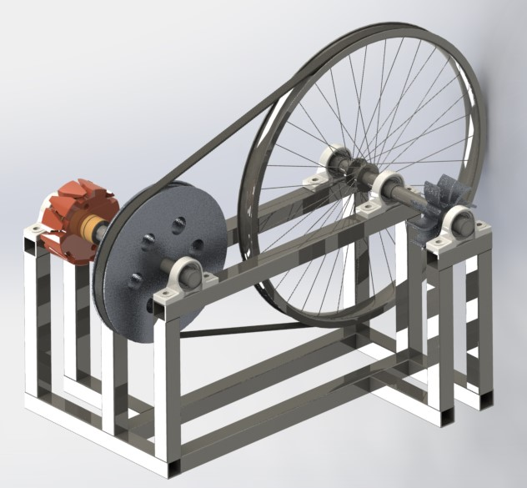

Table of Contents
Executive Summary…………………………………………………………………………….. 3

Thought Process & Execution……………………..……………………………………………4

Design Concepts…………………………………………………………..........................4

Design Executed……………………………………………………….………...…….....6

Methodology & Results…………………………..………………………………………...……9

Conclusion……………………………………………………………………………….…….. 19

Appendix……………………………………………………………………………..………… 20

Works Cited……………………..……………………………………………………………... 21

Executive Summary
Owner of Magnetic Power Company, Hastings Mkandawire, came to us looking for a way to increase the efficiency of his homemade hydroelectric generators that are used to produce power for people in rural Malawi, Africa. In response, our team designed a hydroelectric generator that uses a flat belt pulley to create a mechanical advantage. The prototype generator comprises of many parts that Hastings should be able to find in a junk yard or aluminum sand cast.
It has been completely built around the idea of 2:1 ratio. For example, if the water wheel were to spin the input shaft and large pulley at 1500 RPM then the output shaft and small pulley would rotate at 3000 RPM. The whole generator consists of multiple lengths of square tubing for structure and part placement, a 24-inch steel bicycle rim that acts as the large pulley, a 12-inch aluminum sand casted pulley that acts as the small pulley, an input and output shaft, an aluminum sand casted water wheel, multiple bearings of the same size, an electric generator that is used to produce power, and a belt that is used to transfer the energy.
The calculations that were used during this project consisted of determining the torque throughout the whole system. We also did a stress analysis on the input and output shafts. This information was vital because it would guarantee that our generator would be able to run smooth and efficiently over a long period of time without having to worry about it breaking. To completely understand the mechanism and its benefits, a physical prototype must be fabricated and used to determine the actual outputs and stresses. This will help the team decide whether to keep or use different parts to maximize the mechanical advantage of using pulleys to double the output RPM’s which in turn directly affects how much power is created.

Thought Process & Execution
Design Concepts
The very first approach to determine what type of mechanical advantage would be the best to use for this specific situation was to identify what the world had already created. Some of these included gears, screws, pulleys, bar mechanisms, and levers. After a quick analysis of these different types of mechanical systems, it was decided that levers and screws would not be very effective in creating the desired outcome of doubling the output speed.

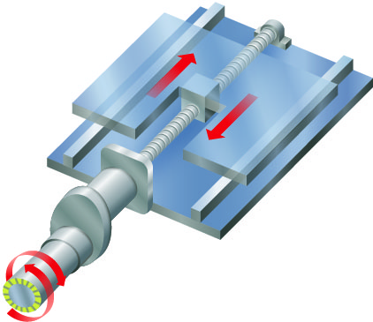
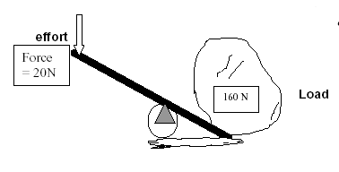


Figure 2: SAASTE Technology/Modules/Mechanical Systems – en.wikibooks.org
Figure 1: Understanding Technology and its Advantages – www.sodick.com

After our team decided to not go with levers and screws, an analysis of the other three design concepts were brainstormed. After much thought and consideration, it was determined that the bar mechanism would not work as well. It would not only be hard for Hastings to find the parts and put this type of mechanism together, but it would not produce a very high mechanical advantage compared to that of a gear or a pulley. All our team’s thoughts were then focused on designing and creating a mechanically advantaged system based solely on either gears or pulleys.
Gears are a great way to transfer energy from one part to another. Not only are they very efficient, they are also very rugged. This would be great considering that the gears would be performing in less than adequate environments. The biggest problem with this idea was that finding multiple gears of different sizes that also shared the same pitch and teeth design was almost close to none. Even though all vehicles have some sort of gears for parts, it wasn’t likely that someone would be able to walk into a junk yard and obtain two gears of the same tooth geometry that would work well together. On the other hand, it wouldn’t work to aluminum sand cast them either. A gear is only as rugged as the material it’s made from. Since aluminum is very soft and because sand casting isn’t a very accurate approach to creating high tolerance gear teeth geometry, it was decided not to use gears to produce a mechanical advantage.
This left our team with only one type of mechanism which would be the pulley. All that’s needed to create a pulley mechanism is to set two different radial dimensioned wheels a certain distance apart where a belt or piece of rope would transmit the input from one pulley to the other pulley. It was also determined that this type of mechanism could be aluminum sand casted because even though the part would be made with a soft material that it wouldn’t ever undergo a force that would alter its physical or mechanical characteristics.

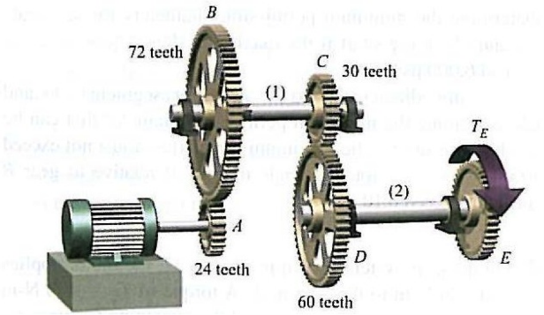
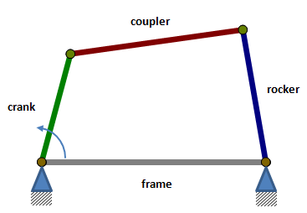
Figure 4: Multiple Gear System – www.google.com
Figure 3: Parallel 4 Bar Linkage – www.coppeliarobotics.com

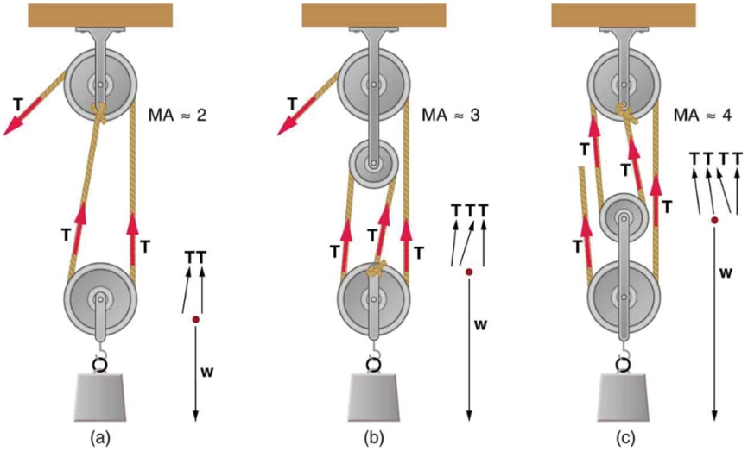

Figure 5: Pulley System – diagram.performancecomercio.com
Design Executed
The final design concept was to create a mechanism with a mechanical advantage that would be supplied by a flat belt pulley system. We decided that a bicycle rim would be appropriate for the large pulley considering it would be something that Hastings could find in a junk yard or around his neighborhood. Our team decided that we should aluminum sand cast the small pulley so that we could control the end result dimensions without having to search through junk. The square tubing would be a little difficult to obtain, as would the multiple bearings. These two components would take the longest to find. A flat belt could ultimately be found within old cars or other mechanical pulley systems. The electric generator would have to be made by Hastings himself, unless he had access to a pre-built generator.
Large Pulley
Bearing #2
(Hidden)
Small Pulley
Bearing #6
Water Wheel
Output Shaft
Bearing #3
Square Tubing
Bearing #5
Input Shaft
Bearing #4
Flat Belt
Electric Generator
Bearing #1
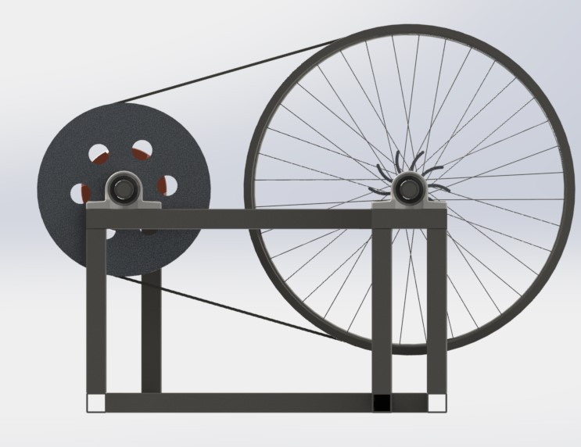
It was determined by the team that the pulley system would have a gear ratio of 2:1 so that the output would be double that of the input. This ratio was chosen because the team wanted to keep as much surface area as possible on the small pulley. According to Robert Juvinall and Kurt Marshek in their academic mechanical book named Fundamentals of Machine Component Design, they wrote, “The capacity of a belt drive is normally limited by the slippage of the smaller pulley” (787). So, the more surface area available for the flat belt to ride on the small pulley, the better. Also, a generator can only produce so much power. Eventually there’s a point where RPM’s surpass the efficiency of the generator. The reason our team decided to use a flat belt instead of a V-belt was because a flat belt is better in high speed applications. Considering we want to at least double our output, a flat belt would work great. The pulley system does not exactly need to be a 2:1 ratio either. If the ratio results in higher output speed compared to the input speed, then it will still create a mechanical advantage system.
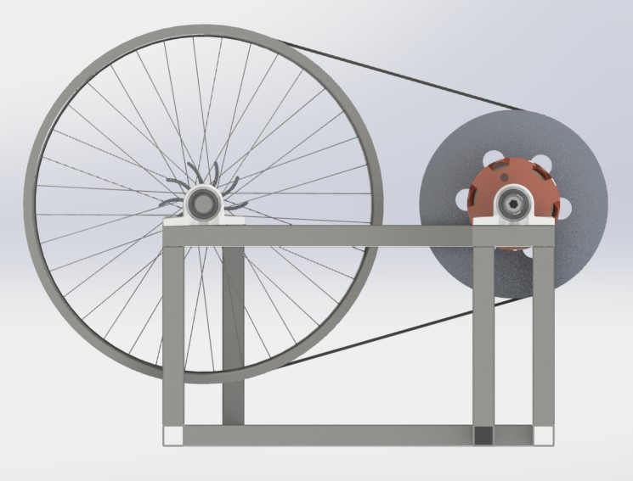
The big pulley in our design consists of a 24-inch diameter steel bicycle rim because we figured there would be decent chance of Hastings finding one laying around the salvage yards. On the other hand, the smaller pulley would have to be aluminum sand casted. This would not only allow the person making it to determine the smaller pulleys exact diameter, but it would also be easier to create it rather than try to find it in a junk yard. The main reason we decided to use so many bearings is because it would allow the whole mechanism to have good shaft rotation and tolerance. Square tubing is great for strong structural support. The geometry of a square can be unbelievably strong. As for the water wheel, we determined that it would be easiest for Hastings to sand cast this part. It would not only spar him from searching through junk, but it could be designed to a specific desired dimension. Overall, the input shaft would have an aluminum sand casted water wheel attached to it with a set screw. A small surface of the rod would have to be ground flat with a file to ensure the set screw would do its job effectively. The large pulley would also be attached to this rod. In this case, the bicycle rim would be welded directly onto the input shaft. The output shaft is set in place with more bearings. This shaft is connected to the small aluminum sand casted pulley that would be fastened to the output shaft. This shaft would also be connected to the electric generator. This would all be mounted on the square tubing support structure.
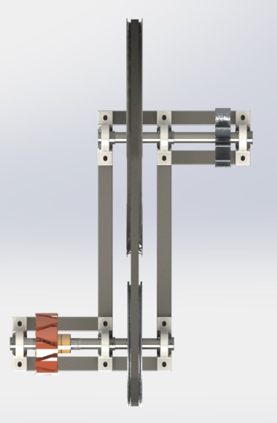
Depending on what Hastings can find in the salvage yards or depending on his aluminum sand casting capabilities, this design concept can be adaptable. Just because in our design we have a total of six bearings doesn’t mean that the final design must have six bearings. This is especially true if Hastings can’t find that many bearings of the same size. He would have to use what he can get his hands on. The input and output shafts for the most part can be of any reasonable diameter. We recommend going no smaller than ten millimeters just to be safe.
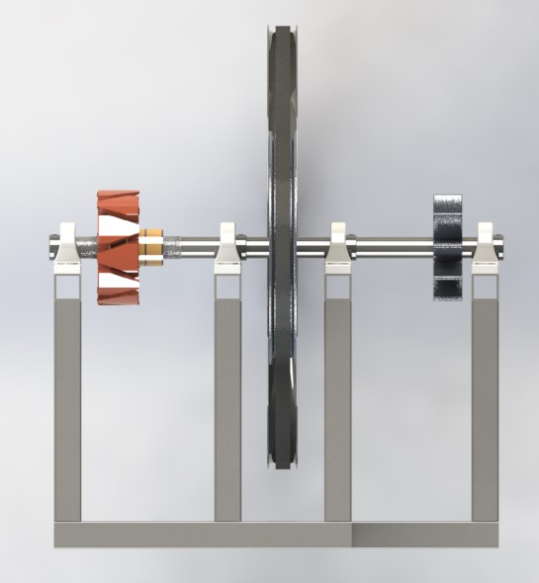

Methodology & Results
One of the first things we did for calculations was to determine the torques applied to the whole mechanical system. This would not only allow us to analysis the torque per individual part, but it would also give us a slight indication if anything may or may not break. All the equations and the variables can be found in the equations table under the appendix section. To figure out the torque on the water wheel we did the following:
T_{w} = F_{w} * r_{w}
Knowns: T_{w} = ?, F_{w} = 75.6 N, r_{w} = 0.0508 m
T_{w} = 75.6 N * 0.0508 m
T_{w} = 3.84 N*m
Next, we set up a series of ratios to determine the torques on the other parts of the mechanism.
r_{bp} T_{bp}
=
r_{w} T_{w}
Knowns: r_{bp} = 0.3048 m, r_{w} = 0.0508 m, T_{bp} = ?, T_{w} = 3.84 N*m
0.3048 m T_{bp______}
=
0.0508 m 3.84 N*m
T_{bp} = 23.04 N*m
r_{sp} T_{sp}
=
r_{bp} T_{bp}
0.1524 m T_{sp______}
=
0.3048 m 23.04 N*m
T_{sp} = 11.52 N*m

The calculations for the torque on the water wheel determined that it was equal to 3.84 N, 23.04 N on the large pulley, and 11.52 N on the small pulley. The input shaft would carry the same initial torque produced by the water wheel. The output shaft would carry the same torque produced by the small pulley. Below is a torque diagram of the entire mechanical system.
3000 RPMS
T_{sp} = 11.52 N
1500 RPMS
T_{bp} = 23.04 N
1500 RPMS
T_{w} = 3.84 N
The next set of calculations our team did were the stress analyses on the input and output shaft. A bending diagram of the shaft was drawn where the moments and shear forces were then determined. After we found the largest moment, we analyzed a stress element about that specific point. This was followed by a Mohr’s circle so that we could create our MDET graph that would give us our overall safety factor for each rod.

F_{w} = 75.6 N
F_{bp} = 13.3 N

INPUT SHAFT

C_{y1}
B_{y1}
A_{y1}
r_{x4} = .0508 m
r_{x3} = .1524 m
r_{x2} = .0762 m
r_{x1} = .0762 m
r_{x6} = .2032 m
r_{x5} = .1524 m
r_{x7} = .3556 m

M_{Ay1} = (-F_{bp})(r_{x1}) + (B_{y11})(r_{x5}) = 0
0 = (-13.3N)(.0762m) + (B_{y11})(.1524m)
B_{y11} = 6.65 N

M_{Cy1} = (F_{w})(r_{x4}) + (-B_{y12})(r_{x6}) = 0
0 = (75.6N)(.0508m) + (-B_{y12})(.2032m)
B_{y12} = 18.9 N

B_{y1} = B_{y11 +} B_{y12}
B_{y1} = 6.65N + 18.9N
B_{y1} = 25.55 N

M_{By12} = (-F_{w})(r_{x3}) + (C_{y1})(r_{x6}) = 0
0 = (-75.6N)(.1524m) + (C_{y1})(.2032m)
C_{y1} = 56.7 N

A_{y1} = (F_{bp} + F_{w}) – (B_{y1} + C_{y1})
A_{y1} = (13.3N + 75.6N) – (25.55N + 56.7N)
A_{y1} = 6.65 N

ƩM_{Ay1} = (-F_{bp})(r_{x1}) + (B_{y1})(r_{x5}) + (-F_{w})(r_{x5} + r_{x3}) + (C_{y1})(r_{x7})
ƩM_{Ay1} = (-13.3N)(.0762m) + (25.55N)(.1524m) + (-75.6N)(.3048m) + (56.7N)(.3556m)
ƩM_{Ay1} = 0
ƩM_{By1} = (F_{bp})(r_{x2}) + (-A_{y1})(r_{x5}) + (-F_{w})(r_{x3}) + (C_{y1})(r_{x6})
ƩM_{By1} = (13.3N)(.0762m) + (-6.65N)(.1524m) + (-75.6N)(.1524m) + (56.7N)(.2032m)
ƩM_{By1} = 0

ƩM_{Cy1} = (F_{w})(r_{x4}) + (-B_{y1})(r_{x6}) + (F_{bp})(r_{x6} + r_{x2}) + (-A_{y1})(r_{x7})
ƩM_{Cy1} = (75.6N)(.0508m) + (-25.55N)(.2032m) + (13.3N)(.2794m) + (-6.65N)(.3556m)
ƩM_{Cy1} = 0
ƩM_{Fw} = (F_{w})(r_{x4})
ƩM_{Fw} = (75.6N)(.0508m)
ƩM_{Fw} = 3.48 N*m
ƩM_{Fbp} = (F_{bp})(r_{x1})
ƩM_{Fbp} = (13.3N)(.0762m)
ƩM_{Fbp} = 1.013 N*m

Bending Moment Diagram
Shear Force Diagram
3.48N*m
18.9N
1.013N*m
M
6.65N
V
-6.65N

-56.7N

τ_{T} = Tr/J
τ_{T} = (3.84N*m)(.015m)
π/2 (.015)⁴
τ_{T} = .724 MPa

σ_{b} = My/I
σ_{b} = (3.48N*m)(.015m)
π/4 (.015)⁴
σ_{b} = 1.31 MPa

Stress Element

S

σ_{r} = sqrt((σ₁ + σ₂)/2)² + (τ_{T}))
σ_{r} = sqrt((1.31N/2)² + (.724N*m))
σ_{r} = 1.18 MPa

σ_{ave} = (σ₁ + σ₂)/2
σ_{ave} = (1.31)/2
σ_{ave} = .655 MPa

τ_{T}

σ_{b}
σ_{max} = .655 MPa + 1.18 MPa
σ_{max} = 1.835 MPa

τ_{max} = σ_{r}
τ_{max} = 1.18 Mpa

σ_{min} = -1.18 MPa + .655 MPa
σ_{min} = -.525 MPa

Mohr’s Circle for Input Shaft

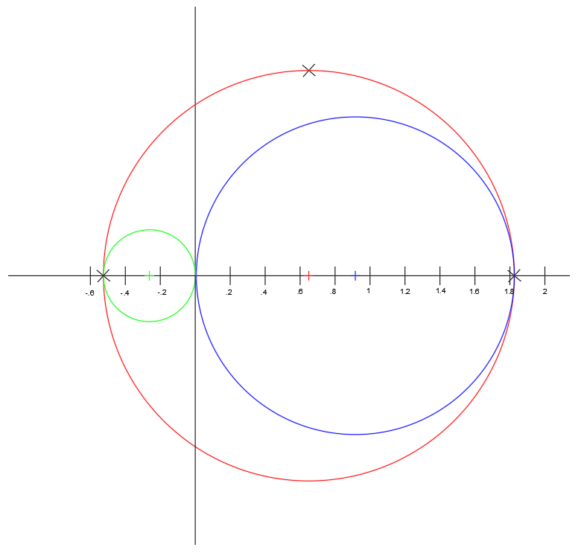
σ₁

σ₂

σ_{max} = 1.835 MPa

σ_{min} = -.525 MPa

τ_{max} = 1.18 Mpa

MDET Diagram for Input Shaft
σ₁

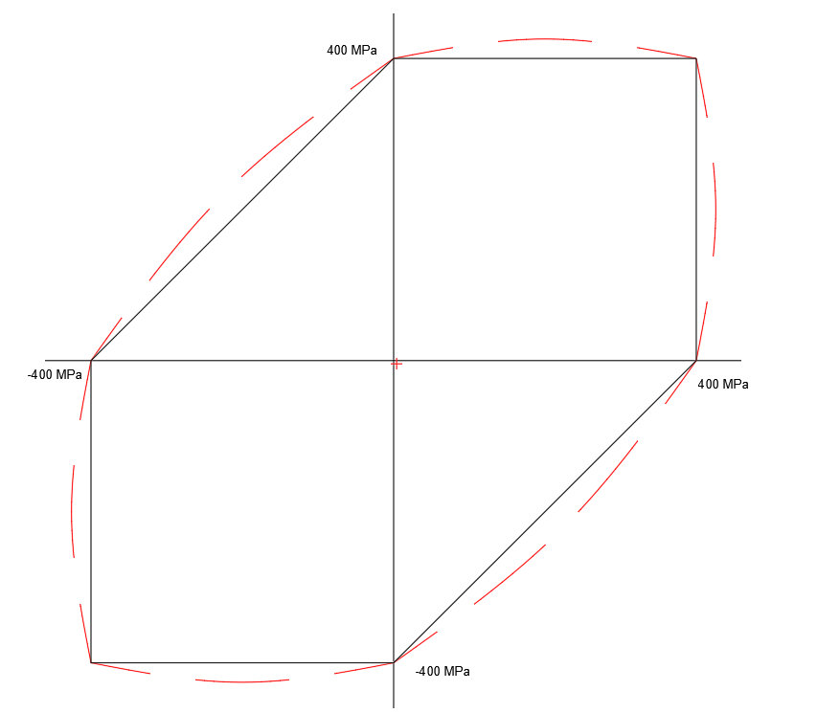
σ₂

(1.834 MPa, -.525 MPa)
\\
Knowns: σ₁ = 1.835 MPa & σ₂ = -.525 MPa

SF = σ_{y}/ σ_{e}
SF = 400 MPa/2.85MPa
SF = 140

σ_{e} = sqrt(σ₁² - σ₂² – σ₁ σ₂ + 3τ_{max})
σ_{e} = sqrt((1.835)² – (-.525)² – (1.835)(-.525) + 3(1.18))
σ_{e} = sqrt(8.146)
σ_{e} = 2.85 MPa

F_{sp} = 70.09 N
F_{m} = 2.22 N

OUTPUT SHAFT

C_{y2}
B_{y2}
A_{y2}
r_{x4} = .0762 m
r_{x3} = .0762 m
r_{x2} = .11125 m
r_{x1} = .11125 m
r_{x6} = .1524 m
r_{x5} = .2225 m
r_{x7} = .3749 m

M_{Ay2} = (-F_{m})(r_{x1}) + (B_{y21})(r_{x5}) = 0
0 = (-2.22N)(.11125m) + (B_{y21})(.2225m)
B_{y21} = 1.11 N

M_{Cy2} = (F_{sp})(r_{x4}) + (-B_{y22})(r_{x6}) = 0
0 = (70.06N)(.0762m) + (-B_{y22})(.1524m)
B_{y22} = 35.045 N

B_{y2} = B_{y21 +} B_{y22}
B_{y2} = 1.11 N + 35.045 N
B_{y2} = 36.155 N

M_{By22} = (-F_{sp})(r_{x3}) + (C_{y2})(r_{x6}) = 0
0 = (-70.09N)(.0762m) + (C_{y1})(.1524m)
C_{y2} = 35.045 N

A_{y2} = (F_{m} + F_{sp}) – (B_{y2} + C_{y2})
A_{y2} = (2.22N + 70.09N) – (36.155N + 35.045N)
A_{y2} = 1.11 N

ƩM_{Ay2} = (-F_{m})(r_{x1}) + (B_{y2})(r_{x5}) + (-F_{sp})(r_{x5} + r_{x3}) + (C_{y2})(r_{x7})
ƩM_{Ay1} = (-2.22N)(.11125m) + (36.155N)(.2225m) + (-70.09N)(.2987m) + (35.045N)(.3749m)
ƩM_{Ay2} = 0
ƩM_{By2} = (F_{m})(r_{x2}) + (-A_{y2})(r_{x5}) + (-F_{sp})(r_{x3}) + (C_{y2})(r_{x6})
ƩM_{By1} = (2.22N)(.11125m) + (-1.11N)(.2225m) + (-70.09N)(.0762m) + (35.045N)(.1524m)
ƩM_{By2} = 0
ƩM_{Cy2} = (F_{sp})(r_{x4}) + (-B_{y2})(r_{x6}) + (F_{m})(r_{x6} + r_{x2}) + (-A_{y2})(r_{x7})
ƩM_{Cy1} = (70.09N)(.0762m) + (-36.155N)(.1524m) + (2.22N)(.26365m) + (-1.11N)(.3749m)
ƩM_{Cy1} = 0
ƩM_{Fsp} = (F_{sp})(r_{x4})
ƩM_{Fsp} = (75.6N)(.0508m)
ƩM_{Fsp} = 5.34 N*m
ƩM_{Fm} = (F_{m})(r_{x1})
ƩM_{Fm} = (2.22N)(.11125m)
ƩM_{Fm} = .2469 N*m

Bending Moment Diagram
Shear Force Diagram
5.34N*m
33.935N

1.11N
.246N*m
M
V
-1.11N

-36.155N

τ_{T} = Tr/J
τ_{T} = (11.52N*m)(.015m)
π/2 (.015)⁴
τ_{T} = 2.17 MPa

σ_{b} = My/I
σ_{b} = (5.34N*m)(.015m)
π/4 (.015)⁴
σ_{b} = 2.014 MPa

Stress Element

S

σ_{r} = sqrt((σ₁ + σ₂)/2)² + (τ_{T}))
σ_{r} = sqrt((2.014N/2)² + (2.17N*m))
σ_{r} = 2.39 MPa

σ_{ave} = (σ₁ + σ₂)/2
σ_{ave} = (2.014)/2
σ_{ave} = 1.007 MPa

τ_{T}

σ_{b}
σ_{max} = 2.39 MPa + 1.007 MPa
σ_{max} = 3.397 MPa

τ_{max} = σ_{r}
τ_{max} = 2.39 Mpa

σ_{min} = -2.39 MPa + 1.007 MPa
σ_{min} = -1.383 MPa

Mohr’s Circle for Output Shaft

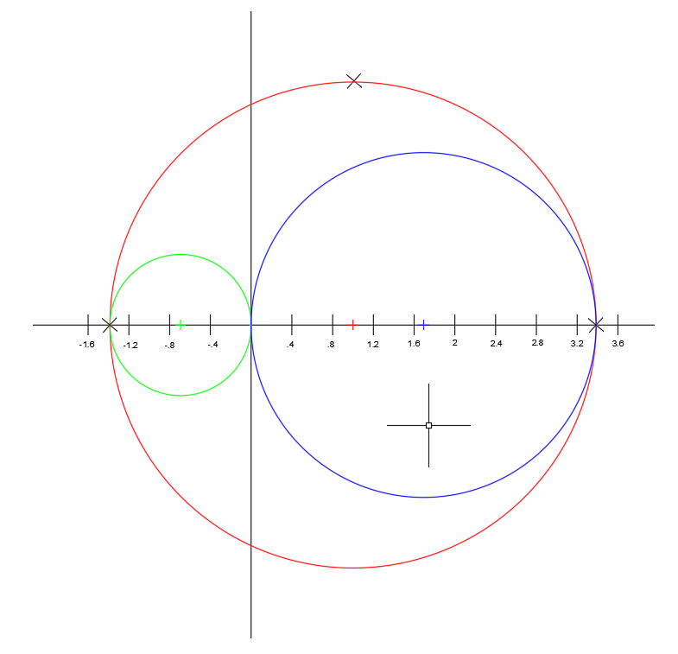
σ₂

σ_{min} = -1.383 MPa

σ₁

σ_{max} = 3.397 MPa

τ_{max} = 2.39 Mpa

MDET Diagram for Output Shaft
σ₁

σ₂

(3.397 MPa, -1.383 MPa)
\\
Knowns: σ₁ = 3.397 MPa & σ₂ = -1.383 MPa

SF = σ_{y}/ σ_{e}
SF = 400 MPa/5.03MPa
SF = 80

σ_{e} = sqrt(σ₁² - σ₂² – σ₁ σ₂ + 3τ_{max})
σ_{e} = sqrt((3.397)² – (-1.383)² – (3.397)(-1.383) + 3(2.39))
σ_{e} = sqrt(25.32)
σ_{e} = 5.03 MPa

Conclusion
After looking at all the opportunities to create a mechanical advantage and after in-depth analysis of our prototype, our team still agrees that the use of a pulley would be the easiest and most convenient mechanism for Hastings to develop. Not only would the basic parts of the pulley itself be easy to find, but it’s also easy to put together. The team wanted to keep a balance between producing a clean and smooth mechanical advantage while also staying away from anything too complex or hard for Hastings to do.
Also, it has been determined that our prototype will withstand any torque, torsion, or shear stress that will be produced by the water, weight of the equipment, or even the mechanism itself. According to the stress analysis of the input shaft, it has a safety rating of 140. The output shaft, however, was calculated to have a safety rating of 80. Both values are very high which almost guarantees that they will never break, at least not for a long time. Another beneficial part of the safety factors being so high would be that we could increase everything by a specific scale and still yield safety factors that are well above unacceptable. This further backs our team’s idea on the generator being very adaptable. Our plan wasn’t to design a product for him to buy, but to create an operation that would produce him the most power possible where we would try to incorporate his original design.
Overall, our team is very happy with the results that were produced throughout this project. We hope that this might shine some light upon the problem that Hastings is trying to solve. If he were to use an operation like this, it might not be too long until his generators can produce even more power at an even faster rate while supplying multiple houses. With the help of the many different people from around Africa and UW-Stout, good things will happen.
Figure 7: Back View of SolidWorks Design Concept
Figure 11: Left Side Isometric View of SolidWorks Concept Design
Work Cited
Juvinall, Robert C., and Kurt M. Marshek. Fundamentals of Machine Component Design. 5th ed. New York: Wiley, 2000. Print.

Nikhil, Nandepu. "Bicycle Rim." GrabCAD. Stratasys, 12 Oct. 2016. Web. 18 Apr. 2017.

"Mounted Ball Bearings." McMaster-Carr. McMaster-Carr, n.d. Web. 15 Apr. 2017.

Appendix
Equation Chart

Moment Equation:
ƩM = (F₁)(d₁) + (F₂)(d₂) + ect.
Variables: ƩM = Sum of the Moments, F₁ = Force, d₁ = Distance

Sigma Equivalent Equation:
σ_{e} = sqrt(σ₁² - σ₂² – σ₁ σ₂ + 3τ_{max})
Variables: σ_{e} = Sigma Equivalent, σ₁ = Sigma max, σ₂ = Sigma min, τ_{max} = Max torsion.

Custom Variables:
A_{y1} = Reaction force #1 on input shaft, B_{y1} = Reaction force #2 on input shaft, C_{y1} = Reaction force #3 on input shaft, A_{y2} = Reaction force #1 on output shaft, B_{y2} = Reaction force #2 on output shaft, C_{y2} = Reaction force #3 on output shaft, F_{sp} = Force of small pulley, F_{m} = Force of generator, F_{bp} = Force of big pulley, F_{w} = Force of water wheel, T_{w} = Torque on water wheel, T_{sp} = Torque on small pulley, T_{bp} = Torque on big pulley.

Safety Factor Equation:
SF = σ_{y}/ σ_{e}
Variables: SF = Safety factor, σ_{y} = Yielding strength of steel, σ_{e} = Sigma Equivalent

Torque Equation:
T = Fr
Variables: T = Torque, F = Force, r = radius.

Sigma Radius Equation:
σ_{r} = sqrt((σ₁ + σ₂)/2)² + (τ_{T}))
Variables: σ_{r} = Radius of Mohr’s Circle, σ₁ = Sigma max, σ₂ = Sigma min, τ_{T} = Max shear stress

Sigma Average Equation:
σ_{ave} = (σ₁ + σ₂)/2
Variables: σ_{ave} = Center of circle for Mohr’s Circle, σ₁ = Sigma max, σ₂ = Sigma min

Torsional Total Equation:
τ_{T} = Tr/J
Variables: τ_{T} = Torsional torque, r = Radius of shaft, J = Polar moment of inertia of the cross section.

Bending Stress Equation:
σ_{b} = My/I
Variables: σ_{b} = bending stress, M = max bending moment, y = radius from neutral axis to outer edge, I = Moment of inertia of cross section with respect to the neutral axis.

