**A simplified model for predicting shrinkage during low temperature air drying of porous food materials**

**Ankita Sinhaa, Atul Bhargava,\***

aDepartment of Mechanical Engineering

Indian Institute of Technology Gandhinagar

Palaj, Gandhinagar, GJ 382355

India

\***Corresponding author**

Tel: +91 792 395 2419, +91 814 030 7813

Email: [atul.bhargav@iitgn.ac.in](mailto:atul.bhargav@iitgn.ac.in)  (Atul Bhargav)

**A simplified model for predicting shrinkage during low temperature air drying of porous food materials**

## Abstract

Food materials shrink when they are air-dried. However, owing largely to the complexity of modelling, most drying models so far have neglected this shrinkage, leading to inaccurate predictions. The empirical nature, inability to yield data on location-specific deformations and computational cost of detailed poro-mechanistic analyses and complex deformation modelling approaches make them unattractive for models that could be used in real-time process control algorithms. In this work, we develop a simplified transport model to predict spatial and temporal shrinkage during low temperature air drying process, and validate the model with experiments. In such drying, volumetric change is dominated by moisture loss; therefore the role of gas induced porosity is neglected. This model predicts shrinkage, temperature and moisture content at each spatial location at time intervals during the drying process. The model agrees well with experiments conducted by us (reported in this paper) as well as with those conducted by others (taken from the literature) on food samples. We expect that this generalized model will find wide applications in the food processing industry.

Keywords: Air drying, porous media, food, modelling, low temperature drying, shrinkage modelling

## Introduction

Drying is an important process in the quality preservation of food materials. Air drying or convection drying refers to the removal of moisture from food materials by passing hot air over it. The process involves complex heat and mass transport with in the porous structure of hygroscopic food materials, leading to shrinkage. Modelling of air drying phenomena facilitates prediction and optimization of thermo-physical changes and final quality of processed food materials. Neglecting shrinkage during modelling may lead to poor understanding of the underlying mechanisms and inaccurate predictions of material behaviour and its quality [1].

The shrinkage deformation has been investigated experimentally for various food materials by various researchers in the past. However, numerical studies that model shrinkage behaviour are limited. Some researchers modelled shrinkage by developing empirical and semi-empirical relations [2]. The major challenge associated with such models is their lack of replicability, especially in case of food materials, due to their organic nature. Various physics-based models such as linear elastic models, hyper-elastic models and viscoelastic models for modelling shrinkage in food materials have also been developed [3,4 5 6]. These models require information about the constitutive relation, Young’s modulus and Poisson’s ratio of the material of interest. Lack of these information due to change in material properties and behaviour owing to geographical variations, different harvest cycles etc. may lead to limited applicability of the model. Further, application of such models are complex, computationally costly and also sometimes involves empirical relations for Young’s modulus. This poses a need of a simplified modelling strategy for capturing shrinkage behaviour during drying.

Wang and Brennan [7] showed experimentally that during low temperature drying, the porosity induced due to the excessive vapour formation (called as gas induced porosity) is negligible and thus shrinkage solely depends on moisture loss for maximum period of drying. Further, modelling studies have also demonstrated that when the food material is in rubbery stage, the net shrinkage is due to moisture loss only and thus gas porosity effect is negligible [5]. Since low temperature drying results in near uniform heating, thus rubbery state is more likely to exist for most of the drying process [8]. Based on these findings in the literature, the current work focuses on developing a simple porous media based prediction tool that could predict transport phenomena and deformation behaviour during low temperature dying, without any need of solving deformation models.

The manuscript is arranged as follows. Firstly, drying experiments are explained. Then, the model development for the drying process is described, followed by simulations and their validation for two cases viz. conducted experiments as well as with that of other reported literature. Parametric sensitivity analysis is then performed to identify sensitive input parameters. Finally a brief discussion about the quantification of assumption criteria for low temperature drying is done.

## Materials and methods

Potato (*Solanum tuberosum*) was used as the subject of study. Potatoes were bought from local market and were kept in local storage. Before experiments, the potatoes were bought to room temperature, washed, peeled and then cut into cubes of 14 mm edge length using a mechanical cutter. Any excess moisture that surfaced due to washing and cutting was removed gently using dry paper napkins. Drying was carried out in a convection oven (Nova Instruments, India) maintained at a temperature of 60oC by passing hot and dry air (zero relative humidity) at a velocity of 1 m s-1.Three variables viz. moisture content, temperature and shrinkage were analysed during the experiments.

The initial moisture content of the potato was measured using gravimetric method. In this method, food material is dried at 103oC for 24 hours and the difference in weight before and after drying is recorded. The change in weight corresponds to the amount of moisture that was originally present in the sample. Ratio of change in weight to the final sample weight is defined as the dry basis moisture content of the food material. Similarly, for capturing variation in average moisture content during drying, food samples were dried for different intervals ranging from 1 min to 300 min. Samples were weighed before and after drying and using difference in weight and initial moisture content, average moisture content was calculated. For temperature measurement, thermocouples were attached to the centre and surface of the food sample and drying was performed under the conditions stated earlier. Temperature was thus recorded as the function of time for whole process. Shrinkage analysis was performed using toluene displacement method [9].

In each of the above-mentioned experiments, three trials of each experiment were performed, each time with a new sample. Sample once used was discarded and not used for other trial or other set of experiment.

## Modelling and simulation

A simplified porous media based transport and deformation model to predict spatial and temporal thermo-physical changes during low temperature air drying processes is developed. The hygroscopic and porous behaviour of food materials is taken into account. Heat transfer is modelled using modified heat diffusion equation whereas moisture and vapour transport is modelled using porous media based mass diffusion models. Darcy’s law is considered for modelling momentum based mass transfer. Water vapour and air is considered as a binary ideal gas mixture [5]. As a novel approach, gas induced porosity was neglected and volumetric changes and shrinkage is predicted using volume balance and mass conservation equations. Spatial variation in temperature and the moisture content of the samples are predicted over time. The transition in shrinkage characteristics from crust to core and its variation over time is also captured.

The following assumptions were considered in the model:

1. Total mass of food material is equal to the sum of mass of dry solids, free water), water vapour and air.
2. Mass of solid remains constant throughout the process.
3. Water vapour and air together makes a binary ideal gas mixture (referred as gas).

|  |  |
| --- | --- |
| Heat: |  |
| $$\frac{∂ρ_{eff}c_{p,eff}T}{∂t}+∇.{\left(ρc_{p}u\right)}_{eff}T =∇.\left(k_{eff}∇T\right)-{\dot{m}}_{vap}h_{vap}$$ | (1) |
| Mass: |  |
| $\frac{∂ϕρ_{w}S_{w}}{∂t}+∇. \text{(}{ρ_{w}u}_{w}\text{)} =∇.\left(D_{w,cap}∇(ϕρ_{w}S_{w})\right)$*- ${ \dot{m}}_{vap}$* | (2) |
| $$S_{w}+S_{g}=1$$ | (3) |
| Momentum: |  |
| $$u_{i}=-\frac{k_{i}^{r}k_{i}^{p}}{μ}∇P$$ | (4) |
| Phase change: |  |
| ${\dot{m}}_{vap}=$*K($ρ_{v,eq}$- $ρ_{v})S_{g}ϕ$* | (5) |
| Ideal gas mixture: |  |
| $$p_{i}=x_{i}P$$ | (6) |

1. Dry solids in the food make a porous .matrix and the water and gas are present in the porous volume.
2. Representative volume approach (REV) is valid and properties remain constant properties within an REV.
3. Non equilibrium evaporation.
4. Gas porosity is neglected.

The governing equations used in the model are as follows:

|  |  |
| --- | --- |
| $$ω_{i}=\frac{M_{i}x_{i}}{\sum_{k=1}^{n}{M_{k}x_{k}}}$$ | (7) |
| Shrinkage estimation: For each element in the food sample, the local shrinkage at any instant is calculated using the following formulae: | |
| $$m_{w}=\int{c_{w}dV}$$ | (8) |
| $$V_{w}=m_{w}/ρ_{w}$$ | (9) |
| $$m_{g}=\int{c_{g}dV}$$ | (10) |
| $$V_{g}=m_{w}/ρ_{w}$$ | (11) |
| $${V=V}_{w}+V_{g}+V_{s}$$ | (12) |

**Computational domain**

Two three-dimensional computational domains as mentioned in figure 2 were considered. Case1 (Figure 1(a)) corresponds to the drying of a cubic potato sample of size 14x14x14 mm3 by passing completely dried air at a temperature of 60oC, 1 m.s-1 velocity and zero relative humidity. Validation of case 1 is done by conducting experiments described in section 2. Case2 (Figure 1(b) corresponds to the drying of potato slab of size 45x20x10 mm3 by temperature of $40℃$ and $70℃$, 4 m/s velocity and zero relative humidity. Case 2 conditions are taken from the literature [7] and thus validated with the same.

**Simulation details**

A porous media based multi-physics model was developed and solved for the two cases by changing the geometry, input parameters and boundary conditions as and when required. . Input data for various thermo-physical parameters and fundamental transport model were selected from one of the literature [5]. Modelling was done using a commercial finite element based, software Comsol5.3a.Free tetrahedral mesh was generated with coarser mesh towards the centre and larger densities of mesh elements at the edges. Grid convergence analyses were performed for mesh refinement and accordingly, number of elements were chosen for case 1 and 2 respectively. Figure 1(c) and 1(d) show the meshed domain. Figure 2 shows the schematic representation for all the phenomena captured and their coupling with each other.

Table 1 shows the meshing parameters for selected mesh structures for both the cases.

## Results and discussions

Results for each of the considered cases are describe in the following order. Firstly, temperature and moisture variation is first described. Observed shrinkage behaviour and spatial shrinkage profile are demonstrated. This is followed by the validation of the proposed model with experiments. Then parametric sensitivity of the model is explained. Finally, some insights are given about the development of a quantification criteria for low temperature drying.

**Case 1:**

In case 1, size of the sample is kept small (14x14x14 mm3) and air temperature was kept 60oC and the transport and deformation behaviour is then studied. Figure 3(a) shows the variation of centre and surface node temperature with time. The heat transfer is near uniform in the structure and centre and surface temperature difference is not very high. This is due to small size of sample and low air velocity. The details of the effect of these parameters is also discussed in a later section.

Figure 3(b) shows the variation in average moisture in the sample with time. Initially, the moisture loss is rapid due to large moisture content with in the sample. As drying proceeds, surface evaporation becomes rapid and drying rate gets limited by the rate of internal diffusion thus slowing down the drying process. Figure 4 shows the contour plots for temperature at moisture at selected intervals.

Figure 5(a) shows the spatial shrinkage profile observed at the intermediate step and end of drying process and Figure 5(b) shows the modelled shrinkage behaviour in the sample with respect to time.

Validation: Model is validated with experiments conducted for potato sample. Figure 3(b) and Figure 5(a) shows the comparison of predicted temporal moisture and shrinkage variation with experimental results.

**Case 2:**

In this case, the behaviour was studied for two air temperature. Therefore, the role of different air temperature on transport and deformation behaviour in a given sample is addressed.

Figure 6 shows the temperature and moisture variation for convection oven drying of a potato slab of dimension 45 mm × 20 mm × 10 mm at air temperature of 40℃ and 70℃ respectively. It is observed that for a drying temperature of 40℃, the spatial temperature is near uniform and there is not much variation in centre and surface temperature at any instant. As the drying temperature increases, surface drying dominates and the temperature at surface increases at a faster rate. Further, due to moisture loss, conductivity of the material in the dehydrated region decreases which impedes heat transfer from core towards the surface.

Near uniform drying also results in uniform shrinkage within in the sample. This corresponds to a more uniform shrinkage with in the sample for low temperature. As we increase the drying air temperature, the spatial variation in temperature becomes significant, leading to different rate of moisture loss within the sample and thus induces non uniform shrinkage. Figure 7 shows the variation in shrinkage ratio with average moisture content.

**Parametric sensitivity analysis**

Sensitivity of the drying process to all the properties except air and water properties was analysed .Initial porosity ($∅_{wo}$), initial water content ($S_{wo}$) and solid density ($ρ_{s}$) were found to be the most sensitive input parameters for the developed physics based model. Figure (9),(10) and (11) show the effect of these parameters on moisture content, temperature and average shrinkage ratio.

Also, the physics based modelling show that pressure change during low temperature drying is almost negligible. Thus, the proposed low temperature drying model could be further simplified by considering constant ambient pressure throughout the process and thus mitigating the need of implementing Darcy’s law for pressure induced flow.

**Quantification of criteria for assuming uniform heating and uniform shrinkage:**

From the current study, it is clear that small sample and low air temperature are crucial parameters in assuring near uniform heating of sample; which in turn ensures uniform shrinkage and negligible gas induced porosity. Similarly, it can be studied that keeping the velocity of passed air low could also contribute to meet the near uniform conditions. Thus, there is a need to define criteria that takes into account the cumulative effect of these parameters. From the fundamental of heat transfer, we can analyse this by utilising the concept of lumped capacitance and Biot number (Bi) [9]. However the analysis here becomes complex due to the variation in properties and sample shrinkage resulting due to moisture loss.

In this case, Bi at any instant can be defined as:

$$Bi\left(t\right)=\frac{hL_{c}\left(t\right)}{k(t)}$$

For lumped capacitance to be valid, Bi<0.1

In the above equation h takes in to account the effect of air velocity. With increase in air velocity h increases resulting in increase in Bi. Similarly as the sample shrinks (decreasing Lc), the heat transfer per unit surface area increases resulting in higher rate of heat transfer at surface as compared to conduction from inner core This results in higher Bi.

Analysis of effect of conductivity here is less straight forward for drying. The net thermal conductivity of any element in a food material is taken as the weighted average of conductivity of starch and moisture. Due to low thermal conductivity of polymers, heat conduction is mainly due to moisture only. At higher drying temperature, the rate of moisture loss from the surface is higher thus the moisture content decreases leading to lower thermal conductivity in the sample’s dried region (also explained in earlier sections). Due to decrease in thermal conductivity, rate of heat conduction slows down as compared to that of surface convention. This corresponds to higher *Biot* number and thus non applicability of lumped capacitance analysis. A more detailed analysis of these parameters could lead to the development of empirical relations for developing the validity criteria for different sample geometries, dimensions and set of operating conditions.

**Conclusions**

A simplified model to capture transport and deformation phenomena during drying of food materials is developed. The major findings and contributions of the work are as follows:

* Need of complex constitutive models for capturing deformation is mitigated due to negligence of gas porosity, without any significant compromise in the accuracy of predicted thermo-physical parameters.
* Moisture content remains near uniform for low temperature drying and thus modelling could be further simplified for commercial applications by considering same temperature across the whole domain, at any instant.
* The spatial as well as overall shrinkage behaviour is captured over time and the phenomena is in agreement with reported microstructural changes.

The proposed work could be used as a prediction tool for analysis and optimization of dryer conditions, process parameters and sample geometry and dimensions during low temperature drying processes for commercial applications. Further, the effect of air velocity and air humidity on the thermo-physical behaviour could also be studied and the criteria for the applicability of model could be quantified.

**References**

1. L. Mayor, and A. M. Sereno. 2004. “Modelling shrinkage during convective drying of food materials: A review.” *Journal of Food Engineering* 61(3): 373–86. doi:10.1016/S0260-8774(03)00144-4.
2. S. Parthasarathi, and C. Anandharamakrishnan. 2014. “Modeling of shrinkage, rehydration and textural changes for food structural analysis: A review.” *Journal of Food Process Engineering* 37: 199–10. doi:10.1111/jfpe.12073
3. S. Chemkhi, F. Zagrouba, and A. Bellagi. 2004. “Mathematical model for drying of highly shrinkable media.” *Drying technology:An International Journal*  22: 1023–39. doi:10.1081/DRT-120038578
4. A. Dhall, and A. K. Datta. 2011. “Transport in deformable food materials: A poromechanics approach.” *Chemical Engineering Science*  66: 6482-97. doi:10.1016/j.ces.2011.09.001
5. T. Gulati, and A. K. Datta. 2015. “Mechanistic understanding of case-hardening and texture development during drying of food materials.” *Journal of Food Engineering* 166: 119–38. doi:10.1016/j.jfoodeng.2015.05.031
6. Y. Llave, K. Takemori, M. Fukuoka, T. Takemori, H. Tomita, and N. Sakai. 2016. “Mathematical modeling of shrinkage deformation in eggplant undergoing simultaneous heat and mass transfer during convection-oven roasting.” *Journal of Food Engineering* 178: 124–36. doi:10.1016/j.jfoodeng.2016.01.013
7. N. Wang, and J. G. Brennan. 1995. “Changes in structure, density and porosity of potato during dehydration.” *Journal of Food Engineering* 24: 61–76. doi:10.1016/0260-8774(94)P1608-Z
8. F. P. Incropera, A. S. Lavine, T. L. Bergman, and D. P. DeWitt. 2013. “*Principles of heat and mass transfer*.” *Wiley.*
9. R. Golestani, A. Raisi and A. Aroujalian. 2013. “Mathematical modeling on air drying of apples considering shrinkage and variable diffusion coefficient.” *Drying Technology*, 31(1):40-51.

Tables

Table 1 Mesh statistics

|  |  |  |
| --- | --- | --- |
| **Attribute** | **Case 1** | **Case 2** |
| Number of elements | 21566 | 9628 |
| Maximum element size(m) | 2.66e-3 | 0.0255 |
| Minimum element size(m) | 5.6e-4 | 3.15e-3 |
| Maximum element growth rate | 1.7 | 2 |

List of figures

|  |  |
| --- | --- |
| Figure 1 | Selected computational domains and their meshing. |
| Figure 2 | Flow chart showing the details of various sections of developed computation model and their coupling. |
| Figure 3 | Variation in centre and surface temperature and average moisture content with time. |
| Figure 4 | (a) Temperature and (b) moisture contours across a diagonal cross section of food sample at 150 and 300 min. |
| Figure 5 | Figure 5. (a) Shrinkage variation across a diagonal cross section of food sample at 150 and 300 min (b) Shrinkage ratio variation with average moisture content ratio. |
| Figure 6 | Variation in (a) centre and surface temperature (b) centre and surface moisture content and (c) average moisture content with time for drying at 40℃ and 70℃. |
| Figure 7 | Obtained characteristic drying rate curves for drying at 40℃ and 70℃ |
| Figure 8 | Shrinkage ratio variation with average moisture content ratio for (a) 40℃ and (b) 70℃. |
| Figure 9 | Effect of variation in solid density on a) centre temperature (b) and surface temperature and (c) average moisture content with time for drying of 14 mm cube at 60℃. |
| Figure 10 | Effect of variation in solid density on a) centre temperature (b) and surface temperature and (c) average moisture content with time for drying of 14 mm cube at 60℃. |
| Figure 11 | Figure 11. Effect of variation in solid density on a) centre temperature (b) and surface temperature and (c) average moisture content with time for drying of 14 mm cube at 60℃. |

Figures



Figure 1. Selected computational domains and their meshing.

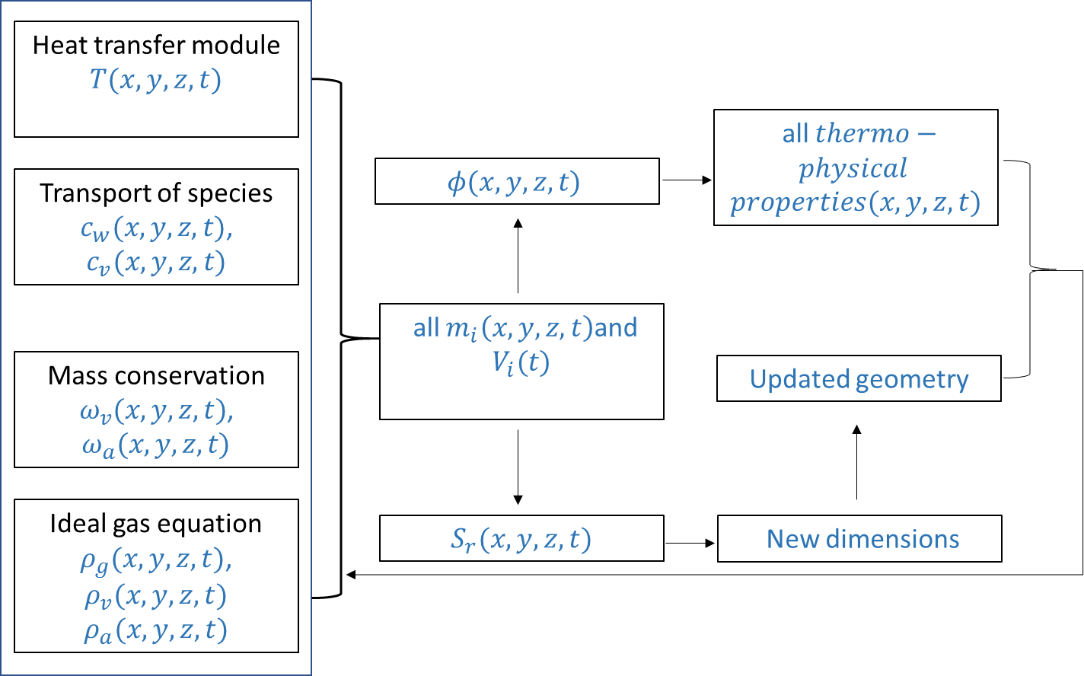

Figure 2. Flow chart showing the details of various sections of developed computation model and their coupling.

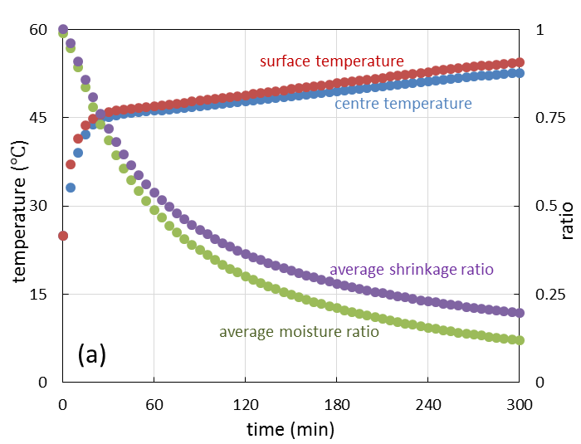

Figure 3. Variation in centre and surface temperature and average moisture content with time.

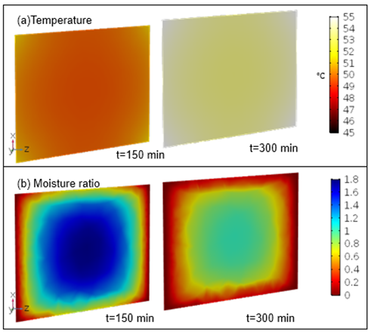

Figure 4. (a) Temperature and (b) moisture contours across a diagonal cross section of food sample at 150 and 300 min.



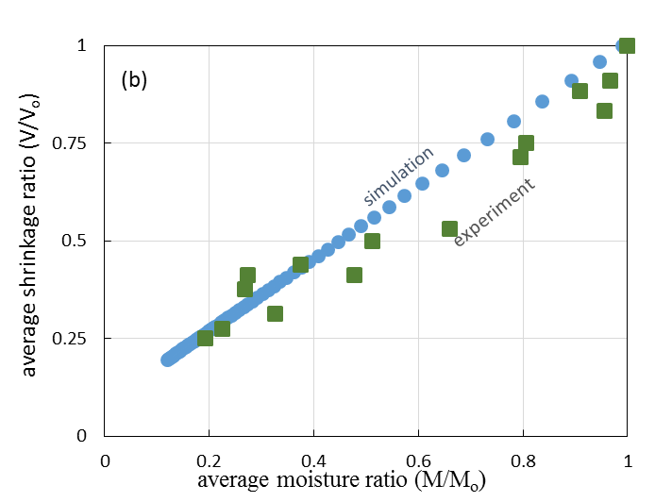

Figure 5. (a) Shrinkage variation across a diagonal cross section of food sample at 150 and 300 min (b) Shrinkage ratio variation with average moisture content ratio.

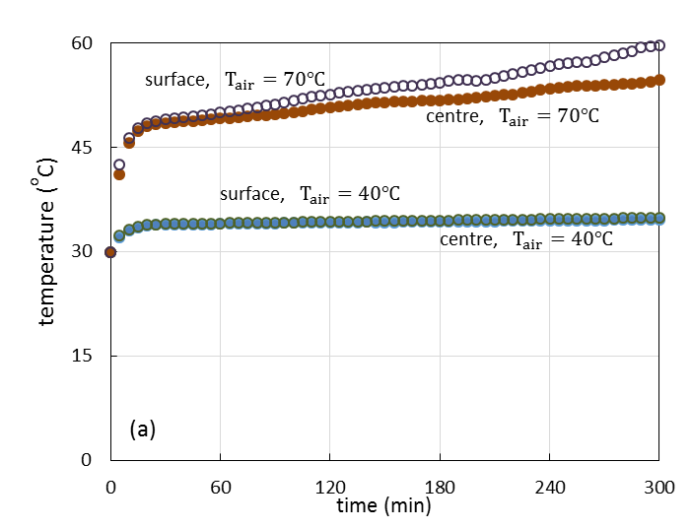

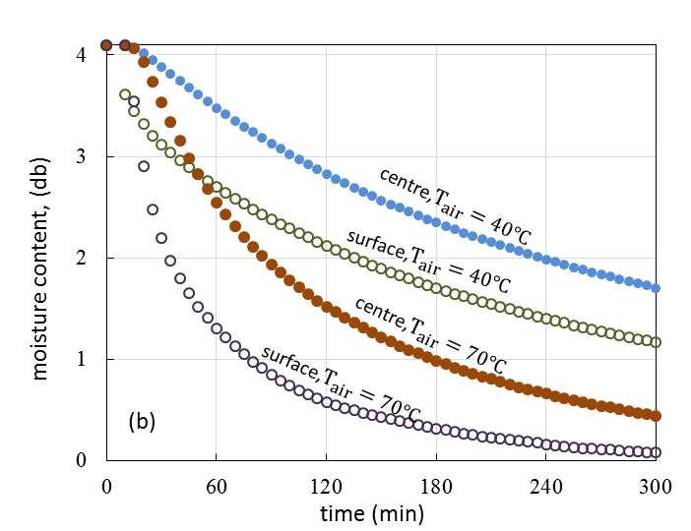

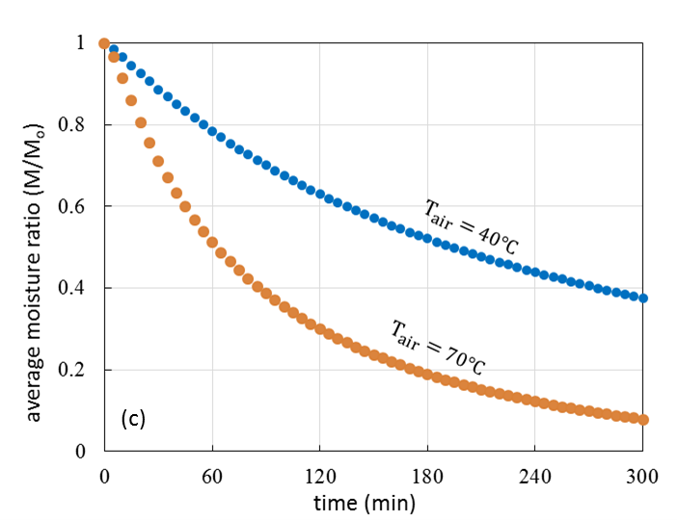

Figure 6. Variation in (a) centre and surface temperature (b) centre and surface moisture content and   
(c) average moisture content with time for drying at 40℃ and 70℃.

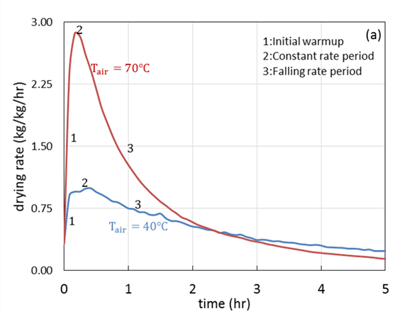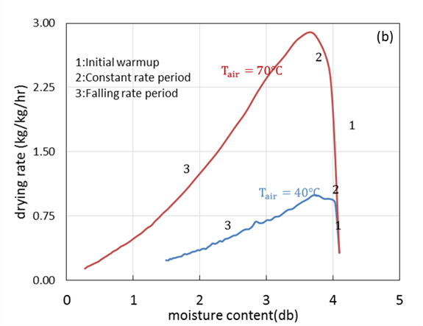

Figure 7. Obtained characteristic drying rate curves for drying at 40℃ and 70℃

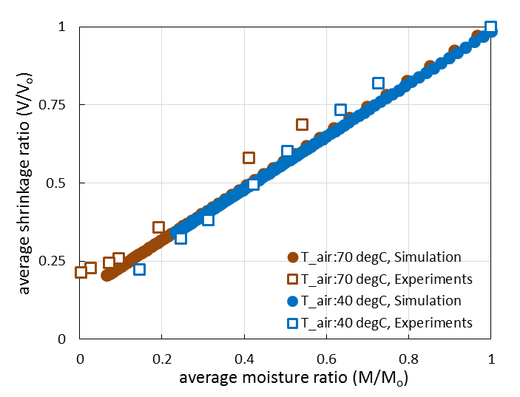

Figure 8. Shrinkage ratio variation with average moisture content ratio for (a) 40℃ and (b) 70℃

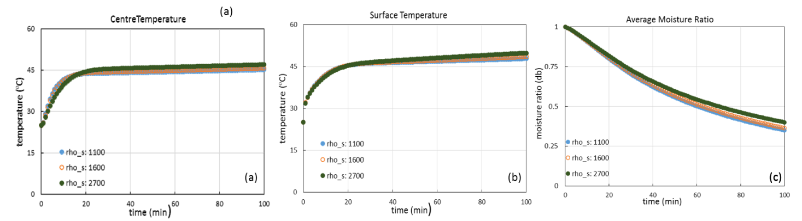

Figure 9. Effect of variation in solid density on a) centre temperature (b) and surface temperature and   
(c) average moisture content with time for drying of 14 mm cube at 60℃.

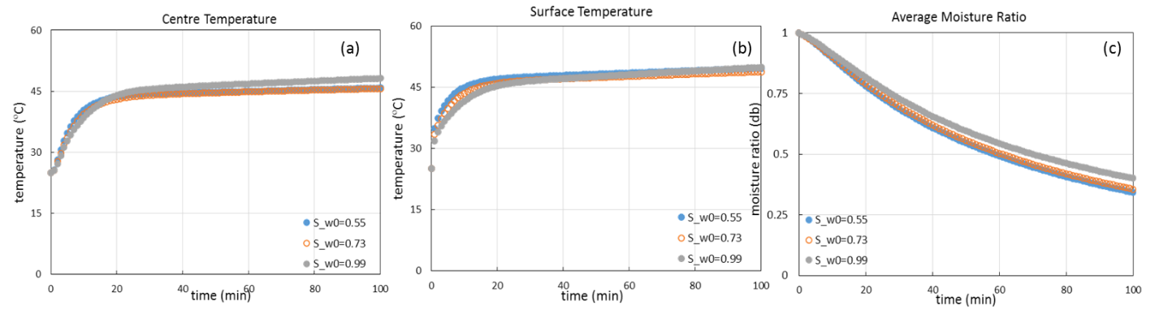

Figure 10. Effect of variation in solid density on a) centre temperature (b) and surface temperature and (c) average moisture content with time for drying of 14 mm cube at 60℃.

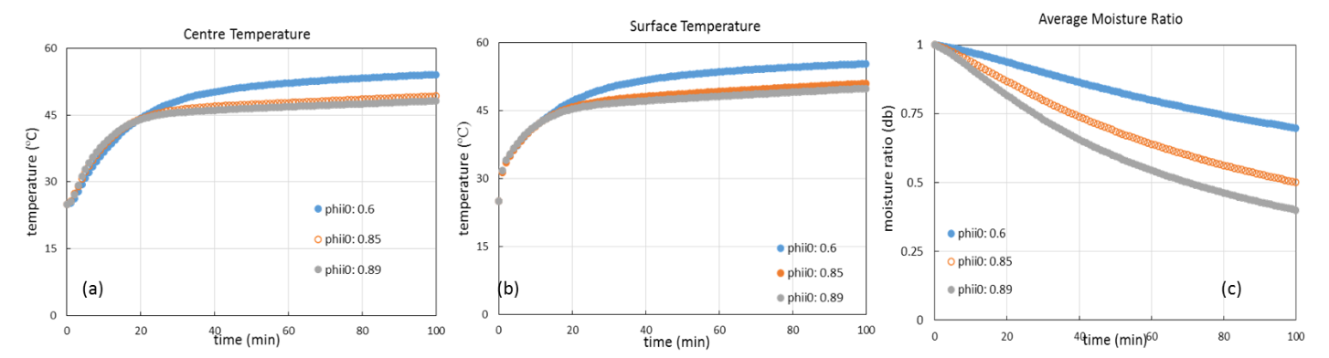

Figure 11. Effect of variation in solid density on a) centre temperature (b) and surface temperature and (c) average moisture content with time for drying of 14 mm cube at 60℃.