Chain and Sprocket Hydro Generator Drive System

Cole Deering, Abdulrahman Alrehaili, Brody Wogernese, Brandon Schindler ,Ben Zabel

Table of Contents

Background Information…………………………..3

Current Design Details…………………………….4

Proposed Design…………………………………....5

Design Specifications……………………………....6

Outcomes…………………………………………...8

References………………………………………….9

Background
This project aims to bring power to rural towns in Malawi through the use of a micro hydro generator. Currently only about 11% of rural Malawi have electrical power access according to the world bank, sustainable energy for all database. The rugged terrain makes it ideal for hydro power. Near Hastings Mkandawire village is a small river which is diverted through plastic pipes. These pipes are plumbed downhill, this allows Hastings to increase the pressure of the water. At the bottom of the hill the water is directed at a water wheel on a shaft hooked up to a small generator. Hastings Mkandawire is the man who started the company Magnetic Power Company who is responsible for building these small generators. Hastings started by converting motor casings and other scrap materials into Nano-hydro-generators. What Hastings would like to have in his future design is sand casted key parts so generators can be mass produced. Hastings and his business want to spread access of electricity in his community and other small towns. We are going to aid in this process by helping to design a drive system that maximizes the performance measured as electrical power output for a flow of water.

Current design details
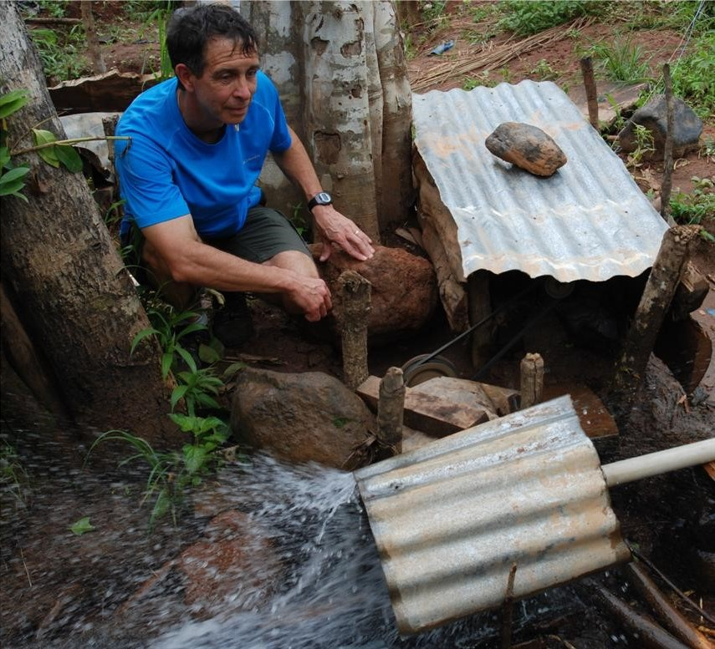
The current design Hastings Mkandawire uses vary for each generator he creates. The current designs consist of motors, belt drives, shafts, and a turbine. The turbines are powered by water which will turn the turbine at 1500 RPM during normal operation, but not all of the water sources provide enough water to turn the turbine at 1500 RPM. One of the main difficulties in which Hastings had controlling the positional tolerance of the two shafts. Another difficulty is the limited supply of parts available, so Hastings goes to junkyards and acquires the parts he needs to create the generators. He can create different advantages through his pulley and belt systems if needed to either raise or lower the ratio to achieve optimum operational speeds to run the generator.

Proposed Design
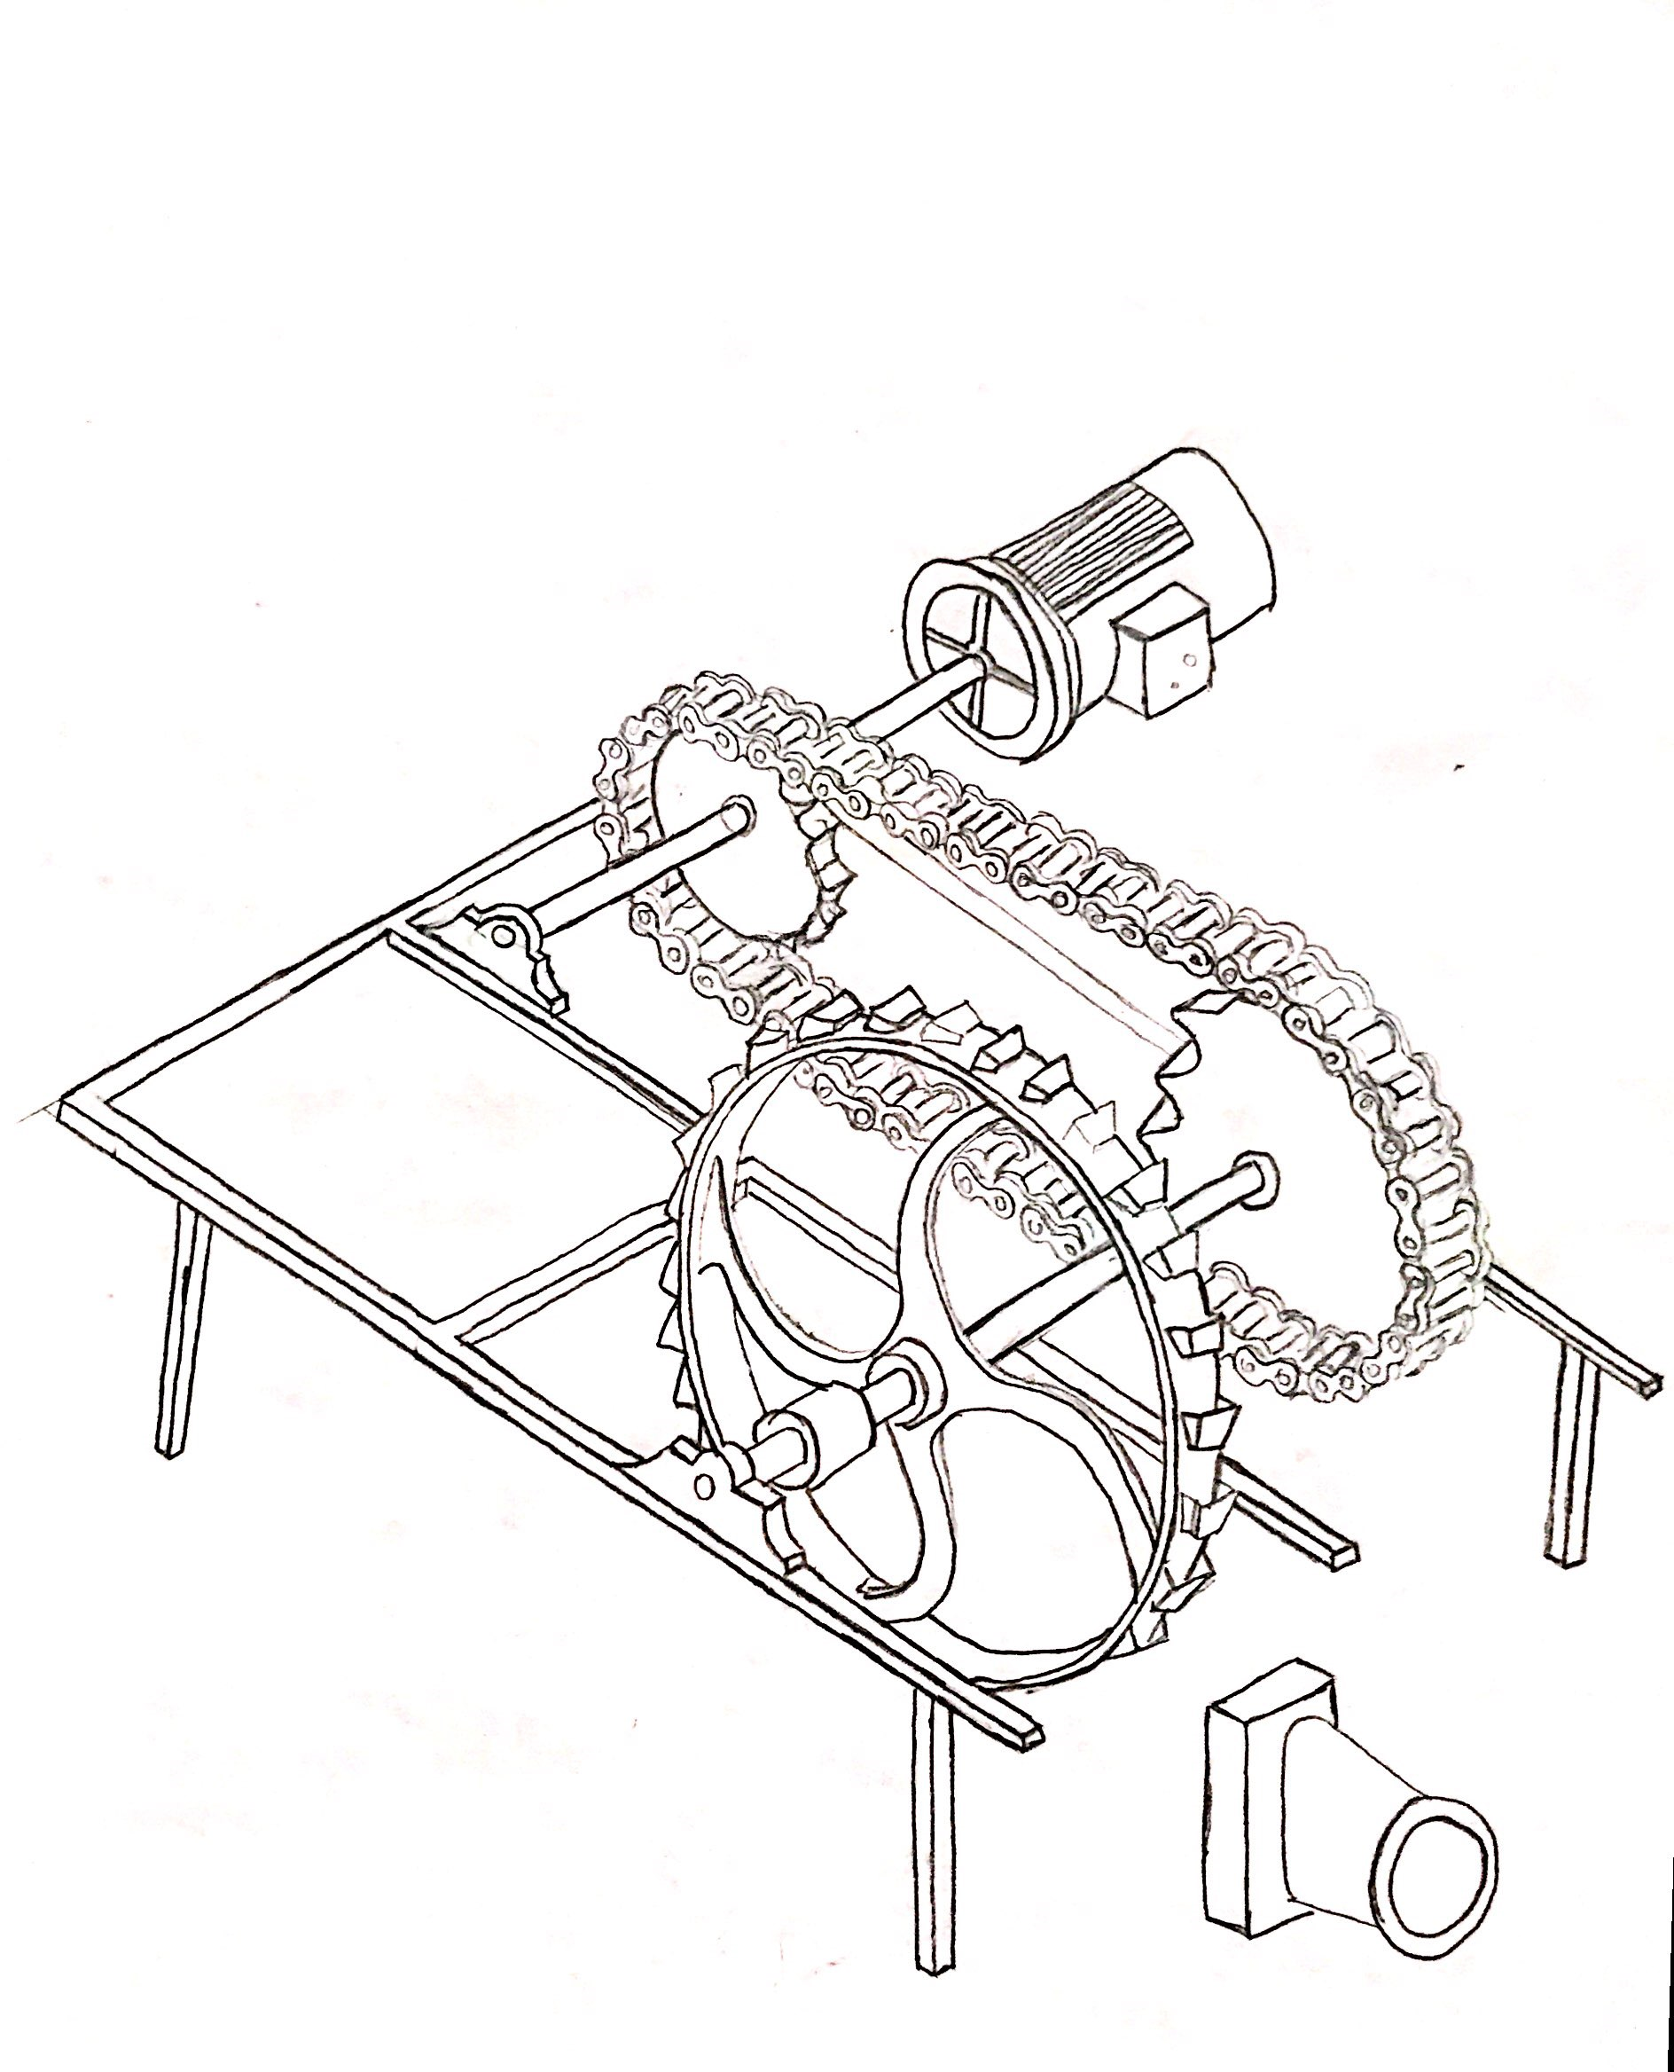
Utilize the sprockets and chain off a bike to increase the turbine's rotational velocity. A chain tensioner will be installed between the two bike sprockets. This will allow the sprockets to be mounted at different distances apart. Hastings Mkandawire will be able to change the bike gear ratio for different water pressures, which will allow him to get the RPMs needed to produce electricity. Hastings should be able to find bike chain and gears at his local junk yard. Hastings will also be able using bearings he finds in the junkyard to help reduce friction on the rotating shafts. With this proposed design, Hastings will be able to produce electricity while using less water and having less water pressure. By using this design, Hastings will be able to provide more electricity to families and homes in Malawi. Using bike chains and sprockets will make it easier for Hasting to obtain parts if needed because there are lots of bikes and their parts are generally very cheap. Reference figure 1-1 to see sketch of proposed design.

Figure 1-1 above shows a sketch of proposed design.

Design Specs
The design for our system needs to be
- Shaft diameter to hold up to torque
  - Shaft diameter should be around 1” to stand up to the fatigue of the system.
- Bearings to support shaft
  - Bearings will be mounted as close to the applied loads as possible to reduce deflections and bending moments and increases critical speeds.
  - Radially loaded bearings will be utilized to support the shaft.
- Drive system to transmit power
  - Helps utilize mechanical advantages to boost or lower system outputs.
- Chain Tensioner to keep chain tight and in line
  - Reduce the chances of slipping within the drivetrain and loss of electricity.
- Access to lubricate chain and sprockets when needed
  - Keeping the chain and sprockets lubricated will help eliminate friction and allow the mechanism to last longer.
- Ease of disassembly to be portable
  - Hastings plan is to make many of these systems and will need to be able to transport and place these systems in rough terrain.
- Parts easy to source (bike chain and sprockets)
  - Helps keep the costs down as well as lowers the down time due to waiting on parts to show up to fix the system.
- Parts easy to replace
  - Accessibility and ease of install will make for less down time on the system when something breaks.
- Rigid Mount System
  - Using a rigid frame helps to keep shafts from misaligning and causing slip in the drive system.

Outcomes
The objective of the design is to increase the mechanical advantage of the system with the materials available to Hastings. The mechanical advantage can be increased by incorporating a chain and sprocket into the system. The chain and sprocket will allow the turbine to spin at a lower rpm and will allow the shaft on the motor to spin at a high rpm. This design will allow for Hastings to place the generators in areas where the water pressure is not as high. The design also contains numerous ball bearings which allow the sprockets to rotate easily. The ball bearings will be need to be found since Hastings does not have the ability to purchase quality ball bearings. This creates a problem because Hasting will not be able to always find the same ball bearings in the junkyard. In the design of the system we must account for the lack of parts and the variation of different parts available to Hastings
. Hasting can use sand casting to create parts also. This process can be utilized to create a more efficient turbine. Right now, Hastings in using whatever he can find in the junkyard for the turbine. The turbine design will allow the turbine to spin easier with less water. Also, Hastings will be able to utilize the sand casting to cast his own sprockets. This will allow him to keep the sprockets the same. This reduces the amount of variance in the system.
We are also looking for a way to ensure the position of the chain and sprocket system does not shift causing a loss in drive power. Hastings in experiencing difficulties with the pulleys on the shaft of the motor and the shaft of the turbine. The misalignment of the shafts will result a loss in the mechanical advantage of the system. The misalignment of the system can be fixed by utilizing a fixture that ensure the locations of the motor and turbine stay aligned. This fixture can be created using any sort of scrap metal that is able to be welded. The frame will be adjustable to allow Hastings to fabricate the fixture in any way to fit any situation the generator is placed.
The fabrication of the generator and fixture is designed to simple and adjustable to any situation. The main purpose of this design is to make the design as simple and as adjustable as possible since the material situation in Malawi is very scarce. The generator with the chain and sprocket system will allow Hastings to create a more efficient system for generating electricity to the nearby villages.

Resources
http://data.worldbank.org/indicator/EG.ELC.ACCS.ZS?end=2014&locations=MW&page=1&start=1990&view=chart
PowerPoint Slides by Devin Berg on D2L

