Nonlinear dynamics of an axially moving beam with fractional viscoelastic damping
Hongxiang Yang ª, Ping Zhu ^{b,} , Lili Zhu ª, Weiyan Liu ^{c}
ª College of Information Science and Technology, Taishan University, Taian, Shandong, P.R. China
^{b} Key Laboratory for Wind and Bridge Engineering of Hunan Province, College of Civil Engineering, Hunan University, Changsha, Hunan, P.R. China
^{c} College of Mathematics and Statics, Taishan University, Taian, Shandong, P.R. China

Abstract: Nonlinear dynamics of an axially moving viscoelastic beam subjected to transverse harmonic excitation is studied. The governing equation of motion of this system is discretized by employing Galerkin’s technique which yields a single-degree-of-freedom Duffing system having nonlinear fractional derivative. The viscoelastic properties of the material are described by the fractional Kelvin–Voigt model based on the Caputo definition. The primary resonance is analytically investigated by the averaging method. With the aid of response curves, a parametric study is conducted to display the influences of the fractional order and the viscosity coefficient on steady-state responses. The validations of this study are given through comparisons between the analytical solutions and numerical ones, where the stability of the solutions is determined by the Routh-Hurwitz criterion. It is found that suppression of undesirable responses can be achieved via changing the viscosity of the system.

Keywords: Axially moving viscoelastic beam; Fractional Kelvin model; Nonlinear dynamics; Steady-state responses.

1. Introduction
The model of axially moving systems is always observed in a wide range of engineering devices, such as paper sheets, magnetic tapes, power transmission belts, chains, fiber textiles, aerial tramways, pipes conveying fluids, and so on. Therefore, research on dynamic behaviors of such systems has been concerned by numerous scholars in the past decades and is still of interest today ^{[1–3]}. Especially, the problem of axially moving beams has widely been tackled in the analysis of some aspects, such as stability analysis ^{[4]}, discretization approaches ^{[5]}, modeling techniques ^{[6]}, different solution methods ^{[7, 8]}, nonlinear dynamics ^{[4-18]}, etc. Recently, in architectural design and construction industry, materials that possess excellent damping characteristics are widely utilized to fabricate the structures to enhance their performance from the viewpoint of control. A growing body of research activities has therefore been appearing to explore the nonlinear vibrations of axially moving viscoelastic beams ^{[4-18]}. To better understand the damping mechanism, some classical constitutive models like the Kelvin-Voigt ^{[4-17]}, three-parameter Zener model ^{[18]}, etc., are adopted to effectively describe the dynamical behavior of the viscoelastic materials. Although the classical models contain combinations of elastic and viscous elements, they do not have sufficient parameters to handle the different shapes of the hysteresis loops reflecting the nature of viscoelastic material and structures. Consequently, the fractional calculus ^{[19]} is introduced in constitutive relations to obtain a satisfactory solution for the real viscoelastic behavior of materials over a large range of frequencies ^{[20, 21]}. Although some of the mathematical issues remain unsolved, fractional calculus-based modern viscoelasticity problems are becoming a recent focus of interest ^{[22-29]}.
This research is devoted to investigating the dynamic behavior of an axially moving viscoelastic beam subjected to harmonic excitation. It is assumed that the material of the beam obeys the Kelvin–Voigt model based on the fractional Caputo definition. Remarkably speaking, by one-term Garlerkin’s technique, the governing equation of the beam is discretized into a nonlinear Duffing type equation that has nonlinear fractional operator ^{[24-26]}. The first order averaging method is utilized to derive the modulation equations governing the steady state amplitudes and phase of the system. Then, the stability of the solution is studied by the Routh-Hurwitz criterion ^{[30]}. Finally, the results of representative calculations are described and briefly discussed from the vibration control point of view.

2. Equation of motion
The present study considers a uniform axially moving viscoelastic beam, shown in Fig. 1, with density $ρ$, cross-sectional area $A$, and moment of inertial $I$. The initial tension is represented by $P_{0}$. The beam travels at a constant axial speed $v$ between two motionless ends separated by distance $L$ and is subjected to an external transverse force $F\left(x, T\right)$. Here, it is assumed that the excitation is spatially uniform and temporally harmonic: $F\left(X,T\right)=F\cos{(WT)}$, where $T$ and $X$ represent the time and the axial coordinate, respectively. Only the bending vibration described by the transverse displacement $U\left(X,T\right)$ is considered here, and Newton’s second law of motion yields
 | $$ρA\left(\frac{∂^{2}U}{∂T^{2}}+2v\frac{∂^{2}U}{∂X∂T}+v^{2}\frac{∂^{2}U}{∂X^{2}}\right)=\frac{∂}{∂X}\left[\left(P_{0}+Aσ\left(X,T\right)\right)\frac{∂U}{∂X}\right]-\frac{∂^{2}M\left(X,T\right)}{∂X^{2}}+F\cos\left(WT\right)$$ | (1)
where $σ\left(X,T\right)$ and $M\left(X,T\right)$ are, respectively, the axial disturbed stress and bending moment.
Fig. 1. Schematic diagram of an axially moving beam.
The viscoelastic material of the beam obeys the fractional Kelvin-Voigt model ^{[25-27]} with the constitution relation as follows:
 | $$σ\left(X,T\right)=E_{0}ε_{L}\left(X,T\right)+E_{1}D_{C}^{α}\left[ε_{L}\left(X,T\right)\right]$$ | (2)
where $E_{0}$ represents the Young’s modulus and $E_{1}$ denotes the viscoelasticity coefficient. To account for the geometric nonlinearity due to small but finite stretching of the beam, the Lagrangian strain $ε_{L}(X,T)$ is adopted, which is defined by
 | $$ε_{L}\left(X,T\right)=\frac{1}{2}{\left[\frac{∂U\left(X,T\right)}{∂X}\right]}^{2}$$ | (3)
In Eq. (2), $D_{C}^{α}$ denotes $α$-order fractional differentiation operator with respect to time $T$ in the Caputo sense given by ^{[19]}
 | $$D_{C}^{α}\left(f\right)=\left\{\begin{aligned}&\frac{1}{Γ\left(m-α\right)}\int_{0}^{T}{\frac{f^{m}\left(τ\right)}{{\left(T-τ\right)}^{α+1-m}}dτ}, m-1<α<m \\ &\frac{d^{m}}{dT^{m}}f, α=m (a positive integer)\end{aligned}\right.$$ | (4)
where $Γ$ is the well-known gamma function. Moreover, for a slender beam, the linear moment-curvature relation is adopted:
 | $$M\left(X,T\right)=\left(E_{0}+E_{1}D_{C}^{α}\right)I\frac{∂^{2}U\left(X,T\right)}{∂X^{2}}$$ | (5)
Substitution of Eqs. (2), (3) and (5) into Eq. (1), yields the governing equation of transverse motion of the axially viscoelastic beam
 | $$ρA\left(\frac{∂^{2}U}{∂T^{2}}+2v\frac{∂^{2}U}{∂X∂T}+v^{2}\frac{∂^{2}U}{∂X^{2}}\right)-P_{0}\frac{∂^{2}U}{∂X^{2}}+E_{0}I\frac{∂^{4}U}{∂X^{4}}+E_{1}ID_{C}^{α}\left(\frac{∂^{4}U}{∂X^{4}}\right)=\frac{3}{2}AE_{0}{\left(\frac{∂U}{∂X}\right)}^{2}\frac{∂^{2}U}{∂X^{2}}+\frac{1}{2}AE_{1}\frac{∂^{2}U}{∂X^{2}}D_{C}^{α}\left[{\left(\frac{∂U}{∂X}\right)}^{2}\right]+AE_{1}\frac{∂U}{∂X}D_{C}^{α}\left(\frac{∂U}{∂X}⋅\frac{∂^{2}U}{∂X^{2}}\right)+F\cos\left(WT\right)$$ | (6)
In the present study, the boundary conditions are taken to be simply supported, i.e.,
 | $$U\left(0,T\right)=U\left(L,T\right)=0, \frac{∂^{2}U\left(0,T\right)}{∂X^{2}}=\frac{∂^{2}U\left(L,T\right)}{∂X^{2}}=0$$ | (7)
Using the following dimensionless scheme,
 | $$\begin{matrix}x=\frac{X}{L}, t=\frac{T}{L}\sqrt{\frac{P_{0}}{ρA}}, ω=WL\sqrt{\frac{ρA}{P_{0}}}, u=\frac{U}{L}, γ=v\sqrt{\frac{ρA}{P_{0}}}, k_{f}=\sqrt{\frac{E_{0}I}{P_{0}L^{2}}}, \\ η=\frac{E_{1}I}{P_{0}L^{2}}\sqrt{{\left(\frac{P_{0}}{ρAL^{2}}\right)}^{α}}, k_{1}=\sqrt{\frac{{AE}_{0}}{P_{0}}}, k_{2}=\frac{{AE}_{0}}{2P_{0}}\sqrt{{\left(\frac{P_{0}}{ρAL^{2}}\right)}^{α}}, p=\frac{πFL}{4P_{0}}\end{matrix}$$ | (8)
Eq. (6) becomes
 | $$\frac{∂^{2}u}{∂t^{2}}+2γ\frac{∂^{2}u}{∂x∂t}+\left(γ^{2}-1\right)\frac{∂^{2}u}{∂x^{2}}+k_{f}^{2}\frac{∂^{4}u}{∂x^{4}}+ηD_{C}^{α}\left(\frac{∂^{4}u}{∂x^{4}}\right)=\frac{3}{2}k_{1}^{2}{\left(\frac{∂u}{∂x}\right)}^{2}\frac{∂^{2}u}{∂x^{2}}+k_{2}\left\{\frac{∂^{2}u}{∂x^{2}}D_{C}^{α}\left[{\left(\frac{∂u}{∂x}\right)}^{2}\right]+2\frac{∂u}{∂x}D_{C}^{α}\left(\frac{∂u}{∂x}⋅\frac{∂^{2}u}{∂x^{2}}\right)\right\}+\frac{4}{π}p\cos\left(ωt\right)$$ | (9)
with boundary conditions
 | $$u\left(0,t\right)=u\left(1,t\right)=0, \frac{∂^{2}u\left(0,t\right)}{∂x^{2}}=\frac{∂^{2}u\left(1,t\right)}{∂x^{2}}=0$$ | (10)

3. Steady state responses and stability analysis
In this study, one term Galerkin’s method is applied to discretize Eq. (9), and its solution is assumed to be
 | $$u\left(x,t\right)=q\left(t\right)\sin\left(πx\right)$$ | (11)
where $q\left(t\right)$ is the modal coordinate of the beam. Then, a nonlinear fractional ordinary differential equation is derived
 | $$\ddot{q}+π^{4}ηD_{C}^{α}q+\frac{3}{4}k_{2}π^{4}qD_{C}^{α}\left(q^{2}\right)+π^{2}\left(π^{2}k_{f}^{2}+1-γ^{2}\right)q+\frac{3}{8}k_{1}^{2}π^{4}q^{3}=p\cos{(ωt)}$$ | (12)
For simplicity in the following analysis, Eq. (12) is rewritten as
 | $$\ddot{q}+μ_{1}D_{C}^{α}q+μ_{2}qD_{C}^{α}\left(q^{2}\right)+ω_{0}^{2}q+k_{n}q^{3}=p\cos{(ωt)}$$ | (13)
with
$$μ_{1}=π^{4}η, μ_{2}=\frac{3}{4}k_{2}π^{4}, ω_{0}=π\sqrt{π^{2}k_{f}^{2}+1-γ^{2}}, k_{n}=\frac{3}{8}k_{1}^{2}π^{4}$$
It is remarkable that Eq. (12) or (13) is a nonlinear Duffing type equation having a nonlinear fractional operator $D_{C}^{α}\left(q^{2}\right)$ ^{[24-26]}.
In what follows, the primary resonance of the fractional system described by Eq. (13) will be investigated by the linear averaging method. We mainly focus on examining the effects of the damping parameters and the fractional order on the steady state response of the beam. The stability of the stationary solutions is examined by the Routh-Hurwitz criterion ^{[30]}.
In order to obtain the primary resonance of the fractional oscillator (Eq. (13)), we introduce a small parameter $ε$. We detune the primary resonance by setting $ω_{0}^{2}=ω^{2}+εσ$. Then, Eq. (13) is rewritten as
 | $$\ddot{q}+ω^{2}q=-ε\left[μ_{1}D_{C}^{α}q+μ_{2}qD_{C}^{α}\left(q^{2}\right)+σq+k_{n}q^{3}-p\cos{(ωt)}\right]$$ | (14)
where the parameter $ε$ merely serves to indicate the assumed smallness of the terms without any physical meaning. The solution at $ε=0$ can be written in the form as,
 | $$q=A\cos{θ}, θ=ωt+φ$$ | (15)
where $A$ and $φ$ are integration constants determined by the initial conditions. When $ε≠0$ the approximate solution near the primary resonant frequency region can be viewed as a perturbation of the solution given by Eq. (15). In this case, $A$ and $φ$ are slowly varying functions of time $t$ such that their derivatives are of $o(ε)$. According to the averaging method, we assume that the solution of the system takes the following form
 | $$q=A\cos{θ} and \dot{q}=-Aω\sin{θ}$$ | (16)
which implies
 | $$\dot{A}\cos{θ}-A\dot{φ}\sin{θ}=0$$ | (17)
Differentiating the second equation in Eq. (16) with respect to $t$ gives
 | $$\ddot{q}=-ω\left(\dot{A}\sin{θ+A\dot{φ}\cos{θ}}\right)-ω^{2}q$$ | (18)
Substituting Eqs. (16) and (18) into Eq. (14) leads to
 | $$\left\{\begin{aligned}&\dot{A}=\frac{ε}{ω}\sin{θ}G\left(x,t\right) \\ &\dot{φ}=\frac{ε}{Aω}\cos{θ}G\left(x,t\right)\end{aligned}\right.$$ | (19)
where $G=μ_{1}D_{C}^{α}q+μ_{2}qD_{C}^{α}\left(q^{2}\right)+σq+k_{n}q^{3}-p\cos{ωt}$.
Based on the averaging method, the right-hand side of Eq. (19) can be replaced by its averages over one period when $G$ is a periodic function with respect to $t$. However, owing to the presence of the fractional derivative in Eq. (19), an infinite interval should be considered, and we have
 | $$Aver\left[\left(D_{C}^{α}q^{m}\right)\left(\begin{matrix}\cos{θ} \\ \sin{θ}\end{matrix}\right)\right]=\lim_{T→∞}{\frac{1}{T}\int_{0}^{T}{\left(D_{C}^{α}q^{m}\right)\left(\begin{matrix}\cos{θ} \\ \sin{θ}\end{matrix}\right)dθ}}, m=1, 2$$ | (20)
Since we consider the steady state only, the fractional order derivative of $q$ can be easily derived approximately based on the fractional definition given in Eq. (4) ^{[19, 25, 29]}, as follows
 | $$D_{C}^{α}q≈ω^{α}A\cos\left(θ+\frac{απ}{2}\right), qD_{C}^{α}\left(q^{2}\right)≈\frac{1}{4}{\left(2ω\right)}^{α}A^{3}\cos\left(θ+\frac{απ}{2}\right)$$ | (21)
Subsequently, the average in Eq. (20) can also be integrated over one period, when the fractional derivative of $q$ is replaced by the respective approximation in Eq.(21). Then, we have the averaged equation of (19) as follows
 | $$\left\{\begin{aligned}&\dot{A}≈\frac{ε}{2ωπ}\int_{0}^{2π}{\sin{θ}\tilde{G}\left(A,θ\right)dθ} \\ &\dot{φ}=\frac{ε}{2ωπA}\int_{0}^{2π}{\cos{θ}\tilde{G}\left(A,θ\right)dθ}\end{aligned}\right.$$ | (22)
where
 | $$\tilde{G}=σA\cos{θ}+Aω^{α}\left(μ_{1}+2^{α-2}μ_{2}A^{2}\right)\cos\left(θ+\frac{απ}{2}\right)+2^{α-2}μ_{2}ω^{α}A^{3}\cos\left(3θ+\frac{απ}{2}\right)+\frac{k_{n}}{4}A^{3}\cos^{3}{θ}-p\cos\left(ωt\right)$$ | (23)
A direct calculation yields
 | $$\left\{\begin{aligned}&\dot{A}=-\frac{ε}{2ω}\left(f_{11}A+f_{12}A^{3}+p\sin{φ}\right) \\ &\dot{φ}=\frac{ε}{2ωA}\left(f_{21}A+f_{22}A^{3}-p\cos{φ}\right)\end{aligned}\right.$$ | (24)
where
 | $$f_{11}=μ_{1}ω^{α}\sin\left(\frac{απ}{2}\right), f_{12}=2^{α-2}μ_{2}ω^{α}\sin\left(\frac{απ}{2}\right),$$  $$f_{21}=σ+μ_{1}ω^{α}\cos\left(\frac{απ}{2}\right), f_{22}=2^{α-2}μ_{2}ω^{α}\cos\left(\frac{απ}{2}\right)+\frac{3}{4}k_{n}$$ | (25)
The small parameter $ε$ is reduced in Eq. (24) by introducing a slow time scale $\tilde{t}=εt$, and we have
 | $$\left\{\begin{aligned}&A^{'}=-\frac{1}{2ω}\left(f_{11}A+f_{12}A^{3}+p\sin{φ}\right) \\ &φ^{'}=\frac{1}{2ωA}\left(f_{21}A+f_{22}A^{3}-p\cos{φ}\right)\end{aligned}\right.$$ | (26)
where $A^{'}=\frac{dA}{d\tilde{t}}$. The steady state conditions $A^{'}=φ^{'}=0$ give
 | $$\left\{\begin{aligned}&A^{2}\left[{\left(f_{11}+f_{12}A^{2}\right)}^{2}+{\left(f_{21}+f_{22}A^{2}\right)}^{2}\right]=p^{2} \\ &\tan{φ}=-\left(f_{11}+f_{12}A^{2}\right){\left(f_{21}+f_{22}A^{2}\right)}^{-1}\end{aligned}\right.$$ | (27)
Then, the variation of the amplitude $A$ and phase $φ$ of the steady state primary response as a function of the fractional order, external excitation as well as other control parameters can be determined by these two equations.
In what follows, the stabilities of the solutions of the system in the neighborhood of the equilibrium state are approximately analyzed by exploring the eigenvalues of the Jacobian matrix of Eq. (26) evaluated at the fixed points of interest. In order to do that, the small disturbances of the response amplitude and phase $ΔA=A-\overline{A}$, and $Δφ=φ-\overline{φ}$, are introduced and substituted into Eq. (26). Then, the linearized equation is obtained as,
 | $$\left(\begin{matrix}\frac{dΔA}{dt} \\ \frac{dΔφ}{dt}\end{matrix}\right)={\left.J\right|}_{\left(\overline{A},\overline{φ}\right)}\left(\begin{matrix}ΔA \\ Δφ\end{matrix}\right)$$ | (28)
where
$${\left.J\right|}_{\left(\overline{A},\overline{φ}\right)}={\left.\left(\begin{matrix}\frac{∂F_{1}}{∂A} & \frac{∂F_{1}}{∂φ} \\ \frac{∂F_{2}}{∂A} & \frac{∂F_{2}}{∂φ}\end{matrix}\right)\right|}_{(\overline{A},\overline{φ})}$$
with
 | $${\left.\frac{∂F_{1}}{∂A}\right|}_{\left(\overline{A},\overline{φ}\right)}=-\frac{1}{2ω}\left(f_{11}+3f_{12}{\overline{A}}^{2}\right), {\left.\frac{∂F_{1}}{∂φ}\right|}_{\left(\overline{A},\overline{φ}\right)}=-\frac{\overline{A}}{2ω}\left(f_{21}+f_{22}{\overline{A}}^{2}\right),$$  $${\left.\frac{∂F_{2}}{∂A}\right|}_{(\overline{A},\overline{φ})}=\frac{1}{2ω\overline{A}}\left(f_{21}+3f_{22}{\overline{A}}^{2}\right), {\left.\frac{∂F_{2}}{∂φ}\right|}_{\left(\overline{A},\overline{φ}\right)}=-\frac{1}{2ω}\left(f_{11}+f_{12}{\overline{A}}^{2}\right).$$ | (29)
The eigenfunction of the linearized equation (Eq. (28)) is
 | $$λ^{2}+aλ+b=0$$ | (30)
with
 | $$\left\{\begin{aligned}&a=-\frac{1}{ω}\left(f_{11}+2f_{12}{\overline{A}}^{2}\right) \\ &b=\frac{1}{4ω^{2}}\left[\left(f_{11}+3f_{12}{\overline{A}}^{2}\right)\left(f_{11}+f_{12}{\overline{A}}^{2}\right)+\left(f_{21}+f_{22}{\overline{A}}^{2}\right)\left(f_{21}+3f_{22}{\overline{A}}^{2}\right)\right]\end{aligned}\right.$$ | (31)
From the Routh-Hurwitz criterion ^{[30]}, the steady-state response is asymptotically stable if and only if the real parts of the eigenvalues are negative. It can be obtained by
 | $$a<0 and b>0$$ | (32)

4. Verifications and Numerical simulations
In this section, a parametric study in primary resonance conditions is performed to examine the influences of control parameters on the steady state responses of the beam from the vibration control point of view. Approximate solutions are obtained and graphically presented by frequency- and forcing amplitude- response curves, in which the solid lines correspond to the stable solutions, and the dotted lines stand for the unstable solutions. The stability of the solutions is determined by inequalities (Eq. (32)) using the Routh-Hurwitz criterion ^{[30]}. In calculations, the system parameters in Eq. (12) have been taken as follows ^{[12]}: $k_{1}=33.526$, $k_{2}=0.05$, $k_{f}=0.173$ and $γ=0.6$.

4.1 Effects of fractional order on system response
In Figs. 2 and 4, the forcing frequency $ω$ near the natural frequency ($ω_{0}≈3.038$) has been chosen as a bifurcation parameter. In Fig. 3, the forcing amplitude-response curves are depicted.
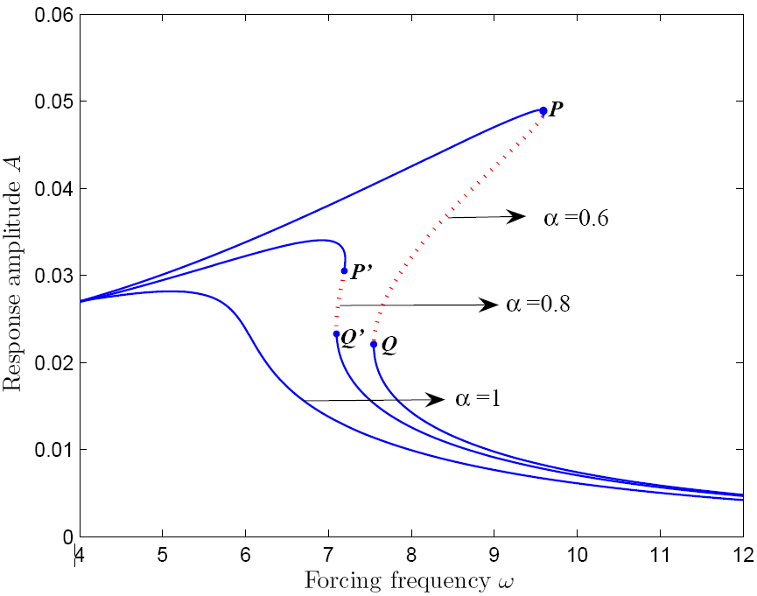
Fig.2. Forcing frequency-response curves for $η=0.04$ and $p=0.6$.
The effect of the fractional order $α$on the dynamic behavior of the beam is firstly investigated. In Fig. 2, the response curves for several cases: $α=0.6, 0.8 and 1.0$ are plotted by spanning a frequency range around the fundamental resonance. It is clearly seen that when $α=0.6$, the response curve has vertical tangents at $P(ω≈9.592)$ and $Q(ω≈7.547)$, by which a bi-stable interval or the hysteresis area is determined. In the bi-stable interval, there are two stable attractors and one unstable attractor in between. This is a typical characteristic of Duffing oscillator due to its cubic nonlinearity in primary resonance ^{[30]}. As the forcing frequency increases gradually from point P, the response jumps down from the resonance branch to the non-resonance branch and the system experiences a saddle node bifurcation at point P. Correspondingly, starting at a high forcing frequency on the non-resonance branch, the response undergoes a conversion to the resonance branch again through a jump up at another saddle node bifurcation point Q. In the response curve for $α=0.8$, although the jump phenomena exist, the positions of the jumps: $P^{'}(ω≈7.192)$ and $Q^{'}\left(ω≈7.096\right)$ are shifted to left, and the width of the jump region (i.e., the hysteresis area) is obviously shrunk. Additionally, the response amplitudes of the system are attenuated at the same time. With the further increase of the fractional order, the hysteresis domain decreases. Eventually, as $α$ increases beyond some critical value, the jumps can be eliminated, which is manifested in Fig. 2 when $α=1$. It means that the fractional order can stabilize the system.
In addition, the amplitude-response curves are also depicted in Fig. 3 to verify the above conclusions, where the response amplitudes are plotted as the function of forcing amplitude. Similar conclusions can easily be drawn.
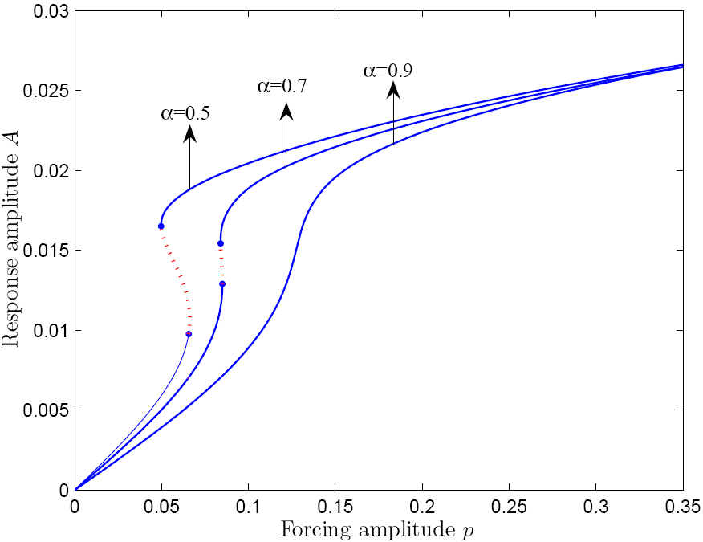
Fig.3. Forcing amplitude-response curves for $η=0.02$, and $ω=4.6$.

4.2 Effects of viscoelasticity coefficient on system response
The effect of viscoelasticity coefficient $η$ on the dynamic behavior of the beam is then examined and graphically presented by the frequency-response curves in Fig. 4 for several cases: $α=0.5, 0.7 and 0.9$. It is observed that the effects of $η$ are very similar to those of the fractional order $α$. When $η=0.02$ for example, as the excitation frequency grows gradually, the amplitude of the stable response increases until the first limit point $P\left(ω≈9.821\right)$, where the response ultimately becomes unstable through a saddle node bifurcation. Contrarily, with the decrease of excitation frequency, the response undergoes a saddle node bifurcation at the jump-up point $Q\left(ω≈7.288\right)$. Moreover, the hysteresis area is shrunk and eventually eliminated as the viscoelasticity coefficient $η$ increases. At the same time, the response amplitudes are attenuated for the cases having a relatively large viscoelasticity coefficient $η$.
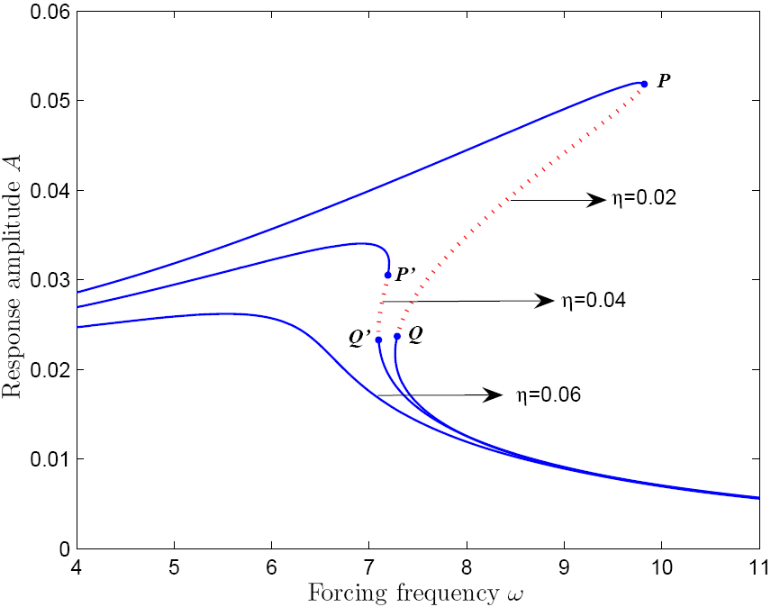
Fig. 4. Frequency-response curves for $p=0.6$ and $α=0.8$.

4.3 Verifications
To validate the discussions above, the solutions are compared with the results through direct numerical integration. The primary resonance of the system is plotted in Fig. 5, where the control parameters are chosen as $η=0.04$, $k_{1}=33.526$, $k_{2}=0.05$, $k_{f}=0.173$, $γ=0.6$, $α=0.6$, and $p=0.6$. The stability of the response is obtained by the conditions in Eq. (32) and is depicted in Fig. 5 as the “stability limit”. We can find that the analytical solutions agree well with those by the numerical method.
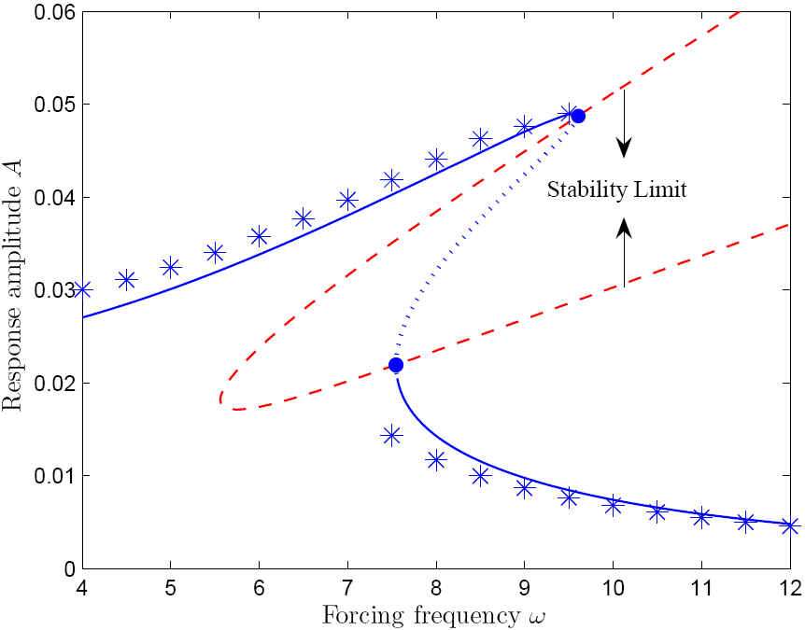
Fig.5 Comparisons between the analytical solutions and numerical ones for $p=0.6$: solid line stands for the stable analytical solution, dotted line unstable analytical solution, and asterisk marks numerical result.

5. Conclusions
In the present study, by the averaging method, the primary resonant response of the axially moving beam system is analytically investigated from the viewpoint of control. The effects of different system parameters on the amplitude frequency responses are graphically presented.
It has shown that possible multiple solutions on the response curves give rise to the jump phenomenon or hysteresis, while the hysteresis area contracts with increase of the fractional order or viscoelastic coefficient. A critical value of these two parameters exists, beyond which the hysteresis region can be eliminated. The increase in them reduces the vibration amplitudes. Obviously, both the fractional order and viscoelastic coefficient are powerful factors in stabilizing the system.

Acknowledgement
The research is supported by the National Natural Science Foundation of China (No. 11502160), the Project Funds for Talents Introduction of Taishan University (No. Y2014-01-18), and the China Postdoctoral Science Foundation (Grant No. 2016M602411).

Conflict of interest
The authors declare that they have no conflict of interest.

References
[1] C.D. Mote. On the nonlinear oscillation of an axially moving string. ASME J Appl. Mech. 33:2(1966), 463-4 .
[2] Y.H. Li, Q.Gao, K.L. Jian and X.G. Yin. Dynamic responses of viscoelastic axially moving belt. Appl. Math. Mech. 24:11(2003), 1348-54.
[3] M. Krzysztof and T. Kapitaniak. Dynamics of axially moving continua. Int. J Mech. Sci. 81(2014), 26-41.
[4] L.Q. Chen and X.D. Yang. Stability in parametric resonance of axially moving viscoelastic beams with time-dependent speed. J Sound & Vib. 284:3(2005), 879-891.
[5] G.C. Zhang, H. Ding and L.Q. Chen. Galerkin method for steady-state response of nonlinear forced vibration of axially moving beams at supercritical speeds. J Sound and Vib. 331:7(2012), 1612-1623.
[6] L.Q. Chen and X.D. Yang. Steady-state response of axially moving viscoelastic beams with pulsating speed: comparison of two nonlinear models. Int. J Solids and Struct. 42:1(2005), 37–50.
[7] S.H. Chen, J.L. Huang and K.Y. Sze. Multidimensional Lindstedt–Poincaré method for nonlinear vibration of axially moving beams. J Sound and Vib. 306 (2007), 1-11.
[8] L.Q. Chen and H. Ding. Steady-state responses of axially accelerating viscoelastic beams: Approximate analysis and numerical confirmation. Sci. China Ser. G: Phys. Mech. Astron. 51:11(2008), 1707-1721.
[9] X.D. Yang and W. Zhang. Nonlinear dynamics of axially moving beam with coupled longitudinal transversal vibrations. Nonlinear Dyn. 78(2014), 2547-56.
[10] X.D. Yang and L.Q. Chen. Non-linear forced vibration of axially moving viscoelastic beams. Acta Mech. Solida. Sin. 19:4(2006), 365-373.
[11] H. Ding and L.Q. Chen. Approximate and numerical analysis of nonlinear forced vibration of axially moving viscoelastic beams. Acta Mech. Sinica. 27(2011), 426-37.
[12] Mergen H. Ghayesh. Nonlinear forced dynamics of an axially moving viscoelastic beam with an internal resonance. Int. J of Mech. Sci. 53 (2011) 1022-1037.
[13] X.Y. Mao, H. Ding and L.Q. Chen. Forced vibration of axially moving beam with internal resonance in the supercritical regime. Int. J Mech. Sciences. 131-132 (2017), 81-94.
[14] H. Ding, G.C. Zhang, L.Q. Chen and S.P. Yang. Forced vibrations of super-critically transporting viscoelastic beams. J Vibr. & Acoust. 134:5(2012), 4825-4829.
[15] H. Ding, X.Y. Mao and L.Q. Chen. Periodic response of an axially high-speed moving beam under 3:1 internal resonance. J Physics: Conference Series. 744 (2016) 012117.
[16] Y.H. Li, Y.H. Dong, Y. Qin and H.W. Lv. Nonlinear forced vibration and stability of an axially moving viscoelastic sandwich beam. Int. J Mech. Sci. (2018): S0020740317320787.
[17] X.Y. Mao H. Ding and L.Q. Chen. Super-harmonic resonance and multi-frequency responses of a super-critical translating beam. J Sound Vib. 385:22 (2016), 267-283.
[18] K. Marynowski and T. Kapitaniak. Zener internal damping in modelling of axially moving viscoelastic beam with time-dependent tension. Inte. J Non-Linear Mech. 42:1(2007), 118-131.
[19] I. Podlubny. Fractional Differential Equations: an introduction to fractional derivatives, fractional differential equations, to methods of their solution and some of their applications. San Diego: Academic Press; 1999.
[20] M. Francesco. Fractional calculus and waves in linear viscoelasticity: an introduction to mathematical models. London: Imperial College Press; 2010.
[21] Y.A. Rossikhin, M.V. Shitikova. Application of fractional calculus for dynamic problems of solid mechanics: novel trends and recent results. Appl. Mech. Rev. 63(2010), 010801-0108052.
[22] A.C. Galucio, J.F. Deü, R. Ohayon, Finite element formulation of viscoelastic sandwich beams using fractional derivative operators, Comput. Mech. 33 (2004) 282-291.
[23] R. Lewandowski, M. Baum, Dynamic characteristics of multilayered beams with viscoelastic layers described by the fractional Zener model, Arch. Appl. Mech. 85 (2015) 1793–1814.
[24] M. Sjöberg and L. Kari. Nonlinear isolator dynamics at finite deformations: an effective hyperelastic, fractional derivative, generalized friction model. Nonlinear Dyn. 33:3(2003), 323-336.
[25] A.Y.T. Leung, H.X. Yang, P. Zhu, Z.J. Guo, Steady state response of fractionally damped nonlinear viscoelastic arches by residue harmonic homotopy, Comput. Struct. 121 (2013), 10-21.
[26] L.Q. Chen and W.J. Zhao. Transient responses of an axially accelerating viscoelastic string constituted by a fractional differentiation law. J. Sound Vib. 278(2004), 861-871.
[27] T.Z. Yang and B. Fang. Stability in parametric resonance of an axially moving beam constituted by fractional order material. Arch. Appl. Mech. 82:12(2012), 1763-1770.
[28] Y. Li and Y. Tang. Analytical analysis on nonlinear parametric vibration of an axially moving string with fractional viscoelastic damping. Hindawi Mathematical Problems in Engineering. (2017), 1393954- 9.
[29] Roman Lewandowski and Przemysław Wielentejczyk. Nonlinear vibration of viscoelastic beams described using fractional order derivatives. J Sound and Vibr. 399:7(2017), 228-243.
[30] A.H. Nayfeh and D.T. Mook. Nonlinear Oscillations. Wiley-Interscience, NY, 1979.

Corresponding author. E-mail address: pingzhu@hnu.edu.cn (Ping Zhu)

