Effects of different parameters on inelastic buckling behavior of composite concrete-filled steel tubes
Hossein Alimohammadi¹, Amin Hesaminejad², Mohammadali Lotfollahi Yaghin³

¹ Ph.D. student, Civil, Construction and Environmental Engineering Department, Iowa State University, Iowa, USA, Email:hosseina@iastate.edu

² Master of Science, Civil engineering department, Azad university of Maragheh, East Azerbaijan, Iran

³ Professor, Civil Engineering Department, Tabriz University, Tabriz, East Azerbaijan, Iran

Abstract:
Composite columns are one of the most used cross-sections in various buildings and bridges. In this research, the impact of different parameters such as effect of eccentricity of loads or the change in the horizontal distance of the loading profiles in buckling of the composite columns with double IPE cross-sections as well as the impact of different value of slenderness on buckling of composite box columns, has been investigated. Based on the results, the steel member's yielding will be delayed by filling the steel sections with concrete. Also, an increase in the amount of composite column capacity is directly related to the associative ratio of composite concrete. In the other words, increasing the ratio of the concrete surface leads to greater capacity which is caused by being filled with concrete.
Keywords: Concrete filled columns, composite columns, buckling, ABAQUS software

1-Introduction
Concrete-filled Steel box Tubes (CFT) have been used since the early 1900s when several bridges and buildings were constructed using CFT columns. Some of them include the directive expressway intersection of Almond Burry in the UK, the Charleroi Railways in Belgium, International Trade Union in Geneva, and a stadium in Martigny and Boury in Switzerland. These members are also can be used as a driven pile in the deep foundation of bridge construction projects, [1]. There are various types of cross-sections used in concrete-filled tubes including circular, rectangular and square sections, which are the most common ones. Some of the advantages of columns filled with concrete can be the high energy absorption, higher ductility, buckling critical load, shear strength, providing coverage for concrete core by steel section and protecting the concrete surface from damage, shorter construction time, and easier transportation. They can be used different structural systems such as steel moment frames, special truss moment frames etc. [2,3],
Considering the benefits mentioned above, composite concrete-filled columns also have some disadvantages. One of these disadvantages is the placement of steel on the outer surface of the column and its vulnerability against fire. Implementation of the fittings on these columns is also difficult which makes the behavior of the fittings not be clear and few studies have been conducted on this matter. Looking from a structural engineering viewpoint, buckling is a phenomenon which can cause the failure of member and probably whole the structure as a resultant. For example, Mousavi et al. showed that how buckling of members in double-layer braced barrel vaults, regarding the position of its supports, can cause a progressive collapse in this structural system, [4]. The restriction, which is created by metal mold around the concrete core, improves concrete behavior by applying hydrostatic force to the concrete. Furthermore, concrete prevents the inside buckling of the side plates of the steel tube.
Filling the steel tube columns with concrete will change the property of the section, and that section in analysis needs to be considered, similar to reinforced concrete members, as a composite section. The quality and quantity of each material can have a significant influence on the behavior of the member and the whole structure [5]. As an example in reinforced concrete structures, Mousavi et al. showed that using the high-strength steel rebar in reinforced concrete moment frames can remarkably change the behavior of these structural systems,[6]. In 1967, theoretical studies by Gardner and Jacobson showed that in low strains, the Poisson ratio of concrete is in the range of 0.15 to 0.25, but for higher strains, the Poisson ratio of concrete can even reach 0.6,[7]. As a result, in the early stages of loading, Poisson's ratio for concrete is lower than steel. Thus, steel tubes do not have any limiting effect on the concrete core. When the axial strain increases, the transverse strain of the concrete slowly becomes greater than steel. As a result, a radial force appears on the contact surface of steel and concrete. In this stage, the concrete core is under tri-axial stress, and steel tubes are under biaxial stress. Because of the ring tension state, (biaxial stress) steel tube cannot withstand the usual yield stress. Therefore, there is a load transfer from the wall of the steel section to the concrete core. The load that fits this type of damage can be significantly larger than the total damages of concrete and steel loads separately. The increase in the critical load caused by the confinement effect of concrete on the steel core depends on many factors. Such as the thickness of the steel tube, slenderness ratio, eccentricity of applied force and cross-section shape. Regarding the circular tube columns, the steel tube has a higher confinement effect compared to square columns because there is a tendency to be circular in a square section under radial loads. Also, the center and corners of the square sections are under greater limiting pressure compared to edges, but a uniformly distributed lateral pressure is expected in a circular column.
Under continuous loading, the performance of CFT is different from ordinary reinforced concrete columns. In reinforced concrete columns, concrete experiences shortening at an early age. This is followed by a long period of contraction and creep under load. In the case of CFT columns, the shortening factor is low due to the moist environment inside a steel tube and contraction occurs very slowly. Nevertheless, the rust is expected inside the steel tube.
The behavior of the CFT columns affected by concentrated axial load depends on the buckle length (Le), the least dimensions of the cross-section, (B), and mechanical properties of steel and concrete. According to the mentioned items, slenderness (Le / B) or slenderness ratio λ $=\frac{le}{r}$ It can be obtained, based on which we can conclude whether the columns are short, medium, or slender. Failure mechanism in a short column occurs in the form of yielding of steel and crushing concrete [8]. Composite columns with medium length have an inelastic behavior, and their behavior analysis is also inelastic. Their failure mechanism is in the form of slight yielding of steel and crushing of concrete under pressure.
Long columns have elastic behavior, and their method of analysis is also elastic. And in this case, early deformations are discarded. And the behavior of the column can be suggested according to the Euler spiral. Research shows that the performance of square and rectangle concrete-filled steel columns are not as good as the circular form. Maybe the reason is that the confining effect that is applied to the concrete core by a steel wall does not take place in square and rectangular columns.
Tao et al. (2005) performed experimental studies on CFT columns that were reinforced with longitudinal stiffeners and examined the effect of these stiffeners,[9]. The results of the experiments showed that the buckling of the columns with stiffeners occurs when the stiffeners start to buckle. The steel plates in columns with stiffeners bend later than columns without stiffeners. The columns which have the stiffeners welded to their internal part buckle later than columns that have the stiffeners welded to their external parts. The cause of this is that filling concrete in columns with internal stiffeners, braces them in itself, and prevents their fast deformation and buckling.
Tao et al. in 2008 conducted further studies on the effects of stiffeners on the strength and ductility of the CFT columns, and this time, they increased the number of stiffeners on each aspect or used a different type of stiffeners,[10]. They also increased the height of the cross-section of the stiffeners. In the samples which had no stiffeners, buckling on steel plates took place when the load reached 30% to 40% of its final value. While this amount was respectively 80 and 100, in the samples with 1 or 2 stiffeners on each aspect, these results show that stiffeners significantly delay buckling of the steel plate. And increasing the number of stiffeners has a good effect on steel's buckling and, therefore its bearing capacity. Stiffeners also increase ductility.
The use of various stiffeners has been suggested to improve the behavior of square CFT columns and improve their confining properties. Gii and Yusami at 1994 proposed the method of welding a longitudinal steel strip on the inner surface of the steel tube,[11]. However, Huang et al. in 2002, proposed the method of welding shears studs,[12]. Ductility was significantly increased by using shear studs, but it did not have much impact on the strength of the samples. They also proposed a new stiffening plan by welding a group of four diagonal steel bars along the longitudinal axis of the steel pipe, which actively strengthens the enclosure of concrete core by a steel pipe. To overcome the disadvantage of confined concrete in square columns, a new stiffening plan was proposed by Cai and Hee in 2006, [13].
Wang et al., in 2004, studied the resistance and ductility of composite columns under axial pressure loads,[14]. The results of their experiments show the steel columns filled with concrete and reinforced with steel cross-sections, has the advantages of both CFT columns and steel columns buried in concrete. Due to the interaction between concrete and steel walls, as well as concrete and steel reinforced cross-section, ductility and energy absorption of SR-CFT columns are higher than ordinary CFT columns and steel columns buried in concrete. The steel-reinforced cross-section in the column significantly prevents the shear cracks and, thus, improves the behavior of the column.
Bambach et al. conducted some research on this matter in 2009 and obtained acceptable results [15]. The results of the experiments show that strengthening CFT columns with CFRD plates delays the buckling of steel plates by up to 4 times. It was also observed that the installation of CFRP plates, significantly increases cross-section capacity and CFT column’s resistance ratio to weight. In 2008, Han et al. conducted studies on thin-walled hollow structural steel columns,[16]. They filled the hollow cross-sections with self-compacting and high efficiency concretes. They used 50 column samples for this experiment and compared the results obtained by experiments to different regulations. They have conducted the experiments with self-compacting concretes, while the relationships of the codes that were used for predicting the behavior of the columns were obtained with ordinary concrete. A comparison of the results of the experiment and the prediction codes indicate that there was no difference between the self-compacting concrete and the ordinary concrete for reinforcing the CFT columns. And its only advantage was the ease of use and benefits of better implement for structural engineers.
In 2008, Yu and Tao investigated the use of high-performance concrete in the reinforcement of CFT columns,[17]. Results of the experiments conducted on this context show that even though the ultimate capacity of cross-sections filled with high strength concrete is higher than samples filled with ordinary concrete, their ductility is less than ordinary columns. Therefore, the use of this type of column is not recommended in earthquake-prone areas where ductility is very important.
Composite columns have been recommended as a fundamental solution for preventing general and local buckling of steel columns and also the prevention of shear failure and deterioration of concrete columns. Moreover, this form of a structural member provides seismic resistance, stiffness, ductility and high absorption capacity properties. Morsi and Yu Wai in 2003 conducted a study on six samples of columns consisting of 4 thin-walled sheets, with coefficients of 40, 50 and 60 of local thinness, with concrete and without concrete to achieve the effect of high strength concrete on buckling capacity (local and general),[18]. They concluded that all columns have relatively linear behavior before reaching the final load. And also, the presence of high strength concrete in the composite samples increases the load-bearing capacity of the column by about 2 to 3 times and slowly reduce stiffness after tolerating the maximum force applied.

2-Steel columns with double IPE cross-section
At this part, the constituent members of the composite column consist of steel and concrete and tie plates. The free space between steel sections is assumed to be filled with concrete, and one column is considered without concrete. The models have been investigated in terms of axial bearing capacity, buckling behavior and post-buckling behavior. The variables of this experiment include changes in the slenderness of the samples, loading with different eccentricity, and the change in distance of steel profiles is in a column (s).
For steel member modeling, Abacus software has been used in this study to investigate the inelastic buckling behavior of composite columns filled with concrete by using the finite element method. Four-node shell element (s4r) is used with six degrees of freedom in each node to consider local buckling and flexibility in three dimensions. Also, the isoperimetric element with cracking and breaking ability is used in the concrete part. Concentrated force is applied to the system through welded stiff plates at one of the ends of the column. The column is bounded to the ground through the same stiff plates at the other end. Static Analysis in the form of Riks analysis is used which is related to inelastic buckling analysis of compressive members in Abacus software [19,20]. The steel has a yield stress of 2690 kg⁄cm², the modulus of elasticity of 2.1×106 kg⁄cm², and Poisson’s coefficient of 0.3. Axial compressive resistance of the concrete is considered to be f’c =270 kg⁄cm².

2-1-The eccentricity effect in buckling of composite columns with double IPE cross-sections
To investigate the eccentricity effect in buckling of composite columns, three samples of concrete-filled steel columns have been modeled. These models have 2.5 m long and consisted of two IPE with the size of 160, 220, and 300, while the profile flanges were welded together without using parallel connecters. The behavior of these models is compared with three similar steel column samples, which were filled with concrete. In this investigation, loading with eccentricity relative to the X-axis is considered for different samples.
For this reason, 1 cm eccentricity was considered for the IPE160 cross-section, 2 cm eccentricity for IPE220 cross-section and 3 cm eccentricity for the IPE300 cross-section. The maximum resistance of the samples and the increase in resistance in samples with concrete compared to the samples without concrete can be seen in Table 1. In this table, CC represents the cross-section with concrete, and UC represents the cross-section without concrete. The numbers immediately after those words on the right represent the profile size next number shows the distance of the profiles in centimeters from each other (s). For example, the term UC-300-15 represents a concrete free steel cross-section consisting of two IPE profiles with a size of 300 and a distance of 15 cm in the axis of the profiles. Figure (2-9) shows the cross-section of samples and the meshed model of the column, by using parallel and also without parallel connectors. The result shows that buckling behavior improved by adding concrete and increasing the cross-sectional area of the steel and keeping the column length constant (decreasing the overall slenderness ratio), and the ultimate resistance, stiffness and flexural strength of the samples were significantly increased. Thus, by increasing the number of the cross-section by 37% to 87% in steel-free concrete samples, the maximum bearing strength increased by 57 to 117%. Whereas, force tolerance capacity changed up to 214% to 331% by adding concrete to the samples.
Based on the force-displacement diagram of the middle of columns in Figure 2, investigating the effect of slenderness on buckling performance under increased loading with eccentricity in steel column with different cross-sections and composite column, it was concluded that steel samples lost their resistance plate based on the downward slope of the diagram after yielding and buckling. In concrete-filled samples, loss of resistance in the column was initially due to overall buckling and, ultimately, due to the sudden drop in column strength in the plastic area due to the concrete failure and folding of the steel wall. Figure 2 shows the deformed shape of the model ().
Table 1- Comparison in the behavior of columns with various slenderness
Resistance increase in % | Maximum Resistance (tons) | Eccentricity (cm) | Model
0.0 | 92 | 1 | UC-160-8.2
27 | 117 | 1 | CC-160-8.2
57 | 146 | 2 | UC-220-11
214 | 197 | 2 | CC-220-11
117 | 200 | 3 | UC-300-15
331 | 305 | 3 | CC-300-15

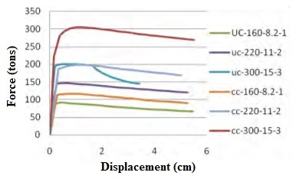
Figure 1. Force displacement behavior of models

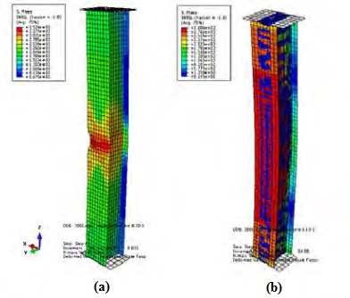
Figure-2 Deformed shape of models (a) UC-160-8.2 (b) CC-160-8.2

2-2-Effect of change in horizontal distance between IPE sections on buckling of columns with double IPE cross-sections
In this part, models include two IPE sections with different center-to-center distances of 11, 16, and 22 cm and a size of 220. The eccentricity in all specimens is equal to 1 cm, and they are considered in two states with and without concrete fill.
The results in Table (2) and the load-displacement response diagram of samples in Figure (2) show that in steel cross-sections without concrete, creasing the horizontal distance of the steel profile with similar eccentricity did not affect the maximum force tolerated by cross-section. The reason for equality of resistance of steel column without concrete by taking the Steel profiles away from each other along the X-axis is the stability of the moment of inertia of the cross-section (I_{X}) and as a result the stability of flexural strength and stiffness of the cross-section.
Table-2 Comparison in resistance of columns with the change in horizontal distance
Increase in resistance (%) | Ultimate Axial Capacity (ton) | Concrete area (cm²) | Model
0.0 | 161 | 242 | UC-220-11
35 | 217 | 242 | CC-220-11
0.0 | 161 | 352 | UC-220-16
53 | 225 | 352 | CC-220-16
0.0 | 161 | 484 | UC-220-22
74 | 279 | 484 | CC-220-22

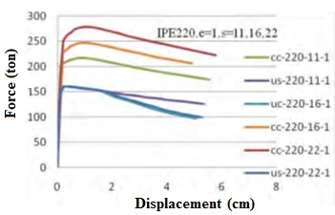
Figure 3. Force displacement behavior of models

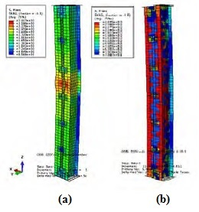
Figure-4 Deformed shape of models (a) UC-220-11 (b) CC-220-11
However, in the steel columns with concrete, the amount of force tolerated by the column has significantly increased by increasing the horizontal distance of the steel profiles. And, as expected, increasing the level of the cross-section of concrete led to an increase in moment of inertia of the cross-section, and as a result, it caused the increase in strength and flexural stiffness of the cross-section. Nevertheless, the cross-section can withstand more compressive force. Using a bigger concrete cross-section leads to better buckling and post-buckling behavior of columns in the nonlinear section. However, it should be considered that an excessive increase in the concrete cross-section increases the possibility of the occurrence of fractures in non-reinforced concrete.
Adding concrete to the steel samples with 11 cm of distance between profiles increases concrete resistance by 35% compared to the resistance of columns without concrete. In the sample with a distance of 16 cm, this increase is 53%, and in the sample, with a distance of 22 cm, this increase was 74%. As expected, adding concrete in the distribution of stress in the steel column improves stress distribution in the system, and the steel wall in the composite sample is in a better position than the concrete-free state.

3-Slenderness effect on buckling of composite columns with box cross-sections
In this section, to investigate the slenderness effect on the buckling of composite columns with steel sections, 15 analytical models are designed and modeled using the finite element method. The considered steel part consists of box cross-sections with dimensions of 300x300 mm and a thickness of 5 mm. Figure 5 shows a schematic view of the cross-section of this column.
Given the equality of all the geometric properties of the cross-section and to consider the different range of slenderness ratio, the slenderness coefficients in short, medium and long columns were used to calculate the lengths of sections modeled with slenderness coefficients of λ₁ = 19, λ₂ = 58 and λ₃ = 92, respectively. Thus, different lengths of 1.73 m, 5.19 m and 8.22 m are obtained for the samples. The introduced columns were placed under axial loading with a certain eccentricity. The boundary condition of columns modeled in the software includes a fixed connection at one end and pinned connection in the other end. A spring with different stiffness at the top of the pinned connection provides horizontal restriction. The stiffness of the spring is considered as a ratio of stiffness of the column. This ratio changes from 0% (one end free) to 100% (one end fixed). Figures 6 shows the stress distribution in the columns and diagrams in figure 7 to 9 show the force-displacement relation for the columns of 1.73 m, 5.19 m and 8.22 m, respectively.
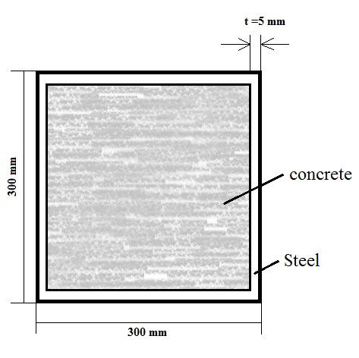
Figure-5 Schematic view of the cross-section column models

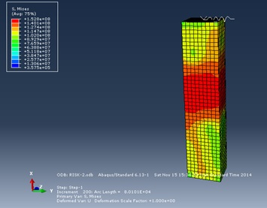 | 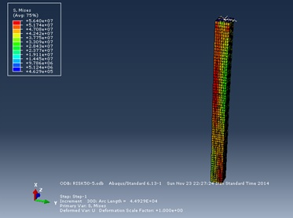 | 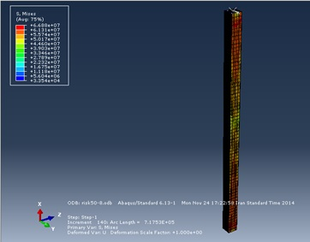
(a) | (b) | (c)
Figure-6 stress distribution in columns with (a) short (b) moderate and (c) long height

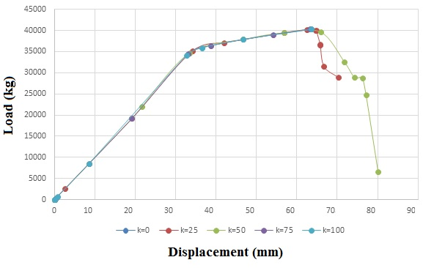
Figure 7 Load-displacement diagrams for the columns with a height of 8.22 m
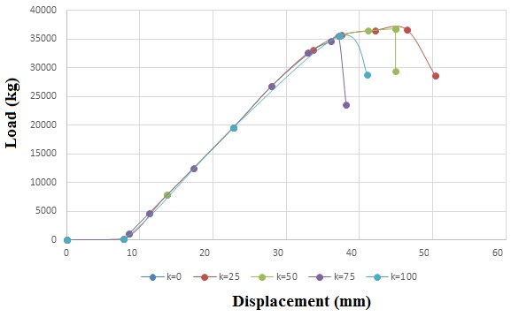
Figure 8 Load-displacement diagrams for the columns with a height of 5.19 m
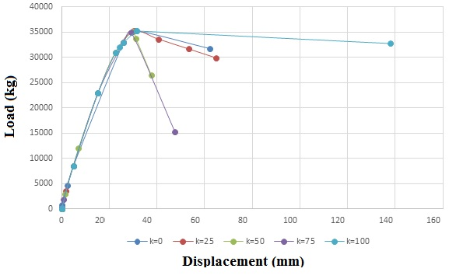
Figure 9 Load-displacement diagrams for the columns with a height of 8.22 m

4-Conclusion
According to conducted research, the results can be summarized as follows:
- Filling the steel cross-sections with concrete will delay the yielding of the steel member.
- The amount of increase in capacity of the composite column has a direct relation with the associative ratio of concrete. This means the higher the ratio of the concrete surface, the greater the capacity due to the concrete filling.
- By increasing the distance between steel profiles in composite samples and as a result of the increase in the concrete cross-sectional area, the moment of inertia of the cross-section and, therefore, resistance and the flexural stiffness of the cross-section increases. However, it should be considered that an excessive increase in the concrete cross-section increases the possibility of the occurrence of fractures in non-reinforced concrete.
-In loading with the eccentricity of variables within the central core range, adding concrete leads to higher load tolerance, and it creates a more favorable buckling behavior for the steel column.
- The stress distribution in the steel column under the impact of compressive axial force is, in a way, concentrated with folding in the middle of the column. However, adding concrete to it and creating a composite column will result in a wider stress distribution throughout the column.
- Increasing the stiffness of the column head results in the reduction in the displacement of the column header. Therefore, this amount is approximately 2% for the column with a length of 1.73 m, 0.06% for the column with a length of 19.15 m, and 0.04%. For the column with a length of 8.22 m.

References
[1] Phares B, Mousavi S, Deng Y “Jimmy.” Construction of New Substructures Beneath Existing Bridges 2019.
[2] Mousavi S, Keramat A, Shekasteband B. Investigation of the Effect of Geometric Parameters on Behavior of Special Truss Moment Frames. Int Res J Eng Technol 2019;6:1566–73.
[3] Alimohammadi H, Lotfollahi Yaghin M. Study on the Effect of the Concentric Brace and Lightweight Shear Steel Wall on Seismic Behavior of Lightweight Steel Structures. Int Res J Eng Technol 2019;6:1358–62.
[4] Mousavi S, Najafpour R, Sheidaii M. Investigating the effect of restraints’ configuration on resistance of double layer braced barrel vaults to Progressive collapse. Int Acad Inst Sci Technol 2019;6:26–38.
[5] Alimohammadi H. Finite element analysis of a Piezoelectric layered plate with different materials. Int J Eng Appl Sci 2019;6.
[6] Mousavi S, Samadi A, Azizpour O. Assessing the Behavior of Concrete Moment Frames Reinforced with High-Strength Steel Rebar. J Emerg Technol Innov Res 2019;6:271–6.
[7] Jacobson NJG and ER. Structural Behavior of Concrete Filled Steel Tubes. Am Concr Inst 1967;64:404–13. https://doi.org/10.14359/7575.
[8] Alimohammadi H, Yashmi Dastjerdi K, Lotfollahi Yaghin M. The study of progressive collapse in dual systems. Eng Arch 2019:1–10. https://doi.org/https://doi.org/10.31224/osf.io/fjym3.
[9] Tao Z, Han LH, Wang Z Bin. Experimental behaviour of stiffened concrete-filled thin-walled hollow steel structural (HSS) stub columns. J Constr Steel Res 2005;61:962–83. https://doi.org/10.1016/j.jcsr.2004.12.003.
[10] Tao Z, Han LH, Wang DY. Strength and ductility of stiffened thin-walled hollow steel structural stub columns filled with concrete. Thin-Walled Struct 2008;46:1113–28. https://doi.org/10.1016/j.tws.2008.01.007.
[11] Ge HB, Usami T. Strength analysis of concrete-filled thin-walled steel box columns. J Constr Steel Res 1994;30:259–81. https://doi.org/10.1016/0143-974X(94)90003-5.
[12] Huang CS, Yeh Y-K, Liu G-Y, Hu H-T, Tsai ; K C, Weng ; Y T, et al. Axial Load Behavior of Stiffened Concrete-Filled Steel Columns. J Struct Eng 2002;128. https://doi.org/10.1061/ASCE0733-94452002128:91222.
[13] Cai J, He ZQ. Axial load behavior of square CFT stub column with binding bars. J Constr Steel Res 2006;62:472–83. https://doi.org/10.1016/j.jcsr.2005.09.010.
[14] Wang Q, Zhao D, Guan P. Experimental study on the strength and ductility of steel tubular columns filled with steel-reinforced concrete. Eng Struct 2004;26:907–15. https://doi.org/10.1016/j.engstruct.2004.02.009.
[15] Bambach MR, Jama HH, Elchalakani M. Axial capacity and design of thin-walled steel SHS strengthened with CFRP. Thin-Walled Struct 2009;47:1112–21. https://doi.org/10.1016/j.tws.2008.10.006.
[16] Han LH, Yao GH, Zhao XL. Tests and calculations for hollow structural steel (HSS) stub columns filled with self-consolidating concrete (SCC). J Constr Steel Res 2005;61:1241–69. https://doi.org/10.1016/j.jcsr.2005.01.004.
[17] Yu Q, Tao Z, Wu YX. Experimental behaviour of high performance concrete-filled steel tubular columns. Thin-Walled Struct 2008;46:362–70. https://doi.org/10.1016/j.tws.2007.10.001.
[18] Mursi M, Uy B. Strength of concrete filled steel box columns incorporating interaction buckling. J Struct Eng 2003;129:626–39. https://doi.org/10.1061/(ASCE)0733-9445(2003)129:5(626).
[19] Alimohammadi H, Abu-Farsakh M. Finite Element Parametric Study on Rutting Performance of Geosynthetic Reinforced Flexible Pavements. Transp Res Board 2019;98. https://doi.org/https://trid.trb.org/view/1572248.
[20] Alimohammadi H, Esfahani MD, Yaghin ML. Effects of openings on the seismic behavior and performance level of concrete shear walls. Eng Arch 2019. https://doi.org/https://doi.org/10.31224/osf.io/phfyd.

