Malawi Hydroelectric Turbine: Pelton Wheel Belt Drive
Tyler Fregine
Matthew Harris
Kyle Okonek
Mike Burant
ET-332
Dr. Devin Berg
May 10, 2017

Table of Contents
Current Situation 2
System Overview 4
Pelton Wheel 4
A-Frame 4
Bearings 4
Belt Tensioner 5
Belts and Pulleys 5
Holding Tank 6
Conclusion 6

Current Situation
Currently in the village of Nkhatabay, Malawi, inventors Hastings Mkandawire and Jimmy Mzilahowa have been making hydroelectric generators to bring power to more than 50 villages. In addition, Hastings is looking to be able to bring electricity to more villages in Malawi by producing more hydroelectric generators. It is the goal of this project help to design a mass producible drive system for his generators.
To effectively solve this problem, we believe that this drive system must meet the following requirements. First, the Pelton wheel (Fig 1) should
run the generator at a maximum of 1500 RPM. It should
contain parts that can be salvaged, cast from aluminum, or easily be manufactured. The system should r
equire minimal maintenance and have the able to o
perate in high heat, humidity, and contamination areas.
The reason for choosing a Pelton wheel design is that Pelton wheels are purposely designed for this type of situation. Due to high head pressure and a low flow rate. The Pelton's design has the jet of water come in and split side to side and then be redirected almost 180 degrees to get the most force for minimal flow. To adjust the RPM all he needs to do is open or close the flow valve accordingly to change the RPM.
To meet these requirements, we had to make the following assumptions about Hastings and Jimmy’s current production methods. That they have the means to produce aluminum castings, with basic tools to do any finishing or cleanup on the parts. One of these tools to be noted is either a drill or drill press capable of drilling through tube steel. That they also have access to welding equipment to manufacture the A-Frame. Lastly, that they have access to common hardware, such as nuts, bolts, and bearings.

For the drive system that we have come up with, we have chosen a Pelton wheel to be the turbine. Because they have access to aluminum casting, we believe that casting the wheel and paddles out of aluminum would allow for a mass producible wheel that would give durability and efficiency. This wheel will be mounted on a shaft separate from the shaft that goes to the generator. These will be held in place with an A-frame to which bearings will be mounted to give the shafts a lower rotating friction. To connect the two separate shafts there will be a series of belt pulleys on each shaft varying in dimeter. This way the belt can be switched between pulleys to switch between the desired torque or speed, similar to how a drill press operates. Finally, the same holding tank design used to hold the water, and the nozzle will be used for this generator that they currently have in the Kavuzi/Mwenera area.

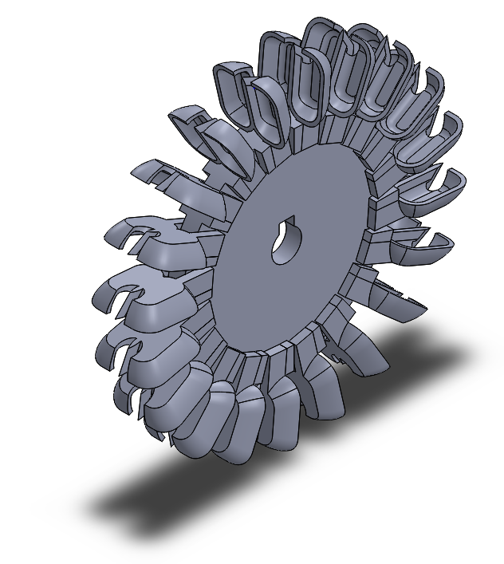
System Overview

Pelton Wheel
For the design of the turbine we chose to use a Pelton wheel (Fig 1). This wheel will be made of cast aluminum that can be salvaged from the scrap yard. The full turbine will be cast in separate parts; consisting of the wheel’s main body and the individual blades. When casting a keyway will be added to it for mounting it onto a drive shaft. The keyway will be designed into the mold for the casting. After casting, any filing and drilling can be done to make mounting holes for the turbine blades. With these holes bolts and screws can be used for attaching the blades. The main wheel without the blades will have a maximum diameter of 7” and then there will be 20 of the blades on it giving it a maximum diameter of 11”. The reason for choosing these dimensions is that to be able to sand cast the parts this is about as small as possible without making them too thin to come out properly.
Figure 1: Pelton Wheel

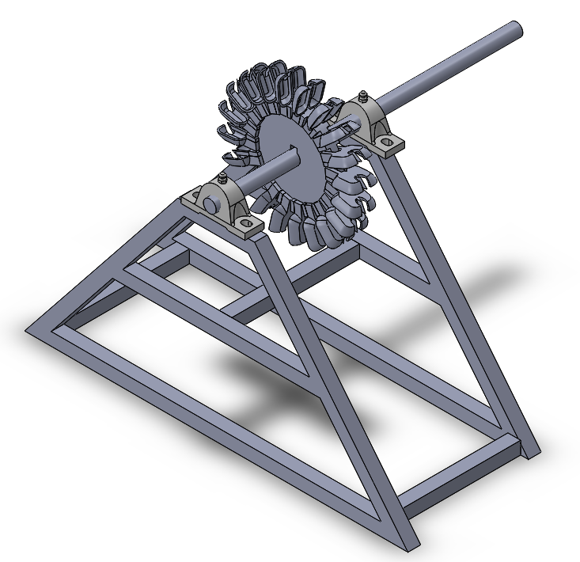
A-Frame
To mount the turbine, we designed an A-frame (Fig. 2), that also includes the locations of the bearings. The frame can be made with square tub steel stock since they have access to welding equipment. Because locating the bearings accurately might be difficult for them, slots can be drilled/filed in the tube stock for adjusting.

Bearings
Bearings will be used to ensure that the shafts rotate smoothly and can endure the harsh operating conditions it will experience. Bearing size will vary based on shaft size. Our calculations were done with a 1" shaft. The bearings used should match the shaft size. Two bearings should be used for each shaft to minimize the chance of the shaft bending and to keep the loading even. For our design, we calculated the radial load of the turbine to be approximately 319 Newtons (see Appendix A), but since these are ideal calculations we added an additional 25% to it to get 400 Newtons The 25% additional torque was added because the generator will be used in conditions where it will be exposed to outdoor elements. This exposure will add additional wear and tear to the generator system. So, whatever bearings are chosen, they should be able to handle this radial load. However, because they’ll have a limited choice on their selection of bearings, the driving factor while be the geometry of the shaft. For our design, we choose that a shaft of either 1” or 25mm would be sufficient for this drive system. The reason for choosing a 1" shaft is that it should be available from the scrap yard by salvaging the torsion bars from a pickup.
Figure 2: A-Frame

Belt Tensioner
To deal with the belts stretching and going slack over time we are including a belt tensioner to compensate for that stretching. The tensioner can consist of a spring and pulley or a pulley with a secured weight to keep it in place. This will be mounted to the frame on a slot cut in the tube stock so it can be positioned for each of the belts changes.

Belts and Pulleys
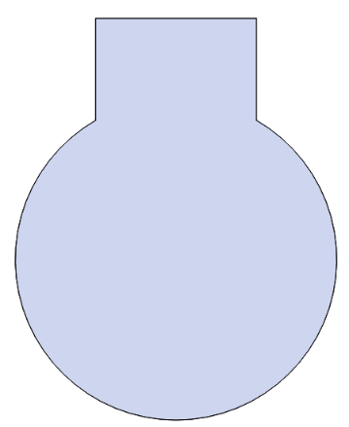
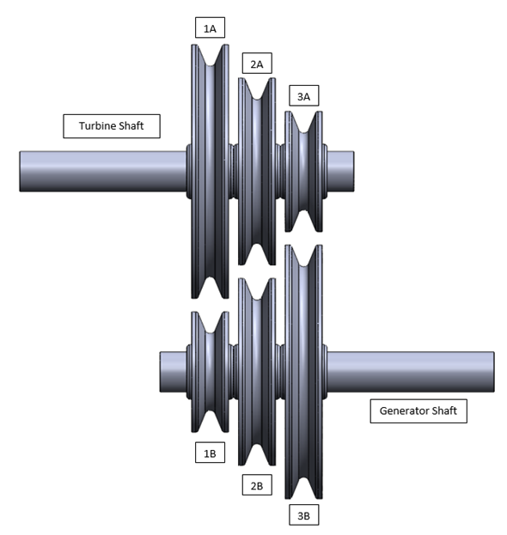
The pulleys that will connect the shaft coming from the turbine to the shaft going to the generator will come in three different sizes (Fig. 3). The orientation that we have laid out will give three different power transmission options depending on which pulleys are connected to each other. First, for a high input torque to a high-speed output conversion, connect pulleys 1A and 1B together. For a one-to-one conversion between shafts, connect pulleys 2A and 2B. Lastly, for a high-speed input to a high torque output conversion, connect pulleys 3A and 3B. To manufacture these pulleys, they will be cast out of aluminum using regular sand casting methods. The aluminum can be salvaged out of the scrap yards that are currently being used to find parts for the generators. When casting them a keyway will be made in each of the wheels so that they can be mounted to the shaft without any slippage. The keyway will be designed into the mold for the casting. General filing/grinding will be needed to clean up the faces of the pulleys so that they belt does not catch on anything. Additional filling can also be done to make the pulleys slide over the shaft easier. Pins can then be inserted on either side of pulley one and three in holes drilled in the shafts to keep the disks in place during operation and allow for them to be removed to perform maintenance on the pulleys.
Figure 4: Shaft Keyway
Figure 3: Pulley Drive System

Holding Tank
The holding tank design that is used for current generator will be the same as what we use. The only variations will be the elevation of the river in relation to the spout the water exits. For the calculations that are made in appendix A, we used the elevation of the current holding tank which is 54 meters and a nozzle diameter of 12.7mm. When the elevations are known for each installation they do they can do the calculations to figure out how much the nozzles need to be opened to get the desired speed of the Pelton wheel, refer to Appendix A for calculations.

Conclusion
The next steps in this drive system is to consult with Hastings and Jimmy on their ability to manufacture these components. If there are any parts that they cannot fabricate themselves then we’ll redesign the system to allow them to. Also, we would need to know the elevation of the source of the water from where it comes out of the nozzle to do the speed calculations for that specific generator.

Appendix A: Calculations
- Pressure and force of the water
P_{Total}= P_{Atmosphere} + P_{Fluid} p=water density
P_{Total} = P_{Atmosphere} + p*g*h g=gravity
P_{Total} = (101,325Pa) + (1000kg/m^3) (9.81m/s^2) (54m) h=height of the water
P_{Total} = 631kPa
F = P*A A=nozzle area
F = (631kPa) (0.000507m^2) A=pi*(0.0127) ^2
F = 319N
- Torque of the turbine
T = F * r D=11”= 0.279m
T= (319N) (0.279m/2)
T= 44.5 Nm

Appendix B: A-Frame Dimensions
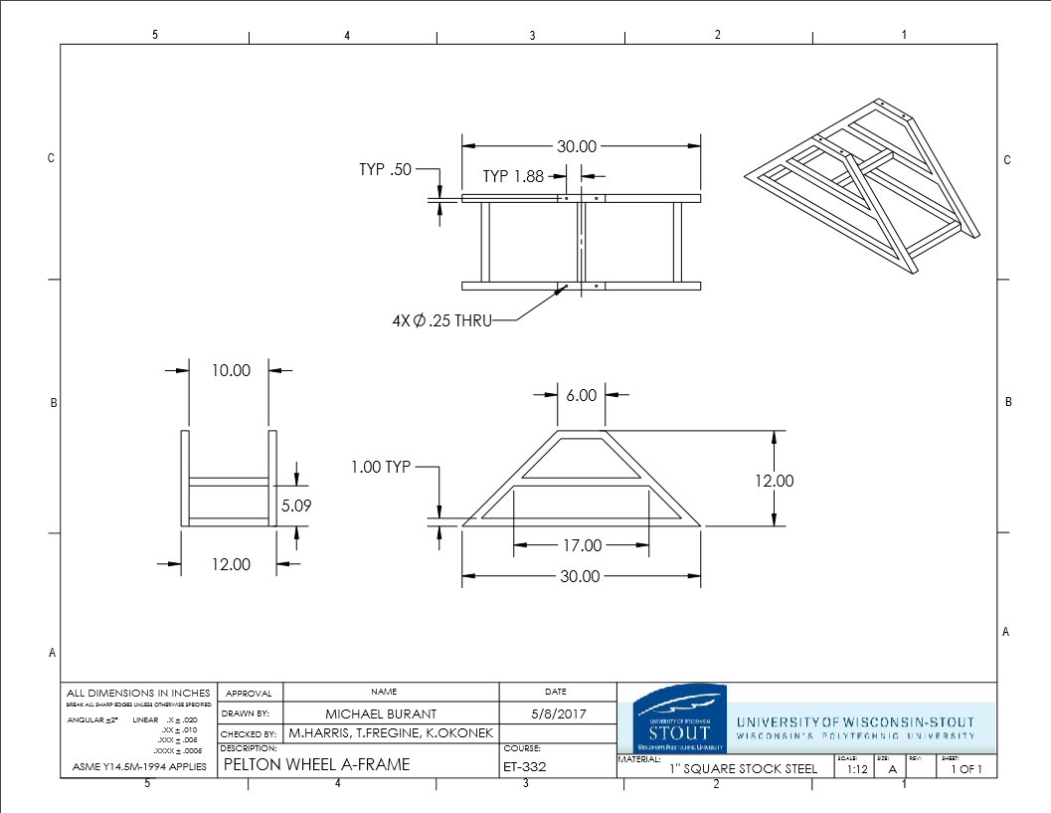

References
Engineering, Learn. Pelton Turbine - Working & Design Aspects. 2011. Article. April 2017.
First, Renewables. Pelton and Turgo Turbines. 2015. Article. April 2017.
Mkandiawre, Hastings. Mphamvu. 20 June 2014. YouTube. April 2017.

