HEATING SYSTEM IN A SMART HOME INFRASTRUCTURE
Sokolov Alexander Vladimirovich

Abstract: This article explores the potential for using a comprehensive innovative dynamic reagent-free homogenization technology in fuel cells of thermodynamic equipment within a dynamic smart home ecosystem. A device for dynamic mixing and simultaneous homogenization of liquid and gaseous media in a flow, requiring no additional energy sources, is described. The technical and commercial aspects of this innovative technology in internal combustion engines (diesel and gasoline), gas turbines, and fuel storage systems are analyzed. Test results confirm the method's effectiveness: a 97% reduction in exhaust gas emissions, a 35% increase in heat release rate, and a 2.5% reduction in fuel savings. The role of homogenization in the use of alternative fuel mixtures (biofuel, ethanol, methanol) to prevent stratification and improve combustion efficiency is substantiated. The technology is used to study contactless monitoring of liquids in pipelines and can be integrated into additional systems without structural changes.
Keywords: Smart home ecosystem; Smart home infrastructure; homogenization; Homogenization in liquid flow; Smart home fuel system; Real-time homogenization; Thermodynamic equipment; Application of the technology; Dynamic motion; Dynamic reagentless homogenization; Liquid hydrocarbon fuel; Homogenization in parallel with fuel recirculation; Homogenization based on the turbulence principle.

During storage, fuel clots may form in liquid hydrocarbon fuel, which can subsequently cause problems with injection and uniform combustion. The higher the viscosity of the fuel, the much greater the real probability of the formation of clots and other types of fuel inhomogeneity; therefore, in order to implement the proposed variants of online contactless monitoring technologies, it is necessary to take into account the level of homogenization required with extreme precision.
Several general requirements and conditions:
As an example, let us take a diesel engine as part of a diesel-generator power unit. The dynamic fuel homogenization system, for instance, is installed in the engine's fuel system on the fuel pipeline between the engine's fuel pump and the engine's high-pressure pump.
As the fuel passes through the dynamic homogenization system, homogenization occurs in the flow according to the level of turbulence, after which the dynamic homogenization process is completed in the high-pressure pump within the available volume and at the corresponding dimensional factor in a three-dimensional coordinate system. The operation of the dynamic fuel homogenization system requires no additional energy sources and no additional structural elements.
The dynamic fuel homogenization system can also be used in processes and devices for homogenization in parallel with fuel recirculation in storage tanks during fuel production and during its storage at filling stations.
Let us consider the types of internal combustion engines in which the comprehensive technology of dynamic homogenization of fuel and fuel mixtures can be applied.
The dynamic homogenization system has minimal dimensions and an optimal geometric shape and can therefore be installed on any internal combustion engine.

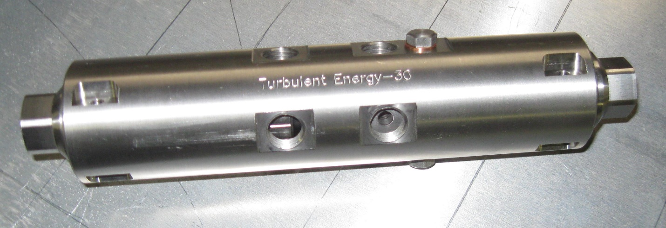
Fig. 1. Device for dynamic online homogenization of pipelines
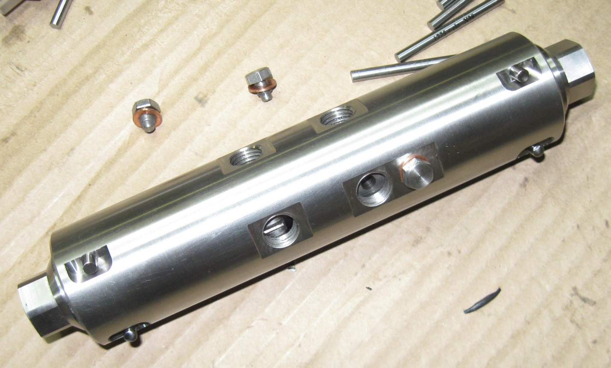
Fig. 2. Device for dynamic online homogenization of pipelines with a flow rate of up to 100 liters per hour at a pressure of 3 bar to 15 bar
As numerous tests have shown, during homogenization there is no pressure drop in the lines, and all pulsations and fluctuations are significantly smoothed out, without any additional energy consumption. As can be seen from the figure, the device is very compact — the outer diameter is only 40 millimeters, with a working diameter of 30 millimeters and a device length of 220 millimeters.
For comparison, let us consider industrial systems that can operate in the fuel lines of large power units — for example, gas turbines of 20 and 25 megawatt power plants.
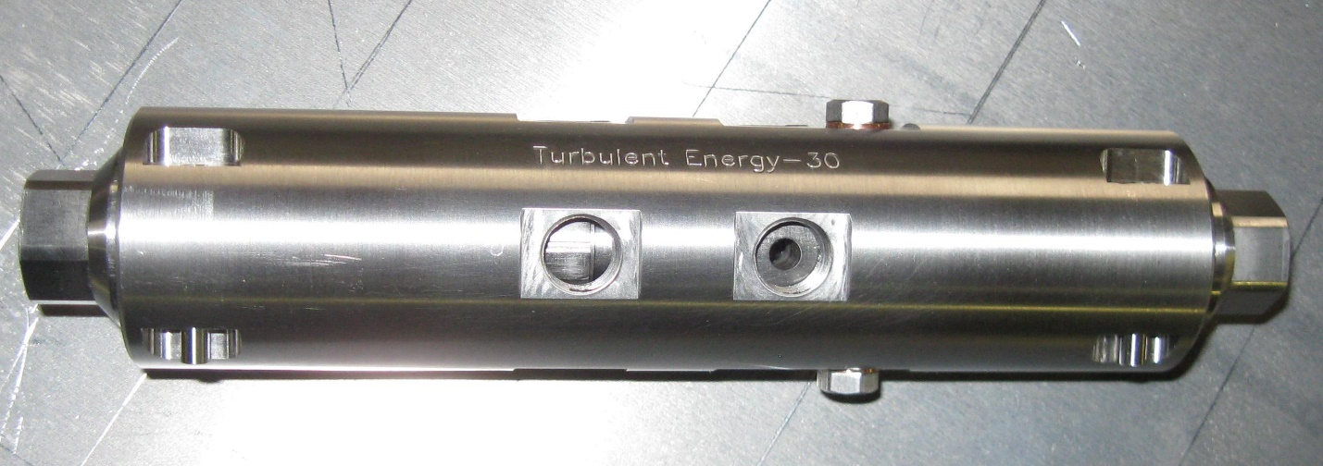
Fig. 3. Device for dynamic online homogenization

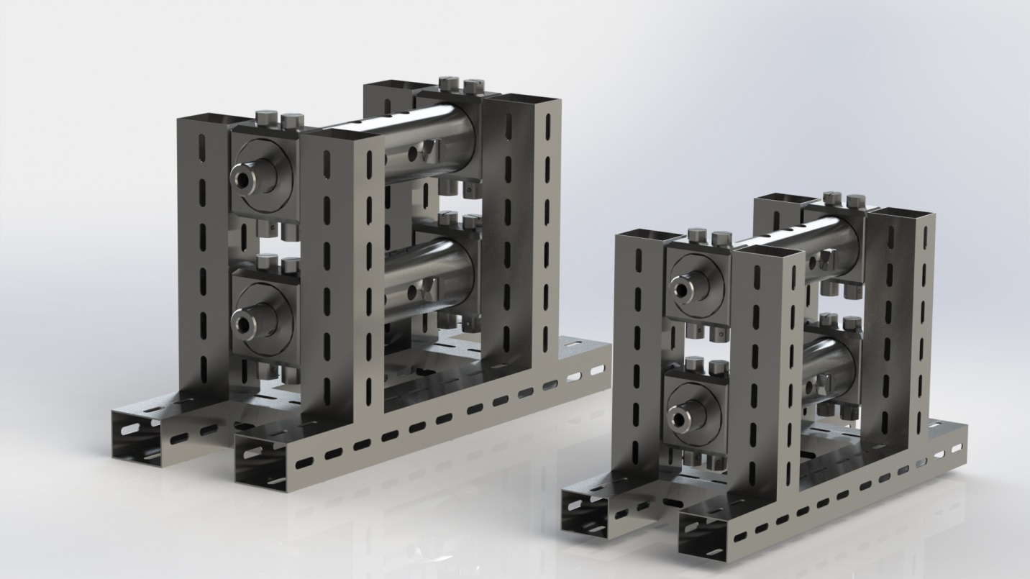
Fig. 4. Online dynamic homogenization systems with working diameters of 200 and 250 millimeters, designed for flow rates of 10,000 liters per hour and 15,000 liters per hour
In installations of this kind, the role of the homogenizing system is multifunctional, since, in addition to stabilizing and unifying the hydrodynamic parameters of the fuel flows, it simultaneously solves other problematic issues, most of which serve the purpose of improving the efficiency of such equipment.
Recently, the issues of forming fuel mixtures using biofuel, ethanol and, especially, methanol in the fuel pipeline of power equipment have become particularly acute, since such mixtures do not create toxic waste and, moreover, reduce the specific cost of the fuel. For such fuel, if the mixture is formed with, for example, diesel fuel, homogenization plays a crucial role not only as a stabilizing factor, but also as a factor preventing, for instance, water in the mixture from causing micro-explosions upon evaporation and tearing the flame away from the burner.
If the fuel mixture is homogenized, micro-capsules form in it, in which a core of, for example, methanol has a shell of diesel fuel. Upon injection, such a core evaporates first and ruptures the shell into micro-particles no larger than 0.5–0.8 microns, which contributes to significantly more efficient and complete combustion at higher efficiency. Most importantly, with such a fuel mixture structure, the energy of evaporation is not lost, and this provides an additional 1.5–2.5 percent fuel savings, which, at a consumption of 10,000 liters per hour, can yield savings of more than 100,000 dollars per unit per year.
The dynamic homogenization system can be equipped with an additional system for forming fuel emulsions of two types — compressible emulsion and incompressible emulsion. The dynamic homogenization system can effectively emulsify up to eight additional components into an emulsion. The dynamic homogenization system, without modification, can effectively dissolve combustible gases in the flow of liquid hydrocarbon fuel before injection into the combustion chamber, both in stationary internal combustion engines and in internal combustion engines installed on vehicles.
Dynamic homogenization is a fairly universal process that can be applied, with virtually no serious adaptation solutions, to a very wide range of equipment types and to practically all kinds and types of liquid fuel. Using dynamic homogenization technology, any type of liquid hydrocarbon fuel can be processed, including virtually all types of biofuel.
Diesel fuel has many varieties whose properties differ considerably, including depending on climatic conditions.
If we take the basic types of diesel fuel in the USA for comparative analysis, then both the cleanest and lightest — No. 2 diesel fuel — and the heaviest and most viscous — No. 6 diesel fuel — require homogenization before injection, especially in winter.
If we consider various grades of fuel oil, especially those with a high sulfur content, it turns out that the homogenization of ordinary fuel oil alone, without the admixture of lighter fuel, makes it possible — thanks to all the advantages of homogenization — to reduce fuel consumption by up to 10%.
Despite the fact that gasoline is the most homogeneous type of liquid fuel, and due to the fact that gasoline is used almost exclusively as a blend with ethanol, in which the ethanol content is at least 10–15%, the homogenization of gasoline and its blends has also become relevant.
Gasoline-based fuel mixtures, such as gasoline-ethanol blends and gasoline-methanol blends, may exhibit, during prolonged storage, the effect of gravitational separation of water from the hydrocarbon part of the fuel mixture.
As the fuel mixture, in which water has separated from the gasoline, passes through the dynamic homogenization system, homogenization occurs in the flow according to the level of turbulence, after which the dynamic homogenization process is completed in the high-pressure pump within the volume and at the micron dimensional factor in a three-dimensional coordinate system.
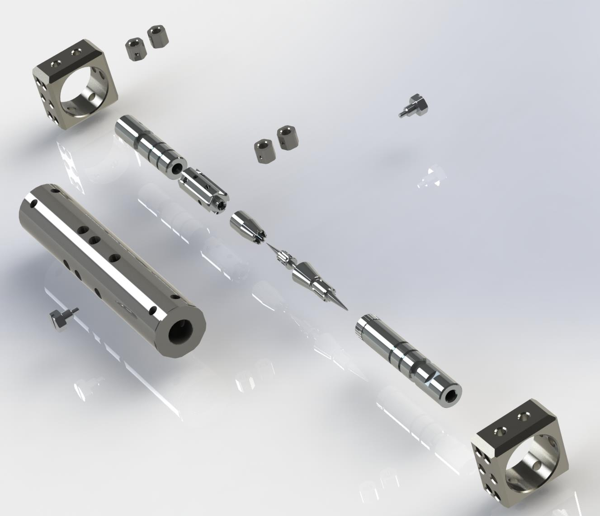
Fig. 5. Device for online homogenization of gasoline and gasoline-based fuel mixtures for engines with a flow rate of 45 liters per hour, with a working diameter of 25 millimeters
For much more viscous diesel fuels and fuel compositions, the need for homogenization is even more obvious — both for pure diesel fuel and for diesel-methanol blends and for diesel-water emulsions of both types: water-in-oil emulsions, in which the water content does not exceed 20%, and oil-in-water emulsions, in which the water content is 50%.
Preparing fuel mixtures from diesel fuel and ethanol or methanol is extremely difficult due to the large difference in the viscosity of these materials. The dynamic fuel-mixture homogenization system can prepare a high-quality and uniform blend of diesel fuel and ethanol or methanol in a fraction of a second, directly in the pipeline and in any required proportion.
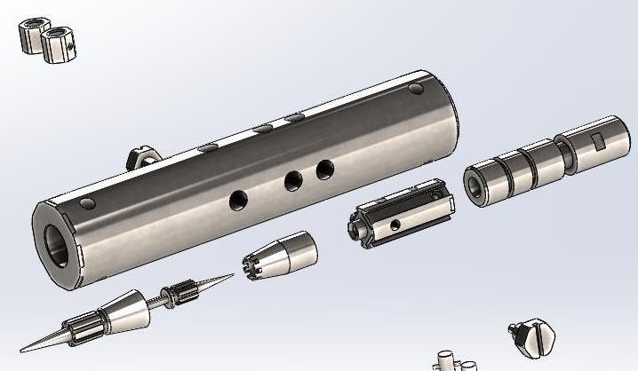
Fig. 6. Internal parts of the device; all working surfaces are coaxial, the design has no moving parts, and thanks to mutual coaxiality it is possible to achieve an accuracy of all working channels at the level of 25 microns with a maximum tolerance of 1 micron
During the homogenization process, water in the form of micro-droplets is uniformly distributed throughout the volume of the hydrocarbon fuel mixture, after which the said mixture is transformed into a micro- or nano-emulsion. According to the test results for the emulsion obtained using the dynamic homogenization system, the soot concentration in the exhaust gases is reduced by 97%, and the level and rate of heat release increase by at least 35%.
Installing the dynamic homogenization system on a diesel engine requires no original additional elements, and no structural changes need to be made to the engine itself.

References

- Patent Application US 20180162377 A1 United States of America. Hybrid Commercial Vehicle Thermal Management Using Dynamic Heat Generator : publ. 14.06.2018 / Colavincenzo D. D.
- Patent Application US 20180163649 A1 United States of America. Method and System for Pre-Ignition Control : publ. 14.06.2018 / Glugla C. P. et al.
- Patent Application US 20180171890 A1 United States of America. Dual Fumigation Homogeneous Charge Compression Ignition (DF-HCCI) Engine : publ. 21.06.2018 / Kamei Wittison.
- Patent Application US 20180171925 A1 United States of America. Secondary Fuel Injection System and Method for Diesel Engines : publ. 21.06.2018 / Pavlov Kevin J.
- Patent Application US 20180179975 A1 United States of America. Engine Control System Including Feed-Forward Neural Network Controller : publ. 28.06.2018 / Merlino Gennaro et al.

