Options of Natural Gas Pipeline Reassignment for Hydrogen: Cost Assessment for a Germany Case Study
Simonas CERNIAUSKAS,⁽¹⁾ Antonio Jose CHAVEZ JUNCO,⁽¹⁾ Thomas GRUBE,⁽¹⁾ Martin ROBINIUS⁽¹⁾ and Detlef STOLTEN^{(1,2)}
⁽¹⁾ Institute of Electrochemical Process Engineering (IEK-3), Forschungszentrum Jülich GmbH, Wilhelm-Johnen-Str., D-52428, Germany
⁽²⁾ Chair for Fuel Cells, RWTH Aachen University, c/o Institute of Electrochemical Process Engineering (IEK-3), Forschungszentrum Jülich GmbH, Wilhelm-Johnen-Str., D-52428, Germany

Abstract
The uncertain role of the natural gas infrastructure in the decarbonized energy system and the limitations of hydrogen blending raise the question of whether natural gas pipelines can be economically utilized for the transport of hydrogen. To investigate this question, this study derives cost functions for the selected pipeline reassignment methods. By applying geospatial hydrogen supply chain modeling, the technical and economic potential of natural gas pipeline reassignment during a hydrogen market introduction is assessed.
The results of this study show a technically viable potential of more than 80% of the analyzed representative German pipeline network. A countrywide analysis shows a cost reduction potential of the transmission system by 20% in comparison to a newly built hydrogen pipeline system. Moreover, investigation of the supply chain indicates that above the hydrogen demand of 300 kt p.a., pipeline reassignment emerges as the least expensive hydrogen supply pathway.

Keywords: Hydrogen infrastructure, pipeline reassignment, hydrogen embrittlement, geospatial analysis

Introduction
The ongoing transition of the energy system to accommodate greenhouse gas emission reduction necessitates the reduction of fossil fuel consumption, including the use of natural gas (NG) [1]. At the same time, the further expansion of NG infrastructure can be observed in many regions of the world [2]. These two trends create a large level of uncertainty with respect to the future role of NG and associated infrastructure in the energy system [3]. One possible solution to this dilemma, which can avoid stranded investments and facilitate NG infrastructure integration within a decarbonized energy system, is the use of NG pipelines for hydrogen delivery. The two most discussed options arising for hydrogen delivery via NG pipelines are: hydrogen blending and NG pipeline reassignment for pure hydrogen transport. In the case of hydrogen blending into NG, recent studies indicate substantial limitations regarding greenhouse gas emissions reduction, mainly caused by technical blending limitations and difficulties in the hydrogen separation process [4]. Therefore, this study will focus on NG pipeline reassignment for hydrogen delivery.
Countrywide hydrogen supply chain analysis receives increasing attention from the scientific community [5-9]. These approaches analyze cost-effective hydrogen delivery methods, including hydrogen pipelines as well as gaseous and liquid hydrogen trailers, whereas hydrogen pipeline transmission shows the highest long-term economic potential for high hydrogen demand [6, 9]. Despite the increasing number of pipeline system assessments for hydrogen, to the best knowledge of the authors, there are no detailed countrywide techno-economic studies of NG pipeline reassignment for hydrogen transport. To close this research gap, we estimate the cost of different pipeline reassignment alternatives and, by applying geospatial supply chain analysis, we assess nationwide hydrogen cost development with increasing hydrogen demand. The emphasis of this study is on the transmission pipelines, due to the fact that long-distance hydrogen delivery has a decisive impact on the final cost of hydrogen during the infrastructure introduction phase [10]. The analyzed NG pipeline reassignment options encompass the admixture of inhibitors to the hydrogen stream, the coating of the pipelines, the implementation of an additional pipeline within existing pipelines and the use of pipelines without substantial modifications while managing hydrogen-induced material degradation. Bottom-up cost curves for selected pipeline reassignment options are derived and related geospatial German NG network data concerning diameter, material, operational pressure and the number of parallel pipelines is estimated. Subsequently, the cost development of countrywide pipeline reassignment is compared with gaseous and liquid hydrogen trailers, as well as newly-built pipeline supply chains. Our results indicate, that NG pipeline reassignment for hydrogen can significantly reduce the hydrogen transmission cost and thus foster the introduction of hydrogen infrastructure.

Pipeline reassignment options for hydrogen transport
The technical viability of pipeline reassignment relies on the capability of minimizing material failure due to hydrogen-induced damage and enabling secure hydrogen delivery. Hydrogen-induced material fracturing is caused by hydrogen permeation into the crystalline steel structure, and serves to diminish the material’s mechanical properties, which are required for proper pipeline utilization [11]. The underlying hydrogen-induced material fracturing mechanisms of carbon steels are well understood, and is one of the reasons for equipment failure in the oil and gas industry [11, 12]. Drawing on the analyses in the literature, this study will focus on the two main mechanisms of pipeline material degradation that most likely result in the premature failure of conventional steel, namely: the degradation of heat-affected zones (HAZ) and fatigue crack propagation (FCP) in the base pipeline material [13]. Degradation of the HAZ occurs due to hydrogen-induced subcritical crack growth under static load in pipeline welds, while the hydrogen-induced FCP rate increase takes place in the base material of the pipeline.
The two aforementioned mechanisms have been analyzed in the literature with the result that the use of pipeline steel X70 is found to be a suitable option to eliminate the former, and to partially address the latter degradation mechanism [13-18]. Xu investigated the subcritical crack growth of the HAZ in pipeline segments of steel X70 and X42, with his results showing no sign of subcritical crack growth in either type of steel [16]. Similar tests conducted on X70 steel to assess the resistance of these materials to subcritical cracking in 6.9 and 4.1 MPa hydrogen gas partial pressures reported no subcritical crack growth for either type [13]. Lastly, Raymond et al. reported that steels with a yield strength ranging from 200 to 580 MPa will not show signs of subcritical crack growth under static loads when exposed to a gaseous hydrogen environment [17]. In the case of steel type X70, the yield strength of the steel is 483 MPa [19], thus falling within the established safe range. From these findings, it can be concluded that X70 has low susceptibility to hydrogen-induced subcritical crack growth at the HAZ and can, therefore, be considered a suitable material for pipeline reassignment.
The material deterioration related to hydrogen-accelerated FCP rate, on the contrary, is more complicated to address because once a crack appears and comes into contact with the high-pressure hydrogen, the FCP will occur regardless of the pipeline steel type used for the reassignment [13]. Although the accelerated FCP during operation with hydrogen cannot be completely eliminated when steel and pure hydrogen are in direct contact, its effects can be diminished and the pipelines safely operated if some appropriate measures are taken [13]. According to An et al. [18], the first measure is to operate the reassigned pipelines under static loads, which would eliminate the concern of cyclic stresses in the pipeline and diminish the occurrence of FCP. Secondly, the exposure of the pipeline crack to the hydrogen environment can be undermined by chemical or mechanical barriers, or alternatively, the crack must be immediately repaired, thus leaving no opportunity for further crack development [5, 13, 20].
There are four pipeline reassignment alternatives suitable for FCP reduction discussed in the literature. The pipeline w/o modification approach mitigates hydrogen embrittlement through additional maintenance and repair procedures for the pipeline. In the case of the coating, an additional safety layer limits the adsorption of hydrogen gas into the pipeline material. Alongside the coating, inhibitors can supplement the gas stream to undermine any reactions between the pipeline material and hydrogen. Lastly, the pipeline-in-pipeline approach combines the strengths of two separate pipelines, where the inner pipeline is designed for hydrogen transport and the outer one provides the necessary stability and safety.
- Pipelines w/o modification (PWM)
- Coating of surfaces that are in direct contact with hydrogen
- Addition of gaseous inhibitors to the hydrogen gas
- Specialized pipeline for hydrogen delivery within the pipeline (pipe-in-pipe approach)

Before discussing these reassignment options, two more general challenges associated with hydrogen pipeline implementation that would increase the complexity of initial reassignment projects should be addressed. First, it must be noted that there exists no specific norm for hydrogen pipeline construction [21]. Therefore, the first reassignment projects should be implemented on industrial sites or in very close cooperation with the associated regulatory bodies. Secondly, there has as yet been no utilization of larger steel pipeline diameters (> 300 mm) operated at high hydrogen pressures [5]. This obstacle would be especially important for pipeline reassignment projects, because typical transmission pipeline diameters in Germany range from 500 mm to 1400 mm. For these reasons, some large-scale testing and appropriate policy measures would be necessary.
Table 1 provides an overview of the strengths and weaknesses of the pipeline reassignment options based on the literature analyzed. In the case of PWM, the main strengths of the approach are the fact that only limited pipeline modifications are required, as the only hydrogen-adapted recompression stations are installed. Furthermore, material fracturing can be diminished in the case of static load operation [18]. However, the increased crack growth will have a negative impact on the material strength and thus on the O&M cost of the pipeline [11]. In the case of coating, the main strength is the coverage of the pipeline with a specific protection layer against hydrogen-induced degradation effects [20]. Metal surface coating is a well-established industrial process [22, 23], but the weakness of this approach is that to the best of the authors’ knowledge, there are no on-site coating procedures that could be applied to coat already installed pipelines. In such a case, the coating would require the excavation of existing NG pipelines, which would significantly add to the complexity and costs of reassignment. In the case of inhibitors, a similar effect to that with the coating is achieved, as admixed inhibitors prevent hydrogen adsorption by the pipeline material [20, 24, 25]. Limited modification of the pipeline is required, as inhibitors can be easily admixed to the hydrogen stream. However, the drawbacks of the inhibitor approach are the toxicity and security risks associated with the specific inhibitor type used [20]. Furthermore, depending on the subsequent hydrogen processing and application, an additional purification step may be required [26-29]. In the case of the pipe-in-pipe approach, the benefits of the two specific pipelines can be combined where the outer pipeline (existing NG pipeline) would provide a mechanical safety barrier and the inner pipeline would be designed specifically for hydrogen delivery [5, 30]. This approach, however, would be capital-intensive, as additional installation within existing pipelines would be required [30-32]. Such a procedure would likely require pipeline excavation what significantly increases the complexity and cost of the pipeline reassignment.
In light of these findings, we discard the coating and combined pipe-in-pipe approaches from our further assessment, as both options are expected to require the excavation of existing pipelines, which would significantly diminish the economic potential of pipeline reassignment. The methodology applied for the techno-economic assessment of PWM and inhibitor admixture is described in the following chapter.

Table 1. Strengths and weaknesses of pipeline reassignment alternatives.
Reassignment alternative | Strengths | Weaknesses
Pipelines without modifications | Few modifications are required  Limited material fracturing under static load [18] | Increased material degradation [11]
Coating | Specific protection layer against H₂ embrittlement [20]  Developed industrial processes on metal surfaces [22, 23] | No known on-site coating procedures  Excavation of pipelines probably required
Inhibitors (O₂, CO, SO₂) | Limited modifications are required  Protection layer undermining hydrogen permeation [20, 24, 33] | Toxicity and security risks [20]  Purity requirements of hydrogen processing and fuel cells [26-29]
Pipe-in-pipe | Combined benefits from inner and outer pipeline [5, 30] | Required additional material [30-32]  Excavation of pipelines probably required

Methodology and data
In this section, the methodology and resulting cost functions for PWM and inhibitor pipeline reassignment options are described. Subsequently, the gathered reassignment-related pipeline system data for the representative NG grid in Germany is presented and the technical pipeline reassignment potential estimated. Furthermore, the applied hydrogen supply chain modeling methodology and countrywide hydrogen demand scenario are described in this section.
  - PWM cost function
In order to derive the cost of the PWM reassignment, the associated pipeline capital and operational cost will be considered. It is assumed that due to the pipeline reassignment, no capital cost for the pipeline itself is required and only new compressor stations that are compatible with the hydrogen environment are installed. Table 2 presents the cost components considered for PWM reassignment.

Table 2. PWM cost structure.
Components | CAPEX | OPEX
Pipeline | No | Yes
Compressor stations | Yes | Yes

As discussed above (see Introduction) the PWM reassignment accelerates the pipeline material degradation, which in turn increases the O&M costs of the pipeline. To quantify this effect, the crack growth in the pipeline material is estimated and multiplied with the reference of O&M of NG pipelines. The applied assumptions are displayed in Table 3 and Table 4.

Table 3. Pipeline modeling assumptions.
Input parameter | Assumption | Sources
Pipeline O&M | 5 €/m | [34]
P_{max} | 100 bar | [35]
P_{min} | 70 bar | [35]

First, to determine the material degradation of the pipeline, the stress intensity range (ΔK) is derived. The ΔK describes the damage to the material due to the crack growth caused by the pipeline load and stress, as well as its geometry [14]. The geometry of the pipeline is represented by the wall thickness (t) and the mean pipeline radius (R_{m}). The former is derived according to Barlow's formula [36] :
$$t=\frac{P_{max}∙d∙Safety Factor}{2∙Yield Stress}$$
Where d is the outside pipeline diameter. With the known wall thickness (t), the mean radius (R_{m}) can be calculated as:
${ R}_{m}=(d-t)/2$.
According to the literature, due to the fact that hoop stress is the main form of stress in steel pipelines, the primary orientation of cracking is axial [37-39]. Thus, with a hoop stress range of ${∆σ}_{φ}$, Folias correction factor (M_{T}) and crack half-length (c), the stress intensity range can be derived as follows:
$∆K=M_{T}∙{∆σ}_{φ}∙\sqrt{π∙c}$
where ${∆σ}_{φ}$ and M_{T} are defined as:
${∆σ}_{φ}=∆P∙d/2t$, $M_{T}=\sqrt{1+1.255∙λ^{2}-0.0135∙λ^{4}}$with$λ=c/{\sqrt{R_{m}∙t}}$.
With the known stress intensity range of the pipelines and the conservative assumption of inert nitrogen atmosphere representing the crack growth under NG operation, the rate of crack growth acceleration can be estimated. Under these assumptions, depending on $∆K,$ the relative hydrogen-induced crack growth is accelerated by a factor of 5-15 [15]. The associated capital and operational costs of the compressor station are estimated according to the hydrogen compressor cost data presented by Reuß et al. [35]. Thereafter, the base compressor station capacity is set to 10 t/d while operating in the range of 70-100 bar.

Table 4. PWM modeling assumptions.
Parameter | Assumption | Literature | Source
Safety factor | 1.6 | 1.6 | [5]
Yield stress of X70 | 483 MPa | 483 MPa | [19]
Crack length (2c) | 25 mm | 25-50 mm | [18, 40]

  - Inhibitors cost function

In the case of the inhibitor admixture to the hydrogen stream, the cost of inhibitors and their subsequent removal before the further processing of hydrogen is additionally taken into account. Furthermore, for the consistency of the analysis, an additional compressor is considered that is required to reach the minimum transmission pipeline operation pressure of 70 bar given the low purification output pressure of 40 bar [41, 42]. The overview of all cost components of the inhibitor reassignment cost can be observed in Table 5.
Table 5. Inhibitor admixture cost structure.
Cost component | CAPEX | OPEX
Pipeline | No | Yes
Compressor stations | Yes | Yes
Inhibitor | No | Yes
Purification | Yes | Yes
Compressor at purification facility | Yes | Yes

Compared to the PWM, the pipeline modeling parameters are displayed in Table 3 and the compressor, while the compressor station modeling is applied in accordance with Reuß et al. [35]. Table 6 presents the required inhibitor concentration to limit hydrogen embrittlement, as well as the associated inhibitor costs for the three analyzed molecules. It must be added that no recycling or disposal costs of the inhibitors are considered in this analysis. One can observe the significantly smaller required O₂ concentration than is the case for SO₂ and CO, which shows the effectiveness of the O₂ admixture. Furthermore, the required O₂ concentration is two orders of magnitude smaller than the lower explosive concentration of the hydrogen and oxygen mixture of 4% [43, 44], thus providing a substantial safety buffer for secure pipeline operation.
Table 6. Inhibitors’ costs modeling assumptions [20, 24, 33, 45-49].
Inhibitor | Required inhibitor concentration [%]: | Inhibitor Quantity [kg_{inhibitor} / kg_{H2}] | Inhibitor price  [€ / kg_{inhibitor}] | Inhibitor cost  [€ / kg_{H2}]
O₂ | 0.015 | 0.0024 | 0.06 | 0.000144
SO₂ | 2 | 0.6531 | 0.2443 | 0.159577
CO | 2 | 0.4490 | 0.5428 | 0.243715

A further novel cost component is the hydrogen purification facility that is used to remove the inhibitors and ensure the required hydrogen purity levels are achieved for further hydrogen processing or application [27-29]. Regarding purification capital cost, the following expression was obtained after implementing the pertinent changes [50]:
$${Purification}_{CAPEX} =a+b×\frac{Q }{n_{H2}}$$
Where $Q$ is the hydrogen mass flow at the purification outlet and $n_{H2}$ the hydrogen concentration (mole fraction) in the feed flow. An overview of the parameters used for the techno-economic analysis is given in Table 7.
Table 7: Input parameters [51, 52]
Parameter | Value
a | 664,800
b | 16,537,000
Lifetime | 20 a
OM | 4%
Hydrogen recovery rate | 93%
Energy demand | 2.46 kWh/kg_{H2}

Wu et al. [51] presented a purification process in which the specific energy demand of a two-bed pressure swing adsorption (PSA) with two pressure equalization steps was calculated. The objective of their process was the separation of CO₂ from CH₄ using Zeolite 13X as an absorbent. The proposed calculation method from Wu et al. [51] was assumed to be applicable to the present work, as according to Meindersmaet et al. [53], zeolites are widely used as adsorbent material in PSA hydrogen purification processes. The required power calculation of the process from Wu et al. [51] was performed with the following equation:
$$E =\left(\frac{γ}{γ-1}\right)R_{g}T_{feed}\left[{\left(\frac{P_{high}}{P_{low}}\right)}^{\left(\frac{γ-1}{γ}\right)}-1\right]\frac{B}{1000η}$$
where $γ$ is the heat capacity ratio of the feed gas, R_{g} is the universal gas constant, T_{feed} is the feed stream temperature, P_{high} is the discharge pressure, P_{low} is the blowdown pressure, B is the molar flow rate that must be compressed for the adsorbent regeneration step and $η$ is the mechanical efficiency of the vacuum pump. It was noted that the considered PSA process requires 0.22 kWh/Nm³_{H2}, or 2.46 kWh/kg_{H2}, which is comparable to the findings of other studies [52]. Table 8 provides an overview of the input parameters for the PSA energy demand calculation.
Table 8. Summary of parameters for the PSA [41, 51, 53-55]
Parameter | Value | Parameter | Value
Heat capacity ratio of feed gas | 1.4 | Blowdown - P_{low} | 1.1 bar
Efficiency of vacuum pump | 0.8 | Blowdown - Mole flow rate | 0.181 mol/s

  - Natural gas system data
Based on the aforementioned variables of pipeline reassignment, the data on the pipeline material, minimal pipeline pressure and the number of parallel pipelines, as well as pipeline age, are derived as representative of the German NG transmission grid. Table 9 presents an overview of pipeline characteristics in relation to the number of pipelines, operational pressure, and material. For a more detailed description of the publicly available data assessment, please see the Appendix.
Based on this data, the classification of considered reassignable and non-reassignable pipelines for hydrogen transmission is implemented. From the presented results, we can infer that the material requirement has a limited effect on the overall potential, as X70 steel is estimated to constitute almost 85% of the analyzed pipelines. On a comparable scale, the technical potential is affected by the minimum pressure requirement, which limits the technical potential to 87% of the overall pipeline length. Furthermore, it can be observed that the number of parallel tranches, which is used as a proxy for compatibility with the further operation of the NG system, has a decisive effect on pipeline availability. More than half (57%) of the reassignable pipelines correspond to segments with only one parallel tranche. Therefore, with the requirement of continued NG transmission through the region, the reassignment potential is diminished by half, to 39% of the total transmission pipeline length.

Table 9. Constraints of pipeline reassignment technical potential.
 | Number of pipelines | Operation Pressure | Material | Percentage of total length | Total
Reassignable for hydrogen transport | 1 | > 70 bar | X70 | 42.96% | 81.9%
Reassignable for hydrogen transport | 2 | > 70 bar | X70 | 25.89% | 81.9%
Reassignable for hydrogen transport | 3 | > 70 bar | X70 | 13.11% | 81.9%
Non-Reassignable for hydrogen transport | 1 | < 70 bar | X60 | 10.72% | 18.0%
Non-Reassignable for hydrogen transport | 1 | < 70 bar | X70 | 0.90% | 18.0%
Non-Reassignable for hydrogen transport | 1 | > 70 bar | X60 | 0.17% | 18.0%
Non-Reassignable for hydrogen transport | 2 | < 70 bar | X70 | 1.41% | 18.0%
Non-Reassignable for hydrogen transport | 2 | > 70 bar | X60 | 2.44% | 18.0%
Non-Reassignable for hydrogen transport | 3 | > 70 bar | X60 | 2.40% | 18.0%

  - Hydrogen supply chain model
The hydrogen supply chain modeling methodology applied for system-wide infrastructure analysis is derived from Cerniauskas et al. and Reuß et al. [6, 10]. The detailed modeling of the components and relevant geospatial constraints enables not only the design of equipment in accordance with the required capacity, purity and output pressure, but also to include the demand distribution, scaling and utilization of distributed operational assets in the region.
Figure 1 depicts the analyzed hydrogen supply chain components in this study: production, storage, conversion and conditioning, transmission, distribution and fueling facilities.
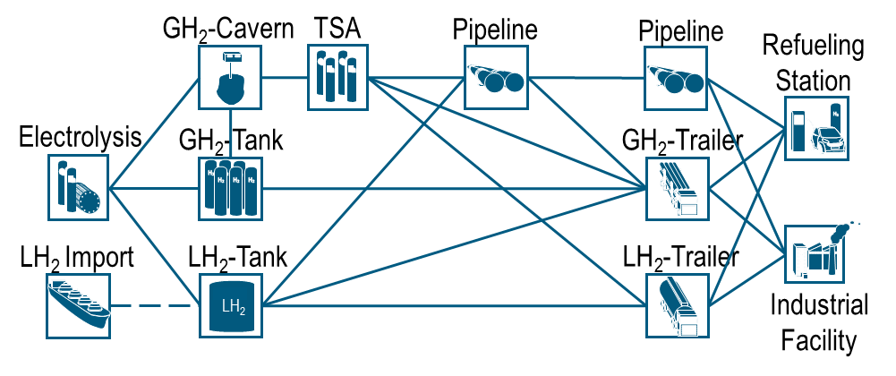
TSA – Temperature swing adsorption
GH₂ – Gaseous Hydrogen
LH₂ – Liquid Hydrogen

Figure 1. Hydrogen supply chain overview [10].
For production and import, we assume PEM electrolysis and liquid hydrogen (LH₂) import costs as derived following the methodology of Heuser et al. [56]. In the case of the capital cost of the electrolysis, the learning and scaling effects of the production plant are considered. The long-term storage capacity is designed for 60 days, whereas no gaseous hydrogen (GH₂) salt caverns will be constructed until a minimal storage capacity of 70,000 m³ is achieved. Temperature swing adsorption (TSA) is used to reduce the water content in the hydrogen stream following the electrolysis and salt cavern components. Hydrogen delivery options encompass 70-100 bar hydrogen pipelines, LH₂ trailers and 500 bar GH₂ trailers, whereas pipeline delivery is separated into transmission and distribution networks. The transmission grid is considered to be the most representative NG grid in Germany and the centroids of the German counties, whereas each county is modeled with its own, separate distribution grid. Hydrogen fueling is considered for both 350 bar and 700 bar technologies, as well as industrial facilities that, in the case of pipeline transmission, are supplied directly from the pipeline network.

Results

In this section, the costs of the analyzed pipeline reassignment options are evaluated and the countrywide cost effects for the preselected options are assessed. Three distinct pipeline availability scenarios are defined and compared with regard to hydrogen supply chain cost sensitivity. Finally, hydrogen pipeline reassignment is compared to other hydrogen supply chain pathways.
  - Pipeline reassignment cost analysis
The resulting cost of the PWM reassignment and its cost structure can be observed in Figure 2. As can be expected, due to the fact that only the CAPEX of the compressor station is included in the cost consideration, the cost of the pipeline is largely dominated by the OPEX. This is especially the case for smaller diameters with very small compressor station expenditures, as the cost is primarily governed by the increased pipeline O&M costs. Moreover, the variation of OPEX with larger detectable crack lengths can be observed. The impact of delayed crack detection diminishes with increasing diameters until it accounts for less than 5% of the overall cost. Due to the fact that transmission pipelines are generally larger than 500 mm, the 25mm crack length is chosen for further analysis. Based on these findings, polynomial regressions are derived for use in the system-wide analysis and are depicted in Table 10.
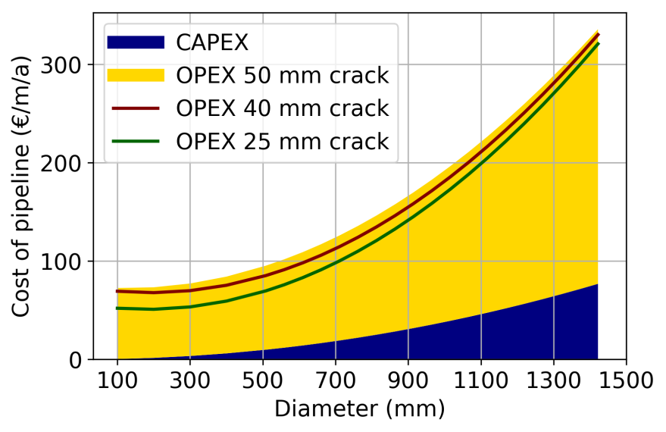
Figure 2. PWM reassignment cost structure with crack length impact on OPEX.

Table 10. Cost functions for PWM for a 25 mm crack length.
 | Unit | Cost function (d in mm)
CAPEX | €/m/a | $$\left(3.8×{10}^{-5}\right)∙d^{2}+\left(-2.2×{10}^{-12}\right)∙d+2.1×{10}^{-11}$$
OPEX | €/m/a | $$\left(1.4×{10}^{-4}\right)∙d^{2}+\left(-6.4×{10}^{-2}\right)∙d+56.6$$

The reassignment costs for the three different inhibitors are presented in Figure 3. Similar to the PWM reassignment method, one can observe increasing cost with rising pipeline diameter. Furthermore, the cost of the inhibitor admixture is also highly dominated by the operational costs that mainly relate to the additional cost components of hydrogen purification with subsequent compression and inhibitor expenditures. It can be observed that the capital costs of the three alternatives remain similar, as the only parameter variation occurs in the required inhibitor concentration, which affects the purification unit investment cost. The derived polynomial regressions in Table 11 for each inhibitor confirm the stated observations.

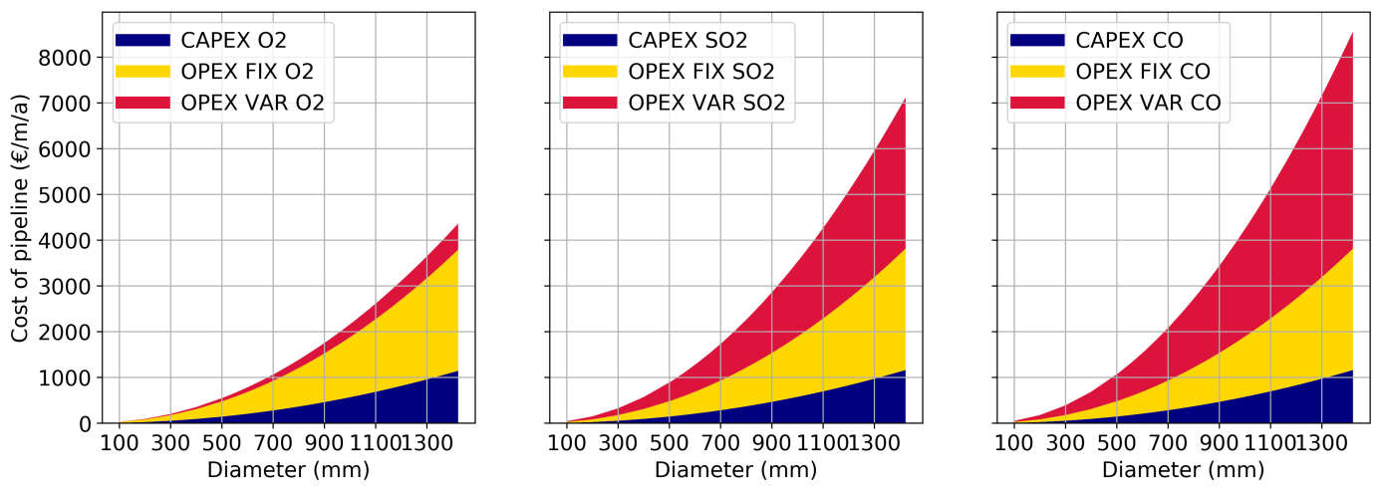
Figure 3. Inhibitors reassignment cost structure for O₂, SO₂, CO.

Table 11. Cost functions for inhibitor admixture of O₂, SO₂, CO.
Inhibitor |  | Unit | Cost function [d in mm]
O₂ | CAPEX | €/m/a | $$\left(5.6×{10}^{-4}\right)∙d^{2}+\left(1.7×{10}^{-12}\right)∙d+1.9×{10}^{-10}$$
O₂ | OPEX | €/m/a | $$\left(1.6×{10}^{-3}\right)∙d^{2}+\left(-1.8×{10}^{-12}\right)∙d+5.0$$
SO₂ | CAPEX | €/m/a | $$\left(5.7×{10}^{-4}\right)∙d^{2}+\left(-1.2×{10}^{-12}\right)∙d-4.1×{10}^{-10}$$
SO₂ | OPEX | €/m/a | $$\left( 2.9×{10}^{-3}\right)∙d^{2}+\left(-2.1×{10}^{-12}\right)∙d+5.0$$
CO | CAPEX | €/m/a | $$\left(5.7×{10}^{-4}\right)∙d^{2}+\left(-1.2×{10}^{-12}\right)∙d+4.1×{10}^{-10}$$
CO | OPEX | €/m/a | $$\left( 3.7×{10}^{-3}\right)∙d^{2}+\left(-1.9×{10}^{-12}\right)∙d+5.0$$

In Figure 4, the resulting total yearly pipeline costs of the analyzed pipeline reassignment alternatives at typical transmission pipeline diameters are displayed. In addition, new hydrogen pipeline costs with compressor stations every 250 km are presented [5, 34]. It can be observed that not all reassignment options deliver lower costs than new hydrogen pipelines, whereas CO and SO₂ admixture are the least competitive options. The significantly lower cost of O₂ admixture is highly related to the lower inhibitor cost and, most notably, the very small required inhibitor quantity that additionally reduces purification costs. However, due to the purification costs, the O₂ inhibitor admixture does not provide any cost reduction in comparison to new hydrogen pipeline construction. Significant cost reductions are observed in the case of the PWM pipeline reassignment that is found to be, on average, one order of magnitude less costly than the O₂ inhibitor admixture. The main reason for such a difference is that, for the PWM approach, no hydrogen purification is required for further hydrogen processing and use. Furthermore, due to its low CAPEX and fixed OPEX, the PWM reassignment is found to be 80% less expensive than building a new hydrogen pipeline. Nevertheless, it should be kept in mind that our cost estimates are based on material tests of small-diameter pipelines in comparably low-pressure conditions. Larger tests under more realistic transmission pipeline operation scenarios are required to gather more accurate results. Moreover, the crack growth acceleration is estimated for the case of the static pipeline load operation, which is facilitated by long-term and buffer hydrogen storage capacities. However, the high intermittency of renewable energy sources may require more flexibility in the pipeline network, which would increase the number of load cycles and, in turn, accelerate material degradation.

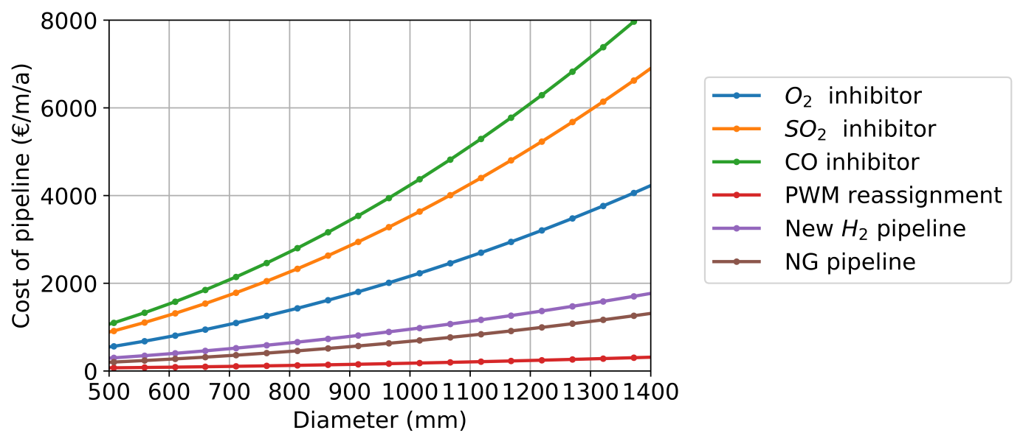
Figure 4. Cost comparison of the pipeline reassignment alternatives and new H₂ pipelines.

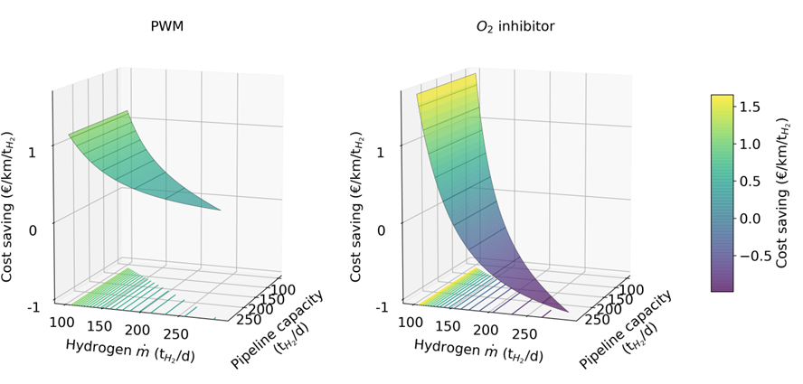
Figure. 5 - Cost savings by pipeline reassignment in comparison to a newly build H₂ pipeline.

Figure 5 displays the specific cost savings of pipeline reassignment for the two least expensive options in comparison to a new pipeline with small diameters of below 250 mm. Pipelines are generally associated with comparably large initial capital investments that are independent of the pipeline capacity and thus have a negative impact on specific costs. As the capacity increases, the specific CAPEX cost of the new H₂ pipeline delivery falls rapidly; therefore, one can observe diminishing specific cost savings with increasing hydrogen throughput. In the case where available NG pipeline capacity is insufficient, no reassignment can be applied and thus no cost comparison to the construction of a new hydrogen pipeline is apparent. Due to the higher variable operating expenses of purification and inhibitors, inhibitor reassignment is highly affected by the increasing pipeline throughput. However, as PWM reassignment costs are mostly governed by the fixed operating costs caused by the accelerated crack growth, pipeline throughput has little impact on the pipeline cost. For these reasons, PWM does not reach a zero-saving point with the construction of a new hydrogen pipeline. On the contrary, O₂ inhibitor reassignment costs reach new hydrogen pipeline costs at hydrogen throughputs of 150 t/d. The upside of such sensitivity is that O₂ inhibitor reassignment is very effective at low pipeline throughput, thus offering a compelling case for the initial upscaling of the hydrogen infrastructure.
  - Countrywide cost of pipeline reassignment
To analyze countrywide effects, Figure 6 presents a system-wide comparison of selected pipeline reassignment options and new transmission pipeline construction. For this comparison, the overall technical reassignment potential is used, thus displaying the most optimistic scenario. These results display rapid cost reduction of a countrywide H₂ pipeline system with increasing demand showing that, with sufficient market size, cost-competitive network costs of 0.6-1 ct/kWh can be achieved. However, the cost reduction effects observed earlier are diminished by 50% due to the limited pipeline availability for reassignment and the methodological requirement to connect county centers with new hydrogen pipelines. Furthermore, these results confirm the positive effect of PWM reassignment, as system-wide costs are consistently lower than in the case of a new pipeline system. An O₂ inhibitor and PWM lead to cost reductions of up to 20% and 35%, respectively. In line with earlier observations, we find that for small overall hydrogen demand (< 250 kt p.a.), an O₂ inhibitor provides a superior pipeline reassignment option over PWM, which is more cost-efficient with larger hydrogen throughputs. However, due to the rapidly increasing operating costs at an overall demand of 500 kt p.a., the O₂ inhibitor reaches the cost of the entirely new hydrogen pipeline system. To account for the varying nature of the least expensive pipeline reassignment option, an optimized mix of PWM and O₂ inhibitor will be further assessed for countrywide pipeline reassignment.

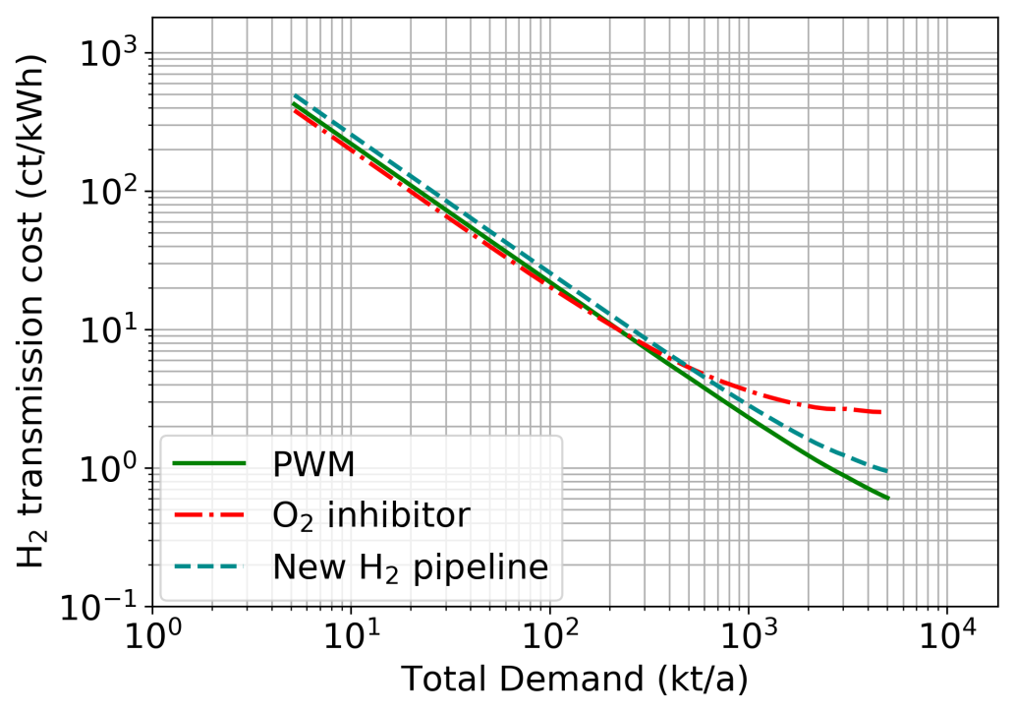
Figure 6. Countrywide H₂ transmission cost comparison.

To critically evaluate the effect of the pipeline’s availability, three distinct pipeline availability scenarios were designed. The analysis of the scenarios is based on the demand scenario for the specific year of 2030, thus allowing the comparison of the geospatial distribution of reassigned pipelines, as well as the associated cost effects. The underlying hydrogen demand scenario for Germany is derived from the market-specific trend overview by Cerniauskas et al. [10]. The scenario encompasses future hydrogen markets of local buses, non-electrified trains, passenger cars, trucks, material handling vehicles (MHV) and the chemical industry. Figure 7 presents the scenario-based, temporal evolution of hydrogen demand as well as its structure, showing the relative weight of each market. It can be observed that in the first half of the analysis period, the demand is mainly governed by captive bus and train vehicle fleets, MHVs and trucks. Passenger vehicles and heavy industry begin to dominate the hydrogen market in the second half of the analysis period, together making up approximately 60% of the total demand in 2050.
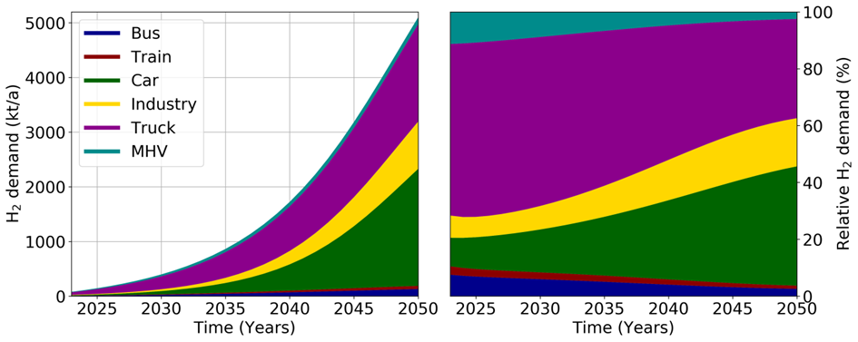
Figure 7. Hydrogen demand development and its relative structure [10].

All three pipeline availability scenarios share common constraints of minimal pipeline pressure, as well as the required pipeline material that is compatible with hydrogen transmission (see Introduction). The scenarios differ with regard to the consideration of the pipelines, which enables both hydrogen and NG transport throughout the region. Moreover, the age of the pipelines is taken into the account to consider the reassignment of the worn-down assets if the reassignment and construction of new NG pipelines proves to be less expensive than new NG and hydrogen pipelines. The summary of the scenario definition and relevant criteria is provided in Table 12. It should be pointed out that a more detailed NG system assessment comprising national and international NG flows, as well as n-1 security requirements, would provide a more detailed picture of pipelines that can be reassigned without diminishing the functionality of the NG system. Nevertheless, these scenarios can highlight the order of magnitude of the available cost reductions in the hydrogen transmission system.
Table 12. Definition of pipeline availability scenarios.
Criteria | Optimistic | Conservative | Balanced
Min. pressure [bar] | 70 | 70 | 70
Steel type | X70 | X70 | X70
# of parallel pipelines | - | >1 | >1
Pipeline age (a) | - | - | >40

As Figure 8 notes, the total pipeline network length for the year 2030 is estimated to be 11,700 km, which amounts to less than 30% of the total length of the representative NG transmission pipelines in Germany [57]. In the case of the optimistic reassignment scenario, which is not restricted by a number of parallel pipelines or pipeline age, we observe that up to 46% of the hydrogen transmission consists of reassigned pipelines covering almost all transmission in eastern Germany and the main transmission routes from wind-rich northwestern regions to the southeastern part of the country. The southwest of the country is highly constrained by pipeline eligibility criteria for hydrogen transmission, and therefore no reassignment can be found in this region (see natural gas system data). In the case of the conservative scenario, however, the total reassigned pipeline makes up only 13% of the transmission system length, thus enabling it to have only a limited effect on the overall system cost. In this case, only the highly industrialized region with the extensive NG system in the northwest of the country receives broader coverage with reassigned pipeline transmission. As the balanced scenario extends the conservative scenario with aged pipelines, it offers a less restrictive solution, with 25% of overall pipeline length. In this third scenario, the reassigned pipeline routes to central Germany, as well as the broad coverage of eastern Germany, are additionally enabled.

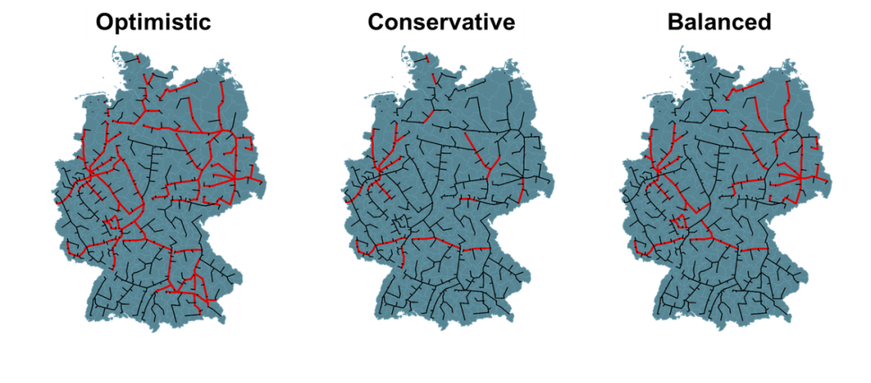
Reassigned
New H₂ pipelines
Reassigned length | 46% | 13% | 25%
Figure 8. Pipeline availability scenarios for the year 2030.

The quantified effects of the observed geospatial pipeline reassignment distribution are displayed in Figure 9, where the hydrogen transmission costs for all three scenarios are compared to the system based on entirely new hydrogen pipeline transmission. We can derive from this that, regardless of the pipeline availability scenario, reassignment reduces the transmission system cost by at least 10%. Furthermore, in the case of the optimistic scenario associated with less than 1/2 of the reassigned total pipeline length, pipeline reassignment enables a cost reduction of 20%. This result is in line with the cost reductions observed in Figure 6. In the conservative and balanced scenarios, transmission costs are reduced by 10% and 15%, respectively. The resulting costs of 3.4-3.8 ct/kWh are substantially larger than current NG grid levies in Germany of 0.33 ct/kWh and 1.25 ct/kWh for industrial and commercial consumers, respectively [58]. This finding indicates that for the selected demand scenario by 2030, the throughput in the countrywide hydrogen pipelines is not yet sufficient to reach a comparable scale of the current NG transmission system.
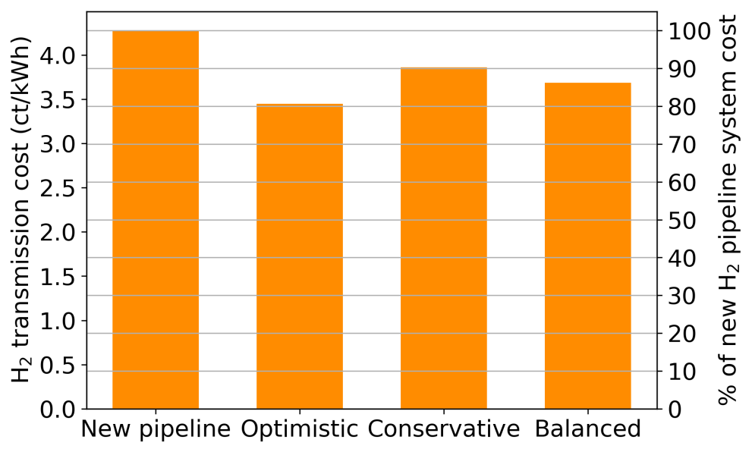
Figure 9. Hydrogen cost comparison related to pipeline availability scenarios for pipeline reassignment in the year 2030

Finally, the pipeline reassignment costs should be compared not only to the new hydrogen transmission, but also to the alternative hydrogen delivery options that utilize GH₂ and LH₂ trailers. In Figure 10, the pipeline reassignment in the case of the optimistic scenario is compared with other hydrogen delivery options that have been derived using the geospatial supply chain model (see the Hydrogen supply chain model). Despite the substantial cost reductions observed in the aforementioned results, we can observe that pipeline reassignment reduces the system cost by 5% in comparison to the new pipeline system. This effect is even smaller in the case of pipeline distribution, as the system cost is primarily dominated by the pipeline distribution rather than transmission costs. From this finding, we can conclude that small new transmission and distribution pipelines, which cannot be reassigned, are the main cost drivers in the pipeline system. Nevertheless, transmission pipeline reassignment becomes the least expensive hydrogen delivery option, surpassing LH₂ trailer delivery by 2030 at the demand of 300 kt p.a. This result indicates the significance of NG pipeline reassignment for the introduction of a cost-efficient hydrogen infrastructure.

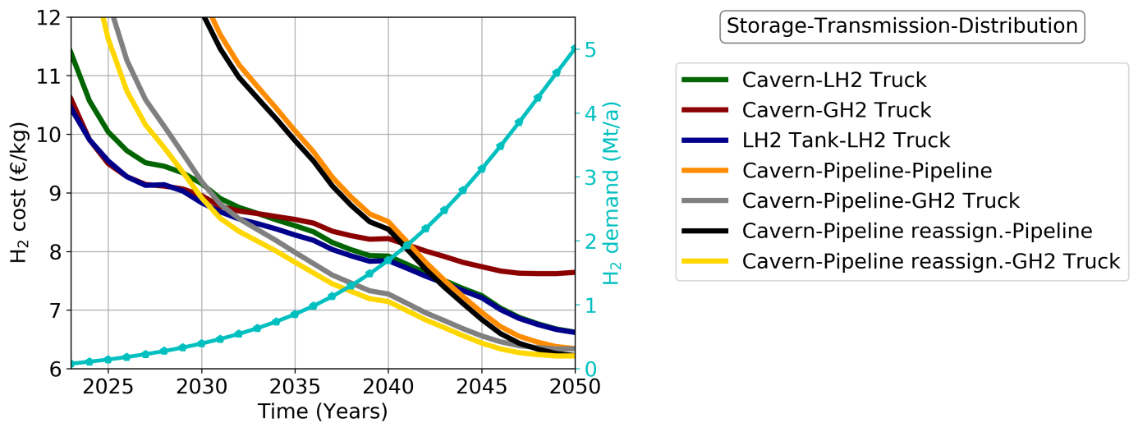
Figure 10. Comparison of hydrogen supply chain cost development under the exogenous hydrogen demand scenario.

To better comprehend the reasons behind the limited impact of the pipeline reassignment on the overall system cost, Figure 11 displays the cost structure of the new pipeline system and pipeline reassignment scenarios. A comparison of the results shows that production and fuel station costs make up more than 2/3 of the total system cost. The main reasons for these two supply chain components having such a sizeable impact are the variable hydrogen production costs, governed by the cost of electricity, and the low utilization of the refueling station network. Thereafter, a large share of production costs and fueling confine the overall impact of the transmission cost variation amongst the pipeline reassignment scenarios.
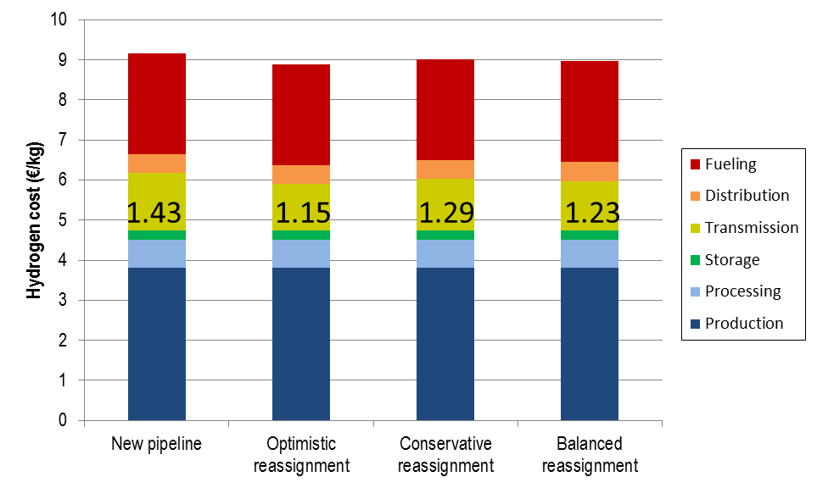
Figure 11. Hydrogen supply chain cost structure for different pipeline reassignment availability according to the hydrogen demand scenario in 2030.

Summary & conclusions
In this study, we examined four natural gas transmission pipeline reassignment alternatives and derived cost functions for the two most promising options, namely inhibitor admixture and pipeline utilization w/o modification (PWM). The bottom-up pipeline reassignment cost assessment consists of hydrogen-induced material fracturing cost in the form of increased O&M and inhibitor cost, as well as requiring new compressor and purification units. Subsequently, the necessary properties of the representative German NG network, such as pipeline material and diameter, pipeline age and the number of parallel pipelines, are derived to assess the technical potential of the NG pipeline reassignment. Based on the derived results, the system-wide cost effects are investigated and compared to the alternative hydrogen supply chain pathways of the truck and pipeline delivery, whereupon the potential role of the NG pipeline reassignment in implementing the hydrogen infrastructure is discussed.
Comparing the pipeline reassignment cost with that of the newly built hydrogen pipelines yielded two-fold results. On the one hand, for larger diameters, only the PWM created substantial cost reductions. Neglecting the cost of their disposal, inhibitors proved to be more cost-intensive than the construction of a new hydrogen pipeline. The main reasons that were identified for the higher inhibitor admixture costs are capital expenditures for inhibitors and purification costs. On the other hand, in the case of small pipeline diameters (<250 mm), and given that the inhibitor-based reassignment cost is less governed by fixed operational costs, using O₂ as an inhibitor offers superior cost reductions over the PWM. The first analysis of the technical reassignment potential of the German transmission network shows that more than 80% of the analyzed pipelines are available for reassignment. The countrywide cost of the reassignment options shows that pipeline reassignment can reduce costs by 20% to 35% compared to the new hydrogen pipeline. Furthermore, the O₂ inhibitor is less expensive than the PWM for overall H₂ demands below 250 kt p.a., indicating its potential during the initial hydrogen infrastructure introduction phase. However, in the case of overall demands larger than 500 kt p.a., the O₂ inhibitor system proves to be even more expensive than a new pipeline network. Therefore, an optimized choice of both pipeline reassignment options is considered in the subsequent analysis.
The assessment of NG pipeline availability scenarios shows that by 2030, the transmission cost is reduced by 20% in comparison to the new hydrogen pipeline system. Subsequently, the comparison of the reassignment cost development with the truck and new pipeline hydrogen supply chains shows that by 2030 (300 kt p.a.), pipeline reassignment will be the least expensive hydrogen delivery option. This finding indicates that NG pipeline reassignment offers a cost-effective hydrogen delivery method and is thus very suitable for a national hydrogen infrastructure. Especially, as it can alleviate the implementation of hydrogen infrastructure by avoiding stranded investments in the natural gas system and abating the planning and approval procedures of hydrogen projects. However, the high-cost share of production and fueling diminishes the overall impact of pipeline reassignment, highlighting that challenges for a cost-competitive hydrogen supply concerning the low-cost hydrogen production and the improved utilization of the refueling station network remain to be solved.
Acknowledgment
The authors gratefully acknowledge funding by the Helmholtz Association under the Joint Initiative, ‘‘EnergySystem 2050 – A Contribution of the Research Field Energy” and the project, “Energy System Integration”.

Conflicts of Interest
The authors declare no conflict of interest.

Acronyms
CAPEX Capital expenditures
FCP Fatigue crack propagation
GH2 Gaseous hydrogen
HAZ Heat affected zones
LH2 Liquid hydrogen
MHV Material handling vehicle
NG Natural gas
OPEX Operational expenditures
O&M Operation and maintenance
PSA Pressure swing adsorption
PWM Pipeline w/o modification
TSA Temperature swing adsorption

References
[1] REGULATION (EU) 2018/842 OF THE EUROPEAN PARLIAMENT AND OF THE COUNCIL of 30 May 2018 on binding annual greenhouse gas emission reductions by Member States from 2021 to 2030 contributing to climate action to meet commitments under the Paris Agreement and amending Regulation (EU) No 525/2013. Official Journal of the European Union: The European Parliament, The European Council; 2018.
[2] Gas market report. Market report series: International Energy Agency (IEA); 2018.
[3] Gillingham K, Huang P. Is Abundant Natural Gas a Bridge to a Low-carbon Future or a Dead-end? Energy Journal. 2019;40:1-26. https://doi.org/10.5547/01956574.40.2.kgil
[4] Ogden J, Jaffe AM, Scheitrum D, McDonald Z, Miller M. Natural gas as a bridge to hydrogen transportation fuel: Insights from the literature. Energy Policy. 2018;115:317-29. https://doi.org/10.1016/j.enpol.2017.12.049
[5] Krieg D. Konzept und Kosten eines Pipelinesystems zur Versorgung des deutschen Straßenverkehrs mit Wasserstoff. Jülich: Forschungszentrum Jülich, Zentralbibliothek; 2012.
[6] Reuß M, Grube T, Robinius M, Stolten D. A hydrogen supply chain with spatial resolution: Comparative analysis of infrastructure technologies in Germany. Applied Energy. 2019;247:438-53. https://doi.org/10.1016/j.apenergy.2019.04.064
[7] Shafiei E, Davidsdottir B, Leaver J, Stefansson H, Asgeirsson EI. Energy, economic, and mitigation cost implications of transition toward a carbon-neutral transport sector: A simulation-based comparison between hydrogen and electricity. Journal of Cleaner Production. 2017;141:237-47. https://doi.org/10.1016/j.jclepro.2016.09.064
[8] Hwangbo S, Lee I-B, Han J. Mathematical model to optimize design of integrated utility supply network and future global hydrogen supply network under demand uncertainty. Applied Energy. 2017;195:257-67. https://doi.org/10.1016/j.apenergy.2017.03.041
[9] Moreno-Benito M, Agnolucci P, Papageorgiou LG. Towards a sustainable hydrogen economy: Optimisation-based framework for hydrogen infrastructure development. Computers & Chemical Engineering. 2017;102:110-27. https://doi.org/10.1016/j.compchemeng.2016.08.005
[10] Cerniauskas S, Grube T, Praktiknjo AJ, Stolten D, Robinius M. Future Hydrogen Markets for Transportation and Industry – The Impact of CO2 Taxes. Energy Policy. 2019;(Submitted). Submitted
[11] Popov BN, Lee J-W, Djukic MB. Chapter 7 - Hydrogen Permeation and Hydrogen-Induced Cracking. In: Kutz M, editor. Handbook of Environmental Degradation of Materials (Third Edition): William Andrew Publishing; 2018. p. 133-62.
[12] Shehata MT, Elboujdaini M, Revie RW. Initiation of stress corrosion cracking and hydrogen-induced cracking in oil and gas line-pipe. In: Pluvinage G, Elwany MH, editors. Safety, Reliability and Risks Associated with Water, Oil and Gas Pipelines 2008.
[13] Laboratories SN. Technical Reference on Hydrogen Compatibility of Materials. 2008.
[14] Glinka G. The Fracture Mechanics Method (da/dN-ΔK). 2010.
[15] Nanninga N, Slifka A, Levy Y, White C. A Review of Fatigue Crack Growth for Pipeline Steels Exposed to Hydrogen. Journal of Research of the National Institute of Standards and Technology. 2010;115:437-52. https://doi.org/10.6028/jres.115.030
[16] Xu K. 14. Hydrogen embrittlement of carbon steels and their welds. Gaseous Hydrogen Embrittlement of Materials in Energy Technologies - Volumen 1. Cambridge: Woodhead Publishing Limited; 2012. p. 526-61.
[17] Raymond L. Hydrogen Embrittlement: Prevention and Control. STP 962. Philadelphia: ASTM; 1988.
[18] An T, Zheng SQ, Peng HT, Wen XL, Chen LQ, Zhang L. Synergistic action of hydrogen and stress concentration on the fatigue properties of X80 pipeline steel. Materials Science and Engineering a-Structural Materials Properties Microstructure and Processing. 2017;700:321-30. https://doi.org/10.1016/j.msea.2017.06.029
[19] Hillenbrand HG, Niederhoff KA, Amoris E, Perdrix C, Streisselberg A, Zeislmair U. Development of Linepipe in Grades up to X-100. EPRG/PRC Biennial Joint Technical Meeting on Linepipe Research. Washington, D. C1997.
[20] Holbrook JH, Cialone HJ, Collings EW, Drauglis EJ, Mayfield ME. Control of hydrogen embrittlement of metals by chemical inhibitors and coatings. Gaseous hydrogen embrittlement of materials in energy technologies Volumen 2: Mechanisms, modelling and future developments: Woodhead Publishing Limited; 2012. p. 129-53.
[21] Gillette JL, Kolpa RL. Overview of Interstate Hydrogen Pipeline Systems. Chicago: Argonne National Laboratory and U.S. Department of Energy; 2007.
[22] Grainger S, Blunt J. Chapter 5: Electrodeposited coatings. Engineering Coatings - Design and applications. Cambridge-England: Abington Publishing; 1998. p. 167-93.
[23] Grainger S, Blunt J. Chapter 6: Physical and chemical vapour deposition techniques. Engineering Coatings - Design and applications. Cambridge-England: Abington Publishing; 1998. p. 194-225.
[24] Kussmaul K, Deimel P, Fischer H, Sattler E. Fracture mechanical behaviour of the steel 15 MnNi 6 3 in argon and in high pressure hydrogen gas with admixtures of oxygen. International Journal of Hydrogen Energy. 1998;23:577-82. https://doi.org/10.1016/s0360-3199(97)00104-3
[25] Michler T, Naumann J. Coatings to reduce hydrogen environment embrittlement of 304 austenitic stainless steel. Surface & Coatings Technology. 2009;203:1819-28. https://doi.org/10.1016/j.surfcoat.2009.01.013
[26] ISO 14687-2: 2012: Hydrogen fuel – product specification – Part 2: Proton exchange membranes (PEM) fuel cell applications for road vehicles. 2012.
[27] Technische Regel - Arbeitsblatt. Gasbeschaffenheit: DVGW; 2013.
[28] Godula-Jopek A, Jehle W, Wellnitz J. Hydrogen Storage Technologies: New Materials, Transport, and Infrastructure: Wiley‐VCH Verlag GmbH & Co. KGaA 2012.
[29] Berstad D. Technologies for hydrogen liquefaction. Gasskonferansen. Trondheim, Trondheim2018.
[30] Wang FC. Effective design of submarine pipe-in-pipe using Finite Element Analysis. Ocean Engineering. 2018;153:23-32. https://doi.org/10.1016/j.oceaneng.2018.01.095
[31] Sburlati R, Kashtalyan M. Elasticity analysis of sandwich pipes with functionally graded interlayers. European Journal of Mechanics a-Solids. 2016;59:232-41. https://doi.org/10.1016/j.euromechsol.2016.03.012
[32] Jiwa MZ, Kim DK, Mustaffa Z, Choi HS. A systematic approach to pipe-in-pipe installation analysis. Ocean Engineering. 2017;142:478-90. https://doi.org/10.1016/j.oceaneng.2017.07.004
[33] Michler T, Boitsov IE, Malkov IL, Yukhimchuk AA, Naumann J. Assessing the effect of low oxygen concentrations in gaseous hydrogen embrittlement of DIN 1.4301 and 1.1200 steels at high gas pressures. Corrosion Science. 2012;65:169-77. https://doi.org/10.1016/j.corsci.2012.08.015
[34] Mischner J, Fasold H-G, Kadner K. Systemplanung in der Gasversorgung Gaswirtschaftliche Grundlagen. Munich-Germany: Oldenbourg Industrieverlag GmbH; 2011.
[35] Reuß M, Grube T, Robinius M, Preuster P, Wasserscheid P, Stolten D. Seasonal storage and alternative carriers: A flexible hydrogen supply chain model. Applied Energy. 2017;200:290-302. https://doi.org/10.1016/j.apenergy.2017.05.050
[36] DIN 2413:2011-06 Seamless steel tubes for oil- and water-hydraulic systems - Calculation rules for pipes and elbows for dynamic loads. 2011.
[37] Gajdoš Ľ, Šperl M. Evaluating the Integrity of Pressure Pipelines by Fracture Mechanics 2012.
[38] Uzelac N. In-Line Inspection (ILI) (“Intelligent Pigging”). Oil and Gas Pipelines: Integrity and Safety Handbook. New Jersey: John Wiley & Sons; 2015. p. 515-36.
[39] El-Sayed M, El Domiaty A, Mourad AHI. Fracture Assessment of Axial Crack in Steel Pipe under Internal Pressure. In: Tu ST, Chen X, editors. Pressure Vessel Technology: Preparing for the Future2015. p. 1273-87.
[40] Solutions PP. Crack Management: Pipeline inspection and integrity services. 2014.
[41] Liemberger W, Gross M, Miltner M, Harasek M. Experimental analysis of membrane and pressure swing adsorption (PSA) for the hydrogen separation from natural gas. Journal of Cleaner Production. 2017;167:896-907. https://doi.org/10.1016/j.jclepro.2017.08.012
[42] Linde. Hydrogen Recovery by Pressure Swing Adsorption. 2018.
[43] Schröder V, Emonts B, Janßen H, Schulze H-P. Explosion Limits of Hydrogen/Oxygen Mixtures at Initial Pressures up to 200 bar. Chemical Engineering & Technology. 2004;27:847-51. https://doi.org/10.1002/ceat.200403174
[44] Cox KR, Chapman WG. The Properties of Gases and Liquids, 5th Edition Journal of the American Chemical Society. 2001;123:6745-. https://doi.org/10.1021/ja0048634
[45] Banaszkiewicz T, Chorowski M, Gizicki W. Comparative analysis of oxygen production for oxy-combustion application. In: Rokke NA, Svendsen H, editors. 7th Trondheim Conference on Co2 Capture, Transport and Storage2014. p. 127-34.
[46] DeJuan F, Donovan H, Tom R, Stew H. Feasibility Study for In-situ Oxygen Separation for Hospitals: Technical Report and Market Analysis. 2006.
[47] Inc. OS. OSI - Energy Cost for VSA Oxygen Gererators & Booster Compressors. 2015.
[48] ICIS. Chemical Profile - SULFUR DIOXIDE. 2005.
[49] George C. Carbon Monoxide. Kirk-Othmer Encyclopedia of Chemical Technology: John Wiley & Sons, Inc; 2001.
[50] Towler GP, Mann R, Serriere AJL, Gabaude CMD. Refinery hydrogen management: Cost analysis of chemically-integrated facilities. Industrial & Engineering Chemistry Research. 1996;35:2378-88. https://doi.org/10.1021/ie950359+
[51] Wu B, Zhang XP, Xu YJ, Bao D, Zhang SJ. Assessment of the energy consumption of the biogas upgrading process with pressure swing adsorption using novel adsorbents. Journal of Cleaner Production. 2015;101:251-61. https://doi.org/10.1016/j.jclepro.2015.03.082
[52] Bensmann B, Hanke-Rauschenbach R, Muller-Syring G, Henel M, Sundmacher K. Optimal configuration and pressure levels of electrolyzer plants in context of power-to-gas applications. Applied Energy. 2016;167:107-24. https://doi.org/10.1016/j.apenergy.2016.01.038
[53] Meindersma GW, Kuczynski M. Implementing membrane technology in the process industry: Problems and opportunities. Journal of Membrane Science. 1996;113:285-92. https://doi.org/10.1016/0376-7388(95)00127-1
[54] Moon D-K, Lee D-G, Lee C-H. H2 pressure swing adsorption for high pressure syngas from an integrated gasification combined cycle with a carbon capture process. Applied Energy. 2016;183:760-74. https://doi.org/10.1016/j.apenergy.2016.09.038
[55] Moon D-K, Park Y, Oh H-T, Kim S-H, Oh M, Lee C-H. Performance analysis of an eight-layered bed PSA process for H2 recovery from IGCC with pre-combustion carbon capture. Energy Conversion and Management. 2018;156:202-14. https://doi.org/10.1016/j.enconman.2017.11.013
[56] Heuser PM, Ryberg DS, Grube T, Robinius M, Stolten D. Techno-economic analysis of a potential energy trading link between Patagonia and Japan based on CO2 free hydrogen. International Journal of Hydrogen Energy. 2019;44:12733-47. https://doi.org/10.1016/j.ijhydene.2018.12.156
[57] Facts and figures. FNB Gas. https://www.fnb-gas.de/en/transmission-systems/facts-and-figures/facts-and-figures.html. 2019/06/25
[58] Monitoringbericht 2018. Bundesnetzagentur für Elektrizität, Gas, Telekommunikation, Post und Eisenbahnen; 2019.

¹ D-52425 Jülich, +49 2461 61-9154, s.cerniauskas@fz-juelich.de, http://www.fz-juelich.de/iek/iek-3
Assuming an electricity cost of 3 ct/kWh and O₂ output of 5 kt/d.
Inflation rate through the years in the USA (1 USD₁₉₉₆ = 1.59 USD₂₀₁₈), in the EU (1 €₂₀₁₃ = 1.038 €₂₀₁₈) and an average exchange rate for 2018 of 0.83 €/USD.
Ammonia, petro-chemical, methanol

