Review
A Simulation-Ready Framework for Electric-Vehicle Gearbox NVH
Integrating Manufacturing Variability, Transmission Error, Structural Acoustics, Machine Learning, and Psychoacoustics
Krisztian Horvath
Department of Vehicle Development, Audi Hungaria Faculty of Engineering, Széchenyi István University, Egyetem tér 1, 9026 Győr, Hungary
Correspondence: horvath.krisztian@ga.sze.hu | ORCID: 0009-0007-1655-2255

Abstract
Electric-vehicle (EV) gearboxes operate in an acoustic environment in which gear whine, motor orders, inverter-related harmonics, and structure-borne responses are readily perceived. Existing research often treats manufacturing variation, transmission error, multibody simulation, housing radiation, condition monitoring, and psychoacoustic assessment as separate topics. This review develops a simulation-ready framework that connects these domains in a single source-path-response-perception chain. The framework maps gear and assembly deviations, including pitch error, run-out, flank waviness, tooth-to-tooth microgeometry variation, bearing preload, misalignment, and housing stiffness, to intermediate quantities such as kinematic and dynamic transmission error, gear-mesh orders, shaft-order sidebands, structural vibration, sound-pressure bands, diagnostic indicators, and psychoacoustic metrics. A structured narrative synthesis of 38 sources combines 21 external publications with 17 representative publications from the author's research program to clarify which physical inputs and validation evidence are required for different engineering claims. Four simulation-readiness levels are proposed: nominal, tolerance-based, measurement-based, and variability-aware. These levels distinguish early concept screening from tolerance robustness, as-built unit reconstruction, and production-scatter prediction. The review also introduces a machine-readable source-claim representation to support transparent reuse of the cited evidence. The resulting framework provides practical guidance for robust EV gearbox NVH modeling, data-driven screening, root-cause analysis, end-of-line interpretation, and perception-oriented validation.
Keywords: electric vehicle gearbox; NVH; gear whine; transmission error; manufacturing variability; pitch error; flank waviness; tooth-to-tooth variability; multibody dynamics; structural acoustics; machine learning; psychoacoustics; condition monitoring; simulation readiness; variability-aware simulation

1. Introduction
Electric powertrains have changed the practical meaning of drivetrain noise, vibration, and harshness (NVH). In conventional vehicles, broadband combustion noise often masked tonal gear and motor-related components. In battery electric vehicles, this masking is strongly reduced, and high-frequency harmonic content from gears, electric machines, inverters, bearings, and lightweight housings can become a dominant refinement issue [1–6]. This shift requires a system-level interpretation: the perceived sound is not determined by a single component, but by the interaction between source strength, transfer-path dynamics, structural radiation, and human perception.
Gearbox excitation is commonly linked to transmission error (TE), which describes the deviation between the actual and ideal relative angular motion of a gear pair. TE is influenced by tooth compliance, mesh-stiffness variation, microgeometry, pitch error, run-out, misalignment, and manufacturing scatter [7–11]. However, TE is not the final receiver quantity. A similar excitation may lead to different radiated sound depending on shaft and bearing dynamics, housing modes, radiation efficiency, and operating condition. Consequently, a reliable EV gearbox NVH model must preserve physically meaningful intermediate quantities rather than reducing the problem too early to a single sound-pressure value.
Recent research has expanded this source-centered interpretation toward coupled multiphysics simulation, harmonic interaction, manufacturing variability, periodic flank structures, tooth-indexed deviations, tolerance-aware design, and assembly-dependent transfer paths [12–20]. Small deviations may become acoustically relevant even when conventional component-level quality metrics are acceptable. Periodic flank waviness can generate ghost orders. Tooth-to-tooth spatial distribution can change sideband structure even at constant nominal microgeometry. Bearing preload and assembly state can alter the transfer path. Housing ribbing and stiffness can shift the frequency bands in which acoustic sensitivity is most visible.
The objective of this review is to formulate a simulation-ready framework for EV gearbox NVH. The paper does not replace detailed standards, gear-contact solvers, or acoustic methods. Instead, it clarifies how manufacturing and assembly data should be connected to excitation indicators, transfer-path models, structural-acoustic response, diagnostic interpretation, and psychoacoustic validation. The main contribution is the introduction of four simulation-readiness levels that distinguish nominal, tolerance-based, measurement-based, and variability-aware models. These levels define which engineering claims can be supported by different evidence bases.

2. Review Design and Evidence-Synthesis Method
A targeted structured literature search was conducted on 24 June 2026 using Crossref-indexed publisher pages and the SpringerLink, SAE Mobilus, ASME Digital Collection, and MDPI platforms. Search strings combined ("electric vehicle" OR "electric drivetrain" OR "e-axle") with (gearbox OR gear) and one or more of the following terms: NVH, gear whine, transmission error, mesh stiffness, manufacturing variability, flank waviness, housing acoustics, condition monitoring, machine learning, psychoacoustics, and sound quality. The search was supplemented by backward citation checking from key review and foundational gear-dynamics papers.
English-language peer-reviewed journal articles, conference or technical papers, theses, and data descriptors were considered. The main publication window was 2018–2026, while earlier seminal works were retained when they established transmission-error theory, contact-ratio effects, profile modification, or the influence of manufacturing and mounting errors. Sources were included when they explicitly connected a physical input or deviation to an excitation, transfer, acoustic, diagnostic, or perceptual quantity. Studies focused solely on electromagnetic motor noise without a gearbox or coupled-drivetrain connection, non-technical commentary, duplicate reports, and sources without sufficient methodological detail were excluded.
The final evidence set contains 38 sources: 21 external publications and 17 author-associated publications selected as representative application evidence. For each source, five elements were extracted: the physical parameter or deviation; the intermediate excitation or transfer quantity; the final response or decision variable; the evidence type; and the main limitation. Numerical results were not pooled across incompatible models or operating conditions. Instead, the synthesis identifies where physical information is retained or lost along the NVH chain. This is a structured narrative review and framework-development study rather than a PRISMA systematic review or meta-analysis.
Generative AI tools were used only to assist with language editing, document organization, and formatting. Literature selection, evidence extraction, numerical verification, scientific interpretation, and final responsibility remained with the author. A full disclosure is provided at the end of the manuscript.

3. Source-Path-Response-Perception Framework
Figure 1 summarizes the proposed chain. The manufacturing and assembly layer describes physical deviations and boundary conditions. The excitation layer converts these deviations into TE, kinematic TE, mesh-frequency content, shaft orders, and sidebands. The dynamic-transfer layer describes how shafts, bearings, mounts, and joints carry these forces to the housing. The structural-acoustic layer represents housing modes, vibration, sound pressure, sound power, and band-limited acoustic response. The final layer interprets these responses through perception, classification, risk, quality control, or diagnostic decisions. This arrangement is consistent with system-level and multiphysics EV powertrain studies [1–6,12,13].
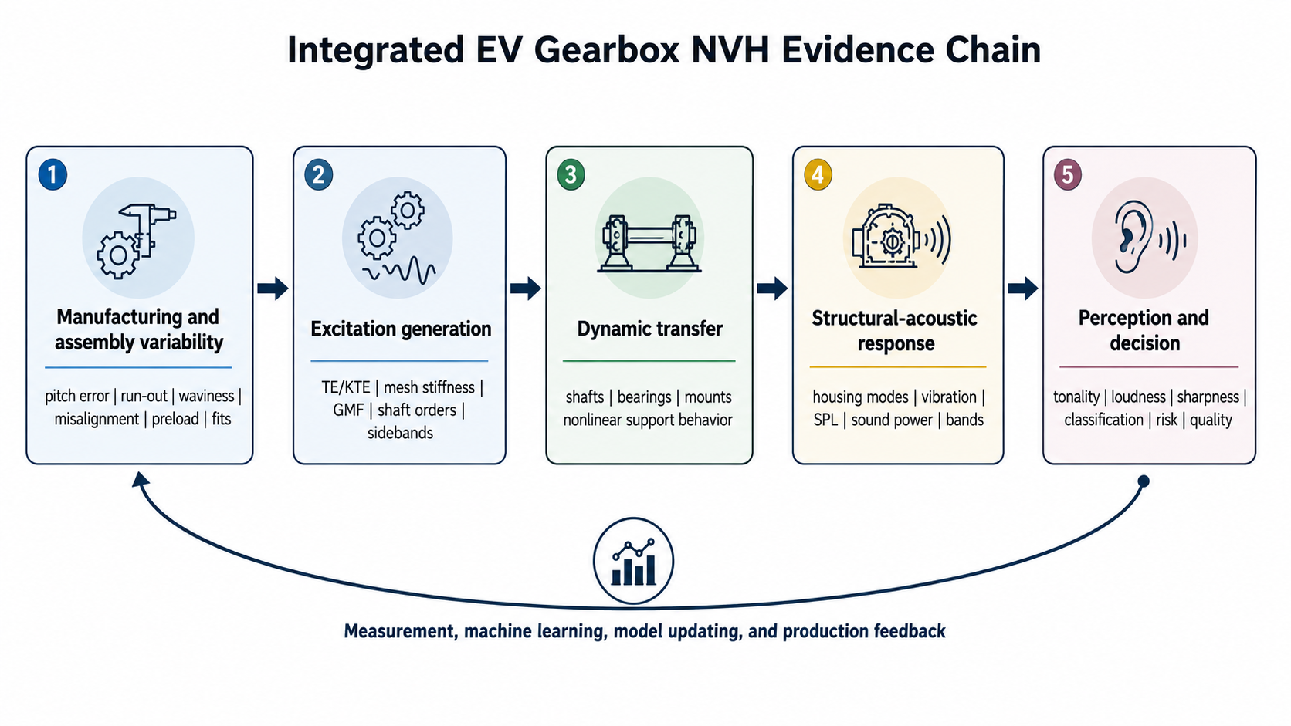
Figure 1. Integrated EV gearbox NVH evidence chain linking manufacturing variability, excitation generation, dynamic transfer, structural-acoustic response, perception, and feedback.

3.1. Physical variability is not only a quality variable
Manufacturing and assembly parameters do not all influence NVH in the same manner. Pitch error and flank waviness can directly shape mesh excitation. Run-out and eccentricity may introduce shaft-order content and modulation. Bearing clearance or preload can modify both alignment and transfer-path stiffness. Housing ribbing and wall-thickness variation can alter the response and radiation efficiency without changing the source itself [14–20]. This distinction is important because a single final acoustic measure cannot identify where in the chain a deviation acts.

3.2. Intermediate quantities preserve causality
Intermediate quantities such as TE, KTE, GMF-band energy, sideband energy, bearing force, surface velocity, band-limited SPL, and psychoacoustic tonality provide checkpoints between physical causes and final decisions. They help distinguish a source change from a transfer-path amplification or a receiver-metric effect. This is particularly important in EV development because gear, motor, inverter, and housing-related orders may overlap in frequency and produce perceptually nonlinear outcomes [2–6,12,13].

4. Manufacturing and Assembly Variability
EV gearbox NVH is sensitive to deviations that are small in manufacturing terms but structured in a way that strongly affects spectral content. A measured pitch-deviation table introduced into a multibody gear model was shown to increase mean TE by nearly one order of magnitude and to generate a shaft-order tone; combining pitch error with measured tooth topographies further increased peak-to-peak TE [16]. The practical implication is that a tooth-indexed representation can be required when sidebands or shaft-order modulation are part of the target response.
Surface waviness represents another mechanism. Periodic or quasi-periodic tooth-flank topography can generate ghost orders that are not explained by nominal tooth-count orders. This makes waviness descriptors, full-surface maps, and process-aware metrology relevant for NVH, especially in low-masking EV powertrains [14,15]. Waviness cannot be fully represented by a single profile or pitch grade if the acoustic concern depends on wavelength, phase, circumferential coherence, or interaction with structural resonance.
Tooth-to-tooth microgeometry variation also has to be interpreted as a sequence, not only as a distribution of amplitudes. A parametric simulation study with constant nominal barreling showed that harmonic, phase-shifted, clustered, and random tooth-level patterns produced different TE waveforms and sideband structures; the clustered outlier case produced the most fault-like response [18]. This supports a broader rule: the ordering, phase, and localization of deviations may matter as much as their maximum magnitude.
Robust design must also balance acoustic behavior against manufacturing effort. Recent work has combined profile corrections, tolerance bands, and production cost in a Pareto-type formulation, demonstrating that nominally optimal microgeometry may not remain optimal under realistic production variation [19].
Assembly state extends the problem from individual gears to the rotor-shaft-gear-bearing-housing chain. Misalignment, preload scatter, centering error, fit variation, thermal growth, and phase indexing can alter the final acoustic response even when individual components remain within tolerance [17,20]. A variability-aware model should therefore include not only component metrology but also as-built assembly information when the goal is unit-to-unit scatter prediction.

5. Transmission Error and Excitation Modeling
TE remains a useful common bridge variable because it connects gear geometry with dynamic excitation. Elastic multibody modeling can convert flank compliance, contact state, and geometry modification into time histories, mesh-order spectra, and pressure indicators. A published helical-gear case showed that a tip-relief change reduced RMS TE and the first mesh order while increasing maximum flank pressure, illustrating the trade-off between acoustic excitation and durability [21]. Independent validation research has also shown that high-fidelity elastic multibody models require staged quasi-static and dynamic correlation, and that improved mesh-stiffness representations can reduce simulation-to-measurement error substantially [22].
Similar reasoning applies to hypoid gears, where contact pattern, transmitted-torque stability, and TE spectral content must be interpreted together [23,24]. Assembly deflection and real-load contact conditions are especially important because hypoid gear whine is sensitive to the installed contact pattern and to the compliance of the axle or housing.
For tolerance studies, high-fidelity simulation can be expensive when many deviations and interactions are considered. A Monte Carlo study with 39,984 cases and 15 tolerance or process-shift variables showed that nonlinear surrogate models such as Random Forest and XGBoost captured KTE behavior more effectively than linear regression. Pitch error, radial run-out, and misalignment were dominant drivers, and a normalized Tonal Risk Index (TRI) was introduced for relative early-stage screening [25]. Related studies have addressed multi-objective e-axle gear optimization involving noise emission and load distribution [26], as well as hybrid metal-composite gear concepts for reducing dynamic transmission error [27]. These findings reinforce the need to treat excitation reduction as a multi-objective design task. TRI is therefore best understood as a source-side risk indicator rather than a direct prediction of perceived cabin sound.

6. Dynamic Transfer, Housing Response, and Acoustic Radiation
Once excitation leaves the gear mesh, the final acoustic outcome is shaped by shafts, bearings, mounts, housing modes, radiation efficiency, and receiver location. Multiphysics EV powertrain NVH should therefore be organized by mechanism rather than by software category. Electromagnetic force harmonics, inverter tones, gear-mesh excitation, bearing nonlinearities, and secondary sources interact through the same structural assembly before producing airborne sound or tactile vibration [2,3,12,13].
Housing design can be a decisive transfer-path intervention. Experimental and finite-element studies of electric-vehicle transmissions have shown that local bearing-hole stiffness, ribbing, and dynamic compliance can amplify or attenuate gear-related orders, and that structural reinforcement can produce measurable noise reductions [28].
Compact acoustic descriptors can be valuable for early screening. A small open housing dataset represented flexible, intermediate, and rigid ribbing concepts using five one-kilohertz SPL bands between 1 and 6 kHz. Exploratory analysis indicated that the 2–4 kHz range contained more stiffness-related information than total integrated energy [29]. A related classifier achieved 0.75 leave-one-out accuracy, separating the flexible concept more clearly than the intermediate and rigid concepts, but uncertainty remained high because only twelve spectra were available [30]. These studies illustrate a useful hierarchy: band features can support screening, while modal, operational, and transfer-path analyses remain necessary for causal explanation.

7. Data-Driven and Diagnostic Interpretation
Data-driven models can accelerate EV gearbox NVH assessment, but they require careful feature definition and validation. Manufacturing-stage data, surface inspection, rolling tests, and end-of-line acoustic measurements can be linked through interpretable variables such as TE, run-out, waviness descriptors, and order-related features [31]. Image-based classification can also be useful when raw numerical vibration data are difficult to export, but image scaling, rendering, and preprocessing must be controlled because they can become hidden model inputs [32].
Condition monitoring and NVH analysis are related but not identical. Condition monitoring often relies on broadband statistical features such as RMS, kurtosis, crest factor, or envelope indicators, whereas NVH analysis usually requires source-specific order and sideband information. A frequency-domain mapping study showed that RMS and envelope peak amplitude had moderate relationships with GMF-related tonal indicators, whereas kurtosis did not show a meaningful association. The amplification pattern also depended on sensor location [33]. Independent acoustic condition-monitoring research likewise shows that airborne sound can retain stable modulation information associated with progressive gear deterioration [34].
A reproducible Gearbox Health Index can provide a stable benchmark for comparing diagnostic methods, but health indicators should not be confused with acoustic comfort metrics. The normalized condition index describes deviation from a reference state; it does not directly quantify tonality, sharpness, or subjective annoyance [35].

8. Psychoacoustic Layer
The receiver in EV gearbox NVH is ultimately not only a microphone but a human listener. Overall SPL and sound power are necessary, but they can miss tonal prominence and modulation. Psychoacoustic metrics such as loudness, sharpness, roughness, fluctuation strength, and tonality quantify different aspects of perceived sound quality [36]. Recent work has also shown that machine-learning models can support tone-perception assessment when trained on controlled electric-powertrain sounds and perceptual labels [37]. A structured review focused on geared drives further demonstrates that these metrics should complement, rather than replace, physical and spectral quantities [38]. Consequently, source-side targets such as KTE or TRI, structural-acoustic targets such as band SPL or sound power, and receiver-side metrics such as tonality or sharpness should be treated as complementary layers.

9. Simulation-Readiness Levels
The proposed simulation-readiness levels rank the evidence behind a model rather than the complexity of the solver. A model can contain detailed finite elements yet remain nominal if its geometry and boundary conditions are idealized. Conversely, a reduced-order model can be more representative for a specific unit if it is based on measured pitch, flank geometry, assembly state, and validation data. Figure 2 summarizes the progression.
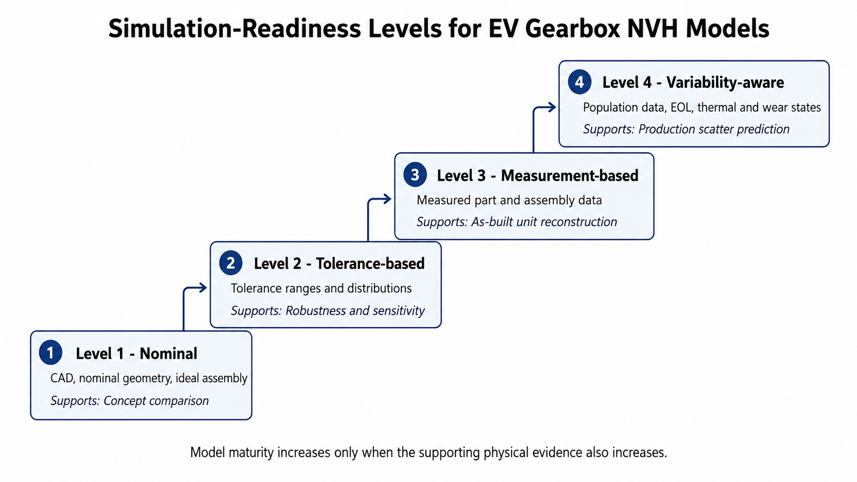
Figure 2. Four simulation-readiness levels for EV gearbox NVH models.
Level | Evidence and typical inputs | Appropriate outputs | Claims that should not be made
1. Nominal | Design intent. Nominal macrogeometry and microgeometry. Ideal alignment. Simplified supports. | Concept trends. Order locations. Baseline TE or force. | Production scatter. As-built correlation. Root-cause attribution.
2. Tolerance-based | Specified variability. Tolerance ranges. Statistical distributions. Monte Carlo or design of experiments. | Sensitivity. Robustness. Surrogate models. Relative risk. | Specific-unit reconstruction without measured inputs.
3. Measurement-based | As-built evidence. Measured pitch. Flank maps. Run-out. Assembly position. Preload. Modal or operational data. | Specific-unit correlation. Measured-order reproduction. Model updating. | Population-level probabilities from one unit.
4. Variability-aware | Population and lifecycle evidence. Production distributions. EOL data. Thermal states. Wear and degradation indicators. | Unit-to-unit scatter. Acceptance probability. Population risk. Adaptive digital twin. | Universal transfer beyond the represented population and operating domain.
Table 1. Evidence basis and supported claims at each simulation-readiness level.

10. Terminology and Machine-Readable Representation
Searchability and reuse are weakened when related concepts are described with inconsistent terminology. Table 2 links frequently used terms to their physical meaning within the proposed framework. The supplementary source-claim map extends this table in machine-readable form, including reference numbers, bibliographic metadata, DOIs, evidence type, research domain, and the claim used in the synthesis.
Preferred term | Related terms | Meaning in this review | Primary examples
Transmission error | TE. Static TE. Dynamic TE. KTE. | Deviation from ideal motion used as a source-side excitation descriptor. | [7–11,16,21–25]
Gear mesh frequency | GMF. Mesh order. Tooth-meshing frequency. | Tooth-passing excitation frequency and its harmonics. | [5–11,21–24]
Sideband | Shaft-order component. Modulation component. | Spectral component around GMF or harmonics caused by modulation. | [14–18,23,33,34]
Ghost order | Ghost frequency. Non-meshing order. | Manufacturing-induced tonal component not explained directly by nominal tooth counts. | [14,15,17,18]
Manufacturing variability | Process scatter. Tolerance variation. | Variation introduced by machining, heat treatment, finishing, and inspection-relevant geometry. | [14–19,25,31]
Assembly variability | Misalignment. Preload scatter. Fit and centering variation. Phase indexing. | As-built variation introduced by component positioning and support conditions. | [17,20]
Psychoacoustic metric | Tonality. Sharpness. Loudness. Roughness. | Perception-oriented descriptor of sound quality. | [36–38]
Table 2. Terminology map for search-oriented and machine-readable reuse.

11. Cross-Domain Evidence Map
Figure 3 positions the reviewed evidence within the proposed framework. It combines external literature and representative author-associated evidence rather than presenting a single-author publication portfolio. The map shows how manufacturing inputs, excitation models, transfer-path analyses, diagnostic methods, and perceptual validation can be linked without treating any one evidence type as sufficient on its own.
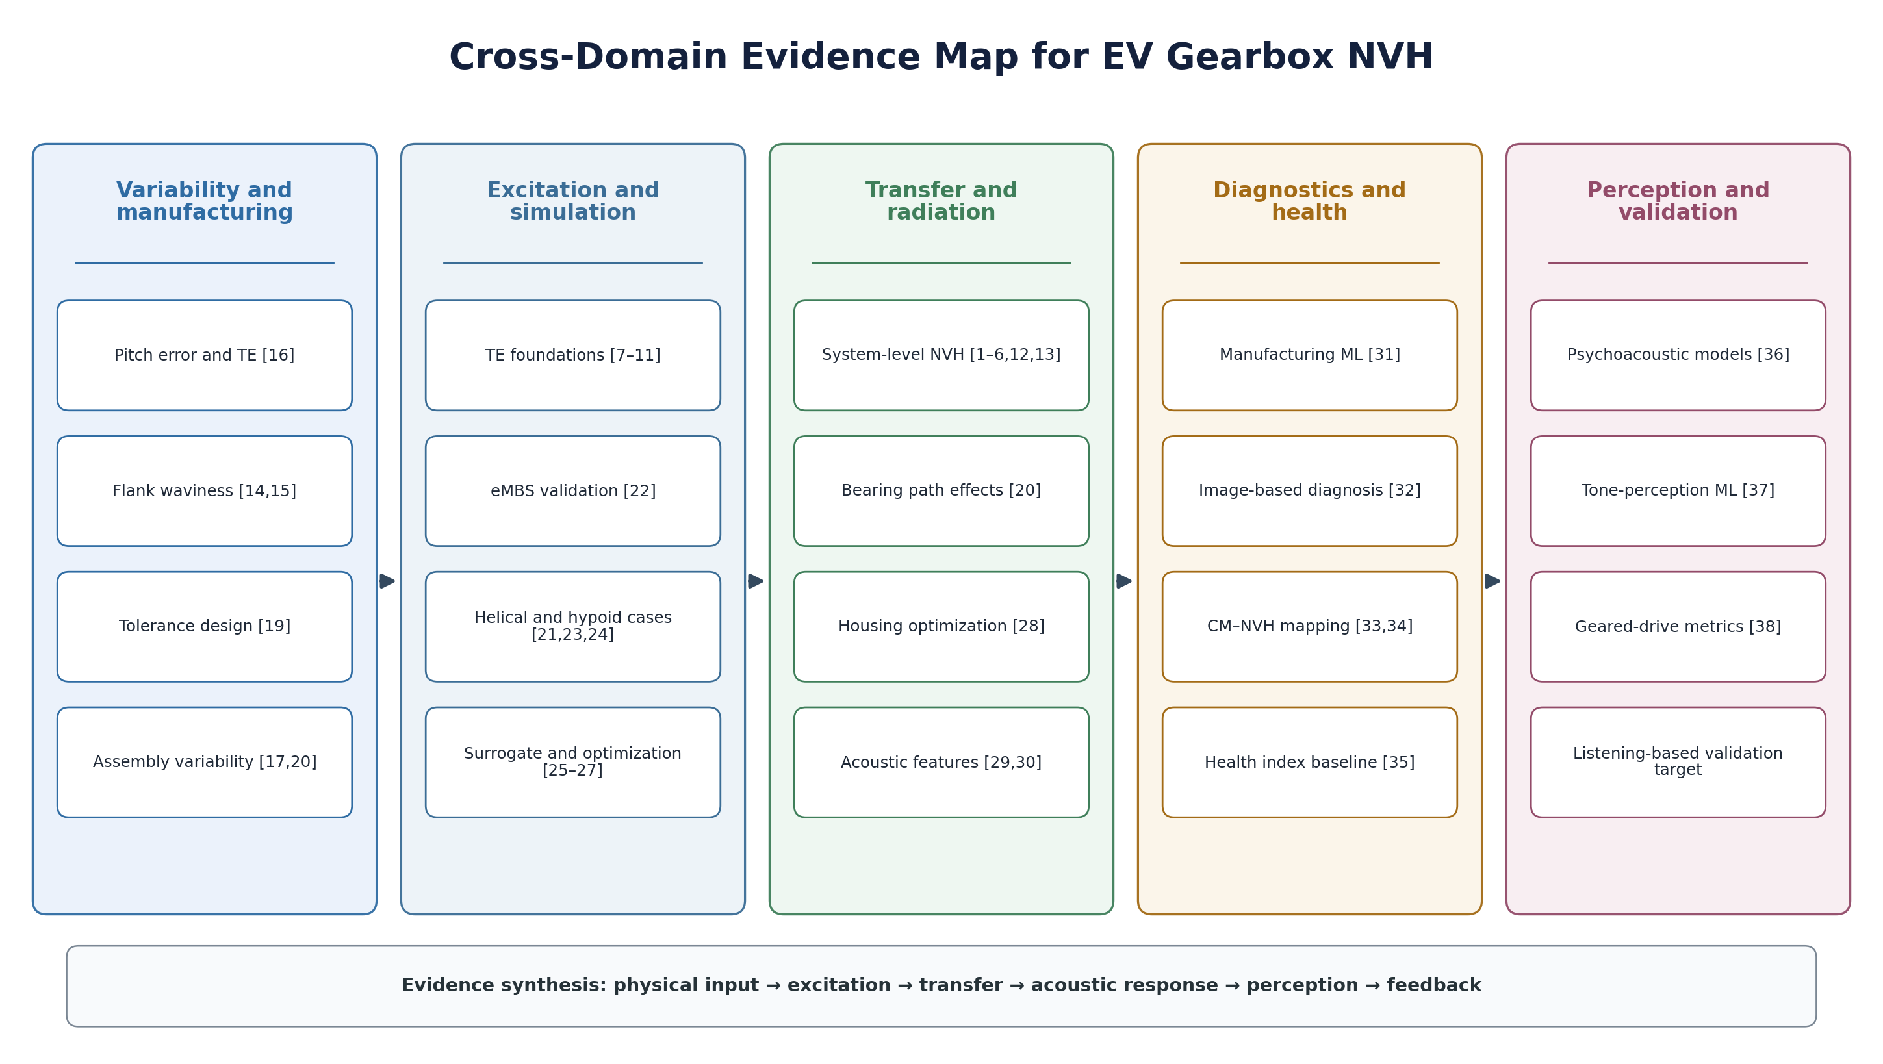
Figure 3. Cross-domain evidence map linking external studies and representative author-associated evidence to the proposed EV gearbox NVH framework.

12. Roadmap for Variability-Aware EV Gearbox NVH
• Retain tooth index and phase in metrology-to-simulation transfer. Pitch, flank topography, and microgeometry distributions should remain sequence-aware when sidebands or ghost orders are investigated.
• Build hierarchical validation chains. Validate TE or mesh force first. Validate bearing or housing response second. Validate radiated sound third. Validate psychoacoustic metrics last.
• Combine population data with physical priors. Monte Carlo tolerance models, end-of-line spectra, and production measurements should be linked through interpretable variables.
• Separate source risk from receiver risk. KTE and TRI can support early tolerance decisions, but transfer-path amplification and perception require additional layers.
• Extend open benchmarks. Larger datasets with multiple speeds, loads, temperatures, microphones, and sensor positions are required for generalizable data-driven models.
• Integrate degradation with acoustic scatter. Wear, backlash growth, bearing changes, and thermal states should be represented as evolving model inputs.
• Develop perception-aware digital twins. Order-resolved simulation should be transformed into audible signals or psychoacoustic descriptors and validated against listening assessments.

13. Limitations
This review has three main limitations. First, it is a structured narrative synthesis rather than a fully exhaustive systematic review. Second, the evidence types differ; review conclusions, numerical case studies, data descriptors, technical papers, and exploratory machine-learning analyses cannot be combined as if they had the same validation strength. Third, several quantitative results are configuration-specific and should not be interpreted as universal gearbox limits. These limitations are addressed by explicitly separating evidence level, model-readiness level, and supported engineering claim.

14. Conclusions
EV gearbox NVH should be interpreted as an evidence chain linking manufacturing and assembly variability to excitation, transfer, structural-acoustic response, perception, and production feedback. TE and KTE are useful bridge variables, but they do not determine final sound quality without transfer-path and receiver layers. Compact spectral descriptors, surrogate models, and condition indicators can accelerate screening, but they require physical anchors and validation appropriate to their intended use. Psychoacoustic metrics complete the chain by connecting engineering response to perceived quality.
The main contribution of this review is the simulation-ready framework and the four-level evidence structure. Nominal models support concept comparison. Tolerance-based models support robustness analysis. Measurement-based models support as-built unit reconstruction. Variability-aware models support production-scatter prediction. Treating these as distinct model-maturity levels provides a transparent route from early design simulation to measurement-based and production-representative EV drivetrain engineering.

Author Contributions
Conceptualization, methodology, literature selection, evidence synthesis, visualization, and writing: Krisztian Horvath.

Funding
This research received no external funding.

Data Availability Statement
No new experimental or simulation dataset was created for this review. The primary datasets and supporting materials remain available through the repositories and data-availability statements of the cited source publications. A separate supplementary ZIP archive accompanies this preprint and contains a machine-readable source-claim map, a BibTeX reference file, JATS 1.4 XML, Schema.org JSON-LD metadata, citation metadata, and the three publication-quality figures.

Conflicts of Interest
The author declares no conflict of interest.

Use of Generative AI
Generative AI tools were used to assist with language editing, document organization, and formatting. The author selected the literature, verified the scientific claims and numerical values against the cited publications, determined the interpretation, and accepts full responsibility for the content.

References
[1] Horvath, K.; Zelei, A. Simulating Noise, Vibration, and Harshness Advances in Electric Vehicle Powertrains: Strategies and Challenges. World Electr. Veh. J. 2024, 15, 367. https://doi.org/10.3390/wevj15080367
[2] Dambir, G.; Selukar, A. NVH Performance Prediction of Electrified Drive System under Influence of Electromechanical Excitations. SAE Technical Paper 2023-01-1670, 2023. https://doi.org/10.4271/2023-01-1670
[3] Xu, Y. Development of Commercial Vehicle E-Axle System Based on NVH Performance Optimization. SAE Technical Paper 2020-01-1421, 2020. https://doi.org/10.4271/2020-01-1421
[4] Zhang, S. Parameter Study and Improvement of Gearbox Whine Noise in Electric Vehicle. Automot. Innov. 2018, 1, 272–280. https://doi.org/10.1007/s42154-018-0029-5
[5] Chen, X.; Song, C.; Zhu, C.; et al. Effects of Macro-Parameters on Vibration and Radiation Noise for High Speed Wheel Gear Transmission in Electric Vehicles. J. Mech. Sci. Technol. 2018, 32, 4153–4164. https://doi.org/10.1007/s12206-018-0813-5
[6] Mughal, H.; Sivayogan, G.; Dolatabadi, N.; et al. An Efficient Analytical Approach to Assess Root Cause of Nonlinear Electric Vehicle Gear Whine. Nonlinear Dyn. 2022, 110, 3167–3186. https://doi.org/10.1007/s11071-022-07800-0
[7] Velex, P.; Maatar, M. A Mathematical Model for Analyzing the Influence of Shape Deviations and Mounting Errors on Gear Dynamic Behaviour. J. Sound Vib. 1996, 191, 629–660. https://doi.org/10.1006/jsvi.1996.0148
[8] Kubo, A. Stress Condition, Vibrational Exciting Force, and Contact Pattern of Helical Gears with Manufacturing and Alignment Error. J. Mech. Des. 1978, 100, 77–84. https://doi.org/10.1115/1.3453898
[9] Kahraman, A.; Blankenship, G.W. Effect of Involute Contact Ratio on Spur Gear Dynamics. J. Mech. Des. 1999, 121, 112–118. https://doi.org/10.1115/1.2829411
[10] Kahraman, A.; Blankenship, G.W. Effect of Involute Tip Relief on Dynamic Response of Spur Gear Pairs. J. Mech. Des. 1999, 121, 313–315. https://doi.org/10.1115/1.2829460
[11] Henriksson, M. On Noise Generation and Dynamic Transmission Error of Gears. Doctoral Thesis, KTH Royal Institute of Technology, Stockholm, Sweden, 2009.
[12] Horvath, K. Multiphysics Modeling and Simulation of NVH Phenomena in Electric Vehicle Powertrains. World Electr. Veh. J. 2026, 17, 183. https://doi.org/10.3390/wevj17040183
[13] Horvath, K. System-Level Harmonic NVH Engineering in Electric Drivetrains: A State-of-the-Art Review from Gear Microgeometry to Sound Branding. World Electr. Veh. J. 2026, 17, 240. https://doi.org/10.3390/wevj17050240
[14] Horvath, K.; Feszty, D. Surface Waviness of EV Gears and NVH Effects—A Comprehensive Review. World Electr. Veh. J. 2025, 16, 540. https://doi.org/10.3390/wevj16090540
[15] Sepp, S.; Wenig, A.; Otto, M.; et al. Acoustical Behavior of Periodic Flank Modifications under Dynamic Operating Conditions. Forsch. Ingenieurwes. 2023, 87, 913–922. https://doi.org/10.1007/s10010-023-00685-4
[16] Horvath, K.; Feszty, D. The Impact of Pitch Error on the Dynamics and Transmission Error of Gear Drives. Appl. Sci. 2025, 15, 7851. https://doi.org/10.3390/app15147851
[17] Horvath, K. Manufacturing and Assembly Variability in Electric Drivetrains: Impacts on NVH Performance—A Review. World Electr. Veh. J. 2026, 17, 261. https://doi.org/10.3390/wevj17050261
[18] Horvath, K.; Zelei, A. Parametric Simulation of Tooth-Level Barreling Distribution Effects on Transmission Error Modulation and Spectral Characteristics in a Single Gear Pair. Appl. Sci. 2026, 16, 5248. https://doi.org/10.3390/app16115248
[19] Roth, L.; Westphal, C.; Brecher, C. Design of Profile Corrections and Tolerances in Cylindrical Gears for Noise-Sensitive Applications in Line with Production Efforts. Forsch. Ingenieurwes. 2025, 89, 11. https://doi.org/10.1007/s10010-025-00786-2
[20] Pingale, A.; Soni, J. NVH Improvement of the BEV Transmission by Altering Bearing Mounting Arrangement. SAE Technical Paper 2025-01-0104, 2025. https://doi.org/10.4271/2025-01-0104
[21] Horvath, K.; Zelei, A. Multibody Simulation of Helical Gear Noise and Vibration Behavior Using MSC ADAMS. Eng. Proc. 2025, 113, 36. https://doi.org/10.3390/engproc2025113036
[22] Wischmann, S.; Mann, A.; Jacobs, G.; et al. Validation of Models for Calculating the NVH Behavior of Gearbox Systems in an Elastic Multibody Simulation. Forsch. Ingenieurwes. 2025, 89, 33. https://doi.org/10.1007/s10010-025-00816-z
[23] Horváth, K.; Zelei, A. Hipoid Fogaskerékpár Zaj- és Rezgésjellemzőinek Vizsgálata Szimulációs Módszerekkel. Multidiszciplináris Tudományok 2025, 15, 55–65. https://doi.org/10.35925/j.multi.2025.3.6
[24] Yoon, J.H.; Choi, B.J.; Yang, I.H.; et al. Deflection Test and Transmission Error Measurement to Identify Hypoid Gear Whine Noise. Int. J. Automot. Technol. 2011, 12, 59–66. https://doi.org/10.1007/s12239-011-0008-x
[25] Horvath, K.; Kaszab, M. Data-Driven Prediction of Kinematic Transmission Error and Tonal Noise Risk in EV Gearboxes Based on Manufacturing Tolerances. Appl. Sci. 2025, 15, 10460. https://doi.org/10.3390/app151910460
[26] Cianciotta, L.; Cirelli, M.; Valentini, P.P. Multi-Objective Optimization of Gear Design of E-Axles to Improve Noise Emission and Load Distribution. Machines 2025, 13, 330. https://doi.org/10.3390/machines13040330
[27] Yoo, H.G.; Chung, W.J.; Kim, B.S.; et al. Effect of Hybrid Metal-Composite Gear on the Reduction of Dynamic Transmission Error. J. Mech. Sci. Technol. 2023, 37, 3445–3457. https://doi.org/10.1007/s12206-023-0610-7
[28] Shi, Z.; Liu, B.; Yue, H.; Wu, X.; Wang, S. Noise Reduction of Two-Speed Automatic Transmission for Pure Electric Vehicles. Vehicles 2023, 5, 248–265. https://doi.org/10.3390/vehicles5010014
[29] Horvath, K. Frequency-Band Acoustic Feature Dataset for Comparative Analysis of Electric Vehicle Gearbox Housing Stiffness. Data 2026, 11, 50. https://doi.org/10.3390/data11030050
[30] Horvath, K.; Feszty, D. Frequency-Band Sensitivity Mapping of Gearbox Housing Concepts Based on Sound Pressure Spectra. Appl. Sci. 2026, 16, 3079. https://doi.org/10.3390/app16063079
[31] Horvath, K. Data-Driven Predictive Modeling for Investigating the Impact of Gear Manufacturing Parameters on Noise Levels in Electric Vehicle Drivetrains. World Electr. Veh. J. 2025, 16, 426. https://doi.org/10.3390/wevj16080426
[32] Horvath, K.; Zelei, A. Gearbox Fault Diagnosis Using Industrial Machine Learning Techniques. Eng. Proc. 2024, 79, 36. https://doi.org/10.3390/engproc2024079036
[33] Horvath, K. Bridging Diagnostic Condition Monitoring and NVH Tonal Excitation Through Frequency-Domain Structural Mapping. Appl. Sci. 2026, 16, 3709. https://doi.org/10.3390/app16083709
[34] Lu, K.; Gu, J.X.; Fan, H.; et al. Acoustics Based Monitoring and Diagnostics for the Progressive Deterioration of Helical Gearboxes. Chin. J. Mech. Eng. 2021, 34, 82. https://doi.org/10.1186/s10033-021-00603-1
[35] Horvath, K. Curated Vibration Features and an Interpretable Gearbox Health Index (GHI) Baseline for Condition Monitoring Bench-Marking. Data 2026, 11, 70. https://doi.org/10.3390/data11040070
[36] Fastl, H.; Zwicker, E. Psychoacoustics: Facts and Models, 3rd ed.; Springer: Berlin, Germany, 2007. https://doi.org/10.1007/978-3-540-68888-4
[37] Ricardo Souza, M.; Haris, A.; Rodrigues, L.; et al. The Use of an Artificial Neural Network for Assessing Tone Perception in Electric Powertrain Noise, Vibration and Harshness. Meccanica 2024, 59, 433–459. https://doi.org/10.1007/s11012-024-01753-x
[38] Horvath, K. Application of Psychoacoustic Metrics in the Noise Assessment of Geared Drives. World Electr. Veh. J. 2025, 16, 611. https://doi.org/10.3390/wevj16110611

