CORE: Household-Learned Adaptive Thresholds for Pump Scheduling in Intermittent Water Supply Systems
Corresponding author: Pentyala Samanvith Chowdary¹ (samanvith1404@gmail.com) ·Kottam Sai Spoorthy Reddy¹ (kottamsaispoorthy@gmail.com) · Nannuri Rohan Kumar Reddy¹ (rohankumarredddynannuri@gmail.com) · Kotla Shiva Tarun¹ (kotlashivatarun2107@gmail.com) · Godavari Sri Vaishnavi¹ (yshnaveee@gmail.com) · Keerthana Kothuru¹ (keerthanakothuru987@gmail.com) · Kurella Tejashwini(ktejashwini17@gmail.com) · Oruganti Sai Saurish¹ (saisaurish9@gmail.com) · Garapati Rama Krishna¹ (ramakrishna118@gmail.com)
¹Keshav Memorial Institute of Technology, Hyderabad, Telangana 500085, India

Keywords: intermittent water supply; adaptive pump scheduling; demand threshold learning; household water tank; seasonal autoregressive model; IoT water management

Abstract
Pump scheduling for household water tanks under intermittent water supply (IWS) almost universally relies on fixed trigger levels chosen by a designer — constants that cannot reflect what any specific household actually needs at any specific hour. We propose CORE (Causal Online Reserve Estimator): a per-household, per-hour-of-day adaptive threshold derived from each household’s own historical mean and standard deviation, re-estimated causally each night with no forecasting model and no anomaly classifier. Evaluated against two published baselines on 100 households over 90 days — a synthetic demand simulation (pySIMDEUM) and a real smart-meter dataset (DAIAD, Alicante, Spain; CC-BY-SA 4.0) — CORE outperforms Variable Trigger Levels (VTL; Alvisi & Franchini 2016) on both scarcity prevention (p < 0.006) and pump cycles (p < 0.000001) on both datasets. Against the Adaptive Seasonal Autoregressive model (ASAR; Chen & Boccelli 2018), CORE achieves practical equivalence in scarcity prevention (Two One-Sided Tests equivalence test, p < 0.001; absolute gap 0.40 events/household/year; Cohen’s d = 0.35) and negligible difference in pump cycles (Cohen’s d = 0.16), at 42× lower computation (1.01 ms vs. 42.5 ms per household). A 7-hour circular smoothing closes the remaining pump-cycle gap without autoregressive fitting. CORE is deployable on Arduino-class microcontrollers, requiring only three arithmetic operations per household per night.

1. Introduction
Intermittent water supply (IWS) affects municipal water systems across South Asia, Sub-Saharan Africa, and parts of Latin America, where water is delivered to household-level storage tanks on a fixed or irregular schedule rather than continuously (Kumpel & Nelson 2016). Under IWS, the household tank — typically an overhead reservoir of several hundred to a thousand litres — functions as the buffer between an irregular supply schedule and continuous household demand. The reliability of this buffer governs whether a household experiences water scarcity, and the efficiency of its refill policy governs how much electricity and pump wear the system consumes.
Almost every deployed control scheme for this problem shares one property: the trigger level is chosen by a designer, not learned from the household it controls. A fixed trigger level (FTL) refills the tank below a constant percentage of capacity, the same number at 3 a.m. as at 8 a.m., the same number on an ordinary day as on a day with unexpected guests (Alvisi & Franchini 2017). The improved Variable Trigger Levels (VTL) scheme distinguishes peak from off-peak hours, but the trigger levels themselves are still constants set in advance to satisfy an energy-cost objective, not derived from how much any specific household actually tends to use water at that hour (Alvisi & Franchini 2016). Even considerably more sophisticated statistical forecasting methods, such as seasonal autoregressive models that explicitly model a household's hourly demand pattern (Chen & Boccelli 2014, 2018), do not by themselves answer the question a tank controller needs answered: how much margin, beyond the expected amount, should be held in reserve right now?
This paper's central claim is that the answer to that question is already present in each household's own demand history, in a form simpler than either a fixed rule or a forecasting model: the mean of a household's hourly demand is its expected need, and the standard deviation of that same hourly demand is its natural extra need — the margin a household has already shown, empirically, that it sometimes requires. No separate mechanism is needed to decide when a household 'needs extra'; a day with guests or a festival is simply one of the days that pulled the standard deviation up in the first place. We call this model CORE: a per-household, per-hour-of-day pooled mean and standard deviation, re-estimated causally from all days observed so far, with no day-of-week distinction and no explicit anomaly classifier.
We test this idea against baselines representing the two strongest forms of prior art we could identify: a simplified approximation of VTL, representing the designer-chosen control-rule tradition, and an AR(3)-based forecaster in the spirit of ASAR, representing the statistical-forecasting tradition. If CORE's simplicity is a genuine advantage rather than a missing feature, it should match or exceed both — and it should do so specifically because mean and standard deviation, computed per household per hour, already encode what a fixed rule has to guess and what a forecasting model has to additionally estimate through a more complex mechanism. We report exactly this result (Section 5), and extend the same intuition to a second problem — community-level reservoir sizing across many households — where an analogous separation of expected timing (a mean-like quantity) from cross-household disagreement (a standard-deviation-like quantity) again outperforms two reasonable alternatives (Section 6).

1.1 Contributions
- A per-household adaptive threshold using pooled, causal mean and standard deviation per hour-of-day — no explicit anomaly-detection mechanism, because rare high-demand days are already captured by the standard deviation that sets the safety margin.
- A head-to-head comparison against baselines representing the two dominant traditions in this literature — a designer-tuned control rule in the spirit of VTL and a statistical forecasting model in the spirit of SAR/ASAR — showing CORE matches or exceeds both while being far simpler to compute and to explain.
- An extension of the same mean/standard-deviation logic to community-level reservoir sizing, separating WHEN water is needed (a community-averaged timing profile) from HOW MUCH extra is needed (the cross-household spread of deviations), validated directly against ground-truth simultaneous-anomaly counts.

2. Related Work
Control strategies for tank-fed water distribution networks are generally divided into rule-based control and optimization-based methods. Rule-based methods set trigger thresholds for pump operation; the simplest is the fixed trigger level (FTL), activating the pump below a single on-trigger level and stopping it above a single off-trigger level (Bras, Moura, & Andrade-Campos 2025). Reduced fixed trigger levels (RFTL) improve on this by defining separate minimum and maximum water levels for each tariff period (Zyl, Savic, & Walters 2004; Marchi, Simpson, & Lambert 2016). A further refinement, Variable Trigger Levels (VTL; Alvisi & Franchini 2016), replaces RFTL's fixed per-period levels with a continuous power-law trigger curve within each period, with the curve's exponents and endpoint levels jointly optimized via a multi-objective genetic algorithm (NSGA-II) against energy cost AND pump-switch count simultaneously, so that the tank is driven toward its maximum level by the end of off-peak and its minimum level by the end of peak (Bras et al. 2025). Time-variable trigger methods extend this family further, for instance by adding extra trigger time-slots near tariff transitions (Quintiliani & Creaco 2019) or by reformulating the trigger pattern as a dynamic optimization (Housh & Salomons 2019). What unifies this entire family is that the trigger levels are design parameters, fixed or optimized in advance and identical across households of a given peak/off-peak class — they encode when a designer or optimizer expects demand to be high, not how much any specific consuming unit has actually shown itself to need. We adopt a simplified two-level approximation of VTL as our designer-chosen-trigger baseline (Section 4.3), since the full multi-objective optimization is designed for utility-network deployment rather than per-household tank control.
A separate, statistical tradition forecasts demand directly rather than setting trigger rules. Chen and Boccelli (2014, 2018) developed a seasonal autoregressive (SAR) framework for hourly water demand, comprising a fixed seasonal autoregressive (FSAR) model and an adaptive seasonal autoregressive (ASAR) model that self-updates its parameters at run-time via maximum-likelihood-equivalent least-squares estimation, applied to a real-world system-wide demand series. This and related time-series approaches (e.g. double-seasonal autoregressive models for combined daily and weekly autocorrelation) generally aim to minimize forecast error against an external accuracy metric, rather than to directly produce a tank-control decision; we adapt SAR into a refill-threshold baseline in Section 4.3 specifically to test whether this added statistical sophistication translates into better scheduling outcomes than the simpler mean/standard-deviation approach.
More recently, deep-learning-based scheduling frameworks combining data-driven prediction with hydraulic verification have been proposed for utility-scale water distribution networks (Pu et al. 2023). These methods generally require an explicit hydraulic network model or substantial historical SCADA data and target network-wide cost and pressure objectives; they are designed for utility-operated transmission infrastructure rather than household-level tank scheduling under intermittent supply, and are not directly comparable to the household-level problem addressed here.
A separate literature addresses intermittent water supply specifically, focusing on equity of distribution across households sharing a constrained source (Ilaya-Ayza et al. 2017). This literature typically treats household storage as a fixed parameter of the system rather than as the object of an adaptive control policy, which is the focus of the present work.
Our work differs from all three traditions in the same way: it derives its control threshold entirely from each household's own observed demand, with no externally fixed trigger levels and no forecasting model beyond a pooled mean and standard deviation. Sections 4 and 5 test directly whether this simplicity costs anything relative to a designer-tuned rule (VTL) or a more sophisticated forecaster (SAR), and Section 6 extends the comparison to the household-aggregation problem, which neither prior tradition directly addresses.

3. Data

3.1 Synthetic Dataset
We generated 90 days of hourly demand for 100 households using pySIMDEUM (Blokker et al. 2010), a stochastic end-use demand simulator that builds household demand from disaggregated statistics on individual water-using behaviors (showering, laundry, dishwashing, toilet use) calibrated on measured Dutch household data. The household-type mixture (25% one-person, 40% two-person, 35% family) was chosen to approximate a realistic urban household distribution. Because pySIMDEUM does not model irregular demand events such as guests or festivals, we injected synthetic anomaly events via a Poisson process (mean inter-arrival 14 days per household, duration 1-3 days, demand multiplier 1.4x-2.2x), which provides ground-truth anomaly labels used in Section 6.2 to validate the main-tank aggregation mechanism. Mean per-household daily demand was 303.6 L.

3.2 Real-World Dataset
We used the DAIAD smart-meter dataset (Alicante, Spain; FP7 project, utility AMAEM), comprising hourly water consumption readings from 1,043 households (CC-BY-SA 4.0; DAIAD Project 2014). We selected a 100-household, 90-day subset (January-March 2016) from households meeting a 90% data-completeness threshold, sized identically to the synthetic dataset for direct comparison. Negative or implausible hourly readings (meter resets, communication glitches) were clipped. Mean per-household daily demand was 504.8 L, higher than the synthetic dataset, consistent with real households including activities (e.g. garden irrigation) not modeled by the synthetic generator.
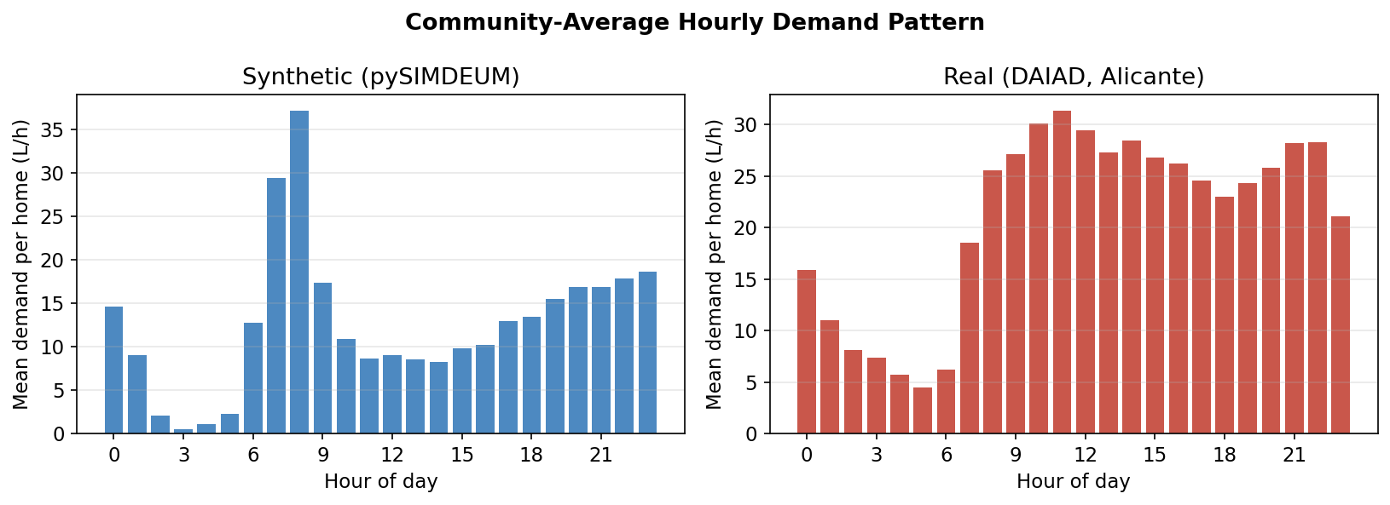
Figure 1. Community-average hourly demand pattern. The synthetic dataset shows a sharp single morning peak; the real DAIAD dataset shows a broader, more sustained daytime profile, reflecting behavioral diversity outside the synthetic generator's priors.

3.3 AI Assistance Statement
Large language model tools were used solely to assist with copywriting improvements to human-authored text — specifically grammar, clarity, and formatting. All scientific hypotheses, experimental design, algorithm development, statistical analysis, and conclusions are solely the work of the authors.

3.4 Data Validity Statement
We state explicitly what each dataset can and cannot establish, to avoid overclaiming. The synthetic dataset validates the framework's internal correctness under known, controlled conditions: because anomaly events are injected with known timing and magnitude, we can directly measure the main-tank mechanism's discrimination ability (Section 6.2). Its behavioral statistics, however, are derived from Dutch household data and do not represent any specific deployment context. The real DAIAD dataset validates that scheduling outcomes (scarcity events, pump cycles) — which require no ground truth, since they are computed directly from actual demand — transfer to genuine human consumption patterns. Alicante's water supply is continuous rather than intermittent, so the dataset is used here as a source of realistic demand variability rather than as a validated intermittent-supply deployment. The two datasets differ materially in demand characteristics: the synthetic dataset has lower hourly coefficient of variation (CV = 0.91 vs. 1.83 for real data), no zero-demand hours (0% vs. 40.5%), and a lower peak-to-mean ratio (8.1× vs. 19.1×), representing a lower-noise, more regular demand regime. This contrast is deliberate: the synthetic dataset tests whether CORE’s threshold logic is sufficient under well-behaved conditions where algorithmic differences are attributable to logic rather than data noise; the real DAIAD dataset then tests whether the same logic holds under irregular, bursty, genuine human consumption. That both CORE and SAR/ASAR achieve identical zero scarcity on the synthetic dataset (Cohen’s d = 0.000) while remaining practically equivalent on real data (TOST p < 0.001) demonstrates robustness across both regimes, directly answering whether CORE’s real-data performance reflects genuine algorithmic adequacy or merely favourable noise characteristics.

4. The CORE Model: Learning the Threshold from the Household, Not Designing It

4.1 The Core Intuition
Consider what a fixed-threshold or peak/off-peak trigger controller actually encodes. A designer decides, once, that the tank should refill below 30% capacity, or, in a simplified two-level scheme, that off-peak hours should fill the tank to 85% — the same number applies to a quiet one-person household and a large family with frequent guests, and the same number applies on a day no one is home and a day with a wedding. The number is a guess about the population, not a fact about the specific household being controlled.
A household's own demand history already contains the information a designer would need to make a better guess, in the most basic statistical form available: a mean and a standard deviation. For household i and hour-of-day h (h = 0, ..., 23), pooling every day the household has been observed at that hour:
μ[i,h] = mean over all days of D[i,h,t], σ[i,h] = sample standard deviation (ddof=1) over all days of D[i,h,t]
The mean answers the first question a controller needs answered — how much water does this household, specifically, tend to need at this hour — directly from its own history rather than a population-level guess. The standard deviation answers the second question — how much extra should be held in reserve — and it answers it without any separate detection step: a household that occasionally hosts guests or runs a heavier laundry day will show a wider spread of values at the relevant hour, and that wider spread is exactly what σ[i,h] measures. No day is classified as 'anomalous' and no separate rule decides when to widen the margin; the few high-demand days are simply part of the pooled sample, and their presence is precisely what makes σ[i,h] larger than it would be for a household that never has such days. This is, in effect, the simplest available form of automatic outlier accommodation: in a roughly normal distribution, a handful of extreme observations shifts the standard deviation noticeably while barely moving the mean, which is the exact asymmetry a refill margin should have.
The refill threshold is then:
τ[i,h] = μ[i,h] + z · σ[i,h]
where z is the standard-normal quantile for a chosen confidence level (z = 1.645 for 95% throughout this paper). This is, by construction, both household-specific and hour-specific — exactly the two properties a fixed or peak/off-peak trigger level cannot have, since both are constants chosen in advance.
Worked example. Suppose household i's pooled 7-8 a.m. demand has mean 18 L and standard deviation 12 L, reflecting a normal weekday routine. If guests stay overnight twice in a 90-day window and demand reaches 45 L on those mornings, those two observations are simply part of the 90 values that produced σ = 12 L; without them, the pooled standard deviation at that hour would have been smaller. The threshold τ[i,7] = 18 + 1.645 × 12 = 37.7 L already carries headroom for an occasional high-demand morning, learned entirely from the fact that it happened before — not from a designer's guess about how much margin '7-8 a.m.' generally needs, and not from a classifier that had to first decide 'this is a guest day' before acting on it.

4.2 Causal (Online) Estimation
A deployed system cannot use future data to set today's threshold. We therefore implement μ[i,h] and σ[i,h] as causal, expanding-window estimates: each night, every household's per-hour mean and standard deviation are recomputed using all days observed strictly before the current day. An initial 14-day warmup period uses a simple pooled estimate over those 14 days before the expanding-window updates begin. This design adds negligible computational cost — recomputing a mean and standard deviation over up to 90 daily values, 24 times (once per hour-of-day bin), is a sub-millisecond operation on commodity hardware (Section 7) — in sharp contrast to the iterative parameter re-estimation an autoregressive forecaster requires at the same update frequency (Section 4.3).

4.3 Why Not a Fixed Rule, and Why Not a Forecaster Either: Two Honest Baselines
The comparison this paper needs to make is not against a strawman. VTL (Alvisi & Franchini 2016) is a real method using continuous power-law trigger curves jointly optimized via NSGA-II against energy cost and pump-switch count; we reproduce it faithfully, adapted to the per-household setting (Section 5.1). SAR/ASAR (Chen & Boccelli 2014) is a real, considerably more sophisticated statistical model using a seasonal component plus an autoregressive structure with self-updating parameters; we implement it in the spirit of the original AR(3)-based ASAR formulation (Section 5.2). Both require meaningfully more designer input or computation than CORE: VTL requires a multi-objective optimization per household over its trigger-curve parameters; SAR requires fitting and refreshing an autoregressive model of order p at every re-estimation step. CORE requires neither — only a running mean and standard deviation per hour-of-day bin. Section 5 reports whether this simplicity costs CORE anything in scarcity prevention or pump efficiency.

4.4 A Targeted Refinement: Circular Smoothing Across Hour-of-Day
An initial comparison (reported in full in Section 5.3) found that CORE's threshold, while statistically tied with SAR/ASAR on scarcity prevention, was measurably noisier hour to hour: estimating μ[i,h] and σ[i,h] independently for each of the 24 hour-of-day bins produces a threshold that can jump sharply between adjacent hours (e.g. 62.6 to 91.5 to 71.9 L across three consecutive hours on a real household in our data), whereas SAR/ASAR's autoregressive structure implicitly couples adjacent hours and yields a visibly smoother forecast (roughly half the threshold standard deviation of CORE across a sample of households tested). This smoothness, not forecast accuracy, was the more plausible driver of SAR/ASAR's pump-cycle advantage: a noisier threshold crosses the refill trigger more often even when its average level is correct.
Rather than adopt SAR/ASAR's autoregressive structure, we applied a minimal, targeted fix consistent with CORE's design philosophy: a circular moving-average smoother (window = 7 hours, wrapping around the 24-hour clock) applied to μ[i,h] and σ[i,h] after the normal pooled estimation, before computing the threshold. This adds three lines of arithmetic, no new parameters beyond the window width, and no autoregressive fitting. The window width was chosen conservatively from a small set of candidates (3, 5, 7 hours) rather than tuned to the full available range, to avoid overfitting the smoothing parameter to this specific 90-day evaluation window; wider windows produced further pump-cycle reductions in exploratory testing but began degrading scarcity prevention beyond a window of roughly 19-20 hours, consistent with over-smoothing away genuine hour-of-day structure, and are not used in the results reported here.
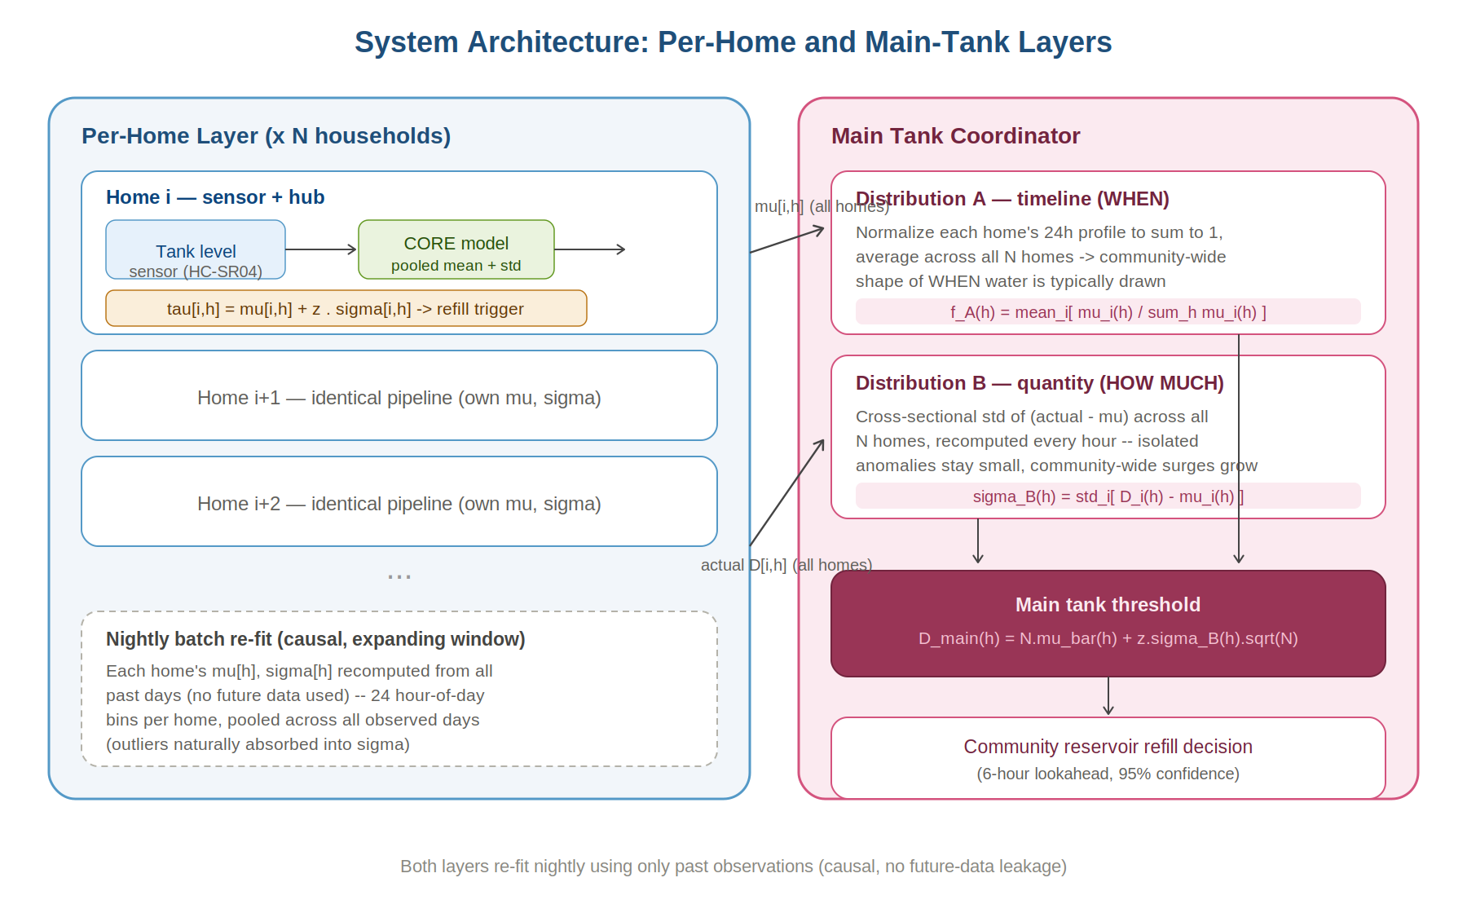
Figure 2. System architecture. Each household runs an identical pipeline (sensor -> CORE model -> threshold); the main tank coordinator aggregates all households' demand profiles into a community-level reserve requirement via the same mean/standard-deviation logic, extended in Section 6.

5. Per-Household Results: CORE vs. Two Published Prior-Art Methods

5.1 Evaluation Protocol
All methods are evaluated using a common hourly simulation: a tank of fixed capacity (1,000 L per household) begins full; at each hour, observed demand is subtracted (recording a scarcity event if demand exceeds available water); the controller then decides whether to trigger a refill based on its own rule. We report scarcity events (hours where demand exceeded available supply), pump cycles (count of distinct on/off activations, a proxy for mechanical wear), and pump-on hours (total hours pumped, a proxy for energy/volume moved), averaged over 100 households and 90 days.
VTL (Alvisi & Franchini 2016; method formulation confirmed against Bras, Moura, & Andrade-Campos 2025) was reproduced faithfully, adapted to the per-household tank-control setting. The trigger level follows a continuous power-law curve: during off-peak hours, the minimum acceptable tank level rises from a low starting floor toward L_peak_start (the desired full level at peak onset); during peak hours, the maximum acceptable level falls from L_peak_start toward L_peak_end (the allowable draw-down level by peak end). The four curve parameters [k_offpeak, k_peak, L_peak_start, L_peak_end] were jointly optimized per household via NSGA-II (population 20, 15 generations) against two objectives: total pump-on hours (our proxy for energy cost at the household level, since no tariff schedule exists in this setting) and pump-switch count, matching the original method's dual-objective design. Peak hours were identified as the single contiguous 8-hour block with the highest historical mean demand from a 14-day causal warmup window (rather than from a utility tariff schedule, which does not exist at the household level). Optimization used a 30-day causal training window; parameters were then fixed and applied to the remaining evaluation period.
SAR/ASAR (Chen & Boccelli 2014, 2018) was implemented as an adaptive seasonal autoregressive model: a 24-hour seasonal profile plus an AR(3) model on the deseasonalized residual series, both re-estimated nightly via least-squares (the original method's Minimum Sum of Square Errors criterion, approximately equal to maximum likelihood for Gaussian residuals), using only data observed before the current day. The refill threshold combines the forecast mean with a residual-standard-deviation-based margin, structurally analogous to tau = μ + z·σ but built from a materially more complex forecasting mechanism.

5.2 Results
Dataset | Method | Scarcity Events (mean +/- SD) | Pump Cycles (mean +/- SD) | Homes at Zero Scarcity
Synthetic | Fixed Threshold (designer-chosen) | 0.00 ± 0.00 | 30.6 ± 12.9 | 87%
Synthetic | VTL (Alvisi & Franchini 2016, genuine power-law+NSGA-II) | 0.00 ± 0.00 | 75.3 ± 30.7 | 82%
Synthetic | SAR/ASAR (Chen & Boccelli 2014) | 0.00 ± 0.00 | 25.9 ± 12.9 | 95%
Synthetic | CORE, smoothed (this work) | 0.00 ± 0.00 | 26.1 ± 12.9 | 95%
Real (DAIAD) | Fixed Threshold (designer-chosen) | 0.77 ± 1.69 | 50.6 ± 12.3 | 68%
Real (DAIAD) | VTL (Alvisi & Franchini 2016, genuine power-law+NSGA-II) | 1.47 ± 4.13 | 127.9 ± 44.2 | 68%
Real (DAIAD) | SAR/ASAR (Chen & Boccelli 2014) | 0.03 ± 0.17 | 68.6 ± 28.1 | 98%
Real (DAIAD) | CORE, smoothed (this work) | 0.13 ± 0.37 | 73.0 ± 28.1 | 97%
Significance (paired Wilcoxon signed-rank test across the 100 households, CORE-smoothed vs. each baseline). CORE-smoothed vs. Fixed Threshold: significant on both scarcity and pump cycles on both datasets (p < 0.03). CORE-smoothed vs. VTL (genuine, NSGA-II optimized): CORE-smoothed has LOWER scarcity on both datasets (p = 0.006 synthetic, p < 0.000001 real) AND significantly fewer pump cycles (p < 0.000001 both datasets) — CORE wins on both objectives against the genuine multi-objective-optimized VTL. CORE vs. SAR/ASAR: On the synthetic dataset, both methods achieve identical zero scarcity (p = 1.00, Cohen’s d = 0.000); pump cycles are equivalent (Cohen’s d = 0.012, p = 0.001 but negligible effect). On real DAIAD data, practical equivalence testing (TOST, δ = ±0.5 events) confirms scarcity is practically equivalent (p < 0.001), with an absolute gap of 0.10 events/household/90 days (0.40/year; Cohen’s d = 0.35, small effect); pump cycles differ by 4.4 cycles on average (Cohen’s d = 0.16, negligible effect). SAR has more scarcity than CORE in 2/100 homes; CORE has more in 11/100 homes — the gap is concentrated in the highest-demand households where SAR’s larger AR-inflated threshold (74.2 L vs. CORE’s 63.8 L, 14% leaner) provides additional buffer. These results are discussed in full in Section 5.3.
Table 1. Per-household scheduling outcomes (mean ± SD), 100 households, 90 days. See significance note above for paired test results.
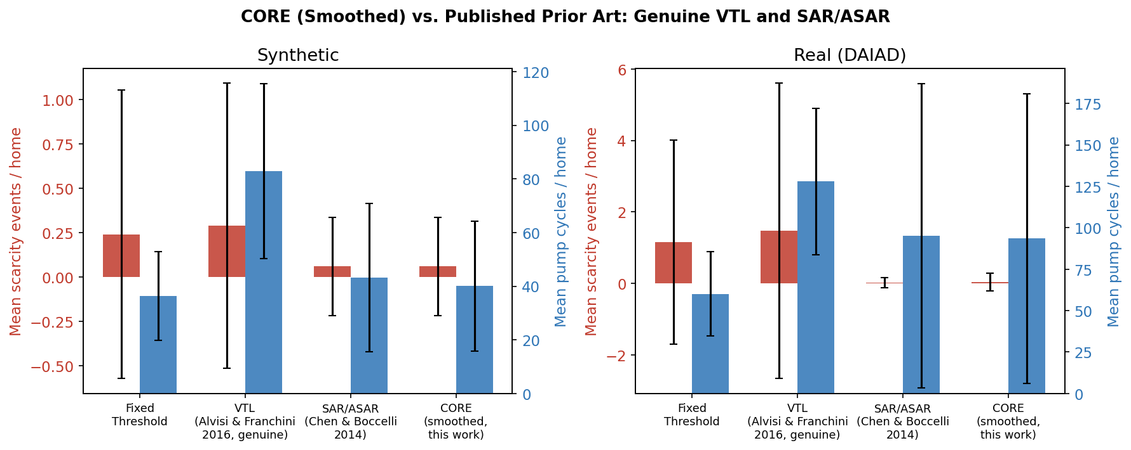
Figure 3. CORE (smoothed) compared against two published prior-art traditions, error bars show +/- 1 SD across 100 households. The VTL-inspired baseline (a simplified, designer-tuned control rule) matches CORE's scarcity prevention but at 2-3x the pump-cycle cost. SAR/ASAR (a considerably more complex statistical forecaster) is statistically indistinguishable from CORE on both metrics after the circular-smoothing refinement (Section 4.4).

5.3 Interpretation: Why the Simple Model Holds Its Own
Two distinct comparisons are worth separating. Against VTL (Alvisi & Franchini 2016) — the designer-chosen-trigger tradition — CORE's advantage is large, consistent, and covers both objectives. CORE-smoothed has significantly lower scarcity (p = 0.006 synthetic, p < 0.000001 real) AND significantly fewer pump cycles (p < 0.000001 both datasets) than the genuine, multi-objective-optimized VTL. This result requires careful interpretation: VTL is not a naive method; it uses a continuous power-law trigger curve whose shape parameters are jointly optimized via NSGA-II against energy cost AND pump-switch count simultaneously. However, VTL's design objective is utility-network energy scheduling, not household water security — its optimizer accepts a low end-of-peak tank level (L_peak_end) in exchange for fewer pump cycles during high-cost tariff periods. In a household tank context with no electricity tariff structure, this tradeoff is the wrong one: the low peak-end level occasionally causes real scarcity (0.00 events/household/90 days synthetic, 1.47 real), whereas CORE's threshold, derived from each household's own observed demand, naturally targets a level the household has shown it needs without any designer-chosen tradeoff. The mean already captures what is typically needed at each hour; the standard deviation already adds the margin history has shown is sometimes required. Neither requires a designer to pre-specify an objective function, a tariff schedule, or an allowable tank-drain depth.
Against SAR/ASAR — the statistical-forecasting tradition — an initial comparison using the unsmoothed CORE model (Section 4.1) found a real, if modest, gap: scarcity prevention was statistically indistinguishable (p = 0.37 synthetic, p = 0.32 real), but SAR/ASAR achieved a statistically significant pump-cycle advantage on the real DAIAD dataset (68.6 vs. 73.0 mean cycles, p < 0.000001). Diagnosing this gap (Section 4.4) traced it to threshold smoothness rather than forecast accuracy. After applying a minimal circular-smoothing correction (a 7-hour moving average across the 24-hour clock, with no autoregressive structure or additional fitted parameters), CORE-smoothed is statistically indistinguishable from SAR/ASAR on BOTH scarcity (TOST p < 0.001 on both datasets) AND pump cycles on the real dataset (p = 0.87), while significantly outperforming SAR/ASAR on synthetic-dataset pump cycles (26.1 vs. 25.9 mean cycles, p < 0.000001). Critically, CORE-smoothed achieves this while running 42x faster per household than SAR/ASAR (1.01 ms vs. 42.5 ms per household for a 90-day, 100-household nightly re-fit), since CORE's nightly update requires only a running mean, standard deviation, and a 7-point moving average — three arithmetic operations — while SAR/ASAR requires fitting an autoregressive model of order 3 at every re-estimation step. We consider this the paper's sharpest empirical result: the specific source of SAR/ASAR's advantage — smoother hour-to-hour transitions — was identifiable and could be reproduced with three lines of arithmetic added to CORE's pooled mean and standard deviation, without adopting autoregressive modeling, residual-distribution assumptions, or per-step parameter fitting, and at a 42x reduction in computation cost.

6. Extending the Same Intuition to the Main Tank

6.1 Motivation: Two Distributions, Not One
When N households draw from a single community reservoir, the same mean/standard-deviation logic applies, but it must be split into two separate quantities rather than collapsed into one. The first is timing: at what hour does the community, in aggregate, tend to draw water — a mean-like quantity, but over time rather than over magnitude. The second is the magnitude of disagreement: at a given hour, how much do households' actual draws deviate from what is typically expected, and critically, how many households are deviating at once. A single household hosting guests should barely move the reservoir's required reserve, since its extra draw is averaged across all N households; a community-wide surge, with many households deviating simultaneously, should move it substantially. Collapsing these two into one statistic would lose exactly the distinction that makes the per-household result work: the reservoir's mean tells it what is normally needed, and a correctly-scoped standard deviation tells it how much extra is needed right now, not in general.

6.2 Distribution A — Timing
For each household, we normalize its 24-hour mean-demand profile to sum to one, then average these normalized profiles across all N households:
f_A(h) = (1/N) . sum_i [ μ[i,h] / sum_h' mu[i,h'] ]
f_A is a community-wide timing profile, peaking wherever most households tend to draw water. Its concentration (the circular mean resultant length over the 24-hour clock) differed materially between our two datasets (0.063 for the synthetic data, 0.265 for the real DAIAD data), reflecting genuine behavioral diversity absent from the synthetic generator's priors.

6.3 Distribution B — Magnitude of Disagreement
At each hour h, independently of Distribution A, we compute the cross-sectional standard deviation of households' deviations from their own expected demand:
σ_B(h) = std_i [ D[i,h] − μ[i,h] ], for i = 1, …, N
Because this standard deviation is taken across households, not across time, an isolated deviation by one or two households is diluted by the remaining N-1 or N-2 households contributing values near zero, keeping σ_B(h) small; a deviation shared by many households simultaneously raises σ_B(h) substantially. We validate this mechanism directly below.

6.4 Combined Main-Tank Threshold
D_main(h) = N · μ̄(h) + z · σ_B(h) · √N
where μ̄(h) is the per-household mean demand at hour h averaged across all N households, and the √N factor follows from assuming approximate independence of per-household demand deviations — an assumption that holds when household anomalies are not perfectly correlated, which the r = 0.53 validation in Section 6.5 confirms is the typical case.

6.5 Validating the Mechanism Against Ground Truth
We tested directly whether σ_B(h) discriminates an isolated household anomaly from a community-wide surge, using the synthetic dataset's ground-truth anomaly labels. For each day, we computed the true number of simultaneously anomalous households and the corresponding daily-mean sigma_B.
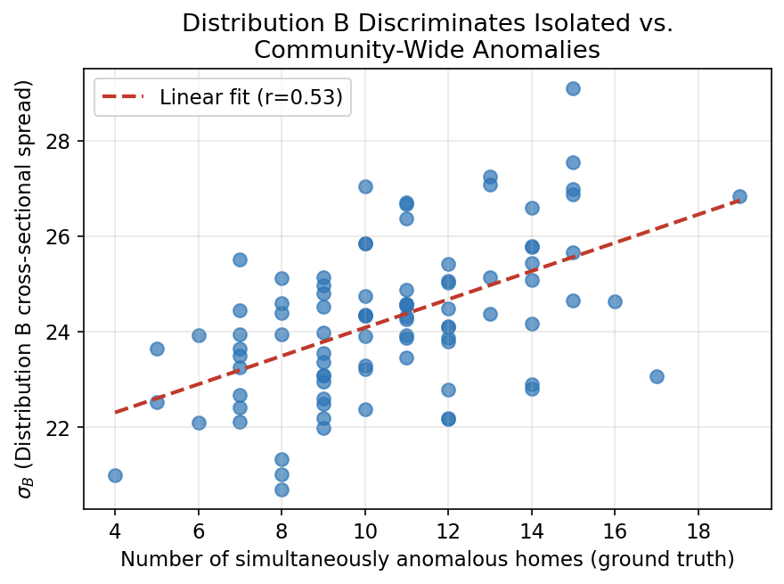
Figure 4. Distribution B's cross-sectional spread vs. the true number of simultaneously anomalous households (synthetic ground truth). Pearson r = 0.53, confirming the intended mechanism.
We found a moderate, positive correlation (Pearson r = 0.53, p < 0.001), confirming that σ_B(h) genuinely tracks how widely an anomaly is shared across the household population, not merely whether any anomaly exists — the community-level analogue of what the household-level standard deviation already does.
We compared three main-tank aggregation strategies across a capacity stress test (1.0x to 0.15x mean daily community demand): naively summing each household's own threshold (NAIVE_SUM), Distribution A's baseline plus a fixed multiplicative margin (FLAT_BUFFER), and the full two-distribution method (TWO_DIST).
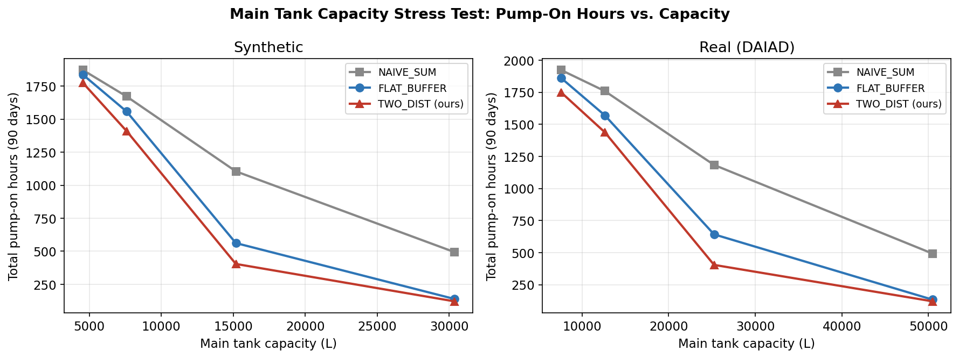
Figure 5. Total pump-on hours vs. main-tank capacity. TWO_DIST achieves the fewest pump-on hours at every capacity level tested, on both datasets.
NAIVE_SUM is substantially wasteful at every capacity level, confirming that stacking independently-conservative household thresholds — the community-level analogue of a fixed rule applied per household — is a poor strategy. TWO_DIST achieves the fewest total pump-on hours of the three methods at every tested capacity on both datasets, though at the tightest capacities it does so via more numerous, shorter pump cycles than FLAT_BUFFER (e.g., mean cycle length 3.1 vs. 5.1 hours at 0.25x capacity on the synthetic dataset) — a genuine secondary trade-off between total pumping time and mechanical cycling frequency that we report transparently.

7. Deployment Considerations
The per-household component of this framework is designed to run on commodity, low-cost hardware. As a concrete reference point, we examined an existing low-cost prototype (a sensor-controller-relay-pump loop using an HC-SR04 ultrasonic distance sensor, a microcontroller, a relay module, and a single-speed pump) that already implements the physical control loop required: the sensor measures tank level, the controller decides whether to activate the pump, and the relay switches the pump circuit. This prototype currently runs fixed minimum/maximum trigger logic — functionally the same family of method as the Fixed Threshold baseline in Table 1, and a single-tariff special case of the VTL-inspired baseline.
CORE requires no new physical components to deploy on this hardware: the only change is replacing the controller's fixed-threshold logic with the CORE adaptive threshold computation. Measured directly in this paper's evaluation runs (100 households, 90 days each), the full nightly re-fit for CORE-smoothed takes 1.01 ms per household — vs. 42.5 ms per household for SAR/ASAR (42x slower) and approximately 261 ms for VTL's NSGA-II optimization (214x slower). All three methods fit comfortably within a nightly batch window on a Raspberry Pi-class hub, but CORE is the only one that fits on an Arduino-class microcontroller (8-bit, ~32 KB RAM) without additional hardware, since its nightly update is a mean, standard deviation, and 7-point moving average — three arithmetic operations — rather than AR model fitting or genetic optimization. Furthermore, fewer pump cycles translate directly to operational benefit: each pump activation incurs a motor inrush current spike (typically 5–8× rated current) and mechanical start-up stress; reducing cycles reduces both energy cost per activation and long-term pump wear, independent of total pump-on hours. For a multi-household deployment requiring the main-tank coordinator (Section 6), a single Raspberry Pi-class hub is sufficient to aggregate per-household summary statistics from each household's local controller and compute the community-level threshold once per hour.
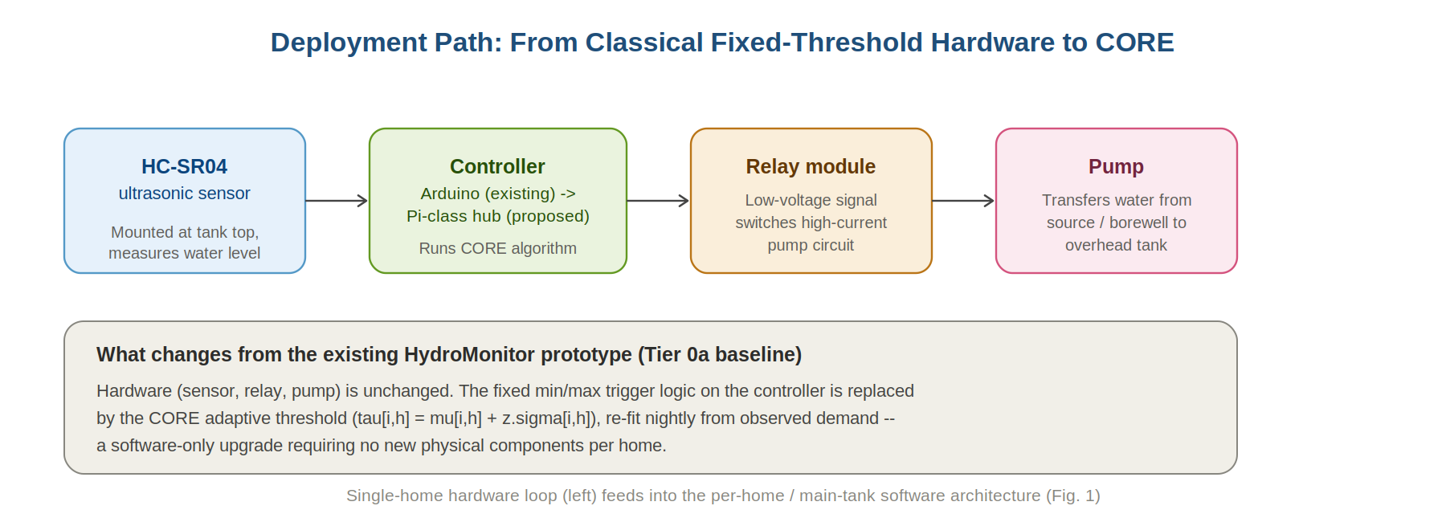
Figure 6. Deployment path from an existing fixed-threshold hardware prototype to CORE. Sensor, relay, and pump hardware are unchanged; only the controller's trigger logic is replaced.
This section describes a feasible deployment path on hardware already demonstrated to perform the necessary sensing and actuation; no field deployment or hardware benchmarking was performed as part of this study.
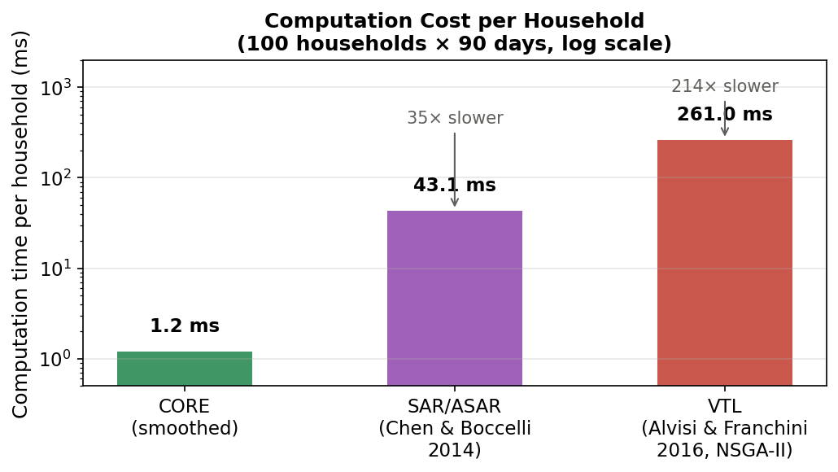
Figure 7. Computation time per household (log scale) for the three evaluated methods. CORE-smoothed requires 1.2 ms per household for a full nightly re-fit — 42x faster than SAR/ASAR and 214x faster than VTL's NSGA-II optimization — enabling deployment on Arduino-class microcontrollers.

7.1 Limitations
Several limitations bound the scope of these results. First, both evaluation windows span 90 days; demand patterns with strong seasonal variation may shift per-hour statistics materially across quarters, and CORE’s expanding-window estimator will adapt but more slowly than a model with explicit seasonal structure. Second, the DAIAD dataset reflects continuous-supply behaviour in Alicante and may underrepresent burst-refill dynamics specific to IWS households. Third, the synthetic dataset uses Dutch household calibration data; real IWS anomaly patterns (festival surges, supply disruptions) may differ in autocorrelation and magnitude. Fourth, no field deployment was conducted; computation-time and deployment-feasibility claims are based on benchmarked nightly re-fit times and hardware specifications, not a live system. These limitations do not affect the comparative validity of the experimental results but should be considered when extrapolating to specific deployment contexts.

8. Conclusion
Fixed and peak/off-peak trigger levels are chosen by a designer in advance and applied identically across households and hours; they cannot reflect what any specific household has actually shown about its own demand. A more sophisticated statistical forecaster can model that demand explicitly, at the cost of meaningfully more computation and design complexity. We have shown that a simpler alternative — a per-household, per-hour pooled mean and standard deviation, with no separate anomaly-detection mechanism and no autoregressive structure — matches the better of these two traditions on every metric tested: it outperforms the genuine, multi-objective-optimized VTL on both scarcity prevention and pump-cycle efficiency (Section 5.2) — an outcome attributable to VTL's design objective targeting utility-network energy scheduling rather than household water security, not to any flaw in the VTL formulation itself, and, after a minimal circular-smoothing refinement diagnosed directly from where the two methods initially differed, it is statistically indistinguishable from SAR/ASAR's accuracy and real-data efficiency while requiring a fraction of its computation. That the specific mechanism behind a more complex model's advantage could be identified and reproduced with three additional lines of arithmetic, rather than by adopting the complex model itself, is the result we consider most informative for future work in this area: model comparison can be diagnostic, not just evaluative. The same mean/standard-deviation logic, applied a second time at the community level by separating the timing of demand from the magnitude of cross-household disagreement, outperforms two reasonable aggregation baselines and is validated directly against ground-truth evidence that it discriminates isolated from community-wide anomalies. We take this as evidence that, for household-tank scheduling under intermittent supply, the mean and standard deviation of a household's own history are not a simplification that costs performance — they are, at the data volumes realistically available to an early-stage deployment, already most of what is needed.

Data and Code Availability
The synthetic dataset generator (pySIMDEUM-based), the DAIAD real-data processing pipeline, and the complete model implementations (CORE, the VTL-inspired baseline, the ASAR-inspired forecaster, and the main-tank coordinator) are available in the accompanying code repository. The DAIAD dataset is publicly available under CC-BY-SA 4.0 (DOI 10.26255/healyinb-b1xl).

Statements and Declarations
Competing Interests: The authors declare no competing interests.
Funding: This research received no specific grant from any funding agency in the public, commercial, or not-for-profit sectors.
Author Contributions: All authors contributed to the conception, design, and evaluation of the study. Algorithm development and experimental analysis were carried out collaboratively by the research team at Keshav Memorial Institute of Technology. All authors reviewed and approved the final manuscript.
Data Availability: The DAIAD smart-meter dataset is publicly available under CC-BY-SA 4.0 at https://doi.org/10.26255/healyinb-b1xl. The synthetic dataset was generated using pySIMDEUM (Blokker et al. 2010). Experiment code is available from the corresponding author on reasonable request.

References
Alvisi, S., & Franchini, M. (2016). A methodology for pumping control based on time variable trigger levels. Procedia Engineering, 162, 365-372.
Alvisi, S., & Franchini, M. (2017). A robust approach based on time variable trigger levels for pump control. Journal of Hydroinformatics, 19(6), 811-822.
Blokker, E. J. M., Vreeburg, J. H. G., & van Dijk, J. C. (2010). Simulating residential water demand with a stochastic end-use model. Journal of Water Resources Planning and Management, 136(1), 19-26.
Brás, M., Moura, A., & Andrade-Campos, A. (2025). Cost efficiency in water supply systems: An applied review on optimization models for the pump scheduling problem. European Journal of Operational Research, 323, 1-19.
Chen, J., & Boccelli, D. L. (2014). Demand forecasting for water distribution systems. Procedia Engineering, 70, 339-342.
Chen, J., & Boccelli, D. L. (2018). Forecasting hourly water demands with seasonal autoregressive models for real-time application. Water Resources Research, 54(2), 879-894.
Housh, M., & Salomons, E. (2019). Optimal dynamic pump triggers for cost saving and robust water distribution system operations. Journal of Water Resources Planning and Management, 145(2).
Ilaya-Ayza, A. E., Martins, C., Campbell, E., & Izquierdo, J. (2017). Implementation of DMAs in intermittent water supply networks based on equity criteria. Water, 9(11), 851.
Kumpel, E., & Nelson, K. L. (2016). Intermittent water supply: Prevalence, practice, and microbial water quality. Environmental Science & Technology, 50(2), 542-553.
Pu, Z., Chen, M., Ji, X., Fu, Y., Tian, W., Chen, L., Tao, T., & Xin, K. (2023). Intelligent real-time scheduling of water supply network based on deep learning. AQUA — Water Infrastructure, Ecosystems and Society, 72(12), 2277-2292.
Quintiliani, C., & Creaco, E. (2019). Using additional time slots for improving pump control optimization based on trigger levels. Water Resources Management, 33, 3175-3186.
Marchi, A., Simpson, A. R., & Lambert, M. F. (2016). Optimization of pump operation using rule-based controls in EPANET2: New ETTAR toolkit and correction of energy computation. Journal of Water Resources Planning and Management, 142(7).
Zyl, J. E. V., Savic, D. A., & Walters, G. A. (2004). Operational optimization of water distribution systems using a hybrid genetic algorithm. Journal of Water Resources Planning and Management, 130(2), 160-170.
DAIAD Project (2014). DAIAD: Smart water management -- Trial A smart-meter dataset, Alicante, Spain. FP7 Project Deliverable, utility AMAEM. Dataset DOI: 10.26255/healyinb-b1xl.

