Climate-Resilient Roadways: Adaptive Strategies for Extreme Weather Events
by
Mohammad Ali Notani
Research Associate at Lyles School of Civil Engineering, Purdue University, West Lafayette, IN.
Email: mnotani@purdue.edu

Abstract
Extreme climate events, including hurricanes, flooding, heatwaves, and wildfires, increasingly challenge the resilience and functionality of transportation infrastructure. This perspective synthesizes multi-hazard vulnerabilities and forward-looking adaptation strategies. Using Hurricane Helene (2024) as a case study, screening-level hydrological simulations show that lime-treated base layers can reduce flood-induced erosion significantly. For heatwaves, phase change material (PCM)-modified asphalt stabilizes pavement temperatures through latent heat absorption, mitigating rutting and oxidative aging. Wildfire modeling further indicates that vegetation-free roadside buffer zones of approximately 20 m can substantially reduce modeled thermal exposure above the roadway, helping preserve the functionality of evacuation routes. These findings underscore the importance of integrating advanced materials, predictive climate modeling, and multi-hazard design frameworks into transportation planning to support long-term infrastructure resilience and community safety.
Keywords: Road Resiliency, Climate Change, Pavement Durability, Flooding, Heatwaves.

Introduction
The effects of climate change, including stronger hurricanes, frequent flooding, prolonged heatwaves, rising sea levels, and severe temperature variations, are becoming increasingly evident^{1–3}. Transportation infrastructure is acutely vulnerable to these shifts, as rising sea levels and intensified weather events continue to damage roads, bridges, and rail networks worldwide^{4,5}. Flooding and storm surges are occurring with greater frequency and severity, imposing substantial damage in coastal and low-lying regions such as the Mississippi River Basin in the United States and the Yangtze River Basin in China^{6,7}. Hurricane Helene in 2024 further demonstrated the vulnerability of roadway systems in the southeastern United States.
Transportation infrastructure designed using historical climate records may be exposed to conditions outside the ranges represented in those records, resulting in accelerated deterioration and unexpected failures⁸. Roadway design traditionally uses historical temperature, precipitation, and weather data to guide material selection and structural configuration. For instance, ASTM D6373, “Standard Specification for Performance-Graded Asphalt Binder “, specifies that binder selection should align with the seven-day average maximum and minimum pavement temperatures. However, these methods are becoming outdated as climate change leads to more frequent and severe extreme weather events, such as prolonged heatwaves, intense rainfall, flooding, and stronger storms, which exceed the thresholds obtained from historical data.
These conditions can exceed the performance ranges assumed for existing infrastructure and increase deterioration rate⁹. Prolonged heat exposure can soften asphalt mixtures and increase susceptibility to rutting and permanent deformation, while excessive rainfall can overwhelm drainage systems and weaken pavement structure. In coastal regions, sea-level rise and storm surge increase the frequency of roadway inundation^{10–12}. According to the National Oceanic and Atmospheric Administration (NOAA), more than 60,000 miles of U.S. roads and bridges in coastal areas are at risk of flooding and endangered by climate change-related sea-level rise¹³. More broadly, the reliability, safety, and efficiency of the U.S. transportation system are at risk from increases in heavy precipitation, coastal flooding, heat, wildfires, and other extreme events, and changes in average climate conditions^{13,14}.
While roadways are designed to endure a range of environmental conditions, human-induced climate change introduces uncertainties about future atmospheric conditions, potentially accelerating deterioration or causing premature failure. Current climate models suggest that many transportation-related impacts of climate change will emerge gradually over time¹⁵. Many pavement systems undergo major rehabilitation or reconstruction over timescales of decades, creating opportunities to incorporate updated climatic inputs and more resilient designs during normal renewal cycles¹⁵.
This perspective synthesizes the effects of extreme events on roadway infrastructure, supported by numerical analysis results, and demonstrates how strategic mitigation approaches can reduce these impacts in an uncertain climate future. As climate change accelerates, transportation infrastructure must endure frequent and severe weather events. Among the most immediate threats are storms and hurricanes, which bring heavy precipitation, flooding, storm surges, and intense heat waves. These phenomena directly compromise the structural integrity and durability of pavements, mostly in coastal, flood-prone, and fire-prone regions. The following section explores the impacts of these extreme events on road infrastructure, focusing on how floodwaters and erosion weaken pavement sublayers and undermine stability, followed by an analysis of proposed mitigation strategies.
Scope and limitations of the numerical examples: the calculations presented below are screening-level illustrations. Their outputs depend on assumed material properties, boundary conditions, empirical relationships, and event data and have not been calibrated against field measurements for the specific pavement systems considered. Accordingly, the numerical values should not be interpreted as design thresholds or as validated predictions of field performance.

Challenge 1: Pavement Structural Integrity and Durability Under Flooding and Tropical Cyclones

Assessment
Heavy precipitation, storm surges, and prolonged inundation can compromise both the stability and functionality of pavement systems¹⁶. These hazards may render roads impassable, erode shoulders and embankments, saturate unbound layers, and prolong closures. Tropical cyclones intensify this vulnerability through the combined effects of rainfall, surge, debris, slope instability, and erosion.
Statistical models have been used to estimate pavement deterioration and time to failure under hurricane hazard scenarios ^{17,18}. Inkoom et al.¹⁹ used competing-risk theory to analyze the effects of Hurricane Categories 1, 2, and 3 on pavement survival probabilities. Their findings indicate that Category 3 hurricanes significantly elevate the hazard ratios for pavement failure across both coastal and non-coastal areas, affecting all roadway types, including urban and rural interstates and non-interstates. The high hazard ratios associated with Category 3 events suggest a substantial increase in the likelihood of pavement failure due to the combined effects of intense wind forces, heavy rainfall, and storm surges ^{19,20}.
Hurricane Helenee in September 2024 caused a considerable transportation disruption in the southeastern United States. The North Carolina Department of Transportation (NCDOT) reported widespread road closures due to flooding and subsequent maintenance, with approximately 207 miles of roads affected and an average closure duration of 1,680 hours per mile. Figure 1 illustrates the analyzed road closure events in North Carolina as of October 4, 2024, showing that most closures occurred on the west side of the state, with over 500 reported incidents. The hurricane disrupted road systems serving more than 120 cities and towns, impacting a residential population exceeding 2.3 million people. Further analysis revealed that 74 percent of the impassable roads were classified as high-severity damage. Interestingly, despite the high severity classification, maintenance time per mile for these roads is estimated to be lower than for roads classified under medium or low severity. This difference may reflect the prioritization of critical state roads and US highways by NCDOT to ensure timely recovery for essential transportation routes.
Figure 1. 2024 Hurricane Helene analysis on road closure incidents at North Carolina State as of 4 Oct, 2024.
Table 1 groups the closure descriptions in the October 4 snapshot into qualitative screening categories. Flooding, erosion, washouts, landslides, debris, and sinkholes were common descriptions among the more disruptive closures. Because these categories were assigned for this analysis, they should not be interpreted as official NCDOT damage-severity ratings.
Table 1. 2024 Hurricane Helene Road closure reasons by severity level grouped by the author.
Severity Level
High | Medium | Low
- Flooding and severe erosion  Bridge Failure  - Section of road washouts  - Power line Down  - Road washed away  - Severe sinkholes  Mud and Debris blocking roads | - Landslides  - Shoulder erosions  - Roadway blocked by debris  - Partial washouts and eroded  - Tree down with power lines  - Water Encroachment | - Road inundates  - Minor flooding  - Pipe failure  - Shoulder washouts and erosions  - Emergency repairs  - Sinkholes

Structural Impact of Flooding
Prolonged water exposure significantly weakens subgrade soils by reducing their shear strength and stiffness, thereby diminishing the pavement’s load-bearing capacity. This degradation can lead to permanent deformation and, in severe cases, the formation of sinkholes within the pavement layers. Inadequate drainage systems exacerbate these effects by trapping moisture within the pavement structure, which saturates and weakens the base and subbase materials. Moisture accumulation also promotes asphalt stripping and erosion of unbound layers, further compromising structural integrity.
Empirical studies confirm the detrimental effects of flooding on pavement performance. For instance, a field study of the LA 46 roadway in Louisiana, conducted before and after Hurricane Katrina, revealed that flooding reduced the subgrade resilient modulus by 10-30 percent²¹. Similar adverse trends were observed in the pavement structural number, indicating a significant loss of structural capacity. This reduction in structural capacity was more pronounced in asphalt pavements compared to concrete pavements, underscoring the vulnerability of flexible pavements to flood-induced damage²¹.
Flexible pavements begin to lose structural strength after just six hours of submersion in floodwaters, with significant weakening occurring within two hours²². Studies have shown that flood-damaged pavements can experience up to a 67 percent reduction in the California Bearing Ratio (CBR) of the subgrade and a 50% decrease in structural number. These substantial reductions highlight the severe impact of flooding on pavement performance. Pavements with pre-existing distress, such as alligator cracking, map cracking, and transverse or longitudinal cracking, are especially vulnerable to accelerated deterioration, as cracks facilitate water infiltration, exacerbating asphalt stripping and washout of filler particles in base or subbase layers²².

Flooding and Road Resiliency
Flooding often results in prolonged roadway submergence, causing significant disruptions that hinder economic activities and emergency response operations. The vulnerability of roads to flooding depends on both the surface material and the underlying structural layers. Alipour et al.²³ analyzed a county road network in Iowa under flooding scenarios ranging from 2-year to 500-year recurrence intervals. Their findings indicate that asphalt pavements (HMA) are particularly susceptible to flood-induced closures. For example, during a 2-year flood event, 7.98 miles of HMA roads required closure, increasing to 18.34 miles during a 500-year event. In contrast, Portland cement concrete (PCC) pavements demonstrated slightly better resilience, with fewer closures under comparable conditions. These results underscore the critical influence of surface material on a pavement’s ability to withstand inundation. The structural base layers also play a pivotal role in road resiliency. Roads constructed with untreated granular subbases or asphalt-treated bases experienced more closures compared to those built with more robust foundational materials. This highlights the importance of both material selection and structural design in mitigating flood-related disruptions²³.
Illustrative Flood-Erosion Screening Analysis
To illustrate how hydraulic loading and material erodibility may be compared, a simplified pavement-edge scenario is considered. The considered conditions include two types of base and subbase materials (regular granular materials and lime-treated materials), different floodwater velocities, and varying angles of flood movement relative to the roadway centerline. Note that, the calculation uses representative material parameters and varying near-surface flow velocity. It is a screening exercise rather than a coupled hydrologic-hydraulic model of a roadway, and it does not account for changing flow depth, turbulence, pavement geometry, progressive scour, or loss of confinement. A conventional pavement structure with fixed layer thicknesses is assumed, as shown in Figure 2.
Yuan et al.²⁴ derived and validated a critical shear stress (τ_{c}) based on the force equilibrium shear stress concept as follows:
$$τ_{c}=\frac{3\left(1-n\right)α tan∅+gd^{2}[\left(G_{s}-1\right)\left(1-n\right)\left(cosθtan∅-sinθ\right)-sinθ]}{0.0235d(1-n_{0})(C_{D}+C_{L}tan∅)}$$ | Eq. 2

where n is soil porosity; α is an integrated cohesion parameter (m³/s²); φ is the internal friction angle; Gs is particle specific gravity; d is representative particle diameter; g is gravitational acceleration (9.81 m/s²); θ is the eroding-surface slope angle in the direction of runoff; and C_{D} and C_{L} are drag and uplift coefficients, respectively. Because the relation was developed for cohesive soil slopes, its application to pavement base and subbase materials requires material-specific validation.
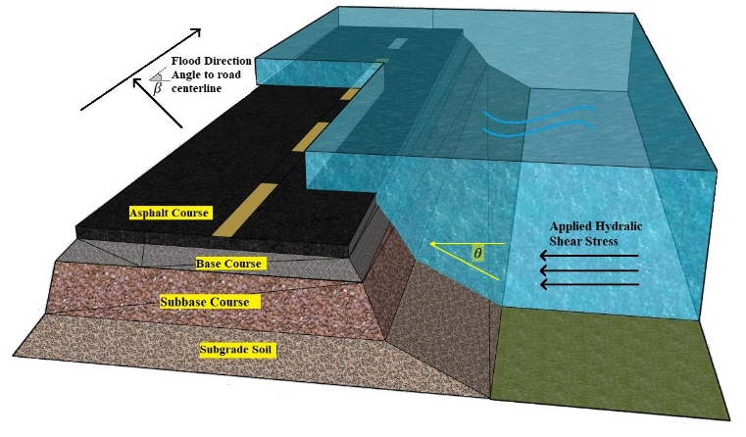
Figure 2. Schematic road configuration for erosion rate analysis.
The applied boundary shear stress is related to friction velocity by^{24,25}:
$$τ_{a}=ρ_{w}μ_{*}^{2}$$ | Eq. 3
Where, $ρ_{w}$ is the density of water, µ* is the friction velocity (m/s), which is related empirically to water velocity in flooding.
In the field of soil erosion, the erosion rate is expressed as the excess shear stress equation as below²⁶:
$$ε={k_{d}(τ_{a}{-τ}_{c})}^{a}$$ | Eq. 4
Where k_{d} is the erodibility coefficient obtained from laboratory tests. Also, exponent a (dimensionless) is often taken to be 1.0²⁴. Both k_{d} and τ_{c} should ideally be obtained from erosion testing of the actual untreated or treated material.
Given the calculated erosion rate, the erosion depth of a pavement subjected to flooding can be estimated based on the duration of inundation. Simulation results, illustrated in Figure 3, demonstrate that lime-treated base and subbase layers provide significantly greater resistance to erosion under various flood conditions compared to untreated granular soils. As flood velocity and angle of attack increase, the erosion rate for untreated soil rises sharply, reaching a peak of 0.02976 kg/m².s at a flood speed of 3.5 m/s and a 90° angle. In contrast, lime-treated layers exhibit much lower erosion rates, with the maximum observed value being only 0.00621 kg/m².s under the same conditions. These findings highlight the effectiveness of lime stabilization in mitigating erosion-related pavement failures during extreme flooding events.
These findings underscore the importance of using treated base or subbase layers to improve the resilience of road infrastructure in areas with potential flooding hazards. By reinforcing the base and subbase layers with treated materials, the damage caused by floodwaters can be significantly mitigated, making roads more resilient and prolonging their service life under extreme weather events. Additionally, to prevent washouts, geomembranes or geogrids can be integrated into the base and subbase soils alongside these treatments. Geomembranes act as impermeable barriers, reducing water infiltration into the subgrade, while geogrids provide tensile reinforcement, improving soil load-bearing capacity and resistance to erosion²⁷. Integrating these materials reinforces the structural integrity of pavement layers, providing increased resistance against severe flooding events.
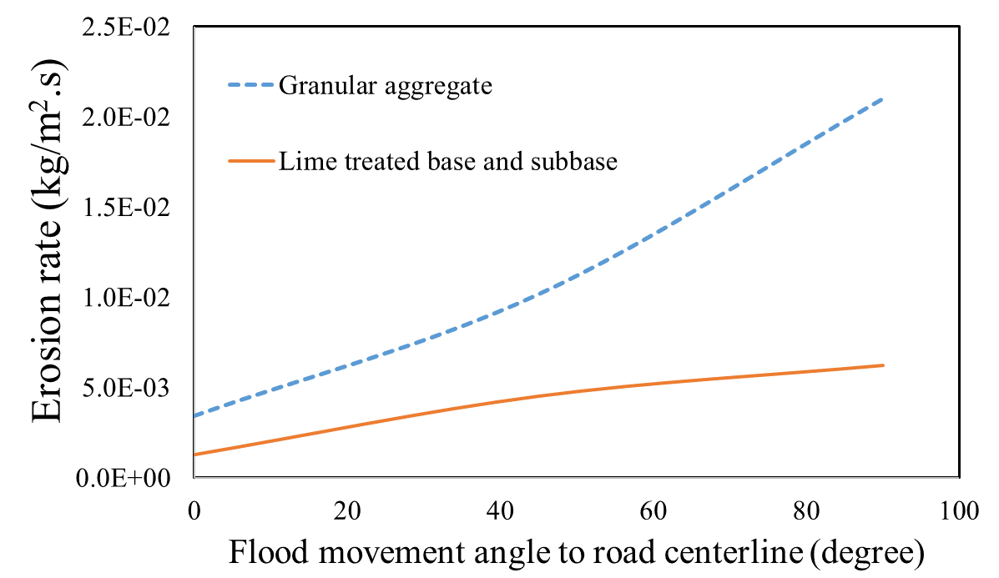 | 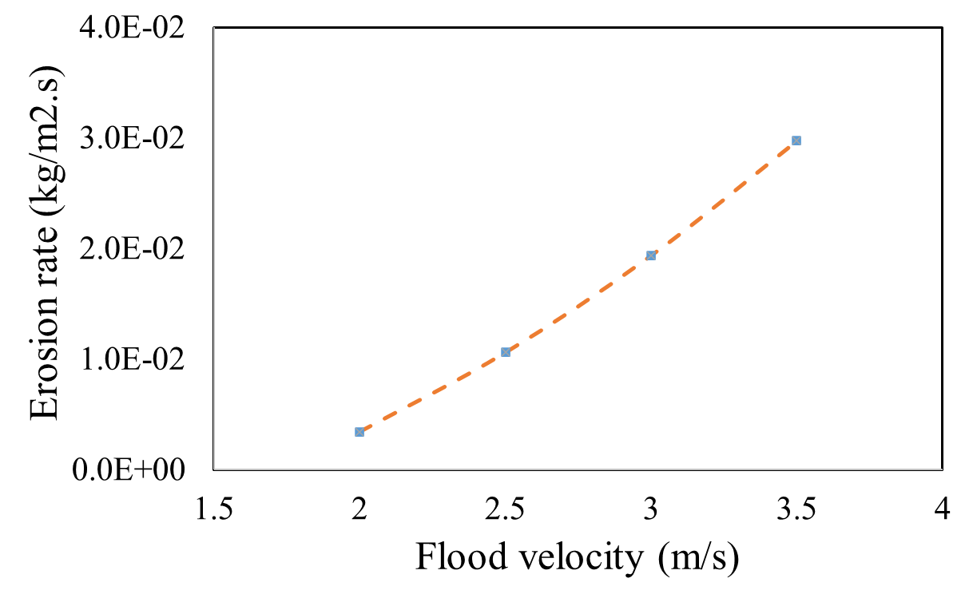
(a) | (b)

Figure 3. Flooding erosion rate at (a) different pavement base and subbase materials; (b) different flood velocities.

Challenge 2: Extreme Temperature Variations and Pavement Performance

Assessment
Weather information is one of the key inputs in road design. For instance, the current method for selecting asphalt binder Performance Grades (PGs), such as the Superpave system, relies heavily on historical climate data to estimate pavement operating temperatures. This approach assumes that future temperature patterns will mirror past trends, an assumption increasingly invalidated by ongoing climatic shifts²⁸. Consequently, the continued use of outdated climate records leads to inappropriate asphalt binder selections, compromising pavement longevity and performance under current and future conditions.
Underwood et al.⁹ analyzed the economic and performance impacts of rising temperatures on U.S. pavement infrastructure using an ensemble of global climate models under various Representative Concentration Pathways (RCPs). Their analysis projects additional costs of $21.8 billion under RCP 4.5 and $35.8 billion under RCP 8.5 by 2070, primarily due to increased maintenance, rehabilitation, and early reconstruction of pavements originally designed for a 20-year lifespan.
To quantify performance vulnerability, Gulzar et al.²⁹ introduced the Extent of Pavement Grade Reliability Loss (EPGRL) index, which integrates asphalt binder rheology with network connectivity metrics to assess serviceability under projected temperature regimes. Application of EPGRL to Colombia and India revealed substantial reliability losses, particularly in the Amazon basin and the northeastern and western regions of India, underscoring the global nature of this challenge.
The limitations of current PG selection methods are further underscored by studies advocating for the integration of predictive climate models into the material selection process. Swarna and Hossain ³⁰ utilized multiple pavement temperature prediction models to examine the implications of climate change on asphalt binder selection. Their analysis predicts rising pavement temperatures over the coming decades, necessitating higher-grade asphalt binders to mitigate issues such as rutting and thermal cracking. Viola and Celauro³¹ similarly concluded that traditional PG binder selections based on past climate data are insufficient, forecasting that many regions will require upgraded binders to cope with expected temperature extremes.
Underwood et al.⁹ evaluated the impact of climate change on asphalt pavements and found that approximately 35 percent of sites were using incorrect asphalt binder grades, leading to increased maintenance costs. They believed in employing predictive models like the Long-Term Pavement Performance and the Mechanistic-Empirical Pavement Design Guide to enhance temperature forecasting and binder selection accuracy. Delgadillo et al.²⁸ conducted analyses using multiple climate models under various emission scenarios, indicating that most regions would require significant binder grade improvements to maintain pavement integrity.

Mitigation Strategies

Material Innovation and Effective Adaptation Selection
Adapting asphalt binder selection to projected climatic conditions is both a technical necessity and an economic imperative. Incorporating polymer-modified binders significantly enhances resistance to rutting and thermal cracking under extreme temperature regimes, thereby reducing life-cycle maintenance costs and extending pavement service life. To improve selection accuracy, it is strongly recommended to integrate predictive climate models and advanced reliability metrics, such as the Extent of Pavement Grade Reliability Loss (EPGRL), into the PG specification process.
In practice, achieving the required binder grade can be challenging, as petroleum refineries may not routinely produce the desired PG. Consequently, binder modification using polymers, elastomers, or industrial by-products is often employed to modify rheological properties for specific climatic demands. This customization ensures compliance with performance thresholds under future temperature extremes.
Innovative thermal mitigation strategies are also emerging. One promising approach involves increasing the thermal storage capacity of asphalt mixtures through the incorporation of phase change materials (PCMs). PCMs absorb and release latent heat during phase transitions, moderating pavement surface temperatures during heatwaves. Experimental studies have demonstrated the feasibility of PCM-modified asphalt for environmentally adaptive pavements, supported by thermodynamic heat transfer simulations that model thermal behavior under projected extreme heat scenarios^{32,33}.
Air temperature and wind speed data from a representative hot day in August 2024 in Phoenix, Arizona, were used to model realistic extreme heat scenarios. The PCM-modified asphalt mixture incorporated phase change materials with a transition temperature of 38 °C, enabling latent heat absorption during peak thermal loads and stabilizing pavement surface temperatures. The model computed the temperature at a depth of 76.2 mm (3 inches) below the surface using the thermal conductivity, specific heat capacity, and density of the asphalt layers. To capture the influence of wind on convective cooling, convective heat transfer equations were integrated into the model.
The venerable McAdams equation³⁴ for wind-driven convection was used to estimate the effect of temperature on pavements by considering air temperature and wind speed ³⁵.
h=5.7+3.8V | Eq. 4
Where h is the convective heat transfer coefficient (W/m².K) and V is the wind speed (m/s). The thermal diffusivity (α=k/(ρc)) of both traditional and PCM-modified asphalt was used to simulate the temperature distribution over time and depth, where 𝑘 is thermal conductivity, 𝜌 is density, and 𝑐 is specific heat capacity.
As illustrated in Figure 4, the PCM-modified asphalt mixture maintains a near-constant temperature around 38 °C during peak thermal loading due to latent heat absorption during the phase transition. This thermal buffering effect significantly reduces surface temperature fluctuations compared to conventional asphalt mixtures. The PCM-modified pavement exhibits a smoother subsurface temperature gradient throughout the diurnal cycle. In contrast, traditional asphalt, characterized by higher solar absorptivity and lower heat capacity, experiences rapid heat accumulation, often exceeding ambient air temperatures. By attenuating extreme temperature peaks, PCM-modified asphalt mitigates rutting, thermal deformation, and oxidative aging, thereby enhancing structural durability and extending service life under heatwave conditions. Although initial implementation challenges exist, such as material cost, PCM encapsulation stability, and integration with existing paving practices, the long-term benefits in performance reliability, reduced maintenance frequency, and lifecycle cost savings position PCM technology as a promising adaptation strategy for climate-resilient pavement systems.
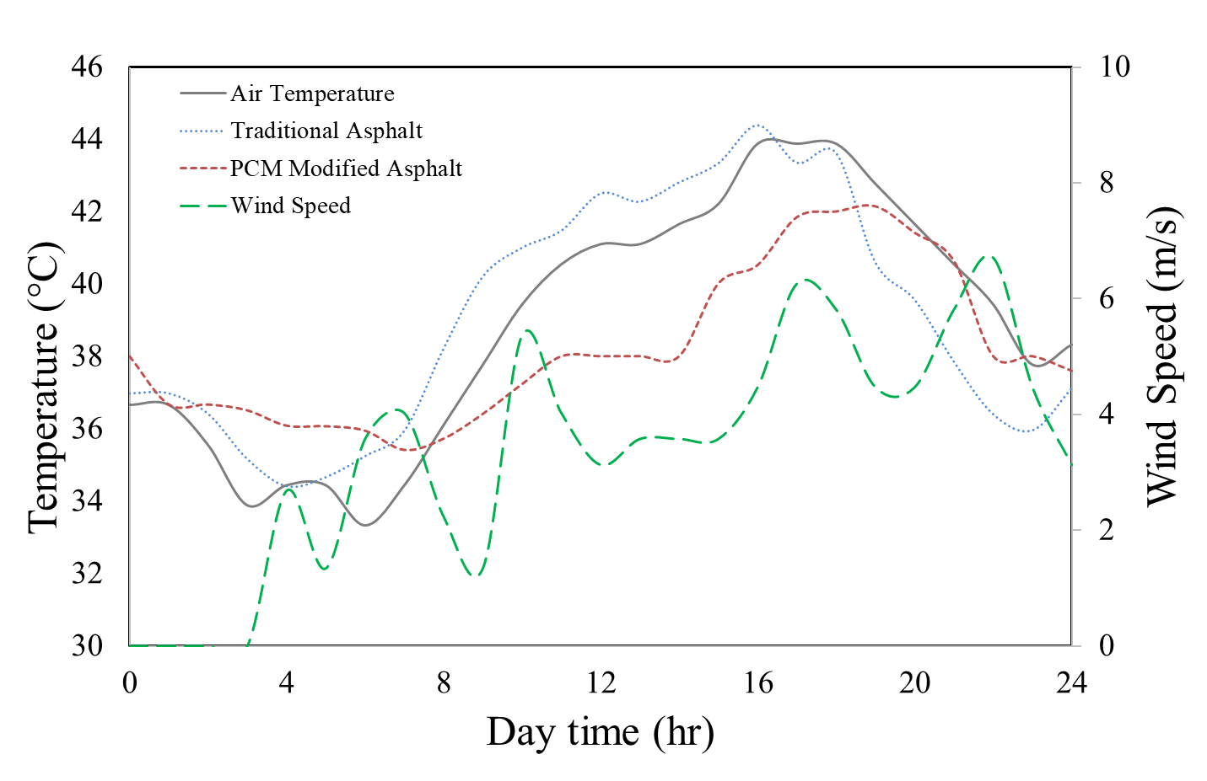
Figure 4. Thermodynamic simulation results of featured and traditional materials in relation to air temperature.

Challenge 3: Wildfire

Assessment
Wildfires can expose roadways to extreme heat, rapidly escalating pavement temperatures. For instance, during the 2018 “Camp Fire” in California, roadway temperatures reportedly reached approximately 297°C within five hours of ignition³⁶. Although asphalt is not inherently combustible, prolonged exposure to high heat or burning debris (i.e., vehicles, vegetation) can cause binder oxidation, volatilization combustion vapor at temperatures above its flash point, and aggregate debonding, leading to surface scarring, deformation, and cracking. These damages are exacerbated by increased traffic from emergency response and debris removal operations, which impose heavy loads on already weakened pavements.
Wildfires not only damage road surfaces but also disrupt transportation networks, hindering evacuation efforts and delaying emergency responses. The economic costs of repairing damaged infrastructure and the social impacts on affected communities are substantial. Understanding how wildfire conditions impact roadway temperatures is critical for assessing potential damage and planning safer evacuation routes^{37–39}. Pavement temperatures within wildfire zones are not uniform; they vary significantly due to factors such as climate, fuel type, and topography. The highest temperatures are typically recorded at the fire's leading edge-the fire line-and decrease sharply as the fire progresses. Studies have shown that wildfire flame temperatures generally range from 850 to 950 K⁴⁰. The distance between a wildfire and a roadway significantly influences pavement temperature, with greater distances slowing the rate of temperature increase.
Multi-hazard interactions amplify the complexity of wildfire impacts. For instance, in January 2018, post-fire heavy rains in Montecito, California, triggered catastrophic floods and debris flows, resulting in fatalities, community destruction, and a two-week closure of a major highway⁴¹. Such cascading events expose the limitations of reactive mitigation programs, which often lack the capacity to address compound hazards. Proactive initiatives like the Four Forest Restoration Initiative (4FRI) aim to reduce wildfire spread and protect communities, yet transportation corridors outside these zones remain highly vulnerable. These challenges underscore the need for risk-based design standards that account for wildfire-induced thermal loads and subsequent geohazards⁴².

Mitigation Strategy
At the network scale, strategic vegetation management is crucial to reduce fire exposure. Removing combustible materials and increasing the width of vegetation-free roadside zones can significantly lower the probability of fires affecting roadways. Creating wider cleared areas along roads acts as a fuel break, slowing the spread of wildfires and reducing heat exposure to pavements. This practice is vital near tunnels, residential areas, and other high-risk zones where road closures can have severe consequences. Implementing wider vegetation-free zones requires coordination with land management agencies and may face challenges such as land ownership issues or environmental concerns. However, successful cases like the fuel breaks established along highways in Australia demonstrate the effectiveness of this approach⁴³.
To understand the effect of vegetation-free roadside zones, a screening heat transfer model was used to estimate air temperature 1 m above the roadway as a function of fire height and distance from the road edge. By combining convective heat transfer and radiative heat flux equations, the model simply calculates the temperature rise due to the fire's proximity. The total distance between the fire and the observation point is calculated using the Pythagorean theorem, accounting for both horizontal and vertical separation. Note that, the calculation is not a validated pavement-temperature model and should not be used directly to establish roadside-clearance requirements.
Figure 5 illustrates the relationship between fire height, distance, and air temperature. Results indicate that as fire height increases and the fire approaches the roadway, air temperature rises sharply, reaching 160.5 °C at a fire height of 9 m and a distance of 6 m from the road edge. Such extreme conditions can severely compromise pavement integrity and create unsafe conditions for vehicles and emergency personnel. Conversely, temperature decreases significantly with increased separation, reinforcing the importance of maintaining adequate buffer zones to protect critical transportation routes during wildfire events.
Figure 5. The air temperature above the pavement surface varies during wildfires at different fire distances and heights from the road edge.
Post-fire recovery traffic can also affect pavement performance. Following the Camp Fire, the removal of over 3.6 million tons of debris imposed heavy loads on local roads, reducing pavement life by several years⁴⁴. Strategic debris management, such as routing heavy vehicles onto more durable pavements or designating alternative haul routes, can mitigate long-term damage. Incorporating pavement condition assessments into recovery plans is essential to prevent accelerated deterioration. Advanced tools like ground-penetrating radar (GPR) can detect subsurface damage, enabling targeted maintenance and reducing lifecycle costs⁴⁵.
Addressing wildfire-related risks requires a multi-layered approach, combining design adaptations, operational planning, and policy integration. Policies should mandate regular inspections, allocate dedicated funding for timely repairs, and incorporate risk-based design standards that account for wildfire-induced thermal loads and subsequent hazards such as flooding and debris flows. Embedding these measures into transportation resilience frameworks ensures that road networks can withstand both the immediate and cascading impacts of wildfires.

Conclusion
Climate change requires roadway design and asset management to move beyond unexamined assumptions of climate stationarity toward adaptive, risk-informed practice. This perspective considered flooding and erosion, extreme heat, and wildfire as interacting threats to roadway function and durability. Published evidence supports updating climatic design inputs, improving drainage and erosion protection, selecting materials for projected service conditions, managing roadside fuels, and planning recovery traffic. The numerical examples in this paper are screening-level illustrations: they show expected qualitative sensitivities but do not establish field-validated performance gains, universal buffer widths, or design thresholds. Future work should calibrate the erosion and heat-transfer models with material-specific laboratory data and field measurements, quantify uncertainty, and evaluate life-cycle performance and implementation constraints before these strategies are adopted in specifications.

Competing financial interests
The author declares no competing financial interests.

Data Availability
The data associated with the 2024 Hurricane Helen Road closure, which support the findings of this study, were obtained from publicly available records on the NCDOT website shortly after the hurricane.

References
1. Graham, F. Daily briefing: Arctic heat wave is’ unequivocal’evidence of climate change. Nature (2020).
2. Costa, R., Bolte, E., Sharp, C. & Bowers, C. Repeated and localized flooding is an underestimated challenge for urban disaster risk management. Nat. Cities 1–10 (2024).
3. Tippett, M. K. & Cohen, J. E. Tornado outbreak variability follows Taylor’s power law of fluctuation scaling and increases dramatically with severity. Nat. Commun. 7, 10668 (2016).
4. Adshead, D. et al. Climate threats to coastal infrastructure and sustainable development outcomes. Nat. Clim. Chang. 14, 344–352 (2024).
5. Melvin, A. M. et al. Climate change damages to Alaska public infrastructure and the economics of proactive adaptation. Proc. Natl. Acad. Sci. 114, E122–E131 (2017).
6. Yang, P. et al. Impacts of climate change-related flood events in the Yangtze River Basin based on multi-source data. Atmos. Res. 263, 105819 (2021).
7. Lewis, J. W., Lytle, S. E. & Tavakoly, A. A. Climate change projections of continental-scale streamflow across the Mississippi River Basin. Theor. Appl. Climatol. 151, 1013–1034 (2023).
8. Neumann, J. E. et al. Climate effects on US infrastructure: the economics of adaptation for rail, roads, and coastal development. Clim. Change 167, 44 (2021).
9. Underwood, B. S., Guido, Z., Gudipudi, P. & Feinberg, Y. Increased costs to US pavement infrastructure from future temperature rise. Nat. Clim. Chang. 7, 704–707 (2017).
10. Williams, S. J. Sea-level rise implications for coastal regions. J. Coast. Res. 184–196 (2013).
11. Schuerch, M. et al. Future response of global coastal wetlands to sea-level rise. Nature 561, 231–234 (2018).
12. Voskaki, A., Budd, T. & Mason, K. The impact of climate hazards to airport systems: a synthesis of the implications and risk mitigation trends. Transp. Rev. 43, 652–675 (2023).
13. Reidmiller, D. R. et al. Impacts, risks, and adaptation in the United States: Fourth national climate assessment, volume II. (2017).
14. Piemontese, L. et al. Over-reliance on water infrastructure can hinder climate resilience in pastoral drylands. Nat. Clim. Chang. 14, 267–274 (2024).
15. Mills, B. & Andrey, J. Climate change and transportation: potential interactions and impacts. in The potential impacts of climate change on transportation vol. 77 (United States Environmental Protection Agency Washington, DC, USA, 2002).
16. Gaines, J. M. Flooding: water potential. Nature 531, S54–S55 (2016).
17. Inkoom, S., Sobanjo, J. O., Chicken, E., Sinha, D. & Niu, X. Assessment of deterioration of highway pavement using Bayesian survival model. Transp. Res. Rec. 2674, 310–325 (2020).
18. Chen, X. & Wang, H. Enhancement of roadway pavement resilience to flooding: impact assessment and mitigation strategies. Transp. Res. Part D Transp. Environ. 104946 (2025).
19. Inkoom, S. & Sobanjo, J. O. Competing risks models for the deterioration of highway pavement subject to hurricane events. Struct. Infrastruct. Eng. 15, 837–850 (2019).
20. Chen, X. & Zhang, Z. Effects of Hurricanes Katrina and Rita flooding on Louisiana pavement performance. in Pavement materials, structures, and performance 212–221 (2014).
21. Zhang, Z., Wu, Z., Martinez, M. & Gaspard, K. Pavement structures damage caused by Hurricane Katrina flooding. J. Geotech. geoenvironmental Eng. 134, 633–643 (2008).
22. Helali, K., Robson, M., Nicholson, R. & Bekheet, W. Importance of a pavement management system in assessing pavement damage from natural disasters: a case study to assess the damage from Hurricanes Katrina and Rita in Jefferson Parish, Louisiana. in 7th International Conference on Managing Pavement Assets (Citeseer, 2008).
23. Indicators, P. & Alipour, A. Asset Management, Extreme Weather, and Proxy Indicators. Bridg. 515, 294–8103 (2021).
24. Yuan, X., Ye, F., Fu, W. & Wen, L. Estimating the critical shear stress for incipient particle motion of a cohesive soil slope. Sci. Rep. 12, 9736 (2022).
25. Julien, P. Y. Erosion and sedimentation. (Cambridge university press, 2010).
26. Knapen, A., Poesen, J. & De Baets, S. Seasonal variations in soil erosion resistance during concentrated flow for a loess-derived soil under two contrasting tillage practices. Soil Tillage Res. 94, 425–440 (2007).
27. Madrazo-Uribeetxebarria, E., Antín, M. G., Eguilegor, G. A. & Andrés-Doménech, I. Analysis of the hydraulic performance of permeable pavements on a layer-by-layer basis. Constr. Build. Mater. 387, 131587 (2023).
28. Delgadillo, R., Arteaga, L., Wahr, C. & Alcafuz, R. The influence of climate change in Superpave binder selection for Chile. Road Mater. Pavement Des. 21, 607–622 (2020).
29. Gulzar, S., Goenaga, B. & Shane Underwood, B. Novel Index for Vulnerability Assessment of Flexible Pavement Infrastructure to Temperature Rise: Case Study of Developing Countries. J. Infrastruct. Syst. 28, 4021055 (2022).
30. Swarna, S. T., Hossain, K., Mehta, Y. A. & Bernier, A. Climate change adaptation strategies for Canadian asphalt pavements; Part 1: Adaptation strategies. J. Clean. Prod. 363, 132313 (2022).
31. Viola, F. & Celauro, C. Effect of climate change on asphalt binder selection for road construction in Italy. Transp. Res. Part D Transp. Environ. 37, 40–47 (2015).
32. Montoya, M. A. et al. Environmentally Tuning Asphalt Pavements Using Phase Change Materials. (2022).
33. Bueno, M. et al. Modification of asphalt mixtures for cold regions using microencapsulated phase change materials. Sci. Rep. 9, 20342 (2019).
34. McAdams, W. H. & McAdams, W. H. Heat transmission. vol. 3 (McGraw-hill New York, 1954).
35. Mirsadeghi, M., Costola, D., Blocken, B. & Hensen, J. L. M. Review of external convective heat transfer coefficient models in building energy simulation programs: Implementation and uncertainty. Appl. Therm. Eng. 56, 134–151 (2013).
36. Robinson, A. California on fire, and can plants think? Books in brief. Nature 611, 659 (2022).
37. Hamideh, S., Sen, P. & Fischer, E. Wildfire impacts on education and healthcare: Paradise, California, after the Camp Fire. Nat. hazards 1–35 (2022).
38. Bramwell, L. Understanding Wildfire in the Twenty-First Century: The Return of Disaster Fires. Environ. Hist. Durh. N. C. 28, 467–494 (2023).
39. Barzegar, M. & Wen, H. Modeling roadway temperatures for wildfire evacuation and assessment of pavement damage. J. Infrastruct. Preserv. Resil. 4, 18 (2023).
40. Dennison, P. E., Charoensiri, K., Roberts, D. A., Peterson, S. H. & Green, R. O. Wildfire temperature and land cover modeling using hyperspectral data. Remote Sens. Environ. 100, 212–222 (2006).
41. Tiwari, B., Ajmera, B., Gonzalez, A. & Sonbol, H. Impact of wildfire on triggering mudslides—a case study of 2018 Montecito debris flows. in Geo-congress 2020 40–49 (American Society of Civil Engineers Reston, VA, 2020).
42. Fraser, A. M., Chester, M. V & Underwood, B. S. Wildfire risk, post-fire debris flows, and transportation infrastructure vulnerability. Sustain. Resilient Infrastruct. 7, 188–200 (2022).
43. Ascoli, D., Russo, L., Giannino, F., Siettos, C. & Moreira, F. Firebreak and fuelbreak. in Encyclopedia of wildfires and wildland-urban interface (WUI) fires 444–452 (Springer, 2020).
44. Modaresi Rad, A. et al. Human and infrastructure exposure to large wildfires in the United States. Nat. Sustain. 6, 1343–1351 (2023).
45. Nassiri, S. et al. Evaluating Road Resilience to Wildfires: Case Studies of Camp and Carr Fires. (2023).

