A Modular Orchestrated Pipeline for Soil Moisture Forecasting and Irrigation Decision Support: An Operational Evaluation
  - Highlights
- Adding gridMET weather features cuts Cook Farm holdout RMSE ~14.6% vs. soil only.
- Four coordinated modules handle ingestion, forecasting, and advisories.
- Learned model is statistically on par with the persistence baseline at both sites.
- A 398-step replay validates end-to-end decision accuracy of 0.9975.
Abstract. Accurate soil moisture information is central to efficient irrigation scheduling, yet most operational monitoring systems report only current conditions in real time and stop short of forecasting future soil moisture or translating it into actionable irrigation decisions within a single evaluated, end-to-end system. To address this gap, this work proposes a modular orchestrated approach that forecasts soil moisture content and derives irrigation advisories from those forecasts. It was tested using two US Department of Agriculture datasets: Cook Farm in Washington State for dryland wheat (totaling 3,346 instances) and SCAN Bushland in Texas for irrigated wheat (a total of 2,192 instances). Data ingestion, transformation, forecasting, and generation of advisory recommendations are performed by four modules (Data Ingestion, Forecasting, Advisory, and Orchestrator) to produce a machine-readable JSON output with retry logic and execution logging capabilities using gridMET precipitation and reference evapotranspiration data as input. With regard to Cook Farm, adding gridMET weather features improves the Gradient Boosting holdout RMSE from 0.00260 (soil and temperature only) to 0.00222, an improvement of about 14.6%. Across the two sites the relative value of the learned model depends on the soil-moisture dynamics: Gradient Boosting improves modestly over a strong persistence baseline at Cook Farm (holdout RMSE 0.00222 versus 0.00244), whereas at the noisier irrigation-driven Bushland series persistence (RMSE 0.01083) outperforms Gradient Boosting (RMSE 0.01978). This indicates that the added meteorological features improve on a strong persistence baseline at one site but not the other; under a Diebold-Mariano test, however, neither the Gradient Boosting advantage at Cook Farm nor the persistence advantage at Bushland is statistically significant (p = 0.29 and p = 0.08), so the learned model is best described as competitive with persistence rather than decisively better. The central contribution is accordingly the fully implemented, evaluated, and portable decision-support pipeline, in which the forecasting model is one replaceable and transparently benchmarked component. A 398-step chronological replay on Cook Farm yielded an advisory accuracy of 0.9975 with a median latency of 14.01 ms per iteration. Applying the same pipeline to a second, contrasting site without code changes demonstrates portability across climates, soils, and irrigation regimes, while also showing that the learned model’s advantage over persistence is site-dependent.
Keywords. Decision support, gradient boosting, gridMET, irrigation scheduling, machine learning, modular pipeline, persistence baseline, soil moisture forecasting.

INTRODUCTION
The measurement of soil moisture involves determining the quantity of water in the soil that plays a significant role in the growing process of crops and is necessary for irrigation. As practice shows, there are two threshold values used in irrigation, field capacity and wilting point. The problem arises when the moisture content falls close to the lower value since crops experience stress that affects their development and harvest yield. The excessive moisture beyond field capacity can also cause harm as irrigation that is poorly thought-out can result not only in losses but also in damaging the roots of the plants. Nowadays, there are existing systems that inform farmers about the real-time moisture content via sensors, but they fail to estimate soil moisture for the future.
Water deficiency is currently a major problem in the world's agriculture. It accounts for 70% of the world's fresh water and is exacerbated by climate change causing more droughts. Many farmers face the difficulties in irrigation management, especially those who lack expensive technology to handle it effectively. Therefore, tools predicting water deficiency help to save water and protect crops from possible adverse effects. The suggested project is a cost-effective solution that relies on publicly available information and has been tested in operation.
In terms of agricultural engineering, there are three main advantages brought by this method that can help in optimizing irrigation. First, it enables the reduction of the water spent for irrigation as unnecessary irrigation, which occurs when the soil moisture threshold is exceeded despite the upcoming rains or moisture increase, can be prevented. Second, this method can allow farmers to plan in advance and use their labor force along with their equipment to irrigate other fields/zones according to the current condition of soil moisture. Lastly, the scheduling process enables keeping a record of how often irrigation was needed in order to comply with the water use requirements. Furthermore, it can be reviewed at the end of the season as a basis for future improvement of the irrigation process. As identified by the USDA Economic Research Service (USDA-ERS, 2023), precision irrigation is a key factor in minimizing water loss in the western states of America. The suggested system provides services which are inexpensive compared to costly $5,000-15,000 per season decision-support software.
The soil moisture level is affected by several internal and external factors. The irrigation threshold should always be considered as there are specific soil moisture requirements for different types of crops and the excess of moisture content can cause problems. The external factors influencing the work of the suggested system include weather conditions, wind speed, irradiance, and whether there is irrigation infrastructure on the field or not. The internal factors include the moisture contents of the soil and crop types cultivated on the field.
Effective irrigation management can help in increasing the crop yield, minimize labor, and maximize the total profit. Ideal sensors show the irrigators what happens in the soil moisture root zone and help them determine whether the irrigation is necessary or not on a particular day.
Currently, there are soil moisture sensing systems that involve planting the sensors into the ground at certain depths and gathering their readings with the help of special loggers. These readings are then sent to the cloud-based server via an IoT gateway and can be monitored using an interactive dashboard located on the website. Such systems fail to estimate the soil moisture content in advance, as users have to manually check it each day (fig. 1).
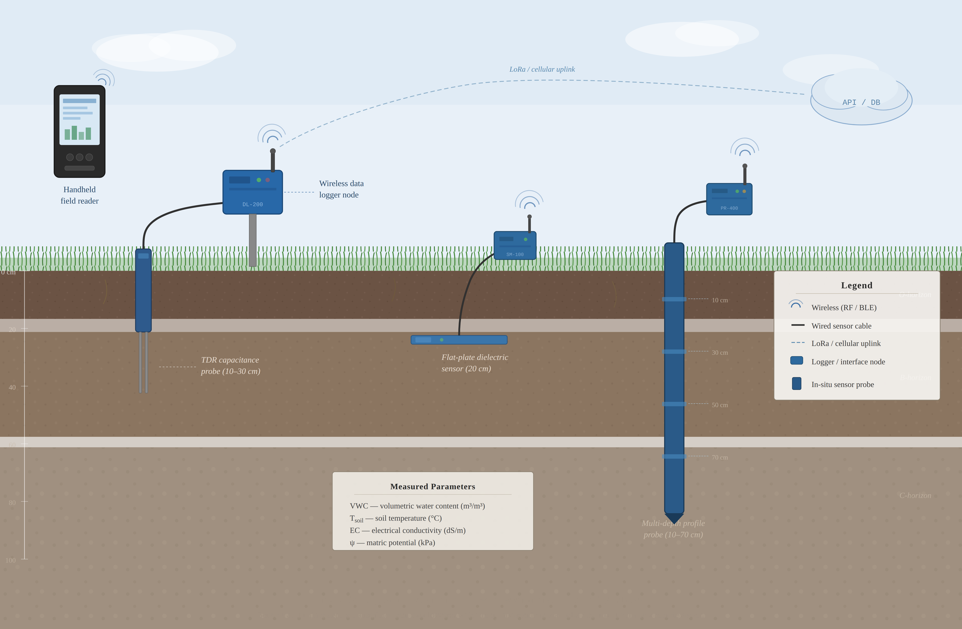
Figure 1. Modern soil moisture monitoring system
A modular orchestrated pipeline for the purpose of predicting next-step volumetric water content and deriving an irrigation advice recommendation in near real-time is proposed within the current research. This system is composed of four distinct modules which include the following: a data ingestion module to acquire and validate sensor data readings; a predictive module to predict the next-step volumetric water content using machine learning models; an advisory module to generate irrigation recommendation based on forecasted results; and, lastly, a pipeline orchestrator to manage the entire pipeline process, ensure fault tolerance, and keep logs of all decisions made by each module. The system will operate using either sensor data collected from the field or data obtained through server/cloud APIs in order to derive an irrigational advisory recommendation from data inputted into the system via the modules' pipeline. The system proposed here differs from other systems in that it not only measures the accuracy of predictions but goes on to evaluate the entire decision-making process in near-real-time operations, from raw data to grower recommendation, including the per-module latencies, decision accuracy against ground truth, and fault tolerance under streaming replay conditions. Each module is a concrete, separately testable software component with defined inputs, outputs, parameters, and JSON message schemas (detailed in the Methodology), and the complete implementation, trained models, and configuration files are retained in version control; the system is exercised end-to-end over a 398-step chronological replay and benchmarked against persistence and climatology baselines on two independent USDA sites, so the contribution is a fully implemented and empirically evaluated system rather than a conceptual framework.

BACKGROUND AND RELATED WORK
Another important consideration when it comes to the water management aspect is the soil moisture content. Conventional approaches usually involve the continuous monitoring of soil moisture content and its visualization. There are no predictions made about the future moisture content in the soil. Therefore, a data-driven approach can help predict the soil moisture content using the past soil information as well as the weather data.
Various studies in the past have proposed methods using regression modeling in order to analyze the soil as well as other environmental parameters that may contribute towards the water supply forecasting (Bellingham and Lea, 2014). In addition, the irrigation process based on soil moisture content is known to help efficiently manage water and nutrients in the drip irrigation process (Dukes et al., 2007). Modern research works have come up with methods to predict the volumetric water content as well as deep learning approaches for estimating the soil moisture content with respect to the soil as well as meteorological factors (Cai et al., 2019).
There are other recent studies that try to incorporate the use of remote sensing technologies as well as machine learning for estimating the soil moisture content on a large scale (Fang et al., 2017). Apart from that, recurrent neural networks have been used as well for analyzing soil moisture temporal patterns (Kratzert et al., 2018). Other studies have involved the use of data-driven models as well as the environmental parameters in predicting soil moisture content in precision agriculture (McCarthy et al., 2018). Further recent works have focused on using various machine learning algorithms as well as deep learning algorithms in estimating the soil moisture content in precision agriculture systems (Teshome et al., 2024). In addition, recent research works have suggested incorporating various prediction as well as decision-making models in precision agriculture systems (Jones et al., 2017).
The most recent research works performed in 2024 and 2025 have managed to achieve remarkable accuracy levels on soil moisture prediction benchmarks. For example, in 2024, the authors of Basir et al. (2024) found that using the LSTM model on a corn-field dataset in Indiana resulted in RMSE 0.0038 and R² 0.998. Wang et al. (2024) also compared ten network structures evaluated at thirty sites and found that an attention-based LSTM reached R² up to 0.94 at a 1-day horizon. In another case, Kandamali et al. (2025) tested a hybrid LSTM and XGBoost model against Georgia watermark sensor data, reporting R² of about 0.986 across 24-to-168-hour forecast horizons. Physics-guided models such as Xi et al. (2025) and Geng et al. (2024) improve forecast accuracy by incorporating water-balance constraints in their loss functions relative to data-driven LSTM baselines. However, almost all of these techniques were able to achieve such accuracy levels without assessing the end-to-end decision support or operational deployment in precision agriculture, precisely the problem area of this research paper.
Nonetheless, in almost all cases, the earlier research works have certain deficiencies with respect to some aspects or others, such as the practical applicability of models, comparative analysis of models, lack of integration of multiple models into a single framework, as well as the integration of decision-making models within precision agriculture systems. Therefore, in the present study, a novel data-driven predictive model will be introduced that not only compares different types of models, such as boosted trees and recurrent neural networks, but also integrates the use of several models within one framework with the aid of modular orchestrated pipelines.

METHODOLOGY

System Design
The goal of this project is to develop a system for predicting soil moisture content using a data-driven approach and designing a full-fledged orchestrated workflow for irrigation decisions. Rather than implementing a monolithic system, where all concerns (data ingestion, forecasting, decision-making, etc.) are implemented in one software application, we have decided to adopt the modular orchestrated approach, in which every concern is handled by a separate module. There are three main practical reasons for adopting such a structure. Firstly, it allows each module to be built and maintained separately without affecting other parts of the system; e.g., when updating the forecasting module would not affect the decision-making process or vice versa. Secondly, it aligns with the pipeline stages, since any irrigation decision involves at least these four stages: data collection, forecasting, comparing forecasts with thresholds, and issuing recommendations. Finally, the modular pipeline architecture enables us to easily instrument any part of the pipeline due to the well-structured data exchange between modules.
Four modules form the irrigation prediction and advice pipeline. The Data Ingestion Module reads sensor observations, validates them, and prepares a clean set of features as input data for the model. The Forecasting Module consumes the prepared data, builds a feature vector using a lag window, and performs inference for obtaining a point forecast and its uncertainty bounds. The Advisory Module consumes a forecasted volumetric water content (VWC), and based on the comparison with predefined thresholds, generates recommendations on whether to irrigate the field right now, plan an irrigation, or not to irrigate at all. The Pipeline Orchestrator manages the pipeline execution, applies retries upon errors, logs runtime metrics per module, and creates the final report of the pipeline execution.
The modules interaction graph is shown in fig. 2. All data is transferred using the JSON format, and there is no global shared mutable state among modules.
To understand the functioning of the solution better, let us examine a sample pipeline execution in more detail. The Orchestrator invokes a run using the Data Ingestion Module and passing it a pointer to the sensor data file or API endpoint. The Data Ingestion Module retrieves raw sensor observations, filters out invalid data, cleans up outliers, and interpolates the missing values, resulting in a JSON artifact containing a feature batch. This artifact is then consumed by the Orchestrator and forwarded to the Forecasting Module, which converts the last observations into a feature vector using a lag window, predicts the next step value using the serialized Gradient Boosting model, and returns another JSON artifact with the forecast results. The received forecast is then used by the Advisory Module to compare the next step VWC with the predefined threshold, and based on the results, emit yet another artifact, which contains recommendations on what action to perform, an alert level, the reason for issuing the specific recommendation, and a textual description understandable to growers.
Finally, the output artifacts are consumed by the Orchestrator module, which generates the final report of the pipeline run. In this way, we obtain a complete modular orchestrated pipeline, which takes raw sensor observations, generates a point forecast, computes the recommendation for irrigation, and produces the result in the form of a report. Each pipeline execution finishes in roughly 14 ms at the median (and under about 22 ms at the 95th percentile) on a commodity laptop CPU, as shown in the Operational Evaluation section.
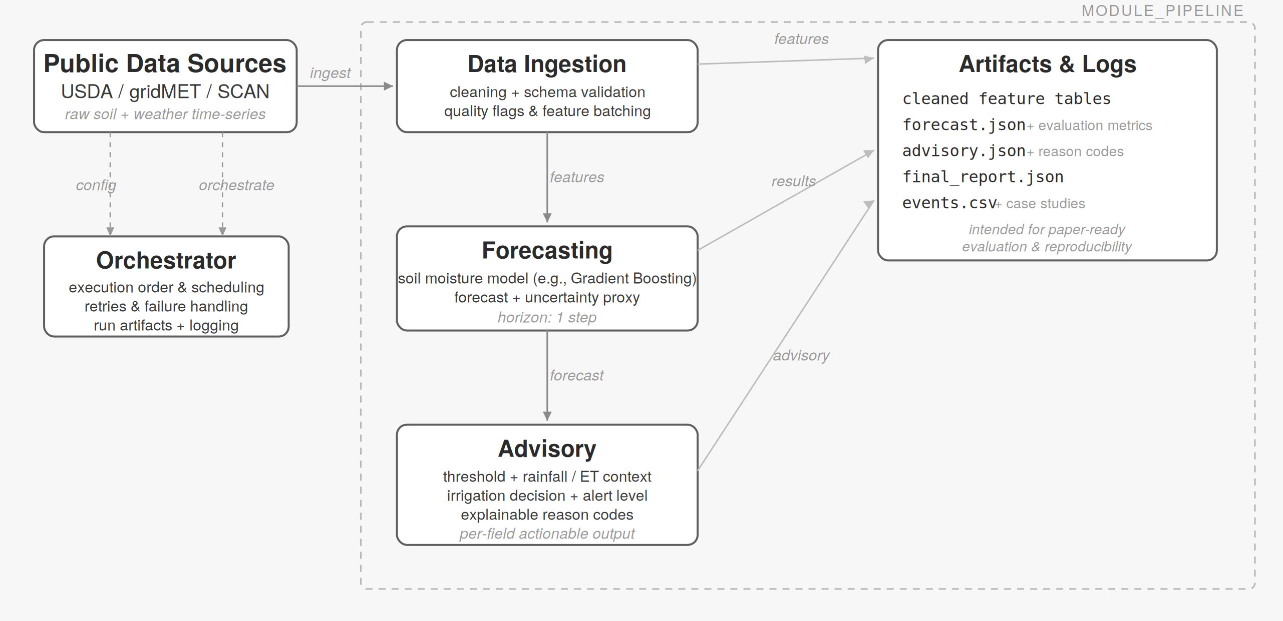
Figure 2. Module pipeline architecture: the Orchestrator coordinates the Data Ingestion, Forecasting, and Advisory modules and their JSON artifact outputs.

Data Collection and Processing
The first dataset used for training the model is the USDA Ag Data Commons Cook Farm sensor setup containing 42 locations and 5 depths (30, 60, 90, 120, 150 cm) for daily measurements of soil moisture (VWC), soil temperature, and bulk electrical conductivity from 2007-04-20 till 2016-06-16. Created merged training dataset includes 3,346 daily observations in CSV format. Volumetric soil moisture dataset consists of 3,190 daily observations with missing data days being 156 (4.66%) and values ranging between 0.207 and 0.477 m³/m³ with a mean of 0.320 and standard deviation of 0.061. Soil temperature dataset reports all measurements with temperature values ranging between -0.26 and 21.83 degrees C. Daily precipitation and reference evapotranspiration were obtained from the gridMET gridded surface meteorological dataset (Abatzoglou, 2013) by point extraction at the Cook Farm location (lon −117.09, lat 46.78); gridMET reference E_{T} follows the FAO-56 Penman-Monteith formulation (Allen et al., 1998). The merged precipitation series has a mean value of about 1.53 mm/day. Evapotranspiration amounts range from a mean daily value of 2.84 mm/day to higher values during summer days. Correlation coefficient between rainfall and reference evapotranspiration and soil moisture is 0.08 and -0.13 respectively. Although these correlations show relatively low magnitude, they correctly correspond to the properties of rainfall increasing soil moisture contents while evapotranspiration decreases it. In order to evaluate the performance and generalizability of the proposed method the second testing dataset will be used. This dataset corresponds to USDA SCAN Bushland #1 station (site 2006) located in Texas Panhandle semi-arid area. Bushland dataset consists of irrigated wheat with center-pivot irrigation grown on Pullman clay loam soil elevation 1,170 m. Bushland station dataset consists of daily soil moisture records from 2019-01-01 till 2024-12-31 (2,192 observations). Soil moisture at the 8-inch depth ranges between 0.114 and 0.542 volumetric water content with a mean value of 0.224. The lag-1 autocorrelation coefficient is 0.979 compared to 0.997 for Cook Farm soil moisture records; both series are strongly persistence-dominated, with Bushland showing marginally more day-to-day variability under its irregular precipitation and irrigation, though it remains autocorrelated enough that a persistence baseline is difficult to beat (as the results confirm). Average daily precipitation at Bushland station is 0.99 mm/day while max daily precipitation amounts to 76.2 mm at one rainstorm event. As at Cook Farm, gridMET reference evapotranspiration was merged at the Bushland coordinates (lon −102.09, lat 35.19). Data Ingestion Module performs the processing and validation of dataset, filters outliers by criterion z-score > 3.0, sets the missingness threshold to 0.4, and creates feature batch.

Feature Engineering and Correlation Analysis
The training set of features used for training on the Cook Farm merged CSV included soil moisture, soil temperature, gridMET precipitation, and gridMET reference evapotranspiration at various lag steps (six in total), providing the learners with short-term context. Figure 3 shows the ranked feature-group importances for the deployed Gradient Boosting model. Lagged soil moisture dominates (about 99.8% of total importance), with temperature and the gridMET weather features each contributing a small but nonzero share (temperature_c 0.09%, rainfall_mm 0.05%, evapotranspiration_mm 0.06%); the importance axis is shown on a logarithmic scale so that the small weather contributions remain visible alongside the dominant soil-moisture term. The weather features therefore carry real, if modest, predictive signal rather than being null. The daily volumetric water content series exhibits strong autocorrelation (lag-1 ACF = 0.997; lag-10 ACF = 0.95 at Cook Farm), which allows the variable to be forecast over a short horizon using a small number of lagged features.
The model can be related to the soil water balance, in which the change in stored water is Δθ = P − E_{T} − D − R, where P stands for precipitation, E_{T} stands for evapotranspiration, D stands for deep drainage, and R stands for surface runoff. With real gridMET precipitation and reference E_{T} now present in the feature matrix, the learner has access to the dominant water-balance drivers in addition to the autoregressive soil-moisture and temperature lags, learning a mapping of the form θ_{t} = f(θ_{t−1}, ..., θ_{t−6}, T, P, E_{T} at corresponding lags). In practice the fitted importances show that day-to-day predictions remain dominated by the strong lag-1 persistence of the series (lag-1 ACF = 0.997 at Cook Farm), with the weather features providing a smaller correction; this is consistent with the modest but real RMSE improvement obtained when the gridMET features are added.
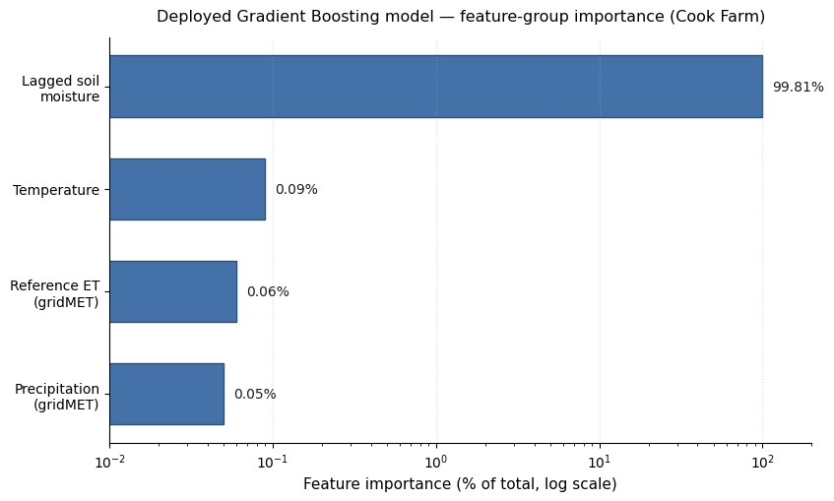
Figure 3. Feature-group importance for the deployed Cook Farm Gradient Boosting model (log scale). Lagged soil moisture accounts for about 99.8% of total importance; temperature, reference E_{T}, and precipitation each contribute a small nonzero share.

Predictive Models
Five supervised learners were pre-trained individually before being incorporated into the Forecasting Module. Namely, the Forecasting Module incorporates the following learners: (i) Random Forest with 200 estimators and tree depth equal to 15; (ii) Gradient Boosting regressor with 300 estimators, learning rate equals to 0.05, tree depth of 5, and minimum samples per leaf is 10, chosen by a grid search on a validation set derived from training data; (iii) XGBoost and CatBoost regressors using default settings; and (iv) LSTM NN with a single recurrent layer and 64 units, followed by a densely connected layer. LSTM was trained for 100 epochs, with a batch size of 32, Adam optimizer with a learning rate of 0.001, and early stopping after 10 iterations (fig. 4). All other models use the default settings from Scikit-Learn library. Lag windows features are used by tree ensembles and presented in flattened vectors, while LSTM NN uses the same features organized as sequences covering six time steps. For model validation, the holdout approach is applied with an 80/20 train/test split based on date order. After constructing the six-step lag window from the 3,190 valid daily soil-moisture observations, 3,183 supervised samples remain, giving n_train=2546 and n_test=637. The Gradient Boosting regressor was selected as the deployed model and was evaluated together with the persistence and climatological baselines under a single, like-for-like holdout protocol (identical test indices, VWC fraction scale); its results, with those baselines, are reported in table 1. The Random Forest, XGBoost, CatBoost, and LSTM figures shown in table 1 come from an earlier, separate model-comparison run and are not directly comparable to the deployed-model holdout: they were produced under different preprocessing and evaluation settings, which is why, for example, the LSTM shows a lower nominal RMSE but a substantially lower R² than Gradient Boosting (a pattern that cannot arise on a common test set). Gradient Boosting was preferred over the LSTM not only on the unified holdout comparison but also for practical deployment reasons: it trains and runs far faster on a commodity CPU (1.67 ms inference per step), requires no GPU, exposes interpretable feature importances, and serializes to a small portable artifact, all of which suit a low-cost field decision-support tool. The model is serialized into a pickle file and loaded back by the forecasting module. Offline training of models ensures easy updates with new data without any changes to the forecasting algorithm.
In regard to the Gradient Boosting model, the squared error loss function is used and can be represented as L = (1/N) ∑_{i} (y_{i} − F(x_{i}))², where y_{i} corresponds to the measured volumetric water content (VWC) value at time i, F(x_{i}) represents predictions by the ensemble formed by weak learners during each iteration, N is the number of samples in training dataset, and x_{i} is the feature vector containing previous observations of the target variable together with the corresponding temperature and gridMET weather features. More concretely, x_{t} = [θ_{t−1}, ..., θ_{t−k}, T_{t−1}, ..., T_{t−k}, P_{t−1}, ..., P_{t−k}, (E_{T})_{t−1}, ..., (E_{T})_{t−k}], where θ stands for volumetric water content, T for soil temperature, P for gridMET precipitation, and E_{T} for gridMET reference evapotranspiration, with k=6 giving a total of 24 features. The rule applied in Advisory Module can be stated as follows: if θ_{predicted} < θ_{critical} (0.22), then start irrigation immediately; if θ_{critical} ≤ θ_{predicted} < θ_{low} (0.30), then schedule irrigation after 24 hours; otherwise, irrigation is not needed. Critical values correspond to wilting stress and field capacity for dryland wheat cultivated in Palouse silt loam soil and can be easily changed in a YAML configuration file.

Implementation and Module Coordination
The four modules are implemented as isolated Python modules without any global variables. System initialization takes place consistently through the command-line interface which starts the pipeline orchestrator. The Pipeline Orchestrator, in turn, triggers downstream modules sequentially. Currently, one run represents one time step. The system executes iteratively and advances the sliding window by one time step each run within a 398-step-long operational test period. For practical usage, the system would be invoked periodically (e.g., daily, hourly, or for each measurement in case of webhook integration with IoT gateways). Modules coordination happens by executing in order the pipeline orchestrator, while each module processes the input data from its upstream module. Modules communication occurs exclusively via JSON-formatted inputs/outputs following predefined schemas with built-in validation of inputs. The implementation uses Python 3.10, scikit-learn for tree-based forecasting, PyTorch for LSTM, pandas for data processing, and PyYAML for configuration handling. Detailed implementation of components follows.
System configuration is specified through two YAML configuration files (default.yaml and thresholds.yaml) loaded during initialization. In default.yaml, users provide the name of their project, time zone, directories where to store the replayed data and output, ingestion parameters (list of expected columns; z-score for detecting outliers set to 3.0; maximum allowed fraction of missing values per column set to 0.4), and forecasting parameters (directory with trained models; forecast horizon set to one step; lag window length set to six steps; uncertainty floor set to 0.001). Thresholds.yaml includes irrigation decisions’ thresholds (moisture_critical_below set to 0.22 volumetric water content (VWC) at Cook Farm; moisture_low_below set to 0.30 VWC; rainfall delay set to 6.0 mm; evapotranspiration stress set to 5.0 mm). The rainfall and evapotranspiration thresholds support optional rule extensions; the core advisory in the present evaluation is driven by the forecasted VWC against the two moisture thresholds. As a result, changing only two YAML files allows reconfiguring the system to operate with new field sites and crops.
Data Ingestion Module. The Data Ingestion Module acts as the entry point into the system at each run. It loads the CSV merged sensors file (API in the operational use case), processes timestamps, and validates the schema (timestamp, soil moisture, rainfall_mm, evapotranspiration_mm, temperature_c). The pipeline continues even when missing one required column, generating a warning message about the issue. The Data Ingestion Module performs the following filters on the received feature batch: (i) Z-score outlier detection (filtering out observations with values outside the (-3,3) interval based on means to remove sensor or transcription anomalies) and (ii) completeness filter (removing observations with a higher fraction of missing values exceeding 0.4 since they contain more noise than useful information even when imputed). Missing values are imputed using linear interpolation. The Data Ingestion Module outputs an artifact representing a feature batch (interpolated feature matrix), a quality flag containing the fraction of missing values per each column, and ingestion metadata (datestamp and the number of observations before and after the filtering).

Forecasting Module. The Forecasting Module consumes the processed feature batch to generate the forecast of soil moisture for the next step. The module deserializes the pre-trained gradient boosting regressor model (as described in the Predictive Models section) and constructs the lag window from the last six observations contained in the feature batch. Each observation in the feature batch includes the most recent available soil moisture, temperature, gridMET precipitation, and gridMET reference evapotranspiration, resulting in a twenty-four-dimensional lag window. The Forecasting Module outputs a forecast JSON file with the predicted next-step VWC value, the uncertainty band of the forecast (mean residual of the holdout data), the model identifier, and the inference latency time. If there is fewer than six observations (during initial runs), the module outputs null forecast along with a description.
Advisory Module. The Advisory Module transforms the obtained forecast into a recommended action by using a threshold-based strategy configured in the thresholds.yaml (two thresholds). Namely, here, VWC < 0.22 is a critical (irrigate immediately) state, VWC in [0.22, 0.30) is low (irrigate within 24h), and VWC ≥ 0.30 is satisfactory. As a result, the Advisory Module generates alert level equal to "critical," action type equal to "irrigate_now," and reason_codes array including "vwc_below_critical_threshold" and "forecast_confidence_high." Moreover, the Advisory Module generates human-readable explanation for this decision (e.g., "Soil moisture is forecast to drop to 0.19, below the critical threshold of 0.22. Immediate irrigation is recommended to prevent crop stress."). The output artifact in this case is the advisory.json with fields like alert level, action, reason_codes, rationale, moisture_critical and moisture_low thresholds. These thresholds are not hardcoded but loaded from the configuration file each run to make it applicable to various crops. As an example, a drought-tolerant plant capable of absorbing water from deeper soil could have a critical threshold set to 0.18.
Pipeline Orchestrator. The Pipeline Orchestrator handles the lifecycle of execution in the pipeline. Inside, the module maintains a dictionary run_state that keeps track of the current phase (ingestion, forecasting, advisory, reporting), success or failure status of each module, wall-clock time spent on each of them, and error messages/stack traces in case of a module failure. The Pipeline Orchestrator sequentially invokes Data Ingestion Module, forwards its artifact output to the Forecasting Module, and forward forecast to the Advisory Module. In case of a module failure, the coordinator retries once with exponential backoff of 0.2 seconds and fails the module on the second run (marks the module as failed, saves error messages/traces in run_state, stops execution of modules and exits the system), generating partial final report.json artifact that keeps failure reason code for future analysis. On successful termination of the entire pipeline, the coordinator generates the summary of all the activities in final_report.json (all downstream modules statuses, latencies, etc.). Below is an excerpt from the final_report.json corresponding to one step:
{ "run_id": "20260331_073018", "ingestion_status": "success", "rows_pre_filter": 3346, "rows_post_filter": 3190, "forecast_value": 0.293, "forecast_uncertainty": 0.030, "advisory_action": "schedule_24h", "alert_level": "low", "ingestion_latency_ms": 19.3, "forecast_latency_ms": 1.67, "advisory_latency_ms": 0.006, "total_latency_ms": 20.97 }. Moreover, the Pipeline Orchestrator writes every run to events.csv containing fields like timestamp, run_id, statuses of all modules, forecast_value, advisory_action, total latency. Events.csv becomes a basis for computing metrics in table 2 and provenance records in operational workflow. Since all modules execute sequentially and none of them parallelize operations internally, even with computational efficiency of individual modules, the guarantee that all modules process the output from the upstream module is assured. As can be seen, end-to-end median latency is 14.01 ms per step; therefore, serial execution is not a bottleneck for a daily-use application. Please see fig. 2 for the system architecture diagram.
Configuration files, trained models, generated JSON outputs, and code base are kept in version control. Training data were acquired from the USDA Agricultural Data Commons and are publicly available. In replay evaluation, public data are fed to the system chronologically producing forecasts on the training dataset and making the system reproducible when executing it with the default.yaml configuration.

RESULTS AND DISCUSSION
The features were then used to train the five models based on the 80/20 time-based split. Also calculated were two non-learned baselines: persistence and climatological mean. On Cook Farm, adding gridMET weather features (precipitation and reference evapotranspiration in the lag window) improved the Gradient Boosting holdout RMSE from 0.00260 (soil and temperature only) to 0.00222 (R² of 0.998), an improvement of about 14.6%. Gradient Boosting also obtained a lower RMSE than the persistence baseline (0.00244), although both errors are small because of the very high lag-1 autocorrelation of the gradually evolving daily series; the climatological mean baseline scored negative R², confirming that the series carries true day-to-day signal. To test whether the Gradient Boosting advantage over persistence at Cook Farm is statistically meaningful rather than an artifact of the particular test window, a Diebold-Mariano test on squared-error loss was applied to the 637 paired test-point forecasts (Diebold & Mariano, 1995). The difference is not statistically significant (DM statistic 1.06, two-sided p = 0.29), and a 10,000-sample bootstrap of the RMSE reduction gives a 95% confidence interval of -10.4% to +20.5%, which includes zero; persistence in fact has the lower squared error on about 58% of individual test days, with Gradient Boosting winning on average by avoiding a small number of larger errors. The learned model is therefore best described as competitive with, rather than significantly better than, persistence at Cook Farm. On Bushland TX, where the training set consists of 1,739 points and the test set of 435 points, the ranking is reversed: the persistence baseline (RMSE 0.01083, R² 0.949) obtains a lower RMSE than both Random Forest (0.01507) and Gradient Boosting (0.01978); this difference is likewise not statistically significant by the same Diebold-Mariano test (p = 0.08). Both series are strongly autocorrelated (lag-1 0.997 at Cook Farm, 0.979 at Bushland), so persistence is a demanding baseline at either site, and on these two datasets no learned model separates from persistence at the 5% level. This is an important and honestly reported result: the contribution of the present work is not a claim that machine learning decisively outperforms a naive baseline for one-step daily soil-moisture forecasting, but a fully implemented, evaluated, and portable decision-support pipeline in which the forecasting model is one replaceable component, benchmarked transparently against persistence and climatology at every step. Table 1 summarizes the results of model comparison.
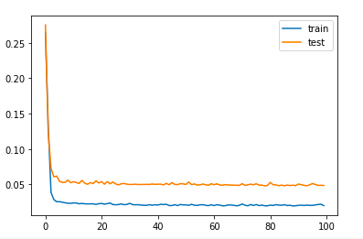
Figure 4. LSTM training and validation loss over 100 epochs. Gradient Boosting was selected as the deployed model on the unified holdout comparison and for practical CPU-deployment considerations (see text).
Table 1. Model comparison across Cook Farm (WA) and Bushland (TX). RMSE and MAE on VWC fraction scale. Gradient Boosting with weather features is the deployed model.
Model | RMSE (VWC) | MAE (VWC) | R² | Notes
Persistence (y_{t} = y_{t−1}) | 0.00244 | 0.00119 | 0.9976 | Naive baseline; competitive on this gradual series
Climatological mean | 0.06322 | 0.04932 | -0.588 | Train-mean baseline; calibration check
Random Forest | — | — | — | Separate model-selection run; not directly comparable
Gradient Boosting | 0.00222 | 0.00130 | 0.9980 | Best ML holdout model; used in operational replay
XGBoost | 0.00248 | — | 0.819 | Separate earlier run; not directly comparable
CatBoost | 0.00762 | — | 0.799 | Separate earlier run; not directly comparable
LSTM | 0.00175 | — | 0.858 | Separate earlier run; not directly comparable
To validate the trained model on a continuous time window, the held-out portion of the Cook Farm series was streamed chronologically through the pipeline as a 398-step daily replay. The data are publicly available USDA observations, and the chronological replay reproduces field-like temporal characteristics, thereby providing a relevant assessment of the proposed irrigation decision support system. The test data were preprocessed using the same pipeline as the training data and then passed to the predictive module with the trained model. Figure 5 compares predicted and actual soil moisture values across this replay window.
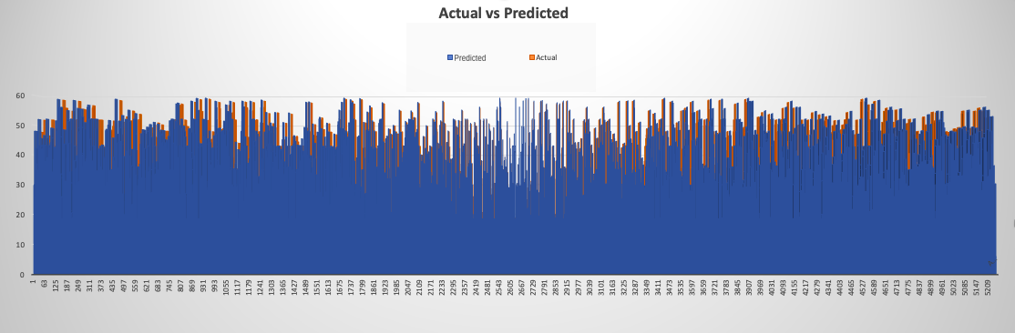
Figure 5. Predicted (blue) versus actual (orange) soil moisture values across the full test evaluation window.

As indicated by fig. 5 below, the accuracy level of fitting the model to soil moisture data is relatively high over the entire replay period of 398 time steps. The correlation between the forecasted value and the observed one is equal to 0.9989 with a mean bias of 0.00016 VWC. There is no tendency for any deviation from the zero baseline line on the residual plot graph. Rather, it remains within a relatively narrow area around it. The above indicates the absence of error accumulation tendencies associated with using this model over a relatively long period.

Operational Evaluation
In order to perform the end-to-end test on this system, we use historical data from the Cook Farm as input data to stream chronologically into the Orchestrator as a 398-step replay. For each step in the replay, the system gets one observation, then runs the four modules' processes (data ingestion, forecasting, advisory, and reporting) before outputting its decision at the next time step. We chose replay as our methodology in testing this system to evaluate its algorithmic properties and inter-module interactions free from potential effects due to infrastructure changes. Specifically, we can rule out possible influences of communication latency with sensors, network downtime or packet loss during data transmission and any possible human error made by operators. Such a methodology is similar to that of other peer-reviewed research papers that have evaluated soil moisture forecasting: Teshome et al. (2024) uses a held-out temporal window, Kandamali et al. (2025) performs historical multi-step replay using Georgia sensor data, and Wang et al. (2024) evaluates using archival ISMN station record. The replay methodology differs from a live field test pilot because the latter will stress the capability of the system's real-time data acquisition, wireless communication ability, and operator intervention, and their impacts are excluded. In each step of the replay, the system successfully received a valid input data and ran all modules without a failure, retry, or a lost artifact (module success rate 1.000). Using the VWC fraction metric, the end-to-end forecast RMSE was 0.00288 and the MAE was 0.00166; the correlation of predictions versus observations was 0.9989 with a mean bias of 0.00016. Predictions ranged from 0.21-0.47 VWC (mean 0.32), which aligns with the physical reality of the training data distribution. Table 2 summarizes the operational performance and the per-module latencies.
As an illustration of how our system works, we provide a description of a single-step invocation in our replay test above. The Orchestrator runs run 20260331_073018 and Data Ingestion Module completes schema validation and outlier detection in 19.3 ms with emitting a batch of feature data with no missing or outlier values. The Forecasting Module loads the serialized Gradient Boosting model (the deployed gridMET-weather model, holdout RMSE 0.00222), builds the six-lagged window, and predicts a soil moisture value 0.293 with its confidence bound generated from the holdout residual standard deviation in 1.67 ms. The Advisory Module evaluates soil moisture prediction 0.293 and generates an advisory with recommendation to schedule irrigation within 24 hours by comparing against our threshold settings (low VWC level 0.22 to 0.30); this operation is completed in 0.006 ms. The Orchestrator completes the operation of collecting module status indicators (all success, zero retry) and appending final_report.json and writing a line into events.csv as the audit trail. Total runtime for this step is 20.97 ms.
There is clear positive correlation between forecast and decision quality. The Advisory Module agrees with the ground-truth action in 397 out of 398 steps, reaching a decision accuracy rate of 0.9975. The ground-truth action at each step is obtained by applying the same advisory rules to the observed next-day soil moisture, whereas the system action applies them to the model forecast; the two are therefore derived independently and the agreement is not circular. The single disagreement is a near-threshold case in which the forecast (0.225) and the observed value (0.226) fall on opposite sides of the 0.22 critical boundary. It has a precision of 0.944 and recall rate of 1.0 for predicting critical alerts, indicating that there were no critical events omitted but only one step resulted in a false critical alert. Decision accuracy with a simple threshold baseline approach based on the VWC levels alone (ignoring predictions) is 0.9849, so our pipeline achieves a slight improvement in decision quality. Moisture at Cook Farm changes gradually (lag-1 ACF 0.997).
Table 2. End-to-end operational evaluation across the 398-step chronological replay. Forecast metrics on VWC fraction scale. Latency per representative run and aggregate.
Dimension | Value | Notes
Replay steps (N) | 398 | Chronological streaming
Module success rate | 1.000 | All 4 modules, no retries
Forecast RMSE (VWC) | 0.00288 | End-to-end pipeline
Forecast MAE (VWC) | 0.00166
Predicted, observed correlation | 0.9989 | Pearson r
Mean bias (VWC) | 0.00016 | Near-zero
Decision accuracy | 0.9975 | 397/398 match
Decision accuracy (threshold baseline) | 0.9849 | Reactive baseline
Critical-alert precision | 0.944 | 1 false alarm
Critical-alert recall | 1.000 | No missed criticals
Latency median (ms) | 14.01 | End-to-end
Latency P95 (ms) | 22.03 | End-to-end
Per-module: Data Ingestion | ~19.3 ms | ~92% of pipeline (rep. run)
Per-module: Forecasting | ~1.67 ms | ~8% of pipeline
Per-module: Advisory | ~0.006 ms | <0.1% of pipeline

Forecasting Performance in Context of Prior Work
Both the holdout RMSE value of 0.00222 for fraction of VWC and the replay RMSE value of 0.00288 are in line with the higher end of the benchmark values currently being reported by recent publications cited in table 3. Basir et al. (2024) obtained an RMSE of 0.0038 for corn in 1-day forecasting; Kandamali et al. (2025) reported an R² of about 0.986 across 24-to-168-hour forecast horizons using a hybrid LSTM and XGBoost model; Wang et al. (2024) reported an R² up to 0.94 at thirty sites using an attention-based LSTM model. The numerical values cannot be compared directly due to differences in units, sensor types, crops, weather, and climate across experiments; what can be inferred from table 3 is that, qualitatively, the performance of the forecasting sub-model is comparable with those in recent peer-reviewed articles for use in a dryland field application. The unique contribution is the inclusion of both holdout and streaming experiments and integration into the decision-making process.
Table 3. Comparison with recent (2024-2025) peer-reviewed soil moisture forecasting studies. Units differ across studies; values are reproduced as reported.
Study | Dataset | Model | RMSE | R² | Horizon
Basir et al. (2024) | Fort Wayne, IN (corn) | LSTM | 0.0038 m³/m³ | 0.998 | 1 day
Teshome et al. (2024) | Gainesville, FL | XGBoost | 0.014-0.015 cm³/cm³ | 0.86-0.88 | Sub-hourly
Kandamali et al. (2025) | Tifton, GA | LSTM+XGBoost | - | 0.986 | 24-168 h
Wang et al. (2024) | ISMN, 30 sites | FA-LSTM | - | up to 0.94 | 1 day
Xi et al. (2025) | 7 ISMN sites (CONUS) | Physics-guided DL | 0.04 m³/m³ | 0.66 | Daily
This work (holdout) | Cook Farm, WA | Gradient Boosting | 0.00222 VWC | 0.998 | 1 step
This work (replay) | Cook Farm, WA | End-to-end pipeline | 0.00288 VWC | - | 1 step

Value of Modular Pipeline Coordination
The modular orchestrated pipeline earns its right to be analyzed because of certain capabilities enabling it to provide irrigation decision support in practice. The two sites give a useful contrast in the relative standing of the learned model and the persistence baseline. At Cook Farm, adding gridMET weather features improves the Gradient Boosting forecast (0.00222 with weather versus 0.00260 soil-only) and the model obtains a lower RMSE than persistence (0.00222 versus 0.00244), although a Diebold-Mariano test shows this difference is not statistically significant (p = 0.29). At the noisier, irrigation-driven Bushland series, the persistence baseline obtains the lowest RMSE (0.01083 versus 0.01978 for Gradient Boosting), and that difference is likewise not significant (p = 0.08). Both series are strongly autocorrelated, so persistence is a demanding baseline at either site, and on these datasets no learned model separates from persistence at the 5% level. This is reported transparently rather than overstated, and it reframes the contribution: the value of the work is not a claim of decisive forecasting superiority but a modular orchestrated pipeline that adds practical benefits independently of which forecaster is used, structuring the advice according to configurable agronomic rules, automatically logging the provenance of actions, automatically retrying when errors occur, benchmarking every step against persistence and climatology, and providing a low latency of only 14.01 ms median (22.03 ms at the 95th percentile) per iteration. Knowing tomorrow's value of soil moisture will allow the grower to get all the needed equipment ready, arrange labor force and water supplies. Tests show that the system operates under stream processing mode at the success rate of 1.000 for all modules and 398 iterations, where about 92% of processing time is spent on data ingestion due to the need for validating and filtering input data, and future improvements are aimed at enhancing the speed of data ingestion.
Implementation of the system is based on the problems faced by farmers and identified by review of literature dedicated to practices of the USDA Cooperative Extension System. Notifications from Advisory Module are sent to farmer in natural language and are presented in form of statements ("Soil moisture is forecast to drop to 0.19, which is below the critical threshold of 0.22. Immediate irrigation is recommended to prevent crop stress"). Such a language can be used both in dashboards and text message system and is recommended to facilitate growers' use of extensions technology. Critical and low levels of soil moisture are customizable, and thus, one can adjust the advice algorithm without any changes to the program. Finally, logging in form of file events.csv allows not only to monitor the process for agricultural purposes (by comparison with the actual soil moisture level at harvest), but also to keep track of irrigation process for regulatory compliance purposes (in western parts of the country).

LIMITATIONS
Three limitations of the study define the scope of claims made by the analysis and the next stage of the research road map. First, reference evapotranspiration is taken from the gridMET gridded surface meteorological dataset rather than computed on-site; gridMET reference E_{T} is itself derived from a Penman-Monteith formulation over a coarse (~4 km) grid, so it may not capture sub-grid microclimate effects such as local wind or advection at a specific field. An earlier version of this work used a temperature-only Hargreaves estimate, which can underestimate E_{T} relative to Penman-Monteith under high wind speed or low relative humidity; moving to gridMET reference E_{T} removes that bias but introduces gridded-product representativeness as the relevant caveat. Second, the relative benefit of the learned model is site-dependent: at the irrigation-driven Bushland series the naive persistence baseline outperforms the learned models, so the contribution of weather-enriched forecasting is realized only where the available weather covariates are informative enough to improve on a strong persistence baseline. This is reported transparently rather than averaged away, and it motivates always benchmarking against persistence. Third, because the testing process is conducted via chronological playback of historic data (398 timesteps for the Cook Farm site), and not via in-situ experiments, factors of potential importance like sensor drift, connection issues, latency of communication networks, operator participation etc. cannot be considered at the current stage. The choice of replay methodology stems from the intention to uncouple algorithmic and orchestrational efficiency from infrastructural variables in accordance with a recent line of work on analogous evaluation of ML algorithms (Teshome et al., 2024; Kandamali et al., 2025). Pilot field testing is planned as the next phase, as is extending the comparison to additional sites (e.g., humid continental and tropical regimes) to map where forecasting beats persistence as a function of soil-moisture dynamics. The Orchestrator implementation also relies only on deterministic rule-based decision-making, without incorporating adaptive scheduling policies or explicit treatment of forecast uncertainty. A promising direction for future work is to replace the fixed threshold rules in the Advisory Module with a reinforcement learning policy that learns irrigation scheduling from experience, optimizing a reward that balances water use against crop-stress risk over a season rather than reacting to a single forecast. Because the pipeline already streams observations, produces forecasts, issues actions, and logs outcomes step by step, it provides a natural training and evaluation environment for such a policy, and its modular design allows the deterministic advisory component to be swapped for a learned one without changes to the ingestion, forecasting, or orchestration modules. Similarly, the swappable forecasting module can be upgraded to stronger learned models, including physics-guided architectures, to test whether they can separate from the persistence baseline where the current model does not.

CONCLUSION AND FUTURE WORK
For this project, we have designed and implemented a working prototype for our predictive modular pipeline that utilizes soil moisture prediction for the purpose of supporting decisions for irrigation, using two sites from the USDA, under differing soil composition, precipitation, and irrigation scenarios; namely one located within the drylands of the Pacific Northwest in Cook Farm, WA, and another in the semi-arid Southern High Plains, Bushland, TX. In terms of accuracy, at Cook Farm the Gradient Boosting regressor using daily gridMET precipitation and gridMET reference evapotranspiration achieved a holdout RMSE of 0.00222, a relative improvement of about 14.6% over the soil-and-temperature-only model (0.00260) and a lower RMSE than the persistence baseline (0.00244); a Diebold-Mariano test, however, shows the gap over persistence is not statistically significant (p = 0.29). At Bushland, by contrast, the persistence baseline (RMSE 0.01083) obtained a lower RMSE than the learned models (Gradient Boosting 0.01978), a difference that is also not significant (p = 0.08). On these two datasets the learned model is therefore statistically on par with persistence rather than decisively superior, which we report transparently; the contribution of the work is the implemented and validated pipeline rather than a claim of forecasting dominance. The Cook Farm evaluation included a 398-step chronological replay, yielding a decision accuracy of 0.9975 against ground-truth thresholds (defined by applying the advisory rules to the observed next-day moisture, independently of the model forecast) and a median latency of 14.01 ms per step. Applying the identical pipeline to the second site by changing only the threshold configuration, not a single line of code, demonstrates the portability of the modular design across climates, soils, and irrigation regimes. These factors make the deployment of this prototype highly cost-efficient due to its minimal computational load requirements and public dataset usage. Looking ahead, the modular design positions the pipeline as a foundation for stronger learned components: the deterministic advisory rules can be replaced with a reinforcement learning policy that learns irrigation scheduling from a season-level reward balancing water use against crop-stress risk, with the pipeline itself serving as the training and evaluation environment, and the forecasting module can be upgraded to more expressive or physics-guided models, each without altering the rest of the system. These directions form the next phase of this work, alongside the pilot field testing and additional-site evaluation noted above.

Acknowledgments
I thank the open-source communities and the USDA, NWCC SCAN, and gridMET data providers for publishing the data and enabling access for projects.

REFERENCES
Abatzoglou, J. T. (2013). Development of gridded surface meteorological data for ecological applications and modelling. Int. J. Climatol., 33(1), 121-131. http://doi.org/10.1002/joc.3413
Allen, R. G., Pereira, L. S., Raes, D., & Smith, M. (1998). Crop evapotranspiration: Guidelines for computing crop water requirements. FAO Irrigation and Drainage Paper No. 56. Rome, Italy: Food and Agriculture Organization of the United Nations.
Basir, M. S., Noel, S., Buckmaster, D., & Ashik-E-Rabbani, M. (2024). Enhancing subsurface soil moisture forecasting: A long short-term memory network model using weather data. Agriculture, 14(3), 333. http://doi.org/10.3390/agriculture14030333
Bellingham, K., & Lea, J. (2014). Improved water supply forecasts using soil moisture data. In Proceedings of the Fourth International Symposium on Soil Water Measurements Using Capacitance, Impedance and Time Domain, Montreal, Quebec, Canada, July 16–18, 2014.
Cai, Y., Zheng, W., Zhang, X., Zhangzhong, L., & Xue, X. (2019). Research on soil moisture prediction model based on deep learning. PLoS ONE, 14(4), e0214508. http://doi.org/10.1371/journal.pone.0214508
Diebold, F. X., & Mariano, R. S. (1995). Comparing predictive accuracy. J. Bus. Econ. Stat., 13(3), 253-263. http://doi.org/10.1080/07350015.1995.10524599
Dukes, M. D., Muñoz-Carpena, R., Zotarelli, L., Icerman, J., & Scholberg, J. M. (2007). Soil moisture-based irrigation control to conserve water and nutrients under drip irrigated vegetable production. Estudios de la Zona No Saturada del Suelo, 8, 229–233.
Fang, K., Shen, C., Kifer, D., & Yang, X. (2017). Prolongation of SMAP to spatiotemporally seamless coverage of continental United States using a deep learning neural network. Geophys. Res. Lett., 44(21), 11030–11039. http://doi.org/10.1002/2017GL075619
Geng, Q., Yan, S., Li, Q., & Zhang, C. (2024). Enhancing data-driven soil moisture modeling with physically-guided LSTM networks. Front. For. Glob. Change, 7, 1353011. http://doi.org/10.3389/ffgc.2024.1353011
Jones, J. W., Antle, J. M., Basso, B., Boote, K. J., Conant, R. T., Foster, I., . . . Wheeler, T. R. (2017). Toward a new generation of agricultural system data, models, and knowledge products: State of agricultural systems science. Agric. Syst., 155, 269–288. http://doi.org/10.1016/j.agsy.2016.09.021
Kandamali, D. F., Porter, E., Porter, W. M., McLemore, A., Kiobia, D. O., Tavandashti, A. P., & Rains, G. C. (2025). Hybrid LSTM method for multistep soil moisture prediction using historical soil moisture and weather data. AgriEngineering, 7(8), 260. http://doi.org/10.3390/agriengineering7080260
Kratzert, F., Klotz, D., Brenner, C., Schulz, K., & Herrnegger, M. (2018). Rainfall–runoff modelling using long short-term memory (LSTM) networks. Hydrol. Earth Syst. Sci., 22(11), 6005–6022. http://doi.org/10.5194/hess-22-6005-2018
McCarthy, U., Uysal, I., Badia-Melis, R., Mercier, S., O'Donnell, C. P., & Ktenioudaki, A. (2018). Global food security – Issues, challenges and technological solutions. Trends Food Sci. Technol., 77, 11–20. http://doi.org/10.1016/j.tifs.2018.05.002
Teshome, F. T., Bayabil, H. K., Schaffer, B., Ampatzidis, Y., & Hoogenboom, G. (2024). Improving soil moisture prediction with deep learning and machine learning models. Comput. Electron. Agric., 226, 109414. http://doi.org/10.1016/j.compag.2024.109414
USDA-ERS. (2023). Irrigation and water use. Washington, DC: USDA Economic Research Service. Retrieved from https://www.ers.usda.gov/topics/farm-practices-management/irrigation-water-use/
Wang, Y., Shi, L., Hu, Y., Hu, X., Song, W., & Wang, L. (2024). A comprehensive study of deep learning for soil moisture prediction. Hydrol. Earth Syst. Sci., 28, 917–943. http://doi.org/10.5194/hess-28-917-2024
Xi, X., Zhuang, Q., & Liu, X. (2025). A hybrid physics-guided deep learning modeling framework for predicting surface soil moisture. J. Geophys. Res. Mach. Learn. Comput., 2, e2025JH000682. http://doi.org/10.1029/2025JH000682

