Quantum Dots Additized Lubricating Oils: A Review

Prasad
Manipal Institute of Technology, Manipal Academy of Higher Education, Manipal – 576104, Karnataka, India

Abstract: In this review, the studies pertaining to the quantum dots dispersed lubricating oils is systematically reviewed. Various aspects such as synthesis of the QDs additive, their dispersion method and stability, dispersion stability enhancement methods, and their tribological performance is presented. It is found that, such additized oils result in friction and wear reduction for steel tribopair by about 37.07 ± 17.25 % and 58.91 ± 23.77 % respectively.

- Introduction
The lubricating oils intended to reduce friction and wear between the interface of relatively moving components are generally mixed with additive to enhance their desired performance. The additive enhances lubricant strength against the friction, wear, extreme load, and extreme environmental conditions [1-3]. However, the currently used organic molecule additives are which are toxic, non-economic, and non-eco-friendly [4].
Using nanoscale particles as additives is reported to be an alternative solution to the chemical additives [5-6]. Particularly, the particles with smallest size result in enhanced performance due to their superior nanoscale tribological action [7-8]. In this perspective, the quantum dots (QDs), which are the special class of nanomaterials are of suitable choice due to their characteristic small size of few nanometres [9].
Zhang et al. [10] extensively reviewed lubricants including polar and apolar base lubricants, self-lubricating solid coatings etc. containing layered-lattice QDs such as MoS₂ QDs, WS₂ QDs, black phosphorous QDs (BPQDs), carbon QDs (CQDs), graphene QDs (GQDs), and graphene oxide QDs (GOQDs). Finally, some of the ideas for controllability of the QD properties, and to use their other properties in the tribological applications were presented.
In this article, the studies pertaining to dispersion of QDs specifically into the lubricating oils is systematically reviewed. The studied papers correspond to the keyword 'quantum dot OR dots tribo oil OR oils' in google scholar database being selective to only mono disperse QDs in oils. This resulted in 14 original research articles. The synthesis methods for the QDs additive, their dispersion in the oil, and the corresponding tribological performance attained is summarised.

- Synthesis

  - Synthesis of QD Additive
As a former step, the synthesis of QD additive involves prior physic-chemical treatment of precursor followed by its intense purification. Finally, the purified product is subjected to drying process.
The summary of the synthesis parameters for the preparation of respective QD additive is presented in Table.1 The most sought one technique is the hydrothermal/solvothermal method, and one-pot pyrolysis. These methods have sustainable synthesis nature [23]. Few studies incorporated hybrid methods, which incorporates several methods. The corresponding QDs prepared include doped and undoped CQDs, GQDs, MoS₂ QDs, and WS₂ QDs. It comes out that all these studied QDs are again a layered-lattice materials. Also, the carbon based QDs such as CQDs, and GQDs are given more importance. This can be attributed to their low toxicity, environmental friendliness, chemical and thermal stability, and also their abundant sources [24-25].

Table 1: Summary of synthesis parameters for the QD additive
Method | Precursor | Temperature (ºC) | Time (hr) | Cooling method | Colour of the product | QD | Size (nm) | Ref.
One-pot pyrolysis | Urea + Citric acid | 180 | 0.5 | natural | Green | N-CQD | 4-12 | [11]
One-pot pyrolysis | Citric acid + 4 -Aminodiphenylamine | 180 | 0.5 | natural | Blue black | N-CQD | 2 | [12]
One-pot pyrolysis | Citric acid + cesium carbonate | 185 | 0.05 | natural | Orange-yellow | Cs-GOQD | 6.3 | [13]
One-pot pyrolysis | Citric acid | 200 | 0.58 | natural | Orange | GQD | 2.2 | [14]
One-pot pyrolysis | Citric acid | 200 | 0.5 | natural | Orange-yellow | CQD | 2.8 | [15]
Hydrothermal/solvothermal | Citric acid + silver acetate + ethylenediamine + distilled water | 180 | 8 | natural | NA | Ag-CQD | 3.57 | [16]
Hydrothermal/solvothermal | Deep eutectic solvent produced by magnetic stirring of thymol with decanoic acid at 60 º C. | 180 | 6 | natural | Brown | CQD | 3.37 | [17]
Hydrothermal/solvothermal | Glucose + Ethanol | 180 | 12 | natural | Brown | CQD | 3 | [18]
Aldol Condensation | Acetaldehyde + NaOH | RT | 2 | natural | Dark yellow | CQD | 2.6 | [19]
Aldol Condensation | Acetaldehyde + urea + NaOH | RT | 2 | natural | Dark yellow | N-CQD | 2.46 | [20]
Hybrid Method | MoS₂ powder + DMF | 140 | 3 + 6 | natural | Light yellow | MoS₂ QD | 3 | [21]
Hybrid Method | WS₂ powder + DMF |  |  |  |  | WS₂ QD | 3.2 | [21]
Hybrid Method | Sodium molybdate dihydrate + thiocarbamide + water | 200 | 8 + 16 | natural | Black | MoS₂ QD | 3 | [22]

After the physic-chemical treatment of the precursor, the obtained product is purified to remove reaction by-products. This is performed with methods such as washing, pH neutralization, centrifugation, syringe filtration, and dialysis to ascertain presence of only the desired QDs and the solvent in the purified suspension. Finally, the solvent is removed by drying this suspension using methods such as lyophilization, rotary evaporation, and vacuum drying. Certain studies also report the mass yield of the QD additive obtained from the methodology followed.
The presence of the desired QD material, its size, functional groups, elemental composition, etc. in the prepared QD additive are evaluated using various characterization techniques. Wang et. al. [16] synthesized both undoped CQDs, and Ag-CQDs additives and examined their material characteristics. The corresponding results are shown in Fig. 1. The XRD diffractogram (Fig. 1a) reveals the characteristic peak at 2θ = 21.5 º corresponding to the family of (0 0 2) planes of graphite. The FTIR pattern (Fig. 1b) reveals the stretching vibration corresponding to the O-H/N-H found at 3450 cm⁻¹, C=O/C=C at 1720 cm⁻¹, and -CH₃ bonds at 2932 cm⁻¹ and 2861 cm⁻¹. Also, the bending vibration of N-H bond at 1556 cm⁻¹, C-N bond at 1402 cm⁻¹, and C-H bond at 1195 cm⁻¹ is found. From the TGA result (Fig.1c), the thermal stability of the CQDs and the Ag-CQDs are found to be around 305 ºC and 351 ºC respectively. From the TEM image (Fig. d), the size of the CQDs and the Ag-CQDs is found to be on an average around 3.51 nm and 3.57 nm respectively. From the HRTEM result (Fig. 1d), the lattice fringe of 0.34 nm for both the additives is obtained corresponding to the (0 0 2) plane of the graphite.
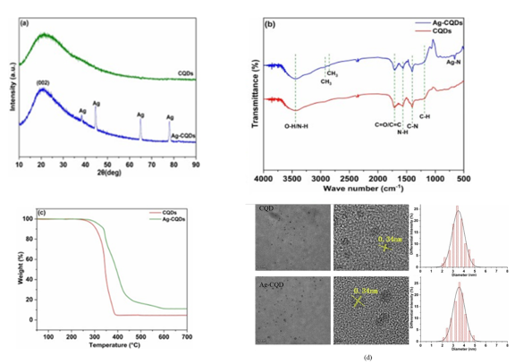
Figure 1: The characterization results of CQDs and Ag-CQD based nano-additives (a) XRD, (b) FTIR (c) TGA and (d) TEM/HRTEM [16]
  - Dispersion in the Oil
The prepared QD additive is then mixed with the target base oil, which is homogenized using mechanical techniques such as magnetic stirring and ultrasonication [26-27]. The magnetic stirring uses a rotating magnetic field used to rotate a magnetic bead placed within the dispersion medium. The important process parameters are the stirring speed and time duration [26]. The ultrasonication method employs mechanical vibrations with frequencies greater than 20000 Hz to propagate through the dispersion medium, thereby homogenizing it. The ultrasonic waves can be transferred from outside (using bath type ultrasonication) or directly (using probe type ultrasonication) to the mixture. Hence, the power transmission is nearly 100 times effective in probe type ultrasonication compared to the bath type, which makes them to be widely used. The important process parameters in the probe ultra-sonicators are the amplitude/power/intensity, frequency, pulsation cycle, diameter of the probe-tip, and time duration [28-29].
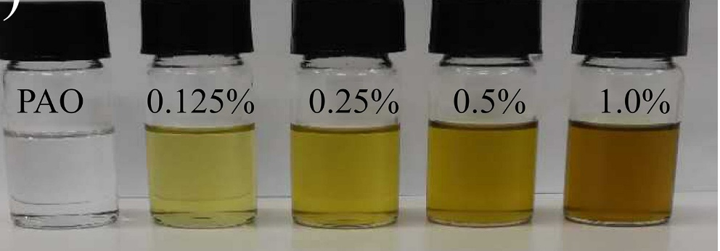
Figure 2: The visuals of hydrophobic N-CQD dispersed PAO oil as synthesized by Shang et al. [11]
Shang et. al [11] synthesized hydrophobic N-CQD additive and dispersed in PAO oil with varied concentrations. The visuals of the dispersions are shown in Fig. 2. The prepared suspension was homogeneously spread throughout the oil medium indicating their good dispersion quality.

- Challenges
The final dispersion should be homogeneous throughout without any noticeable phase distinction over time. However, achieving this kind of dispersion stability is hindered by particle sedimentation caused by clustering and their chemical incompatibility with the base oil molecules. The particle cluster both during drying step and after their dispersion in the oil [30-31]. The drying stage involves removal of solvent resulting in development of capillary stresses on the particles, which results in mechanical binding of the particles [32]. In addition, if heating is employed the particles chemically sinter due to condensation reaction between their surface groups [33]. This type of clustering is difficult to revert to the individual particles form due to their irreversible nature.
After their dispersion in the oil, the particles agglomerate due to secondary bonding forces caused by active functional groups. This results in increase of effective particles’ size over time. This type of cluster can be reverted back to individual particles form through methods like probe-sonication [34]. The agglomeration can be minimized by enhancing the binding compatibility between the oil molecules and the particles’ surface.
Nearly all of the lubricating oils have apolar molecules, which makes them suitable for particles with apolar functional groups [10, 35]. Most often the prepared QDs contain polar functional groups such as hydroxyl, carboxyl groups etc., which makes them incompatible with the oils. In such cases, their surface chemistry is altered to apolar nature through proper surface functionalization methods [10, 27, 36].
Shang et al. [11] synthesized N-CQD through one-pot pyrolysis method, which was purified and dried. The corresponding FTIR spectra as shown in Fig.3 indicated the presence of hydroxyl functional groups making it lyophobic. The obtained powder was then treated with oleyl amine (OA) at 130 ºC for 6 hr and refluxed. The FTIR spectra of the obtained product and OA indicated grafting of OA onto the N-CQD through condensation reaction. Thus, the product is ascertained to be N-CQD @ OA.
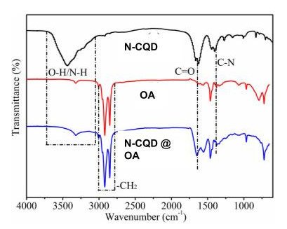
Figure 3: The FTIR spectra for the study by Shang et al. involving the synthesis of N-CQD @ OA [11]
Only few cases are available where the lyophilic QD additives are directly synthesized without undergoing any further functionalization step. As an instance Liang et al. [37] synthesized hexadecylamine (HA) functionalized CQD (CQD @ HA) through one-pot pyrolysis of citric acid and hexadecylamine at 240 ºC with continuous magnetic stirring under Ar atmosphere for 4 hr. The involved chemical reaction is represented in Fig.4. The obtained gel like remnant is then washed with high-speed centrifugation with ethanol solvent, which after vacuum drying at 70 ºC overnight resulted in brown powder. The corresponding FTIR spectra of the citric acid, HA, and CQD @ HA is shown in Fig. 5. The corresponding peak positions at 2923 cm⁻¹, 2855 cm⁻¹ and region below 1500 cm⁻¹ are similar to that of HA suggesting the effective grafting of HA onto the CQDs surface.

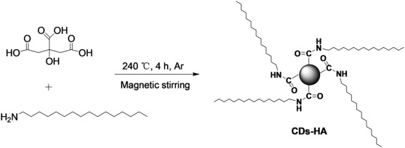
Figure 4: The involved chemical reaction in the synthesis of CQD @ HA [37]
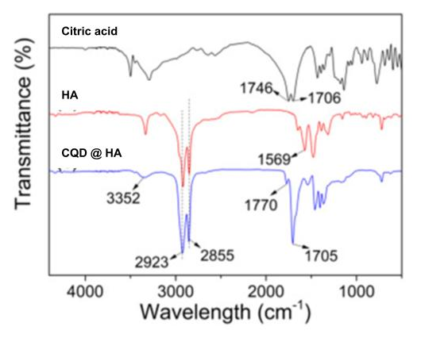
Figure 5: The FTIR spectra for the study by Liang et al. involving the synthesis of CQD @ HA [37]

The dispersion stability of the prepared QDs additized oils are evaluated using methods such as gravitational sedimentation, centrifugal sedimentation, and spectroscopic methods such as UV-Vis spectroscopy is used to ascertain the stability duration [34, 38]. The gravitational sedimentation involves keeping the prepared lubricant under stationary conditions for a required duration of time and seeing for the formation of sediment. However, this method is time-consuming, which can be overcome by accelerating the sedimentation process using centrifugation. Subjecting the prepared lubricant to centrifugation for a fixed duration results in the formation of sediment. In both the cases observation of negligible sediment height is the indication of good stability over the duration [38]. In UV-Vis spectroscopy, the additized lubricant is subjected to ultraviolet light and the corresponding absorbance spectra is obtained. If the lubricants contain small quantity of dispersed particles due to sedimentation, the absorbance intensity is lower compared to the one containing more quantity of dispersed particles [38-39].
As a case, Zhang et al. [18] synthesized lauroyl chloride functionalized CQDs (CQD @ LA) and dispersed in PAO4 synthetic oil with concentration of 1.7 wt.%. The suspension was then kept under stationary conditions for 30 days at temperatures of -15 ºC, 25 ºC, and 150 ºC. Also, the sample was subjected to centrifugation at 10000 rpm for 20 min. The visuals of the sample after the study are shown is Fig. 6a. In addition, the sample was also subjected to UV-Vis spectroscopy study in daily basis for 30 days. The obtained absorbance result is shown in Fig. 6b. As it can be seen, no changes in the phase observed indicating good dispersion stability over the duration.
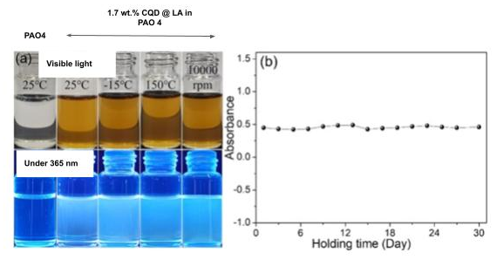
Figure 6: The dispersion stability study of CQD @ LA dispersed PAO4 oil using (a) sedimentation methods, and (b) UV-Vis absorbance study [18]

- Tribological Performance
After preparing the stable QDs dispersed lubricating oils, its tribological performance is evaluated using instruments called ‘tribometer’. It is intended to mimic the actual rubbing conditions during the performance testing of the oil. It mainly consists of a pair of rubbing surfaces, acted by a normal load. The oil to be tested is applied in their interface and the corresponding friction performance and wear performance are calculated. There are different types of tribometers available. The most common ones used are the ball-on-disk, ball-on-plate, and four-ball configurations. The ball-on-disk configurations use a stationary ball-point pin held against a lubricated rotating disk [40]. In the ball-on-plate method, the ball-point is held against a lubricated reciprocating plate. In four-ball testing, a rotating ball is held against triangularly placed stationary balls. The tests are performed in accordance with the ASTM standards. The commonly used standards include ASTM G99/G133 for ball-on-disk method, ASTM G133/G181 for ball-on plate, and the ASTM D2266/D4172/D2783/D2596 standards for four ball testing [41].
The friction performance of the oil is calculated using the parameter ‘coefficient of friction (COF)’, which is graphically obtained after the test. The obtained graph is called a “friction curve”. A friction curve contains initially increasing COF values with time, which attains a maximum peak, and attains a stable COF value for the remaining duration. The initial time varying COF region is called “running-in stage”, and the maximum COF obtained is called “static friction coefficient”. The next region involving steady COF value is called “steady-state region”. The values that are to be reported is this stable COF value obtained [42]. It is required to minimize both running-in duration and the steady-state COF [43].
The wear is characterized by the quantity of material lost using techniques such as weight loss measurement, stylus surface profilometry, and microscopy methods [41-42]. The weight loss measurement technique involves measurement of weight loss due to rubbing compared to the initial weight before rubbing. However, such a method is only suitable for the situation in which the weight loss is measurable by a weight measuring device [42]. In the case of lubricants additized with nanoscale particles, the wear is significantly reduced, which makes the weight loss measurement not suitable for them. In surface profilometry, a depth measuring stylus is traversed across the wear track on one of the partners. This gives the map of wear depth against the traverse distance. Using this, the cross-sectional area of the wear track is calculated, which when multiplied with the length of the wear track gives the approximate volume of material lost [42, 44]. However, this technique is only suitable for the situations involving measurable wear track length. In the case of rubbing balls, the weight loss and the wear track length are not measurable by direct measurement as the above techniques. In such conditions, the small wear regions (called wear scars) are analyzed with microscopic techniques such as optical microscopy and scanning electron microscopy (SEM) [41-42]. This involves measuring the depth, width, and volume of the wear scars, which are termed ‘wear scar depth’, ‘wear scar width’, and ‘wear scar volume’ respectively [45]. Both the friction and wear performance of the additized oil are expressed in percentage of reduction of COF and wear compared with that of the base oil.
Li et. al [17] synthesized different samples of PAO4 oil additized with conventional chemical additive ZDDP, deep eutectic solvent (DES) produced by magnetic stirring of thymol with decanoic acid at 60 ºC, and CQD all with 3wt.% concentration. The samples were tested in ball-on-plate tribometer with reciprocating ball of diameter 12.7 mm rubbing against a stationary plate both made of AISI 52100 Steel. Prior to the test the tribopair was ultrasonically cleaned with acetone for 10 min. The tests were performed under the load of 40 N at sliding speed of 10 mm/s with an amplitude of 5 mm. The friction curve of the samples in comparison to the plain PAO4 oil is shown in Fig. 7a. It can be inferred that the CQD additized sample exhibited lowest COF corresponding to reduction of 43.7 % compared to the base oil. To examine the wear performance, the tested surfaces were again ultra-sonicated in acetone. Then, the worn surfaces were examined in white light interferometer to get wear profiles as shown Fig. 7b. The surface lubricated with CQD additized oil exhibited lowest cross-sectional area of 235.2 µm². Using the amplitude as wear track length, the wear volume was calculated corresponding to 56.6 % compared to that of plain base oil lubricated surface.
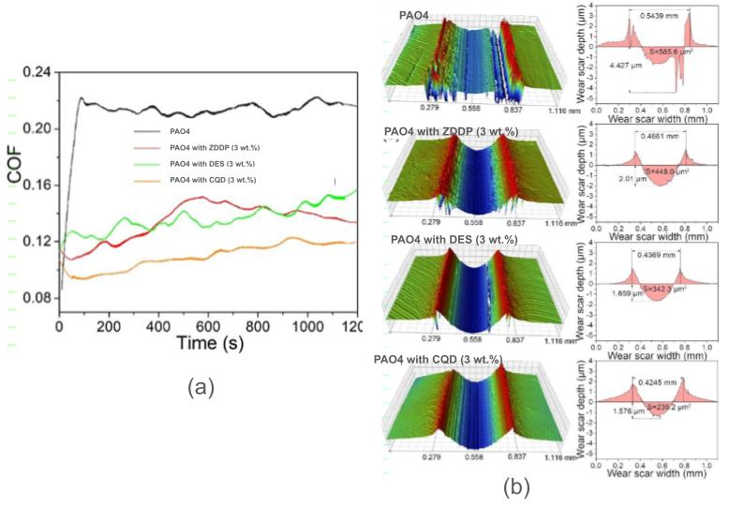
Figure 7: The tribological performance of the oil developed by Li et. al. showing (a) friction performance and (b) wear scar profile [17]
After the tribological performance of the oil is evaluated, it then involves evaluation possible reason for the enhanced performance of additized oils. As an instance, Ye et al. [12] synthesized 0.5 wt.% N-CQD @ OA dispersed PAO oil and was lubricated to AISI 52100 steel balls in the four-ball tribometer under different loading conditions of 196 N, 392 N, and 588 N. After evaluating the friction and wear performance, the surfaces were subjected to SEM imaging, EDS elemental mapping, and micro-Raman spectroscopy as shown in Fig.8. From the EDS mapping it appears that with the increase of load the deposition of carbon increases in the scar surface. From the RS study, the increase in the I_{D}/I_{G} ratio is seen, which indicates reduction in the graphitic nature of the deposited N-CQD. This implies the inter-layer shearing of the deposited N-CQD due to the loading, which increases with the load. Also, the surface lubricated with non-additized PAO oil was studied and the corresponding Raman spectra shown peak at 700 cm⁻¹ indicating the formation of iron oxide layer on the surface due to Tribochemical reaction.

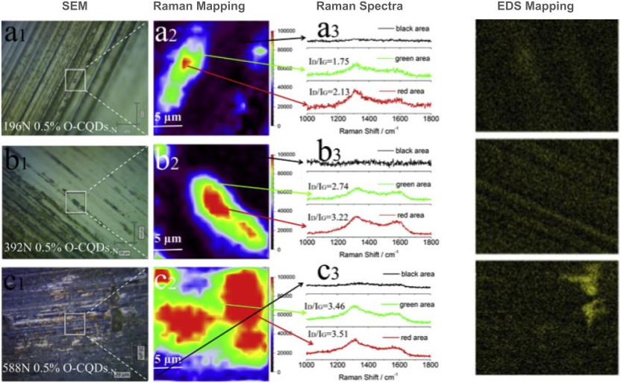
Figure 8: The worn surface analysis of steel surface lubricated with 0.5 wt.% N-CQD-OA dispersed PAO oil using SEM, RS, and EDS [12]
The studies pertaining to tribological performance of the QDs dispersed oils are summarized in Table. 2. The corresponding average friction and wear reduction are calculated excluding the missing values as given in the supplementary file. The addition of QDs to the oils result in average friction reduction of 37.07 ± 17.25 % and the wear by 58.91 ± 23.77 %.

Table 2: The summary of tribological performance evaluation of QDs additized lubricating oils
Year | Base Oil | QD Additive | Size (nm) | Dispersion Method | Optimal Concentration (wt.%) | Dispersion Stability (months) | Test Configuration | Tribo Pair | Test Conditions | Friction Reduction (%) | Wear Reduction (%) | Ref.
2018 | PAO ¹ | N-CQD @ OA | NA | NA | 1 | NA | Four-ball | AISI 52100 Steel | 1200 RPM, 392 N, 1 hr, 75 ºC | 47.1 | 90.5 | [11]
2018 | 5W-30 Engine Oil | N-CQD @ OA | NA |  |  |  |  |  |  | 27 | 32.6 | [11]
2018 | PAG ² | MoS₂QD | 3 | Stirring (30 min) + Ultrasonication (30 min) | 0.5 | NA | Ball-on-plate | Steel-Steel | 25 Hz, 2 mm stroke, 100 N, 30 min, 150 ºC | 32.8 | 98 | [21]
 | PAG ² | WS₂QD | 3.2 |  |  |  |  |  |  | 30 | 97 | [21]
2019 | Castor Oil | N, S, B-CQD @ OA | 4 | NA | 0.2 | >5 | Four-ball | AISI 52100 Steel | 1200 RPM, 392 N, 1 hr, 75 ºC | - | 44.7 | [12]
2019 | PAO | N, S, B-CQD @ OA | 4 | NA | 0.5 | NA |  |  |  |  | 28.5 | [12]
2020 | Paroline Oil | MoS₂QD | 3 | Ultrasonication | 0.3 | NA | Ball-on-plate | AISI 52100 Steel | 1.5 Hz, 6 mm stroke, 6 N, 30 min | 64 | 96.8 | [22]
2021 | PAO 4 | CQDs @ HA | 4.2 | NA | 1 | > 3 | Ball-on-plate | AISI 52100 Steel | 10 mm/s, 10 mm stroke, 20 N, 20 min | 27.1 | 45.9 | [37]
 |  |  |  |  |  |  |  |  | 100 N, 20 min | 6.9 | 29.6 | [37]
 |  |  |  |  |  |  |  |  | 40 N, 200 min | 20.4 | 33.6 | [37]
2022 | PAO 6 | CQD | 3.51 | Ultrasonication (2 hr, 40 kHz) | 0.05 | >1 | Ball-on-plate | Si₃N₄ – GH 4169 Superalloy Pair | 2 Hz, 10 mm stroke, 15 N, 15 min | 34.1 | 29.8 | [16]
2022 | PAO 6 | Ag-CQD | 3.57 |  |  |  |  |  |  | 42.2 | 35.3 | [16]
2022 | SFO ³ | CQD | 2.6 | Ultrasonication (30 min) | 0.05 | NA | Ball-on-disc | AISI 52100 Steel – 15 # Steel pair | 200 RPM, 2 N, 30 min | 50 | 57.08 | [19]
2023 | SFO | N-CQD | 2.46 | Ultrasonication | 1 | >1 day | Ball-on-disc | AISI 52100 Steel – 45# Steel | 200 RPM, 1 N | 60 | 57 | [20]
2023 | PAO 10 | N-CQD | 2.46 | Ultrasonication | 0.12 | >1 day | Ball-on-disc | AISI 52100 Steel – 45# Steel | 200 RPM, 3 N | 50 | 61 | [20]
2024 | PAO 4 | CQD | 3.37 | NA | 3 | >1 | Four-ball | AISI 52100 Steel | 40 N, 10 mm stroke, 10 mm/s, 2 hr. | 70.5 | 58.1 | [17]
2024 | PAO 4 | CQD @ Lauroyl acid | 3 nm core | NA | 1.7 | >1 | Ball-on-plate | AISI 52100 Steel | 40 N, 10 mm stroke, 10 mm/s, 20 min | 32.2 | 76.4 | [18]
2025 | Machine Oil | Cs-GOQD | 6.3 | NA | 0.1 | NA | Four-ball | Steel-Steel | 392 N, 461 mm/s, 75 ºC | 14.6 | 9.2 | [13]
2025 | PESO ⁴ | GQD | 2.2 nm | Ultrasonication | 0.9 | NA | Ball-on-disk | AISI 52100 Steel | 10 N, 15Hz, 1mm stroke | 86.67 | 44.4 | [14]
2025 | PAO 10 | N-CQD @ DEHP | NA | NA | 0.013 | 0.5 | Ball-on-plat | AISI 52100 Steel | 70N, 3Hz, 1hr | 15.24 | 50.87 | [46]
2025 | PAO 4 | CQD | 2.8 | NA | 0.5 | 1 | Ball-on-plat | AISI 52100 Steel | 100 N, 8 mm stroke, 8Hz, 0.5 hr | 20.8 | 52 | [15]

1 – Polyalphaolefin, 2 - Polyalkylene Glycol, 3 – Sunflower Oil, 4 - Polyether-modified silicone oil

Conclusions
Due to their characteristic small size, the quantum dots are preferred to be potential alternative over the conventional additives in lubricating oils. All available studies used layered-lattice QDs with major focus towards CQDs. After their synthesis in dry form dispersion in target base oil is done using mechanical methods such as magnetic stirring and ultrasonication. The average optimal concentration is found to be about 0.683 wt.%.
However, the important challenge involved is the particle clustering caused during their initial drying stage and after their dispersion in the oil. The de-clustering of particles in the latter case takes place during dispersion process itself. Again, the prepared additives commonly contain hydrophilic groups making them less stable over time. Hence, prior to their dispersion their surface chemistry is altered to lyophilic nature through surface functionalization treatment. On an average, the studies focus on achieving shelf life of about 1.78 months. Hence, there is scope for further research to enhance the shelf-life duration.
The tribological performance of the QDs additized oils are largely evaluated using ball-on-disc/plate and four-ball tribometers using AISI 52100 steel pair with varied loading conditions. It is preferable to use or device tribometers with universal testing conditions for better comparability of the developed oils. The QDs additized lubricating oils result in reduction of friction and wear by about 37.07 ± 17.25 % and 58.91 ± 23.77 % respectively.
It is found that, the oils showing optimal dispersion stability also exhibit optimal tribological performance in terms of the friction and wear reduction. A generalized approach for the synthesis of stable QDs additized lubricating oils is shown in the Figure.
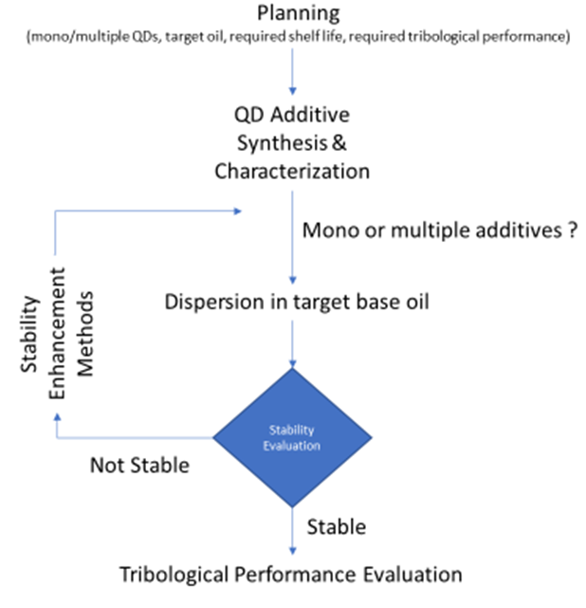
Figure: The generalized approach for the synthesis of stable QDs additized lubricating oils

References
[1] Menezes PL, Reeves CJ, Lovell MR. Fundamentals of lubrication. In Tribology for scientists and engineers: from basics to advanced concepts 2013 (pp. 295-340). New York, NY: Springer New York.
[2] Raina A, Irfan Ul Haq M, Anand A, Sudhanraj J. Lubrication characteristics of oils containing nanoadditives: influencing parameters, market scenario and advancements. Journal of The Institution of Engineers (India): Series D. 2021;102(2):575-87.
[3] Nyholm N, Espallargas N. Functionalized carbon nanostructures as lubricant additives–A review. Carbon. 2023;201:1200-28.
[4] Zhao J, Huang Y, He Y, Shi Y. Nanolubricant additives: A review. Friction. 2021;9(5):891-917.
[5] Wang QJ, Chung YW, editors. Encyclopedia of tribology. New York: Springer; 2013.
[6] Gulzar M, Masjuki HH, Kalam MA, Varman M, Zulkifli NW, Mufti RA, Zahid R. Tribological performance of nanoparticles as lubricating oil additives. Journal of Nanoparticle Research. 2016;18(8):223.
[7] Deepika. Nanotechnology implications for high performance lubricants. SN Applied Sciences. 2020;2(6):1128.
[8] Pownraj C, Valan Arasu A. Effect of dispersing single and hybrid nanoparticles on tribological, thermo-physical, and stability characteristics of lubricants: a review: C. Pownraj, A. Valan Arasu. Journal of Thermal Analysis and Calorimetry. 2021;143(2):1773-809.
[9] Hassan A, Kaur J, Chen O, Bawendi MG. Quantum dots: A journey from fundamental discovery to technological impacts. MRS Bulletin. 2025:1-5.
[10] Zhang W, Li T, An R, Wang J, Tian Y. Delivering quantum dots to lubricants: Current status and prospect. Friction. 2022;10(11):1751-71.
[11] Shang W, Ye M, Cai T, Zhao L, Zhang Y, Liu D, Liu S. Tuning of the hydrophilicity and hydrophobicity of nitrogen doped carbon dots: A facile approach towards high efficient lubricant nanoadditives. Journal of Molecular Liquids. 2018;266:65-74.
[12] Ye M, Cai T, Zhao L, Liu D, Liu S. Covalently attached strategy to modulate surface of carbon quantum dots: Towards effectively multifunctional lubricant additives in polar and apolar base fluids. Tribology International. 2019;136:349-59.
[13] Gomaa I, Elsoudy S, Elmahgary MG, Abdel-Rehim AA. Reducing friction in machine oil via cesium-hybridized graphene oxide quantum dot additives. Scientific Reports. 2025.
[14] Ma Q, Lu M, Liang M, Duan W, Hua K, Wang H. Superior lubrication effect enabled by soluble carboxylated graphene quantum dots in polyether-modified silicone oil. Friction. 2026.
[15] Yu H, Zuo X, Zhang X, Wang X, Zhou F. Bioinspired carbon quantum dots nanofluid fabricated by a facile two-step synthesis toward high performance lubrication. Chemical Engineering Journal. 2025;510:161810.
[16] Wang J, Li X, Deng Y, Chen S, Liang W, Zhang L, Wei X, Gao S, Wan Y. Carbon quantum dots doped with silver as lubricating oil additive for enhancing tribological performance at various temperatures. Applied Surface Science. 2022;599:154029.
[17] Li X, Wang B, Dai S, Lu H. Carbon dot-based nanofluids as additives for mechanical lubrication. ACS Applied Nano Materials. 2024;7(7):7925-33.
[18] Zhang Z, Zhao J, Li X, Wang B. Transforming water-soluble carbon dots with high particle size regularity as the high-performance oil-based lubricant additives by one-step surface modification. Diamond and Related Materials. 2024;141:110715.
[19] Zhang Y, Jia X, Tian Q, Yang J, Wang S, Li Y, Shao D, Feng L, Song H. Synthetic kilogram carbon dots for superior friction reduction and antiwear additives. Langmuir. 2022;38(25):7791-801.
[20] Zhang Y, Jia X, Tian Q, Yang J, Wang S, Li Y, Shao D, Feng L, Song H. Nitrogen-doped carbon dot as a lubricant additive in polar and non-polar oils for superior tribological properties via condensation reaction. Langmuir. 2023;39(10):3589-600.
[21] Wu X, Gong K, Zhao G, Lou W, Wang X, Liu W. MoS2/WS2 quantum dots as high‐performance lubricant additive in polyalkylene glycol for steel/steel contact at elevated temperature. Advanced Materials Interfaces. 2018;5(1):1700859.
[22] Guo J, Peng R, Du H, Shen Y, Li Y, Li J, Dong G. The application of nano-MoS2 quantum dots as liquid lubricant additive for tribological behavior improvement. Nanomaterials. 2020;10(2):200.
[23] Sen B, Sarma H. Carbon quantum dots as multifunctional nanomaterials for sustainable optoelectronic biosensing and green photonics. Communications Materials. 2026.
[24] Tang W, Zhang Z, Li Y. Applications of carbon quantum dots in lubricant additives: a review. Journal of Materials Science. 2021;56(21):12061-92.
[25] Xu H, Chen L, Jin Z, Miao M. Natural Sources Used to Fabricate Carbon Quantum Dots. In Carbon Quantum Dots from Natural Sources 2025 (pp. 20-41). CRC Press.
[26] Mudidana RK, Miditana V, Rambabu V. Synthesis of nanofluids preparation–A review. Materials Today: Proceedings. 2024;115:265-73.
[27] Ilyas SU, Pendyala R, Marneni N. Stability of nanofluids. In Engineering applications of nanotechnology: from energy to drug delivery 2017 Jan 12 (pp. 1-31). Cham: Springer International Publishing.
[28] Low ZL, Low DY, Tang SY, Manickam S, Tan KW, Ban ZH. Ultrasonic cavitation: An effective cleaner and greener intensification technology in the extraction and surface modification of nanocellulose. Ultrasonics Sonochemistry. 2022;90:106176.
[29] Rao MV, Sengar AS, Rawson A. Ultrasonication-A green technology extraction technique for spices: A review. Trends in Food Science & Technology. 2021;116:975-91.
[30] Jiang J, Oberdörster G, Biswas P. Characterization of size, surface charge, and agglomeration state of nanoparticle dispersions for toxicological studies. Journal of Nanoparticle Research. 2009;11(1):77-89.
[31] Endres SC, Ciacchi LC, Mädler L. A review of contact force models between nanoparticles in agglomerates, aggregates, and films. Journal of Aerosol Science. 2021;153:105719.
[32] Wang B, Zhang W, Zhang W, Mujumdar AS, Huang L. Progress in drying technology for nanomaterials. Drying Technology. 2005;23(1-2):7-32.
[33] Shrestha S, Wang B, Dutta P. Nanoparticle processing: Understanding and controlling aggregation. Advances in colloid and interface science. 2020;279:102162.
[34] Sokolov SV, Tschulik K, Batchelor-McAuley C, Jurkschat K, Compton RG. Reversible or not? Distinguishing agglomeration and aggregation at the nanoscale. Analytical chemistry. 2015;87(19):10033-9.
[35] Khairi M, Erdélyi Z, Baumli P. Wettability of Polar and Apolar Liquids on Metal Surfaces. Metals. 2024;15(1):23.
[36] Gidwani B, Sahu V, Shukla SS, Pandey R, Joshi V, Jain VK, Vyas A. Quantum dots: Prospectives, toxicity, advances and applications. Journal of Drug Delivery Science and Technology. 2021;61:102308.
[37] Liang Z, Wang B, Luo M, Lu H. Synthesis of hexadecylamine modified carbon dots and their friction-reducing and anti-wear performance in polyalphaolefin. Diamond and Related Materials. 2021;112:108238.
[38] Wang J, Yang X, Klemeš JJ, Tian K, Ma T, Sunden B. A review on nanofluid stability: preparation and application. Renewable and Sustainable Energy Reviews. 2023;188:113854.
[39] Azman NF, Samion S. Dispersion stability and lubrication mechanism of nanolubricants: a review. International journal of precision engineering and manufacturing-green technology. 2019;6(2):393-414.
[40] Kaushik J, Khan HA, Tiwari A, Nafees K, Varshney S, Singh SP. A review on application and optimization processes used for wear testing machine (pin on disc apparatus). Materials Today: Proceedings. 2022;64:1440-4.
[41] Muralidharan K, Vignesh V, Vignesh RV, Govindaraju M, Baghad A, Narassima MS, Suyambulingam I, Siengchin S. Comprehensive overview of nano, micro, and macro tribometers in practice. Journal of Bio-and Tribo-Corrosion. 2024;10(3):44.
[42] Randall NX. Experimental methods in tribology. In Tribology for Scientists and Engineers: From Basics to Advanced Concepts 2013 (pp. 141-175). New York, NY: Springer New York.
[43] Liu H, Wang X, Yao Z, Yang S, Zhang X. Macroscale superlubricity with rapid running-in and ultralow wear achieved by alkaline polyethyleneimine-ethylene glycol solutions. Tribology International. 2025:111499.
[44] Wang Y, Xie F, Ma S, Dong L. Review of surface profile measurement techniques based on optical interferometry. Optics and Lasers in Engineering. 2017;93:164-70.
[45] Liu Y, Yu S, Li J, Ge X, Zhao Z, Wang W. Quantum dots of graphene oxide as nano-additives trigger macroscale superlubricity with an extremely short running-in period. Materials Today Nano. 2022;18:100219.
[46] Pei X, Liu X, Wang H, Chen J, Guo F. Interaction mechanism for ionic nitrogen-doped carbon dots and ZDDP combinations as lubricant additives. Tribology International. 2025;204:110441.

