Distributed Autonomous Snow-Clearing Systems for Public Roads:
A Conceptual Design, Sizing Analysis, and Economic Framework
Samuel Ayo Oyedemi, B.Tech. (ICT Engineering), MBA
Independent Research • Manchester, New Hampshire, USA • oyedemisam@gmail.com
Conceptual design report (preprint draft) — August 2026. Concept-stage work: sizing analyses are first-order engineering estimates; economic figures are stated assumptions; no physical prototype has been built or field-tested.
Abstract—Winter road conditions kill more than 1,300 people and injure over 116,800 annually in the United States on snowy, slushy, or icy pavement alone, while national winter-maintenance operations consume approximately $2.3 billion per year and roughly 20% of state Department of Transportation budgets. The prevailing operational model—human-operated plow trucks working overnight storm shifts—is capacity-constrained, fatigue-limited, and budget-fragile: documented state responses to cost pressure include deliberately leaving low-traffic highways unplowed overnight. This paper proposes a distributed autonomous snow-clearing system (ASU fleet architecture): compact autonomous plow units operating in coordinated convoys during low-traffic overnight windows, protected by an escort/signal vehicle following the beacon-signaling precedent established in active U.S. DOT truck-platooning pilots. The paper presents (i) a quantified problem analysis from federal safety and cost data; (ii) a systems architecture with orthographic general-arrangement drawings; (iii) first-order sizing calculations covering blade forces, power, traction, stopping distance, battery capacity, and fleet sizing; (iv) an economic and nationwide-scaling analysis benchmarked against current DOT expenditure; and (v) a phased deployment pathway grounded in three operating precedents: commercial autonomous haulage in mining, winter-condition truck platooning on public highways, and a decade of academic autonomous-snowplow robotics. First-order results indicate per-unit blade power of order 14 kW, unit mass of order 1,200 kg, and a 12–15 unit fleet sufficient for a 500 priority-lane-mile city within a four-hour window—physically plausible scales using present-day components.
Keywords—autonomous ground vehicles; winter road maintenance; physical AI; V2X; fleet robotics; transportation safety; snow removal economics

1. Introduction and Problem Quantification

1.1 The Human Cost of Winter Roads
Federal Highway Administration (FHWA) data establish the scale of the problem this work addresses. Each year in the United States, 24% of weather-related vehicle crashes occur on snowy, slushy, or icy pavement, and 15% occur during active snowfall or sleet [1]. Over 1,300 people are killed and more than 116,800 are injured annually in crashes on snow-, slush-, or ice-covered pavement [1], [2]. Disaggregated by condition, the American Highway Users Alliance compilation of federal data reports approximately 870 annual fatalities, 70,900 injuries, and 225,000 crashes during active snow and sleet; 680 fatalities, 62,700 injuries, and 190,100 crashes on icy pavement; and 620 fatalities, 47,700 injuries, and 168,300 crashes on snowy or slushy pavement [3]. Beyond casualties, snow, ice, and fog account for approximately 544 million vehicle-hours of delay per year—nearly one quarter of all non-recurrent delay [3].
The exposure base is national in scope: approximately 70% of U.S. roads are located in snowy regions (defined as receiving at least five inches of average annual snowfall), and roughly 70% of the U.S. population lives in those regions [1], [4]. Snowy or slushy pavement reduces average arterial speeds by 30–40%; heavy snow reduces freeway speeds by up to 40% [1], [4].
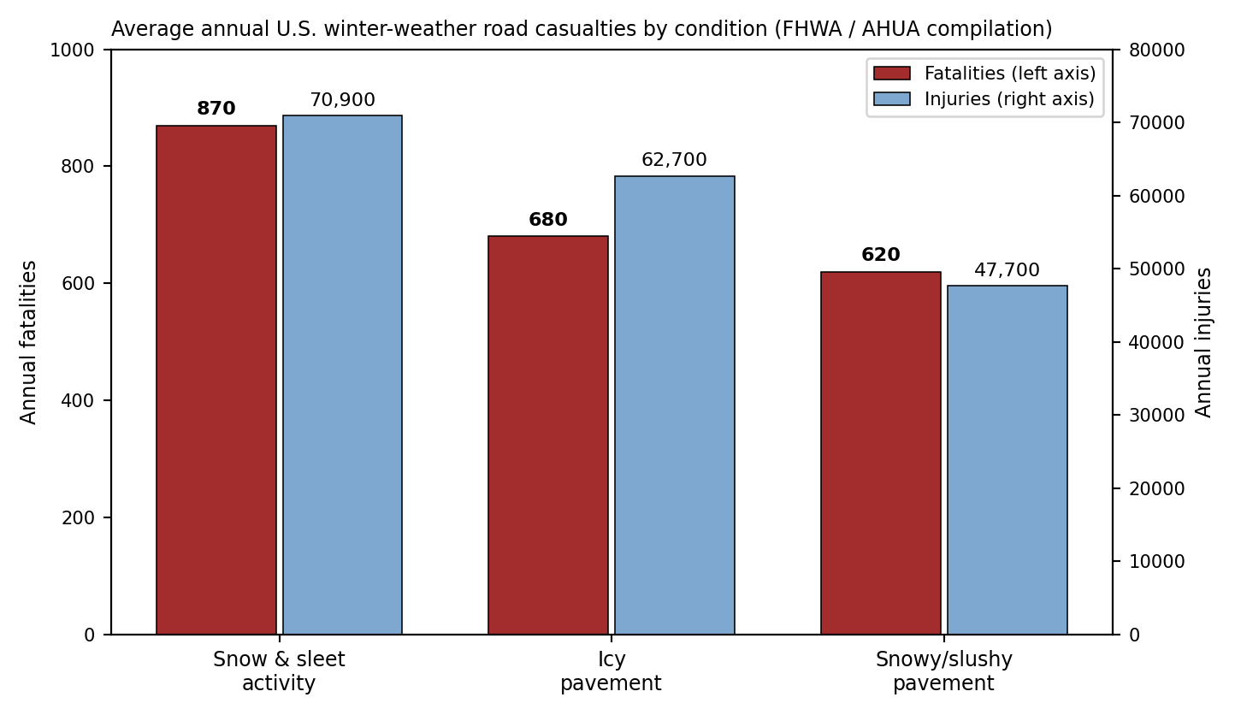
Fig. 1. Average annual U.S. winter-weather road casualties by pavement/weather condition (FHWA / AHUA data [1], [3]).

1.2 The Fiscal Cost of the Current Solution
Winter maintenance operations consume approximately $2.3 billion annually in the United States and roughly 20% of state DOT maintenance budgets, alongside approximately 15 million tons of deicing salt applied to roads each year [5], [6]. Individual state figures illustrate the operating intensity: the Colorado DOT dispatches approximately 950 maintenance trucks, clears 23,000 lane-miles of state highway, plows the equivalent of 6 million lane-miles per season, and spends approximately $69 million annually on snow removal alone [7]. A conventional plow truck costs approximately $200,000 [8].
The budget structure is fragile against severe seasons. Massachusetts spent $154 million against a $107 million winter budget in the 2014–2015 season (110 inches of snowfall); Maryland spent $108 million the same season; Wyoming DOT ran approximately $10 million over budget in 2019–2020; and 23 states reported combined winter spending exceeding $1 billion and 8 million work-hours in a single October–March period [8], [9]. Because state maintenance budgets are typically net-zero, overruns are financed by deferring summer construction and repair—propagating winter costs into year-round infrastructure quality [8].

1.3 Why the Current Model Is Structurally Limited
Three structural limitations of human-operated plowing motivate this work, each documented rather than hypothesized:
(a) Labor-capacity ceiling. Clearing capacity scales linearly with available trained operators, who must work extended overnight storm shifts. Documented municipal responses to labor cost pressure include Minneapolis reducing its full-time winter driver and equipment-operator staff from 134 to 80, and Colorado deliberately allowing snow to remain overnight on 2,800 miles of sparsely traveled highway specifically to reduce overtime costs [10]—a direct, documented case of roads left uncleared because human labor is the binding constraint.
(b) Operator exposure. The operating environment—overnight, low-visibility, active-storm road work alongside residual live traffic—concentrates risk on the operators themselves, during precisely the hours and conditions when crash risk per vehicle-mile is highest (Section 1.1).
(c) Response-time physics. Casualties in Section 1.1 accrue during the interval between snowfall and clearance. A capacity-constrained fleet clears priority roads serially; every hour of serial delay is an hour of elevated crash exposure across the uncleared network. Increasing parallelism—more clearing agents operating simultaneously—is the only structural way to compress this interval, and is exactly what a distributed autonomous fleet provides.

2. Precedent Systems and Prior Art
No individual subsystem proposed here is unprecedented. Three operating bodies of evidence establish component-level feasibility.

2.1 Commercial Autonomous Heavy Ground Vehicles (Mining)
Mining provides the strongest existence proof that heavy autonomous ground vehicles operate safely and economically at scale in harsh environments. Komatsu's FrontRunner Autonomous Haulage System (AHS), commercially launched in 2008, commissioned its 1,000th autonomous ultra-class haul truck in April 2026; FrontRunner fleets have collectively moved over 11.5 billion metric tons of material [11]. Komatsu reports that autonomous operation within the design envelope yields an average 40% improvement in tire and brake life and a 13% reduction in overall maintenance relative to human operation [12]. Caterpillar's competing Command for Hauling system operated 690 autonomous trucks as of end-2024, from 100 in 2017, with a stated target exceeding 2,000 by 2030 [13]. Komatsu has additionally deployed autonomous water trucks for mine-site road maintenance—a direct adjacent-duty precedent for autonomous road-surface work [11]. Notably, the deployment literature documents a scaling failure mode ('pit of despair'): pilots succeed but production scaling fails absent workforce transition planning; Nevada Gold Mines conducted over 9,000 hours of automation retraining across 100+ employees to mitigate it [14]. Section 8 incorporates this lesson.

2.2 Truck Platooning in Winter Conditions on Public Highways
The escort/signal-vehicle architecture proposed in Section 3 is a direct extension of operating practice in U.S. and Canadian platooning programs. A 2025 peer-reviewed trial on the Queen Elizabeth II Highway (Calgary–Edmonton) operated cooperative truck platoons under commercial load in genuine winter conditions—ambient temperatures from −27°C to +12°C, truck weights of 16–39 t—across 41 incident-free trips covering 22,855 km, achieving platooning engagement ratios up to 88.9% [15]. Separately, the Ohio DOT (DriveOhio) and Indiana DOT deployed automated follower-truck platooning on I-70 between Columbus and Indianapolis in 2025, explicitly to validate automation performance in Midwest winter weather; the digitally linked trucks display an illuminated purple beacon so that law enforcement and surrounding drivers can visually identify the automated convoy [16]. This purple-beacon convention is adopted unchanged in the present architecture.

2.3 Autonomous Snowplow Robotics (Academic and Published)
The Institute of Navigation (ION) Autonomous Snowplow Competition has run for more than a decade, with entries including the University of Minnesota's Snow Squirrel (first place in fully autonomous S-path clearing), Case Western Reserve University's platform descended from a 2007 DARPA Urban Challenge program, North Dakota State University's THUNDAR, Dunwoody College of Technology, and the University of Ottawa's Canadian Automated Snow Plow Initiative [17], [18]. Published research on a residential-scale autonomous robotic snowplow specifies a battery-electric unit clearing 3–5 in of snow at 4 mph with 4 h endurance per charge [19]—concrete validated performance figures against which the scaled-up sizing of Section 4 is cross-checked.

3. System Architecture
The proposed system comprises three cooperating layers: (L1) a distributed fleet of compact Autonomous Snow-clearing Units (ASUs) performing the physical clearing; (L2) an escort/signal vehicle managing the interface with residual live traffic; and (L3) a coordination layer scheduling operations within measured low-traffic windows.

3.1 ASU-1 Unit General Arrangement
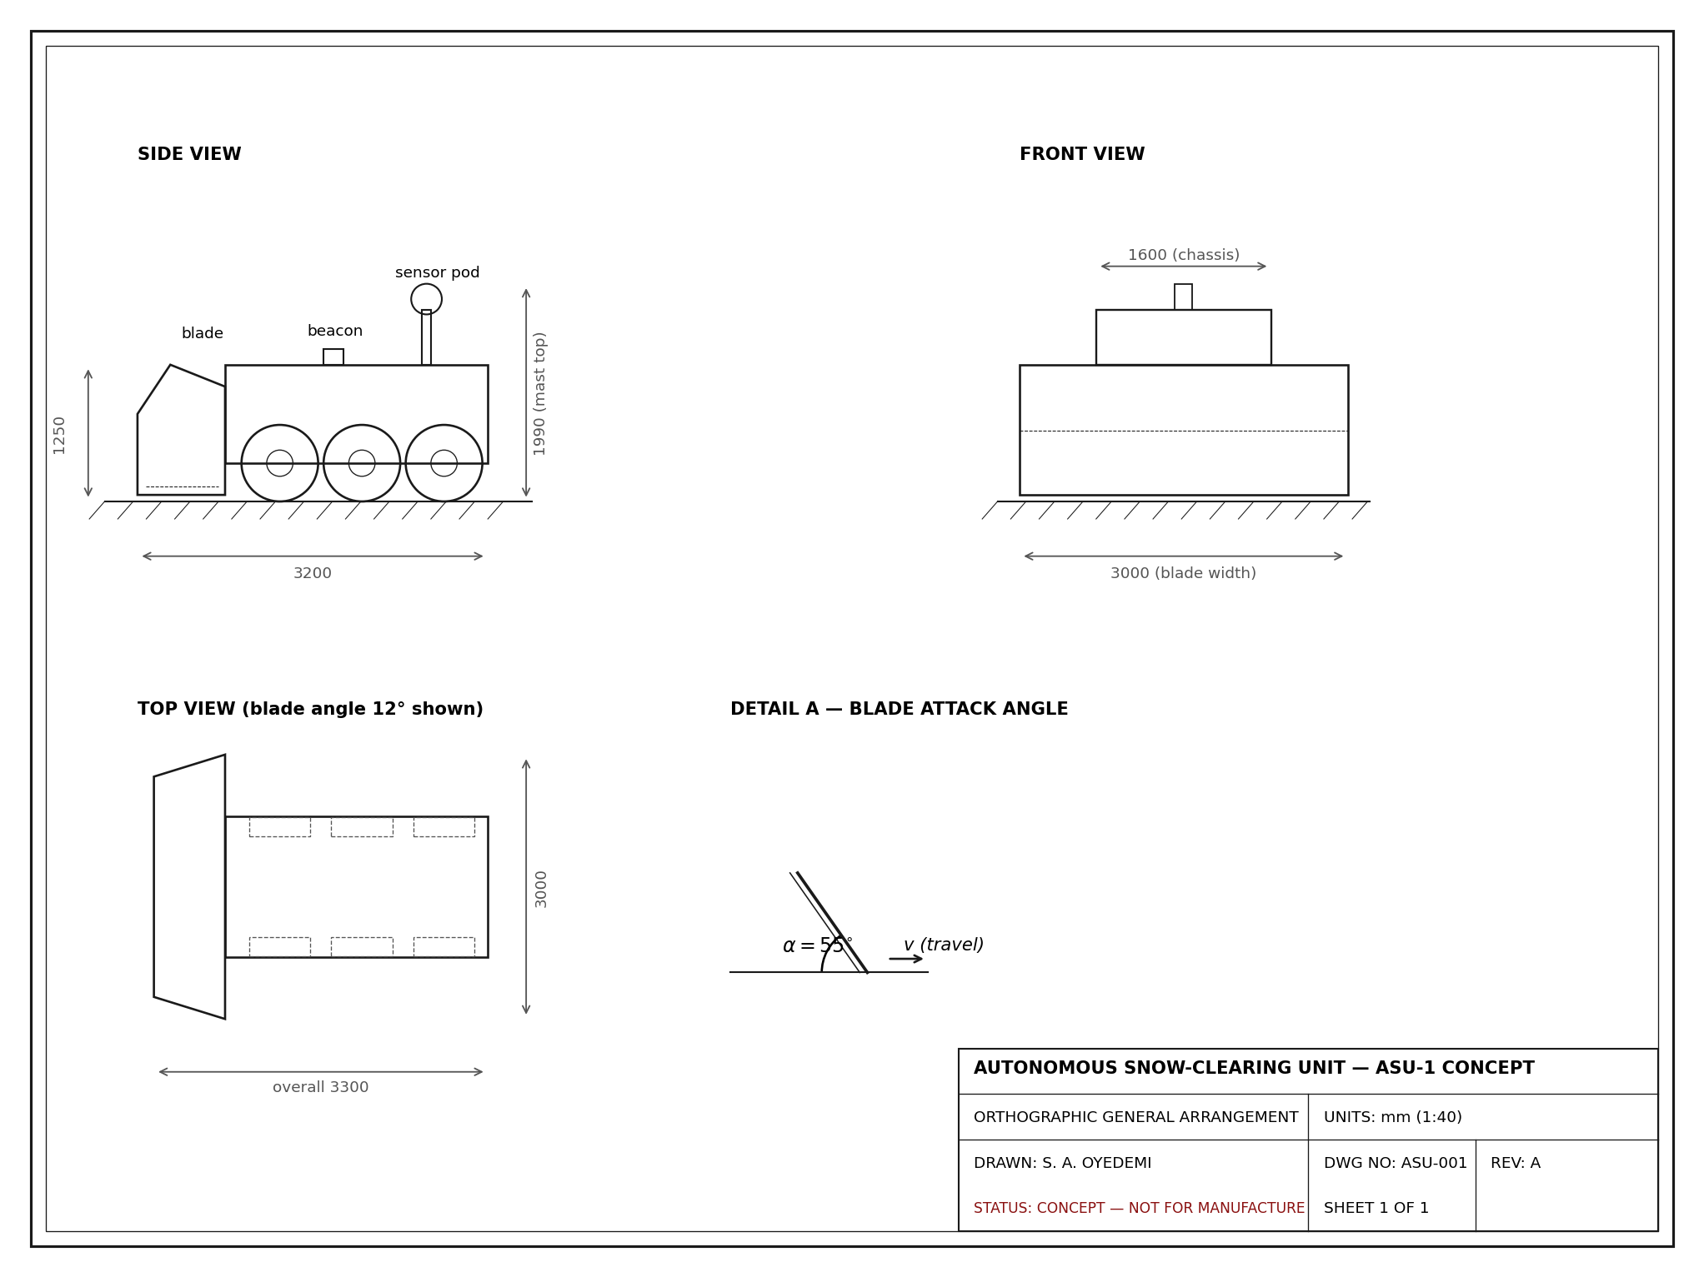
Fig. 2. ASU-1 concept general arrangement: orthographic side, front, and top views with blade attack-angle detail. Dimensions in mm. Concept drawing—not for manufacture.
Subsystem | Specification (concept) | Rationale
Chassis | 3,300 mm × 1,600 mm, three-axle, est. 1,200 kg all-up (Sec. 4.4) | Kinetic energy ≪ full-size plow truck; survivable worst-case collision profile
Blade | 3,000 mm width, attack angle α = 55°, plan skew 12° | Single-lane coverage per pass; skew discharges snow to shoulder side
Perception | 77 GHz radar + LWIR thermal + lidar, sensor-fusion stack | Radar penetrates active snowfall; thermal detects warm objects in whiteout; lidar provides precise geometry in clear air
Signaling | Amber strobe (unit); V2X beacon broadcasting position/heading/status | Matches existing driver expectations for plow equipment; machine-readable warning for equipped vehicles
Powertrain | Battery-electric, ≥ 75 kWh usable (Sec. 4.5), heated pack enclosure | Overnight duty cycle; zero tailpipe emissions; thermal management is an open design problem (Sec. 8)
Fail-safe | Loss of sensor confidence, comms, or localization → controlled stop + beacon escalation | Fail-toward-stationary; mirrors mining AHS safe-park protocols [12]

3.2 Convoy and Escort Vehicle (L2)
ASUs operate in staggered echelon formation, each unit offset laterally to overlap clearing passes, with an escort vehicle trailing the convoy. The escort vehicle—human-driven in deployment Phases 1–3, candidate for automation in Phase 4 following the automated-follower precedent [15], [16]—carries the purple convoy beacon, acts as the physical rear buffer against approaching traffic, and serves as a communications relay and remote-supervision node. This mirrors, in reverse, the leader–follower structure of platooning: here the automated units lead and the supervisory vehicle follows, because the protection requirement is from behind.

3.3 Coordination Layer (L3)
L3 ingests municipal/DOT traffic-sensor feeds to schedule clearing within measured—not assumed—low-traffic windows; assigns units to segments by DOT priority class; enforces automatic stand-down when segment traffic density exceeds threshold; and maintains a complete decision log for post-event audit, mirroring mining AHS practice [12]. The stand-down rule is asymmetric by design: the system requires positive confirmation of low traffic to operate, and defaults to paused otherwise.

4. First-Order Sizing Analysis
All calculations in this section are first-order engineering estimates intended to establish order-of-magnitude physical plausibility. They deliberately exclude granular-flow snow mechanics, ice adhesion, blade-geometry losses beyond a single decomposition term, and drivetrain detail; a detailed design phase would replace them with discrete-element modeling and component-level analysis.

4.1 Design-Point Assumptions
Parameter | Symbol | Value | Basis
Blade width | w | 3.0 m | Single standard lane per pass
Design snow depth | d | 0.15 m | Common DOT design-storm depth; scaled from validated 3–5 in residential-unit envelope [19]
Snow density | ρ | 250 kg/m³ | Mid-range, fresh-to-lightly-packed (fresh ≈ 100–150; wet packed ≈ 300–500 kg/m³)
Operating speed | v | 5 m/s (18 km/h) | Conservative night-operations speed; > 4 mph validated small-unit speed [19]
Blade attack angle | α | 55° | Typical highway plow practice range 50–75°
Blade–snow friction coeff. | μ_b | 0.30 | Steel on compacted snow, mid-range estimate
Tire–snow friction coeff. | μ_t | 0.30 | Winter tire on packed snow, conservative
Drivetrain efficiency | η_dt | 0.85 | Electric drivetrain, single reduction

4.2 Mass Flow, Blade Force, and Power
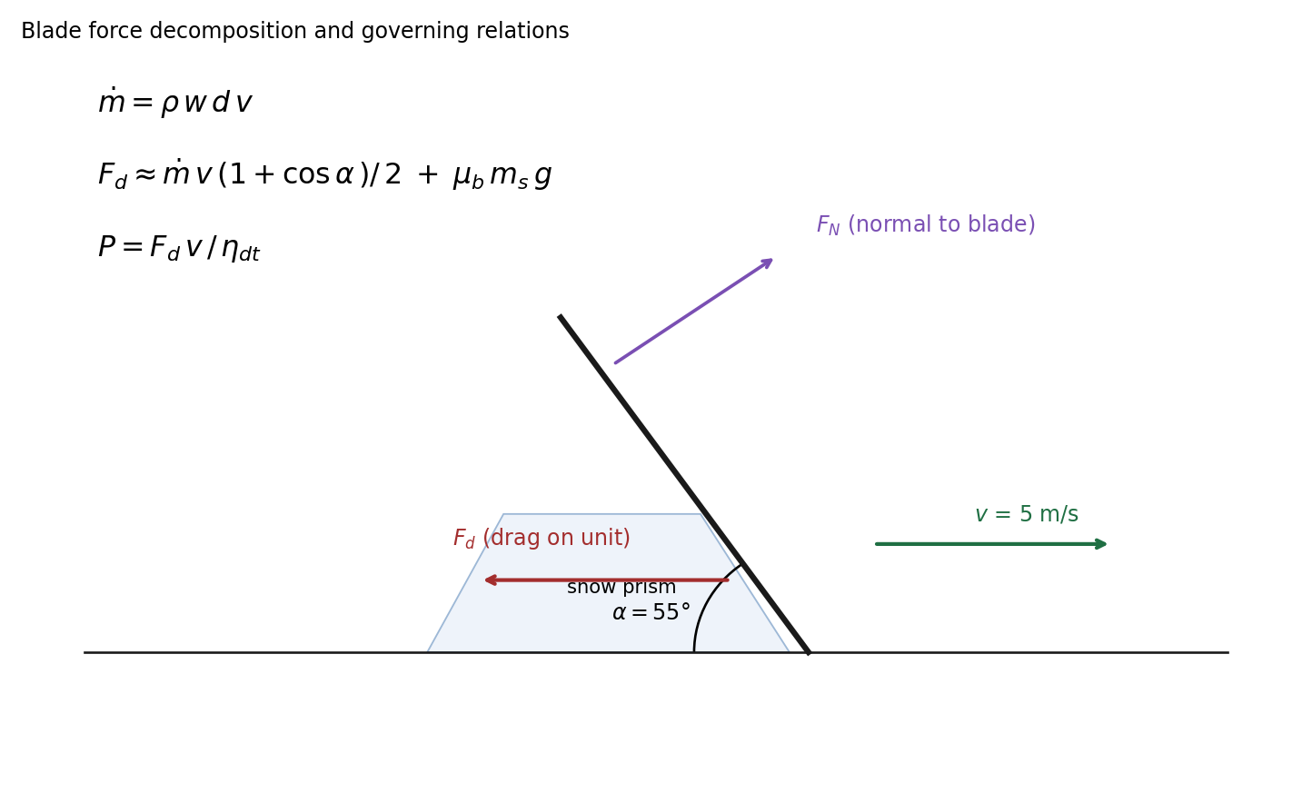
Fig. 3. Blade force decomposition and governing relations.
Mass flow of snow engaged by the blade:
ṁ = ρ w d v = 250 × 3.0 × 0.15 × 5 = 562.5 kg/s (1)
Idealized momentum drag (snow accelerated to blade speed), with the geometric factor for a blade at attack angle α redirecting rather than fully arresting flow, plus sliding friction of the carried snow prism (taking a carried mass m_s ≈ 200 kg as a representative steady-state prism):
F_d ≈ ṁ v (1 + cos α)/2 + μ_b m_s g (2)
F_d ≈ 562.5 × 5 × (1 + 0.574)/2 + 0.30 × 200 × 9.81 ≈ 2,213 + 589 ≈ 2,802 N
Blade-face power and shaft power at drivetrain efficiency:
P_blade = F_d v = 2,802 × 5 ≈ 14.0 kW (3)
P_shaft = P_blade / η_dt ≈ 14.0 / 0.85 ≈ 16.5 kW (≈ 22 hp) (4)
Installed power should carry a 2–3× margin over Eq. (4) for blade actuation hydraulics, sensor/compute heating loads, gradients, and wet-snow density excursions (ρ → 400+ kg/m³ roughly doubles F_d): installed power of order 35–50 kW is the planning figure.

4.3 Traction Constraint and Minimum Unit Mass
The drive wheels must transmit F_d to the road without slip. The traction limit gives a minimum vehicle mass:
μ_t M g ≥ F_d ⇒ M ≥ F_d / (μ_t g) = 2,802 / (0.30 × 9.81) ≈ 953 kg (5)
A design mass of M = 1,200 kg provides a 26% traction margin at the design point and headroom for the wet-snow case. This is a critical scaling insight: the unit cannot be arbitrarily light—plowing force, not payload, sets the mass floor—yet 1,200 kg remains an order of magnitude below a loaded conventional plow truck (≈ 15,000–30,000 kg), preserving the low-kinetic-energy safety rationale.

4.4 Stopping Distance and Sensor-Range Requirement
Braking on packed snow at the traction limit:
s_stop = v² / (2 μ_t g) = 25 / (2 × 0.30 × 9.81) ≈ 4.2 m (6)
With perception latency t_p ≈ 0.3 s (1.5 m travel) and a 3× safety factor, the forward obstacle-detection requirement is (4.2 + 1.5) × 3 ≈ 17 m assured range in active snowfall—comfortably within 77 GHz automotive radar capability, which is precisely why radar anchors the sensor suite (Sec. 3.1). At v = 5 m/s the unit's kinetic energy is ½ × 1,200 × 25 = 15 kJ, versus ≈ 1.9 MJ for a 15 t plow truck at 30 mph—a 125× reduction in worst-case collision energy.

4.5 Energy and Battery Sizing
E = P_shaft × t_window × k_overhead = 16.5 kW × 4 h × 1.3 ≈ 85.8 kWh (7)
where k_overhead = 1.3 covers sensing, compute, actuation, and pack heating. At a pack-level specific energy of 0.20 kWh/kg (conservative for automotive-grade LFP with heating hardware), the pack mass is ≈ 429 kg—36% of the 1,200 kg design mass, which is high but within precedent for compact electric work vehicles; a 3.5 h window or mid-shift swap-charging reduces it proportionally. Cold-weather capacity derating (commonly 20–30% at −10°C without pack heating) is the reason heated enclosures are specified and why k_overhead is not optional.

4.6 Coverage Rate and Fleet Sizing
Coverage per unit = v × 3,600 = 18,000 m/h ≈ 11.2 lane-miles/h (8)
Worked example (mid-size city, 500 priority lane-miles, 4 h window):
N = 500 / (11.2 × 4) ≈ 11.2 → 12 units; with 25% routing/redundancy buffer → 15 units (9)
Scaling reference: Colorado's 23,000 state lane-miles [7] at the same duty point implies N ≈ 23,000/(11.2 × 4) × 1.25 ≈ 640 units for full single-pass state coverage per storm cycle—against a current human fleet of ≈ 950 trucks [7]. The distributed model does not require fewer vehicles; it requires fewer exposed overnight operators per cleared lane-mile.

5. Economic Analysis and Nationwide Scaling
All unit-cost figures in this section are stated assumptions for a first-pass model, benchmarked to adjacent published prices (conventional plow truck ≈ $200k [8]); none are vendor quotes.

5.1 Per-Unit Cost Model (Assumption Set)
Cost element | Assumed range | Note
ASU capital cost | $150k–$300k | Low-volume production; brackets the $200k conventional truck [8]
Service life | 6 seasons | Assumption; unvalidated for this duty cycle
Annualized capital | $25k–$50k /unit-yr | Straight-line, zero salvage
Energy | ≈ $1.3k /unit-season | 86 kWh × 100 storm-nights × $0.15/kWh
Maintenance | $8k–$15k /unit-yr | Directionally informed by −13% maintenance and +40% wear-life under mining autonomy [12]; not directly transferable
Remote supervision labor | $6k–$10k /unit-yr | 1 supervisor : 8–12 units, fully loaded
Total annual cost | ≈ $40k–$76k /unit-yr | Sum of above
At 11.2 lane-miles/h × 4 h × 100 storm-nights ≈ 4,480 lane-miles cleared per unit-season, the implied cost is $9–$17 per lane-mile cleared. Published state data give a coarse human-fleet benchmark: Colorado's $69M for ≈ 6M plowed lane-miles [7] implies ≈ $11.5 per lane-mile—indicating the autonomous model must reach the low end of its assumed cost range, or displace the overnight-premium portion of labor specifically, to compete on cost alone. The stronger near-term case is therefore capacity and safety (clearing roads that today wait—cf. Colorado's documented overnight no-plow policy [10]) rather than pure cost displacement.

5.2 Nationwide Scaling Envelope
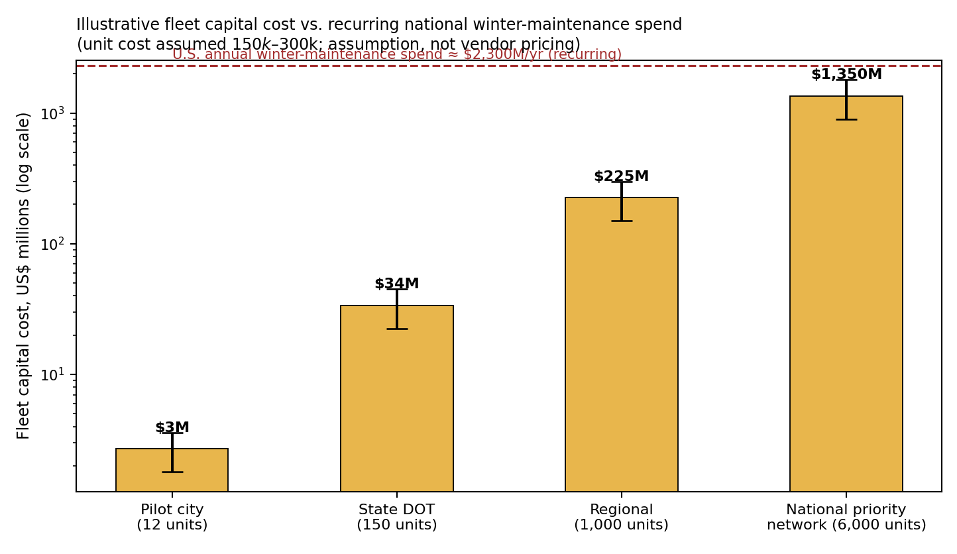
Fig. 4. Illustrative fleet capital cost across deployment scales versus the recurring $2.3B/yr national winter-maintenance spend [5], [6]. Unit cost $150k–$300k (assumption).
A 6,000-unit national priority-network fleet—enough, at Eq. (8) duty, to add ≈ 270,000 single-pass lane-miles per storm-night of parallel clearing capacity—carries an illustrative capital cost of $0.9–$1.8B: less than a single year of current national winter-maintenance expenditure, amortized over a multi-season service life. Even under substantial cost overrun, fleet capital remains small against the recurring spend it augments. The binding constraints at national scale are manufacturing ramp, regulatory approval, and workforce transition (Sec. 8)—not capital.

5.3 Relevance to State DOTs and FHWA Programs
Three institutional alignment points: (i) state DOTs already contract private fleets for winter service, so a clearing-as-a-service procurement requires no new contracting structure [7]; (ii) the same DOTs now running platooning pilots (Ohio, Indiana) [16] are the natural Phase-2/3 partners, since the escort-vehicle protocol extends their existing beacon and public-communication frameworks; and (iii) FHWA's Road Weather Management Program already publishes the condition data (RWIS networks) that the L3 coordination layer consumes, and quantifies the delay externality (544M vehicle-hours [3]) against which system benefits would be evaluated. For budget-constrained agencies, the documented failure mode—deferring summer repairs to fund winter overruns [8]—means any technology that flattens winter cost variance has value beyond its mean cost.

6. Current Solutions and Their Forward Limits
Current practice | What it does well | Structural limit going forward
Human-operated plow fleets | Proven, flexible, handles edge cases | Linear labor scaling; overnight fatigue exposure; documented staffing cuts (Minneapolis 134→80) and deliberate no-plow windows (Colorado, 2,800 mi) under cost pressure [10]
Chemical pre-treatment / 15M t salt per yr | Prevents bonding; extends plow effectiveness | Environmental loading and infrastructure corrosion costs recognized in DOT guidance [5]; effectiveness collapses below ≈ −10°C pavement temperature
Contracted private plows | Surge capacity per storm | Same labor pool; procurement lag; quality variance; cost spikes in severe seasons (MA $154M vs $107M budget [9])
RWIS / weather-responsive ops | Better timing of treatments | Optimizes dispatch of the same capacity-limited human fleet; does not add clearing agents
Driver-assist plow retrofits (GPS guidance, gates) | Reduces operator workload | Operator still present and exposed; no parallelism gain
The pattern across all five rows is the same: existing approaches optimize a fixed, human-limited clearing capacity. None adds autonomous parallel capacity, which is the specific gap this architecture addresses.

7. Phased Deployment Pathway
Phase | Operating environment | Exit criterion (safety-gated, not calendar-gated)
P1 — Controlled sites | Parking lots, campuses, business parks; no mixed traffic | N storm-events of incident-free autonomous clearing; perception validated in active snowfall (ION-competition-class environment [17])
P2 — Residential off-peak | Low-speed public streets, 01:00–05:00, DOT-supervised | Stand-down triggers and V2X interaction validated against real residual traffic
P3 — Arterials with escort | City arterials; human-driven escort, purple beacon per I-70 convention [16] | Sustained multi-storm duty cycles at contract scale; DOT-reviewed safety record
P4 — Highway operation | State highways; escort automation candidate per automated-follower precedent [15], [16] | Regulatory approval building on platooning frameworks; this system follows, not leads, that path

8. Open Problems — Stated Plainly
(1) Perception in active snowfall remains the hardest general problem in cold-weather autonomy; the radar/thermal/lidar fusion proposed here is directionally supported but unvalidated at this scale and duty cycle. (2) No open-source AV stack (Autoware, Apollo) targets blade control or convoy clearing; substantial original software engineering is required, not integration. (3) Cold-weather battery thermal management for a ≈ 430 kg pack in continuous sub-freezing duty is an unresolved engineering problem, not a sizing line-item. (4) The economic model of Section 5 is assumption-based; early-unit costs could substantially exceed the assumed band, replicating the early mining-autonomy cost curve [13]. (5) Regulatory approval for autonomous equipment among live traffic is nascent even for platooning [16]; Phase 4 is contingent on that external path. (6) Workforce transition is a first-order deployment requirement, not an afterthought: the mining literature's 'pit of despair' scaling failure [14] and the labor-displacement sensitivity inherent in Section 1.3(a) both demand an explicit operator-retraining and role-transition program (plow operators are the strongest candidate remote supervisors) as part of any DOT contract.

9. Conclusion
The United States loses more than 1,300 lives and $2.3 billion to winter roads every year while the clearing model that addresses both remains structurally bound to human overnight labor—a constraint so binding that states document leaving highways unplowed to control overtime cost. This paper has argued, with first-order engineering analysis and operating precedent rather than speculation, that a distributed autonomous clearing fleet is physically plausible at present component technology (14 kW blade power, 1,200 kg units, 4.2 m stopping distances, 86 kWh packs), economically small against the recurring spend it augments ($0.9–$1.8B national fleet capital versus $2.3B annual expenditure), and institutionally adjacent to programs DOTs already run (platooning beacons, RWIS data, contracted winter service). Every subsystem has an operating analog: 1,000 autonomous ultra-class trucks in mining, incident-free winter platooning at −27°C on public highways, and a decade of academic autonomous snowplow validation. What does not yet exist is their integration into a purpose-built clearing architecture—and a safety-gated, four-phase pathway to build exactly that has been specified. The open problems of Section 8 are real; none is a physics problem, and all have named precedents for their resolution.

References
[1] Federal Highway Administration, “Snow & Ice,” FHWA Road Weather Management Program. ops.fhwa.dot.gov/weather/weather_events/snow_ice.htm
[2] Stewart Law Offices / FHWA compilation, “Winter Driving Accident Statistics,” 2026.
[3] American Highway Users Alliance, “Winter Weather Highway Safety: Preventing Crashes, Injuries and Deaths” (FHWA data compilation), highways.org.
[4] AutoInsurance.com Research, “Winter Driving Tips and Statistics” (NHTSA/FHWA data), 2026.
[5] AASHTO / NCHRP 20-07(318), “Revised Chapter 8, Winter Operations and Salt, Sand and Chemical Management,” 2013 (FHWA 2012; EPA 2010 data).
[6] S. et al., “Current Practices of Winter Maintenance Operations and Perceptions of Winter Weather Conditions,” J. Cold Regions Engineering, vol. 33, no. 3, ASCE, 2019.
[7] Colorado DOT winter operations summary, via BidNet Direct, “State Spending on Winter Maintenance,” 2022.
[8] The Hustle, “Why snow costs America a fortune every year” (Snow and Ice Pooled Fund Cooperative Program interview; plow cost, budget-deferral mechanism), 2024.
[9] AASHTO winter-maintenance survey via Associated Press, “States spent heavily to clear winter snow, ice,” 2015 (23-state, $1B+, 8M work-hours; MA $154M/$107M).
[10] PBS NewsHour / Wall Street Journal, “States Plow Through Snow-Removal Budgets,” 2009 (Colorado 2,800-mile overnight no-plow policy; Minneapolis staffing 134→80).
[11] Komatsu Ltd., “Komatsu becomes first OEM to commission 1,000 ultra-class autonomous haul trucks,” Newsroom, Apr. 2026.
[12] Komatsu Ltd., “FrontRunner Autonomous Haulage System,” product documentation, 2026.
[13] International Mining, “Caterpillar sets out to hit over 2,000 autonomous mining trucks by 2030,” Nov. 2025.
[14] Engineering & Mining Journal field reporting via Autonocion, “Komatsu 1,000th autonomous truck / Nevada Gold Mines deployment,” 2026 (9,000+ training hours; ‘pit of despair’).
[15] L. Jiang, J. Kheyrollahi, C. R. Koch, and M. Shahbakhti, “Cooperative truck platooning trial on Canadian public highway under commercial operation in winter driving conditions,” Proc. IMechE Part D: J. Automobile Engineering, SAGE, 2025.
[16] Ohio DOT DriveOhio / Indiana DOT, I-70 automated truck platooning deployment (Kratos Defense technology; purple beacon convention), CCJ Digital / TruckingInfo, Apr. 2025.
[17] Communications of the ACM, “Autonomous Vehicles Battle in the Snow,” ION Autonomous Snowplow Competition, 2023.
[18] University of Minnesota Robotics, “Autonomous Snowplow”; NDSU Robotics THUNDAR; University of Ottawa CASPI program materials.
[19] “Development of an Autonomous Robotic Snowplow for Residential Use,” 2024 (3–5 in clearing depth, 4 mph, 4 h endurance).

