Novel Insight of Dislocation Multiplication in Metallic Materials
Junjie Xiu ^{a,b,c}*
ª College of Nuclear Equipment and Nuclear Engineering, Yantai University, Yantai 264005, Shandong, China
^{b} Shandong Key Laboratory of Special Metallic Materials for Nuclear Equipment, Yantai University, Yantai 264005, Shandong, China
^{c} Yantai Key Laboratory of Advanced Nuclear Energy Materials and Irradiation Technology, Yantai University, Yantai 264005, Shandong, China

*E-mail address: xjjwxf@163.com

Abstract: This paper demonstrates that high-angle grain boundaries tend to induce inhomogeneous intergranular stress distribution based on a bicrystal model. It further proposes a novel insight into dislocation multiplication in metals. Plastic deformation originates from crystal slip accompanied by dislocation generation. Crystal slip in polycrystalline materials is induced by a heterogeneous intergranular stress distribution, which arises from uneven deformation among grains. This deformation heterogeneity stems from the anisotropy of grain elastic moduli. Furthermore, greater differences in elastic moduli facilitate crystal slip, generating three-dimensional (3D) dislocations. Slip is favored in close-packed systems because their dislocations have smaller Burgers vectors, facilitating crystal slip and greater dislocation multiplication. For crystalline materials, greater dislocation half-width means longer slip length, accompanied by reduced yield strength and enhanced plastic capacity. Compared to body-centered cubic (BCC) crystals, face-centered cubic (FCC) metals possess more closely packed slip systems, larger dislocation half-widths, and smaller Burgers vectors. The more extensive slip in FCC crystals more effectively homogenizes the internal stress, thereby leading to their lower strength and higher plasticity compared to BCC crystals.

Keywords: dislocation multiplication, elastic modulus anisotropy, dislocation half-width.

- Introduction
Dislocation multiplication is important in the theory of crystal deformation. There are a few possible mechanisms including the Frank-Read (FR) sources and grain boundary dislocation ledge (GBDL) sources etc. [1,2]. For polycrystalline metals and alloys, dislocation multiplication has historically been attributed to FR sources operation at grain interiors, where dislocations with identical Burgers vectors are emitted toward grain boundaries. Plastic strain, arising from dislocation slip, is maximized near the FR sources due to concentrated dislocation activity. In contrast, strain at grain boundaries remains lower, primarily because limited dislocation accumulation occurs there relative to the nucleation site. However, the plastic strain of heterostructured materials at the grain boundary or phase boundary, which were tested using a high-resolution digital correlation technique, is higher [3]. The FR sources in the grain interior cannot explain the higher plastic strain of the boundary. Although Zhu et al. found that the FR sources were observed adjacent to the zone boundary [4], this only proves that the plastic strain of closing to boundary is higher. Under plastic deformation conditions, equiaxed grains can transform into elongated grains. The strain at grain boundaries should be higher than within grain interiors, demonstrating that plastic deformation preferentially occurs at grain boundary regions. This phenomenon indicates that grain boundaries serve as favorable sites for dislocation nucleation. Dislocation emission from grain boundaries has been observed in nanocrystalline metal and high-Mn twining-induced plasticity (TWIP) steel [5,6]. As pointed out in ref [7,8], Li proposed GBDL as dislocation sources in contrast to FR sources. His research suggests that the dislocation loops at grain boundaries act as mechanisms for dislocation multiplication. These dislocation loops are formed by the heterogeneous shear of the boundary plane or from the coalescence of multiple extrinsic grain boundary dislocations within the interface. Whether it is a dislocation originating from FR or GBDL sources, the emitted dislocations are considered as a two-dimensional dislocation line, which is difficult to characterize the plasticity of materials. High-resolution transmission electron microscopy (HRTEM) observations show that the upper part of the edge dislocation observed in the experiment is generally more than a half plane of atoms [9,10], extending into 3D space, and emitted dislocations can form closed dislocation lines or dislocation loops. Dislocations multiplied via FR or GBDL sources are inherently 2D line defects, which fail to account for the emergence of 3D dislocation structures. Furthermore, anomalous slip behavior has been extensively documented in BCC single crystals under low-temperature compression or tension [11,12]. Contemporary research indicates that this phenomenon is predominantly attributed to the unusually high mobility of dislocation multi-junction structures, which can be construed as manifestations of 3D dislocation networks. Current theoretical frameworks in dislocation dynamics remain inadequate to fully elucidate the nucleation mechanisms and kinematic behavior of these 3D dislocation configurations.
Polycrystalline metals are composed of grains with different misorientations and are connected by grain boundaries. Studies have shown that grain boundary regions are structurally disordered with a lower elastic modulus than the matrix; in other words, grain boundaries act as inherently soft zones compared to the rigid matrix [13]. Based on a simple mechanical model, when polycrystalline materials are under tensile stress, the deformation of grain boundary should be higher due to the lower elastic modulus. This leads to higher strains and higher stress concentrations at grain boundaries than within the grain interiors. In this case, intergranular fracture and cleavage fracture caused by grain boundaries are more likely to occur in polycrystalline metals, which is logical. However, polycrystalline metal materials with tension plastic deformation basically do not undergo intergranular fracture except the tungsten. Tungsten with a weak elastic anisotropy is prone to intergranular fracture, which cannot be correlated with the difference in grain boundary impurities [14]. Nevertheless, most metal materials show elastic anisotropy including the iron, aluminium and nickel. In addition, elastically anisotropic metals primarily exhibit the transgranular fracture characteristic under tensile stress. The results indicate that the elastic modulus anisotropy of grain orientation may affect the fracture mode.
From the above analysis, a novel insight for dislocation multiplication was proposed, which could explain the formation of 3D dislocations, as well as the formation of grain refinement strengthening and the close-packed slipping of dislocation, etc.
- Analytical Method
Selecting BCC metallic materials for discussion does not lose generality. Assume the presence of two interconnected grains within a BCC metal polycrystal with elastic anisotropy. Fig. 1 shows cubic grains A and B with a side length of l, where the side length l corresponds to the diameter of a circular grain. Grain A is oriented with the <100> direction vertical, corresponding to the lowest elastic modulus, and grain B is oriented along the <111> direction with the highest elastic modulus. The selection of specific crystallographic directions such as <100> and <111> is mainly to facilitate understanding of how high-angle grain boundaries are easily formed. In this paper, grains A and B also generally refer to the low and high elastic moduli in the vertical direction within adjacent grains, respectively. Grains A and B tend to form a high-angle grain boundary, which is more susceptible to dislocation pile-up than a low-angle grain boundary [2]. It is assumed that the elastic modulus of the matrix excluding these two grains is uniform. When the BCC polycrystal is subjected to tensile stress along the vertical direction, the difference in elastic moduli between the two interconnected grains results in smaller deformation in the <111> oriented grain B and larger deformation in the <100> oriented grain A. Fig. 2 illustrates the deformation of grains A and B that ignores intergranular interactions, where$Δl_{A}$, $Δl_{B}$, and $Δl$ represent the extension of grain A, the extension of grain B, and the extension difference between grains A and B, respectively. Their relationship is expressed by Equations (1) and (2), where $ε_{A}$ and $ε_{B}$are the vertical strains of grains A and B, $E_{A}$ and $E_{B}$ are the vertical elastic moduli of grains A and B, and $σ$ is the applied stress. The deformation of grains A and B accounting for intergranular interactions is shown in Fig. 3, where $Δl_{A}^{'}$ and $Δl_{B}^{'}$ denote the reduction in extension of grain A and the increase in extension of grain B, respectively. Their relationship is described by Equation (3). It is assumed that deformation remains unaffected on the leftmost side of grain A and the rightmost side of grain B. The force decreased in grain A is equal to the force increased in grain B, and their lengths remain consistent at the interface. Their relationship is expressed by Equation (4). The right side of Equation (4) represents the decreasing force of grain A, while the left side corresponds to the increasing force of grain B. Its simplification leads to Equation (5). The uneven loading at the ends of grains A and B results in bending deformation. The maximum rotation angles $θ_{A}$ and $θ_{B}$ of grains A and B at the end are expressed by Equations (6) and (7), and it follows that the maximum rotation angle depends only on the applied stress and the difference in elastic modulus between adjacent grains, not on the grain size. Furthermore, the maximum rotation angle $θ_{A}$ of grain A is greater than that ($θ_{B}$) of grain B due to the higher elastic modulus of grain B compared to grain A. The distinct rotation angles of grains A and B lead to different deflection curves. Equation (8) defines the differential equation for the deflection curve of grain A, derived from bending theory. The coordinate system has its origin at the grain center, with $M_{A}$denoting the bending moment and I the moment of inertia. Equation (9) describes the bending rotation angle of grain A, which shows that the rotation angle is maximum at the grain ends. Accordingly, the maximum rotation angle $θ_{A}$ of grain A is defined by Equation (10). Equation (11) presents the deflection curve for the rightmost side of grain A, expressed using the maximum rotation angle $θ_{A}$instead of the bending moment and inertia. This substitution is valid because Equation (6) defines the maximum angle in terms of the intergranular elastic modulus contrast. The deflection curve for the leftmost side of grain B is provided in Equation (12), where the parameter b is the position of maximum tensile displacement. By adjusting the parameter b, the deflection curve of grain B can be shifted horizontally. The overlapping region of the deflection curves of grains A and B corresponds to mutual compression between the grains, resulting in horizontal compressive stress ($F_{c}$ ), whereas the non-overlapping region corresponds to mutual separation, resulting in horizontal tensile stress ($F_{t}$). The mismatch between the deflection curves of grains A and B creates tensile and compressive force regions at their interface as shown in Fig. 4. The blue line corresponds to the deflection curve on the rightmost side of grain A, while the red line corresponds to that on the leftmost side of grain B. Fig. 4 (a) shows the distinct tensile and compressive zones of grains A and B upon connection, where the overlapping region is under compressive force and the non-overlapping region is under tensile force. Fig. 4 (b) shows half of the deflections of grains A and B, the deflection of grain B is adjusted through the maximum tensile displacement b so that the resultant force in the horizontal direction is zero. The resultant forces, $F_{t}$in horizontal tension and$F_{c}$ in horizontal compression, are captured by Equations (13) and (14), where $E$ is the transverse elastic modulus of the grains, $x_{J}$is the intersection point of the deflection curves. In Equation (13), $\frac{f_{B }\left(x\right)-f_{A }\left(x\right)}{l}$represents the normal tensile strain in any horizontal direction, while in Equation (14), $\frac{f_{A }\left(x\right)-f_{B }\left(x\right)}{l}$ represents the normal compressive strain in any horizontal direction; $ldx$is the area element. Although the transverse elastic moduli of grains A and B are expected to differ, the force calculations in Equations (13) and (14) ultimately reduce to the equality of the areas of the tensile and compressive regions. Since both the $F_{t}$ and $F_{c}$regions encompass grains A and B, the assumption of equal transverse elastic moduli E for grains A and B has no effect on the computed results. Under equilibrium conditions $F_{t}$equals $F_{c}$​, the values of the maximum tensile displacement b and compressive displacement e can be given by Equations (15) and (16). Here, b denotes the maximum tensile separation distance between grains A and B, with a higher b value implying that the grains are more readily separated. Meanwhile, e denotes the maximum displacement due to mutual compression between grains, and a higher e value corresponds to greater compressive deformation, rendering the grains more prone to plastic deformation. The function in Equation (17) is monotonically decreasing within the range [0, 1]. As shown in Equations (15) and (16), parameters b and e increase with larger applied stress and grain size. With the applied stress, grain size, and the elastic modulus of grain A ${(E}_{A})$ fixed, a smaller ratio of $\frac{E_{A}}{E_{B}}$ which corresponds to x in Equation (17) and lies in the interval (0, 1), facilitates the formation of high-angle grain boundary, resulting in an increase in the tensile displacement b and compressive displacement e. Therefore, it can be concluded that the larger the grain size l and the greater difference in elastic modulus between adjacent grains (which corresponds to a high-angle grain boundary) under the same applied stress, the larger the values of b and e. The fact that the tensile displacement b is greater suggests a propensity for intergranular cracking. Correspondingly, the increase in compressive displacement e indicates a higher susceptibility to plastic deformation.

$\frac{Δl}{2}=\frac{Δl_{A}}{2}-\frac{Δl_{B}}{2}$……………………………….………..(1)
$\frac{Δl}{l}=\frac{Δl_{A}}{l}-\frac{Δl_{B}}{l}=ε_{A}-ε_{B}=\frac{σ}{E_{A}}-\frac{σ}{E_{B}}$ …………………….……..(2)
$\frac{Δl}{2}=\frac{Δl_{A}^{'}}{2}+\frac{Δl_{B}^{'}}{2}$…………………………………………..(3)
$\int_{0}^{l}{E_{A}\frac{Δl_{A}^{'}}{2l^{2}}xldx=}\int_{0}^{l}{E_{B}\frac{Δl_{B}^{'}}{2l^{2}}xldx}$…………………………….…..(4)
$\frac{Δl_{B}^{'}}{Δl_{A}^{'}}=\frac{E_{A}}{E_{B}}$………………………………………..…..(5)
$θ_{A}≈\tan{θ_{A}}$=$\frac{Δl_{A}^{'}}{2l}=\frac{σ(E_{B}-E_{A})}{{2(E_{A}+E_{B})E}_{A}}$…………………………….……..(6)
$θ_{B}≈\tan{θ_{B}}$=$\frac{Δl_{B}^{'}}{2l}=\frac{σ(E_{B}-E_{A})}{2{(E_{A}+E_{B})E}_{B}}$…………………………………..(7)
$\frac{d^{2}f_{A }\left(x\right)}{dx^{2}}=\frac{M_{A}}{E_{A}I}$ ……………………….…………………..(8)
$θ_{A}\left(x\right)=\frac{df_{A }\left(x\right)}{dx}=\frac{M_{A}}{E_{A}I}x$ …………………………..…..(9)
${θ_{A}=θ}_{A}\left(\frac{l}{2}\right)=\frac{M_{A}l}{{2E}_{A}I}$ …………………………………..(10)
$f_{A }\left(x\right)=\frac{M_{A}}{2E_{A}I}x^{2}{=θ}_{A}\frac{x^{2}}{l}$ ……………………………..………..(11)
$f_{B }\left(x\right)=θ_{B}\frac{x^{2}}{l}+b , b>0$……………………….………..(12)
$F_{t}=\int_{0}^{x_{J}}{\frac{f_{B }\left(x\right)-f_{A }\left(x\right)}{l}Eldx}$……………………..……..(13)
$F_{c}=\int_{x_{J}}^{\frac{l}{2}}{\frac{f_{A }\left(x\right)-f_{B }\left(x\right)}{l}Eldx}$……………..……….……..(14)
$b=\frac{l(θ_{A}-θ_{B})}{12}≈\frac{σl{(1-\frac{E_{A}}{E_{B}})}^{2}}{24E_{A}(1+\frac{E_{A}}{E_{B}})}$ ……………………..………..(15)
$e=f_{A }\left(\frac{l}{2}\right)-f_{B }\left(\frac{l}{2}\right)=\frac{l(θ_{A}-θ_{B})}{6}≈\frac{σl{(1-\frac{E_{A}}{E_{B}})}^{2}}{12E_{A}(1+\frac{E_{A}}{E_{B}})}$ …………..……..(16)
$g\left(x\right)=\frac{{(1-x)}^{2}}{1+x}$……………………..………....……..(17)

- Results
3.1 Crystal Slip Caused by Non-Uniform Grain Boundary Stress
The low elastic modulus near grain boundaries leads to a concentration of intergranular deformation in these regions. When the compressive displacement e attains a certain threshold, grain B can form an atomic scale concave depression at its grain boundary, as schematically shown in Fig. 5(a). Partial crystal slip involving a one-lattice-spacing (Burgers vector) displacement nucleates a screw dislocation at the concave depression region and its dislocation line extends into the interior of grain B as shown in Fig. 5(b). With increasing applied stress, the bending deformation progressively intensifies, leading to expansion of the plastically yielded zone as shown in Fig. 6 (a). The progressive lattice-spacing displacement in the yielded zone of grain B leads to the nucleation of a conjunction of edge dislocation and screw dislocation as shown in Fig. 6(b). The screw dislocation can move along the direction of parallel edge dislocation to expand the grain yielded zone range. The crystal from the grain boundary to the edge dislocation line moves one Burgers vector. The plastically deformed region expands progressively under continued loading, and the adjacent crystal moves one Burgers vector along the direction of tension, as shown in Fig. 7(a). The concave region of grain B is displaced along the tensile direction, while the screw dislocation annihilates, forming an edge dislocation along the tensile direction. This leads to the formation of complex dislocation junctions consisting of five distinct segments (labeled 1-5), as depicted in Fig. 7 (b). The segments 1, 2, and 3 are of pure edge character, while dislocations 4 and 5 are of pure screw character. Segment 1 resides on the primary {110} slip plane, in contrast to segments 2 and 3, which occupy anomalous slip planes. Due to the plastic deformation of grain B, a concave depression forms at the grain boundary. This depression can be characterized as a disclination or a disconnection. Plastic deformation can reduce the orientation difference between grains A and B, and further deformation may lead to the convergence of their orientations. This reduction occurs because the slipped crystal rotates by an amount equal to the angle β₁ of the depression formed at the grain boundary, as shown in Fig. 7(c). With increasing applied stress, the crystal undergoes progressive displacement, generating a series of dislocations (second, third, fourth, and ultimately forming a dislocation array), as illustrated in Fig. 8. The dislocation array may form complex dislocation networks, in which dislocations can interconnect with one another. The crystal rotation angle increases to β₂, which is greater than β₁. When grain B is more plastically deformed and less stressed than grain A. Subsequently, grain A can bulge outward and experiences crystalline (dislocation) slip under continuous plastic deformation. The interactive plastic deformation between grains A and B leads to a more consistent orientation difference between them, thereby facilitating the formation of a textured microstructure.
Dislocation glide, which corresponds to the relative movement of crystal lattices, is primarily driven by two mechanisms. First, the compressive force exerted by the grain boundary promotes dislocation slip. Second, the stress gradient between deformed and undeformed regions promotes dislocation slip. In plastically deformed areas where slip has occurred, the crystal undergoes elongation leading to stress relaxation, while in unslipped regions the crystal remains undeformed and maintains higher stress levels. This stress imbalance creates a driving force for dislocations to propagate into unslipped regions, thereby transferring plastic deformation progressively through the crystal structure and enabling macroscopic shape change.
3.2 Influence of Grain Size on Yield Strength
In polycrystalline metals, the influence of grain size on yield strength and plasticity is conventionally described by the Hall-Petch relationship [1], which posits an inverse correlation between grain size and mechanical properties. Specifically, coarser grain structures generally lead to reduced yield strength and diminished plasticity. Assuming that crystal slip is solely dependent on compressive displacement e, the dislocations are generated once the displacement exceeds a critical value $e_{c}$. The stress at this onset of slip is defined as the dislocation nucleation stress $σ_{n}$. Equation (18) can be derived as the expression for the dislocation nucleation stress $σ_{n}$ from Equation (16), and it follows that larger grain sizes and high-angle grain boundaries are conducive to reducing the dislocation nucleation stress. In polycrystalline materials, when the grain boundary orientation is constant, the dislocation nucleation stress depends only on the grain size and varies inversely with it, as expressed by Equation (19). It has been shown by molecular dynamics simulations that the dislocation nucleation stress in nanomaterials agrees with Equation (19) [15,16].
$σ_{n}=\frac{12e_{c}}{l\frac{{(1-\frac{E_{A}}{E_{B}})}^{2}}{E_{A}(1+\frac{E_{A}}{E_{B}})}}$ …………..…………..…....……..(18)
$σ_{n}∝\frac{1}{l}$ …………..…………..…....……..(19)
Yield limit $σ_{s}$and nucleation stress $σ_{n}$ are different concepts. Nucleation stress refers to the stress at which dislocations first begin to form, while yield limit is the stress at which significant yielding occurs in the material. For example, the conditional yield strength $σ_{0.2}$ is defined as the stress at which 0.2% plastic deformation is observed. According to the Hall-Petch relationship, the yield limit is inversely proportional to the square root of the grain size ($l^{\frac{1}{2}}$), while the nucleation stress is inversely proportional to the grain size (l) from Equation (19). The difference between the yield limit and the nucleation stress mainly stems from the fact that, under the same macroscopic volume, finer grains result in a greater number of grains. Under conditions that satisfy the stress for dislocation nucleation, finer grains provide more sites for dislocation nucleation. This may be the reason for the difference between the yield limit and the nucleation stress.
According to Equations (6) and (7), the rotation angle of the grain depends on the applied stress. Under identical applied stress conditions, grains A and B with different sizes produce the same rotation angle θ. Equations (16) and (18) reveal that compressive displacement e increases with grain size under the same applied stress. Therefore, coarser grains induce greater compressive displacement e at grain boundaries. This ultimately leads to earlier dislocation emission in coarse-grained structures under lower applied stresses, explaining why coarse-grained materials exhibit lower yield strength. In fine-grained materials, generating the same compressive displacement e requires a larger rotation angle θ, implying the need for higher applied stress. This accounts for the typically higher yield strength observed in fine-grained materials. According to Equation (16), under a constant applied stress, a reduction in grain size to the nanoscale leads to a small compressive displacement e in grain boundary. The resulting difficulty in crystal slip inhibits plastic deformation, thereby preventing the relief of stress concentrations between grains and consequently yielding high strength coupled with poor ductility. When coarse-grained and fine-grained materials undergo identical macroscopic plastic deformation (i.e., emitting equal total numbers of dislocations), each individual coarse grain must emit a greater number of dislocations to accommodate the strain. Consequently, grain boundaries in coarse-grained structures experience higher stress to drive dislocation glide, and coarse grains exhibit a more nonuniform stress distribution. Under these elevated stress conditions, grain boundaries of coarse-grained become more susceptible to fracture. Therefore, compared to fine-grained materials, coarse-grained counterparts can exhibit inferior plasticity.
3.3 The Mechanism of Crystal Slip
When metallic materials with heterogeneous elastic moduli undergo tensile loading. Stress concentration at the grain boundary is relieved through crystal slip, as the compressive state facilitates slip activation. The magnitude of stress concentration reduction scales with the glide of crystal. Specifically, as the crystal between the grain boundary and dislocation line translates by one Burgers vector, the accumulated plastic strain elongates the grain, thereby progressively diminishing stress concentration. This mechanism is schematically illustrated in Fig. 9. During tensile deformation, a greater number of crystals deforming along the tensile direction facilitate deformation and reduces stress concentration. The function describing the crystal along the vertical direction displacement is given by Equation (20), where D is the function of crystal vertical displacement, $\vec{b}$ is the Burgers vector of the slip system, d is the length of the slipped crystal, which is also the distance from the grain boundary to the dislocation line, h is the vertical height of the displaced crystal, and γ is the angle between the slip plane and the vertical direction, ranging from 0 to 90 degrees. A larger crystal vertical displacement D indicates a greater number of crystals displaced vertically. D reaches its maximum value when γ equals 45 degrees. The larger the crystal vertical displacement D, the more effectively stress concentration is reduced. Therefore, dislocations are most prone to glide along the 45-degree direction to the tensile axis, which is also the direction of the maximum resolved shear stress.
D(γ)= $\vec{b}$dh cosγ sinγ………………………………….……….…….(20)
3.4 Influence of Dislocation Half-Width and Burgers Vector
During vertical tension, grains A and B with different elastic moduli exert mutual compression, resulting in dislocation emission. When the deflection reduces to zero, the compressive force between grains A and B vanishes, and no further dislocations are emitted. In this process, a higher number of emitted dislocations and a larger slip spacing per dislocation lead to greater overall plastic deformation in the crystal. This promotes more uniform deformation between grains A and B, a more homogeneous stress distribution, and a reduction in the internal energy of the grains. Consequently, the process is more likely to occur. Compared to close-packed slip systems, non-close-packed systems are characterized by a less densely packed atomic structure and a larger Burgers vector. This implies that under identical compressive displacement e condition, fewer dislocations are activated in non-close-packed slip systems, which is detrimental to mitigating stress concentration.
The dislocations with smaller half-widths interact over shorter ranges, enabling higher dislocation densities in the same long crystal. The emission of dislocations with smaller half-widths from grain boundaries reduces the microscopic displacement propagated into the crystal. As a result, the macroscopic strain is diminished, which in turn leads to an increase in yield strength. When slip occurs on non-close-packed planes (e.g., {100} in BCC metals) along low-index directions like <100>, the sparse atomic packing and the narrow dislocation half-widths result in restricted dislocation glide displacement, which leads to short crystal slip distances. Consequently, only a small volume of crystal undergoes slip. The resultant limited elongation of grains fails to effectively relieve stress concentration. This can cause severe stress accumulation at grain boundaries, ultimately promoting brittle fracture. In contrast, when slip occurs on close-packed slip systems such as {110}<111> in BCC metals, the dense atomic packing and the broader dislocation half-widths enable more extensive crystal glide than on the non-close-packed {100} planes, resulting in longer slip distances. This can alleviate stress concentration at grain boundaries and enhance material plasticity.
The BCC {110}<111> close-packed slip system with a Burgers vector of 1/2 a<111> can emit a greater number of dislocations under the same compressive displacement e. Slip is initiated in the close-packed slip system at a crystal displacement of $\frac{\sqrt{3}}{2}$a, whereas the non-close-packed system {100}<100> requires a larger lattice translation distance a. This comparison clearly demonstrates that the close-packed slip system activates at a significantly lower critical compressive displacement, indicating its propensity to initiate slip first under identical conditions. After more dislocation glide occurs on close-packed planes, greater crystal sliding (i.e., higher elongation) reduces stress disparities between grains of different orientations, leading to more uniform stress distribution. Compared to slip on the BCC non-close-packed slip system {100}<100>, close-packed slip system {110}<111> more effectively alleviates stress concentration. Consequently, close-packed slip systems prevail over non-close-packed systems in this competition, making them dominant in crystals. This mechanism fundamentally explains why slip preferentially initiates along close-packed planes and directions in crystalline materials.
Compared to BCC crystals, FCC metals possess more densely packed close-packed planes, broader dislocation half-widths and smaller Burgers vectors. Under equivalent conditions, this enables greater dislocation multiplication and a longer glide distance per dislocation in FCC slip systems, resulting in higher crystal slip and elongation, thereby further reducing stress concentration at grain boundaries. This mechanistic framework accounts for the generally superior plasticity yet lower yield strength of FCC metals relative to their BCC counterparts.
- Discussion
Why propose a new insight of dislocations? Because there are many unreasonable aspects in the existing dislocation theory.
First, when a crystal is subjected to tension, the plane with the maximum shear stress is the plane at an orientation angle α of 45 degrees. Assuming a dislocation exists on this plane, its stress state is as shown in Fig. 10(a). The diagonal length is $\sqrt{2}$f, which is also expressed as the sum of the interplanar spacings of a certain number of planes perpendicular to the slip planes, equal to f. The shear stress indicated by the red circle in Fig. 10(a) is not equivalent to the compressive stress depicted in Fig. 10(b). The slip of a crystal requires a squeezing stress as illustrated in Fig. 10(b), but it is difficult for such a squeezing stress to exist during uniform crystal deformation. Fig. 10(c) shows the actual loading condition of the crystal, with the red dashed line indicating the actual deformation after loading. The orientation angle α₁ of the plane indicated by the red dashed line is greater than 45 degrees, and the sum of the interplanar spacings of the planes perpendicular to the slip planes exceeds f, indicating that the spacing between each plane increases, making it less likely to generate compressive stress and making dislocation slip even more difficult. Fig. 11(a) illustrates the unloaded stress state of a crystal, where the sum of the interplanar spacings of planes perpendicular to the slip planes is f. After shear deformation, these interplanar spacings become as shown by the blue lines in Fig. 11(b) and are smaller than the undeformation spacing f, indicating that under pure shear deformation, it is easier for dislocations to be compressed and slip. The inhomogeneous deformation of twin crystals with different elastic moduli generates a squeezing stress. This squeezing stress can induce slip in certain parts of the crystal, thereby generating dislocations. This insight is consistent with practical observations, where dislocation lines are prone to forming at high-angle grain boundaries. It argues that the dislocation lines at grain boundaries are not formed by pile-up but rather originate from the slip of localized crystal regions.
Second, if dislocation slip is related to the critical resolved shear stress, then grain size should not have a significant effect on the critical resolved shear stress. When the shear stress reaches the critical value, dislocation slip occurs, indicating the onset of plastic deformation. This suggests that the yield limit is independent of grain size. Compared to coarse-grained materials, finer-grained materials have more grain boundaries. Therefore, finer-grained materials possess more grain boundaries to hinder dislocation motion, which indicates that finer-grained materials should have a larger strengthening exponent. However, the actual situation is that fine-grained materials generally have a higher yield limit but a lower hardening exponent, which is not easily explained by the critical resolved shear stress theory. In contrast, according to the novel insight I propose, the smaller the grain size, the smaller the compressive displacement. The difficulty of slip in crystals leads to a higher yield limit. When plastic deformation occurs, fine-grained materials, possessing more grains and grain boundaries, allow more crystals to undergo slip, which results in a lower hardening exponent. This novel insight provides a good explanation for fine grain strengthening.
Third, cleavage fractures generally initiate at grain boundaries and are typically brittle in nature. One theory for crack initiation in cleavage fractures suggests that dislocation pile-ups at grain boundaries lead to crack formation. Dislocation generates a pile-up stress. Eshelby et al.^{[17]} proposed an algebraic method to determine the pile-up stress at the leading dislocation, as shown in Equation (21), where τ is the applied shear stress, τ* is the pile-up stress at the leading dislocation, and n is the number of dislocations in the pile-up. Eshelby's method assumes interaction forces among all dislocations, leading to the derivation of Equation (21). The dislocation can only interact with its immediate neighboring dislocations and cannot exert force on dislocations separated by intervals; therefore, the dislocation pile-up stress does not exist. A dislocation should be analogous to a spring, where stress increases under compression. An array of dislocations is similar to a set of springs connected in series and would not generate pile-up stress.
τ*=nτ……………………….……………….(21)
The deformation of metallic polycrystalline materials is primarily influenced by the heterogeneous stress distribution, and the mechanical property of grain boundary is often lower than that of the matrix. In metals such as tungsten, where the elastic modulus is nearly identical across different crystal orientations, the absence of elastic modulus anisotropy leads to a deformation mechanism dominated by grain boundary weakening, resulting primarily in intergranular fracture. In contrast, for metallic materials with anisotropic elastic moduli, a competition exists between grain boundary weakening and heterogeneous stress distribution, which can lead to either intergranular fracture or plastic deformation. Under the same applied stress, coarse grain vertical boundaries exhibit larger displacement in tension and compression, are more prone to dislocation nucleation resulting in lower yield strength and are susceptible to intergranular fracture. The prevention of plastic deformation in polycrystalline metals can cause intergranular stress to accumulate, thereby promoting cracking. In contrast, materials that deform plastically relieve this stress and resist cracking. This results in the well-known inverse correlation between strength and plasticity.
Plastic deformation in metallic materials stems primarily from crystal movement, which causes crystals to propagate through the crystal lattice in one Burgers vector. When the crystal between the grain boundary and the edge dislocation line shifts by one Burgers vector, a depression equivalent to one Burgers vector is left at the grain boundary. As plastic deformation continues, multiple large depressions corresponding to several Burgers vectors accumulate at the grain boundary, eventually forming a dislocation array within the grain. Moreover, the accumulated Burgers vector at the grain boundaries should equal the number of dislocations within the grain. This novel insight proposes that dislocations are formed due to mutual extrusion between slipped and unslipped regions within a grain. Dislocations are considered a byproduct and sign of plastic deformation rather than a prerequisite. In contrast, mechanisms such as the FR source suggest that dislocation slip is the fundamental driver of crystal plasticity, meaning dislocations are essential for the occurrence of plastic deformation.
This inhomogeneous movement generates dislocations, which are 3D closed curves. In polycrystalline materials, dislocations are emitted at sites of stress anisotropy, such as grain boundaries. Moreover, the larger the misorientation angle of the grain boundary, the more prone it is to dislocation formation. While such as the FR mechanism suggest that high-angle grain boundaries tend to dislocation pile-up, the novel insight proposed in this paper posits that high-angle grain boundaries facilitate dislocation formation through crystal slip rather than dislocation pile-up. Following dislocation emission from grain boundaries, the reduction in misorientation between adjacent grains facilitates texture formation. This process alleviates stress concentration at the boundaries, leading to a more homogeneous stress distribution throughout the crystal, resulting in strengthening of the crystal. Moreover, the strengthening of polycrystalline materials after plastic deformation is attributed to a more homogeneous stress distribution.
It is generally accepted that the susceptibility of metallic materials to brittle fracture is governed by high critical resolved shear stress for dislocation slip and low cohesive strength. Cleavage fracture is a typical form of brittle fracture; one crack initiation mechanism for cleavage is crack nucleation arising from dislocation pile-up at grain boundaries. Microvoid coalescence corresponds to typical ductile fracture, which features considerable macroscopic plastic deformation before failure and is accompanied by intensive dislocation multiplication. Crack initiation occurs through interactions between dislocations and second-phase particles. This raises a fundamental question: why does dislocation multiplication accompanying microvoid coalescence not trigger cracking through dislocation and grain boundary interactions? Alternatively, based on the dislocation pile-up theory, there should exist a finite probability that ductile failure could evolve into cleavage fracture. In reality, such a transition is scarcely observed. This suggests that the dislocation pile-up theory of fracture is incorrect.
The viewpoint proposed in this paper suggests that there are roughly two mechanisms governing brittle fracture in metallic materials. First, materials susceptible to brittle fracture lack intrinsic microscale inhomogeneity of internal stress. Although the stress distribution appears macroscopically uniform, it is actually heterogeneous at the microscopic scale. Such stress heterogeneity mainly originates from the anisotropy of elastic moduli among grains. Without this intergranular stress heterogeneity, plastic deformation cannot readily take place. For instance, pure tungsten exhibits nearly identical elastic moduli along different crystallographic orientations, so intergranular stress heterogeneity is absent. Consequently, brittle fracture tends to occur under applied loading.
Second, during crystal slip, each newly generated dislocation only accommodates a short slip distance, meaning that the volume of crystals participating in slip is limited. Microscopically, such materials possess less closely packed slip planes and smaller dislocation half-widths. Under these conditions, only a small fraction of crystals undergo slip, making a limited contribution to macroscopic plastic deformation. The heterogeneous intergranular stress state cannot be readily relieved. Moreover, a larger external load is required to sustain a steady macroscopic strength, which manifests as high macroscopic strength and generally low plasticity. Within the framework of the viewpoint proposed in this work, dislocations do not necessarily multiply under brittle fracture conditions, and dislocation pile-ups may not form at grain boundaries. Brittle fracture can occur as long as the heterogeneous intergranular stress distribution remains unrelieved.
Dislocation glide preferentially occurs on close-packed slip systems primarily due to the smaller Burgers vector and the larger dislocation half-width. Because the Burgers vector of the close-packed slip system is small, a smaller compressive displacement e can initiate crystal slip and form dislocations. For a given compressive displacement e, the small Burgers vector of dislocations on close-packed planes facilitates preferential dislocation nucleation and the emission of more dislocations. Their larger half-width permits greater slip distances, thereby increasing the distance between dislocations and enabling them to mitigate stress inhomogeneity more effectively. Consequently, a greater half-width implies lower yield strength and better ductility under identical conditions. This novel insight elucidates the preference for slip on close-packed planes. In FCC metals, which generally exhibit higher packing density, larger dislocation half-widths and smaller Burgers vectors compared to BCC metals, dislocations can propagate over longer distances, thereby more effectively reducing stress concentration. This accounts for the generally lower strength and superior plasticity of FCC metals relative to BCC metals.
- Conclusions
Classical dislocation theories such as the FR source and GBDL hold that plastic deformation originates from dislocation slip. In contrast to classical dislocation theories, the present work argues that plastic deformation takes place prior to the generation of dislocations. Plastic deformation of polycrystalline metals is caused by intergranular heterogeneous stress distribution, which mainly stems from inconsistent grain deformation resulting from elastic modulus anisotropy of diverse crystal orientations. Plastic deformation originates from partial crystal slip; one dislocation is generated after each slip event, and dislocation multiplication takes place throughout the plastic deformation process.
Crystals tend to slip on close-packed planes due to their dense atomic arrangement, which only needs a small compressive displacement e because of its small Burgers vector. Slip hardly occurs on non-close-packed planes owing to the large required compressive displacement e. Slip initiates once the compressive displacement reaches the critical value corresponding to close-packed planes; it rarely happens that the compressive displacement rises to the higher magnitude e required for slip on non-close-packed planes. This paper argues that crystal slip on close-packed planes does not arise from a lower critical resolved shear stress for these planes, but rather from the smaller compressive displacement required for close-packed planes. Slip along non-close-packed planes yields higher macroscopic strength. The loosely packed atoms on such planes shorten slip distances and reduce the volume of slipped crystals, thereby resulting in a narrow dislocation half-width; greater external loading is therefore needed to produce identical macroscopic plastic deformation, raising the overall strength. However, this state aggravates intergranular stress inhomogeneity and degrades plastic performance.
From the above discussion, five conclusions are summarized as follows.
1 The elastic anisotropy of metallic polycrystals leads to both inhomogeneous stress distribution at high-angle grain boundaries and crystal slip accompanied by the formation of 3D dislocations.
2 Coarser-grained materials exhibit greater tensile displacement b and compressive displacement e under the same applied stress. Their grain boundaries are prone to dislocation activity, resulting in lower yield strength and poorer ductility.
3 The dislocation nucleation stress varies inversely with the grain size l, $σ_{n}∝\frac{1}{l}$ .
4 Dislocations preferentially glide on close-packed planes because their Burgers vector is smaller. This allows them to be emitted under a lower compressive displacement e.
5 FCC metals have a larger dislocation half-width and greater slip distance per dislocation than BCC metals. This enhances plastic deformation, which in turn results in superior ductility but lower strength.

Data Availability
Data will be made available on request.

References
[1] P.M. Anderson, J.P. Hirth, J. Lothe, Theory of dislocations, 3rd ed., Cambridge University Press, Cambridge, 2017.
[2] L.E. Murr, Dislocation ledge sources: dispelling the myth of Frank–Read source importance, Metall. Mater. Trans. A 47 (2016) 5811-5826.
[3] C.X. Huang, Y.F. Wang, X.L. Ma, S. Yin, H.W. Höppel, M. Göken, X.L. Wu, H.J. Gao, Y.T. Zhu, Interface affected zone for optimal strength and ductility in heterogeneous laminate, Mater. Today 21 (2018) 713-719.
[4] H. Zhou, C.X. Huang, X.C. Sha, L.R. Xiao, X.L. Ma, H.W. Höppel, M. Göken, X.L. Wu, K. Ameyama, X.D. Han, Y.T. Zhu, In-situ observation of dislocation dynamics near heterostructured interfaces, Mater. Res. Lett. 7 (2019) 376-382.
[5] Y.T. Zhu, X.L. Wu, X.Z. Liao, J. Narayan, S.N. Mathaudhu, L.J. Kecskés, Twinning partial multiplication at grain boundary in nanocrystalline fcc metals, Appl. Phys. Lett. 95 (2009) 031909.
[6] X.L. Wu, X.Z. Liao, S.G. Srinivasan, F. Zhou，E.J. Lavernia, R.Z. Valiev, Y.T. Zhu, New deformation twinning mechanism generates zero macroscopic strain in nanocrystalline metals, Phys. Rev. Lett. 100 (2008) 095701.
[7] J.C.M. Li, High-angle tilt boundary—a dislocation core model, J. Appl. Phys. 32 (1961) 525-541.
[8] J. C.M Li, C. Feng, B.B. Rath, Emission of dislocations from grain boundaries and its role in nanomaterials, Crystals 11 (2020) 41.
[9] V. Ribić, A. Rečnik, M. Komelj, A. Kokalj, Z. Branković, M. Zlatović, G. Branković, New inversion boundary structure in Sb-doped ZnO predicted by DFT calculations and confirmed by experimental HRTEM, Acta Mater. 199 (2020) 633-648.
[10] V. Fallah, A. Korinek, N. Ofori-Opoku, N. Provatas, S. Esmaeili, Atomistic investigation of clustering phenomenon in the Al–Cu system: Three-dimensional phase-field crystal simulation and HRTEM/HRSTEM characterization, Acta Mater. 61 (2013) 6372-6386.
[11] D. Caillard, B. Bienvenu, E. Clouet, Anomalous slip in body-centred cubic metals, Nature 609 (2022) 936-941.
[12] C. Marichal, K. Srivastava, D. Weygand, S. Van Petegem, D. Grolimund, P. Gumbsch, H. V. Swygenhoven, Origin of anomalous slip in Tungsten, Phys. Rev. Lett. 113 (2014) 025501.
[13] K. Lu, H.Y. Zhang，Y. Zhong，H.J. Fecht, Grain size dependence of mechanical properties in nanocrystalline selenium, J. Mater. Res. 12 (1997) 923-930.
[14] B. Gludovatz, S. Wurster, T. Weingärtner, A. Hoffmann, R. Pippan, Influence of impurities on the fracture behaviour of tungsten, Philos. Mag. 91 (2011) 3006-3020.
[15] A. Kedharnath, R. Kapoor, A. Sarkar, Classical molecular dynamics simulations of the deformation of metals under uniaxial monotonic loading: A review, Comput. Struct. 254 (2021) 106614.
[16] V. Yamakov, D. Wolf, S.R. Phillpot, A.K. Mukherjee, H. Gleiter, Deformation-mechanism map for nanocrystalline metals by molecular-dynamics simulation, Nat. Mater. 3 (2004) 43-47.
[17] J.S. Zhao, The fundamentals of dislocation theory, National Defense Industry Press, Beijing, 1989.

Competing interest
I declare that I have no known competing financial interests or personal relationships that could have appeared to influence the work reported in this paper.

Acknowledgements
This research did not receive any specific grant from funding agencies in the public, commercial, or not-for-profit sectors.

Figure captions
Fig. 1 Cubic grains A and B.
Fig. 2 Grains A and B after deformation without interactions.
Fig. 3 Grains A and B after deformation with interactions.
Fig. 4 (a) The distinct tensile and compressive zones of grains A and B, overlapping region corresponds to compression, while the non-overlapping region corresponds to tension, (b) half of the deflection curves of grains A and B, $x_{J}$ is located at the point of zero net force; $F_{t}$ is the region subjected to tensile stress, and $F_{c}$ is the region subjected to compressive stress.
Fig. 5 Schematic diagram of screw dislocation nucleation at grain boundary, (a) concave depression induced by mutual compression of grains, (b) screw dislocation nucleating at the grain boundary, denoted by blue line.
Fig. 6 Schematic diagram of the expansion yielded zone, (a) expansion of concave depression induced by the higher applied stress, (b) screw and edge dislocations are denoted by blue and yellow lines, respectively; the grain boundary to the yellow line corresponds to a slip of one Burgers vector.
Fig. 7 Schematic diagram of dislocation multijunction, (a) expansion of the concave depression along the vertical grain boundary, (b) the multijunction of edge dislocations (1, 2, and 3) and screw dislocations (4 and 5), dislocation 1 lies on the primary slip plane, while dislocations 2 and 3 are located on anomalous slip planes, (c) side view of the grain boundary.
Fig. 8 Multiple dislocations nucleate at the grain boundary forming a dislocation array.
Fig. 9 Schematic diagram of crystal slip at a grain boundary.
Fig. 10 (a) stress state on the plane at a 45-degree angle in a tensile specimen, (b) shear stress on the slip plane, (c) actual deformation of a crystal
Fig. 11 (a) the unloaded stress state of a crystal, (b) the shear deformation of a crystal

Fig. 1
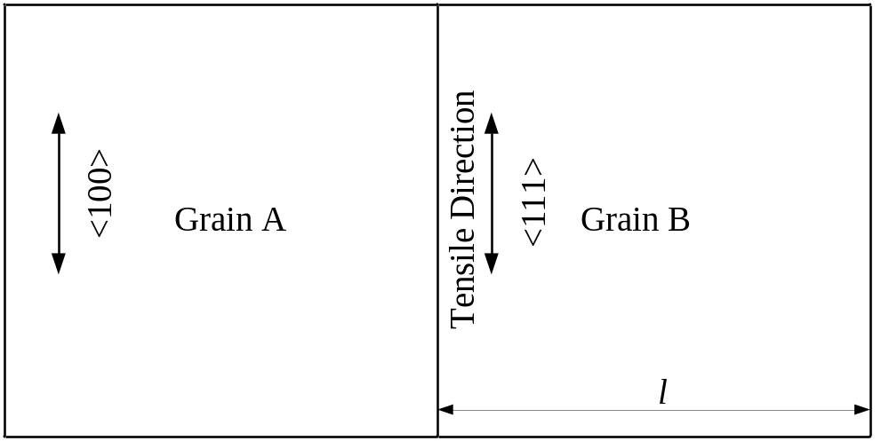

Fig.2
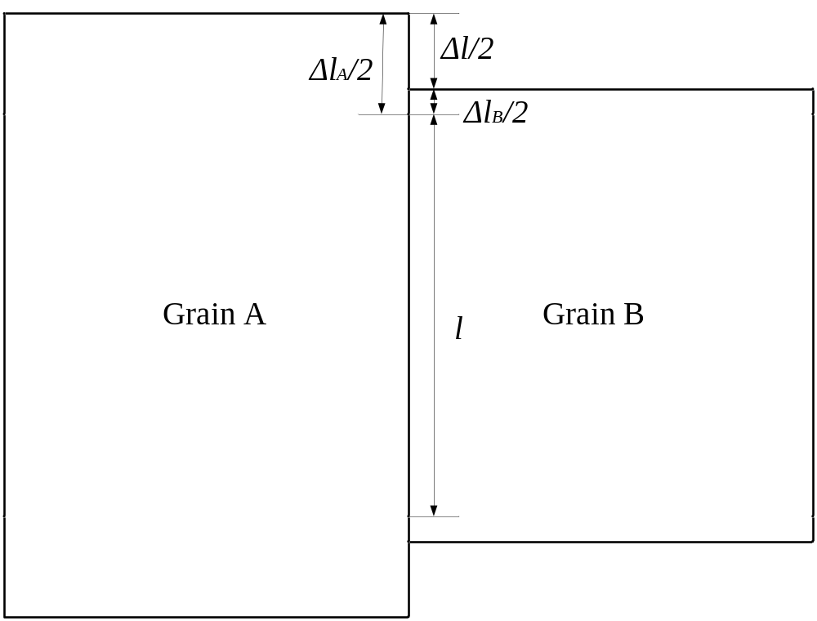

Fig.3
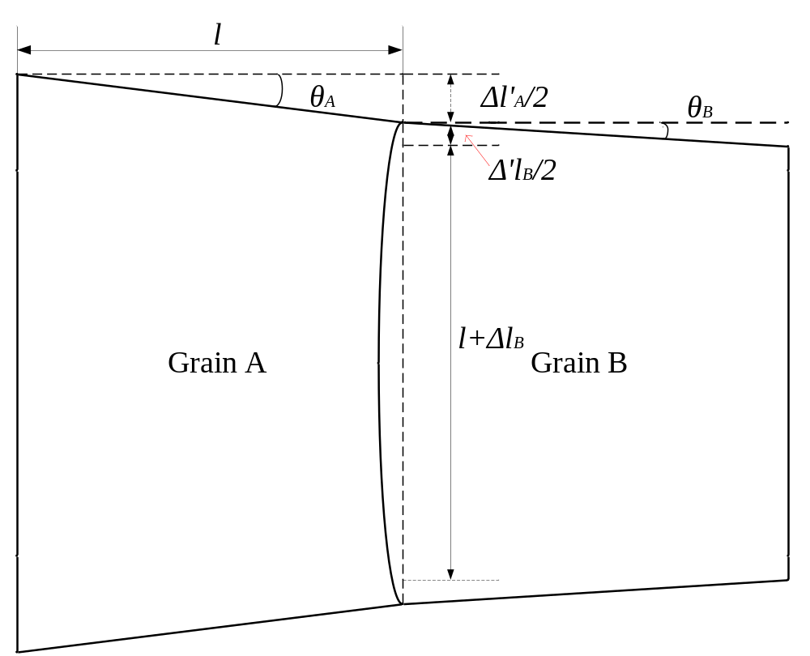

Fig.4
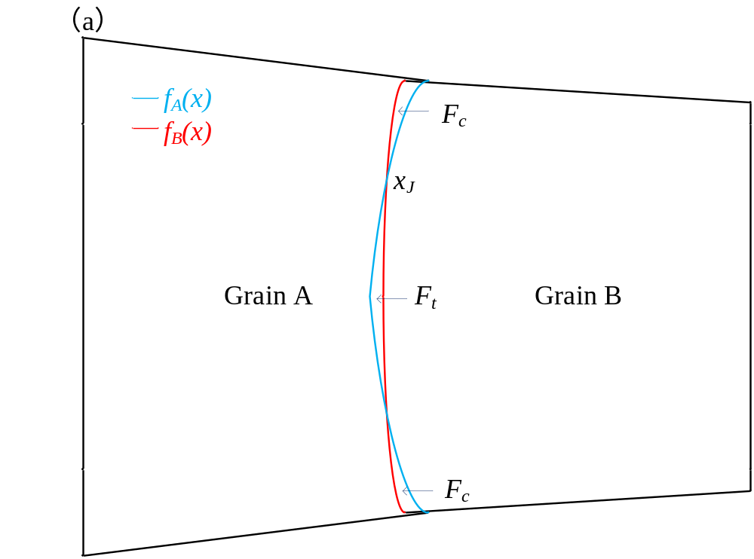
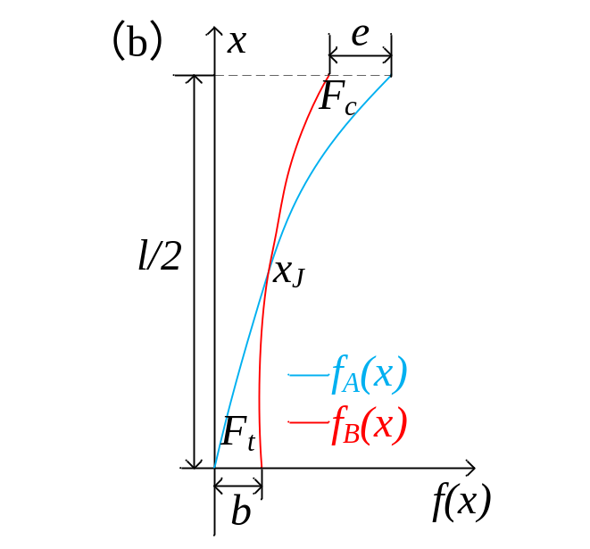

Fig.5
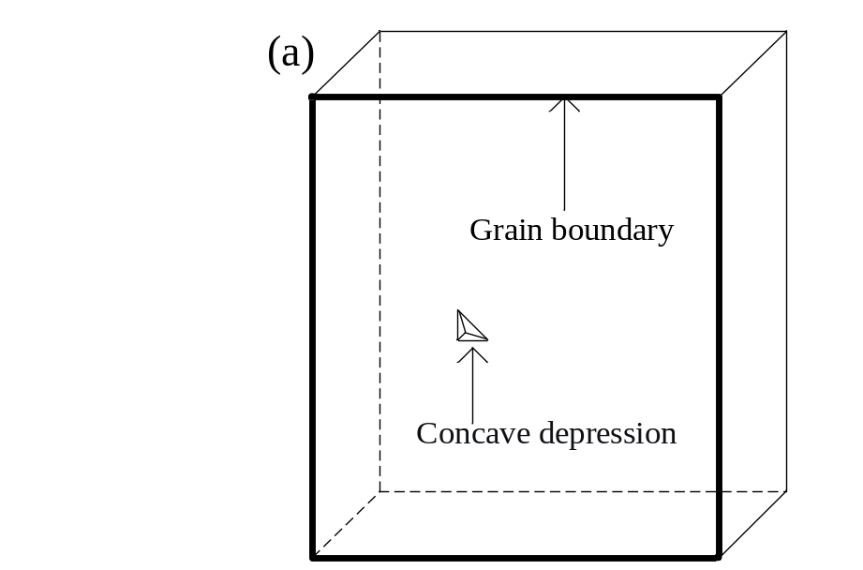
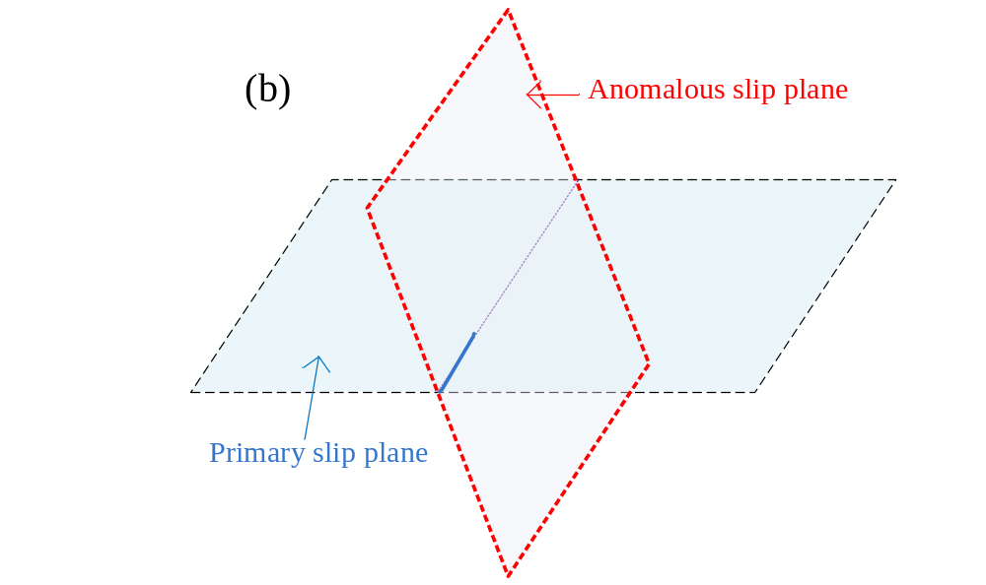

Fig. 6
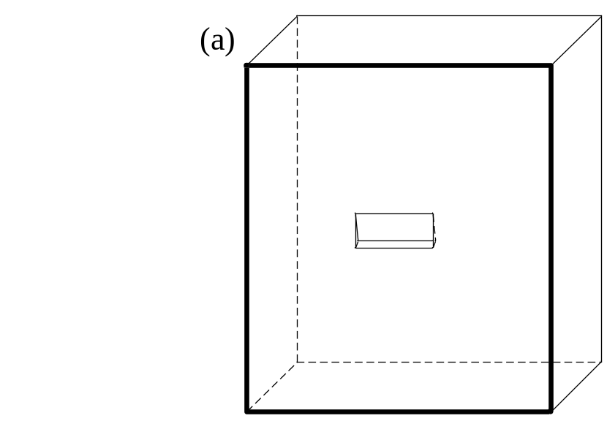
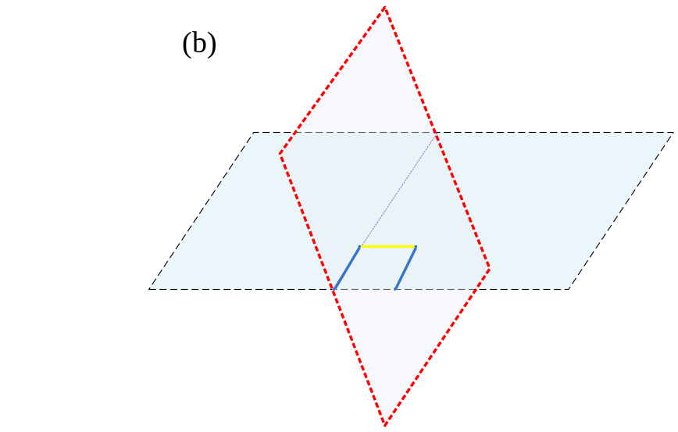

Fig. 7
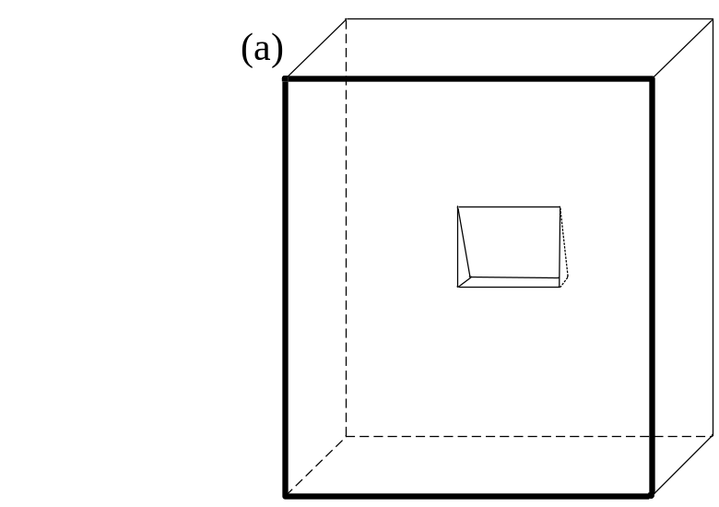
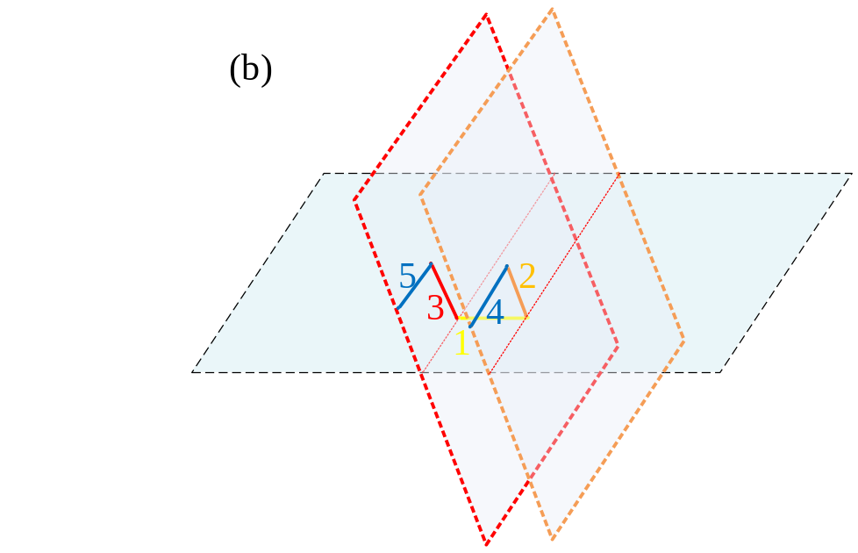
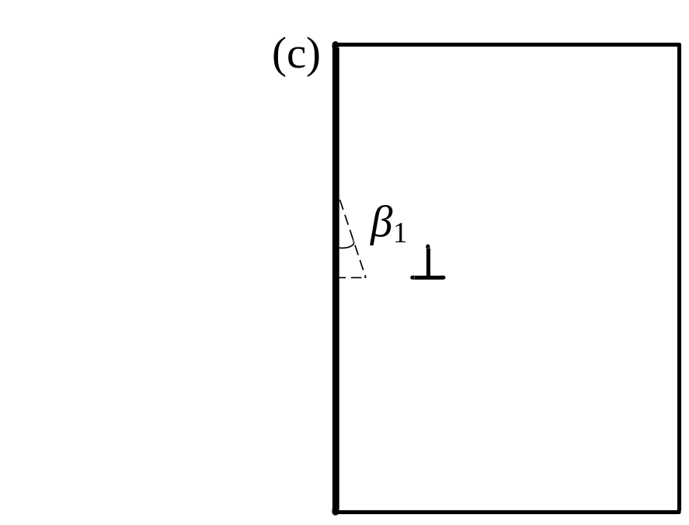

Fig. 8
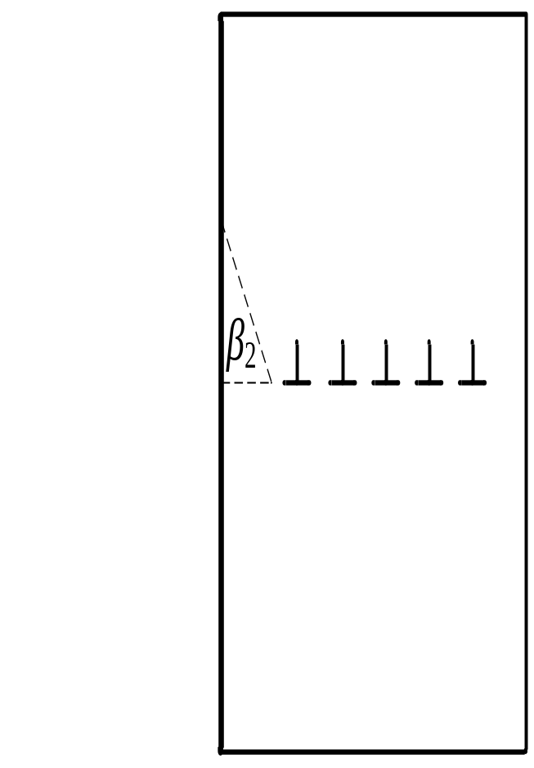

Fig. 9
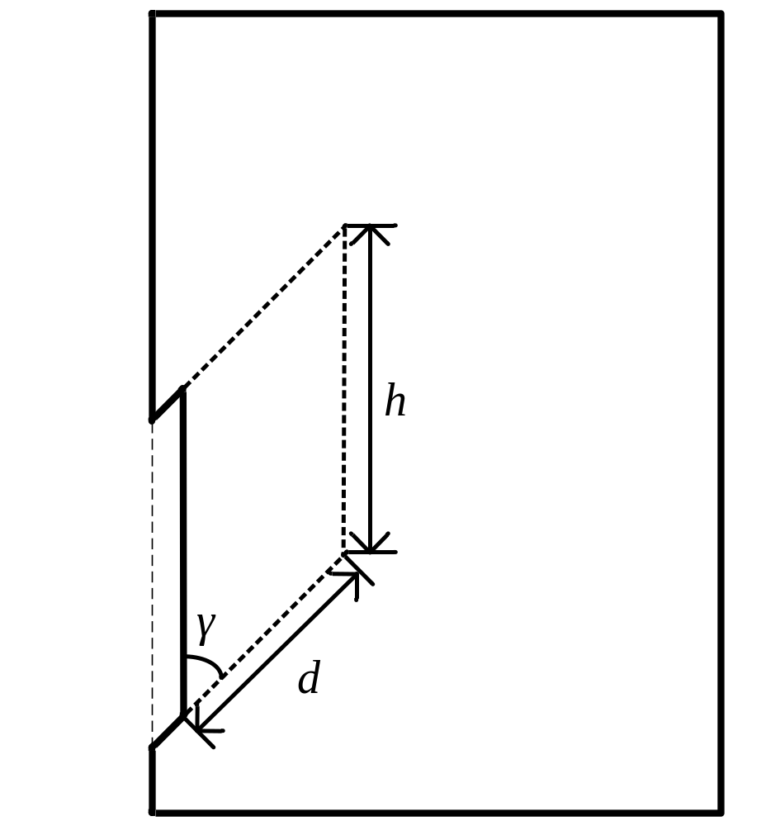

Fig. 10
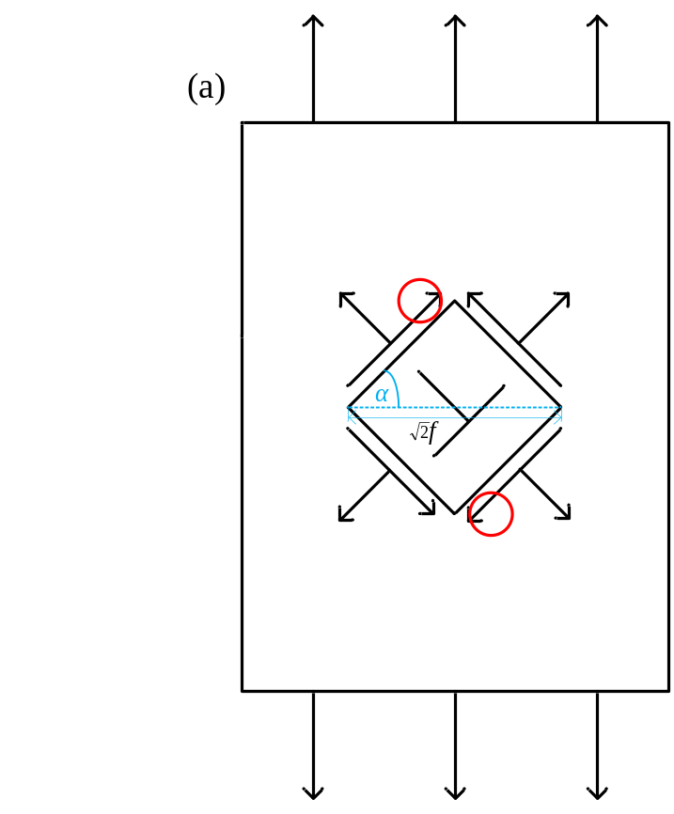
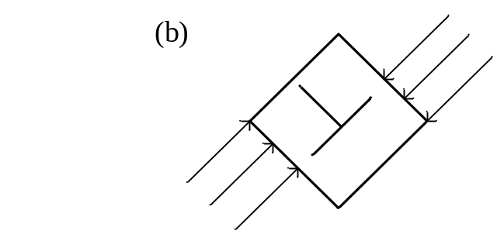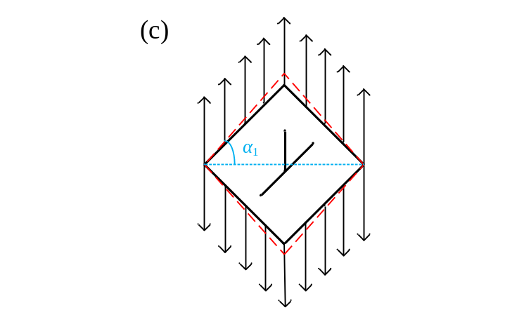

Fig. 11
