Effect of Divergent-Section Straight-Segment Length on Secondary-Injection Thrust Vector Control in a Planar Convergent–Divergent Nozzle: A RANS Study
Deepak Gupta^{1*} and Bhavesh Jindal²
¹Assistant Professor, Department of Aerospace, GNA University, Phagwara, Punjab 144401, India
²Undergraduate Student, Department of Aerospace, GNA University, Phagwara, Punjab 144401, India
*Corresponding author: deepakgupta7060@gmail.com

Abstract—Fluidic thrust vector control (FTVC) can redirect a propulsion jet without moving nozzle components, although its performance is sensitive to the nozzle contour near the injection location. This study presents steady, two-dimensional Reynolds-averaged Navier–Stokes (RANS) simulations of a planar convergent–divergent nozzle at a nozzle pressure ratio of approximately 8.9. The primary stagnation conditions are about 899 kPa and 500 K, while a hot secondary stream at approximately 139 kPa and 1000 K is introduced through a single port in the upper wall. Five divergent contours are considered: one fully curved contour and four variants with straight portions occupying 10%, 20%, 25%, or 30% of the divergent length. Each contour is evaluated with and without injection, for a total of ten cases. Integrated wall forces are checked against a control-volume momentum balance, with differences no greater than 3.5%; exit-plane thrust coefficients are within ±1.4% of the corresponding isentropic estimates. At secondary-to-primary mass-flow ratios of 0.16%–0.37%, the calculated side-force increments are 140–1078 N·m−1, the thrust-vector-angle increments are 0.01°–0.09°, and the amplification factors range from 0.29 to 1.92. For the geometrically consistent 10%, 20%, and 30% pairs, the exit-plane thrust change remains below 0.12%. Side force decreases monotonically with increasing straight-segment length across those three pairs, while the hot secondary flow reduces the viscous axial wall force by 5%–11%. The low secondary-to-primary stagnation-pressure ratio (approximately 0.155) restricts jet penetration, and the baseline side-force asymmetry is comparable in magnitude to the injection-induced change. These findings motivate grid-converged and three-dimensional follow-up studies.
Keywords—Computational fluid dynamics, convergent–divergent nozzle, fluidic thrust vectoring, secondary injection, shock vector control, shock–boundary-layer interaction, supersonic flow.
I. Introduction
Thrust vector control (TVC) provides directional authority for launch vehicles, tactical missiles, and maneuverable aircraft [1]. Conventional systems—including gimbaled nozzles, jet vanes, and mechanical deflectors—are established technologies, but require actuators and moving hardware exposed to severe exhaust conditions. Fluidic thrust vectoring (FTV) instead uses controlled secondary flows to alter the exhaust direction, and has consequently been investigated for several decades [2]–[4].
Deere [2] grouped the fluidic concepts investigated at NASA Langley Research Center into three principal categories: shock vector control, throat shifting, and counterflow. In shock vector control, also termed secondary-injection thrust vector control (SITVC), a transverse gas jet enters the supersonic divergent section and behaves like an obstruction. This interaction generates a separation zone and an oblique shock upstream of the port. The resulting asymmetric pressure loading on the nozzle wall, together with the jet reaction, produces a lateral force [5]–[7]. Throat-shifting and dual-throat arrangements skew the sonic line to redirect the primary stream [8]–[10], whereas counterflow systems deflect the shear layer by drawing flow along a collar [11]–[13].
Despite extensive investigation of these concepts, the effect of the divergent-wall geometry upstream of an SITVC port remains insufficiently quantified. Practical nozzles may contain a straight or conical segment immediately downstream of the throat, followed by a curved section. Changing the straight-segment length alters the local wall pressure and the compression waves produced where the wall curvature changes; both can affect the shock generated by secondary injection. The present work examines this coupling in a planar nozzle through ten steady RANS cases and explicitly discusses the verification evidence and limitations that constrain interpretation of the results.
II. Literature Review
A. Physics of Secondary Injection
Early theoretical studies represented the secondary jet as an equivalent solid obstacle. Broadwell [5] applied a blast-wave analogy to the injection interaction, while Karamcheti and Hsia [6] developed an integral method for estimating the resulting side force. Experiments by Zukoski and Spaid [7] and by Spaid and Zukoski [14] documented the principal features for circular and slot injectors, including the separation and bow shocks and the recirculation regions on either side of the jet. Zukoski [15] investigated how obstacle height affects separation upstream of a forward-facing step, and Malik and Tagirov [16] proposed a method for estimating the extent of the shock–boundary-layer interaction region.
Mahesh [17] reviewed the broader physics of jets in crossflow, and Huang [18] focused on supersonic crossflow conditions. Viti et al. [19] detailed the flow structures associated with supersonic jet interaction, while Erdem and Kontis [20] combined experimental measurements with numerical predictions for transverse injection. For slot injectors—the planar counterpart of the configuration considered here—Huang et al. [21] showed that predictions depend on both turbulence closure and slot width; Huang et al. [22] examined interactions between an incident shock and transverse slot injection. Work on dual transverse injection [23] and scale-resolving simulations of supersonic jet mixing [24]–[26] has also identified unsteady processes that steady RANS models cannot resolve.
B. Performance of SITVC Systems
Balu et al. [27] used three-dimensional Euler simulations to examine a hot-gas injection TVC system and evaluated secondary-jet amplification and axial-thrust augmentation from integrated wall pressures, reporting agreement with static-test measurements. Prince et al. [28] subsequently modeled the performance of a hot-gas system. Dhinagaran and Bose [29] compared Euler and Navier–Stokes predictions for injected nozzle flows and discussed the influence of viscosity. Other studies have addressed secondary injection into conical rocket nozzles [30] and measured the thrust losses associated with injecting air through nozzle walls [31].
A coordinated experimental and computational effort by Zmijanovic and colleagues examined shock vector control in axisymmetric nozzles [32]–[34], formulated an analytical model [35], and considered the role of injectant thermodynamic properties [36]. Deng et al. [37] simulated FTV in an axisymmetric supersonic nozzle. Chen and Liao [38] varied injection pressure, location, angle, and injectant properties, while Forghany et al. [39] investigated injection-angle optimization. Shi et al. [40], [41] studied confined transverse injection and its coupling with an aero-engine. Li et al. [42] proposed thrust pitching moment as a location-independent metric, and Ferlauto and Marsilio [43] numerically compared several FTV approaches.
C. Alternative Fluidic Concepts
Dual-throat and throat-skewing configurations have been explored using experiments and computation [10], [44]–[47]. Related work includes bypass designs [48] and large-eddy simulation of bypass-flow shock vector control [49]. Deere et al. [9] investigated separation control in a recessed cavity, while Anderson et al. [50] studied hybrid fluidic/mechanical vectoring. Counterflow systems have been examined under static conditions [11]–[13], in forward flight [51], and for hysteresis effects [52], [53]. Coflow injection [54] and combined thrust modulation and vectoring in planar nozzles [55] further broaden the available design options. Planar-nozzle experiments [56] and system-level studies [3] connect these concepts to vehicle applications.
D. Nozzle Contours and Flow Separation
Rao’s method provides bell-nozzle contours intended to maximize axial thrust for a specified length [57], and advanced nozzle designs are reviewed by Hagemann et al. [1]. Under overexpanded operation, the nozzle boundary layer can separate. Östlund and Muhammad-Klingmann [58] reviewed separation criteria for supersonic rocket-nozzle flows; Nasuti and Onofri [59] described shock structures in separated flows; Martelli et al. [60] numerically studied transitions between free and restricted shock separation; and Papamoschou et al. [61] characterized separation in planar nozzles.
Dual-bell nozzles contain an inflection between a base contour and an extension, making them a useful comparison for the contour junction examined in this study. Their design and transition behavior have been investigated analytically, numerically, and experimentally [62]–[68]. Further studies address ambient-pressure fluctuations [69], sneak transitions [70], film cooling [71], side loads [72], and cold-flow transition [73]–[75]. Secondary injection has also been used to control dual-bell transition [76]–[79], demonstrating that injection near a contour discontinuity can modify the wall-pressure field.
E. Turbulence Modeling and Verification
Shock–boundary-layer interaction (SWBLI) is a key mechanism in SITVC and has been reviewed in detail [80]–[84]. Among RANS closures, the shear-stress-transport (SST) k–ω model [85], [86] combines the near-wall k–ω formulation of Wilcox [87], [88] with a k–ε-type treatment in the outer flow [89]. The one-equation Spalart–Allmaras model [90] is another commonly used option. Compressibility corrections [91], detached-eddy simulation [92], and large-eddy simulation [93], [94] can provide additional physical detail at greater computational expense. Roe’s approximate Riemann solver [95], AUSM-family schemes [96], [97], and MUSCL reconstruction [98] are established choices for upwind discretization of compressible flows. Verification and validation methods are discussed in [99]–[103], while Richardson extrapolation [104] and the grid-convergence-index procedure of Celik et al. [105] are widely used to quantify discretization uncertainty.
F. Research Gap and Contributions
Previous studies identify injection location and local flow conditions as important controls on SITVC performance [34], [37], [38]. Research on dual-bell nozzles likewise indicates that a nearby contour discontinuity can substantially alter the injection interaction [76], [77]. However, the effect of varying the straight-wall length between the throat and a downstream curved contour has not been systematically documented. This paper therefore: (1) assembles a consistent ten-case set of forces, moments, and flow-field averages for five contours with and without injection; (2) checks integrated wall forces using an independent momentum balance and compares exit-plane thrust with isentropic estimates; (3) quantifies changes in side force, vector angle, amplification factor, and viscous force as functions of straight-segment length; and (4) identifies modeling and numerical limitations and proposes follow-up work.
III. Problem Formulation and Numerical Method
A. Geometry and Test Matrix
The computational domain is a two-dimensional planar convergent–divergent nozzle, extending from a stagnation-condition inlet through a conical convergent section and throat to the exit plane (Fig. 1). The principal dimensions are provided in Table I. The inlet and exit heights are 1150 mm, the throat height is 300 mm, and the overall length is 2775 mm, corresponding to a geometric exit-to-throat area ratio of 3.833. The divergent length, Ld, consists of a straight section of length Ls beginning at the throat and a downstream curved section that directs the flow toward the nozzle axis. The straight-section fraction is s = Ls/Ld; the cases are s = 0, 0.10, 0.20, 0.25, and 0.30. A single 30-mm-wide secondary port is positioned on the upper divergent wall, 1456.875 mm from the inlet. Mass-flow results (Section V-A) imply an effective throat height near 0.288 m and effective area ratios of 3.74–4.12 (Table IV). The difference from the geometric ratio corresponds to discharge coefficients of 0.93–0.99 and is attributed to boundary-layer blockage and sonic-line curvature.
TABLE I
Geometry Specification
Parameter | Value
Inlet height | 1150 mm
Throat height, h_{t} | 300 mm
Outlet height, h_{e} | 1150 mm
Injector axial position, x_{j}ª | 1456.875 mm
Injector width, w_{j} | 30 mm
Total nozzle length | 2775 mm
Geometric area ratio, A_{e}/A_{t} | 3.833
ªMeasured from the inlet; given for Case 3 as the “3rd injector length.” Confirm that it applies to all five geometries.
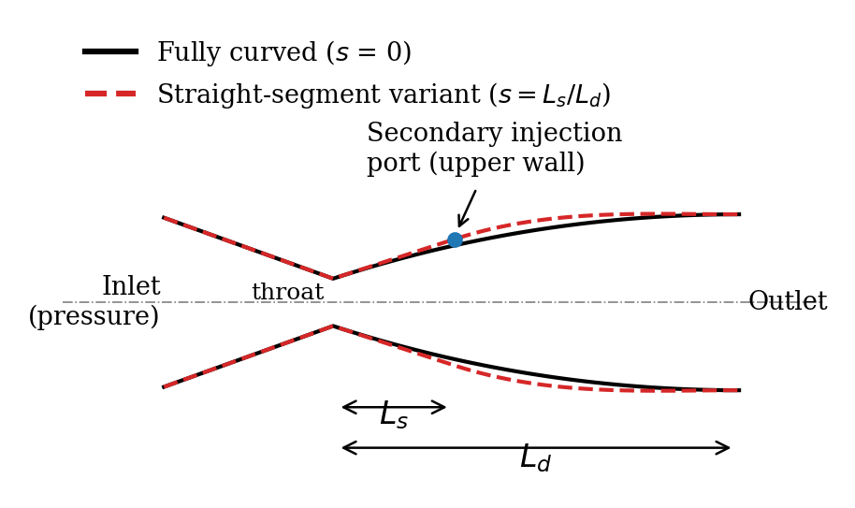
Fig. 1. Schematic of the planar convergent–divergent nozzle (not to scale). The solid line is the fully curved contour (s = 0); the dashed line is a straight-segment variant in which a straight wall of length L_{s} extends downstream of the throat before the curved contour begins (s = L_{s}/L_{d} > 0). The filled circle marks the upper-wall secondary injection port; the dash-dotted line is the nozzle axis.
B. Governing Equations
The flow is treated as steady, compressible, and turbulent, with air represented as a calorically perfect ideal gas. The Favre-averaged conservation equations for mass, momentum, and energy are given in [94].
$∇·\left(ρu\right)=0$ (1)
where ∇· is the divergence operator (m⁻¹), ρ is the Favre-averaged density (kg·m⁻³), and 𝐮 is the Favre-averaged velocity vector (m·s⁻¹). Equation (1) states that the net mass flux out of any control volume is zero in steady flow.
$∇·\left(ρu⊗u\right)=-∇p+∇·τ_{eff}$ (2)
where 𝐮⊗𝐮 is the dyadic (outer) product of the velocity with itself, p is the static pressure (Pa), ∇p is its gradient, and τ_{eff} is the effective stress tensor (Pa), which contains both the molecular viscous stress and the modeled turbulent (Reynolds) stress.
$∇·\left[u\left(ρE+p\right)\right]=∇·\left(k_{eff}∇T+τ_{eff}·u\right)$ (3)
where E is the total specific energy (J·kg⁻¹), k_{eff} = k_{th} + c_{p}μ_{t}/Pr_{t} is the effective thermal conductivity (W·m⁻¹·K⁻¹), composed of the molecular conductivity k_{th} and a turbulent contribution with turbulent Prandtl number Pr_{t}, T is the static temperature (K), and τ_{eff}·𝐮 represents the work done by viscous and turbulent stresses.
$τ_{eff}=\left(μ+μ_{t}\right)\left[\left(∇u+{∇u}^{T}\right)-\frac{2}{3}\left(∇·u\right)I\right]$ (4)
where μ is the molecular dynamic viscosity (Pa·s), μ_{t} is the eddy viscosity supplied by the turbulence model (Pa·s), ∇𝐮 is the velocity-gradient tensor and ∇𝐮^{T} its transpose, ∇·𝐮 is the velocity divergence (dilatation, s⁻¹), and 𝐈 is the identity tensor. The term in brackets is twice the deviatoric strain-rate tensor.
$E=c_{v}T+\frac{{|u|}^{2}}{2}$ (5)
where c_{v} is the specific heat at constant volume (J·kg⁻¹·K⁻¹), c_{v}T is the specific internal energy, and |𝐮|²/2 is the specific kinetic energy.
$p=ρRT$ (6)
where R = 287 J·kg⁻¹·K⁻¹ is the specific gas constant of air. With the ratio of specific heats γ = c_{p}/c_{v} = 1.4, (6) closes the system (1)–(5).
$M=\frac{|u|}{\sqrt{γRT}}$ (7)
where M is the local Mach number and √(γRT) is the local speed of sound (m·s⁻¹). M is the principal quantity used to interpret the contour plots.
Turbulence is represented by the SST k–ω model of Menter [85]. The transport equations for the turbulent kinetic energy and its specific dissipation rate are
$∇·\left(ρuk\right)={P̃}_{k}-β^{*}ρkω+∇·\left[\left(μ+σ_{k}μ_{t}\right)∇k\right]$ (8)
where k is the turbulent kinetic energy (m²·s⁻²), P̃_{k} is its production rate with the SST production limiter (kg·m⁻¹·s⁻³), β∗ = 0.09 is a model constant, ω is the specific dissipation rate (s⁻¹), and σ_{k} is the turbulent Prandtl number for k, obtained by blending σ_{k1} = 0.85 and σ_{k2} = 1.0 through (11).
$∇·\left(ρuω\right)=αρS^{2}-βρω^{2}+∇·\left[\left(μ+σ_{ω}μ_{t}\right)∇ω\right]+2\left(1-F_{1}\right)ρσ_{ω2}\frac{∇k·∇ω}{ω}$ (9)
where S is the magnitude of the strain-rate tensor (s⁻¹); α, β, and σ_{ω} are blended model coefficients (α₁ = 5/9, β₁ = 0.075, σ_{ω1} = 0.5 in the inner layer; α₂ = 0.44, β₂ = 0.0828, σ_{ω2} = 0.856 in the outer layer); F₁ is the first blending function, equal to one near walls and zero in the free stream; and the last term is the cross-diffusion term that arises from transforming the k–ε model [89] into k–ω form.
$μ_{t}=\frac{ρa_{1}k}{max\left(a_{1}ω, SF_{2}\right)}$ (10)
where a₁ = 0.31 is the structure-parameter constant and F₂ is the second blending function, equal to one in boundary layers. The limiter prevents the overprediction of μ_{t} in adverse-pressure-gradient boundary layers, which is relevant to the SWBLI produced by the secondary jet [86].
$φ=F_{1}φ_{1}+\left(1-F_{1}\right)φ_{2}$ (11)
where φ denotes any of the model coefficients (σ_{k}, σ_{ω}, α, β), φ₁ is its value in the inner (k–ω) layer, and φ₂ its value in the outer (k–ε-like) region.
C. Boundary Conditions and Operating Point
The primary boundary is specified as a pressure inlet and the nozzle exit as a pressure outlet. Static pressures are reported as gauge values relative to the operating pressure of 101 325 Pa, taken as ambient pressure pa. This interpretation is supported by the ideal-gas relation (6), which reproduces the reported inlet density to within 0.1% only when ambient pressure is included. The stagnation state is recovered from the computed inlet averages using the isentropic relations.
The imposed boundary conditions are listed in Table II. The primary inlet total pressure of 800 kPa gauge corresponds to 901 kPa absolute, and the injector total pressure of 38 kPa gauge to 139 kPa absolute.
TABLE II
Boundary Conditions
Boundary condition | Value
Primary inlet pressure, P_{in} | 800 kPa (gauge)
Primary inlet temperature, T_{in} | 500 K
Secondary injection pressure, P_{inj} | 38 kPa (gauge)
Secondary injection temperature, T_{inj} | 1000 K
Working fluid | Air (ideal gas)
Secondary pressure ratio, SPR^{b} | 1.05
Outlet | Pressure outlet, 0 Pa (gauge)
Wall condition | No-slip, adiabatic
^{b}As specified. State which pressures form this ratio. Baseline cases use the same primary conditions with the injector closed.
$\frac{T_{0}}{T}=1+\frac{γ-1}{2}M^{2}$ (12)
where T₀ is the stagnation temperature (K) and T and M are the area-averaged static temperature and Mach number at the inlet.
$\frac{p_{0}}{p}={\left(1+\frac{γ-1}{2}M^{2}\right)}^{\frac{γ}{γ-1}}$ (13)
where p₀ is the stagnation pressure (Pa, absolute) and p is the absolute static pressure at the inlet, i.e., the gauge value plus p_{a}.
Equations (12) and (13) give p₀ ≈ 899 kPa (absolute) and T₀ ≈ 500 K for all ten cases, so that the nozzle pressure ratio is NPR = p₀/p_{a} ≈ 8.88. Applied to the injector averages, they give p_{0s} ≈ 139 kPa and T_{0s} ≈ 1000 K. The walls are adiabatic and no-slip. For reference, the one-dimensional isentropic area–Mach relation and choked mass flux are
$\frac{A}{A^{*}}=\frac{1}{M}{\left[\frac{2}{γ+1}\left(1+\frac{γ-1}{2}M^{2}\right)\right]}^{\frac{γ+1}{2(γ-1)}}$ (14)
where A is the local cross-sectional area per unit depth (m), A∗ is the sonic (throat) area per unit depth (m), and M is the corresponding isentropic Mach number; for a given area ratio A/A∗ > 1, (14) has one subsonic and one supersonic root.
$\frac{ṁ}{A^{*}}=\frac{p_{0}}{\sqrt{T_{0}}}\sqrt{\frac{γ}{R}}{\left(\frac{2}{γ+1}\right)}^{\frac{γ+1}{2(γ-1)}}$ (15)
where ṁ is the mass flow rate per unit depth (kg·s⁻¹·m⁻¹) through the choked throat. At the present stagnation state, (15) gives 1626 kg·s⁻¹·m⁻², which was used to infer the effective throat height from the computed mass flow.
D. Numerical Method
The governing equations were solved in Ansys Fluent 2026 R1 using a steady pressure-/density-based formulation and second-order upwind spatial discretization. For compressible supersonic nozzle calculations, commonly used density-based approaches include Roe-type [95] or AUSM-family fluxes [96], [97] with MUSCL reconstruction [98]. The computational mesh is structured and quadrilateral, with clustering near the walls, as seen in the contours in Section V. The mesh cell count and near-wall resolution are reported as N ≈ __ cells and y+ ≈ __; Table III summarizes the numerical setup.
TABLE III
Numerical Setup
Item | Setting
Solver | Ansys Fluent 2026 R1, pressure-/density-based, steady
Dimensionality | 2-D planar; forces per unit depth (N·m⁻¹)
Turbulence model | k–ω SST [85]
Working fluid | Air, ideal gas, γ = 1.4, R = 287 J·kg⁻¹·K⁻¹
Primary inlet | Pressure inlet, p₀ ≈ 899 kPa abs., T₀ ≈ 500 K
Secondary inlet | Pressure inlet, p_{0s} ≈ 139 kPa abs., T_{0s} ≈ 1000 K
Outlet | Pressure outlet, p_{a} = 101.325 kPa
Walls | No-slip, adiabatic
Mesh | Structured quadrilateral, N ≈ __ cells, y⁺ ≈ __
Discretization | Second-order upwind
Convergence | Residuals ≤ 10⁻⁴ (continuity), ≤ 10⁻⁵ (others); flat force and mass-flow monitors; net mass imbalance < 0.001%
E. Convergence
Iterations continued until the scaled residuals had decreased by at least four orders of magnitude and the monitored axial wall force and mass-flow rates had stabilized. Figure 2 contains residual histories for the nine cases for which records were available; the force and mass-flow monitors, which are not plotted, became steady after approximately 40 iterations. Convergence required 105–125 iterations. The continuity residual reached about 10−4, while the remaining residuals fell to 10−7–10−5. A transient rise near iteration 15 appears in every case and coincides with the establishment of supersonic flow in the divergent section. In all cases, the net mass imbalance—including the secondary stream—remained below 0.001% of the inlet mass flow (Table VI).
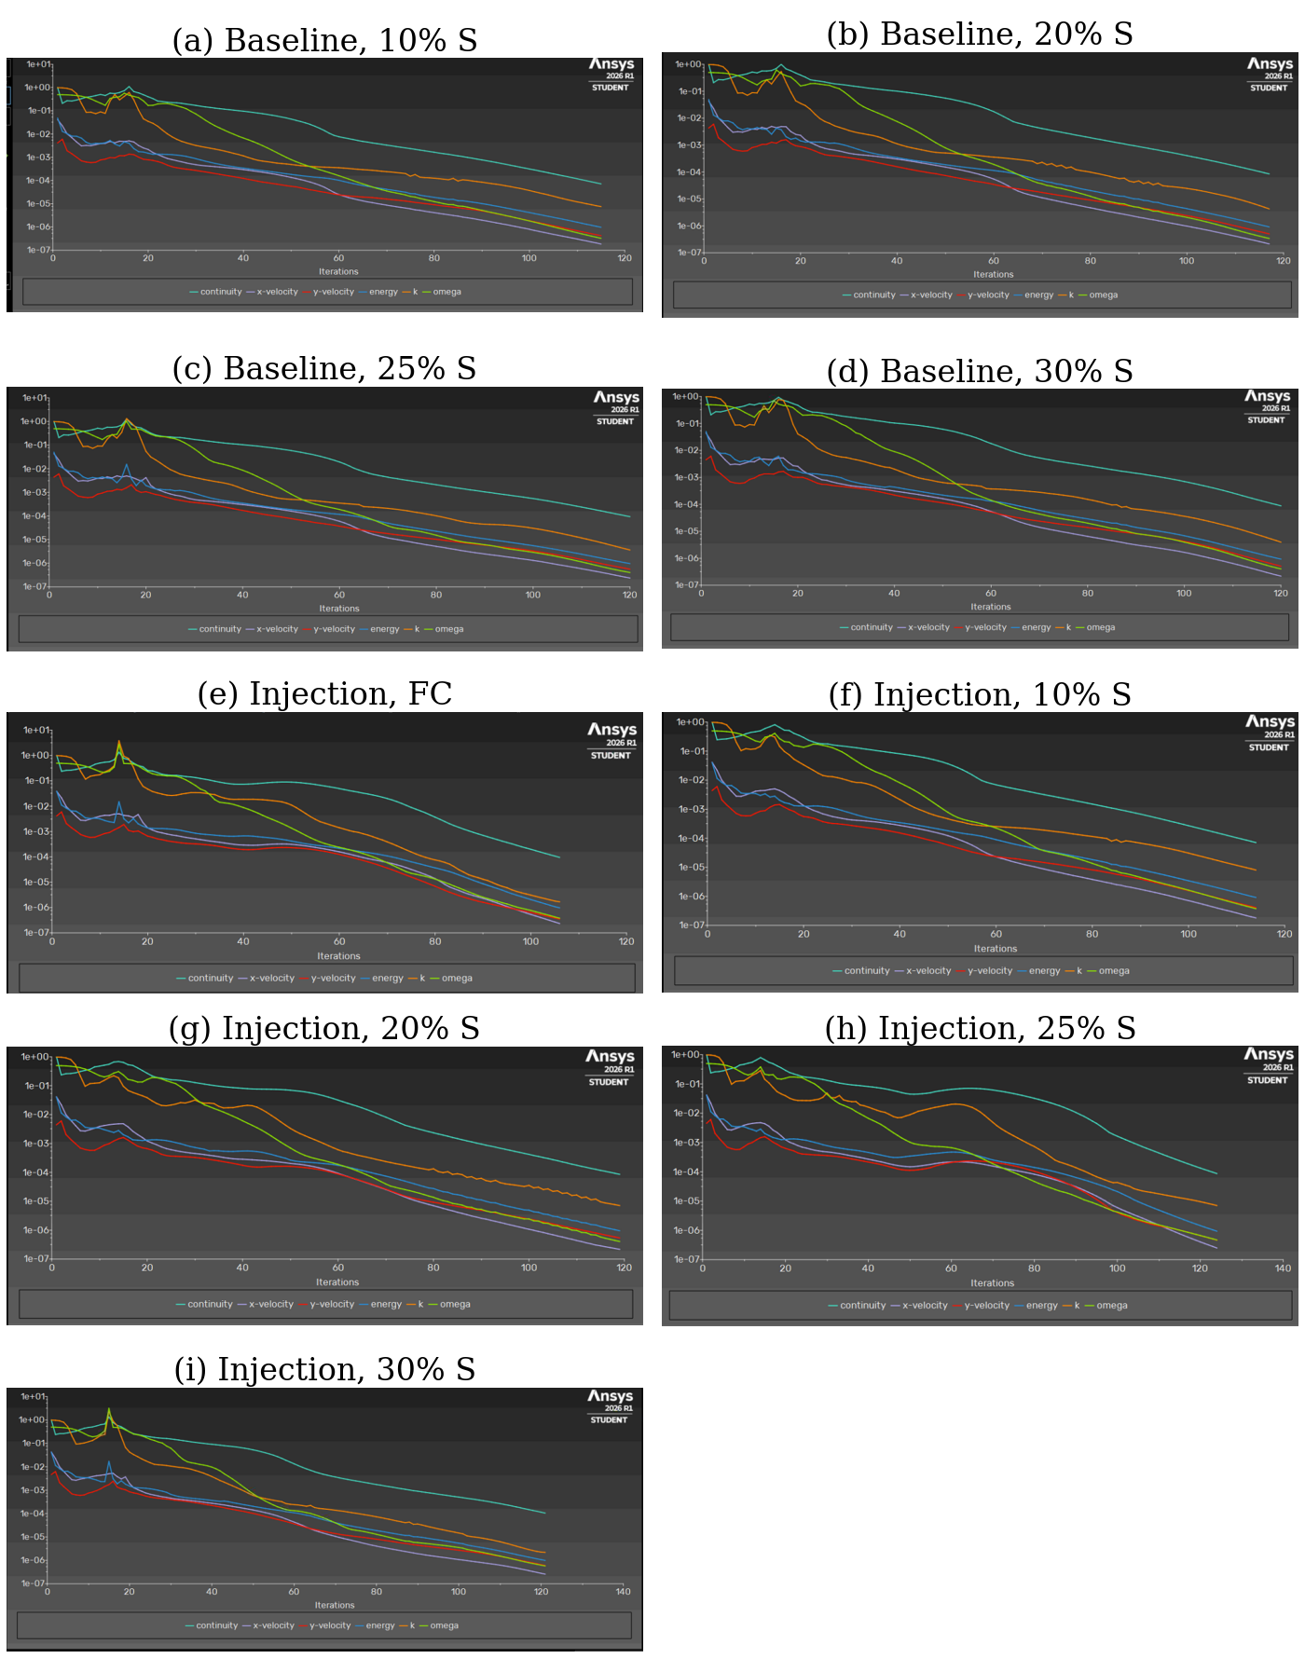
Fig. 2. Scaled residual histories (continuity, x- and y-velocity, energy, k, and ω) versus iteration. Baseline cases without injection: (a) 10%, (b) 20%, (c) 25%, and (d) 30% straight segment. Cases with single-port injection: (e) fully curved (FC), (f) 10%, (g) 20%, (h) 25%, and (i) 30% straight segment. All residuals fall by at least four orders of magnitude; continuity ends near 10⁻⁴.
IV. Performance Metrics
The force exerted by the flow on the nozzle walls is calculated by integrating gauge pressure and viscous traction over the wall surface:
$F_{w}=∮_{S_{w}}\left(-p_{g}n+τ·n\right) dS$ (16)
where 𝐅_{w} = (F_{x}, F_{y}) is the wall-force vector per unit depth (N·m⁻¹), S_{w} is the wall boundary, p_{g} = p − p_{a} is the gauge pressure (Pa), 𝐧 is the unit normal pointing from the fluid into the wall, τ·𝐧 is the viscous traction (Pa), and dS is the element of wall length. The first term gives the pressure force and the second the viscous force; both are reported separately in Table VI.
An independent control-volume momentum balance, evaluated using area-averaged inlet and exit quantities, provides a check on the axial component:
$F_{w,x}≈{p̄}_{g,i}A_{i}-{p̄}_{g,e}A_{e}+ṁ\left({V̄}_{i}-{V̄}_{e}\right)$ (17)
where F_{w,x} is the axial wall force per unit depth (N·m⁻¹); p̄_{g,i} and p̄_{g,e} are the area-averaged gauge static pressures at the inlet and exit (Pa); A_{i} = ṁ/(ρ̄_{i}V̄_{i}) and A_{e} = ṁ/(ρ̄_{e}V̄_{e}) are the inlet and exit areas per unit depth (m) inferred from the averages; ṁ is the mass flow per unit depth; and V̄_{i} and V̄_{e} are the area-averaged velocity magnitudes (m·s⁻¹).
The computational domain excludes the chamber head end; accordingly, the axial wall force is not equivalent to engine thrust. Thrust per unit depth is instead estimated at the nozzle exit plane as follows:
$F_{T}=ṁ_{e}{V̄}_{e}+\left({p̄}_{e}-p_{a}\right)A_{e}$ (18)
where F_{T} is the thrust per unit depth (N·m⁻¹), ṁ_{e} is the exit mass flow, ṁ_{e}V̄_{e} is the momentum thrust, and (p̄_{e} − p_{a})A_{e} is the pressure thrust, which is negative for an overexpanded nozzle.
The thrust is normalized to obtain the thrust coefficient and is compared with the one-dimensional isentropic value for the same area ratio [1]:
$C_{F}=\frac{F_{T}}{p_{0}A^{*}}$ (19)
where C_{F} is the thrust coefficient and A∗ is the effective throat area per unit depth obtained from the computed mass flow through (15).
$C_{F,id}=\sqrt{\frac{2γ^{2}}{γ-1}{\left(\frac{2}{γ+1}\right)}^{\frac{γ+1}{γ-1}}\left[1-{\left(\frac{p_{e}}{p_{0}}\right)}^{\frac{γ-1}{γ}}\right]}+\frac{p_{e}-p_{a}}{p_{0}}ε$ (20)
where C_{F,id} is the isentropic thrust coefficient, p_{e} is the isentropic exit pressure for the area ratio ε = A_{e}/A∗ obtained from (14) and (13), and p_{a}/p₀ is the inverse of the NPR. The ratio η = C_{F}/C_{F,id} serves as a consistency check of the exit-plane estimate.
The thrust-vector angle, injection-induced side-force increment, and amplification factor are defined as follows:
$δ=\tan^{-1}\left(\frac{F_{y}}{F_{x}}\right)$ (21)
where δ is the thrust-vector angle (deg) and F_{y} and F_{x} are the side and axial wall forces from (16). Because F_{x} is the wall force rather than the thrust, δ is a wall-force angle that is conservative with respect to the true vector angle [42].
$ΔF_{y}=F_{y}^{inj}-F_{y}^{base}$ (22)
where ΔF_{y} is the injection-induced side-force increment (N·m⁻¹), F_{y}^{inj} is the side force with injection, and F_{y}^{base} is the side force of the corresponding baseline. Subtracting the baseline removes, to first order, any side force that exists without injection.
$K=\frac{ΔF_{y}/ṁ_{s}}{F_{T}/ṁ_{p}}$ (23)
where K is the amplification factor [27], ṁ_{s} is the secondary mass flow, ṁ_{p} is the primary mass flow, ΔF_{y}/ṁ_{s} is the side-specific impulse of the injectant (N·s·kg⁻¹), and F_{T}/ṁ_{p} is the axial specific impulse of the primary stream. K > 1 means that the injectant produces more side force per unit mass than the primary stream produces thrust per unit mass.
$Π_{m}=\frac{ṁ_{s}}{ṁ_{p}}, Π_{p}=\frac{p_{0s}}{p_{0}}$ (24)
where Π_{m} is the injection mass-flow ratio, Π_{p} is the injector-to-primary stagnation-pressure ratio, and p_{0s} is the injector stagnation pressure (Pa, absolute). These two ratios are the principal independent parameters of SITVC studies [34], [36], [38].
The solver’s default reference quantities—unit area, density of 1.225 kg·m−3, and velocity of 1 m·s−1—make the monitor labeled “drag coefficient” numerically equal to Fx/0.6125. This monitor therefore has no independent aerodynamic interpretation; the analysis uses dimensional forces throughout.
V. Results and Discussion
A. Verification of Integrated Quantities
Figure 3 contrasts the axial wall force obtained by direct integration of (16) with the estimate from the momentum balance (17). Across the ten cases, the difference is 1.4%–3.5%, with direct integration consistently giving the slightly larger value. This small systematic offset is compatible with the use of area-averaged rather than flux-weighted exit properties in (17), which gives disproportionate weight to the low-momentum boundary layer. The agreement indicates that the integrated forces and averaged flow quantities are mutually consistent.
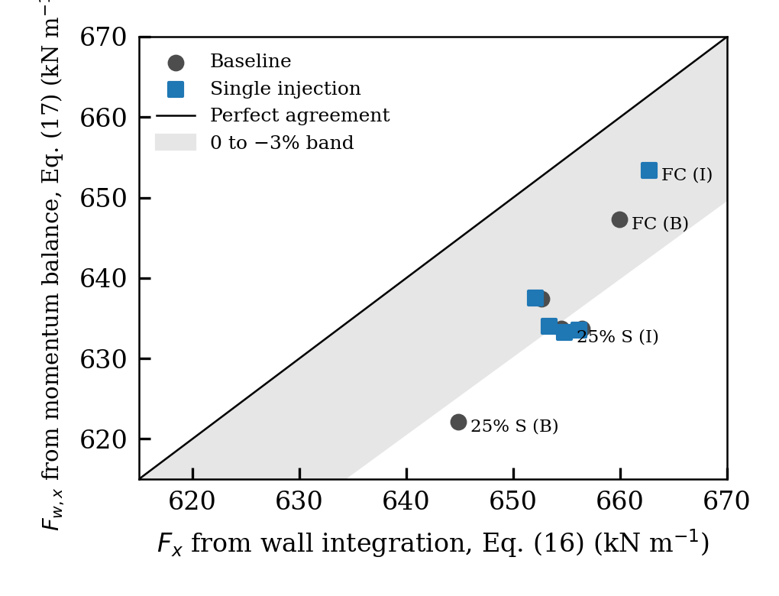
Fig. 3. Verification of the axial wall force: direct integration of wall pressure and shear, Eq. (16), versus the control-volume momentum balance, Eq. (17). Circles denote baseline cases (B) and squares injection cases (I). All points lie within 0 to −3.5% of the line of perfect agreement (shaded band shows 0 to −3%).
Table IV summarizes the effective throat area, area ratio, and thrust coefficients. For both baseline and injection cases, the primary mass flow is 468.8 kg·s−1·m−1 for the 10%, 20%, and 30% contours, indicating matching throat geometry within each pair. The fully curved cases (456.6 and 452.0 kg·s−1·m−1) and the 25% baseline (483.4 kg·s−1·m−1, compared with 468.5 kg·s−1·m−1 under injection) do not match. Their effective throat heights are approximately 2.6%–3.6% smaller and 3.1% larger, respectively. Consequently, comparisons for these two contours include a geometric effect as well as the influence of injection and are identified accordingly. The ratio η = CF/CF,id ranges from 0.986 to 1.008, within ±1.4% of unity. Values slightly above unity are not physically realizable as efficiencies; instead, they indicate approximately ±1% uncertainty in the exit-plane estimate (18), which uses area-averaged quantities and assumes a unit discharge coefficient in (15). Losses smaller than this uncertainty cannot be resolved.
TABLE IV
Effective Geometry and Thrust Coefficient
Case | A∗ (m) | ε | M_{e,is} | M̄_{e} | C_{F} | C_{F,id} | η
B FC | 0.2807 | 4.095 | 2.965 | 2.874 | 1.0912 | 1.1026 | 0.9897
I FC | 0.2780 | 4.124 | 2.972 | 2.839 | 1.0849 | 1.1002 | 0.9861
B 10% | 0.2883 | 3.966 | 2.931 | 2.905 | 1.1111 | 1.1133 | 0.9980
I 10% | 0.2883 | 3.976 | 2.934 | 2.882 | 1.1107 | 1.1125 | 0.9985
B 20% | 0.2883 | 3.888 | 2.910 | 2.940 | 1.1254 | 1.1197 | 1.0051
I 20% | 0.2883 | 3.898 | 2.913 | 2.898 | 1.1241 | 1.1188 | 1.0047
B 25% | 0.2973 | 3.742 | 2.870 | 2.906 | 1.1380 | 1.1314 | 1.0058
I 25% | 0.2881 | 3.893 | 2.912 | 2.910 | 1.1277 | 1.1193 | 1.0075
B 30% | 0.2883 | 3.866 | 2.904 | 2.920 | 1.1253 | 1.1214 | 1.0035
I 30% | 0.2881 | 3.868 | 2.905 | 2.910 | 1.1266 | 1.1213 | 1.0047
B: baseline; I: injection. M_{e,is} is the isentropic exit Mach number for area ratio ε from (14); M̄_{e} is the computed area-averaged exit Mach number.
The area-averaged exit Mach number differs from the isentropic value at the same area ratio by −0.13 to +0.04. The largest shortfalls occur in the fully curved nozzle, whereas several straight-segment baseline cases show small positive differences. These deviations reflect competing effects: the low-Mach boundary layer reduces the area average, while the nonuniform internal wave field can produce local values above the one-dimensional prediction. The isentropic relations are therefore used as a consistency check rather than as a detailed representation of the exit flow.
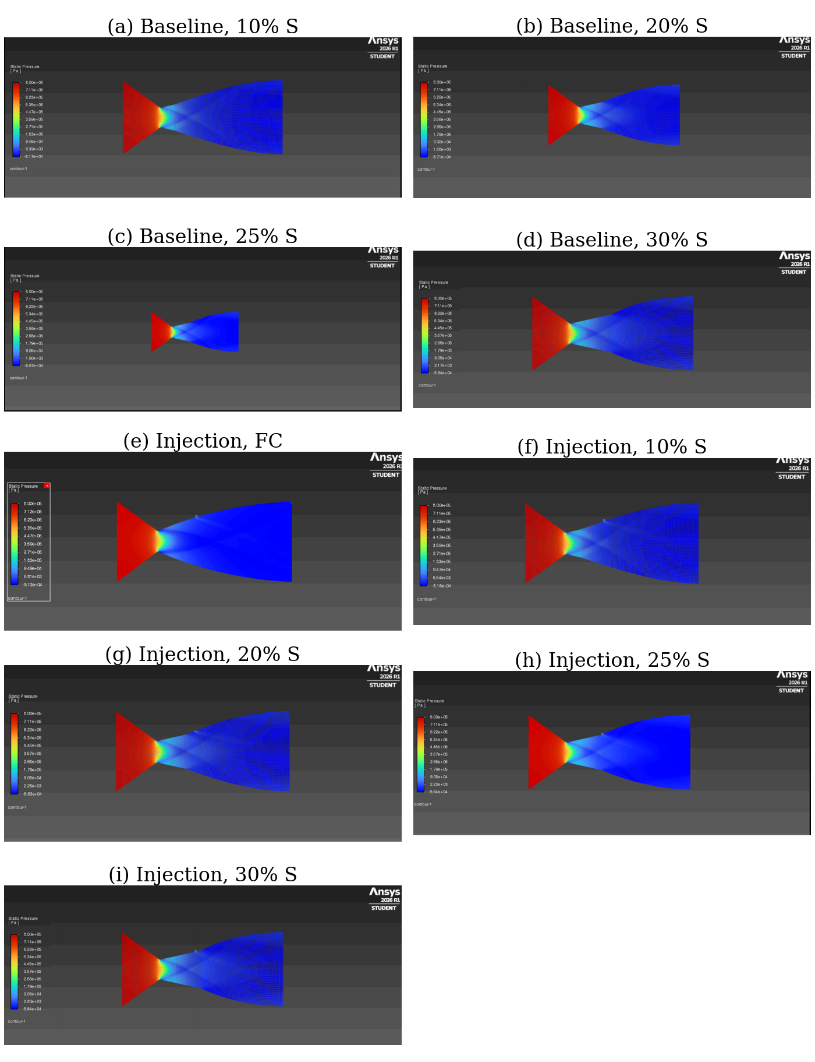
Fig. 4. Static-pressure contours (gauge, Pa; scale approximately −8×10⁴ to 8.0×10⁵ Pa). Baseline: (a) 10%, (b) 20%, (c) 25%, and (d) 30% straight segment. With injection: (e) fully curved, (f) 10%, (g) 20%, (h) 25%, and (i) 30% straight segment. The pressure falls from about 7.8×10⁵ Pa in the convergent section to negative gauge values in the divergent section; the local disturbance on the upper wall in (e)–(i) marks the injection port.
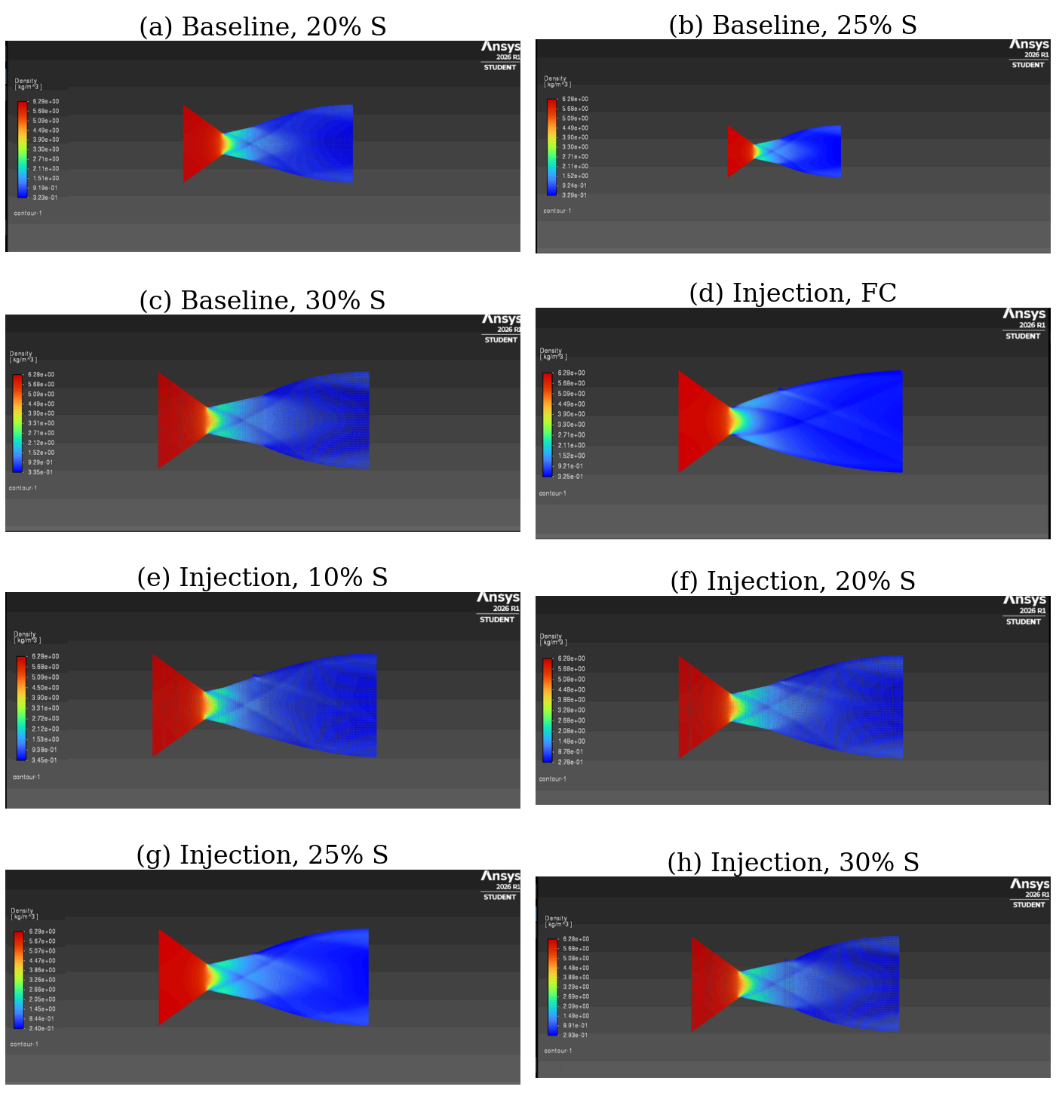
Fig. 5. Density contours (kg·m⁻³; scale approximately 0.24–6.29 kg·m⁻³). Baseline: (a) 20%, (b) 25%, and (c) 30% straight segment. With injection: (d) fully curved, (e) 10%, (f) 20%, (g) 25%, and (h) 30% straight segment. The crossing oblique-wave pattern in the divergent core is clearly visible; the low-density hot injectant appears as a thin layer along the upper wall downstream of the port.
B. Baseline Flow Field
Figures 4–8 show the computed static pressure, density, Mach number, velocity, and static-temperature fields. In every baseline case, the flow chokes at the throat and accelerates to an area-averaged exit Mach number of 2.87–2.94 (Fig. 6(a)–(d)). Static pressure decreases from approximately 785 kPa gauge in the inlet region to −69 to −74 kPa gauge (27–33 kPa absolute) at the exit. Thus, at the specified pressure ratio, the nozzle is overexpanded, with pe/pa approximately 0.27–0.32 (Fig. 4).
In the straight-segment configurations, compression waves originate at the junction between the straight and curved walls, where wall curvature changes abruptly. The waves intersect near the axis and reflect from the opposite wall, producing the oblique-wave pattern visible in the density contours (Fig. 5(a)–(c)). Increasing the straight-section length shifts the junction downstream, so the flow reaches it at a higher Mach number and the wave angles become smaller. The fully curved contour has continuous curvature and therefore produces a smoother expansion with weaker internal waves. This behavior is qualitatively similar to waves generated at the contour inflection of a dual-bell nozzle [63], [64], [66].
Static temperature decreases from approximately 500 K in the convergent section to an exit area average of 187–190 K (Fig. 8(a)–(d)). Along the adiabatic walls, kinetic-energy recovery within the boundary layer creates a thin region at approximately 340–350 K, appearing as a lighter band in the temperature contours.
Although the nominal geometry and boundary conditions are symmetric, the baseline side force is nonzero, ranging from −541 to +2159 N·m−1 (Fig. 9). These values are below 0.33% of the axial wall force but are comparable to the injection-induced increments discussed later. The asymmetry suggests small mesh- or convergence-related biases; for this reason, the injection effect is measured using the baseline-subtracted quantity in (22). The center of pressure on x = 0 lies 2.4–7.5 mm below the axis in every case (Table VI), further indicating a persistent small numerical bias rather than a physical asymmetry.
C. Flow Field with Secondary Injection
For the injected cases (Figs. 4(e)–(i) and 6(e)–(h)), a weak oblique shock forms on the upper wall just upstream of the port and travels through the core, interacting with the wave pattern already present. The shock remains weak because the secondary stream has limited momentum: its stagnation pressure is only Πp ≈ 0.155 of the primary value. In contrast, SITVC configurations producing vector angles of several degrees commonly use injector pressures comparable to chamber pressure and mass-flow ratios of several percent [34], [37], [38]. Nevertheless, the injector static pressure at the port (134–139 kPa absolute) exceeds the local wall pressure, allowing the jet to enter at low Mach numbers of 0.06–0.21.
The temperature contours (Fig. 8(e)–(i)) indicate that the 1000 K injectant does not penetrate the core; instead, it remains as a thin hot layer along the upper wall downstream of the port. Area-averaged wall temperature rises from 342–348 K in the baseline cases to 365–396 K with injection. The velocity fields (Fig. 7) likewise show that the disturbance is concentrated near the upper wall, with little change in the core flow. The resulting structure resembles a wall film more than a penetrating jet, consistent with the dependence of transverse-jet penetration on the jet-to-crossflow momentum ratio [14], [18], [19].
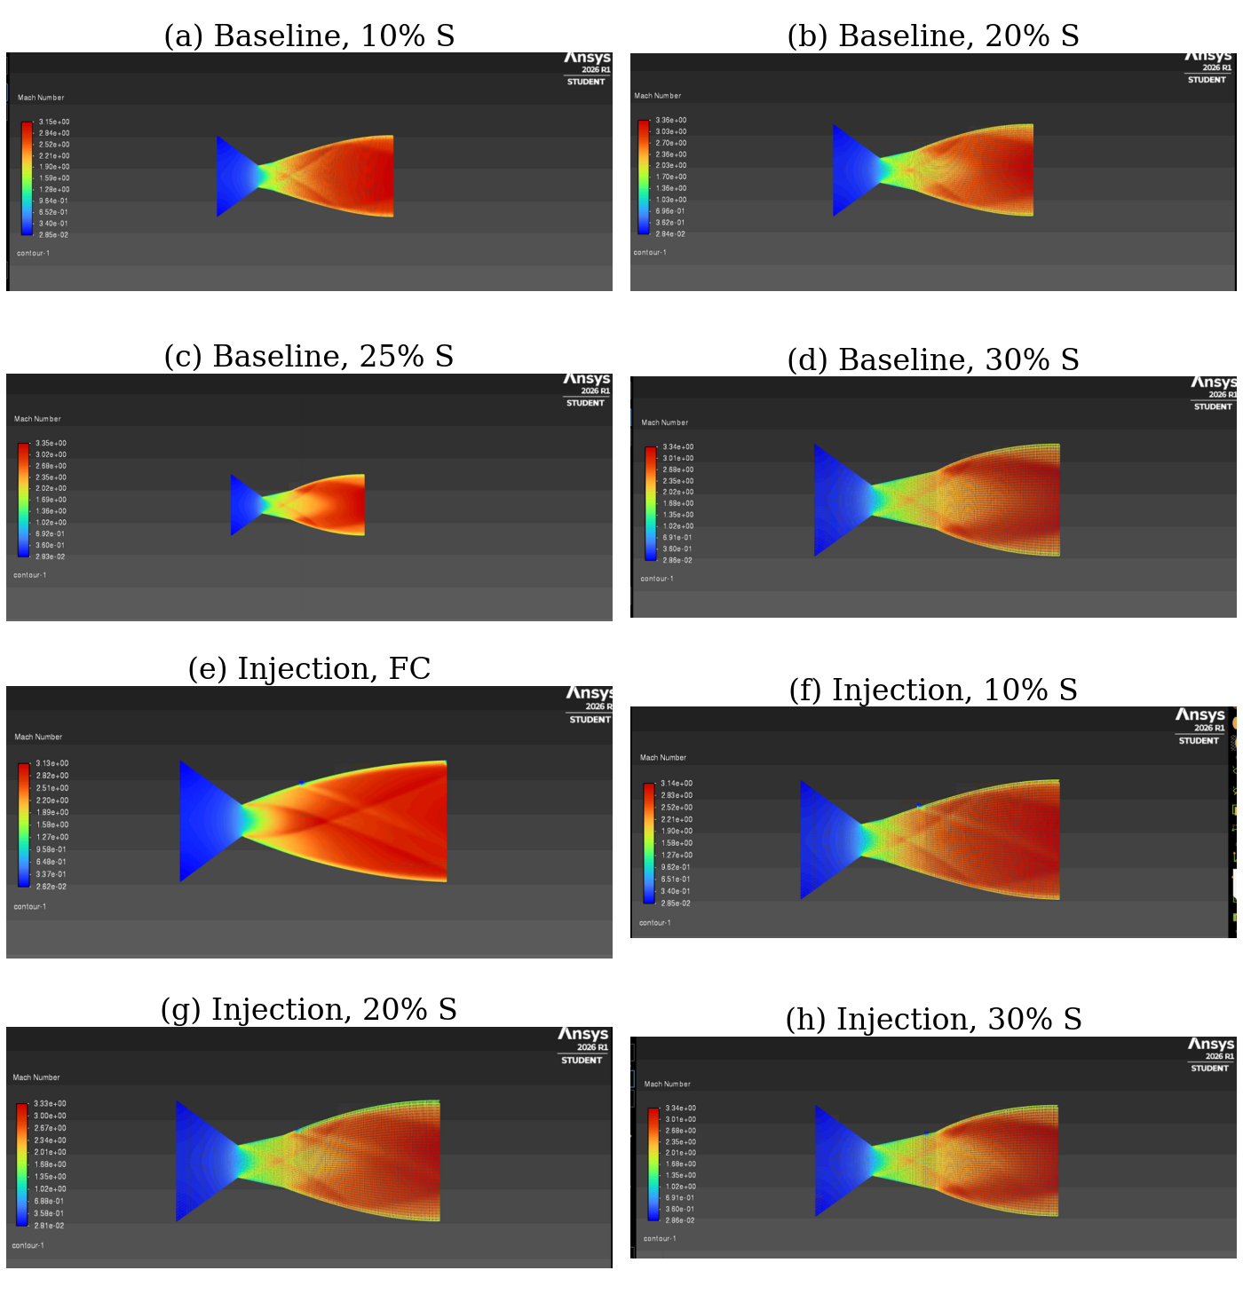
Fig. 6. Mach-number contours (scale approximately 0.03–3.36). Baseline: (a) 10%, (b) 20%, (c) 25%, and (d) 30% straight segment. With injection: (e) fully curved, (f) 10%, (g) 20%, and (h) 30% straight segment (no Mach contour was recorded for the 25% injection case). The wave lattice originating at the straight-to-curved junction and the weak injection-induced shock on the upper wall are visible.
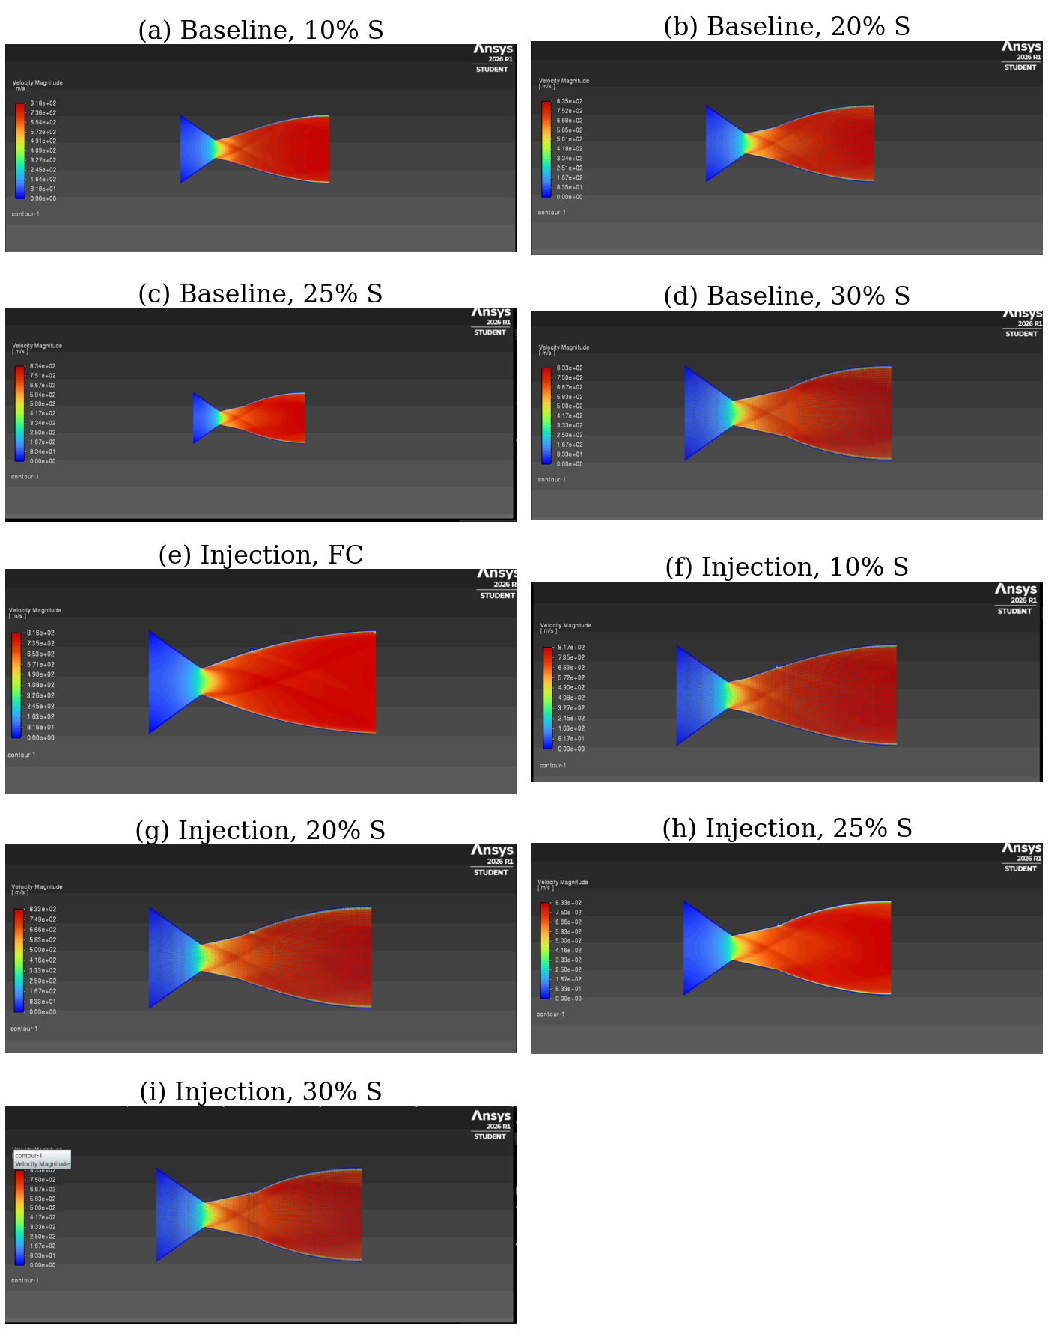
Fig. 7. Velocity-magnitude contours (m·s⁻¹; scale 0 to approximately 835 m·s⁻¹). Baseline: (a) 10%, (b) 20%, (c) 25%, and (d) 30% straight segment. With injection: (e) fully curved, (f) 10%, (g) 20%, (h) 25%, and (i) 30% straight segment. The no-slip boundary layers appear as thin low-velocity bands along the walls; injection produces only a local deficit near the upper-wall port.
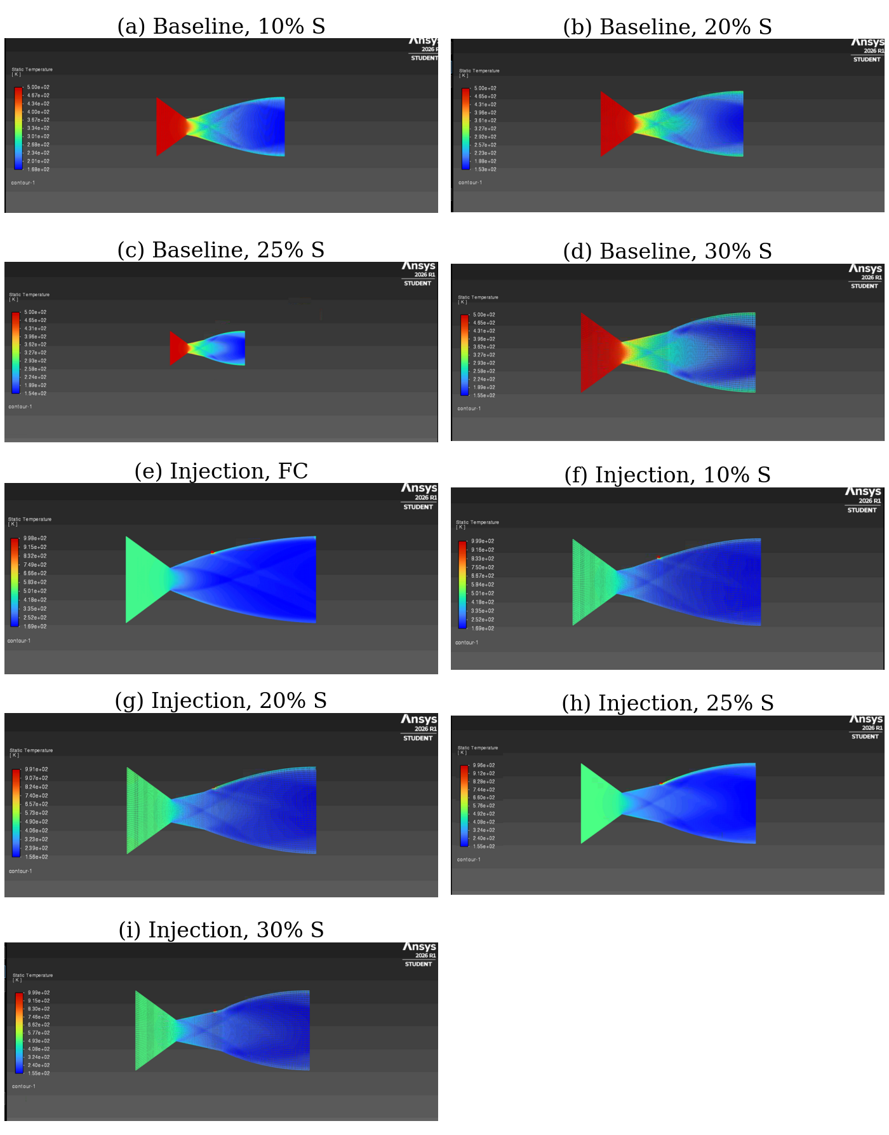
Fig. 8. Static-temperature contours (K). Baseline (scale approximately 153–500 K): (a) 10%, (b) 20%, (c) 25%, and (d) 30% straight segment. With injection (scale approximately 155–999 K): (e) fully curved, (f) 10%, (g) 20%, (h) 25%, and (i) 30% straight segment. The hot injectant forms a thin wall layer downstream of the port in (e)–(i); note that the convergent section appears green in (e)–(i) only because of the wider color scale.
D. Side Force and Vector Angle
Injection increases the wall side force in each simulated configuration (Fig. 9). Table V reports the side-force increments, vector-angle increments, and amplification factors. For Πm = 0.16%–0.37%, the computed ΔFy is 140–1078 N·m−1 and Δδ is 0.012°–0.092°. At the present thrust level, a 2° vector angle would require a side force of approximately 104 N·m−1; the increments obtained here are therefore one to two orders of magnitude below that indicative control level. For context, axisymmetric-nozzle studies have reported angles of 5°–9° at mass-flow ratios of 5%–8% [34].
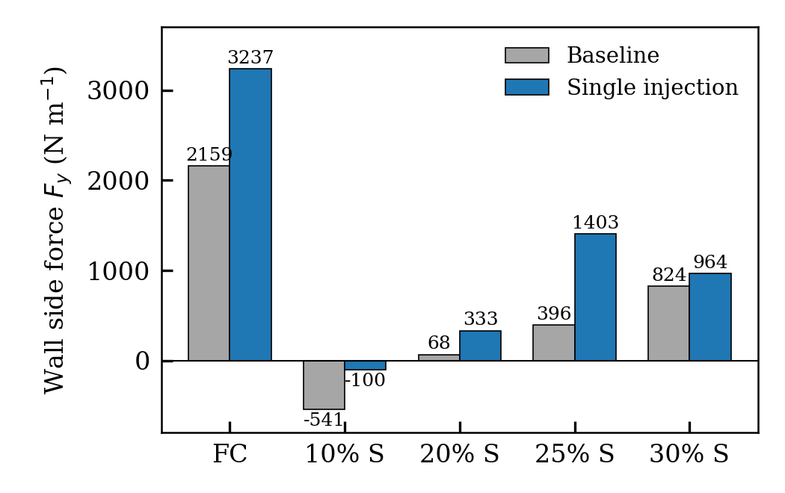
Fig. 9. Wall side force F_{y} for the baseline (gray) and single-injection (blue) configurations, with values annotated in N·m⁻¹. FC denotes the fully curved nozzle and n% S the nozzle with an n% straight segment. The nonzero baseline values reflect numerical asymmetry.
TABLE V
Injection Performance Metrics
Case | ṁ_{s} (kg·s⁻¹·m⁻¹) | Π_{m} (%) | ΔF_{y} (N·m⁻¹) | Δδ (deg) | K | ΔF_{T}/F_{T} (%)
FC† | 0.936 | 0.207 | 1,078 | 0.092 | 1.92 | -1.56
10% S | 0.959 | 0.205 | 441 | 0.039 | 0.75 | -0.03
20% S | 1.484 | 0.317 | 266 | 0.023 | 0.29 | -0.11
25% S† | 1.750 | 0.374 | 1,007 | 0.088 | 0.92 | -3.96
30% S | 0.729 | 0.156 | 140 | 0.012 | 0.31 | 0.06
†Baseline and injection geometries differ in effective throat height (Section V-A); increments include a geometric contribution.
E. Injector Operating Conditions
The injector stagnation conditions are identical across the five injected cases, but the secondary mass flow varies by a factor of 2.4—from 0.73 kg·s−1·m−1 for the 30% contour to 1.75 kg·s−1·m−1 for the 25% contour (Fig. 10). Injector static pressure and Mach number vary as well. Because the secondary flow remains subsonic, its mass flow responds to the difference between stagnation pressure and the local static pressure at the port. That local pressure depends on the port’s position relative to the straight-to-curved junction and its associated wave field. The variation in secondary mass flow therefore provides indirect evidence that changing the straight-section length modifies the port pressure.
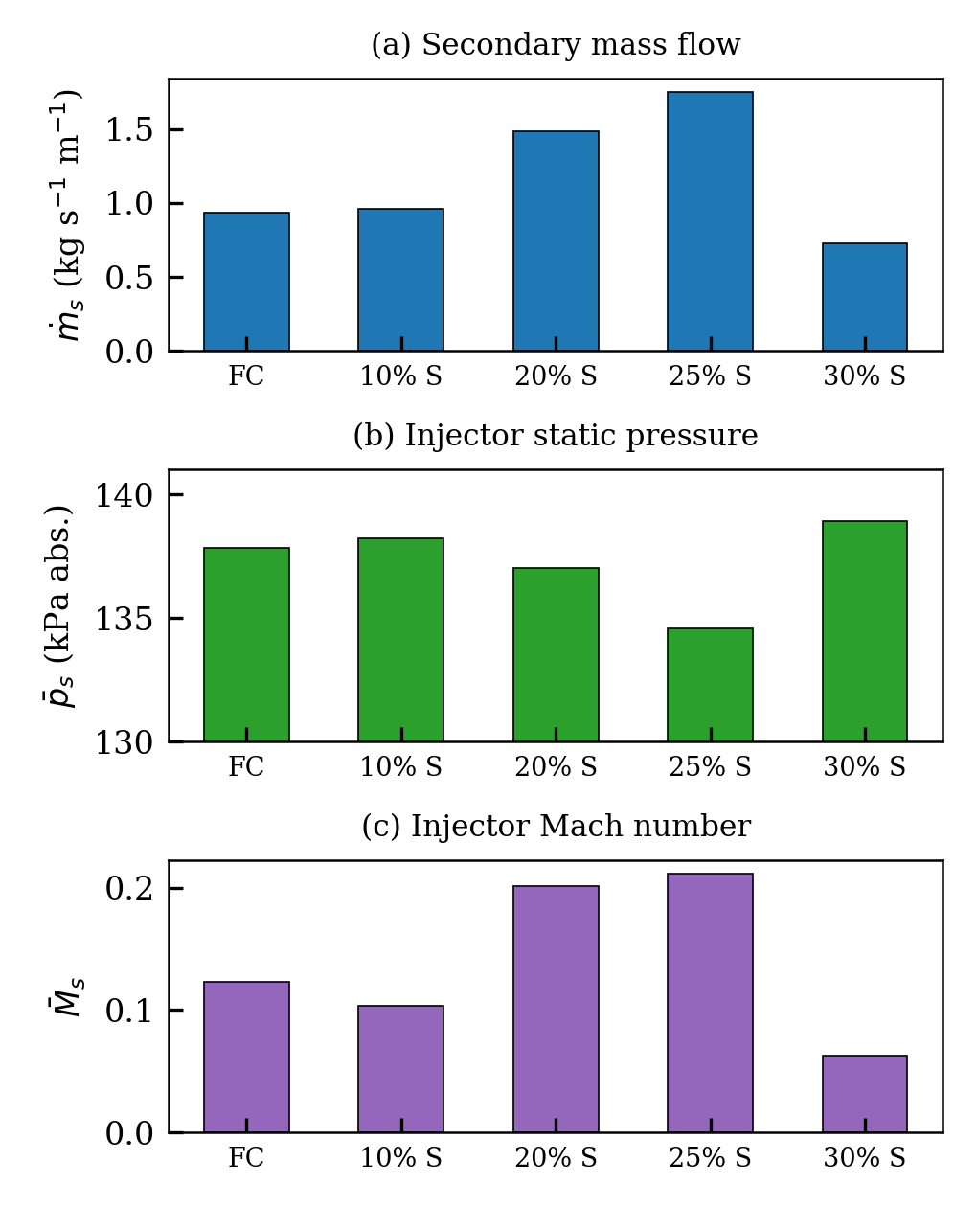
Fig. 10. Secondary injector operating conditions for the five injection cases: (a) secondary mass flow per unit depth, ṁ_{s}; (b) area-averaged static pressure at the injector (absolute); (c) area-averaged Mach number at the injector. The stagnation conditions are identical in all cases, so the variation reflects the local wall pressure at the port.
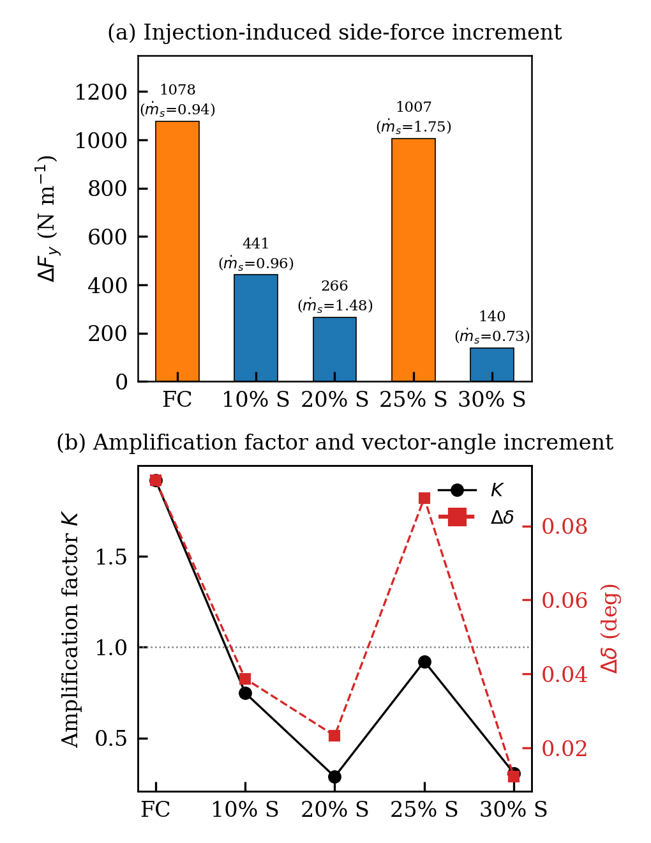
Fig. 11. (a) Injection-induced side-force increment ΔF_{y}, Eq. (22), with the secondary mass flow ṁ_{s} (kg·s⁻¹·m⁻¹) annotated; orange bars denote cases with baseline–injection geometric mismatch. (b) Amplification factor K, Eq. (23), on the left axis, and vector-angle increment Δδ on the right axis; the dotted line marks K = 1.
F. Effect of Straight-Segment Length
For the three matching geometry pairs (10%, 20%, and 30%), ΔFy decreases monotonically as the straight segment becomes longer: 441, 266, and 140 N·m−1, respectively (Fig. 11(a)). The amplification factor similarly falls from 0.75 to 0.29 and 0.31 (Fig. 11(b)). This trend cannot be attributed to secondary mass flow alone: among these cases, the 20% contour has the largest ṁs but an intermediate side-force increment. One possible explanation is that the downstream shift of the wall junction changes the relative positions of the port and compression waves, modifying the local pressure field and potentially the shock reflection from the opposite wall. Chen and Liao [38] noted the importance of avoiding internal shock reflection for efficient vectoring. The proposed mechanism remains provisional because wall-pressure distributions were not extracted in the present study.
The fully curved contour produces the largest side-force increment, 1078 N·m−1, and the only amplification factor above unity (K = 1.92). The 25% contour yields 1007 N·m−1 and K = 0.92. These observations are compatible with the suggestion that a smooth wall upstream of the port can support side-force generation [33], [37]. However, because the baseline and injection geometries are not identical for these cases, the results should be treated as indicative rather than definitive.
G. Axial Performance
For the 10%, 20%, and 30% configurations, the exit-plane thrust estimate changes by less than 0.12% with injection (Fig. 12(a)). Under these low secondary mass-flow ratios, the computed axial-thrust penalty is therefore negligible, consistent with the small losses measured for secondary-air injection [31]. The larger reductions for the fully curved (−1.6%) and 25% (−4.0%) cases coincide with the effective throat-height mismatches described in Section V-A and cannot be assigned to injection alone. Across the consistent baseline cases, FT rises from 288.0 to 291.8 kN·m−1 between the 10% and 20% contours and remains approximately unchanged at 30%. The area-averaged exit Mach number remains between 2.88 and 2.94, and exit pressure is 29–31 kPa absolute (Fig. 12(b)). The thrust coefficient follows a similar pattern, increasing from 1.111 to 1.125 between the 10% and 20% cases and staying near 1.125 at 30% (Fig. 13(b)). This change is mainly associated with the reduction in effective area ratio from 3.97 to 3.87, which reduces the negative pressure-thrust contribution in the overexpanded nozzle.
H. Viscous Force and Hot-Film Effect
The viscous component accounts for only 0.18%–0.24% of the total axial wall force, yet it changes consistently with injection (Fig. 13(a)). For the geometrically consistent straight-segment cases, injection lowers the viscous axial force by 7.5% at 10%, 11.0% at 20%, and 4.9% at 30%. This reduction is consistent with the hot, low-density secondary layer decreasing the near-wall velocity gradient downstream of the port, an effect related to film cooling in nozzles [71]. The fully curved case instead shows a 5.0% increase, although its baseline geometry differs from the injected configuration. The influence on total thrust is small, but the result indicates that secondary flow can modify the upper-wall boundary layer even without penetrating the core.
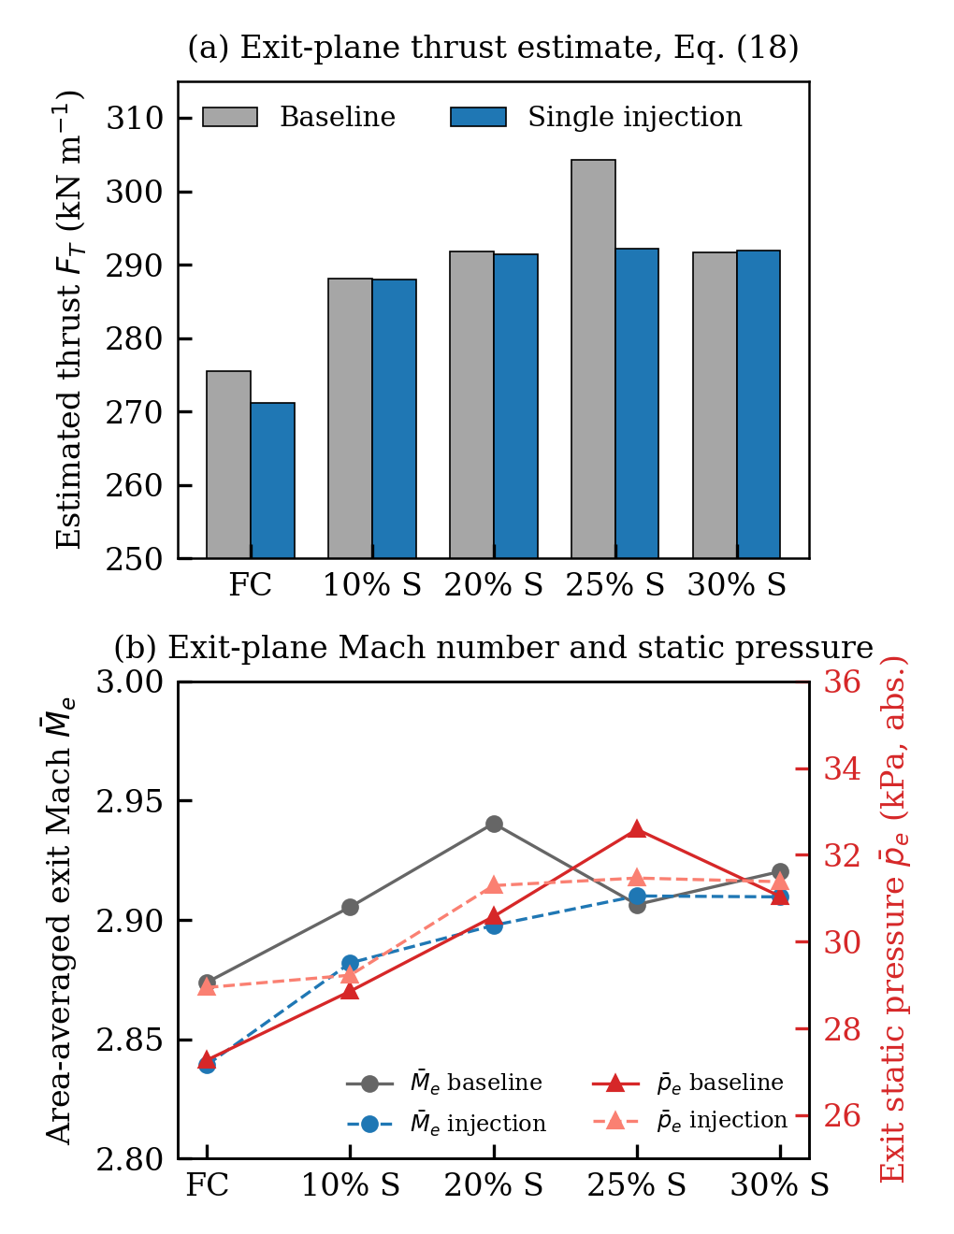
Fig. 12. (a) Exit-plane thrust estimate F_{T}, Eq. (18), for baseline (gray) and injection (blue) cases; note the suppressed zero. (b) Area-averaged exit Mach number (left axis, circles) and exit static pressure in absolute terms (right axis, triangles) for baseline (solid) and injection (dashed) cases.
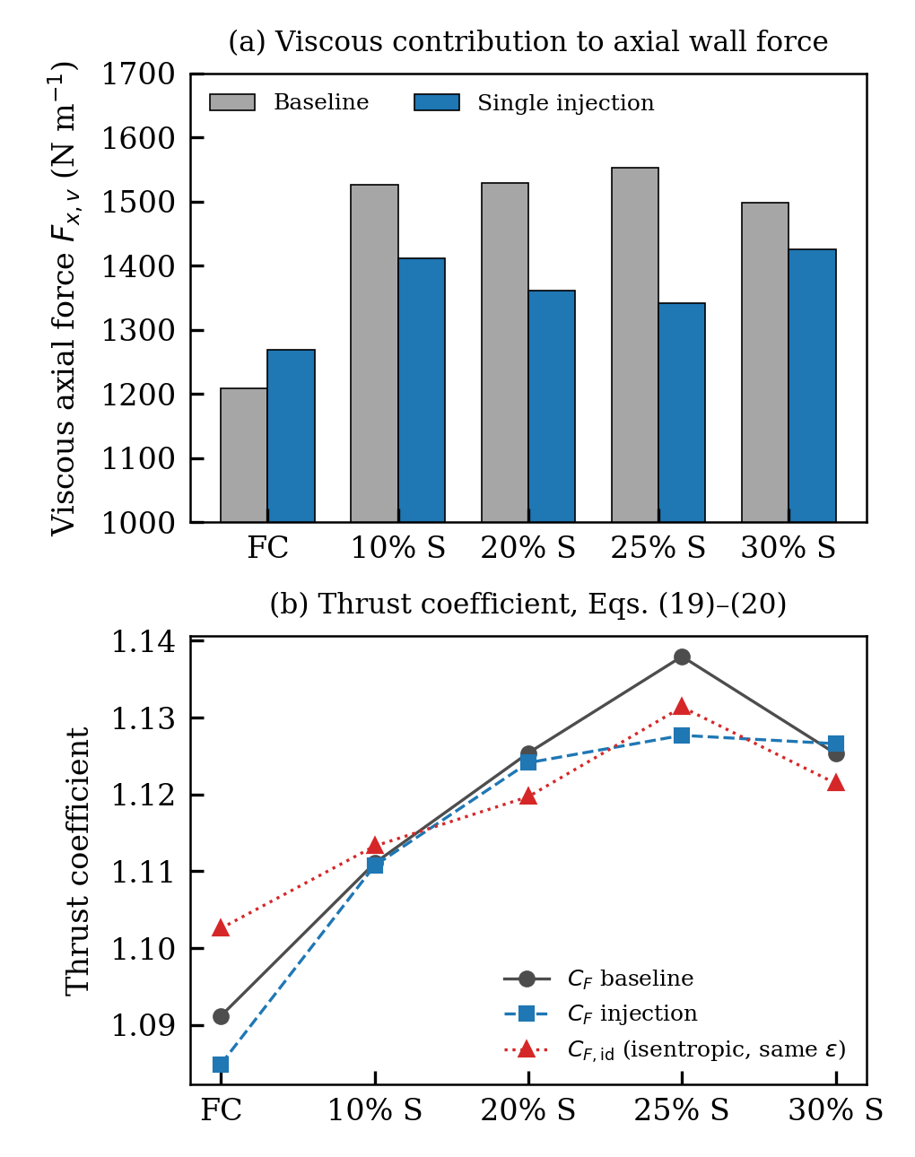
Fig. 13. (a) Viscous contribution to the axial wall force for baseline and injection cases; injection reduces the viscous force in all straight-segment nozzles. (b) Thrust coefficient C_{F}, Eq. (19), for baseline and injection cases, compared with the isentropic thrust coefficient C_{F,id}, Eq. (20), evaluated at the same effective area ratio.

TABLE VI
Master Table of Computed Results for All Ten Cases
Quantity | Fully curved |  | 10% straight |  | 20% straight |  | 25% straight |  | 30% straight
 | Base | Inj. | Base | Inj. | Base | Inj. | Base | Inj. | Base | Inj.
Mass flow (kg·s⁻¹·m⁻¹)
Primary inlet, ṁ_{p} | 456.57 | 452.05 | 468.77 | 468.77 | 468.76 | 468.76 | 483.40 | 468.49 | 468.75 | 468.48
Outlet, |ṁ_{e}| | 456.57 | 452.98 | 468.77 | 469.73 | 468.76 | 470.24 | 483.40 | 470.24 | 468.75 | 469.21
Secondary, ṁ_{s} | — | 0.936 | — | 0.959 | — | 1.484 | — | 1.750 | — | 0.729
Net imbalance (%) | 0.0010 | 0.0002 | 0.0001 | 0.0001 | 0.0001 | 0.0000 | 0.0000 | 0.0004 | 0.0001 | 0.0001
Wall forces and moment (per unit depth)
F_{x}, pressure (kN·m⁻¹) | 658.70 | 661.40 | 651.14 | 650.68 | 652.98 | 651.96 | 643.28 | 653.40 | 654.89 | 654.74
F_{x}, viscous (kN·m⁻¹) | 1.209 | 1.269 | 1.527 | 1.412 | 1.529 | 1.361 | 1.553 | 1.342 | 1.498 | 1.425
F_{x}, total (kN·m⁻¹) | 659.91 | 662.67 | 652.66 | 652.09 | 654.51 | 653.32 | 644.83 | 654.75 | 656.39 | 656.17
F_{w,x}, Eq. (17) (kN·m⁻¹) | 647.27 | 653.38 | 637.42 | 637.50 | 633.71 | 634.04 | 622.09 | 633.25 | 633.74 | 633.54
Difference (%) | 1.92 | 1.40 | 2.34 | 2.24 | 3.18 | 2.95 | 3.53 | 3.28 | 3.45 | 3.45
F_{y}, total (N·m⁻¹) | 2,159.2 | 3,236.8 | -540.9 | -99.6 | 67.6 | 333.3 | 396.2 | 1,402.7 | 824.3 | 964.0
M_{z} about (1,0,0) (N·m·m⁻¹) | 1,293.6 | 1,734.2 | 3,246.8 | 2,765.5 | 2,181.6 | 1,262.4 | 2,162.0 | 1,015.0 | 1,742.0 | 1,410.5
Centre of pressure y at x=0 (mm) | -5.26 | -7.48 | -4.17 | -4.07 | -3.45 | -2.38 | -3.98 | -3.65 | -3.93 | -3.61
δ, Eq. (21) (deg) | 0.187 | 0.280 | -0.047 | -0.009 | 0.006 | 0.029 | 0.035 | 0.123 | 0.072 | 0.084
Area-weighted averages
Inlet static pressure, gauge (kPa) | 785.1 | 785.4 | 784.3 | 784.3 | 784.3 | 784.3 | 783.3 | 784.3 | 784.3 | 784.3
Exit static pressure, gauge (kPa) | -74.05 | -72.38 | -72.47 | -72.10 | -70.75 | -70.03 | -68.74 | -69.86 | -70.28 | -69.94
Exit static pressure, abs. (kPa) | 27.27 | 28.94 | 28.86 | 29.23 | 30.58 | 31.29 | 32.59 | 31.47 | 31.04 | 31.38
Exit Mach number | 2.874 | 2.839 | 2.905 | 2.882 | 2.940 | 2.898 | 2.906 | 2.910 | 2.920 | 2.910
Exit velocity (m·s⁻¹) | 790.0 | 781.9 | 791.2 | 789.0 | 791.5 | 787.1 | 787.5 | 788.0 | 789.5 | 788.2
Exit density (kg·m⁻³) | 0.5027 | 0.5054 | 0.5182 | 0.5194 | 0.5284 | 0.5316 | 0.5517 | 0.5321 | 0.5327 | 0.5342
Exit static temperature (K) | 189.5 | 195.2 | 188.2 | 191.0 | 187.4 | 192.2 | 190.4 | 191.8 | 189.0 | 190.5
Wall static pressure, gauge (kPa) | 174.8 | 174.3 | 182.9 | 182.1 | 186.7 | 187.6 | 188.0 | 186.7 | 187.3 | 186.8
Wall static temperature (K) | 344.6 | 377.5 | 342.3 | 370.6 | 345.5 | 384.1 | 347.8 | 395.8 | 346.2 | 364.7
Injector static pressure, gauge (kPa) | — | 36.50 | — | 36.91 | — | 35.69 | — | 33.25 | — | 37.62
Injector static temperature (K) | — | 996.9 | — | 997.8 | — | 990.6 | — | 990.1 | — | 999.2
Injector Mach number | — | 0.123 | — | 0.104 | — | 0.201 | — | 0.211 | — | 0.063
Mass-weighted averages over the fluid zone
Static pressure, gauge (kPa) | 501.7 | 503.9 | 499.9 | 499.4 | 499.6 | 499.0 | 494.0 | 499.1 | — | 499.3
Velocity (m·s⁻¹) | 309.8 | 308.1 | 311.3 | 311.2 | 310.7 | 310.6 | 315.2 | 310.4 | 310.2 | 310.1
Mach number | 0.9545 | 0.9496 | 0.9477 | 0.9450 | 0.9403 | 0.9362 | 0.9480 | 0.9348 | 0.9350 | 0.9331
Density (kg·m⁻³) | 4.410 | 4.423 | 4.411 | 4.408 | 4.415 | 4.410 | 4.385 | 4.412 | 4.417 | 4.415
Static temperature (K) | 409.4 | 410.1 | 410.3 | 410.7 | 411.1 | 411.8 | 410.3 | 412.0 | 411.7 | 412.0
Derived performance
F_{T}, Eq. (18) (kN·m⁻¹) | 275.5 | 271.2 | 288.0 | 288.0 | 291.8 | 291.4 | 304.2 | 292.2 | 291.7 | 291.9
C_{F}, Eq. (19) | 1.0912 | 1.0849 | 1.1111 | 1.1107 | 1.1254 | 1.1241 | 1.1380 | 1.1277 | 1.1253 | 1.1266
Recovered p₀ (kPa abs.) | 899.4 | 899.4 | 899.3 | 899.3 | 899.3 | 899.3 | 899.2 | 899.3 | 899.3 | 899.3
Recovered T₀ (K) | 499.7 | 499.7 | 499.7 | 499.7 | 499.7 | 499.7 | 499.7 | 499.7 | 499.7 | 499.7
Gauge pressures are relative to 101.325 kPa. Forces and moments are per unit depth of the planar domain. For the 25% injection case, the wall forces include a separately named injector-wall zone (1.64 N·m⁻¹ axial), and the mass-weighted averages refer to the fluid zone “surface_body”. “—” denotes a quantity not reported for that case.

VI. Limitations and Recommendations
1) Flow separation. The nozzle operates overexpanded (p_{e}/p_{a} ≈ 0.27–0.32), a range in which the criteria reviewed in [58] predict shock-induced separation, possibly in free- or restricted-shock form [59], [60] and asymmetrically in planar nozzles [61]. Because the domain ends at a supersonic exit plane, separation cannot be captured; an external plume region should be added.
2) Discretization error. No grid-independence study was performed, and the baseline side-force asymmetry is of the same order as the injection effect. A three-grid study reporting the grid convergence index [105], following [99], [100], [104], with identical meshes for each baseline–injection pair, is required before the ΔF_{y} trends can be regarded as quantitative.
3) Turbulence modeling and dimensionality. RANS predictions of shock-induced separation length are model-sensitive [21], [81], [84]; comparison with alternative closures [88], [90] and compressibility corrections [91], and ultimately scale-resolving methods [25], [92], [93], is recommended. The planar slot also omits the counter-rotating vortex pair and lateral spillage of a circular injector [17], [19].
4) Injection pressure and validation. The injector pressure (Π_{p} ≈ 0.155) is far below typical SITVC values, so the trends may not extrapolate to penetrating jets [14], [35]; a Π_{p} sweep from 0.2 to 1.0, extraction of wall-pressure distributions, and validation against published experiments [33], [34], [56] following established practice [101]–[103] are recommended.
VII. Conclusion
A steady, two-dimensional RANS investigation of single-port secondary-injection thrust vector control was conducted for a planar convergent–divergent nozzle. The divergent contour was fully curved in one configuration and included straight segments equal to 10%, 20%, 25%, or 30% of the divergent length in the others. The principal conclusions are summarized below.
Directly integrated wall forces agree with the independent momentum-balance estimate to within 3.5%, while the exit-plane thrust coefficients are within ±1.4% of the corresponding isentropic values.
References
[1] G. Hagemann, H. Immich, T. V. Nguyen, and G. E. Dumnov, “Advanced rocket nozzles,” J. Propuls. Power, vol. 14, no. 5, pp. 620–634, 1998, doi: 10.2514/2.5354.
[2] K. A. Deere, “Summary of fluidic thrust vectoring research conducted at NASA Langley Research Center,” in Proc. 21st AIAA Appl. Aerodyn. Conf., Orlando, FL, USA, 2003, Paper AIAA 2003-3800, doi: 10.2514/6.2003-3800.
[3] H. Van Pelt, A. Neely, and J. Young, “A system study on fluidic thrust vectoring,” in Proc. 20th AIAA Int. Space Planes Hypersonic Syst. Technol. Conf., Glasgow, U.K., 2015, doi: 10.2514/6.2015-3565.
[4] M. S. Mason and W. J. Crowther, “Fluidic thrust vectoring for low observable air vehicles,” in Proc. 2nd AIAA Flow Control Conf., 2004, Paper AIAA 2004-2210, doi: 10.2514/6.2004-2210.
[5] J. E. Broadwell, “Analysis of the fluid mechanics of secondary injection for thrust vector control,” AIAA J., vol. 1, no. 5, pp. 1067–1075, 1963, doi: 10.2514/3.1726.
[6] K. Karamcheti and H. T.-S. Hsia, “Integral approach to an approximate analysis of thrust vector control by secondary injection,” AIAA J., vol. 1, no. 11, pp. 2538–2544, 1963, doi: 10.2514/3.2106.
[7] E. E. Zukoski and F. W. Spaid, “Secondary injection of gases into a supersonic flow,” AIAA J., vol. 2, no. 10, pp. 1689–1696, 1964, doi: 10.2514/3.2653.
[8] D. N. Miller, P. J. Yagle, and J. W. Hamstra, “Fluidic throat skewing for thrust vectoring in fixed geometry nozzles,” in Proc. 37th AIAA Aerosp. Sci. Meeting, Reno, NV, USA, 1999, Paper AIAA 99-0365, doi: 10.2514/6.1999-365.
[9] K. A. Deere, B. L. Berrier, J. D. Flamm, and S. K. Johnson, “Computational study of fluidic thrust vectoring using separation control in a nozzle,” in Proc. 21st AIAA Appl. Aerodyn. Conf., Orlando, FL, USA, 2003, Paper AIAA 2003-3803, doi: 10.2514/6.2003-3803.
[10] K. A. Deere, J. D. Flamm, B. L. Berrier, and S. K. Johnson, “A computational study of a new dual throat fluidic thrust vectoring nozzle concept,” in Proc. 41st AIAA/ASME/SAE/ASEE Joint Propuls. Conf., 2005, Paper AIAA 2005-3502, doi: 10.2514/6.2005-3502.
[11] P. J. Strykowski, A. Krothapalli, and D. J. Forliti, “Counterflow thrust vectoring of supersonic jets,” in Proc. 34th AIAA Aerosp. Sci. Meeting, Reno, NV, USA, 1996, Paper AIAA 96-0115, doi: 10.2514/6.1996-115.
[12] C. A. Hunter and K. A. Deere, “Computational investigation of fluidic counterflow thrust vectoring,” in Proc. 35th AIAA/ASME/SAE/ASEE Joint Propuls. Conf., 1999, Paper AIAA 99-2669, doi: 10.2514/6.1999-2669.
[13] J. D. Flamm, “Experimental study of a nozzle using fluidic counterflow for thrust vectoring,” in Proc. 34th AIAA/ASME/SAE/ASEE Joint Propuls. Conf., 1998, Paper AIAA 98-3255, doi: 10.2514/6.1998-3255.
[14] F. W. Spaid and E. E. Zukoski, “A study of the interaction of gaseous jets from transverse slots with supersonic external flows,” AIAA J., vol. 6, no. 2, pp. 205–212, 1968, doi: 10.2514/3.4479.
[15] E. E. Zukoski, “Turbulent boundary-layer separation in front of a forward-facing step,” AIAA J., vol. 5, no. 10, pp. 1746–1753, 1967, doi: 10.2514/3.4299.
[16] T. I. Malik and R. K. Tagirov, “Calculation of the length of the shock boundary layer interaction zone,” Fluid Dyn., vol. 22, no. 2, pp. 318–321, 1987, doi: 10.1007/BF01052272.
[17] K. Mahesh, “The interaction of jets with crossflow,” Annu. Rev. Fluid Mech., vol. 45, pp. 379–407, 2013, doi: 10.1146/annurev-fluid-120710-101115.
[18] W. Huang, “Transverse jet in supersonic crossflows,” Aerosp. Sci. Technol., vol. 50, pp. 183–195, 2016, doi: 10.1016/j.ast.2016.01.001.
[19] V. Viti, R. Neel, and J. A. Schetz, “Detailed flow physics of the supersonic jet interaction flow field,” Phys. Fluids, vol. 21, no. 4, Art. no. 046101, 2009, doi: 10.1063/1.3112736.
[20] E. Erdem and K. Kontis, “Numerical and experimental investigation of transverse injection flows,” Shock Waves, vol. 20, no. 2, pp. 103–118, 2010, doi: 10.1007/s00193-010-0247-1.
[21] W. Huang, W. D. Liu, S. B. Li, Z. X. Xia, J. Liu, and Z. G. Wang, “Influences of the turbulence model and the slot width on the transverse slot injection flow field in supersonic flows,” Acta Astronaut., vol. 73, pp. 1–9, 2012, doi: 10.1016/j.actaastro.2011.12.003.
[22] W. Huang, Z. G. Wang, J. P. Wu, and S. B. Li, “Numerical prediction on the interaction between the incident shock wave and the transverse slot injection in supersonic flows,” Aerosp. Sci. Technol., vol. 28, no. 1, pp. 91–99, 2013, doi: 10.1016/j.ast.2012.10.007.
[23] S.-H. Lee, “Characteristics of dual transverse injection in scramjet combustor, Part 1: Mixing,” J. Propuls. Power, vol. 22, no. 5, pp. 1012–1019, 2006, doi: 10.2514/1.14180.
[24] S. Kawai and S. K. Lele, “Mechanisms of jet mixing in a supersonic crossflow: A study using large-eddy simulation,” in Proc. 44th AIAA/ASME/SAE/ASEE Joint Propuls. Conf., 2008, Paper AIAA 2008-4575, doi: 10.2514/6.2008-4575.
[25] S. Kawai and S. K. Lele, “Large-eddy simulation of jet mixing in supersonic crossflows,” AIAA J., vol. 48, no. 9, pp. 2063–2083, 2010, doi: 10.2514/1.J050282.
[26] D. M. Peterson and G. V. Candler, “Hybrid RANS/LES of a supersonic combustor,” in Proc. 44th AIAA/ASME/SAE/ASEE Joint Propuls. Conf., 2008, Paper AIAA 2008-6923, doi: 10.2514/6.2008-6923.
[27] R. Balu, A. G. Marathe, P. J. Paul, and H. S. Mukunda, “Analysis of performance of a hot gas injection thrust vector control system,” J. Propuls. Power, vol. 7, no. 4, pp. 580–585, 1991, doi: 10.2514/3.23365.
[28] R. L. Prince, P. Rejith, and R. Balu, “Numerical simulation of a hot gas injection thrust vector control system performance,” Procedia Eng., vol. 38, pp. 1745–1749, 2012, doi: 10.1016/j.proeng.2012.06.212.
[29] R. Dhinagaran and T. K. Bose, “Comparison of Euler and Navier–Stokes solutions for nozzle flows with secondary injection,” in Proc. 34th AIAA Aerosp. Sci. Meeting, Reno, NV, USA, 1996, Paper AIAA 96-0453, doi: 10.2514/6.1996-453.
[30] H. Ko and W. S. Yoon, “Performance analysis of secondary gas injection into a conical rocket nozzle,” J. Propuls. Power, vol. 18, no. 3, pp. 585–591, 2002, doi: 10.2514/2.5972.
[31] D. Azevedo, “Measured thrust losses associated with secondary air injection through nozzle walls,” J. Propuls. Power, vol. 9, no. 1, pp. 43–50, 1993, doi: 10.2514/3.11483.
[32] V. Zmijanovic, L. Leger, V. Lago, M. Sellam, and A. Chpoun, “Experimental and numerical study of thrust-vectoring effects by transverse gas injection into a propulsive axisymmetric C-D nozzle,” in Proc. 48th AIAA/ASME/SAE/ASEE Joint Propuls. Conf., Atlanta, GA, USA, 2012, Paper AIAA 2012-3874, doi: 10.2514/6.2012-3874.
[33] V. Zmijanovic, V. Lago, M. Sellam, and A. Chpoun, “Thrust shock vector control of an axisymmetric conical supersonic nozzle via secondary transverse gas injection,” Shock Waves, vol. 24, no. 1, pp. 97–111, 2014, doi: 10.1007/s00193-013-0479-y.
[34] V. Zmijanovic, L. Leger, E. Depussay, M. Sellam, and A. Chpoun, “Experimental–numerical parametric investigation of a rocket nozzle secondary injection thrust vectoring,” J. Propuls. Power, vol. 32, no. 1, pp. 196–213, 2016, doi: 10.2514/1.B35721.
[35] M. Sellam, A. Chpoun, V. Zmijanovic, and V. Lago, “Fluidic thrust vectoring of an axisymmetrical nozzle: An analytical model,” Int. J. Aerodyn., vol. 2, no. 2/3/4, pp. 193–209, 2012, doi: 10.1504/IJAD.2012.049112.
[36] M. Sellam, V. Zmijanovic, L. Leger, and A. Chpoun, “Assessment of gas thermodynamic characteristics on fluidic thrust vectoring performance: Analytical, experimental and numerical study,” Int. J. Heat Fluid Flow, vol. 53, pp. 156–166, 2015, doi: 10.1016/j.ijheatfluidflow.2015.03.005.
[37] R. Deng, F. Kong, and H. D. Kim, “Numerical simulation of fluidic thrust vectoring in an axisymmetric supersonic nozzle,” J. Mech. Sci. Technol., vol. 28, no. 12, pp. 4979–4987, 2014, doi: 10.1007/s12206-014-1119-x.
[38] J.-L. Chen and Y.-H. Liao, “Parametric study on thrust vectoring with a secondary injection in a convergent–divergent nozzle,” J. Aerosp. Eng., vol. 33, no. 4, Art. no. 04020020, 2020, doi: 10.1061/(ASCE)AS.1943-5525.0001136.
[39] F. Forghany, M. Taeibi-Rahni, and A. Asadollahi-Ghohieh, “Numerical investigation of optimization of injection angle effects on fluidic thrust vectoring,” J. Appl. Fluid Mech., vol. 10, no. 1, 2017, doi: 10.18869/acadpub.jafm.73.238.26519.
[40] J. W. Shi, Z. X. Wang, X. B. Zhang, and Z. W. Liu, “Performance estimation for fluidic thrust vectoring nozzle coupled with aero-engine,” in Proc. 50th AIAA/ASME/SAE/ASEE Joint Propuls. Conf., 2014, Paper AIAA 2014-3771, doi: 10.2514/6.2014-3771.
[41] J. W. Shi, L. Zhou, Z. X. Wang, and X. L. Sun, “Investigation on flowfield characteristics and performance of shock vector control nozzle based on confined transverse injection,” J. Eng. Gas Turbines Power, vol. 138, no. 10, Art. no. 101502, 2016, doi: 10.1115/1.4033140.
[42] L. Li, M. Hirota, K. Ouchi, and T. Saito, “Evaluation of fluidic thrust vectoring nozzle via thrust pitching angle and thrust pitching moment,” Shock Waves, vol. 27, no. 1, pp. 53–61, 2017, doi: 10.1007/s00193-016-0637-0.
[43] M. Ferlauto and R. Marsilio, “Numerical simulation of fluidic thrust-vectoring,” Aerotecnica Missili Spazio, vol. 95, no. 3, pp. 153–162, 2016, doi: 10.1007/BF03404724.
[44] C.-S. Shin, H.-D. Kim, T. Setoguchi, and S. Matsuo, “A computational study of thrust vectoring control using dual throat nozzle,” J. Therm. Sci., vol. 19, no. 6, pp. 486–490, 2010, doi: 10.1007/s11630-010-0413-x.
[45] M. Ferlauto and R. Marsilio, “Numerical investigation of the dynamic characteristics of a dual-throat-nozzle for fluidic thrust-vectoring,” AIAA J., vol. 55, no. 1, 2017, doi: 10.2514/1.J055044.
[46] J. D. Flamm et al., “Design enhancements of the two-dimensional, dual throat fluidic thrust vectoring nozzle concept,” in Proc. 3rd AIAA Flow Control Conf., 2006, Paper AIAA 2006-3701, doi: 10.2514/6.2006-3701.
[47] E. Bellandi and A. Slippey, “Preliminary analysis and design enhancements of a dual-throat FTV nozzle concept,” in Proc. 39th AIAA Fluid Dyn. Conf., San Antonio, TX, USA, 2009, Paper AIAA 2009-3900, doi: 10.2514/6.2009-3900.
[48] R. Gu, J. Xu, and S. Guo, “Experimental and numerical investigations of a bypass dual throat nozzle,” J. Eng. Gas Turbines Power, vol. 136, no. 8, Art. no. 084501, 2014, doi: 10.1115/1.4026943.
[49] R. Deng, T. Setoguchi, and H. D. Kim, “Large eddy simulation of shock vector control using bypass flow passage,” Int. J. Heat Fluid Flow, vol. 62, pt. B, pp. 474–481, 2016, doi: 10.1016/j.ijheatfluidflow.2016.08.011.
[50] C. J. Anderson, V. J. Giuliano, and D. J. Wing, “Investigation of hybrid fluidic/mechanical thrust vectoring for fixed-exit exhaust nozzles,” in Proc. 33rd AIAA/ASME/SAE/ASEE Joint Propuls. Conf., 1997, Paper AIAA 97-3148, doi: 10.2514/6.1997-3148.
[51] F. S. Alvi and P. J. Strykowski, “Forward flight effects on counterflow thrust vector control of a supersonic jet,” AIAA J., vol. 37, no. 2, pp. 279–281, 1999, doi: 10.2514/2.705.
[52] K. X. Wu, Y. Z. Jin, and H. D. Kim, “Fluidic thrust vector control based on counter-flow concept,” Proc. Inst. Mech. Eng. G, J. Aerosp. Eng., vol. 233, no. 4, pp. 1412–1422, 2019, doi: 10.1177/0954410017752580.
[53] K. X. Wu, Y. Z. Jin, and H. D. Kim, “Hysteresis behaviors in counter-flow thrust vector control,” J. Aerosp. Eng., vol. 32, no. 4, Art. no. 04019041, 2019, doi: 10.1061/(ASCE)AS.1943-5525.0001027.
[54] J. Y. Heo and H. G. Sung, “Fluidic thrust-vector control of supersonic jet using coflow injection,” J. Propuls. Power, vol. 28, no. 4, pp. 858–861, 2012, doi: 10.2514/1.B34266.
[55] A. Ashraf, “Combination of fluidic thrust modulation and vectoring in a 2D nozzle,” in Proc. 48th AIAA/ASME/SAE/ASEE Joint Propuls. Conf., 2012, Paper AIAA 2012-3780, doi: 10.2514/6.2012-3780.
[56] B. Mangin, A. Chpoun, and L. Jacquin, “Experimental and numerical study of the fluidic thrust vectoring of a two-dimensional supersonic nozzle,” in Proc. 24th AIAA Appl. Aerodyn. Conf., San Francisco, CA, USA, 2006, Paper AIAA 2006-3666, doi: 10.2514/6.2006-3666.
[57] G. V. R. Rao, “Exhaust nozzle contour for optimum thrust,” J. Jet Propuls., vol. 28, no. 6, pp. 377–382, 1958, doi: 10.2514/8.7324.
[58] J. Östlund and B. Muhammad-Klingmann, “Supersonic flow separation with application to rocket engine nozzles,” Appl. Mech. Rev., vol. 58, no. 3, pp. 143–177, 2005, doi: 10.1115/1.1894402.
[59] F. Nasuti and M. Onofri, “Shock structure in separated nozzle flows,” Shock Waves, vol. 19, pp. 229–237, 2009, doi: 10.1007/s00193-008-0173-7.
[60] E. Martelli, F. Nasuti, and M. Onofri, “Numerical calculation of FSS/RSS transition in highly overexpanded rocket nozzle flows,” Shock Waves, vol. 20, pp. 139–146, 2010, doi: 10.1007/s00193-009-0244-4.
[61] D. Papamoschou, A. Zill, and A. Johnson, “Supersonic flow separation in planar nozzles,” Shock Waves, vol. 19, no. 3, pp. 171–183, 2009, doi: 10.1007/s00193-008-0160-z.
[62] M. Frey and G. Hagemann, “Critical assessment of dual-bell nozzles,” J. Propuls. Power, vol. 15, no. 1, pp. 137–143, 1999, doi: 10.2514/2.5402.
[63] G. Hagemann, M. Terhardt, D. Haeseler, and M. Frey, “Experimental and analytical design verification of the dual-bell concept,” J. Propuls. Power, vol. 18, no. 1, pp. 116–122, 2002, doi: 10.2514/2.5905.
[64] E. Martelli, F. Nasuti, and M. Onofri, “Numerical parametric analysis of dual-bell nozzle flows,” AIAA J., vol. 45, no. 3, pp. 640–650, 2007, doi: 10.2514/1.26690.
[65] H. Wong and R. Schwane, “Numerical analysis of dual-bell nozzle transition,” J. Propuls. Power, vol. 18, no. 1, pp. 84–92, 2002, doi: 10.2514/2.5683.
[66] C. Nürnberger-Génin and R. Stark, “Flow transition in dual bell nozzles,” Shock Waves, vol. 19, pp. 265–270, 2009, doi: 10.1007/s00193-008-0176-4.
[67] H. Kbab, M. Sellam, T. Hamitouche, S. Bergheul, and L. Lagab, “Design and performance evaluation of a dual bell nozzle,” Acta Astronaut., vol. 130, pp. 52–59, 2017, doi: 10.1016/j.actaastro.2016.10.015.
[68] T. Chehat, H. Kbab, W. Hamaidia, and B. Zouaoui, “Analysis of dual bell nozzle configurations: Design parameters and performance measurements,” J. Appl. Fluid Mech., vol. 18, no. 7, pp. 1767–1781, 2025, doi: 10.47176/jafm.18.7.3239.
[69] S. B. Verma, R. Stark, and O. Haidn, “Effect of ambient pressure fluctuations on dual-bell transition behavior,” J. Propuls. Power, vol. 30, no. 5, pp. 1192–1198, 2014, doi: 10.2514/1.B35067.
[70] S. B. Verma, A. Hadjadj, and O. Haidn, “Unsteady flow conditions during dual-bell sneak transition,” J. Propuls. Power, vol. 31, no. 4, pp. 1175–1183, 2015, doi: 10.2514/1.B35558.
[71] M. Verma, N. Arya, and A. De, “Investigation of flow characteristics inside a dual bell nozzle with and without film cooling,” Aerosp. Sci. Technol., vol. 99, Art. no. 105741, 2020, doi: 10.1016/j.ast.2020.105741.
[72] M. Cimini, E. Martelli, and M. Bernardini, “Numerical analysis of side-load reduction in a sub-scale dual-bell rocket nozzle,” Flow Turbul. Combust., vol. 107, no. 3, pp. 551–574, 2021, doi: 10.1007/s10494-021-00243-4.
[73] D. Schneider and C. Génin, “Numerical investigation of flow transition behavior in cold flow dual-bell rocket nozzles,” J. Propuls. Power, vol. 32, no. 5, pp. 1212–1219, 2016, doi: 10.2514/1.B36010.
[74] K. Davis, E. Fortner, M. Heard, H. McCallum, and H. Putzke, “Experimental and computational investigation of a dual-bell nozzle,” in Proc. 53rd AIAA Aerosp. Sci. Meeting, 2015, Paper AIAA 2015-0377, doi: 10.2514/6.2015-0377.
[75] T. Tomita, M. Takahashi, M. Sasaki, and H. Tamura, “Investigation on characteristics of conventional-nozzle-based altitude compensating nozzles by cold-flow tests,” in Proc. 42nd AIAA/ASME/SAE/ASEE Joint Propuls. Conf., 2006, Paper AIAA 2006-4375, doi: 10.2514/6.2006-4375.
[76] T. Tomita, M. Takahashi, and M. Sasaki, “Control of transition between two working modes of a dual-bell nozzle by gas injection,” in Proc. 45th AIAA/ASME/SAE/ASEE Joint Propuls. Conf., Denver, CO, USA, 2009, Paper AIAA 2009-4952, doi: 10.2514/6.2009-4952.
[77] L. Léger, V. Zmijanovic, M. Sellam, and A. Chpoun, “Experimental investigation of forced flow regime transition in a dual bell nozzle by secondary fluidic injection,” Int. J. Heat Fluid Flow, vol. 89, Art. no. 108818, 2021, doi: 10.1016/j.ijheatfluidflow.2021.108818.
[78] A. Ferrero, A. Conte, E. Martelli, F. Nasuti, and D. Pastrone, “Dual bell nozzle for space launchers with fluidic control of transition,” in Proc. AIAA Propuls. Energy Forum, 2021, Paper AIAA 2021-3586, doi: 10.2514/6.2021-3586.
[79] S. Benlembarek, K. Talbi, A. Chehhat, A. Tatar, and I. Bayezit, “Investigating the direction and location effect on the dual bell nozzle flow through secondary injection,” J. Appl. Fluid Mech., vol. 19, no. 3, pp. 364–379, 2026, doi: 10.47176/jafm.19.3.3901.
[80] J. M. Délery, “Shock wave/turbulent boundary layer interaction and its control,” Prog. Aerosp. Sci., vol. 22, no. 4, pp. 209–280, 1985, doi: 10.1016/0376-0421(85)90001-6.
[81] D. S. Dolling, “Fifty years of shock-wave/boundary-layer interaction research: What next?” AIAA J., vol. 39, no. 8, pp. 1517–1531, 2001, doi: 10.2514/2.1476.
[82] H. Babinsky and J. K. Harvey, Eds., Shock Wave–Boundary-Layer Interactions. Cambridge, U.K.: Cambridge Univ. Press, 2011, doi: 10.1017/CBO9780511842757.
[83] N. T. Clemens and V. Narayanaswamy, “Low-frequency unsteadiness of shock wave/turbulent boundary layer interactions,” Annu. Rev. Fluid Mech., vol. 46, pp. 469–492, 2014, doi: 10.1146/annurev-fluid-010313-141346.
[84] D. V. Gaitonde, “Progress in shock wave/boundary layer interactions,” Prog. Aerosp. Sci., vol. 72, pp. 80–99, 2015, doi: 10.1016/j.paerosci.2014.09.002.
[85] F. R. Menter, “Two-equation eddy-viscosity turbulence models for engineering applications,” AIAA J., vol. 32, no. 8, pp. 1598–1605, 1994, doi: 10.2514/3.12149.
[86] F. R. Menter, “Review of the shear-stress transport turbulence model experience from an industrial perspective,” Int. J. Comput. Fluid Dyn., vol. 23, no. 4, pp. 305–316, 2009, doi: 10.1080/10618560902773387.
[87] D. C. Wilcox, “Reassessment of the scale-determining equation for advanced turbulence models,” AIAA J., vol. 26, no. 11, pp. 1299–1310, 1988, doi: 10.2514/3.10041.
[88] D. C. Wilcox, “Formulation of the k–ω turbulence model revisited,” AIAA J., vol. 46, no. 11, pp. 2823–2838, 2008, doi: 10.2514/1.36541.
[89] B. E. Launder and D. B. Spalding, “The numerical computation of turbulent flows,” Comput. Methods Appl. Mech. Eng., vol. 3, no. 2, pp. 269–289, 1974, doi: 10.1016/0045-7825(74)90029-2.
[90] P. R. Spalart and S. R. Allmaras, “A one-equation turbulence model for aerodynamic flows,” in Proc. 30th AIAA Aerosp. Sci. Meeting, Reno, NV, USA, 1992, Paper AIAA 92-0439, doi: 10.2514/6.1992-439.
[91] S. Sarkar, “The pressure–dilatation correlation in compressible flows,” Phys. Fluids A, vol. 4, no. 12, pp. 2674–2682, 1992, doi: 10.1063/1.858454.
[92] P. R. Spalart, S. Deck, M. L. Shur, K. D. Squires, M. K. Strelets, and A. Travin, “A new version of detached-eddy simulation, resistant to ambiguous grid densities,” Theor. Comput. Fluid Dyn., vol. 20, no. 3, pp. 181–195, 2006, doi: 10.1007/s00162-006-0015-0.
[93] N. J. Georgiadis, D. P. Rizzetta, and C. Fureby, “Large-eddy simulation: Current capabilities, recommended practices, and future research,” AIAA J., vol. 48, no. 8, pp. 1772–1784, 2010, doi: 10.2514/1.J050232.
[94] S. B. Pope, Turbulent Flows. Cambridge, U.K.: Cambridge Univ. Press, 2000, doi: 10.1017/CBO9780511840531.
[95] P. L. Roe, “Approximate Riemann solvers, parameter vectors, and difference schemes,” J. Comput. Phys., vol. 43, no. 2, pp. 357–372, 1981, doi: 10.1016/0021-9991(81)90128-5.
[96] M.-S. Liou and C. J. Steffen, “A new flux splitting scheme,” J. Comput. Phys., vol. 107, no. 1, pp. 23–39, 1993, doi: 10.1006/jcph.1993.1122.
[97] M.-S. Liou, “A sequel to AUSM: AUSM+,” J. Comput. Phys., vol. 129, no. 2, pp. 364–382, 1996, doi: 10.1006/jcph.1996.0256.
[98] B. van Leer, “Towards the ultimate conservative difference scheme. V. A second-order sequel to Godunov's method,” J. Comput. Phys., vol. 32, no. 1, pp. 101–136, 1979, doi: 10.1016/0021-9991(79)90145-1.
[99] P. J. Roache, “Perspective: A method for uniform reporting of grid refinement studies,” J. Fluids Eng., vol. 116, no. 3, pp. 405–413, 1994, doi: 10.1115/1.2910291.
[100] P. J. Roache, “Quantification of uncertainty in computational fluid dynamics,” Annu. Rev. Fluid Mech., vol. 29, pp. 123–160, 1997, doi: 10.1146/annurev.fluid.29.1.123.
[101] W. L. Oberkampf and T. G. Trucano, “Verification and validation in computational fluid dynamics,” Prog. Aerosp. Sci., vol. 38, no. 3, pp. 209–272, 2002, doi: 10.1016/S0376-0421(02)00005-2.
[102] F. Stern, R. V. Wilson, H. W. Coleman, and E. G. Paterson, “Comprehensive approach to verification and validation of CFD simulations—Part 1: Methodology and procedures,” J. Fluids Eng., vol. 123, no. 4, pp. 793–802, 2001, doi: 10.1115/1.1412235.
[103] C. J. Roy, “Review of code and solution verification procedures for computational simulation,” J. Comput. Phys., vol. 205, no. 1, pp. 131–156, 2005, doi: 10.1016/j.jcp.2004.10.036.
[104] L. F. Richardson, “The approximate arithmetical solution by finite differences of physical problems involving differential equations, with an application to the stresses in a masonry dam,” Philos. Trans. R. Soc. A, vol. 210, pp. 307–357, 1911, doi: 10.1098/rsta.1911.0009.
[105] I. B. Celik, U. Ghia, P. J. Roache, C. J. Freitas, H. Coleman, and P. E. Raad, “Procedure for estimation and reporting of uncertainty due to discretization in CFD applications,” J. Fluids Eng., vol. 130, no. 7, Art. no. 078001, 2008, doi: 10.1115/1.2960953.

