Climate-Change Mitigation Through Efficient Convergent–Divergent Nozzles: Influence of Divergent Straight-Section Length and Symmetric Double Secondary Injection
Deepak Gupta¹* and Swati Gill^{2,} Bhavesh Jindal³
¹Assistant Professor, Department of Aerospace, GNA University, Phagwara, Punjab 144401, India
^{2,3}Undergraduate Student, Department of Aerospace, GNA University, Phagwara, Punjab 144401, India
*Corresponding author: deepakgupta7060@gmail.com

Abstract—Improving nozzle energy conversion can reduce the propellant needed to deliver a given impulse and, consequently, propulsion-related carbon dioxide emissions. This study uses steady two-dimensional Reynolds-averaged Navier–Stokes simulations to examine a planar convergent–divergent nozzle with 1150 mm inlet and exit heights, a 300 mm throat, and an overall length of 2775 mm. Air enters at 800 kPa gauge and 500 K. Symmetric secondary hot-air injection is supplied through opposed 30 mm wall ports at 38 kPa gauge and 1000 K. Five divergent shapes are considered: a fully curved contour and contours with straight portions occupying 10%, 20%, 25%, and 30% of the divergent length. Double-injection predictions are compared against baseline and single-injection results for the same geometries. Integrated wall forces match a control-volume momentum balance within 1.9%. The straight-section cases yield velocity coefficients of 98.9%–99.2% and exit Mach numbers of 2.86–2.89, compared with the isentropic value of 2.90; the fully curved case yields 97.7% and Mach 2.80. With total secondary-to-primary mass-flow ratios of 0.13%–0.71%, double injection changes exit-plane thrust by −0.33% to +0.42% relative to single injection and limits residual side force to 0.04%–0.29% of axial force. Nonetheless, nominally identical ports do not always deliver equal flow: the 10% case has a 73% imbalance, and one port reverses in the 30% case. These findings indicate that an injector stagnation-pressure ratio near 0.155 is marginal. Hot injection raises adiabatic wall temperature by 42–92 K and lowers viscous axial force by 16%–23%. Across the cases examined, divergent-contour selection has a stronger association with efficiency than low-pressure injection.
Keywords- Climate-change mitigation, computational fluid dynamics, convergent–divergent nozzle, double secondary injection, nozzle efficiency, supersonic flow.
I. Introduction
Convergent–divergent (C–D) nozzles convert thermal energy into directed exhaust motion in propulsion and high-speed-flow systems. Any inefficiency in this process requires additional propellant to achieve a prescribed thrust. For fixed thrust, propellant flow varies inversely with effective exhaust velocity; a one-percent increase in nozzle velocity coefficient can therefore correspond to roughly one-percent lower fuel consumption and, for hydrocarbon fuels, related CO2 emissions. C–D nozzles also feature in gas-separation and carbon-capture technologies. Supersonic separators use nozzle expansion for gas removal and CO2 capture [1]; other work has considered CO2 condensation and pressure recovery with wall microgrooves [2], as well as CO2 capture from flue gas [3]. Nozzle efficiency is thus relevant to both propulsion emissions and separation-system performance.
The divergent contour governs the expansion process. Rao’s method establishes thrust-oriented bell contours for a prescribed length [4], while Hagemann et al. review advanced nozzle concepts [5]. In manufactured designs, a straight or conical section may follow the throat before transitioning to a curved wall, changing the wave pattern in the expanding flow. Overexpanded operation can also cause shock-induced boundary-layer separation; Östlund and Muhammad-Klingmann review separation criteria [6].
Secondary injection into the divergent section is a widely studied fluidic thrust-vector-control method. Deere summarized fluidic concepts investigated at NASA Langley [7], and Balu et al. analyzed hot-gas injection for thrust-vector control [8]. Zmijanovic and colleagues investigated transverse injection in axisymmetric nozzles through experiments and numerical simulations [9], [10]. Other studies address jet-in-crossflow physics [11], injection-angle effects [12], axisymmetric vectoring [13], and analytical modeling [14]. Additional strategies include dual-throat nozzles [15], [16], counterflow vectoring [17], and bypass-flow shock control [18]. Mohammadi and Toloei compared dual and single secondary injection using three-dimensional RANS [19], while Gupta reviewed secondary-injection design parameters [20].
With identical operating conditions at injectors on opposite walls, the ideal transverse forces should cancel. This arrangement allows axial consequences—such as thrust change, wall heating, and skin-friction variation—to be considered separately from vectoring, and it provides a test of injector symmetry. Here, this configuration is assessed across five divergent contours. The work contributes a consistent double-injection data set with baseline and single-injection comparisons, checks integrated wall forces against momentum conservation, evaluates velocity and discharge coefficients, and documents injector-flow imbalance and reversal at low supply pressure.
II. Numerical Methodology
A. Geometry and Cases
The planar nozzle dimensions are listed in Table I and its layout is shown in Fig. 1. The exit-to-throat area ratio is Ae/At = 3.833. Two opposing 30 mm ports are located on the upper (s_inlet) and lower (ss_inlet) divergent walls. The divergent length Ld comprises an initial straight portion Ls followed by a curved segment. The ratio s = Ls/Ld defines the five geometries: Case 1 has s = 0, while Cases 2–5 have s = 0.10, 0.20, 0.25, and 0.30.
TABLE I
Geometry Specification
Parameter | Value
Inlet diameter (height) | 1150 mm
Throat diameter (height) | 300 mm
Outlet diameter (height) | 1150 mm
Injector axial positionª | 1456.875 mm
Injector diameter (width) | 30 mm
Total nozzle length | 2775 mm
Area ratio A_{e}/A_{t} | 3.833
aThe injector axial location is given for Case 3 as “3rd injector length”; its datum and whether it is common to all geometries require confirmation.
Fig. 1. Planar C–D nozzle schematic showing opposing secondary-injection ports (vertical scale not to scale). The solid outline denotes the fully curved contour and the dashed outline the contour with a 30% straight section.
Fig. 1. Schematic of the planar C–D nozzle with symmetric double secondary injection (not to scale in the vertical direction). Solid line: fully curved divergent contour; dashed line: 30% straight-segment contour.
The modeled flow is steady, compressible, and turbulent. The Favre-averaged conservation equations for mass, momentum, and energy are written as follows:
The flow is steady, compressible, and turbulent. The Favre-averaged conservation equations of mass, momentum, and energy are
where ρ denotes density (kg·m−3) and 𝐮 is the mean velocity vector (m·s−1).
where ρ is the density (kg·m⁻³) and 𝐮 the mean velocity vector (m·s⁻¹).
where p is static pressure (Pa), and τeff is the effective stress tensor combining molecular and turbulent Reynolds stresses (Pa).
where p is the static pressure (Pa) and τ_{eff} the effective stress tensor, the sum of the molecular and turbulent (Reynolds) stresses (Pa).
where E = e + |𝐮|2/2 is total specific energy (J·kg−1), T is static temperature (K), and keff is effective thermal conductivity (W·m−1·K−1).
where E = e + |𝐮|²/2 is the total specific energy (J·kg⁻¹), T the static temperature (K), and k_{eff} the effective thermal conductivity (W·m⁻¹·K⁻¹).
For air, the specific gas constant is R = 287 J·kg−1·K−1 and the specific-heat ratio is γ = 1.4.
Turbulence closure uses the k–ω shear-stress-transport (SST) model [21], with eddy viscosity given by:
Turbulence is modeled with the k–ω shear-stress transport (SST) model [21], whose eddy viscosity is
Here, μt denotes eddy viscosity (Pa·s), k turbulent kinetic energy (m2·s−2), ω specific dissipation rate (s−1), a1 = 0.31 a model constant, S the strain-rate magnitude (s−1), and F2 a blending function ranging from 0 to 1.
where μ_{t} is the eddy viscosity (Pa·s), k the turbulent kinetic energy (m²·s⁻²), ω the specific dissipation rate (s⁻¹), a₁ = 0.31 a model constant, S the strain-rate magnitude (s⁻¹), and F₂ a blending function between 0 and 1.
C. Boundary Conditions
Table II summarizes the boundary conditions. Pressures are gauge values referenced to ambient pressure pa = 101.325 kPa. Inlet averages give stagnation pressure p0 = 899.3–899.4 kPa absolute and stagnation temperature T0 = 499.7 K, corresponding to NPR = p0/pa ≈ 8.88. The injector stagnation pressure is 139.0–139.7 kPa absolute. The isentropic area–Mach relation and choked mass flux are provided for reference.
TABLE II
Boundary Conditions
Boundary condition | Value
Primary inlet pressure, P_{in} | 800 kPa (gauge)
Primary inlet temperature, T_{in} | 500 K
Secondary injection pressure, P_{inj} | 38 kPa (gauge)
Secondary injection temperature, T_{inj} | 1000 K
Working fluid | Air (ideal gas)
Pressure ratio^{b} | 1.05
Outlet | Pressure outlet, 0 Pa (gauge)
Wall condition | No-slip, adiabatic
bThe pressure ratio is reported as specified; identify explicitly which pressures are used to form it.
$\frac{A}{A^{*}}=\frac{1}{M}{\left[\frac{2}{γ+1}\left(1+\frac{γ-1}{2}M^{2}\right)\right]}^{\frac{γ+1}{2(γ-1)}}$ (6)
Here, A denotes local flow area (m2 per unit depth in the planar model), At the sonic throat area, and M the Mach number. With Ae/At = 3.833, Eq. (6) gives an isentropic exit Mach number Me,is = 2.896.
$\frac{ṁ^{*}}{A_{t}}=\frac{p_{0}}{\sqrt{T_{0}}}\sqrt{\frac{γ}{R}}{\left(\frac{2}{γ+1}\right)}^{\frac{γ+1}{2(γ-1)}}$ (7)
In this expression, ṁ is ideal choked mass flow per unit depth (kg·s−1·m−1), At is throat area, and p0 and T0 are stagnation conditions. For the present inlet state, the ideal mass flux is 1626 kg·s−1·m−2, equivalent to 487.8 kg·s−1·m−1 for At = 0.300 m.
D. Solver and Convergence
Ansys Fluent 2026 R1 was used with the numerical settings listed in Table III. Scaled residuals decreased by four to six orders of magnitude over 108–127 iterations, and the axial wall-force monitor stabilized after roughly 40 iterations (Fig. 2). Case 5 continuity residuals level near 10−4 with small fluctuations, consistent with the upper-injector behavior described in Section IV-D. The overall mass imbalance, including both secondary streams, is below 0.001% of primary flow in every case (Table IV). The “interior-surface_body” monitor integrates internal faces and reports −20 000 to +90 000 kg·s−1; it is not a physically meaningful inlet/outlet flow measure and was not used.
TABLE III
Numerical Setup
Item | Setting
Solver | Ansys Fluent 2026 R1, pressure-/density-based, steady
Domain | 2-D planar; forces per unit depth (N·m⁻¹)
Turbulence model | k–ω SST [21]
Mesh | Structured quadrilateral, N ≈ __ cells, y⁺ ≈ __
Discretization | Second-order upwind
Convergence | Residuals ≤ 10⁻⁴ (continuity), ≤ 10⁻⁵ (others); constant force monitor; mass imbalance < 0.001%
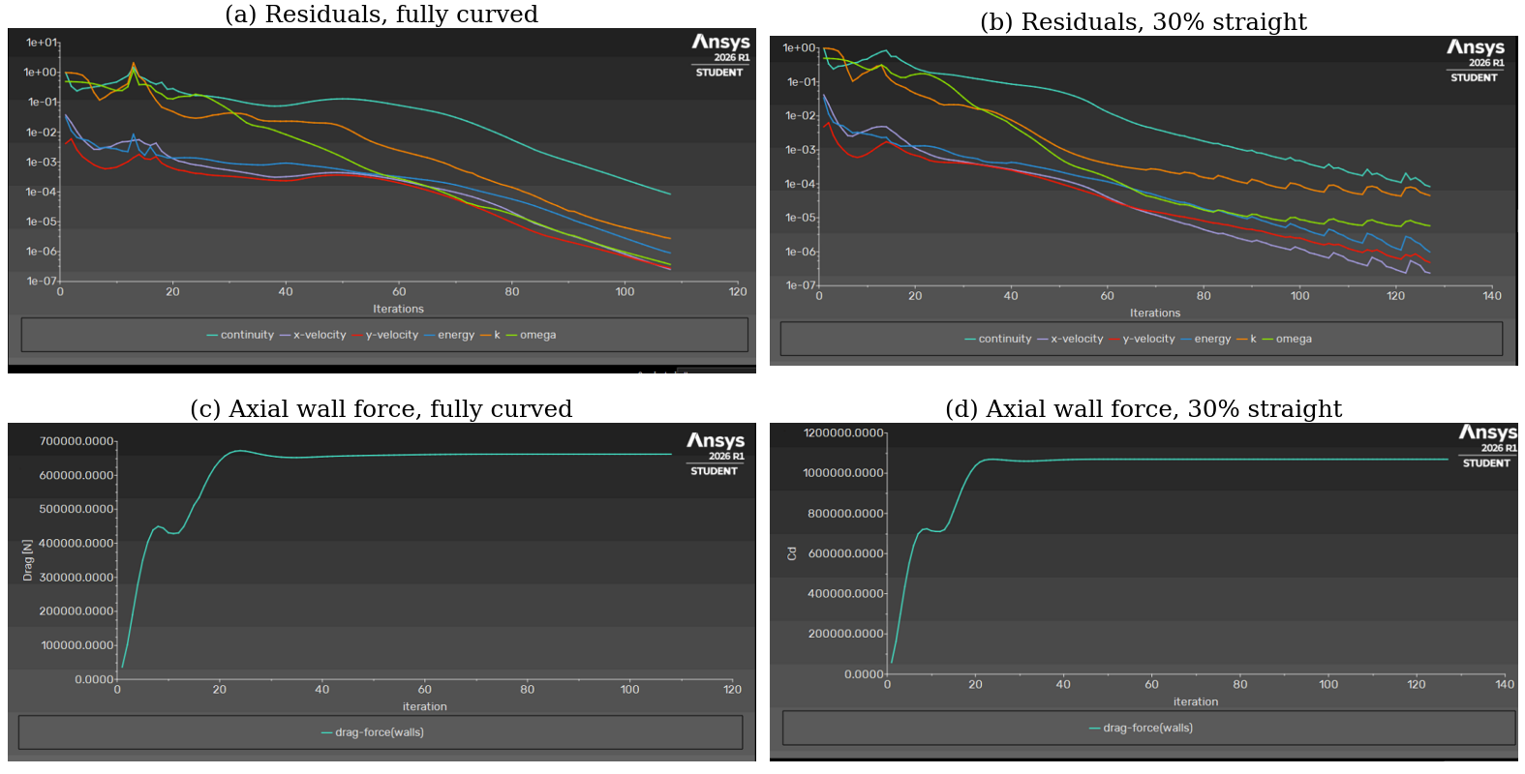
Fig. 2. Convergence traces for Case 1 (fully curved) and Case 5 (30% straight): (a), (b) scaled residuals; (c), (d) axial wall-force monitors.
III. Performance Metrics
The force exerted by the fluid on wall surface Sw is evaluated by integrating gauge pressure and viscous stress:
$F_{w}=∮_{S_{w}}\left(-p_{g}n+τ·n\right) dS$ (8)
where Fw = (Fx, Fy) is wall force per unit depth (N·m−1), pg is gauge static pressure, n is the unit wall normal, τ is viscous stress, and dS is a wall-length element.
An independent check of the axial component is made using a momentum balance over a control volume between the inlet (i) and exit (e) planes:
$F_{x,mom}=\left({p̄}_{g,i}-{p̄}_{g,e}\right)A_{e}+ṁ_{i}{V̄}_{i}-ṁ_{e}{V̄}_{e}$ (9)
Here, p̄g and V̄ are area-averaged gauge pressure and velocity; ṁi and ṁe are inlet and exit mass flow per unit depth (kg·s−1·m−1); and Ai = Ae = 1.15 m are the inlet and exit heights. Secondary-stream momentum is omitted because it is less than 0.1% of the inlet value.
Because the chamber head end is outside the computational domain, Fx does not represent complete engine thrust. Exit-plane thrust per unit depth is instead estimated as:
$F_{T}=ṁ_{e}{V̄}_{e}+\left({p̄}_{e}-p_{a}\right)A_{e}$ (10)
The area-averaged gauge exit pressure equals p̄e − pa. Nozzle performance is described by the thrust, velocity, and discharge coefficients:
$C_{F}=\frac{F_{T}}{p_{0}A_{t}}, η_{V}=\frac{{V̄}_{e}}{V_{e,is}}, C_{D}=\frac{ṁ_{i}}{ṁ^{*}}$ (11)
The isentropic exit velocity is Ve,is = 793.0 m·s−1 for Me,is = 2.896 and T0 = 499.7 K. Mass flow ṁ is calculated from Eq. (7) using At = 0.300 m.
The thrust-vector angle and secondary-injection parameters are defined as:
$δ=\tan^{-1}\left(\frac{F_{y}}{F_{x}}\right)$ (12)
Here Fy is the transverse wall force; ideal symmetric double injection gives δ = 0.
$Π_{m}=\frac{ṁ_{s}^{u}+ṁ_{s}^{l}}{ṁ_{i}}, Π_{p}=\frac{p_{0s}}{p_{0}}$ (13)
The quantities ṁsu and ṁsl denote upper- and lower-port mass flows, respectively, while p0s is the injector stagnation pressure obtained from port averages.
The solver’s default reference values (area 1 m2, density 1.225 kg·m−3, and velocity 1 m·s−1) cause its reported “drag coefficient” to equal Fx/0.6125 numerically (approximately 1.07 × 106). This value has no aerodynamic interpretation; dimensional forces are reported instead.
IV. Results and Discussion
A. Verification
Table IV compares the directly integrated axial force Fx with the momentum-based value Fx,mom from Eq. (9). Agreement is within 0.01% for Case 1 and 0.96%–1.90% for Cases 2–5. Exit Mach numbers of 2.80–2.89 are within 3.4% of the isentropic value 2.896, consistent with expansion set by the geometric area ratio. Cases 2–4 have primary flow rates of 468.5–468.8 kg·s−1·m−1, matching their single-injection counterparts and indicating identical throat geometry. Case 5 has 0.45% more primary flow, whereas Case 1 has 3.6% less; their discharge coefficients are 0.965 and 0.927, compared with 0.960–0.961 for Cases 2–4.
B. Flow Field
Figure 3 presents the Mach-number distributions. The flow chokes near the throat and accelerates through the divergent core, reaching local Mach numbers of about 2.8–3.3. All geometries exhibit a strong pattern of oblique compression and reflected waves. In the straight-section designs, the waves begin near the straight-to-curved transition, where wall curvature changes abruptly; they are weaker near the throat for the fully curved geometry. Each injector creates an oblique shock just upstream of its opening, and the shocks cross the core and meet near the centerline. The static-pressure and velocity fields in Fig. 5 show corresponding structures. The area-averaged exit pressure is 29.6–32.3 kPa absolute, or pe/pa = 0.29–0.32, indicating overexpanded operation.

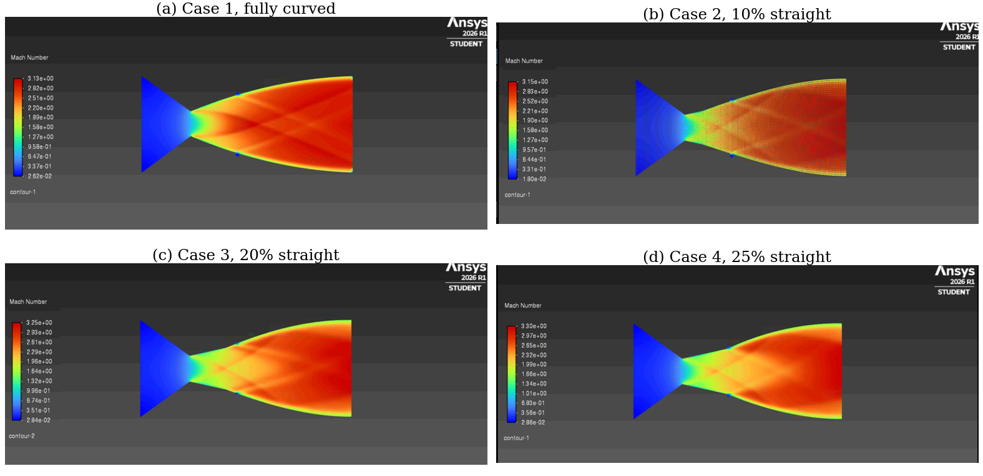
Fig. 3. Mach-number contours with symmetric double secondary injection: (a) Case 1, fully curved; (b) Case 2, 10%; (c) Case 3, 20%; (d) Case 4, 25% straight segment. No Mach-number contour was exported for Case 5.
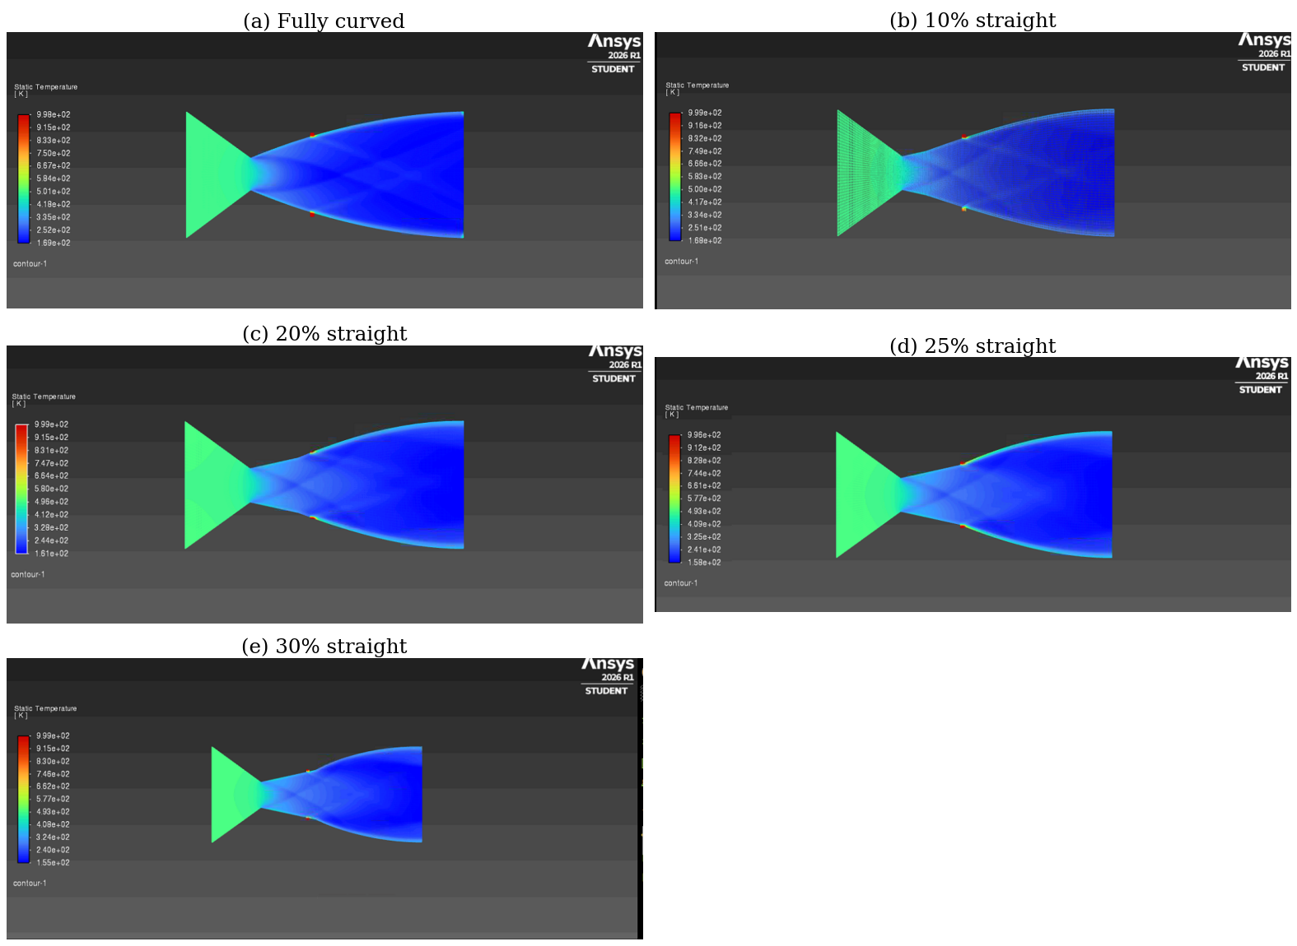
Fig. 4. Static-temperature contours with double injection for all five cases. The 1000 K injectant forms thin hot layers along both walls downstream of the ports.

The static-temperature fields (Fig. 4) show that the 1000 K injectant does not penetrate the core. It forms thin layers along both walls downstream of the ports. This behavior follows from the low stagnation-pressure ratio Π_{p} ≈ 0.155: the jet enters the nozzle because the port pressure exceeds the local wall pressure, but its momentum is small and the primary stream turns it quickly.
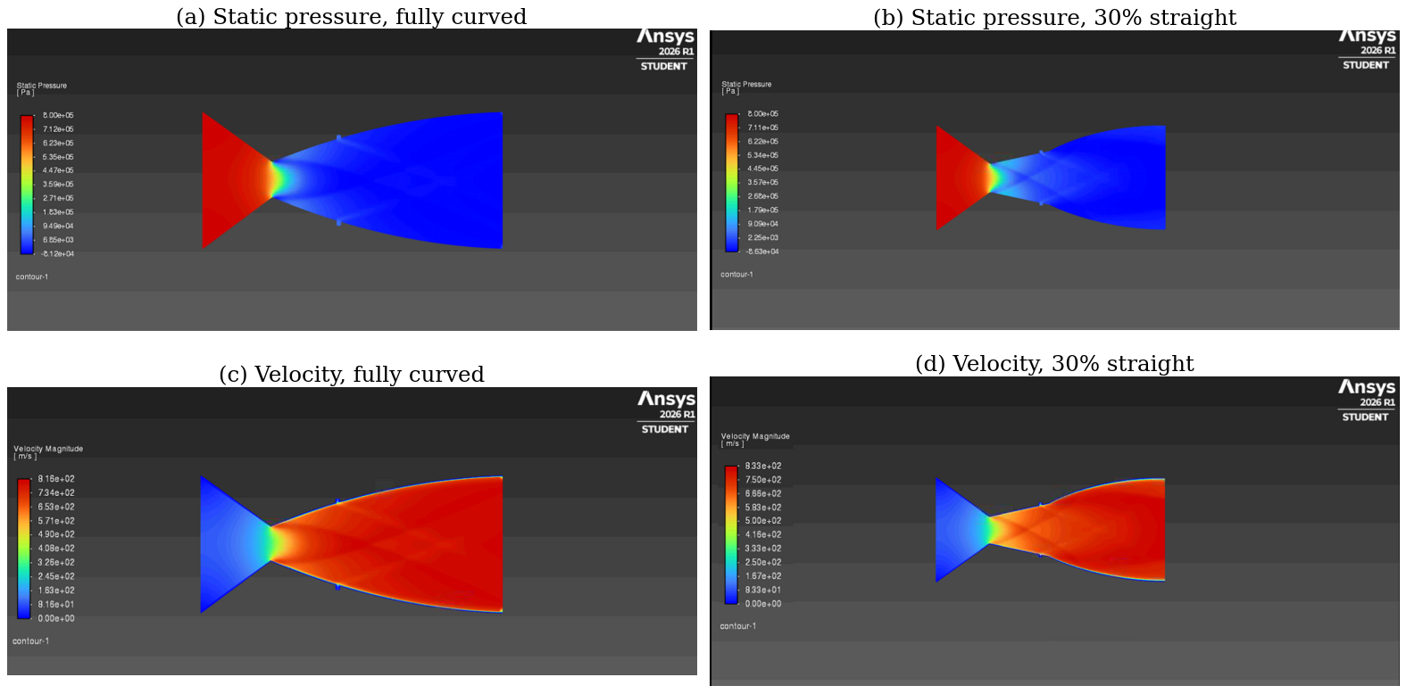
Fig. 5. Static-pressure contours for (a) Case 1 and (b) Case 5, and velocity-magnitude contours for (c) Case 1 and (d) Case 5, with double injection.
C. Nozzle Efficiency and Thrust
Axial performance is summarized in Fig. 6 and Table V. Straight-section nozzles achieve velocity coefficients ηV = 98.9%–99.2% and thrust coefficients CF = 1.064–1.078; the fully curved configuration yields 97.7% and 1.001. Among the geometrically consistent Cases 2–4, exit-plane thrust increases from 287.0 to 290.9 kN·m−1 as s rises from 0.10 to 0.25. Case 5 produces 290.6 kN·m−1, indicating that gains level off near s = 0.25. The lower discharge coefficient of Case 1 (0.927) points to a different throat condition, so contour effects cannot be isolated from throat effects in that comparison.
Relative to single injection, double injection shifts exit-plane thrust by −0.33% to +0.42%; relative to comparable baseline cases, the difference is −0.18% to +0.48%. For Πm = 0.13%–0.71%, these changes are effectively neutral within the resolution of the simulations. The velocity-coefficient gap between Case 1 and Cases 2–5 is 1.2–1.5 percentage points, larger than the injection-associated change. Within the cases analyzed, contour selection is therefore more strongly associated with efficiency than low-pressure secondary injection.
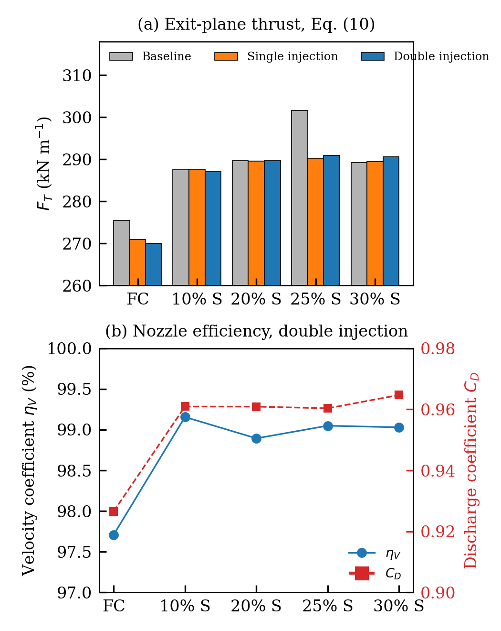
Fig. 6. (a) Exit-plane thrust F_{T}, Eq. (10), for baseline, single-injection, and double-injection solutions. (b) Velocity coefficient η_{V} and discharge coefficient C_{D}, Eq. (11), for double injection. The baseline of Case 1 and Case 4 has a different throat geometry from the injection solutions.

D. Side Force and Injector Symmetry
Opposed injectors are expected to cancel transverse force. As Fig. 7 indicates, double injection lowers |Fy| compared with single injection in four of the five cases, by 20% in Case 3 to 70% in Case 5. Residual side force is 0.04%–0.29% of Fx (|δ| ≤ 0.16°). These values are comparable with baseline side forces (−541 to +2159 N·m−1), which reflect small numerical asymmetries in nominally symmetric solutions.
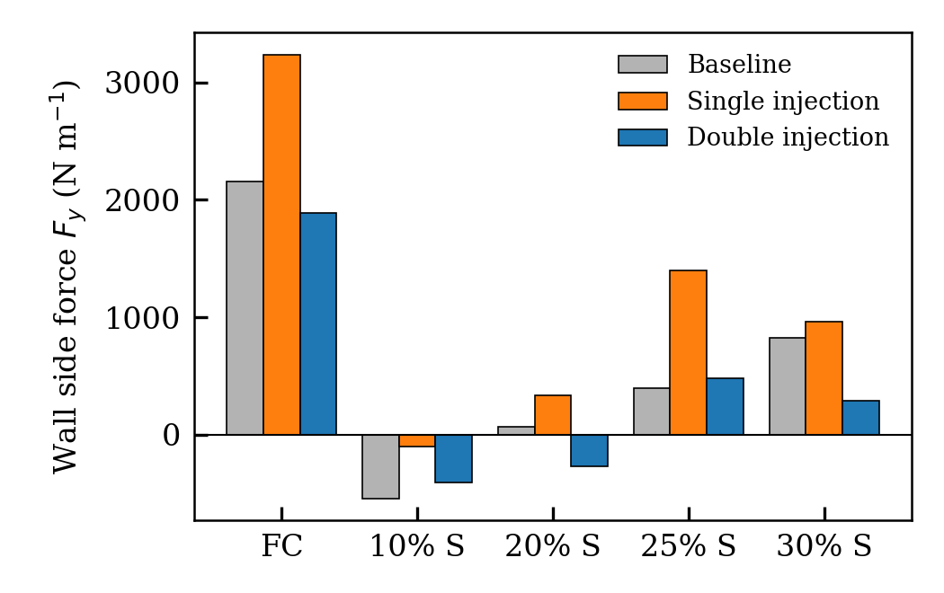
Fig. 7. Wall side force F_{y} for baseline, single-injection, and double-injection solutions. FC denotes the fully curved nozzle and n% S the nozzle with an n% straight segment.
Case 2 is the exception: its side force changes from −100 N·m−1 with single injection to −404 N·m−1 with double injection. Figure 8 shows that, despite identical inlet specifications, its lower port supplies only 0.26 kg·s−1·m−1 compared with 0.95 kg·s−1·m−1 from the upper port, a 73% mismatch. The lower-port face temperature of 807 K also suggests mixing with the primary flow. In Case 5, the upper port reverses and ingests 0.047 kg·s−1·m−1, while the lower port supplies 0.68 kg·s−1·m−1. Only Cases 1 and 4 have port flows within 6% of each other. Injector static pressures of 28.8–37.9 kPa gauge are close to stagnation pressure, leaving the ports at low Mach numbers (0.03–0.31) and sensitive to local wall pressure. Since the wave pattern described in Section IV-B modifies that pressure, injection at Πp ≈ 0.155 is not robust: local shock differences can determine whether a port injects, stalls, or reverses.
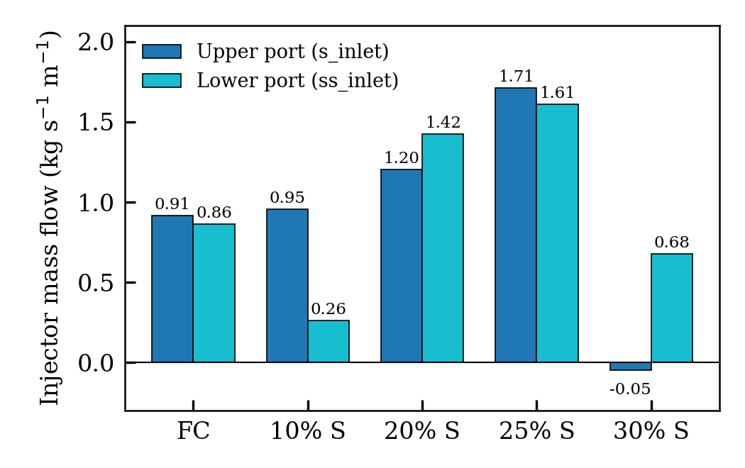
Fig. 8. Mass flow through the upper and lower injection ports under identical boundary conditions. Negative values denote reverse flow into the injector.
E. Wall Heating and Skin Friction
Hot injection increases area-averaged adiabatic wall temperature by 42–92 K relative to baseline and by 21–44 K relative to single injection (Fig. 9a). In Cases 2–5, viscous axial force decreases by 16%–23% from baseline (Fig. 9b), as the low-density hot layer reduces near-wall momentum and velocity gradient. The skin-friction change is modest in absolute terms—less than 0.2% of Fx—whereas the temperature rise creates a thermal-management penalty for cooled or temperature-limited structures.
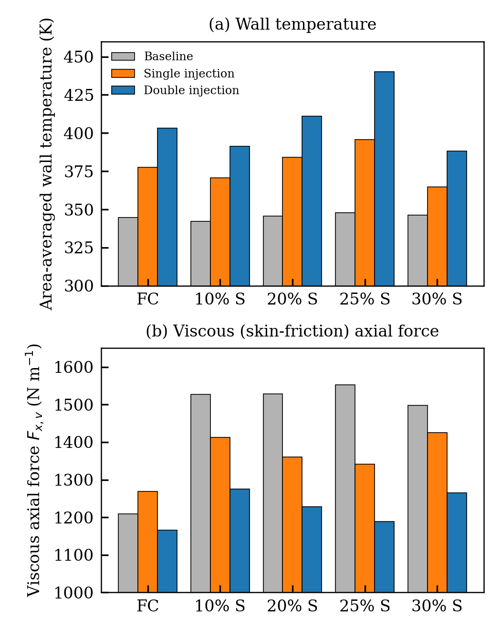
Fig. 9. (a) Area-averaged wall temperature and (b) viscous axial wall force for baseline, single-injection, and double-injection solutions.

TABLE IV
Master Table of Computed Results, Double Secondary Injection
Quantity | Case 1 (FC) | Case 2 (10% S) | Case 3 (20% S) | Case 4 (25% S) | Case 5 (30% S)
Mass flow (kg·s⁻¹·m⁻¹)
Primary inlet, ṁ_{i} | 452.049 | 468.773 | 468.755 | 468.492 | 470.597
Outlet, |ṁ_{e}| | 453.826 | 469.990 | 471.381 | 471.814 | 471.224
Upper port (s_inlet) | 0.9146 | 0.9547 | 1.2019 | 1.7119 | -0.0474
Lower port (ss_inlet) | 0.8633 | 0.2614 | 1.4231 | 1.6101 | 0.6786
Π_{m} (%) | 0.393 | 0.259 | 0.560 | 0.709 | 0.134
Net imbalance (%) | 0.0002 | 0.0003 | 0.0001 | 0.0001 | 0.0009
Wall forces and moment (per unit depth)
F_{x}, pressure (N·m⁻¹) | 660,891.3 | 650,963.5 | 651,212.6 | 652,378.1 | 653,673.8
F_{x}, viscous (N·m⁻¹) | 1,165.5 | 1,275.4 | 1,228.5 | 1,189.3 | 1,264.9
F_{x}, total (N·m⁻¹) | 662,056.8 | 652,238.9 | 652,441.1 | 653,567.4 | 654,938.7
F_{x,mom}, Eq. (9) (N·m⁻¹) | 661,962.1 | 645,972.3 | 643,352.3 | 642,052.5 | 642,466.1
Difference (%) | 0.01 | 0.96 | 1.39 | 1.76 | 1.90
F_{y}, total (N·m⁻¹) | 1,885.6 | -403.5 | -266.4 | 480.5 | 292.7
M_{z} (N·m·m⁻¹) | 1,177.6 | 3,631.0 | 2,313.6 | 1,871.6 | 2,070.5
Centre of pressure y (mm) | -4.65 | -4.97 | -3.15 | -3.61 | -3.62
δ (deg) | 0.163 | -0.035 | -0.023 | 0.042 | 0.026
Area-weighted averages
Inlet static pressure, gauge (kPa) | 785.37 | 784.30 | 784.30 | 784.31 | 784.16
Inlet velocity (m·s⁻¹) | 63.85 | 66.28 | 66.28 | 66.24 | 66.55
Inlet temperature (K) | 497.67 | 497.49 | 497.49 | 497.50 | 497.47
Exit static pressure, gauge (kPa) | -70.91 | -71.75 | -69.57 | -69.25 | -69.06
Exit static pressure, abs. (kPa) | 30.41 | 29.58 | 31.75 | 32.07 | 32.27
Exit Mach number | 2.7989 | 2.8603 | 2.8677 | 2.8832 | 2.8900
Exit velocity (m·s⁻¹) | 774.82 | 786.30 | 784.22 | 785.45 | 785.29
Exit density (kg·m⁻³) | 0.5117 | 0.5212 | 0.5338 | 0.5349 | 0.5418
Exit temperature (K) | 200.58 | 193.12 | 195.57 | 195.37 | 192.75
Wall static pressure, gauge (kPa) | 173.53 | 180.94 | 188.48 | 186.72 | 187.40
Wall temperature (K) | 403.24 | 391.24 | 411.01 | 440.14 | 388.36
Upper-port static pressure (kPa g) | 36.35 | 36.91 | 28.81 | 32.38 | 35.39
Lower-port static pressure (kPa g) | 37.06 | 37.89 | 36.44 | 33.84 | 37.39
Upper-port temperature (K) | 996.6 | 997.8 | 980.7 | 988.3 | 994.6
Lower-port temperature (K) | 998.1 | 807.5 | 996.8 | 991.4 | 998.7
Upper-port Mach number | 0.1287 | 0.1040 | 0.3140 | 0.2339 | 0.1752
Lower-port Mach number | 0.0983 | 0.0347 | 0.1197 | 0.2021 | 0.0794
Mass-weighted averages over the fluid zone
Static pressure (kPa) | 503.51 | 498.99 | 498.57 | 498.56 | 497.84
Density (kg·m⁻³) | 4.4198 | 4.4045 | 4.4071 | 4.4089 | 4.4071
Temperature (K) | 410.55 | 411.13 | 412.30 | 412.60 | 412.29
Velocity (m·s⁻¹) | 308.05 | 310.97 | 310.52 | 310.53 | 310.64
Mach number | 0.9473 | 0.9419 | 0.9332 | 0.9320 | 0.9313
Derived performance
p₀ (kPa abs.) | 899.4 | 899.3 | 899.3 | 899.3 | 899.3
T₀ (K) | 499.7 | 499.7 | 499.7 | 499.7 | 499.7
p_{0s} mean (kPa abs.) | 139.3 | 139.3 | 139.2 | 139.0 | 139.5
Π_{p} | 0.1549 | 0.1549 | 0.1548 | 0.1545 | 0.1551
F_{T}, Eq. (10) (kN·m⁻¹) | 270.08 | 287.04 | 289.66 | 290.94 | 290.63
C_{F} | 1.0009 | 1.0639 | 1.0736 | 1.0784 | 1.0773
η_{V} (%) | 97.71 | 99.16 | 98.89 | 99.05 | 99.03
C_{D} | 0.9266 | 0.9609 | 0.9609 | 0.9604 | 0.9647
Gauge pressures are relative to 101.325 kPa. Forces and moments are per unit depth; moments are about (1, 0, 0) m. For Case 3, the wall forces include a separate injector-wall zone contributing 54.5 N·m⁻¹ axially. For Case 4, the wall zone is named “wals” in the solver output.
TABLE V
Comparison of Baseline, Single, and Double Injection
Case | F_{T} base (kN·m⁻¹) | F_{T} single (kN·m⁻¹) | F_{T} double (kN·m⁻¹) | Δ vs single (%) | Δ vs base (%) | T_{w} rise vs base (K) | ΔF_{x,v} vs base (%)
Case 1 (FC)† | 275.5 | 271.0 | 270.1 | -0.33 | -1.97 | 58.6 | -3.6
Case 2 (10% S) | 287.6 | 287.7 | 287.0 | -0.23 | -0.18 | 48.9 | -16.5
Case 3 (20% S) | 289.7 | 289.6 | 289.7 | 0.02 | -0.01 | 65.5 | -19.6
Case 4 (25% S)† | 301.7 | 290.2 | 290.9 | 0.26 | -3.55 | 92.4 | -23.4
Case 5 (30% S) | 289.2 | 289.4 | 290.6 | 0.42 | 0.48 | 42.2 | -15.6
†The baseline of this case has a different effective throat (primary mass flow 456.6 and 483.4 kg·s⁻¹·m⁻¹ for Cases 1 and 4); comparisons with the baseline include a geometric contribution.

F. Limitations
Four limitations qualify these conclusions. First, grid independence has not been established. Baseline side-force asymmetry is comparable in magnitude to the small injection effects, so a grid-convergence-index assessment following Celik et al. [22] and Roache [23] is needed. Second, operation is overexpanded (pe/pa ≈ 0.3), where real nozzles may experience separation [6]. The domain ends at the exit, excluding the external plume and preventing ambient-pressure effects and separation from being captured. Third, the planar model represents circular ports as spanwise slots and omits three-dimensional jet structure [9], [11]. Fourth, behavior in Cases 2 and 5 may be unsteady or bistable, phenomena not resolved by the steady solver. Finally, the climate-related interpretation concerns potential efficiency gains only; fuel use, combustion, and life-cycle emissions were not computed.
V. Conclusion
A steady two-dimensional RANS study examined five planar C–D nozzle contours with symmetric double secondary injection and compared them with baseline and single-injection configurations. Integrated wall forces agreed with a momentum balance within 1.9%. The main results are: (1) straight divergent sections of 10%–30% produced velocity coefficients of 98.9%–99.2%, with exit Mach numbers within 1.2% of the isentropic value; thrust increased by 1.4% between the 10% and 25% cases and then changed little; (2) the fully curved case yielded a velocity coefficient of 97.7% and discharge coefficient of 0.927, although its throat differs from the other configurations; (3) for Πm = 0.13%–0.71%, double injection changed thrust by −0.33% to +0.42% relative to single injection and reduced side force to 0.04%–0.29% of axial force in four cases; (4) at Πp ≈ 0.155, identical port boundary conditions did not ensure equal flow, and reversal occurred in one port of the 30% case; and (5) injection increased wall temperature by 42–92 K while reducing viscous axial force by 16%–23%. In this data set, contour variation is associated with the larger efficiency differences. Future studies should verify grid independence, include the external plume, test higher injection pressures for reliable port delivery, and calculate fuel and CO2 impacts for a representative engine cycle.
References
[1] E. Lakzian et al., “Supersonic separation towards sustainable gas removal and carbon capture,” Prog. Energy Combust. Sci., vol. 103, Art. no. 101158, Jul. 2024, doi: 10.1016/j.pecs.2024.101158.
[2] K. Das Sahu, S. S. Yadav, and M. S. Dasgupta, “Impact of microgrooves on supersonic CO₂ condensation and pressure recovery in a converging-diverging nozzle,” Case Stud. Therm. Eng., vol. 72, Art. no. 106376, Aug. 2025, doi: 10.1016/j.csite.2025.106376.
[3] J. Chen and Z. Huang, “Numerical study on carbon dioxide capture in flue gas by converging-diverging nozzle,” Fuel, vol. 320, Art. no. 123889, Jul. 2022, doi: 10.1016/j.fuel.2022.123889.
[4] G. V. R. Rao, “Exhaust nozzle contour for optimum thrust,” J. Jet Propuls., vol. 28, no. 6, pp. 377–382, 1958, doi: 10.2514/8.7324.
[5] G. Hagemann, H. Immich, T. V. Nguyen, and G. E. Dumnov, “Advanced rocket nozzles,” J. Propuls. Power, vol. 14, no. 5, pp. 620–634, 1998, doi: 10.2514/2.5354.
[6] J. Östlund and B. Muhammad-Klingmann, “Supersonic flow separation with application to rocket engine nozzles,” Appl. Mech. Rev., vol. 58, no. 3, pp. 143–177, 2005, doi: 10.1115/1.1894402.
[7] K. A. Deere, “Summary of fluidic thrust vectoring research conducted at NASA Langley Research Center,” in Proc. 21st AIAA Appl. Aerodyn. Conf., Orlando, FL, USA, Jun. 2003, Paper AIAA 2003-3800, doi: 10.2514/6.2003-3800.
[8] R. Balu, A. G. Marathe, P. J. Paul, and H. S. Mukunda, “Analysis of performance of a hot gas injection thrust vector control system,” J. Propuls. Power, vol. 7, no. 4, pp. 580–585, 1991, doi: 10.2514/3.23365.
[9] V. Zmijanovic, V. Lago, M. Sellam, and A. Chpoun, “Thrust shock vector control of an axisymmetric conical supersonic nozzle via secondary transverse gas injection,” Shock Waves, vol. 24, no. 1, pp. 97–111, 2014, doi: 10.1007/s00193-013-0479-y.
[10] V. Zmijanovic, L. Leger, E. Depussay, M. Sellam, and A. Chpoun, “Experimental–numerical parametric investigation of a rocket nozzle secondary injection thrust vectoring,” J. Propuls. Power, vol. 32, no. 1, pp. 196–213, 2016, doi: 10.2514/1.B35721.
[11] E. Erdem and K. Kontis, “Numerical and experimental investigation of transverse injection flows,” Shock Waves, vol. 20, no. 2, pp. 103–118, 2010, doi: 10.1007/s00193-010-0247-1.
[12] F. Forghany, M. Taeibi-Rahni, and A. Asadollahi-Ghohieh, “Numerical investigation of optimization of injection angle effects on fluidic thrust vectoring,” J. Appl. Fluid Mech., vol. 10, no. 1, 2017, doi: 10.18869/acadpub.jafm.73.238.26519.
[13] R. Deng, F. Kong, and H. D. Kim, “Numerical simulation of fluidic thrust vectoring in an axisymmetric supersonic nozzle,” J. Mech. Sci. Technol., vol. 28, no. 12, pp. 4979–4987, 2014, doi: 10.1007/s12206-014-1119-x.
[14] M. Sellam, A. Chpoun, V. Zmijanovic, and V. Lago, “Fluidic thrust vectoring of an axisymmetrical nozzle: An analytical model,” Int. J. Aerodyn., vol. 2, no. 2/3/4, pp. 193–209, 2012, doi: 10.1504/IJAD.2012.049112.
[15] C.-S. Shin, H.-D. Kim, T. Setoguchi, and S. Matsuo, “A computational study of thrust vectoring control using dual throat nozzle,” J. Therm. Sci., vol. 19, no. 6, pp. 486–490, 2010, doi: 10.1007/s11630-010-0413-x.
[16] M. Ferlauto and R. Marsilio, “Numerical investigation of the dynamic characteristics of a dual-throat-nozzle for fluidic thrust-vectoring,” AIAA J., vol. 55, no. 1, 2017, doi: 10.2514/1.J055044.
[17] J. D. Flamm, “Experimental study of a nozzle using fluidic counterflow for thrust vectoring,” in Proc. 34th AIAA/ASME/SAE/ASEE Joint Propuls. Conf., 1998, Paper AIAA 98-3255, doi: 10.2514/6.1998-3255.
[18] R. Deng, T. Setoguchi, and H. D. Kim, “Large eddy simulation of shock vector control using bypass flow passage,” Int. J. Heat Fluid Flow, vol. 62, pt. B, pp. 474–481, 2016, doi: 10.1016/j.ijheatfluidflow.2016.08.011.
[19] E. Mohammadi and A. Toloei, “Numerical investigation of dual secondary injection for thrust vector control,” in Proc. 7th Int. Conf. Heat Transf., Fluid Mech. Thermodyn. (HEFAT), Antalya, Turkey, Jul. 2010. [Online]. Available: http://hdl.handle.net/2263/44425
[20] D. Gupta, “Secondary flow injection in convergent-divergent nozzles for fluidic thrust vectoring: A review,” engrXiv preprint, 2025, doi: 10.31224/7408.
[21] F. R. Menter, “Two-equation eddy-viscosity turbulence models for engineering applications,” AIAA J., vol. 32, no. 8, pp. 1598–1605, 1994, doi: 10.2514/3.12149.
[22] I. B. Celik, U. Ghia, P. J. Roache, C. J. Freitas, H. Coleman, and P. E. Raad, “Procedure for estimation and reporting of uncertainty due to discretization in CFD applications,” J. Fluids Eng., vol. 130, no. 7, Art. no. 078001, 2008, doi: 10.1115/1.2960953.
[23] P. J. Roache, “Quantification of uncertainty in computational fluid dynamics,” Annu. Rev. Fluid Mech., vol. 29, pp. 123–160, 1997, doi: 10.1146/annurev.fluid.29.1.123.

