Load Alleviation By Morphing Wind Turbine Blades Under Uniform, Gust And Turbulent Inflow
RESEARCH ARTICLE
Muhammad Athar Syahreza (student)¹ , Kieran Tait (mentor)²
1. American International School of Riyadh, Al Bustan Village Unit No. 313B, Riyadh, Riyadh Province, 13332, Saudi Arabia
*Muhammad.Athar.Syahreza@gmail.com
Abstract
Morphing wind turbine blades promise to improve wind turbines by allowing blades to adapt to changing winds, alleviating the fatigue loads that impact blade life. The benefit of load alleviation, however, came at the trade-off of lost power production. The concept of a morphing blade was then split into passive and active concepts. The study compared the different morphing blades against a conventional blade from the NREL 5MW reference turbine. The blades were simulated in OpenFAST v4.2.1 and underwent a steady uniform wind sweep from 4 to 20 m/s, a deterministic 1-cosine gust, and IEC Kaimal turbulence at 12 m/s. Under steady sheared wind, the active and passive blades removed up to 55% and 20% of the blade root flapwise damage equivalent load (DEL), respectively. Furthermore, the passive blade retained its performance with a reduced flapwise fatigue load by 21.8% in turbulent winds. The trade-off for these benefits is only a 2- 3% cost in annual energy production against the conventional blade in both the active and passive blades. The benefits of morphing are therefore dependent on the wind condition and the type of blade.
Keywords
Engineering, Wind Energy, Aeroelasticity, Morphing Blades, Bend-Twist Coupling
Introduction
Every time a wind turbine experiences non-uniform wind, in the form of turbulence or gusts, the fatigue caused by the wind shortens the blades' lifespan and raises operating costs,¹ yet conventional blades have no other option but to endure it. Morphing blades could potentially fix the issue by reducing the amount of load and therefore the amount of fatigue accumulated. The importance of such solutions is important since wind energy as a source of renewable energy is growing, with global wind capacity reaching approximately 1300 GW in 2025, with around 165 GW added in 2025 alone.² Continued cost reductions in wind energy therefore depend heavily on improving the aerodynamic efficiency and structural durability of turbine blades.³
1.1 Context
Horizontal axis wind turbines currently make up around ~99% of all power generated by wind turbines,⁴ yet wind and solar only make up 17.3% of the 2025 global electricity generation.⁵ New wind turbines, therefore, must address the current issues before renewables can generate more of the global electricity demand. The implementation of morphing blades, blades that change their shape in response to, or in anticipation of, changing wind conditions,⁶ could be a way to ease the tension of blade loading and extend the lifespan of these blades. Two broad strategies currently exist within morphing blades, with passive morphing blades utilizing tailored composite layups so that aerodynamic loads themselves bend and twist the blade in a favorable direction, referred to as bend-twist coupling, requiring no actuators or control system.^{7, 8} Whereas, active morphing changes the geometry of the blade through actuation, using controllable surfaces, such as changing trailing edges or active cambers, commanded by a controller that measures feedback loads from the surrounding wind to morph the blade into a position where it can best regulate the loads in real time.^{9,10}
1.2 Research Question
How do active and passive morphing blade concepts on a horizontal axis wind turbine relate to a conventional blade in regards to power output and structural loading under uniform, gust and turbulent wind conditions?
1.3 Stakes
While both approaches towards morphing blades have been studied individually, such as active trailing edge flaps^{11,12} and passive load alleviating designs.⁷ Other pieces of literature¹³ only compared both active and morphing blades in isolated two-dimensional (2-D) models, which made the comparison on a 2-D blade section instead of a full turbine model. This paper aims to address that gap by holding the turbine platform, solver, and operating conditions fixed and varying only the blade design and the wind inflow conditions.
1.4 Hypothesis
Both active and passive morphing blades are expected to outperform conventional blades in power output and load alleviation under gust and turbulence conditions. Prior works have shown that these characteristics are plausible, as other active morphing concepts which incorporate an active trailing edge design have been seen to reduce tip deflection by around 30%⁹ compared to hinged flaps. However, it is expected for the conventional blade to outperform both morphing blades below rated, uniform wind speeds in terms of power output because of the tradeoff that morphing blades have made for added load alleviation at the cost of a slight reduction in power.⁶⁻⁸ However, the morphing blades are expected to converge with the conventional blade in terms of power output above rated wind speeds. The convergence is expected, despite the trade-off in power, due to the increased power generated above rated, with any reductions being insignificant despite differences in wind speed or the blade due to limitations imposed by the generator to ensure the turbine holds at rated generator power.
1.5 Background
A morphing blade is never evaluated in isolation, since it’s in a wind field that varies with height and with time, on a machine that is already regulating its own loads through pitch and torque, and within a structure where deformation feeds back into the aerodynamics that caused it. Each of these shapes is what a morphing device can achieve and how its effect must be measured. Ultimately, each of these distinctions should be taken into account when trying to optimize wind turbines through morphing blades.
1.5.1 Dynamics and Control
A modern horizontal-axis wind turbine is a controlled system that continuously adjusts its own operating point, with control as a prerequisite for interpreting load measurements, because the controller is the mechanism that enables any morphing device added to the blade to alleviate the load rather than add to it.
Rotor behavior is governed by the power coefficient, a function of two variables: the tip-speed ratio as:
$λ=\frac{ΩR}{V}$ | (1)
Where Ω is rotor angular velocity, R the rotor radius and V the hub-height wind speed, and β the collective blade pitch angle. For a given blade, there exists a combination (λopt, βopt) maximizing Cp(λ, β), and the controller’s task below rated wind speed is to hold the rotor there as the wind varies.
This produces the conventional division into operating regions. In Region 2, below rated, pitch is held at its fine setting, 0° for the NREL 5MW,¹⁴ and generator torque is commanded proportional to the square of rotor speed; this torque law lets the rotor accelerate and decelerate with the wind such that λ remains near optimum.¹⁵ In Region 3, where wind is above rated speeds, the available aerodynamic power exceeds the rating that the generator can safely use, so the controller pitches toward feather to shed the excess power generated in order to hold power constant at rated. There is a transition period, however, that connects regions 2 and 3 where the rotor speed is capped while torque continues rising to rated.
Collective pitch actuation is when all three blades receive the same command, actuating in unison. This collective moment is sufficient for power regulation, since power is a rotor-averaged quantity and not largely dependent on where the azimuth is distributed, but it cannot address loads that differ between blades at any given moment. Individual pitch control (IPC), however, allows each blade to have individual freedom, moving and actuating on its own, independent of the other blades. IPC can, therefore, alleviate asymmetric rotor loading due to the independence given to each blade, allowing the changes to each blade to be unique and tailored to the different distributions of loading throughout the three different blades.¹⁶
All pitch actuation is physically constrained, with commercial conventional systems typically rate-limited to the order of 8–10 °/s,¹⁴ and the resulting lag being determined by how quickly the controller can respond to a disturbance.¹⁴ Nacelle yaw operates far more slowly, aligning the rotor with wind direction over tens of seconds.¹⁴
1.5.2 Cyclic Loading and Frequency
Fatigue damage is driven by frequency through how often a specific load repeats,¹ therefore, the load a turbine experiences must be defined to include frequency. The source of repeating loads comes from the rotation of the turbine, where loading is conventionally described in multiples of the rotational frequency, denoted nP¹⁷: 1P, once per revolution; 2P, twice per revolution; 3P, three times per revolution.
A blade experiences the greatest variance in load at 1P, where passing through faster wind at the top and slower wind at the bottom causes the loading it experiences to vary significantly at 1P. Furthermore, the blade passes the tower shaft at least once per revolution, contributing to the variations in loading experienced throughout each revolution. Ultimately, these variations are dependent on the blade's position throughout the rotation, and allow active morphing concepts to predict what cycle to schedule the azimuth to allow the blade position to predict how to move into a position where it can best alleviate load when it is high, and maximize power capture when it is low.
1.5.3 Conventional and Morphing Turbines
Utility-scale conventional turbines have converged on a three-bladed, upwind, variable-speed, pitch-regulated configuration due to the three blades being able to balance the rotor dynamically, and variable speed with pitch regulation allowing optimal energy capture below rated and controlled power limiting above it.¹⁷ The NREL 5MW reference turbine ¹⁴ embodies this design optimization, following in the footsteps of other turbines with three blades, each 61.5 m long.
Passive morphing, specifically, uses bend-twist coupling so that bending twists the blade towards feather, allowing it to reduce the amount of load the blade experiences, without actuation or a control mechanism.⁶ There is a structural challenge, however, in allowing the blade to have bend-twist coupling, as the passive morphing concept risks losing the stiffness of the blade, potentially risking the blade breaking in operation.¹⁸ Another trade-off is that coupling is always present, so it costs energy capture even when no alleviation or morphing is needed, especially during uniform wind below rated.
Active morphing, however, includes trailing-edge flaps and continuous camber morphing when implemented in turbine blades to alter the blade geometry. Examples of this include a piezoelectric adaptive trailing edge,¹⁰ a FishBAC design that actively changes the camber of the whole airfoil,¹⁹ and a deformable control surface.⁹ The advantages of such blade concepts that utilize active morphing is the authority and control that the user has over how much load alleviation is necessary, as every reduction in the fatigue experienced results in a loss of power. Furthermore, other costs and limitations of the concept include: the additional power needed to actuate the change, added complexity, and the need for reliability over 20 years in a blade that runs unattended.
Methodology
All three of the horizontal axis wind turbines either used or, in the case of the morphing blades, modeled off the NREL 5 MW reference wind turbine ¹⁴ and its corresponding blade files. The reference turbine is a conventional three-bladed, upwind, variable-speed, collective-pitch-controlled machine with a 126 m rotor diameter and rated wind speed of 11.4 m/s.¹⁴ The implementation of morphing concepts caused a new rated wind speed of 12m/s after wind sweeps. All simulations were run in OpenFAST v4.2.1, combining modules of AeroDyn, ElastoDyn, BeamDyn, ServoDyn, and InflowWind for all simulation runs.
3.1 OpenFAST Modeling
All simulation runs were run on OpenFAST v4.2.1 with ElastoDyn, BeamDyn, and AeroDyn. CompElast, which selects the blade structural model in the main file, was used to couple ElastoDyn and BeamDyn together, where BeamDyn represented the blades with exact geometric beam dimensions with torsional degrees of freedom enabled to allow for bend-twist coupling, while ElastoDyn contained the states of the tower, drivetrain, nacelle, and hub degrees of freedom, rotor speed, and azimuth states. Simulations utilized blade-element momentum theory with Wake_Mod, the wake model selector, configured in Aerodyn to have no sweep pitch twist projection, Prandtl tip and hub loss models, skewed wake correction enabled, and the Pierce Beddoes-Leishman unsteady aerodynamics model with UA_Mod, the unsteady aerodynamics model of OpenFAST, which selects a variant of the Beddoes-Leishman dynamic stall model. Dynamic wake was set to quasi-steady with DBEMT_Mod, the dynamic BEM model. The glue code time step was 0.0015s, with identical time steps across all three configurations.
3.2 Passive Blade Parameters
Specific to the passive case, BeamDyn introduced bend-twist coupling parametrically through the BeamDyn 6x6 cross sectional stiffness matrix²⁰ with the population of bending and torsion off-diagonal terms.
$K_{56}=K_{65}=α⋅\sqrt{K_{55}⋅K_{66}}$ | (2)
Where K₅₅ is the flapwise bending stiffness, K₆₆ is the torsional stiffness, and K₅₆ is the flap twist coupling term; all three share the same units of Nm². The coupling coefficient, dimensionless, is defined as α and constrained to |α| < 1.
Indices 5 and 6 represent flapwise bending and torsion, respectively, in BeamDyn, with a coupling coefficient of ⍺ = 0.3, which was applied from 45% of the span until the tip and tapered at over 10% of the span with a half-cosine profile to avoid stiffness discontinuity. All other diagonal stiffness terms, full mass matrix, station locations, and damping coefficients were kept constant from the conventional blade to ensure that the passive morphing blade only differed in two entries. Furthermore, the sign of ⍺ was determined through an initial sweep of the conventional blade and its blade root flapwise moment compared to tip twist at rated wind speed, which confirmed that a positive ⍺ produced a twist toward feather. The sweep resulted in a mean blade tip twist of −5.28° for the passive blade, compared to −0.37° for the conventional blade.
3.3 Active Flap Aerodynamics
The active blade was structured to be identical to the conventional blade, with the only difference being present in the aerodynamics and control to allow for a clear cause-and-effect relationship when comparing performance. Active morphing was modeled as a trailing edge flap with aerodynamics represented using thin airfoil plain flap theory, with the flap containing a fraction of the chord, E, hinged at x/c = 1 - E where x is the chordwise distance from the leading edge and c is the section chord. The lift and moment derivatives per radian of deflection are calculated as.²¹
$θ_{h}=arccos(2E-1)$ | (3)
$\frac{dC_{1}}{dδ}=2(π-θ_{h}+sinθ_{h})$ | (4)
$\frac{dC_{m}}{dδ}=-\frac{1}{2}(1-cosθ_{h})sinθ_{h}$ | (5)
Where E, dimensionless, is the flap chord expressed as a fraction of the section chord; θ_{h}, radians, is the hinge position in the transformed coordinate; and δ, radians, is the flap deflection angle and is defined as positive when the trailing edge is down. C₁ and C_{m} are the section lift and pitching moment coefficients, respectively.
With the active flap as 20 percent of the section chord, E = 0.20, equation 4 gives a flap lift derivative of 3.455 per radian or an equivalent of 0.0603 per degree. The viscous efficiency factor of 0.75 was assumed and applied to account for the boundary layer effects, which cause a reduction in how effective the flap is, resulting in an effective 0.0452 per degree. Furthermore, instead of just adding the resulting lift increment to the polar as a constant offset, it was applied to the active case as a shift along the angle of attack axis, as Δ⍺ = ΔC₁/C_{l⍺}, rather than a constant, to allow the stall angle to move with the flap and to preserve the polar shape. The shift was also tapered to zero between 20° and 45° angles of attack, and a drag penalty was assumed and added, over the same range, of ΔCd = 0.005·(sin)².
Five polar values were generated for each flap section from -10°, -5°, 0°, +5°, to +10° deflection. The zero-degree deflection table was an identical copy to the conventional turbine to ensure that both configurations had identical aerodynamics at zero deflection. The multiple tables were organized and managed through Aerodyn, interpolating between the multiple tables. The flaps were applied to only the NACA64 blade sections and spanned r/R = 0.71 to the tip, with Blade span 43.05 m to 61.50 m.²²
The flaps and their corresponding deflection were commanded through ServoDyn with an open-loop flap actuation system to reduce 1P loads^{22,23} and modeled as a cosine cycle defined through AfCmode, ServoDyn’s airfoil control flap mode:²⁴
$δ(ψ)=A⋅cos(ψ+φ)$ | (6)
Where δ, degrees, is the flap deflection; ψ, degrees, is the blade azimuth; A is the command amplitude; and φ, degrees, is the phase offset.
The amplitude was set to 5° and the phase offset to 180 °, with the blade azimuth being measured from the vertical. At a phase offset of 180°, the 1P load range was minimized, leading to the ultimate selection of this value as the phase for all active blade cases. The value inverts the commanded cosine so that the flap opposes rather than reinforces the shear-driven 1P load cycle. This inversion was then confirmed after an initial sweep from a range of values of 0°, 90°, 180°, and 270° at 11.4m/s which compared blade root flapwise moment amplitude to the unflapped conventional blade.
3.4 Turbine Controller
All three blade configurations used an identical controller input file taken from the NREL GitHub,²⁴ with a bladed-style dynamic library controller managed through ServoDyn with PCMode, the pitch control mode, and VSContrl, the variable speed torque control mode. The active case, however, utilized ROSCO 2.10.1 compared to OpenFAST v4.2.1’s DISCON to allow for the active flap capability, with pitch, torque gains, filter settings, minimum pitch schedules, and peak shaving settings kept constant to minimize case-specific controller differences. The ability to use the different dynamic libraries across the wind turbine cases was crucial to the success of the investigation, as DISCON did not allow for any flap control, and resulted in all the simulations being run in OpenFAST v4.2.1, despite the benefits of the newly developed tight coupling algorithm on v5.0.0, due to limited ROSCO support on OpenFAST v5.0.0.²⁴
3.5 Uniform Wind Parameters
In simulating the uniform wind study as a baseline comparison of the morphing turbines, active and passive blade cases, against the conventional turbine, the turbines were simulated at an onshore site with a 31 m square grid of steady wind with an average horizontal wind speed ranging from 4 m/s to 20 m/s with intervals of 2 m/s between every wind speed. To ensure no turbulence was present, there was no wind on any axis other than the x-axis, with zero yaw misalignment and zero upflow. Furthermore, the reference height for horizontal wind speed was defined as 90 meters across all three configurations, and a power law exponent of 0.2. All three turbine cases were simulated in the uniform wind for 200s, with statistics and output data being calculated from the final 120s due to the removal of transient data occurring in the first 80 s of startup.
3.6 Non-Uniform Wind Parameters
A deterministic gust was modeled as a 1-cosine gust and defined as:
$V(t)=V_{0}+\frac{A}{2}⋅[1-cos(\frac{π(t-t_{0})}{t_{r}})], t_{0}≤t<t_{0}+t_{r}$ | (7)
Where V₀ was defined as the base wind speed of 12 m/s, where the simulation begins and ends; A as gust amplitude of 6 m/s, the total rise; (t - t₀)/t_{r} as the progress during the gust rise and represented as a fraction, zero at the start and one at the end. Parameters gave a rise and fall of the gust for 3 s each and a peak of 18 m/s at t = 63 s, with a return to baseline at t = 66 s. Shear exponent, direction, and upflow were held at the steady inflow values to represent a suitable comparison against the uniform wind study to allow for a comparison against a gust with minimal confounding variables. Simulations were run for 120 s.
Another turbulent wind field was generated with TurbSim, where full-field turbulence was generated with TurbSim using the IEC Kaimal ²⁵ spectral model, IEC 61400-1 edition 3,²⁵ class B turbulence characteristic, and normal turbulence model, at a reference wind speed of 12 m/s with a 0.14 power-law profile at 90 m reference height. The grid spanned 144.76 m in both directions on a 31-square-point mesh at a 0.05 s time step, sized to 1.15 times the rotor diameter so that the full rotor disc lies within the field with margin. Tower wind points were generated to supply inflow below the grid for the tower aerodynamic nodes. Wind fields were generated using fixed random seeds, and the same wind fields were applied to all three turbine configurations, so that inflow realization is common to each comparison pair and cancels in the seed-by-seed differences. Each simulation ran 660 s with the first 60 s discarded, giving 600 s of analyzed data.
3.7 Data Processing
To find how much fatigue the blades experienced, damage-equivalent loads (DEL) were taken as a measured variable. However, due to DEL not being a direct output of OpenFAST, DEL had to be computed from the resulting OpenFAST data from each study through a three-point rainflow counting algorithm, which counted the load range and was implemented in accordance with ASTM E1049.^{26.} Each counted cycle had a range S_{i} and a count of n_{i}, where n_{i} was one for a fully closed cycle and n_{i} was 0.5 for a half cycle remaining in the residue. The damage-equivalent load was then calculated as:
$DEL=(\frac{\sum_{i}{}n_{i}S_{i}^{m}}{N_{eq}})^{\frac{1}{m}}$ | (8)
$N_{eq}=f_{eq}⋅T$ | (9)
The Wohler exponent of the material was defined as m; T is the duration of the analyzed window and f_{eq} is the equivalent cycle frequency, so that the product is defined as the number of equivalent cycles over the time of the window. The analyzed window was 120 s for the steady inflow cases and 600 s for the turbulent cases, in each case following the discard of the initial transient. No mean-stress correction was applied, as the comparison is made between configurations on the same load channel rather than as an absolute estimate of fatigue life.
Annual energy production was then estimated by weighing each power curve against a Rayleigh wind speed distribution, IEC 61400-1,^{25,} which evaluated the annual mean wind speeds at 10 and 8.5 m/s in accordance with IEC Class I and II sites.²⁵ The integration ran from a cut-in of 3 m/s to a cut-out of 25 m/s, with the power interpolated linearly from zero at cut-in speeds to the lowest simulated speed, and then held at 20 m/s up until cut-out speeds.
Results
This section presents the aeroelastic response of the three blade configurations under three inflow conditions: a steady uniform wind speed sweep, a deterministic gust, and a turbulent inflow condition. All simulations share an identical tower, drivetrain, nacelle, and controller, with the blade as the only difference between cases, and all load statistics are reported after discarding the initial transient. Results are reported as damage-equivalent loads for fatigue-relevant channels and as peak excursions for the transient case.
4.1 Uniform Wind Study
All three cases share the same tower, drivetrain, nacelle, and controller; the blade is the only difference. Simulations were run in OpenFAST v4.2.1 with ElastoDyn for tower, drivetrain, and platform degrees of freedom and BeamDyn for the blades. Blade pitch and generator torque are commanded by ROSCO 2.10.1 for active and DISCON for both conventional and passive with identical gains, schedules, and filter settings; no case-specific controller tuning was applied. Ten hub-height wind speeds were simulated, with the active case at 4 m/s removed due to outlier data caused by OpenFAST’s simulation of turbines at low wind speeds. All wind speeds were under steady inflow with a 0.20 power-law shear exponent, zero yaw misalignment, and zero upflow. Each run is 200 s of simulated time; the first 80 s are discarded as start-up transient, and all statistics are computed on the remaining 120 s. Rated wind speed determined from the sweep is approximately 12 m/s: the conventional case first pitches away from zero (1.71°) and first reaches the rated rotor speed of 12.10 rpm at 12 m/s, with generator power within 0.6% of the 5000 kW rating.
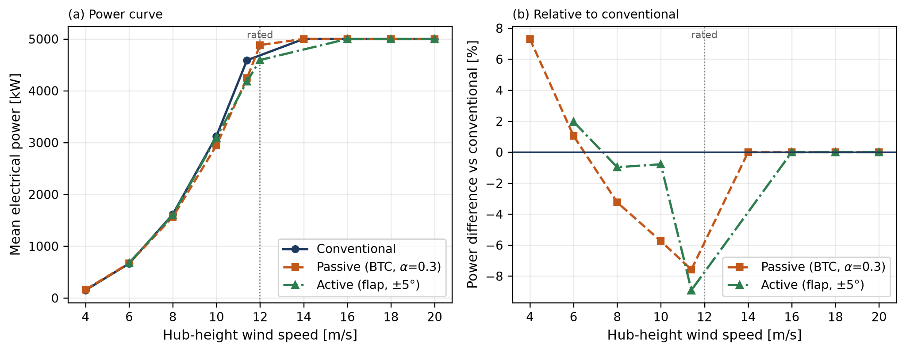
Figure 1a (Left). Power curve (kW) across tested wind speeds (m/s). The figure was created with Matplotlib.
Figure 1b (Right). Power difference (%) relative to the conventional turbine across tested wind speed (m/s). The figure was created with Matplotlib.
Above rated, the three cases are indistinguishable, all regulating to 5000 kW and agree to within 0.01% of each other (Figure 1a), resulting in every difference between the blades lying below rated. In that region, both morphing cases lose power relative to conventional, and in both the deficit grows as rated is approached, reaching its maximum in the last bin before rated: 7.6% for passive and 8.9% for active at 11.4 m/s (Figure 1b). The two morphing concepts converge with conventional by different routes, shown through the different shapes in Figure 1b. The passive blade gave up power marginally, degrading progressively, sitting marginally above conventional at 6 m/s and falling steadily below it through 8 and 10 m/s, until converging with the conventional blade at 5 MW at 14 m/s. The continuous fall is consistent with a coupling-induced twist that grows with aerodynamic loading, where the gap between the conventional and passive blade grows as load builds up. The power that the passive lost below rated wind speeds is exactly the tradeoff that is made when using bend-twist coupling for load alleviation. Active, however, had a loss that was concentrated rather than continuous, staying within conventional to 2% through most of the below-rated range before dropping sharply at 11.4 m/s (Figure 1b), suggesting a localized penalty rather than a progressive one. The localized penalty can be explained by the active case’s azimuth control schedule not pitching correctly at 12 m/s, suggesting that the penalty only belongs to this transition period and not the whole operating range of the active blade.
Weighted over the Rayleigh wind-speed distribution, both morphing blades had an annual energy loss of roughly 2–3% in the below-rated wind speed deficit. The annual energy loss compared to the conventional blade was slightly larger at a Class II site of an annual mean wind speed of 8.5 m/s, with a 2.6% loss for passive and 2.9% for active. However, the loss was less at a Class I site of an annual mean wind speed of 10 m/s, with a 2.1% loss for passive and 2.5% for active compared to the conventional blade. The difference between the two sites can be explained because the lower-mean site, Class II, spends more of the year in a region of lower wind speeds, resulting in a smaller total annual output against the same measured absolute energy loss. Specifically, both sites had similar power losses, with 500 MWh per year for passive and 570 MWh for active, yet because at the Class II site, the power loss was a larger fraction of a smaller total, it resulted in higher power losses over the course of a year.
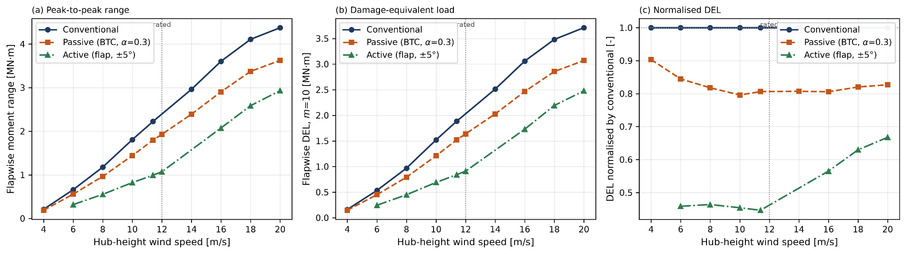
Figure 2a (Left). Flapwise moment range (MN·m) across tested wind speeds (m/s). The figure was created with Matplotlib.
Figure 2b (Center). Flapwise DEL across tested wind speeds (m/s). The figure was created with Matplotlib.
Figure 2c (Right). DEL of active and passive blade normalized to DEL of conventional blade across tested wind speeds (m/s). The figure was created with Matplotlib.
Both morphing concepts reduced blade root flapwise loading across every wind speed. The ordering of the blades from highest to lowest fatigue, measured in DEL, was conventional, then passive, then active. This order was held throughout all the tested wind speeds in both figures 2a and 2b. The two morphing blades differed by roughly a factor of three in effectiveness, whereas when compared with the conventional blade, the passive blade removed a consistent 15–20% of flapwise DEL across all tested wind speeds. The data then suggest that the passive blade’s load alleviation is independent of wind speed when compared to the conventional blade (Figure 2c). The independence was expected due to how structural coupling scales when responding under load. Active, however, compared to the conventional blade decreased more than half of its DEL at and below rated relative to the conventional blade, peaking at 55.4% at 11.4 m/s. However, the benefits of the active blade eroded steadily above rated to only about a third by 20 m/s (Figure 2c). The reduction in how much the active blade was able to alleviate is because the fixed ±5° flap amplitude represents a shrinking fraction of the aerodynamic load as wind speed rises, resulting in limited effectiveness. This is illustrated by rising DEL after passing the rated wind speed.
Table 1. Load channel summary at 11.4 m/s, with ranges across the 4–20 m/s sweep, relative to the conventional blade. MN·m = Meganewton-meter (torque).
 | Units | Conventional | Passive | Active | Passive, range over sweep | Active, range over sweep
Mean blade root flapwise moment | MN·m | 9.505 | 7.746 (−18.5%) | 8.013 (−15.7%) | −18.5% to −0.7% | −15.7% to +0.9%
Blade root flapwise peak-to-peak range | MN·m | 2.224 | 1.795 (−19.3%) | 0.992 (−55.4%) | −20.3% to −10.4% | −55.4% to −33.0%
Blade root flapwise DEL (m = 10) | MN·m | 1.886 | 1.520 (−19.4%) | 0.842 (−55.4%) | −20.4% to −9.7% | −55.4% to −33.2%
Blade root edgewise DEL (m = 10) | MN·m | 6.036 | 5.975 (−1.0%) | 5.968 (−1.1%) | −1.3% to +0.1% | −2.1% to −0.2%
Mean tower base fore-aft moment | MN·m | 63.290 | 52.907 (−16.4%) | 51.577 (−18.5%) | −16.4% to −0.2% | −18.5% to −1.6%
Low-speed shaft bending DEL (m = 4) | MN·m | 1.388 | 1.652 (+19.0%) | 2.685 (+93.4%) | −22.8% to +28.3% | +16.9% to +146.9%
Mean blade tip twist | deg | −0.17 | −5.12 | −0.56 | −4.95° to −0.30° | −0.39° to +0.18°

Mean and cyclic loads respond differently, and the split is present between the two morphing blades and shown in the same channel. Passive lowered the mean blade root flapwise moment by up to 18.5% below rated, alongside a 20% reduction in its DEL. Yet, the active blade only left the mean of the conventional blade to within 1% and reduced its DEL by 55% (Table 1). The differences show that the passive blade alleviates the load from the rotor, while the active blade rearranges the load already present in the rotor and distributes it elsewhere. The rearrangement can be seen through the results of low-speed shaft bending DEL for the active case, running 93.4% above the conventional blade at 11.4 m/s. The difference from the conventional is further seen at 16 m/s, where the active case is about 150% at 16 m/s. Yet, in terms of the passive blade, the blade only moves between -22.8% and +28.3% in terms of low-speed shaft bending. Despite differences in low-speed shaft bending, neither morphing blade differs in edgewise DEL, staying within 2% of the conventional blade.
4.2 Gust Wind Study
A 1-cosine gust was superimposed on a 12 m/s hub-height wind with an amplitude of 6 m/s and a 3 s rise beginning at t = 60 s followed by a 3 s fall.
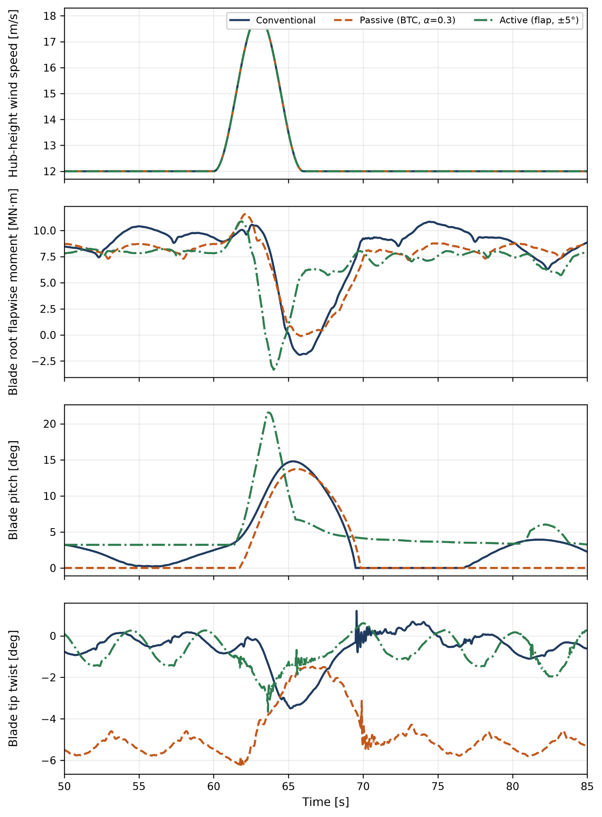
Figure 3a (Top). Hub height wind speed (m/s) across simulation time (s). The figure was created with Matplotlib.
Figure 3b (2nd Highest). Blade root flapwise moment (Mnm) of all three blades across simulation time (s). The figure was created with Matplotlib.
Figure 3c (2nd Lowest). Blade pitch (°) of all three blades across simulation time (s). The figure was created with Matplotlib.
Figure 3d (Bottom). Blade twip twist (°) of all three blades across simulation time. The figure was created with Matplotlib.
The gust gave a peak of 18.0 m/s at t = 63.00 s (Figure 3a), with the wind field identical across all three cases. The three turbines do not enter the gust from the same state: pre-gust blade root flapwise moment is highest for conventional at 9.142 MN·m and progressively lower for passive and active, and pre-gust collective pitch differs similarly, sitting at 1.512° for conventional, zero for passive and 3.21° for active. Comparisons below are therefore made as excursions from each case’s own baseline rather than as absolute values.
All three blades responded to the gust in the same sequence, where there was a brief rise in root moment as the wind speed built up, then a sharp unloading as the collective pitch on all the blades engaged, causing a damped recovery to the pre-gust state (Figure 3b, 3c). The difference, however, lies in how the cases separate in the depth of that unloading and in how much pitch activity it costs due to the morphing blades offering an alternative mechanism to alleviate load other than collective pitch of the whole blade. The passive blade gave the smallest load alleviation with 24.3% below conventional, achieving it with only slightly less pitch travel than conventional. Active, however, behaved differently, with it responding the earliest and reaching its minimum roughly 1.7 s before the other two. However, the early action did not come without a cost as it overshoots to the lowest absolute moment of the three and ends with an excursion 2.3% larger than conventional (Figure 3b). That earlier and deeper response is accompanied by a more aggressive pitch demand, a peak of 21.56° for the active blade against roughly 14–15° for the other two cases. Blade tip twist shows the structural differences between the two morphing concepts as unchanged from the steady-wind results (Figure 3d). Passive sits at a large pre-gust twist of −5.327° and unloads toward zero as the blade sheds load during the gust, while conventional and active both start near zero and twist in the opposite direction by about 3°. Generator power was expected to dip and did so, falling in all three cases as the controller pitches through the gust, with active retaining the most power through the dip and conventional the least. However, the power retained by the active blade is a result that is most likely stemming from the active blade’s recovery beginning from an already lower pre-gust level.
4.3 Turbulent Wind Study
Turbulent inflow was simulated at 12 m/s mean hub-height wind speed using IEC Kaimal²⁵ spectra with class B turbulence intensity, a 0.14 power-law shear exponent and the normal turbulence model, for two TurbSim realizations. The same two wind fields were applied to all three turbines, and comparisons are made seed by seed before averaging. Each run was 660 s with the first 60 s discarded, giving 600 s of analyzed data.
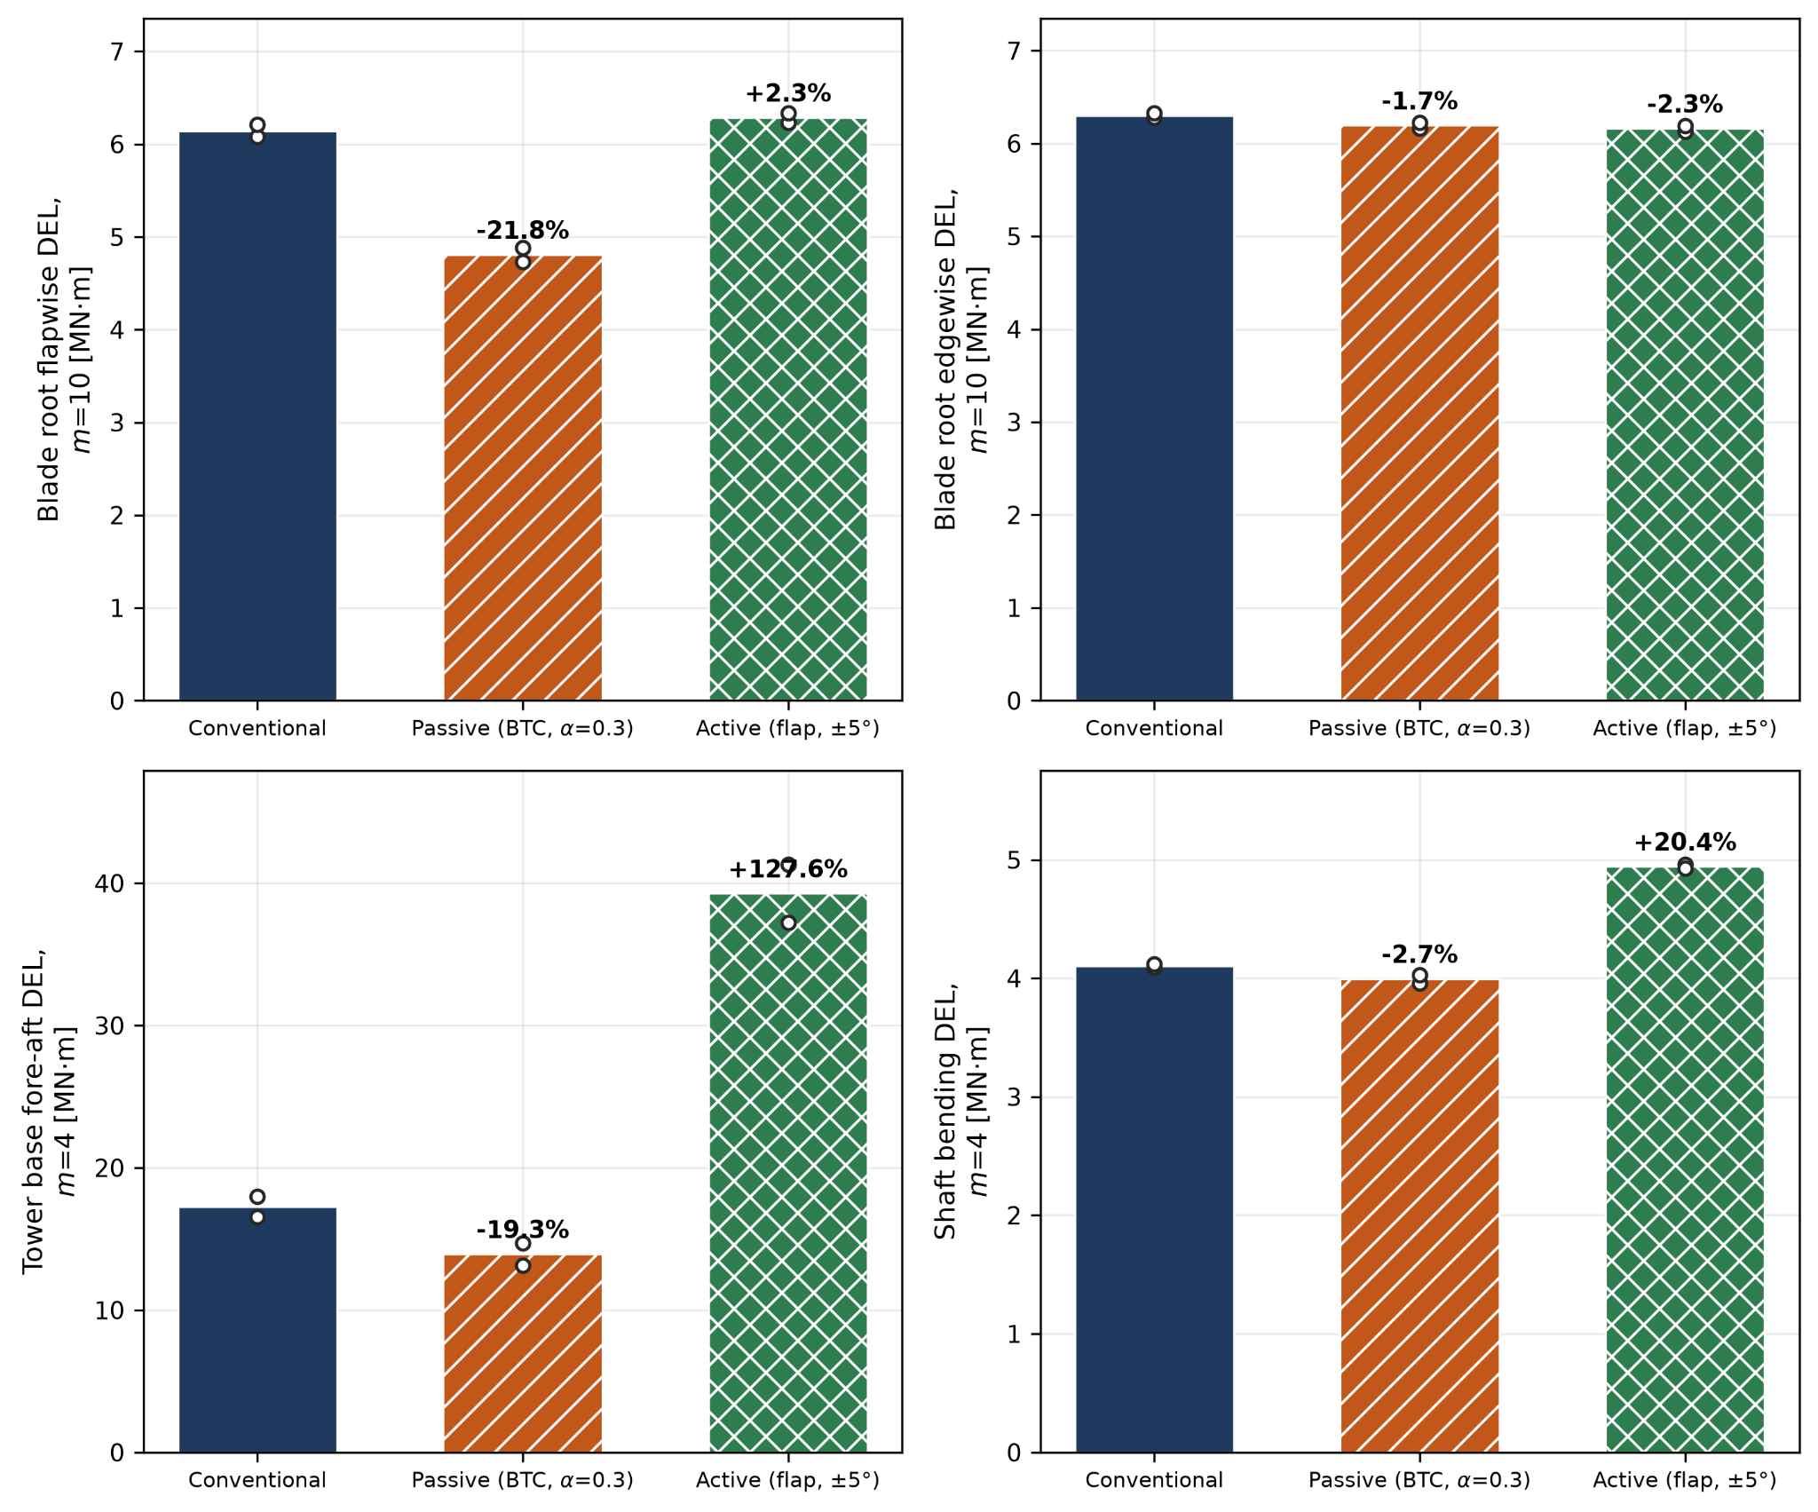
Figure 4a (Top Left). Blade root flapwise DEL (MNm) across blade types. The figure was created with Matplotlib.
Figure 4b (Top Right). Blade root edgewise DEL (Mnm) across blade types. The figure was created with Matplotlib.
Figure 4c (Bottom Left). Tower base fore-aft (Mnm) across blade types. The figure was created with Matplotlib.
Figure 4d (Bottom Right). Shaft bending DEL (Mnm) across blade types. The figure was created with Matplotlib.
The similarities seen between the blades under steady wind do not transfer when under turbulence, as the two morphing concepts diverge sharply. Passive carried its benefit into turbulence, reducing blade root flapwise DEL by 21.8%, a value that is comparable to or slightly better than its 15–20% reduction in steady wind. Furthermore, it reduced tower base fore-aft DEL by 19.3% in turbulence (Figure 4a, 4c), an almost exactly similar value to the steady wind case, as the passive blade reduced the tower base fore-aft DEL by 19.6 at 11.4 m/s, compared to the mean 12 m/s turbulent seed. Ultimately, the results indicate that the passive blade is consistent between the steady and turbulent wind fields. Active, however, loses its advantage compared to the other two blades entirely. Where it once removed more than half the flapwise DEL in steady wind, under turbulence it produces a 2.3% increase instead (Figure 4a). The penalty is far larger in the support structure, where active raises tower base fore-aft DEL by more than a factor of two and shaft bending DEL by 20.4% (Figure 4c, 4d). Both concepts leave edgewise DEL essentially untouched, within about 2% of conventional (Figure 4b), consistent with the steady-wind result that neither modification acts in the edgewise direction. Seed-to-seed agreement is close for every result except the active tower base DEL, where the two realizations differ by more than 40 percentage points (Figure 4c), the widest spread anywhere in the study, and a caution against reading that figure as a converged value from only two seeds. Mean generator power under turbulence follows the steady-wind pattern, with passive down 2.8% and active down 6.5% relative to conventional, and mean pitch activity is comparable in all three cases.
Discussion
The passive configuration reduced blade root flapwise DEL by 15.5% to 20.4% across the steady wind speed sweep, by 24.3% in peak excursion during the gust, and by 21.8% under turbulent inflow. The consistency is the notable feature: the reduction varies by only a few percentage points across inflow conditions that differ substantially in character, and the per-seed turbulent values (−22.2% and −21.3%) agree closely. This follows from how the mechanism works, as bend-twist coupling is driven by the load itself, with flapwise bending inducing twist toward feather through the off-diagonal terms of the cross-sectional stiffness matrix, reducing local angle of attack and hence lift. The response requires no sensing, no actuation, and no prediction, and it acts on whatever load arrives regardless of whether that load is periodic, transient, or stochastic. The mechanism engaged as designed in all three cases, reaching a standing tip twist of −5.28° at rated in steady inflow and deepening to −6.1° during the gust before recovering.
The active configuration behaved very differently across inflow conditions. Under steady sheared inflow, it reduced blade root flapwise DEL by 53.6% to 55.4% below rated, substantially outperforming passive. Under turbulent inflow at the same mean wind speed, it produced a 2.3% increase in DEL. During the gust its peak load excursion was 2.3% larger than conventional. The explanation lies in what azimuth-scheduled actuation can and cannot address. In steady sheared inflow, the entire load variation seen by a blade is deterministic and periodic with rotation: it arises from wind shear, gravity and tower shadow, all of which are functions of azimuth. A flap deflection scheduled on azimuth and correctly phased can therefore cancel nearly all of it, which is what the 180° phase selection achieved. The magnitude of the reduction was found to be consistent across the literature, as wind tunnel measurements found that adaptive trailing edge geometry, similar to that modeled in OpenFAST, could reduce the amplitude of lift in an airfoil in sinusoidal pitch by approximately 80%.¹⁰ In turbulent inflow, most load variation is stochastic and uncorrelated with blade position. The prescribed cycle continues to inject energy at 1P while leaving the stochastic content untouched, and the net effect on fatigue is marginally adverse. The gust result is the same limitation in transient form: an event the schedule cannot anticipate. That the mechanism’s advantage is largest precisely where the disturbance is most predictable, and vanishes where it is not, is consistent across all three test cases and constitutes the principal finding of this study.
The secondary load channels distinguish the two mechanisms more sharply than the blade root results alone. Under turbulent inflow, the passive configuration reduced tower base fore-aft DEL by 19.3% and low-speed shaft bending DEL by 2.7% alongside its blade root reduction. The active configuration increased tower base DEL by 128.5% and shaft bending DEL by 20.4%, having produced no blade root benefit at all. In steady inflow, the passive case increased shaft bending DEL by 19.0% at 11.4 m/s and active up to 93.4% at higher wind speeds, even where blade root loads were substantially reduced. This distinction matters for any assessment of net benefit. Passive coupling removes load from the system: less thrust is generated, so less load reaches the blade root, the tower and the drivetrain alike. Cyclic flap actuation redistributes it. Reducing the load on one blade by deflecting its flap changes the balance of forces across the rotor, and the resulting asymmetry is transmitted through the hub to the shaft and the tower. A mechanism that halves blade root fatigue while more than doubling tower base fatigue is not a load-alleviation system in any useful sense, and the tower result alone would disqualify the open-loop configuration tested here from practical consideration. The seed-to-seed spread on this figure was wide (+107.1% and +149.9%), so the magnitude carries uncertainty, but the direction and scale are unambiguous.
Limitations
Bend-twist coupling was applied parametrically (α = 0.3 from 45% span with a cosine taper) rather than derived from a laminate layup via cross-sectional analysis, and the resulting −5.3° tip twist at rated sits at the upper end of published values for coupled blades. Flap aerodynamics were represented by thin-airfoil plain-flap theory with a viscous efficiency factor of 0.75, applied as an angle-of-attack shift tapered to zero in deep stall, rather than by section-resolved CFD or wind-tunnel data. Neither configuration was optimized; the reported values characterize these particular designs rather than the achievable limit of either mechanism.
The turbulent condition used two seeds. Per-seed agreement was close for blade root and shaft channels, supporting the reported values, but the tower base result for the active case varied widely between realizations and its magnitude should be treated as indicative.
A single turbine, and single turbulence class and shear exponent, one flap span and deflection amplitude, and one coupling coefficient were tested. Generalization to other rotor scales, site conditions or morphing configurations cannot be established by these results.
Conclusion
Three blade configurations, conventional, passive through bend twist coupling, and active through an azimuth scheduled trailing edge flap, were simulated in OpenFAST v4.2.1 on the NREL 5 MW reference turbine ¹⁴ under steady, gust and turbulent wind fields. All variables were kept constant, with the only difference lying in the blade, to allow a direct comparison between the two morphing concepts and the conventional as a baseline to investigate the benefits and costs of implementing a morphing blade onto a horizontal axis wind turbine. Compared to the conventional blade, the passive blade reduced blade root flapwise damage equivalent load by 15-20% in steady wind, 21.8% under turbulence, and 24.3% in peak gust excursion. The results support the idea that the passive blade is consistent across all three wind fields and is not disadvantaged despite the situation. Additionally, these benefits of the passive blade only came at a cost of 2.1-2.6% of the annual energy production of a conventional blade. Alternatively, the active blade removed 55.4% of the flapwise damage equivalent load in steady sheared inflow, but produced a 2.3% increase under turbulence, and cost a 6.5% loss of mean power compared to the conventional turbine. The determining factor at the end of the investigation was ultimately that a morphing concept is not best defined by whether it is active or passive, but rather whether it responds to the load that is present or acts on predictions. The difference was made clear when the active azimuth scheduling canceled the deterministic shear-driven cycle in the steady wind cycle but had nothing to act on when the disturbance was stochastic in turbulence. The bend twist coupling, however, was driven by the load in the wind itself and could not be out of phase with what it opposed.
AI Acknowledgement
During the preparation of this work, the author used Claude Opus 5 to analyze data and generate Python scripts for the creation of figures through Matplotlib and bulk equation solving/data processing from data generated by the author through OpenFAST. After using this tool, the author reviewed and edited the resulting content as necessary and took full responsibility for the content of the publication.
Acknowledgements
The author acknowledges the help of Kieran Tait, mentor and advisor.
References
(1) Freebury, G.; Musial, W. Determining Equivalent Damage Loading for Full-Scale Wind Turbine Blade Fatigue Tests. In 2000 ASME Wind Energy Symposium; Reno, NV, 2000. https://doi.org/10.2514/6.2000-50.
(2) Global Wind Energy Council. Global Wind Report 2026; GWEC, 2026. https://www.gwec.net/reports/globalwindreport (accessed 2026-10-15).
(3) Franco, J. A.; Jauregui, J. C.; Carbajal, A.; Toledano-Ayala, M. Shape Morphing Mechanism for Improving Wind Turbines Performance. J. Energy Resour. Technol. 2017, 139 (5), 051214. https://doi.org/10.1115/1.4036724.
(4) Leonczuk Minetto, R. A.; Paraschivoiu, M. Simulation Based Analysis of Morphing Blades Applied to a Vertical Axis Wind Turbine. Energy 2020, 202, 117705. https://doi.org/10.1016/j.energy.2020.117705.
(5) Ember. Global Electricity Review 2026; Ember, 2026. https://ember-energy.org/latest-insights/global-electricity-review-2026/ (accessed 2026-10-15).
(6) Lachenal, X.; Daynes, S.; Weaver, P. M. Review of Morphing Concepts and Materials for Wind Turbine Blade Applications. Wind Energy 2013, 16, 283–307. https://doi.org/10.1002/we.531.
(7) Viola, I. M.; Pisetta, G.; Dai, W.; Arredondo-Galeana, A.; Young, A. M.; Smyth, A. S. M. Morphing Blades: Theory and Proof of Principles. Int. Mar. Energy J. 2022, 5 (2), 183–193. https://doi.org/10.36688/imej.5.183-193.
(8) Scott, S.; Capuzzi, M.; Langston, D.; Bossanyi, E.; McCann, G.; Weaver, P. M.; Pirrera, A. Gust Response of Aeroelastically Tailored Wind Turbines. J. Phys.: Conf. Ser. 2016, 753, 042006. https://doi.org/10.1088/1742-6596/753/4/042006.
(9) Daynes, S.; Weaver, P. M. A Morphing Trailing Edge Device for a Wind Turbine. J. Intell. Mater. Syst. Struct. 2012, 23 (6), 691–701. https://doi.org/10.1177/1045389X12438622.
(10) Bak, C.; Gaunaa, M.; Andersen, P. B.; Buhl, T.; Hansen, P.; Clemmensen, K.; Moeller, R. Wind Tunnel Test on Wind Turbine Airfoil with Adaptive Trailing Edge Geometry. In 45th AIAA Aerospace Sciences Meeting and Exhibit; AIAA Paper 2007-1016; American Institute of Aeronautics and Astronautics: Reno, NV, 2007.
(11) Najafian, A.; Jahangirian, A. Optimum Design of Morphing Flaps for Improving Horizontal Axis Wind Turbine Performance. Energy Sci. Eng. 2023, 11 (7), 2431–2443. https://doi.org/10.1002/ese3.1464.
(12) Wolff, T.; Ernst, B.; Seume, J. R. Aerodynamic Behavior of an Airfoil with Morphing Trailing Edge for Wind Turbine Applications. J. Phys.: Conf. Ser. 2014, 524 (1), 012018. https://doi.org/10.1088/1742-6596/524/1/012018.
(13) Corsini, A.; Castorrini, A.; Boezi, M.; Rispoli, F. Numerical Study on Active and Passive Trailing Edge Morphing Applied to a Multi-MW Wind Turbine Section. In Proceedings of the VI International Conference on Computational Methods in Marine Engineering (MARINE 2015); Salvatore, F., Broglia, R., Muscari, R., Eds.; Rome, Italy, 2015.
(14) Jonkman, J.; Butterfield, S.; Musial, W.; Scott, G. Definition of a 5-MW Reference Wind Turbine for Offshore System Development; NREL/TP-500-38060; National Renewable Energy Laboratory: Golden, CO, 2009.
(15) Johnson, K. E.; Pao, L. Y.; Balas, M. J.; Fingersh, L. J. Control of Variable-Speed Wind Turbines: Standard and Adaptive Techniques for Maximizing Energy Capture. IEEE Control Syst. Mag. 2006, 26 (3), 70–81.
(16) Bossanyi, E. A. Individual Blade Pitch Control for Load Reduction. Wind Energy 2003, 6 (2), 119–128. https://doi.org/10.1002/we.76.
(17) Burton, T.; Jenkins, N.; Sharpe, D.; Bossanyi, E. Wind Energy Handbook, 2nd ed.; Wiley: Chichester, 2011.
(18) Bishay, P. L.; McKinney, T.; Kline, G.; Manzo, M.; Parian, A.; Bakhshi, D.; Langwald, A.; Ortega, A.; Gagnon, M.; Funes Alfaro, G. SCAMORSA-1: A Camber-Morphing Wind Turbine Blade with Sliding Composite Skin. J. Eng. Res. 2024, 12 (4), 931–940. https://doi.org/10.1016/j.jer.2024.04.006.
(19) Woods, B. K. S.; Bilgen, O.; Friswell, M. I. Wind Tunnel Testing of the Fish Bone Active Camber Morphing Concept. J. Intell. Mater. Syst. Struct. 2014, 25 (7), 772–785. https://doi.org/10.1177/1045389X14521700.
(20) Bir, G. User's Guide to PreComp (Pre-Processor for Computing Composite Blade Properties); NREL/TP-500-38929; National Renewable Energy Laboratory: Golden, CO, 2006.
(21) Abbott, I. H.; von Doenhoff, A. E. Theory of Wing Sections: Including a Summary of Airfoil Data; Dover Publications: New York, 1959.
(22) Perez-Becker, S.; Marten, D.; Paschereit, C. O. Active Flap Control with the Trailing Edge Flap Hinge Moment as a Sensor: Using It to Estimate Local Blade Inflow Conditions and to Reduce Extreme Blade Loads and Deflections. Wind Energy Sci. 2021, 6 (3), 791–814. https://doi.org/10.5194/wes-6-791-2021.
(23) Plumley, C. The Smart Rotor Wind Turbine. Ph.D. Dissertation, University of Strathclyde, Glasgow, UK, 2015.
(24) National Renewable Energy Laboratory. ROSCO: NREL's Reference Open Source Controller, version 2.10.1; NREL, 2025. https://github.com/NREL/ROSCO (accessed 2026-09-23).
(25) International Electrotechnical Commission. Wind Turbines — Part 1: Design Requirements; IEC 61400-1, 3rd ed.; IEC: Geneva, 2005.
(26) ASTM International. Standard Practices for Cycle Counting in Fatigue Analysis; ASTM E1049-85(2023); ASTM International: West Conshohocken, PA, 2023.
Authors
The author, Muhammad Athar Syahreza, is an aspiring Material Science and Engineering major, with hopes to work in the energy industry, potentially even the wind energy sector.

