Solar One – A Proposal for The First Manned Interstellar Spaceship
Alberto Caballero
The Exoplanets Channel

Abstract

In this paper it is presented the concept and design of a beam-powered propulsion system that could become the first manned interstellar spaceship. Light-sail spacecrafts such as the so-called Starships from the Starshot project have already been designed, but this type of spaceship might not be the best option to explore exoplanets in detail. Solar one would be a manned spaceship that would integrate three existing or near-term technologies, namely: the LANL Mega Power Reactor, a larger version of the Sunjammer light sail and an updated HELLADS laser system. Building a spaceship with these components could have an overall cost of less than 100 million dollars and it might be ready for launch by the mid-20s. Solar One could reach 30% the speed of light with an acceleration of 0.18 g and a mile-long light sail, reaching the Alpha Centauri system in around 15 years.

1. INTRODUCTION
In 2016, scientists announced the first design for a beam-powered spacecraft that could reach speeds of 0.2c. The project, called StarShot, entailed the idea of sending 1,000 nanocrafts with light sails attached that would be powered by a 100 GW laser array. As of today, the concept is still considered to be the best option for unmanned interstellar travel. Potentially habitable exoplanets such as Proxima b could be reached in only 20 years.
However, the idea is to send the Starshot nanocrafts 1 AU away from Proxima b. This distance would be enough to photograph the exoplanet, but perhaps not sufficient to notice the presence of a possible intelligent civilization less advanced than humanity. For this reason, and to better study the exoplanet, a manned interstellar spaceship becomes necessary and we already have the technology to build one.

2. CONCEPT
Solar One is the first design for a manned spaceship that would be powered by beam propulsion. The name ‘Solar One’ has been

chosen to better represent our civilization: the term ‘Solar’ refers to the solar system and the term ‘One’ refers to the first design of a possible fleet of future spaceships. Three are the technologies that would be used: the LANL Mega Power Reactor, a slightly larger version of the Sunjammer light sail and an updated version of HELLADS (High Energy Liquid Laser Area Defense System).
Firstly, the LANL Mega Power Reactor is a NASA fission reactor with a weight of 35 tons and able to produce up to 10 MW (2 MW of continuous power for 12 years) (Los Alamos National Laboratory, 2019). The nuclear fuel could be uranium oxide enriched up to 19.5% in uranium 235. Using a fusion reactor instead of one based on nuclear fission would be more effective and safe. The future versions of Solar One should use nuclear fusion once the technology becomes available. Secondly, the Sunjammer light sail is a proposed NASA sail with a size of 38 x 38 m (1,444 m²) (NASA, 2017). Finally, HELLADS is a ground-based laser weapon system demonstrator operated by DARPA. There is a project to update the system and launch it into space by 2023, with a goal of 5 kg per KW (Air Force Technology, 2013).
The idea behind Solar One is to combine these three projects. A 2-crew spaceship with a total mass of 91 tons (32 tons from the reactor, 50 tons from the laser system, 4 tons of fuel and 5 tons from the structure, equipment and crew) could be powered by an approx. 1,600 x 1,600 m light sail and achieve the speed of 0.3c with a constant acceleration and deceleration during the first and last one year and a half of the trip.

F* = 2 (P x A) / c
F = 2 (10,000,00 x 2,560,000) / 300,000,000
F = 170,667 newtons
F* = force (newtons)
P*= power (watts / m2)
A*= surface area of light sail (m2)
c* = speed of light
10 MW* = duration of 2.4 years

a = F/M

a = 170,667 / 91,000

a = 1.87 m/s2 = 0.18 g

a* = acceleration (m/s2)
M = mass (kg)

t = v / a

t = 89,994,000* / 1.87

t = 48,125,133 sec = 1.52 years

89 million m/s* = 0.3 c

3.8 tons of fuel would be needed for both the acceleration and deceleration. The LANL Mega Power reactor has a capacity of 3 tons and, therefore, it would be necessary to slightly increase that capacity. At the speed of 0.3 c, the crew would arrive to the Alpha Centauri system in 16 years. All the necessary measures would be taken in order to enable the crew to withstand the lack of gravity during such a long trip.

Average speed = 0.095* · 0.15* + 0.81* · 0.3* + 0.095 · 0.15 = 0.2715 c
0.095* = approx. % trip time during acceleration
0.15* = average speed during acceleration and deceleration
0.81* = approx. % trip time with constant speed
0.3* = maximum speed

Duration of the trip to Alpha Cen = Distance / Average speed = 4.37 / 0.2715 = 16 years

3. DESIGN
The spaceship would be composed of the following main elements: a laser system equipped with a beam expander, a light sail, a nuclear micro-reactor, a descend module and a cockpit protected from space radiation. An extra amount of light sail would be ideal in case of damage caused by micro-meteorites. To reduce damage and drag, the light sail would be rolled when the spaceship is neither accelerating nor decelerating, that is, 81% of the time.
For the deceleration, the hydraulic structure would re-orientate the laser system 180º. Once the destination is reached, the crew could orbit the exoplanet, take images and send a robot to the surface. If the air turns out to be breathable, the crew could choose to land in order to personally explore the exoplanet.
However, if the crew decides to do so, they would probably have to wait for the next expedition to leave the exoplanet.
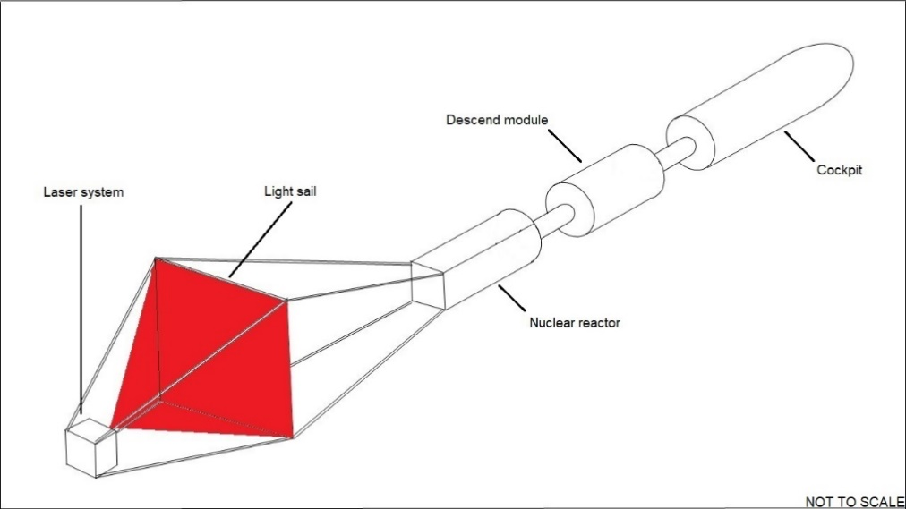

4. COSTS
A micro fission reactor such as the LANL Mega Power Reactor could cost around 16 million dollars (The Guardian, 2008). The Sunjammer mission had a total cost of 27 million dollars (Space.com, 2013). With respect to the HELLADS laser, it was reported that an amount of 21 million dollars was allocated for the fabrication of the first prototype (Wired, 2008). The sum of the three budgets leads to a total number of 64 million dollars. SpaceX’s Big Falcon Rocket (BFR) would be suitable for the launch, which is estimated to cost around 30 million dollars (Brian Wang, 2017). Overall, the total cost of Solar One could stay below 100 million dollars.

5. CHALLENGES
The main challenges in building this spaceship would be to protect the reactor module from a potential nuclear failure and protect the light sail from micro-asteroid impacts. The module containing the nuclear micro-reactor would have a protective coating thicker than the rest of the spaceship. The cockpit could also be equipped with an emergency propulsion system such as an ion thruster in case there is a nuclear failure and the crew has to separate from the spaceship. However, this additional system would probably increase the budget and there is also a low chance of survival if the failure occurs outside the solar system.

6. CONCLUSIONS
In this paper it has been analysed the possibility of building a manned interstellar spaceship propelled by a laser system, which would receive the necessary electricity from a small nuclear fission reactor. Small modular reactors such as the Russian EGP-6 already exist, large light sails such as Sunjammer have already been built, and Kilowatt-class lasers such as HELLADS have proved successful. For the laser system, it would necessary to reach the goal of 5 kilograms per KW of power. For the launch, it would be required to have the BFR in order to keep the budget under 100 million dollars. The first launch of a BFR is expected to happen in 2022 and the 5 kg per KW goal for HELLADS is expected to take place in 2023. Thus, Solar One might be ready for launch in the mid-20s.

REFERENCES
Air Force Technology (2013) ‘High Energy Liquid Laser Area Defense System (HELLADS) Programme.’ Link: https://www.airforce-technology.com/projects/high-energy-liquid-laser-programme/

Brian Wang (2017) ‘Spacex BFR to be lower cost than Falcon 1 at $7 million per launch’. Link: www.nextbigfuture.com/2017/10/spacex-bfr-to-be-lower-cost-than-falcon-1-at-7-million-per-launch.html

DARPA. ‘High Energy Liquid Laser Area Defense System (HELLADS).’ Link: https://www.darpa.mil/program/high-energy-liquid-laser-area-defense-system

How Stuff Works. ‘How Solar Sail Technology Works.’ Link: https://science.howstuffworks.com/solarsail2.htm

Idaho National Laboratory (2018) ‘Preliminary Assessment of Two Alternative Core Design Concepts for the Special Purpose Reactor’. Link: https://www.osti.gov/servlets/purl/1413987

Los Alamos National Laboratory (2019) ‘Megapower’. Link: https://www.lanl.gov/discover/publications/1663/2019-february/_assets/docs/1663-33-Megapower.pdf

NASA (2017) ‘Solar Sail Demonstrator (‘Sunjammer’). Link: https://www.nasa.gov/mission_pages/tdm/solarsail/index.html

Nextbigfuture (2018) ‘Russia claims 100 times smaller nuclear reactor than submarine reactors but with more power.’ Link: www.nextbigfuture.com/2018/03/russia-claims-100-times-smaller-nuclear-reactor-than-submarine-reactors-but-with-more-power.html

Pasquale M Sforza (2016) ‘Manned Spacecraft Design Principles.’
Rene Heller (2016) ‘Deceleration of high-velocity interstellar photon sails into bound orbits at
α centauri.’ Link: https://arxiv.org/pdf/1701.08803v1.pdf

Space.com (2013) ‘World's Largest Solar Sail to Launch in November 2014’. Link: www.space.com/21556-sunjammer-solar-sail-launch-2014.html

The Drive (2001) ‘The U.S. Military Wants Tiny Road Mobile Nuclear Reactors That Can Fit In A C-17.’ Link: www.thedrive.com/the-war-zone/26152/the-u-s-military-wants-tiny-road-mobile-nuclear-reactors-that-can-fit-in-a-c-17

The Guardian (2008) ‘Mini nuclear plants to power 20,000 homes’. Link: www.theguardian.com/environment/2008/nov/09/miniature-nuclear-reactors-los-alamos

University of Alaska-Fairbanks. ‘Physics The physics behind solar sails.’ Link: http://ffden-2.phys.uaf.edu/webproj/212_spring_2015/Robert_Miller/physics.html
Wired (2008) ‘What's Inside Darpa's $21 Million 'Liquid' Laser?’ Link: www.wired.com/2008/12/darpas-21m-for/

Based on the calculation that a 4-crew spacecraft is expected to have a mass of 10 tons (Manned Spacecraft Design Principles, Pasquale M Sforza).
The structure would have to be folded in order to fit inside the BFR.

