An Integrated Layer-Resolved Heat Transfer and Thermodynamic Model for Boil-Off Gas Prediction in LH₂ Storage Tanks
Muhammad Yasir¹, Junaid Haider^{2, *}, Saad Saeed¹, Salman Farrukh², Tony Roskilly²

¹ NFC Institute of Engineering and Technology, P.O. Fertilizers Project Khanewal Road, Multan 60000, Pakistan
²Department of Engineering, Stephenson Building, Stockton Road, Durham University, DH1 3LE, United Kingdom

Corresponding Author
* Junaid Haider (junaid.haider@durham.ac.uk)
+44 (0) 79 2847 9634

Abstract
Liquid hydrogen (LH₂) is a key energy carrier for decarbonization due to its high gravimetric energy density, which makes it an attractive option for applications ranging from large-scale energy storage to transport and aerospace systems. However, the storage of LH₂ in cryogenic vacuum-insulated vessels introduce challenges associated with heat ingress from surrounding as hydrogen has a very low boiling point at 20 K (1 atm), even small heat leaks can result in continuous mass through boil-off. Quantifying this loss is essential to control the large-scale LH₂ storage economic viability. To address the limitations in conventional approaches that typically rely on constant heat transfer rates or decouple the insulation design from boil-off dynamics, this study presents a layer-resolved heat transfer model integrated with a two-phase boil-off thermodynamic model. The framework considers a horizontal cylindrical tank with hemispherical ends and incorporates an economic model that evaluates the storage-related levelized cost of hydrogen (LCOH), which dynamically uses boil-off predictions to quantify losses in overall revenue due to boil-off. At nominal conditions, LCOH varies from $6.19 to $6.88/kg depending on the hydrogen price. This study also incorporates a comprehensive parametric analysis across seven design and operational variables, including total MLI layers, vacuum pressure, fill level, ambient temperature, cylindrical length, relief pressure, and tank’s wall thickness, followed by a global sensitivity analysis based on normalized swing (NS). Vacuum pressure emerges as the single most influential variable with an NS index of 12.76 on total BOG fraction, increasing it from 10-50% over a 90-days storage run as the vacuum state degrades from a newly commissioned tank to a severe vacuum failure (0.46 Pa). As a result, fill level strongly affects the BOG dynamics through liquid-vapor space heat partitioning, with diminishing-return design point fill level ~75%. The total MLI layer count is the third most influential variable with an diminishing-return design point design point near 60-70 MLI layers, where diminishing returns intersect increasing capital cost. The model confirms that vacuum integrity is both the main thermodynamic as well as economic lever in LH₂ storage design.
Keywords: Liquid hydrogen; boil-off gas; multi-layer insulation; thermodynamic modeling; parametric analysis;

Introduction
Liquid hydrogen (LH₂) is increasingly recognized as a cornerstone of future zero-carbon energy systems that offer a viable pathway for large-scale transport of clean energy [1,2]. Its high gravimetric density makes it a particularly attractive option for various applications, including heavy transport, aerospace, and long-duration stationary storage, where gaseous hydrogen becomes impractical due to lower volumetric energy density [3]. Unlike gaseous hydrogen, which requires large volumes for storage, LH₂ is stored at cryogenic conditions, 20 K (-253 °C), at atmospheric pressure [4], almost close to absolute zero, which allows a volumetric density gain of ~800 times compared to gaseous hydrogen [5]. These storage conditions make LH₂ the preferred form for large-scale hydrogen logistics [2,6].
Liquefying and storing hydrogen in a liquid state at scale requires double-walled vacuum jacketed vessels lined with multi-layer insulation (MLI) to suppress the heat leak [1]. Despite these measures in insulating cryogenic storage tanks, no practical insulation system achieves perfect thermal isolation [7]. As a result, heat ingress via solid conduction, radiation, and residual gas conduction across the MLI stack is unavoidable, which leads to the vaporization of the stored liquid and generates boil-off gas (BOG) [8]. The BOG must either be vented, as a direct economic loss reducing the storage efficiency, or it can be managed through re-liquefaction, which adds a cost penalty [9]. For large-scale LH₂ storage applications, even a modest BOG fraction (amount of hydrogen lost due to boil-off) represents a substantial revenue loss, and this fraction can climb sharply under vacuum degradation or suboptimal insulation design [10]. Therefore, BOG management is not an afterthought in LH₂ storage system design, but it is a central challenge and primary economic variable [11].
The transition of concept to large-scale deployment is constrained by the cost of maintaining cryogenic conditions as LH₂ is stored at 20K and the temperature gradient between ambient and storage is severe, roughly around 280 K. This gradient drives a continuous heat leak regardless of the insulation quality. The advantage of storing hydrogen in a liquid state over gaseous, mainly due to it occupying lower volumes, comes at a price of a high thermodynamic penalty in the form of inevitable heat ingress. Every joule of heat that enters the tank is directly linked to the cost penalty associated with it, which makes the BOG generation a central loss mechanism in LH₂ storage systems [12].
The BOG generation is not governed by a single mechanism but by the intersection of several physical processes, including heat transfer through the multi-layer insulation (MLI) system, vacuum interlayers, and tank walls [13,14]. Once inside the tank, this heat is then distributed within the fluid through conduction and buoyancy-driven convection [15]. Heat ingress leaking inside the tank not only vaporizes the stored cryogenic liquid but also increases the temperature of vapors above the liquid surface, creating a significant difference in temperature between the two nodes (vapor and liquid) known as thermal stratification. This thermal stratification effect is not secondary, as it governs the interfacial heat transfer and increases the BOG generation as a result [16].
Controlling heat ingress requires careful insulation design. MLI systems, which consist of alternating reflective shields and low-conductivity spacers, are wrapped around the inner storage vessel inside a vacuum jacketed space is state-of-the-art passive insulation technology for cryogenic storage [17]. The thermal performance of MLI depends mainly on the total number of layers (MLI count) and the residual gas/vacuum pressure [7]. Both the total MLI layers and the vacuum pressure dictate the BOG losses, and modeling these variables realistically requires an integrated layer-resolved heat transfer framework coupled with a transient thermodynamic BOG model.
A substantial body of work has addressed different aspects of LH₂ boil-off, resulting in a diverse set of modeling strategies with varying levels of complexity and applicability. Broadly, these efforts are characterized into different sections, including reduced or lumped thermodynamic models [18], high-fidelity computational fluid dynamics (CFD) approaches [19], experimental investigations [20], and data-driven system-level mitigation strategies [21]. Lumped parameter models have been widely used due to their ability to simulate log duration storage with minimal computational cost. They are the simplest models that solve material and energy balances within a controlled volume and assume the tank to be in thermal equilibrium. Latest models, such as BoilFast [18], have emerged and captured the underlying physics of BOG generation, including self-pressurization and thermal stratification. Modeling approaches must balance physical fidelity with computational feasibility for applications involving long storage durations. Simplified thermodynamic models either ignore the overall transfer assessment or use a constant heat transfer rate to simplify calculations and reduce the overall computational cost. Whereas high-fidelity numerical methods capture the realistic unsteady state thermodynamic changes at the expense of computational cost. Addressing these limitations, a robust modeling framework is required that not only handles BOG physics but also integrates the heat transfer framework, which can enable fine-tuning certain insulation parameters.
To summarize and systematically compare the key contributions in the LH₂ body of work, a comprehensive literature review has been carried out. Table 1 contains the summary of the literature review:
Table 1: State-of-the-art research on LH₂ storage systems
Focus Area | Study Overview | Key Contribution | Limitations/Gaps | Reference
Two-phase BOG Thermodynamic Model | Developed BoilFast, a non-equilibrium, two-phase BOG prediction tool | Captures accurate boil-off physics inside a cryogenic tank, designed for various components and geometries | For heat transfer calculations, the tool either uses constant heat rates or constant heat transfer coefficients throughout the BOG simulation.  Due to its simplest nature and absence of rigorous heat transfer integration, there’s no provision for insulation design or to study the effects of vacuum degradation on boil-off rates. | Al Ghafri et al. [18]
Two-phase BOG Thermodynamic Model | Couples a thermal resistance network with a two-phase thermodynamic model, also covers natural convection correlations on internal and external tank walls | Explicitly acknowledges and mitigates the structural limitation of constant heat transfer rate shared by BoilFast and other similar tools | No distinct geometry, it rather used a rectangular cuboid tank with a storage capacity of 1 m³.  The working fluid used in this study was LN₂.  Insulation was considered a lumped resistance rather than layer-resolved MLI. | Kim et al. [22]
Seasonal analysis of BOG rates in LH₂ storage tanks | Couples ambient temperature time-series data (hourly profiles for Rome, 2024) with a BOG model implemented in Modelica. | Demonstrates significant seasonal variation in boil-off rate with change in ambient temperature. | MLI is modeled as an ideal vacuum, which may not fully capture real-world scenarios.  No insulation design, no economic analysis. | Ravichandran et al. [1]
Effects of vacuum degradation of MLI stack | Measured apparent thermal conductivity (K_eff) and outer surface temperature of a 50-layer MLI stack at a liquid nitrogen (LN₂) cold boundary across 10x vacuum pressure levels. | The pressure thresholds are physically grounded and experimentally verified.  Pressure below 0.1 Pa, radiation dominates, and K_eff is essentially constant; above that, residual gas conduction takes over, and K_eff climbs sharply. | Cold boundary is LN₂ (77 K), not LH₂ (20 K). The larger the temperature gradient, the larger will be the impacts of gas conduction. Moreover, the paper does not connect or use K_eff degradation data to BOG rates or any economic analysis. | Wang et al. [23]
Analytical study of varying residual gas pressure for insulation performance for LH₂ | Extends the electrical-analogy MLI heat transfer model to the LH₂ boundary. Quantifies the contribution of radiation, solid conduction, and gas conduction at each pressure level. | Demonstrates that LH₂ storage tanks are more sensitive to vacuum degradation than LN₂ systems, not marginally but structurally, due to the significant temperature difference, which increases the contribution of gas conduction. | Steady state 1D analysis only, with no tank geometry exploration | Lee et al. [10]
Machine learning models to predict K_eff of MLI materials | Applied 05x machine learning models, including support vector regression (SVR), to predict K_eff of MLI materials from material type, vacuum pressure, and layer density. | SVR achieves a mean absolute percentage error of ~3.27% against theoretical models.  Study confirms that an accurate prediction of MLI thermal performance remains an active research problem. | Black-box approach, the model predicts K_eff but does not explain why it behaves as it does at any given pressure. No-layer-by-layer physics or BOG prediction. | Rahman et al. [21]
LH₂ insulation design and review | Comprehensive review of passive and active thermal protection technologies for LH₂ tanks, including MLI, VCS, composite insulation, perlite, hollow glass, microspheres, and aerogel. | The study covers stationary storage and mobile/maritime applications and clearly states that future research needs an optimal insulation structure design coupled to BOG management. | Identifies that future research should focus on the optimal design of insulation linked to BOG management. | Yin et al. [24]
Layer-resolved heat transfer model | Predicts MLI temperature distribution, solves for heat flux calculations, and compares MLI with MLI-VCS integration | Models heat transfer phenomena in the MLI-vacuum interlayer, including radiation, solid conduction, and gas conduction. The study also performs parametric analysis on MLI variables (number of layers) and VCS position. | There’s no integration of the heat transfer model with that of the BOG model. The study models heat transfer through a horizontal cylindrical tank, although it skips heat transfer through hemispherical heads. | Lu et al. [13]
Multi-zone thermodynamic model (M-TDM) | Study develops an M-TDM for BOG prediction for LN₂ under open-vent conditions and compares analytical results with experimental data | It dynamically updates heat transfer coefficients, wetted areas, and thermodynamic states.  Model predictions showed strong agreement with experimental data, with deviations below ~5.4%. | The working fluid was limited to LN2, and Expanded Polystyrene (EPS) was used as insulation rather than MLI. | Kim et al. [12]
Lifecycle cost (LCC) analysis of three BOG management strategies | Study includes BOG management strategies; high-pressure storage, reliquefication, and combustion as ship fuel for large LH₂ carriers typically 50,000 – 160,000 m³ | Study systematically applies an economic optimum insulation thickness in a maritime LH₂ context. The study also links the insulation performance directly to the levelized shipping cost of hydrogen (LSCOH) | The BOG rate used in the study is a parametric function of insulation thickness, not a simulation output, so the LSCOH optimum is only accurate as the BOG rate. | Yu et al. [25]

After conducting a thorough literature review, presented in Table 1, reveals that no existing model resolves the layer-by-layer MLI heat transfer model and couples it dynamically to a transient two-phase BOG prediction while also connecting the BOG physics to a time-varying economic analysis [12,13,18]. Existing models either fix the heat ingress and bypass the insulation design altogether or treat insulation as a lumped resistance that cannot present the effect of MLI variables on BOG dynamics [13]. Economic analysis that exists in the LH₂ storage context, such as Yu et al. [25], use a scalar BOG rate as an input rather than a simulation output, which means economic figures are as accurate as the assumed scalar BOG rate. Removing these limitations is exactly where this study contributes, and the framework it presents addresses four principal gaps.
None of the fifteen studies summarized in Table 1 links a time-varying, layer-resolved insulation state to a quantified boil-off consequence and a resulting cost. Existing frameworks either fix the heat transfer rate as an external input to the BOG solver [1,12,18], or resolve the insulation physics in isolation without ever coupling it to a transient two-phase boil-off calculation [13,21,23]. This is the specific gap the present framework closes; this model lets a change in vacuum quality or MLI layer count propagate, at every simulation timestep, through to a boil-off fraction and a storage-related levelized cost of hydrogen.
First, a layer-resolved MLI shooting solver is embedded within a transient two-phase thermodynamic BOG prediction model. Unlike previous studies, which do not solve layer-by-layer for accurate temperature profiles and heat transfer estimates. This study removes this entire assumption and runs a complete heat transfer simulation at every time step of the main BOG simulation. The layer-resolved solver accounts for heat transfer through radiation, solid conduction, and residual gas conduction. Second, this study covers the comprehensive parametric study yet reported for LH₂ storage effectively considers 7 design and operational variables, including the total number of layers, fill level, tank thickness, length of the tank, relief pressure, vacuum/residual gas pressure, and ambient temperature. Third, a vacuum sensitivity analysis that quantifies BOG escalations caused by the vacuum degradation in MLI over time. It considers 5 vacuum states, anchored to MLI performance data of Wang et al. [23], ranging from a freshly commissioned tank (5x10⁻⁴ Pa) to severe vacuum failure (0.46 Pa). This study also presents the impacts of vacuum degradation on the overall economics of storage. Fourth, it includes an economic analysis of the storage system, including capital expenditure (CAPEX), operational expenditure (OPEX), and the levelized cost of hydrogen (LCOH). In prior economic analysis, when the economic analysis for LH₂ storage was presented, a fixed scalar BOG rate (a single value rather than BOG rate vs time data) was used. The present framework not only presents the time-varying economic response but also covers the impact of major design/operational variables on LCOH and other costs, providing engineers with insights to reduce losses due to BOG.

Proposed methodology
The study developed a transient, fully coupled modeling framework to predict thermodynamic behavior inside an LH₂ storage tank. A horizontal cylindrical storage tank with hemispherical ends, illustrated in Figure 1, was considered for the study. The geometry (nominal configuration, Table 4) was adopted from the work of Lu et al. [13]. However, the framework itself is not restricted to this specific design and is formulated to be geometry and operating variable flexible, which allows application to a wide range of cylindrical cryogenic storage systems. This includes, but is not limited to, large-scale stationary storage tanks for liquid hydrogen infrastructure, marine applications, and aerospace propellant tanks where similar geometric configurations are employed.
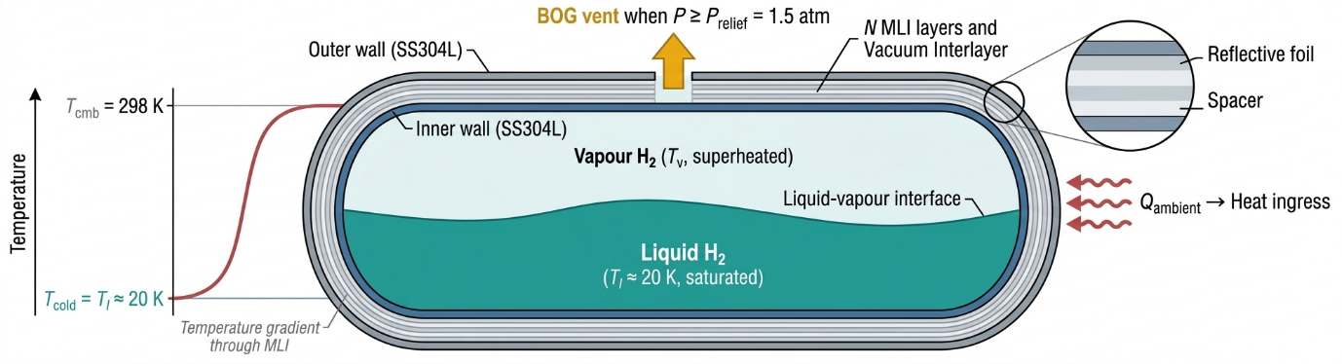
Figure 1 Horizontal Cylindrical Tank with Hemispherical Ends - LH₂ Storage
Inner tank, containing liquid hydrogen, has an inner diameter of 4.2 m and a total cylindrical length of 21.184 m. The insulation scheme, consistent with Lu et al. [13], an inner tank followed by a multi-layer insulation (MLI) network, followed by a vacuum interlayer, and the outer tank. Both inner and outer tanks are of similar materials, i.e., SS304L, and share the same wall thickness of 10 mm. The system is subjected to an ambient temperature of 298.15 K with a relief pressure of 1.5 atm to regulate internal pressure build-up during storage. These conditions establish the boundary environment for heat ingress and subsequent BOG generation.

Simulation Framework
The overall simulation integrates the transient thermodynamic two-phase BOG model, layer-resolved heat transfer model, and an economic analysis model into a unified framework to predict an accurate boil-off behavior in LH₂ storage tanks. The framework is implemented in Python due to its flexibility in scientific computations and the vast collection of libraries. Famous libraries like NumPy, pandas, SciPy, and Matplotlib are used for array handling, data visualization, numerical computation, and plotting, respectively.
The thermophysical properties of hydrogen are evaluated using CoolProp, a REFPROP library for Python, which provides high-fidelity real fluid property calculations across both liquid and vapor phases [26,27]. Moreover, REFPROP has optimized parameters based on experimental data and provides accurate properties for hydrogen [28–30]. The same library has already been employed in previously published BOG management studies [12].
Aspen HYSYS Dynamic mode was evaluated before adopting a custom Python implementation and was not used for the following three reasons:
- Its dynamic vessel model assumes internal phase thermal equilibrium, with no native representation of the liquid–vapor non-equilibrium this study requires.
- It has no MLI-specific unit operation, treating insulation only as a single lumped thermal resistance, which precludes the layer-resolved analysis in Section 3.2.1.
- And a fully time-stepped simulation with a nonlinear solver at every timestep runs substantially slower in its dynamic engine than in a vectorized Python implementation, relevant given the seven-variable parametric sweep in Section 3.2.
Python was selected over other languages (e.g., MATLAB) specifically for its access to CoolProp (a REFPROP-backed property library).
Subsequent sections contain the details of sub-models: the BOG prediction model, the heat transfer model, and the economic model.

Sub-model A: The BOG Prediction Model
The BOG prediction model is formulated as a transient, non-equilibrium two-phase thermodynamic system detailing the evaluation of liquid and vapors with time. At the start of the simulation, the liquid hydrogen is saturated at 1 atm (T₀ = 20.37 K), and the ullage, the unfilled portion of the tank volume (33% at the nominal 67% fill level), is charged with saturated vapor at the same pressure and temperature. This represents a freshly loaded, unpressurized tank in liquid-vapor equilibrium. Both the vapor superheat and the tank pressure rise from this baseline as heat ingress accumulates over the storage period [31].
The model is further divided into two parts: before and after the vent. In the pre-venting stage, as vapors accumulate in the ullage [32], driving the self-pressurization behavior of the tank, the pressure inside the tank increases while the liquid remains saturated with its temperature (T_{L}) rising accordingly along the saturation curve [20]. The process continues until the internal pressure reaches the relief pressure (Pr = 1.5 atm), at which point, the venting condition is triggered.
In the post-venting stage, the tank operates under constant pressure conditions. The tank pressure is maintained at the relief setpoint through continuous venting of excess vapor. As a result, the liquid temperature (T_{L}) remains constant. The heat ingress continues generating more vapors due to the part that directly heats the liquid region (based on liquid wetted area), while the vapor temperature (T_{V}) will keep on increasing as vapor area continues to absorb heat, leading to the formation of a warmer vapor layer above the interface, creating thermal stratification [15].
Due to the temperature difference between the vapor and liquid, some amount of heat from the vapor goes into the liquid, creating more vapor [16]. The unsteady-state energy balance, governing the thermodynamic behavior inside the tank, is as follows [18]:
$\frac{dH_{L}}{dt}=Q_{L}+Q_{VL}-{\dot{m}}_{boil} h_{boil}+V_{L} \frac{dP}{dt}$ (1)
$\frac{dH_{V}}{dt}=Q_{V}-Q_{VL}+{\dot{m}}_{boil} h_{boil}-{\dot{m}}_{relief} h_{V}+V_{V} \frac{dP}{dt}$ (2)
where ṁ_boil and ṁ_relief are the boil-off and relief mass flow rates (kg/s), h_{boil} = λ(T_{L}) is the latent heat carried by the boil-off stream, and h_{V} is the specific enthalpy of the vented vapor (J/kg). $V_{L}$ and $V_{V}$ are the corresponding liquid and vapor volumes, $\frac{dP}{dt}$ is the rate of pressure change. The complete derivation of these energy balance expressions is given in the Supplementary Information S6.
The balances are written for the two phases as separate open control volumes, not for the tank as a whole, since a single control volume carries one temperature and cannot represent vapor superheat above the interface.
During the vent, dP/dt is zero, and both $\frac{dP}{dt}$ terms vanish, giving Eqs. (3) and (4).
$\frac{dH_{L}}{dt}=Q_{L}+Q_{VL}-{\dot{m}}_{\text{boil}} h_{\text{boil}}$ (3)
$\frac{dH_{V}}{dt}=Q_{V}-Q_{VL}-{\dot{m}}_{\text{relief}} h_{V}+{\dot{m}}_{\text{boil}} h_{\text{boil}}$ (4)
In the preceding self-pressurization stage, dP/dt is not zero, and the reduced forms do not apply; the model does not integrate the liquid energy balance, Eq. (1), as a solution is not possible in the pre-vent stage. The vapor balance is integrated in both stages (Supplementary Information S9.3).
When the value of ${\dot{m}}_{\text{boil}}$, from $Q_{L}+Q_{VL}={\dot{m}}_{\text{boil}} λ(T_{L})$ is substituted, every component cancels out, and a solution is not possible in that stage. The liquid (temperature) is instead constrained to the saturation curve, and pressure is recovered from the vapor equation of state, as set out in the timestep sequence in Supplementary Section S5.
Mass balances on both control volumes are as follows:
$\frac{dm_{L}}{dt}=-{\dot{m}}_{\text{boil}}$ (5)
$\frac{dm_{V}}{dt}={\dot{m}}_{\text{boil}}-{\dot{m}}_{\text{relief}}$ (6)
the volume constraint $V_{L}(t)+V_{V}(t)=V_{\text{tank}}$, and the evaporation-rate closure $Q_{L}+Q_{VL}={\dot{m}}_{\text{boil}} λ(T_{L})$, where λ is the latent heat of vaporization evaluated at the current liquid temperature via CoolProp.
During the post-venting stage, the vent mass flow rate is not calculated from a valve flow-coefficient expression; it is the residual required to satisfy the vapor-phase mass balance at fixed pressure Pr and current vapor temperature TV at each timestep:
${\dot{m}}_{\text{relief}}={\dot{m}}_{\text{boil}}-{\left.\frac{dm_{V}}{dt}\right|}_{P=P_{r}}$ (7)
closing the system without reference to a physical relief-valve geometry. Within each timestep, the two phases are not updated simultaneously; the order depends on regime, since pressure is an output before venting and a constraint after. The full sequence is appended in Supplementary Information Section S5.

Sub-model B: Layer-Resolved MLI Heat Transfer Model
Sub-model computes heat ingress at each timestep by calculating heat transfer rates and temperature profiles across all nodes. This sub-model is the component that distinguishes this study from all prior BOG models. Rather than assuming a constant heat rate or calculating heat rates with a constant heat transfer coefficient, it treats each of the insulation layers as an individual thermal resistance. Three heat transfer mechanisms take place in parallel in each MLI layer: heat transfer through radiation (between two adjacent reflecting surfaces), solid conduction (through each layer), and residual gas conduction (through evacuated space). The cumulative effect of these heat transfer mechanisms determines the overall heat transfer rate and temperature profile across all nodes, including the inner tank wall, MLI layers, vacuum interlayer, and outer tank wall. The following sections provide a detailed framework of governing equations and computational procedures used to calculate heat flux and temperature evolution.

Heat Conduction Through Tank Walls
For the calculation of the heat transfer rate through tank walls (both inner and outer), Fourier’s law expressions, as adopted from Lu et al.’s work [13] were employed. While these expressions accurately capture conduction through the cylindrical section, they do not account for the hemispherical ends of the tank; neglecting them would result in an underestimation of the total heat ingress. To address these limitations, this model incorporates expressions for heat transfer rates through both cylindrical and hemispherical ends, ensuring a comprehensive representation of heat transfer throughout the geometry. These expressions are as follows [13]:
$Q_{wall,cyl}=\frac{2πLk\left(T_{out}-T_{in}\right)}{ln​\left(d_{out}/d_{in}\right)}$ (8)
$Q_{wall,sph}=\frac{4π r_{in} r_{out} k\left(T_{out}-T_{in}\right)}{r_{out}-r_{in}}$ (9)
where $r=d/2$, L is the length of the cylindrical section, k is the thermal conductivity, $r_{in}$, $d_{in}$, $r_{out}$, $d_{out}$, $T_{in}$, $T_{out}$ is the inner radius, inner diameter, outer radius, and outer diameter, temperature at the inner node, and temperature at the outer node, respectively. Subscript “out” represents the outer tank-side node, while “in” represents the inner tank-side node.

Heat Transfer Through MLI
Heat transfer through the MLI stack is modeled by treating each layer as an individual resistance and solving for all three heat transfer modes, including radiation, solid conduction, and residual gas conduction. Total heat transfer rate through each MLI-layer is obtained by summing all three heat transfer modes. The governing expressions for each mode are as follows [13]:
$Q_{rad,cyl}=\frac{π d_{out} L σ\left(T_{out}^{4}-T_{in}^{4}\right)}{\frac{1}{ε_{out}}+\frac{d_{out}}{d_{in}}​\left(\frac{1}{ε_{in}}-1\right)}$ (10)
$Q_{solid,cyl}=\frac{2πL C_{s} f_{sp} k_{sp}\left(T_{out}-T_{in}\right)}{ln​\left(d_{out}/d_{in}\right)}$ (11)
$Q_{gas,cyl}=π d_{out} L α p \frac{γ+1}{γ-1}\sqrt{\frac{R}{8πM_{g}T_{amb}}}\left(T_{out}-T_{in}\right)$ (12)
where $Q_{rad,cyl}$, $Q_{solid,cyl}$, $Q_{gas,cyl}$ is the heat transfer rate through the cylindrical section via radiation, solid conduction, and residual gas conduction, respectively. $σ$ is the Stephan–Boltzmann constant, $ε$ is the emissivity of each MLI layer, and the surface is computed using the correlation given in equation 8 [13]. $C_{s}$ is an empirical constant with a value of 0.008, $f_{sp}$ is the relative density of the spacer material, $k_{sp}$ is the thermal conductivity of the spacer material, $R$ is the general gas constant, $γ$ is the ratio of heat capacities (Cp/Cv), $α$ is the thermal accommodation coefficient with a value of 0.9, $M_{g}$ is the molecular mass of gas, $T_{amb}$ is the ambient temperature and $p$ is the residual gas pressure.
The sum of all heat rates through each MLI-layer (cylindrical section) would be calculated using equation [9].
$ε(T)=2.18×{10}^{-3} T^{0.67}$ (13)
$Q_{mli,cyl}=Q_{rad,cyl}+Q_{solid,cyl}+Q_{gas,cyl}$ (14)
Since Lu et al.’s work [13] accounts only for heat transfer through the cylindrical section, to ensure a complete representation of the tank’s geometry, additional expressions for heat transfer through hemispherical ends are incorporated in this model.
$Q_{rad,sph}=\frac{4π r_{out}^{2} σ\left(T_{out}^{4}-T_{in}^{4}\right)}{\frac{1}{ε(T_{out})}+{\left(\frac{r_{out}}{r_{in}}\right)}^{2}​\left(\frac{1}{ε(T_{in})}-1\right)}$ (15)
$Q_{solid,sph}=\frac{4π r_{in} r_{out} C_{s} f_{sp} k_{sp}\left(T_{out}-T_{in}\right)}{r_{out}-r_{in}}$ (16)
$Q_{gas,sph}=4π r_{out}^{2} α p \frac{γ+1}{γ-1}\sqrt{\frac{R_{u}}{8πM_{g}T_{amb}}}\left(T_{out}-T_{in}\right)$ (17)
$Q_{mli,sph}=Q_{rad,sph}+Q_{solid,sph}+Q_{gas,sph}$ (18)

Heat Transfer Through Vacuum Interlayer
Heat transfer through the vacuum interlayer is modeled by solving heat transfer via radiation and residual gas conduction. Expressions for vacuum interlayer heat transfer are similar to expressions (10) to (18) except that they do not contain the solid conduction term, and the heat transfer rate through the vacuum interlayer is obtained by summing the contributions from radiative and pressure-dependent gas conduction. The governing equations are as follows:
$Q_{vac,cyl}=Q_{rad,cyl}+Q_{gas,cyl}$ (19)
$Q_{vac,sph}=Q_{rad,sph}+Q_{gas,sph}$ (20)
Since all resistances are arranged in series across the tank wall, MLI, and the vacuum interlayer, the total heat rate through each component remains equal for a given section, accordingly [33–35].
$Q_{ingress,cyl}$ = $Q_{inner tank wall,cyl }= Q_{mli,cyl} = Q_{vac,cyl} = Q_{outer_tank_wall,cyl }$ (21)
$Q_{ingress, sph}$ = $Q_{inner tank wall,sph }= Q_{mli,sph} = Q_{vac,sph} = Q_{outer_tank_wall,sph }$ (22)
The total heat ingress into the tank is calculated by combining the heat rates through the cylindrical section and the hemispherical ends:
$Q_{ingress total}$ = $Q_{ingress, cyl}$ + $Q_{ingress, sph}$ (23)
Thus, the overall heat ingress accounts for both the cylindrical body and the two hemispherical ends (equivalent to one full sphere).
This framework is implemented as a separate module from the main thermodynamic loop and is called at each timestep with updated boundary conditions (ambient and cold temperatures). By dynamically resolving heat ingress, this model removes a key limitation present in earlier studies and ensures consistent embedding with the transient thermodynamic model. The total heat ingress into the tank, obtained from the heat transfer model, is treated as a single input and subsequently partitioned between liquid and vapor regions of the tank based on the wetted surface area. This approach is adopted from NASA’s study [36] which states that the direct liquid heat input (Q_{L}) is proportional to the fraction of wetted wall area if a uniform heat flux is assumed. In simpler terms, the distribution of the total heat between liquid and vapor depends on the relative areas occupied by each phase inside the tank [12]. In addition to that, the effective cold side temperature (Tcold) used in the heat transfer calculations is calculated using an area-weighted expression instead of a simple average, which ensures consistency with the phase distribution. Expressions are as follows [36]:
$f_{A}=\frac{A_{L}}{A_{L}+A_{v}}$ (24)
$Q_{L}=f_{A} Q$ (25)
$Q_{v}=Q-Q_{L}$ (26)
$T_{cold}=\frac{A_{L} T_{L}+A_{v} T_{v}}{A_{L}+A_{v}}$ (27)
The sensitivity of total heat ingress to this cold boundary temperature is quantified directly in Figure 5(i): across the full 20-30 K range observed in the nominal 90-day simulation, total heat rate changes by less than 0.5% (124.7 W to 124.2 W). To discuss the influence of wetted area fraction on the BOG results, a separate analysis is performed where the wetted area fraction is perturbed by up to ±20% from its nominal value, at fixed total heat ingress. Results indicate that the total BOG fraction responds with an elasticity of 0.53-0.57. Partition uncertainty therefore propagates weakly into BOG fraction; details are available in the supplementary information.
Interfacial heat transfer is calculated as follows [18]:
$Q_{vl}=h_{vl} A_{vl}​\left(T_{v}-T_{L}\right)$ (28)
where $f_{A}$ is the wetted area fraction, $Q$ is the total heat ingress, $Q_{L}$ is the liquid heat rate, $Q_{v}$ is the vapor heat rate, $Q_{vl}$ is the interfacial heat transfer rate, $T_{L}$ is the temperature of liquid hydrogen, $T_{v}$ is the temperature of vapor hydrogen, the interfacial surface area, and $h_{vl}$ is the interfacial film coefficient.
It is evaluated from a natural-convection correlation for the vapor–liquid interface, following the same formulation used by Kim and Lee [22]:
$h_{VL}=0.27 \frac{k_{L}}{D} Ra_{VL}^{0.25}, {10}^{5}≤Ra_{VL}≤{10}^{10}$ (29)
$Ra_{VL}=Gr⋅Pr=\frac{gβ(T_{V}-T_{L})D^{3}}{ν_{L}^{2}}⋅\frac{μ_{L}C_{p,L}}{k_{L}}$ (30)
where D is the characteristic length of the vapor–liquid interface, computed from the interface geometry at the current fill height, and k_{L}, ν_{L}, μ_{L}, and Cp_{L} are liquid-side thermophysical properties evaluated at the current liquid state via CoolProp. The interfacial area A_{VL} is the flat liquid-surface area returned by the tank-geometry module at the current fill height, given explicitly in the Supplementary Information.
Moreover, for the sake of validation, in the BoilFast comparison (Table 3, Figure 4), h_{VL} is instead fixed at 4 W/m²K to match BoilFast’s own constant-coefficient formulation, as noted in Section 2.6.

Numerical Solution of the Layer-Resolved System
Because the radiative term in Eqs. (10) and (15) is fourth-order in temperature, the N coupled layer-balance equations (Eqs. 21-23) cannot be solved directly and are instead closed as a nonlinear root-finding problem with the following residual vector:
$r(T)=\left[ Q_{1}(T)-Q_{2}(T), Q_{2}(T)-Q_{3}(T), …, Q_{N}(T)-Q_{N+1}(T) \right]=0$ (31)
is driven to zero using SciPy’s scipy.optimize.root function with the Powell hybrid method (method='hybr') and a convergence tolerance of 1×10⁻⁴ on the residual vector. The initial temperature guess is a linear interpolation between the cold-boundary and warm-boundary temperatures across all N+2 nodes (inner wall, N MLI layers, outer wall), rather than an arbitrary or random starting point. Non-convergence of the root-finding routine raises an exception, so no un-converged solution is silently accepted. This procedure is repeated at every timestep of the outer transient BOG loop, using the current cold node temperature as updated boundary conditions.
The governing energy and mass balances (Eqs. 3-7) are integrated using explicit (forward) Euler time-marching at a fixed timestep of 10 minutes, with each step closed by a CoolProp equation-of-state evaluation rather than a general-purpose ODE solver.

Sub-model C: The Economic Model
The economic model translates physics-based BOG simulation output into a lifecycle cost framework. It is built around one principle: for every kilogram of BOG that leaves the storage tank represents a real cost, and whether the insulation investment can prevent it. This question cannot be answered using a fixed value of BOG rate, which is why the output of BOG simulation is handed over to the economic analysis module, which calculates the CAPEX, OPEX, and LCOH as a function of BOG rate, insulation, and tank design.
For each simulation run, a 90-day storage cycle was considered. After each cycle, the tank is refilled to the same initial charge, which makes 4 cycles in one year.

Capital Expenditure (CAPEX)
The total CAPEX is the sum of six components, each of which is described in subsequent sections with its parameters, constants, and literature-sourced cost estimates.
Pressure Vessel
The primary cost reference for a cryogenic double-walled LH₂ vessel is the DOE-funded analysis [37,38]. Vessel cost is calculated using the widely adopted volume-cost scaling rule (the six-tenths scaling rule) for a pressure vessel using expression 24 [39]. The DOE target for cryogenic storage is $3.3M at 3500 m³ capacity.
$C_{vessel}=C_{ref}{\left(\frac{V_{t}}{V_{ref}}\right)}^{0.6}f_{cont}$ (32)
where $C_{vessel}$ is the cost of the vessel, $C_{ref}$ is the cost of the reference vessel ($3.3 M), $V_{t}$ is the tank volume, $V_{ref}$ is the volume of the reference vessel (3500 m³) and $f_{cont}This$ is the contingency factor that accounts for the cryogenic construction complexity, pressure testing, and certification, currently valued at 2.
MLI
MLI cost scales linearly with layer count (N) and surface area (As). This cost in CAPEX is the only component that changes with insulation layer count; all other components are N-independent. Total MLI cost is comprised of MLI material cost, dependent on N and As, and MLI installation cost, which accounts for labor and installation. Expressions are as follows [37,38]:
$C_{MLI mat}=N A_{s} c_{layer}$ (33)
$C_{MLI}=C_{MLI mat}\left(1+f_{lab}\right)$ (34)
where $C_{MLI}$ is the total MLI cost, $C_{MLI mat}$ is the MLI material cost, $N$ is the layer count, $A_{s}$ is the surface area (inner vessel, outer surface area), $c_{layer}$ is the cost one layer per unit surface area [38], and $f_{lab}$ is the labor cost factor, 30% of the material cost.
Vacuum System
A fixed cost is assigned to the turbomolecular pumping system, instrumentation, and interlocking valve assembly required to establish and maintain a vacuum inside the annular space between two tanks (vessels). Source [37] reports a cost of $50000 – 80000 for a system capable of reaching 10⁻³ Pa in a vessel this size, a central value ($65000) is used.
Balance of Plant (BOP)
BOP cost accounts for the pressure relief system, vent stack, fill and drain piping, instrumentation, and control systems. The BOP cost factor, 30% of vessel cost, consistent with industry practice for double-walled cryogenic storage tanks, is used [12,25].
Civil and Site Costs
A factor of 0.25 ($f_{civ}$) is applied to the vessel cost, which accounts for civil and site costs, including foundations, access roads, and site integration [40].
Engineering and Commissioning Cost (EPC)
This cost includes engineering works, procurement, and commissioning, and is estimated at 10% of all direct costs, consistent with standard project cost estimation [41].
Annualized CAPEX
Total CAPEX is annualized using the capital recovery factor (CRF), which converts a lump-sum investment amount into an equivalent annual payment over the asset's lifetime at a given discount rate, defined as [42]:
$CRF=\frac{i(1+i)^{n}}{(1+i)^{n}-1}$ (35)
where $n$ is the asset lifetime, currently selected as 15 years for this study, and $i$ is the discount rate, 7%, selected for this study.

Operational Expenditure (OPEX)
OPEX has three components, each of which is detailed in the subsequent sections, with cost factors:
Operational and Maintenance (O&M) Cost
Annual O&M cost is calculated as a fixed fraction of annualized CAPEX:
$C_{OM}=f_{om} C_{annualized CAPEX}$ (36)
where $f_{om}$ = 0.02 i.e., 2% rate covers the planned maintenance, prior repairs, and staff costs [40].
Vacuum Maintenance Cost
The annular space must be periodically pumped down, estimated once every 3-5 years. Based on NASA KSC data [4,43]. The cost of annual amortized vacuum maintenance is around $5000-1000/year. A central value of $7000/year is selected for C_{VAC-OM} for the study.
Annual BOG Cost
The annual cost of hydrogen lost to boil-off is calculated using output time-varying data from the BOG simulation and the price of hydrogen. Three price scenarios are evaluated covering the range of grey, blue, and green hydrogen. Grey hydrogen, developed from steam-methane reforming (SMR), is priced at $2.5/kg [44], blue hydrogen, developed using the SMR process with carbon capture, is priced at $5 [44] and green hydrogen, developed from electrolysis, is priced at $9 [45].

Levelized Cost of Hydrogen (LCOH)
The LCOH is defined by analogy with the levelized cost of electricity (LCOE) [40,44], but applied to storage systems. It represents the minimum price per kilogram at which hydrogen must be sold to recover all the capital and operational costs or hit the break-even point, over the asset’s lifetime [40,44]. Since the scope of the study is limited to BOG management, LCOH only covers the storage-related capital and operational costs. It is calculated as:
$LCOH=\frac{C_{annualized CAPEX} + C_{OPEX}}{{\dot{m}}_{H_{2}}} (\$/kg)$ (37)
A detailed flowchart of the complete simulation framework is displayed in Figure 2. It starts by prompting the user to provide all the necessary inputs (geometry, insulation, and operational variables), initializes the system-state variables, initiates the BOG-time loop, calls the heat transfer module at every timestep, updates the state variables, provides necessary inputs for economic analysis, generates plots, and saves the results.
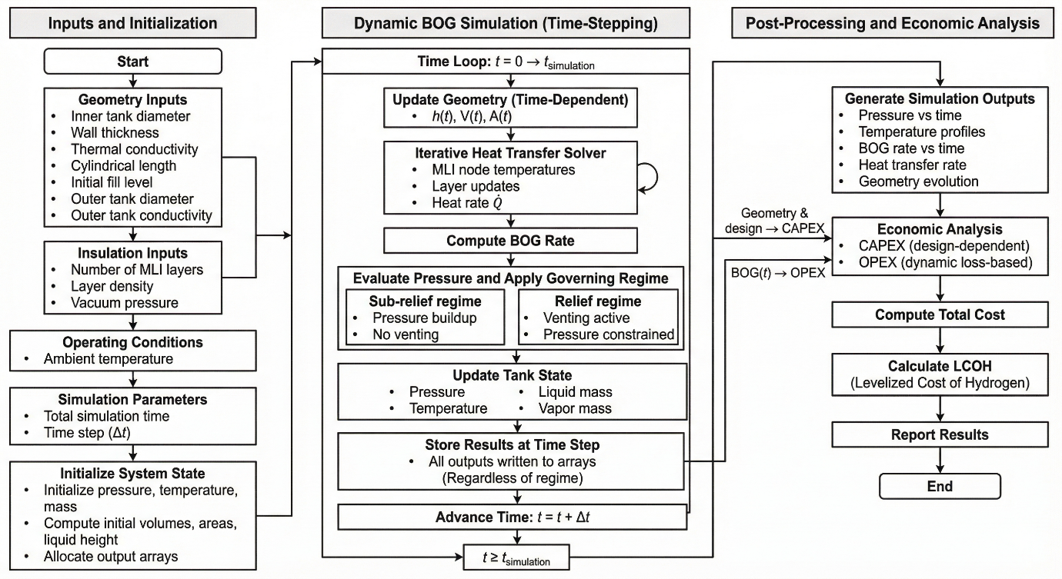
Figure 2 Flowchart of Simulation Framework

Process Model Assumptions
To keep the overall framework tractable while still capturing the real physics of LH₂ boil-off, the following assumptions are made:
- The tank is considered a closed system before venting, and mass loss only occurs after venting.
- Only two nodes are considered, vapor and liquid, consistent with the lumped stratification formulation of Gursu et al. [32] and the two-node approach used in Al Ghafri et al. [18] and Kim and Lee [22]. The model tracks the temperature difference between these two bulk phases; it does not resolve a continuous temperature field within either phase, which would require a CFD-level treatment outside the scope of this study. Moreover, in the vent section, the model uses bulk vapor temperature for density evaluation instead of solving for various nodes inside the vapor-controlled volume.
- Both phases, liquid and vapor, are not in thermal equilibrium to realize thermal stratification.
- Liquid temperature rises with an increase in tank pressure, following the saturation curve, before venting. After venting, the liquid temperature remains constant, corresponding to fixed relief pressure.
- Uniform heat distribution is considered in each phase after splitting.
- Only one-dimensional heat transfer, at each timestep, is assumed to occur.
- Ortho/para conversion heat generation is neglected, assuming adequately catalytically converted hydrogen; incomplete conversion may introduce an additional internal heat load and lead to underprediction of BOG.
- In the layer-resolved heat transfer sub-model, both film resistances are neglected, external as well as internal. The rationale behind this assumption is to minimize deviations in transport properties of internal and external fluids. Studies mention that variations due to these film resistances have a very minimal effect on the overall heat transfer rate [22].

Model Validation
The developed models, both BOG prediction and layer-resolved heat transfer, are validated individually. BOG prediction is validated against results generated by BoilFast [18] at the same process parameters, while the layer-resolved heat transfer model is validated against experimental data published by NASA [46].
This two-stage approach, validating each physical sub-model against the most directly comparable independent source available, follows the same convention used by Kim and Lee [22] in validating their coupled thermal-resistance/thermodynamic model.
Two sources were selected for validation, each matched to the sub-model it tests. The NASA dataset [46] reports measured heat flux and temperature profiles across MLI stacks at 20, 40, 60, and 100 total layers, spanning the same layer-count range swept in Section 3.2.1, and is used to validate the heat transfer sub-model directly. BoilFast [18] is used to validate the thermodynamic/BOG sub-model. The comparison in Table 3 therefore tests the correctness of our implementation of that shared formulation rather than an independent physical model. BoilFast was itself validated by Al Ghafri et al. [18] against NASA Kennedy Space Center and Glenn Research Center LH₂ tank data, so the underlying validation chain for the thermodynamic sub-model traces back to experiment. The operating conditions listed in Table 3 (tank type, volume, fill level, ambient temperature, relief pressure) were matched by design for this comparison.
The number of MLI layers was varied with similar layer density, and the effect on the heat flux and temperature profile was recorded. Heat flux comparison with percentage deviation is given in Table 2, while the temperature profiles for each N-case are given in Figure 3.
Table 2 Layer-resolved heat transfer model – Validation Results
No. of layers | Layer Density | Warm Boundary Temperature | Experimental Results [46] | Predicted Results (Model) | Deviation
- | layers/cm | K | W/m² | W/m² | %
100 | 20.5 | 290.3 | 0.1888 | 0.1977 | 4.71
60 | 20.5 | 293.6 | 0.3186 | 0.3418 | 7.28
40 | 20.5 | 293 | 0.4949 | 0.5024 | 1.51
20 | 20.5 | 285.4 | 0.872 | 0.8691 | -0.33

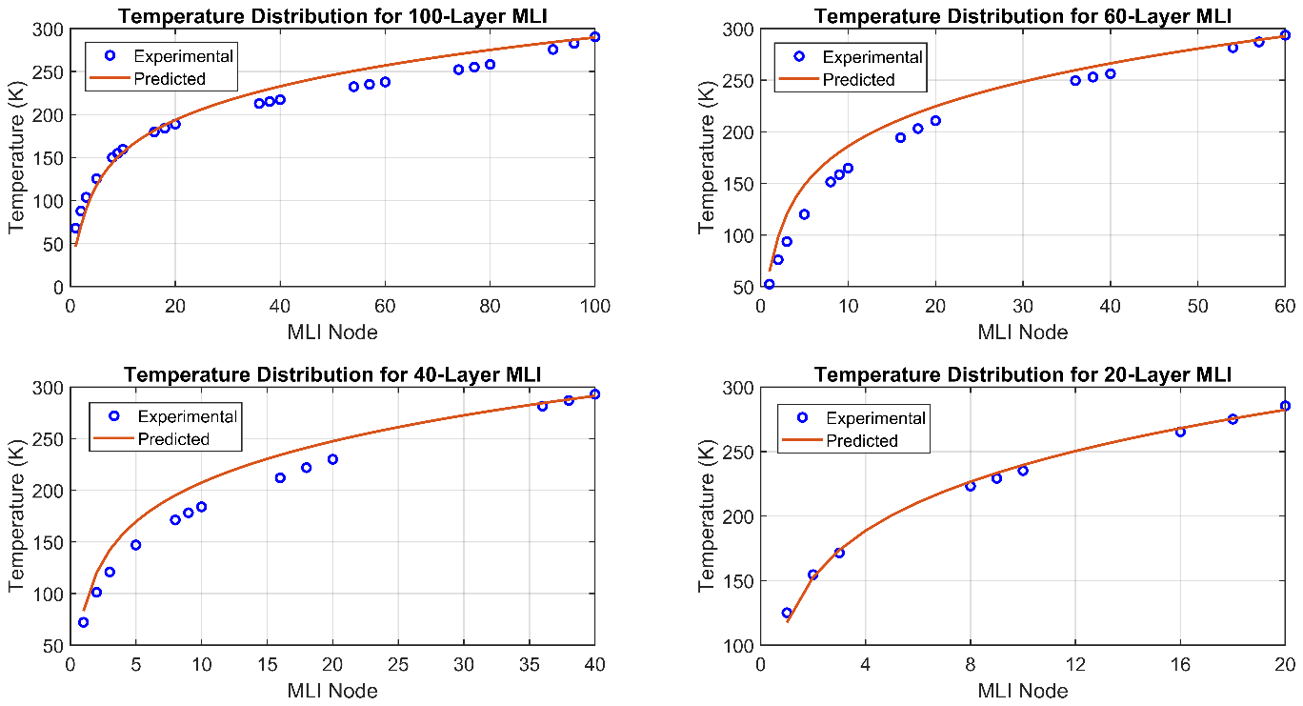
Figure 3 Layer-resolved Heat Transfer Model - Validation Results
Across the four validation cases, the mean absolute percentage error is 3.46%, the root-mean-square error is 4.40%, and the maximum absolute error is 7.28% (100-layer case). None of the model constants used in the heat-transfer sub-model, the emissivity correlation, the spacer thermal conductivity, or the empirical solid-conduction constant C_{s} = 0.008, were fitted or adjusted using the Stochl [46] dataset; the comparison in Table 2 is a forward prediction using literature-sourced values only.”
Consequently, the BOG prediction model was validated against results from BoilFast framework under identical geometric and operating parameters. The comparison shows strong agreement across all thermodynamic variables, including pressure evolution, temperature profiles, BOG rates, etc. Validation results are given in Table 3, while pressure and temperature profiles are displayed in Figure 4.

Table 3 Validation Results - BOG Prediction Model
Parameter | Unit | BoilFast | Model
Geometry
Tank Type |  | Spherical | Spherical
Diameter | m | 3.006 | 3.006
Total Volume | m³ | 2.27 | 2.27
Fill Level | % | 84 | 84
Operating Parameters
Ambient Temperature | K | 110 | 110
Relief Pressure | atm | 1.5 | 1.5
*Overall Heat Transfer Coefficient - Liquid | W/m²K | 0.34 | 0.34
*Overall Heat Transfer Coefficient - Vapor | W/m²K | 0.35 | 0.35
*Overall Heat Transfer Coefficient - Interface | W/m²K | 4 | 4
Duration
Simulation Time | hr | 60 | 60
Results
Final Pressure | atm | 1.48 | 1.52
Initial Liquid Temperature | K | 20.53 | 20.37
Final Liquid Temperature | K | 21.77 | 22.03
Initial Vapor Temperature | K | 20.53 | 20.67
Final Vapor Temperature | K | 29.8 | 29.96
Initial Liquid Height | m | 2.24 | 2.24
Final Liquid Height | m | 1.56 | 1.52
Total BOG Fraction | % | 39.18 | 40.91
Average BOG Rate | kg/day | 132.26 | 138.53
Average BOG Rate | %/day | 15.67 | 16.36
*Note: U_{L}, U_{V}, and h_{VL} are held fixed in this comparison only, matching BoilFast’s own constant-coefficient requirement.
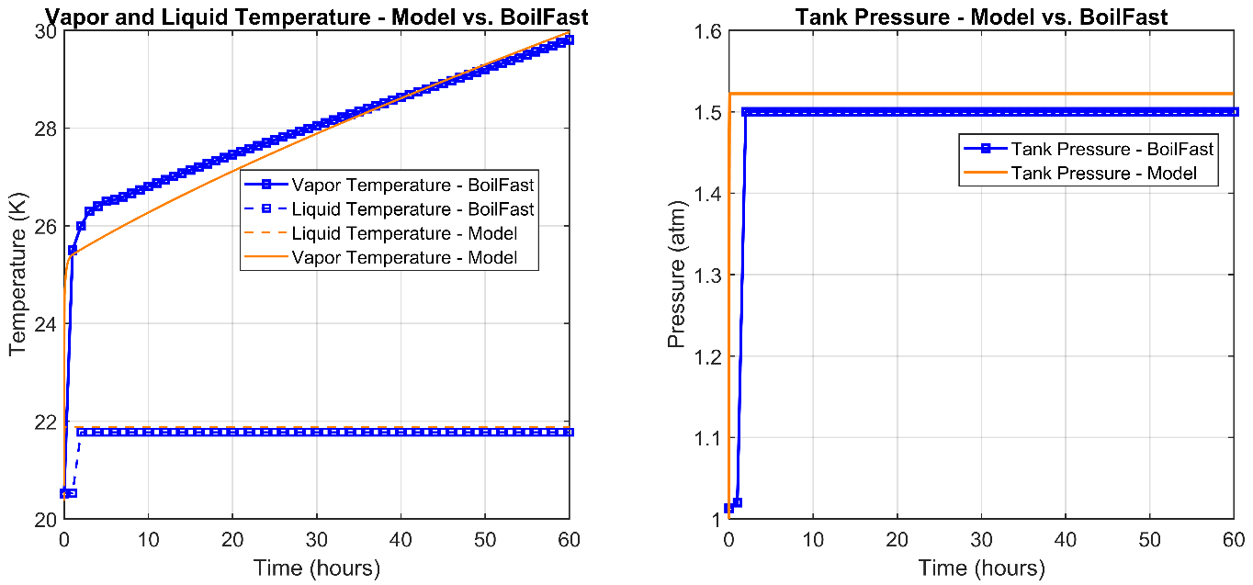
Figure 4 Validation Results - BOG Prediction Model

This comparison intentionally holds U_{L}, U_{V}, and h_{VL} fixed, matching BoilFast’s own constant-coefficient formulation [18], so that the underlying mass and energy balance solver can be checked against BoilFast’s results independently of the layer-resolved coupling; the effect of allowing these coefficients to vary dynamically, the contribution of this study, is instead demonstrated throughout the parametric analysis in Section 3.2.
The predicted final pressure of 1.52 atm closely matches the reference value of 1.48 atm; this minor deviation was a result of different modeling methodologies. Vapor and liquid temperature predictions remain within a narrow deviation range (~0.2-0.3 K), which indicates consistent thermodynamic behavior. In terms of mass loss due to boil-off, the model predicts a total BOG fraction of 40.91% compared to 39.2%, which corresponds to a deviation of 4.4%.
The coupled framework introduces no new empirical expression. At each timestep, the layer-resolved solver (a Python function) returns heat ingress from the current boundary temperatures; that heat is divided between the phases by wetted-area fraction, the phase energy balances are integrated, and the resulting outputs are supplied as the next boundary condition. The coupling contains no fitted coefficient or free parameter; it replaces a prescribed constant heat rate with the one evaluated from the validated heat transfer physics at each step. Because the return path gain is below 0.5% (impact of cold node temperature on heat rate), error cannot amplify around the loop, and the coupled deviation is bounded by the sum of the sub-model deviations.

Results and discussions
This section presents simulation results in three stages. The first stage begins by discussing the results of the nominal configuration in detail, including temperature and pressure profiles, BOG matrices, geometrical parameters evolution, and economic profile. The second stage comprises a comprehensive parametric analysis where 7 input variables are varied while holding everything else at nominal. This stage also includes a vacuum degradation sensitivity analysis in which residual gas pressure inside the annular area is varied and its impact on the outputs is recorded. This stage terminates with a heat map of normalized swing, which provides insight into which variables matter the most and can bring out a significant impact in the output. The third stage comprises the economically driven sensitivity analysis and discusses the impact of certain variables on the LCOH and other costs.

Nominal Configuration
The nominal case is a horizontal cylindrical tank with hemispherical ends. It has a diameter of 4.2 m and a cylindrical section length of 21.184 m, consistent with the baseline study [13]. The rest of the input variables are tabulated in Table 4, while the result curves are displayed in Figure 5, and the BOG outputs are tabulated in Table 5.
Table 4 Nominal Configuration - Horizontal Cylindrical Tank with Hemispherical Ends
Parameter | Unit | Value
Inner tank inner diameter | m | 4.2
Outer tank inner diameter | m | 4.8
Tank thickness | mm | 10
Length of cylindrical section | m | 21.184
Initial fill level | % | 67
Tank Material | - | SS304L
MLI count | - | 60
Layer density | layers/cm | 25
Vacuum pressure | Pa | 0.001
Ambient Temperature | K | 298.15
Relief Pressure | atm | 1.5
Simulation duration | hr | 2160 (90 days)
Timestep | min | 10

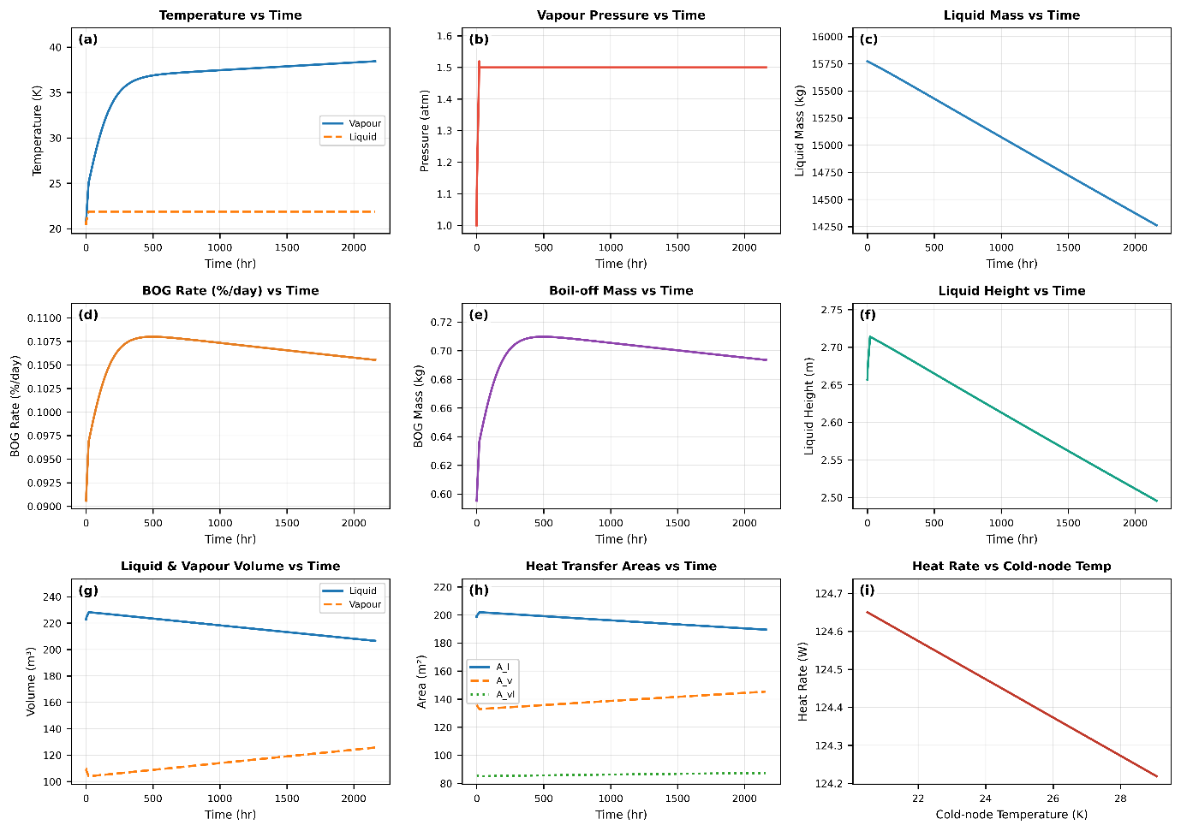
Figure 5 Result Curves - Nominal Configuration
Table 5 BOG Prediction Results - Nominal Configuration
Parameter | Unit | Value
Duration | hours | 2160 (90 days)
Initial liquid mass | kg | 15772.73
Final liquid mass | kg | 14262.77
Total BOG mass | kg | 1509.96
BOG fraction | % | 9.57
BOG rate (average) | %/day | 0.1064
BOG rate (average) | kg/day | 16.78
Final pressure | atm | 1.5
Final liquid temperature | K | 21.87
Final vapour temperature | K | 38.44
Surface area (Inner Tank) | m² | 334.93
Average heat rate | W | 124.27
Average heat flux | W/m² | 0.371

Figure 5 contains 9x subplots, including temperature profile, pressure profile, and evolution of liquid mass, BOG rate, BOG mass, liquid height, volumes, and areas with time. Last subplot (i) depicts the change in the total heat ingress when the temperature inside the tank increases.
After visualizing the results, it can be assessed that the liquid temperature remains constant throughout the 90-days run, corresponding to fixed tank pressure. On the other hand, vapor temperature climbs steeply over the first 200-300 hours as the small vapor mass absorbs the net heat ingress entering the ullage directly, then it flattens. Liquid mass and height both bear a linear drop as time progresses.
Liquid volume, surface area, and heat transfer rate (displayed in the supplementary information) increase slightly at first before venting. This happens due to the effect of thermal expansion of the liquid as its temperature increases before venting. This phenomenon is confirmed by NASA’s work [47], before venting, as the liquid temperature rises, mass remains constant, and its density decreases, and volume expands slightly, which is shown in subplot (g). A similar trend can also be observed in liquid height and liquid area, being the function of liquid height, it can be observed in subplot (h) as well.
On the other hand, vapor volume, surface area, and heat follow the opposite trend; it drops initially, then rise as time progresses.
Boil-off rate and boil-off mass, subplots (d) and (e), rise steeply until they reach their maximum at ~400 hours; after that, a gradual decline is observed. This behavior is governed by the dependency chain within the model: the BOG rate is directly influenced by the heat input Q_{L,} which itself depends on the wetted surface area A_{L}. Since A_{L} is a function of liquid height, the BOG rate decreases as liquid height drops. Subplot (i) shows that there’s a negligible change in total heat rate entering the tank with cold-node temperature (area weighted average temperature inside the tank).
Figure 6, subplots (a) and (b), displays the variation in temperature with diameter (starting from the inner tank to the outer tank) for cylindrical sections and spherical sections, respectively. While subplots (c) and (d) display the same temperature variation, but along MLI nodes.
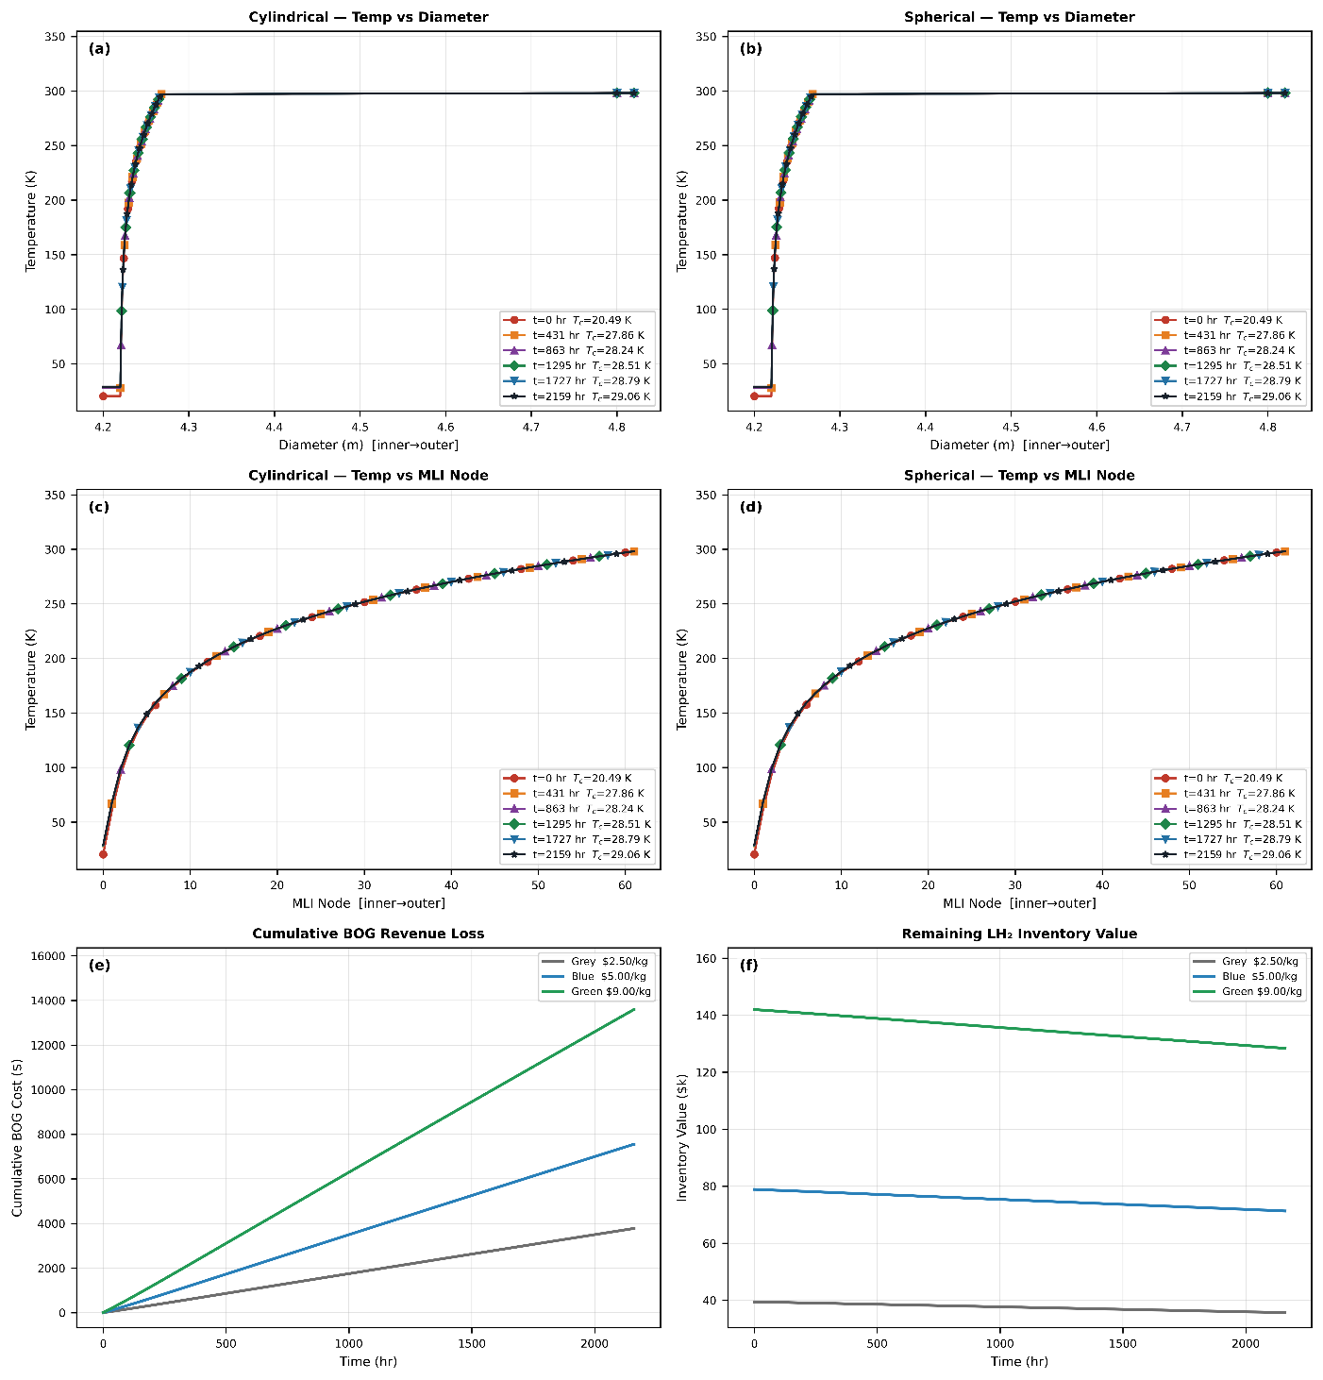
Figure 6 MLI Temperature Distribution and Economic Results - Nominal Configuration
Table 6 and Figure 6, subplots (e) and (f), give the economic outputs at the nominal configuration. The CAPEX is dominated by the vessel cost, second largest cost is of the MLI (material + labor). Revenue loss due to boil-off is highest in green hydrogen and lowest in grey hydrogen. The time-varied cumulative revenue loss (cumulative sum) due to boil-off is displayed in subplot (e), while subplot (f) depicts the time-varied inventory value. Plots depict that after 90 days, revenue loss due to BOG would be ~$4,000 for grey, $8,000 for blue, and $14,000 for green hydrogen. Similarly, the inventory value of green hydrogen would see the highest drop compared to blue and grey hydrogen.
Table 6 Economic Results - Nominal Configuration
Cost Parameter | Unit | Value
CAPEX
Vessel | $ | 1,606,975
MLI (material + labour) | $ | 170,755
Total CAPEX | $ | 2,999,223
Annualized CAPEX | $/yr | 329,299
OPEX
BOG loss Grey ($2.50/kg) | $/yr | 15,309
BOG loss Blue ($5.00/kg) | $/yr | 30,619
BOG loss Green ($9.00/kg) | $/yr | 55,114
Total OPEX Grey | $/yr | 28,895
Total OPEX Blue | $/yr | 44,205
Total OPEX Green | $/yr | 68,700
LCOH
Grey ($2.50/kg H₂) | $/kg | 6.1925
Blue ($5.00/kg H₂) | $/kg | 6.4571
Green ($9.00/kg H2) | $/kg | 6.8806

Parametric Study
Parametric study comprises 07x variables sweep, one at a time. In every sweep, all other parameters remain at nominal values (Table 4). The purpose is not to find the global optimum, which would require a rigorous run; the purpose is to understand how each variable drives BOG independently so that sensitivity ranking can be grounded in physical reasoning rather than just index numbers.
Lower and upper bounds of all 07x sweep variables are tabulated in Table 7.
Table 7 Variables Range for Parametric Sweep
Sweep Variable | Unit | Lower Bound | Upper Bound
Fill Level | % | 10 | 90
Total MLI layers | - | 20 | 100
Cylindrical length | m | 2 | 26
Relief pressure | atm | 1.2 | 2.5
Ambient temperature | K | 270 | 315
Tank thickness | mm | 4 | 20
Vacuum pressure | Pa | 0.0005 | 0.46

MLI Layer Count (N)
MLI layer count is the most influential variable in this study. Increasing the total number of insulation layers results in reduced heat leak, which leads to the generation of boil-off. Figure 7 contains 06x subplots, from which subplots (a) and (b) depict the change in total BOG fraction (fraction of LH₂ lost due to boil-off in a 90-day storage run) and BOG rate due to the total MLI layers. Similarly, subplots (c) and (d) depict the change in total heat ingress and heat flux with total MLI layers, while subplots (e) and (f) depict the time-varying response of BOG rate and temperatures for configurations with different numbers of total MLI layers.
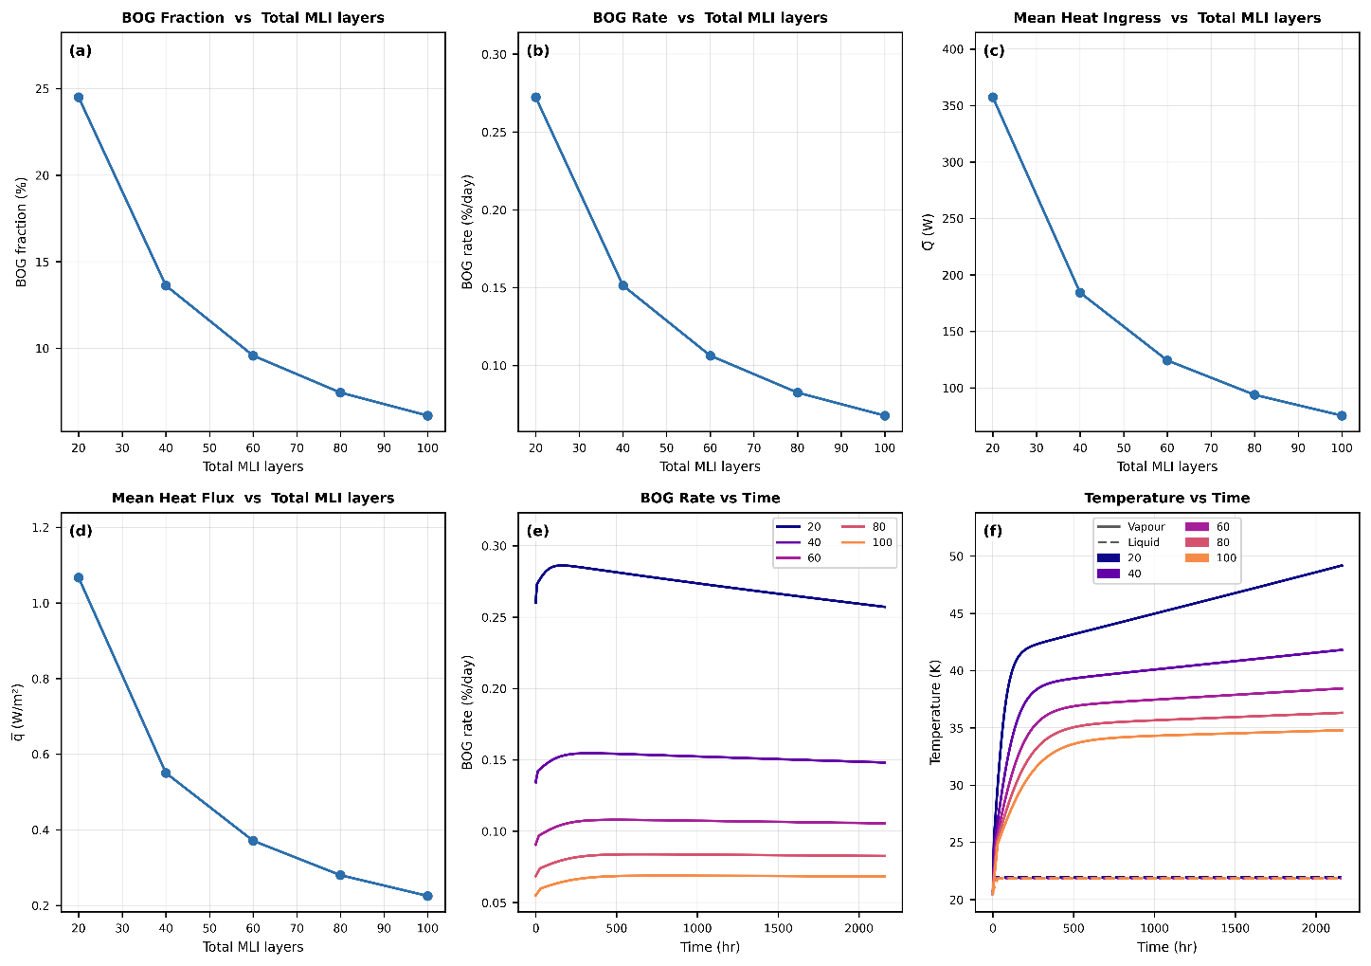
Figure 7 Parametric Sweep - Total MLI Layers (N)

The total BOG fraction, BOG rate, total heat rate, and heat flux drop steeply as N increases from 20 to 60, then gradually decrease as N increases to 100. This diminishing return profile has a physical explanation: adding the first 20-40 layers intercepts the bulk of the radiation heat flux because the radiation resistance scales as N (each layer halves the view factor contribution approximately). Adding more layers reduces the remaining radiation profile and the minor contribution from gas conduction (which has already been suppressed by the high vacuum).
The time-varying BOG profiles indicate a clear dependence on the number of MLI layers, with lower layer count resulting in significantly higher boil-off rates, while the highest layer count yields the lowest BOG generation. The trend is consistent with BOG temperature profiles. At a smaller layer count, although the liquid temperature remains constant, which is tied to the tank pressure, the vapor temperature rises substantially due to increased heat ingress. As the count increases, the thermal resistance of MLI improves, reducing the heat ingress and ultimately reducing the temperatures as well as BOG rates.
From a practical standpoint, increasing the total MLI layers would improve insulation performance and reduce the overall BOG rates and vapor temperatures; however, this improvement comes at a cost. Adding more layers would increase the CAPEX significantly. This cost penalty raises an important design question regarding the diminishing-return design point number of MLI layers. To answer this question, an economics-driven sensitivity analysis has been performed, which evaluates the impact of N on LCOH and other cost metrics. Figure 8 provides the answer to this question. It displays the impact of total MLI layers on LCOH for different hydrogen price scenarios (grey, blue, and green).
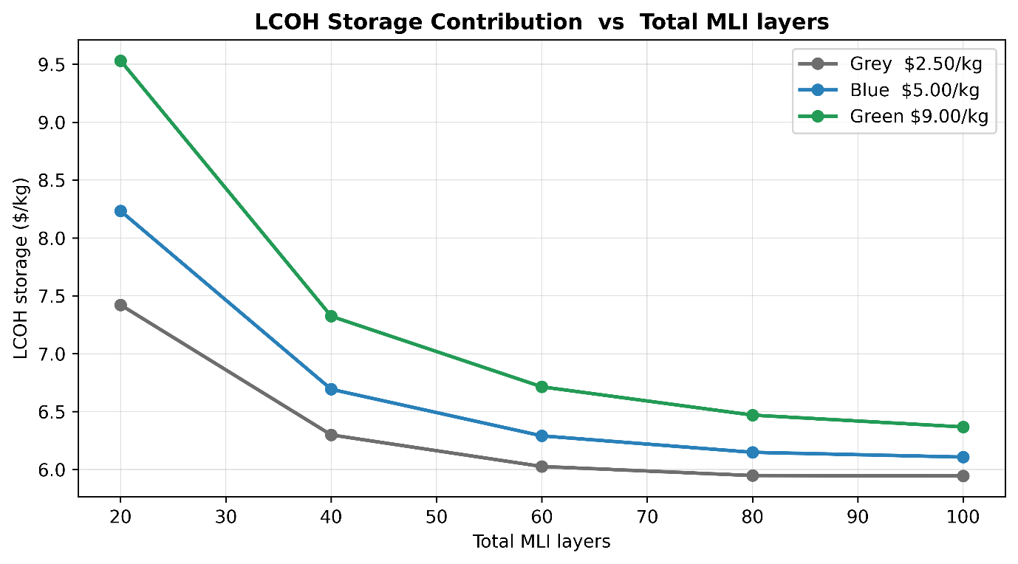
Figure 8 Economics-driven Parametric Sweep (LCOH) - Total MLI Layers
The relationship between LCOH storage contribution and total MLI layers shows a clear diminishing return trend across all hydrogen cost scenarios. Increasing the number of total MLI layers from 20 to 40 results in a substantial reduction in LCOH. Increasing layer count beyond 60 suggests diminishing marginal benefits; therefore, a diminishing-return design point emerges around 60-70, where the most achievable cost reduction can be realized. The impact of layer count on individual cost metrics, including CAPEX and OPEX, can be found in the supplementary information.
A diminishing-return design point is defined as the value beyond which each additional increment of the swept variable (i.e., MLI layers) reduces LCOH by less than 5% of the total LCOH range observed across the swept interval. This value reflects diminishing marginal benefit under the stated threshold and is not presented as global or constrained optima.

Vacuum Pressure
The vacuum pressure or the residual gas pressure inside the annular area between tanks is the most consequential result for real-world tank operation, as it tests the vacuum degradation scenario that actually occurs during the service [48,49]. All tanks, when commissioned, start at high vacuum or low vacuum pressure. Over the years of operation, outgassing from MLI materials, micro leaks in the vacuum jacket, and permeation through tank walls would result in vacuum degradation or an increase in vacuum pressure [43,50]. Wang et al. [23] showed that K_{eff} is nearly constant till 10⁻² Pa, then it starts to increase sharply at a vacuum pressure of 10⁻¹ Pa. And when pressure reaches 0.46 Pa, K_{eff} has increased significantly. The sweep here, shown in Figure 10, reproduces that physics in the context of an operating tank. Ravichandran et al. [1] identified vacuum degradation as a gap and explicitly mentioned that future studies should explore the impact of long-term vacuum deterioration on insulation performance. Lee et al. [10] analytically model the MLI cavity insulation performance across varying residual gas pressure (vacuum pressure). The study demonstrates the effect of vacuum degradation on both the total heat flux and the effective thermal conductivity of MLI.
Prior studies have largely focused on evaluating insulation performance in terms of overall heat transfer rate/flux or K_{eff}, without extending the analysis to the resulting tank-level thermodynamic behavior. In contrast, this work builds upon these inputs and advances the analysis a step further. It incorporates the analysis that directly links insulation performance under varying vacuum conditions to the dynamic response of the storage system. Integrating the layer-resolved heat transfer model with the BOG prediction framework, the model has enabled the simultaneous prediction of heat ingress, pressure evolution, temperature profiles, and boil-off metrics.
The five pressure levels selected for this analysis, 5x10⁻⁴, 4.65x10⁻³, 0.0425, 0.0775, and 0.46 Pa, represent distinct vacuum conditions spanning the full operational spectrum of the tank. These correspond to ideal high vacuum state, a newly commissioned tank, mild degradation, moderate degradation, and severe vacuum failure. This range enables systematic evaluation of how progressive vacuum degradation influences the heat transfer mechanism and consequently drives overall boil-off.
Figure 9, subplots (a) and (b), shows the impact of vacuum pressure on BOG fraction and rate, respectively. Subplots (c) and (d) show the impact of total heat rate and flux, while subplots (e) and (f) show the time-varying response of BOG rates and temperatures at different vacuum levels. Results depict that at ideal and newly commissioned tank-vacuum conditions, there’s a negligible impact on the overall heat transfer rates as well as BOG metrics. This highlights that, in this regime, heat transfer is dominated by radiation and solid conduction while gas conduction is negligible. At mild and moderate vacuum levels, a similar change in all four outputs can be observed. BOG fraction and BOG rate increase by ~70% from the newly commissioned vacuum state to moderate degradation; gas conduction starts to increase. It represents the transition from high-performance insulation to a degraded state. At the vacuum failure state (residual gas/vacuum pressure of 0.46 Pa), a significant jump in all four outputs can be observed. BOG fraction jumps to 50% (nearly half of LH₂ loses due to boil-off in 90 days) when the vacuum pressure reaches 0.46 Pa. Here, gas conduction dominates over radiation and solid conduction. Similarly, vapor temperature increases significantly to ~70 °C at the stage of vacuum failure.
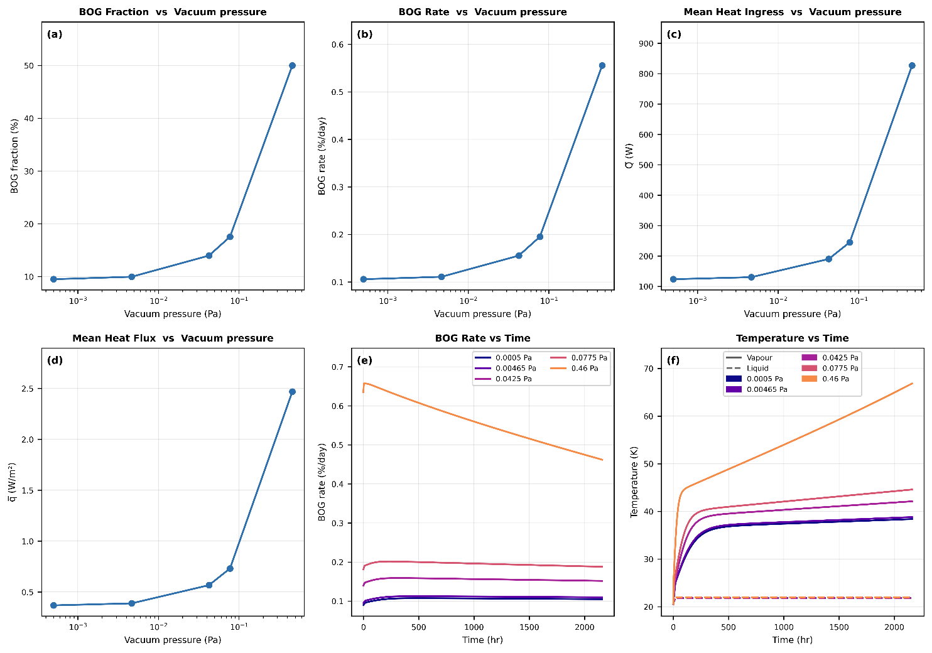
Figure 9 Parametric Sweep - Vacuum Pressure
Figure 10 depicts the change in LCOH with vacuum pressure across all hydrogen price scenarios. The results highlight a strong sensitivity of LCOH to vacuum quality with a distinct non-linear trend across the pressure range. At low pressure or ideal to newly commissioned tank-vacuum level, LCOH remains stable and starts to increase at moderate vacuum settings. A sharp escalation in LCOH can be observed as vacuum degradation enters from moderate to severe failure. At this point, LCOH nearly doubles compared to the newly commissioned tank’s vacuum state. This trend indicates that maintaining high vacuum is only thermodynamically critical, but it's also economically essential, as even moderate vacuum degradation can lead to a significant cost increase.
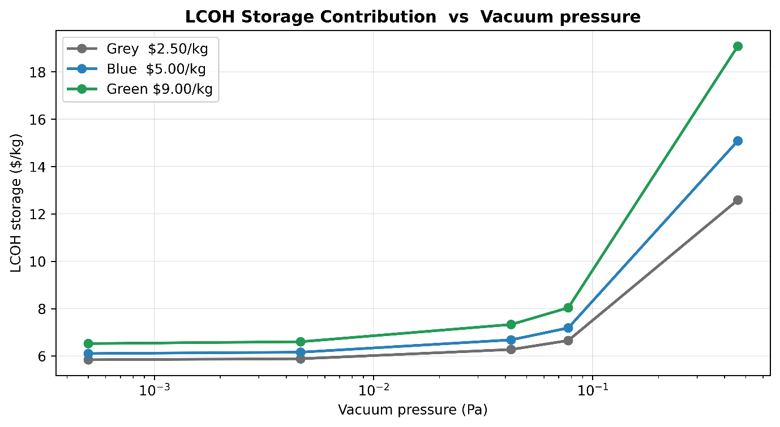
Figure 10 Economics-driven Parametric Sweep (LCOH) - Vacuum Pressure
The vacuum-degradation results carry a direct process safety implication. Blaylock et al. [51] modeled two distinct hydrogen release categories for maritime LH₂ storage: routine, continuous boil-off venting, found to produce no flammable concentration under normal operating conditions, and a full blowdown following a failed relief device, the governing scenario for hazardous-zone classification. The present results show these two categories are not fixed and separate. A degrading vacuum state moves the routine boil-off rate progressively closer to the flow magnitude associated with the abnormal case, rising from 16.8 kg/day at nominal vacuum to over five times that at severe vacuum failure (0.46 Pa). This is exactly the information a relief-device sizing exercise and a hazardous-zone classification review [52] would need as an input, and it is not available from any of the fixed-heat-leak BOG models reviewed in Table 1.

Fill Level
The fill level sweep runs from 10% to 90% in 8 equidistant points. Figure 11 contains 6x subplots, just like previous sweeps, highlighting the change in BOG fraction, BOG rate, mean heat transfer rate, mean heat transfer flux, and temperatures at different fill levels.
Mean heat rate and mean heat flux, displayed in Figure 11 subplots (c) and (d), respectively, show no significant change throughout the sweep. On the other hand, the BOG fraction and rate are maximum at low fill levels. It happens because, at low fill levels, most of the ullage volume contains vapor. Even though the total heat rate remains constant, ullage volume absorbs a major portion of the heat ingress, and as a result, vapor temperature rises. This trend can be visualized in subplot (f), where the vapor temperature crossed 70 °C at a fill level of 10%. This high temperature creates a strong driving force between vapor and liquid, pushing more heat towards the liquid-vapor interface, which leads to more evaporation. This effect can be seen in subplots (a) and (b), where both the total BOG fraction and BOG rate are reduced as the fill level increases. At higher fill levels, vapor temperature also reduces.

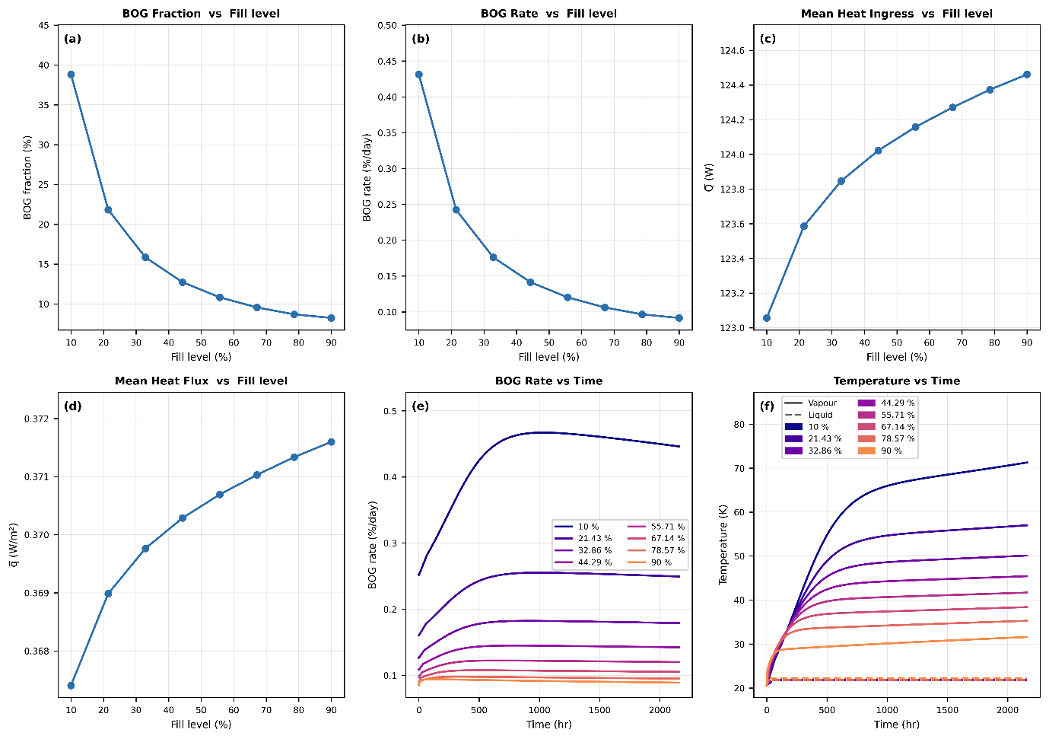
Figure 11 Parametric Sweep - Fill Level

The economic metric (LCOH), displayed in Figure 12, depicts a similar trend, with its maximum at low fill levels, which corresponds to a high BOG fraction analyzed earlier. It starts to decrease as the fill level rises, but the change is low across LH₂ price scenarios. At a fill level greater than 80%, no significant change in LCOH is observed, which puts the diminishing-return design point fill level at ~75%.
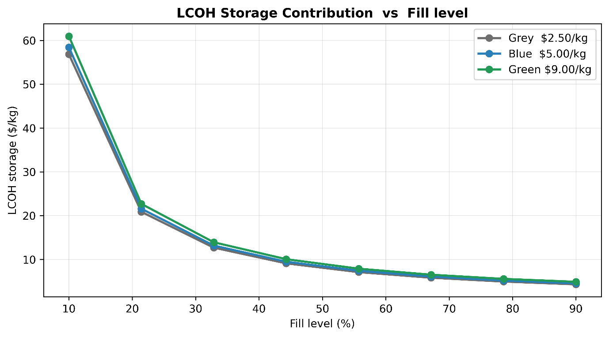
Figure 12 Economics-driven Parametric Sweep (LCOH) - Fill Level

Ambient Temperature (T_{amb})
The ambient temperature sweep covers temperatures from 270 to 315K, representing a range from cold northern climates to a hot tropical port. Figure 14 displays 06x subplots, just as the previous parametric analysis. Changing the ambient temperature directly disrupts the driving force. At low T_{amb}, the driving force is low, which keeps the heat rate lower compared to higher temperatures. This low heat rate is directly translated into lower BOG fraction, BOG rate, and temperatures, which can be seen in Figure 13.
A 16% change in ambient temperature (from 270 to 315 K) is directly translated into a BOG fraction change of ~16%, and it can be said that the variation of outputs remains nearly linear with the ambient temperature.

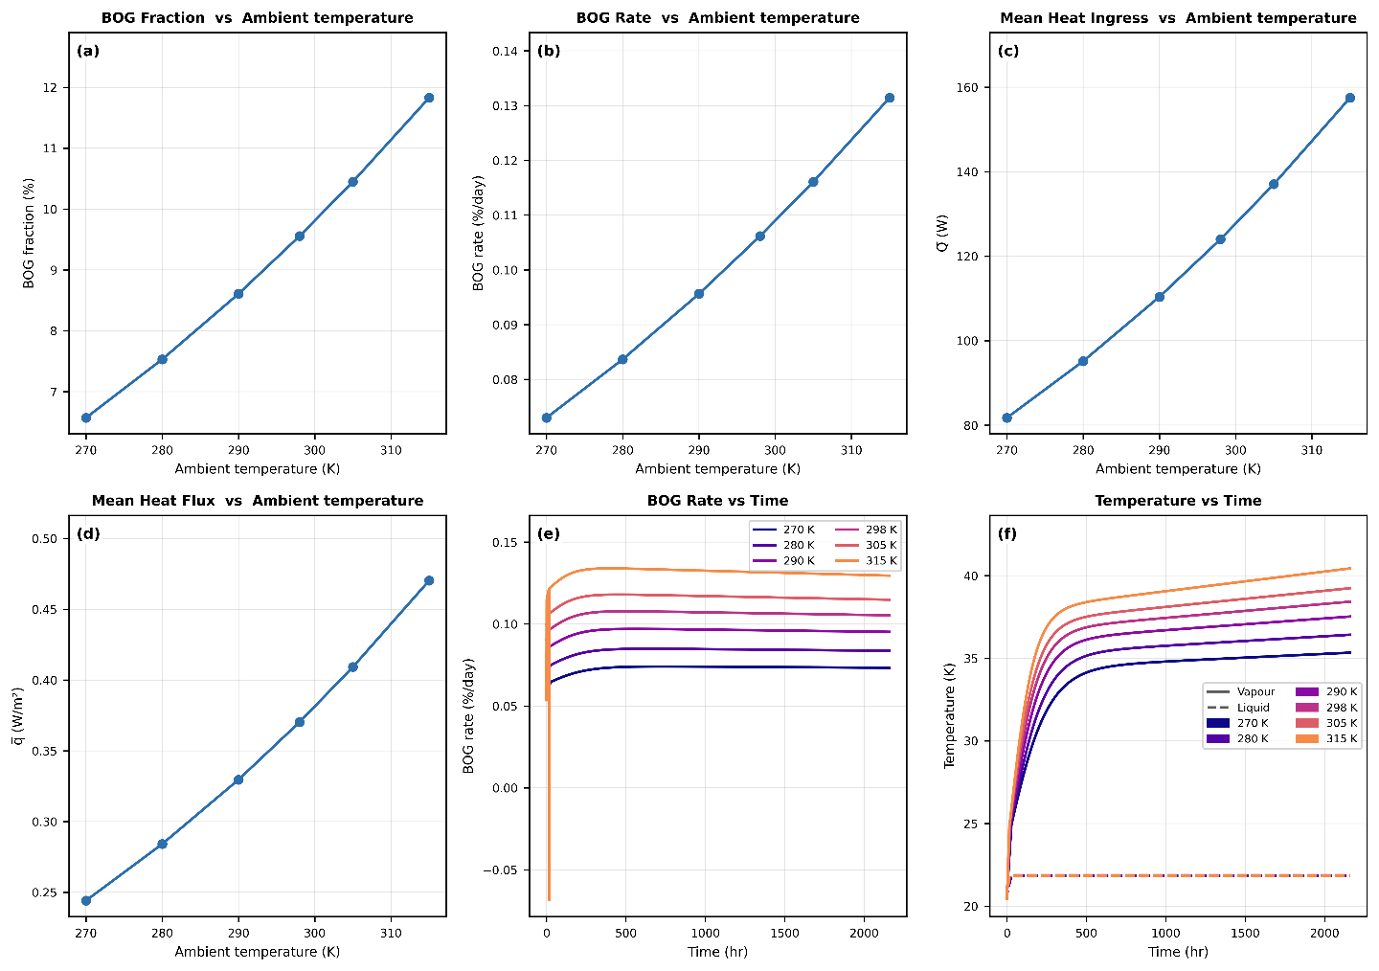
Figure 13 Parametric Sweep - Ambient Temperature
In economically driven sensitivity, a similar trend can be observed in LCOH variation against the ambient temperature. Figure 14 illustrates the dependence of total storage cost on external temperature across different hydrogen price scenarios. The results indicate that lower ambient temperatures lead to reduced LCOH values primarily due to the decreased temperature gradient.
Therefore, from both thermodynamic and economic perspectives, operating under lower external temperature is advantageous as it minimizes both the BOG rates as well as total storage cost.
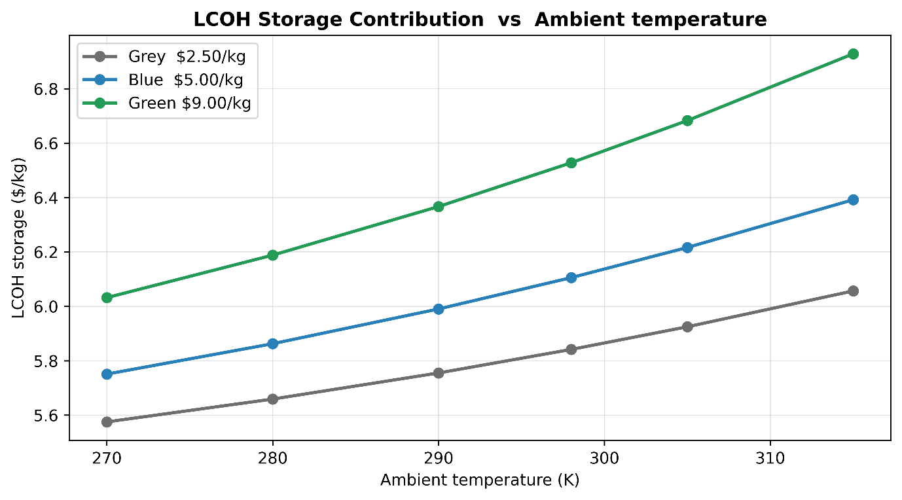
Figure 14 Economics-driven Parametric Sweep (LCOH) - Ambient Temperature

Tank’s Length (L)
The parametric analysis on length starts from 2 m and ends at 26m. Figure 15 carries the subplots, which illustrate that the total heat rate increases as the length increases, but the heat flux, BOG fraction, and BOG rate are observed to be decreasing.
As the length increases at the fixed diameter, the cylindrical wall surface area and the stored liquid mass grow linearly with length. The hemispherical end caps, however, present a fixed heat ingress which does not change with length, so their contribution per unit stored mass diminishes as the tank is elongated. The net effect is a monotonic decrease in BOG rate with the increase in length. This behavior is consistent with the well-established principle that BOG losses are governed by the surface area-to-volume ratio (SA/V), as tank size is elongated, SA/V decreases, reducing the heat ingress per unit stored mass [53,54]. This scaling effect is widely recognized in cryogenic storage practice, where large tanks consistently achieve lower BOG rates than smaller transport vessels. For reference, a plot containing variations in SA/V against the length of the tank is provided in the supplementary information.
Increasing length would also result in lower vapor temperature, as illustrated in subplot (f). This parametric analysis reaffirms this well-established principle, demonstrating that the model accurately captures the geometric scaling effects.
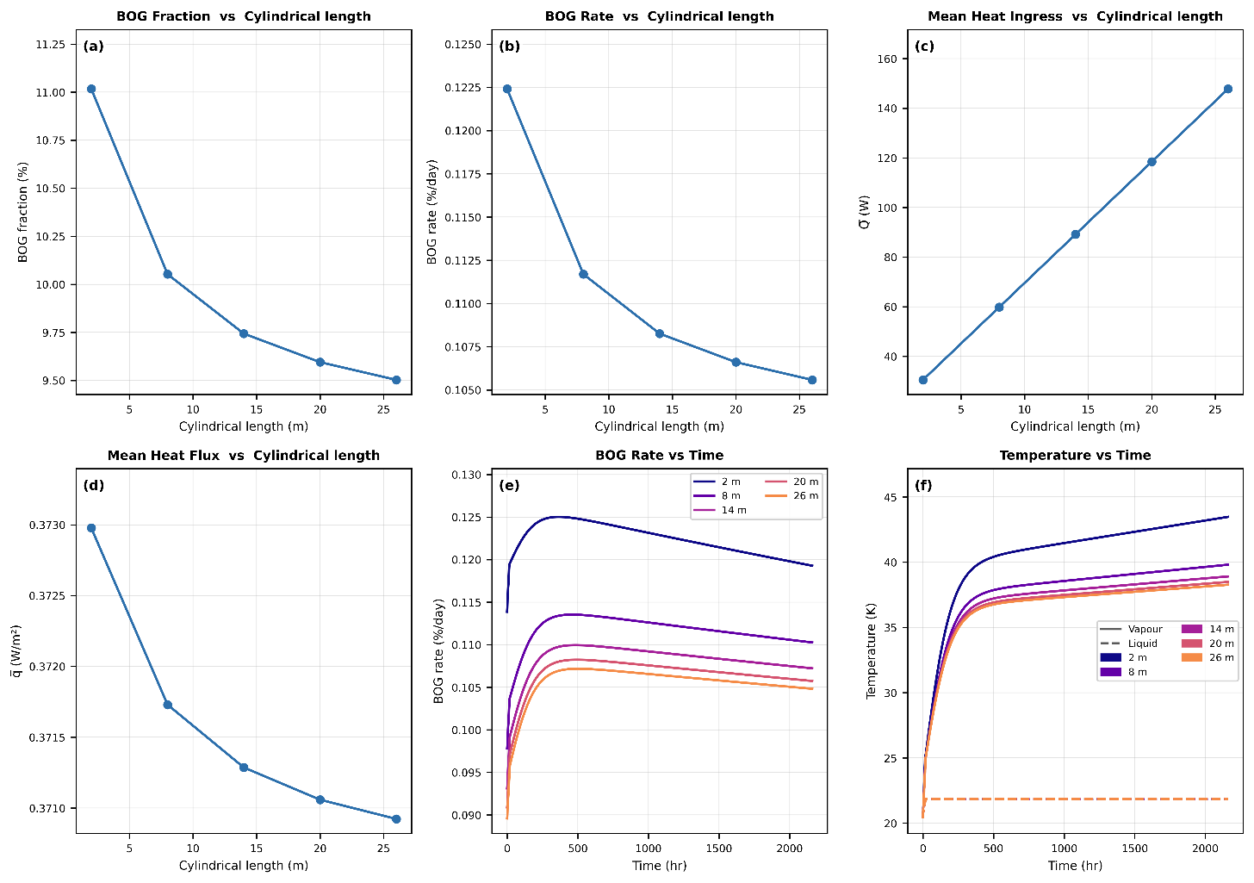
Figure 15 Parametric Sweep - Tank's Length

Figure 16 depicts that increasing the length of the tank from 2m to 26m would result in a substantial reduction in LCOH across all LH₂ price scenarios. This decrease is particularly pronounced at lower lengths and provides diminishing returns as the talk length increases. For the tank size considered in this study, i.e., diameter of 4.2m, a length exceeding 20 m yields economic benefits because of reduced SA/V.
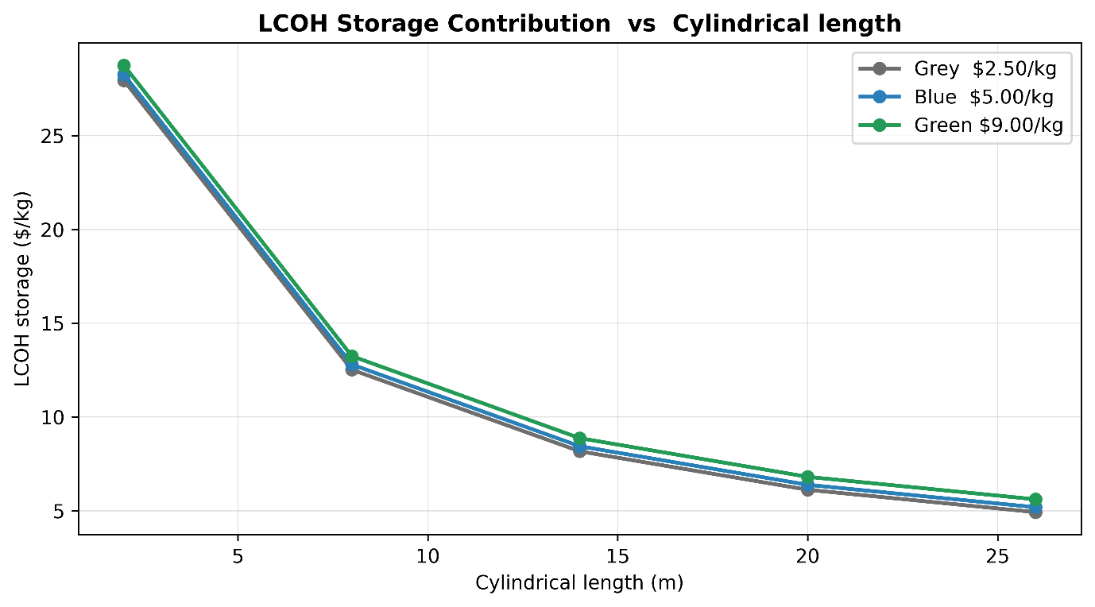
Figure 16 Economics-driven Parametric Sweep (LCOH - Tank's Length

Relief Pressure (Pr)
The effect of relief pressure on tank performance metrics, i.e., heat ingress, BOG rates, and temperatures, introduces a different trade-off compared to geometric parameters. Relief pressure directly governs the boil-off dynamics inside the tank. A parametric analysis covering relief pressure is presented. In this analysis, the relief pressure is changed from 1.2 to 2.5 atm (covering all possible operational ranges); the results are appended in the supplementary info.
Total heat transfer rate and flux are observed to be decreasing, subplots (c) and (d), but this drop is negligible. Relief pressure brings a change in the total BOG fraction and BOG rate, both of which increase with an increase in the relief pressure. The reason behind this rise is simple thermodynamics. At higher tank pressures, the liquid temperature increases along the saturation curve, which can be observed in the subplot (f). And as the liquid temperature rises, its heat of vaporization drops; as a result, the BOG rate increases, which can be observed in subplots (a) and (b). However, this change is not that significant, and from an economic perspective, this variable does not bring a significant change in LCOH, as illustrated in the supplementary info. It increases LCOH by ~1% across all price scenarios. This indicates that, unlike other variables, relief pressure does not serve as a dominant economic driver in LH₂ storage tank design. However, selecting a lower relief pressure may be more favorable from a design standpoint, as it reduces the structural loads and mechanical requirements.

Tank’s Wall Thickness
To study the influence of the wall thickness of both tanks simultaneously, this parametric sweep is carried out, and the tank wall thickness is varied from 4 to 20 mm. The influence of tank wall thickness introduces a competing effect between structural integrity and thermal performance. Results are illustrated in the supplementary info.
Subplots (c) and (d) indicate that total heat and heat flux both increase with wall thickness. In usual heat transfer problems, wall thickness increases the thermal resistance and reduces the overall heat transfer; however, in the storage of cryogenic fluids, especially LH₂, increasing tank thickness actually increases total heat ingress, which increases the BOG rates. The same phenomenon can be seen in subplots (a) and (b).
In cryogenic storage, wall thickness is not the dominant thermal resistance when high-performance insulation such as MLI is present. As a result, variations in all thicknesses have a secondary impact on overall heat ingress compared to insulation parameters [53]. Increasing the wall thickness increases the surface area of the wall, which directly influences the radiative heat transfer, so the overall heat ingress increases. As a result, the BOG rate increases.
The wall thickness has a near-zero impact on the economics. The LCOH variation against the wall thickness, illustrated in the supplementary info, shows a negligible impact, confirming that wall thickness is not a controlling resistance in the presence of high-performance MLI. However, wall thickness remains a critical variable from a structural point of view as it directly governs the tank's ability to withstand internal as well as external pressure.

Range-Based One-at-a-Time Sensitivity Ranking (Normalized Swing Index)
In this section, results of a range-based one-at-a-time sensitivity ranking are presented. It's not a global sensitivity analysis: it quantifies how much each output changes across the specific input range swept in Table 7, and it does not capture interactions between variables or propagate input uncertainty via probability distributions. The Normalized Swing (NS) index for variable i is defined as:
$NS_{i}=\frac{\left(O_{i,max}-O_{i,min}\right)/O_{\text{baseline}}}{\left(x_{i,max}-x_{i,min}\right)/x_{i,\text{baseline}}}$ (36)
where O_{i,max} and O_{i,min} are the output values at the upper and lower bounds of variable i’s swept range (Table 7), O_{baseline} and x_{i,baseline} are the nominal output and input values (Table 4), and x_{i,max}, x_{i,min} are the swept input bounds. Because the swept range for vacuum pressure spans nearly three orders of magnitude, reflecting the documented degradation envelope from a freshly commissioned tank to severe vacuum failure [23] rather than an arbitrarily chosen interval, its NS ranking should be read as conditioned on that physically motivated range, consistent with the one-at-a-time nature of the method.
The NS analysis, illustrated in a bar chart in Figure 17 subplot (a), ranks the input variables according to the change they brought in the outputs. While the same results can also be visualized using a heat map, as displayed in subplot (b). Both figures provide a consolidated view of the relative influence of each input variable on 03x key outputs such as total BOG fraction, BOG rate, and mean heat ingress/heat transfer rate.
Across all cases, vacuum pressure emerges as the most dominant variable of them all, producing the largest variation in the BOG fraction with an NS index of 12.76, followed by the fill level with an NS index of 9.639 and MLI layer count with an NS index of 5.8.
The same hierarchy is reflected in the BOG rate, where vacuum pressure with an NS index of 4.227 leads both fill level (NS = 3.193) and MLI layer count (NS = 1.921). This clearly confirms that residual gas pressure/vacuum pressure is the principal driver of insulation performance, while the MLI count comes second. The heat map reveals output-specific sensitivities. Fill level has a very strong effect on the BOG fraction and BOG rate, but its influence on the mean heat rate is negligible (NS = 0.011). This indicates that fill level does not alter the total heat coming in but instead decides how heat is partitioned between liquid and vapor regions, influencing BOG rate. The total MLI layer shows a consistent and strong secondary influence across all three outputs, reinforcing the earlier observation that layer count reduces the heat ingress and controls boil-off.
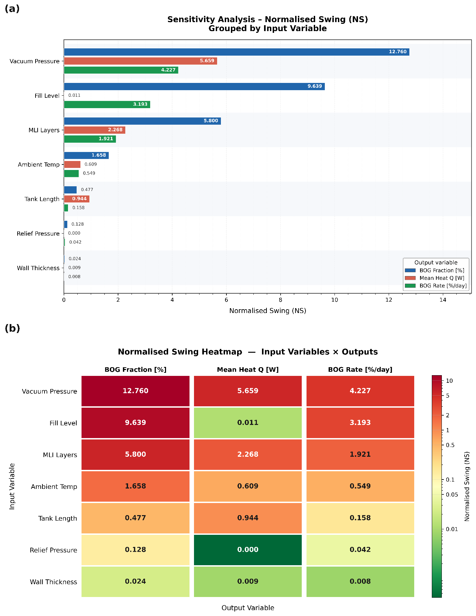
Figure 17 Normalized Swing – Bar Chart and Heat Map
Ambient temperature and cylindrical length of tank show moderate to weak effects, while relief pressure and tank’s wall thickness remain the least sensitive parameters overall. Overall, these results establish a clear ranking of design importance where vacuum pressure is the most critical and influential variable, followed by the fill level and the total MLI layer count. Whereas the ambient temperature and the cylindrical length of the tank influence moderately, and relief pressure and the tank’s wall thickness play minor roles in the boil-off response of the LH₂ storage tank. This sensitivity analysis shows that the proposed model captures both the dominant physics and the practical design trade-offs governing LH₂ storage performance.

Conclusion
This study developed a layer-resolved heat transfer model integrated with a two-phase thermodynamic BOG prediction model for an LH₂ storage tank. It also presents a comprehensive parametric analysis and NS-based variable ranking. The following conclusions are drawn:
- The layer-resolved heat transfer model, validated against NASA experimental data, shows a mean absolute percentage error of 3.46% (RMSE 4.40%, maximum absolute error 7.28%) and accurately captures the heat transfer through MLI. This model is then integrated with a BOG prediction model, which is validated against BoilFast results with a deviation of <4.4%. Coupling this model dynamically removes the fixed heat transfer limitation found in existing BOG prediction frameworks.
- At nominal conditions, the model predicts an average BOG rate of 0.1064%/day at an average het flux of 0.371 W/m², consistent with published data for well-insulated LH₂ tanks in this size range.
- Vacuum/residual gas pressure is the single most influential design variable with an NS index of 12.76 on BOG fraction. Progressive vacuum degradation from the newly commissioned state to severe failure drives the BOG fraction from 10% to 50% in a 90-day storage run.
- Fill level, which governs the partitioning of heat between liquid and vapor phases, and MLI layer count, the principal design variable for insulation, both play a critical role in driving BOG dynamics.
- Ambient temperature and the cylindrical tank’s length influence the BOG dynamics moderately, while relief pressure and wall thickness are the least sensitive variables in the sweep.
The model currently assumes a saturated-liquid initial state, while subcooled charging and other initialization approaches can also be performed using this exact framework. Two limitations and paths for future work have been identified: the coupled framework was validated component rather than measured via a single experiment; a combined experimental campaign remains outstanding. The safety contribution of this study is the quantification of BOG-driven self-pressurization severity as a function of vacuum degradation, while consequence modelling, relief-system sizing, and risk assessment are outside the scope of this framework and would require a dedicated study.
Future studies should also focus on optimizing the design variables for minimum LCOH, incorporating active cooling techniques, integrating ortho/parahydrogen conversion during storage into the BOG dynamics, and performing CFD studies for multi-node thermal stratification.

Conflicts of interest
The authors declare no competing financial interest.

Acknowledgement
This research was conducted as part of the UK Clean Maritime Research (UK-MaRes) Hub, and gratefully acknowledge funding from the UK Department for Transport (DfT) through the UK Shipping Office for Reducing Emissions (UK SHORE) Programme, and from the Engineering and Physical Sciences Research Council (EPSRC) [grant number EP/Y024605/1].

References
[1] Ravichandran K, Cavaliere PD. Seasonal analysis of boil-off gas rates in liquid hydrogen storage tank using time-series analysis. Int J Hydrogen Energy 2025;128:725–31. https://doi.org/10.1016/j.ijhydene.2025.04.275.
[2] Tamburini F, Kluge M, Habib AK, Ustolin F, Cozzani V, Paltrinieri N. Exploring experimental tests concerning liquid hydrogen releases. Process Safety and Environmental Protection 2024;192:1330–43. https://doi.org/10.1016/J.PSEP.2024.11.014.
[3] Claussner LM, Scarponi GE, Manzi A, Ustolin F. Investigation of liquid hydrogen tank no-vent filling operations. Process Safety and Environmental Protection 2026;212:108851. https://doi.org/10.1016/J.PSEP.2026.108851.
[4] Claussner LM, Scarponi GE, Ustolin F. Thermo-Fluid Dynamics Modelling of Liquid Hydrogen Storage and Transfer Processes. Hydrogen (Switzerland) 2025;6. https://doi.org/10.3390/hydrogen6040122.
[5] Zhang T, Uratani J, Huang Y, Xu L, Griffiths S, Ding Y. Hydrogen liquefaction and storage: Recent progress and perspectives. Renewable and Sustainable Energy Reviews 2023;176. https://doi.org/10.1016/j.rser.2023.113204.
[6] Amos WA. Costs of Storing and Transporting Hydrogen. n.d.
[7] Wesley Louis Johnson. THERMAL PERFORMANCE OF CRYOGENIC MULTILAYER INSULATION AT VARIOUS LAYER SPACINGS. 2007.
[8] Notardonato WU, Swanger AM, Fesmire JE, Jumper KM, Johnson WL, Tomsik TM. Zero Boil-Off Methods for Large Scale Liquid Hydrogen Tanks using Integrated Refrigeration and Storage. n.d.
[9] Choi M, Jung W, Lee S, Joung T, Chang D. Thermal efficiency and economics of a boil-off hydrogen re-liquefaction system considering the energy efficiency design index for liquid hydrogen carriers. Energies (Basel) 2021;14. https://doi.org/10.3390/en14154566.
[10] Lee TY, Kim JS. Insulation Performance of Vacuum-MLI Cavity Under Varying Residual Gas Pressure: Analytical Study and Application to Liquid Hydrogen System. Energies (Basel) 2026;19. https://doi.org/10.3390/en19051184.
[11] Alam Towhid MS, Hossain SB. Advances and challenges in cryogenic liquefied hydrogen (LH2) maritime transportation: Thermal performance, tank design, boil-off gas management, and techno-economic considerations. Renewable and Sustainable Energy Reviews 2026;233:116850. https://doi.org/10.1016/J.RSER.2026.116850.
[12] Kim MS, Kim M-S, Lee JH. Prediction of boil-off gas in cryogenic tanks using a multi-zone thermodynamic model: filling height effects. Cryogenics (Guildf) 2025:104256. https://doi.org/10.1016/j.cryogenics.2025.104256.
[13] Lu J, Chen L, Zhou X. Thermodynamic Modeling of Multilayer Insulation Schemes Coupling Liquid Nitrogen Cooled Shield and Vapour Hydrogen Cooled Shield for LH2 Tank. Processes 2025;13. https://doi.org/10.3390/pr13082574.
[14] Camplese D, Scarponi GE, Chianese C, Hajhariri A, Eberwein R, Otremba F, et al. Modeling the performance of multilayer insulation in cryogenic tanks undergoing external fire scenarios. Process Safety and Environmental Protection 2024;186:1169–82. https://doi.org/10.1016/J.PSEP.2024.04.061.
[15] Adler EJ, Martins JRRA. Liquid Hydrogen Tank Boil-off Model for Design and Optimization. J Thermophys Heat Trans 2025;39:505–19. https://doi.org/10.2514/1.T7005.
[16] Wang J, Alkhaledi AN, Hughes TJ, Webley PA. Technoeconomic investigation of optimal storage pressure and boil-off gas utilisation in large liquid hydrogen carriers. Appl Energy 2025;384. https://doi.org/10.1016/j.apenergy.2025.125356.
[17] Marlow WA. Design of Multilayer Insulation for the Multipurpose Hydrogen Test Bed. n.d.
[18] Al Ghafri SZS, Swanger A, Jusko V, Siahvashi A, Perez F, Johns ML, et al. Modelling of Liquid Hydrogen Boil‐Off. Energies (Basel) 2022;15. https://doi.org/10.3390/en15031149.
[19] Majumdar A, Valenzuela J, Leclair A, Moder J. Numerical modeling of self-pressurization and pressure control by a thermodynamic vent system in a cryogenic tank. Cryogenics (Guildf) 2016;74:113–22. https://doi.org/10.1016/j.cryogenics.2015.12.001.
[20] Stewart MEM, Moder JP. Self-Pressurization of a Flightweight, Liquid Hydrogen Tank: Simulation and Comparison with Experiments. n.d.
[21] Rahman AA, Wang B, Yu J, Gao Y, He Y, Jin T, et al. Machine learning approaches for the prediction of thermal performance of multilayer insulation materials at low temperatures. Appl Therm Eng 2025;264:125527. https://doi.org/10.1016/J.APPLTHERMALENG.2025.125527.
[22] Kim MS, Lee JH. Prediction of Boil-Off Gas in Cryogenic Tanks with a Coupled Thermal Resistance and Thermodynamic Model. Processes 2025;13. https://doi.org/10.3390/pr13113584.
[23] Wang B, Luo R, Chen H, Zheng C, Gao Y, Wang H, et al. Characterization and monitoring of vacuum pressure of tank containers with multilayer insulation for cryogenic clean fuels storage and transportation. Appl Therm Eng 2021;187. https://doi.org/10.1016/j.applthermaleng.2021.116569.
[24] Yin L, Yang H, Ju Y. Review on the key technologies and future development of insulation structure for liquid hydrogen storage tanks. Int J Hydrogen Energy 2024;57:1302–15. https://doi.org/10.1016/J.IJHYDENE.2024.01.093.
[25] Yu C, Choi M, Chang D. Economic analysis of cargo containment systems and boil-off hydrogen handling options for large-scale liquid hydrogen carriers considering insulation-layer thickness of liquid-hydrogen storage tank. Int J Hydrogen Energy 2025;97:1055–67. https://doi.org/10.1016/J.IJHYDENE.2024.11.334.
[26] Lemmon EW, Bell IH, Huber ML, Mclinden MO. REFPROP Documentation Release 10.0. 2018.
[27] Huber ML, Lemmon EW, Bell IH, McLinden MO. The NIST REFPROP Database for Highly Accurate Properties of Industrially Important Fluids. Ind Eng Chem Res 2022;61:15449–72. https://doi.org/10.1021/acs.iecr.2c01427.
[28] Riaz A, Naquash A, Qyyum MA. Simulation-based thermodynamic analysis of hydrogen liquefaction processes: Design implications and limitations. Energy Convers Manag 2026;347. https://doi.org/10.1016/j.enconman.2025.120542.
[29] Song W, Liu K, Zhao Z, Zhang L, Dong X, Yang X, et al. Simulation and Analysis of a Novel Hydrogen Liquefaction Process Based on the Liquid Nitrogen and Helium Joule-Brayton Cycle. ACS Omega 2025;10:8089–102. https://doi.org/10.1021/acsomega.4c09299.
[30] Corpening JH. ANALYTIC MODELING OF PRESSURIZATION AND CRYOGENIC PROPELLANT CONDITIONS FOR LIQUID ROCKET BASED VEHICLE DESIGNS. n.d.
[31] Kartuzova O, Kassemi M, Agui J, Moder J. Self-pressurization and spray cooling simulations of the multipurpose hydrogen test bed (MHTB) ground-based experiment. 50th AIAA/ASME/SAE/ASEE Joint Propulsion Conference 2014, American Institute of Aeronautics and Astronautics Inc.; 2014. https://doi.org/10.2514/6.2014-3578.
[32] Gursu S, Sherif SA, Veziroglu TN, Sheffield JW. Analysis and optimization of thermal stratification and self- pressurization effects in liquid hydrogen storage systems part 1: Model development. Journal of Energy Resources Technology, Transactions of the ASME 1993;115:221–7. https://doi.org/10.1115/1.2905997.
[33] S C, Richardson. Flow, Fluid Transfer, Heat Transfer, Mass n.d.
[34] R. K. Rajput. Heat & Mass Transfer 2012:1–903.
[35] Kern DQ. Process Heat Transfer n.d.
[36] Van Drew NT, Lin CS, Hasan MM. SELF-PRESSURIZATION OF A FLIGHTWEIGHT LIQUID HYDROGEN TANK: EFFECTS OF FILL LEVEL AT LOW WALL HEAT FXUX. n.d.
[37] Houchins C, James BD. Hydrogen Storage Cost Analysis. 2022.
[38] Houchins C, Prosser JH, Graham M, Watts Z, James BD. Hydrogen Storage Cost Analysis. 2023.
[39] Peters MS, Timmerhaus KD. Plant Design and Economics for Chemical Engineers. n.d. https://doi.org/10.1201/9780429487040-2.
[40] Bracci J, Koleva M, Chung M. Levelized Cost of Dispensed Hydrogen for Heavy-Duty Vehicles. 2024.
[41] Connelly E, Penev M, Elgowainy A, Hunter Peer Reviewed By C, Burgunder A, Martinez A, et al. DOE Hydrogen and Fuel Cells Program Record Title: Current Status of Hydrogen Liquefaction Costs. 1900.
[42] Yasir M, Haider J, Saeed S, Amanipour M, Roskilly T. Integrated rotating packed bed reactor design for post combustion carbon capture: Parametric analysis, optimization and economic viability. Sep Purif Technol 2026;386. https://doi.org/10.1016/j.seppur.2025.136584.
[43] Spond DE, Laintz DJ, Hall CA, Dulaigh DE, Corporation MM, Notardonato J. Vacuum Jacketed Composite Propulsion Feedlines for Cryogenic Launch and Space Vehicles Contract NAS3-16762. n.d.
[44] Lazard’s Levelized Cost of Hydrogen Analysis-Executive Summary Overview of Analysis. 2021.
[45] GREEN HYDROGEN COST REDUCTION SCALING UP ELECTROLYSERS TO MEET THE 1.5°C CLIMATE GOAL H 2 O 2. 2020.
[46] Stochl RJ. BASIC PERFORMANCE OF A MULTILAYER INSULATION SYSTEM CONTAINING 20 T O 160 LAYERS. n.d.
[47] Aydelott JC. NORMAL GRAVITY SELF-PRESSURIZATION OF 9-INCH-(23 CM) DIAMETER SPHERICAL LIQUID HYDROGEN TANKAGE. n.d.
[48] Martin JJ, Marshall LH. Large-Scale Liquid Hydrogen Testing of a Variable Density Multilayer Insulation With a Foam Substrate. n.d.
[49] Hastings LJ, Bryant CB, Flachbart RH, Holt KA, Johnson E, Hedayat A, et al. Large-Scale Demonstration of Liquid Hydrogen Storage With Zero Boiloff for In-Space Applications. 2010.
[50] Ding Y, Shao D, Jin S, Yu M, Wang Y, Jiang L. Numerical Study on Composite Multilayer Insulation Material for Liquid Hydrogen Storage. Coatings 2024;14. https://doi.org/10.3390/coatings14111417.
[51] Blaylock M, Pratt J, Bran-Anleau G, Proctor C. SANDIA REPORT INFORMING HAZARDOUS ZONES FOR ON-BOARD MARITIME HYDROGEN LIQUID AND GAS SYSTEMS. n.d.
[52] Aziz M. Liquid hydrogen: A review on liquefaction, storage, transportation, and safety. Energies (Basel) 2021;14. https://doi.org/10.3390/en14185917.
[53] Lee DH, Cha SJ, Kim JD, Kim JH, Kim SK, Lee JM. Practical prediction of the boil-off rate of independent-type storage tanks. J Mar Sci Eng 2021;9:1–15. https://doi.org/10.3390/jmse9010036.
[54] Khan MS, Qyyum MA, Ali W, Wazwaz A, Ansari KB, Lee M. Energy saving through efficient BOG prediction and impact of static boil-off-rate in full containment-type LNG storage tank. Energies (Basel) 2020;13. https://doi.org/10.3390/en13215578.

Abbreviations and Acronyms
Abbreviation | Definition
BOG | Boil-off Gas
BOR | Boil-off Rate
CAPEX | Capital Expenditure
CFD | Computational Fluid Dynamics
CRF | Capital Recovery Factor
DOE | Department of Energy
EPC | Engineering, Procurement, and Commissioning
LCOH | Levelized Cost of Hydrogen
LSCOH | Levelized Shipping Cost of Hydrogen
LCOE | Levelized Cost of Electricity
LH₂ | Liquid Hydrogen
LN₂ | Liquid Nitrogen
LNG | Liquefied Natural Gas
MLI | Multi-layer Insulation
NASA | National Aeronautics and Space Administration
NS | Normalised Swing
O&M | Operations and Maintenance
OPEX | Operational Expenditure
SA/V | Surface Area-to-Volume Ratio
SMR | Steam Methane Reforming
SVR | Support Vector Regression
VCS | Vapour-Cooled Shield

Nomenclature
A_{L} | Wetted (liquid-side) wall area | m²
A_{s} | Total inner surface area of tank | m²
A_{v} | Vapour-side wall area | m²
A_{vl} | Vapour–liquid interface area | m²
C_{annualized CAPEX} | Annualised capital expenditure | $/yr
C_{BOG} | Annual cost of hydrogen lost to boil-off | $/yr
C_{bop} | Balance of plant cost | $
C_{CAPEX} | Total capital expenditure | $
C_{civil} | Civil and site cost | $
C_{epc} | Engineering, procurement, and commissioning cost | $
C_{MLI} | Total MLI cost (material + labour) | $
C_{MLI,mat} | MLI material cost | $
C_{OM} | Annual operations and maintenance cost | $/yr
C_{OPEX} | Total annual operational expenditure | $/yr
C_{ref} | Reference vessel cost | $
C_{s} | Empirical spacer conduction constant (0.008) | –
C_{VAC-OM} | Annualised vacuum maintenance cost | $/yr
C_{vessel} | Pressure vessel cost | $
c_{layer} | MLI material cost per layer per unit area | $/m²/layer
CRF | Capital recovery factor | –
d_{in} | Inner diameter (node inner surface) | m
d_{out} | Outer diameter (node outer surface) | m
f_{A} | Wetted area fraction | –
f_{bop} | Balance of plant cost factor | –
f_{civ} | Civil and site cost factor | –
f_{cont} | Contingency cost factor | –
f_{epc} | EPC cost factor | –
f_{lab} | Labour cost factor for MLI installation | –
f_{om} | O&M cost factor | –
f_{sp} | Spacer relative density | –
H_{L} | Enthalpy of liquid phase | J
H_{V} | Enthalpy of vapour phase | J
h_{boil} | Latent heat carried by the boil-off stream, λ(T_{L}) | J/kg
h_{V} | Specific enthalpy of vented vapour | J/kg
h_{vl} | Vapour–liquid interfacial heat transfer coefficient | W/m²K
i | Discount rate | –
k | Thermal conductivity (tank wall) | W/mK
k_{sp} | Spacer material thermal conductivity | W/mK
LCOH | Levelised cost of hydrogen (storage contribution) | $/kg
L | Cylindrical section length | m
M_{g} | Molar mass of residual gas | kg/mol
ṁ_{BOG} | Boil-off gas mass flow rate | kg/s
ṁ_{H₂} | Hydrogen mass flow rate delivered | kg/s
n | Asset lifetime | yr
n_{boil} | Molar boil-off rate | mol/s
n_{relief} | Molar relief venting rate | mol/s
N | Total number of MLI layers | –
p | Residual gas pressure in vacuum annulus | Pa
P_{H₂} | Hydrogen price | $/kg
P_{r} | Relief pressure | atm
Q | Total heat ingress rate | W
Q_{gas},_{cyl} | Residual gas conduction - cylindrical section | W
Q_{gas},_{sph} | Residual gas conduction - spherical ends | W
Q_{ingress},_{cyl} | Total heat ingress - cylindrical section | W
Q_{ingress},_{sph} | Total heat ingress - spherical ends | W
Q_{L} | Heat rate to the liquid phase | W
Q_{mli},_{cyl} | Total MLI heat transfer - cylindrical section | W
Q_{mli},_{sph} | Total MLI heat transfer - spherical ends | W
Q_{rad},_{cyl} | Radiative heat transfer - cylindrical section | W
Q_{rad},_{sph} | Radiative heat transfer - spherical ends | W
Q_{solid},_{cyl} | Solid conduction - cylindrical section | W
Q_{solid},_{sph} | Solid conduction - spherical ends | W
Q_{v} | Heat rate to the vapour phase | W
Q_{vac},_{cyl} | Vacuum interlayer heat transfer - cylindrical | W
Q_{vac},_{sph} | Vacuum interlayer heat transfer - spherical | W
Q_{VL} | Vapour–liquid interfacial heat transfer rate | W
Q_{wall},_{cyl} | Wall conduction - cylindrical section | W
Q_{wall},_{sph} | Wall conduction - spherical ends | W
R | Universal gas constant | J/mol·K
r_{in} | Inner radius (node inner surface) | m
r_{out} | Outer radius (node outer surface) | m
T_{amb} | Ambient temperature | K
T_{cold} | Area-weighted cold-side temperature | K
T_{in} | Temperature at inner node | K
T_{L} | Liquid hydrogen temperature | K
T_{out} | Temperature at outer node | K
T_{r} | Saturation temperature at relief pressure | K
T_{V} | Vapour hydrogen temperature | K
V_{ref} | Reference vessel volume | m³
V_{t} | Total tank volume | m³
α | Thermal accommodation coefficient (0.9) | –
γ | Ratio of heat capacities, Cp/Cv, of residual gas | –
ε_{in} | Emissivity of inner MLI layer surface | –
ε_{out} | Emissivity of outer MLI layer surface | –
λ | Latent heat of vaporization at T_{L} | J/kg
σ | Stefan–Boltzmann constant | W/m²K⁴

