Electropolishing of surfaces in metallic parts obtained by Additive Manufacturing

P. Rodriguez¹, F. Ruiz², J. Dillard³, P. Tyagi⁴
^{1,2}Escuela de Ingeniería Industrial, University of Leon, 24071 Leon, Spain
^{3,4}Department of Mechanical Engineering, University of the District of Columbia, Washington, DC, 20008, USA

Abstract. In this paper a study of the process of Electropolishing (EP) to be applied to metallic parts obtained by Additive Manufacturing is presented. The roughness of parts obtained by Additive Manufacturing is not acceptable in many applications and consequently they require a postprocessing stage to improve the surface roughness of these parts. If the material hardness is very high, like in Stainless Steels, the process of mechanical grinding is not suitable, since there is an important wear in the tool and residual stresses can be generated in the part. EP is a process in which the roughness required is obtained without tool-part contact. The conditions for this process in 17-4PH and 316 Stainless Steel parts with a Tungsten or Lead electrode are worked out in order to achieve a fast and effective smoothing process. DC voltage and an electrolyte of H₃PO₄ and H₂SO₄ are used between the tool, which acts as the cathode, and the part, which is the anode. A micropositioning system is used to set the interelectrode gap to the optimum value. Decrease in roughness R_{a} from 12 μm to values about 3 μm with this process was achieved.
Keywords: Electropolishing, Additive Manufacturing, Electrochemical Machining, optimization of parameters

Introduction
Additive manufacturing (AM) technologies are rapidly changing from an exciting way of making physical prototypes of a CAD model to an actual manufacturing process for developing products and production tools. This generates an interest among researchers in industry and academia to study the accuracy and reliability in the AM production. One of the key issues, that needs significant improvement in today’s AM processes, is the surface texture and integrity. In most of AM processes, including fused deposition modelling (FDM), the surface quality is drastically affected by the layer-based manufacturing nature of the process. As a result, the estimation and control of the surface roughness of the FDM products are two considerable challenges [1]. The functionality of AM parts is highly dependable on their geometric and dimensional accuracy, as well as their surface integrity.
The weak surface integrity of additive manufactured parts has been recognized as one of the major concerns in employing these technologies in the manufacturing and production systems. Ippolito et al. in one of the earliest papers published in this field expressed this concern and benchmarked various AM technologies for their products’ dimensional accuracy and surface finish [2]. The surface roughness achieved by AM is in the order of 5-50 μm for the parameter of R_{a}, depending on the inclination of the surface respect the plane of the layers deposited by the machine and the post-polishing of the workpiece [3].
Electropolishing is a promising process to reduce the surface roughness of the parts obtained by AM. It consists in immersing the workpiece in acidic solution with an electrode which acts as the cathode and it is placed at a short distance from the workpiece. By setting a voltage between the part and the electrode, current passes through the electrolyte by which the material of the part is removed by anodic dissolution. The peaks of the surface are more exposed to the dissolution and they are dissolved more quickly than the valleys. Therefore, there will be a levelling effect which causes polishing. The great advantage of this process, as compared to mechanical polishing, is that there is no contact between the tool and the part. Hence there will be no wear of the tool nor residual stress in the surface of the workpiece. Since EP involves no mechanical or thermal impact, small and mechanically fragile parts can be treated. EP can be applied to parts of almost any shape or size [4].
In addition, EP causes beneficial influence on the slowing down the corrosion processes because of the formation of a protective passive oxide layer. Since corrosion resistance, except for noble metals, relies rather on protective oxide films than on inherent inertness, surface oxide film formation of great importance for some metals. During EP, the simultaneous surface dissolution and brightening effect could generate smooth mirror-like surface. In this way the deleterious influence of surface defects, microstructural variations and preferred crystallographic orientations on the electrochemical properties and biological response could also be minimized. It is therefore considered that EP of stainless steel implants could be an effective method to improve corrosion resistance, biocompatibility and service longevity [5]. Since the surface quality of biomedical devices may determine the mechanical properties and corrosion behavior, the EP method is widely used for the final surface treatment, especially for the coronary stent, because of the smooth surface and improved corrosion resistance by a passive oxide layer on the polished surface. Due to the high quality of the surface obtained by EP, high effectiveness of polishing and possibility of processing multiple work-pieces simultaneously, EP has been recommended for the manufacture of hip joint prostheses [6].
In this work EP process was tested to reduce the roughness of surfaces of 17-4PH and 316 steel AM components. For this study, we focused on four factors: electropolishing time, temperature, agitation, and electrolyte composition [7,8]. Optimum EP parameters were determined based on prior studies [9,10].
- Experimental setup
The equipment for the experiments rests on an anti-vibration table TMC, which provides a floating bench that keeps the tool and the part from oscillations. The position of the recipient is controlled by a three-dimensional nanometric positioning system PI-Micos based on a piezoelectric technology and with a resolution of 1 nm.
The electrode and the sheet are connected to a DC Power Source Keytheley 2220G-30-1 which provides a current limiting system, so the intensity of the process can be controlled. The electrochemical process is observed by means of a Supereyes USB Portable Digital Miroscope B008 connected to a computer in which the amplified image of the tool and the area of the part being machined can be seen. This microscope is also helpful to set the approach the tool to the workpiece in order to set the reference of distance. In order to observe and measure the dimensions of the features machined, as well as the tip of the tools, a Scanning Electron Microscope and an Optic Microscope were used. The reference of the position of the tool is taken in the point of value 0 for the IEG, which corresponds to the contact between the electrode and the part.
Two sets of parameters have been used for the experiments. In one of them, the workpiece was a cube of 17-4PH Stainless Steel with dimensions 10 x 10 x 10 mm, obtained by AM of metallic powder through the Selective Laser Melting strategy. Figure 1 shows the workpiece used for the experiments. The electrode was a sheet of 304 Stainless Steel with an area of 10 x 10 mm and 1 mm thickness. A picture of the electrolytic cell is shown in Figure 2. A system for recirculating the electrolyte was used, making it flow constantly through the cell to a tank from which it is pumped to the cell after passing through a filter. Thus, the particles that appear in the cell are constantly being removed from the electrolyte. Experiments were performed in an electrolyte consisting in a mixture of phosphoric acid and sulfuric acid in a 3:1 proportion.
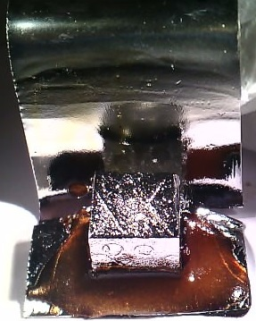
Fig. 1. Stainless steel cube used for the experiments with Stainless Steel as the cathode

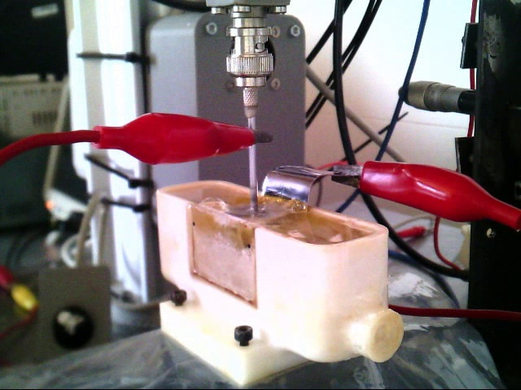
Fig. 2. Electrochemical cell used for experiments
In the other set of conditions, the electrolyte solution consisted of 85% phosphoric acid and 15% sulfuric acid. The process was conducted at 75 ± 2 ̊ C. Lead metal was used as the counter electrode. The surface area of the lead counter electrode was maintained to be higher than the AM sample surface area. The solution was agitated by rotating a magnetic stirrer at 200 rpm to avoid the agglomeration of the etching product near the AM sample surface. During electropolishing, a 60 A/dm² current was maintained for 30 min. The workpiece used for the experiments is shown in Figure 3.
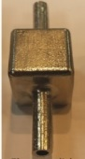
Fig. 3. Stainless steel cube used for the experiments with Lead as the cathode
To investigate the impact of electropolishing on the surface properties and microstructure we conducted optical profilometry with a Filmetrics Profilm3D® optical profilometer. This device utilized the white light interferometry to measure surface profiles and roughness. The profilometer’s software could measure surface properties with the ISO25718 standard. For the quantitative analysis, the R_{a} parameter was used, since it is considered to be the key roughness parameter.
- Results and Discussion
The electropolished sample showed a highly rough textured internal surface (Fig. 4). The pattern of the hexagonal lattice for printing the part can be seen. The typical R_{a} roughness of the as produced AM component, before abrasive blasting, was above 20 μm.
Fig. 4. Surface of the workpiece as produced
EP works on the principle of Faraday’s laws of electrolysis [11]. The process consists in applying a potential difference between the tool and the workpiece so that an electrochemical reaction arises that removes material from the workpiece. The metal is detached atom by atom from the anode surface and appears in the electrolyte as ions (Fe²⁺). These ions give place to the precipitate of ferrous hydroxide Fe(OH)₂. Simultaneously, the hydrolysis causes the molecules of water gain electrons from the cathode and they separate into free hydrogen gas and hydroxyl ion [12]. The reactions can be summarized in the following equations:
$Fe→{Fe}^{2+}+2e^{-}$ (1)
$2H_{2}O+2e^{-}→H_{2}↑+2{OH}^{-}$ (2)
${Fe}^{2+}+2{OH}^{-}→Fe{\left(OH\right)}_{2}$ (3)
Material removal rate is a crucial variable in machining, since it determines the productivity of the process. This variable depends on the overpotential η, according to the Butler-Volmer equation:
$i=i_{0}\left[e^{\left(1-β\right){ηF}/{RT}}-e^{-β{ηF}/{RT}}\right]$ (4)
Where i is the current density, i₀ the equilibrium exchange current density, β the symmetry factor of the reaction, F Faraday’s constant (96500 C), η the overpotential, R the ideal gas constant and T the temperature in K. So, the amplitude of the voltage signal determines the current intensity. Nevertheless, as the voltage signal applied to the cell consists in pulses, what determines MRR is the mean value of the current, according to Faraday’s law of electrolysis:
$MRR=\dot{m}=\frac{A∙I}{Z∙F}$ (5)
Where A is the gram atomic weight, Z is the valence of dissolution, F is Faraday’s constant and I is the average current.
The way of attaining the best results in EP is to work in the limiting current plateau of the polarization curve, in which the speed of the process is limited by a passive oxide layer generated on the surface of the workpiece. In this way a moderate process is carried out and the material removal is optimum to obtain a smooth mirror-like surface.
  - Steel Electrode
A measurement of the evolution of the current intensity with the voltage was taken in order to obtain the polarization curve of the process, shown in Figure 5.
After several attempts of working in the limiting current plateau, it was observed that the best results were achieved with a voltage value of 20 V, which causes a current intensity of about 200 mA. The EP process has to be carried out for approximately 30 minutes. In these conditions, a value of 592 nm for R_{a} is achieved, which makes the parts suitable to be used in very demanding applications, as biomechanical implants. As it can be seen in Figure 6, a mirror-like surface is obtained.

Fig. 5. Polarization curve of the process carried out with Stainless Steel as the cathode
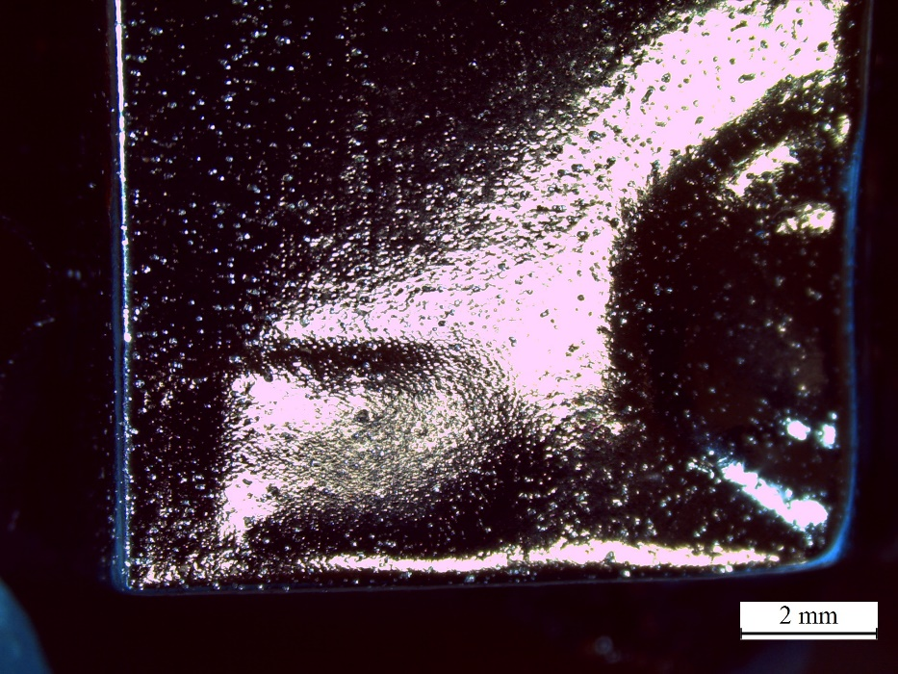
Fig. 6. Surface of the workpiece after electropolishing with Stainless Steel as the cathode
From the roughness measurements made with the profilometer shown in Figure 7 it can be observed that, besides the low values of punctual roughness indicated by the parameter R_{a}, there are very small differents in the profile of the different segments of the workpiece taken for measurements. Hence, there is not only absence of short wavelength roughness, but also of long wavelength roughness.
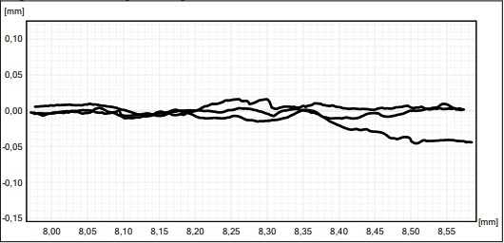
Fig. 7. Profile of the 3 segments measured on the surface of the polished part
  - Lead Electrode
To gain further insight into the difference in surface morphologies, SEM study on the 316 steel samples in the various stages was performed. An unpolished surface possessed irregular features, exhibiting a significant difference in high and low points on the surface (Fig. 8a). EP appears to yield a smooth texture containing sporadic holes or cavities (Fig. 8b). It is worth noticing that sub-microscopic regions are faintly seen in Fig. 8b.
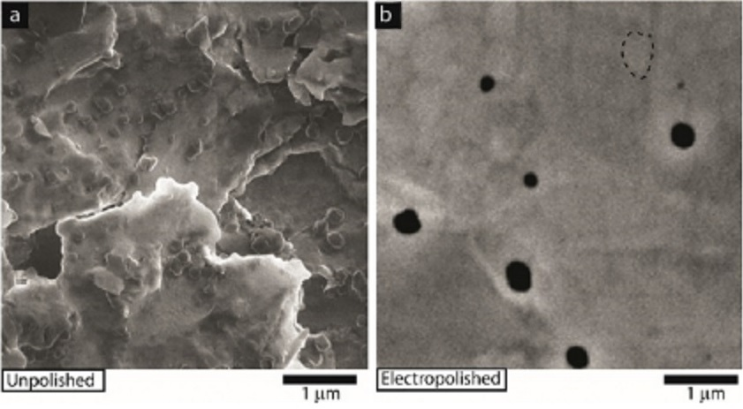
Fig. 8. SEM study of (a) unpolished and and (b) electropolished AM sample surfaces. Area encircled by dashed line highlight the faint sub-microscopic regions.
To further investigate the difference in surface morphology of the electropolished samples 3D images were reconstructed by integrating SEM images collected at various focus distances. Data for Fig. 9 were collected from the central regions of the top square face of the electropolished AM sample shown in Fig. 3. The electropolished AM sample produced a flat surface. In addition to optical profilometry, SEM data were used to study the surface roughness. Electropolished AM sample showed a smooth surface texture. The R_{a} surface roughness parameter for the electropolished AM sample was 48 nm. The SEM study provides clear evidence that electropolishing produced remarkably smooth surface morphology. An understanding of the surface energies of AM components is critical for realizing high adhesion properties between desired coating materials and electropolished AM components.
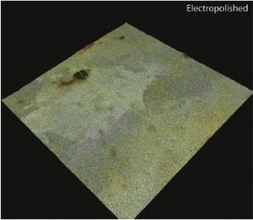
Fig. 9. 3D images reconstructed from the SEM data on electropolished AM sample
- Conclusions
This paper produced insight into the finishing of AM steel components by means of Electropolishing. Very good results have been achieved by this process in order to reduce surface roughness on the parts, which make them suitable to be used in many applications, as for biomechanical implants. An unpolished AM component surface was covered with irregular shaped ∼100 μm high hills and valleys. These irregular features make an unpolished AM product prone to surface sensitive failure modes. Hence a significant improvement in surface sensitive mechanical properties is expected after the surface finishing method discussed in this paper. Two set of conditions were used for carrying out the process: one with Stainless Steel as the anode and the other one with lead. Both of them achieve smooth surface on the workpiece, but the process with lead gives lower R_{a} values. The difference in surface morphology due to surface finishing processes must be considered before selecting a surface finishing approach in the context of the specific application involving various types of mechanical loadings and stresses. The surface finishing approach discussed in this paper leaves some microscopic cavities (Fig. 8) and produced sub-μm deep cavities that occupied nearly 1.3% of the surface area. A future work will focus on conducting tensile, fatigue, creep and toughness testing to investigate the effect of surface finishing methods on the mechanical properties of the AM samples. Also, surface finishing may impact other useful properties such as corrosion, wear, and adhesion of desired coatings on the AM components. Researchers are actively attempting to produce various coatings on the surface of AM components. The surface finishing method discussed here can yield specific surface morphologies that may impact the adhesion of coatings and films on the AM components.
Acknowledgements
This work is in part supported by the Department of Energy’s Kansas City National Security Campus. The Department of Energy’s Kansas City National Security Campus is operated and managed by Honeywell Federal Manufacturing & Technologies, LLC under contract number DE-NA0002839. We also acknowledge experimental facility support from the Center of Nanoscience and Technology at NIST, Gaithersberg.

References
[1] A. Barari, H.A. Kishawy, F. Kaji, M.A. Elbestawi, On the surface quality of additive manufactured parts, Int. J. Adv. Manuf. Technol. 89 (2017) 1969–1974. https://doi.org/10.1007/s00170-016-9215-y.
[2] R. Ippolito, L. Iuliano, A. Gatto, Benchmarking of Rapid Prototyping Techniques in Terms of Dimensional Accuracy and Surface Finish, CIRP Ann. 44 (1995) 157–160. https://doi.org/10.1016/S0007-8506(07)62296-3.
[3] A. Triantaphyllou, C.L. Giusca, G.D. Macaulay, F. Roerig, M. Hoebel, R.K. Leach, B. Tomita, K.A. Milne, Surface texture measurement for additive manufacturing, Surf. Topogr. Metrol. Prop. 3 (2015). https://doi.org/10.1088/2051-672X/3/2/024002.
[4] D. Landolt, P.F. Chauvy, O. Zinger, Electrochemical micromachining, polishing and surface structuring of metals: Fundamental aspects and new developments, Electrochim. Acta. 48 (2003) 3185–3201. https://doi.org/10.1016/S0013-4686(03)00368-2.
[5] Z. ur Rahman, K.M. Deen, L. Cano, W. Haider, The effects of parametric changes in electropolishing process on surface properties of 316L stainless steel, Appl. Surf. Sci. 410 (2017) 432–444. https://doi.org/10.1016/j.apsusc.2017.03.081.
[6] A.M. Awad, E.A. Ghazy, S.A. Abo El-Enin, M.G. Mahmoud, Electropolishing of AISI-304 stainless steel for protection against SRB biofilm, Surf. Coatings Technol. 206 (2012) 3165–3172. https://doi.org/10.1016/j.surfcoat.2011.11.046.
[7] F. Nazneen, P. Galvin, D.W.M. Arrigan, M. Thompson, P. Benvenuto, G. Herzog, Electropolishing of medical-grade stainless steel in preparation for surface nano-texturing, J. Solid State Electrochem. 16 (2012) 1389–1397. https://doi.org/10.1007/s10008-011-1539-9.
[8] T. Hryniewicz, K. Rokosz, R. Rokicki, Electrochemical and XPS studies of AISI 316L stainless steel after electropolishing in a magnetic field, Corros. Sci. 50 (2008) 2676–2681. https://doi.org/https://doi.org/10.1016/j.corsci.2008.06.048.
[9] S. Habibzadeh, L. Li, D. Shum-Tim, E.C. Davis, S. Omanovic, Electrochemical polishing as a 316L stainless steel surface treatment method: Towards the improvement of biocompatibility, Corros. Sci. 87 (2014) 89–100. https://doi.org/https://doi.org/10.1016/j.corsci.2014.06.010.
[10] C. Rotty, M.L. Doche, A. Mandroyan, J.Y. Hihn, G. Montavon, V. Moutarlier, Comparison of electropolishing behaviours of TSC, ALM and cast 316L stainless steel in H3PO4/H2SO4, Surfaces and Interfaces. 6 (2017) 170–176. https://doi.org/10.1016/j.surfin.2017.01.008.
[11] A.J. Bard, L.R. Faulkner, ELECTROCHEMICAL METHODS: Fundamentals and applications, 2001. https://doi.org/10.1146/annurev.matsci.30.1.117.
[12] J.P. Davim, Machining. Fundamentals and Recent Advances, Springer, London, 2008.

