Simulation of cavitation effects in blister-assisted laser-induced forward transfer of fluids
J. Moreno-Labella, D. Munoz-Martin, M. Morales, A. Márquez, C. Molpeceres
Centro Láser, Universidad Politécnica de Madrid, Alan Turing 1, 28038, Madrid, Spain
juanjose.moreno.labella@upm.es, david.munoz@upm.es, miguel.morales@upm.es, andres.marquez@upm.es, carlos.molpeceres@upm.es

Abstract
In Blister Assisted - Laser-Induced Forward Transfer (BA-LIFT), laser pulse generates a blister in an intermediate layer to push away the fluid. In this work, a Phase Field model has been proposed to study the first stages of transference. Simulations and experimental shadowgraphy images for BA-LIFT of water-glycerol mixtures have been compared. The transference mechanism is ideally only mechanical, but it does not explain some observed effects that have already been described for direct LIFT transference. Given its analogy with direct LIFT processes, four causes have been studied: direct interaction between laser and fluid, thermal conduction, a mechanical rebound, or pressure fall due to fluid velocity. After the analysis, the first three explanations have been rejected, and a hypothesis is proposed: the velocity field generated by the blister generates a cavitation bubble in the interface between the polyimide layer and the fluid. The inclusion of the effects of a cavitation bubble in the numerical model –in the form of a second push– is enough to replicate these secondary effects observed that take place at intermediate times in BA-LIFT.
KEYWORDS: Laser-Induced Forward Transfer (LIFT), Laser, Modelling, Fluid dynamics, Cavitation Bubble.

Introduction – LIFT and BA-LIFT state-of-art
Laser-Induced Forward Transfer (LIFT) is a material transfer technique in which the fluid is not deposited through a contact process. Similar to other direct-write techniques [1,2], LIFT's main features are flexibility in design (in opposition to those which need a prefabricated pattern, such as stamping, molding or lithographic masking [3]) and the transference of very small volumes in the form of well-defined volumetric pixels (voxels). Besides, LIFT does not suffer from ink clogging, like inkjet printing does due to the absence of a nozzle for the process [4].
Regarding the method by which the motion is generated, LIFT techniques can be sorted in two groups [5]: those in which laser evaporates, directly or indirectly, the transferable fluid in the form of a bubble that pushes the fluid [6,7], such as direct LIFT, and those in which the velocity field is induced by the deformation of an intermediate layer [8,9]. Blister Assisted LIFT (BA-LIFT), for instance, is a case of transference using an intermediate layer of polyimide which absorbs the laser pulse. Because of the absorption, the polyimide is partially vaporized. As the generated vapor is confined in the form of a highly-pressurized bubble between the glass substrate and the polyimide layer itself, its expansion begins, deforming the remaining polyimide layer into the shape of a gaussian-like blister [10] that pushes away the fluid spread on it [5,11-13].
To study fluid dynamics during the transference, there are two main image acquisition methods: high-speed video recording [14] and single picture acquisition by shadowgraphy [15]. Images for this study have been taken using shadowgraphy technique. Image series allow distinguishing between primary effects that characterize the transference process (in the shape of a jet, in general) and secondary effects in the form of bulgy shapes at long times [16,17].
Previous simulations have been developed using Level Set [11-13,18] or Volume Of Fluid methods [19], only considering the movement of the blister, leading to acceptable results during the first microseconds of evolution [19-21]. However, these models are not able to reproduce those secondary effects that can be seen after about 10 μs. Both direct LIFT and BA-LIFT physics share several key features. Despite the direct LIFT mechanism has been thoroughly discussed, little had been said about BA-LIFT physics. The comparison between direct LIFT and BA-LIFT results in the hypothesis of the generation of a vapor bubble inside the transferable fluid in the BA-LIFT processes.
In this work, BA-LIFT of water-glycerol mixtures has been studied. These fluids have been selected because their wide viscosity range [22-24] allows exemplifying each transference regime [16,25,26]. A Phase Field model [27] is proposed to understand the whole transference process. Starting from a model that can replicate the first microseconds of transference, the modification of the dynamics of the blister enables the understanding of these effects that turns up after the ejection of fluid in the shape of a jet. This article aims to simulate the secondary effects seen in BA-LIFT processes at intermediate times.

Experimental setup
In this article, different water-glycerol mixtures have been transferred using BA-LIFT technique at several laser fluence values. Glycerol (Panreac, 99.0 % pure) was mixed with de-ionized water to prepare different solutions of water-glycerol mixtures between 20 and 80 % glycerol weight. Standard soda-lime glass microscope slides were covered with a 30 µm polyimide tape (Caplinq PIT0.5S-UT/19), and a 30 or 70 µm second layer of the same material tailored to form a well to contain the liquid. About 500 µl of glycerol-water solution were placed on top of the polyimide layer by blade coating, which removes the excess. The thickness of the fluids deposited by this method has been measured through a chromatic confocal probe. In this setup, the light emitted from the source is transmitted through an optical fiber and a fiber coupler to the optical probe. The light on the return path is received by the optical probe and is subsequently analyzed by a spectrometer (Precitec CHRocodile 2 S). The layer thickness can be determined from the spectral distance and the refractive index of the layer material. In this work, two thicknesses have been studied: 30 and 70 µm. The analysis of measured thicknesses shows a standard deviation in fluid thickness of 10 µm [28].
The laser beam of a diode-pumped solid-state Nd:YVO₄ laser (Spectra Physics HIPPO), emitting at 355 nm with a pulse duration of 12 ns, was focused into the interface between glass and polyimide layer using an optical scanner (Scanlab hurrySCAN II) with an f-theta lens (250 mm focal length). The beam waist radius (ω₀) at the focus is 18±1 μm. Laser pulse energy is adjusted employing an external attenuator from 18 to 50 μJ.
Time-resolved shadowgraphy was used to get images of the transference [29]. Images were obtained through a microscope objective (Mitutoyo 10x and 20x Long-WD) attached to a CCD camera (Mightex CXE-C013_U). Illumination is provided by strobing a 24-ns flash lamp (Nanolite KL-L) after a specified time delay relative to the laser pulse, set by a digital delay generator (SRS DG645). The analysis of the image series helps to understand the mechanisms related to jet formation and expansion.

Numerical model

Model description
To simulate the process, a FEM CFD model has been set in commercial software COMSOL 5.3a [30]. The first assumption taken is that the whole system is fully symmetrical, so the physics are approached by a 2D-axisymmetrical model. This assumption reduces the deviations from the ideal condition, such as jet tilting or uneven parallel surfaces.
To take both fluid and air into account, a Phase Field method has been chosen for this study. Other authors have implemented Level Set [11,12] or Volume of Fluid definitions (VOF) [13,19], instead. The choice of a Phase Field method was made considering that it is especially suitable for microfluidics or processes in which tracking the interface in its exact shape is of primary importance. It considers the minimization of mixing energy, taken as the sum of the surface energy and bulk energy of the flow [31]. The auxiliary function to follow the interface, Φ, has a range of values between 0 (fluid) to 1 (air) in Phase-Field. The interface, thus, is diffuse and centered around 0.5.
The motion of each single fluid phase is ruled, according to fluids mechanics, by two equations [32-35]: continuity equation assuming incompressible flow (1) and momentum equation (2), derived from Navier-Stokes equations.
$ρ∇·u=0$ (1)
$ρ{∂u}/{∂t}+ρ\left(u·∇\right)u=∇·\left[-pI+μ\left(∇u+{∇u}^{T}\right)\right]+F_{g}+F_{st}$ (2)
The last two terms of equation (2) stand for volume forces. Parametric studies have been done to quantify the influence of gravity forces ($F_{g}$). When compared to transference forces, they have scarce influence and they can be neglected in the model. In this model, only surface tension ($F_{st}$) is considered for the study and is implemented in Phase-Field methods as follows [31]:
$F_{st}=G∇ϕ$ (3)
where $G$ is the chemical potential, defined as:
$G=λ\left(-∇^{2}ϕ+{ϕ\left(ϕ^{2}-1\right)}/{ε^{2}}\right)$ (4)
In these equations, the quantity λ is the mixing energy density and ε represents a capillary width that scales with the thickness of the interface. To track the position of the interface, there are additional equations:
${∂ϕ}/{∂t}+\left(u·∇\right)ϕ=∇·{γλ}/{ε^{2}}∇ψ$ (5)
$ψ=-∇·ε^{2}∇ϕ+\left(ϕ^{2}-1\right)ϕ$ (6)
These involved quantities, as well as γ and the surface tension coefficient, σ, are interrelated through the equations:
$σ={2\sqrt{2}}/3·λ/ε$ (7)
$γ=χε^{2}$ (8)
The parameter χ represents the mobility tuning parameter, which governs the diffusion-related time for the interface, according to the time scale of the Cahn-Hilliard diffusion [36], typically set to 1. The volume fraction of fluid is computed as follows:
$V_{f}=min\left(max\left({\left(1+ϕ\right)}/2, 0\right),1\right)$ (9)
Properties of the materials are then the weighted sum of those of each phase:
$ρ=V_{f}ρ_{2}+\left(1-V_{f}\right)ρ_{1}$ (10)
$μ=V_{f}μ_{2}+\left(1-V_{f}\right)μ_{1}$ (11)
The mean curvature of the interface can be calculated as:
$κ=2\left(1+ϕ\right)\left(1-ϕ\right)·G/σ$ (12)
The movement of the fluid is only induced by the impulse of the blister. To replicate this movement, a deforming boundary is implemented. This blister model, shown in equations (13-16), is commonly used by different authors [11,12,37]. Its evolution may be split into two separable functions: a spatial (only radius dependent) function, B(r), and its time response, T(t), unitary. By multiplying these two functions, the displacement equation turns out as follows:
$δ\left(r,t\right)=B\left(r\right)·T(t)$ (13)
Spatial function replicates the shape of the blister without time evolution consideration and is defined as:
$B\left(r\right)=H_{0}{\left(max\left({\left(1-r/{R_{0}}\right)}^{2},0\right)\right)}^{CC}$ (14)
In the equation, the exponent CC is a geometric parameter that controls the curvature of the blister. Both parameters H₀ and R₀ are the height and the radius of the blister, respectively, for times at which no significant evolution takes place. Blister height, H₀, has been fit to a second-degree polynomial, according to the time-resolved images:
$H_{0}=-AE^{2}+BE+C$ (15)
Regarding blister radius, R₀, the adjustment has been made according to a logarithmic relationship:
$D_{0}=2R_{0}=F·log\left(E\right)+K$ (16)
A, B, C, D, F, and K are just numerical values to fit the curve, and E stands for the laser pulse energy. To adjust these parameters to our experimental conditions, blister height and radius at different energies have been measured for long times, at which no further significant evolution happens (Figure 1). Sweeping over energy from 15 to 50 μJ allows to fit the proposed curves –second degree polynomial for height and logarithmic for radius– for $H_{0}$ and $R_{0}$.
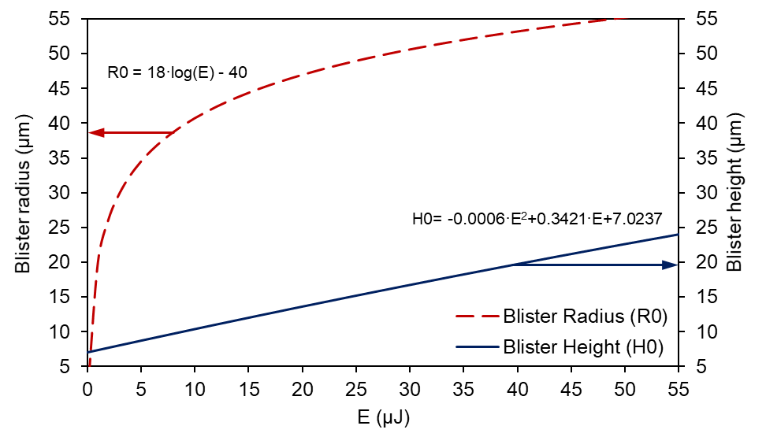

Fig 1.- Polynomial and logarithmic adjustment for blister height (blue solid line) and radius (red dash line), respectively, for times at which no further quick evolution has been observed in the blister, as a function of laser pulse energy.
This parametrization simplifies the model, in terms of reducing the amount of input data. Blister evolution is then only dependent on the laser pulse energy.
Regarding the time spatial function, T(t), image acquisition studies of blister expansion have been carried out to adjust the parameters present in the polynomial steps. Images of the first microsecond after laser pulse are taken and the height of the blister is measured at 22 μJ, a typical work energy value (Figure 2). Three main regimes can be distinguished: an initial expansion, an elastic recovery, and a stabilized stage. In the model, the blister expands for the first 0.1 μs. Then, it recovers elastically within the following 0.4 μs. Once it has deflated, it is assumed that no further evolution takes place. Image studies show that during this last stage the blister continuously deflates, but its effect on the fluid dynamics is neglectable owing to its slow evolution.
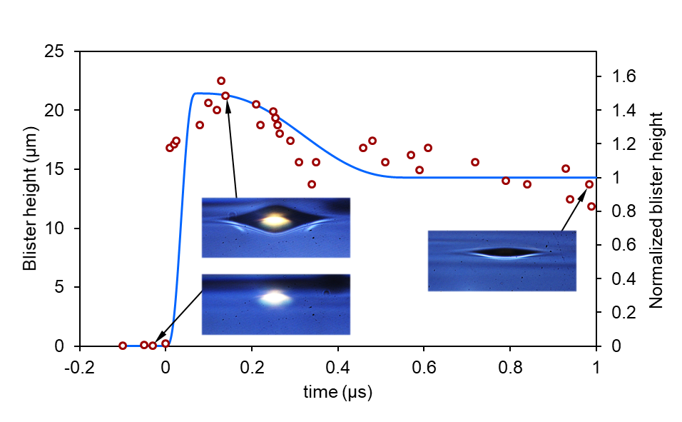

Fig 2.- First microsecond analysis and modeling of blister dynamics for 22 μJ. Blister height measurements (red circles) is plotted in real height units and polynomial fit (blue solid line) is represented as a normalized height by dividing by the infinite-time blister height. Representative images have also been put along to exemplify the three different stages during blister evolution.
Height data has been normalized considering the blister infinite-time height. This temporal-normalized evolution during the first microsecond is modeled by a quick, positive step, for the inflating stage of the blister, followed by a negative and slow one, which simulates the deflation because of elastic behavior. The resultant curve is the input for the model (Figure 4).
The described model closely replicates LIFT processes in their first stages. Different regimes are simulated and validated both against other published models and process images taken by the described system [20].

Results and discussion
Figure 3 shows the possible regimes that have been observed during BA-LIFT of low viscosity fluids. In direct LIFT studies, these regimes have already been described and explained [16,17,25,26], but no proposal has been made regarding BA-LIFT. From left to right, the two first regimes (Figure 3, a and b) are the main primary regimes for transferring low-viscosity fluids. These two regimes appear always for each fluid employed. If the energy is high enough to overcome surface tension and viscosity forces, the jet will travel through the gap (Figure 3, b). Else, the fluid will deform elastically and will return to its original shape (Figure 3, a).
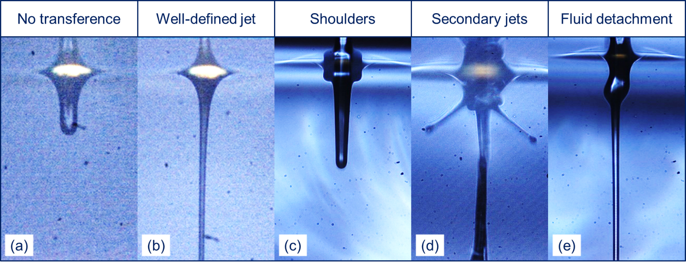

Fig 3.- Compilation of the five typologies of BA-LIFT transference. From left to right: no transference (a), well-defined jet (b), bulgy shape as shoulders (c), bulgy shape in explosive secondary jets (d), and long-time fluid detachment (e). Each picture was extracted from experiments considering different pulse energies, viscosities, thicknesses and times.
For some specific combinations of fluid properties and laser fluences, some secondary effects may appear. These effects, sometimes globally named as “bulgy shape” [25], are mainly grouped in two typologies: shoulders (Figure 3, c) and secondary jets (Figure 3, d), which lead after a while to a massive detachment of fluid which is redistributed over time along the principal jet (Figure 3, e).

BA-LIFT simulation without secondary effects
The regimes in which only a singular jet [16,38] is obtained are acceptably replicated by the described model. In these simulations, the temporal function for the wall movement which pushes the fluid away follows a step-like function including the described elastic peak, as shown in Figure 4. This curve is derived from image studies carried out by some authors [18,39] and blister measurements performed by using the image acquisition system (Figure 2).
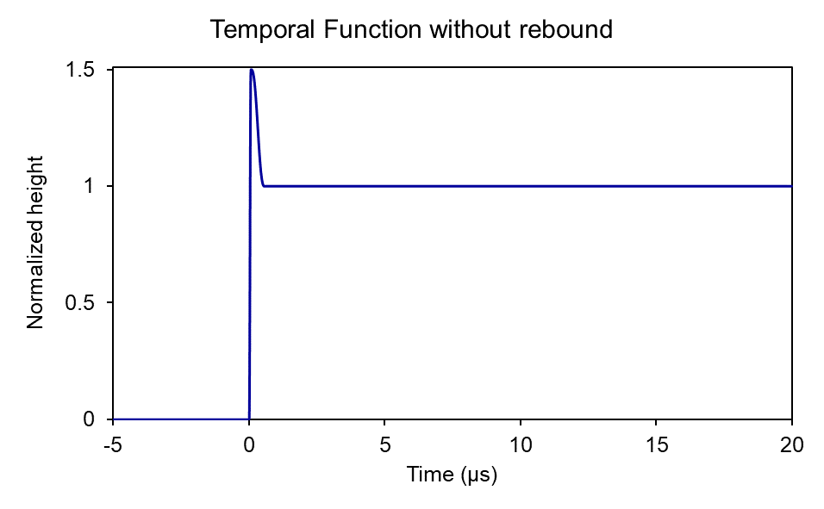

Fig 4.- Temporal function of the blister for the first 20 μs with no consideration of further effects.
Low laser pulse energies, high viscosities or thick layers of fluid, result in the non-transference regime, in which the fluid is merely deformed. The generation of a fluid bell-like shape does not evolve in a transference jet, and thus it suffers from elastic forces to return to its initial state. Figure 5 compares experimental images and simulation results for a particular case of this regime of transference for high viscosity water-glycerol mixture (80 %wt glycerol; 45 mPa·s [22]). Fluid layer thickness is set to 70±10 μm. In the model, the best agreement with the experiments has been obtained for 60 μm thickness –within the measurement uncertainty– considering a laser pulse energy of 19 μJ.
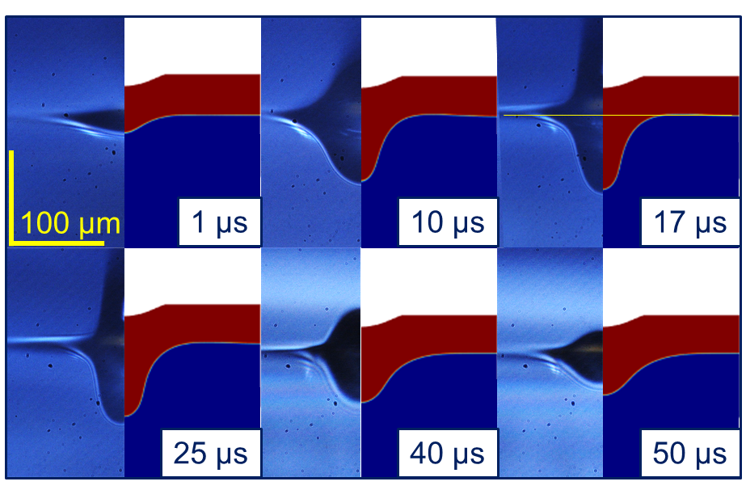

Fig 5.- Non-transference regime images versus simulation comparison.
On the contrary, high laser pulse energies, low viscosities or thin layers of fluid lead to the jet-transference regime. The yet-described fluid bell-like shape has enough energy to beat surface tension forces and travel towards the acceptor in a thin filament –jet– shape. Figure 6 compares experimental images and simulation results for a particular case of this regime of transference for intermediate viscosity water-glycerol mixture (66 %wt glycerol; 13 mPa·s [22]). Fluid layer thickness is set to 30±10 μm. In the model, the best agreement with the experiments has been obtained for 40 μm thickness –within the measurement uncertainty– considering a laser pulse energy of 27 μJ. This model can replicate BA-LIFT transference for the two regimes previously described.
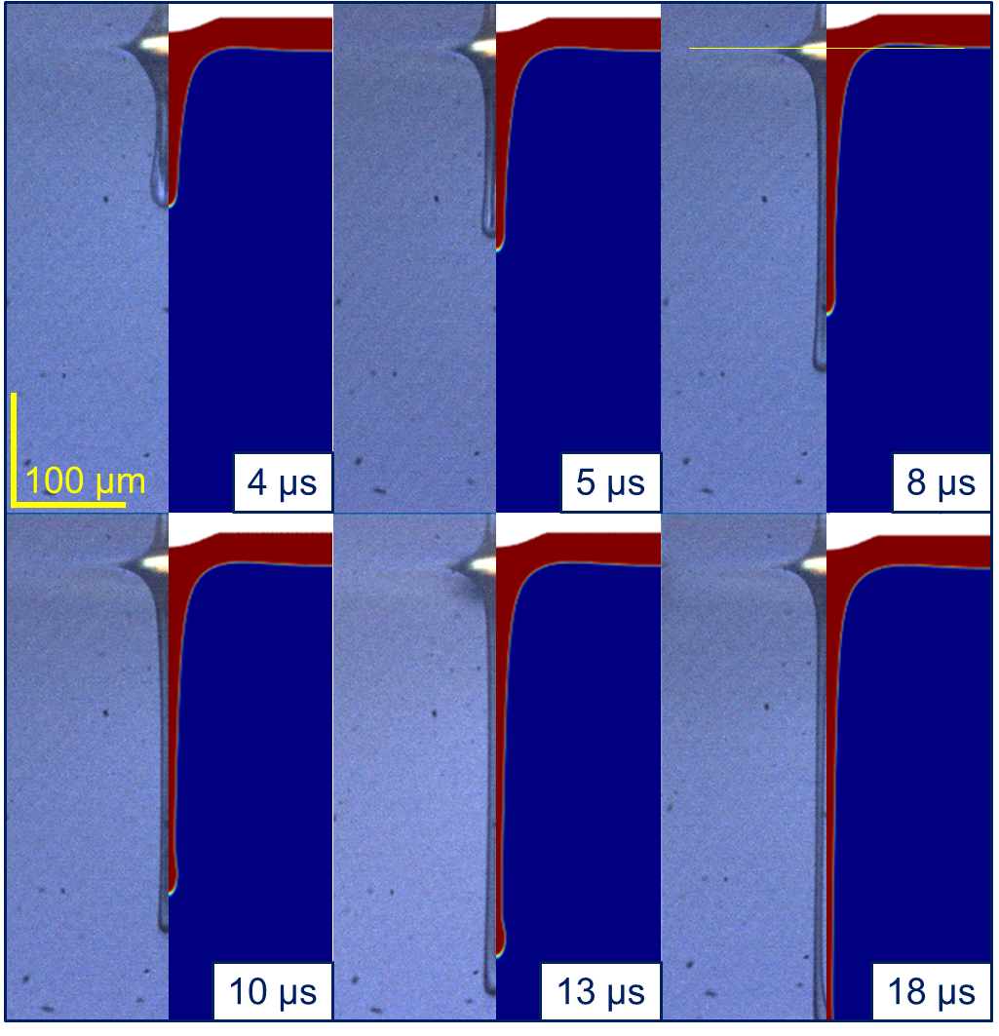

Fig 6.- Jet regime images versus simulation comparison.
The image acquisition system actually takes just a single picture of each transference process, and afterward, the image series is reassembled. Due to the yet quantified uncertainty that accompanies this process, each picture is taken from a particular combination of parameters. Owing to that, the accuracy in fluid thickness seems to be critical to replicate the experimental data. A sensitivity analysis has been carried out to quantify the effects of varying fluid thickness.

Thickness sensitivity in the described model
The sensitivity analysis of fluid thickness in the described model was performed through a parametric sweep for fluid thickness, keeping fixed the rest of process parameters: energy and gap between donor and acceptor. Figure 7 shows the results of the study to quantify the influence of fluid thickness on jet length. To this purpose, an intermediate viscosity water-glycerol mixture (66 %wt glycerol; 13 mPa·s [22]) has been chosen. Simulations were run for a laser pulse energy (E) of 27 μJ, varying fluid layer thickness (Th) between 20 and 30 μm every 2 μm, to assess the possible deviation between the simulation and the experimental images of the transference process due to the thickness uncertainty. The analysis shows that, for a given time, the length of the jet may vary in 20 μm at most, as shown in Figure 7.
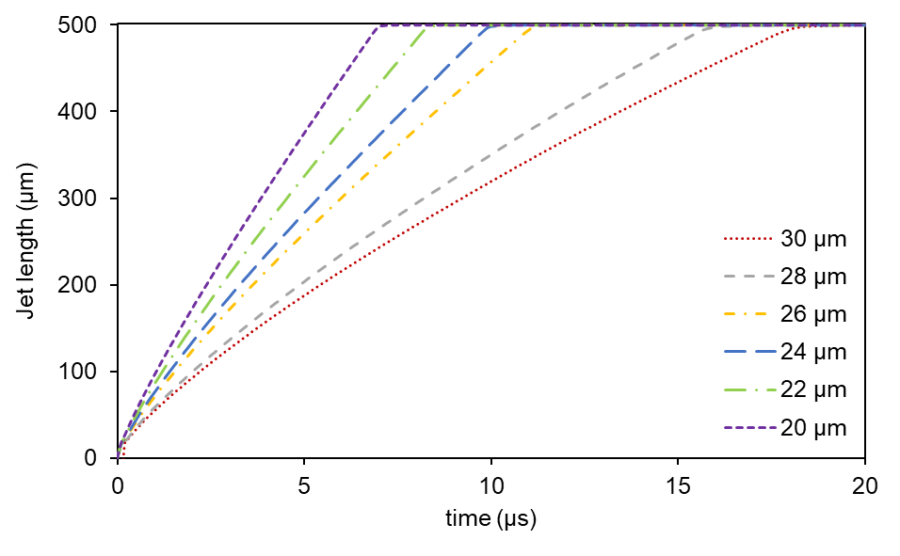

Fig 7.- Thickness sensitivity based on measuring jet lengths for fluid thicknesses between 20 and 30 μm.
This study explains why fluid thickness in the simulation does not precisely match the layer thickness which is ideally set in the experiments. To properly replicate the experimental image series, small deviations in fluid thickness should be considered. This consideration explains the differences observed in Figure 6 between the length of the jet in the simulations and in the images acquired, at the same time. Since every single picture has an uncertainty of 10 μm in fluid thickness, the deviations are acceptable.

Long-time images and simulation of BA-LIFT – Secondary effects
Despite the simulations does match the experimental images for short times, both in jet shape and velocity, at a certain time between 10 and 15 μs some unexpected effects are sometimes witnessed in both LIFT and BA-LIFT processes but do not appear using neither the described model nor in other authors’ simulations yet [16,19]. In direct LIFT, an accepted explanation falls on the generation of a cavitation bubble generated by the laser pulse, by direct interaction between laser and fluid [38]. Nonetheless, no attempt of explanation has been proposed for BA-LIFT. These effects do also appear at certain combinations of energy fluence and fluid properties [40], although only mechanical transference is expected, for typical BA-LIFT processes [20,41].
As said, the appearance of these secondary effects does not always take place, but only for a combination of values of laser fluence, fluid thickness, and fluid viscosity. The inclusion of these effects makes BA-LIFT more similar to direct LIFT transference, in which the movement of the fluid is pushed by a bubble generated by laser [16] and these secondary effects are caused by a cavitation bubble.

Discussion of the possible explanations of secondary effects in BA-LIFT:
From the comparison between direct LIFT and BA-LIFT, it is assumed that a bubble also appears in BA-LIFT processes. The causes below its appearance are then discussed.

Direct laser interaction
In direct LIFT processes, a small amount of fluid is directly evaporated due to the absorption of the laser pulse by the fluid layer [38]. In BA-LIFT, even though an intermediate layer is inserted between glass and fluid, it might be possible for the laser pulse to cross through both layers and to reach the fluid mass, depending on the absorbance of both materials at the picked laser wavelength.
BA-LIFT processes are typically developed with ultraviolet (355 nm) laser pulse, as done in this work. At this wavelength, soda lime and silica glass are almost fully transparent, and polyimide is completely opaque. The analysis of the absorbance of both materials as well as the superposition of them have been studied. Considering ultraviolet wavelength (355 nm), only 9 % of the energy is absorbed by the soda-lime glass. Both the polyimide layer and the superposition of glass and polyimide are entirely opaque to the laser at this wavelength. Therefore, there is no possible absorption in the fluid, given that no laser radiation reaches it [28].

Thermal cavitation bubble
Even though the direct interaction between laser and fluid was rejected, heat conduction may allow the formation of a vapor bubble inside the mass of fluid. Typical times in thermal conduction effects (in the scale of μs) would fit the scale time of the effects observed.
The heat transmitted by the laser pulse might also be the source of the unexpected effects, only if the temperature reached is high enough to vaporize an amount of liquid, resulting in a vapor bubble which pushes the fluid to transfer. Despite the thermal conductivity of the mixture gets worse as glycerol percentage increases [41], the variation in its vapor pressure [23,24] makes water the most adverse case for thermal vaporization of the fluid.
A thermal model was set up in COMSOL 5.3a, and the heat transfer is ruled by the following equations [42]:
$ρC_{p}{∂T}/{∂t}+ρC_{p}u·∇T+∇q=Q$ (17)
$q=-k∇T$ (18)
The laser pulse is modeled as a Gaussian function, and its energy is attenuated by polyimide reflectivity and glass absorptivity. The domain edges allow the heat flow to escape. Numerical simulations have been computed considering the properties of thermal conductivity for commercial silica glass (Thermo Scientific Menzel-Gläser Microscope Slides) and polyimide layer, as well as a polyimide reflectivity of 0.04 and glass absorptivity of 0.09. In the model, the laser spot radius has been set to 18 μm long and its temporal width lasts 12 ns, according to the experimental values. The typical laser pulse energy for this study (20 μJ) was chosen.
Its analysis shows that the maximum temperature in the interface between the polyimide layer and fluid (water, for this study) is about 70 ºC. It does not reach water’s boiling point at ambient pressure, as shown in Figure 8. Thus, the possibility of a bubble generated by heating conduction is rejected.
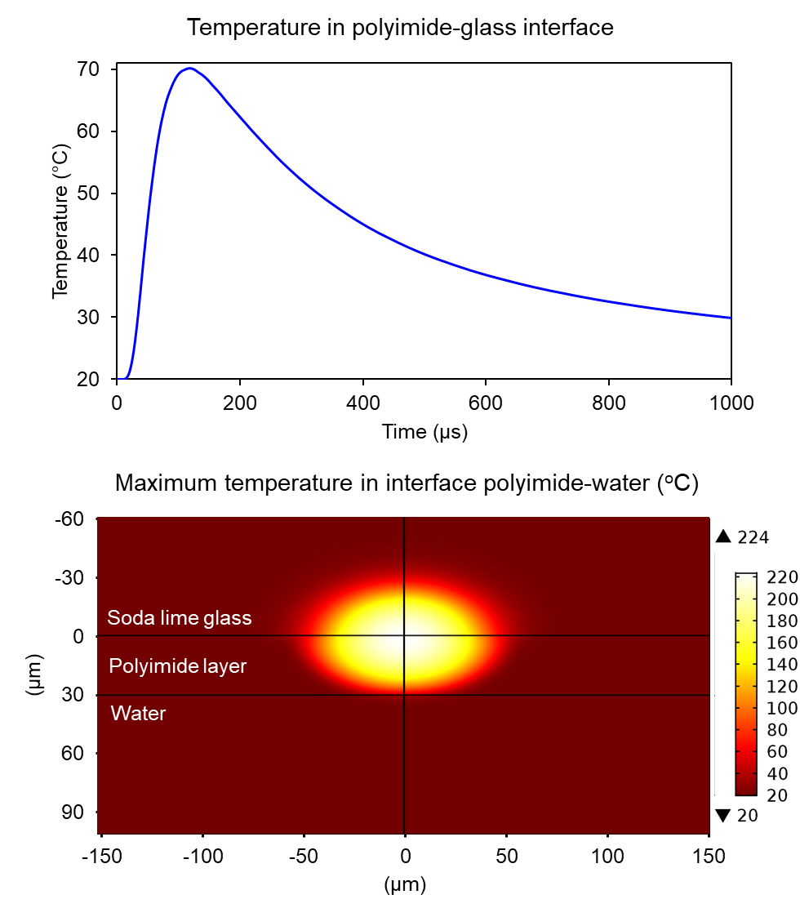

Fig 8.- Thermal analysis of BA-LIFT transference. The graph in the left shows the temperature over time at the interface polyimide-water, where the bubble is expected to be generated. In the map at the right is plotted the temperature throughout the whole domain at the time of maximum temperature in this interface.

Blister rebound
Once rejected the possibility that thermal physics were not beneath the genesis of the bubble, mechanical cavitation caused by a late blister rebound is considered. It has been reported that an abrupt movement of a wall inside a fluid can cause a depressurization that evaporates the fluid [44]. In the case of BA-LIFT, a depressurized area would be generated assuming that the blister would act as a piston owing to its elastic behavior. When it goes back, it would empty the interface between the fluid and the polyimide and would induce the vaporization of a small volume of the fluid at the times at which it has been observed.
By the acquisition of images of the blister, similarly to the study done to model the movement within the first microseconds (Figure 2), the study of the times for which the rebound should appear –around 10 μs– was made. Nevertheless, after measuring the images, no rebound was observed further than the elastic peak in the initial microsecond. The blister is modeled to be static after that initial movement. Blister evolution is plotted in Figure 9 for its 20 first μs.
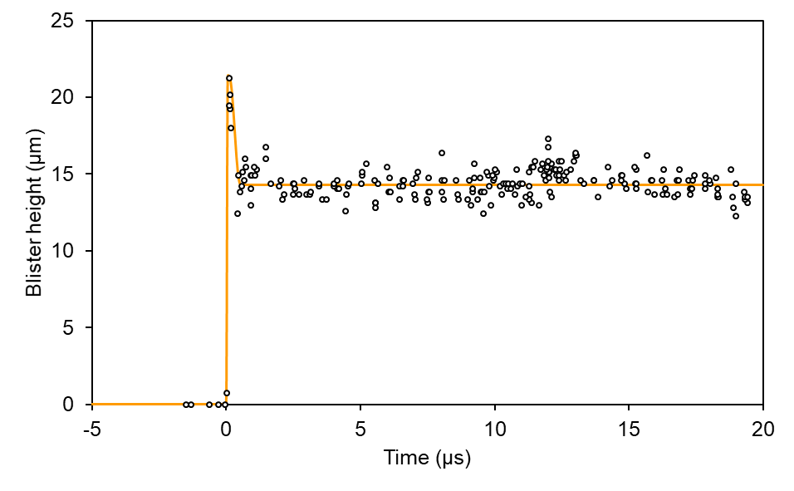

Fig 9.- Blister measurement for 20 μs after laser pulse. No further effect is seen apart from the elastic peak.

Depressurized cavitation bubble
Another kind of cavitation happens in a fluid owing to its velocity. Huge values of accelerations and speeds may lead the fluid to cavitate during BA-LIFT transference, as it happens on the surface of the mechanical parts of a water pump [45]. Figure 10 shows the pressure field at 0.1 μs for two cases (fluid thickness of 20 and 30 μm) of a BA-LIFT case at 19 μJ considering an intermediate viscosity water-glycerol mixture (66 %wt glycerol; 13 mPa·s [22]). It can be seen that the pressure falls below water-glycerol vapor pressure [23,24] just in front of the interface polyimide-fluid. On the contrary, for low laser fluence values, vapor pressure is only slightly lower than reference pressure. These results open the possibility of the generation of a vapor bubble for the first steps of transference.
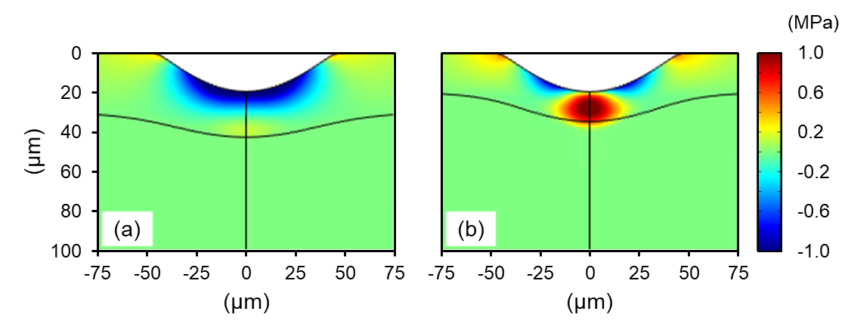

Fig 10.- Depressurized zone due to velocity field at 0.1 μs after laser pulse. Pressure values are relative pressures. Two extreme cases are plotted: 20 μm of fluid layer (a) and 30 μm (b). Fluid properties (water-glycerol 66 %w) and laser pulse energy (19 μJ) are fixed for both cases.
Taking into account the thermal conduction effects reinforces the possibility of generating a bubble. If heat reaches the interface between polyimide and water, even when it is not high enough to make the fluid boil, it would help cavitation to happen, because raising the temperature tends to increase vapor pressure values [23,24].

Model improvement to simulate secondary effects
In the experimental images, at certain times, the flow grows wider than expected during the first stages. After a time, this bell-shaped structure seems to collapse, leading to the generation of secondary effects. The assumption that a cavitation bubble is generated in front of the blister owing to the velocity acquired by the flow implies that the fluid should expand in the first stages, as occurs in direct LIFT processes. When the bubble has grown till the point at which both inner and outer pressures equals, it starts to deflate, and the jet shape of the experiments with and without secondary effects are rather similar (Figure 12, 9.0 μs and Figure 6, 8-10 μs). After this moment, the bubble collapses provoking its implosion and pushing the fluid away again.
In the model, this second push is introduced as a full rebound of the blister. Though there is no real rebound, the effects of a bubble imploding can be closely replicated by the assumption of this second push. The adjustment based on the comparison with experimental images shows that the best results are gotten with rebound times near 9 μs. Despite the difference between the second push and a real vapor bubble, the pressure measurement of a cavitating bubble [46] is rather like the squared-first derivative of the temporal function proposed before, apart from a scale factor [47]. Both functions are plotted in Figure 11.
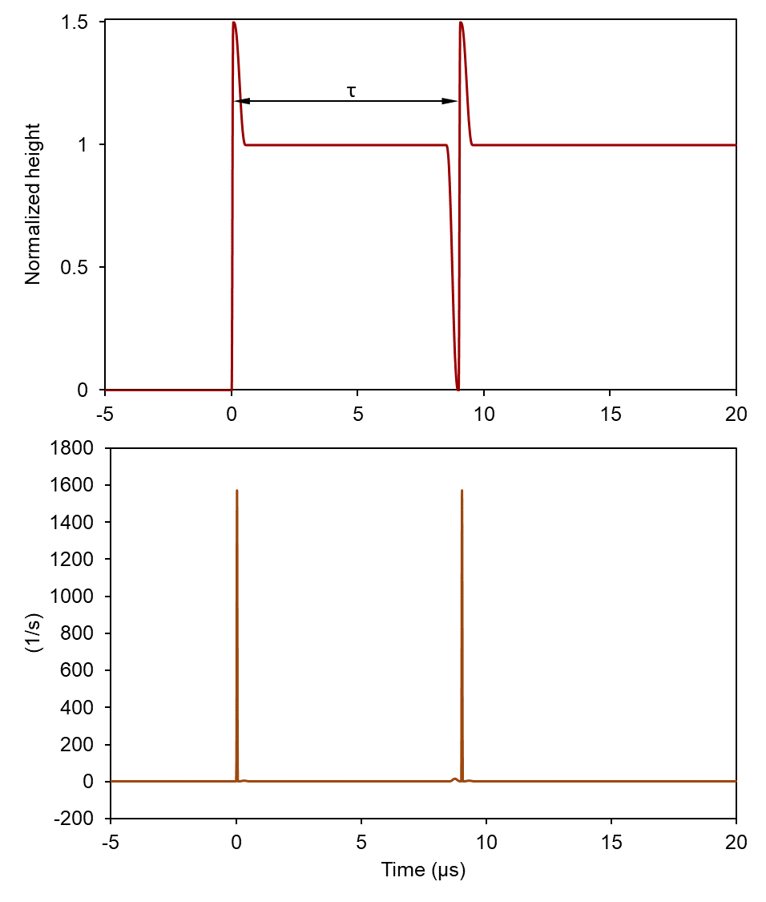

Fig 11.- Modified temporal function that includes second rebound at 9 μs (up) and its squared derivative function (down).

BA-LIFT simulation considering secondary effects
This simplified model of the effects of the cavitation bubble reproduces the bulgy shapes closely by only introducing a second push that resembles the pressure peak, as shown in Figure 12. Each image has been chosen to show the main phenomena that take place. In the first row, the first image (Figure 12, 0.5 μs) compares the initial growth of the deformed shape: simulation and experiments are close. The second comparison in the series (Figure 12, 3.0 μs) shows that the experimental image differs from the simulation. The fluid develops actually in a much wider bell-like shape, due to the existence of a phase change when the vaporized mass is generated and expands itself. After a while (Figure 12, 7.0 μs and 9.0 μs), the over-expanded bell begins to collapse, and simulation and experiments come close again. In the second row, the burst of the bubble takes place. The first image (Figure 12, 9.0 μs) shows the time at which the implosion happens. Both experimental and simulated jets have almost the same shape. After the second push in the simulation and the pressure peak in the experiment, a bulgy shape begins to grow in the shape of small shoulders, as compared in the next two pictures (Figure 12, 10.0 μs and 12.0 μs). Finally, surface tension reshapes the modified jet and fluid detachment is seen in both experiments and simulation (Figure 12, 14.0 μs).
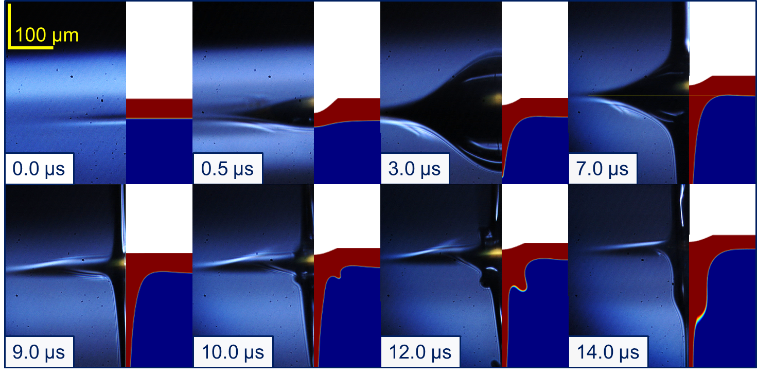

Fig 12.- Comparison between acquired images and simulations considering water-glycerol mixture. Secondary effects are closely simulated assuming the second push. Two stages can be distinguished: bubble generation phase (upper row) and bubble burst phase (lower row).
At that point, only the first bubble implosion is considered, even though several further pressure peaks are considered to happen [46,48]. The subsequent movements of the next rebounds are not supposed to induce any relevant effect and are not taken into account. Despite the cavitation physics are not fully modeled but only the velocity fields that would appear when the former bubble collapse, the effects are closely reproduced for intermediate times.

Simulation of explosive effects observed in experimental image series
The assumption of thickness variability due to experimental uncertainties, as explained before, enables the possibility of replicate further explosive effects, which are only seen in a single image due to the distribution of thicknesses, that appear in simulations for low thicknesses or high laser fluence. Figure 13 compares simulation (a) and experimental (b) pictures in the case of this regime of transference. The fluid layer thickness was set to 30±10 μm. In the model, these results were obtained for 20 μm thickness –within the measurement uncertainty– considering a laser pulse energy of 49 μJ. The viscosity of the water-glycerol mixture was intermediate (66 %wt glycerol; 13 mPa·s [22]). In (Figure 13, b), an image acquired for the described fluid shows explosive lateral jets.
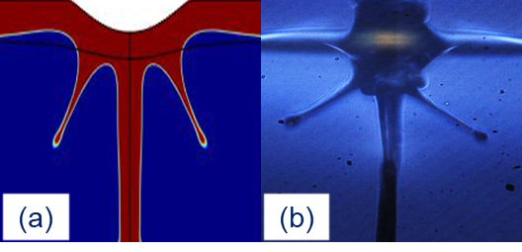

Fig 13.- Random explosive effects observed experimentally (b) and its simulation decreasing fluid thickness to 30 μm (a) for a 66 &wt water-glycerol mixture. Both simulation and experiment were run at 49 μJ. As the images are individually taken, there is no series that exemplify the generation of these lateral secondary jets.

Discussion of bubble dynamics in BA-LIFT
According to the accepted explanation of the dynamics of laser-generated bubbles in LIFT (without deformable intermediate layer), a big vapor cavity turns up after the laser pulse. Then, its cooling compress itself and two jets are generated: the most important one, pushing the fluid forward, leads the transference, and the secondary one, which is pointed to the inner face of the bubble, transforms the vaporized mass in a toroid shape.
Though these dynamics are commonly accepted in direct LIFT [38], similar effects are seen in BA-LIFT techniques, with no currently accepted explanation for now. A proposal for fluid movement during BA-LIFT is displayed in Figure 14. When the laser vaporizes the polyimide layer, it pushes the fluid forward. Due to this huge acceleration, a low-pressure area is generated in front of the blister, as Figure 10 exemplify, and then some fluid is vaporized. The bell-shaped structure of fluid (Figure 14, a) grows in both radius and height, and the jet is thus wider than expected (Figure 12, 3.0 μs). When the pressure inside and outside the cavitation bubble equals, the jet grows only in the axial direction (Figure 14, b), and only inertial-ruled expansion continues. Owing to this overexpansion, the cavitation bubble starts to collapse while the jet continues its expansion (Figure 14, c and d). When the bubble fully collapses (Figure 14, e), the jet shape is almost the same that it would have without the consideration of cavitation, as seen in the comparison between images and simulation in Figure 12, 9.0 μs. This collapse induces a second push due to the implosion of the cavitation bubble that generates the secondary effects described in this work (Figure 14, f).
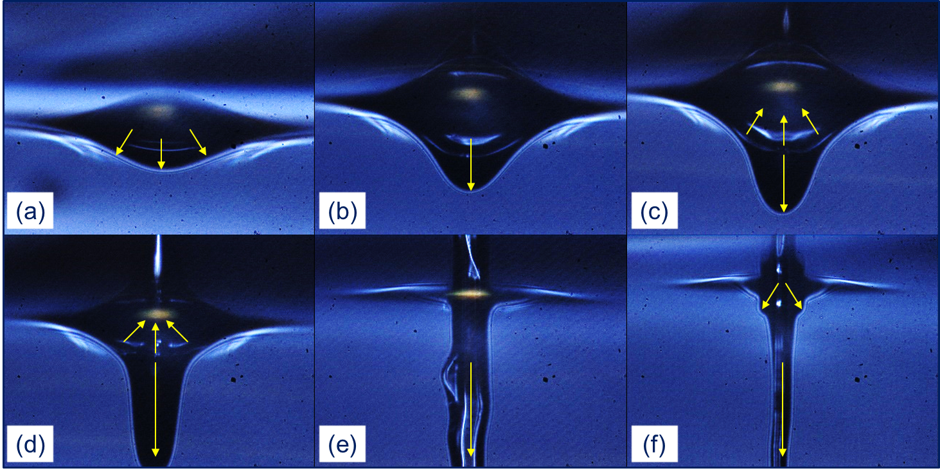

Fig 14.- BA-LIFT qualitative flow during transference. Generation and collapse of vapor bell is pointed out, as well as the further burst because of bubble implosion.

Conclusions
The BA-LIFT transference mechanism is ideally only mechanical, but it does not explain some observed effects that have already been described for direct LIFT transference. The transference from a layer of 30 and 70 μm of different concentrations of water-glycerol have been studied, and image series have been taken by shadowgraphy. Though only-mechanical-consideration models replicate the first microseconds of transference, there are some secondary effects that are not explained taking only this assumption into account. The analysis of the image series, as well as the comparison of the secondary effects that does also appear in direct LIFT transference, reveals that the behavior of the fluid is rather similar in both techniques. The cavitation of a laser-generated bubble in this last sort of process induces the hypothesis of the presence of an analogous cavitation bubble in BA-LIFT. For its study, four causes have been discussed as the cause of the bubble, and three of them are discarded through this work. The analysis of the absorbance of the intermediate layer rejects the possibility of direct interaction between laser and fluid. Through thermal simulations is seen that the generation of a bubble by heat transfer is not possible. At last, image series analysis of the blister that pushes the fluid away discards the chance of a mechanical rebound that lowers the pressure. The only remaining reason to generate a cavitation bubble is the depressurization of an area in front of the interface between the intermediate layer and the fluid, as finite-elements simulations support.
As cavitation phenomena have widely been reported, its effects are well-known. The inclusion of the effects of a cavitation implosion for intermediate times in the form of a second push in a BA-LIFT model makes the fluid acquire the shape observed in experimental images due to secondary effects.
A sensitivity analysis has been made to quantify the effects of the experimental fluid layer thickness variation of 10 μm in the transference. The simulations run within this experimental range are able to even replicate the explosive lateral jets observed under certain conditions in the acquired image series. The proposed enhanced model can simulate each experimentally observed transference regime. A fluid movement explanation, considering that a cavitation bubble may appear under some conditions, has been made to understand BA-LIFT process.

Acknowledgments
This research has been funded by Spanish MINECO projects SIMLASPV-MET (ENE2014-58454-R) and CHENOC (ENE2016-78933-C4-4-R) and Comunidad de Madrid Projects ADITIMAT-CM (S2018/NMT-4411) and BIOPIELTEC-CM (P2018/BAA4480)

References
[1] D.B. Chrisey, A. Pique, J. Fitz-Gerald, R.C.Y. Auyeung, R.A. McGill, H.D. Wu, M. Duignan, New approach to laser direct writing active and passive mesoscopic circuit elements, Applied Surface Science. 154 (2000) 593-600. doi:10.1016/S0169-4332(99)00465-1.
[2] K.K.B. Hon, L. Li, I.M. Hutchings, Direct writing technology—Advances and developments, CIRP Annals - Manufacturing Technology. 57 (2008) 601-620. doi:10.1016/j.cirp.2008.09.006.
[3] M.J. Madou, Fundamentals of Microfabrication and Nanotechnology, 3. ed. ed., CRC Press, Boca Raton, Florida, 2012.
[4] C.B. Arnold, A. Piqué, Laser Direct-Write Processing, MRS Bulletin. 32 (2007) 9-15. doi:10.1557/mrs2007.9.
[5] M. Morales, D. Munoz-Martin, A. Marquez, S. Lauzurica, C. Molpeceres, Chapter 13 - Laser-Induced Forward Transfer Techniques and Applications, in: Anonymous Advances in Laser Materials Processing, Elsevier Ltd, 2018, pp. 339-379.
[6] M. Duocastella, P. Serra, J. Morenza, J. Fernández-Pradas, Time-resolved imaging of the laser forward transfer of liquids, Journal of Applied Physics. 106 (2009) 084907-7. doi:10.1063/1.3248304.
[7] M. Duocastella, J. Fernández-Pradas, P. Serra, J. Morenza, Jet formation in the laser forward transfer of liquids, Appl. Phys. A. 93 (2008) 453-456. doi:10.1007/s00339-008-4781-y.
[8] N.T. Kattamis, P.E. Purnick, R. Weiss, C.B. Arnold, Thick film laser induced forward transfer for deposition of thermally and mechanically sensitive materials, Applied Physics Letters. 91 (2007) 171120. doi:10.1063/1.2799877.
[9] N. Kattamis, S. Bernhard, N. McDaniel, C. Arnold, Laser direct write printing of sensitive and robust light emitting organic molecules, Applied Physics Letters. 94 (2009) 103306-3. doi:10.1063/1.3098375.
[10] J. Hong, Thermo-mechanical analysis of blister formation on a rigid substrate in blister-actuated laser-induced forward transfer, TCPMT. (2019) 1. doi:10.1109/TCPMT.2019.2959708.
[11] I. López, Simulación de procesos de transferencia de material con láser asistida por capa de polímero (BA-LIFT), (2017).
[12] L. Rubio, Simulación con COMSOL de Procesos de Transferencia de Material Inducida por Láser, (2014).
[13] C. . Brasz, C.B. Arnold, H.A. Stone, J.R. Lister, Early-time free-surface flow driven by a deforming boundary, Journal of Fluid Mechanics. 767 (2015) 811-841. doi:10.1017/jfm.2015.74.
[14] S.A. Mathews, R.C.Y. Auyeung, H. Kim, N.A. Charipar, A. Piqué, High-speed video study of laser-induced forward transfer of silver nano-suspensions, Journal of Applied Physics. 114 (2013) 64910. doi:10.1063/1.4817494.
[15] C. Boutopoulos, A.P. Alloncle, I. Zergioti, P. Delaporte, A time-resolved shadowgraphic study of laser transfer of silver nanoparticle ink, Applied Surface Science. 278 (2013) 71-76. doi:10.1016/j.apsusc.2012.12.002.
[16] J. Yan, Y. Huang, C. Xu, D.B. Chrisey, Effects of fluid properties and laser fluence on jet formation during laser direct writing of glycerol solution, Journal of Applied Physics. 112 (2012) 83105. doi:10.1063/1.4759344.
[17] A. Kalaitzis, M. Makrygianni, I. Theodorakos, A. Hatziapostolou, S. Melamed, A. Kabla, F. de la Vega, I. Zergioti, Jetting dynamics of Newtonian and non-Newtonian fluids via laser-induced forward transfer: Experimental and simulation studies, Applied Surface Science. 465 (2019) 136-142. doi:10.1016/j.apsusc.2018.09.084.
[18] N.T. Kattamis, M.S. Brown, C.B. Arnold, Finite element analysis of blister formation in laser-induced forward transfer, Journal of Materials Research. 26 (2011) 2438-2449. doi:10.1557/jmr.2011.215.
[19] A. Kalaitzis, M. Makrygianni, I. Theodorakos, A. Hatziapostolou, S. Melamed, A. Kabla, F. de la Vega, I. Zergioti, Jetting dynamics of Newtonian and non-Newtonian fluids via laser-induced forward transfer: Experimental and simulation studies, Applied Surface Science. 465 (2019) 136-142. doi:10.1016/j.apsusc.2018.09.084.
[20] M.S. Brown, F.C. Brasz, Y. Ventikos, C.B. Arnold, Impulsively actuated jets from thin liquid films for high-resolution printing applications, Journal of Fluid Mechanics. 709 (2012) 341. doi:10.1017/jfm.2012.337.
[21] E. Turkoz, R. Fardel, C.B. Arnold, Advances in Blister‐Actuated Laser‐Induced Forward Transfer (BA‐LIFT), in: Anonymous Laser Printing of Functional Materials, Wiley‐VCH Verlag GmbH & Co. KGaA, Weinheim, Germany, 2018, pp. 91-121.
[22] N. Cheng, Formula for the viscosity of a glycerol-water mixture, Industrial and Engineering Chemistry Research. 47 (2008) 3285-3288. doi:10.1021/ie071349z.
[23] H.K. Cammenga, F.W. Schulze, W. Theuerl, Vapor pressure and evaporation coefficient of glycerol, Journal of Chemical & Engineering Data. 22 (1977) 131-134. doi:10.1021/je60073a004.
[24] A.R. Carr, R.E. Townsend, W.L. Badger, Vapor Pressures of Glycerol-Water and Glycerol-Water-Sodium Chloride Systems, Industrial & Engineering Chemistry. 17 (1925) 643-646. doi:10.1021/ie50186a043.
[25] Z. Zhang, R. Xiong, D.T. Corr, Y. Huang, Study of impingement types and printing quality during laser printing of viscoelastic alginate solutions, Langmuir : the ACS journal of surfaces and colloids. 32 (2016) 3004-3014. doi:10.1021/acs.langmuir.6b00220.
[26] Z. Zhang, R. Xiong, R. Mei, Y. Huang, D.B. Chrisey, Time-resolved imaging study of jetting dynamics during laser printing of viscoelastic alginate solutions, Langmuir : the ACS journal of surfaces and colloids. 31 (2015) 6447-6456. doi:10.1021/acs.langmuir.5b00919.
[27] P. Yue, C. Zhou, J.J. Feng, C.F. Ollivier-Gooch, H.H. Hu, Phase-field simulations of interfacial dynamics in viscoelastic fluids using finite elements with adaptive meshing, Journal of Computational Physics. 219 (2006) 47-67. doi:10.1016/j.jcp.2006.03.016.
[28] A. Márquez, M. Gómez Fontela, S. Lauzurica, R. Candorcio-Simon, D. Munoz Martin, M. Morales Furio, M. Ubago Torres, C. Toledo Morcuende, P. Lauzurica Gomez, C. Molpeceres, Fluorescence enhanced BA-LIFT for single cell detection and isolation, Biofabrication. (2019). doi:10.1088/1758-5090/ab6138.
[29] D. Munoz-Martin, C.F. Brasz, Y. Chen, M. Morales, C.B. Arnold, C. Molpeceres, Laser-induced forward transfer of high-viscosity silver pastes, Applied Surface Science. 366 (2016) 389-396. doi:10.1016/j.apsusc.2016.01.029.
[30] COMSOL Multiphysics®, 5.3a.
[31] P. Yue, J.J. Feng, C. Liu, J. Shen, A diffuse-interface method for simulating two-phase flows of complex fluids, Journal of Fluid Mechanics. 515 (2004) 293-317. doi:10.1017/S0022112004000370.
[32] R.L. Panton, Incompressible Flow, 3rd ed., Wiley, New York, 2005.
[33] G.K. Batchelor, An Introduction to Fluid Dynamics, 9th ed., Cambridge Univ. Press, Cambridge, 2007.
[34] P.M. Gresho, R.L. Sani, Incompressible Flow and the Finite Element Method, Wiley, Chichester, 2000.
[35] J.H. Ferziger, M. Peric, R.L. Street, Computational Methods for Fluid Dynamics, 4th ed., Springer International Publishing, Switzerland, 2019.
[36] J.W. Cahn, J.E. Hilliard, Free Energy of a Nonuniform System. I. Interfacial Free Energy, The Journal of Chemical Physics. 28 (1958) 258-267. doi:10.1063/1.1744102.
[37] M.S. Brown, Experimental and Numerical Study of Laser-Induced Forward Transfer Printing of Liquids, (2011).
[38] C. Unger, M. Gruene, L. Koch, J. Koch, B. Chichkov, Time-resolved imaging of hydrogel printing via laser-induced forward transfer, Appl. Phys. A. 103 (2011) 271-277. doi:10.1007/s00339-010-6030-4.
[39] M. Brown, N. Kattamis, C. Arnold, Time-resolved study of polyimide absorption layers for blister-actuated laser-induced forward transfer, Journal of Applied Physics. 107 (2010) 083103-8. doi:10.1063/1.3327432.
[40] E. Turkoz, A. Perazzo, H. Kim, H.A. Stone, C.B. Arnold, Impulsively Induced Jets from Viscoelastic Films for High-Resolution Printing, Physical review letters. 120 (2018) 074501. doi:10.1103/PhysRevLett.120.074501.
[41] O.K. Bates, Binary Mixtures of Water and Glycerol - Thermal Conductivity of Liquids, Industrial & Engineering Chemistry. 28 (1936) 494-498. doi:10.1021/ie50316a033.
[42] H. R. Thomas, Roland Wynne Lewis, Karen Morgan, Kankanhalli N. Seetharamu, The Finite Element Method in Heat Transfer Analysis, Wiley, Chichester [u.a.], 1996.
[43] J.M. Liu, Simple technique for measurements of pulsed Gaussian-beam spot sizes, Optics letters. 7 (1982) 196. doi:10.1364/OL.7.000196.
[44] H. Shahmohamadi, R. Rahmani, H. Rahnejat, C.P. Garner, CFD modelling of cavitation phenomenon in piston ring / cylinder liner conjunction, (2013).
[45] S.A. Nourbakhsh, B.A. Jaumotte, C. Hirsch, H.B. Parizi, Cavitation, in: S.A. Nourbakhsh, B.A. Jaumotte, C. Hirsch and H.B. Parizi (Eds.), Turbopumps and Pumping Systems, Berlin, Heidelberg: Springer Berlin Heidelberg, Berlin, Heidelberg, 2008, pp. 42-50.
[46] M.A. Maiga, M. Adama, A.M. M, Single Bubble SonoLuminescence of Particles model, (2012).
[47] O. Supponen, D. Obreschkow, M. Tinguely, P. Kobel, N. Dorsaz, M. Farhat, Scaling laws for jets of single cavitation bubbles, Journal of Fluid Mechanics. 802 (2016) 263-293. doi:10.1017/jfm.2016.463.
[48] I. Akhatov, O. Lindau, A. Topolnikov, R. Mettin, N. Vakhitova, W. Lauterborn, Collapse and rebound of a laser-induced cavitation bubble, Physics of Fluids. 13 (2001) 2805-2819. doi:10.1063/1.1401810.

Vitae

Juan José Moreno-Labella

Juan José Moreno Labella is doing his thesis in Mechanical Engineering at Universidad Politécnica de Madrid. He received his degree in Industrial Engineering in the speciality of Materials Science in 2016 at the same university. Currently, he is Graduate Teaching Assistant at Escuela Técnica Superior de Ingenieros Industrial in Madrid, in Universidad Politécnica de Madrid. His research line includes laser processing and finite-elements simulation.

David Muñoz-Martin
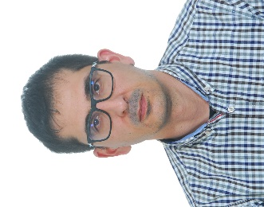
David Muñoz Martín received his M.Sc. degree and his Ph.D. degree in Physics from Universidad Complutense de Madrid in 2005 and 2009, respectively. During his Ph.D., he worked in Instituto de Óptica – CSIC, where he studied the nonlinear optical properties of heavy metal oxide thin film glasses for photonic applications. Currently, he is associate professor in mechanical engineering in Universidad Politécnica de Madrid. His research interests include laser processing of materials for photovoltaic applications, laser induced forward transfer (LIFT) for flexible electronics and biofabrication and additive manufacturing.

Miguel Morales

Miguel Morales is currently Associate Director at Laser Centre Universidad Politécnica de Madrid (Centro Láser UPM) and Professor at Department of Applied Physics and Material Engineering of ETSI Industriales at same institution. His research activity is focused in modelling of laser-matter interaction, including the experimental validation, and in the development of new laser micro and nano processing, using state of the art laser research activity. As a result of some of these investigations he is funding member of two spin-off companies BIOD (systems for optical biosensing) and Innofluence (systems for LIFT applications).

Andrés Márquez

Andrés Márquez is a PhD student with a degree in mechanical engineering and specialized in equipment development and laser technologies. His research focuses in the implementation of LIFT technologies in the biological and medical field.

Carlos Molpeceres

Carlos Molpeceres is currently Director at Laser Centre Universidad Politécnica de Madrid (Centro Láser UPM) and Full Professor at Department of Applied Physics and Material Engineering of ETSI Industriales at same institution. He is currently Chair of LAMOM conference at SPIE Photonics West. Currently his research activity is focused in the development of new laser micro and nano processing, using state of the art laser technology, in different fields, but in special in energy and biomedicine.

